POLAR Spacecraft Status As of: Weds July 6, 16:00 EST
(changes from last week in bold border)
Subsystem/  Component | NOAA-12D  AM: 1651=AN  STIP data only | NOAA-14J  AM: 2039=AN  STIP data only | NOAA-15K  AM: 1806=AN  GAC data only | NOAA-16L  PM: 1441=AN  GAC&LAC data | NOAA-17M  AM: 2225=AN  GAC&LAC data | NOAA-18N  OV PM; 14:00=AN  APT/HRPT/GAC
LAUNCHED | 05/14/91 | 12/30/94 | 05/13/98 | 09/21/00 | 6/24/02 | 5/20/05
CNTL OBP | OBP2 | OBP2  OBP1 inoperative | OBP2 | OBP2 | OBP2 | OBP2
BUS | B-BUS  XSU-1 | B-BUS  XSU2 (XSU1 inop) | B-BUS  XSU-1 | B-BUS  XSU-1  XSU1 TOAR 444 | B-BUS  XSU-1 | B-BUS  XSU-1
BUS VETO | NO | NO | NO | NO | NO | NO
ADACS  X=Yaw  Y=Roll  Z=Pitch | Nominal Mode  RGmode=Monitor  Gyro chans=XYZ | Nominal Mode  Rgmode=Disabled  Gyro chans=XYZ  SS check Disabled when mode=YGC | Nominal Mode  Rgmode=Monitor  Gyro-3 Off 6/26/00 Gyro chans=AAB  N2 Low PSI invalid | Nominal Mode  Rgmode=Monitor  Gyro-3 Off 6/10/04  Gyro chans=AAA | Nominal Mode  Rgmode=Monitor  Gyro-3 Off 6/10/04  Gyro chans=AAB  Gyro-2 current spike under investigation | Nominal Mode  Gyro-A MIMU-2  Z-wheel -Pitch  TOAR 447
RXO | PRI  BU random enables  daily bias+6.5 mS | PRI  BU random enables daily bias–7.0 mS | PRI  daily bias -8 mS  +100 mS 31Aug04 | PRI  Daily Bias –5.5 mS  -100 mS 31Aug04 | PRI  Daily Bias –3 mS | PRI  23 May05
CLOCK DIV | 2 | 2 | 2 | 2 | 2 | 2
MIRP | External Synch  Rephase Enabled | External Synch  Rephase 0730 Daily | External Synch Rephase 0730 daily | External Sync  Rephase each orbit | External Sync  Rephase Enabled | External Synch  Rephase Enabled
TIP SIDE | 1 | 1 | 2  (since 4/23/03)  3 Channels inop | 2  since 4/18/05 | 1  Analog telem drifting | 1
DTRs | 3A, 4, 5B  Safestate 5B | 1, 2B, 5 Safestate- 1B | 1, 2, 3, 4 Safestate 1B EOT | 1,2,3,4A  Safestate 3A  4B STIP only | 1,2,3,4  Safestate=1B  DTR2-SSR | 1,2,3,4,5  All solid state digital.  Current spikes under investigation  TOAR 450
VTX  (APT data) | #1 ON  137.50 MHZ | OFF  Since 8/14/02 | #1 ON  137.50 MHZ | INOP  OFF since 11/15/00 | #2 ON  137.62 MHZ  Powered off over CDA’s 3-5 Jul | #2 ON  137.9125 MHZ
BTX | #1  136.77 MHZ | #2  137.77 MHZ | #1  137.35 MHZ | OFF  Since 30May05 | #2 ON  137.77 MHZ | #2  137.77 MHZ
STX  #1=1698.0 mhz  #2=1702.5 mhz  #3=1707.0 mhz  #4=2247.5 mhz | 1 – HRPT;  2,3 - Playback | 3 – HRPT  2, 1 – Playback | 2-Omni HRPT  Power drop  TOAR 446  4-Playback  1,2,3-Degraded | 1 – HRPT;  2– Playback;  4 – Playback  3 low power unused | 3 – HRPT  TOAR424 low power  2 & 4 Playback  1-Standby  STX-1 output power drop TOAR 443. | 3 - HRPT  1&2 Playback  STX1&3 swap assignments occurred 28June  4-Standby
POWER  (Array offset and CANT angle, charge & V/T rates, eclipse states and sun angle) | ArrayOff +60  since 6/23/04  Eclipse season 21Apr-17Aug  Sun Angle 37 start downtrend to 12 mid-Oct 05  Batts 1&2=LRC  V/T=4  Shunt degraded  SA CANT=37 degs | Array Off -55  Since 8/21/03  Eclipse all year  Sun angle 51  Steady trend  Batts 1-3= LRC  Batts 1&3V/T=7/11  Batt2 VT=8/11  SS trigger =18.98  Shunt Degraded  SA CANT=22 degs | Array Off -45  Since 1/25/01  Eclipse Season  16 May-23 Jul  Sun Angle 30 downtrend to 2 degs on 10 Oct 05  Batts 1-3= LRC  V/T=7/9  SA CANT=37 degs | Array Off -40  Since 7/16/02  Eclipse all year  Sun Angle 58  Start downtrend to 41 on 30 Oct 05  Batts 1-3= LRC  V/T=4/8  SA CANT=22 degs | Array Off. –40  Since 1/29/04  Eclipse all year  Sun Angle at 70  Steady trend  Batts 1-3= LRC  V/T= 4/8  SA CANT=37 degs | Array Off. -40  Since 6/6/05  Eclipse all year  Batts 1-3=LRC  Batts 1-3 V/T=4/8  SA CANT=22  PSSS enabled 30May
AVHRR | Nominal | INOP  Scan motor stalled  14 Apr 04 | Nominal  Rare major scan motor surges. Last  Incident 11/18/04 | Operational  TCE24 OFF 4/14/04  Bar coded imagery typical since 29June05  Channel 3B only. | Nominal  3A-B switch enabled | Nominal  3A-B switch Enabled  6/23/2005
AMSU-A1 |  |  | Operational  Ch14 inoperative  Ch11 inoperative | Operational  Primary PLLO chans 9-14 bias shift.  Backup PLLO inop.  Channel 9-14 noise | OFF/INOP  Since 10/30/03  Survival heat on. | Nominal  Space view 1  Since 6/7/05
AMSU-A2 |  |  | Nominal | Nominal  Space Position-2 | Nominal | Nominal  Space view-2  since 6/08/05
AMSU-B |  |  | Operational  Bias in All Chans.  Motor surges most recent 11/14/04  IPD Reports of degraded data on Chan-3 since 4/30 | Operational  Space Position-3  IPD reports channel 8 degradation | Nominal | Replaced by MHS
HIRS | OFF/Inop  Turned off 6/23/05  For power balance  Filter Wheel turned OFF 10/17/02. | NOMINAL  Operational  Occasional loss of Fwheel synch | INPROVED  Upgraded to Yellow status  16 May 05  FW Abrupt return to nomial at 09:00Z  TOAR 445 open  FW mode=Hi Powr  FW Heater OFF  Frequent Filter | Operational  High levels of imagery radiometric noise  TOAR 441 open  Occasional major FM surges, most recent  12/9/04 | NOMINAL  1 Pixel cross track misalignment . | ON  TOAR 448  Noise in long wave  channels 1-12.  Some improvement reported. Investigation ongoing
MHS/MIU |  |  |  |  |  | Nominal  Final config on 6/4 Now Operational
MSU | OFF/Inop  Turned off for power balance  6/23/05 | Operational  Scan motor and antenna problems
SSU |  | Nominal
DCS | Nominal | Nominal | Nominal | Nominal | Nominal | ON  DRU’s 1-7 On  DRU-8 TOAR 449 turned off 6/13
SARR |  | Nominal | Operational  A-Side, AGC Mode  Intermittent failures for 243MHz A&B | Operational  Switched back to mode AA  26Apr05 14:10Z  A-side, AGC Mode  (B-side in FG mode)  243 MHz = INOP. | Nominal  A-side  All AGC Mode | ON  A-Side  AGC-mode  (correction from last week)  Since 27 June
SARP |  | OFF  Power Failure | Nominal  RCVR B/W = 2 | Nominal  RCVR B/W = 2 | Nominal | ON  A-side 23 May  All DRU’s on
SEM | ON/Nominal  Turned on 8/30/04  Elec-CH-HVPS=4  Prot-CH-HVPS=0 | Operational  Elec-CH-HVPS=0  Prot-CH-HVPS=0  1 of 4 Tscopes inop | Nominal  E-CDEM-HVPS=2  P-CDEM-HVPS=0 | Nominal  E-CDEM-HVPS=5  P-CDEM-HVPS=4 | Nominal  E-CDEM-HVPS=2  P-CDEM-HVPS=3 | ON  Turned on  6 June at 14:05z
SBUV |  | Degraded  Grate motor sticks  Flex memory 3 (giant step) ops suspended 12/2/03  Reduced operations |  | Operational  Degraded Ozone data  Backup Diffuser inop  Primary Diffuser deployment problem TOAR 426  AMSU EMI causing erratic Behavior in PMT cathod, range 3 | Nominal  Anode Mode  Plan sweep mode Standard Ops Procedure change  starting 17 May | ON  since 27 May  Commanded to Cathode mode  5 July 17:15z  Back to anode mode 6 July 13:30z  OV testing continues
SADPOS |  |  | N/A | ON  Enabled MFactor50%  Timer = 12 mins | ON  ENABLED  Timer = 12mins | ON  Enabled
THERMAL  Heaters, louvers  TCE’s | Nominal  TCE’s back to nominal configuration following 7/25/04 UVtrip. | Nominal | TCE26 & 15H  Telem invalid  TOAR 432  HIRS FW Heat tuned ON 17 Apr and OFF on 18 Apr  TCE24L&25L (HIRS & AVHRR) failed 5/13/98  RCE thermostat failed 5/13/98 | Nominal  TCE24 OFF 4/14 (AVHRR H&L)  HIRS Filter heater turned OFF 1/18/05 | TCE3H Batt 2A heater failed ON, turned off 8/26/03 TOAR 428  CLOSED 9/14/04 no corrective action possible.  AMSU-A1 survival heaters on 10/29/03 | All TCE’s active
 | N12 | N14 | N15 | N16 | N17 | N18

COMMENTS/CHANGES:

NOAA-12 The N12 battery’s maximum discharge voltage began to slowly trend upward (exiting eclipse at approximately 19.7
volts) during the past week in conjunction with the start of its eclipse season waning. Shunts also improved over past weeks (from a workload perspective) although as eclipse season continues to wind down additional loading will be necessary to maintain these reduced shunt workloads. On the other hand, battery temps remained relatively elevated (averaging 10.5 degs) during the past week. Additional reconfigurations are anticipated for the N12 power subsystem in the coming weeks although, other than turning HIRS and MSU back on, the specific operations are not yet defined. Carl Gliniak is EMOSS POC for this situation.

NOAA-14: Spacecraft is operating nominally and power subsystem remains stable and above safe state threshold values as the
percentage darkness time per orbit has stabilize at or slightly below 20% darkness per orbit which will be sustained for the remainder of the year. Otherwise there were no changes to N14 during the past reporting period.

NOAA-15: The N15 AMSU’s were all generally stable and nominal during the past week (illustration 1) including the AMSU-B which quickly recovered from a scan motor current surge the previous week. The N15 AVHRR and the HIRS were also stable and nominal throughout the week (illustration 2) with the AVHRR scan motor current dropping abruptly several mAmps on 5 July (typically a positive development). N15 continues progressing nominally through its eclipse season which recently peaked and is now waning (illustration 3). No power subsystem reconfigurations appear even remotely necessary. There has been no change to the STX-2 situation on N15 which experienced a significant drop on 27 May. The transmitter continues to transmit HRPT data at approximately 5.6 watts down from the previously nominal 7.5 watts. EMOSS engineers have seen no indication of HRPT imagery degradation as a result of this event nor have any HRPT user complaints been received.

NOAA-16: The N16 AVHRR scan motor current continued its slow increase into higher mean values for the 12th week in a row
(illustration 4) and is now operating within the threshold where bar coded imagery appears. In contrast, the synch delta values have actually started to slightly improve, that is they are not always pegged as they were last week (illustration 5) although they remain far from nominal at this time. Bar codes started to appear on HRPT, GAC and LAC images starting on 29 June and, with each passing day, have become more prevalent (illustration 6 & 7). At the present time almost all N16 AVHRR images contain at least partial bar codes on them and in many cases it is continuous. In addition, AVHRR temperatures remain nominal and the TCE’s that control AVHRR temperatures remain turned off, primarily to keep the AVHRR cooler. On the positive side, the AVHRR situation does not seem to have influenced the N16 HIRS in any way (illustration 8) contrary to what occurred the previous time that the AVHRR was anomalous. Although there have been spurious reports of degraded N16 HIRS products during the past several months, from an engineering point of view the N16 HIRS has been stable and nominal during that entire period.

NOAA-17: The remaining two operational AMSU’s, the AVHRR and the HIRS on N17 were nominal during the past week
(illustrations 9 -11). Gyro-2 spin motor current was relatively stable at its new higher level although it did show some slight signs of less than perfect stability (illustration 12). The spin motor notwithstanding, N17’s ADACS also appeared to operate nominally during the last reporting period.

On 3 July at 08:50z, the N17 VTX-2 transmitter, used for APT transmissions, began turning off over each CDA support and then powering back on when the support was completed. This commanding was initiated by the stored command table with the turnoff commands only occurring during CDA supports, but not during blind periods (illustration 13). Numerous reports were received by NOAA from outside users concerning this situation which was corrected on 5 July at 14:00z by taking the VTX-2 off commands out of the stored command table and commanding VTX-2 back on continuously. Along with the N16 BTX turnoff (which remains in effect) concerns regarding this VTX situation are centering on the SOMS program and the current configuration of its RF priority algorithms.

As stated last week, starting 11 July, N17 will be used to test Svalbards ability to receive GAC (or any playback) data and re-transmit that data back to the SOCC. Should this concept prove to be viable, Svalbard could then be incorporated into POES data dump scheduling thus reducing data latency and enhancing spacecraft analysis capabilities.

NOAA-18: The OV period officially ended on 3 July for N18. However, N18 is not expected to become “fully operational” until
late summer. Therefore, until that day, the operational status of N18 can be considered “transitionally operational”. Some OV testing continues primarily on SBUV while other tests which are being performed to investigate TOARS that were generated by NASA during the OV period (HIRS, Z-axis control, DCS-DRU8) . During the past week NASA opened one more TOAR on the DDR current spikes which have been discussed in this report previously. HIRS testing continued under the coordination of a tiger team that is investigating the higher then desired noise levels in channels 1-12. Last week EMOSS did received reports that the noise problem was improving but had not yet reached nominal levels. This week the latest HIRS test on behalf of this investigation had EMOSS engineers dwell on the Z-reaction wheel current, then switch SATCU from Mode-B (normal on-orbit configuration) to Mode-A (primarily a launch/deploy configuration), then point HIRS to Space View for 2 orbits after which it was returned to full scan mode.

This operation was nominally implemented by EMOSS engineers Jim Walters and Sally House although the test results produced by this operation are unknown by EMOSS at this time.

One lesson learned from the SATCU operation was that when switching SATCU to Mode-A SADPOS should be disabled before the switch occurs and remain disabled until the switch back to Mode-B. The reason for implementing this reconfiguration is that Mode-A replaces two of the three illumination sensor values (CSCLI1 and 2) used by SADPOS to determine if the sun was inadvertently lost with two other, non SADPOS related values (array hinge deployments). However, while in Mode-A SADPOS remains unaware that these illumination sensors readings have been replaced with the hinge readings and continues reading the raw hinge values as CSCl1 and 2 illumination readings. Fortunately, the two hinge deployment raw values (which should never change after array deployment) are in conflict relative to how they are read by SADPOS (one hinge raw value is the raw equivalent of spacecraft lit the other hinge is equivalent to spacecraft dark). Therefore, SADPOS will “break the tie” by using SADSCI (which is not replaced in SATCU mode switches) to determine spacecraft illumination status. As long as SADSCI remains nominal, operational and/or not “locked out”, the worst case scenario of switching to SATCU Mode-A with SADPOS enabled is that an illumination sensor miscompare will be reported (the conflicting hinge readings). However, if for any reason, the SADSCI sensor is non-operational and/or is locked out, switching to SATCU mode-A with SADPOS enabled would immediately result in the SADPOS timer starting its 8 minute (to be changed to 15 minutes prior to the next solar eclipse) countdown timer after which, without intervention by the ground, SADPOS would take over control of the solar array and move the offset to zero degrees. (Refer to illustration 14.)

Also on 5 July, the SBUV was switched to cathode mode for one day (at approximately 17:00z) and then back to anode mode at 13:30z on 6 July. Jim Walters and Sally House were the EMOSS engineers in charge of this implementation.
SBUV testing out of stored command also continued during the past week on Jday 180, 181, 182, and 183) the results of which are assumed to have been nominal. (Refer to Procedure 050620-1505: NOAA-18 SBUV Activities J172-183.)

Because of projected frequent and planned RF conflicts with N16, N18 had its STX assignments swapped on 28 June at 01:30z. The swap made STX-3, previously a playback STX, into the HRPT transmitter and reassigning STX-1, previously HRPT transmitter to playback operations. Additional transmitter re-assignments for a variety of spacecraft and transmitter types are planned for August of 2005. Will Chadwick is EMOSS POC for these operations.

See illustrations 15-21 for a sample of N18 performance over the past week.

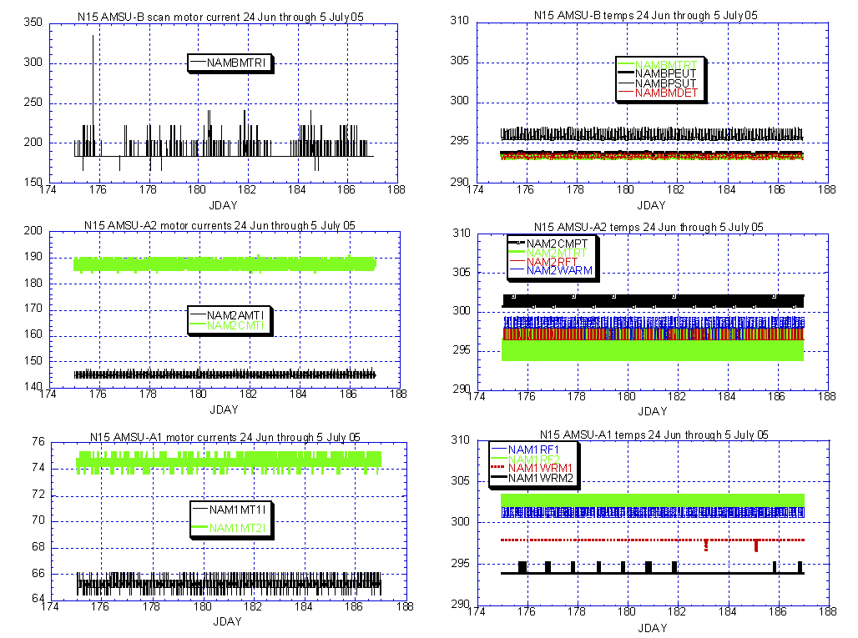

Illustration 1: N15 AMSU’s Analysis:

(Nominal and stable)

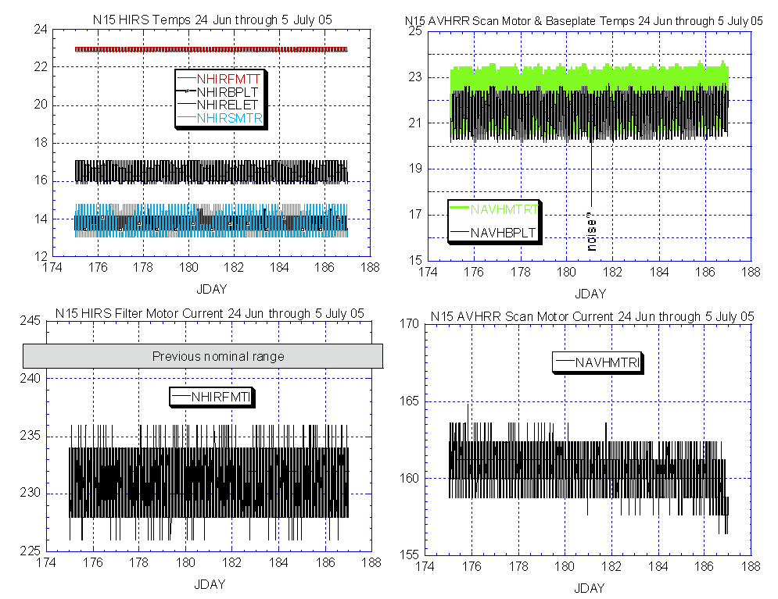

Illustration 2: N15 AVHRR & HIRS Analysis

(Nominal and stable. Perhaps even a little improvement in the AVHRR scan motor)

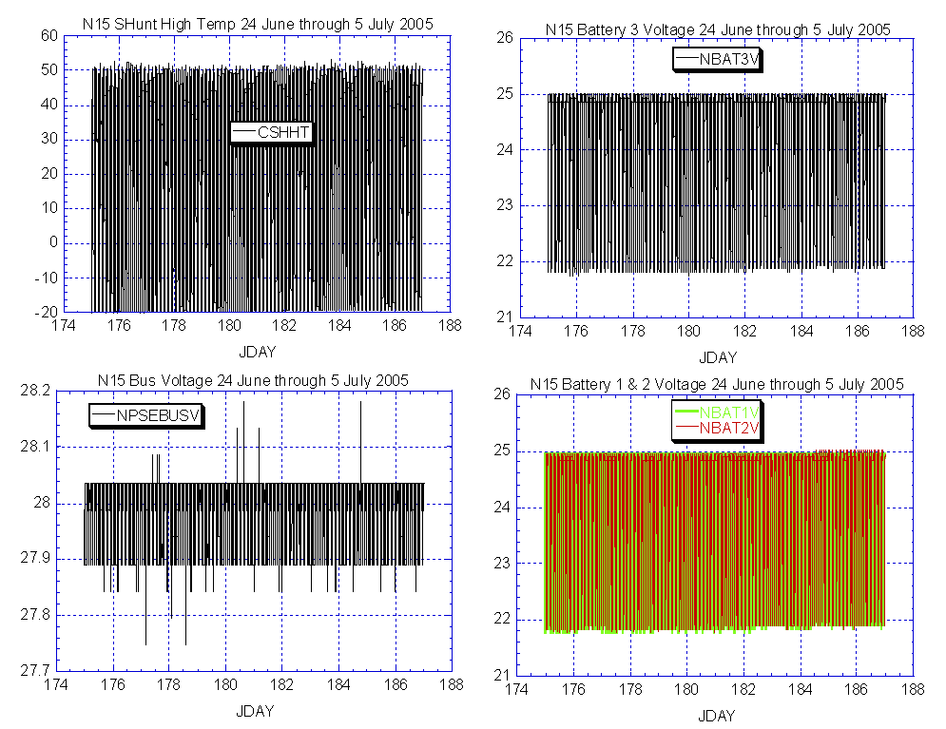

Illustration 3: N15 EPS Analysis
(Eclipse season beginning to wane, nominal behavior)

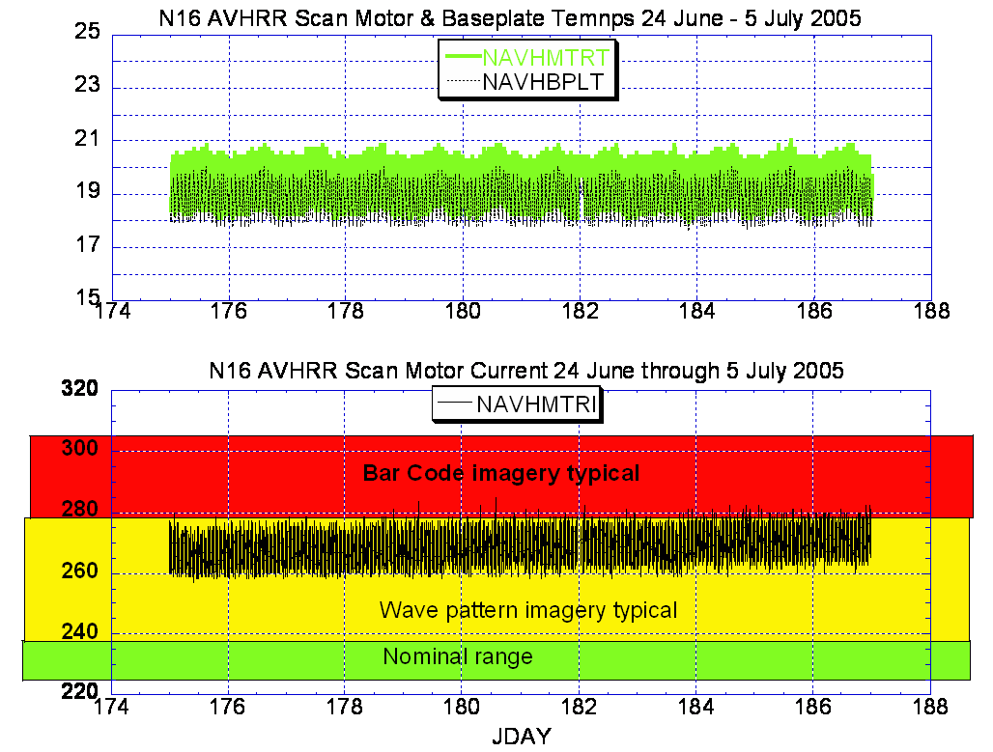

Illustration 4: N16 AVHRR Analysis
(As has been a concern reported in this report over the past several weeks, scan motor current degradation has now breeched the bar code imagery threshold.)

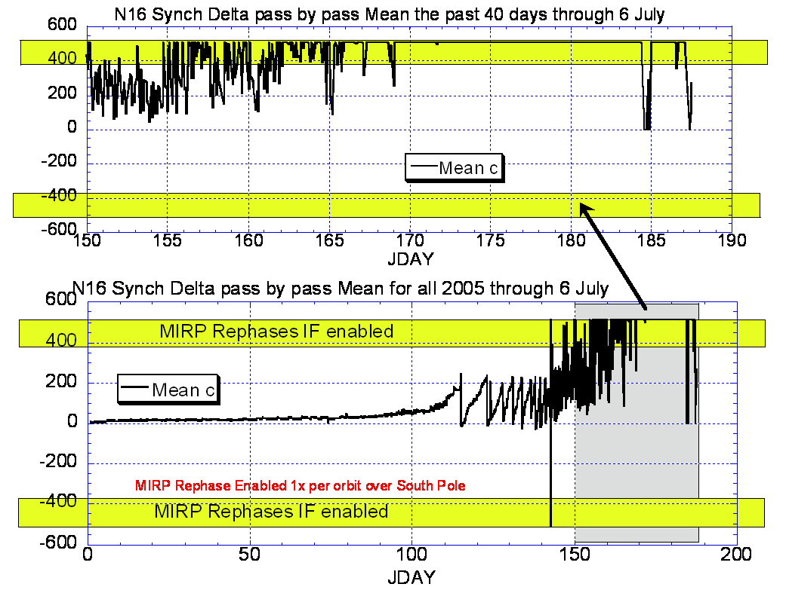

Illustration 5: N16 AVHRR Synch Delta Analysis

(Not as bad as last week but not at all good either. Still rephasing each orbit with the synch delta typically pegging out again within 15-30 minutes.)

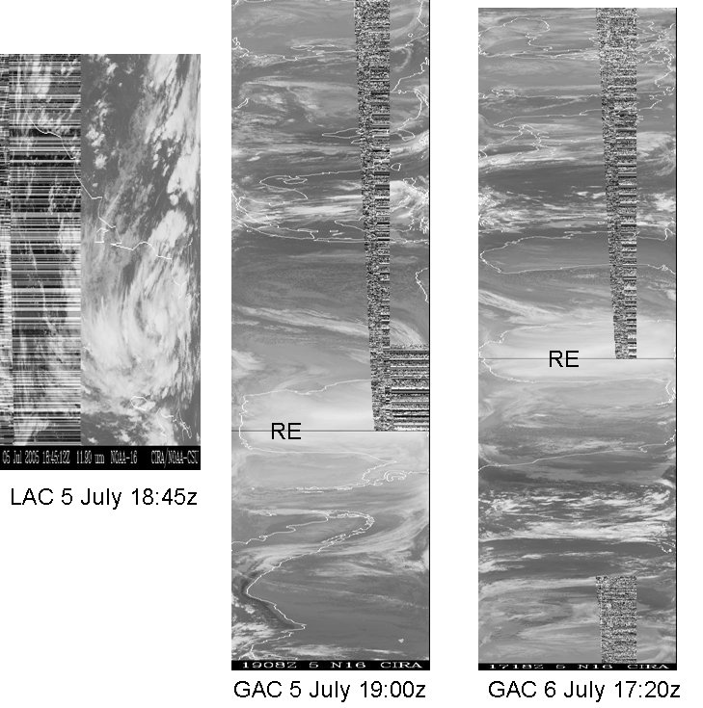

Illustration 6: N16 AVHRR GAC & LAC Analysis
(Note on the GAC’s how the rephase (RE) does clean up the imagery. Unfortunately, as depicted by the 6 July GAC, the clean up doesn’t last long.)

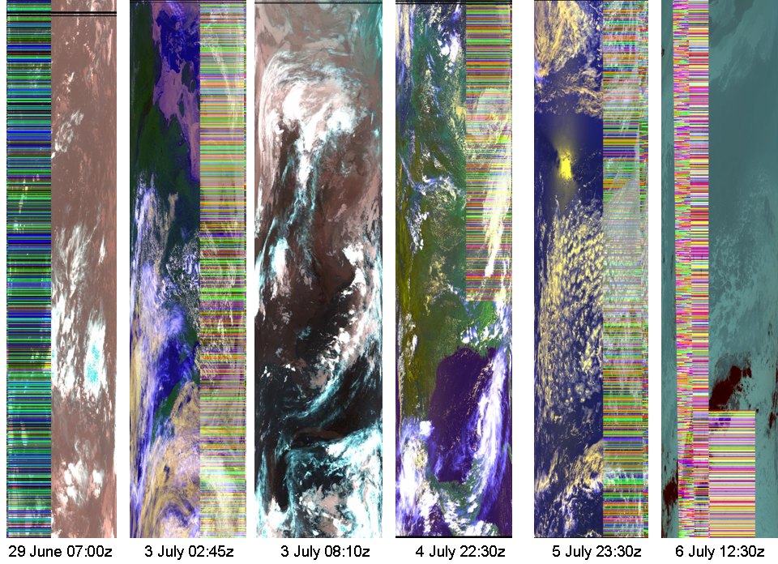

Illustration 7: N16 AVHRR HRPT ANALYSIS
(First bar code showed up on 29 June, by 3 July over 50% occurrence was noted. By today almost every image is bar coded..)

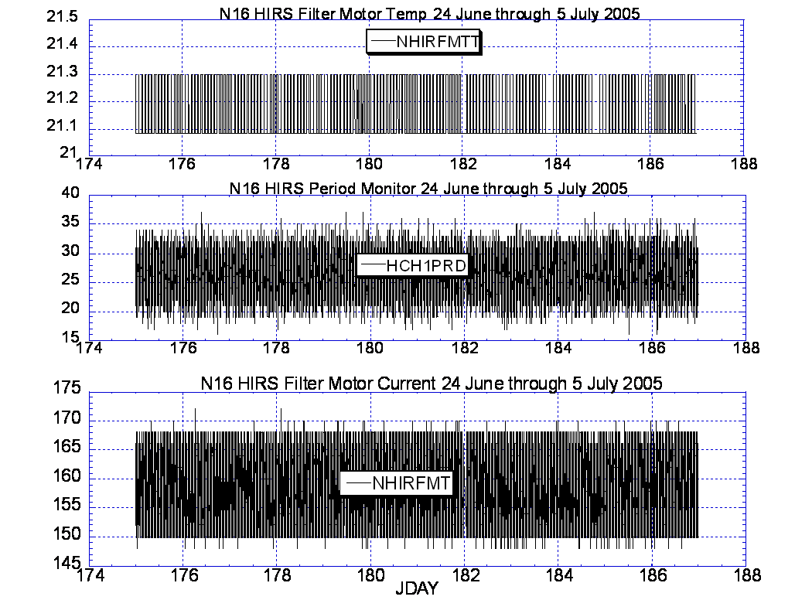

Illustration 8: N16 HIRS Health Analysis

(Nominal and stable. No apparent influences from the AVHRR problems)

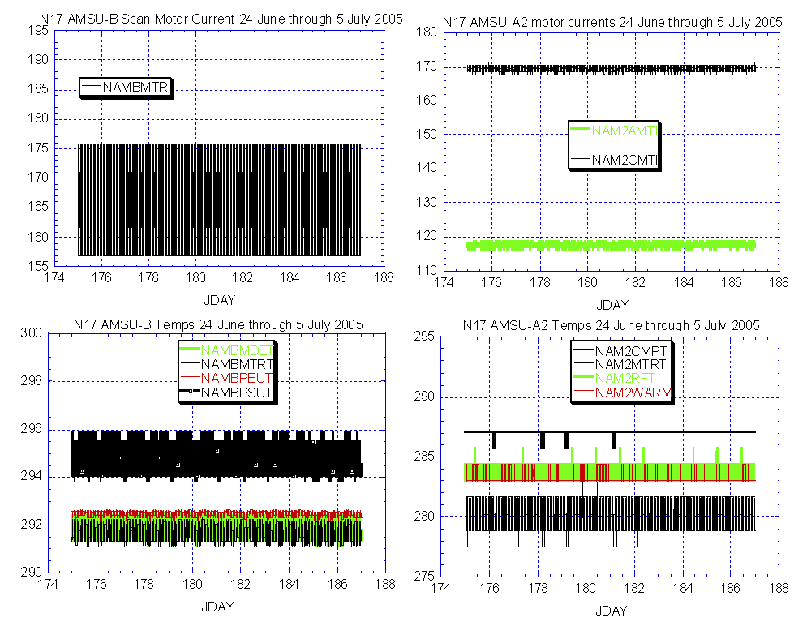

Illustration 9: N17 AMSU Health Analysis
(Nominal and stable.)

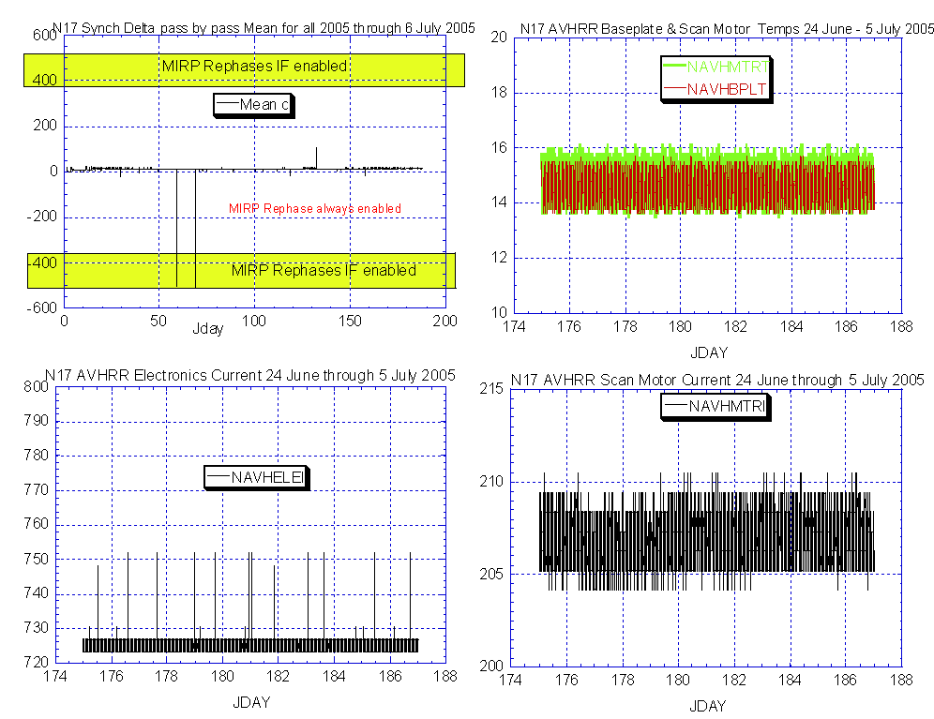

Illustration 10: N17 AVHRR Analysis
(Nominal and stable except for some spikes in the electronics current.)

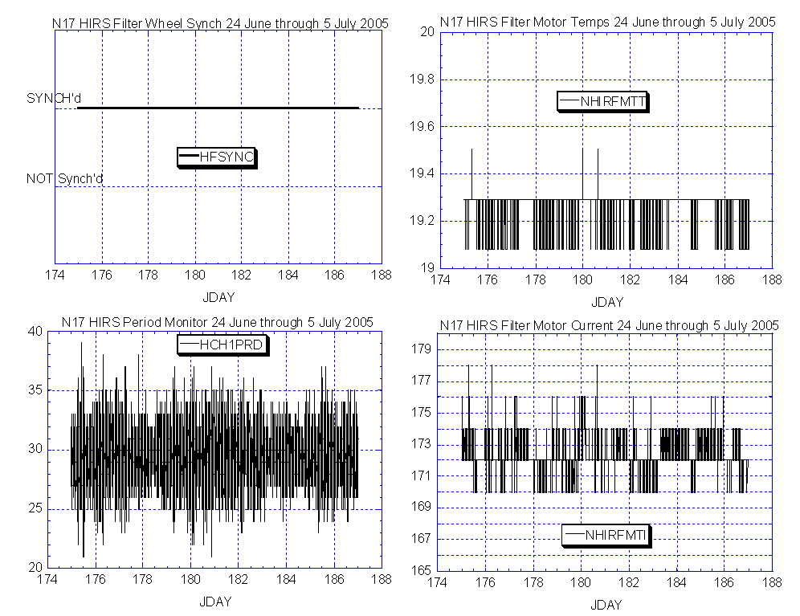

Illustration 11: N17 HIRS Health Analysis

(Nominal and stable)

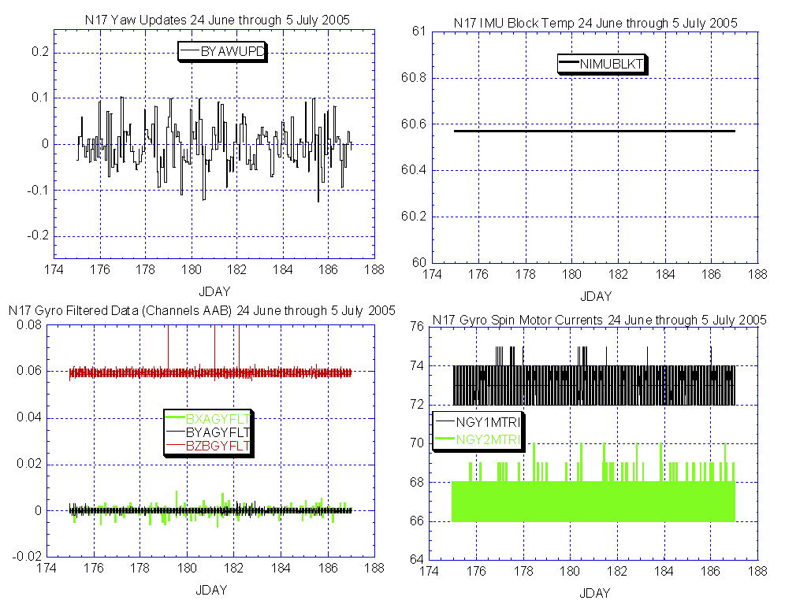

Illustration 12: N17 ADACS Performance Analysis

(Generally nominal and stable although a reduction is the fluctuation in Gyro-2 current would certainly be preferred.)

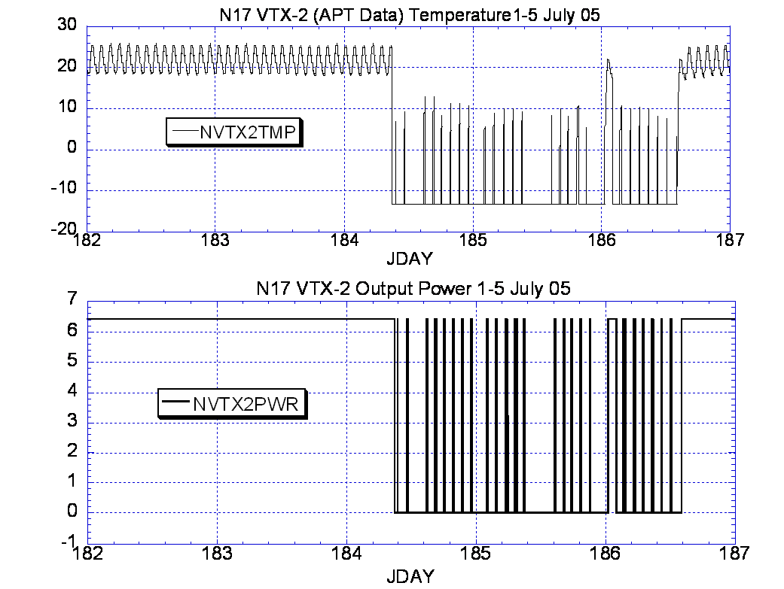

Illustration 13: N17 VTX-2 (APT data) Analysis
(Note the turnoffs that inadvertently occurred on 3, 4 and 5 July. Problem has since been resolved.)

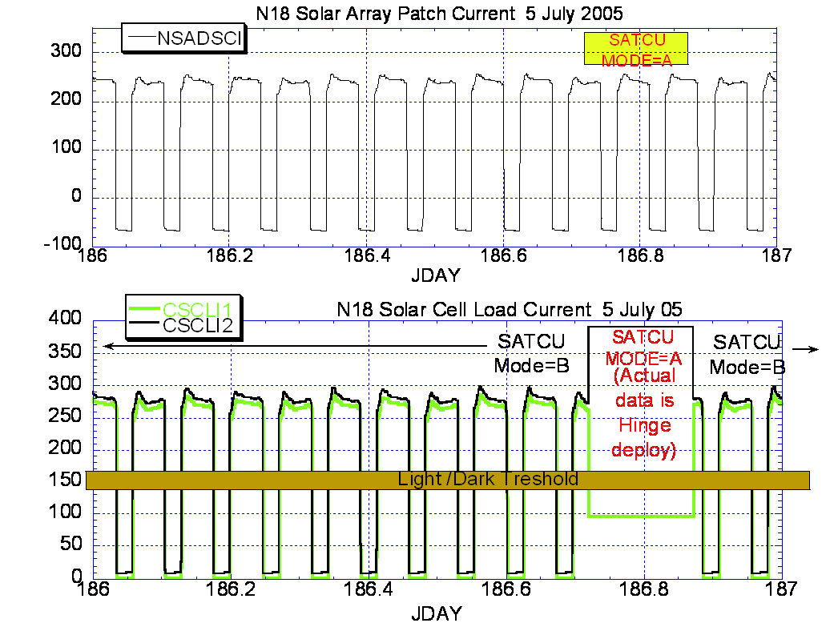

(data source=ABE)

Illustration 14: N18 SATCU Mode Swap Analysis

(Note the change in CSCLI1&2 and no change in SADSCI. Also note how one hinge is relatively high, which is read by SADPOS as spacecraft illuminated while the other is below the darkness threshold and is read by SADPOS as spacecraft dark. When such conflict occurs, SADSCI is the deciding factor regarding the initiation of the SADPOS timer.)

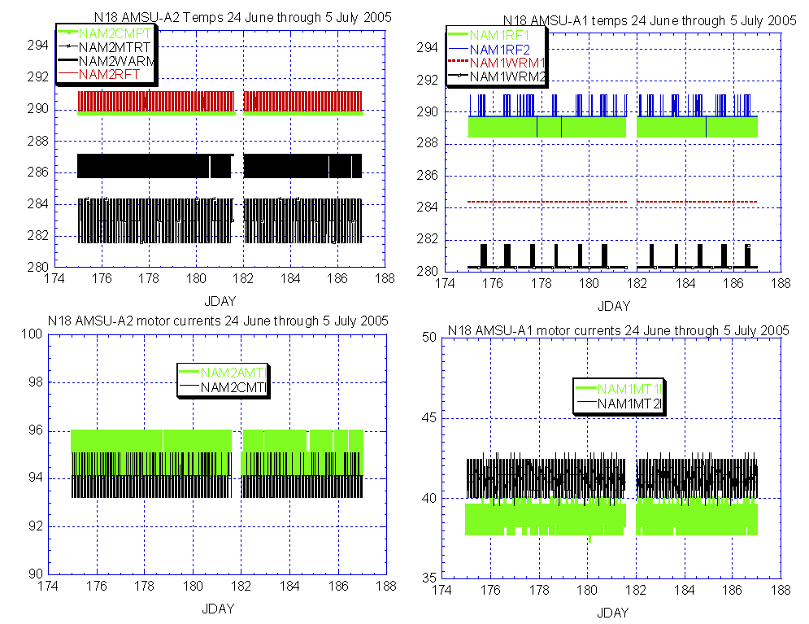

Illustration 15: N18 AMSU Health Analysis

(Nominal and stable)

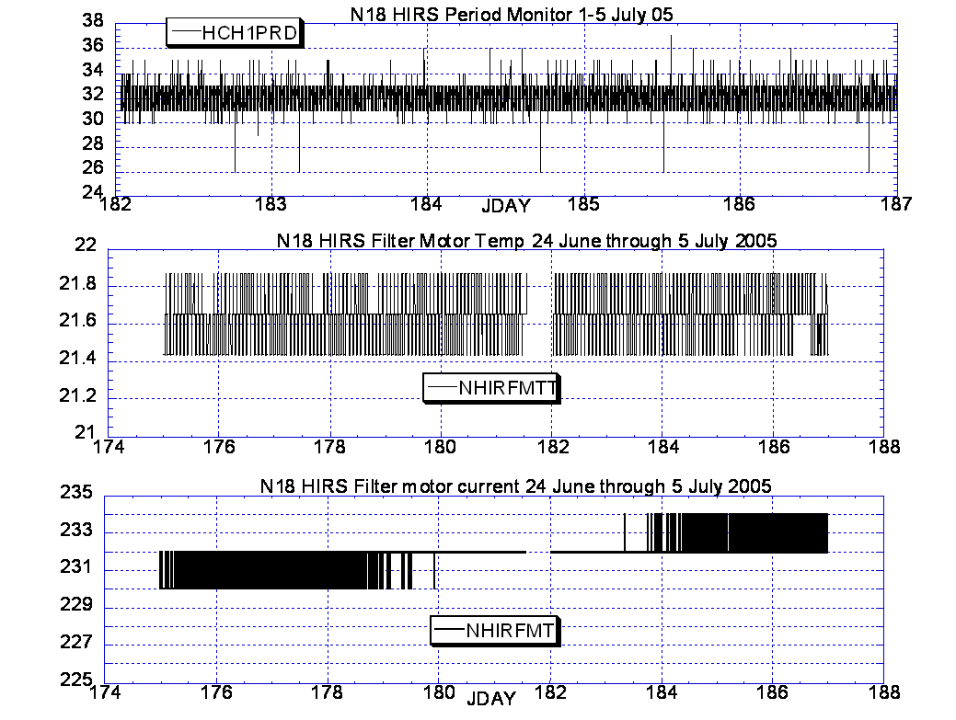

Illustration 16: N18 HIRS Health Analysis
(Nominal and stable from an engineering perspective. Testing and tiger team coordination continue. )

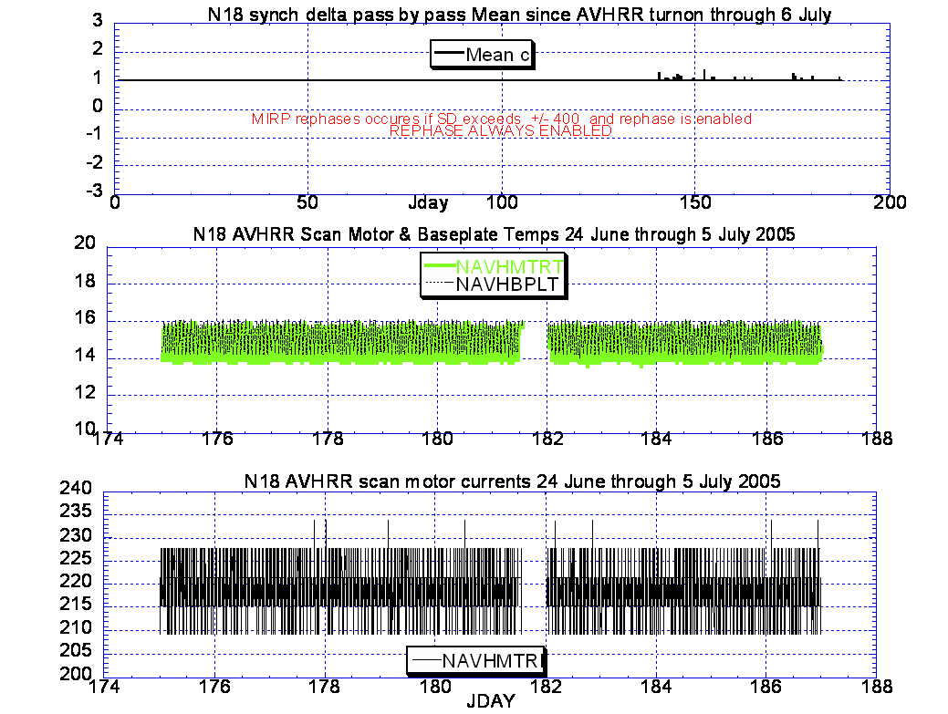

Illustration 17: N18 AVHRR Analysis.
(Stable and nominal)

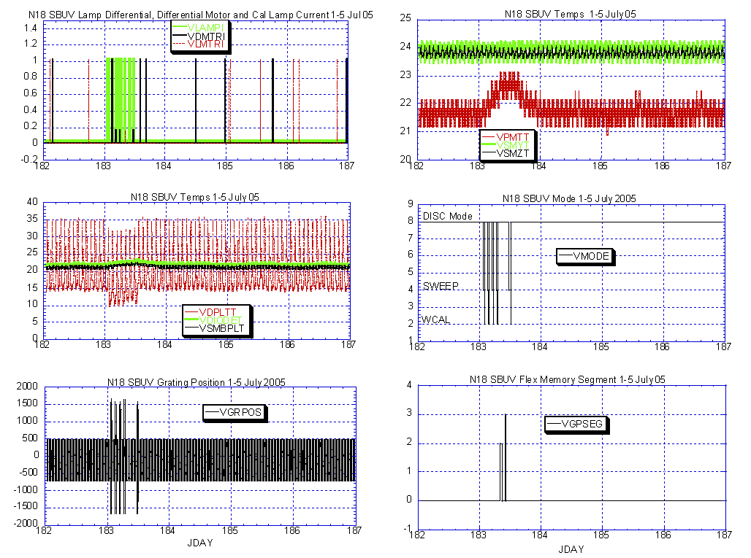

Illustration 18: N18 SBUV Analysis
(Stable and nominal. Testing continued last week with a one day switch to cathode mode on 5 July and back to anode mode on 6 July.)

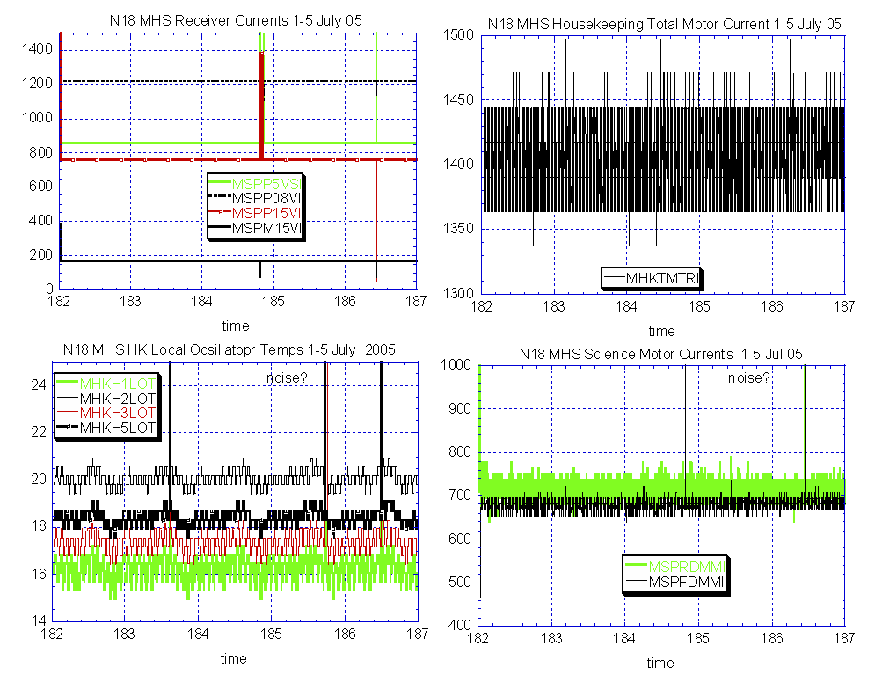

Illustration 19: N18 MHS Analysis

(Data spikes cause not yet ascertained. Possible ground processing problem. Source of data = ABE. )

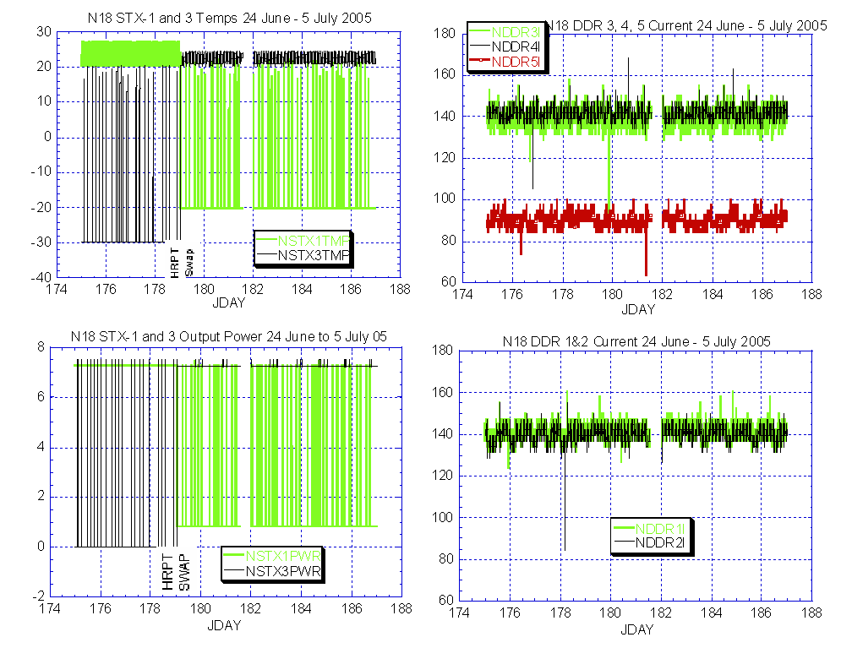

Illustration 20: N18 DHS/Comm Health Analysis

(DDR spikes not as frequent as previous weeks although a new TOAR was submitted last week. STX transmitter performance following swap appears to be nominal.)

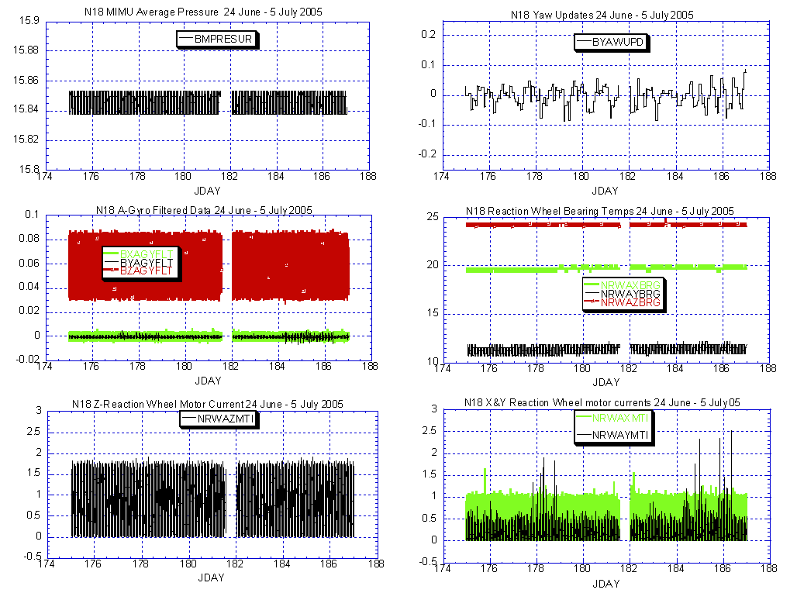

Illustration 21: N18 ADACS Health Analysis
(Y-wheel current showing additional increases beyond that from previous weeks. Otherwise performance looks nominal and stable.)

N17 MEMORY SCRUB REPORT

Last week.

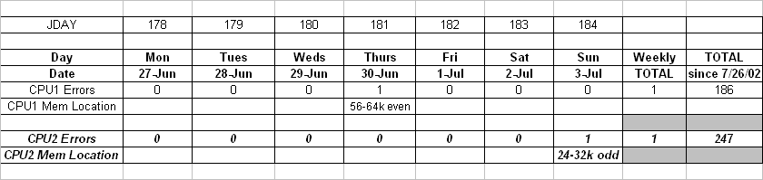

POLAR SPACECRAFT TIP CLOCK ERROR

WEEK ENDING July 1, 2005
DAY/DATE | NOAA-12 | NOAA-14 | NOAA-15 | NOAA-16 | NOAA-17 | NOAA-18
FRI. 06/24 | -761 msec | +202 msec | -202 msec | +121 msec | +060 msec | -076 msec
SAT. 06/25 | -763 msec | +203 msec | -204 msec | +121 msec | +063 msec | -074 msec
SUN. 06/26 | -764 msec | +209 msec | -204 msec | +122 msec | +064 msec | -073 msec
MON. 06/27 | N/A | +209 msec | -205 msec | +122 msec | +064 msec | -072 msec
TUE. 06/28 | -766 msec | +206 msec | -205 msec | +122 msec | +065 msec | -072 msec
WED. 06/29 | -766 msec | +206 msec | -207 msec | +123 msec | +065 msec | -070 msec
THU. 06/30 | -768 msec | +207 msec | -208 msec | +126 msec | +065 msec | -073 msec

EMOSS POC for this chart is JIM SHEPHERD

NOAA-14: As of 12/23/03 the TIP clock is corrected daily by –7.0 msec to compensate for drift.
NOAA-15: As of 04/22/03 the TIP clock is corrected daily by –8.0 msec to compensate for drift.
NOAA-16: As of 12/23/03 the TIP clock is corrected daily by -5.5 msec to compensate for drift.
NOAA-17: As of 12/23/03 the TIP clock is corrected daily by –3.0 msec to compensate for drift.
NOAA-12: As of 12/10/03 the TIP clock is corrected daily by +6.5 msec to compensate for drift.
* A clock jump of +500 milliseconds on 01/31/05 due to fractional second daily ETCUP. A clock
jump of +500 milliseconds on 04/17/05 due to fractional second daily ETCUP. Alternating +/-
500 millisecond clock jumps will ccur at 76-day intervals as long as fractional second daily
ETCUP is utilized to manage clock drift. The next +500 millisecond jump is expected on 07/02/05.

POES Engineering Contact List

Government

Renee Smith-Dearing NOAA POES Constellation Lead 301-817-4117
Dong Han: NOAA, POES Payloads 301-817-4127

Micky Fitzmaurice: NOAA, POES Bus, IJPS 301-817-4016
Nicolaie Todirita (Todi): NOAA Ground Systems 301-817-4229

EMOSS-2 Contractor

Jeff Devine: EMOSS POES Lead 301-817-4020
Jim Walters: EMOSS, POES Payload Engineer 301-817-4033

Carl Gliniak, EMOSS POES Power and Thermal 301-817-4207

Jim Sheperd, EMOSS POES Attitude Control 301-817-4030
Jon Woodward EMOSS, POES Flight Software C&CS 301-817-4019

Sally House EMOSS POES Payloads 301-817-4026
William Chadwick EMOSS, POES Comm and DHS 301-817-4015

