UNITED STATES ENVIRONMENTAL PROTECTION AGENCY

WASHINGTON, D.C. 20460

MEMORANDUM DP Barcodes: DP334029, P334030, DP332756, DP333122, DP333123, DP333124, DP333125, DP333126, DP330568, DP330569
PC Code: 129099
April 13, 2007

SUBJECT: New Use Drinking Water Assessment for Imidacloprid on Peanuts, Soybeans and IR-4 Registration for Crop Group 13A: Caneberries

TO: Jennifer R. Tyler
RAB1 (7509P)
Health Effects Division

Barbara Madden, Risk manager Reviewer
RIMUERB (7505P)
Registration Division

FROM: Ronald D. Parker, Ph.D. Senior Environmental Engineer
ERB5 (7507P)
Environmental Fate and Effects Division

THRU: Mah Shamim, Branch Chief
ERB5 (7507)
Environmental Fate and Effects Division

EXECUTIVE SUMMARY. This memo summarizes estimated drinking water concentrations (EDWCs) for new uses of Imidacloprid insecticide on peanuts and soybeans and on IR-4 Crop Group 13A (Caneberries). Exposure concentration values for all crops were calculated with the FQPA Index Reservoir Screening Tool (FIRST) which is described below. New ground water concentration values were not estimated because they have been shown previously to be substantially lower in magnitude than the surface water concentrations. See Imidacloprid: Tier I Drinking Water EECs for Use in the Human Health Risk Assessment”, February 25, 2003, from Michael Barrett (EFED) to Jennifer Tyler (HED) attached to this memo as Appendix B.

Calculated EDWCs for these new Imidacloprid uses do not exceed concentrations for crops evaluated previously and therefore overall result of this exposure assessment is unchanged. Assessment results are as follows in Table 1.

Table 1. Drinking Water EDWCs for Peanuts, Soybeans and Caneberries (CG 13)
Models Used | Maximum Percent Cropped Area (PCA) | 1/10 Peak (Acute) (ppb) | 1/10 Annual (Chronic non-cancer) (ppb) | Avg Annual  (Chronic cancer) (ppb)
FIRST | Peanuts (0.87) | 9.2 | 4.0 | 4.0
FIRST | Soybeans (0.41) | 4.6 | 2.0 | 2.0
FIRST | Caneberries (0.87) | 35.0 | 15.3 | 15.3

The previous highest acute value was 36.0 (range: 35.4 to 36.0) for Imidacloprid usage on citrus. The previous highest chronic value was 17.2 (range: 16.5 to 17.2) also for usage on citrus.

A summary of the input parameter values used in the modeling for this assessment is presented in Table 2 below. The output file for FIRST is attached in Appendix 1.

PROBLEM FORMULATION

This assessment uses environmental fate and transport computer simulation modeling to estimate possible human exposure to pesticide in drinking water which might occur as a result of Imidacloprid application to the assessed crops. There are a number of possible routes of exposure by which applied pesticide might reach a drinking water source. A schematic diagram of possible routes of exposure is presented in Figure 1 below. The main routes are through pesticide runoff to surface waters or leaching to ground waters which might serve as a source of supply for a public or private drinking water facility.

For human health exposure assessments undertaken for FQPA, EFED has developed an “index agricultural watershed-drinking water reservoir” or “index reservoir” scenario. The concept behind use of a model of an “index” reservoir to screen pesticides, is that the chosen reservoir – and its associated characteristics – would become the standard set of conditions by which EPA would judge the potential of a pesticide to contaminate drinking water derived from surface water. The “index” reservoir was selected from a group of reservoirs that provide drinking water to communities throughout the country. EPA selected the particular reservoir because it had characteristics associated with a higher potential for pesticide contamination of surface water. Because the “index” reservoir has characteristics that are associated with a higher potential for pesticide contamination of surface water, the model is likely to be protective of other drinking water sources which are less vulnerable to contamination. The reservoir simulated is a small drinking water reservoir located in Shipman, Illinios. Shipman City Lake is 13 acres in area, 9 feet deep, and has a watershed area of 427 acres. The “index agricultural watershed-drinking water reservoir” configuration is moved to simulation sites which are consistent with the growth of the crop being assessed. The fields associated with the reservoir are designed as “high-exposure” soil-weather combinations with the goal of representing a site worse that 90% of the area on which the crop is grown. True relative vulnerability of the site vis-à-vis the sites which were not developed for modeling is not known.

Figure 1. Possible routes of human exposure to pesticide through drinking water.

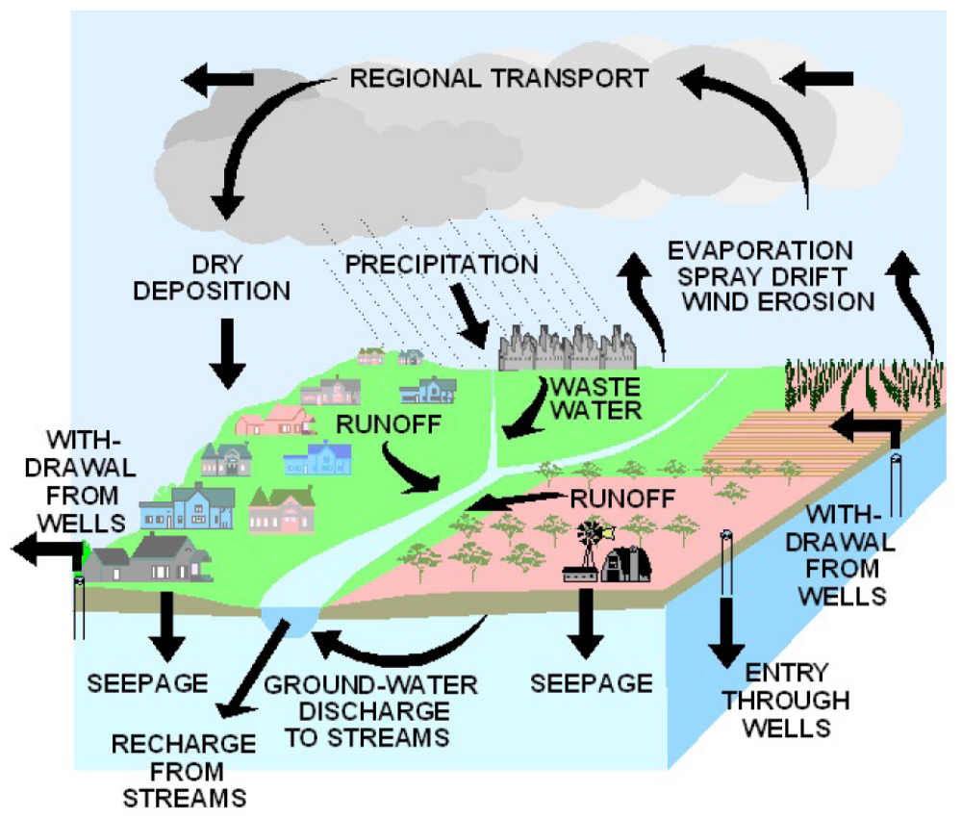

Background Information on FIRST Fate and Transport Model:

FIRST is a screening-level computer model designed to estimate the pesticide concentrations found in water for use in drinking water assessments. It provides high-end values on the concentrations that might be found in a small drinking water reservoir due to the use of pesticide. Like GENEEC, the model previously used for Tier I screening level, FIRST is a single-event model (one run-off event), but can account for spray drift from multiple applications. FIRST uses a Drinking Water Reservoir instead of a pond as the standard scenario. The FIRST scenario includes a 427 acres field immediately adjacent to a 13 acres reservoir, 9 feet deep, with continuous flow (two turnovers per year). The pond receives a spray drift event from each application plus one runoff event. The runoff event moves a maximum of 8% of the applied pesticide into the pond. This amount can be reduced due to degradation on field and the effect of binding to soil. Spray drift is equal to 6.4% of the applied concentration from the ground spray application and 16% for aerial applications.

FIRST also makes adjustments for the percent crop area. While FIRST assumes that the entire watershed would not be treated, the use of a PCA is still a screen because it represents the highest percentage of crop cover of any large watershed in the US, and it assumes that the entire crop is being treated. Various other conservative assumptions of FIRST include the use of a small drinking water reservoir surrounded by a runoff-prone watershed, the use of the maximum use rate, no buffer zone, and a single large rainfall. Lower tiers of assessment such as this one are designed to screen out chemicals with low potential risk and allows OPP to focus resources on more refined risk assessments for chemicals that potentially present more significant risks.

It is recognized that most watersheds large enough to support a community drinking water system (CWS) are not entirely planted in only one crop. The modeling system, therefore, has developed a method to consider a maximum percent cropped area (PCA) factor to account for this fact. Maximum national PCA values are used for each of the crops in this assessment. PCA values are developed for four major crops based upon national crop maps. A PCA of 0.87 represents the maximum area of all other crops in there respective watershed.

Exposure Assessment Methodology

A single simulation site is designed to represent the risk of Imidacloprid usage throughout the national growing area of the crop. Figure 2 represents the assessment area for soybeans and Figure 3 represents this assessment area for peanuts.

Peanuts and Soybeans

The exposure assessment for peanuts and soybeans is based in the screening-level FIRST model. Calculated EDWCs for these new Imidacloprid uses do not exceed concentrations for crops evaluated previously and therefore overall result of this exposure assessment is unchanged. For this reason a higher tier assessment was not required. A tier 1 assessment such as this, may over-estimate concentrations routinely found in the environment, but are unlikely to under-estimate environmental values.

New ground water concentration values were not estimated because they have been shown previously to be substantially lower in magnitude than the surface water concentrations. See Imidacloprid: Tier I Drinking Water EECs for Use in the Human Health Risk Assessment”, February 25, 2003, from Michael Barrett (EFED) to Jennifer Tyler (HED) attached to this memo as Appendix B.

Figure 2. Peanut Assessment Area (Census of Agriculture, 2002)
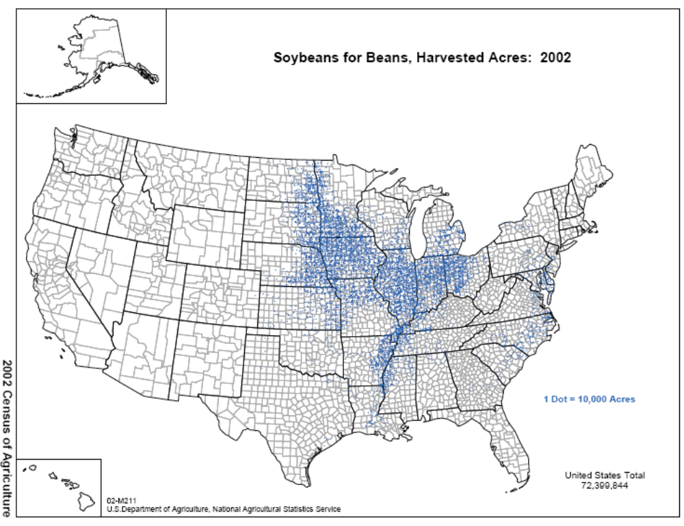

Figure 3. Peanut Assessment Area (Census of Agriculture, 2002)
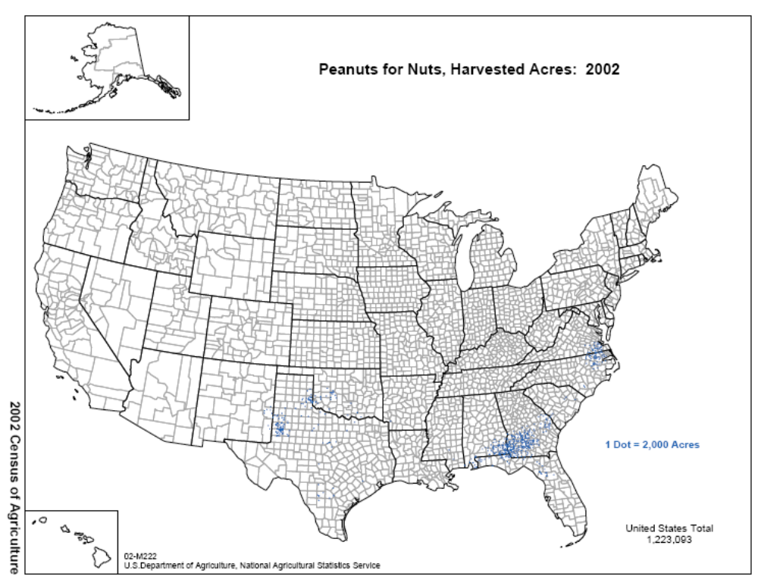

Crop Group 13A (Caneberrries)

This exposure assessment also includes application on IR-4 Crop Group (Caneberries). This group includes the following crops:

1). Amur River grape, Vitis amurensis Rupr (Vitaceae)
2). Aronia berry, Aronia spp. (Rosaceae)
3). Bayberry, Myrica spp. (Myricaceae)
4). Bearberry, Arctostaphylos uva-ursi (L.) Spreng (Ericaceae)
5). Bilberry, Vaccinium myrtillus L. (Ericaceae)
6). Blackberries, Rubus spp. (Rosaceae)
7). Blueberry, Vaccinium spp. (Ericaceae)
8). Blueberry, Lowbush, Vaccinium angustifolium Aiton (Ericaceae)
9). Buffalo Currant, Ribes aureum Pursh. (Grossulariaceae)
10). Buffaloberry, Shepherdia argentea (Pursh) Nutt.(Eleagnaceae)
11). Che, Cudrania tricuspidata Bur. ex Lavallee (Moraceae)
12). Chilean guava, Myrtus ugni Mol. (Myrtaceae)
13). Chinese Egg Gooseberry, Actinidia rubricallus Dunn (Actinidiaceae)
14). Chokecherry, Prunus virginiana L. (Rosaceae)
15). Cloudberry, Rubus chamaemorus L. (Rosaceae)
16). Cranberry, Vaccinium macrocarpon Aiton (Ericaceae)
17). Currant, Black, Ribes nigrum L. [Grossulariaceae (Saxifragaceae)], and Currant, Red, Ribes rubrum L. (syn: R. sativum (Rchb.) Syme) [Grossulariaceae (Saxifragaceae)]
18). Elderberry, Sambucus spp. (Caprifoliaceae)
19). European Barberry, Berberis vulgaris L. (Berberidaceae)
20). Gooseberry, Ribes spp. [Grossulariaceae (Saxifragaceae)]
21). Grape, Vitis spp. (Vitaceae)
22). Highbush cranberry, Viburnum opulus L. var. Americanum Aiton (Caprifoliaceae)
23). Honeysuckle, Lonicera caerula L. var. emphyllocalyx Nakai (Caprifoliaceae)
24). Huckleberry, Gaylussacia spp. (Ericaceae)
25). Jostaberry, Ribes x nidigrolaria Rud. Bauer & A. Bauer. [Grossulariaceae (Saxifragaceae)]
26). Juneberry (including Saskatoon Berry), Amelanchier spp. (Rosaceae)
27). Kiwifruit, fuzzy, Actinidia deliciosa (A. Chev.) C.F. Liang & A.R. Ferguson (Actinidaceae)
28). Kiwifruit, hardy, Actinidia arguta (Siebold & Zucc.) Planch. Ex Miq (Actinidaceae)
29). Lingonberry, Vaccinium vitis-idaea L. (Ericaceae)
30). Maypop, Passiflora incarnata L. (Passifloraceae)
31). Mountain Pepper Berries, Tasmannia lanceolata (Poir.) A.C. Sm.(Winteraceae)
32). Mulberry, Morus spp. (Moraceae)
33). Muntries, Kunzea pomifera F. Muell. (Myrtaceae)
34). Native Currant, Acrotriche depressa R. Br. (Epacridaceae)
35). Partridgeberry, Mitchella repens L. (Rubiaceae)
36). Phalsa, Grewia subinaequalis DC. (Tiliaceae)
37). Pincherry, Prunus pensylvanica L. f. (Rosaceae)
38). Raspberries, Rubus spp. (Rosaceae)
39). Riberry, Syzygium luehmannii (Myrtaceae)
40). Salal, Gaultheria shallon Pursh (Ericaceae)
41) Schisandra berry (Schisandra chinensis (Turcz.) Baill. (Schisandraceae)
42). Sea Buckthorn, Hippophae rhamnoides L. (Eleagnaceae)
43). Serviceberry, Sorbus spp. (Rosaceae)
44). Strawberry, Fragaria x ananassa Duchesne, (Rosaceae)
45). Wild raspberry, Rubus muelleri Lefevre ex P.J. Mull (Rosaceae)

Approximately two-thirds of US blackberry/raspberry production occurs in the states of Washington and Oregon, but 33 other states also report some production. Harvest data from 2002 is presented in Figure 1 and 2.

Figure 4. Map of Blackberry Harvested Acres.
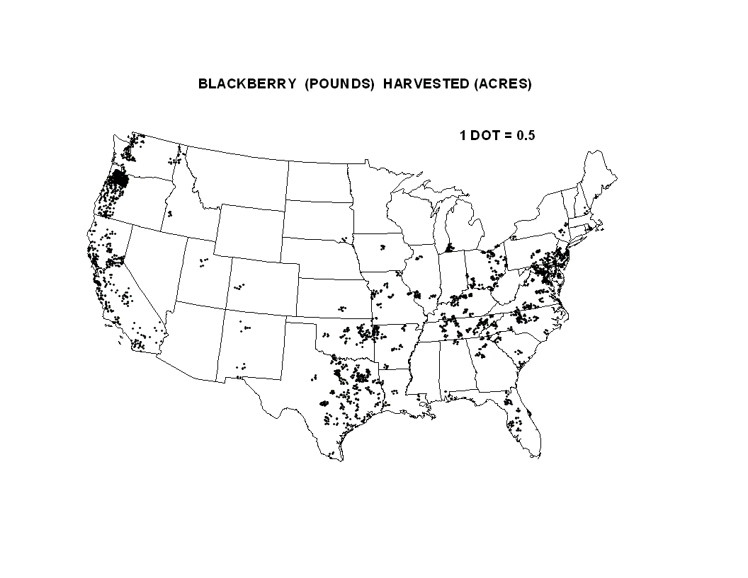
Figure 5. Map of the Raspberry Harvested Acres.
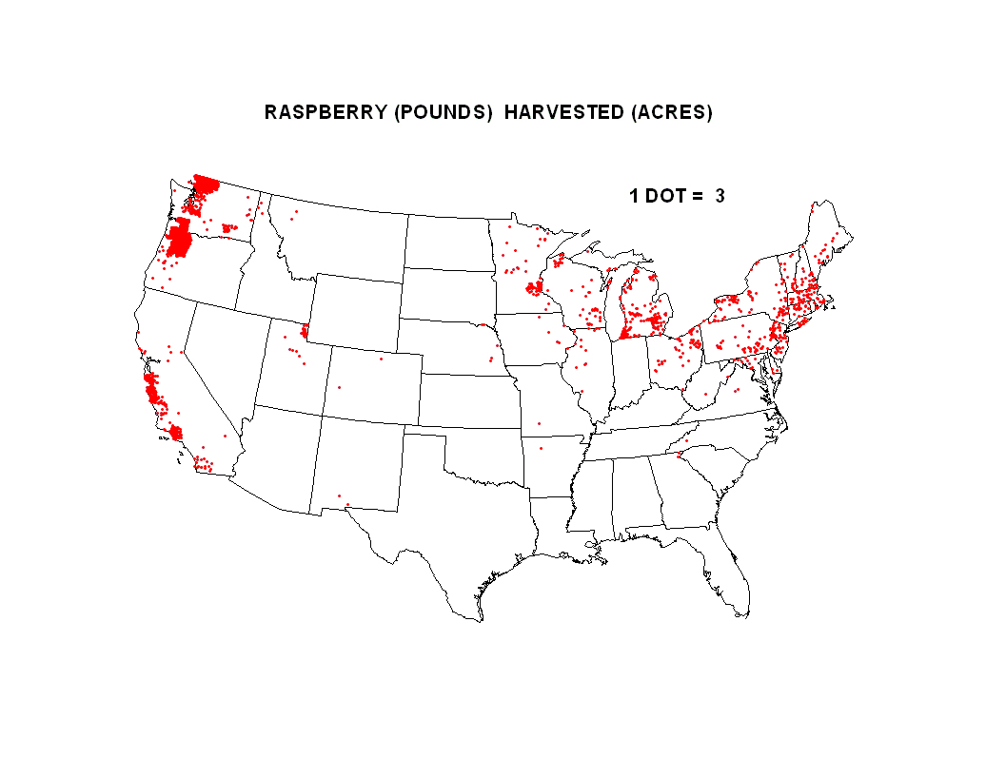2005 - BLACKBERRIES ( http://www.oregon-berries.com/cx6/Worldwide_Production_of_Blackberries_Strik_3-2006_acres.pdf )
USA = 11,905 acres
Oregon = 7,755 acres
California = 700 acres
Texas = 680 acres
Arkansas = 600 acres
Georgia = 315 acres
North Carolina = 125 to 250 acres
Ohio = 125 to 250 acres
Virginia = 125 to 250 acres
Washington = 125 to 250 acres
Another 26 states reported from 5 to 125 acres of blackberries.
Strik, B.C. et al., 2006

Crop and State Acreage Harvested ( www.epa.gov/oppsrrd1/op/azinphos/bead_ Caneberry 1.pdf )
Raspberries, Washington = 9,500 acres
Raspberries, Oregon = 4,100
Raspberries, California = 1,800
Blackberries, Oregon = 5,850
Source: Oregon Ag. Stat. Service, 2000.
ANALYSIS

Environmental Fate Summary

Imidacloprid is stable to hydrolysis, and typically persists for many months in soil. However, imidacloprid appears to be more rapidly transformed under anaerobic conditions and appears to be particularly photolabile in pure, clear shallow water. Given that imidacloprid is mobile, and likely to be highly persistent in the subsurface, it may leach to ground water (results of the prospective ground-water monitoring studies confirm this). Imidacloprid may also pose a contamination hazard to surface waters via runoff, and may be especially persistent in surface water with high turbidity.

The environmental fate for imidacloprid is as follows (See Appendix D for further details):

Water solubility (200C) = 580 ppm
Hydrolysis (pH 5 and 7) = stable
Hydrolysis (pH 9) = 355 days
Photolysis half-life, distilled water = 0.2 days
Photolysis half-life,soil = 39 (estimates from the single study range from 39 to 171 days)
Aerobic soil metabolism half-life = 359 (188 to 660 days, 4 soils including 1 in U.S.)
Anaerobic Aquatic = 27 days
Freundlich adsorption coefficient between 0.96 to 4.76
Soil leaching (Koc) = 178 (132 to 256) ml/g
Field dissipation half-life (0 to 3-inch depth) = 107 to >>365 days (5 sites)

EFED concludes that the available data on Imidacloprid show that the compound is mobile and persistent, has potential to leach to ground water, and also presents concerns for transport to surface water by runoff. No direct environmental fate studies have been conducted for the degradates {several of which retain the (pyridinyl)methyl-imidazoli-amine backbone of the imidacloprid molecule}, including the following: 1) imidacloprid guanidine, 1-[(6-chloro-3-pyridinyl)methyl]-2-imidazolidinimine {Alias NTN 38014, NTN 33823}; 2) imidacloprid olefin, 1-[(6-chloro-3-pyridin1yl)methyl]-1,3-dihydro-2H-imidazol-2-imine; and 3) imidacloprid urea, 1-[(6-chloro-3-pyridinyl)methyl]-2-imidazolidinone.{NTN 33519}. Please refer to the Table 2 for modeling input parameters. See Appendix C for chemical structures of these degradates.

Use Characterization

Table 1 is a summary of all new agricultural use patterns for Imidacloprid. The use information was obtained from the current labels for products containing Imidacloprid.

Table 4a. IR-4 Application to Caneberries (Crop Group 13A)
Formulation  (% active ingredient) | Number Appls  (Min Interval) | Application Rate  fluid oz (lbs) / acre | Max Per Season fluid oz (lbs) / acre | Pre-Harvest Interval (days)
Admire® 2 Flowable  (21.4%) | 1-2 (not given) | 16.0-32.0 (0.25-0.50) | 32.0 (0.50) | 7
PROVADO® 1.6 Flowable (17.4%) | 3 (7) | 8.0 (0.10) | 24.0 (0.30) | 3
PROVADO® 70 WG  (70%) | 3 (7) | 2.3 (0.10) | 6.9 (0.30) | 3
PROVADO® PRO  (16.5%) | 3 (7) | 8.0 (0.10) | 24.0 (0.30) | 3
GAUCHO® 550 SC  (42.8%) | 1-2 (not given) | 7.0-14.0 (0.25-0.50) | 14.0 (0.50) | 7

Table 4b. Application to Soybeans
Formulation  (% active ingredient) | Number Appls  (Min Interval) | Application Rate -  fluid oz (lbs) / acre | Max Per Season - fluid oz (lbs) / acre | Pre-Harvest Interval (days)
ENCORE  (40.7%) | 3 (7) | 1.50 (0.047) | 4.50 (0.14) | 7
TRIMAXTM PRO  (40.7%) | 3 (7) | 1.35 (0.047) | 4.05 (0.14) | 7

Table 4c. Application to Peanuts (only)
Formulation  (% active ingredient) | Number Appls  (Min Interval) | Application Rate -  fluid oz (lbs) / acre | Max Per Season - fluid oz (lbs) / acre | Pre-Harvest Interval (days)
PROVADO® PRO  (16.5%) | 3 (5) | 3.5 (0.044) | 10.5 (0.13) | 14
GAUCHO® 75 ST  (seed treatment only) | 1 (N/A) | 0.67-1.33 fl oz /cwt |  | N/A

Table 4d. IR-4 Application to Peanuts, Proso millet, pearl millet, kava, oats, artichoke
Formulation  (% active ingredient) | Number Appls  (Min Interval) | Application Rate -  fluid oz (lbs) / acre | Max Per Season - fluid oz (lbs) / acre | Pre-Harvest Interval (days)
Admire® 2 Flowable  (21.4%) | 1 (peanuts)  1-2 (artichoke)  1 (kava) | 16.0-24.0(0.25-0.38)  16.0-32.0(0.25-0.50)  10.0-24.0(0.16-0.38) | 24.0 (0.38) 32.0 (0.50)  24.0 (0.38) | 14  7  21
PROVADO® 1.6 Flowable (17.4%) | 3 (5) (peanuts)  4(14) (artichoke) 3(5) (kava) | 3.5 (0.044)  4.0-10.0 (0.05-0.10)  3.5 (0.044) | 10.5 (0.13)  40.0 (0.50)  10.5 (0.13) | 14  7  7
PROVADO® 70 WG  (70%) | 3 (5) (peanuts)  4(14) (artichoke) 3(5) (kava) | 1.0 (0.044)  1.1-2.9 (0.05-0.10)  1.0 (0.044) | 3.0 (0.13)  11.5 (0.50)  3.0 (0.13) | 14  7  7
GAUCHO® 480 Flowable (40.7%)  (seed treatment only) | (millet)  (barley)  (oats) | 8.0 fl oz/cwt  1.0-3.0 fl oz/cwt  1.0-3.0 fl oz/cwt
GAUCHO® 550 SC  (42.8%) | 1 (peanuts)  1-2 (artichoke)  1 (kava) | 7.0-10.5(0.25-0.38)  7.0-14.0(0.25-0.50)  4.4-10.5(0.16-0.38) | 10.5 (0.38) 14.0 (0.50)  10.5 (0.38) | 14  7  21
GAUCHO® 600 Flowable (48.7%)  (seed treatment only) | (oats, barley, millet) | 8.0 fl oz/cwt
GAUCHO® 600 SC  (48.7%) | 1 (peanut) 1-2 (artichoke)  1 (kava) | 6.4-9.6 (0.26-0.38)  6.4-12.8 (0.25-0.50)  6.4-9.6 (0.26-0.38) | 9.6 (0.38)  12.8 (0.50)  9.6 (0.38) | 14  7  21

Table 2. FIRST Input Parameters for Imidacloprid New Uses.

Parameter | Input | Source
Solubility (ppm) | 580 | Product chemistry submissions
Hydrolysis t_{1/2} @ pH 7 (days) | Stable | MRID 42055337
Aerobic soil t_{1/2} (days) | 520 | MRIDs 452393-01, 02, 42073501; 90% upper bound confidence limit of mean
Aerobic aquatic t_{1/2} (days) | 1040 | 2x the aerobic soil input value, per EFED guidance document
Photolysis t_{1/2} in water (days) | 39 | Input guidance & MRIDs 42256376; 42256377
Organic carbon partition coefficient - K_{oc} (mL/g) | 178 | MRIDs 425208-01 and 420553-38
Application rates (lb a.i./Acre) | 0.5 | Label maximum rate for Tree Nuts  (Crop Group 14)
Applications / year | 1 | Label maximum rate for Tree Nuts  (Crop Group 14)
Application spacing | N/A | Label maximum rate for Tree Nuts  (Crop Group 14)

Table 1. Drinking Water EDWCs for Peanuts and Soybeans
Concentration Duration | Crop (PCA) | 1/10 Peak (Acute) | 1/10 Annual (Chronic non-cancer) | Avg Annual  (Cancer)
Conc. (ppb) | Peanuts (0.87) | 9.2 | 4.0 | 4.0
Concentration Duration | Crop (PCA) | 1/10 Peak (Acute) | 1/10 Annual (Chronic non-cancer) | Avg Annual  (Cancer)
Conc. (ppb) | Soybeans (0.41) | 4.6 | 2.0 | 2.0

Appendix 1a. FIRST Results for Caneberries, Peanuts and Soybeans

RUN No. 1 FOR Imidacloprid ON Caneberry * INPUT VALUES *
--------------------------------------------------------------------
RATE (#/AC) No.APPS & SOIL SOLUBIL APPL TYPE %CROPPED INCORP
ONE(MULT) INTERVAL Koc (PPM ) (%DRIFT) AREA (IN)
--------------------------------------------------------------------
.500( .500) 1 1 178.0 580.0 GROUND( 6.4) 87.0 .0

FIELD AND RESERVOIR HALFLIFE VALUES (DAYS)
--------------------------------------------------------------------
METABOLIC DAYS UNTIL HYDROLYSIS PHOTOLYSIS METABOLIC COMBINED
(FIELD) RAIN/RUNOFF (RESERVOIR) (RES.-EFF) (RESER.) (RESER.)
--------------------------------------------------------------------
520.00 2 N/A 39.00- 4836.00 1040.0 855.93

UNTREATED WATER CONC (MICROGRAMS/LITER (PPB)) Ver 1.1.0 DEC 12, 2005
--------------------------------------------------------------------
PEAK DAY (ACUTE) ANNUAL AVERAGE (CHRONIC)
CONCENTRATION CONCENTRATION
--------------------------------------------------------------------
  - 15.287

RUN No. 1 FOR Imidacloprid ON Peanuts * INPUT VALUES *
--------------------------------------------------------------------
RATE (#/AC) No.APPS & SOIL SOLUBIL APPL TYPE %CROPPED INCORP
ONE(MULT) INTERVAL Koc (PPM ) (%DRIFT) AREA (IN)
--------------------------------------------------------------------
.044( .131) 3 5 178.0 580.0 GROUND( 6.4) 87.0 .0

FIELD AND RESERVOIR HALFLIFE VALUES (DAYS)
--------------------------------------------------------------------
METABOLIC DAYS UNTIL HYDROLYSIS PHOTOLYSIS METABOLIC COMBINED
(FIELD) RAIN/RUNOFF (RESERVOIR) (RES.-EFF) (RESER.) (RESER.)
--------------------------------------------------------------------
520.00 2 N/A 39.00- 4836.00 1040.0 855.93

UNTREATED WATER CONC (MICROGRAMS/LITER (PPB)) Ver 1.1.0 DEC 12, 2005
--------------------------------------------------------------------
PEAK DAY (ACUTE) ANNUAL AVERAGE (CHRONIC)
CONCENTRATION CONCENTRATION
--------------------------------------------------------------------
9.189 4.010

RUN No. 2 FOR Imidacloprid ON Soybeans * INPUT VALUES *
--------------------------------------------------------------------
RATE (#/AC) No.APPS & SOIL SOLUBIL APPL TYPE %CROPPED INCORP
ONE(MULT) INTERVAL Koc (PPM ) (%DRIFT) AREA (IN)
--------------------------------------------------------------------
.047( .140) 3 7 178.0 580.0 GROUND( 6.4) 41.0 .0

FIELD AND RESERVOIR HALFLIFE VALUES (DAYS)
--------------------------------------------------------------------
METABOLIC DAYS UNTIL HYDROLYSIS PHOTOLYSIS METABOLIC COMBINED
(FIELD) RAIN/RUNOFF (RESERVOIR) (RES.-EFF) (RESER.) (RESER.)
--------------------------------------------------------------------
520.00 2 N/A 39.00- 4836.00 1040.0 855.93

UNTREATED WATER CONC (MICROGRAMS/LITER (PPB)) Ver 1.1.0 DEC 12, 2005
--------------------------------------------------------------------
PEAK DAY (ACUTE) ANNUAL AVERAGE (CHRONIC)
CONCENTRATION CONCENTRATION
--------------------------------------------------------------------
4.614 2.013

Appendix B. February 2003 Imidacloprid Drinking Water Assessment


UNITED STATES ENVIRONMENTAL PROTECTION AGENCY
WASHINGTON, D.C. 20460

OFFICE OF
PREVENTION, PESTICIDES, AND
TOXIC SUBSTANCES

PC Code: 129099
DP BARCODES:D271770, D271825, D278761, D285742, D286723, D285499

MEMORANDUM February 25, 2003

SUBJECT: Imidacloprid: Tier I Drinking Water EECs for Use in the Human Health Risk Assessment.

TO: Jennifer R. Tyler
RAB1/HED (7509C)

FROM: Michael R. Barrett, Ph.D. Chemist
ERB5/EFED (7507C)

THRU: Mah Shamim, Branch Chief
ERB5/EFED (7507C)

This memo summarizes the Tier I estimated environmental concentrations (EECs) for imidacloprid total residues in surface water and in ground water for use in the human health risk assessments. The EECs are summarized in Table 1 (Tier 1 EECs for parent imidacloprid alone are also provided for comparison). EFED used the simulation model FIRST to calculate the surface water EECs and used the regression model SCI-GROW to calculate the ground water EEC. Insufficient ground and surface water monitoring data are available to fully assess exposure from monitoring data. Modeling output and chemical structures of imidacloprid and its degradates are provided in Attachments 1 and 2, respectively.

For the surface water and ground water assessments the citrus use was modeled, which has the highest overall seasonal application rate (modeled as two applications of 0.25 lb ai/A at a 14-day interval, this gives the highest EECs for any use with the tier I models). A summary of the model input parameter values used in FIRST is presented in Table 2. A summary of the model input parameter values used in SCI-GROW is presented in Table 3.

Updated modeling was performed using the FIRST model (previous modeling was performed with GENEEC, which has been replaced with FIRST for drinking water exposure assessments by EFED). In the absence of definitive data on the persistence and mobility of the important degradates (imidacloprid urea, imidacloprid guanidine, and imidacloprid olefin) the total residues were modeled using tentatively identified total residue data from aerobic soil metabolism studies and then assuming that the partitioning of all residues was at the same degree as imidacloprid parent. Each of these assumptions is conservative in terms of tending to result in overestimate of exposure except for with respect to the partioning of imidacloprid urea, which, from published studies, appears to be more mobile than the parent compound. A tendency to underestimate imidacloprid urea with this procedure should not significantly affect the total residue Estimated Environmental Concentration (EEC) calculations in this review because the extent of formation of imidacloprid urea in soil metabolism studies was small and the levels of the urea degradate found to leach in field studies were also small.

Background on Imidacloprid Total Residue Modeling Inputs. For inputs related to persistence of imidacloprid total residues, the sum of all compounds of interest was subject to first-order regression modeling in the same fashion as is typically done for parent compounds alone in EFED. In some cases the registrant did not unambiguously identify the residues chromatographed from soil extracts, in these cases, the peaks containing the degradates were summed with the realization that some of the peaks could, in addition to the compounds of interest, contain some amount of degradates other than imidacloprid urea, imidacloprid olefin, or imidacloprid guanidine.

Information on imidacloprid degradate soil mobility is found in both guideline studies submitted and the published literature. One study on soil adsorption / desorption for the imidacloprid guanidine degradate has been received from the registrant (MRID 42520802); K_{oc} values ranged from 327 to 942 g/ml in five soils indicating significantly less mobility than for imidacloprid parent. In published studies (not officially submitted to EPA) investigators found that the relative mobility of imidacloprid and certain degradates was imid. urea > imidacloprid > imid. olefin >= imid. guanidine Separate studies with the degradates on persistence and mobility (especially from aerobic soil metabolism and batch equilibrium adsorption / desorption studies) submitted to OPP under Subdivision N (Environmental Fate study) guidelines would be needed to more accurately model the total residues, especially should higher tier assessments be needed in the future. The current assessment is sufficiently conservative for a Tier 1 assessment since the assumptions for the parent alone already estimate near-maximum surface water exposure (as demonstrated by the small differences in the exposure levels between the parent only and total residue EECs in Table 1). The very high persistence of imidacloprid in the environment is the primary reason that only a small increase in EECs results from adding degradates in this Tier 1 assessment.

Table 1. Estimated Tier 1 concentrations of imidacloprid in drinking water.
Chemical | Surface Water (ug/L) |  | Groundwater (ug/L)
Chemical | Acute | Chronic | Acute and Chronic
Imidacloprid parent | 35.28 to 35.89 | 2.18 to 16.52 | 1.43
Imidacloprid total residues | 35.42 to 36.04 | 2.20 to 17.24 | 2.09

Table 2. FIRST input parameters (pesticide specific) for imidacloprid total residues: citrus modeling scenario.
Parameter | Input | Source
Solubility (ppm) | 580 | Product chemistry submissions.
Hydrolysis Half-Life (pH 7) (days) | 0 | MRID 42055337
Aerobic soil t_{1/2} (days) | 1016 | MRIDs 452393-01, 02, 42073501; 90% upper bound confidence limit of mean
Aerobic aquatic t_{1/2} (days) | 2031 | 2x the aerobic soil input value, per EFED guidance document
Photolysis t_{1/2} in water (days) | 0.2 to 39¹ | Input guidance & MRIDs 42256376; 42256377
Organic carbon partition coefficient - K_{oc} (mL/g) | 162 | MRIDs 425208-01 and 420553-38
Application rate (lb a.i./Acre) | 0.25 | Label -max. rate for citrus (foliar application)
# applications/year | 2 | Label maximum for citrus

Table 3. SCI-GROW input parameters for Imidacloprid.
Parameter | Input | Source
Aerobic soil metabolism t_{1/2} (days) | 483 | MRIDs 452393-01, 02, & 03; 42073501; mean value
K_{oc} (mL/g) | 172 | MRIDs 425208-01 and 420553-38
Application rate (lb a.i./Acre) | 0.5 | Label -max. rate for citrus

Review of Degradate Monitoring Data:
Degradate exposure was assessed both through monitoring data (for ground water sources only) and modeling (both ground and surface water). In ground water sampled from two small-scale Prospective Ground-Water (PGW) Monitoring study sites, the degradates imidacloprid urea, imidacloprid guanidine, and imidacloprid guanidine olefin were all a very minor component of the detected residues. However, it is important to understand that total residues detected were almost always less than 0.5 ppb (ug/L) and usually less than 0.1 ppb whereas the minimum detection limit for imidacloprid and each of its degradates was 0.03 ppb. The implication of this is that theoretically, degradation products, if they were present at slightly less than 0.03 ppb would be the dominant residues present in many samples.

At the Michigan study site, imidacloprid urea was the most commonly detected degradate in soil pore water, but generally much less frequently than parent imidacloprid (Table 2). In ground water imidacloprid parent was consistently detected in one of six monitoring well clusters in the treated field beginning about 500 days after application and continuing through the close of the study some 5 years after application. No degradation products were detected in ground water during this period (there were a very few detections before application that may have been due to previous uses nearby or sample contamination). The maximum concentration of imidacloprid parent detected in ground water in any one sample at the Michigan study site was 0.24 ppb.

Table 4. Percentage of quantified residues present as degradation products at representative days after imidacloprid treatment in soil pore water at a 9-foot depth: Prospective ground-water monitoring study in Montcalm County, Michigan (1996 to 2001).
 | Days after Treatment
Lys. ID | 446 | 747 | 1126 | 1605
L1 | nd | 0.0% | 21.4% | 0.0%
L2 | nd | 0.0% | 0.0% | 0.0%
L3 | 0.0% | 0.0% | 0.0% | 0.0%
L4 | nd | nd | nd | nd
L5 | nd | nd | 0.0% | 0.0%
L6 | nd | 0.0% | nd | nd

A second PGW study was conducted in Monterrey County, California. This study is inadequate to fully address the leaching potential of imidacloprid because very little ground-water recharge occurring during the course of the study as evidenced by the almost complete lack of detection of the bromide tracer (applied concurrently with imidacloprid) in ground water. The limited number of detections in soil pore water and ground water indicated that imidacloprid urea may contribute to the total residue that leached at the California site. No imidacloprid guanidine or imidacloprid olefin was found in any groundwater sample. Imidacloprid urea was detected in seven groundwater samples at a maximum concentration of 0.05 ppb (just over the method detection limit of 0.04 ppb). The maximum combined imidacloprid, imidacloprid-guanidine, imidacloprid olefin, and imidacloprid-urea residue found in the suction lysimeters was 0.62 ppb at 633 days post application. The maximum combined imidacloprid residue in the ground water at the California site was 0.14 ppb found 149 days post application.

Important input parameter used in running the FIRST and SCI-GROW models are provided in Tables 3 and 4. Modeling output and chemical structures of imidacloprid and its degradates are provided in Attachments 1 and 2, respectively.

RUN No. 3 FOR Imidacloprid Total Residues ** INPUT VALUES **
--------------------------------------------------------
APP RATE APPS/ TOTAL/ SOIL AEROBIC SOIL METAB
(LBS/AC) YEAR SEASON KOC HALFLIFE (DAYS)
--------------------------------------------------------
.250 2 .500 172.0 483.00

GROUND-WATER SCREENING CONCENTRATION (IN UG/L - PPB)
--------------------------------------------------------
2.090082
--------------------------------------------------------

APPENDIX C: Imidacloprid and Degradates Mentioned in this Memorandum

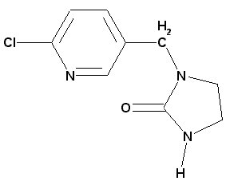
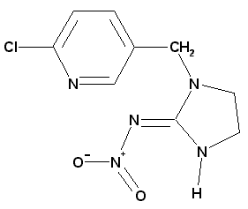

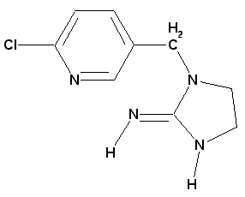

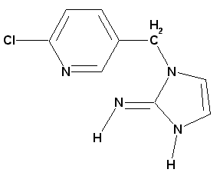

Appendix D: Environmental Fate and Transport

a. Degradation

Hydrolysis of Imidacloprid (161-1)–Imidacloprid was stable to hydrolysis in pH 5 and 7 buffer solutions, and slowly degraded at pH 9 with an extrapolated half-life of 355 days (MRID 42055337; EFGWB review nos. 92-0210, 92-0196). No degradation products accumulated significantly during the course of the study.

Photolysis in water (161-2) - The only environmental fate study in which extensive degradation occurred within a period of hours or a few days was the aqueous photolyis study (MRID 42256376; EFGWB reviews no.92-0847, 92-1039, and 92-1042). The possibility of rapid photolysis has some obvious implications for surface water exposure, but should not be assumed to universally occur in surface waters because there is not supporting evidence from surface water monitoring studies, the photolytic rate can be substantially different from distilled water in natural waters, and the amount of pesticide actually exposed to sunlight can be quite low in many surface waters.

Imidacloprid degraded with an "environmental" half-life of 4.2 hours (0.2 days) in pH 7 buffer solutions maintained at 24 C. The 50% and 75% disappearance times were approximately 1 and 2 hours, respectively.

Residue analysis. Thin-layer chromatography (TLC) in multiple solvent systems and radiometric detection (exposure of TLC plates to X-ray film) was used to confirm the identity of imidacloprid and two degradation products. In addition, residues were also determined with reverse phase high-performance liquid chromatography (HPLC). A linear analyzer was used to quantify residues eluted on TLC plates. Imidacloprid guanidine was the most prominent degradate, accumulating to 17% of the applied imidacloprid at the last sampling interval 2 hours after treatment. The only other degradation product that was identified was imidacloprid urea, which constituted 10% of the applied material 2 hours posttreatment. No effort was made to carry the experiment on to follow the degradation of imidacloprid more completely, and other degradation products were not identified. Two other separated, but unidentified photodegradation products reach maximum levels of 13% and 8% of the applied imidacloprid when the experiment was terminated after 2 hours of irradiation.`

The initial concentration of imidacloprid was 5.4 mg/l (5400 ppb) in sterile, buffered solution. The study was conducted with a Xenon lamp rather than natural sunlight (the study summary mentions that "under natural sunlight 60% of the compound were [sic] degraded after 4 hours", but a detailed description of the natural sunlight experiment was not provided). The light intensity of the lamp was 8.9 to 9.5 uW/cm2 compared to 4.1 to 5.3 uW/cm2 for "sunlight intensity on bright days" at the Yuki Institute in Japan, where the experiment was apparently conducted. Imidacloprid was shown to be more stable in sterile solution kept in the dark, but the last sample was taken only after two hours.
This study failed to identify most of the residues by two hours after application, and also failed to demonstrate the long-term stability of imidacloprid in the dark control. Although the stability of imidacloprid at pH 7 in solution has been demonstrated in a separate hydrolysis study, this should have been confirmed in the exact same solution that was used for the photolysis study. A further limitation was that the long-term stability of imidacloprid degradation products to photolysis was not evaluated.

Photolysis on soil (161-3) – Imidacloprid degraded with a registrant-calculated second-order half-life of 39 days (calculated environmental half-life of 171 days). Two experiments were run, one for 5 and the other for 15 days. At the end of the 15 days, imidacloprid parent accounted for 81.6% of the applied radioactivity; consequently an accurate estimate of the degradation rate under the conditions of this test is not possible.

Aerobic soil metabolism (162-1) – Imidacloprid degraded in a Kansas sandy loam soil (series name or classification unknown; MRID 421073501) with a half life well over 1 year (the duration of the study), extrapolation of the data with assumption of continued decay at a first-order rate results in a calculated half-life of 660 days (Table E-1). In contrast, in three European soils (MRID 452393), the first-order half-lives were calculated to be 248, 341, and 188 days. The mean first-order half-life was 359 days (90% upper bound confidence value of 520 days); however there appeared to be greater persistence during the latter part of these studies than predicted by a simple first-order model. These studies were conducted at 20 C (except 22 C for the Kansas soil), persistence might have been lower at 25 C, the temperature of most laboratory soil metabolism studies.

Under aerobic conditions no specific compound has been identified as accumulating to 10% or more of the applied in soil or water. The lack of identification of major degradates was a factor of both the limited transformation of parent compound over the duration of these studies and the failure to identify the nature of much of the residues.

Anaerobic soil metabolism (162-2) - No anaerobic soil metabolism study has been conducted; however, an anaerobic aquatic soil metabolism study was conducted in lieu of this study.

Anaerobic aquatic soil metabolism (162-2) - Imidacloprid degradation was evaluated in a water / sediment mixture (obtained from a pond in Stilwell, Kansas) (MRID 42256378).Characteristics of the sediment were: silt loam textural class (14% sand, 58% silt, 28% clay), 3.2% organic matter, pH 6.9. The pond water was not characterized. The study was conducted with 500 ml pond water and 100 g of sediment in flasks under unspecified conditions; imidacloprid was added to the overall system at a concentration of 0.56 ppm (presumably part per million by weight). The incubation flasks were purged with nitrogen and the maintenance of anaerobic conditions was documented with periodic measurement of redox potential, pH, and oxygen concentration. Imidacloprod degraded with a first order anaerobic half-life of 27 days over the 358-day post-application incubation period. Under the anaerobic conditions of this study, imidacloprid underwent a nitro-reduction reaction to the degradate imidacloprid guanidine, a compound which accumulated to 66% of applied 249 days after application of parent imidacloprid. Imidacloprid guanidine appears to be extremely persistent under anaerobic conditions; residues of this degradate still represented 64% (50% in the sediment and 14% in the water) of the applied imidacloprid at the last sampling date of 358 days posttreatment. Virtually no mineralization of imidacloprid occurred, evolved carbon dioxide represented less than 0.2% of the applied imidacloprid.

b. Mobility

Mobility/Adsorption/Desorption (163-1) -Based on two sets of batch equilibrium studies (MRID 420553-38 - American soils; and M in a total of eight soils (four American and four German), parent imidacloprid is moderately mobile with Freundlich adsorption coefficients ranging between 0.96 and 4.76. Soil organic carbon partition coefficients (Koc) values did not vary greatly, the range for eight soils was 132 to 256 ml/g (161 to 239 for the four American soils) with an average Koc of 178. Results for the American and German soil studies are given in Tables E-2 and E-3, respectively. Several articles reflecting further research on imidacloprid sorption in soil have since been published in the open literature, which provide insight into topics such as the increased sorption observed with time and also with lower initial concentrations of imidacloprid in soil water. Sorption coefficients measured in published studies are generally in the same range as the registrant-submitted studies, at least over the short-term (Oi, 1999, Cox et al. 1998).

In addition to the above-mentioned studies, an aged soil column leaching study with imidacloprid parent (MRID 420553-39) and an adsorption / desorption study with imidacloprid guanidine (MRID 425208-02) have been completed. In the imidacloprid guanidine study the same four American soils were studied as with the parent compound (compare Table E-4 with Table E-2). The degradate was more strongly adsorbed than parent imidacloprid in all four of the test soils.

Prospective ground-water studies.

Prospective ground-water studies have been conducted at two locations and in both cases the predominant compound detected in soil, soil-pore water throughout the vadose zone, and in ground-water (when detectable) was parent imidacloprid. Of the three degradates analyzed for (imidacloprid guanidine, olefin, and urea derivatives) only imidacloprid urea leached at concentrations that were frequently detectable (minimum detection limit of 0.02 ug/L).

There is a possibility that exposure to these degradates could be significant. Therefore, it is important that either specific analytical methods for the degradates or some sort of total residue method for residues in water and soil samples should be developed and made publicly available (specific methods would be required for any degradate identified as being of toxicological concern).

c. Accumulation

Accumulation in Laboratory Fish (165-4) This data requirement has been waived. Octanol/water partitioning (Kow) data provided by the registrant implies a low potential to bioaccumulate (Kow for imidacloprid = 3.7 @21 C).

d. Field Dissipation

Terrestrial field dissipation (164-1). Terrestrial field dissipation studies have been submitted from Georgia (loamy sand, bareground), Minnesota (sandy loam, planted to corn), California (sandy loam, planted to tomatoes), Minnesota (loam, turf plot), and a Georgia loamy sand (turf plot) (Table E-5). The dissipation half-lives (based on analyses of 0-6 inch soil cores only) ranged from 107 days to much greater than 1 year (no significant dissipation over the one year of the study at three of the sites). In each of these studies a single or broadcast application at 0.5 lb ai/A was made.

e. Special Field Studies

Small-Scale Prospective Ground-Water Monitoring Studies (164-1).

The registrant is currently conducting two small-scale Prospective Ground Water Monitoring studies: one each in Montcalm County, Michigan and Monterey County, California. In both studies, the registrant is monitoring for imidacloprid parent, imdacloprid guanidine, imdiacloprid olefin, and imidacloprid urea in the vadose zone and in shallow ground water.

In the California study (located near Salinas, Monterey County) imidacloprid was applied at 0.45 lb ai/A within the planting furrow (broccoli crop) in July 1996. At this site, more leaching of imidacloprid residues has been found to occur in the "control" plot than in the treated area. The registrant believes the imidacloprid found in control plot samples is from four foliar applications of imidacloprid in 1995 and 1996. Although it appears that sufficient irrigation water has been applied at this site to facilitate some ground-water recharge, interpretation of this study is complicated by the relative insensitivity of the analytical method for the conservative tracer (bromide) to be used to confirm this. In fact, there have been only a handful of detections of bromide in the first 3+ years of sampling of ground water, providing no definitive evidence that sufficient water has been applied at the site for any pesticide residues to reach ground water. Our conclusion therefore is, that even though there have only been three detections of imidacloprid in ground water (at 0.09, 0.10 and 0.14 ppb; the method has a claimed ability to quantitate imidacloprid at 0.01 ppb in water samples although apparently only detections above 0.05 ppb have been reported), there still could be substantial potential for imidacloprid to leach to ground water following application to irrigated vegetable or fruit crops in California (if sufficient water is added and time allowed for the aquifer to be recharged with water from the surface postttreatment). Additionally, we note that all three of the imidacloprid degradates were detected leaching through the vadose zone and there were also a few detections of imidacloprid urea in ground water at the California study site.

In the Michigan study (located near Vestaburg, Montcalm County) imidacloprid was applied at 0.34 lb ai/A by an unspecified method (potato crop) May 31, 1996. Imidacloprid has been found to be leaching at a variable rate and concentration in all six of the lysimeter clusters with residues so far having occasionally exceeded 1 ppb at 12 feet, the lowest depth sampled (Figure 2). Residues in ground water so far are somewhat lower, reaching up to 0.24 ppb (Figure 3). This study is ongoing, and it appears there may be a potential for higher residue levels to be detected. Note that the Tier 1 screening model concentration of 1.4 ppb is higher than residues observed in ground-water but lower than the concentration observed in the deepest soil pore-water (12-foot depth) at the Michigan study site. Complete breakthrough into ground water had not yet clearly been observed; consequently it is possible that higher concentrations of imidacloprid in ground water could still be observed. Consistent with this is that residues in the deepest soil-pore water and in groundwater were increasing in most lysimeter and well clusters at some point during the last year of sampling (there has been a marked seasonal fluctuation in concentrations in imidacloprid in soil pore-water).

f. Other (non-registrant) Ground-Water Monitoring

Recently, EPA has received several reports summarizing monitoring of ground water that is vulnerable to contamination in New York state (primarily Long Island). For imidacloprid, there have been about 27 detections of imidacloprid above a detection limit of 0.2 ppb in about 5000 ground water samples taken by the Suffolk County Department of Health Services, to date, with much of the monitoring targeted to areas with known histories of imidacloprid use and previously documented ground-water contamination issues. Overall, imidacloprid detections are rare in drinking water wells. Three wells had detections above the model-predicted maximum of 1.4 ppb. After closer investigation, however, EPA has concluded that those three wells are not reliable indicators of imidacloprid values that can be expected in groundwater from agricultural use of imidacloprid. The first of these wells is a private well in Mattituck, Long Island in which imidacloprid was found at a level of 6.69 ppb. An investigation by the New York authorities, however, concluded that these high levels were due to misuse of the pesticide in a greenhouse adjacent to the well where imidacloprid contaminated water was drained onto the ground in the immediate vicinity of the well. The second well was one of five shallow monitoring wells installed directly down gradient from imidacloprid use sites for the purpose of monitoring pesticide levels. One of those wells, "Jamesport B-2", showed levels of imidacloprid as high as 2.06 ppb. It was discovered, however, that this well was in all likelihood contaminated as a result of a manmade sump nearby that was constructed to alleviate ponding in the field and directly connected surface water to ground water. Imidacloprid was detected in only one of the other five wells, and the level of imidacloprid detected in the other well did not exceed 0.24 ppb. Finally, imidacloprid has been detected in shallow ground water wells directly downgradient from a site investigating use of tree injection treatments of imidacloprid. The highest level of imidacloprid found in these wells was 3.9 ppb. These wells, however, are not representative of wells used to supply ground water for drinking water. The wells were screened at extremely shallow depths (screens beginning only 4 to 10 feet from surface) due to the fact that the depth to ground water averaged about five feet. It was concluded by the researchers (EFED makes no comment on this at this time without further investigation ourselves) that these wells are "no more representative of what would likely occur in drinking water supplies than pesticide concentrations in samples taken from a weir draining an agricultural field are representative of what would occur in a community water supply drawing from a river or reservoir downstream."

stored as NCPnutIRAM1.out
Chemical: Imidacloprid
PRZM environment: NCpeanutC.txt modified Satday, 12 October 2002 at 15:12:46
EXAMS environment: ir298.exv modified Thuday, 29 August 2002 at 14:34:12
Metfile: w13737.dvf modified Wedday, 3 July 2002 at 08:06:30
Water segment concentrations (ppb)

Year Peak 96 hr 21 Day 60 Day 90 Day Yearly
1961 8.1 7.953 7.367 6.508 5.93 2.519
1962 3.863 3.827 3.696 3.464 3.194 1.713
1963 11.14 10.92 10.15 8.586 7.616 3.199
1964 2.483 2.439 2.265 2.063 1.878 1.353
1965 2.228 2.188 2.028 1.732 1.583 0.8783
1966 4.888 4.831 4.669 4.236 3.88 1.76
1967 2.51 2.482 2.437 2.155 1.951 1.026
1968 3.475 3.412 3.159 2.73 2.437 1.171
1969 3.227 3.168 2.956 2.748 2.535 1.238
1970 3.921 3.871 3.614 3.088 3.035 1.609
1971 2.678 2.654 2.582 2.304 2.088 1.095
1972 2.966 2.913 2.725 2.57 2.421 1.185
1973 4.622 4.54 4.348 4.201 3.882 1.779
1974 2.979 2.925 2.721 2.392 2.177 1.179
1975 5.882 5.778 5.36 5.112 4.922 2.463
1976 4.409 4.328 4.052 3.441 3.062 1.553
1977 4.356 4.302 4.01 3.616 3.311 1.596
1978 5.522 5.438 5.292 4.991 4.598 2.16
1979 8.897 8.763 8.513 7.559 6.885 3.324
1980 8.085 7.962 7.38 6.253 5.559 2.761
1981 1.969 1.934 1.833 1.682 1.58 1.022
1982 2.115 2.076 1.936 1.667 1.501 0.7642
1983 4.422 4.376 4.118 3.795 3.55 1.646
1984 10.77 10.58 9.798 8.374 7.946 3.867
1985 3.776 3.708 3.549 3.099 2.827 1.675
1986 3.755 3.704 3.471 3.128 2.893 1.429
1987 4.329 4.257 4.051 3.843 3.598 1.703
1988 2.561 2.538 2.448 2.258 2.073 1.082
1989 2.865 2.812 2.607 2.271 2.166 1.144
1990 2.346 2.304 2.155 2.009 1.895 0.9624

Sorted results
Prob. Peak 96 hr 21 Day 60 Day 90 Day Yearly
0.032258064516129 11.14 10.92 10.15 8.586 7.946 3.867
0.0645161290322581 10.77 10.58 9.798 8.374 7.616 3.324
0.0967741935483871 8.897 8.763 8.513 7.559 6.885 3.199
0.129032258064516 8.1 7.962 7.38 6.508 5.93 2.761
0.161290322580645 8.085 7.953 7.367 6.253 5.559 2.519
0.193548387096774 5.882 5.778 5.36 5.112 4.922 2.463
0.225806451612903 5.522 5.438 5.292 4.991 4.598 2.16
0.258064516129032 4.888 4.831 4.669 4.236 3.882 1.779
0.290322580645161 4.622 4.54 4.348 4.201 3.88 1.76
0.32258064516129 4.422 4.376 4.118 3.843 3.598 1.713
0.354838709677419 4.409 4.328 4.052 3.795 3.55 1.703
0.387096774193548 4.356 4.302 4.051 3.616 3.311 1.675
0.419354838709677 4.329 4.257 4.01 3.464 3.194 1.646
0.451612903225806 3.921 3.871 3.696 3.441 3.062 1.609
0.483870967741936 3.863 3.827 3.614 3.128 3.035 1.596
0.516129032258065 3.776 3.708 3.549 3.099 2.893 1.553
0.548387096774194 3.755 3.704 3.471 3.088 2.827 1.429
0.580645161290323 3.475 3.412 3.159 2.748 2.535 1.353
0.612903225806452 3.227 3.168 2.956 2.73 2.437 1.238
0.645161290322581 2.979 2.925 2.725 2.57 2.421 1.185
0.67741935483871 2.966 2.913 2.721 2.392 2.177 1.179
0.709677419354839 2.865 2.812 2.607 2.304 2.166 1.171
0.741935483870968 2.678 2.654 2.582 2.271 2.088 1.144
0.774193548387097 2.561 2.538 2.448 2.258 2.073 1.095
0.806451612903226 2.51 2.482 2.437 2.155 1.951 1.082
0.838709677419355 2.483 2.439 2.265 2.063 1.895 1.026
0.870967741935484 2.346 2.304 2.155 2.009 1.878 1.022
0.903225806451613 2.228 2.188 2.028 1.732 1.583 0.9624
0.935483870967742 2.115 2.076 1.936 1.682 1.58 0.8783
0.967741935483871 1.969 1.934 1.833 1.667 1.501 0.7642

0.1 8.8173 8.6829 8.3997 7.4539 6.7895 3.1552
Average of yearly averages: 1.6952

Inputs generated by pe4.pl - 8-August-2003

Data used for this run:
Output File: NCPnutIRAM1
Metfile: w13737.dvf
PRZM scenario: NCpeanutC.txt
EXAMS environment file: ir298.exv
Chemical Name: Imidacloprid
Description Variable Name Value Units Comments
Molecular weight mwt 255.6633 g/mol
Henry's Law Const. henry 4.0e-12 atm-m^3/mol
Vapor Pressure vapr 1.5e-9 torr
Solubility sol 580 mg/L
Kd Kd mg/L
Koc Koc 178 mg/L
Photolysis half-life kdp 39 days Half-life
Aerobic Aquatic Metabolism kbacw 1040 days Halfife
Anaerobic Aquatic Metabolism kbacs 81 days Halfife
Aerobic Soil Metabolism asm 520 days Halfife
Hydrolysis: pH 7 0 days Half-life
Method: CAM 2 integer See PRZM manual
Incorporation Depth: DEPI 0.0 cm
Application Rate: TAPP .0143 kg/ha
Application Efficiency: APPEFF 0.99 fraction
Spray Drift DRFT 0.064 fraction of application rate applied to pond
Application Date Date 05-04 dd/mm or dd/mmm or dd-mm or dd-mmm
Interval 1 interval 2 days Set to 0 or delete line for single app.
Interval 2 interval 2 days Set to 0 or delete line for single app.
Interval 3 interval 2 days Set to 0 or delete line for single app.
Interval 4 interval 2 days Set to 0 or delete line for single app.
Interval 5 interval 2 days Set to 0 or delete line for single app.
Interval 6 interval 2 days Set to 0 or delete line for single app.
Interval 7 interval 2 days Set to 0 or delete line for single app.
Interval 8 interval 2 days Set to 0 or delete line for single app.
Interval 9 interval 2 days Set to 0 or delete line for single app.
Interval 10 interval 2 days Set to 0 or delete line for single app.
Interval 11 interval 2 days Set to 0 or delete line for single app.
Interval 12 interval 2 days Set to 0 or delete line for single app.
Interval 13 interval 2 days Set to 0 or delete line for single app.
Interval 14 interval 2 days Set to 0 or delete line for single app.
Interval 15 interval 2 days Set to 0 or delete line for single app.
Interval 16 interval 2 days Set to 0 or delete line for single app.
Interval 17 interval 2 days Set to 0 or delete line for single app.
Interval 18 interval 2 days Set to 0 or delete line for single app.
Interval 19 interval 2 days Set to 0 or delete line for single app.
Interval 20 interval 2 days Set to 0 or delete line for single app.
Interval 21 interval 2 days Set to 0 or delete line for single app.
Interval 22 interval 2 days Set to 0 or delete line for single app.
Interval 23 interval 2 days Set to 0 or delete line for single app.
Interval 24 interval 2 days Set to 0 or delete line for single app.
Interval 25 interval 2 days Set to 0 or delete line for single app.
Record 17: FILTRA
IPSCND 1
UPTKF
Record 18: PLVKRT
PLDKRT
FEXTRC 0.5
Flag for Index Res. Run IR IR
Flag for runoff calc. RUNOFF total none, monthly or total(average of entire run)

stored as NCPnutIRAM2.out
Chemical: Imidacloprid
PRZM environment: NCpeanutC.txt modified Satday, 12 October 2002 at 15:12:46
EXAMS environment: ir298.exv modified Thuday, 29 August 2002 at 14:34:12
Metfile: w13737.dvf modified Wedday, 3 July 2002 at 08:06:30
Water segment concentrations (ppb)

Year Peak 96 hr 21 Day 60 Day 90 Day Yearly
1961 7.66 7.521 6.965 6.07 5.551 2.37
1962 3.818 3.766 3.64 3.43 3.16 1.676
1963 11.79 11.57 10.74 9.091 8.063 3.364
1964 2.56 2.515 2.335 2.134 1.931 1.397
1965 2.255 2.214 2.052 1.752 1.594 0.8817
1966 4.894 4.821 4.67 4.259 3.901 1.774
1967 2.402 2.38 2.344 2.085 1.892 1.006
1968 3.381 3.319 3.072 2.657 2.371 1.115
1969 3.357 3.295 3.074 2.832 2.62 1.273
1970 4.079 4.026 3.759 3.213 3.151 1.671
1971 2.761 2.728 2.662 2.374 2.154 1.13
1972 2.947 2.894 2.71 2.496 2.369 1.173
1973 4.384 4.306 4.108 3.94 3.662 1.695
1974 2.793 2.742 2.552 2.254 2.027 1.072
1975 5.6 5.5 5.099 4.794 4.615 2.333
1976 4.561 4.477 4.192 3.56 3.168 1.584
1977 4.32 4.259 3.978 3.559 3.268 1.581
1978 5.65 5.581 5.416 5.147 4.75 2.228
1979 8.434 8.3 8.088 7.191 6.521 3.162
1980 8.464 8.326 7.723 6.545 5.818 2.845
1981 2.04 2.003 1.901 1.734 1.626 1.058
1982 2.116 2.089 1.957 1.687 1.517 0.7739
1983 4.559 4.494 4.239 3.915 3.663 1.688
1984 10.34 10.15 9.399 7.971 7.344 3.622
1985 3.979 3.907 3.754 3.253 2.974 1.714
1986 3.576 3.544 3.334 2.992 2.775 1.392
1987 4.285 4.215 3.986 3.737 3.519 1.672
1988 2.49 2.463 2.382 2.205 2.031 1.068
1989 2.772 2.721 2.521 2.149 2.016 1.064
1990 2.363 2.32 2.161 2.004 1.883 0.9564

Sorted results
Prob. Peak 96 hr 21 Day 60 Day 90 Day Yearly
0.032258064516129 11.79 11.57 10.74 9.091 8.063 3.622
0.0645161290322581 10.34 10.15 9.399 7.971 7.344 3.364
0.0967741935483871 8.464 8.326 8.088 7.191 6.521 3.162
0.129032258064516 8.434 8.3 7.723 6.545 5.818 2.845
0.161290322580645 7.66 7.521 6.965 6.07 5.551 2.37
0.193548387096774 5.65 5.581 5.416 5.147 4.75 2.333
0.225806451612903 5.6 5.5 5.099 4.794 4.615 2.228
0.258064516129032 4.894 4.821 4.67 4.259 3.901 1.774
0.290322580645161 4.561 4.494 4.239 3.94 3.663 1.714
0.32258064516129 4.559 4.477 4.192 3.915 3.662 1.695
0.354838709677419 4.384 4.306 4.108 3.737 3.519 1.688
0.387096774193548 4.32 4.259 3.986 3.56 3.268 1.676
0.419354838709677 4.285 4.215 3.978 3.559 3.168 1.672
0.451612903225806 4.079 4.026 3.759 3.43 3.16 1.671
0.483870967741936 3.979 3.907 3.754 3.253 3.151 1.584
0.516129032258065 3.818 3.766 3.64 3.213 2.974 1.581
0.548387096774194 3.576 3.544 3.334 2.992 2.775 1.397
0.580645161290323 3.381 3.319 3.074 2.832 2.62 1.392
0.612903225806452 3.357 3.295 3.072 2.657 2.371 1.273
0.645161290322581 2.947 2.894 2.71 2.496 2.369 1.173
0.67741935483871 2.793 2.742 2.662 2.374 2.154 1.13
0.709677419354839 2.772 2.728 2.552 2.254 2.031 1.115
0.741935483870968 2.761 2.721 2.521 2.205 2.027 1.072
0.774193548387097 2.56 2.515 2.382 2.149 2.016 1.068
0.806451612903226 2.49 2.463 2.344 2.134 1.931 1.064
0.838709677419355 2.402 2.38 2.335 2.085 1.892 1.058
0.870967741935484 2.363 2.32 2.161 2.004 1.883 1.006
0.903225806451613 2.255 2.214 2.052 1.752 1.626 0.9564
0.935483870967742 2.116 2.089 1.957 1.734 1.594 0.8817
0.967741935483871 2.04 2.003 1.901 1.687 1.517 0.7739

0.1 8.461 8.3234 8.0515 7.1264 6.4507 3.1303
Average of yearly averages: 1.6780

Inputs generated by pe4.pl - 8-August-2003

Data used for this run:
Output File: NCPnutIRAM2
Metfile: w13737.dvf
PRZM scenario: NCpeanutC.txt
EXAMS environment file: ir298.exv
Chemical Name: Imidacloprid
Description Variable Name Value Units Comments
Molecular weight mwt 255.6633 g/mol
Henry's Law Const. henry 4.0e-12 atm-m^3/mol
Vapor Pressure vapr 1.5e-9 torr
Solubility sol 580 mg/L
Kd Kd mg/L
Koc Koc 178 mg/L
Photolysis half-life kdp 39 days Half-life
Aerobic Aquatic Metabolism kbacw 1040 days Halfife
Anaerobic Aquatic Metabolism kbacs 81 days Halfife
Aerobic Soil Metabolism asm 520 days Halfife
Hydrolysis: pH 7 0 days Half-life
Method: CAM 2 integer See PRZM manual
Incorporation Depth: DEPI 0.0 cm
Application Rate: TAPP .0143 kg/ha
Application Efficiency: APPEFF 0.99 fraction
Spray Drift DRFT 0.064 fraction of application rate applied to pond
Application Date Date 06-04 dd/mm or dd/mmm or dd-mm or dd-mmm
Interval 1 interval 2 days Set to 0 or delete line for single app.
Interval 2 interval 2 days Set to 0 or delete line for single app.
Interval 3 interval 2 days Set to 0 or delete line for single app.
Interval 4 interval 2 days Set to 0 or delete line for single app.
Interval 5 interval 2 days Set to 0 or delete line for single app.
Interval 6 interval 2 days Set to 0 or delete line for single app.
Interval 7 interval 2 days Set to 0 or delete line for single app.
Interval 8 interval 2 days Set to 0 or delete line for single app.
Interval 9 interval 2 days Set to 0 or delete line for single app.
Interval 10 interval 2 days Set to 0 or delete line for single app.
Interval 11 interval 2 days Set to 0 or delete line for single app.
Interval 12 interval 2 days Set to 0 or delete line for single app.
Interval 13 interval 2 days Set to 0 or delete line for single app.
Interval 14 interval 2 days Set to 0 or delete line for single app.
Interval 15 interval 2 days Set to 0 or delete line for single app.
Interval 16 interval 2 days Set to 0 or delete line for single app.
Interval 17 interval 2 days Set to 0 or delete line for single app.
Interval 18 interval 2 days Set to 0 or delete line for single app.
Interval 19 interval 2 days Set to 0 or delete line for single app.
Interval 20 interval 2 days Set to 0 or delete line for single app.
Interval 21 interval 2 days Set to 0 or delete line for single app.
Interval 22 interval 2 days Set to 0 or delete line for single app.
Interval 23 interval 2 days Set to 0 or delete line for single app.
Interval 24 interval 2 days Set to 0 or delete line for single app.
Interval 25 interval 2 days Set to 0 or delete line for single app.
Record 17: FILTRA
IPSCND 1
UPTKF
Record 18: PLVKRT
PLDKRT
FEXTRC 0.5
Flag for Index Res. Run IR IR
Flag for runoff calc. RUNOFF total none, monthly or total(average of entire run)

stored as MSSoyIRJA1.out
Chemical: Imidacloprid
PRZM environment: MSsoybeanSTD.txt modified Wedday, 23 August 2006 at 10:35:02
EXAMS environment: ir298.exv modified Thuday, 29 August 2002 at 14:34:12
Metfile: w03940.dvf modified Wedday, 3 July 2002 at 08:05:46
Water segment concentrations (ppb)

Year Peak 96 hr 21 Day 60 Day 90 Day Yearly
1961 0.7086 0.6894 0.6482 0.5944 0.5394 0.2073
1962 0.6536 0.6358 0.5677 0.458 0.4439 0.2073
1963 0.4843 0.4715 0.4283 0.3291 0.2914 0.1668
1964 0.9896 0.9679 0.8777 0.7881 0.7416 0.3319
1965 1.742 1.694 1.512 1.2 1.021 0.3793
1966 1.469 1.446 1.324 1.083 0.9331 0.3959
1967 0.991 0.9637 0.888 0.7251 0.6337 0.2743
1968 0.6374 0.6227 0.5635 0.4736 0.413 0.1921
1969 1.647 1.604 1.438 1.13 0.9739 0.3572
1970 0.8212 0.7988 0.744 0.6615 0.6149 0.2977
1971 1.442 1.403 1.251 0.9863 0.8511 0.3701
1972 0.447 0.4348 0.388 0.3623 0.3416 0.2101
1973 0.4228 0.4112 0.3768 0.3021 0.2658 0.1196
1974 0.8088 0.7866 0.7146 0.6053 0.5305 0.193
1975 2.528 2.479 2.325 2.084 1.839 0.652
1976 1.156 1.131 1.059 0.8501 0.7304 0.3659
1977 0.9473 0.9214 0.8269 0.6913 0.6339 0.293
1978 0.9582 0.9324 0.8721 0.7037 0.6113 0.2588
1979 1.645 1.601 1.438 1.378 1.297 0.5601
1980 0.4391 0.4293 0.391 0.3205 0.2787 0.2001
1981 0.6493 0.6316 0.5728 0.4647 0.4044 0.1697
1982 1.549 1.518 1.381 1.106 1.112 0.4815
1983 0.984 0.9624 0.8962 0.7762 0.6899 0.3516
1984 1.007 0.9853 0.8994 0.7376 0.6846 0.3016
1985 1.861 1.812 1.634 1.322 1.136 0.4277
1986 0.7098 0.6905 0.6166 0.5777 0.5274 0.2891
1987 0.5322 0.5204 0.4858 0.3991 0.3434 0.1995
1988 0.877 0.8583 0.7756 0.6856 0.6275 0.273
1989 0.6712 0.6532 0.5846 0.5091 0.4635 0.2199
1990 0.7854 0.7637 0.701 0.576 0.4966 0.2047

Sorted results
Prob. Peak 96 hr 21 Day 60 Day 90 Day Yearly
0.032258064516129 2.528 2.479 2.325 2.084 1.839 0.652
0.0645161290322581 1.861 1.812 1.634 1.378 1.297 0.5601
0.0967741935483871 1.742 1.694 1.512 1.322 1.136 0.4815
0.129032258064516 1.647 1.604 1.438 1.2 1.112 0.4277
0.161290322580645 1.645 1.601 1.438 1.13 1.021 0.3959
0.193548387096774 1.549 1.518 1.381 1.106 0.9739 0.3793
0.225806451612903 1.469 1.446 1.324 1.083 0.9331 0.3701
0.258064516129032 1.442 1.403 1.251 0.9863 0.8511 0.3659
0.290322580645161 1.156 1.131 1.059 0.8501 0.7416 0.3572
0.32258064516129 1.007 0.9853 0.8994 0.7881 0.7304 0.3516
0.354838709677419 0.991 0.9679 0.8962 0.7762 0.6899 0.3319
0.387096774193548 0.9896 0.9637 0.888 0.7376 0.6846 0.3016
0.419354838709677 0.984 0.9624 0.8777 0.7251 0.6339 0.2977
0.451612903225806 0.9582 0.9324 0.8721 0.7037 0.6337 0.293
0.483870967741936 0.9473 0.9214 0.8269 0.6913 0.6275 0.2891
0.516129032258065 0.877 0.8583 0.7756 0.6856 0.6149 0.2743
0.548387096774194 0.8212 0.7988 0.744 0.6615 0.6113 0.273
0.580645161290323 0.8088 0.7866 0.7146 0.6053 0.5394 0.2588
0.612903225806452 0.7854 0.7637 0.701 0.5944 0.5305 0.2199
0.645161290322581 0.7098 0.6905 0.6482 0.5777 0.5274 0.2101
0.67741935483871 0.7086 0.6894 0.6166 0.576 0.4966 0.2073
0.709677419354839 0.6712 0.6532 0.5846 0.5091 0.4635 0.2073
0.741935483870968 0.6536 0.6358 0.5728 0.4736 0.4439 0.2047
0.774193548387097 0.6493 0.6316 0.5677 0.4647 0.413 0.2001
0.806451612903226 0.6374 0.6227 0.5635 0.458 0.4044 0.1995
0.838709677419355 0.5322 0.5204 0.4858 0.3991 0.3434 0.193
0.870967741935484 0.4843 0.4715 0.4283 0.3623 0.3416 0.1921
0.903225806451613 0.447 0.4348 0.391 0.3291 0.2914 0.1697
0.935483870967742 0.4391 0.4293 0.388 0.3205 0.2787 0.1668
0.967741935483871 0.4228 0.4112 0.3768 0.3021 0.2658 0.1196

0.1 1.7325 1.685 1.5046 1.3098 1.1336 0.47612
Average of yearly averages: 0.29836

Inputs generated by pe4.pl - 8-August-2003

Data used for this run:
Output File: MSSoyIRJA1
Metfile: w03940.dvf
PRZM scenario: MSsoybeanSTD.txt
EXAMS environment file: ir298.exv
Chemical Name: Imidacloprid
Description Variable Name Value Units Comments
Molecular weight mwt 255.6633 g/mol
Henry's Law Const. henry 4.0e-12 atm-m^3/mol
Vapor Pressure vapr 1.5e-9 torr
Solubility sol 580 mg/L
Kd Kd mg/L
Koc Koc 178 mg/L
Photolysis half-life kdp 39 days Half-life
Aerobic Aquatic Metabolism kbacw 1040 days Halfife
Anaerobic Aquatic Metabolism kbacs 81 days Halfife
Aerobic Soil Metabolism asm 520 days Halfife
Hydrolysis: pH 7 0 days Half-life
Method: CAM 2 integer See PRZM manual
Incorporation Depth: DEPI 0.0 cm
Application Rate: TAPP .0025 kg/ha
Application Efficiency: APPEFF 0.99 fraction
Spray Drift DRFT 0.064 fraction of application rate applied to pond
Application Date Date 05-07 dd/mm or dd/mmm or dd-mm or dd-mmm
Interval 1 interval 2 days Set to 0 or delete line for single app.
Interval 2 interval 2 days Set to 0 or delete line for single app.
Interval 3 interval 2 days Set to 0 or delete line for single app.
Interval 4 interval 2 days Set to 0 or delete line for single app.
Interval 5 interval 2 days Set to 0 or delete line for single app.
Interval 6 interval 2 days Set to 0 or delete line for single app.
Interval 7 interval 2 days Set to 0 or delete line for single app.
Interval 8 interval 2 days Set to 0 or delete line for single app.
Interval 9 interval 2 days Set to 0 or delete line for single app.
Interval 10 interval 2 days Set to 0 or delete line for single app.
Interval 11 interval 2 days Set to 0 or delete line for single app.
Interval 12 interval 2 days Set to 0 or delete line for single app.
Interval 13 interval 2 days Set to 0 or delete line for single app.
Interval 14 interval 2 days Set to 0 or delete line for single app.
Interval 15 interval 2 days Set to 0 or delete line for single app.
Interval 16 interval 2 days Set to 0 or delete line for single app.
Interval 17 interval 2 days Set to 0 or delete line for single app.
Interval 18 interval 2 days Set to 0 or delete line for single app.
Interval 19 interval 2 days Set to 0 or delete line for single app.
Interval 20 interval 2 days Set to 0 or delete line for single app.
Interval 21 interval 2 days Set to 0 or delete line for single app.
Interval 22 interval 2 days Set to 0 or delete line for single app.
Interval 23 interval 2 days Set to 0 or delete line for single app.
Interval 24 interval 2 days Set to 0 or delete line for single app.
Interval 25 interval 2 days Set to 0 or delete line for single app.
Record 17: FILTRA
IPSCND 1
UPTKF
Record 18: PLVKRT
PLDKRT
FEXTRC 0.5
Flag for Index Res. Run IR IR
Flag for runoff calc. RUNOFF total none, monthly or total(average of entire run)

stored as MSSoyIRJA2.out
Chemical: Imidacloprid
PRZM environment: MSsoybeanSTD.txt modified Wedday, 23 August 2006 at 10:35:02
EXAMS environment: ir298.exv modified Thuday, 29 August 2002 at 14:34:12
Metfile: w03940.dvf modified Wedday, 3 July 2002 at 08:05:46
Water segment concentrations (ppb)

Year Peak 96 hr 21 Day 60 Day 90 Day Yearly
1961 0.7187 0.6992 0.653 0.5977 0.5422 0.2106
1962 0.6631 0.6451 0.5759 0.4647 0.4501 0.2121
1963 0.5004 0.4871 0.4425 0.3283 0.2913 0.1687
1964 1.004 0.9787 0.889 0.8038 0.756 0.3371
1965 1.816 1.766 1.576 1.251 1.064 0.3931
1966 1.332 1.308 1.202 0.9915 0.8581 0.3773
1967 1.021 0.9926 0.9154 0.7483 0.6546 0.2745
1968 0.6319 0.6201 0.5641 0.4758 0.4161 0.1954
1969 1.563 1.525 1.37 1.077 0.9307 0.3469
1970 0.8707 0.8468 0.7934 0.7109 0.6517 0.3099
1971 1.475 1.435 1.28 1.008 0.8705 0.3741
1972 0.4483 0.436 0.3891 0.3645 0.3411 0.2125
1973 0.4314 0.4195 0.3846 0.3085 0.2702 0.1213
1974 0.8293 0.8065 0.7327 0.6201 0.5436 0.1973
1975 2.348 2.293 2.16 1.938 1.719 0.619
1976 1.146 1.121 1.05 0.8427 0.7239 0.3542
1977 0.9648 0.9384 0.8422 0.7066 0.6331 0.2934
1978 0.9762 0.95 0.8882 0.7167 0.6226 0.2601
1979 1.613 1.57 1.411 1.346 1.27 0.5517
1980 0.4507 0.4406 0.4012 0.3287 0.2857 0.205
1981 0.668 0.6497 0.5894 0.4786 0.4168 0.174
1982 1.651 1.617 1.472 1.178 1.179 0.5063
1983 1.008 0.9827 0.915 0.7929 0.7046 0.3639
1984 1.016 0.9912 0.905 0.7432 0.6924 0.3034
1985 1.761 1.718 1.552 1.264 1.09 0.4133
1986 0.7212 0.7016 0.6263 0.5929 0.5333 0.287
1987 0.5396 0.5304 0.4958 0.4081 0.3512 0.2052
1988 0.8991 0.8769 0.7947 0.707 0.6496 0.2806
1989 0.684 0.6657 0.5957 0.5181 0.472 0.2242
1990 0.8074 0.7851 0.7205 0.5922 0.5106 0.2094

Sorted results
Prob. Peak 96 hr 21 Day 60 Day 90 Day Yearly
0.032258064516129 2.348 2.293 2.16 1.938 1.719 0.619
0.0645161290322581 1.816 1.766 1.576 1.346 1.27 0.5517
0.0967741935483871 1.761 1.718 1.552 1.264 1.179 0.5063
0.129032258064516 1.651 1.617 1.472 1.251 1.09 0.4133
0.161290322580645 1.613 1.57 1.411 1.178 1.064 0.3931
0.193548387096774 1.563 1.525 1.37 1.077 0.9307 0.3773
0.225806451612903 1.475 1.435 1.28 1.008 0.8705 0.3741
0.258064516129032 1.332 1.308 1.202 0.9915 0.8581 0.3639
0.290322580645161 1.146 1.121 1.05 0.8427 0.756 0.3542
0.32258064516129 1.021 0.9926 0.9154 0.8038 0.7239 0.3469
0.354838709677419 1.016 0.9912 0.915 0.7929 0.7046 0.3371
0.387096774193548 1.008 0.9827 0.905 0.7483 0.6924 0.3099
0.419354838709677 1.004 0.9787 0.889 0.7432 0.6546 0.3034
0.451612903225806 0.9762 0.95 0.8882 0.7167 0.6517 0.2934
0.483870967741936 0.9648 0.9384 0.8422 0.7109 0.6496 0.287
0.516129032258065 0.8991 0.8769 0.7947 0.707 0.6331 0.2806
0.548387096774194 0.8707 0.8468 0.7934 0.7066 0.6226 0.2745
0.580645161290323 0.8293 0.8065 0.7327 0.6201 0.5436 0.2601
0.612903225806452 0.8074 0.7851 0.7205 0.5977 0.5422 0.2242
0.645161290322581 0.7212 0.7016 0.653 0.5929 0.5333 0.2125
0.67741935483871 0.7187 0.6992 0.6263 0.5922 0.5106 0.2121
0.709677419354839 0.684 0.6657 0.5957 0.5181 0.472 0.2106
0.741935483870968 0.668 0.6497 0.5894 0.4786 0.4501 0.2094
0.774193548387097 0.6631 0.6451 0.5759 0.4758 0.4168 0.2052
0.806451612903226 0.6319 0.6201 0.5641 0.4647 0.4161 0.205
0.838709677419355 0.5396 0.5304 0.4958 0.4081 0.3512 0.1973
0.870967741935484 0.5004 0.4871 0.4425 0.3645 0.3411 0.1954
0.903225806451613 0.4507 0.4406 0.4012 0.3287 0.2913 0.174
0.935483870967742 0.4483 0.436 0.3891 0.3283 0.2857 0.1687
0.967741935483871 0.4314 0.4195 0.3846 0.3085 0.2702 0.1213

0.1 1.75 1.7079 1.544 1.2627 1.1701 0.497
Average of yearly averages: 0.29938

Inputs generated by pe4.pl - 8-August-2003

Data used for this run:
Output File: MSSoyIRJA2
Metfile: w03940.dvf
PRZM scenario: MSsoybeanSTD.txt
EXAMS environment file: ir298.exv
Chemical Name: Imidacloprid
Description Variable Name Value Units Comments
Molecular weight mwt 255.6633 g/mol
Henry's Law Const. henry 4.0e-12 atm-m^3/mol
Vapor Pressure vapr 1.5e-9 torr
Solubility sol 580 mg/L
Kd Kd mg/L
Koc Koc 178 mg/L
Photolysis half-life kdp 39 days Half-life
Aerobic Aquatic Metabolism kbacw 1040 days Halfife
Anaerobic Aquatic Metabolism kbacs 81 days Halfife
Aerobic Soil Metabolism asm 520 days Halfife
Hydrolysis: pH 7 0 days Half-life
Method: CAM 2 integer See PRZM manual
Incorporation Depth: DEPI 0.0 cm
Application Rate: TAPP .0025 kg/ha
Application Efficiency: APPEFF 0.99 fraction
Spray Drift DRFT 0.064 fraction of application rate applied to pond
Application Date Date 06-07 dd/mm or dd/mmm or dd-mm or dd-mmm
Interval 1 interval 2 days Set to 0 or delete line for single app.
Interval 2 interval 2 days Set to 0 or delete line for single app.
Interval 3 interval 2 days Set to 0 or delete line for single app.
Interval 4 interval 2 days Set to 0 or delete line for single app.
Interval 5 interval 2 days Set to 0 or delete line for single app.
Interval 6 interval 2 days Set to 0 or delete line for single app.
Interval 7 interval 2 days Set to 0 or delete line for single app.
Interval 8 interval 2 days Set to 0 or delete line for single app.
Interval 9 interval 2 days Set to 0 or delete line for single app.
Interval 10 interval 2 days Set to 0 or delete line for single app.
Interval 11 interval 2 days Set to 0 or delete line for single app.
Interval 12 interval 2 days Set to 0 or delete line for single app.
Interval 13 interval 2 days Set to 0 or delete line for single app.
Interval 14 interval 2 days Set to 0 or delete line for single app.
Interval 15 interval 2 days Set to 0 or delete line for single app.
Interval 16 interval 2 days Set to 0 or delete line for single app.
Interval 17 interval 2 days Set to 0 or delete line for single app.
Interval 18 interval 2 days Set to 0 or delete line for single app.
Interval 19 interval 2 days Set to 0 or delete line for single app.
Interval 20 interval 2 days Set to 0 or delete line for single app.
Interval 21 interval 2 days Set to 0 or delete line for single app.
Interval 22 interval 2 days Set to 0 or delete line for single app.
Interval 23 interval 2 days Set to 0 or delete line for single app.
Interval 24 interval 2 days Set to 0 or delete line for single app.
Interval 25 interval 2 days Set to 0 or delete line for single app.
Record 17: FILTRA
IPSCND 1
UPTKF
Record 18: PLVKRT
PLDKRT
FEXTRC 0.5
Flag for Index Res. Run IR IR
Flag for runoff calc. RUNOFF total none, monthly or total(average of entire run)

Oliviera, R. S., W. C. Koskinen, N. R. Werdin, and P. Y. Yen. 2000. Sorption of imidacloprid and its metabolites on tropical soils. J. Environ. Sci. Health. B35:39-49.
Cox, L., W.C. Koskinen, and P.Y. Yen. 1997. Sorption-desorption of imidacloprid and its metabolites in soils. J. Agric. Food Chem. 45:1468-1472.

