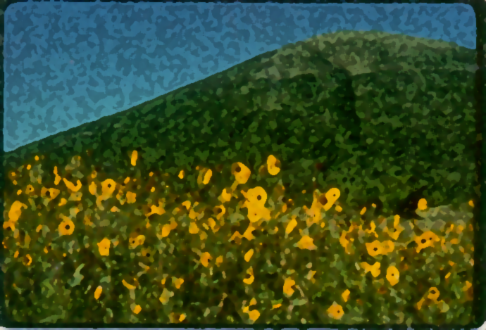

On – Site Activities

Jr. Geologist Lesson Plan

Title: Jr. Geologist

Goals: The students will be able to use mapping skills to draw conclusions about Capulin Volcano. The students will be able to use their field books as a source of information for a report.

Objectives: The student will be able to
- determine why the crater rim is uneven
- write the history of Capulin Volcano
- describe their experience at Capulin as a geologist would

Materials Needed:
Activity One:
Oaktag
Glue
Magazines/brochures
Field guide copies
Activity Two:
Field guide

Background Instructions:
When geologists venture out into the field, one of the items they always carry with them is a field book. In a field guide, a geologist will sketch a formation, and write detailed information on its contents. Such observations are described by size, shape, texture, smell, color, orientation, and even taste. This allows them to make observational notes of the formation they are studying to take back to the lab for further investigation, rather than trying to remember information stored in their heads.

Activity:
Presite
- This is the actual construction of the field guide. It can be done with the art teacher if desired.
- The contents of the Jr. Geologist book can be found in the following pages. Before constructing the booklet with the students, make enough copies so that each student will be able to participate in this activity.
- First the book cover will be cut out. Using oaktag (or other heavy paper), cut a 6’’ by 9’’ rectangle and fold it in half. (The cover may be collaged now or after the book is constructed depending on teacher preference.)
- Have the students cut ONLY along the dotted horizontal line. Then set page one face up on top of the oaktag rectangle, followed by page 2 (face up), page 3 (face up), and finally page 4/5 (this will be the middle page in the booklet).
- Fold all pages and cover along solid line and staple twice along the creased line. The cover can be collaged now if it isn’t already.
- The book is ready.

Onsite
- The activities in the Jr. Geologist book can be done while at the park and in conjunction with other activities.
- See attached answer sheet for objective activities.

Postsite
- Below is a list of possible activities that use the Jr. Geologist booklet as a primary source of information. The teacher may make up other activities if desired.
- Pretend you are a piece of magma and tell a story of going through the volcano building cycle.
- Write a geologist report of what you saw at Capulin and draw conclusions from it (cinder cone, bombs….)
- Create your own volcano and include all of the components and a cross section.

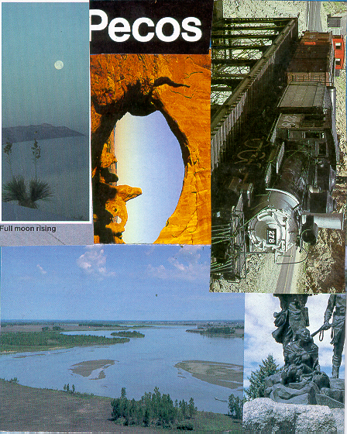
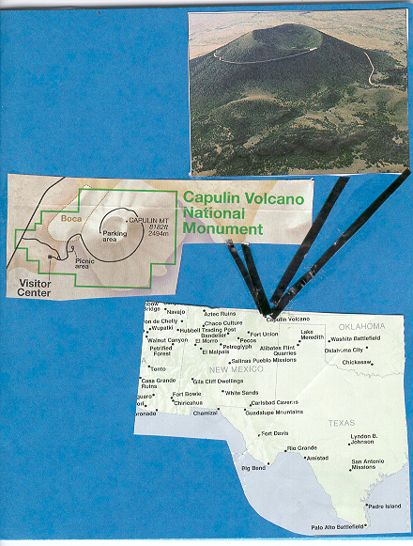
Examples of collages
for the Jr. Geologist
books:
Directions: Listen to the ranger talk and fill in the | Special Journal
blanks with the appropriate answer. | Directions: Think of a special place or event that
 | happened during your trip to Capulin, and write about it
1.Capulin erupted ________ thousand years ago. | using the remaining space of your field book.
2.The eruption lasted between ______ and ________ years.
3. When you shake a soda bottle and open it, it
____________________, just like the eruption of Capulin.
4. The ____________, or spanish word for mouth, is where
three if the four lava flows flowed from.
5. The lava flowed like cool ___________________.
6. Capulin is an example of a ____________ __________
volcano.
7. Sierra Grande is a _________________ volcano.
Directions: Sketch trees in the diagram below as
they appear in the real crater and answer the questions
using the compass.
E
N W
S
1. What side of the crater has the most vegetation? _______
2. What side of the crater is the tallest? _____________
3. Which direction was the wind blowing from when Capulin
erupted? _________________
4. How can you tell?
Lava Flows
Directions: Using the map scale and compass draw in, to
the best of your ability, all four lava flows and label them!
1. The first lava flow flowed to the south east one mile from
the base of Capulin
2. The next lava flow came from the south end of the boca,
and flowed south for about 2 and a half miles.
3. The third lava flow also came from the boca and flowed
all over the west and has a width of about a mile.
4. The final lava flow went about four miles from the boca to
the north.
Observations
Directions: Look at some of the geology and biology of
Capulin. Pick some rocks or plants and describe them in
the next two pages of your field book, so that someone
would be able to read thisand get a clear picture of what you
saw. Some good methods to describe things are by size,
shape, color, texture, and of course, to draw it.
Interview The Volcano Lesson Plan

Title: Interview the Volcano

Goals: The students will develop their observational skills. They will be able to relate the meaning of their object to Capulin Volcano.

Objectives: The student will be able to
- create a story about an object they find on the volcano
- incorporate their story and object into the story of Capulin Volcano

Materials Needed:
Activity Sheet
Clipboard

Background Information:
Every single object on the volcano, from the smallest rock to the largest wayside sign, tells a story about the volcano. It is our hope that through this activity, the students will begin to understand the story of the volcano and begin to appreciate it for everything that it is.

Activity:
Pre-visit:
Using an object that can be found in the classroom, like a pencil or a book, have a discussion with your students about how that object can tell you a story. You may want to compile a list of question on the chalk board. Ask the object the questions from the board and write the answers on the board. What is that object's story?
Explain to the students that when you arrive at Capulin Volcano, they will need to find a quiet area along any of the three trails (rim trail, vent trail, and nature trail) in the park and, staying on the trails, find an object that they think will tell them a story about the volcano. They will then fill out the activity sheet that you will provide.
On-site:
Remind the students that they must stay on the trails. Also remind them that there is to be NO collecting of any kind. You will want to group them with an adult and then have the adult find an area along the trail. Hand out the activity sheet and clipboard (if possible). They should only need about ten to fifteen minutes to do the actual activity.
Post-site:
Have the students share with the class what their objects story was.
Topics of discussion:
How do the objects that you found relate to the story of the volcano?
Why are the stories so important?
Compare and contrast the students objects.
Have the students write a creative story about their object.

Assessment:
The satisfactory completion of the activity will indicate the extent to which each student understands the concept that objects can tell us a story. The post-site discussion will reinforce the concept.

Interview the Volcano
On-Site Activity
There are many things on the volcano that can tell you a story. Find a quiet area along the rim trail or the vent trail. Look around you. What do you see? What is the most interesting thing in the area where you are sitting? Look closely at it. Feel it. Smell it. Listen to it. If it’s a rock, feel free to pick it up, but make sure you put it back where you found it. What’s its story?

What is your object? ____________________________________________________________________

What color is it? ________________________________________________________________________

Is it big or small? _______________________________________________________________________

What does it feel like? ___________________________________________________________________

Is it rough or soft? ______________________________________________________________________

What does it smell like? __________________________________________________________________

How do you think it got on the volcano? ____________________________________________________________________________________________________________________________________________________________________________

Does it say anything? ____________________________________________________________________________________________________________________________________________________________________________

What is its story? __________________________________________________________________________________________________________________________________________________________________________________________________________________________________________________________________

Why is it an important part of the volcano? ____________________________________________________________________________________________________________________________________________________________________________

Why do you need to leave it where you found it? ____________________________________________________________________________________________________________________________________________________________________________

Draw a picture of your object:

Scavenger Hunt Lesson Plan Plan

Title: Scavenger Hunt

Goals: The students will be able to identify a variety of plants and animals that can be found in and around the volcano.

Objectives: The student will be able to
- identify items found on the volcano
- relate the flora and fauna of the volcano to the landscape it lies within

Materials Needed:
Scavenger Hunt activity sheet
Clipboard
Pencil

Background Information:
Capulin (cah-poo-LEEN) is a Spanish word, meaning chokecherry. Chokecherry bushes can be found in and around the crater, of which Capulin is named. Because of the encroachment of the Pinion and Juniper trees, however, the number of chokecherry bushes have diminished over the years. In addition to the Pinion and Juniper forest, many trees and plants can be found on the volcano.
There are many animals that call Capulin home. A wide variety of birds can be found soaring around the volcano. Mule deer can be seen in the morning, while the bull snake can be found sunning itself on the hottest bit of pavement. The ladybugs, a summer native of Capulin, rarely leave the highest point of the volcano. The Juniper trees provide these fascinating bugs with shelter and food.
From the smallest bug to the tallest tree, Capulin Volcano provides a unique habitat that can be seen from either up close or from far away. We think it is best to see it up close, and hope that this activity provides your students with the opportunity to view nature at its finest.

Activity:
*This activity will be done throughout your visit to the volcano and can be done in conjunction with other activities.
- Hand out a copy of the ABC activity sheet to each students. If you have the students in groups, you may want to hand out one copy to each group.
- Read the directions to the students. This can be found on the top of the activity sheet.
- Reinforce that this is a non-collecting scavenger hunt. All they need to do is write down the names of things they see for each letter of the alphabet.
- Challenge them to try to fill in every letter of the alphabet.
- When you return to the classroom, you will want to have a group discussion on habitats and how the flora and fauna of the volcano impact one another.

Assessment:
Assessment will be based on the successful, and correct, completion of the activity sheet.

On-Site Activity

Alphabet Scavenger Hunt
For this activity, you must find at least one item for each letter of the alphabet. Some items, which can be found in the park, fall into many different categories. For example the pinyon pine can be listed under P. It can also be listed under T for tree. Be creative, but realistic. This is a non-collecting scavenger hunt.

A: O:
B: P:
C: Q:
D: R:
E: S:
F: T:
G: U:
H: V:
I: W:
J: X:
K: Y:
L: Z:
M:
N:

True/False Lesson Plan

Title: True/False VC

Goal: The students will improve their reading and evaluative skills.

Objectives: The student will be able to
1) answer questions with information provided in the visitor center

Materials Needed:
True/False VC worksheet
Clipboard
Pencil

Background Information:
Visitor’s centers hold a wealth of information, it’s just a matter of finding it. This activity will give the students an opportunity to explore the visitor’s center, while giving them an opportunity to learn a few things about the park and the surrounding area.

Activity:
*This lesson will take as much time as you would like to give the students.
*Before you arrive at the visitor’s center, give each student a copy of the True/False VC worksheet. Read the directions to the students, making sure everyone understands the task.
*You can do this activity before or after you watch the video.

Assessment:
- Successful completion of the True/False VC worksheet.
- (You will find the answers in the answer sheet section.)

True or False

For this activity, you will have to determine if the statements below are true or false. Taking this sheet with you, walk around the visitor center. All of the answers can be found in the visitor center.

____Capulin Volcano National Monument was established on August 10, 1961.

____The American and New Mexico flags are located in the visitors center.

____According to the display, a rapid cover of plant stabilized Capulin's loose ash and cinders, preserving its steep slopes.

____The two pictures that show Capulin span over a seventy-six year period.

____There are four gold plates on the plaque on the wall next to the video room door.

____The spear points in the 'Capulin influences man' display are the original points that scientists found in 1926.

____The first accepted evidence of Ice Age man in North America was discovered near Folsom, New Mexico, in 1926.

____Food and drinks are allowed in the visitors center.
____Spindle bombs form as molten basalt twists in mid-air and hardens.

____Ribbon bombs form from fluid lava that stretches and twists.

____Geologists have extensive evidence indicating that the Earth's crust is made up of rigid rocks 'sinking' and drifting on hot, plastic layers below.

____Monopoly makes a National Parks Edition.

____You can touch the objects on the "Please Touch" table.

____The rangers at Capulin Volcano always have a smile on their faces.

Challenge: Using the information in the visitors center, make up your own true or false statements. Road them to a classmate and see if they can find the correct answer.

