Report

This report documents research aimed at predicting the performance of scientific applications on high-end computing systems.

Performance modeling techniques use either an analytical approach or a simulation approach. Snavely’s framework for performance modeling is simulation-based. The POEMS project incorporates both simulation and analytical models. The CEPBA-IBM Research Institute is attempting to derive a linear model of execution time of MPI applications as a function of parameters such as processor speed, network latency, network bandwidth and number of processors. The CARNIVAL project employs a Lost Cycles Analysis approach, which involves measurement and modeling of all sources of overhead in a parallel program. Clement’s work applies multivariate data analysis techniques to performance prediction of Dataparallel C codes. Zhang’s work applies a semi-empirical methodology, combining analytical modeling and measurements, in predicting performance. Mendes’ work transforms trace obtained from an instrumented run of an application on a base machine to predict performance on a target real or hypothetical machine. Each of these research efforts is now described in greater detail.

Snavely’s framework

Allan Snavely, Laura Carrington, Nicole Wolter, Jesus Labarta, Rosa Badia, Avi Purkayastha , SC2002, Baltimore
A Framework for Application Performance Modeling and Prediction

Laura Carrington, Nicole Wolter, Allan Snavely, and Cynthia Bailey Lee
UGC 2004, Williamsburgh, June 2004.
Applying an Automated Framework to Produce Accurate Blind Performance Predictions of Full-Scale HPC Applications

Xiaofeng Gao and Allan Snavely, ICCS Workshop on Performance Modeling and Analysis (PMA03), June 2003, Melbourne
Exploiting Stability to Reduce Time-Space Cost for Memory Tracing

The framework is instantiated with
- MAPS and PMB benchmark data for machine profiles
- MetaSim tracer and MPIDtrace for application signatures
- Dimemas and MetaSim convolver to provide the automated convolving step

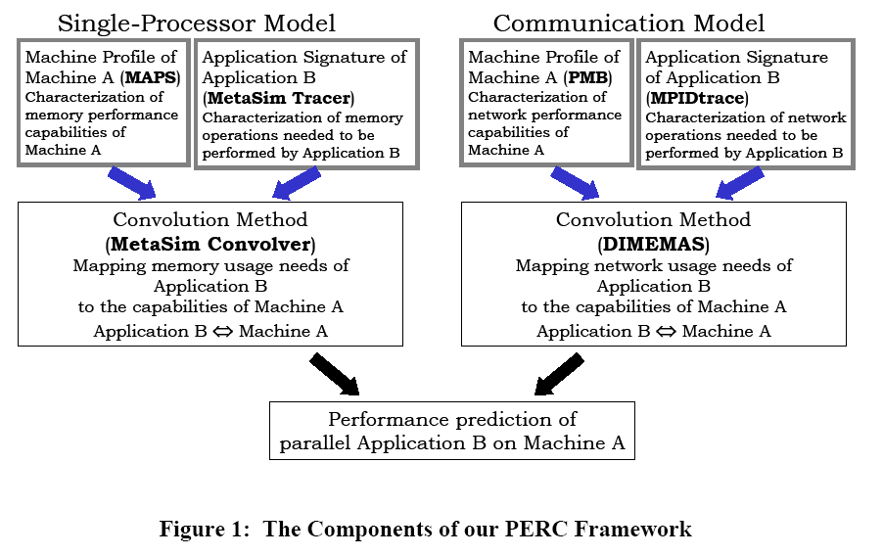

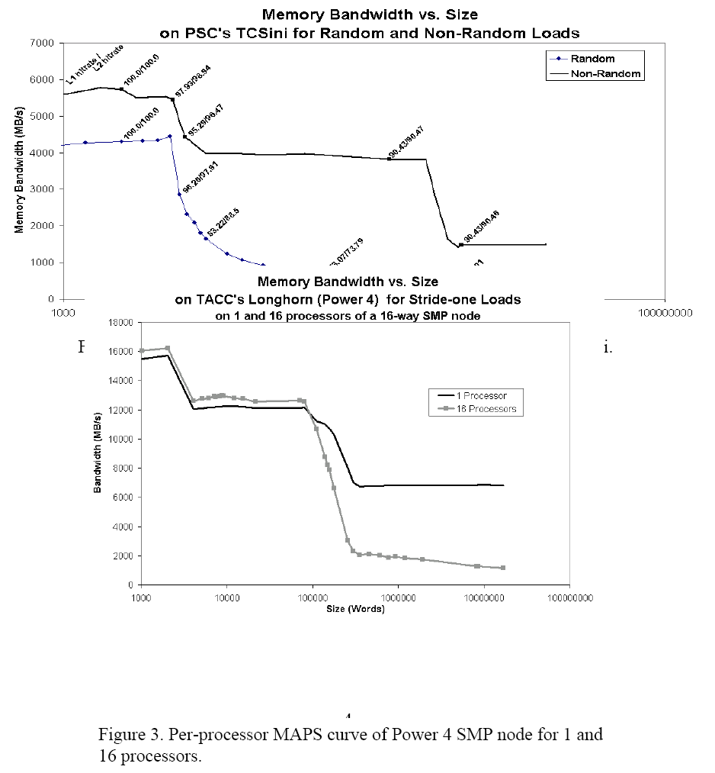

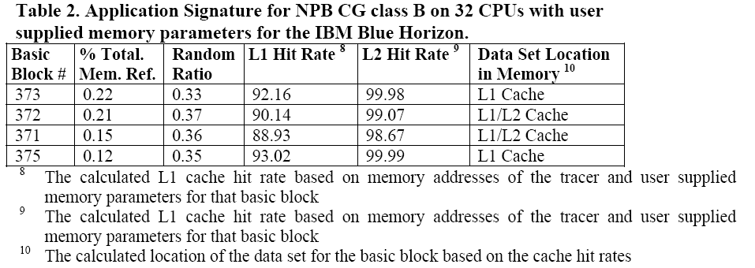

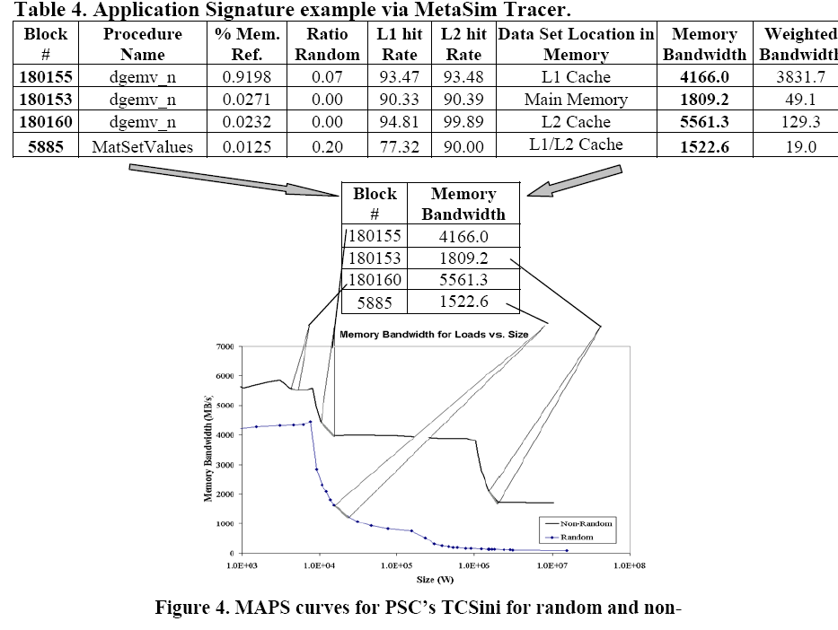

Some additional details on Snavely’s work is contained in
http://www.cse.ohio-state.edu/~shet/Snavely_summary.doc

POEMS

“V. S. Adve, R. Bagrodia, J. C. Browne, Deelman, E., A. Dube, E. Houstis, J. Rice, R. Sakellariou, D. Sundaram-Stukel, P. J. Teller, and M. K. Vernon, "POEMS: End-to-end Performance Design of Large Parallel Adaptive Computational Systems", IEEE Transactions on Software Engineering, Special Section of invited papers from the WOSP '98 Workshop, Vol. 26, No. 11, Nov. 2000, pp. 1027-1048”
http://www.cs.wisc.edu/~vernon/papers/poems.00tse.pdf

Sundaram-Stukel, D. and M. K. Vernon, "Predictive Analysis of a Wavefront Application Using LogGP", Proc. 7th ACM SIGPLAN Symp. on Principles and Practices of Parallel Programming (PPoPP '99), Atlanta, GA, May 1999, pp. 141-150
http://www.cs.wisc.edu/~vernon/papers/poems.99ppopp.pdf

"Performance Prediction of Large Parallel Applications Using Parallel Simulations," Rajive Bagrodia, Ewa Deelman, Steven Docy, Thomas Phan; ACM SIGPLAN 1999 Symposium on Principles and Practice of Parallel Programming, Atlanta, Georgia, May 4-6, 1999
http://www.cs.utexas.edu/users/poems/Papers/Bagrodia_ppopp.ps

The POEMS framework integrates multiple modeling paradigms
- Component models:
- Analytical models: deterministic task graph analysis, LogP, LogGP, LoPC and customized Approximate Mean Value Analysis (AMVA)
- Simulation models: SimpleScalar simulator (for processor and memory hierarchy simulation), MPI-Sim and COMPASS (for MPI program simulation), parallel I/O system simulators, interconnection network models using the PARSEC parallel simulation language
- Direct measurements

- Application models: Static and dynamic task graph representation of Sweep3D

Analytical modeling in POEMS:-
For predicting the execution time of Sweep3D on an IBM SP-2 system, a LogGP model of Sweep3D is developed. The parameters L, o, G are derived using simple two-node micro-benchmarks. Other model parameters are obtained by measuring small application problem sizes on four SP nodes. The LogGP model is then used to predict execution time for large problems running on 128 nodes. Projections are also provided for very large future processor configurations.
The LogGP model of Sweep3D is shown below.
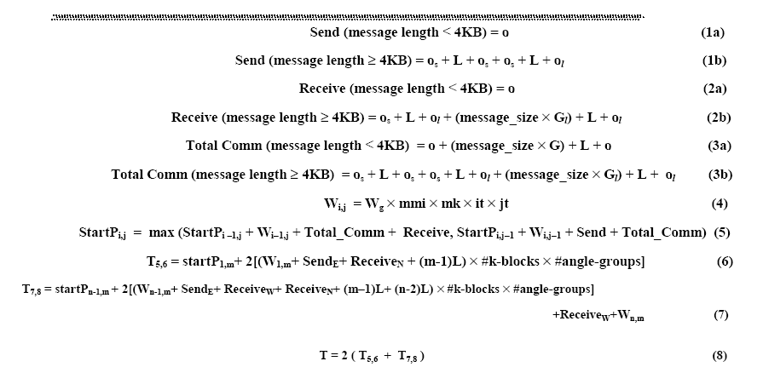

The following document summarizes machine models proposed in literature: http://www.cse.ohio-state.edu/~shet/Parallel_Machine_Models.doc

CEPBA-IBM Research

"Deriving Analytical Models from a Limited Number of Runs", Rosa M. Badia,
G. Rodriguez, Jess Labarta, Minisymposium on Performance Analysis, ParCo
2003
http://www.cepba.upc.edu/dimemas/docs/models_parco.pdf
"Generation of Simple Analytical Models for Message Passing Applications",
G. Rodriguez, R.M. Badia, and J. Labarta, Euro-Par 2004 Parallel
Processing, 10th International Euro-Par Conference, Pisa, Italy, August 31 - September 3, 2004
http://www.cepba.upc.edu/dimemas/docs/europar04.pdf

The DIMEMAS tool used in Snavely’s communication performance model is developed by CEPBA. DIMEMAS is a network simulator that simulates a network of SMPs by accepting user definitions of initial and target machines.

For each application that is to be analyzed, a real execution is performed to extract the tracefile that feeds DIMEMAS. The tracefile characterizes an instantiation of problem size and number of processors. The tracefile obtained contains information of communication requests by each process as well as the CPU demands between those requests. Additionally, by accepting user input for processor ratio (the speed of the target machine relative to the machine where the trace was obtained) and network bandwidth/latency characteristics of the target machine, DIMEMAS predicts execution time on the target machine. The processor ratio is used to approximate the computation time. The communication time is modeled with the simple linear model T = L + S/BW where L = network latency, S = message size and BW = network bandwidth. The summation of computation and communication times gives the execution time.

To fit a linear model to architectural parameters like processor speed, network latency and network bandwidth, a bunch of simulations of the same tracefile is launched randomly, varying for each simulation the values of these parameters. From the results of the simulations a linear regression is performed to extract a linear model for the elapsed time of the application against the architectural parameters. The coefficients in the model become the summarized characterization of the application.

To fit a linear model to processor count, several traces are obtained with different numbers of processors and linear regression is done.

Results:
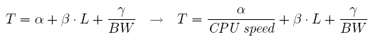

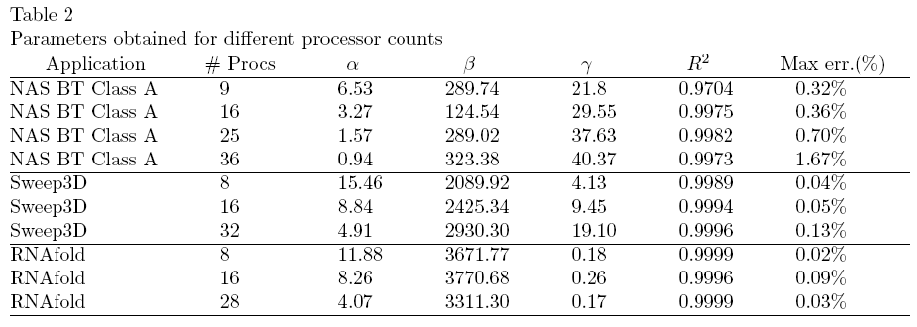

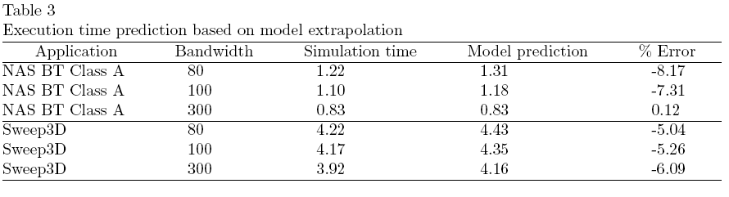

Parallel Performance Prediction Using Lost Cycles Analysis

Mark E. Crovella, Thomas J. LeBlanc (1994)
Parallel Performance Prediction Using Lost Cycles Analysis.
In: Proceedings of Supercomputing '94. pp. 600--609.

Crovella, M. Performance Prediction and Tuning of Parallel Programs. Ph.D. Dissertation, TR 573, Computer Science Department, University of Rochester, August 1994.
Wagner Meira Jr., Modeling Performance of Parallel Programs, TR 589, Computer Science Department, University of Rochester, June 1995.
Lost cycles analysis is based on the observation that the distinction between productive computation and parallel overhead is useful both for performance diagnosis and for performance prediction. To predict performance, total parallel overhead To, and pure computation Tc, are modeled as functions of environment variables like the size of the input dataset, the structure of the input dataset, the specific problem definition, the number of processors used, and the particular machine used. Given To and Tc, running time is predicted as Tp = (To + Tc) / p.

The parallel overhead is broken down into categories that can be separately modeled. The categories are
- Load Imbalance (LI): processor cycles spent idling, while unfinished parallel work exists.
- Insufficient Parallelism (IP): processor cycles spent idling, while no unfinished parallel work exists.
- Synchronization Loss (SL): processor cycles spent acquiring a lock, or waiting in a barrier.
- Communication Loss (CL): processor cycles spent waiting while data moves through the system.
- Resource Contention (RC): processor cycles spent waiting for access to a shared hardware resource.
Each category is modeled as a separate function of each environment variable. A small number of measurements for each environment variable suffice to parameterize the models, leading to an aggregate model of performance prediction spanning the entire environment space.

Lost cycles analysis is supported by two tools, pp and lca. The role of pp is to accurately measure parallel overheads and attribute them to defined categories. While the output of pp can provide insight to parallel programmers in its own right, the main use of pp's output is as input to the tool lca. The role of lca is to guide the user in fitting performance models to the data output from pp. The output from lca forms the basis for the performance model of the application.

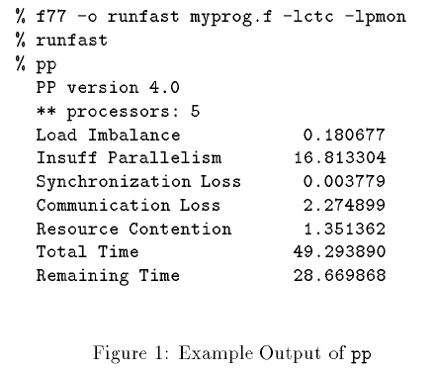

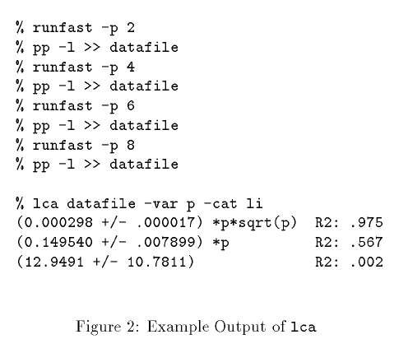

Using Lost Cycles Analysis to model the performance of 2D FFT:-

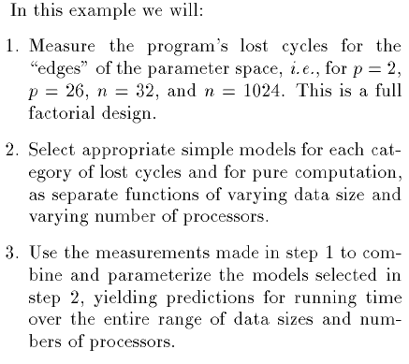

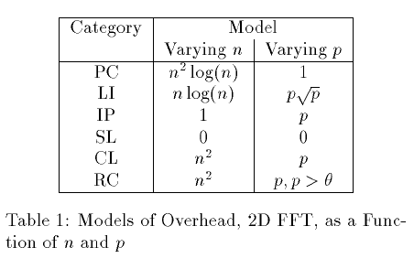

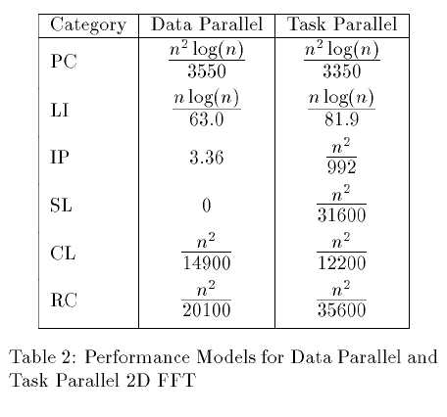

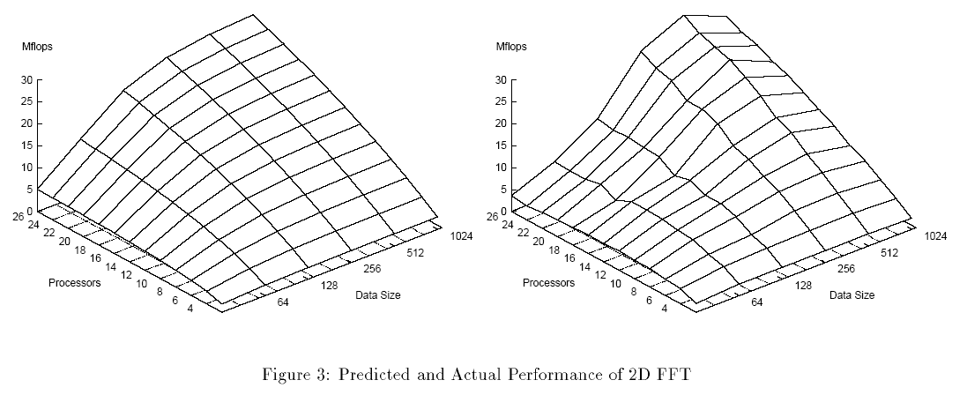

Multivariate Statistical Techniques for Parallel Performance Prediction

TR BYU-NCL-95-100 "Multivariate Statistical Techniques for Parallel Performance Prediction", Mark J. Clement and Michael J. Quinn. Also appeared in Proceedings of the 28th Hawaii International Conference on System Sciences, HICSS-28 January 3-6, 1995.
TR BYU-NCL-95-101 "Symbolic Performance Prediction of Scalable Parallel Programs", Mark J. Clement and Michael J. Quinn. Also appeared in Proceedings of the 9th International Parallel Processing Symposium, April 1995.
TR BYU-NCL-94-102 "Analytical Performance Prediction of Data-Parallel Programs", Mark J. Clement. Dissertation, August, 1994.
This work uses counts of critical operations like counts of arithmetic operations, virtual processor emulation loops, level one cache misses, messages sent and the number of bytes transmitted as predictor variables for multivariate analysis. Given Dataparallel C source code, instrumentation code is inserted to determine execution characteristics which will be used to build a call graph for the application. Architecture specifications for the target machine are then passed to a linearization phase which outputs operation counts for significant system parameters. Given a statistically significant number of experimental runs with different problem sizes and numbers of processors, Linear least-squares models is used to obtain the cost in seconds for each operation type. The counts, combined with costs in time for each operation type, results in a symbolic equation for execution time. Since the result of this model is an equation rather than a time estimate for a given problem size, the execution time can be differentiated with respect to a given system parameter. The resulting equation can be used to determine the sensitivity of the application to changes in that parameter as the problem is scaled up.
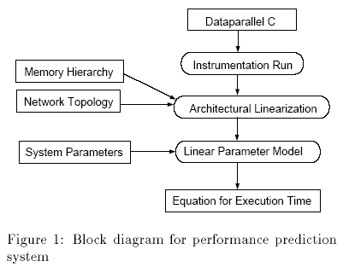
The execution time is modeled as
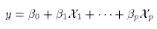
where χ_{i} denotes an operation count and β_{i} denotes the corresponding operation cost. The β_{i} values are determined using the S-PLUS statistical software package.
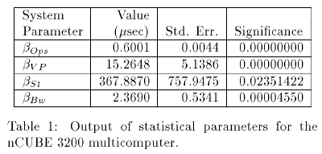
where β_{Ops} denotes the time for an arithmetic operation, β_{VP} denotes the time to set up a virtual processor emulation loop, β_{St} denotes message startup time, β_{Bw} denotes the time to transfer one byte.

Semi-empirical Multiprocessor Performance Predictions
TR-96-05-01.pdf Z. Xu, X. Zhang and L. Sun, ``Semi-empirical multiprocessor performance predictions”, Journal of Parallel and Distributed Computing, Vol. 39, No. 1, 1996, pp. 14-28.

TR-95-03-01.pdf X. Zhang and Z. Xu ``Multiprocessor Scalability Predictions Through Detailed Program Execution Analysis", In Proceedings of the 9th ACM International Conference on Supercomputing, (ICS'95), July 1995.

TR-94-02-01.pdf X. Zhang, Y. Yan, and K. He, ``Latency metric: an experimental method for measuring and evaluating parallel program and architecture scalability". The revised version was published in Journal of Parallel and Distributed Computing, Vol. 22, No. 3, 1994.

This work uses a combination of analytical and empirical results to predict performance. The proposed methodology is based on a two-level hierarchical model. In the higher level, a graphical model called the thread graph is used to characterize parallel applications, and a graphical algorithm is used to estimate the parallel execution time of a parallel application, assuming the elapsed times of all individual segments and events in the thread graph are known. On the lower level, the elapsed times of individual segments and events in the thread graph are determined with both analytic and experimental methods. Implicit and non-deterministic system effects are obtained through experimental
measurements.
This work also proposes a latency metric as a practical method to effectively predict and evaluate scalability based on measured latencies inherent in the program and the architecture.

Performance Scalability Predictions on Multicomputers

Celso L. Mendes, "Performance Prediction by Trace Transformation," Fifth Brazilian Symposium on Computer Architecture, Florianopolis, Brazil, September 1993.

Celso L. Mendes and Daniel A. Reed, "Performance Stability and Prediction," IEEE International Workshop on High Performance Computing (WHPC'94), Sao Paulo, Brazil, March 28-30, 1994.

Celso L. Mendes, "Performance Scalability Prediction on Multicomputers, 1997

This work explores stability of parallel programs and crossmachine performance prediction on multicomputers. Program behavior is characterized by an execution graph, obtained from running an instrumented version of the program. Program stability is assessed using time perturbations, and the resulting execution graphs are analyzed with an approximation of a graph comparison metric based on subgraph isomorphism. On programs with stable behavior, performance is predicted across different systems by transforming the observed execution trace; this trace transformation adjusts timestamps of events according to the architectural parameters of the systems under study, assuming the same partial event order on both systems. This technique allows performance to be predicted for future, hypothetical systems.

