
Personnel & Document Security
Winter Newsletter

USDA/DA/OPPM/PDSD

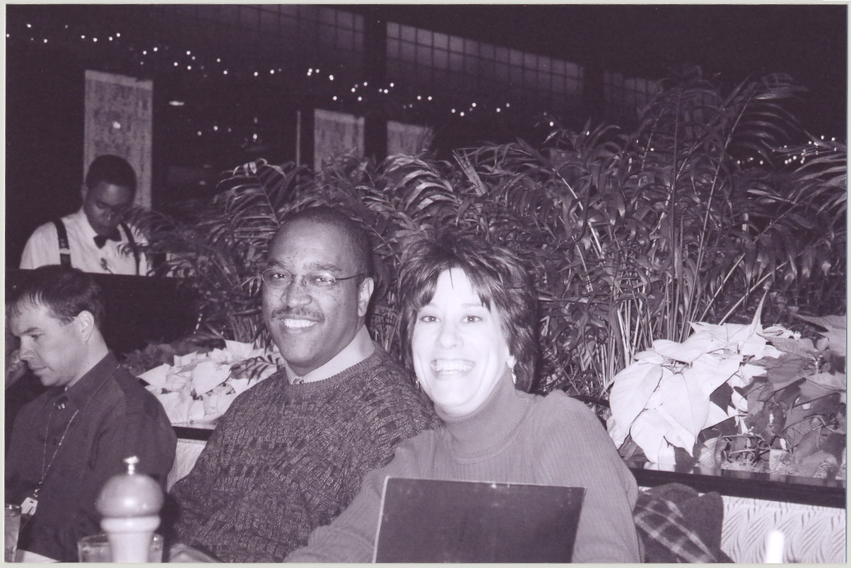

Upcoming Events in PDSD

• Local, Initial Security Indoctrinations will be held in-house on 1/12 and 1/19. February dates TBD.

Susan Gulbranson and Carl Johns enjoying the holiday luncheon.

Season’s greetings from PDSD!

“The greatest source of America’s generosity is not our government. It’s the heart of the American people.”

President George W. Bush, 1/3/05

I hope you all had a happy and safe holiday season! We are looking forward to 2005, with many goals ahead of us. Within Information Security, we will continue to implement our Original Classification Authority (OCA) by publishing a USDA Security Classification Guide (SCG). We will also be issuing a Departmental Regulation and Manual on Information Security. Within Personnel Security, we will be modernizing the Personnel Security Database, moving towards 100% e-QIP participation, and issuing a Departmental Regulation and Manual on Personnel Security.
Marty Brumback, PDSD Chief



Internet Roulette (Email and Websites)

It’s faster, easier, and can be tracked. Why not use the Internet for EVERYTHING? No more snail mail – sail with email – Right? Sure, but as with everything in life, you must be aware of the risks. One Internet website states that there are nearly 900 million people worldwide accessing the Internet. This includes individuals involved in terrorism directed against the United States and our allies.
Consider that everything USDA publishes on its website can be viewed by 900 million people from every country imaginable. Therefore, it is everyone’s responsibility to ensure that classified information, sensitive security information, and privacy act information are not placed on USDA websites.
All unclassified email traffic should be considered publicly releasable. On July 20, 2004, the U.S. Federal Appeals Court in Boston, MA ruled on a wiretapping case between two companies, and stated in part: “The law (Eavesdropping Law) only protects eavesdropping on messages that are not stored - such as an unrecorded phone conversation - but does not afford the same legal protections to stored messages.”
Everything we say and do outside of classified protections should pass questions like “Can this information, when compiled with other public information, do harm to our national security?” “If what I write in this email is published in a national newspaper, will it do harm to our program or our national security?” “Can December’s topical Blackberry messages be put together by the service provider to create classified or highly sensitive information?” Asking such questions can be considered a form of Operations Security or OPSEC. Applying these questions and others are OPSEC measures that facilitate an excellent information security program.



Marty Brumback and Diane Dixon at the holiday luncheon held at Old Ebbitt Grill in Washington, DC.

OPM Increases Its Investigative Capacity


Effective February 20, 2005, the Defense Security Service (DSS), Personnel Security Investigations, will transfer over 1,800 personnel security investigative staff to the U.S. Office of Personnel Management (OPM). After the DSS consolidation, OPM will conduct 90-95 percent of all Federal background investigations (BI).

The transfer of personnel, which was permitted in the 2004 Defense Authorization Bill, will allow OPM to perform the most sensitive investigations for the federal government.

OPM currently has over 3,000 investigative staff working under an OPM contract with U.S. Investigations Service, a company created in 1996 when OPM privatized the staff that conducts federal background investigations. Last summer, OPM awarded contracts to five companies for an additional 2,000 background investigators and related staff.

This significant consolidation and increase in investigative capacity should reduce the backlog of BI requests and reduce BI completion times. According to available statistics, OPM has about 340,000 on-going cases on hand at any one time, while DSS has about 325,000 pending investigations. In 2003, the average processing time for all BI’s was 357 days for OPM and 375 days for DSS. After the DSS merger, OPM’s goal is to complete the TOP SECRET clearance process within 90 days.

“The men and women who conduct background investigations for the Federal government play a very critical role in securing the nation.”
Kay Coles James, OPM Director

USDA Sensitive Security Information (SSI)

Sensitive Security Information (SSI) requires special handling, document markings, and distribution. SSI is defined as unclassified information of a sensitive nature, that if publicly disclosed could be expected to have a harmful impact on the security of Federal operations or assets, the public health or safety of the citizens of the United States or its residents, or the nation's long-term economic prosperity; and which describes, discusses, or reflects:
a. The ability of any element of the critical infrastructure of the United States to resist intrusion, interference, compromise, theft, or incapacitation by either physical or computer-based attack or other similar conduct that violates Federal, State, or local law; harms interstate, international commerce of the United States; or, threatens public health or safety;
b. Any currently viable assessment, projection, or estimate of the security vulnerability of any element of the critical infrastructure of the United States, specifically including, but not limited to vulnerability assessment, security testing, risk evaluation, risk-management planning, or risk audit;
c. Any currently applicable operational problem or solution regarding the security of any element of the critical infrastructure of the United States, specifically including but not limited to the repair, recovery, redesign, reconstruction, relocation, insurance, and continuity of operations of any element.
A bulletin addressing SSI is forthcoming. Additional Information on SSI can be obtained from DR 3440-002, Control and Protection of "Sensitive Security Information": http://www.ocio.usda.gov/directives/files/dr/DR3440-002.htm



Definition of Adjudication: An overall common sense determination based upon consideration and assessment of all available information, both favorable and unfavorable, with particular emphasis being placed in the seriousness, recency, frequency and motivation for the individual’s conduct; the extent to which conduct was negligent, willful, voluntary, or undertaken with knowledge of the circumstances or consequences involved; and, to the extent that it can be estimated, the probability that conduct will or will not continue in the future.

Page 2
Winter 2004-2005 ● Eighth Edition ● USDA/DA/OPPM/PDSD ● (202) 720-7373

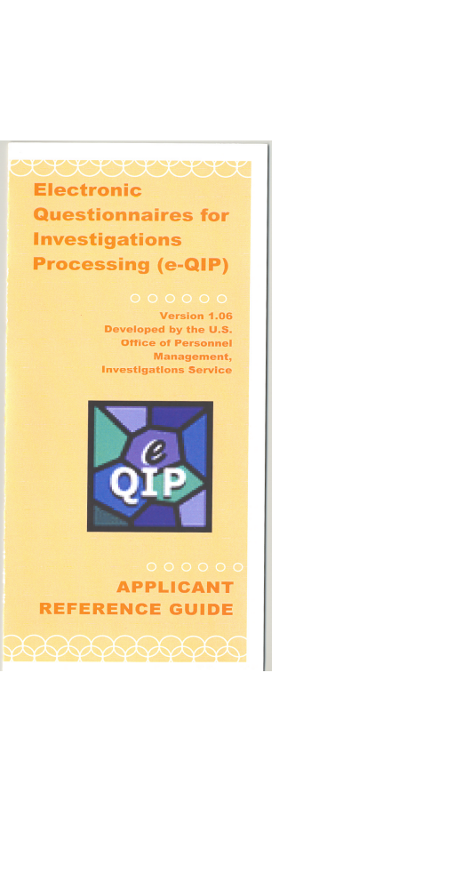
Recent Developments in e-QIP

During the first quarter of FY05, USDA has concluded the association with the OPM to schedule Electronic Questionnaires for Investigations Processing (e-QIP) training. The last of these e-QIP training sessions were conducted by the OPM in December 04. As of December 15, 2004, security points-of-contact from 17 different agencies have been trained to use e-QIP. This completed USDA's final e-QIP structured training phase and ensured that each agency had one or more trained security point-of-contact qualified to use the e-QIP system.
USDA began the initial implementation of e-QIP in June 2004 by receiving e-QIP requests from two select agencies whose point of contact had the required OPM training. Within the 1st quarter of 2005, three additional agencies successfully submitted personnel security requests for national security clearances via e-QIP.
In November 2004, Susan Gulbranson briefed the Survey and Investigations Staff, House Appropriations Committee, on the eClearance initiative. The briefing provided an overview of the initiative, current status of each component, and projections for continued implementation in FY 2005.
PSB has developed a plan to require that every USDA agency use e-QIP in 25% of all national security requests submitted during the second quarter of FY05, as all submitters have received training. This percentage will increase incrementally until 100% of national security requests submitted will be via e-QIP by the end of FY05. Additional information will be forthcoming in the next few weeks.
The Department of Defense (DoD) plans to have all of DoD using e-QIP by the end of FY05. The Joint Personnel Adjudication System (JPAS) will be the e-QIP portal for DOD employees.

The Personnel Security Branch (PSB) has customized the E-QIP brochure for each agency POC office. If you would like to receive a sample copy or an electronic version for reproduction, please contact Carrie Moore at carrie.moore@usda.gov.

A favorite family phrase or slogan can go here.


InfoSec Security Forms

SF702, Security Container Check Sheet – This form is used each time individuals open and close a security container:
http://web1.whs.osd.mil/forms/SF0702.pdf#search='SF%20702'
Sensitive Security Information Cover Sheet:
http://www.usda.gov/da/infosec/SSICoverSheet.pdf

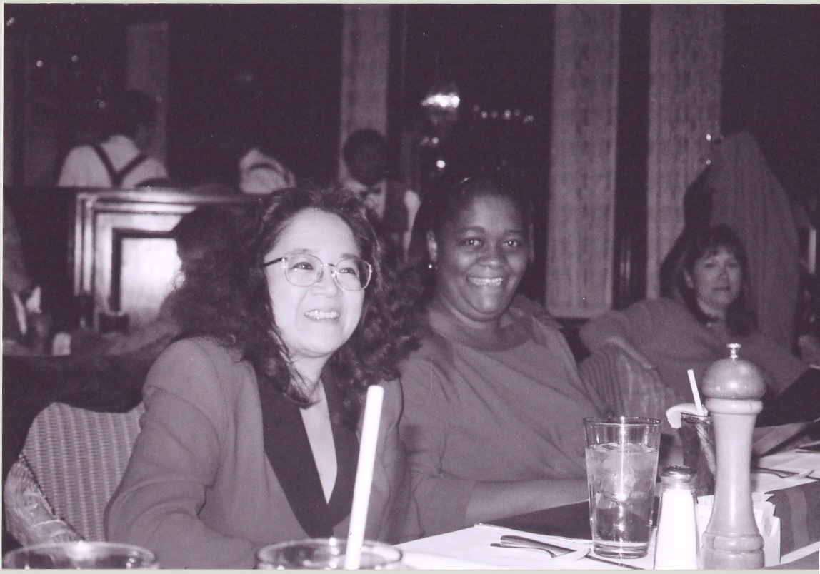

* UPDATE*

In our Spring 04 PDSD Newsletter, we reported that the Information Security Oversight Office (ISOO) would be conducting an Information Security Audit in the first quarter of FY05. That has been delayed until August 2005. The scope of the audit is discussed in the Spring 04 Newsletter.

Lucy Lew and Tiffany Brooks at the PDSD holiday luncheon.

Page 3 Winter 2004-2005 ● Eighth Edition ● USDA/DA/OPPM/PDSD● (202) 720-7373
PPER
SECURITY CROSSWORD PUZZLE

¹ |  |  | ² |  | ³ |  | ⁴
⁵ | ⁶
 |  |  |  |  | ⁷
 |  | ⁸ |  |  |  |  |  |  |  | ⁹
 |  |  |  |  |  |  | ¹⁰
 |  | ¹¹
 |  |  |  |  |  |  |  |  | ¹²
¹³

ACROSS  4. Federal positions are designated as either National Security positions or _____ _____ positions. (2 words)  5. Type of reinvestigation required for those holding a TS clearance.  7. If you hold a security clearance, you must have a ______ before departing USDA.  8. There are this many levels of classification.  11. Original ________ Authority  12. Classified documents must be stored in a ____ approved container.  13. The _________ form must accompany all initial security clearance requests. | DOWN  1. This agency is merging with OPM.  2. New online questionnaire processing system.  3. This crosscut device is used to destroy classified information.  6. A facility used to store SCI information.  8. Employees holding this clearance level are subject to random drug testing.  9. A communication or physical transfer of classified information to an unauthorized recipient is Unauthorized _____.  10. The number of adjudicative guidelines used to determine the eligibility for access to classified information.

Page 4 Winter 2004-2005 ● Eighth Edition ● USDA/DA/OPPM/PDSD● (202) 720-7373

Highlighting Areas of Concern to the OPM Investigator

If a supervisor or personnel security point-of-contact has specific concerns about an employee or contractor that you would like to ensure the OPM investigator covers during the investigation process, simply attach a memo outlining your concerns to the “Request for Personnel Security Services” form.
These concerns can include abnormal behavior in the workplace possibly relating to illegal drug use or alcohol abuse, unexplained affluence or indebtedness, outside employment or affiliations, and foreign associations or influences. Provide as much information in the memo as possible to assist the investigator.
To notify PDSD of any such concerns, especially for those employees holding a security clearance, please contact Susan Gulbranson at 202/720-7373.

USDA/DA/OPPM/PDSD
1400 Independence Ave, SW
STOP 9305, RM S-310
Washington, DC 20250
Phone:
(202) 720-7373
Fax:
(202) 720-7708

E-Mail:
pdsd@usda.gov
Web Site:
http://www.usda.gov/da/pdsd


If you are submitting a new investigation request for an employee being assigned overseas, please place a “1” (one) in Block B, Extra Coverage Code(s), in the Agency Use Block on the SF86.

Code 1 is used when an individual is going on a foreign assignment. The questions asked, as listed in the OPM Investigator's Handbook, are to assess an individual's potential for foreign assignment.

When Code 1 is entered into OPM’s system for a particular investigation, the system prints out instructions to the Investigators on the Case Assignment Transmittal (CAT) to alert them to provide the additional coverage.

It is also advisable to note the location and date of the foreign assignment on the Continuation Space (page 9) of the SF 86 so that OPM can schedule the personal interview appropriately.

FINAL THOUGHT…

If you would like to see PDSD address a particular topic, process, or guideline in a future newsletter, please submit your request to Carrie Moore at carrie.moore@usda.gov.

Crossword Puzzle Answers:
- DSS
- EQIP
- SHREDDER
- PUBLIC TRUST
- SSBIPR
- SCIF
- DEBRIEFING
- TS
- DISCLOSURE
- THIRTEEN
- CLASSIFICATION
- SCIF
- JUSTIFICATION

Contact Info:
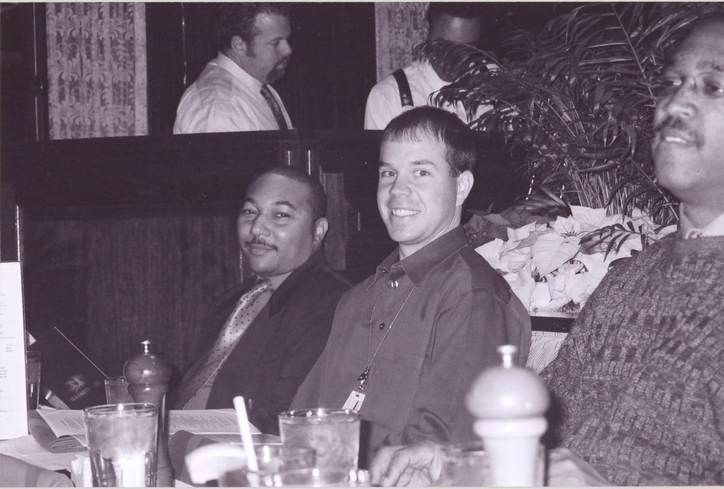
Arviet Thorpe, Michael Radford, and Carl Johns at the holiday luncheon.
Page 5 Winter 2004-2005 ● Eighth Edition ● USDA/DA/OPPM/PDSD● (202) 720-7373
To help provide all of you with streamlined customer service, we have designated the following employees to assist you with questions or actions relating to…
Personnel Security Policy: Contact Susan Gulbranson at 202/720-7373 or susan.gulbranson@usda.gov
E-QIP: Contact Carl Johns at 202/720-7844 or carl.johns@usda.gov
Sensitive Compartmented Information (SCI) or Personnel Security Database guidance: Contact Carrie Moore at 202/720-3487 or carrie.moore@usda.gov
Debriefings: Contact Michael Radford at 202/720-1859 or persec5@usda.gov
Forms Processing/Request for Personnel Security Services: Contact Valerie Ramirez at 202/205-7934 or persecadmin@usda.gov
All “Request to Pass a Clearance” forms should continue to be faxed to the main PDSD line at 202/720-7708. Questions should be directed to 202/720-7373.

Points-of-Contact in Personnel Security

Foreign Assignments

