USDA Foreign Agricultural Service
GAIN Report

Template Version 2.09

Global Agriculture Information Network

Required Report - public distribution
Date: 6/27/2006
GAIN Report Number: BR6010
BR6010
Brazil
Citrus
Semi Annual
2006

Approved by:
Morgan Perkins, ATO Director
U.S. Agricultural Trade Office
Prepared by:
Sergio Barros, Agricultural Specialist

Report Highlights:
The Brazilian orange crop for MY 2006/07 is forecast at 454 MBx, up 48 MBx from MY 2005/06 due to improved yields. The Sao Paulo and western Minas Gerais commercial areas should produce 365 MBx. Total FCOJ production for MY 2006/07 is forecast at 1.365 mmt (65 Brix), up 80,000 from the previous MY. FCOJ exports for MY 2006/07 are projected at 1.347 mmt (65 Brix), similar to MY 2005/06. Note that the FCOJ PS&D includes NFC converted to FCOJ 65 Brix equivalent.

Includes PSD Changes: Yes
Includes Trade Matrix: No
Semi-Annual Report
Sao Paulo [BR3]
[BR]
Table of Contents
FRESH ORANGES 3
PS&D Table 3
Production 4
PS&D Tables 4
General 4
Area and Tree Inventory 5
Diseases 6
Cost of Production 8
Producers’ Prices 10
Consumption 12
Trade 12
ORANGE JUICE (OJ) 14
PS&D Table 14
Production 14
PS&D Tables 14
General 16
Consumption 16
Trade 16
Stocks 18
Policy 18
Exchange Rate 19

FRESH ORANGES

PS&D Table

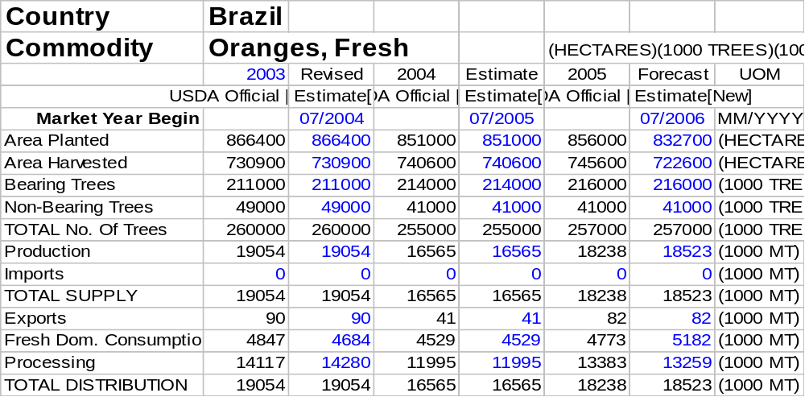

Production

PS&D Tables

The following tables provide revised data for Sao Paulo and total Brazilian fresh orange production, supply and demand (PS&D) for marketing years (MY) 2004/05, 2005/06 and MY 2006/07 (July-June).

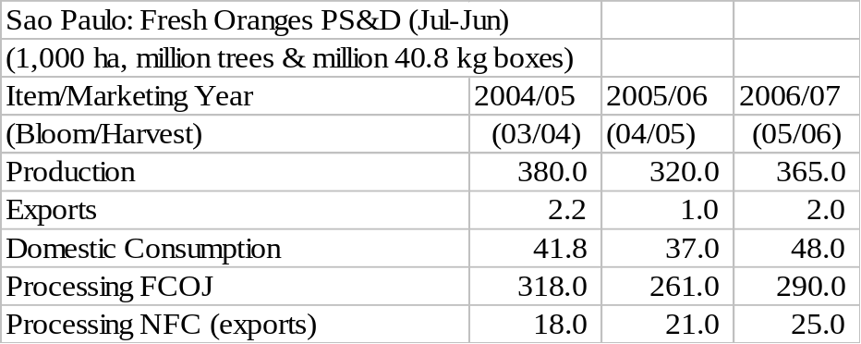

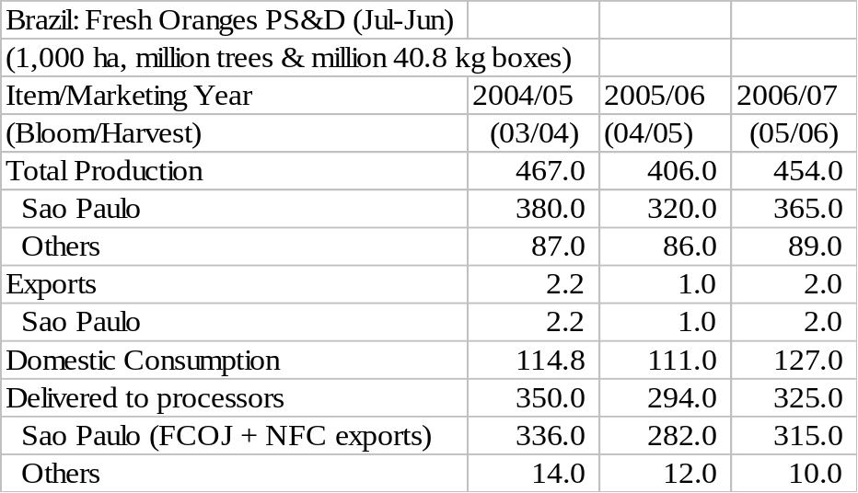

General

The Agricultural Trade Office (ATO)/Sao Paulo forecasts the MY 2006/07 (July-June) Brazilian orange crop at 454 million 40.8 kg boxes (Mbx), up 48 MBx relative to previous MY (406 Mbx). The commercial area of the state of Sao Paulo and the western part of Minas Gerais are expected to produce 365 Mbx, up slightly from the previous forecast. The crushing season began in May, but processing should intensify in July. Other growing regions should account for 89 Mbx, according to the latest estimates of the Brazilian Geography and Statistics Institute (IBGE).

The increase in production is explained mainly by higher expected yields. The Brazilian agricultural yield for MY 2006/07 is projected at 2.1 boxes/tree, an 11 percent increase over the previous season. Orange trees were less stressed by the smaller crop in 2005 and the Hamlin and Valencia varieties are in the on-year of the biennial production cycle. In addition, improved weather allowed for better fruit-setting and development.

The Sao Paulo State Institute of Agricultural Economics (IEA) released the results of the fourth orange crop survey (April 2006) for the 2005/06 crop (MY 2006/07). The Sao Paulo crop, including both commercial and non-commercial areas, is estimated at 356.9 MBx, up 4.8 MBx compared to MY 2005/06 (352.1 Mbx). Note that IEA takes into account the entire state of Sao Paulo, while ATO estimates follow the citrus industry methodology limited to the commercial production area of the state plus the western part of Minas Gerais. IEA also reports that the state of Sao Paulo orange tree inventory is estimated at 212.6 million trees (182.7 million bearing and 29.9 million non-bearing trees). Industry sources indicate that the Sao Paulo and Minas Gerais orange commercial areas could contribute 345 to 375 MBx for MY 2006/07.

Area and Tree Inventory

Total Brazilian tree inventory for MY 2006/07 is projected at 257 million trees (216 million bearing and 41 million non-bearing trees), up 2 million trees from revised figures for MY 2005/06 (214 million bearing and 41 million non-bearing trees). The tree inventory projection for MY 2006/07 in the Sao Paulo citrus belt remains unchanged at 164 and 37 million bearing and non-bearing trees, respectively.

Total MY 2006/07 orange area is forecast at 832,700 (ha), a 2 percent decrease from the previous crop (851,000 ha.). The reduction in area is a consequence of a revision of the bearing tree density (number of bearing trees per area) estimate for the commercial areas of Sao Paulo and western Minas Gerais; now estimated at 309 trees per hectare.

The table below shows the estimates for area and tree inventory for MY 2004/05, MY 2005/06 and MY 2006/07.

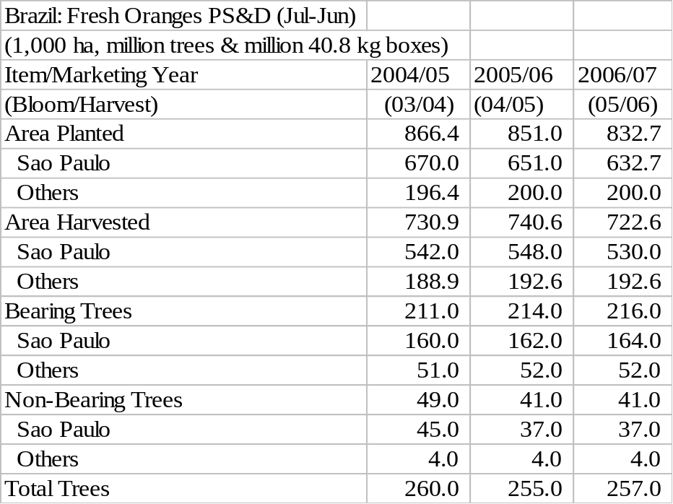

Sugarcane has been replacing orange groves to some extent in the state of Sao Paulo. The Center for Advanced Studies in Applied Economics (CEPEA) of the University of Sao Paulo’s College of Agriculture “Luiz de Queiroz” (ESALQ) has estimated the area coefficient between sugarcane and oranges based on IEA figures for 2001 and 2005, as shown below. While in 2001, there was 1.9 hectares of sugarcane for each 1 hectare of oranges; this relationship increased 63 percent to 3.1 to 1.

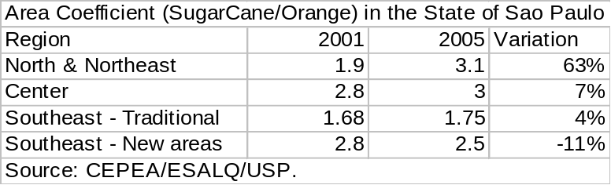

Data should be viewed in context; it does not mean that sugarcane has been planted in uprooted citrus groves. Most replacement has occurred in old, unproductive groves or in those with disease problems (which would normally be eradicated), especially in the north-northeast region. Competitive and profitable citrus groves remain and investments in new plantings continue, mainly by large producers.

As reported by the Citriculture Defense Fund (Fundecitrus), 509 inspected nurseries were in operation in March 2006. They are virtually all protected (508 out of 509 units), e.g., they maintain seedlings within screened enclosures, in accordance with Sao Paulo State law. The number of inspected seedlings amounted to 11,364,587 and the number of inspected rootstock totaled 8,723,941. These figures represent a decrease in the average number of seedlings available for planting compared to the same period in 2005 and could represent a limitation for the next planting season.

Diseases

The 2006 citrus canker sampling survey in the commercial area of the states of Sao Paulo and Minas Gerais has not been released yet, but preliminary data indicate that 0.20 to 0.25 percent of the sampled blocks show citrus canker, due to weather conditions which favor the disease and reduced inspections. Fundecitrus reports 0.14 and 0.11 percent for 2004 and 2005, respectively. The higher than expected incidence of canker in 2006 does not, however, indicate that the situation is out of control.

The tables below show the evolution of citrus canker for 2005 and 2006 (January-March), according to Fundecitrus. Cumulative tree eradication from commercial groves in 2005 was 204,898 down 39,347 tress compared to 2004. Cumulative eradication from commercial groves in 2006 (January-March) is 89,621, up 15,642 trees relative to the same period in 2005.

Note that approximately 1 million seedlings were eradicated in the beginning of 2006 due to detection of canker in protected nurseries. Through June 6, citrus canker was found in 13 nurseries in the citrus belt. Fundecitrus and the Sao Paulo State Secretariat of Agriculture have been continuously working to combat the disease, since canker still represents a problem in the citrus belt.

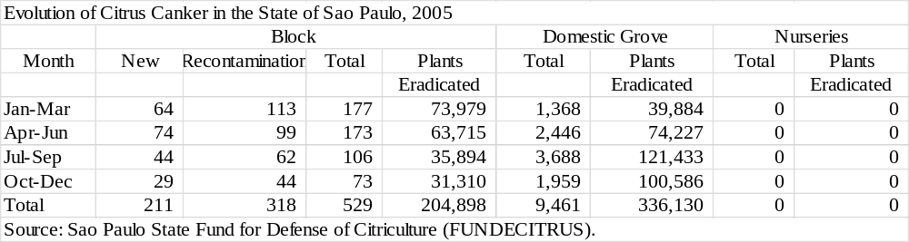

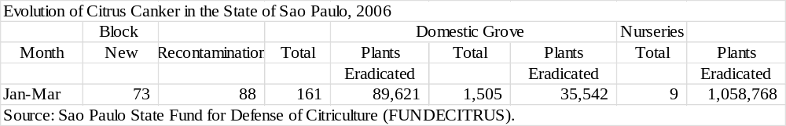

At the moment, Greening or huanglongbing (HBL) is the major threat confronted by the citrus industry, due to its severity and rapid dissemination. According to Fundecitrus, the 2006 survey (updated 06/06/2006) shows that 115.9 and 32.8 million trees were inspected and reinspected, respectively for HBL. Fundecitrus estimates that 0.1 to 0.2 percent of the tree inventory is affected by the disease (200,000 to 400,000 plants) and that another 400,000 plants have already been eradicated. A total of 2,131 farms (27 percent of inspected farms) showed contamination by HBL and the disease has spread out to approximately 100 counties. However, 90 percent of the disease is concentrated in the Araraquara region. Planting of healthy seedlings, vector (Diaphorina citri) control and eradication of affected plants are the principal measures being taken to control the disease. Regular inspecting of groves is fundamental to containment of HBL.

Fundecitrus has made attempts to increase growers’ awareness of the importance of this disease as well as of the need to regularly inspect or monitor groves. According to a survey conducted by the institute, about 82 percent of growers are conscious of the disease, whereas the reminder are either not conscious or show some resistance towards inspection. On the other hand, only 18 percent responded that they have a team prepared for regular inspections. The survey also shows that only 45 percent of growers spray regularly to control the vector, whereas 40 percent do not spray at all.

The resistance to inspection and/or spraying may be due to the additional cost. The cost of 6 inspections per year is estimated at R$ 0.25 – 0.55/box; depending on the productivity of the grove (1,200 to 500 box/ha). The additional cost to control the vector is estimated at R$ 0.10 – 0.25/box for farms with productivity of between 1,200 and 500 boxes/ha.

The tables below show the evolution of the Sudden Death of Citrus in the state of Sao Paulo. According to the latest survey (2005), approximately 87,000 plants show symptoms. Cumulative data shows that almost 1 million trees were affected since 2002. The disease has spread since 2002, especially in the counties of Barretos and Colombia. SDC is restricted to the northern and northwestern region of Sao Paulo and the western region of Minas Gerais. The expansion of SDC could be slower than initially predicted by the industry. Note that no SDC survey will be conducted by Fundecitrus in 2006.

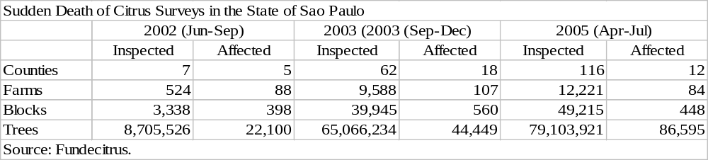

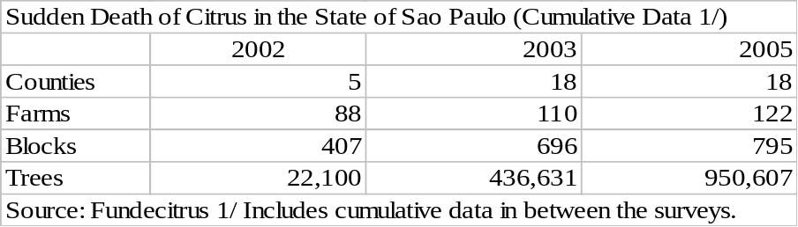

Cost of Production

The cost to produce oranges can differ significantly depending on the variables and technical coefficients utilized in estimating line items, and in the cost components considered. The table below shows a comparison among different sources organized by GHILARDI, A.A., and presented at the 28th Citrus Week in Cordeiropolis, Sao Paulo.

Note the variation in cost components included in cost analyses, depending on the source. According to the results, total production cost varies from R$ 7.35 to R$ 11.17/box. In dollar terms, total production costs range between US$ 3.31 and 6.72/box. Considering only the effective operational costs, results show a 63 percent variance (R$ 5.17 to 8.43/box or US$ 2.33 to 3.73/box), indicating that citrus production does not follow one production system pattern.

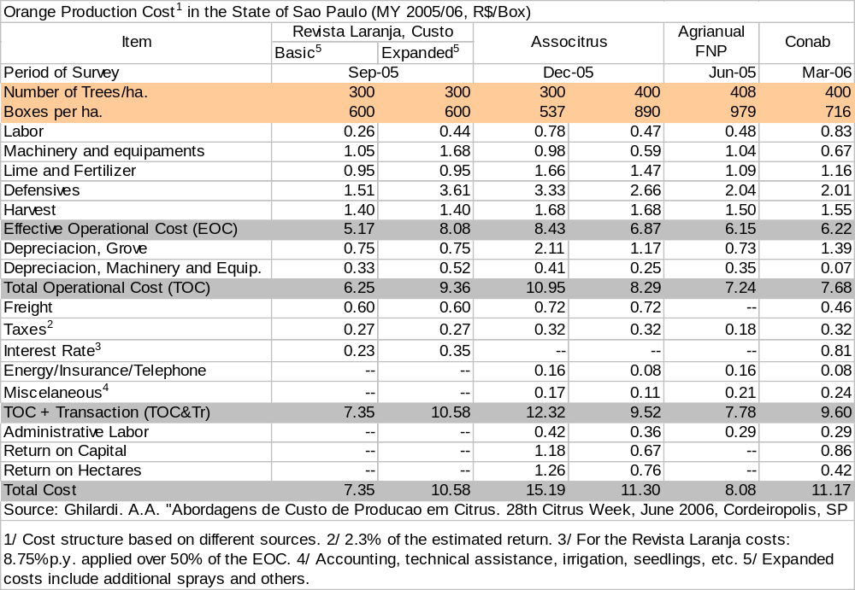

GHILARD, A.A. also generated a table including cost components not incorporated in the original cost structure tables of some of these institutions, as seen below (imputed data in yellow). Note that the total costs still show a wide variance (R$ 10.21 to 15.56/box) or US$ 4.60 to 6.88/box).

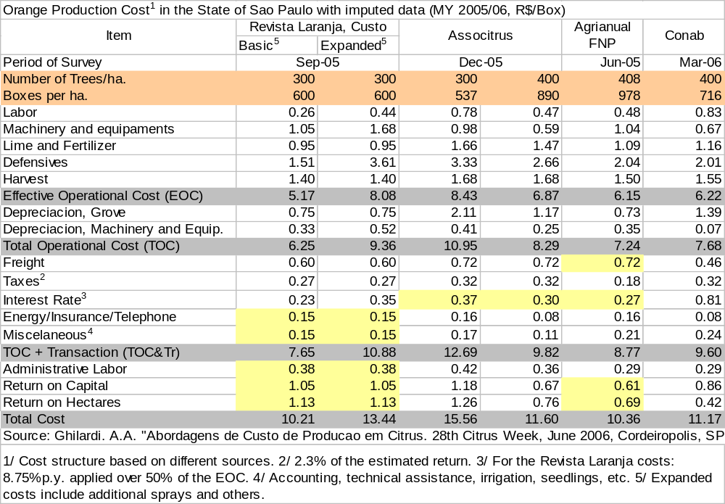

Producers’ Prices

The Orange Index price series released by the University of Sao Paulo’s College of Agriculture “Luiz de Queiroz” (ESALQ) records prices for both the fresh domestic market and product delivered to orange juice processing plants in the state of Sao Paulo. Both series have tracked orange prices since September 1994. Prices for the fresh market are for fruit on the tree. Dollar based prices varied between US$ 3.04 and 5.47/box (spot prices – industry) along the MY 2005/06 processing season. Index prices follow:

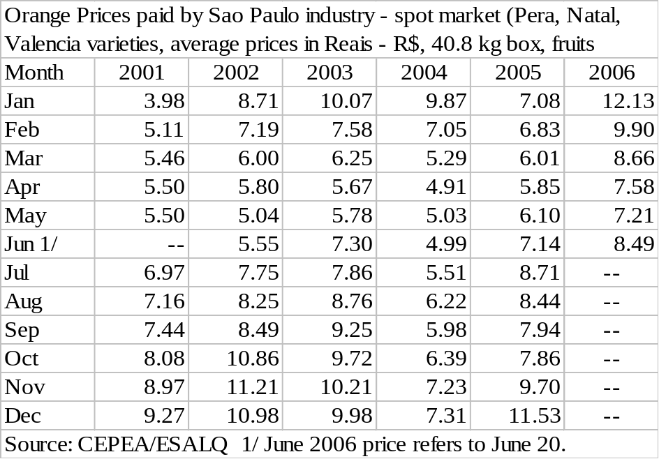

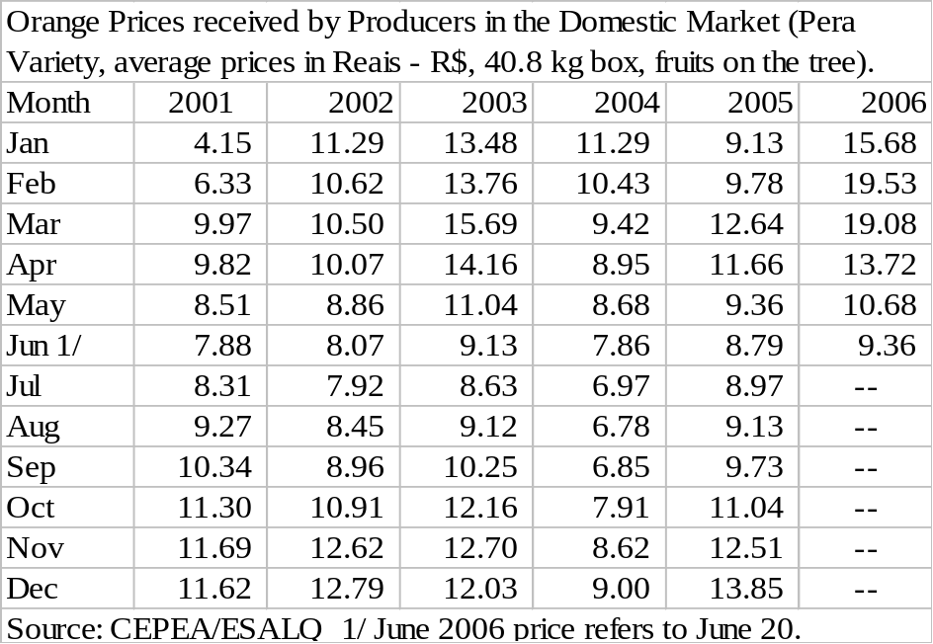

Citrus growers have been actively attempting to renegotiate orange contracts with the industry since April 2006. The collective negotiations include representatives of the Brazilian Citriculture Association (Associtrus), the Agricultural Federation of the State of Sao Paulo (FAESP), Cutrale and Coinbra (Louis-Dreyfus). As of June 23, no agreement had been reached. Citrosuco and Citrovita have not joined the meetings but will likely renegotiate contracts on an individual or case-by-case basis.

According to CEPEA, most contracts were set in 2004 at US$ 2.80 – 3.30/box, delivered at the gate, for 3 to 5 years. However, drastic changes have occurred to the industry during the past 2 years and growers have sought to renegotiate. Some renegotiated contracts include additional payments tied to variation of the price of orange juice in Europe.

Citrus production in Florida has fallen as a consequence of the hurricanes in 2004 and 2005 and disease related problems such as Canker and Greening. In addition, recent studies conducted by the University of Florida project a continuation of this decline in production for up to 15 years. As a consequence of short supply, orange Juice prices in the New York Exchange and Rotterdam have increased steadily and current prices are over US$ 2,000 per metric ton. However, most contracts were set by Brazilian growers before June 2005 and do not reflect the sharp increase the juice prices that occurred thereafter.

The attractiveness of sugarcane has affected growers’ decision on renewing old citrus groves or those affected by diseases such as cvc, Canker, SDC and Greening. Some growers have shifted to sugarcane to pursue a better return on investment. According to CEPEA, during MY 2002/03, the return on 3 boxes of oranges was equivalent to the return on 1 metric ton of sugarcane, whereas 5 boxes of orange were necessary to match 1 metric ton of sugarcane for MY 2005/06.

The appreciation of the local currency, the Real, vis-à-vis the US dollar has also reduced the profitability of citrus, since contracts are negotiated in dollars but producers receive payment in Reais. The value of the US dollar fell 23 percent between August 2004 and June 2006. At the same time, production costs increased as a consequence of increased spraying due to disease, increases in diesel prices and other cost increases.

CEPEA estimates the total income of the citrus industry in 2005 at R$ 2.6 billion, down 16 percent compared to 2004. Citrus delivered to the industry for processing (R$ 2 billion) is entirely responsible for this reduction, since delivery of citrus to the domestic market increase by 6 percent (R$ 600 million).

Consumption

ATO/Sao Paulo forecasts total Brazilian orange consumption for MY 2006/07 at 127 Mbx, up 14 percent compared to MY 2005/06 (111 MBx). Domestic consumption estimates are taken as the difference between production and the volume of oranges delivered to processors for FCOJ and NFC production for exports. Note that these figures include actual domestic consumption plus losses from natural drop, harvesting, transportation and packing. Fruit delivered to processors for “not from concentrate (NFC)” orange production for the domestic market is also included in these figures.

Trade

The total fresh orange export projection for MY 2006/07 remains unchanged from previous forecast at 2 Mbx. The table below shows official fresh orange exports (NCM 080510.00) by country of destination, for Calendar Year (CY) 2004 and MY 2003/04 and 2004/05 (July-April), according to SECEX.

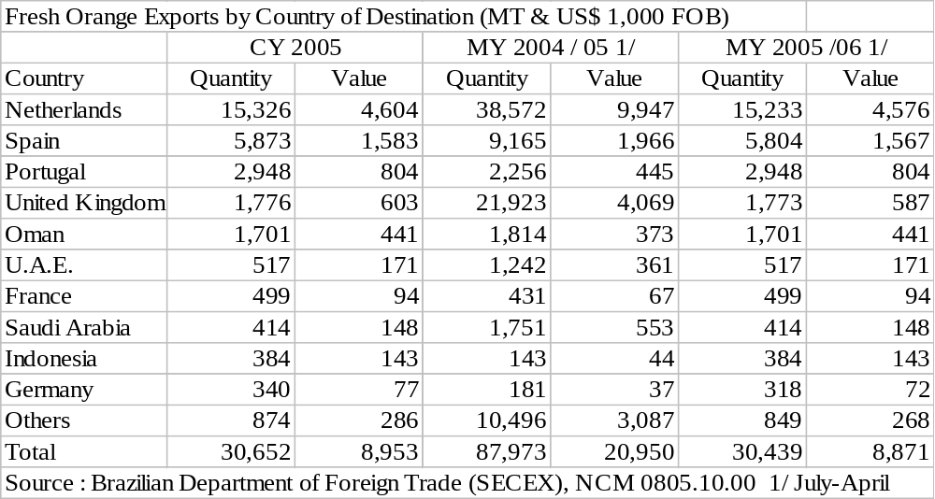

ORANGE JUICE (OJ)

PS&D Table

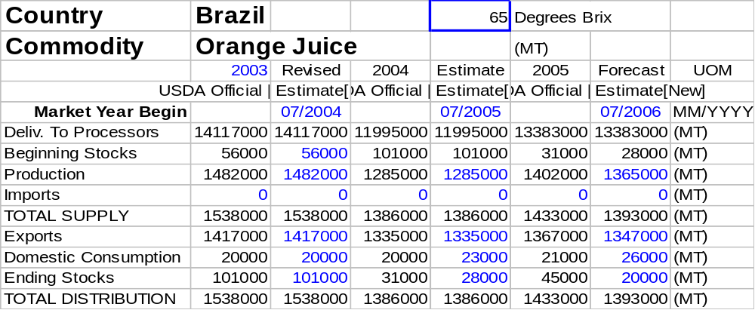

NOTE: The tables include Not From Concentrate (NFC) production for exports converted to FCOJ 65 Brix equivalent using the following conversion factor: 1 metric ton of FCOJ 65 Brix equals 5.273 metric tons of NFC 11.8 Brix.

Production

PS&D Tables

The following tables provide revised data for Sao Paulo and total Brazilian frozen concentrated orange juice production, supply and demand (PS&D) for marketing years (MY) 2004/05, 2005/06 and 2006/07 (July-June).

To reiterate, the tables include Not From Concentrate (NFC) production for exports converted to FCOJ 65 Brix equivalent using the following conversion factor: 1 metric ton of FCOJ 65 Brix equals 5.273 metric tons of NFC 11.8 Brix.

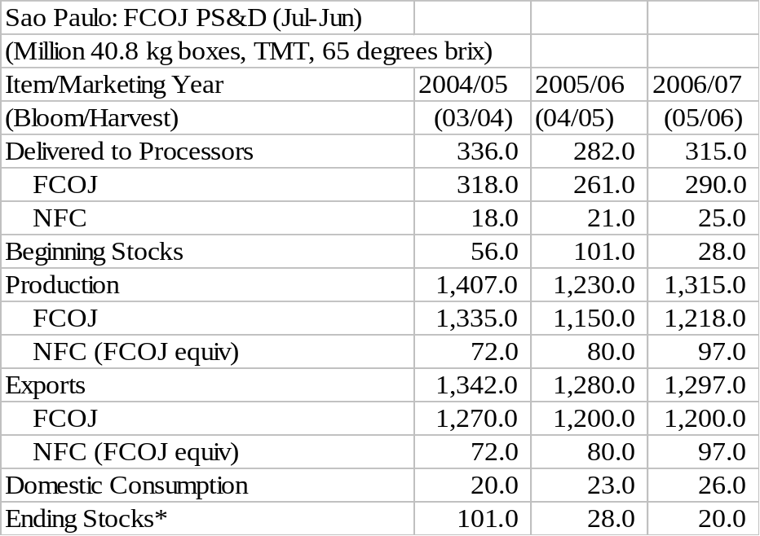

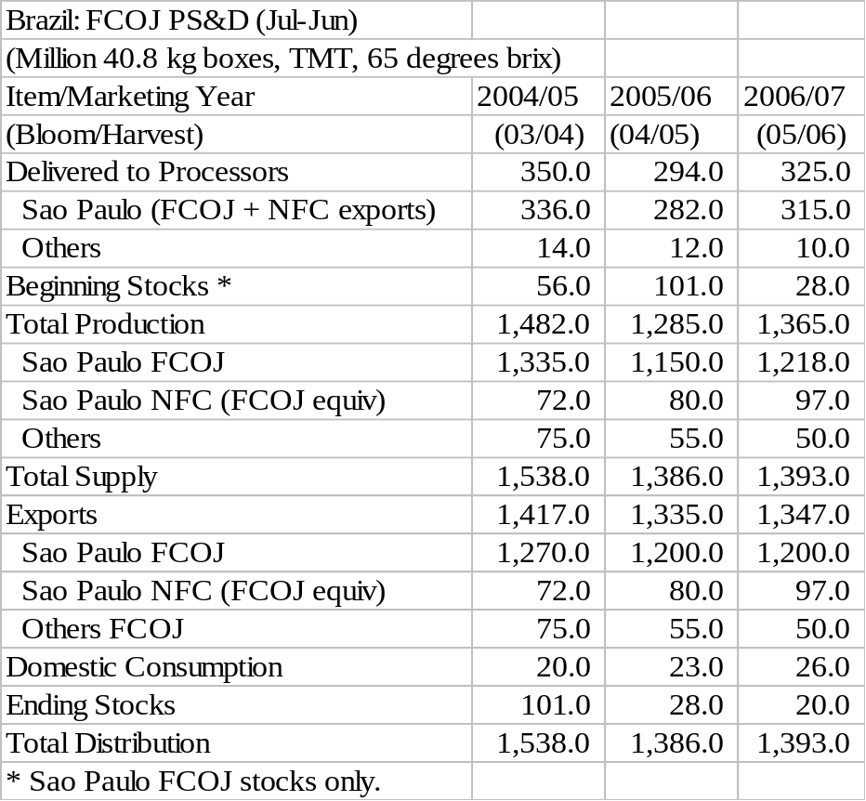

General

Total Brazilian FCOJ 65 Brix equivalent production for MY 2006/07 (July-June) is forecast at 1.365 million metric ton (mmt), up 80,000 mt compared to MY 2005/06 estimate (1.285 mmt), due to the expected higher availability of fruit for crushing. In addition, stocks are reported to be at the lowest level in the past 15 years and the industry will likely crush as much fruit as possible. The Sao Paulo industry should process 314 MBx of oranges for FCOJ and NFC production, yielding 1.315 mmt of juice (1.218 mmt and 92,000 metric tons of FCOJ and NFC, respectively). Other producing states should deliver 10 MBx for processing.

Some processing plants began operations in May, however the crushing pace should jump in late July. The sector is highly concentrated with only five processors: Cutrale, Citrosuco, Citrovita, Louis Dreyfus-Coinbra and Bascitrus.

Consumption

ATO/Sao Paulo’s projection for FCOJ domestic consumption for MY 2006/07 is 26,000 mt (65 Brix), up 3,000 mt from revised figure for MY 2005/06 (23,000 mt). The consumption of fruit juices, including orange juice, has increased steadily in recent years.

Trade

Total Brazilian FCOJ exports for MY 2006/07 is forecast at 1.347 mmt (65 Brix), similar to MY 2005/06 (1.335 mmt), based on expected stable FCOJ consumption in the European Union and in new markets such as China and Eastern Europe.

The Sao Paulo industry should contribute 1.2 mmt of FCOJ (65 Brix) and 97,000 mt of NFC (converted to FCOJ equivalent), whereas other FCOJ producing states should export 50,000 mt. Major destinations include Europe and the U.S. Eastern Europe and China represent the major growth markets for exports. As reported by trade sources, current FCOJ export prices to Europe are reported at US$ 1,700 per metric ton FOB (bulk), compared to US$ 1000 a year ago.

The tables below show official FCOJ exports (NCM 2009.11.00, NCM 2009.12.00 and 2009.19.00) by country of destination for CY 2005, MY 2004/05 and 2005/06 (July-May), according to SECEX. Note that the “Others” category includes both FCOJ and Not From Concentrate (NFC) exports. Post considers the average monthly price by country of destination for the “Others” category as a criterion to distinguish between FCOJ and NFC exports.

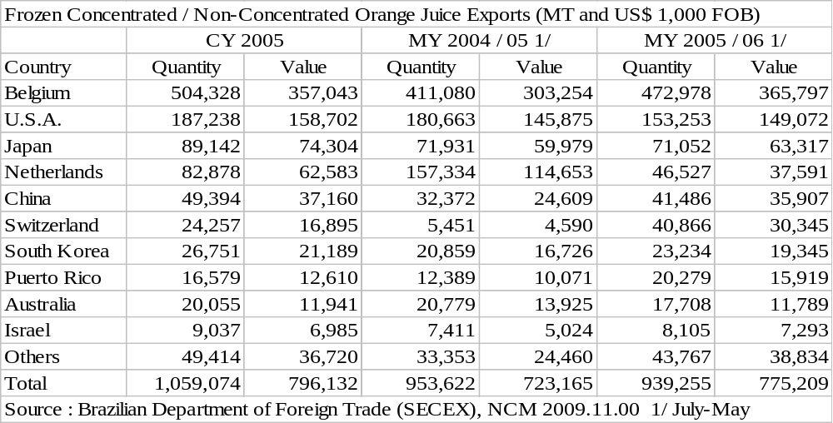

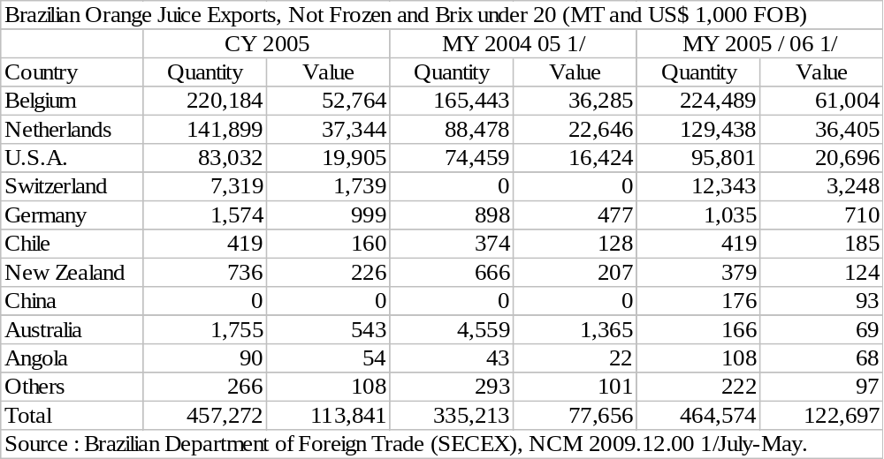

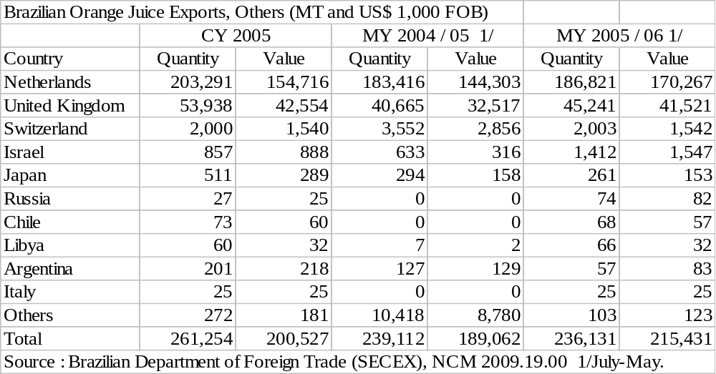

Stocks

ATO/Sao Paulo ending stocks for MY 2006/07 are projected at 20,000 mt (65 Brix), down 8,000 mt in comparison with the revised estimate for MY 2005/06 (28,000 mt). Post contacts report that current stock levels are the lowest in the past 15 years. Actual stocks data is not available.

Policy

In late January 2006, the Secretariat for Economic Defense (SDE) confiscated several documents from orange juice processing plants in a search for evidence of collusion or the possible formation of an industry cartel. This investigation is still underway.

In February 2006, the International Trade Commission’s confirmed provisional anti-dumping duties applied to Brazilian orange juice. These duties range from 9 to 60 percent, depending on the processor. According to the industry, the duties should not decrease orange juice exports to the U.S., due to a shortage in the U.S. supply.

Exchange Rate



