Buenos Dias, Artritis

(Good Morning Arthritis)

~

Guide to Conducting a Health Communication Campaign to

Reduce the Burden of Arthritis in the Hispanic Population

~

Presented by:
Centers for Disease Control and Prevention

September 29, 2006 – September 2011

DEPARTMENT OF HEALTH AND HUMAN SERVICES Public Health Services
Centers for Disease Control and
Prevention (CDC)
Atlanta, GA 30314-3724

Dear Colleague: September 29, 2006

I am pleased to introduce Buenos Dias, Artritis, a campaign to promote physical activity as a method of arthritis self-management for the Spanish-speaking Hispanic population between the ages of 45 and 64.

Research shows that although the prevalence of arthritis among the Hispanic population is less than that experienced by whites, higher proportions of Hispanics report work limitations due to arthritis and severe joint pain.

As you know, physical activity can have an important and beneficial effect on arthritis pain and associated disability. Working together, state arthritis programs and their partners, along with the Centers for Disease Control and Prevention aim to encourage audience members to begin or increase participation in moderate exercise. The campaign promotion materials are designed to:

- Raise awareness of physical activity as a way to manage arthritis pain and increase function
- Increase understanding of how to use physical activity (types and duration) to ease arthritis symptoms and prevent further disability
- Enhance the confidence or belief of persons with arthritis that they can be physically active
- Increase trial of physical activity behaviors

The CDC has developed the information in this package to assist you in disseminating the campaign. From September 2005– January 2006, the materials were pilot tested by five state health departments, and information regarding their experiences has been included to improve your results. You will find the following within the guide:

- Tools to help you plan your campaign, including an audience profile
- Information about placing public service announcements (PSAs) and buying radio airtime or print space
- Specifications and technical information for localizing and reproducing print materials and radio advertisements
- Suggestions for partnering with local Hispanic organizations that can help spread the message
- An abbreviated Implementation Guide to assist your implementation partners
- Compact disks (CDs) containing master copies of radio spots, print creative and both guides

I hope these materials will be useful to you in reaching the Spanish-speaking Hispanic audience with arthritis.

Sincerely,

Teresa J. Brady, Ph.D.
Senior Behavioral Scientist

Arthritis Program
Table of Contents

I. Background and Implementation Information Page

- Campaign Overview and Planning 5
- The Role of Communication and Media Relations Tools 9
- Demographic Information and Media Habits
of the Hispanic Population 10
- Suggested Implementation Timeline 12
- Ensuring PSA and Advertising Placement Effectiveness 13
- Identifying Community Partnerships & Opportunities 17

II. Sample Campaign Materials Page

- Campaign Overview* 27
- Target Audience Profile 30
- Print Creative Materials* 33
- Radio Creative Materials* 56
- Printing and Reproduction Specifications 65

III. Additional Resources Page
68
74
77
79
81
83
87
91
92
96
102
109
112

113
- Appendix A - Implementation Planning Worksheet*
- Appendix B - Sample Pitch Letter for Public Service Director*
- Appendix C - Sample Letter: Response to Public Inquiries*
- Appendix D - Sample Thank You Letter for Post Meeting*
- Appendix E - Sample Thank You Letter after Media Runs PSA*
- Appendix F - Newsletter Article*
- Appendix G - Resources Fact Sheet*
- Appendix H - Tracking Form
- Appendix I - Template Web Site Copy*
- Appendix J - Hispanic Population by Largest U.S. Cities
- Appendix K - Density of Hispanic Population by U.S. City
- Appendix L - Frequently Asked Questions
- Appendix M - Campaign Feedback Form

IV. Step-by-Step Partner Implementation Guide
- This version is for your information only. The entire Step-by-Step Implementation Guide, complete with sample creative and additional resources is contained in the Partner Guide file on Disk 1. You can easily print it, or e-mail it to partners from the Partner Guide file on Disk 1.

*Marked items are available in English and Spanish

Section 1

Background and Implementation Information

Campaign Overview and Planning

The Hispanic population is growing at a rate of 1.7% per year, making them the nation’s largest minority population. In fact, the U.S. population now has more than 39.8 million Hispanics, and by 2050 the Hispanic population will comprise approximately one-quarter of the U.S. population.

Unfortunately, arthritis imposes a serious economic, social and psychological threat to the Hispanic population. In total, 2.6 million Hispanics have arthritis.

According to the February 11, 2005 Morbidity and Mortality Weekly Report (MMWR), although Hispanics have a lower prevalence of doctor-diagnosed arthritis than whites (21.9% versus 15.8%), more Hispanics report severe joint pain, compared to whites (32.5% versus 22.6%). In addition, Hispanic people with arthritis, when compared to white people with arthritis, report similar rates of activity limitation attributable to arthritis (39.7% versus 34.1%) but a higher rate of arthritis attributable work limitations (38.8% vs. 28%).

As you know, physical activity or exercise can have a beneficial effect on arthritis; yet, many within the target population do not engage in moderate exercise as a way to manage their arthritis. Therefore, the goal of this campaign is to encourage the target audience to begin or improve management of their arthritis by beginning or increasing participation in moderate exercise.

NOTE: While the general campaign used the phrase “physical activity,” research conducted for Buenos Dias, Artritis determined that the term “exercise” is more motivating to this target audience.

Objective of this Guide:
This guide was designed to provide the following:
- Background information on target audience and the campaign’s development
- Recommendations and suggestions on implementing the campaign
- Supplemental materials, such as pitch letters, newsletter articles, etc. to help you implement the campaign

Target Audience:
The primary audience for this campaign is lower socio-economic status (SES) segments (income under $35,000) within the Hispanic population, who are Spanish speaking, ages 45-64, with doctor-diagnosed arthritis, or possible arthritis, which threatens to affect valued life roles.

Target Demographic Areas:
This guide is specifically designed for the 36 state health departments that receive Centers for Disease Control and Prevention funding for arthritis and their partners that work with them to implement health communication activities. Other organizations are welcome to use the campaign as well (see Section IV for the Step-by-Step Partner Implementation Guide).

Key Messages From the Campaign:
Overarching messages to be communicated to Hispanic/Latino populations are similar to those of CDC’s general arthritis campaign, launched in 2002:

- Exercise can help persons with arthritis do something themselves to improve their arthritis symptoms.

- Moderate exercise has important and beneficial effects on arthritis pain and associated disability. Studies show that 30 minutes of moderate exercise, at least three days per week can help relieve arthritis pain and stiffness and help persons with arthritis be more active and feel more energetic and positive. The 30 minutes of exercise per day can be done in three 10-minute increments throughout the day.

- Walking, swimming, and biking are particularly good activities for people with arthritis.

Campaign Elements:
The Buenos Dias, Artritis campaign consists of taped radio spots and live-announcer scripts, a brochure and sticker to be placed as a counter top display, and print advertisements including outdoor billboards, bus shelter placards, flyers, bill stuffers, and bookmarks. All radio and print executions can also be used as either a PSA or a paid placement.

To conduct the campaign, it is necessary to use, at a minimum, the following Spanish campaign materials: brochures distributed in community locations, and either the radio spots, bus shelter placards, or outdoor billboards. Print ads, flyers, bill stuffers, and bookmarks are all useful additions to the core campaign elements.

Quick Tip

Above, we mention four different ways to use the print creative provided, including print ad, flyer, bill stuffer, and bookmark. Each of these pieces also can be used as an advertisement or a PSA so, you can also think of it as having four different sizes available to support your campaign goals.

All campaign materials are in Spanish; however, select English translations have been provided to support local clearance requirements, as well as to provide additional options for those situations when you want to supplement the Spanish campaign with a few English placements (as our target audience does consume some English media).

Campaign elements were designed with feedback from you on the Physical Activity. The Arthritis Pain Reliever. campaign. For this reason, you will receive a CD ROM package, as well as find materials posted on the CDC web site at http://www.cdc.gov/arthritis.

Creative materials are provided in both hard copy (within this guide), as well as on CD ROM. The information below outlines the variety of materials provided to support this campaign. Please refer to Section II – Sample Campaign Materials, Printing and Reproduction Specifications.

IMPORTANT NOTE

All radio and print materials may be aired/placed from September 2006 through September 1, 2011. Campaign materials expire after September 1, 2011 making it illegal to use the creative materials after this date.

Print Materials:
- 7 x 10 (print advertising)
- 8.5 x 11 (flyer)
- 5.25 x 3.25 (bill stuffer)
- 2.25 x 6 (bookmark)
- 19’ x 48’ (outdoor billboard)*
- 4’ x 6’ (bus shelter placard)**

There are four different visuals for the first four creative executions listed above, including:
- Couple walking outdoors
- Couple walking indoors (mall)
- Man walking dog
- Group of women walking

*The billboard execution uses two visuals: group of women walking and couple walking outdoors
**The bus shelter placard execution uses only one visual: couple walking outside.

Each of the above is provided in color and black and white versions. The national versions are provided in PDF format. These versions are “locked” and cannot be modified. The national format uses the Arthritis Foundation toll-free number and Spanish web site as the response mechanism. The localizable versions are provided in Quark and can be adapted, by a designer with access to this program, to include a local program logo, as well as a local phone number or web site (you would replace the Arthritis Foundation contact information). In addition, Quark allows each of the creative elements to be re-sized, providing you limitless options in meeting any media outlet’s specifications.

When selecting which visuals to use, it is important to note that testing revealed that the target audience was most attracted to these materials because they were in Spanish, had “arthritis” in the title, and were colorful. You do not need to be concerned if the graphics do not look just like the Hispanic population you are targeting.

Most target audience members did perceive the individuals depicted in the campaign graphics as Hispanic, and like themselves or people they knew. However, the specific appearance of the people depicted did not influence whether or not an individual was attracted to the campaign material. In addition, the type of dog pictured in the graphic of the man walking a dog was irrelevant to the target audience.

Brochure:
A three-panel brochure is provided for distribution in your market. See Identifying Community Partners & Opportunities for ideas on where to distribute your brochures. In addition, a sticker has been designed to use on a brochure holder. There is no specified brochure holder; you select the style that best suits your needs. For example, you can order brochure holders from Screen Art Posters, Inc., 4333 East 10th Lane, Hialeah, FL 33013 (305-681-4641). BRO-HOLD model # A414-112 has worked well in past campaigns.

Quick Tip

Several states found that an effective use of the brochure is in arenas where personal contact with the target audience is possible. For example, the California Arthritis Program distributed brochures to community clinics in Hispanic areas. Uptake of the brochures was high and clinics called to receive additional brochures. Social service centers, local farmers markets, and community events targeting the Hispanic population were also identified as good locations.

The Oklahoma Arthritis Program posted flyers above the brochure rack at community locations to ensure longevity of the campaign messaging if/when the brochure supply became depleted.

Radio Creative:
The following radio creative is provided for your use. Please use the unique code that identifies each spot when working with a radio station.

- :60-second taped radio spot (HART-0560)
- :50/:10-second taped radio spot with ability to add :10 second local tag (HART-0550)
- :30-second taped radio spot (HART-0530)
- :25/:05-second taped radio spot with ability to add :05 second local tag (HART-0525)
- :30-second live announcer script (to be read by on-air personality, not pre-recorded)
- :25/:05-second live announcer script (to be read by on-air personality, not pre-recorded

When to Run Your Campaign:
Besides National Arthritis Month in May, you also may want to keep in mind the following:

- Seasons: Think about activating the campaign at times when campaign messages will be most relevant -- such as spring through fall, when people are most inclined to get active outside
- Timing: Consider other community activities to tag on to and competing activities to avoid
- Special Months: Consider focusing efforts around Hispanic Heritage Month (usually runs September 15 – October 15 of each year) when media outlets already may have promotions planned
- Community Celebration Days: September 15 marks Independence Day for Costa Rica, El Salvador, Guatemala, Honduras, Nicaragua; September 16 is Mexican Independence Day; and El Dia de la Raza is celebrated October 12
- Partner Activities: Try to have your efforts coincide with a partner’s media or event activities

See Identifying Community Partners & Opportunities for ideas on different local organizations to partner with, including Hispanic organizations.

Important Note

Health department or arthritis coalition names and/or logos can be added to the materials. The addition of other logos will require approval of the CDC Technology Transfer Office. This approval can take several months to receive. See Section III – Additional Resources, Appendix L for Frequently Asked Questions.

The Role of Communication and Media Relations Tools

In today’s competitive public service announcement (PSA) world, it isn’t enough to just send a PSA to a media outlet or partner organization and hope for the best. You must consider the entire news angle, convince them of why the issue is important, develop a communication package and strategy, and be prepared to follow up with them.

To garner media attention about the campaign and the issue overall (prevalence of arthritis and disparity within the Hispanic community), consider the following ideas to help strengthen your approach:

- Find a local Spanish-speaking rheumatologist or general practitioner (ideally one who has a large Hispanic patient volume) to act as a spokesperson for the campaign
- Ask a person with arthritis who is Hispanic to hand-deliver the materials to the station with you or for you. This creates a very personal element and allows a member of the target audience to reiterate the importance of the campaign
- Refer to the Appendix to create a full media kit and consider including information such as the most recent MMWR on arthritis (Racial/Ethnic Differences in the Prevalence and Impact of Doctor-Diagnosed Arthritis --- United States, 2002; February 11, 2005), which is a credible resource for the media
- Pitch stories to local radio stations, television stations and newspapers to interview key arthritis experts or run feature stories about the benefits of exercise in managing arthritis
- If you do receive confirmation that a story will run, ask if you can get space/air time to run the campaign creative within or next to the story or air the radio spot immediately after the story runs

Quick Tip

Once a media outlet shows interest in how arthritis affects the Hispanic population, now is the time to also ask if they are willing to place/air the creative for several weeks.

Communication and Media Materials to Support Your Goals:
Within the Appendix, you will find several materials to support your communication and, potentially, your media relations goals. Please refer to Section III – Additional Resources for the following materials:

- Sample Pitch Letter for Public Service Director, Appendix B
- Newsletter Article Template, Appendix F
- Post-Meeting Sample Thank You Letter , Appendix D
- Sample Thank You Letter after Media Runs PSA, Appendix E
- Template Web site copy, Appendix I

Demographic Information and Media Habits of the Hispanic Population

Chart Outlining Population Information for Each City/State:
To assist in targeting efforts within each state, Appendix J provides information on the prevalence of the Hispanic population in major cities in the state. Appendix K lists those cities in the state with the highest percentage of Hispanic population. With limited dollars and time, these may help prioritize which cities to target.

Quick Tip

The Florida and California Arthritis Programs found it helpful to use census data to determine the geographical location of their target audience. The California Arthritis Coordinator recommends that other states do this because the target population was ‘not where I thought they were”. If time and budget permit, you may find it helpful to use census tracts too. Visit http://www.census.gov/ for more information.

Customizing Your Media Materials:
To assist you in customizing your media materials, state-specific estimates can be found at http://www.cdc.gov/arthritis/data_statistics/state_data.htm. Here, you can search for the total number of adults in your state living with arthritis and identify what percentage of the adult population are Hispanic. This information is taken from The Behavioral Risk Factor Surveillance System (BRFSS), a state-based survey of the U.S. population aged 18 years or older.

Media Habits of the Hispanic Population:
The following information provides an overview of media habits for people of Hispanic origin, not necessarily Spanish speaking and not specifically for people with arthritis. The data includes both men and women between the ages of 35-54 and 55+. The research should help you to determine how best to reach out to your target population.

- The older Hispanic population has a variety of media habits that flow back and forth from Spanish to English, so a varied media strategy is best.

- Highest usage of newspapers is by Hispanic males 55+ who are more likely to mix their media exposure between Spanish and English media. Hispanic men in this age group spend the least number of their media hours with radio.

- Hispanic women age 55+ spend more time with media than Caucasian or African American women, and Hispanic females are more partial to Spanish media than are Hispanic men. Hispanic women in this age range spend the majority of their time with television and radio; however, they still maintain a varied media habit switching between English and Spanish.

- Hispanic women between 35-54 spend twice as much time listening to Spanish radio than English radio. This group’s next highest category of information consumption is magazines; they spend the same amount of time with English magazines as they do with Spanish magazines.

- Hispanic men between 35-54 also spend more time with Spanish radio than English. This group’s next highest area of consumption is newspapers, where they spend a little more time with English papers than Spanish papers.

*Synovate: 2004 U.S. Hispanic Market Report

Prioritizing Your Time and Potentially Your Money:
Consider the last two sections above, as well as the demographic information in Appendices J and K, as you consider which cities and which media outlets to place your efforts.

Suggested Implementation Timeline

Below is a suggested timeline and checklist, which shows each step of the campaign implementation process. Because resources vary, we have included a variety of ideas to consider. Please identify and implement the steps that are ideal for your organization.

Month One:
- Print Buenos Dias, Artritis How-To Guide
- Review contents to become familiar with campaign goals, content of the guide, and resources
- Conduct a brainstorming session with your team to determine the best implementation process, local organizations to partner with and ideal timing for your state

Month Two:
- Develop your contact list (public service directors for PSAs; advertising personnel for paid placement; healthcare reporters if you choose to create a larger story with the media)
- Schedule in-person meetings with key PSA Directors or reporters; identify members of the Hispanic population with arthritis to attend meetings with you, a member of one of the organizations you are partnering with or a rheumatologist
- Customize enclosed template media materials for both in-person meetings and mailings (see Section III – Additional Resources for a variety of media outreach materials)
- Determine appropriate distribution method for materials (hard copy, CD ROM, or e-mail)
- Create custom kits for each contact/media outlet
- Distribute kits to media targets (consider personally delivering kits), and/or finalize list of outlets to receive paid placements

Month Three:
- Follow up with media you meet or talk to within 48 hours. If you spoke to someone on the phone or in person, send a follow-up thank you letter (see Section III - Appendix D).
- Follow up with all other contacts, within two weeks, by placing a phone call to assess interest and determine if additional information is needed

Continuous Follow-Up Steps:
- Send thank you letters to all outlets that do run the PSA campaign. Ideally, ask multiple individuals from your organization, partner organizations, and people with arthritis to send a thank you letter to show the depth and breath of your thanks and to encourage the media outlet to continue running the campaign
- Follow up with media who have yet to run the campaign to determine if there are any additional options (select ideal times of the year, such as the following: National Arthritis Month, New Year’s (resolution time), spring, summer or fall (active outdoor seasons), a special event, etc.

Tracking Your Placements:
It’s important not only to garner a placement of your PSA and/or an article, but also to track which outlets, contacts, and target audience you reached (see Section III – Additional Resources, Appendix H for a sample tracking form). Use a separate tracking form for each outlet and if you receive multiple placements, consider attaching a blank chart to continue monitoring the campaign’s progress.

Ensuring PSA and Advertising Placement Effectiveness

The Buenos Dias, Artritis campaign provides both PSAs and advertising options to expand your campaign options. PSAs are used when a media outlet uses your creative free-of-charge, (i.e. you do not pay for the placement). Advertising is when you use this same creative, but pay the media outlet for the placement. There are advantages and challenges to both options. This section will cover both PSA placement methods and suggestions on placing paid advertising.

Effective PSA Placement:
The PSAs the CDC has created as part of its Buenos Dias, Artritis campaign represent a powerful and economical way to raise awareness about arthritis management. To ensure the PSAs are effective in reaching audiences, the PSAs need to make it into the hands of the right people. This is where you can play a critical role -- by meeting or talking to your local public service directors to explain the impact of arthritis on their local audience and the importance of disseminating information on exercise to help reduce pain and related disability among Spanish-speaking Hispanic populations.

The following section outlines actions to help ensure your success when you are not purchasing advertising space.

Creating Your PSA Distribution List:
- Make a list of radio stations, local newspapers, and magazines. Keep in mind your primary audience is Hispanic people between the ages of 45-64. You want to be sure your list includes stations and publications that cater to this audience -- specifically Spanish-language formats. If you are unsure of the listening audience or readership of a certain outlet, check the phone book or the Internet and contact the station to confirm

- Research contact information for public service directors. Most radio stations, as well as print publications and web sites, have a public service director who schedules PSAs. Here again, the Internet is a good starting place. Most radio stations, newspapers, and magazines in your community will have web sites that include contact information. You will want to be sure the names and addresses listed are current, so be sure to call and verify the information. Or check your phone book for main numbers of the outlets, and track down appropriate contacts that way

- Identify non-media outlets. Consider opportunities beyond media to place your PSA. Your print PSA packet includes several formats (advertisement, flyer, bookmark, bus shelter placard, and bill stuffer) that will help you disseminate your message in a variety of ways (see Identifying Community Partnerships & Opportunities section for more ideas and specific details).

Placing Radio PSAs:
Format – Your PSA package includes pre-recorded PSAs and live announcer scripts. Many stations prefer the latter, so their own on-air personalities can read the script themselves, which provides a local feel to the piece. You can copy the scripts and send them to radio stations together with a pitch letter (see Section III – Additional Resources, Appendix B for sample pitch letter). Other stations may prefer to use pre-recorded versions. To reproduce the radio PSAs, take the master CD (included in this packet) to your local CD duplication company. (Simply check your phone book if you are unsure of area vendors who handle this work.) You can also try to make a copy at your computer; however, with large graphic files you may find it easier to outsource. If you would like to localize your radio PSA with information, such as a local 800 number or program name, contact a local recording studio or production house to record the remaining 5-10 seconds.

Quick Tip

Some radio stations will create the local tag for free, especially if they are agreeing
to run one or more of the radio PSAs. Just ask.

Depending on your resources, consider sending both the announcer script and a hard copy of the CD to the public service director. Or you can contact stations in advance and ask which format they prefer. The radio piece also will be available via MP3 format at http://www.cdc.gov/arthritis/.

Timing – Consider timing when distributing your PSAs. Radio stations usually require several weeks’ notice to work a PSA into rotation. Encourage public service directors to play your PSAs when you can reach the largest audience – such as morning and evening drive time.

Placing Print PSAs:
Your package includes four print PSAs. Print PSAs tend to be more difficult to place than radio PSAs due to space limitations and competition from paying advertisers. As with radio, your success will depend largely on your “pitch” to the outlet. Print outlets will be especially interested in local statistics, so be prepared to explain how many readers in your city and state are affected by arthritis.

Format –We have designed the full-page PSA to meet most print publication requirements. The less work the print publication has to do to use your PSA, the more likely they are to use it.

Usage – See Section II – Sample Campaign Materials, Printing and Reproduction Specifications for instructions on how to localize your creative materials.

Timing – As with radio PSAs, print publications typically require two to four weeks notice to put PSAs into rotation, so plan accordingly. Again, look for times of the year when your messages will be most suitable to readers. Conduct background research to identify any annual issues or promotions that may be appropriate, such as arthritis, physical activity or Hispanic health.

Quick Tip

All pilot states used local partners to help determine which media outlets were most likely to reach the target audience. Several states found that the local partners were also more successful in getting PSAs placed.

Paid Placement of Your Creative
The print and radio creative in your packet also can be used for paid advertising, if your budget allows. (Remember: advertising is when you pay for placement and is therefore not considered a PSA although your creative is the same.)

The advantage to paying for your ads to be placed is guaranteed dissemination of your message -- you know your ads will air on the radio station or appear in your local print publication. Also, you have control over when the creative is placed or aired. You pay for a specific time slot, a specific day, and you determine how often it will run. All this is based on the advertising contract you negotiate with the media outlet. The following are a few things to consider when purchasing advertising.
Purchasing Air Time/Radio:
Make sure your ad reaches who you want when you want. As discussed previously in this section, you will want to consider print publications and radio stations that cater to your target audience, in this case, Spanish-speaking individuals of Hispanic descent. With radio, consider buying spots during peak times, if your budget allows. Be sure to ask the station’s advertising sales representative you are working with for a listener report. This data can tell you how many people listen during which windows of time, the average age of those listeners, gender, and race.

Quick Tip

Both Florida and Oklahoma’s Arthritis Programs used a media buyer, which they found helpful in selecting media outlets and in negotiating a better advertising rate. Oklahoma specified that the media buyer needed experience in placing Spanish language ads
in the Request for Proposals.

The California Arthritis Program used its local partner, a non-profit organization, to place ads, and the partner was able to obtain the non-profit advertising rates.

Purchasing Space/Print:
When talking with your advertising sales representative, be sure to ask for a media kit, outlining audience demographics for your consideration. You want to know the following: Who reads this publication (age, gender, race/ethnicity)? Which day is the paper is most highly read (often Sundays)? Which sections are highly read? Do they provide links to articles on the outlet’s web site?

How to Work Within Your Budget
As discussed above, advertising costs vary depending upon time of day the ad is aired or location within a publication, from the more expensive (upper right corner of the front section of the paper) to less expensive (bottom left corner of the local section). To ensure you get the most leverage for your ad buy, consider the following tips:

- Repeat your message again and again…and again. A significant advantage to purchasing advertising space for these spots is the ability to run your message several times. Research shows that the more a message is heard or viewed, the greater likelihood it will prompt a person to act. If budget allows, arrange to have the ads aired or placed frequently

- Maximize your ad buy. Radio and print outlets offer packaged advertising buys, which means you purchase a number of commercial spots for use at different times throughout the year. For instance, you may want to have an ad placed every month, or every quarter. The per-ad charge is typically lower than if you were to purchase the ad space one spot at a time. Or if you prefer not to have your ads run on a continuous basis, but do plan to run your ad more than once, negotiate with your sales representative to buy the spots up front. This again will likely reduce your per-ad cost
- Maximize your message. In addition to purchasing the “best” placement spot (time, placement on page), and considering how you can bundle your buy to maximize your budget, it’s also important to consider how your buy can maximize your message. If you spread out your message too much, especially when purchasing radio time, you are less likely to break through the clutter and motivate people to action. For example, it’s better to run your ad four times a day for two weeks than one time a day for 56 weeks. The goal is to achieve as much “saturation” as possible

- Ask for added value. Depending on your media market, once you purchase space the radio stations and/or publications you are working with may be willing to throw in complimentary, or discounted, ad space. Be proactive in this regard and have an “ask” in mind when you go in to negotiate. For instance, ask them to match every two paid spots you purchase with one free airing. Or ask them for a weather or traffic sponsorship, which ends with a “brought to you by” tag that includes the 800 number or web site

Quick Tip

Be aware that you diminish your chances of receiving free PSA placement if you have previously purchased advertising space.

- Be flexible. If your campaign allows some flexibility, tell radio stations and publications that you are willing to have your spots run in place of ads cancelled at the last minute. This option may mean you do not get your targeted airtime or position in the daily paper, but it is guaranteed placement nonetheless and is worth considering

- Don’t forget about the brochures. Remember that the brochures and brochure holder are also a vital part of the Buenos Dias, Artritis campaign. When developing your budget, look for places to distribute your brochure where Hispanic populations already frequent (See the section on Identifying Community Opportunities and Partnerships for ideas)

Quick Tip

When negotiating your buy or placements with a media outlet, consider what types of existing activities they many already be doing, such as health screenings. Ask if your partner would be willing to distribute your brochures or flyers at their events.

Identifying Community Partnerships & Opportunities

Often, health campaigns like Buenos Dias, Artritis are conducted with the support of organizations that already have relationships with your target audience. It has been shown that grassroots activities (efforts spearheaded by local and community organizations) can greatly influence the success of health promotion campaigns. National Hispanic organizations that focus on health and wellbeing are in great positions to help deliver health promotion messages. In addition to traditional methods of earned and paid media, reaching out to your local organizations can be valuable. To this end, a Partner Guide has been developed to support your implementation efforts (see Section IV – Step-by-Step Partner Implementation Guide).

We believe that partnering with Hispanic organizations in your area will help you carry out the goals of this campaign. In the list below, organizations that serve the healthcare community are grouped together as are those that focus on consumers. We provided national organizations that have local affiliates; however, local organizations with no national affiliation are also great partners to help disseminate the message. We have also provided you with information on beginning your partnerships, identifying community outlets, and working with potential health partners. We hope the following information will aid you in identifying and creating a number of partnerships.

National Organizations with Local Affiliates:
The following information provides a list of national organizations that offer local divisions in communities across the U.S.

Hispanic Provider Organizations:

Institute for Hispanic Health (IHH)
The National Council of La Raza’s (NCLR) Institute for Hispanic Health (IHH) works in close partnerships with NCLR affiliates, government partners, private funders, and other Hispanic-serving organizations to deliver quality health interventions. These interventions focus on improvement of, access to, and utilization of quality health promotion and disease prevention programs.

Telephone: 202-785-1670
Web site: www.nclr.org

National Alliance for Hispanic Health (Alliance)
The National Alliance for Hispanic Health is the oldest and largest network of Hispanic health and human service providers. Alliance members include community-based, government, provider, and national organizations as well as universities and private citizens.

Telephone: 202-387-5000
Web site: www.hipsanichealth.org

National Association of Hispanic Nurses (NAHN)
The National Association of Hispanic Nurses (NAHN) is a network of more than 40,000 Hispanic nurses organized in 31 local chapter affiliates. The mission of NAHN is to encourage Hispanic nurses to improve the health of their communities.

Telephone: 202-387-2477
Web site: www.thehispanicnurses.org

National Hispanic Medical Association (NHMA)
The National Hispanic Medical Association (NMHA) is a non-profit association representing 36,000 licensed Hispanic physicians in the U.S. The mission of the organization is to improve the health of Hispanics and other underserved populations.

Telephone: 202-628-5895
Web site: www.nhmamd.org

Consumer Hispanic Organizations:

League of United Latin American Citizens (LULAC)
The League of United Latin American Citizens (LULAC) serves to advance the economic condition, educational attainment, political influence, and health and civil rights of Hispanics living in the U.S. With approximately 115,000 members and 600 councils nationwide, LULAC is the largest Hispanic organization in the U.S.

Telephone: 202-833-6130
Web site: www.lulac.org

MANA, a National Latina Organization
MANA is a non-profit advocacy organization whose mission is to empower Latinas through leadership development and community action. MANA’s vision is a national community of informed Latina activists working together to create a better quality of life for all Hispanics in the U.S.

Telephone: 202-833-0060
Web site: www.hermana.org

National Council of La Raza (NCLR)
The National Council of La Raza (NCLR) is a non-profit, non-partisan organization established in 1968 to reduce poverty and discrimination and to improve life opportunities for Hispanic Americans. NCLR is the nation’s largest constituency-based Hispanic organization, serving all Hispanic nationality groups through a formal network of affiliates.

Telephone: 202-785-1670
Web site: www.nclr.org

National Hispanic Council on Aging (NHCOA)
The National Hispanic Council on Aging (NHCOA) was established in 1979 as an advocacy organization with the primary purpose of improving the quality of life for Latino elderly, families, and communities. NHCOA addresses issues of health disparities, economic security, abuse, and victimization of the elderly and their families, and builds affordable housing for the elderly.

Telephone: 202-265-1288
Web site: www.nhcoa.org

Beginning Your Partnership:
Here are some action steps you can take to begin developing partnerships with organization like those listed above.

- Identify an organization of interest from the list and visit its web site. Research the organization to find out whether it has an affiliate or chapter in your area

- Get local area contact information, which should include telephone number, fax number, e-mail address, and key officers or board members

- Contact the organization and identify the appropriate contact person, ideally someone in their marketing, partnership or education department

- Introduce yourself, the Buenos Dias, Artritis campaign, and your agency or department. Let the organization know that you can e-mail or fax (whichever is preferred) more detailed information on the campaign (see Section IV - Step-by-Step Partner Implementation Guide) and the role that organization can play. In addition, encourage them to visit your web site to learn more about your organization. Be sure to leave your contact information if they have any questions in the meantime

NOTE: The complete Step-By-Step Partner Implementation Guide with sample creative and relevant appendices can be easily printed out or e-mailed to partners by using the Partner Guide file on Disk 1.

- Follow up by phone and e-mail to confirm your contact received the information and to set up a call to further discuss the organization’s participation. If you are able, set up an in-person meeting to discuss participation specifics

- Always be available to answer any questions and/or provide any documents regarding Buenos Dias, Artritis

Ideas for Partnering with Area Organizations:
While many organizations interested in Buenos Dias, Artritis may have their own ideas regarding partnership, you should have a list of potential opportunities. Below are a few ideas you can offer to organizations.

- Display a link to Buenos Dias, Artritis on organization’s web site
- Feature the campaign in organization’s newsletter
- Display campaign materials at members’ places of employment (e.g. lunch or break rooms, locker rooms, etc.), or physicians and nurses can display information in the waiting room areas of their offices and clinics
- Utilize established networks to help in driving the campaign’s message (e.g., area churches, placement of print or radio spots at known media outlets, etc.)
- Conduct community seminars or presentations on arthritis

Quick Tip

All pilot states found their local partners’ expertise and knowledge about the community and target audience to be essential for effective implementation of the campaign. It is important to identify an agency with strong ties to the Hispanic community. For Example: the New York Arthritis Program partnered with a Hispanic Community Service agency; the Wisconsin Arthritis Program partnered with a Latino health organization.

Before speaking to these organizations, think through what the benefitswill be to them if they in this campaign. The benefits need to support both organizations’ goals. Remember that no organization has lots of free time or money, so be ready to sell how your campaign can help them achieve their goals. Also, plan to give partner organizations sufficient time to prepare and coordinate resources. Allowing partner organizations adequate time is essential in order to have all existing resources available to you. In addition, don’t forget to use the Partner Guide (see Section IV - Step-by-Step Partner Implementation Guide) to educate and empower your partners to successfully help you implement the campaign.

Ideas for Partnering with Area Organizations
While many organizations interested in Buenos Dias, Artritis may have their own ideas regarding partnership, you should have a list of potential opportunities. Below are a few ideas you can offer to organizations.

- Display a link to Buenos Dias, Artritis on the organization’s Web site.
- Feature the campaign in the organization’s newsletter.
- Display campaign materials at members’ places of employment (e.g., lunch or break rooms, locker rooms, etc.), or physicians and nurses can display information in the waiting room areas of their offices and clinics.
- Utilize established networks to help in driving the campaign’s message (e.g., area churches, placement of print or radio spots at known media outlets).
- Conduct community seminars or presentations on arthritis

Identifying Community Outlets:
The ideas recommended below will serve as a guide to assist you in reaching out to a key audience -- the local community. You can rely on the relationships you have already established with many local organizations, in addition to forging new relationships with local groups you may not have considered partnering with in the past. Here are some examples of how you can work within your area to help support the campaign and potentially reduce the burden of arthritis among the Hispanic population.

Spanish/Hispanic Grocery Stores
Grocery stores are an ideal place to post flyers for customers to view as they wait in line. They also are a great place to leave brochure displays and bookmarks for customers to pick up as they shop. Contact local grocery store managers for permission to post campaign materials, such as print PSAs, flyers or posters. Also, check with the manager to see if store clerks would be allowed to insert brochures into grocery bags -- even if it’s just during a special promotional month. This would provide an additional chance to reach customers who may have overlooked the Buenos Dias, Artritis campaign materials in the store.

Spanish/Hispanic Restaurants
Popular restaurants, such as taquerias are a great place to reach our target audience. Often, your favorite local spot is more flexible and easier to work with – so consider that as a starting point. Call local restaurant owners or managers to see if they would be interested in displaying campaign materials in their restaurants. Ask the owner or manager to display the poster and/or brochures in the waiting area and/or restrooms. Posters and brochures, which patrons may have observed in the waiting area, could become a topic for discussion at the dinner table. Or, if patrons were to spot brochures on their way out of the restaurant, they would be likely to pick up brochures to share with family or friends who may have arthritis.

Video Stores
Video stores are an ideal venue to place campaign materials due to the high-traffic customer volume. Take advantage of this excellent way to reach individuals as well as small and large groups of people, such as family and friends, who typically spend a substantial amount of time visiting video stores and browsing through the store aisles. Ask local video storeowners and managers to discuss opportunities to display the Buenos Dias, Artritis campaign materials in their stores. Supply them with posters, brochures, and bookmarks, which they can either leave on display or include in shopping bags along with customer rentals.

Beauty Shops/Barbershops
Local beauty shops or barbershops are another excellent location to display campaign materials; particularly those shops where you can reach adults between 45-64 years of age who are considered the primary audience for this program. When customers visit beauty shops, they typically spend a large part of their time sitting and waiting for their appointment with a hairstylist to begin. Providing the Buenos Dias, Artritis campaign reading materials, in addition to the usual beauty shop magazines and newspapers would be an effective way to engage customers in reading these informative brochures and would result in expanding the reach of the campaign messages. Also, keep in mind beauty shops give you the opportunity to reach families who frequently take trips to the beauty shop together. Imagine if a mother and daughter visiting a shop were to spot brochures discussing the benefits of exercise for managing arthritis. They would be very likely to share any information and brochures with their family members who may have arthritis.
Contact shop managers and owners in your area to discuss opportunities to provide the establishment with the Buenos Dias, Artritis campaign materials, such as a full page PSA or flyers. This would provide an opportunity to educate clients as they come into the shop. Again, including flyers and bookmarks in shopping bags would also be beneficial ways to spread the message.

Libraries
Contact your local librarian or person in charge of community outreach and ask if you can provide the library with campaign materials. Local libraries are a leading source of free educational information. For instance, many libraries offer senior citizens complimentary tax assistance. There also are community rooms where a variety of information, including public health messages, can be displayed. These community rooms are a key spot to place brochures, bookmarks, and flyers.

Churches
Communicating through churches also will be very useful, given the strong faith-based ties within Hispanic communities. Consider working with church administrators to incorporate the brochures, PSAs, and overall campaign messages into any communications channels they have. Options to consider include:
- Mentioning the campaign in church bulletins, newsletters or on web sites
- Posting print PSAs on bulletin boards, as bulletin inserts or in pews
- Offering exercise sessions for older adults in the church hall, hosted by a member of your team or a parishioner with appropriate credentials

Active Adult Centers
Active adult centers cater to the 50+ crowd and are ideal for reaching our target age group. These centers increasingly focus on physical activity; therefore, they should be instrumental in partnering with a campaign aimed at improving quality of life through promoting exercise.

Ask directors of local centers to display and provide Hispanic arthritis campaign materials, such as flyers, bookmarks, and brochures in their facilities. This can be an effective way of reaching members of the key audience who share particular interests or concerns, e.g. exercising and spending time with friends.
Quick Tip

The New York program printed the bookmark graphic on coffee mugs and then handed them out with brochures after Sunday church services.

The Wisconsin program partnered with a Hispanic grocery to put bookmarks in all the grocery bags, and with a temporary agency worker that included bill stuffers in weekly paychecks.

The Oklahoma program partnered with the state Medicaid agency to post web information on their web site (see Section III – Additional Resources, Appendix I for web page template).

Other Community Outlets
Other community outlets to consider where you may successfully reach your target audience include:

- Coin laundry mats
- Nail shops
- Pawn shops
- General stores, i.e. Dollar General, Wal-Mart
- Hardware stores and do-it-yourself stores, i.e. Home Depot, Lowes
- Convenience stores
- Auto parts stores
- Movie theaters (especially those featuring Spanish-language movies)
- Shopping malls (or strip malls which house Spanish clothing stores, convenience stores, banks, check-cashing locations, etc.)
- Bingo halls/bridge club meetings
- Bowling alleys
- Check-cashing locations (stand alone)
- Local recreation centers such as YMCAs and YWCAs
- Chambers of Commerce, who can provide access to businesses interested in providing a program for employees
- Walking groups, such as those that congregate daily or weekly in shopping malls or at community centers
- Hispanic bookstores
- Hispanic gift shops

Working with Community Health Partners:
Health care providers have the most direct contact with people living with arthritis and can be among the most effective influencers. Informing providers and others in the health care arena about the Buenos Dias, Artritis campaign serves as a reminder for providers to engage in dialogue with their patients about the importance of exercise in managing arthritis.

Conducting a Health Briefing:
The Buenos Dias, Artritis campaign is an opportunity to bring members of the health care community together to seek opportunities for collaboration. Many providers may be aware of the high prevalence, but some may not, or may not realize the scope locally. Talk with healthcare providers about offering campaign materials to help raise awareness about the benefits of exercise to improve quality of life. These professionals may also have suggestions on how you can further spread the campaign’s messages within the community.

Following are a few suggestions to help get your health briefing underway.

- Determine which providers will be interested. Arthritis manifests itself in a variety of ways and as a result is relevant to a variety of providers, including gerontologists, primary care physicians, nurses, exercise physiologists, pain management specialists, and internists. You likely have relationships with specialists in many of these areas, so start with those people you know. You may want to brief groups separately to address questions specific to each specialty versus one comprehensive briefing
- Contact local chapters of professional societies. Groups such as the American Academy of Family Physicians, the American Society for Pain Management, AARP, and others are a good place to start. Check their web sites for local chapter/affiliate contact information and inquire about being placed on the agenda of an upcoming monthly or quarterly membership meeting. Incorporating your briefing into an existing meeting will significantly minimize legwork and costs for you. You also may want to see about purchasing the chapter mailing lists to issue invitations
- Provide compelling information. As with your media outreach, having local data plus a physician and/or patient on hand will be valuable when addressing healthcare groups. Also think of specific “asks” where groups can help you spread the campaign’s message. As budget allows, you may want to provide a take-away packet that includes background on the campaign, high resolution, camera-ready copies of the print ad, and CD copies of the radio spots. The easier you can make it for provider groups to share your information, the more likely they are to help out

Potential Health Partners:

Pharmacies
Pharmacies are natural partners in reaching people with arthritis. Many people visit pharmacies on a regular basis, regardless of whether they use prescription medication. They look to pharmacists as trusted sources of health information, and there are often lines and waiting time at pharmacy counters, which gives customers the opportunity to read through informative brochures. Speak with the storeowner, manager, or pharmacist about displaying campaign materials. Make sure flyers, bookmarks, and brochures are available to customers at the pharmacy counter or in another convenient spot. NOTE: chain pharmacies may require approval from their regional office, so allow plenty of lead time.

Hospitals, Urgent Care Facilities and Physician’s Offices
Ask local hospitals, urgent care facilities, or physician offices to display campaign materials in waiting rooms. The offices of general practitioners, orthopedic specialists, and rheumatologists may be good places to start. Many university hospitals have arthritis centers. Talk to the education director and ask him/her to incorporate campaign materials in a presentation or seminar on arthritis.

Quick Tip

It is important to remember that the best way to start implementing the Buenos Dias, Arthritis campaign materials in your community is to begin by utilizing the relationships you currently have. If you don’t have relationships now, that’s OK. Begin by considering organizations that are already in touch with your target audience. Keep your eyes open for other local organizations or venues off-the-beaten- path that may be useful.

Section II

Sample Creative Material

Buenos Dias, Artritis

Campaign Overview
Background:
Research shows that although the prevalence of arthritis within the Hispanic population is less than that experienced by whites, a higher proportion of Hispanics report work limitations due to arthritis and severe joint pain. Unfortunately, research also indicates that many in this population are not aware of the important and beneficial effects of regular moderate exercise on arthritis pain and associated disability.

Objective:
The Buenos Dias, Artritis campaign is designed to:
- Raise awareness of exercise as a way to manage arthritis pain and increase mobility
- Increase understanding of how to use exercise (which types and for how long/duration) to ease arthritis symptoms and prevent further disability
- Enhance the confidence or belief of persons with arthritis that they can engage in moderate exercise
- Increase trial of moderate exercise behaviors

Target Audience:
The primary audience for this campaign is lower socio-economic segments (income under $35,000) within the Hispanic population, who are Spanish speaking, ages 45-64, with doctor-diagnosed arthritis, or possible arthritis, which threatens to affect valued life roles (such as caring for their family, maintaining their job or conducting activities of daily living).

Key Messages From the Campaign:
- Exercise can help persons with arthritis do something themselves to improve their arthritis symptoms
- Moderate exercise has important and beneficial effects on arthritis pain and associated disability. Studies show that 30 minutes of moderate exercise, at least three days per week, can help relieve arthritis pain and stiffness, and help persons with arthritis be more active and feel more energetic and positive. The 30 minutes of exercise per day can be done in three 10-minute increments throughout the day
- Walking, swimming, and biking are particularly good activities for people with arthritis

Campaign Materials:

Print Materials: 7 x 10 (for print advertising); 8.5 x 11 (for flyers); 5.25 x 3.25 (for use as a bill stuffer); 2.25 x 6 (for use as a bookmark); Outdoor billboard template; Bus shelter placard template; and Brochure (and sticker to place on a brochure holder)

Radio: 30-second taped radio spot; 60-second taped radio spot; 50-second taped radio spot with ability to add local tag; 25-second taped radio spot with ability to add local tag; 30-second live announcer script

Contact Information:
[YOUR NAME]
[YOUR ORGANIZATION]
[PHONE NUMBER/[E-MAIL]
Buenos Días, Artritis
Información general sobre la campaña
Antecedentes:
Las investigaciones indican que a pesar de que la prevalencia de la artritis entre la población hispana es inferior a la que experimenta la población caucásica, una proporción mayor de hispanos divulgan las limitaciones del trabajo debido a la arthritis y al dolor articular grave. Desdichadamente, las investigaciones indican que muchas personas de esta población desconocen la importancia y los beneficios del ejercicio regular para la artritis y las discapacidades asociadas.

Objetivo:
La campaña Buenos Días, Artritis ha sido diseñada para:
- Informar a la población sobre los beneficios de la actividad física como una forma de controlar el dolor artrítico y de aumentar la movilidad.
- Lograr una mayor comprensión sobre cómo se debe usar el ejercicio (qué tipos y durante cuánto tiempo o con qué duración) para aliviar los síntomas de la artritis y prevenir otras discapacidades.
- Aumentar la confianza o la creencia de las personas que padecen de artritis para que puedan realizar ejercicios moderados.
- Aumentar los intentos de práctica de ejercicios moderados.

Audiencia objetivo:
La audiencia primaria de esta campaña está compuesta por los sectores socioeconómicos más bajos (ingresos inferiores a $35,000) dentro de la población hispana, de habla española, de entre 45 y 64 años de edad, con diagnóstico comprobado, o probable, de artritis realizado por un médico, que amenaza afectar los roles valorados de la vida (tales como la atención de su familia, el mantenimiento del trabajo o la realización de las actividades cotidianas).

Mensajes claves de la campaña:
- El ejercicio puede ayudar a las personas con artritis a hacer algo para mejorar los síntomas de la enfermedad.
- El ejercicio moderado tiene efectos importantes y beneficiosos sobre el dolor artrítico y las discapacidades asociadas. Los estudios indican que 30 minutos de ejercicio moderado, por lo menos tres veces por semana, pueden ayudar a aliviar los dolores artríticos y la rigidez además de ayudar a las personas con artritis a mantenerse más activas y sentirse optimistas y con más energía. Los 30 minutos de ejercicio por día se pueden realizar en tres incrementos de 10 minutos a lo largo del día.
- Caminar, nadar y andar en bicicleta son actividades particularmente buenas para las personas que padecen de artritis.

Materiales de la campaña:

Materiales impresos: 7 x 10 (para publicidad impresa), 8.5 x 11 (para volantes), 5.25 x 3.25 (para usar como relleno de carteles), 2.25 x 6 (para usar como señalador de libros), modelo de cartelera exterior, modelo para los carteles de los ómnibus y folleto (y una etiqueta para colocar en el porta folletos)

Radio: espacio de grabación de radio de 30 segundos; espacio de grabación de radio de 60 segundos; espacio de grabación de radio de 50 segundos preparado para agregar un comercial local; espacio de grabación de radio de 25 segundos preparado para agregar un comercial local y guión del anunciador en vivo de 30 segundos.

Información de contacto:
[SU NOMBRE]
[SU ORGANIZACIÓN]
[NÚMERO TELEFÓNICO/[DIRECCIÓN DE CORREO ELECTRÓNICO]
Target Audience Profile

The Buenos Dias, Artritis campaign is designed to reach Spanish-speaking Hispanics with arthritis between the ages of 45-64, with an annual household income of $35,000 or less. This campaign is targeted primarily to persons within this audience whose symptoms have advanced to the point that arthritis is perceived as interfering with one or more life activities, such as work or family obligations.

In order to reach this group through the most appropriate channels, research data was analyzed from multiple sources, including the following:

- Literature review of Hispanics’ attitudes, behaviors and beliefs regarding arthritis, exercise and physical activity
- Environmental scan
- Focus groups
- Key informant interviews

The data provided the following insights about the audience:

Hispanics’ General Knowledge and Beliefs About Arthritis:
- Because many Hispanics work under physically demanding conditions, there is a widely held belief that arthritis is the result of the work they do
- Many are aware of the connection between arthritis and particular behaviors, such as lack of exercise, obesity, and dietary habits

Hispanics’ General Knowledge and Beliefs About Physical Activity and Exercise:
- Although most believe physical activity and exercise play a positive role in managing arthritis, there is an expressed lack of knowledge regarding specific types of activities that will help. There is also an importance placed on being able to rationalize behaviors with concrete outcomes—they want to know that exercising my knee this way will help take this pain away
- Hispanics who are actively engaged in physical activity and exercise for their arthritis believe it is a good alternative to taking medications

Areas of Misinformation/Lack of Information:
- Some Hispanics believe arthritis comes from working with their bodies; therefore, they are skeptical that doing more exercise or physical activity will help

Attitudes About Arthritis:
- Many Hispanics accept arthritis as a part of life
- Many discussed coping mentally and spiritually with arthritis as an important part of addressing more subtle aspects of the disease, such as depression and feelings of helplessness
- Many spoke of their faith in God and the strength they find in that faith to cope with the arthritis. For some, acknowledging that they have little or no control over the disease has caused them to turn to their faith even more for comfort and support

Attitudes About Physical Activity and Exercise:
- Hispanics make distinctions between exercise and physical activity according to the intent behind the activity. For example, while exercise connotes an activity solely with the purpose of exercise, physical activity can be a routine activity that may be physically strenuous but is not intended for exercise
- Negative aspects of physical activity and exercise are that it can be high-impact, can lead to injury if done incorrectly or increase intensity of the pain from arthritis
- There are several barriers to increased physical activity and exercise:
  - Lack of information on how to do physical activity or exercise, or what specific exercises do
  - Lack of time to set aside for physical activity/exercise
  - Lack of energy or motivation to be active after working all day
  - Experience of pain that prevents certain physical activities and exercises
  - Lack of resources to support physical activity and exercises

Some Insights Specific to Hispanic Women:
- Arthritis causes fear and worry that they will not be able to work and take care of their families in the future. They are afraid they will not be able to perform family duties
- Many describe becoming depressed because of their arthritis. They are embarrassed and in some cases, ashamed by the limitations arthritis imposes upon them
- Women do not like to take arthritis medicine because of its powerful side effects; they would rather endure the pain than suffer the effects of such strong medicine
- Most women believe they should watch their diets, lose weight, and exercise more to better manage their arthritis. Most reported walking to be a fairly regular routine for feeling better

Some Insights Specific to Hispanic Men
- Hispanic men talk about pain as something they just have to endure without complaining. Men report that they won’t complain or go to the doctor until they are “practically dying”
- Many men experience difficulties with their work due to arthritis. Some have had to change their jobs or learn new skills to compensate for their limitations. Anger, shame, and frustration are some of the common responses to the activity limitations caused by arthritis
- Additionally, men are distressed by the limitations arthritis can put on their family lives, including their love lives. They also are afraid they will not be able to provide for their families

Physicians’ Knowledge, Attitudes, Beliefs and Behaviors
- Physicians acknowledge arthritis as a major problem for Hispanics. They also believe that arthritis is a part of a more complex problem, stemming from the co-morbid occurrence of other conditions, such as obesity, diabetes, heart disease, and depression
- Physicians rarely see Hispanic patients about their arthritis, although when they do, it tends to already have become a major health problem
- Arthritis is a lower health priority to Hispanic physicians and patients alike than other conditions
- Physicians commented that Hispanic patients are resigned to the feeling that their arthritis is beyond their control
- Physicians commented that an important part of getting patients to actively manage their arthritis by making behavioral changes is to shift Hispanic/Latino attitudes from the belief arthritis can be cured with medications. They need to understand that arthritis is a “chronic” disease that can be “managed” and “controlled,” physicians stated

Print Creative Materials

~

Print Advertising (7 x 10)
All four versions in English and Spanish

Flyer (8.5 x 11)
One example each, English and Spanish

Bill Stuffer (5.25 x 3.25)
One example each, English and Spanish

Bookmark (2.25 x 6)

One example each, English and Spanish

Outdoor Billboard (19’ x 48’)
One example each, English and Spanish

Bus Shelter Placard (4’ x 6’)
One example each, English and Spanish

Brochure (8.5 x 11)
Spanish version; English text

Sticker (4 x 3)
One example each, English and Spanish

~

*The following creative is for viewing only.
Please use materials provided on DVD/CD to implement creative.
Print Advertisement

7 x 10

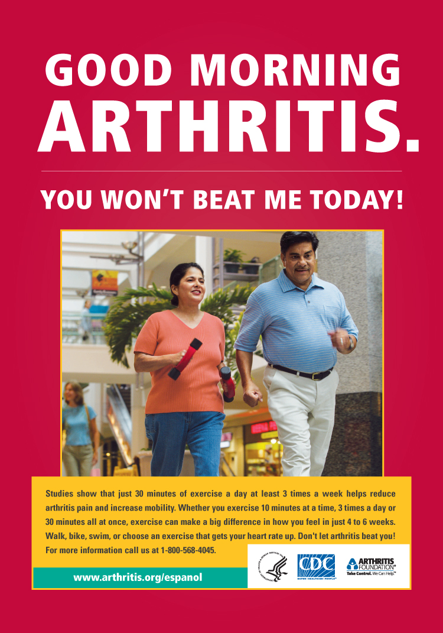

SAMPLE CREATIVE. FOR VIEWING ONLY.

Print Advertisement

7 x 10

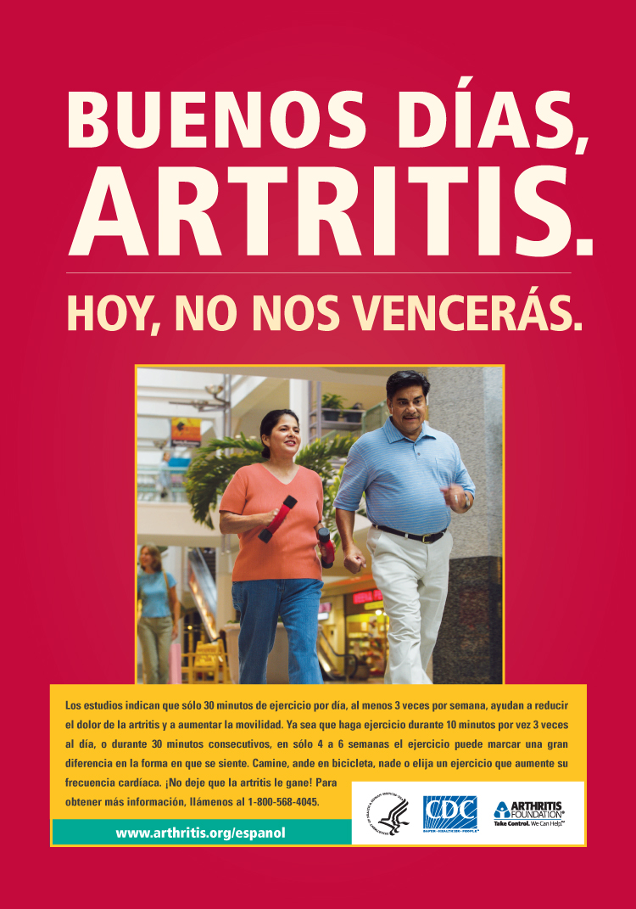

SAMPLE CREATIVE. FOR VIEWING ONLY.

Print Advertisement

7 x 10

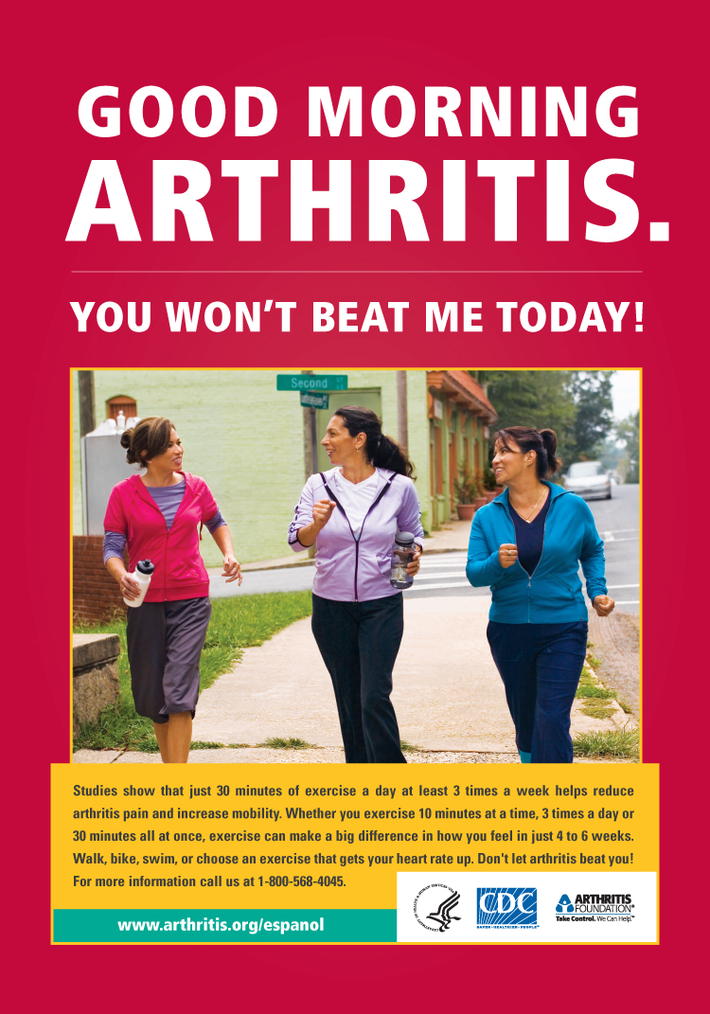

SAMPLE CREATIVE. FOR VIEWING ONLY.
Print Advertisement

7 x 10

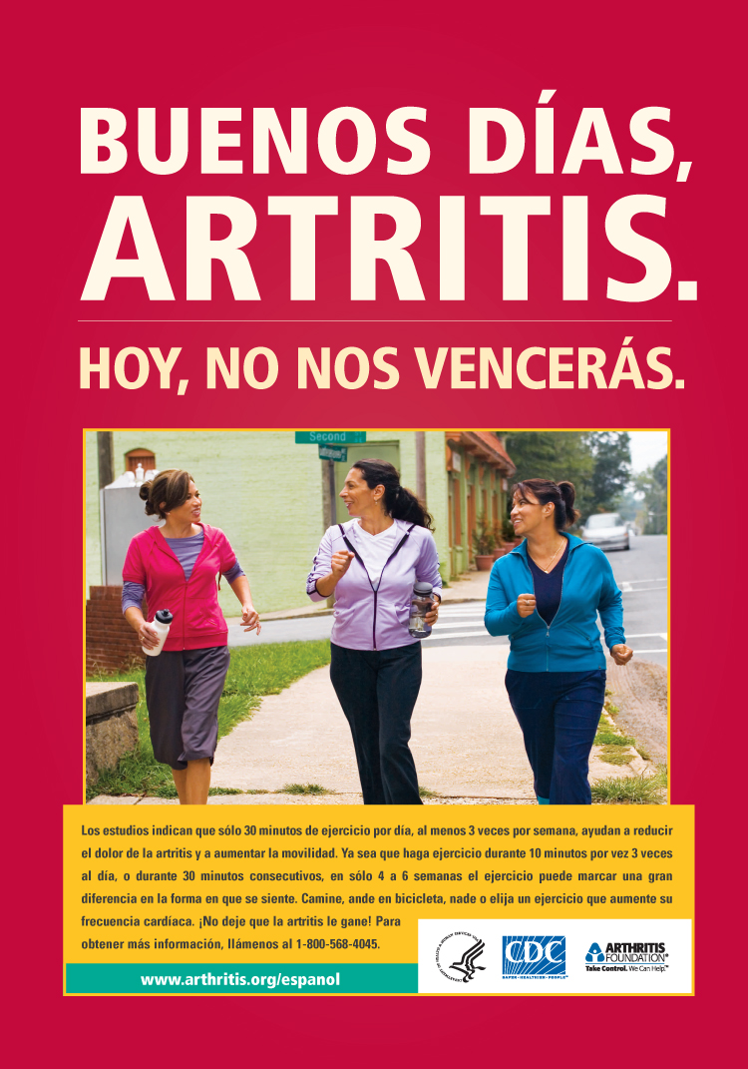

SAMPLE CREATIVE. FOR VIEWING ONLY.

Print Advertisement

7 x 10

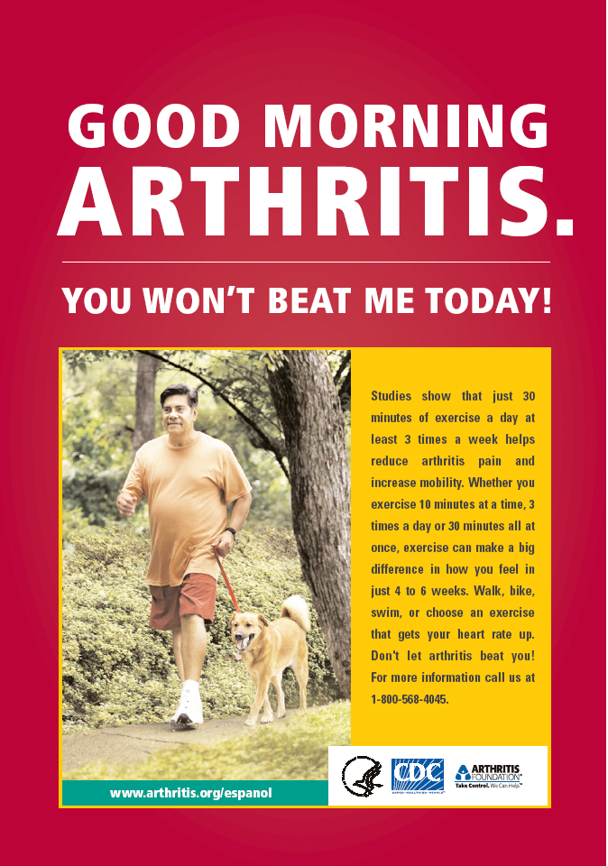

SAMPLE CREATIVE. FOR VIEWING ONLY.

Print Advertisement

7 x 10

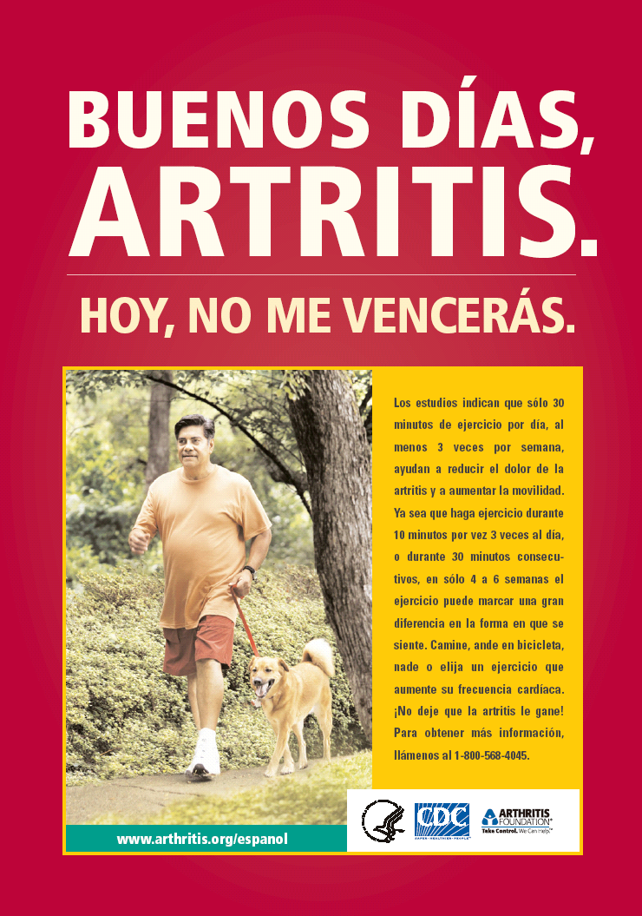

SAMPLE CREATIVE. FOR VIEWING ONLY.
Print Advertisement

7 x 10

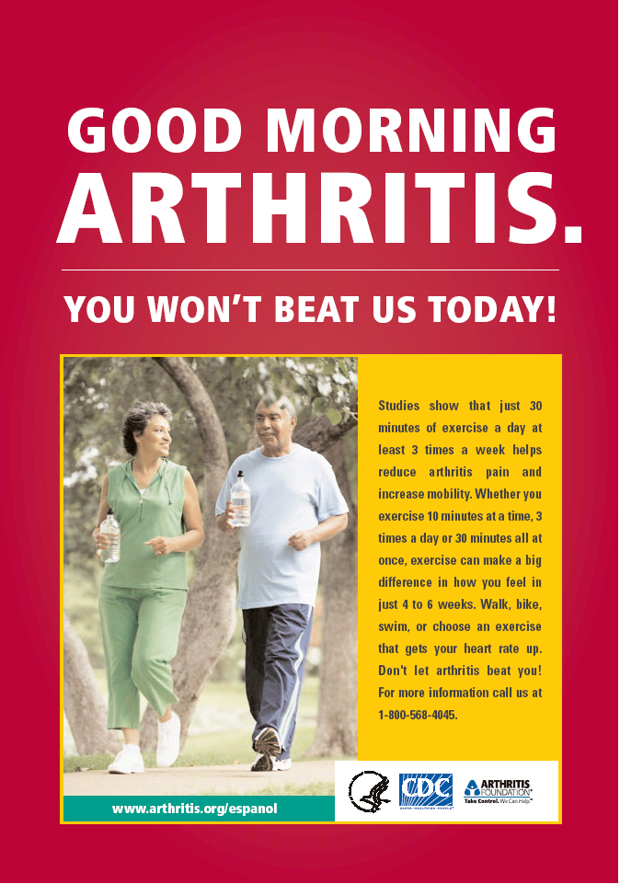

SAMPLE CREATIVE. FOR VIEWING ONLY.
Print Advertisement

7 x 10

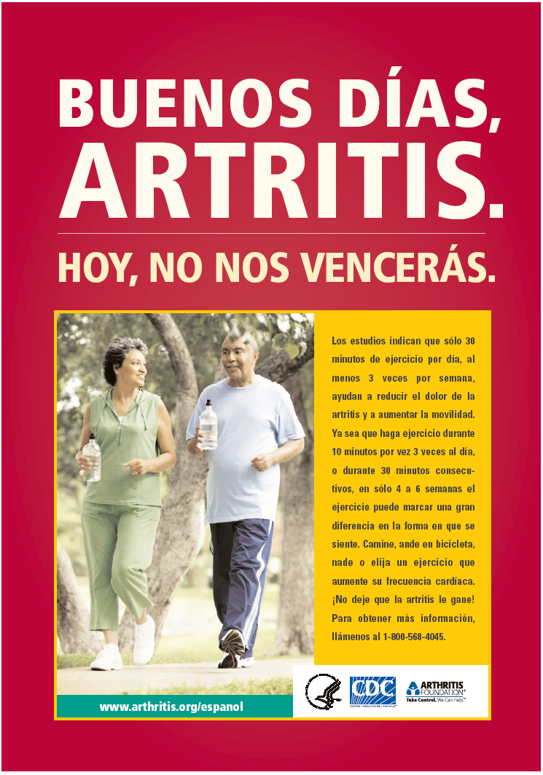

SAMPLE CREATIVE. FOR VIEWING ONLY.

Flyer

8.5 x 11

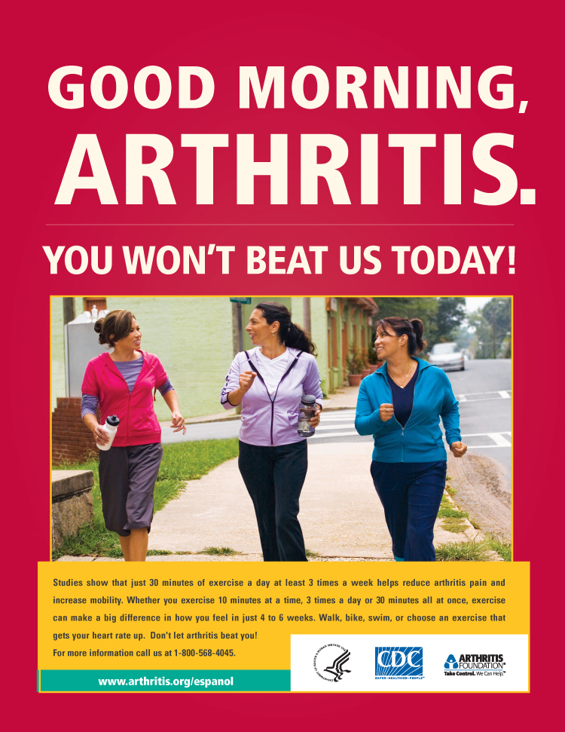

SAMPLE CREATIVE. FOR VIEWING ONLY.

Flyer

8.5 x 11

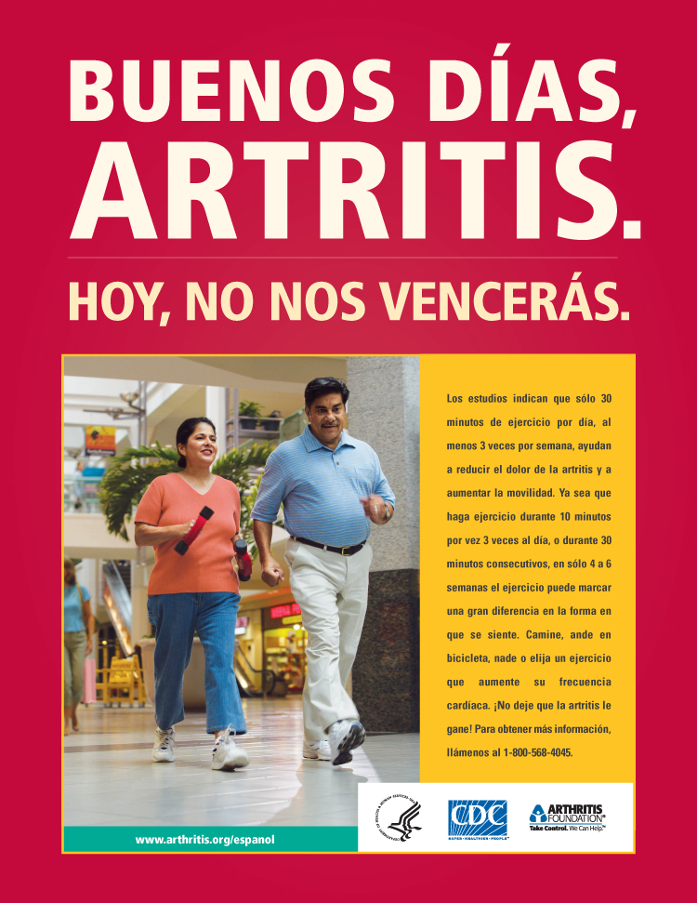

SAMPLE CREATIVE. FOR VIEWING ONLY.
Bill Stuffer

5.25 x 3.25

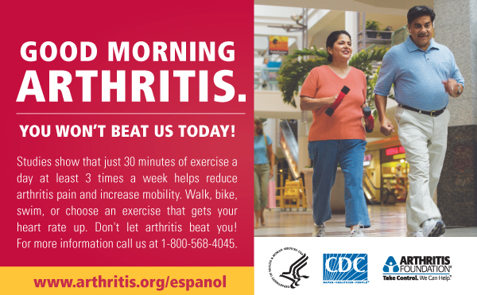

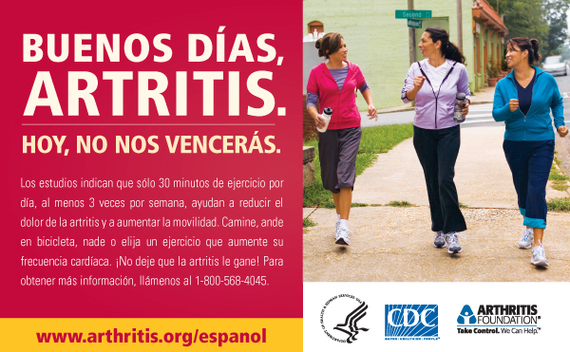

SAMPLE CREATIVE. FOR VIEWING ONLY.

Bookmark

2.25 x 6

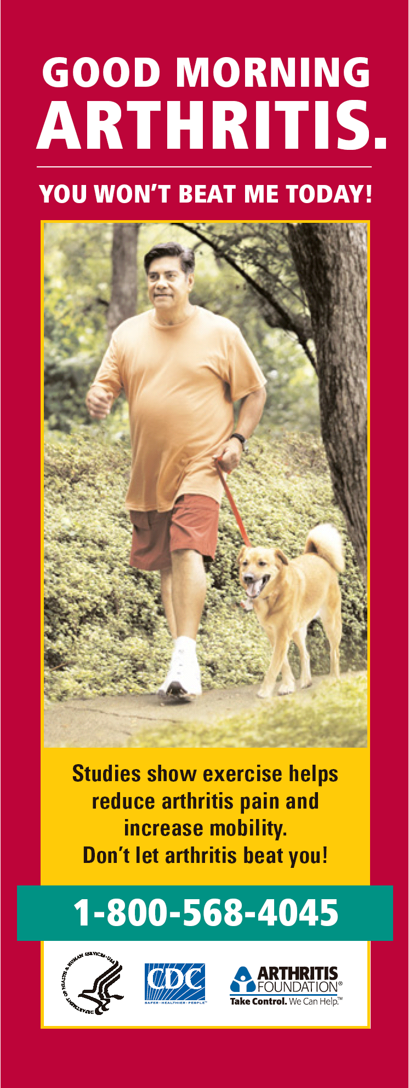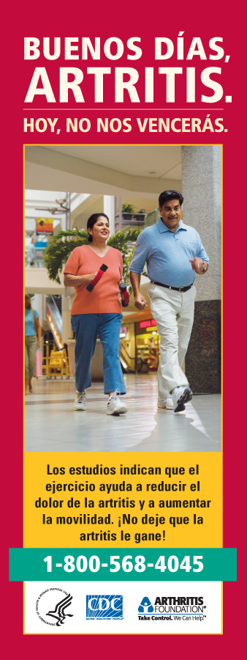

SAMPLE CREATIVE. FOR VIEWING ONLY.
Outdoor Billboard

19’ x 48’

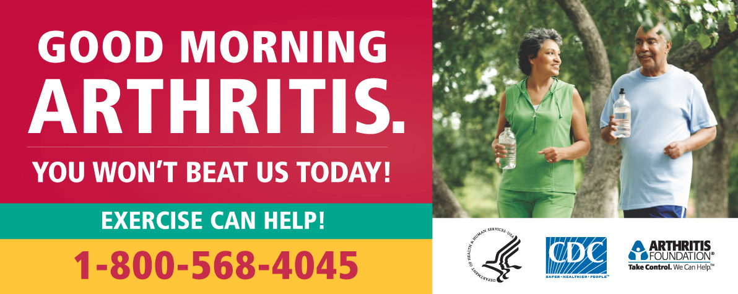

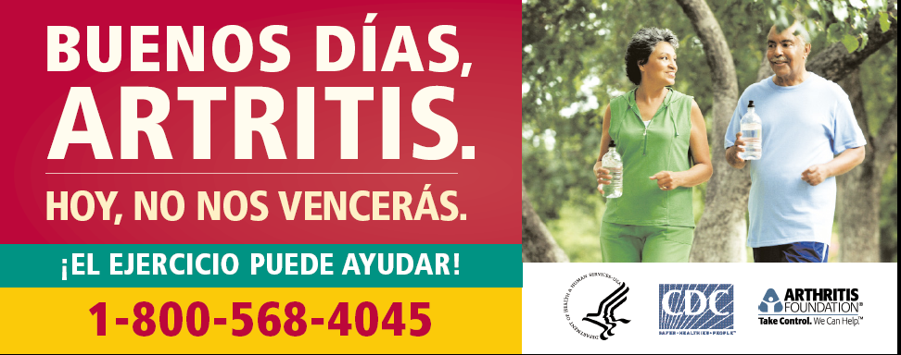

SAMPLE CREATIVE. FOR VIEWING ONLY.
Bus Shelter Placard

4’ x 6’

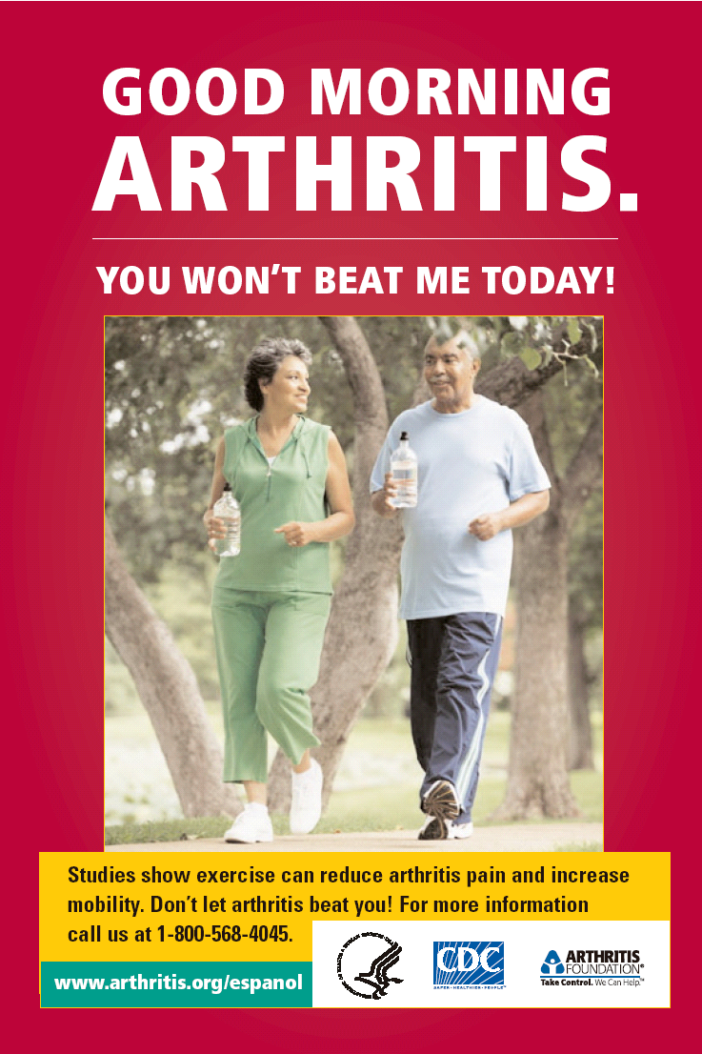

SAMPLE CREATIVE. FOR VIEWING ONLY.
Bus Shelter Placard

4’ x 6’

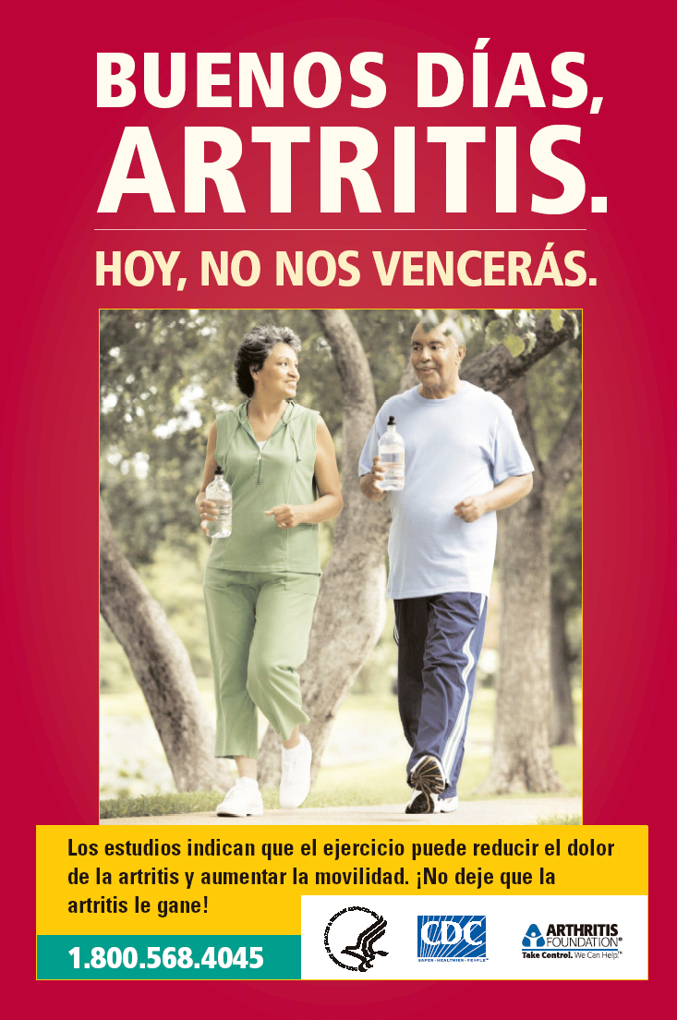

SAMPLE CREATIVE. FOR VIEWING ONLY.

Brochure

8.5 x 11

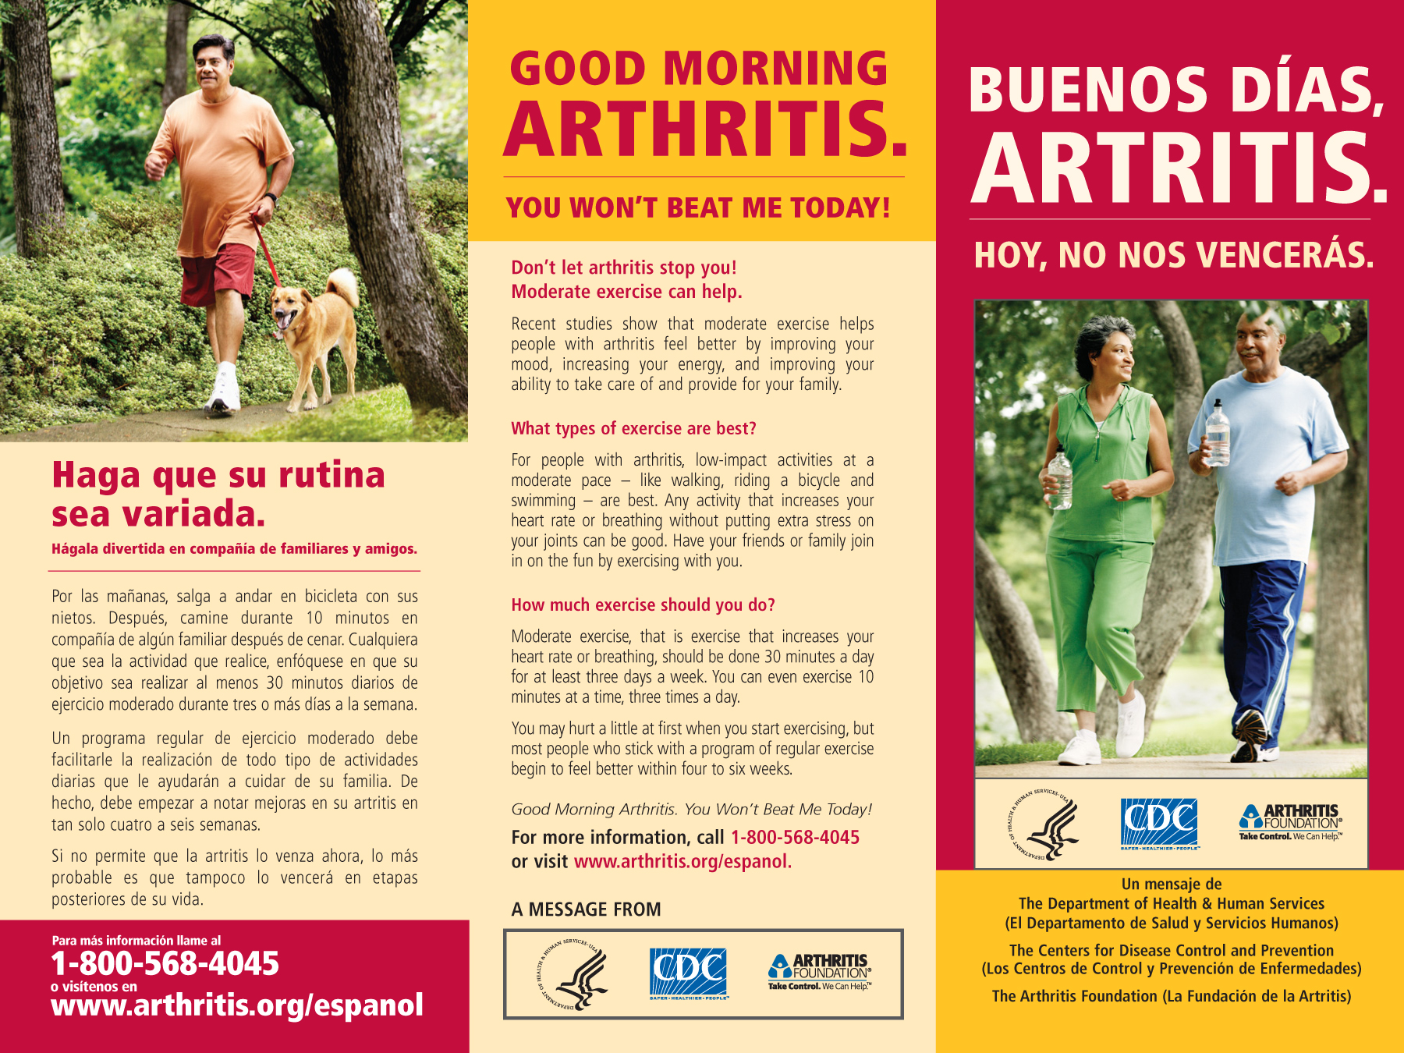

SAMPLE CREATIVE. FOR VIEWING ONLY.

Brochure

8.5 x 11

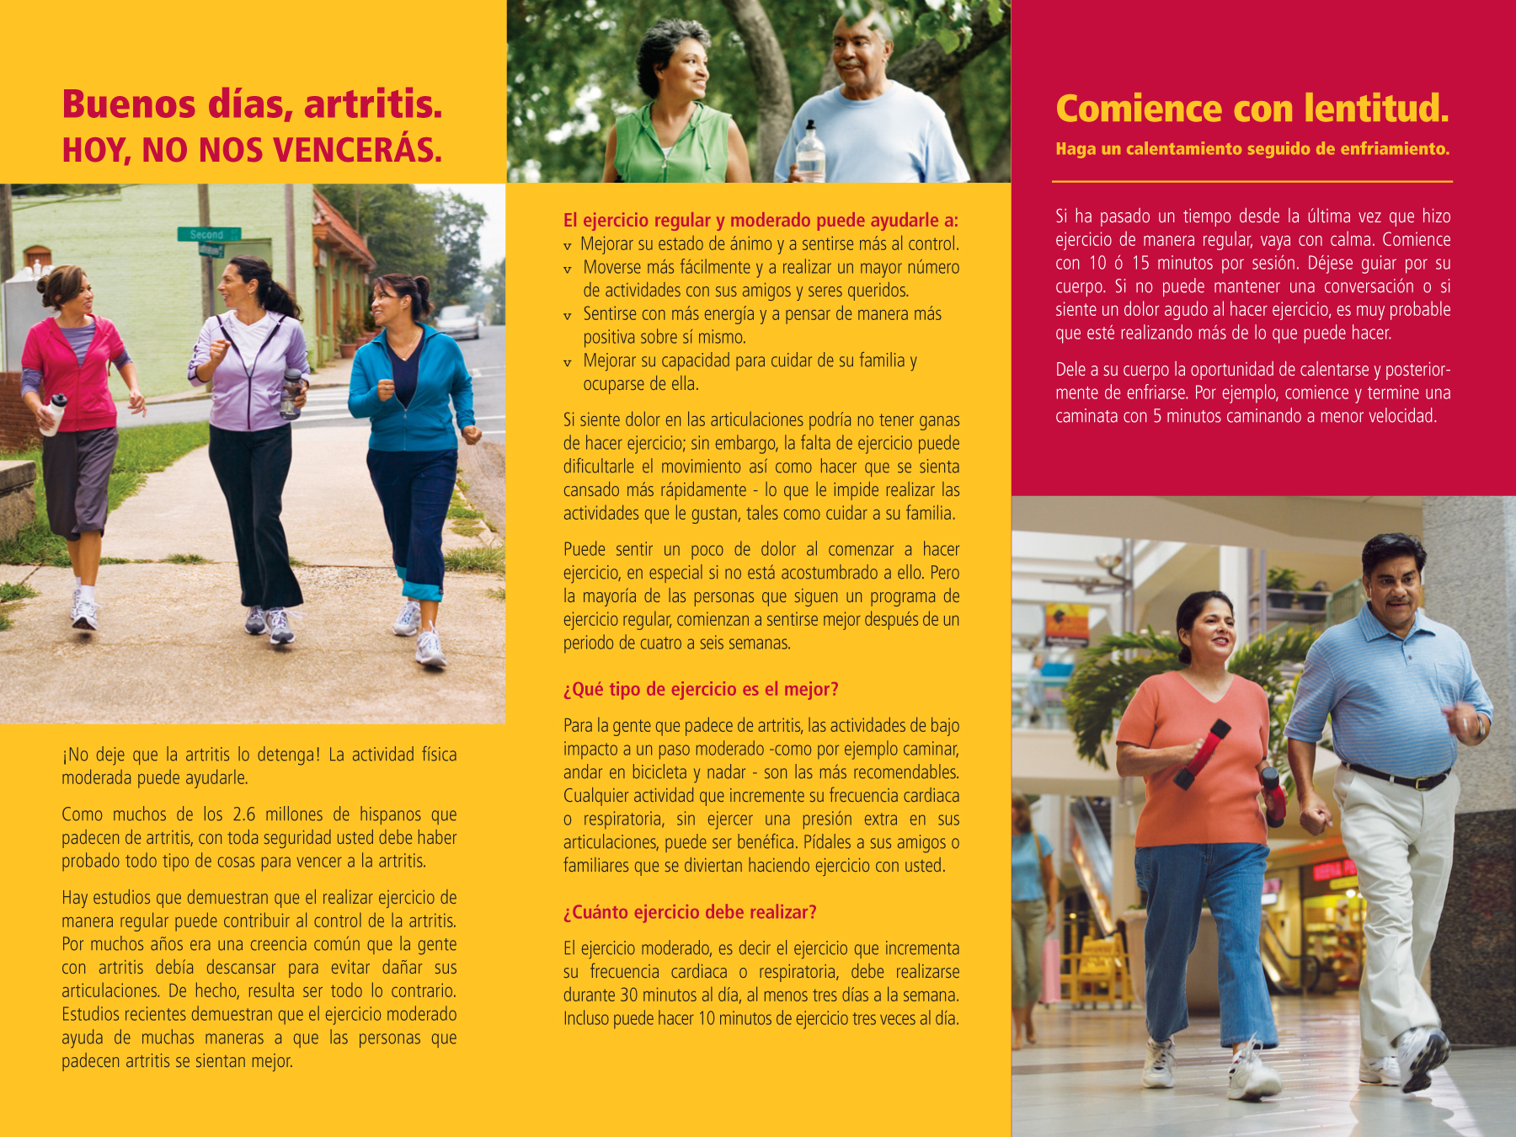

SAMPLE CREATIVE. FOR VIEWING ONLY.

English Brochure Copy

Page One, Left Panel, Inside
Good Morning Arthritis. You Won’t Beat Me Today!

Don’t let arthritis stop you! Moderate exercise can help.

Like most of the 2.6 million Hispanics who have arthritis, you’ve probably tried all kinds of things to beat your arthritis.

Studies show that regular exercise can help you control your arthritis. For many years, everyone thought that people with arthritis should rest to spare their joints. In fact, just the opposite is true. Recent studies show that moderate exercise helps people with arthritis feel better in several ways.

Page One, Middle Panel, Inside
Regular, moderate exercise can help you:
- Improve your mood and feel more in control.
- Move more easily and do more activities with friends and loved ones.
- Feel more energetic and positive about yourself.
- Improve your ability to take care of and provide for your family.

If your joints hurt, you may not feel like exercising; however, lack of exercise can actually make it harder to move and make you tire more easily – keeping you from doing the things you cherish, like taking care of your family.

You may hurt a little at first when you start exercising, especially if you are not used to it. But, most people who stick with a program of regular exercise begin to feel better within four to six weeks.

What types of exercise are best?

For people with arthritis, low-impact activities at a moderate pace – like walking, riding a bicycle and swimming – are best. Any activity that increases your heart rate or breathing without putting extra stress on your joints can be good. Have your friends or family join in on the fun by exercising with you.

How much exercise should you do?

Moderate exercise, that is exercise that increases your heart rate or breathing, should be done 30 minutes a day for at least three days a week. You can even exercise 10 minutes at a time, three times a day.

Page One, Right Panel, Inside

Start slowly. Warm up and cool down.

If it has been a while since you’ve done regular exercise, start slowly. Start with 10 or 15 minutes at a time. Let your body be your guide. If you can’t carry on a conversation, or if you feel severe pain during the activity, you’re probably pushing too hard.

Give your body a chance to warm up and cool down. For example, start and end your walk with 5 minutes of walking at a slower speed.

Page Two, Left Panel, Outside
Add variety. Make it fun with family and friends.

In the morning, go on a bike ride with your grandchildren. Then, take a 10-minute walk after dinner with a family member. Whatever you do, make your goal at least 30 minutes of moderate exercise a day, three or more days a week.

A regular program of moderate exercise should make it easier for you to do all kinds of everyday activities that help you take care of your family. In fact, in just four to six weeks you should begin to notice improvement in your arthritis.

If you don’t let arthritis beat you now, chances are good it won’t beat you later in life.

Page Two, Middle Panel, Outside (This panel is in English)
Good Morning Arthritis. You Won’t Beat Me Today!

Don’t let arthritis stop you! Moderate exercise can help.

Recent studies show that moderate exercise helps people with arthritis feel better by improving your mood, increasing your energy, and improving your ability to take care of and provide for your family.

What types of exercise are best?

For people with arthritis, low-impact activities at a moderate pace – like walking, riding a bicycle and swimming – are best. Any activity that increases your heart rate or breathing without putting extra stress on your joints can be good. Have your friends or family join in on the fun by exercising with you.

How much exercise should you do?

Moderate exercise, that is exercise that increases your heart rate or breathing, should be done 30 minutes a day for at least three days a week. You can even exercise 10 minutes at a time, three times a day.

You may hurt a little at first when you start exercising, but most people who stick with a program of regular exercise begin to feel better within four to six weeks.

Good Morning Arthritis. You Won’t Beat Me Today!
Call 1-800-568-4045 for more information.

A message from
The Department of Health & Human Services (logo)
The Centers for Disease Control and Prevention (logo)
The Arthritis Foundation (logo)

Page Two, Right Panel/ FRONT COVER
Good Morning Arthritis. You Won’t Beat Me Today!

A message from
The Department of Health & Human Services
The Centers for Disease Control and Prevention
The Arthritis Foundation

Sticker

4 x 3

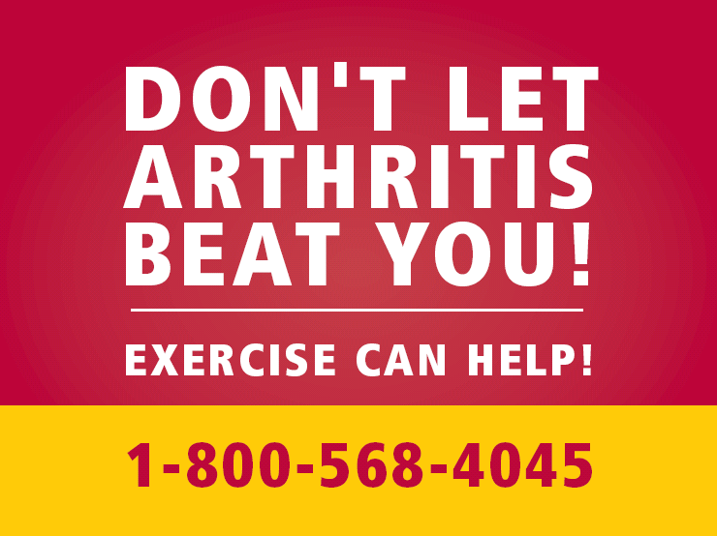

SAMPLE CREATIVE. FOR VIEWING ONLY.

Sticker

4 x 3

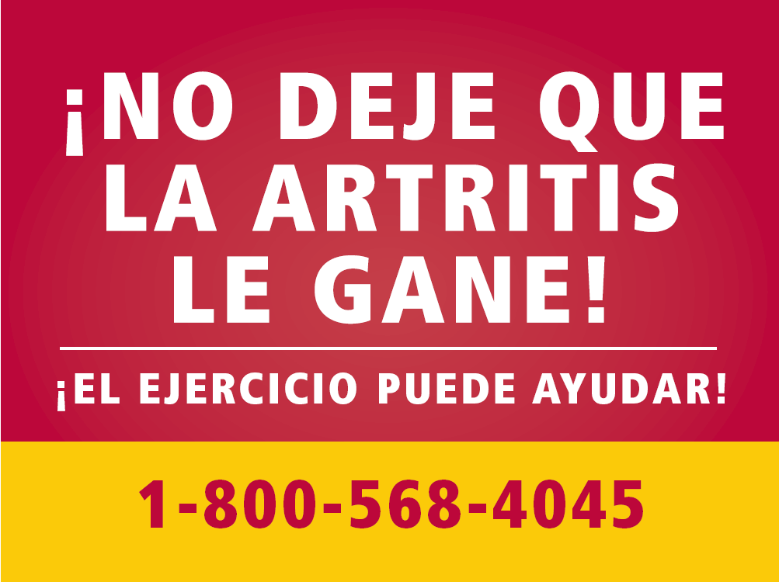

SAMPLE CREATIVE. FOR VIEWING ONLY.

Radio Scripts

~

:60-second taped radio spot

:50/:10-second taped radio spot with ability to add :10 second local tag

:30-second taped radio spot

:25/:05-second taped radio spot with ability to add :05 second local tag

:30-second live announcer script
(to be read by on-air personality, not pre-recorded)

:25/:05-second live announcer script
(to be read by on-air personality, not pre-recorded)

~

Buenos Dias, Artritis
“I Will!”
:60 second version; no local tag option

WOMAN: Today, even though I feel pain from my arthritis I will exercise.

MAN: I will walk.

WOMAN2: I will ride my bike.

MAN2: I know it will be difficult to start.

WOMAN: But I also know that afterwards, I will feel better.

ANNCR: Studies show that just 30 minutes of exercise a day at least 3 times a week can reduce the pain caused by arthritis and improve mobility. Exercise can help you feel better in just 4 to 6 weeks whether you exercise 10 minutes at a time 3 times a day or 30 minutes all at once.

WOMAN: Arthritis, you have defeated me in the past.

MAN1: But today, you will not beat me.

ANNCR: Don’t let arthritis beat you. Choose an exercise that gets your heart rate up a little. For more information, call 1-800-568-4045. This is a message from the Department of Health and Human Services, The Centers for Disease Control and Prevention and the Arthritis Foundation.

Buenos Días, Artritis
“¡Te ganaré!”
versión de :60 segundos, sin opción de comercial local.

WOMAN: Hoy, aunque sienta dolor por mi artritis, haré ejercicio.

MAN: Caminaré.

WOMAN2: Andaré en bicicleta.

MAN2: Sé que será difícil comenzar.

WOMAN: Pero también sé que después me sentiré mejor.

ANNCR: Los estudios demuestran que tan sólo 30 minutos de ejercicio por día, por lo menos tres veces a la semana, pueden reducir los dolores provocados por la artritis y mejorar la movilidad. El ejercicio te ayudará a sentirte mejor en sólo 4 a 6 semanas ya sea que hagas ejercicio durante 10 minutos 3 veces por día o 30 minutos de una sola vez.

WOMAN: Artritis, tu me has vencido en el pasado

MAN1: Pero hoy, no me vencerás.

ANNCR: ¡No dejes que la artritis te gane! Elige un ejercicio que acelere tu ritmo cardíaco. Para más información, llama al 1-800-568-4045. Este es un mensaje del Departamento de Salud y Servicios Humanos, los Centros para el Control y la Prevención de Enfermedades y de la Fundación contra la Artritis.

Buenos Dias, Artritis

“I Will!”
:50 second version with option for :10 second local tag

WOMAN: Today, even though I feel pain from arthritis, I will exercise.

MAN2: I know it will be difficult to start.

WOMAN2: But I also know that afterwards I will feel better.

ANNCR: Studies show that just 30 minutes a day of exercise at least 3 times a week can reduce the pain from arthritis and improve mobility—whether you exercise for periods of 10 minutes 3 times a day or for 30 minutes at one time.

WOMAN: Arthritis, you have beaten me in the past.

MAN1: But today you will not beat me.

ANNCR: Don’t let arthritis beat you. Choose an exercise that gets your heart rate up. For more information, call 1-800-568-4045. This is a message from the Department of Health and Human Services, The Centers for Disease Control and Prevention and the Arthritis Foundation.

:10 TAG

Buenos Días, Artritis

“¡Te ganaré!”
versión de :50 segundos con opción para comercial local de :10 segundos

WOMAN: Hoy, aunque sienta dolor por mi artritis, haré ejercicio.

MAN2: Sé que será difícil comenzar.

WOMAN2: Pero también sé que después me sentiré mejor.

ANNCR: Los estudios demuestran que tan sólo 30 minutos de ejercicio por día, por lo menos tres veces a la semana, reducen los dolores provocados por la artritis y mejoran la movilidad —ya sea que hagas ejercicio en períodos de 10 minutos 3 veces al día o de 30 minutos de una sola vez.

WOMAN: Artritis, tu me has vencido en el pasado.

MAN1: Pero hoy, no me vencerás.

ANNCR: ¡No dejes que la artritis te gane! Elige un ejercicio que acelere tu ritmo cardíaco. Para más información, llama al 1-800-568-4045. Este es un mensaje del Departamento de Salud y Servicios Humanos, los Centros para el Control y la Prevención de Enfermedades y de la Fundación contra la Artritis.

COMERCIAL DE :10

Buenos Dias, Artritis
“I Will!”
:30 second version, no option for local tag

ANNCR: If you have arthritis, studies show that just 30 minutes of exercise daily at least 3 times a week can reduce the pain caused by arthritis and improve mobility.

WOMAN: Today, arthritis will not beat me.

ANNCR: Exercise and don’t let arthritis beat you. For more information, call 1-800-568-4045. This is a message from the Department of Health and Human Services, The Centers for Disease Control and Prevention and the Arthritis Foundation.

Buenos Días, Artritis
“¡Te ganaré!”
versión de :30 segundos, sin opción para un comercial local.

ANNCR: Si tienes artritis, los estudios demuestran que tan sólo 30 minutos de ejercicio diarios por lo menos 3 veces a la semana pueden reducir los dolores provocados por la artritis y mejorar la movilidad.

WOMAN: Hoy, la artritis no me vencerá.

ANNCR: Hagas ejercicio y no dejes que la artritis te gane. Para más información, llama al 1-800-568-4045. Este es un mensaje del Departamento de Salud y Servicios Humanos, los Centros para el Control y la Prevención de Enfermedades y de la Fundación contra la Artritis.

Buenos Dias, Artritis
“I Will!”
:25/:05 second version, with :5 second option for local tag

ANNCR: If you have arthritis, studies show that just 30 minutes of exercise daily at least 3 times a week can reduce the pain caused by arthritis and improve mobility. Exercise and don’t let arthritis beat you. For more information, call 1-800-568-4045. This is a message from the Department of Health and Human Services, The Centers for Disease Control and Prevention and the Arthritis Foundation.

:05 TAG

Buenos Días, Artritis
“¡Te ganaré!”
versión de :25/:05 segundos, con opción para un comercial
local de :05 segundos

ANNCR: Si tienes artritis, los estudios demuestran que tan sólo 30 minutos de ejercicio diarios por lo menos 3 veces a la semana pueden reducir los dolores provocados por la artritis y mejorar la movilidad. Hagas ejercicio y no dejes que la artritis te gane. Para más información, llama al 1-800-568-4045. Este es un mensaje del Departamento de Salud y Servicios Humanos, los Centros para el Control y la Prevención de Enfermedades y de la Fundación contra la Artritis.

COMERCIAL DE :05

LIVE ANNOUNCER SCRIPT
To be read by the live radio personality.

Buenos Dias, Artritis
“I Will!”
:30 second version, no local tag

Today, don’t let arthritis beat you!

Studies show that just 30 minutes of exercise daily at least 3 times a week can reduce the pain caused by arthritis and improve mobility.

Exercise and don’t let arthritis beat you. For more information, call 1-800-568-4045. This is a message from the Department of Health and Human Services, The Centers for Disease Control and Prevention and the Arthritis Foundation.

Buenos Días, Artritis
“¡Te ganaré!”
versión de :30 segundos, sin opción para un comercial local.

¡Hoy, no dejes que la atritis te gane!

Los estudios demuestran que tan sólo 30 minutos de ejercicio diarios por lo menos 3 veces a la semana pueden reducir el dolor causado por la artritis y mejorar la movilidad.

Hagas ejercicio y no dejes que la artritis te gane. Para más información, llama al 1-800-568-4045. Este es un mensaje del Departamento de Salud y Servicios Humanos, los Centros para el Control y la Prevención de Enfermedades y de la Fundación contra la Artritis.

LIVE ANNOUNCER SCRIPT
To be read by the live radio personality.

Buenos Dias, Artritis
“I Will!”
:25/:05 second version, with :5 second local tag

If you have arthritis, studies show that just 30 minutes of exercise daily at least 3 times a week can reduce the pain caused by arthritis and improve mobility.

Exercise and don’t let arthritis beat you. For more information, call 1-800-568-4045. This is a message from the Department of Health and Human Services, The Centers for Disease Control and Prevention and the Arthritis Foundation.

:05 TAG

Buenos Días, Artritis
“¡Te ganaré!”
versión de :25/:05 segundos, con opción para un comercial
local de :05 segundos

ANNCR: Si tienes artritis, los estudios demuestran que tan sólo 30 minutos de ejercicio diarios por lo menos 3 veces a la semana pueden reducir los dolores provocados por la artritis y mejorar la movilidad. Hagas ejercicio y no dejes que la artritis te gane. Para más información, llama al 1-800-568-4045. Este es un mensaje del Departamento de Salud y Servicios Humanos, los Centros para el Control y la Prevención de Enfermedades y de la Fundación contra la Artritis.

COMERCIAL DE :05
Printing and Reproduction Specifications

The CD and DVD provided with this guide include all the creative elements in a variety of formats to help you successfully implement this campaign.

Viewing/Printing/Listening to Your Materials:
Print: You can view all of the print materials from PDF files, which are read by Adobe® Acrobat®. Most office computers have Adobe® Acrobat® Reader installed, which allows you to view and print all of the non-localizable print executions. If you don’t have Adobe, use this link http://www.adobe.com/products/acrobat/readstep2.html to download it for free and follow the instructions. The materials provided in Quark are the versions you can localize and are specifically for use by a designer, a media outlet, or a print services (i.e.;Kinko’s-type) company.

Most of the non-localizable versions of print materials are available in high resolution PDFs—this means they are print quality. However, the outdoor billboard and bus shelter placard are provided in PDF low resolution for viewing only. Please use the Quark files located on the DVD for printing.

In addition, the non-localizable versions of the brochure, outdoor billboard, and bus shelter placard are also provided in Quark because these materials often require the highest level of print quality. (a Quark file offers a higher level of print quality than does a PDF.)

Radio: Your radio creative is provided in hard copy within this guide, in both English and Spanish. The CD labeled with the radio spots is a MP3 CD. It can only be played on a computer equipped with MP3 software, such as Windows Media Player or Itunes, or a stereo equipped to play MP3s.

Localizing Your Materials:
Print: Use the materials in Quark format to localize your information. Ask your media representative if he/she is willing to localize the materials for you for free. If the representative cannot, you can take the CD ROM to a local print or design shop for customization. If you are adding another logo to the piece, be sure to obtain that logo in the format (jpeg, pdf, tiff, etc.) requested by the media outlet/designer. NOTE: Only health department or Arthritis coalition logos can be added without permission from CDC’s Technology Transfer Office. See Section III-Additional Resources, Appendix L, Frequently Asked Questions for more information.

Radio: To localize your radio spots, first try to work with the radio station you are placing the PSA or ad on. If they are unable to localize it for you, find a recording studio in your area.

*Be aware that even if a media outlet is willing to adapt your materials for you, they may still charge a small fee.

Creating High-Resolution, Camera-Ready Slicks:
You may also choose to create slicks for distribution in your media kits. Slicks are an easy way for small publications to quickly drop-in your creative. To create the slicks, take the CD to a local designer or print shop and let them know what you want. Your design shop will work with you to select the best application (PDF or Quark) based on your quality needs.

Resizing Your Print Materials:
Whether you are interested in using the national/non-localizable or local versions of your print materials, you may have a need for a different size than what is provided. Simply work with your media outlet or designer to resize the Quark versions provided. The Quark versions include a space for an additional logo. If you do not have an additional logo, just ask them to equally space out the logos.

Sending Materials to Media Outlets:
When sending materials to a media outlet for either print or radio, e-mail your selected file or burn a copy of the creative onto a CD. It’s important to speak with your media representative first, as some outlet’s e-mail systems will not accept large attachments.

CD and DVD Disc Reports:
These reports are a complete listing of the materials on your CD and DVD. Be sure to ask your printer or graphic designer if he or she would like a copy of the report before beginning your project. We have found it helpful in guiding designers and printers in finding all the correct files. The disk reports are available as a separate file on Disk 1.

Section III

Additional Resources

APPENDIX A – Implementation Planning Worksheet

Select target audience/market segment
The campaign is designed for Hispanic men and women between the ages of 45-64 with incomes below $35,000
Does your local market include the entire audience segment, or will you focus on a subset? Be specific.
Which cities/areas in your state have high concentrations of your target audience? Where will you target efforts? Be specific.
What do you know about this audience and the community?

What radio stations do they listen to?
What time of day does the target audience listen to the radio?
What newspapers do they read?
Does your target audience listen to or read both Spanish and English media? If yes, how will your approach take your audiences’ media habits into consideration?
What community locations do they frequent ? These are potential locations for brochures/posters.
Who are your logical partners to help you reach this audience with the message?

What local organizations already have relationships with or interest in your target audience? Consider both Hispanic and mainstream organizations.
How can you partner with them? What tools/resources do you have to help them serve their audience better?
What events or activities do these organizations host in which you could partner/participate?
When is a good time to run the campaign?

Are there any existing events, observances or activities in which you can participate?
Are there any competing activities to avoid?
Which materials best match your campaign target audience and plans?

What materials are you planning to use? At a minimum, you need to use brochures and either the radio spots, billboard, or bus shelter placard.
Will print ads, flyers, bill stuffers, and/or bookmarks help you to reach the target audience?
How will you track the reach of your campaign efforts?

Can you get readership, traffic (volume of people) or listner reports?
Can you track the number of inquiries coming into your designated phone number and/or web site?
Can you track the number of brochures or flyers distributed, as well as how many were picked up by consumers?
Are there other measures you should consider in order to effectively track your efforts?
How will you direct consumers to additional resources? What response mechanism will you use?

Will you use the Arthritis Foundation’s web site address?
Will you use the Arthritis Foundation’s 800 number or a local phone number?
How will your response mechanism affect your ability to track the effectiveness of the campaign? Think through your rationale.
Can you identify local arthritis classes which have a Spanish-speaking instructor available?

ANEXO A – Planilla de trabajo de planificación de la implementación

Seleccionar el segmento de audiencia/mercado objetivo
La campaña está diseñada para hombres y mujeres hispanos de entre 45 y 64 años de edad con ingresos inferiores a $35,000
¿Incluye su mercado local todo el segmento de la audiencia o se concentrará sólo en un subgrupo? Sea específico.
¿Qué ciudades/áreas de su estado tienen la mayor concentración de audiencia objetivo? ¿Hacia dónde apuntará sus esfuerzos? Sea específico.
¿Qué sabe acerca de esta audiencia y la comunidad?

¿Qué estaciones de radio escucha?
¿En qué horario del día la audiencia objetivo escucha la radio?
¿Qué periódicos lee?
¿La audiencia objetivo escucha o lee medios de comunicación en español e inglés? En caso afirmativo, ¿de qué forma tendrá en cuenta su enfoque los hábitos de las audiencias en lo referente a medios de comunicación?
¿Qué lugares de la comunidad frecuentan (ubicación potencial para los folletos/carteles)?
¿Quiénes son sus socios lógicos para ayudarlo a llegar con el mensaje a esta audiencia?

¿Qué organizaciones locales ya tienen relación con la audiencia objetivo o tienen interés en ella? Considere tanto las organizaciones convencionales como las hispanas.
¿Cómo puede asociarse con ellos? ¿Qué herramientas/recursos tiene para ayudarlos a atender mejor a la audiencia?
¿Qué eventos o actividades llevan a cabo estas organizaciones dónde usted puede asociarse o participar?
¿Cuál es un buen momento para realizar la campaña?

¿Hay algunos eventos, ceremonias o actividades en las cuáles puede participar?
¿Hay algunas actividades rivales que debe evitar?
¿Qué materiales se adaptan mejor a su audiencia objetivo y a los planes de su campaña?

¿Qué materiales planea usar? Como mínimo, necesita usar folletos y espacios de radio, carteleras o carteles en los omnibuses.
¿La publicidad impresa, los volantes, los rellenos de las carteleras y/o señaladores le ayudarán a llegar a la audiencia?
¿Cómo rastreará la llegada de los esfuerzos de la campaña?

¿Puede obtener informes de lectores, de tráfico (volumen de gente) o de oyentes?
¿Puede rastrear la cantidad de consultas que se realizan a un número telefónico designado y/o su sitio en Internet?
¿Puede rastrear la cantidad de folletos o volantes distribuidos así como también cuántos fueron recogidos por los consumidores?
¿Hay otras medidas que debería considerar para rastrear sus esfuerzos con eficacia?
¿Cómo dirigirá a los consumidores para que encuentren los recursos adicionales? ¿Qué mecanismos de respuesta utilizará?

¿Utilizará la dirección del sitio en Internet de la Fundación contra la Artritis (Arthritis Foundation)?
¿Utilizará el número 800 de la Fundación contra la Artritis (Arthritis Foundation) o un número telefónico local?
¿Cómo afectará el mecanismo de respuesta su capacidad para rastrear la eficacia de la campaña? Medite su análisis.
¿Puede identificar clases locales sobre la artritis en dónde se dispone de un instructor de habla hispana, por ejemplo, ASHC, PACE, ejercicios acuáticos, etc.?

APPENDIX B – Sample Pitch Letter for Public Service Director

(Feel free to personalize this letter and put it on your organization’s letterhead.)

[PUBLIC SERVICE DIRECTOR’S NAME]
[ADDRESS]
[ADDRESS]
[ZIP]

Dear Mr./Ms. [NAME]:

[INSERT STATE NUMBER] Hispanics in [YOUR STATE] live with arthritis, the most prevalent chronic condition in the U.S., affecting more than 20 percent of the population. And, this number is expected to rise.

Unfortunately, in comparison to whites, a higher proportion of Hispanics have work limitations related to arthritis and severe joint pain. Yet many Hispanics don’t know that moderate exercise for just 30 minutes a day, three or more times a week, can not only lessen pain but can also help them become more active and energetic.

You can help those in your state beat arthritis!

The enclosed PSA(s) will help your [LISTENERS/READERS] learn more about what they can do themselves to relieve pain, stiffness, and disability associated with arthritis. Included is a toll-free [OR LOCAL] telephone number that your [LISTENERS/ READERS] can call to get more information: 1-800-568-4045 [OR REPLACE THIS WITH YOUR LOCAL TELEPHONE NUMBER]. We hope that you will help us encourage the many Hispanic citizens in our community who have arthritis pain and disability to become more active and participate in work and leisure activities, which are critical to quality of life.

I will follow up this letter with a phone call in the next week and at that time can provide you with any additional information and materials. Thank you in advance for your time and your support.

Sincerely,

[NAME]
[TITLE]
[ORGANIZATION]
[PHONE]

TIP: YOU MAY WANT TO INCLUDE THE ENGLISH AND SPANISH CREATIVE MATERIALS, IF FOR NO OTHER REASON THAN FOR THE REVIEWER’S REFERENCE.

ANEXO B – Modelo de carta de propaganda para el Director de los Servicios Públicos

(Siéntase libre de personalizar esta carta y colocarle el membrete de su organización).

[NOMBRE DEL DIRECTOR DE LOS SERVICIOS PÚBLICOS]
[DIRECCIÓN]
[DIRECCIÓN]
[CÓDIGO POSTAL]

Estimado/a Sr./Sra. [NOMBRE]:

[INSERTE EL NÚMERO DE ESTADO] Los hispanos de [SU ESTADO] conviven con la artritis, la enfermedad crónica con mayor prevalencia de los EE.UU., que afecta a más del 20 por ciento de la población. Y se espera que aumente esta cantidad.

Desdichadamente, en comparación con los caucásicos, una proporción mayor de hispanos tienen limitaciones laborales relacionadas con la artritis y dolores articulares graves. Aún así, muchos hispanos no saben que el ejercicio moderado durante tan sólo 30 minutos por día, tres o más veces por semana, no sólo puede reducir el dolor sino que también puede ayudar a que se sienta más activo y tenga más energía.

¡Usted puede ayudar a aquéllas personas de su estado a ganarle a la artritis!

El/ los anuncio(s) de servicio público (PSA) adjuntos ayudarán a los [OYENTES/LECTORES] a informarse sobre lo que pueden hacer para aliviar el dolor, la rigidez y las discapacidades asociadas con la artritis. Se incluye un número telefónico gratuito [O LOCAL] al que sus [OYENTES/ LECTORES] pueden llamar para obtener más información: 1-800-568-4045 [O REEMPLÁCELO POR SU NÚMERO TELEFÓNICO LOCAL]. Esperamos que nos ayude a alentar a muchos ciudadanos hispanos de nuestra comunidad que padecen de artritis y discapacidades a aumentar su nivel de actividad y participar en el trabajo y las actividades de esparcimiento críticas para la calidad de vida.

Haré un seguimiento de esta carta con un llamado telefónico la semana próxima y, en ese momento, podré proporcionarle cualquier otra información y materiales adicionales. Gracias de antemano por su tiempo y su apoyo.

Atentamente,

[NOMBRE]
[CARGO]
[ORGANIZACIÓN]
[TELÉFONO]

DATO: TAL VEZ QUIERA INCLUIR LAS VERSIONES EN ESPAÑOL E INGLÉS, AUNQUE SEA PARA REFERENCIA DEL REVISOR.

APPENDIX C – Sample Letter: Response to Public Inquiries

Dear Mr./Ms. [NAME]:

Congratulations on taking the first step toward beating arthritis. Keep going and you could be hurting less, moving more easily and feeling more energetic in just four to six weeks.

Recent studies show that moderate exercise three or more days a week can help relieve arthritis pain, improve your mood, help you to feel more in control, give you more energy, and make you feel better about yourself. Most importantly, exercise can help you improve your ability to take care of and provide for your family.

Low impact activities at a moderate pace work best for people with arthritis. These include walking, biking, swimming, and everyday activities like gardening and washing the car.

You may hurt a little at first, especially if you are not regularly exercising now. But most people who stick with a program feel better within four to six weeks.

Enclosed you will find additional information outlining national and local resources, as well as information on moderate exercise to help you get active and beat arthritis.

If you don’t let arthritis beat you now, chances are good it won’t beat you later in life!

Sincerely,

[NAME]
[TITLE]
[ORGANIZATION]

Enclosures:
Buenos Dias, Artritis brochure
Resources Fact Sheet
[OTHER]

ANEXO C – Modelo de carta: Respuesta para las consultas públicas

Estimado/a Sr./Sra. [NOMBRE]:

Felicitaciones por haber dado el primer paso para ganarle a la artritis. Continúe así y podrá sufrir menos dolor, podrá moverse con más facilidad y sentirse con más energía en sólo un período de cuatro a seis semanas.

Los estudios recientes indican que practicar ejercicio en forma moderada tres o más veces por semana puede ayudar a aliviar el dolor artrítico, mejorar el humor, ayudarlo a sentirse más en control, darle más energía y hacer que se sienta mejor con usted mismo. Y lo que es más importante, el ejercicio puede ayudarlo a mejorar su capacidad para cuidar de su familia y ocuparse de ella.

Las actividades de bajo impacto a un ritmo moderado son las mejores para las personas con artritis. Entre éstas se incluyen: caminar, andar en bicicleta, nadar y actividades diarias como jardinería o lavar el automóvil.

Puede sentir un poco de dolor al principio, especialmente si usted no está haciendo ejercicio en forma regular. Pero la mayoría de la gente que se adhiere al programa se siente mejor en el lapso de cuatro a seis semanas.

Hemos adjuntado información adicional que describe los recursos locales y nacionales, así como también información acerca del ejercicio moderado para ayudarlo a mantenerse activo y ganarle a la artritis.

Si ahora no se deja vencer por la artritis, ¡lo más probable es que tampoco lo haga más adelante!

Atentamente,

[NOMBRE]
[CARGO]
[ORGANIZACIÓN]

Material adjunto:
Folleto Buenos Días, Artritis
Hoja informativa de recursos
[OTRO]

APPENDIX D – Sample Thank You Letter Post Meeting

(Feel free to personalize this letter and put it on your organization’s own letterhead.)

[PUBLIC SERVICE DIRECTOR’S NAME]
[ADDRESS]
[ADDRESS]
[ZIP]

Dear Mr./Ms. [NAME]:

Thank you for taking the time out of your busy schedule to learn more about how you can reduce the burden of arthritis affecting [STATE’S] Hispanic population.

As the nation’s number one cause of disability, arthritis affects one in five Americans. In [STATE], there are more than [INSERT NUMBER] people of Hispanic descent who are living with arthritis.

We appreciate your willingness to learn how you can support our efforts by spreading the word that moderate exercise can lessen arthritis pain and disability.

We know you receive many requests to support other campaigns and causes with PSAs, and I thank you for considering Buenos Dias, Artritis.

Sincerely,

[NAME]
[TITLE]
[ORGANIZATION]
[PHONE]

ANEXO D – Modelo de carta de agradecimiento posterior a la reunión

(Siéntase libre de personalizar esta carta y colocarle el membrete de su organización).

[NOMBRE DEL DIRECTOR DE LOS SERVICIOS PÚBLICOS]
[DIRECCIÓN]
[DIRECCIÓN]
[CÓDIGO POSTAL]

Estimado/a Sr./Sra. [NOMBRE]:

Le agradecemos que se tome un momento para informarse sobre cómo puede reducir el peso que la artritis ejerce sobre la población hispana de [ESTADO].

Como la causa numero uno de descapacidad en los estados unidos, la arthritis afecta uno en cinco personas. En [ESTADO], hay más de [NUMERO] personas de linaje hispano que estan viviendo con arthritis.

Agradecemos su interés en informarse sobre cómo puede apoyar nuestros esfuerzos difundiendo el concepto de que el ejercicio moderado puede reducir el dolor artrítico y las discapacidades.

Sabemos que recibe muchos pedidos para apoyar otras campañas y causas de anuncios de servicios públicos (PSA, por sus siglas en inglés) y le agradecemos que considere a Buenos Días, Artritis.

Atentamente,

[NOMBRE]
[CARGO]
[ORGANIZACIÓN]
[TELÉFONO]

APPENDIX E – Sample Thank You Letter After Media Runs PSA

(Feel free to personalize this letter and put it on your organization’s letterhead.)
(If possible, ask those living with arthritis to send similar letters.)

[PUBLIC SERVICE DIRECTOR’S NAME]
[ADDRESS]
[ADDRESS]
[ZIP]

Dear Mr./Ms. [NAME]:

Thank you!

On behalf of the Hispanic residents in the state of [STATE HERE], thank you for sharing our important public service announcement about arthritis and moderate exercise.

We have received a great deal of positive feedback on the PSA and your support is recognized and truly appreciated. [IF POSSIBLE, INCLUDE INCREASES IN CALL VOLUME OR WEB SITE HITS SINCE THE PSA RAN TO SHOW THE MEDIA OUTLET HOW THIS MESSAGE RESONATES WITH ITS AUDIENCE.]

We hope you will continue to run the Buenos Dias, Artritis campaign materials, helping us to spread the word that moderate exercise can help our community beat arthritis!

Sincerely,

[NAME]
[TITLE]
[ORGANIZATION]
[PHONE]

ANEXO E – Modelo de carta de agradecimiento después de que los medios difundan el PSA.

(Siéntase libre de personalizar esta carta y colocarle el membrete de su organización).
(Si es posible, pida a aquéllos que padecen de artritis que envíen cartas similares).

[NOMBRE DEL DIRECTOR DE LOS SERVICIOS PÚBLICOS]
[DIRECCIÓN]
[DIRECCIÓN]
[CÓDIGO POSTAL]

Estimado/a Sr./Sra. [NOMBRE]:

¡Gracias!

En nombre de los residentes hispanos del estado de [COLOCAR AQUÍ EL NOMBRE DEL ESTADO], queremos agradecerle por compartir nuestro importante anuncio público (PSA, por sus siglas en inglés) sobre la artritis y el ejercicio moderado.

Hemos recibido comentarios muy positivos sobre el PSA y reconocemos y realmente agradecemos su apoyo. [SI ES POSIBLE, INCLUIR EL AUMENTO EN LA CANTIDAD DE LLAMADAS O DE VISITAS AL SITIO EN INTERNET DESDE QUE SE REALIZÓ EL PSA PARA MOSTRAR A LOS MEDIOS CÓMO ESTE MENSAJE ES RECIBIDO POR LA AUDIENCIA].

¡Esperamos que continúe transmitiendo los materiales de la campaña Buenos Días, Artritis y nos ayude a difundir el concepto de que el ejercicio moderado puede ayudar a nuestra comunidad a ganarle a la artritis!

Atentamente,

[NOMBRE]
[CARGO]
[ORGANIZACIÓN]
[TELÉFONO]

APPENDIX F – Newsletter Article

Don’t Let Arthritis Beat You!
Moderate Exercise Can Help.

In [STATE], there are more than [INSERT NUMBER] people of Hispanic descent who are living with arthritis, yet many do not know that regular moderate exercise can help them beat it. It’s true!

“For many years, everyone thought that people with arthritis should rest to spare their joints. In fact, just the opposite is true. Recent studies show that becoming more active can help people with arthritis feel better,” said [NAME, TITLE] of [STATE]’s state health department.

Studies show that regular moderate exercise can help you:
- Improve mood and feel more in control
- Move more easily and do more activities with friends and loved ones
- Feel more energetic and positive about yourself
- Improve your ability to take care of and provide for your family

Consider Mrs. [BLANK] who has been living with arthritis for more than [XX] years. It used to keep her from taking care of her family/socializing with friends/working. [“QUOTE FROM MRS. BLANK ON HOW ARTHRITIS KEPT HER FROM DOING THE THINGS SHE LOVED,” said MRS. BLANK.] Today, [MRS. BLANK] is more in control of her arthritis. [“QUOTE ABOUT HOW REGULAR MODERATE EXERCISE HELPED HER REGAIN CONTROL OF HER ARTHRITIS,” said MRS. BLANK.]

“If your joints hurt, you may not feel like being active; however, lack of activity can actually make your joints even more stiff and painful,” according to [LAST NAME – same name from state health department as above].

What types of exercise are best?

For people with arthritis, low-impact activities at a moderate pace – like walking, riding a bicycle and swimming – are best. Any activity that increases your heart rate or breathing without putting extra stress on your joints can be good.

If it has been a while since you’ve done regular exercise, start slowly. In fact, exercising just 10 minutes a day, three times a day for three or more days a week can make a difference.

Add variety. Make it fun with family and friends.

Try taking your grandchildren to the pool and swimming for 20 minutes. Then, take a 10-minute walk with your spouse. Whatever you do, make your goal at least 30 minutes of moderate exercise a day three or more days a week.
If you don’t let arthritis beat you now, chances are good it won’t beat you later in life.

To learn more about how you can beat arthritis call 1-800-568-4045, click on the Arthritis Foundation’s web site at www.arthritis.org/Espanol, or you can also access the below resources:

[INSERT RESOURCES HERE]

[Include appropriate resources for your area. See Section III - Additional Resources, Appendix G for a complete list of Arthritis Foundation resources to include in this section. If available, include local resources (programs, classes), as well as your local web site and contact number.]

CONSIDER YOUR WORD COUNT REQUIREMENTS
[IF YOU ARE DEVELOPING THIS FOR A SPECIFIC PUBLICATION, ASK WHAT THE REQUIREMENTS ARE FOR WORD COUNT. IF YOU ARE SENDING THIS TO A NUMBER OF OUTLETS, SHOOT TO HAVE YOUR WORD COUNT BETWEEN 500 AND 1,000.]

ANEXO F – Artículo del boletín informativo

¡No deje que la artritis le gane!
La actividad física moderada puede ayudarle.

En [ESTADO], hay más de [INSERTAR LA CANTIDAD] personas de descendencia hispana que padecen de artritis; aún así, muchos no saben que el ejercicio moderado regular puede ayudar a vencerla. ¡Es verdad!

“Durante muchos años se creyó que la gente que padecía de artritis debía descansar para evitar dañar las articulaciones. De hecho, resulta ser todo lo contrario. Los estudios recientes indican que aumentar el nivel de actividad puede ayudar a las personas con artritis a sentirse mejor”, dijo [NOMBRE, CARGO] del Departamento de Salud del Estado de [ESTADO].

Los estudios demuestran que el ejercicio moderado regular puede ayudarlo a:
- Mejorar su estado de ánimo y sentirse más en control.
- Moverse más fácilmente y realizar una mayor cantidad de actividades con sus amigos y seres queridos.
- Sentirse con más energía y pensar de manera más positiva sobre sí mismo.
- Mejorar su capacidad para cuidar de su familia y ocuparse de ella.

Piense en la Sra. [EN BLANCO] que sufre de artritis desde hace más de [XX] años. La artritis le impedía cuidar de su familia/socializar con sus amigos/trabajar. [“COMENTARIO DE LA SRA. -EN BLANCO- ACERCA DE CÓMO LA ARTRITIS NO LA DEJABA REALIZAR LAS COSAS QUE LE GUSTABAN”, dijo la SRA. -EN BLANCO-]. Hoy, la [SRA. -EN BLANCO-] tiene más control sobre su artritis. [“COMENTARIO ACERCA DE CÓMO EL EJERCICIO MODERADO REGULAR LA AYUDÓ A VOLVER A TENER CONTROL SOBRE SU ARTRITIS”, dijo la SRA. -EN BLANCO-]

“Si le duelen las articulaciones, es probable que no tenga ganas de mantenerse activa, sin embargo, la falta de actividad puede realmente producir una mayor rigidez de las articulaciones y más dolor”, según [APELLIDO – mismo nombre que el de la persona del departamento de salud del estado que mencionó con anterioridad].

¿Qué tipo de ejercicio es el mejor?

Para la gente que padece de artritis, las actividades de bajo impacto a un paso moderado - como por ejemplo caminar, andar en bicicleta y nadar - son las más recomendables. Cualquier actividad que incremente su frecuencia cardíaca o respiratoria, sin ejercer una presión extra en las articulaciones, puede ser buena.

Si ha pasado un tiempo desde la última vez que hizo ejercicio de manera regular, hágalo con calma. De hecho, realizar ejercicio sólo 10 minutos por día, tres veces por día, tres o más días por semana puede marcar la diferencia.

Haga que su rutina sea variada. Hágala divertida en compañía de familiares y amigos.

Intente llevar a sus nietos a la piscina y nadar durante 20 minutos. Después, camine 10 minutos con su cónyuge. Cualquiera sea la actividad que realice, concéntrese en realizar al menos 30 minutos diarios de ejercicio moderado durante tres o más días a la semana.

Si ahora no se deja vencer por la artritis, lo más probable es que tampoco lo haga más adelante.

Para obtener más información sobre cómo ganarle a la artritis llame al 1-800-568-4045, haga clic en el sitio en Internet de la Fundación contra la Artritis (Arthritis Foundation) en www.arthritis.org/Español, o también puede acceder a los recursos que se mencionan a continuación:

[INSERTAR LOS RECURSOS AQUÍ]

[Incluir los recursos adecuados para su área. Ver el ANEXO G para obtener una lista completa de los recursos de la Fundación contra la Artritis (Arthritis Foundation) para incluir en esta sección. Si se encuentra disponible, incluya los recursos locales (programas, clases), así como también su sitio local en Internet y el número de contacto telefónico].

CONSIDERE LOS REQUISITOS DEL RECUENTO DE PALABRAS
[SI ESTÁ PREPARANDO ESTO PARA UNA PUBLICACIÓN ESPECÍFICA, CONSULTE CUÁNTAS PALABRAS PUEDE UTILIZAR. SI ESTÁ ENVIANDO ESTO A UNA CANTIDAD DE SUCURSALES, EL RECUENTO DE PALABRAS DEBE SER ENTRE 500 Y 1,000].

APPENDIX G – Resources Fact Sheet
Consider putting this on your letterhead, sending it out with all public inquires
and posting on your web site.

Additional Resources to Help You Beat Arthritis!

Local Resources [INCLUDE ONLY IF YOU HAVE SPANISH OPTIONS]:
- [Local phone number with Spanish-speaking operator]
- [Local web site, listing local programs and resources in Spanish]
- [Local programs that are hosted by Spanish-speaking instructors]

Resources from the National Institute on Aging:
- The National Institute on Aging offers resources in Spanish, as well as a Spanish-speaking specialist
- To order a copy of the fact sheet, Consejos Sobre la Arthritis, which covers common forms of arthritis, treatment options and additional resources, call 1-800-222-2225 or visit www.nia/nih.gov (under Health Information select en Espanol, then select http://www.niapublications.org, then select Spanish Language Materials). You will find the fact sheet listed here

Resources from the Arthritis Foundation:
The Arthritis Answers Information Line (1-800-568-4045) with a Spanish language option, where callers can:
- Request Spanish language brochure
- Find their local office of the Arthritis Foundation
- Get connected to a Spanish Information Specialist to ask questions about arthritis, treatment and resources for those affected by arthritis and related diseases

A Spanish language web site at www.arthritis.org/Espanol where Spanish-speaking customers can find accurate information on arthritis, treatment and resources. The Spanish site also has Spanish Message Boards.

E-mail address of Help@arthritis.org where questions in Spanish can be sent to an Information Specialist for a personalized response.

Spanish language brochures:
- El ejercicio y la artritis (Exercise and Your Arthritis)
- Osteoartritis (Osteoarthritis)
- Fibromialgia (Fibromyalgia)
- Artritis Reumatoidea (Rheumatoid Arthritis)
- Respuestas Sobre la Artritis (Arthritis Answers)
- Lupus (Lupus)
- Controlando su Dolor (Managing your Pain)

Spanish language easy-to-read tear sheets:
- Vivir con Osteoartritis (Living with Osteoarthritis)
- Vivir con Fibromialgia (Living with Fibromyalgia)
- Vivir con Artritis Reumatoidea (Living with Rheumatoid Arthritis)
- Proteja sus articulaciones (Protect your Joints)
- Ejercicios de Amplitud de Movimiento (Range-of-Motion Exercises)
- Ejecicios de Fortalecimiento (Strengthening Exercises)
- Conozca a su Equipo de Salud de la Artritis (Meet Your Arthritis Health Care Team)
- Conozca sus Medicamentos para la Artritis (Learn About Your Arthritis Medicine)
- Manténgase en Movimiento (Keep Moving)

ANEXO G – Hoja informativa de recursos

Considere colocar esto en su membrete, enviarlo a los distintos puntos de consulta públicos y colocarlo en su sitio en Internet.

¡Recursos adicionales para ayudarlo a vencer la artritis!

Recursos locales [INCLUIRLOS SÓLO SI TIENE OPCIONES EN ESPAÑOL]:
- [Número telefónico local con un operador de habla hispana]
- [Sitio local en Internet, listas de los programas y recursos locales en español]
- [Programas locales que están conducidos por instructores de habla hispana]

Recursos del Instituto Nacional para la Tercera Edad (National Institute on Aging)
- El Instituto Nacional para la Tercera Edad (National Institute on Aging) ofrece recursos en español así como especialistas que hablan español.
- Para solicitar una copia de la hoja informativa, Consejos sobre la Artritis, que cubre distintas formas comunes de artritis, opciones de tratamientos y recursos adicionales, llame al 1-800-222-2225 o visite www.nia/nih.gov (en Health Information -Información sobre Salud- seleccione "Español", luego seleccione http://www.niapublications.org, y después seleccione Spanish Language Materials -materiales en idioma español-). Aquí encontrará la hoja informativa.

Recursos de la Fundación contra la Artritis (Arthritis Foundation):
Línea de información para obtener respuestas acerca de la artritis (1-800-568-4045) con una opción en español donde las personas que llamen pueden:
- Solicitar un folleto en idioma español
- Encontrar la oficina local de la Fundación contra la Artritis (Arthritis Foundation)
- Comunicarse con un especialista en información en español para realizarle preguntas acerca de la artritis, los tratamientos y los recursos para quiénes padecen de artritis y enfermedades relacionadas.

Sitio en Internet en español: www.arthritis.org/Español donde los clientes de habla hispana pueden obtener información exacta sobre la artritis, los tratamientos y los recursos. El sitio en español también tiene Paneles de mensajes en español.

Puede enviar un mensaje de correo electrónico a Help@arthritis.org con sus preguntas en español para que las responda un especialista en información si desea obtener una respuesta personalizada.

Folletos en español:
- El ejercicio y la artritis (Exercise and Your Arthritis)
- Osteoartritis (Osteoarthritis)
- Fibromialgia (Fibromyalgia)
- Artritis Reumatoidea (Rheumatoid Arthritis)
- Respuestas Sobre la Artritis (Arthritis Answers)
- Lupus (Lupus)
- Controlando su Dolor (Managing your Pain)

Folletos fáciles de leer en idioma español:
- Vivir con Osteoartritis (Living with Osteoarthritis)
- Vivir con Fibromialgia (Living with Fibromyalgia)
- Vivir con Artritis Reumatoidea (Living with Rheumatoid Arthritis)
- Proteja sus articulaciones (Protect your Joints)
- Ejercicios de Amplitud de Movimiento (Range-of-Motion Exercises)
- Ejercicios de Fortalecimiento (Strengthening Exercises)
- Conozca a su Equipo de Salud de la Artritis (Meet Your Arthritis Health Care Team)
- Conozca sus Medicamentos para la Artritis (Learn About Your Arthritis Medicine)
- Manténgase en Movimiento (Keep Moving)

APPENDIX H – Tracking Form

Use this form to track the usage of your creative (radio and print) and use this for both PSAs (non-paid placement) and advertising (paid placement).

Today’s Date:______________________

Type of Media Outlet:

Radio__ Newspaper__ Magazine__ Other__

Name of Media Outlet:________________ City:_____________________

Name of Your Contact:__________________________________________

Description of Media Outlet: (audience, circulation, location (if restaurant or bus shelter placard)

Creative Execution Selected: (indicate which radio or print piece was used)

Print: Man Walking Dog __ Group of Women Walking __
Couple Walking (indoors)__ Couple Walking Outdoors __

Radio: :25 spot __ :30 spot__ :50 spot __ :60 spot__
Live Announcer Script: ___

Other Creative: Billboard __ Bus Shelter Placard __
Flyer __ Bill Stuffer __

Length of Run: (indicate how long/many times this piece has or will run)

Response Rate: (To help you track which outlets are most effective, if possible indicate wheter your phone number or web site traffic increased due to the this piece running. Using national response mechanisms may inhibit tracking.)

APPENDIX I – Template Web Site Copy

Don’t Let Arthritis Beat You!
Exercise Can Help!

If you are one of the many Hispanics in [YOUR STATE] who have arthritis, you have probably tried all kinds of things to relieve your arthritis pain and to help you feel better about yourself. As someone with arthritis, you may even have concerns about not being able to work for a living or take care of or provide for your family. It’s true: arthritis impacts the everyday lives of many people and sometimes stops them from doing the things they once enjoyed.

But it doesn’t have to. Don’t let arthritis beat you! Research shows that becoming more active can help. Just 30 minutes of moderate exercise, at least three days a week, can help reduce the pain caused by arthritis and help you get back to doing the things you want to do. You can do 10 minutes of exercise three times per day to reach your 30 minutes. From taking a walk around the block to riding your bike, moderate exercise can help you feel better in just four to six weeks.

Buenos Dias, Artritis
[INSERT YOUR ORGANIZATION] and the Centers for Disease Control and Prevention (CDC) recently launched a program called Buenos Dias, Artritis. You may have read about it in a newspaper or heard about it on the radio.

The goal of Buenos Dias, Artritis is to spread the word to the Hispanic population living with arthritis that exercise can make people feel better in several ways.

Regular, moderate exercise can help you:
- Improve mood and feel more in control
- Move more easily and do more activities with friends and loved ones
- Feel more energetic and positive about yourself
- Improve your ability to take care of and provide for your family

[INSERT PARAGRAPH: The section below is an example of what you can include if you have local resources to provide]

Click on the links below to view educational materials that will give you more information on different exercise options and the recommended time to spend on them. Here, you will also find more information on how to manage your arthritis.

[INSERT LINKS TO DOWNLOADABLE INFORMATION]

NOTE: You must have Adobe® Acrobat® Reader software on your computer to view these files. Please enable pop-ups on your browser.

Local Resources
Below is a listing of several organizations in your area that offer resources to help you beat arthritis.

[INSERT CONTACT INFORMATION FOR COMMUNITY RESOURCES AND PARTNERS]

Additional Resources Available on the Web
You can also access the resources below for additional information to help you feel more in control!

[INSERT STATE ARTHRITIS ORGANIZATION]

Centers for Disease Control and Prevention (CDC)
http://www.cdc.gov/arthritis/index.htm

Arthritis Foundation
http://www.arthritis.org/

[CONSIDER LISTING MATERIALS AVAILABLE ONLINE FROM THE Arthritis Foundation]

National Institute of Arthritis and Musculoskeletal and Skin Diseases (NIAMS)
http://nihseniorhealth.gov/arthritis/toc.html

ANEXO I – Copia del modelo del sitio en Internet

¡No deje que la artritis le gane!
¡El ejercicio puede ayudar!

Si usted es uno de los tantos hispanos en [SU ESTADO] que padecen de artritis, probablemente haya probado todo tipo de cosas para calmar el dolor artrítico y para sentirse mejor con usted mismo. Como cualquier persona que padece de artritis, es probable que esté preocupado por no poder trabajar para mantenerse o cuidar de su familia y ocuparse de ella. Es verdad: la artritis afecta la vida cotidiana de mucha gente y a veces no les permite hacer las cosas que alguna vez disfrutaron.

Pero no tiene que ser así. ¡No deje que la artritis le gane! Las investigaciones demuestran que aumentar el nivel de actividad puede ayudar. Sólo 30 minutos de ejercicio moderado, por lo menos tres veces por semana puede ayudar a reducir el dolor provocado por la artritis y puede ayudarlo a que vuelva a realizar las cosas que desea hacer. Puede hacer 10 minutos de ejercicio tres veces por día hasta alcanzar los 30 minutos. Desde dar una vuelta a la manzana hasta andar en bicicleta, el ejercicio moderado puede hacerlo sentir mejor en un período de sólo cuatro a seis semanas.

Buenos Días, Artritis
[INSERTAR SU ORGANIZACIÓN] y los Centros para el Control y la Prevención de las Enfermedades (Centers for Disease Control and Prevention, CDC) lanzaron en forma reciente un programa llamado Buenos Días, Artritis. Puede haber leído sobre él en un periódico o haberlo escuchado en la radio.

El objetivo de Buenos Días, Artritis es difundir la idea a la población hispana que padece de artritis de que el ejercicio puede ayudarlo a sentirse mejor de distintas maneras.

El ejercicio regular y moderado puede ayudarle a:
- Mejorar su estado de ánimo y a sentirse más en control.
- Moverse más fácilmente y a realizar una mayor cantidad de actividades con sus amigos y seres queridos.
- Sentirse con más energía y pensar de manera más positiva sobre sí mismo.
- Mejorar su capacidad para cuidar de su familia y ocuparse de ella.

[INSERTAR PÁRRAFO: La sección a continuación es un ejemplo de lo que usted puede incluir si tiene recursos locales para ofrecer].

Haga clic en los enlaces a continuación para ver los materiales educativos que le darán más información sobre las distintas opciones de ejercicios y la duración recomendada. Aquí también encontrará más información sobre cómo tratar la artritis.

[INSERTAR ENLACES PARA OBTENER INFORMACIÓN QUE SE PUEDA DESCARGAR]

NOTA: Debe tener el programa Adobe® Acrobat® instalado en su computadora para ver estos archivos. Por favor, suprima las ventanas emergentes en su navegador.

Recursos locales
A continuación hemos incluido una lista de las distintas organizaciones en su área que ofrecen recursos para ayudarlo a vencer la artritis.

[INSERTAR INFORMACIÓN DE CONTACTO PARA LOS RECURSOS COMUNITARIOS Y ASOCIADOS]

Recursos adicionales disponibles en Internet
También puede acceder a los recursos que se mencionan a continuación para obtener más información que lo ayude ¡a sentirse más en control!

[INSERTAR ORGANIZACIONES PARA LA ARTRITIS EN EL ESTADO]

Centros para el Control y Prevención de las Enfermedades
http://www.cdc.gov/arthritis/index.htm

Fundación contra la Artritis
http://www.arthritis.org/espanol
=
[CONSIDERE PONER A DISPOSICIÓN UNA LISTA DE MATERIALES EN LÍNEA DE LA Fundación contra la Artritis (Arthritis Foundation)]

Instituto Nacional de Artritis y Enfermedades Musculoesqueléticas y de la Piel
http://nihseniorhealth.gov/arthritis/toc.html
APPENDIX J – Hispanic Population by Largest U.S. Cities

Note: This table describes the percentage of the total state population that is Hispanic, as well the percentage of Hispanic population in selected larger cities in each state. Cities are listed in alphabetical order by state.

Example: 1.7% of Alabama residents are Hispanic. Birmingham is one of Alabama’s largest cities and 1.6% of Birmingham residents are Hispanic.

State | City | % of Population that is  Hispanic
Alabama |  | 1.7
 | Birmingham | 1.6
 | Mobile | 1.4
 | Montgomery | 1.2
Alaska |  | 4.1
 | Anchorage | 5.7
 | Juneau | 3.4
Arizona |  | 25.3
 | Glendale | 24.8
 | Mesa | 19.7
 | Phoenix | 34.1
 | Tucson | 35.7
Arkansas |  | 3.2
 | Fort Smith | 8.8
 | Little Rock | 2.7
 | North Little Rock | 2.4
California |  | 32.4
 | Anaheim | 46.8
 | Fresno | 39.9
 | Long Beach | 35.8
 | Los Angeles | 46.5
 | Oakland | 21.9
 | Sacramento | 21.6
 | San Diego | 25.4
 | San Francisco | 14.1
 | San Jose | 30.2
 | Santa Maria | 59.7
Colorado |  | 17.1
 | Arvada | 9.8
 | Aurora | 19.8
 | Colorado Springs | 12.0
 | Denver | 31.7
 | Fort Collins | 8.8
 | Lakewood | 14.5
Connecticut |  | 9.4
 | Bridgeport | 31.9
 | Hartford | 40.5
 | New Haven | 21.4
 | Stamford | 16.8
Delaware |  | 4.8
 | Dover | 4.1
 | Newark | 2.5
 | Wilmington | 9.8
Florida |  | 16.8
 | Fort Lauderdale | 9.5
 | Hialeah | 90.3
 | Jacksonville | 4.2
 | Miami | 65.8
 | Orlando | 17.5
 | Saint Petersburg | 4.2
 | Tallahassee | 4.2
 | Tampa | 19.3
Georgia |  | 5.3
 | Athens | 6.4
 | Atlanta | 4.5
 | Augusta | 2.8
 | Columbus | 4.5
 | Macon | 1.2
 | Savannah | 2.2
Hawaii |  | 7.2
 | Hilo | 8.8
 | Honolulu | 4.4
 | Kailua | 6.1
Idaho |  | 7.9
 | Boise | 4.5
 | Idaho Falls | 7.2
 | Nampa | 17.9
 | Pocatello | 4.9
Illinois |  | 12.3
 | Aurora | 32.6
 | Chicago | 26.0
 | Naperville | 3.2
 | Rockford | 10.2
Indiana |  | 3.5
 | Evansville | 1.1
 | Fort Wayne | 5.8
 | Indianapolis | 3.9
 | South Bend | 8.5
Iowa |  | 2.8
 | Cedar Rapids | 1.7
 | Davenport | 5.4
 | Des Moines | 6.6
Kansas |  | 7.0
 | Kansas City | 16.8
 | Overland Park | 3.8
 | Topeka | 8.9
 | Wichita | 9.6
Kentucky |  | 1.5
 | Bowling Green | 4.1
 | Lexington- Fayette | 3.3
 | Louisville | 1.9
 | Owensboro | 1.0
Louisiana |  | 2.4
 | Baton Rouge | 1.7
 | LaFayette | 1.9
 | New Orleans | 3.1
 | Shreveport | 1.6
Maine |  | 0.7
 | Bangor | 1.0
 | Lewiston | 1.3
 | Portland | 1.5
Maryland |  | 4.3
 | Baltimore | 1.7
 | Bowie | 2.9
 | Frederick | 4.8
 | Gaithersburg | 19.8
Massachusetts |  | 6.8
 | Boston | 14.4
 | Cambridge | 7.4
 | Lowell | 14.0
 | Springfield | 27.2
 | Worcester | 15.1
Michigan |  | 3.3
 | Detroit | 5.0
 | Flint | 3.0
 | Grand Rapids | 13.1
 | Warren | 1.4
Minnesota |  | 2.9
 | Duluth | 1.1
 | Minneapolis | 7.6
 | Rochester | 3.0
 | St. Paul | 7.9
Mississippi |  | 1.4
 | Biloxi | 3.6
 | Gulfport | 2.6
 | Jackson | 0.8
Missouri |  | 2.1
 | Kansas City | 6.9
 | Springfield | 2.3
 | St. Louis | 2.0
Montana | Biiii | 2.0
 | Billings | 4.2
 | Butte | 2.7
 | Great Falls | 2.4
 | Missoula | 1.8
Nebraska |  | 5.5
 | Bellevue | 5.9
 | Lincoln | 3.6
 | Omaha | 7.5
Nevada |  | 19.7
 | Henderson | 10.7
 | Las Vegas | 23.6
 | Reno | 19.2
New Hampshire |  | 1.7
 | Concord | 1.5
 | Manchester | 4.6
 | Nashua | 6.2
 | Rochester | 0.9
New Jersey |  | 13.3
 | Elizabeth | 49.5
 | Jersey City | 28.3
 | Newark | 29.5
 | Paterson | 50.1
New Mexico |  | 42.1
 | Albuquerque | 39.9
 | Las Cruces | 51.7
 | Santa Fe | 47.8
New York
 | Buffalo | 7.5
 | New York | 27.0
 | Rochester | 12.8
North Carolina |  | 4.7
 | Charlotte | 7.4
 | Greensboro | 4.4
 | Raleigh-Durham | 7.0
 | Winston-Salem | 8.6
North Dakota |  | 1.2
 | Bismarck | 0.7
 | Fargo | 1.3
 | Grand Forks | 1.9
Ohio |  | 1.9
 | Cincinnati | 1.3
 | Cleveland | 7.3
 | Columbus | 2.5
Oklahoma |  | 5.2
 | Norman | 3.9
 | Oklahoma City | 10.1
 | Tulsa | 7.2
Oregon |  | 8.0
 | Eugene | 5.0
 | Gresham | 11.9
 | Portland | 6.8
 | Salem | 14.6
Pennsylvania |  | 3.2
 | Allentown | 24.4
 | Philadelphia | 8.5
 | Pittsburgh | 1.3
Rhode Island |  | 8.7
 | Cranston | 4.6
 | Providence | 30.0
 | Warwick | 1.6
South Carolina |  | 2.4
 | Charleston | 1.5
 | Columbia | 3.0
 | Greenville- Spartanburg | 3.4
South Dakota |  | 1.4
 | Rapid City | 2.8
 | Sioux Falls | 2.5
Tennessee |  | 2.2
 | Chattanooga | 2.1
 | Knoxville | 1.6
 | Memphis | 3.0
 | Nashville | 4.7
Texas |  | 32.0
 | Arlington | 18.3
 | Austin | 30.5
 | Corpus Christi | 54.3
 | Dallas | 35.6
 | El Paso | 76.6
 | Fort Worth | 29.8
 | Garland | 25.6
 | Houston | 37.4
 | Laredo | 94.1
 | Odessa | 41.4
 | Plano | 10.1
 | San Antonio | 58.7
 | Waco | 23.6
Utah |  | 9.0
 | Provo | 10.5
 | Salt Lake City | 18.8
 | West Valley City | 18.5
Vermont |  | 0.9
 | Burlington | 1.4
Virginia |  | 4.7
 | Chesapeake | 2.0
 | Norfolk | 3.8
 | Richmond | 2.6
 | Virginia Beach | 4.2
Washington |  | 7.5
 | Bellevue | 5.3
 | Seattle | 5.3
 | Spokane | 3.0
 | Tacoma | 6.9
 | Vancouver | 6.3
West Virginia |  | 0.7
 | Charleston | 0.8
 | Huntington | 0.8
 | Parkersburg | 0.8
 | Wheeling | 0.6
Wisconsin |  | 3.6
 | Green Bay | 7.1
 | Madison | 4.1
 | Milwaukee | 12.0
Wyoming |  | 6.4
 | Casper | 5.4
 | Cheyenne | 12.5
 | Laramie | 7.9

Source – This data is taken from the 2000 U.S. Census, currently the most up-to-date source of information on Hispanic population statistics. If you are interested in locating the percentage of Hispanics in cities not present in the above chart, go to:

http://quickfacts.census.gov/qfd

Here you can select a state and search for city-specific statistics.

APPENDIX K – Density of Hispanic Population by U.S. City

Note: The following table lists the five cities in each state with the highest density of Hispanic population. High density cities are those cities with the highest percentages of Hispanic populations.

Both population size and population density should be considered when selecting target areas. A small city can have a high density of Hispanic population but still have a relatively small number of Hispanic people because the total population is small.

Example: The total population of Avondale AZ is 54,710. Since 46% of Avondale is Hispanic, there are 25,276 Hispanic people in Avondale. In contrast, only 34% of the Phoenix population is Hispanic, but since the total population of Phoenix is over one million (1.3 M), the total number of Hispanic people in Phoenix (473,000) is larger than the total number of Hispanic people in Avondale.

Appendix J: Hispanic Population by Largest U.S. Cities and Appendix K: Density of Hispanic Population can be used in combination to determine the best geographical location to reach your target audience. Both grids can also be used with additional information gathered from the U.S. Census site to determine actual number of people reached in each city.

Please visit http://quickfacts.census.gov/qfd to find the populations of each city listed in the chart below.

State | City | % of Population that is  Hispanic
Alabama |  | 1.7
 | Decatur | 5.6
 | Hoover | 3.8
 | Homewood | 2.8
 | Gadsden | 2.7
 | Auburn | 1.5
Alaska |  | 4.1
 | Fairbanks | 6.1
 | Anchorage | 5.7
 | Juneau | 3.4
Arizona |  | 25.3
 | Avondale | 46.2
 | Yuma | 45.7
 | Casa Grande | 39.1
 | Tucson | 35.7
 | Phoenix | 34.1
Arkansas |  | 3.2
 | Springdale | 19.7
 | Rogers | 19.3
 | Fort Smith | 8.8
 | Fayetteville | 4.9
 | Hot Springs | 3.8
California |  | 32.4
 | Maywood | 96.3
 | Huntington Park | 95.6
 | Calexico | 95.3
 | Bell Gardens | 93.4
 | South Gate | 92.0
Colorado |  | 17.1
 | Pueblo | 44.1
 | Denver | 31.7
 | Greeley | 29.5
 | Thornton | 21.3
 | Northglenn | 20.3
Connecticut |  | 9.4
 | Hartford | 40.5
 | Bridgeport | 31.9
 | New Britain | 26.8
 | Waterbury | 21.8
 | New Haven | 21.4
Delaware |  | 4.8
 | Wilmington | 9.8
 | Dover | 4.1
 | Newark | 2.5
Florida |  | 16.8
 | Hialeah | 90.3
 | Miami | 65.8
 | Miami Beach | 53.4
 | Homestead | 51.8
 | Coral Gables | 46.6
Georgia |  | 5.3
 | Dalton | 40.2
 | Gainesville | 33.2
 | Marietta | 16.9
 | Smyrna | 13.8
 | Roswell | 10.6
Hawaii |  | 7.2
 | Hilo | 8.8
 | Mililani Town | 7.8
 | Pearl City | 7.3
 | Kaneohe | 7.2
 | Kailua | 6.1
 | Waipahu | 6.1
Idaho |  | 7.9
 | Caldwell | 28.1
 | Nampa | 17.9
 | Twin Falls | 8.9
 | Idaho Falls | 7.2
 | Pocatello | 4.9
Illinois |  | 12.3
 | Cicero | 77.4
 | Waukegan | 44.8
 | Carpentersville | 40.6
 | Berwyn | 38.0
 | Elgin | 34.3
Indiana |  | 3.5
 | East Chicago | 51.6
 | Hammond | 21.0
 | Goshen | 19.3
 | Elkhart | 14.8
 | Portage | 9.9
Iowa |  | 2.8
 | Marshalltown | 12.6
 | Sioux City | 10.9
 | Des Moines | 6.6
 | Davenport | 5.4
 | Council Bluffs | 4.5
Kansas |  | 7.0
 | Garden City | 43.9
 | Dodge City | 42.9
 | Emporia | 21.5
 | Kansas City | 16.8
 | Wichita | 9.6
Kentucky |  | 1.5
 | Bowling Green | 4.1
 | Lexington-Fayette | 3.3
 | Jeffersontown | 2.5
 | Louisville | 1.9
 | Hopkinsville | 1.7
Louisiana |  | 2.4
 | Kenner | 13.6
 | Bossier City | 4.0
 | New Orleans | 3.1
 | Slidell | 2.7
 | Lafayette | 1.9
Maine |  | 0.7
 | Portland | 1.5
 | Lewiston | 1.3
 | Bangor | 1.0
Maryland |  | 4.3
 | Gaithersburg | 19.8
 | Rockville | 11.7
 | Annapolis | 6.4
 | Frederick | 4.8
 | Bowie | 2.9
Massachusetts |  | 6.8
 | Lawrence | 59.7
 | Chelsea | 48.4
 | Holyoke | 41.4
 | Springfield | 27.2
 | Lynn | 18.4
Michigan |  | 3.3
 | Holland | 22.2
 | Grand Rapids | 13.1
 | Pontiac | 12.8
 | Saginaw | 11.7
 | Lansing | 10.0
Minnesota |  | 2.9
 | St. Paul | 7.9
 | Minneapolis | 7.6
 | Richfield | 6.3
 | Moorhead | 4.5
 | Inver Grove Heights | 4.2
Mississippi |  | 1.4
 | Pascagoula | 3.9
 | Biloxi | 3.6
 | Gulfport | 2.6
 | Southaven | 2.3
 | Hattiesburg | 1.4
 | Tupelo | 1.4
Missouri |  | 2.1
 | Kansas City | 6.9
 | Independence | 3.7
 | Gladstone | 3.6
 | Blue Springs | 2.8
 | Liberty | 2.7
Montana |  | 2.0
 | Billings | 4.2
 | Butte-Silver Bow | 2.7
 | Great Falls | 2.4
 | Missoula | 1.8
 | Helena | 1.7
Nebraska |  | 5.5
 | Grand Island | 15.9
 | Omaha | 7.5
 | Bellevue | 5.9
 | Fremont | 4.3
 | Kearney | 4.1
Nevada |  | 19.7
 | North Las Vegas | 37.6
 | Las Vegas | 23.6
 | Sparks | 19.7
 | Reno | 19.2
 | Carson City | 14.2
New Hampshire |  | 1.7
 | Nashua | 6.2
 | Manchester | 4.6
 | Concord | 1.5
 | Dover | 1.1
 | Rochester | 0.9
New Jersey |  | 13.3
 | Union City | 82.3
 | West New York | 78.7
 | Perth Amboy | 69.8
 | Passaic | 62.5
 | Paterson | 50.1
New Mexico |  | 42.1
 | Las Cruces | 51.7
 | Santa Fe | 47.8
 | Roswell | 44.3
 | Hobbs | 42.2
 | Albuquerque | 39.9
New York |  | 16.0
 | Bronx | 48.4
 | Port Chester | 46.2
 | Newburgh | 36.3
 | Freeport | 33.5
 | Hempstead | 31.8
North Carolina |  | 4.7
 | Monroe | 21.4
 | Burlington | 10.1
 | Jacksonville | 10.0
 | Winston-Salem | 8.6
 | Concord | 7.8
North Dakota |  | 1.2
 | Grand Forks | 1.9
 | Minot | 1.5
 | Fargo | 1.3
 | Bismarck | 0.7
Ohio |  | 1.9
 | Lorain | 21.0
 | Cleveland | 7.3
 | Toledo | 5.5
 | Youngstown | 5.2
 | Findlay | 3.9
Oklahoma |  | 5.2
 | Oklahoma City | 10.1
 | Lawton | 9.4
 | Tulsa | 7.2
 | Moore | 5.1
 | Enid | 4.7
Oregon |  | 8.0
 | Hillsboro | 18.9
 | McMinnville | 14.6
 | Salem | 14.6
 | Keizer | 12.3
 | Gresham | 11.9
Pennsylvania |  | 3.2
 | Reading | 37.3
 | Lancaster | 30.8
 | Allentown | 24.4
 | Bethlehem | 18.2
 | York | 17.2
Rhode Island |  | 8.7
 | Providence | 30.0
 | Pawtucket | 13.9
 | Woonsocket | 9.3
 | Newport | 5.5
 | Cranston | 4.6
South Carolina |  | 2.4
 | Hilton Head | 11.5
 | Goose Creek | 4.0
 | North Charleston | 4.0
 | Greenville- Spartanburg | 3.4
 | Columbia | 3.0
South Dakota |  | 1.4
 | Rapid City | 2.8
 | Sioux Falls | 2.5
Tennessee |  | 2.2
 | Clarksville | 6.0
 | Franklin | 4.8
 | Nashville | 4.7
 | Murfreesboro | 3.5
 | Memphis | 3.0
Texas |  | 32.0
 | Laredo | 94.1
 | Brownsville | 91.3
 | Edinburg | 88.7
 | Del Rio | 81.0
 | El Paso | 76.6
Utah |  | 9.0
 | Ogden | 23.6
 | Midvale | 20.8
 | Salt Lake City | 18.8
 | West Valley City | 18.5
 | Taylorsville | 12.2
Vermont |  | 0.9
 | Burlington | 1.4
Virginia |  | 4.7
 | Manassas | 15.1
 | Alexandria | 14.7
 | Harrisonburg | 8.8
 | Leesburg | 5.9
 | Virginia Beach | 4.2
Washington |  | 7.5
 | Pasco | 56.3
 | Mount Vernon | 25.1
 | Kennewick | 15.5
 | SeaTac | 13.0
 | Burien | 10.7
West Virginia |  | 0.7
 | Morgantown | 1.5
 | Charleston | 0.8
 | Huntington | 0.8
 | Parkersburg | 0.8
 | Wheeling | 0.6
Wisconsin |  | 3.6
 | Racine | 14.0
 | Milwaukee | 12.0
 | Kenosha | 10.0
 | Beloit | 9.1
 | Green Bay | 7.1
Wyoming |  | 6.4
 | Cheyenne | 12.5
 | Laramie | 7.9
 | Casper | 5.4

**Several states have data on Hispanic population by density for less than five cities as listed in the 2000 U.S. Census; for the states with less than five cities, information on all cities provided in the 2000 U.S Census are included.

Source – This data is taken from the 2000 U.S. Census, currently the most up-to-date source of information on Hispanic population statistics. If you are interested in locating the percentage of Hispanics in cities not present in the above chart, go to:

http://quickfacts.census.gov/qfd

Here you can select a state and search for city-specific statistics.

APPENDIX L – Frequently Asked Questions

Organizations in your area, especially those interested in partnering with you, may have specific questions regarding the Buenos Dias, Artritis campaign, your department/agency, and their possible participation in the campaign. Below are questions area organizations may ask, with some suggested answers. The questions below still require customization.

Frequently Asked Questions

What is Buenos Dias, Artritis?
Buenos Dias, Artritis is a health communication campaign designed to promote exercise among Spanish-speaking people in the Hispanic population who have arthritis.

What is the target audience for Buenos Dias, Artritis?
The campaign’s target audience is people who are Hispanic and have arthritis between the ages of 45 and 64, and who have an income of less than $35,000 a year.

Why is [YOUR ORGANIZATION] doing this?
Many Hispanic citizens in your community who live with the pain of arthritis don’t know or think that moderate exercise for 30 minutes a day, three or more times a week, can not only lessen pain but can also help them become more active and energetic. With your help, we want to communicate this potentially life-changing information.

What materials are available to support the campaign?
All campaign materials are in Spanish and include radio spots, print advertising, a brochure, a bookmark, a billboard, a bus shelter placard, a bill stuffer, and a flyer. A limited number of materials are also available in English.

What materials are suggested as the minimum for implementing the campaign?
Organizations should partner with a state health department to implement the campaign and at least use the brochures and radio spots, bus shelter placards, or billboards.

Are there any TV spots for the Buenos Dias, Artritis campaign?
At this time, campaign materials have not been designed or tested for TV. You can supplement your campaign by arranging interviews with local experts on TV station news or talk shows geared toward our target population.

Can the materials be localized?
You can add the local program logo and the local toll-free number for arthritis information, assuming you offer information in Spanish and a Spanish-speaking operator. A web site address for a Spanish language web page that offers information on local programs can also be added.

How can we help? What does this partnership involve?
See Ideas for Partnering with Organizations section and customize this area.

Can corporate logos be added to the campaign materials?
Health departments, arthritis programs, or arthritis partnership name(s) and logo(s) can be added to the materials. It is possible to add corporate logos, but because the CDC logo is embedded in the materials, the process of seeking approval for this change is complicated and time-consuming.

The CDC Technology Transfer Office needs to approve placement of any corporate logo with the CDC logo. A written request for approval must be submitted. The request should specify a clear plan that identifies the intervention and rationale for the additional logo and the purpose of the corporate sponsor. These requests generally require several rounds of questions from the Technology Transfer Office. In general, CDC may approve requests related to activities of the corporate sponsor as “good corporate citizenship” but will be reluctant to approve requests when it is clear that the goal is purely gain for the corporate partners.

What other partners are involved in the campaign:
List your partners here and consider including information regarding what they are doing to help disseminate the campaign. By seeing how others are contributing, it may spur potential partners to sign up.

How will this partnership benefit my organization?
You will have the opportunity to accomplish several things:

Assist in the development of community programs and events that …

Address a serious economic, social and psychological threat to members of the Hispanic community

Help those with arthritis live a more active and pain-free life.

Enhance your presence as an organization committed to improving the lives of Hispanics in the U.S./our city.
- Increase the exposure of your mission and objectives.

Is there a financial cost in partnering with you?
Not necessarily. It depends on how we decide to partner together and how this campaign can help you reach your organization’s goals.

Are you interested in receiving in-kind support?
Yes, in-kind support is very welcome. Perhaps you can include campaign information on your web site or in your newsletter. In addition, if your organization runs or attends any consumer conferences, perhaps our materials could be distributed at your booth. In the end, what is most important is that we get the message out in a variety of ways to reach as many people in our target audience as possible. We are open to any ideas you have to share.

How long is the campaign?
The campaign materials expire in 6 years (September 1, 2011), which correlates to the length of our talent agreements. When considering how long to run the campaign in your market, we recommend approximately four weeks. It is better to achieve a higher saturation of your message during a shorter period of time than to space your campaign out over several months. You may choose to run the campaign again at a later date, just keep the saturation concept in mind.

APPENDIX M – Campaign Feedback Form

Buenos Dias, Artritis ~ Campaign Feedback Form

We want to hear from you! Help us learn which components of the campaign are working well, give us ideas for additional materials or just share your experience. Thank you!

Name/Title: _________________________________________________________

Organization: ________________________________________________________

Phone Number: _____________________ Email address: ____________________

- What components of the campaign worked well? (i.e. partner guide, media buying, community outreach) _______________________________________________
____________________________________________________________________
____________________________________________________________________
____________________________________________________________________
____________________________________________________________________
____________________________________________________________________
____________________________________________________________________

- What components of the campaign did not work well? (i.e., pitching PSAs, implementation timeline) ____________________________________________
____________________________________________________________________
____________________________________________________________________
____________________________________________________________________
____________________________________________________________________
____________________________________________________________________
____________________________________________________________________

- Are there additional resources or materials you feel would have helped you achieve better results? _____________________________________________________
____________________________________________________________________
____________________________________________________________________
____________________________________________________________________
____________________________________________________________________
____________________________________________________________________

Please fax or mail this form to the contact below:
Teresa J. Brady, PhD
Arthritis Program, Centers for Disease Control and Prevention
4770 Buford Hwy NE MS K-51
Atlanta, GA 30341
Fax: 770-488-5856

Section IV

Step-by-Step Partner Implementation Guide

This version is for your information only.

The entire Step-by-Step Partner Implementation Guide, complete with sample creative and additional resources is contained in the Partner Guide file on Disk 1. You can easily print it, or e-mail it to partners from the Partner Guide file on Disk 1.

Buenos Dias, Artritis

(Good Morning Arthritis)

~

Partner Guide:
Conducting a Health Communication Campaign to

Reduce the Burden of Arthritis in the Hispanic Population

~

Presented by:
Centers for Disease Control and Prevention
And
[YOUR STATE] Arthritis Programs

September 29, 2006 – September 2011

[PLACE ON YOUR STATE HEALTH DEPARTMENT LETTERHEAD]

Dear Partner:

Thank you for agreeing to help implement the Buenos Dias, Artritis communications campaign to help the Spanish-speaking Hispanic population with arthritis understand the importance of exercise in managing their arthritis.

Currently 2.6 million Hispanics in the United States have arthritis, and arthritis imposes a serious physical, psychological, and economic threat to the Hispanic population. Research shows that although the prevalence of arthritis among the Hispanic population is less than that experienced by Caucasians, a higher proportions of Hispanics report work limitations due to arthritis and severe joint pain. Research has also demonstrated that appropriate exercise can reduce pain and disability and improve mood for people with arthritis.

Buenos Dias, Artritis was designed specifically to reach the Spanish–speaking Hispanic population with arthritis between ages 45 and 64. Pilot-test results demonstrate that target audience members both remember the message of the campaign, and are motivated to take action—to exercise to improve their arthritis.

This guide includes an overview of the Buenos Dias, Artritis campaign, campaign materials, and step-by-step suggestions to help you implement the campaign. We hope this will make it easy for you to help spread this important information to the Spanish-speaking Hispanic population in your area.

Once again, thank you for your help in implementing the Buenos Dias, Artritis campaign. If you have any questions after reviewing the guide, please contact me at [PHONE NUMBER] OR [E-MAIL].

Sincerely,

[YOUR NAME]
[YOUR TITLE]
[STATE] Arthritis Program

Table of Contents

- Step-By-Step Implementation Information Page
- Campaign Overview 5
- Campaign Materials 6
- Step 1: Selecting Who to Target and When and Where
to Run the Campaign 9
- Step 2: Select the Campaign Materials You Will Use 11
- Step 3: Materials Selection Worksheet 13

Step 4: Getting the Materials Distributed and Used Effectively 14

Step 5: Tracking the Reach of Your Campaign Efforts 19
- Suggested Implementation Timeline 20

II. Sample Campaign Materials Page

- Campaign Overview* 22
- Target Audience Profile 25
- Print Creative Materials* 28
- Radio Creative Materials* 51
- Printing and Reproduction Specifications 60

III. Additional Resources Page
63
69
72
74
76
78
82
86
87
91
97
104
107
- Appendix A - Implementation Planning Worksheet*
- Appendix B - Sample Pitch Letter for Public Service Director*
- Appendix C - Sample Letter: Response to Public Inquiries*
- Appendix D - Sample Thank You Letter for Post Meeting*
- Appendix E - Sample Thank You Letter after Media Runs PSA*
- Appendix F - Newsletter Article*
- Appendix G - Resources Fact Sheet*
- Appendix H - Tracking Form
- Appendix I - Template Web Site Copy*
- Appendix J - Hispanic Population by Largest U.S. Cities
- Appendix K - Density of Hispanic Population by U.S. City
- Appendix L - Frequently Asked Questions
- Appendix M - Campaign Feedback Form

* Marked items are available in English and Spanish

NOTE: This entire set of materials is available on Disk 1 in the Partner Guide file

Section I

Step-by-Step Implementation Information

Buenos Dias, Artritis Campaign Overview

Background:
Research shows that although the prevalence of arthritis among the Hispanic population is less than that experienced by Caucasians, Hispanics report a higher proportion of work and activity limitations due to arthritis and a higher proportion of severe joint pain. Unfortunately, research also indicates that many in this population are not aware of the important and beneficial effects of regular moderate exercise on arthritis pain and associated disability. The goal of the Buenos Dias, Artritis campaign is to encourage the target audience to begin or improve management of their arthritis by beginning or increasing participation in moderate exercise.

Objectives:
The Buenos Dias, Artritis campaign is designed to:
- Raise awareness of exercise as a way to manage arthritis pain and increase mobility
- Increase understanding of how to use exercise (which types and for how long/duration) to ease arthritis symptoms and prevent further disability
- Enhance the confidence or belief of persons with arthritis that they can engage in moderate exercise
- Increase trial of moderate exercise behaviors

Target Audience:
The primary audience for this campaign is Spanish-speaking people with arthritis (or possible arthritis) of Hispanic descent. Additional characteristics include:
- Ages 45-64
- Income under $35,000
- Arthritis threatens to affect valued life roles (such as caring for their family, maintaining their job or conducting activities of daily living)

Key Messages From the Campaign:
- Exercise can help people with arthritis do something to improve their arthritis symptoms
- Moderate exercise has important and beneficial effects on arthritis pain and associated disability. Studies show that 30 minutes of moderate exercise, at least three days per week, can help relieve arthritis pain and stiffness, and help persons with arthritis be more active and feel more energetic and positive. The 30 minutes of exercise per day can be done in three 10-minute increments throughout the day
- Walking, swimming, and biking are good activities for people with arthritis

Campaign Elements:
The Buenos Dias, Artritis campaign consists of
- Radio spots (taped or live announcer scripts)
- Brochure and coordinating sticker to be placed on a counter top display
- Outdoor advertising (billboard and bus shelter placard)
- Print advertisements (full page ad, flyer, bill stuffer, and bookmark)

Buenos Dias, Artritis Campaign Materials

The Buenos Dias, Artritis campaign materials include radio spots, outdoor advertising, a brochure and brochure holder, and print materials in four different sizes. The specifics are listed below, and samples are included in Section II: Sample Campaign Materials. All radio and print executions can also be used as either a public service announcement or a paid placement.

Radio Spots:
All radio spots have the same theme: “I will exercise… arthritis, you will not beat me today”. Live announcer scripts can be read or recorded by a local radio personality, or taped spots can be used. The taped spots are available in four lengths; please use the unique code that identifies each spot when working with a radio station.

Taped Spots:
- 60-second taped spot (HART-0560)
- 30-second taped spot (HART-0530)
- 50-second taped (which allows a 10-second tag to be added to include the state arthritis program or coalition as a sponsor) (HART-0550)
- 25-second taped spot (which allows a 5-second tag to be added to include the state arthritis program or coalition as a sponsor) (HART-0525)

Live announcer Scripts:
- 30-second live announcer script (to be read by on-air personality, not pre-recorded)
- 25 second live announcer script (to be read by on-air personality, not pre-recorded), which allows for a 5-second tag to be added to include the state arthritis program or coalition as a sponsor

Outdoor Advertising:
Two forms of outdoor advertising are available.
- 4’ X 6’ bus shelter placard featuring couple walking outdoors
- 19’ X 48’ outdoor billboard with two different pictures
  - Group of three women walking
  - Couple walking outdoors

Brochure:
The three-panel brochure is provided for distribution at local community sites. The brochure is available in color and in black and white via PDF format (ready to use) or Quark format, which can be localized to include the health department logo or a local Spanish-speaking telephone response number. A brochure holder sticker is also available.

Note: There is no specified brochure holder; you select the style that best suits your needs. For example, you can order brochure holders from Screen Art Posters, Inc., 4333 East 10th Lane, Hialeah, FL (305-681-4641). BRO-HOLD model # A414-112 has worked well in past campaigns.

Print Ads and Supplemental Materials:

Print ads come in 4 sizes, and with 4 different visual images. All print materials are available in color or black and white. All materials come in a PDF format that is ready-to-use (not localizable), and a Quark format (localizable). The versions formatted in PDF cannot be modified; they include the Arthritis Foundation’s toll-free number and Spanish web site as the response mechanism (e.g. where to go for more information).

The localizable versions are provided in Quark and can be adapted, by a printer or graphic designer with access to this program, to include the health department or arthritis coalition logo, as well as a local Spanish-speaking phone number or web site (you would replace the Arthritis Foundation contact information). In addition, Quark allows each of the materials to be re-sized, providing you limitless options in meeting any media outlet’s specifications.

All print materials can be used as paid ads, public service announcements, or supplemental materials such as bookmarks, bill stuffers, bag inserts, mug imprints, or other creative uses.

Important Note:
All campaign materials expire on September 1, 2011.
It is illegal to use them after this date.

Print ad images:
• Couple walking outdoors
• Couple walking indoors (mall)
• Man walking dog
• Group of three women walking outdoors

Print material sizes:
- 7 x 10 (full page print advertising)
- 8.5 x 11 (flyer)
- 5.25 x 3.25 (bill stuffer size)
- 2.25 x 6 (bookmark size)

Important Note:
Health department or arthritis coalition names and/or logos can be added to the materials. The addition of other logos will require approval of the CDC Office of Technology Transfer. This approval can take several months to receive. See details in Appendix L.

English Print Materials:
All campaign materials are in Spanish; however, select English translations have been provided to support situations where you want to supplement the Spanish campaign with a few English placements (as the target audience does consume some English media).
The following ads are available in English:
- 7 x 10 (print ad) – all graphic versions provided
- 8.5 x 11 (flyer) – women walking outdoors
- 5.25 x 3.25 (bill stuffer) – couple walking indoors
- 2.25 x 6 (bookmark) – man walking dog
- 19’ x 48’ (outdoor board) – couplewalking outdoors
- 4’ x 6’ (bus shelter placard)– couple walking outdoors

Step-by-Step Campaign Implementation—Step 1

Now that you are familiar with the campaign objectives and materials it is time to begin planning your campaign implementation. This section walks you through the campaign implementation planning process.

Step 1: Selecting Who to Target, and When and Where to Run the Campaign

Questions to Ask Yourself:

- Do you want to reach the entire target population (Spanish-speaking people with arthritis of Hispanic descent, ages 45-64, and income below $35,000), or some sub-group (i.e.; primarily women, primarily those 55-64, or some other segment)?

- Where does your target audience live? What geographic areas should you target your efforts?

- Are there other community events (i.e.; Arthritis Walks, Hispanic Heritage Month, etc) that would complement your campaign? Are there certain events that would compete with the campaign?

Things to Consider:

Target Audience:
Whether you decide to focus on the entire target audience or a sub-group may depend on how easy the sub-group is to reach (i.e. are there places only women would see the ads), and how far your financial resources will go.

Target Area:
You may have the resources to blanket your entire area with brochures, print ads, and outdoor advertising. More than likely, financial resources will limit how large an area you can reasonable reach with the brochures and other materials placed in the community. Keep in mind, people remember a message better if they hear and see it multiple times, so it is better to saturate a smaller area than try to reach a large area. Make sure you target areas with high numbers of Hispanic people in them. Information on the Hispanic population, by state and city, is available from http://www.census.gov.

Campaign Timing
Besides National Arthritis Month in May, you also may want to keep in mind the following:

- Seasons: Think about running the campaign at times when campaign messages will be most relevant – such as spring through fall, when people will be most inclined to get active outside
- Other Activities: Consider other community activities to tag on to and competing activities to avoid
- Special Months: Consider focusing efforts around Hispanic Heritage Month (usually runs Sept. 15 – Oct. 15th of each year) when media outlets already may have promotions planned
- Community Celebration Days: Consider coordinating with special days such as:
  - September 15 -- Independence Day for Costa Rica, El Salvador, Guatemala, Honduras, Nicaragua;
  - September 16 -- Mexican Independence Day; and
  - October 12 -- El Dia de la Raza

Make sure you allow enough time to plan your campaign and distribute the campaign materials. See Campaign Implementation Timeline after Step 5 in this guide.
Step-by-Step Campaign Implementation—Step 2

Step 2: Select the Campaign Materials You Will Use

Questions to Ask Yourself:

- What do you know about your target audience?
  - What radio stations do they listen to? At what time of day?
  - What newspapers do they read?
  - What community locations (shops, restaurants, bus stops, doctors’ offices, community centers) do they go to frequently?

- What Spanish-speaking communication vehicles exist in your target area?
  - Is there a Spanish-speaking radio station?
  - Is there a Spanish-language newspaper or magazine?

- Are there bus routes that are used by many Spanish-speaking people?

- Do you want to localize the materials by adding the name of the health department or arthritis program/coalition? Reminder: No other names or logo’s can be added without written permission from the CDC Office of Technology Transfer; however, localizing the phone number or Web site does not require approval.

- Do you have the capacity to receive phone calls from Spanish-speaking individuals who want more information? If so, do you plan to replace the Arthritis Foundation toll-free number with a local telephone response number?

- Do you want to print the materials in color or black and white?

Things to Consider:

Mandatory Campaign Elements: To fully implement the campaign you must use, at a minimum,
- Radio spots OR outdoor advertising (billboards or bus shelter placards)
AND
- Brochures placed in community locations

Pilot test results suggest that print ads and flyers are also very helpful.

Color versus black and white: Audience research demonstrated that the vibrant color was one of the elements of the materials that attracted attention. It is definitely worth investing in color materials if at all possible.

Materials selection: Audience testing revealed that the target audience was most attracted to these materials because they were in Spanish, had “arthritis” in the title, and were colorful. You do not need to be concerned if the graphics do not look just like the Hispanic population you are targeting.

Most target audience members did perceive the individuals depicted in the campaign graphics as Hispanic, and like themselves or people they knew. However, the specific appearance of the people depicted DID NOT influence whether or not an individual was attracted to the campaign material. Similarly, the type of dog pictured in the graphic of the man walking a dog was irrelevant to the target audience.

The materials selection worksheet on the next page will help you record your decisions regarding materials selection.
Step-by-Step Campaign Implementation—Step 3

Step 3: Materials Selection Worksheet
You must use the mandatory campaign elements. You can use as many additional elements as you like. Remember, the more frequently the message is heard or viewed, the more likely it is to be remembered.

1. Check which MANDATORY elements you plan to use:
- Brochures (mandatory)
AND
- Radio Spots
AND/OR
- Outdoor Advertising
  - Billboards (Couple walking outdoors or group of women walking outdoors)
AND/OR
  - Bus shelter placards

2. Check which OPTIONAL elements you plan to use:
- 7 x 10 (full page print advertising)
- 8.5 x 11 (flyer)
- 5.25 x 3.25 (bill stuffer size)
- 2.25 x 6 (bookmark size)
*Don’t forget about the opportunity to use these images for mugs, grocery bags, etc.

- For the supplemental print materials, which graphic is most likely to resonate with your target audience?

  - Couple walking outdoors. Which size[s]?:
  - Couple walking indoors (mall). Which size[s]?:
  - Man walking dog. Which size[s]?:
  - Group of three women walking outdoors. What size[s]?:

- Do you plan to localize the materials? (add health department or arthritis program/coalition name and/or logo, or replace national with local response number)?
____ YES (use print files in QUARK; 50-second and/or 25-second radio spots)
____ NO (use PDF print files and 60-second and/or 30-second radio spots)

- Do you plan to print in color or black and white?

- Do you plan to supplement your materials with any of the materials provided in English? If so, which ones?
Step-by-Step Campaign Implementation—Step 4

Step 4: Getting the Materials Distributed and Used Effectively

Questions to Ask Yourself:

- What mix of paid advertising, public service announcements, and distribution of brochures, flyers, and other supplemental materials will maximize your budget?

- What creative ideas do you have for using the supplemental print materials?

- Do you have, or do you need to develop, relationships with public service directors at Spanish-speaking radio stations and newspapers?

- Who can distribute the brochures, flyers, and other items to be placed at community locations?

Things to Consider:

The Buenos Dias, Artritis campaign provides both public service announcements (PSAs) and advertising options to expand your campaign options. PSAs are used when a media outlet uses your material free-of-charge, i.e. you do not pay for the placement. Advertising is when you use this same material, but pay the media outlet for the placement. There are advantages and challenges to both options. Be aware that you diminish your chances of receiving free PSA placement if you have previously purchased advertising space. It is sometimes possible to bargain for a match—you purchase some ads and the radio station or newspaper donates additional space. See the next few pages for tips on placing PSA’s and paid advertising.

Creative use of supplemental print materials from State Health Departments that pilot tested the campaign materials:
Use of the additional print materials is limited only by your imagination. For example:
- New York created banners from the bus placards and hung them on the outside of a local community center.
- Oklahoma re-sized the billboard ad to fit on bus benches.
- Wisconsin included the bill-stuffer in the paychecks of workers at a temporary employment agency, and in the utility bills in their target area.
- California mailed the brochure to all the homes in their target area (defined by census tracts).
- Florida and California both placed brochures in multiple medical clinics where Spanish-speaking Hispanics receive care.
- New York imprinted campaign graphics on coffee mugs distributed at churches

Step-by-Step Campaign Implementation—Step 4 (continued)

Effective PSA Placement

The PSA announcements the CDC has created, as part of its Buenos Dias, Artritis campaign, represent a powerful and economical way to raise awareness about arthritis management. To ensure the PSAs are effective in reaching audiences, the PSAs need to make it into the hands of the right people. This is where you can play a critical role – by meeting with or talking to your local public service directors to explain the impact of arthritis on their local audience and the importance of disseminating information on exercise to help reduce pain and related disability among Spanish-speaking, Hispanic populations.

The following section outlines actions to help ensure your success when you are not purchasing advertising space.

Creating Your PSA Distribution List:
- Make a list of radio stations and local newspapers and magazines. Keep in mind your primary audience is Spanish-speaking people of Hispanic decent between the ages of 45-64. You want to be sure your list includes stations and publications that cater to this audience – specifically Spanish-language formats.

- Obtain contact information for public service directors. Most radio stations, as well as print publications and web sites, have a public service director who schedules PSAs.

- Identify non-media outlets. Consider opportunities beyond media to place your PSA, such as billboards or bus shelter placards.

Placing Radio PSAs:
Format – Your PSA package includes pre-recorded PSAs and live announcer scripts. Many stations prefer the latter, so their own on-air personalities can read the script themselves, which provides a local feel to the piece. You can photocopy the scripts and send them to radio stations together with a pitch letter (see Appendix B for sample pitch letter).

Other stations may prefer to use pre-recorded versions. To reproduce the radio PSAs, take the master CD (included in this packet) to your local CD duplication company. If you would like to localize your radio PSA with information, such as a local 800 number or program, contact a local recording studio or production house to record the remaining 5-10 seconds. Some radio station will create the local tag for free, especially if they have agreed to run one or more of the PSAs. Just ask.

Depending on your resources, consider sending both the announcer script and hard copy CD to the public service director. Or you can contact stations in advance and ask which format they prefer. The radio piece is also available via MP3 format at http://www.cdc.gov/arthritis/.

Timing – Consider timing when distributing your PSAs. Radio stations usually require several weeks’ notice to work a PSA into rotation. Encourage public service directors to play your PSAs when you can reach the largest audience – such as morning and evening drive time.

Placing Print PSAs:
Your package includes 4 print PSAs. Print PSAs tend to be more difficult to place than radio PSAs due to space limitations and competition from paying advertisers. As with radio, your success will depend largely on your “pitch” (position the importance of this issue to the outlets readers/listeners) to the outlet. Print outlets will be especially interested in local statistics, so be prepared to explain how many readers, in your city and state, are impacted by arthritis.

Format –We have designed the full-page PSA to meet most print publication requirements. The less work the print publication has to do to use your PSA, the more likely they are to use it. The other print pieces can also be used as PSAs if different sizes are required.

Usage – See Section II: Sample Campaign Materials for instructions on how to localize your creative materials.

Timing – As with radio PSAs, print publications typically require two to four weeks notice to put PSAs into rotation, so plan accordingly. Again, look for times of the year when your messages will be most suitable to readers. Conduct background research to identify any annual issues or promotions that may be appropriate, such as arthritis, physical activity or Hispanic health.
Step-by-Step Campaign Implementation—Step 4 (continued)

Effective Paid Advertising Placement

The print and radio creative also can be used for paid advertising. (Remember: advertising is when you pay for placement and is therefore not considered a PSA; although the creative material is the same.)

The advantage to paying for your ads to be placed is guaranteed dissemination of your message – you know your ads will air on the radio station or appear in your local print publication. Also, you have control over when the creative is placed/aired. You pay for a specific time slot, a specific day and you determine how often it will run. All this is based on the advertising contract you negotiate with the media outlet. Following are a few things to consider when purchasing advertising.
Purchasing Air Time/Radio:
Make sure your ad reaches WHO you want WHEN you want. As discussed previously in this section, you will want to consider print publications and radio stations that cater to your target audience, in this case, Spanish-speaking individuals of Hispanic descent. With radio, consider buying spots during peak times, if your budget allows. Be sure to ask the station’s advertising sales representative for a listener report. This data can tell you how many people listen during which windows of time, the average age of those listeners, gender and race.

Purchasing Space/Print:
When talking with your advertising sales representative, be sure to ask for a media kit, outlining audience demographics for your consideration. You want to know the following: Who reads this publication (age, gender, race)? Which day the paper is most highly read (it is often Sunday)? Which sections are highly read? Do they provide links to articles on the outlet’s web site?

Note: Using a media buyer can be helpful in getting your message out—especially in areas with multiple media outlets—and negotiating a better advertising rate. A media buyer with specific knowledge of the Hispanic market may be able to assist you in making choices about paid advertising.

Making the Most of your Advertising Budget
As discussed above, advertising costs vary depending upon time of day the ad is aired or location within a publication (upper right corner of the front section of the paper, vs. bottom left corner of the local section). To ensure you get the most leverage for your ad buy, consider the following tips:

- Repeat your message again and again…and again. Research shows that the more a message is heard or viewed, the greater likelihood it will prompt a person to action

- Maximize your ad buy. Radio and print outlets offer packaged advertising buys, where you purchase a number of commercial spots for use at different times throughout the year. For instance, you may want to have an ad placed every month, or every quarter. The package is typically less expensive than if you were to purchase the ad space one spot at a time
- Maximize your message. In addition to purchasing the “best” placement spot (time, placement on page), and considering how you can bundle your buy to maximize your budget, it’s also important to consider how your buy can maximize your message. If you spread your message out too much, especially when purchasing radio time, you are less likely to break through the clutter and motivate people to action. For example, it’s better to run your ad 4 times a day for 2 weeks than 1 time a day for 56 weeks. The goal is to achieve as much “saturation” as possible

- Ask for added value. Depending on your media market, once you purchase space the radio stations and/or publications you are working with may be willing to throw in complimentary, or discounted, ad space. Be proactive in this regard and have an “ask” in mind when you go in to negotiate. For instance, ask them to match every two paid spots you purchase with one free airing. Or ask them for a weather or traffic sponsorship, which ends with a “brought to you by” tag that includes the 800 number or web site
- Be flexible. If your campaign allows some flexibility, tell radio stations and publications that you are willing to have your spots run in place of ads cancelled at the last minute. This option may mean you do not get your targeted airtime, or position in the daily paper, but it is guaranteed placement nonetheless it is worth considering
Step-by-Step Campaign Implementation—Step 5

Step 5: Tracking the Reach of your Campaign Efforts

Things to Remember:

- It is important to obtain listener-ship reports from radio stations for when your PSA’s or paid ads ran, and readership reports for any newspapers or newsletters that ran your print PSAs or ads.

- It is useful to keep track of the number of flyers and posters distributed, and the number of brochures both distributed to community locations, and picked up by individuals at those locations.

- Although the “call-to-action” for these materials is to exercise, not call for more information, it will be useful to track how many calls were received on the 800 number or how many hits were received on the web site used (assuming materials are localized).

NOTE: If your state health department has not provided you with a tracking form to record these exposures, a sample form is included in Appendix H.
Suggested Campaign Implementation Timeline

Below is a suggested timeline and checklist, which shows each step of the campaign implementation process. Because resources vary, we have included a variety of ideas to consider. Please identify and implement steps that are ideal for your organization.

Month One:
- Print Buenos Dias, Artritis How To Guide
- Review contents to become familiar with campaign goals, guide content and resources
- Conduct a brainstorm with your team to determine the best implementation process
- Plan how you will monitor your campaign implementation

Month Two:
- Develop your contact list (PSA Directors for PSAs; advertising personnel for paid placement; healthcare reporters if you choose to create a larger story with the media)
- Schedule in-person meetings with key PSA Directors or reporters; identify members of the Hispanic population with arthritis to attend meetings with you, a member of one of the organizations you are partnering with or a rheumatologist
- Customize enclosed template media materials for both in-person meetings and mailings. See Appendix B.
- Determine appropriate distribution method for materials (hard copy, CD, or e-mail)
- Create custom kits for each contact/media outlet
- Distribute kits to media targets (consider personally delivering kits), and/or finalize list of outlets to receive paid placements

Month Three:
- Follow up with media you meet or talk to within 48 hours. If you spoke to someone on the phone or in person, send a follow-up thank you letter. See Appendix D.
- Follow up with all other contacts, within two weeks, by placing a phone call to assess interest and determine if additional information is needed

Continuous Follow-Up Steps:
- Send thank you letters to all outlets that do run the PSA campaign. Ideally, ask multiple individuals from your organization, partner organizations and people with arthritis to send a thank you letter to show the depth and breath of your thanks and to encourage the media outlet to continue running the campaign
- Follow up with media who have yet to run the campaign to determine if there are any additional options (select ideal times of the year, such as the following: National Arthritis Month, New Year’s (resolution time), spring, summer or fall (active outdoor seasons), a special event, etc.)

Tracking Your Placements:
It’s important not only to garner a placement of your PSA and/or an article, but also to track which outlets, contacts and target audience you reached. See Appendix H for a sample tracking form.

