
National Wild & Scenic Rivers
Proposed in H.R. 6270
October 9, 2006

North Fork San Jacinto River
and Fuller Mill Creek
AT A GLANCE

North Fork
San Jacinto River
CLASSIFICATION:
Wild – 7.18 miles
Scenic – 2.26 miles
Recreational – .68 miles
Total: 10.12 miles

Fuller Mill Creek
CLASSIFICATION:
Scenic – 2.6 miles
Recreational – .9 miles
Total: 3.5 miles

OUTSTANDING VALUES:
Wildlife
Scenery
Recreation

AGENCY:
San Bernardino National Forest

COUNTY:
Riverside



Steven L. Evans
Friends of the River
915 20th Street
Sacramento 95814
916.442.3155 #221
sevans@friendsoftheriver.org
www.friendsoftheriver.org

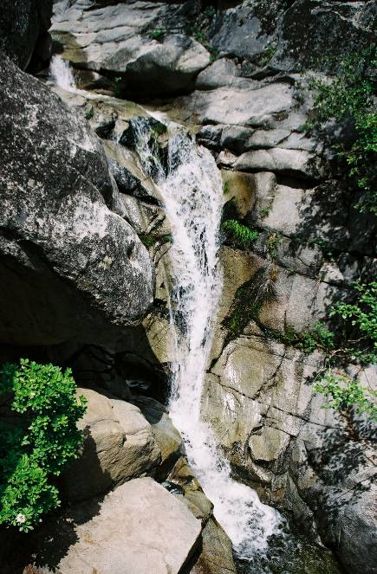
The North Fork San Jacinto River and its tributary, Fuller Mill Creek, offer a unique opportunity to protect a Southern California river from its alpine source to the foothills. The North Fork watershed was identified by the Forest Service as an area of high ecological significance. It is home to the southern-most population of endangered Mountain yellow-legged frog. The river’s upper watershed and tributaries (including Fuller Mill Creek) also contain high quality mixed conifer and big cone Douglas-fir forest. This old growth forest habitat supports several sensitive species, including nesting pairs of California spotted owl, the southernmost population of rubber boa, and the San Bernardino flying squirrel.
Steve Evans

The Pacific Crest Trail traverses the upper watershed of the North Fork. The popular Seven Pines Trail climbs up the North Fork through beautiful conifers and many granite boulders to the river’s headwaters at Deer Springs. The Dark Canyon Campground and Fuller Mill Picnic Area provide gateways to the river and can be accessed via Highway 243, which is part of the Palms to Pines Scenic Byway.

Downstream of Hwy 243, the river plunges into a wild and rugged canyon with only a few trails providing access, including the historic Webster trail, which is named after a fictional character in Helen Hunt Jackson’s 1884 novel, Ramona. This trail begins in the pine forest but then drops 1,800 feet into the chaparral-covered canyon to the river’s willow-lined banks. A popular off-highway vehicle trail also crosses this section of the river and provides motorized access to the backcountry.
National Wild & Scenic Rivers
Proposed in H.R. 6270
October 9, 2006
Bautista Creek

AT A GLANCE

bautista creek

CLASSIFICATION:
Recreational – 9.8 miles
Total: 9.8 miles

OUTSTANDING VALUES:
Wildlife
Historical/Cultural

AGENCY:
San Bernardino National Forest

COUNTY:
Riverside

CONTACT:
Steven L. Evans
Friends of the River
915 20th Street
Sacramento 95814
916.442.3155 #221
sevans@friendsoftheriver.org
www.friendsoftheriver.org

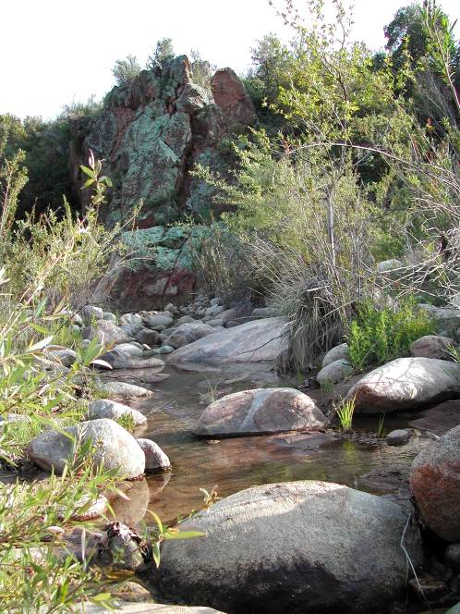
Bautista Creek supports the largest number of sensitive and endangered wildlife species on the San Bernardino National Forest. Although a seasonal stream, Bautista Creek is home to nationally significant populations of endangered arroyo toad and San Bernardino kangaroo rat. The endangered southwestern willow fly-catcher nests in the riparian habitat along the creek. The canyon also provides critical habitat for the endangered Quino checkerspot butterfly and supports several sensitive reptile, bird, and insect species. It is home to the largest of only two known populations of the endangered slender-horned spineflower on National Forest lands in Southern California.
Holly Owens

Bautista Creek also has outstanding cultural and historical values. There are several documented Native American place names within the drainage. In addition, Bautista Creek was the route of the historic de Anza expeditions in 1774 and 1776, which connected Mexico with San Francisco and ultimately led to the colonization of California. Following today’s Bautista Canyon Road, the route through the canyon, is a designated National Historic Trail.
National Wild & Scenic Rivers
Proposed in H.R. 6270
October 9, 2006
Palm Canyon Creek

AT A GLANCE

palm canyon creek

CLASSIFICATION:
Wild – 8.1 miles
Total: 8.1 miles

OUTSTANDING VALUES:
Wildlife
Historical/Cultural

AGENCY:
San Bernardino National Forest

COUNTY:
Riverside

CONTACT:
Steven L. Evans
Friends of the River
915 20th Street
Sacramento 95814
916.442.3155 #221
sevans@friendsoftheriver.org
www.friendsoftheriver.org

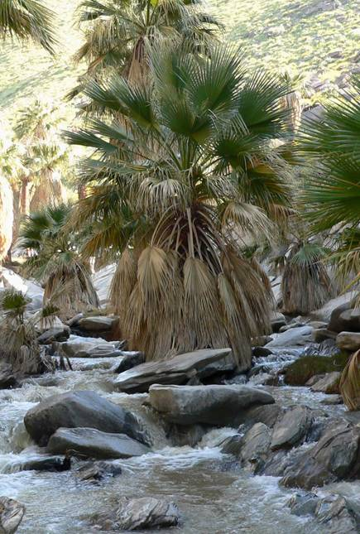
Palm Canyon Creek supports the largest California fan palm oasis in the United States. Relics from millions of years ago, the abundance of these native palms is nationally significant and unique. Palm Canyon’s seasonal surface flows, year-round springs, and
high water table are crucial to maintain the palm oasis and provide important water sources for the endangered Peninsular bighorn sheep.

Palm Canyon also provides habitat for the federally endangered southwestern willow flycatcher and least Bell’s vireo, and it is home to many other sensitive bird species, including summer tanager, yellow warbler, yellow-breasted chat, and gray vireo.
Stan Shebs

Native Americans have used Palm Canyon for more than two thousand years. A pre-historic trail follows the canyon and is used today by Native Americans for traditional purposes. The trail is also a popular route for hikers and mountain bike riders.

