Region 12: Atlanta-Sandy Springs-Marietta, GA CBSA

- Geographic Boundaries, Political Jurisdictions and Infrastructure

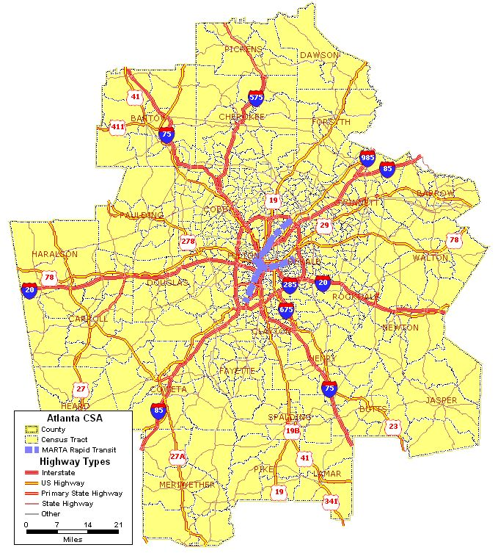
Map 12.1: Atlanta-Sandy Springs-Marietta CBSA Major Highways and Fixed Guideway System

The Atlanta-Sandy Springs-Marietta CBSA is comprised of 28 counties. The City of Atlanta is the most populous city in the CBSA and the most populous city in the State of Georgia. Atlanta also is the state capital. The CBSA is 8,483 square miles and has a total population of more than 4.2 million people. The state population in 2000 was 8,186,453.

The region is served by numerous interstate and U.S. highways. Interstates 85 and 75 are the primary north-south freeways and Interstate 20 is the primary east-west freeway. These freeways converge at Atlanta. Interstate 285 is a bypass that forms a beltway around downtown Atlanta. The region also is served by a number of U.S. Highways including Highways 19, 23, 29, 78, and 278. The Metropolitan Atlanta Rapid Transit Authority (MARTA) operates two heavy rail lines.

The CBSA is located on the Piedmont plateau, which divides the Appalachian Mountain chain and the fall line leading to the eastern seaboard. The climate of the Atlanta-Sandy Springs-Marietta CBSA is classified as humid subtropical, which is marked by hot, humid summers and mild winters. The region receives consistent rainfall throughout the year. Due to its proximity to Gulf of Mexico and the prevailing winds, the region receives a fair amount of severe weather including violent thunderstorms, tornadoes, tropical storms and hurricanes. Although the area does not receive an appreciable amount of snowfall during winter, the confluence of cold air from the north and tropical moisture from the Gulf can result in ice storms causing power outages and property damage. The region also is located near the Eastern Tennessee seismic zone, which is one of the more active earthquake zones in the eastern United States according to the U.S. Geological Survey (USGS). However, no damaging earthquakes have been recorded in the CBSA within the past 80 years.

- Agencies Operating in the Atlanta-Sandy Springs-Marietta, GA CBSA

Agency | Jurisdictions Served | Population Served | Operating Budget | Staff Size
Georgia DOT (GDOT) Districts 1, 2, 3, 6 and 7 | Barrow , Bartow , Butts , Carroll, Cherokee , Clayton , Cobb , Coweta , Dawson , DeKalb , Douglas , Fayette , Forsyth , Fulton , Gwinnett , Haralson , Heard , Henry , Jasper , Lamar , Meriwether , Newton , Paulding , Pickens , Pike , Rockdale , Spalding , Walton counties | 4,247,981 | $2 billion  (total agency) | 6,000  (total agency)
Atlanta Regional Commission (ARC) | Cherokee, Gwinnett, DeKalb, Cobb, Douglas, Fulton, Fayette,  Clayton, Rockdale, Henry, Coweta, Forsyth, Paulding, Barrow, Bartow, Hall Newton, Spaulding, Walton | 3.8 million | $5.4 Million | (a)
Metropolitan Atlanta Rapid Transit Authority  (MARTA) | Fulton, DeKalb, Atlanta | 1,541,500 | $3.0 million | 4,355
Cobb Community Transit | Sandy Springs, Canton, Kennesaw, Smyrna, Atlanta, Vinings, Mableton, Lithia Springs, Powder Springs, Woodstock, Hiram,  Arcworth | 630,000 | $475 million | 155
Georgia Regional Transportation Authority  (GRTA) | Cherokee, Gwinnett, DeKalb, Cobb, Douglas, Fulton, Fayette,  Clayton, Rockdale, Henry, Coweta, Forsyth, Paulding, | (a) | (a) | (a)
Gwinnett County Department of Transportation | Auburn, Berkeley Lake, Braselton, Buford, Dacula, Duluth, Grayson, Lawrenceville, Lilburn, Loganville, Nocross, Rest Haven, Snellville,  Sugar Hill, Suwanee | 726,723 | $1.5 billion | 171
Georgia Rail Passenger Authority | State of Georgia | 9,072,576 | $2.82 billion | (a)
(a) Not available

Table 12.1: Atlanta-Sandy Springs-Marietta CBSA Transportation Agencies

- Transit Service Area: Fixed Guideway and Bus Service Area

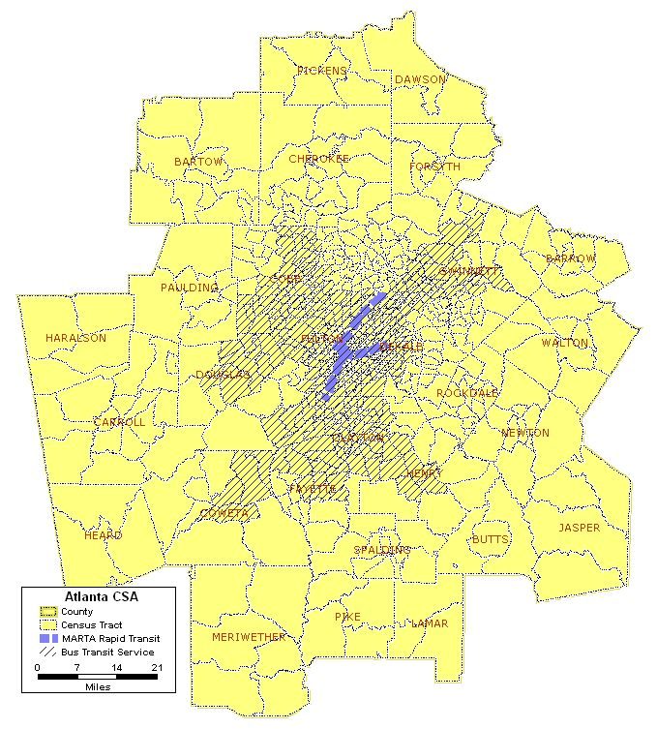
Map 12.2: Atlanta-Sandy Springs-Marietta CBSA Fixed Guideway and Bus Transit Service Area

There are a number of public transportation operators in the CBSA that provide fixed-route bus service. These agencies are identified in Table 12.1. Passenger rail services are provided by the Metropolitan Atlanta Rapid Transit Authority (MARTA). The following is a brief description of the public transportation agencies in the CBSA.

  - MARTA – operates 125 bus routes using 691 buses. In 2004, MARTA carried more than 66 million unlinked passenger trips on its bus system. In addition to bus service MARTA, operates two heavy rail (rapid transit) lines, the North-South Rail Line and the East-West Rail Line. Service is provided to 38 stations along a 48 mile rail network using 350 rail cars. In FY2004, MARTA rail service carried more than 69 million passenger trips. MARTA also provides paratransit services using a fleet of 110 paratransit vans and carrying more than 306,000 trips annually.

  - Cobb Community Transit (CCT) – operates 19 bus routes, including local and peak-hour express services. It operates a fleet of 66 buses through a private contractor. In FY2004, CCT provided 3.4 million passenger trips. CCT also operates a fleet of 15 paratransit vans for persons with disabilities unable to use the fixed route system. CCT provided approximately 58,000 paratransit trips in FY2004.

  - Georgia Regional Transportation Authority (GRTA) – GRTA was established in 1998 to improve regional mobility. Under agreements with a number of counties in the region, GRTA sponsors services that are designed to relieve congestion. These services are operated under contract and consist of express commuter bus service and vanpool services. In FY2004, services operated under GRTA’s sponsorship involved 138 buses providing express commuter services and 67 vehicles in vanpool operations. In the same year, GRTA services carried 6.1 million bus passenger trips and approximately 170,000 vanpool trips.

  - Gwinnett County Department of Transportation – operates the Gwinnett County Transit (GC Transit) service. The service began in 2000 consists of a mix of local (seven routes), express (six routes) and paratransit service. In addition to its own services, GC Transit operates two express bus routes for GRTA. GC Transit’s services are operated using a fleet of 60 buses and eight paratransit vehicles. All of GC Transit’s services are contracted out to private providers. In FY1994 GCT carried approximately 1.6 million passenger trips on its fixed-route bus services and 3,500 trips on its paratransit services.

  - Georgia Rail Passenger Authority – the Authority was formed to plan and develop intra-city and commuter rail projects for the State of Georgia. Currently, the Authority does not operate any transportation services.

- Number and Proportion of Minority, Below Poverty and Limited English Proficient Populations in Relation to the Transit Service Area
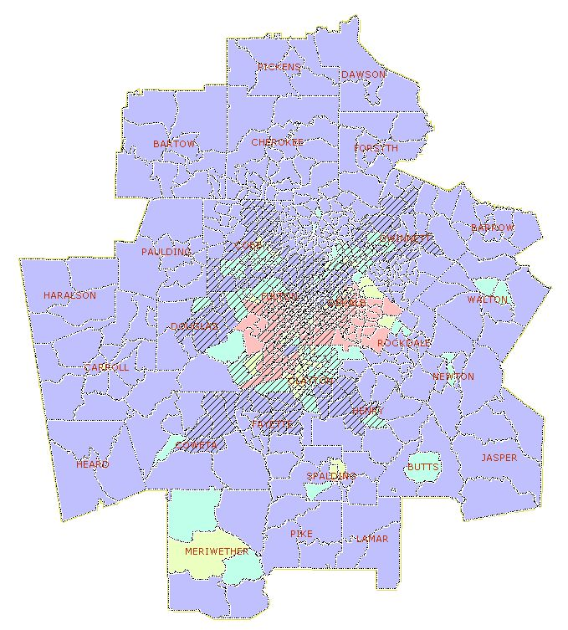
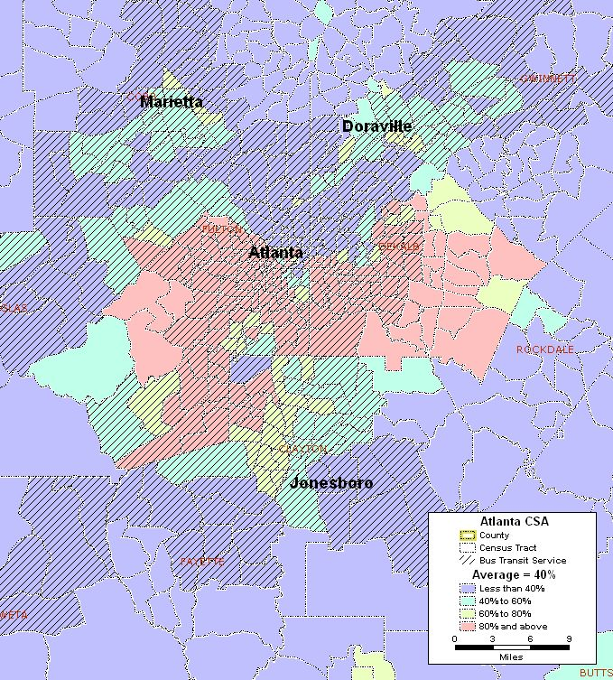
Map 12.3: Atlanta-Sandy Springs-Marietta CBSA Minority Population
Area of Detail
Total Number of Census Tracts in CBSA 690
Total Population of CBSA 4,247,981
Total Minority Population residing in CBSA 1,552,523
Regional Average of Minority Population in the CBSA 40%
Number (%) of Census Tracts with above average minority population 280 (41%)
Total Minority Population in the above average census tracts 1,100,000

According to 2000 U.S. Census data, 40 percent of the population in the Atlanta-Sandy Springs-Marietta CBSA are minority. Of the 690 census tracts in the CBSA, 280 have a higher than average minority population. Together the minority population for these 280 census tracts is 1.1 million people. As shown in Map 12.3, the majority of these census tracts are in the City of Atlanta. Other areas of higher than average minority populations include Marietta, Doraville, and Jonesboro. Isolated census tracts of higher than average minority populations also occur in the southern counties (i.e., Meriwether, Spalding and Butts) as well as counties to the east (i.e., Newton and Walton). Although there is a significant amount of transit coverage in the minority counties, many are not currently served by transit, reflecting the large proportion of service that is oriented towards suburban commuters. Thirty-nine of the 280 census tracts that have higher than average minority populations are currently not served by public transit. These census tracts account for approximately six percent (256,581 persons) of the total CBSA population.

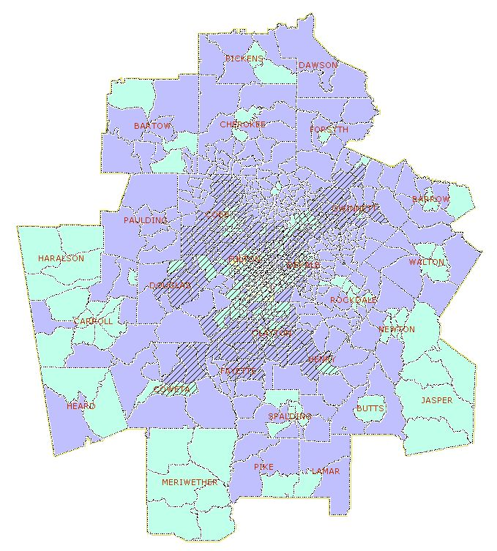
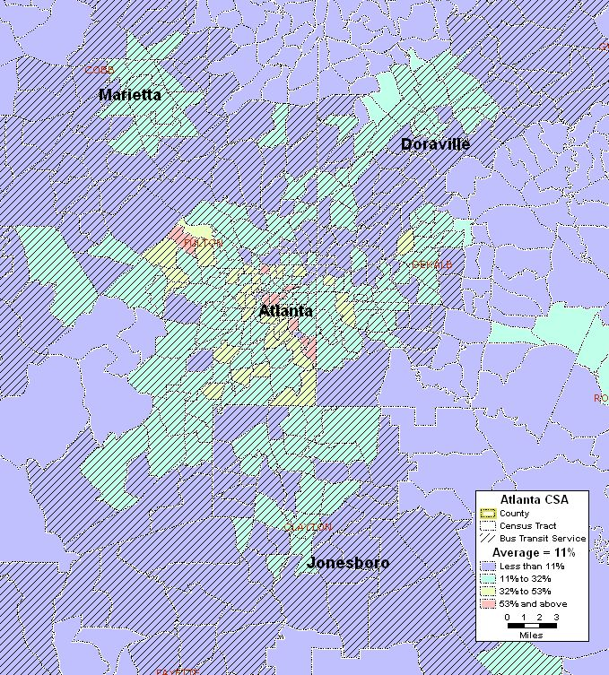
Map 12.4: Atlanta-Sandy Springs-Marietta CBSA Below Poverty Population
Area of Detail
Total Number of Census Tracts in CBSA 690
Total Population of CBSA 4,247,981
Total Below Poverty Population residing in CBSA 397,037
Regional Average of Below Poverty Population in the CBSA 11%
Number (%) of Census Tracts with above average Below Poverty pop. 258 (37%)
Total Below Poverty Population in the above average census tracts 242,142

Approximately 11 percent (397,037 people) of the CBSA’s population is below the poverty level. Of the 690 census tracts in the region, 258 have below poverty populations that exceed the regional average, which accounts for 242,142 persons. Most of these tracts are concentrated in the urban areas – Atlanta, Marietta and Doraville – as shown in Map 12.4. Pockets of below poverty census tracts also occur in the more rural areas surrounding the central urban core. Nearly all of the census tracts in the urban areas with higher than average below poverty populations are served by public transit. However, 65 of the census tracts with higher than average below poverty populations lie outside of the transit service area. These tracts account for nearly eight percent (332,921 persons) of the total CBSA population.

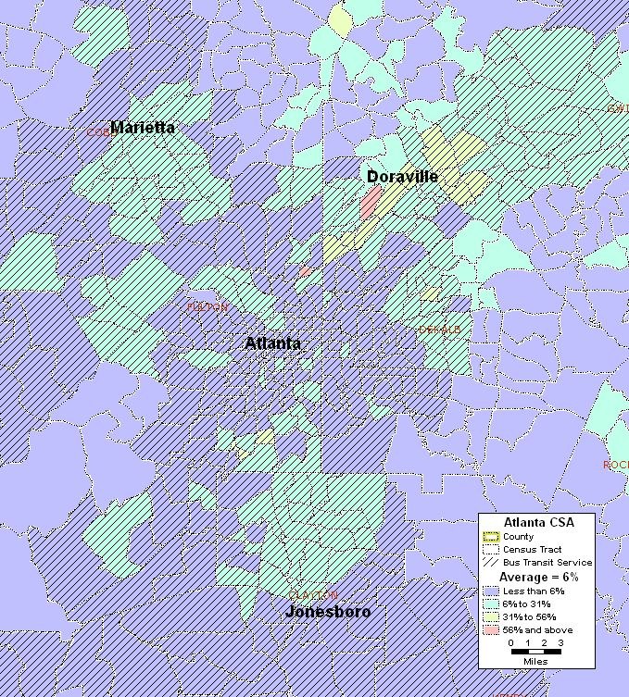
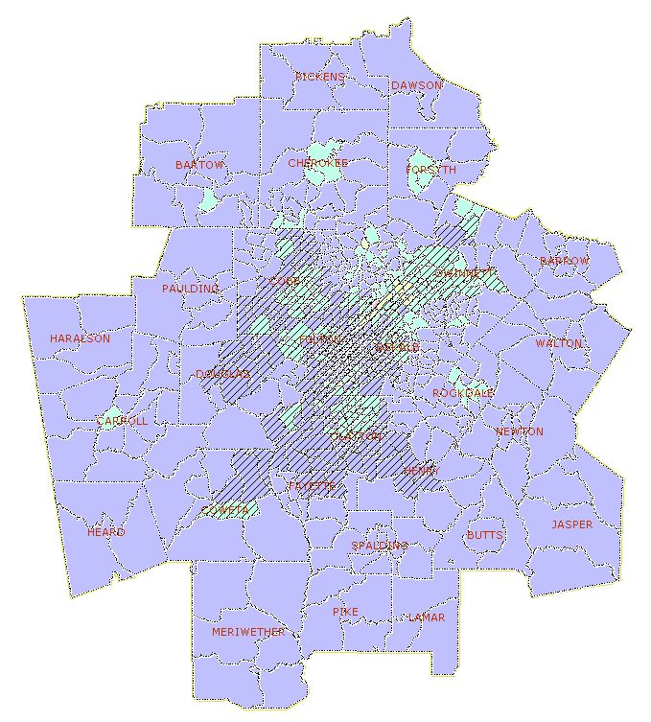
Map 12.5: Atlanta-Sandy Springs-Marietta CBSA Limited English Proficient Population
Area of Detail
Total Number of Census Tracts in CBSA 690
Total Population of CBSA 4,247,981
Total Population (5 years and older) of CBSA 4,190,991
Total LEP Population* residing in CBSA 259,256
Regional Average of LEP Population* in the CBSA 6%
Number ( %) of Census Tracts with above average LEP population* 196 (28%)
Total LEP Population* in the above average census tracts 186,996

* LEP includes those 5 years of age and older

The distribution of census tracts with higher than average populations of persons with limited English proficiency (LEP) is shown in Map 12.5. There are 196 census tracts with higher than average LEP populations. The LEP populations in these areas is 186,996 people. As shown in Map 12.5, the majority of these census tracts are in the urbanized area and are fairly well served by public transit. However, 33 of the 196 census tracts with higher than average LEP populations are outside of the transit service area, representing slightly over five percent (220,241 persons) of the total CBSA population.

- Number and Proportion of Zero Car Households: Greater than the Regional Average
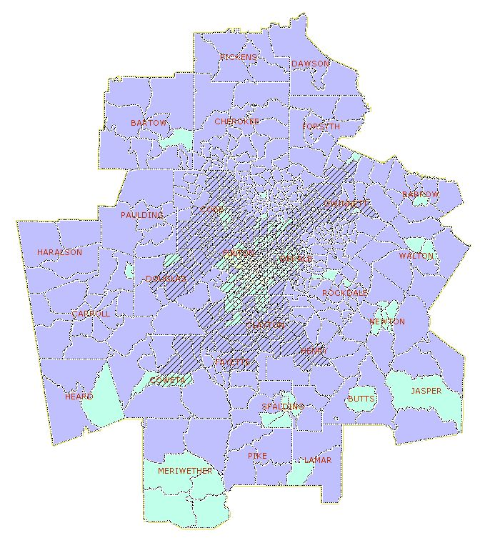
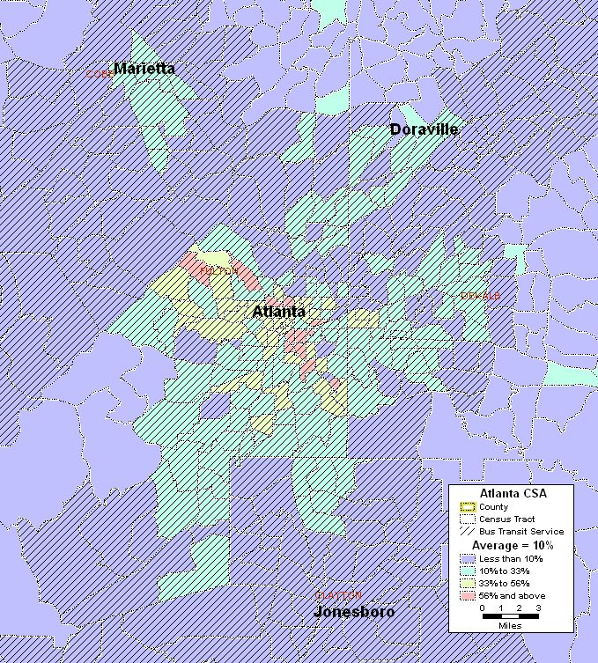
Map 12.6: Atlanta-Sandy Springs-Marietta CBSA Zero Car Households
Area of Detail
Total Number of Census Tracts in CBSA 690
Total Households in CBSA 403,240
Total Zero Car Households in CBSA 114,014
Regional Average of Zero Car Households in the CBSA 10%
Number (%) of Census Tracts with above average Zero Car Households 189 (27%)
Total Zero Car Households in the above average census tracts 67,383

There are 114,014 households in the CBSA that do not have a car, approximately 10 percent of all households. The census tracts with higher than average number of zero car households are shown in Map 12.6. Of the 690 census tracts in the CBSA, 189 have a higher than average number of zero car households. These 189 census tracts account for 67,383 of the zero car households in the region. The majority of these households are in the Atlanta, Marietta and Doraville areas and are well served by public transit. The remaining census tracts (34 of the 189) with higher than average zero car households are in the rural areas in the outlying counties of the CBSA and are not served by transit. These tracts account for 3.8 percent (163,201 persons) of the total CBSA population.

- Number and Proportion of Minority Population with Overlay of Below Poverty Population
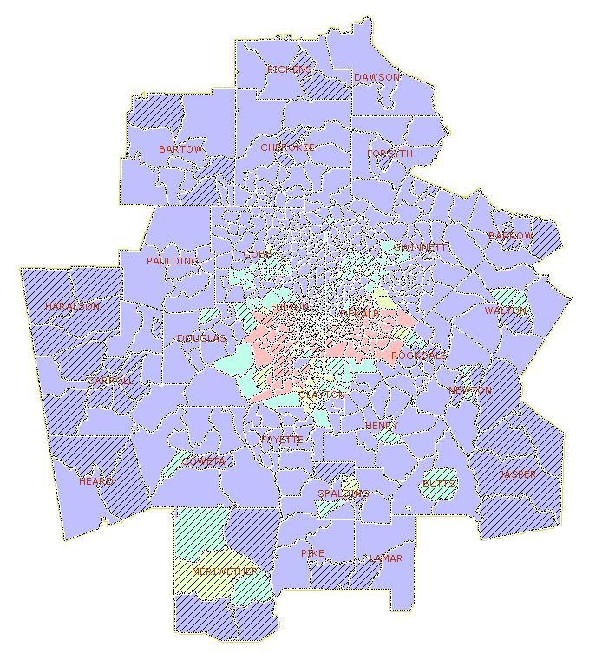
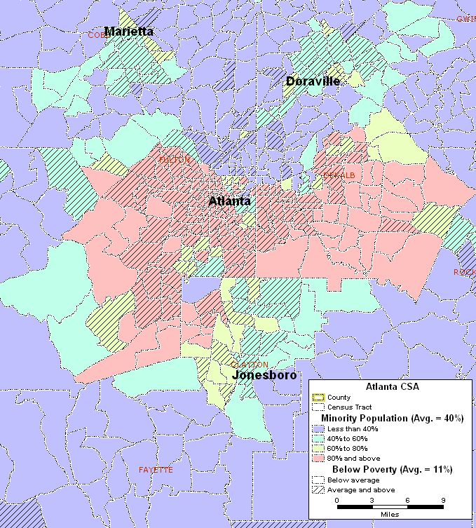
Map 12.7: Atlanta-Sandy Springs-Marietta CBSA Minority Population with an Overlay
Area of Detail
of Below Poverty Population
Map 12.7 shows the distribution of minority census tracts with an overlay of census tracts with above average below poverty populations. As shown, there is a significant amount of overlap between these two statistics. There are 187 census tracts (27 percent) in which the minority and below poverty populations are above the regional averages for these statistics. The areas of overlap occur mostly in Atlanta, Marietta, Doraville, and Meriwether County.

- Number and Proportion of Minority Population with Overlays of Below Poverty Population and Zero Car Households
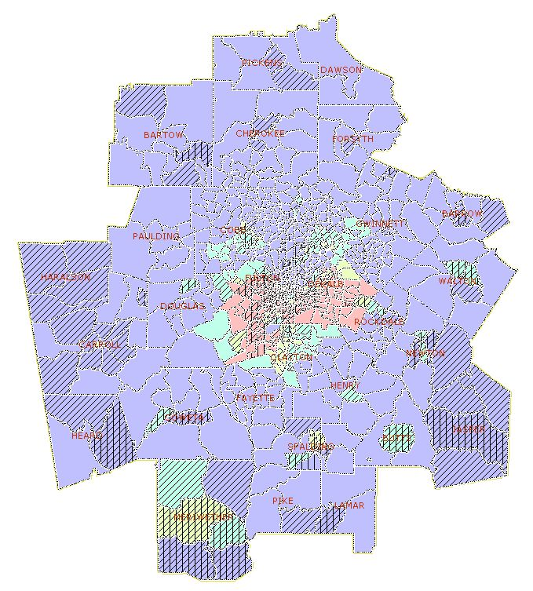
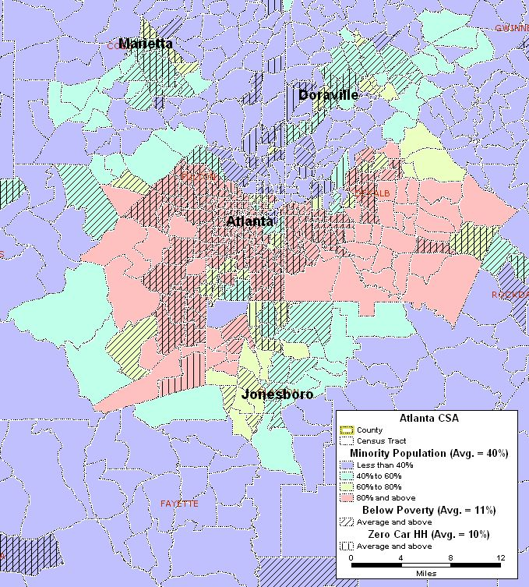
Map 12.8: Atlanta-Sandy Springs-Marietta CBSA Minority Population with Overlays
Area of Detail
of Below Poverty Population and Zero Car Households
Map 12.8 shows the minority population with overlays of the census tracts with higher than average below poverty populations and the census tracts with higher than average zero car households. Similar to Map 12.7, there is a significant number of census tracts in which all three statistics coincide. In total, 146 census tracts (21 percent) have above average values for these three statistics. Furthermore, the areas in which these statistics are coincident include Atlanta, Marietta, parts of Doraville and Meriwether County.

- Correlation Among Minority Population, Below Poverty Population, LEP Population and Zero Car Households

 | Minority | Below Poverty | LEP | Zero Car HH
Minority | 1.00
Below Poverty | 0.63 | 1.00
LEP | 0.15 | 0.13 | 1.00
Zero Car HH | 0.63 | 0.90 | 0.05 | 1.00

Table 12.2: Atlanta-Sandy Springs-Marietta CBSA Correlation Coefficients

As has already been shown in the maps of these statistics, there is a positive correlation between minority and below poverty populations of 0.63 (see Table 12.2). Likewise, the correlation between minority populations and zero car households appears to be fairly strong with a 0.63 correlation coefficient. The strongest correlation exists between the below poverty population and zero car households with a 0.90 correlation coefficient. Limited English proficiency does not seem to have a correlation with any of the other statistics.

- Natural Disasters

Event(s) | Date | Location | Human Impact | Financial Impact
Flooding, Severe Storm, Tornadoes | February 10, 1990 | Douglas, Fulton, Cobb, Clayton, Gwinnett, Coweta, Henry, Lamar, Spalding, DeKalb, Walton, Butts,  Newton | 3 deaths  16 injuries | $10.5 million
Heavy Rains, High Winds, Tornadoes | November 22, 1992 | Cobb, Cherokee, Fulton, Henry, Spaulding | 0 deaths  49 injury | $30.3 million
Tornadoes, Flooding, Heavy Rain, Tropical Storm Alberto | July 7, 1994 | Fulton | 1 death  2 injuries | $116,000
Hurricane Opal | October 10, 1995 | Atlanta metropolitan area | 8 deaths  7 injuries | $125 million
Ice Storms | January 22, 2000 and  January 28, 2000 | Barrow, Bartow, Butts, Carroll, Cherokee, Cobb, Dawson, DeKalb, Douglas, Forsyth, Fulton, Gwinnett, Haralson, Henry, Jasper, Lamar, Newton, Paulding, Pickens, Pike, Rockdale, Spalding counties | 0 deaths  1 injury | $50 million
Flood damage/Hurricane  Frances | September 4, 2004 | Atlanta metropolitan area | None | $41.1 million
Hurricane Ivan | September 18, 2004 | Carroll, Cherokee, Clayton,  Cobb, Dawson, DeKalb, Forsyth, Fulton, Heard counties | None | (a)
Tropical Storm  Frances | September 24, 2004 | Butts, Jasper, Lamar, Pike, Spalding | None | (a)
Scattered winds, flood damage/ Hurrican Dennis | July 11, 2005 | Atlanta metropolitan area | 0 deaths  1 injury | $16.2 million
High winds and flooding/Hurricane Katrina | August 29, 2005 | all 159 counties | 1 death  10 injuries | $14.6 million
(a) No significant damage reported

Table 12.3: 20-Year History of Natural Disasters in the Atlanta-Sandy Springs-Marietta CBSA (Source: FEMA and NOAA National Climatic Data Center)

The majority of the natural disasters occurring in the Atlanta-Sandy Springs-Marietta CBSA result from hurricanes, tropical storms and tornadoes as shown in Table 12.3. Most of the fatalities, injuries and damage from these storms result from the flooding that occurs due to the significant amounts of rain that fall, flooding rivers, creeks and streams and overwhelming storm drainage systems. The only other natural disaster occurring in the CBSA during the past 20 years were ice storms in January 2000. The injuries and damage resulting from these storms are mainly due to vehicular accidents on iced-over roadways as well as downed power and communication lines.

- Man-made Disasters

Event(s) | Date | Location | Human Impact | Financial Impact
Olympic Village Bombing | July 27, 1996 | Atlanta (DeKalb County) | 2 deaths  111 injuries | (a)
Bio Lab Fire | May 25, 2004 | City of Conyers (Rockdale County) | (a) | (a)
(a) No significant damage reported

Table 12.4: 20-Year History of Man-made Disasters in the Atlanta-Sandy Springs-Marietta CBSA

As shown in Table 12.4, two man-made disasters have occurred in the CBSA during the past 20 years. The first disaster, the Olympic Village bombing, occurred on July 27, 1996 while the City of Atlanta hosted the Games of the XXVI Olympiad. The bombing was perpetrated by Eric Robert Rudolph and killed two people and injured 10 others. The second event occurred in May 2004 and involved a fire at a company that supplies chemicals, including chlorine, for swimming pools. The fire resulted in the evacuation of several hundred people in the area and closed down Interstate 20 until the fire was brought under control.

In addition to these events, there are potential events that could threaten people who live and work in the CBSA including other industrial accidents involving chemical and bioscience companies. Other potential events include possible terrorist strikes, particularly by groups focusing on major corporations and government facilities. The Atlanta-Sandy Springs-Marietta CBSA is the home to a number of major corporate headquarters including The Coca-Cola Company, Home Depot, Bell South and the United Parcel Service – all Fortune 500 companies. Other corporate headquarters in the CBSA include the Cable News Network (CNN) and a number of its sister networks (e.g., Cartoon Network, TNT and TBS), which are all owned by Time Warner. The Weather Channel also broadcasts from the CBSA. The region also is the home of the Centers for Disease Control and Prevention (CDC), an agency within the U.S. Department of Health and Human Services. Any of these entities could be likely targets for terrorist groups.

The potential for radiological hazards is relatively low since there are no nuclear facilities in the region. The closest nuclear facilities are the Sequoyah Plant in Chattanooga, Tennessee (118 miles to the north of Atlanta) and the Vogtle Plant (148 miles to the east of Atlanta) in Augusta, Georgia.

