BAER Final Report

Invasive Plant Monitoring Following 2004 Fires
USFWS National Wildlife Refuges – Alaska Region
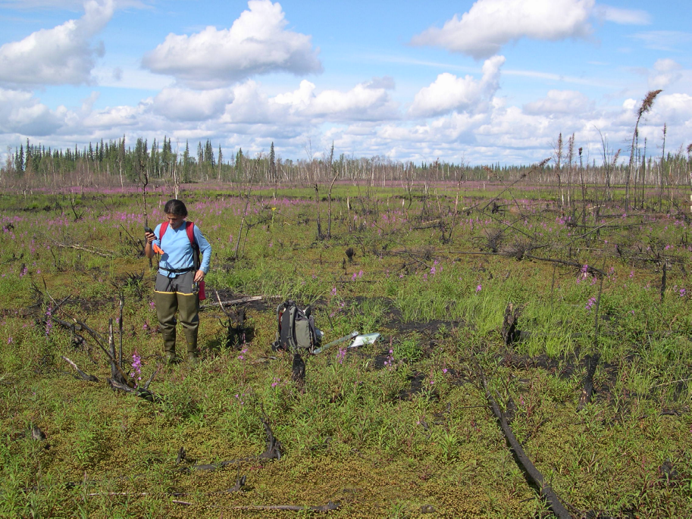

Collection site. Kanuti National Wildlife Refuge.

Helen Cortés-Burns and Matt Carlson

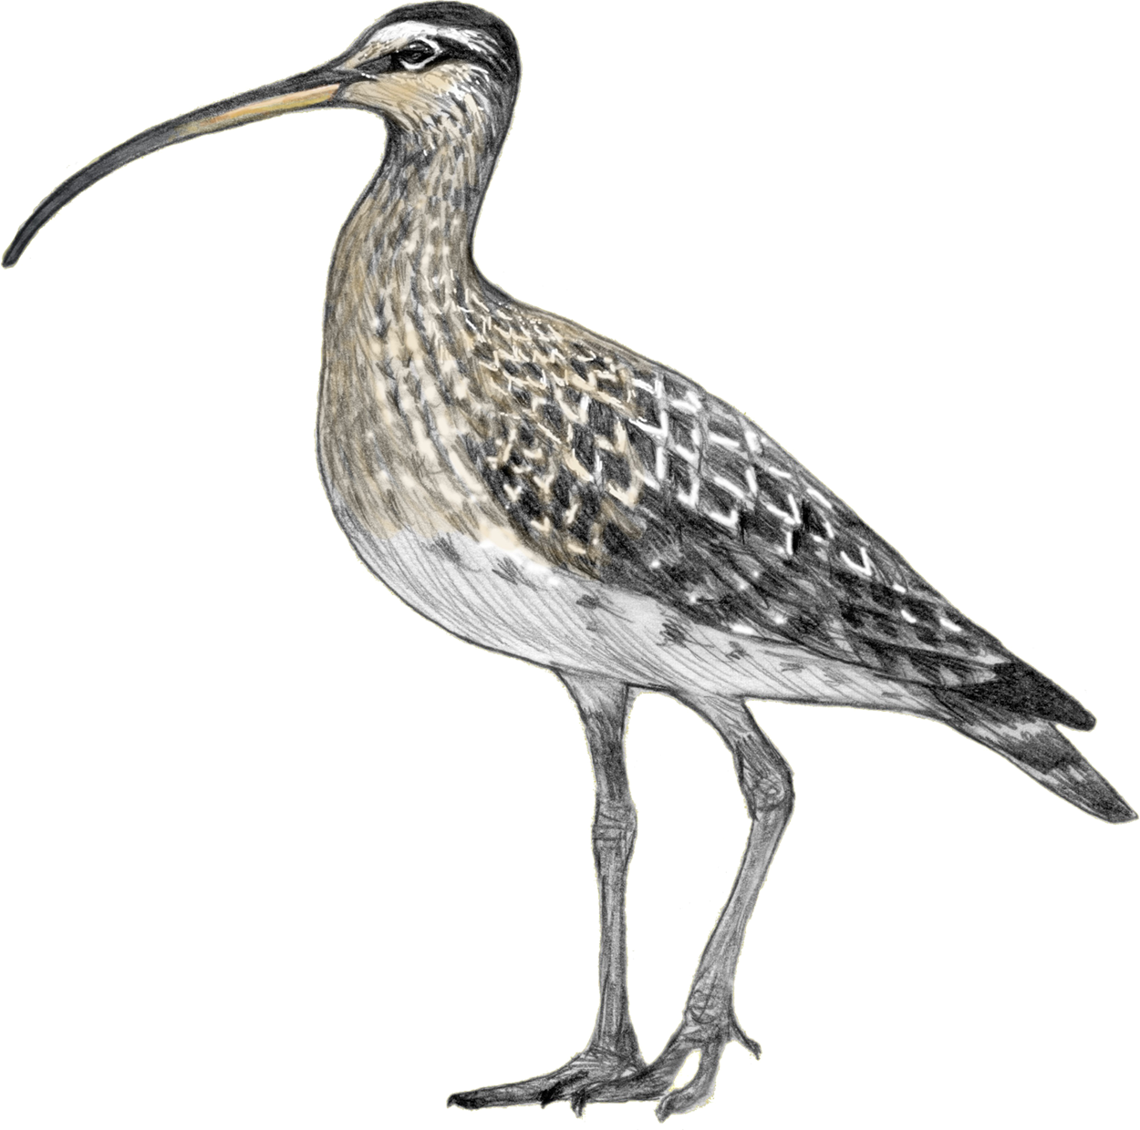
Alaska Natural Heritage Program
Environment and Natural Resources Institute
University of Alaska Anchorage
707 A Street
Anchorage, Alaska 99501

Report funded by and prepared for:
USFWS, Alaska Regional Office

February 2006

Abstract - 4 -
Acknowledgements - 5 -
Introduction - 6 -
Treatment Specification - 6 -
Logistics, sampling protocols, and data analysis - 7 -
Pre-fieldwork: logistics - 7 -
Fieldwork: methodology - 7 -
Temporary plots - 8 -
Permanent plots - 8 -
Post-fieldwork: data processing - 9 -
Fieldwork/Activity Accomplishments - 10 -
Kenai Refuge - 10 -
Indian Creek - 10 -
Moose Creek - 11 -
Clear Creek - 12 -
Tetlin Refuge - 12 -
Lakeview Campground - 13 -
Deadman’s lake Campground - 13 -
Roadside campground - 13 -
Gardiner Creek - 14 -
1990, 1996 and 1998 burns - 15 -
Kanuti Refuge - 16 -
Fish Creek Lake - 16 -
South Fork of the Koyukuk - 16 -
Clawanmenka, Kaldolyeit and Minnkokut Lakes - 17 -
Bettles - 17 -
Yukon Flats Refuge - 18 -
Winter Trail Fire - 18 -
Lower Mouth Fire - 19 -
Dall City Fire - 20 -
Preacher Creek Fire - 20 -
Fort Yukon - 20 -
Summary of findings - 21 -
Treatment Effectiveness - 22 -
Future Directions & Recommendations - 23 -
References - 24 -
Appendices - 25 -
Table 1. List of non-native plant species found in Kenai National Wildlife Refuge. - 25 -
Table 2. List of non-native plant species found in Tetlin National Wildlife Refuge. - 26 -
Table 3. List of non-native plant species found in Yukon Flats National Wildlife Refuge. - 28 -
Table 4. List of non-native plant species found in/near the Bettles, near Kanuti refuge. - 29 -
Table 5. Kenai waypoints. - 30 -
Table 6. Tetlin waypoints. - 31 -
Table 7. Kanuti waypoints. - 32 -
Table 8. Yukon Flats waypoints. - 33 -
Maps of sites visited and surveyed in Kenai. - 34 -
Maps of sites visited and surveyed in Tetlin. - 36 -
Map of sites visited and surveyed in Kanuti. - 38 -
Maps of sites visited and surveyed in Yukon Flats. - 39 -
Table 9. Burn severity code matrix - 41 -
Table 10. US Forest Service/AKNHP list of “Alaskan Invasive” plant species. - 46 -

Abstract
We have completed inventories for specified 2004 fires on Kenai, Tetlin, Yukon Flats and Kanuti Refuges. Overall, areas burned in 2004 do not appear to harbor greater numbers of non-native plants than unburned regions at this time (i.e. first growth season following the fires). Non-native establishment was recorded in 30 of the 68 sites visited. Based on the data collected during the 2005 field season, we conclude that invasive plant infestations are strongly correlated with high-intensity human use zones (roads, cabins, campgrounds, trails, allotments), and hold little (or no) relation to burn severity. However, because there were few signs of revegetation in most of the burned sites when we conducted the surveys (neither by native nor non-native species), it is crucial that we continue to monitor these same burned sites throughout the next 2-5 growth seasons in order to corroborate the herein hypothesized lack of correlation between burn severity and non-native plant establishment in Alaska’s ecosystems.

Acknowledgements
This project was funded by the Fish and Wildlife Service, USDI. Karen Murphy gave helpful comments and direction through this process. We also thank the staff at each of the refuges visited for providing assistance with fieldwork logistics.

Introduction
Non-native plant species pose a serious threat to native ecosystems: they alter community composition, successional pathways, and fire regimes, as well as reduce or eliminate threatened and endangered native species populations (Busch 1995, Brooks 1999).

While they are a major threat to National Wildlife Refuge Lands (NWR) in the Lower 48 states (cf. Randall 1996), Alaska has until recently been considered immune to this problem (Shephard 2004). In the past five years, however, an increase in commercial and leisure activities connecting urbanized and developed areas to the backcountry, combined with the longer growth season and milder winters that result from climate change, have changed this perception (Shephard 2004). Even so, invasive plant species in Alaska still do not constitute as great a threat as they do in the rest of the country, because they are largely restricted to the few regions of greatest anthropogenic disturbance. Consequently, land managers in Alaska have a unique opportunity to be proactive in managing exotic and invasive plants.

Invasive plants are generally opportunistic, early successional species, and therefore thrive under the types of conditions created by disturbance activities: increased light and nutrient availability, reduced interspecific competition, and increased bare soil (Rejmanek 1989). In this context, the 2004 fires that burned over six million acres in Alaska provided an ideal opportunity for the expansion of established weeds and invasion of new weed species into the state’s wildlands.

As part of the Burned Area Emergency Rehabilitation and Stabilization plan for Alaska’s 2004 fires, the U.S. Fish and Wildlife Service (FWS) received funding to investigate fire related sites that may have introduced invasive plants, and entered into a cooperative agreement with the Alaska Natural Heritage Program (AKNHP), University of Alaska, to study the interaction of fires and weed invasion in selected sites in five National Wildlife Refuges (Innoko, Kanuti, Kenai, Tetlin, and Yukon Flats). (Although we were unable to organize fieldwork with Innoko Refuge personnel in time for the 2005 field season, we plan to survey selected sites for this refuge in 2006, using the funds remaining from the 2005 FWS-AKNHP grant).

The AKNHP agreed to investigate sites where people and equipment were located on refuge lands, such as helispots, camp sites, staging areas, dozer lines, hand lines, etc. Potential ‘source’ locations (where invasive plants are known or are reasonably expected to occur) were also investigated within Refuge boundaries or off-refuge if appropriate landowner permission was obtained. High severity burn sites located within 1 mile of source sites (communities, cabins, roads, travel corridors etc…) were monitored since the exposed mineral soil at these high burn severity sites may be particularly susceptible to the establishment of non-native plants. The FWS provided local expertise at each refuge, and participated in one of the field sampling trips. This final report includes a description of the methods used to conduct the 2005 surveys, an account of the data collected at each site, and a discussion of most likely determinants underlying the presence/absence of invasive plant species in the different refuges visited.

Treatment Specification
V-2 Noxious and Invasive Plant Monitoring and Control, CESU Agreement # 10100-0-J001

Logistics, sampling protocols, and data analysis

Pre-fieldwork: logistics
AKNHP and additional UAA staff set up the grant, hired, and assigned personnel to work on the project. With assistance and guidance from USFWS staff, we identified priority sites within specific fires from 2004 in four refuges.

In this work, we define “priority sites” as those that are most likely to be invaded by non-native plants following the 2004 fires, due to a) their proximity to high human use/high disturbance zones, and/or b) their proximity to a high severity burn, where the soil burned down to the mineral layer, thus facilitating non-native plant establishment (Harrod & Reichard 2001). The priority sites visited included allotments, cabins, campsites, dozer lines, helispots, rivers, roads, trails, travel corridors (Winter trails), and associated high severity burned areas near these locations.

Using a series of GIS shapefiles provided by FWS, AKNHP constructed a time table and made the logistical arrangements needed to reach all the priority sites listed by FWS. We contacted the local refuge personnel from each of the refuges to coordinate our sampling and get more detailed logistical information. Special use permits were obtained from refuges requiring them. Transportation arrangements were made for each of the refuge trips. FWS provided local expertise at each refuge, and participated in one of the field sampling trips (Merben Cebrian, Tetlin NWR).

Fieldwork: methodology
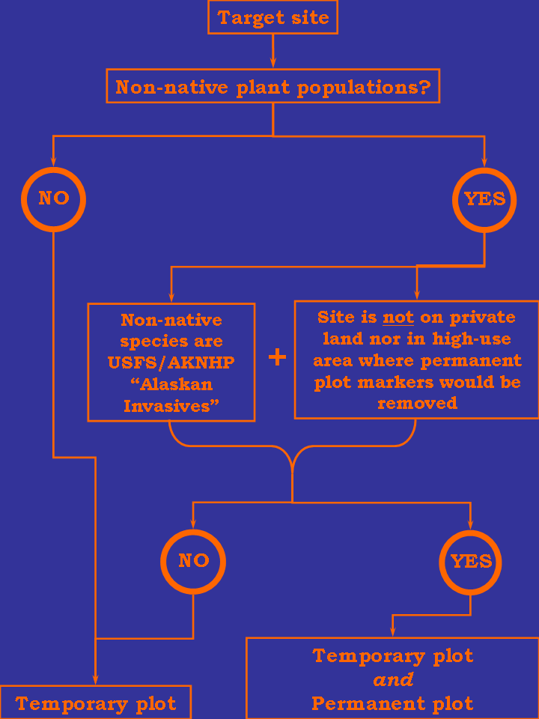
Fig. 1. Decision-making process followed to determine what kind of plot should be read at a given site
From early May to mid-June we coordinated with USFWS staff on sampling protocols and developed datasheets to best address the type of problems that we were likely to encounter in the field. Two types of datasheets were created: one for temporary and one for permanent plots (blank copies of these are provided in the “USFWS AKNHP 05 dtshts” excel file, included in the “BAER AKNHP FWS Report” folder).

At every site visited temporary plots were read, whether or not they had non-native plant species. In contrast, permanent plots were only set up when the following three conditions were met (Fig. 1):
- invasive plant species were in/near the site
- one or more of these species is listed as “Alaskan Invasive” by the US Forest Service/AKNHP (Appendices, Table 10)
- the site is not on private land nor in a high-use area where permanent plot markers are likely to be removed by people

Temporary plots
In the temporary plots we inventoried the plant species diversity (including percent cover for each species) within a 10m² area (for a blank sample of this datasheet, cf. the “USFWS AKNHP 05 dtshts” excel file). Information on the amount and type of unvegetated ground within the plot was also noted. We described the surrounding habitat/landcover classes, recorded the soil pH, and made soil profiles down to the first 10cm. For non-native taxa, we also collected AKEPIC data: size of the infestation, age and type of disturbance, and control methods employed, if any. In burned areas we took note of any vegetation and soil fire indicators (% ground burned, % trees dead from fire, burned needles, fire scars, etc.), and also assigned a soil and vegetation severity burn code to each plot (these codes had been established by FWS fire ecologists. See Appendices, Table 9, for a description of these codes, and Appendices, Figs. 28-43, for photographs of sites with different burn severity codes).
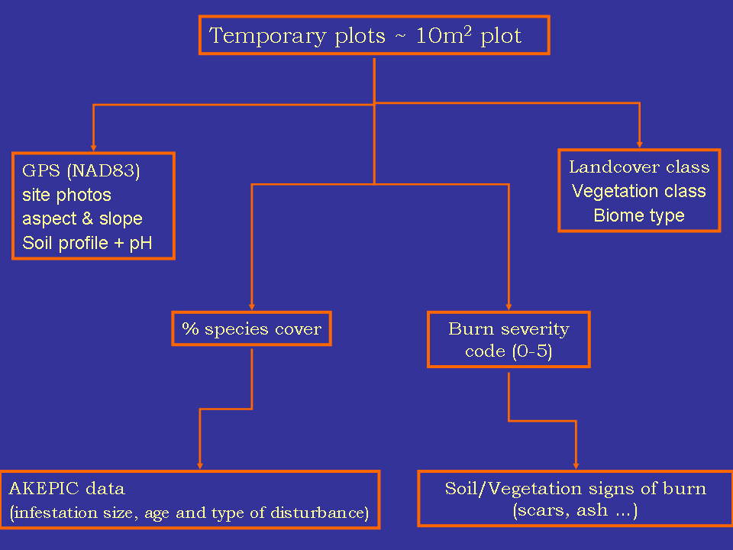
Fig. 2. Chart illustrating the key data collected for each temporary plot.

Permanent plots
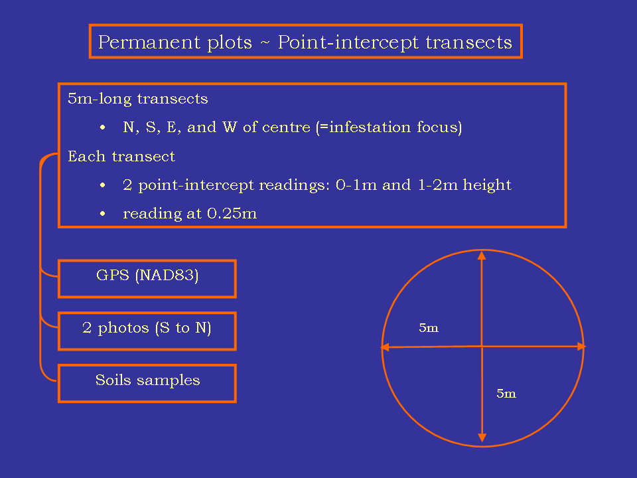
Fig. 3. Chart illustrating the key data collected for each permanent plot.
Permanent plots followed protocols developed in coordination with FWS, and only two were set up, both of which are located in Tetlin refuge (waypoints #25 and #33) and had Melilotus alba infestations (this species is included in the USFS/AKNHP “Alaskan invasive” list, cf. Appendices, Table 10).
Below we briefly summarize the steps followed to erect a permanent plot:
- Plant marker rods at the center of the (white sweetclover) infestations
- Establish four, 5m long transects that radiate from the infestation foci/marker in each of the cardinal directions
- Take a total of 80 point-intercept readings along the transects (20 per transect, at 0.25m distance each)
- At each point, count: a) species intercepting between 0-1m, and b) species intercepting between 1-2m
- Collect soil samples from the plot
- Take two photographs of the site. The pictures require that there be an observer or object/point of reference. The photographer must stand at the end of the 5m transect that runs south of the infestation focus, and then takes a photograph centered on the observer/point of reference, which must be situated at the end of the 5m transect running north of the plot’s center. The second picture is taken vertically, by moving the camera 20cm to the right of the observer/point of reference.

Post-fieldwork: data processing
All plant material collected was identified, and herbarium specimens will be made using the majority of non-native plants collected, as well as some native taxa. The data collected at each site were compiled into the database included in this report. GIS shapefiles showing the location of a) the sites visited in each refuge, and b) the native and non-native plant species collected at each on of these sites are also provided. In addition, non-native plant collections data are being entered into AKEPIC, the statewide non-native plant database.

Fieldwork/Activity Accomplishments

Kenai Refuge
On 27 July 2005 the two principal investigators (M. L. Carlson and K. W. Boggs) and research associate botanist (Helen Cortes-Burns) traveled to the Glacier Creek Fire on Tustumena Lake. While waiting for the USFWS at the upper Kasilof River landing we conducted an AKEPIC plant survey and observed a number of non-native species (Taraxacum officinale ssp. officinale, Matricaria discoidea, Trifolium hybridium, Phleum pratense, Poa annua, and Polygonum aviculare). These species were observed at the transition from imported fill and the vegetative margin of the boat launch parking lot, down to the river’s edge. We did not observe any highly invasive species such as Phalaris arundinacea, Melilotus alba or M. officinale, or Hieracium aurantiacum. However, we did observe the extremely invasive Hieracium aurantiacum along roadsides in a new development adjacent to Longmere Lake (Mere Circle and Edgington Road), Soldotna.

Within refuge lands, all our sites were located within the Glacier Creek burn perimeter, by Tustumena Lake. The vegetation in this area is mixed, open, white spruce forests (at sections with over 50% mortality due to bark beetle), with grassy clearings dominated by Calamagrostis canadensis, Equisetum arvense and Epilobium angustifolium. We read plots at five cabin sites, the Emma Lake Trail, and lower section of the Moose Creek Trail. Non-native plants species were observed in four of the five cabins and in two points along the Emma Lake Trail.

Indian Creek
On 28 July 2005 we found a small population of the non-native Capsella bursa-pastoris in a marsh along the banks of Tustumena Lake, southeast of Indian Creek (waypoint #1). The plants were growing on the back side of a beach ridge, submerged in 20 cm of seasonally flooding water, in an otherwise native community. Capsella bursa-pastoris is a weed of gardens and roadsides, so it was surprising to observe it along the lake margin far from obvious human activity.

We also surveyed (in addition to establishing and reading a non-permanent 20 x 20 m vegetation plot) around the nearby Blakely Cabin (waypoint #2), which is located on a former beach terrace, in a white spruce forest clearing. No non-native species were observed here. However, a thick stand of the native grass Hordeum brachyantherum was found adjacent to the cabin entrance. This grass often appears weedy and establishes in areas of human disturbance.

North of Indian Creek, we tried to retrace Emma Lake trail (waypoint #3), which starts uphill from the Taylor cabin pasture, and was obliterated in the 2004 fire (the trail was restored by Kenai refuge staff later in the summer). The white spruce forest in this area had been severely burned (severity burn code “1” for both substrate and vegetation), with more than 95% of the trees completely burned and downed, and 95% of mineral soil exposed. Although largely unvegetated, there were trace amounts of Chamerion angustifolium (= Epilobium angustifolium), Linnaea borealis, Calamagrostis canadensis, and Betula papyrifera. We also found a single Taraxacum officinale ssp. officinale here, which we destroyed (Fig. 4). It is most likely that this plant survived the burn and resprouted. The burned, lower slope appears to be most susceptible to invasion from the multiple, nearby sources at Taylor cabin.

We followed the trail as closely as possible and found sections of it in a number of locations where the fires had been less intense. A second population of Taraxacum officinale ssp. officinale was observed along the trail (waypoint #11), approximately 1.5 km west of Emma Lake, in a well established, open, Calamagrostis canadensis meadow (Fig. 5).
Approximately 50 plants spaced across 1 acre were pulled, but there were too many individuals to eradicate the entire population. The meadow was lightly burned in some areas (burn severity code “4” to “5”), and untouched by fire in others. It is therefore most likely that this infestation was there prior to the 2004 fires, and can be attributed to human use of the trail.
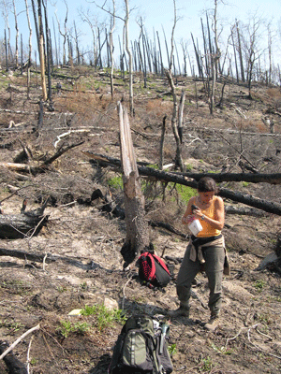
Fig. 4. Taraxacum officinale ssp. officinale site at the beginning of Emma Lake Trail, Kenai Refuge.
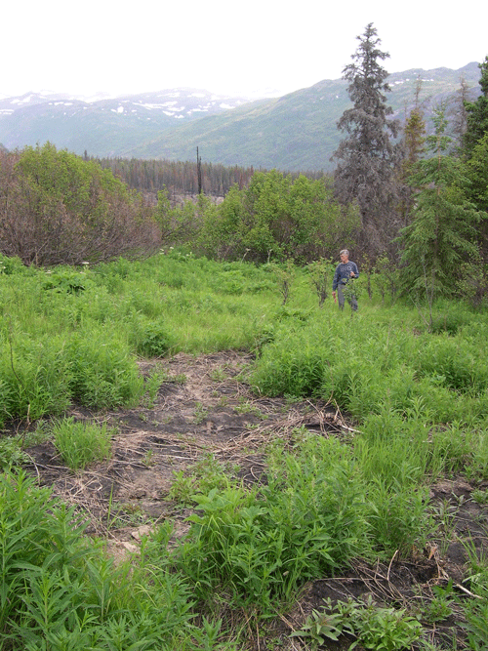
Fig. 5. Taraxacum officinale ssp. officinale site along Emma Lake Trail, Kenai Refuge.
A large diversity of non-native plants was observed at Emma Lake Cabin (waypoint #10). This included Trifolium repens, Poa annua (dominant species around cabin), Matricaria discoidea, and Stellaria media. All of these species were clustered on the compacted soil at the cabin entrance. We pulled most of the pineapple weed and the clover infestations, but the other species were too numerous and well established for immediate manual control.

Moose Creek
On 29 June 2005 we surveyed the Moose Creek region, including the beach, cabin, and approximately 1 mile of the Moose Creek Trail. Small populations of Matricaria discoidea, Poa annua, Poa pratensis, and Alopecurus pratensis were located on the beach adjacent to the confluence of Moose Creek and Tustumena Lake (waypoint #13). We pulled all individuals of both of these species at this site.

The Moose Creek Cabin site (waypoint #14) was very rich in non-native plants. The dominant species here were the native Chamerion angustifolium and the non-native forage grass Alopecurus pratensis (>60% cover), as well as smaller populations of Phleum pratense. Additionally, numerous non-natives were found in areas of compacted soil near the cabin and at the beginning of the Moose Creek Trail. These non-natives included: Erysimum cheiranthoides ssp. cheiranthoides, Taraxacum officinale ssp. officinale, Matricaria discoidea, and the extremely rarely collected Asperugo decumbens (no collections are present in the UA Museum database). We surveyed for non-natives along the first mile of the trail (waypoint #15) in an unburned white spruce forest, but found none outside of the immediate cabin area. The trail was largely overgrown and did not offer disturbed substrates for the establishment of non-native species.
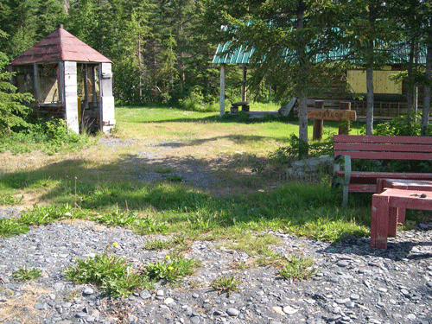
Fig. 6. Dandelions (front) and white clover (back) at Taylor Cabin, Kenai Refuge.

Taylor Cabin (waypoint #17) also harbors a very large repository of non-native species (Fig. 6). This includes the lawn grass, Poa pratensis, with 70% cover, and forage grasses, Alopecurus pratensis and Phleum pratense. Additional non-natives were: Capsella bursa-pastoris, Elymus repens, Erysimum cheiranthoides, Leucanthemum vulgare, Matricaria discoidea,
Poa pratensis, Polygonum aviculare, Taraxacum officinale ssp. officinale, and Trifolium repens. Many of these species are known to be quite invasive in south-central Alaska.

The Andrew Berg Cabin (waypoint #18) had small infestations of Erysimum cheiranthoides ssp. cheiranthoides and Matricaria discoidea at the cabin entrance, but was otherwise free from non-native plants. We pulled the larger plants, but were not able to eradicate the entire population because there were many, small plants growing underneath the cabin’s porch floorboards.

Clear Creek
We also visited the Clear Creek Cabin site (the cabin was destroyed in the 1960’s). Interestingly, there was a healthy population of the forage grasses Alopecurus pratensis, Phleum pratense, and Poa pratensis (30% cover) on a beach ridge that was the likely site of this cabin (waypoint #20) (Fig. 7). We surveyed the surrounding areas but did not observe any other non-native infestations. Assuming this was not a more recent introduction, it appears that once established these grasses can persist for a considerable length of time, but do not appear to be very successful in spreading in native vegetation.

To conclude, we found exotic plant species in four of the five cabin sites (Taylor, Andrew Berg, Blakely, Moose Creek and Indian Creek cabins) we visited in Kenai NWR, even though none of these had been burned in 2004. We did locate a small number of non-native plants along severely and lightly burned sections of the Emma Lake Trail. Non-native plant infestations seem to be more closely linked to high-use areas than to fires in the first year following the fire. Nonetheless, it is important to note that the cabins and remaining section of the Emma Lake trail are potential sources of non-native propagules. This is especially the case for the Taylor Cabin site: the proximity of this cabin, with eight moderately invasive plant species, to a severely burned section of the Glacier Creek Fire, makes it a likely focus of dispersal for exotic plant species into the new, yet to be colonized habitats created by the fires.
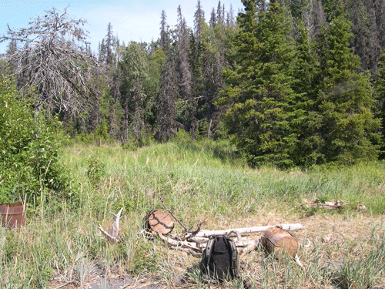
Fig. 7. Timothy grass and meadow foxtail at Clear Creek Cabin site, Kenai Refuge.

Tetlin Refuge
In early July 2005, two AKNHP botanists (H. Cortes-Burns and M. Sturdy) coordinated fieldwork with Merben Cebrian (Tetlin NWR biologist), and visited three campgrounds and the intersection of Gardiner Creek with the Alaska Highway, all unburned in the 2004 Gardiner Creek fire, but used in support of the fire suppression efforts – i.e. they were the campsites for the firefighters. In addition, we visited a number of sites along the highway that were burned in one of the following years: 2004, 1998, 1996 and 1990.
This provided us with a unique opportunity to assess: a) the extent to which wildfires and firefighting activity constitute a vector for the establishment and spread of non-native plants, and b) the ability of infestations to persist through the secondary successional sequence. Even though some of the sites we surveyed were set in white spruce and alder woodlands, Tetlin is dominated by black spruce forests/bogs.

Lakeview Campground
On 6 July 2005 we surveyed Lakeview Campground and took data for three plots. One plot was located in the campground at Yarger Lake’s edge (waypoint #22); the plot had a low density of Hordeum jubatum, Matricaria discoidea, Taraxacum officinale ssp. officinale, Plantago major, and Trifolium hybridum. A permanent plot was not established since the plants were in the center of an established campground. We also looked for non-native species in the surrounding mixed, white spruce-quaking aspen forest, but none were located.

The second plot was set up halfway down the campground road (waypoint #23), on a path that extended beyond a campsite into the forest. No exotics were recorded.

The third site was a grassy clearing in the forest, located within 20-30 m of the Alaska Highway (waypoint #24). A number of non-native plants were found there, including the highly invasive Melilotus alba, as well as Crepis tectorum, Bromus inermis ssp. inermis, and Taraxacum officinale ssp. officinale. Given the abundance of Melilotus alba along the highway, it seems most likely that the few individuals found in the third plot were the result of dispersal from roadside populations. A permanent plot was erected at this site (waypoint #25).

Deadman’s lake Campground
Deadman's Lake campground was surveyed on 6 July 2005 and three non-permanent plots were read at this location. Unlike Lakeview, this area is dominated by black spruce forest/bog.

The first site was completed halfway down the Nature Trail boardwalk that runs through a black spruce forest/fen, from the campground to Deadman Lake (waypoint #27). We found, and manually removed, clumps of Poa pratensis ssp. irrigata (P. subcoerulea) and Hordeum jubatum growing next to the boardwalk, in a mound of gravel and pebbles that had recently been laid on top of the (native) peat/tussock-grass (Fig. 8).
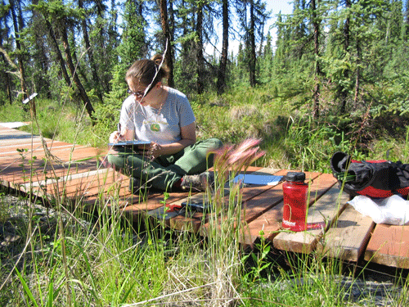
Fig. 8. Hordeum jubatum along the Nature trail in Deadman’s Lake Campground, Tetlin Refuge.

The second site was by the boat ramp, on imported mineral soils (waypoint #28). The following exotics were observed: Crepis tectorum, Hordeum jubatum, Matricaria discoidea, Poa pratensis, Phleum pratense, Plantago major, and Taraxacum officinale ssp. officinale. Permanent monitoring plots were not constructed in either of these first two sites because both were located in high use areas.

The last site at Deadman’s Lake Campground was in a clearing in the forest, next to the campsites (waypoint #29). This site had a high density of Trifolium hybridum and smaller densities of Taraxacum officinale ssp. officinale, Hordeum jubatum (pulled), Poa annua and Plantago major. No other non-native taxa were observed in Deadman’s Lake Campground.

Roadside campground
The crew surveyed a small campground by an RV rest area on the south side of the highway (waypoint #30). The area, even though surrounded by mixed, white spruce forest, was largely unvegetated (70%), and had no exotics. This is somewhat surprising since the campsite is located on imported, mineral soils and receives a considerable amount of traffic.

Gardiner Creek
On 7 July 2005, Tetlin NWR biologist Merben Cebrian, who is currently carrying out weed inventories along the section of the Alaska Highway extending from the Canadian border to Tok, joined us on our fieldwork. We surveyed the area of the Refuge where the highway intersects Gardiner Creek, as well as two areas that had burned in years previous to 2004.

We conducted our first plot at the intersection of Gardiner Creek and the Alaska Highway, on the southwest side of the creek crossing (waypoint #31). The area was a grassy, partially flooded meadow in a mixed, white spruce-aspen stand. Small amounts of the non-natives Lappula squarrosa, Plantago major, Hordeum jubatum, and Trifolium hybridum were observed. We were unable to locate Gardiner Creek downstream from here, as it almost immediately went underground through cobbles and gravel into a dense alder shrubland.

On the southeast side of the crossing (waypoint #32), which had a much greater diversity of non-native species, we set up our second temporary plot and a permanent plot (waypoint #33) (Fig. 9). The exotics recorded in this locality were: Bromus inermis ssp. inermis, Hordeum jubatum, Lappula squarrosa, Lepidium densiflorum, Matricaria discoidea, Melilotus alba, Plantago major, Polygonum aviculare, Taraxacum officinale ssp. officinale, and Trifolium hybridum.

The area encompassed by the first and second sites had been hydroaxed within the past year, therefore creating open habitats that were subsequently colonized by roadside weeds. In addition, the creek had been dammed up to divert the riverbed, which explains why many terrestrial plants (including the exotics listed above) were underwater.
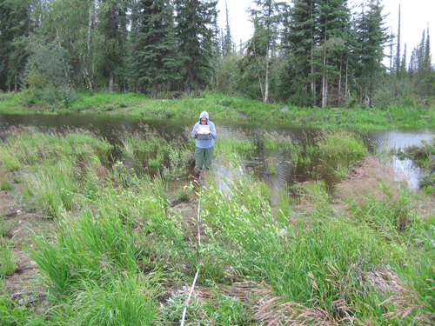
Fig. 9. Permanent non-native plant species monitoring plot. SE side of Gardiner Creek crossing. Tetlin Refuge.

The third Gardiner Creek site, located northeast of the crossing (waypoint #35), did not show signs of recent disturbance and had a much greater diversity of native plants, as well as the following non-native plants: Chenopodium album, Hordeum jubatum, Lepidium densiflorum, Plantago major, and Trifolium repens, all of which occurred at low density.

We then moved east ca. 150 m along the highway, where the 2004 fire had reached the road. Two non-permanent sites were established within the Gardiner Creek Fire on the north side of the Alaska Highway. The first plot (waypoint #37) was carried out in a black spruce-deciduous woodland, which had been severely burned [USFWS burn severity code “1” to “2” for both substrate and vegetation]. The area was largely unvegetated, and we found no exotics (Fig. 10).

We then surveyed the nearby roadside area that had been driven over with earth moving equipment the previous year (waypoint #38). This site had a high percent cover of the taxonomically problematic grass Bromus inermis that has both native and non-native subspecies, which widely hybridize.

1990, 1996 and 1998 burns
On 7 July 2005 we surveyed the 1996/1998 burned areas (waypoint #39). The two burns appeared contiguous at their intersection with the highway. Here we investigated a dirt road that branched off the highway and extended ca. 1 km into a regenerating alder woodland. We found and extirpated 3-4 clumps of Hordeum jubatum and a single Taraxacum officinale ssp. officinale plant along the dirt track, but no exotics were observed in the woodland itself.
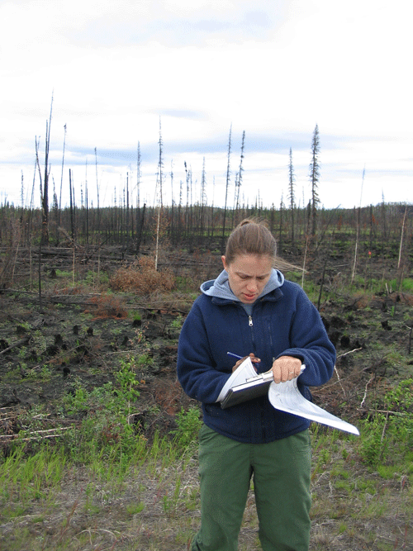
Fig. 10. 2004 burned site by the Alaska Highway, Tetlin Refuge.

On 8 July 2005 two plots were read in the 1990 burned area. The first plot was by the roadside (waypoint #44): Taraxacum officinale ssp. officinale and Melilotus alba were observed here (Fig. 11). We then did a second plot, approximately 30 m off the roadside (waypoint #47), within the regenerating black spruce forest (Fig. 12). No exotics were seen here.

Overall, our findings from Tetlin suggest that non-native plant infestations are limited to sites that are close to the highway and have been recently cleared or disturbed by humans. The Gardiner Creek surveys illustrate this correlation: exotics were found in roadside areas that had been recently hydroaxed, but not in the nearby burned woodland, even though the latter is potentially susceptible to colonization from adjacent, weed populations on the highway. This is further corroborated by the absence of weeds in older, regenerating, burned areas (1990, 1996, and 1998), all of which intersected the highway.
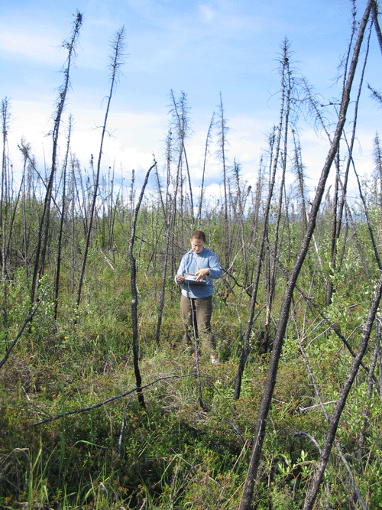
Fig. 12. 1990 burn: regenerating, black spruce forest, Tok.
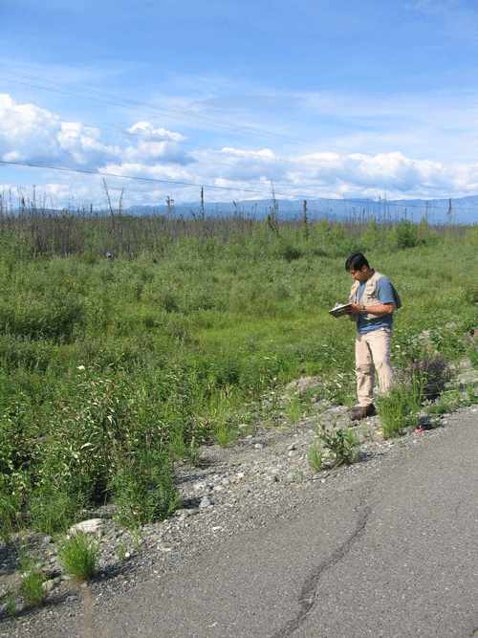
Fig. 11. 1990 burn: roadside plot. Alaska Highway near Tok.
In this context, firefighting activity (places where machinery was used to create firebreaks, rest areas for firefighters, water recharge zones, etc.) also constitutes a potential vector for the dispersal of exotic plants. We learned from USFWS staff that the Yarger, Eliza, and Deadman Lakes had all been used by firefighting crews as water recharge zones. However, we did not have detailed locality information on this, so we limited our surveys to the Lakeview and Deadman campground areas, as these were the only places around the lakes that could be accessed from the Highway (we were unable to get to Eliza Lake because both roads leading to it were private). Although exotics were found at both campgrounds, they were most likely there prior to the 2004 fires, and had been brought in by campground visitors and/or weed dispersal from the road system.

Kanuti Refuge
From 13 July to 16 July 2005, two AKNHP botanists (M. Carlson and H. Cortés-Burns) surveyed a total of 16 sites in the area affected by 2004 Clawanmenka fire, in Kanuti NWR. We inventoried the boundary lands of nine allotments that had been burned, and two unburned ones along the South Fork of the Koyukuk, as well as approximately 50 river miles of the South Fork (including the portion of the Winter Trail that intersects the river south of the Jim River). The dominant vegetation type encountered was black spruce forest/muskeg. No invasive species were found in any of the 16 plots read in Kanuti Refuge.

Fish Creek Lake
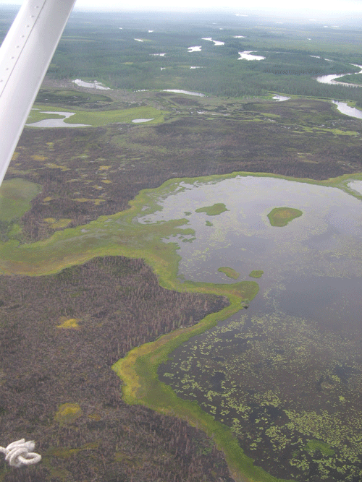
Fig. 13. Aerial view of Fish Creek Lake, and the South Fork Koyukuk River, Kanuti Refuge.
On 13 July 2005 we surveyed the boundary of an allotment on the southeast side of Fish Creek Lake (Fig. 13). One of our plots was set up in a burned, 50% unvegetated, black spruce forest/bog (burn severity code for substrate and vegetation “3”) (waypoint #50). The other plot was read in an area that had hardly been burned (vegetation and substrate burn severity code “4” to “5”), dominated by black spruce, liverworts (Marchantia sp.), and peat moss (Sphagnum sp) (waypoint #53).

On 14 July 2005 we tried to reach Fish Creek and adjacent allotment boundaries by boat, but were unable to find any navigable sloughs or streams connecting the lake to the creek (they were all too shallow and/or obstructed by extensive mats of floating, aquatic plants). We then carried out three surveys in burned FWS land located between the allotments on the north shore of Fish Creek Lake and those bisected by Fish Creek to the north.

The first plot (waypoint #64) was carried out in a burned, black spruce peatland, dominated by liverworts (Marchantia sp.) and mosses (burn severity code for both substrate and vegetation “3”). We then read a plot (waypoint #66) by the lakeshore, in a small, very lightly burned alder-birch woodland (substrate and vegetation code “4”). The last site we surveyed near Fish Creek Lake (waypoint #68) was set in largely (80%) unvegetated, burned, shrub-tussock tundra, with only a few dead alder/birch trees left standing (substrate and vegetation burn severity code “3”).

In the late evening we were moved to a river bar on the South Fork Koyukuk by fixed-wing.

South Fork of the Koyukuk
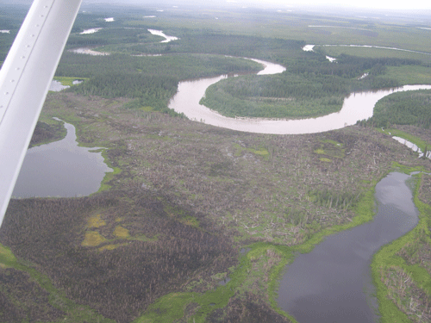
Fig. 14. Aerial view of the South Fork of the Koyukuk River, Kanuti Refuge.
On 15 July 2005 we navigated the South Fork of the Koyukuk up to the confluence with the Jim River (Fig. 14), surveying for non-native species the entire length. In addition, we read non-permanent plots in the following seven sites:

- Two in open, unburned, riverbank habitats. The first plot (waypoint #73) was carried out at a silty-cobbly river bar dominated by cottonwoods. The second one (waypoint #74), located at the confluence of the Jim River and the South Fork of the Koyukuk, was a largely (95%) unvegated, sandy-cobbly area surrounded by mixed, open white spruce forests. Even though these sites were not affected by the 2004 fires, they could still, potentially, harbor exotics if the river is being used as a dispersal vector by weeds growing along the Dalton Highway.
- FWS land near two private cabins, about 5 miles down river from our camp, which was located at waypoint #70. As we did not have landowner permission to access the cabins, we took notes on the plant species found in the surrounding area.
- Three in burned areas along the South Fork (waypoint #75, #77, and #79). All three were in black spruce forests/bogs that were largely (>50%) unvegetated, and with both substrate and vegetation burn severity codes of “3” (Fig. 15).
- The unburned intersection of the Winter Trail with the South Fork (waypoint #76). The vegetation at this site was a dry to mesic, mixed white spruce woodland (white spruce-cottonwood-alder) (Fig. 16).

Unlike the sections of winter trail we saw in the Yukon Flats (see below) no exotics were found along this portion of the Kanuti winter trail. It is likely that it is not used in the summer, unlike the Yukon Flats winter trail, as is suggested by the fact that the vegetation along the trail was largely overgrown at its intersection with the river. Additionally, much of the Kanuti winter trail runs through vast expanses of muskeg, which is unlikely to support the establishment of non-native species.

Clawanmenka, Kaldolyeit and Minnkokut Lakes
On 16 July 2005 we surveyed a total of four plots in Clawanmenka, Kaldolyeit and Minnkokut lakes. The first one was read in a burned, largely (90%) unvegegated, mixed white spruce forest by Clawanmenka Lake (waypoint #81). The site surveyed at Kaldolyeit Lake (waypoint #82) was also set in a burned, mixed white spruce forest. Lastly, we set up two plots at Minnkokut Lake. The first one (waypoint #83) was burned and almost completely unvegetated (burn severity code “3”); while the second one (waypoint #85), just approx. 150m away, was in an unburned, mixed deciduous forest. As in all the previous localities, no non-native plant species were found. We were unable to land at a small lake with a parcel southeast of Minnkokut Lake since it was too shallow for the plane.
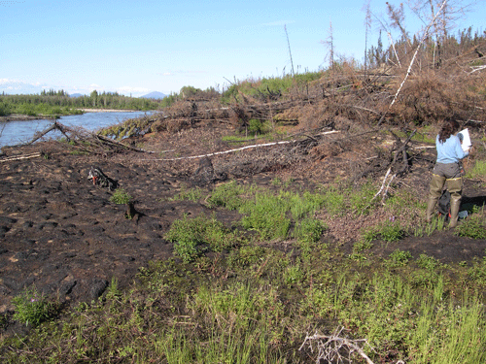
Fig. 15. Burned area by the South Fork, Kanuti Refuge.
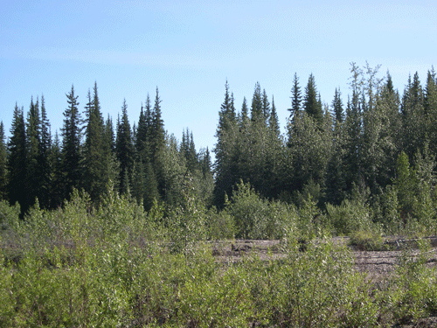
Fig. 16. Winter Trail at the South Fork, Kanuti Refuge, visible as the gap in the white spruce trees.

Bettles
Non-native plant species growing along the shores of the Bettles floatplane pond (waypoint #86) and in the airfield were recorded. These included: Chenopodium album, Hordeum jubatum, Matricaria discoidea, Plantago major, Poa pratensis ssp. irrigata (P. subcoerulea), and Taraxacum officinale ssp. officinale. These plants may facilitate the establishment of non-natives in remote sites in Kanuti Refuge, since Bettles is heavily used by eco-tourists and big game hunters.

Yukon Flats Refuge
AKNHP botanists Anna Jansen, Michelle Sturdy, and Helen Cortes-Burns surveyed the Yukon Flats NWR in collaboration with two foresters from the Tanana Chiefs Conference (TCC). The dominant type of vegetation encountered was mixed, open, white-spruce forest. We flew by helicopter to four burns (Winter Trail, Lower Mouth, Preacher Creek and Dall City), and inventoried the boundary lands for a total of nine allotments, three cabins, three helispots, and a section of a winter trail. Non-native species were found in three allotments, one FWS cabin, and along the Lower Mouth section of the Winter Trail.
It must be noted that, although our initial goal was to walk the entire perimeter of each allotment surveying for invasive plants, we were unable to do so due to logistical (time/cost) constraints. Hiking the contour of each parcel would have required that we spend much more time per site, which not only would have made sharing helicopter time with the TCC foresters hard to coordinate, but would have also greatly increased: a) the duration of the entire trip, and b) the budget for the trip, as the TCC workers left on July 25th, and any flight time we incurred on after that was charged solely to us.

However, if we work under the premise that the main paths of entry for non-native plants into these areas coincide with the points of access to the allotments used by landowners and firefighting crews, we believe that we adequately sampled the possible ‘invasion routes’ for each land parcel. We achieved this by inventorying: 1) sections of each allotment’s perimeter, 2) the area around each helispot we landed at, and 3) possible boat pull-in sites, which often coincided with lakeshore clearings used by our pilot as a landing zone.

Winter Trail Fire
On 22-23 July 2005 we visited a total of seven allotments, two cabins and four helispots in the Winter Trail Fire region.

We first inventoried an allotment by Tivehaun Lake, where we read a total of four plots (waypoint #88, #90, #91, and #92), all of which were burned and located within 40m of the allotment boundary.
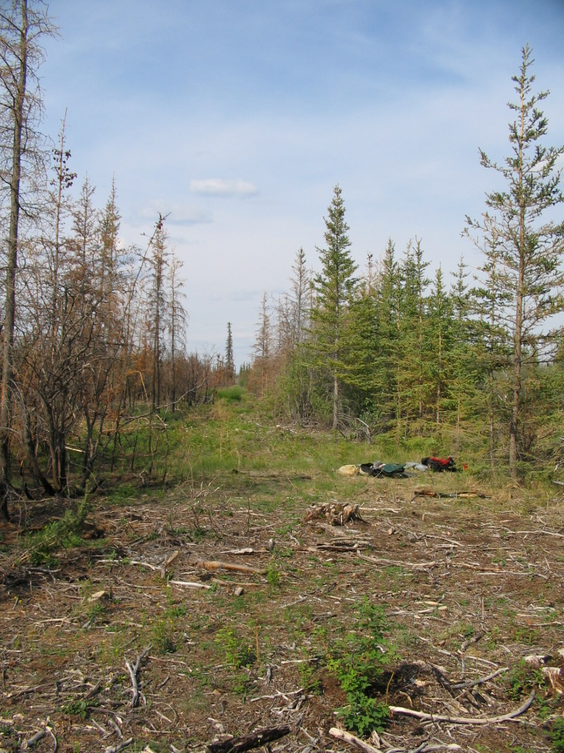
Fig. 17. Winter Trail fire: allotment perimeter. The allotment, to the right, was protected by firefighters and was unburned, while the land outside the parcel was burned). Yukon Flats Refuge.
The presence of felled trees and of a well-defined firebreak surrounding the entire allotment (clearly visible both when flying over it, as well as at waypoints #88 and #90, cf. Fig. 17) indicates that significant fire fighting work took place here, leaving the parcel itself unburned. In contrast, the land immediately outside the allotment was moderately to severely burned (Fig. 17).

Non-native species were found in two of the four plots: one had Chenopodium album and Erysimum cheiranthoides spp. cheiranthoides (waypoint #88), while the other had Chenopodium album and Descurainia sophia (waypoint #90). We removed all the Chenopodium album individuals we saw, and most of the D. sophia. Lastly, we surveyed the landing zone used by our pilot (waypoint #87), a grassy clearing in the forest just inside the allotment’s boundary, but found no invasives here.

We then surveyed two sites along the perimeter of an allotment located south of Tivehaun Lake, close to Twentymile Lake. In flying over the area, no signs of firefighting activities were detected (unlike the Tivehaun parcel), and we noted that the fire here had been less intense. We only found one place where the helicopter could land safely, and set up two plots in its vicinity: one on the margin of a moderately burned (vegetation severity burn code “2”; substrate code “3”), white spruce forest (waypoint #93), and another one in a lightly burned area (vegetation and substrate burn code “3”) by the lake’s edge (waypoint #94). No exotics were recorded at these sites.

Further south, we inventoried the portion of another allotment’s perimeter that coincided with one of the FWS priority helispots. The landing zone (waypoint #95) was a grassy meadow by the lake’s edge, surrounded by an unburned, mixed, white spruce forest. A single Chenopodium album was found and pulled. We flew west of here over another “target” helispot, but did not land because: a) the helispot was in the middle of the parcel; b) it was not burned, and c) there seemed to be no signs of human disturbance.

On 23 July 2005, a section of the perimeter of an allotment that lies northwest of Shotuih Hill was investigated. Two plots were set up here: one in a moderately burned (substrate and vegetation burn code “3”) white spruce/quaking aspen forest (waypoint #96); and the other (waypoint #97), only 20 meters away, was in an unburned grassland by the lake’s edge that we used as a landing zone. Although we found no exotics here, the TCC foresters collected a single Chenopodium album inside the allotment, close to the cabin.

Another two parcels adjacent to Shovun Lake were visited. One of them had two cabins sites and we obtained permission from TCC to survey them. The first cabin (waypoint #98) was situated in a portion of the parcel that had not been burned in 2004 (Fig. 18). The Calamagrostis canadensis-Artemisia frigida meadow surrounding the cabin also had well established populations of Chenopodium album, Erysimum cheiranthoides ssp. cheiranthoides, Hordeum jubatum, and Lepidium densiflorum (especially in the area surrounding the fire pit).
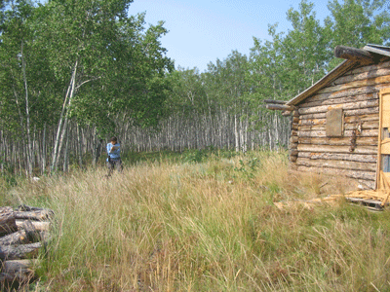
Fig. 18. Meadow with lambsquarters and foxtail. Shovun Lake allotment, Yukon Flats Refuge.

We then read two plots at the second cabin site (waypoint #101 and #103), even though the cabin itself had been completely burned down (substrate and vegetation burn code 3-4). In the clearcut where the cabin formerly stood (waypoint #101) we recorded low densities of Chenopodium album, Erysimum cheiranthoides spp. cheiranthoides, Hordeum jubatum, and Lepidium densiflorum. However, less than 10 m away (waypoint #103), in a part of the white spruce forest that had been severely burned, no exotics were observed.

The second allotment (waypoint #104), set in a mixed, white spruce/quaking aspen forest, had hardly been affected by the 2004 fire, and no exotic species were found along its perimeter.

Finally, we flew to the Veteran’s allotment, and landed at one of the two FWS priority site helispots (we did not find the second one). The area (waypoint #106) was not burned, and no exotics were recorded.

Lower Mouth Fire
On 24 July 2005 we surveyed the Lower Mouth Fire. We did not find invasive plant species in the first three allotments visited: one west of Tlozhavun Lake (waypoint #108), partially burned, another south of Chissovun Lake (waypoint #109 and #110), moderately burned (vegetation and substrate code 3-4), and the third west of Canvasback Lake (waypoint #112), also moderately burned. However, Erysimum cheiranthoides ssp. cheiranthoides and Hordeum jubatum were recorded at the USFWS cabin by Canvasback Lake (waypoint #114), which had not been affected by the fires.

Another three plots were read along the FWS portion of the winter trail that traverses the northeast corner of the Lower Mouth fire (waypoint #115, #116, and #117) (Fig. 19). Although non-native species were found growing along the trail (Bromus inermis ssp. inermis, Chenopodium album, Erysimum cheiranthoides ssp. cheiranthoides, and Hordeum jubatum), these small infestations did not extend into the surrounding, lightly burned forest (vegetation and substrate burn code ‘4’).
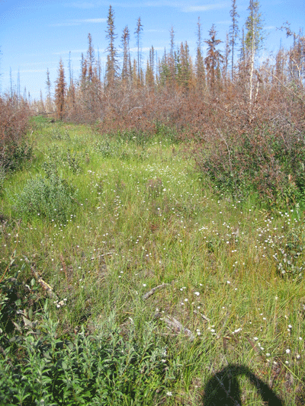
Fig. 19. Winter Trail. Lower Mouth Burn, Yukon Flats Refuge.

Dall City Fire
On 25 July 2005 we flew out to the Dall City Burn. Although we were able to fly over the FWS target allotments, there were no safe places near them in which to land the helicopter in (the ground was saturated in water). We finally decided to do a plot in a burned (substrate and vegetation code ‘4’), regenerating, marshy meadow that was close to but not adjacent to the priority sites (waypoint #118). No exotics were observed. We also tried landing along the section of the winter trail that runs through the Dall City Burn, but the trail was too narrow for the helicopter to land in safely.

Preacher Creek Fire
Two cabins were listed as FWS priority in this burn (coordinates: N 66.00, W -145.63 and N 65.99, W -144.81). However, as we flew over the areas where they were supposed to be (we had coordinates for one of them in our GPS unit) we were not able to find neither them nor any signs of old cabin sites within the burned forest.

Fort Yukon
In Fort Yukon, we surveyed the section of the riverbank at the boat launch (waypoint #120) and the airport runway (no waypoint taken here). The following exotics were recorded: Chenopodium album, Descurainia sophia, Hordeum jubatum, Lappula squarrosa, Lepidium densiflorum, Matricharia discoidea, Polygonum aviculare, and Taraxacum officinale ssp. officinale.

Despite a series of logistical problems in Yukon Flats, we were still able to survey three burned areas and four types of sites (cabins, allotments, winter trails, and landing zones). Successful establishment of non-native plant species is most strongly correlated with areas of high human activity. Exotics in this refuge were found near cabins, in helispots, in firefighting activity zones and along the winter trail. Unlike the Kanuti Refuge winter trail, this one was well maintained and clearly delineated. Also, gathering from the volume of cultural debris that we found along the 2-4 km of trail surveyed, it is very likely that it is more heavily used than the trail in Kanuti.

Summary of findings
Both Tetlin and Kenai refuges have non-native species in 90% or more of the sites surveyed, and also harbor the most aggressively invasive taxa collected from all four refuges (Bromus inermis var. inermis, Melilotus alba, and Taraxacum officinale ssp. officinale in Tetlin; Alopecurus pratensis, Leucanthemum vulgare, and Taraxacum officinale ssp. officinale in Kenai). All infestations were found at or near high human use areas (the highway, campgrounds, cabins, trails). Also worth noting is that in both these refuges less than 20% of the plots inventoried were burned, and only one site (beginning of Lake Emma trail, Kenai NWR) was severely burned. Nonetheless, and particularly in the case of the area around Taylor Cabin (Kenai Refuge), the high human use sites visited in 2005 should be monitored again in the coming growth seasons, as they could act as source areas for the dispersal of invasive plants into the surrounding, (moderate to high intensity) burned land, especially where the soil had burned to the mineral layer.

The non-natives found in Yukon Flats refuge rank low in terms of their degree of invasiveness, and were also consistently associated with either human use areas and/or with sites in which firefighting activities had taken place. Finally, no invasives were found in the sites visited in Kanuti Refuge (and yet one must note that more than 50% of the plots were located in lightly to moderately burned land). We reiterate, however, that the presence of invasives on the shores of the Bettles float-plane pond, which is used by aircraft flying out to the refuge (including firefighting planes), constitutes an important (potential) means of dispersal for these plants into refuge lands.

Treatment Effectiveness
In both Kenai and Tetlin NWR we were able to visit 100% of the priority sites listed, and also did additional plots in areas of special interest (e.g.: Indian creek marsh, Tetlin’s 1990 and 1998 burned areas). In the case of the Kanuti and Yukon Flats refuges, most but not all priority sites were targeted. The primary reason for not covering all priority sites listed for Kanuti and Yukon Flats was not the methodology used, but rather a series of logistical problems we encountered once we were in the field (non-navigable sloughs and marshes, Trimble units not working, etc.). In this context, it is unlikely that changes in the methodology or in the pre-fieldwork plans could have improved locating the remaining sites. Also, as stated earlier in the report, we were unable to organize fieldwork with Innoko Refuge personnel in time for the 2005 field season. However, we plan to survey selected sites (burned and unburned) located in this refuge, in the proximity of the town of Galena (with known non-native plant populations), and along the Yukon River in the 2006 field season, using the funds remaining from the 2005 FWS-AKNHP grant.

Although we did not systematically survey high severity burn sites within a 1mile radius from priority sites, we did walk around the targeted source area trying to see how far the infestation (when there was one) extended. In all cases, we found that non-natives were centered strictly on the high use zones (trails, campsites, etc.), and that only liverworts, mosses and fireweed grew in severely burned areas in the first growth season following the fires (the one exception to this is the Taraxacum officinale ssp. officinale individual we found at the beginning of the Lake Emma Trail, which most likely survived the burn and resprouted).

During our trips to the refuges we set up both temporary and permanent plots. However, we found that we were often unable to establish permanent plots for future monitoring in sites with invasive species because they were either in high-use zones (e.g. winter trails, campground clearings), or near/in private parcels. We suggest that only temporary plots be used in future field seasons, as they provide all the key information needed to revisit an infestation site at a later stage, such as the extent of the infestation, age of disturbance and control method (through the AKEPIC data table), severity of the surrounding burn, and GPS coordinates to relocate the plot.

However, a more thorough and permanent plot approach is necessitated if we want to gain more detailed information on the spatial patterns of non-native plant invasion, the interaction of native and non-native species, and the impact of non-native plants on community and ecosystem function. For this purpose, we suggest developing a more consistent and accurate way of measuring the size and shape of invasive plant populations (e.g. GPS the perimeter), and also focusing future survey work on areas affected by different age burns and that are relatively easy to access (e.g. Tetlin infestations), to guarantee that they will be monitored over at least the next three to five years.

Future Directions & Recommendations
This report presents the data and conclusions derived from the 2005 non-native plant surveys that were carried out in selected refuge sites affected by the 2004 fires. The taxonomy of a small number of plants collected (<10 grass/sedge specimens) still remains questionable, and these will be sent to the UAF Herbarium for final determination.

During the month of October we visited biologists at the Kanuti, Yukon Flats and Kenai refuges to give brief presentations on our findings. These meetings allowed us to exchange opinions with the three refuges’ staff on the possible reasons for the presence/absence of non-natives in the sites visited, and provided us with greater insight into the causes underlying the establishment of invasive plant species in the areas surveyed (although we did not give a presentation at Tetlin NWR, the conclusions reached following our fieldwork there were adequately discussed with biologist Merben Cebrian both in the field and in subsequent communications). We also gave the talk "Summary of Burned Area Emergency response, Invasive Plant Surveys" at the 2005 CNIPM (Alaska Committee for Noxious and Invasive Plants Management) conference held in Fairbanks, in collaboration with Ruth Gronquist from BLM.

We strongly recommend revisiting the Kenai and Tetlin sites, given that: a) these had a wider range of burned/unburned habitat types infested by exotics (cabins, unburned marshes, trails, campgrounds, etc.), b) they are more easily accessible, and therefore more likely to be monitored in the following years, and c) in the case of Tetlin, there are burns of different ages that should be further investigated for the presence of non-native plants (priority areas would be those known to have been used by firefighters). Although we did not find any invasive species in the sites surveyed in Kanuti, we want to emphasize that floatplanes and firefighting aircraft that use the Bettles pond as a base pose a potential risk for successful weed introduction in refuge lands, given the number of non-native species that grow by the pond’s margin. Lastly, in the case of Yukon Flats refuges, we would like to highlight the important role that Winter Trails, in addition to cabins and helispots, play as routes for the expansion of invasive species into refuge lands.

To conclude, we emphasize that the observations made in this work on the relationship (or lack thereof) between burns and non-native plant infestations are preliminary, especially given that most burned sites visited this summer were still largely unvegetated and could become colonized by exotics in the next growing season. It is therefore central to the success of this project that some of the sites surveyed this year be revisited over the following growing seasons. In this context, biologists from Kenai, Tetlin and Yukon Flats refuges will be revisiting 2004 burn sites on which invasive plants were found, and will be doing so in collaboration with one of the AKNHP botanists that carried out the 2005 surveys. In addition to this, all four refuges will be carrying out BAER non-native plant surveys in selected sites affected by the 2005 fires.

Finally, we propose that experimental plots be set up in burned/unburned areas that are readily accessible and can be carefully and regularly monitored over time. This could be done in an area such as Tetlin NWR, where there are different age burns, various kinds of habitats infested (roadside areas, campgrounds, etc.), and refuge biologists that are already carrying out weed inventories. It would also be worthwhile to seek collaboration with other landowners in selected areas (e.g. BLM), as this would give us access to study sites in and around refuge lands.

References
Brooks, M.L. 1999. Alien annual grasses and fire in the Mojave Desert. Madrono, 46:13–19.
Busch, D.E. 1995. Effects of fire on southwestern riparian plant community structure. Southwestern Naturalist, 40:259–267.
Harrod, R. J. and S. Reichard. 2001. Fire and invasive species within temperate and boreal coniferous forests of western North America. Pages 95-101 in K. E. M. Galley and T. P. Wilson (eds.). Proceedings of the Invasive Species Workshop: the Role of Fire in the Control and Spread of Invasive Species. Fire Conference 2000: the First National Congress on Fire Ecology, Prevention and Management. Miscellaneous Publication No.11, Tall Timbers Research Station, Tallahassee, FL.
Randall, J. M. 1996. Weed control for the preservation of biological diversity. Weed technology, 10: 370-383.
Rejmanek, M. 1989. Invasibility of plant communities. Pages 369-388 in J. A. Drake, H. A. Mooney, F. di Castri, R. H. Groves, F. J. Kruger, M. Rejmanek, and M. Williamson (eds.). Biological invasions: a global perspective. John Wiley & Sons, Brisbane, Australia.
Shephard, M. 2004. Status of Exotic Invasive Organisms in Alaska. USDA Forest Service. Anchorage, AK. http://www.cnipm.org/statusofinvasivesak04.pdf

Appendices

Table 1. List of non-native plant species found in Kenai National Wildlife Refuge.
Collection locality | Genus | Species | Veg. code | Soil code | % cover | Rank | Control action
Indian Creek marsh | Capsella | bursa-pastoris | 5 | 5 | <10 |  | none
Emma Lake trail (1) | Taraxacum | officinale ssp. officinale | 1 | 1 | <10 | 64 | pulled
Emma Lake cabin | Matricaria | discoidea | 5 | 5 | trace | 34 | pulled most of it
Emma Lake cabin | Poa | annua | 5 | 5 | <10 | 51 | none
Emma Lake cabin | Stellaria | media | 5 | 5 | <10 |  | none
Emma Lake cabin | Trifolium | repens | 5 | 5 | trace | 59 | pulled most of it
Emma Lake trail (2) | Poa | annua | 4 to 5 | 4 | trace | 51 | none
Emma Lake trail (2) | Taraxacum | officinale ssp. officinale | 4 to 5 | 4 | <10 | 64 | pulled some of it
Moose Creek cabin | Alopecurus | pratensis | 5 | 5 | trace | 70 | pulled
Moose Creek cabin | Matricaria | discoidea | 5 | 5 | trace | 34 | pulled
Moose Creek cabin | Poa | annua | 5 | 5 | trace | 51 | none
Moose Creek cabin | Poa | pratensis | 5 | 5 | trace | 57 | none
Moose Creek cabin | Alopecurus | pratensis | 5 | 5 | 60 | 70 | none
Moose Creek cabin | Asperugo | procumbens | 5 | 5 | trace |  | none
Moose Creek cabin | Erysimum | cheiranthoides ssp. cheiranthoides | 5 | 5 | trace
Moose Creek cabin | Phleum | pratense | 5 | 5 | <10 | 56 | none
Moose Creek cabin | Taraxacum | officinale ssp. officinale | 5 | 5 | <10 | 64 | none
Taylor cabin | Alopecurus | pratensis | 5 | 5 | trace | 70 | none
Taylor cabin | Capsella | bursa-pastoris | 5 | 5 | trace |  | none
Taylor cabin | Elymus | repens | 5 | 5 | <10 | 59 | none
Taylor cabin | Erysimum | cheiranthoides ssp. cheiranthoides | 5 | 5 | trace
Taylor cabin | Leucanthemum | vulgare | 5 | 5 | trace | 61 | none
Taylor cabin | Matricaria | discoidea | 5 | 5 | trace | 34 | none
Taylor cabin | Phleum | pratense | 5 | 5 | trace | 56 | none
Taylor cabin | Poa | pratensis ssp. irrigata | 5 | 5 | 5 | 57 | none
Taylor cabin | Poa | pratensis | 5 | 5 | 70 | 57 | none
Taylor cabin | Polygonum | aviculare | 5 | 5 | trace |  | none
Taylor cabin | Taraxacum | officinale ssp. officinale | 5 | 5 | <10 | 64 | none
Taylor cabin | Trifolium | repens | 5 | 5 | 20 | 59 | none
Andrew berg cabin | Erysimum | cheiranthoides ssp. cheiranthoides | 5 | 5 | trace
Andrew berg cabin | Matricaria | discoidea | 5 | 5 | trace | 34 | none
Clear Creek cabin | Alopecurus | pratensis | 5 | 5 | trace | 70 | none
Clear Creek cabin | Phleum | pratense | 5 | 5 | trace | 56 | none
Clear Creek cabin | Poa | pratensis | 5 | 5 | 30 | 57 | none

Table 2. List of non-native plant species found in Tetlin National Wildlife Refuge.

Collection locality | Genus | Species | Veg. code | Soil code | % cover | Rank | Control action
Deadman Campground 1 | Hordeum | jubatum | 5 | 5 | <10 | 63 | pulled
Deadman Campground 1 | Poa | pratensis ssp. irrigata | 5 | 5 | <10 | 57 | pulled
Deadman Campground 2 | Argentina | anserina | 5 | 5 | <10 |  | none
Deadman Campground 2 | Crepis | tectorum | 5 | 5 | <10 | 43 | none
Deadman Campground 2 | Hordeum | jubatum | 5 | 5 | trace | 63 | none
Deadman Campground 2 | Matricaria | discoidea | 5 | 5 | <10 | 34 | none
Deadman Campground 2 | Plantago | major | 5 | 5 | <10 | 44 | none
Deadman Campground 2 | Poa | pratensis | 5 | 5 | <10 | 57 | none
Deadman Campground 2 | Taraxacum | officinale ssp. officinale | 5 | 5 | <10 | 64 | none
Deadman Campground 3 | Hordeum | jubatum | 5 | 5 | trace | 63 | pulled
Deadman Campground 3 | Plantago | major | 5 | 5 | <10 | 44 | none
Deadman Campground 3 | Poa | annua | 5 | 5 | <10 | 51 | none
Deadman Campground 3 | Taraxacum | officinale ssp. officinale | 5 | 5 | <10 | 64 | none
Deadman Campground 3 | Trifolium | hybridum | 5 | 5 | <10 | 57 | none
Lakeview Campground 1 | Hordeum | jubatum | 5 | 5 | <10 | 63 | none
Lakeview Campground 1 | Matricaria | discoidea | 5 | 5 | <10 | 34 | none
Lakeview Campground 1 | Plantago | major | 5 | 5 | <10 | 44 | none
Lakeview Campground 1 | Poa | annua | 5 | 5 | <10 | 51
Lakeview Campground 1 | Taraxacum | officinale ssp. officinale | 5 | 5 | <10 | 64 | none
Lakeview Campground 1 | Trifolium | hybridum | 5 | 5 | <10 | 57 | none
Lakeview Campground 3 | Bromus | inermis var. inermis | 5 | 5 | 60 | 62
Lakeview Campground 3 | Crepis | tectorum | 5 | 5 | <10 | 43 | none
Lakeview Campground 3 | Melilotus | alba | 5 | 5 | trace | 80 | none
Lakeview Campground 3 | Taraxacum | officinale ssp. officinale | 5 | 5 | <10 | 64 | none

Collection locality (contd.) | Genus | Species | Veg. code | Soil code | % cover | Rank | Control action
Gardiner Creek area: Tetlin 2 | Hordeum | jubatum | 5 | 5 | <10 | 63 | none
Gardiner Creek area: Tetlin 2 | Lappula | squarrosa | 5 | 5 | <10 | 43 | none
Gardiner Creek area: Tetlin 2 | Plantago | major | 5 | 5 | <10 | 44 | none
Gardiner Creek area: Tetlin 2 | Trifolium | hybridum | 5 | 5 | <10 | 57 | none
Gardiner Creek area: Tetlin 3 | Bromus | inermis var. inermis | 5 | 5 | <10 | 62
Gardiner Creek area: Tetlin 3 | Hordeum | jubatum | 5 | 5 | <10 | 63 | none
Gardiner Creek area: Tetlin 3 | Lappula | squarrosa | 5 | 5 | trace | 43 | none
Gardiner Creek area: Tetlin 3 | Lepidium | densiflorum | 5 | 5 | <10 |  | none
Gardiner Creek area: Tetlin 3 | Matricaria | discoidea | 5 | 5 | <10 | 34 | none
Gardiner Creek area: Tetlin 3 | Melilotus | alba | 5 | 5 | <10 | 80 | none
Gardiner Creek area: Tetlin 3 | Plantago | major | 5 | 5 | <10 | 44 | none
Gardiner Creek area: Tetlin 3 | Polygonum | aviculare | 5 | 5 | trace |  | none
Gardiner Creek area: Tetlin 3 | Taraxacum | officinale ssp. officinale | 5 | 5 | <10 | 64 | none
Gardiner Creek area: Tetlin 3 | Trifolium | hybridum | 5 | 5 | <10 | 57 | none
Gardiner Creek area: Tetlin 4 | Chenopodium | album | 5 | 5 | <10 | 35 | none
Gardiner Creek area: Tetlin 4 | Hordeum | jubatum | 5 | 5 | <10 | 63 | none
Gardiner Creek area: Tetlin 4 | Lepidium | densiflorum | 5 | 5 | <10 |  | none
Gardiner Creek area: Tetlin 4 | Plantago | major | 5 | 5 | <10 | 44 | none
Gardiner Creek area: Tetlin 4 | Trifolium | repens | 5 | 5 | <10 | 59 | none
Gardiner Creek area: Tetlin 6 | Bromus | inermis var. inermis | 5 | 5 | 30 | 62
1990 burn (roadside plot) | Melilotus | alba | 5 | 5 | <10 | 80 | none
1990 burn (roadside plot) | Taraxacum | officinale ssp. officinale | 5 | 5 | <10 | 64 | none

Table 3. List of non-native plant species found in Yukon Flats National Wildlife Refuge.

Collection locality | Genus | Species | Veg. code | Soil code | % cover | Rank | Control action
Tivehaun lake parcel | Chenopodium | album | 1 | 1 | <10 | 35 | none
Tivehaun lake parcel | Erysimum | cheiranthoides ssp. cheiranthoides | 1 | 1 | <10
Tivehaun lake parcel | Chenopodium | album | 1 to 2 | 1 to 2 | <10 | 35 | pulled
Tivehaun lake parcel | Descurainia | sophia | 1 to 2 | 1 to 2 | <10 | 47 | none
Winter Trail burn: allotment 1 | Chenopodium | album | 5 | 5 | <10 | 35 | pulled
Winter Trail burn: allotment 2 | Chenopodium | album | 5 | 5 | <10 | 35 | none
Shovun Lake cabin | Chenopodium | album | 5 | 5 | <10 | 35 | none
Shovun Lake cabin | Erysimum | cheiranthoides ssp. cheiranthoides | 5 | 5 | <10
Shovun Lake cabin | Hordeum | jubatum | 5 | 5 | <10 | 63 | none
Shovun Lake cabin | Lepidium | densiflorum | 5 | 5 | <10 |  | none
Shovun Lake old cabin site | Chenopodium | album | 4 | 3 to 4 | <10 | 35 | none
Shovun Lake old cabin site | Erysimum | cheiranthoides ssp. cheiranthoides | 4 | 3 to 4 | trace
Shovun Lake old cabin site | Hordeum | jubatum | 4 | 3 to 4 | <10 | 63 | none
Shovun Lake old cabin site | Lepidium | densiflorum | 4 | 3 to 4 | <10 |  | none
Canvasback Lake FWS cabin | Erysimum | cheiranthoides ssp. cheiranthoides | 5 | 5 | <10
Canvasback Lake FWS cabin | Hordeum | jubatum | 5 | 5 | 10 | 63 | none
Lower Mouth fire: Winter Trail section | Erysimum | cheiranthoides ssp. cheiranthoides | 4 to 5 | 4 to 5 | <10
Lower Mouth fire: Winter Trail section | Bromus | inermis var. inermis | 4 to 5 | 4 to 5 | <10 | 62
Lower Mouth fire: Winter Trail section | Hordeum | jubatum | 4 to 5 | 4 to 5 | <10 | 63 | none
Lower Mouth fire: Winter Trail section | Elymus | trachycaulus ssp. trachycaulus | 4 to 5 | 4 to 5 | <10 |  | none
Fort Yukon boat put-in | Argentina | anserina | 5 | 5 | <10 |  | none
Fort Yukon boat put-in | Chenopodium | album | 5 | 5 | 15 | 35 | none
Fort Yukon boat put-in | Descurainia | sophia | 5 | 5 | 15 | 47 | none
Fort Yukon boat put-in | Elymus | trachycaulus ssp. trachycaulus | 5 | 5 | <10 |  | none
Fort Yukon boat put-in | Hordeum | jubatum | 5 | 5 | <10 | 63 | none
Fort Yukon boat put-in | Lappula | squarrosa | 5 | 5 | 10 | 43 | none
Fort Yukon boat put-in | Lepidium | densiflorum | 5 | 5 | <10 |  | none
Fort Yukon boat put-in | Polygonum | aviculare | 5 | 5 | <10 |  | none
Fort Yukon boat put-in | Taraxacum | officinale ssp. officinale | 5 | 5 | 10 | 64
Fort Yukon airport | Matricaria | discoidea | 5 | 5 |  | 34 | none
Fort Yukon airport | Hordeum | jubatum | 5 | 5 |  | 63 | none

Table 4. List of non-native plant species found in/near the Bettles, near Kanuti refuge.

Collection locality | Genus | Species | Veg. code | Soil code | % cover | Rank | Control action
Bettles Float Plane Pond | Hordeum | jubatum | 5 | 5 |  | 63 | none
Bettles Float Plane Pond | Matricaria | discoidea |  |  |  | 34 | none
Bettles Float Plane Pond | Poa | pratensis ssp. irrigata |  |  |  | 57 | none
Bettles Float Plane Pond | Plantago | major |  |  |  | 44 | none

Table 5. Kenai waypoints.
Refuge Name | Collection Locality | Waypoint ID | Latitude (dd) | Longitude (dd) | Elevation (m)
KENAI | Tustumena 01 | 001 | 60.110616 | -150.613441 | 172
KENAI | Tustumena 02 | 002 | 60.112526 | -150.615260 | 145
KENAI | Tustumena 03 | 003 | 60.122554 | -150.629343 | 192
KENAI | Tustumena track | 005 | 60.123014 | -150.628262 | 229
KENAI | Tustumena track | 007 | 60.123594 | -150.626779 | 319
KENAI | Tustumena track | 009 | 60.124581 | -150.626113 | 419
KENAI | Tustumena 04 | 010 | 60.123709 | -150.557051 | 1065
KENAI | Tustumena 05 | 011 | 60.130592 | -150.575739 | 1061
KENAI | Tustumena 06 | 013 | 60.152569 | -150.706353 | 119
KENAI | Tustumena 07 | 014 | 60.153205 | -150.705977 | 141
KENAI | Tustumena 08 | 015 | 60.155771 | -150.700139 | 177
KENAI | Tustumena 09 | 017 | 60.121414 | -150.631301 | 136
KENAI | Tustumena 10 | 018 | 60.117445 | -150.630067 | 128
KENAI | Tustumena 11 | 020 | 60.046429 | -150.644081 | 123

Table 6. Tetlin waypoints.
Refuge Name | Collection Locality | Waypoint ID | Latitude (dd) | Longitude (dd) | Elevation (m)
TETLIN | Lakeview Campground 1 | 022 | 62.964227 | -141.640693 | 1728
TETLIN | Lakeview Campground 2 | 023 | 62.964553 | -141.639937 | 1773
TETLIN | Lakeview Campground 3 | 024 | 62.964171 | -141.637651 | 1791
TETLIN | Permanent plot #1 | 025 | 62.964255 | -141.637527 | 1748
TETLIN | Deadman's Campground 1 | 027 | 62.888864 | -141.542787 | 1769
TETLIN | Deadman's Campground 2 | 028 | 62.888088 | -141.543226 | 1743
TETLIN | Deadman's Campground 3 | 029 | 62.889002 | -141.541128 | 1741
TETLIN | Tetlin 1 | 030 | 62.893718 | -141.516401 | 1891
TETLIN | Tetlin 2 | 031 | 62.853731 | -141.461235 | 1794
TETLIN | Tetlin 3 | 032 | 62.853350 | -141.459563 | 1803
TETLIN | Permanent plot #2 | 033 | 62.853288 | -141.459498 | 1759
TETLIN | Tetlin 4 | 035 | 62.853673 | -141.459144 | 1785
TETLIN | Tetlin 5 | 037 | 62.853053 | -141.456505 | 1780
TETLIN | Tetlin 6 | 038 | 62.852954 | -141.456681 | 1798
TETLIN | Tetlin | 039 | 63.237805 | -142.355231 | 1819
TETLIN | Tetlin 7 | 044 | 63.327699 | -142.874222 | 1685
TETLIN | Tetlin 8 | 047 | 63.327216 | -142.874966 | 1677

Table 7. Kanuti waypoints.
Refuge Name | Collection Locality | Waypoint ID | Latitude (dd) | Longitude (dd) | Elevation (m)
KANUTI | Kanuti 01 | 050 | 66.584022 | -151.450979 | 566
KANUTI | Kanuti 02 | 053 | 66.588325 | -151.454953 | 558
KANUTI | Kanuti 03 | 064 | 66.604153 | -151.476975 | 534
KANUTI | Kanuti 04 | 066 | 66.605500 | -151.472322 | 553
KANUTI | Kanuti 05 | 068 | 66.599536 | -151.506343 | 539
KANUTI | South Fork of the Koyukuk camp | 070 | 66.605509 | -151.600116 | 0
KANUTI | Kanuti 10 | 073 | 66.673160 | -151.470817 | 556
KANUTI | Kanuti 06 | 074 | 66.791088 | -151.201009 | 675
KANUTI | Kanuti 06 | 074 | 66.791088 | -151.201009 | 675
KANUTI | Kanuti 06 | 074 | 66.791088 | -151.201009 | 675
KANUTI | Kanuti 06 | 074 | 66.791088 | -151.201009 | 675
KANUTI | Kanuti 06 | 074 | 66.791088 | -151.201009 | 675
KANUTI | Kanuti 06 | 074 | 66.791088 | -151.201009 | 675
KANUTI | Kanuti 07 | 075 | 66.772146 | -151.308411 | 641
KANUTI | Kanuti 08 | 076 | 66.771350 | -151.314144 | 648
KANUTI | Kanuti 09a | 077 | 66.729977 | -151.388022 | 594
KANUTI | Kanuti 09b | 079 | 66.670735 | -151.411884 | 564
KANUTI | Kanuti 11 | 081 | 66.511130 | -151.363258 | 823
KANUTI | Kanuti 12 | 082 | 66.532857 | -151.303040 | 787
KANUTI | Kanuti 13 | 083 | 66.569818 | -151.681928 | 541
KANUTI | Kanuti 14 | 085 | 66.569841 | -151.677758 | 540

Refuge Name | Collection Locality | Waypoint ID | Latitude (dd) | Longitude (dd) | Elevation (m)
KANUTI | Bettles Float Plane Pond | 086 | 66.884672 | -151.497188 | 677

Table 8. Yukon Flats waypoints.
Refuge Name | Collection Locality | Waypoint ID | Latitude (dd) | Longitude (dd) | Elevation (m)
YK FLATS | Helispot nr. YK 01, at WP 87 | 087 | 66.836660 | -145.382920 | 485
YK FLATS | YK 01 | 088 | 66.837251 | -145.386512 | 477
YK FLATS | YK 02 | 090 | 66.837050 | -145.386666 | 480
YK FLATS | YK 04 | 092 | 66.835313 | -145.381121 | 471
YK FLATS | YK 05 | 093 | 66.819417 | -145.431395 | 455
YK FLATS | WP 94 | 094 | 66.818750 | -145.430281 | 404
YK FLATS | YK 06a | 095 | 66.808558 | -145.455594 | 441
YK FLATS | YK 06b | 096 | 66.802418 | -145.426812 | 488
YK FLATS | YK 07 | 097 | 66.802561 | -145.425840 | 458
YK FLATS | YK 08 | 098 | 66.793119 | -145.407457 | 469
YK FLATS | YK 09 | 101 | 66.799761 | -145.406710 | 481
YK FLATS | YK 10 | 103 | 66.799955 | -145.407449 | 488
YK FLATS | YK 11 | 104 | 66.795726 | -145.389070 | 469
YK FLATS | YK 12 | 106 | 66.777724 | -145.312048 | 483
YK FLATS | YK 13 | 108 | 66.404656 | -145.790784 | 433
YK FLATS | YK 14 | 109 | 66.362130 | -145.753811 | 454
YK FLATS | YK 15 | 110 | 66.361816 | -145.753572 | 442
YK FLATS | YK 16 | 112 | 66.387301 | -146.434294 | 419
YK FLATS | YK 17 | 114 | 66.385922 | -146.387203 | 430
YK FLATS | YK 18 | 115 | 66.344699 | -145.716939 | 451
YK FLATS | YK 19 | 116 | 66.344378 | -145.717198 | 492
YK FLATS | b/w YK19 - YK 20 | 117 | 66.336057 | -145.732134 | 458
YK FLATS | YK 20 | 117 | 66.336057 | -145.732134 | 458
YK FLATS | YK 21 | 118 | 66.216215 | -149.598732 | 362

Refuge Name | Collection Locality | Waypoint ID |  | Latitude (dd) |  | Longitude (dd) |  | Elevation (m)
YK FLATS | YK 22 | 120 | 66.568806 |  | -145.284220 |  | 491

Maps of sites visited and surveyed in Kenai.

Old site of Glacier Creek cabin

Fig. 20. Collection sites in the Glacier Creek burn, Kenai Refuge.
Moose Cr eek cabin
Emma Lake cabin
Andrew Berg cabin
Taylor cabin
Blakely cabin

Old site of Indian Creek cabin
Emma Lake cabin
Emma Lake trail
Taylor cabin
Tustumena Lake
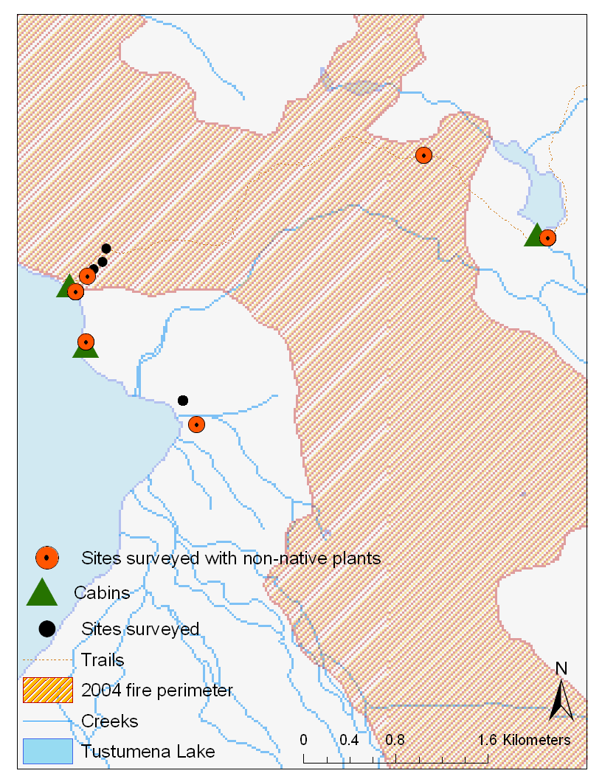
Fig. 21. Taylor Cr. Cabin to Emma Lake Cabin trail and collection sites.
Tustumena Lake
Taylor cabin
Tustumena Lake

Maps of sites visited and surveyed in Tetlin.

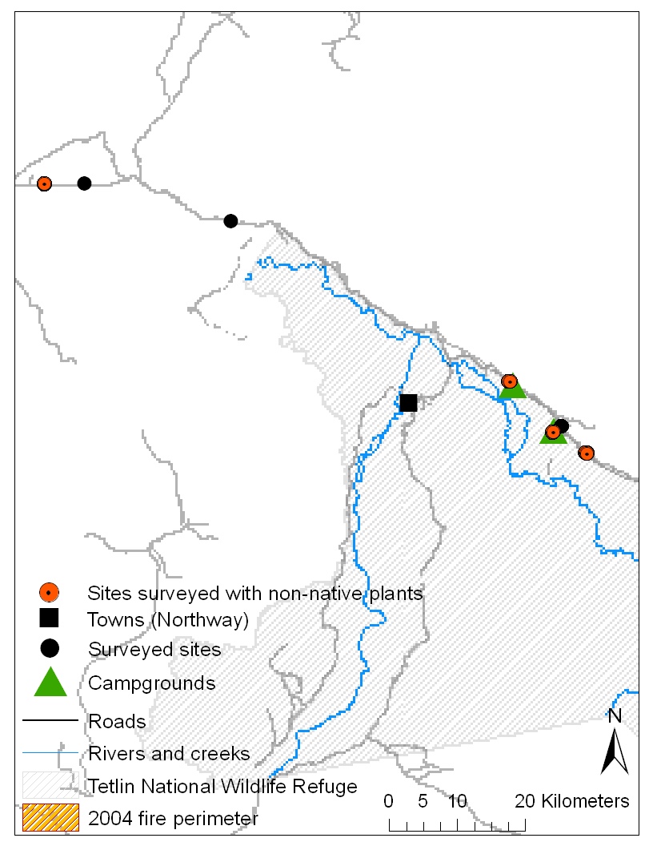
Fig. 22. Collection sites near the Gardiner Creek fire, Tetlin Refuge.

Alaska Highway
Northway Junction
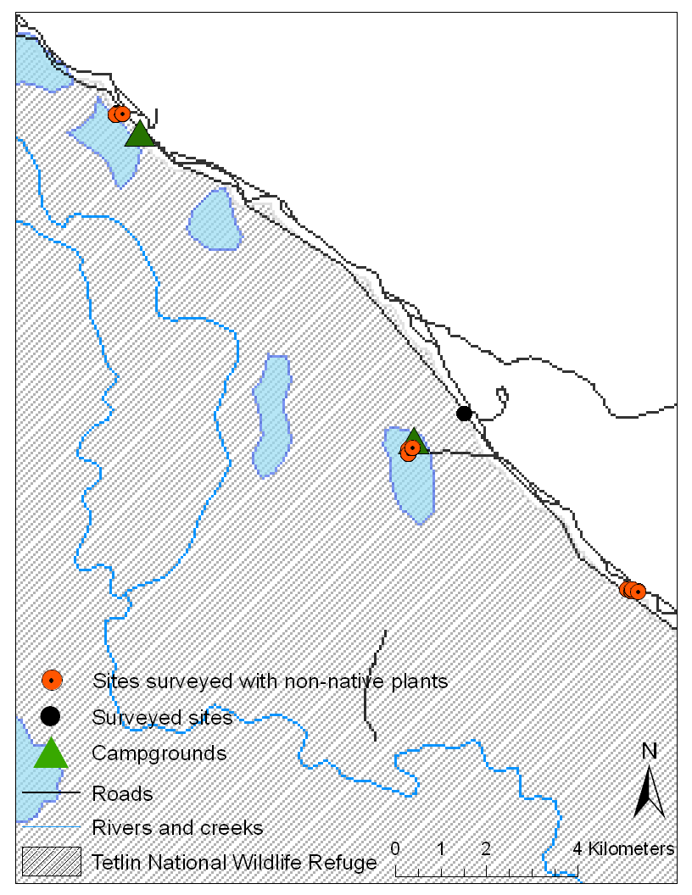
Fig. 23. Collection sites near the Gardiner Creek fire, Tetlin Refuge.
Gardiner Creek
Deadman’s campground
Lakeview Campground
Highway RV rest area

Map of sites visited and surveyed in Kanuti.

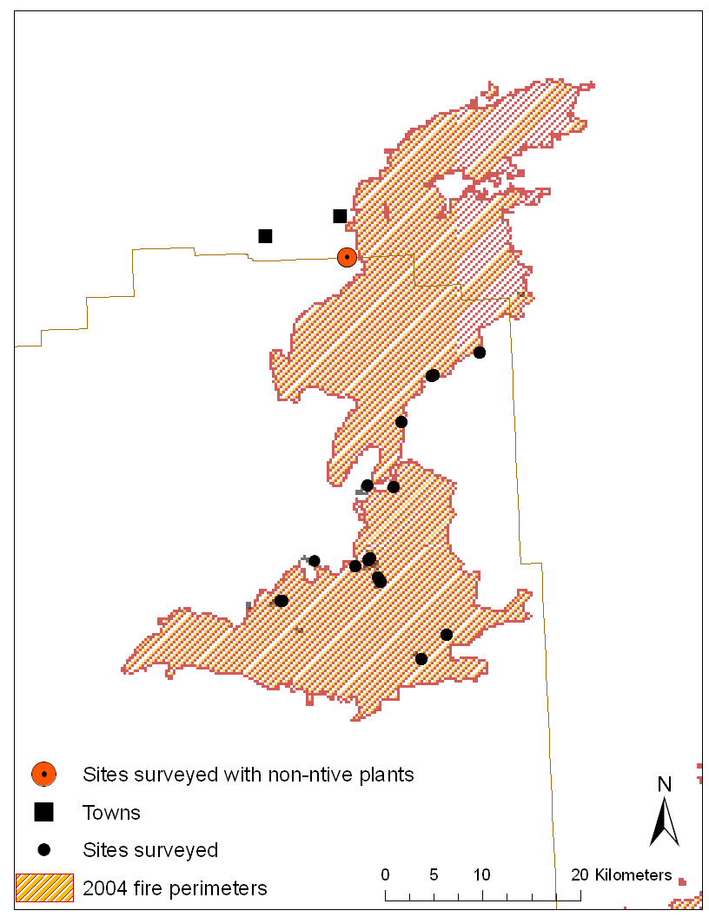
Fig. 24. Track and plots followed going up the South Fork of the Koyukuk (dotted line), Fish Creek Lake plots (circled), and other Kanuti collection sites.

Bettles

South Fork of the Koyukuk track

Fish Creek lake plots

Clawenmenka fire

Maps of sites visited and surveyed in Yukon Flats.

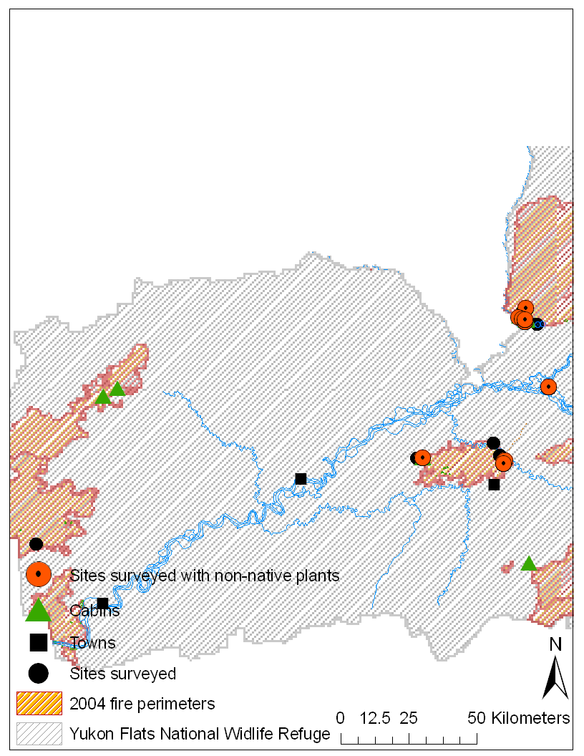
Fig. 25. Collection sites for the Lower Mouth, Winter Trail, and Dahl City fires (Yukon Flats Refuge)

Winter Trail Fire

Lower Mouth Fire

Dahl City Fire

Fig. 26. Winter Trail fire collection sites.

Fig. 27. Lower Mouth fire collection sites.
Winter Trail Fire
Winter Trail section
FWS cabin
Table 9. Burn severity code matrix – FWS Alaska modifications to NPS Fire Monitoring Handbook (2003) June 23, 2005
 | Forest Types |  | Shrub types
 | Substrate (S) | Vegetation (V) | Substrate (S) | Vegetation (V)
(5)  Unburned | Not burned | Not burned | Not burned | Not burned
(4)  Scorched | Litter partially blackened; duff nearly unchanged; wood/leaf structures unchanged. Mosses and lichens clearly visible, though scorched. | Foliage scorched and attached to supporting twigs (red needles may have dropped and be found at base of trunks) | Litter partially blackened; duff nearly unchanged; wood/leaf structures unchanged. Mosses and lichens clearly visible, though scorched. | Foliage scorched and attached to supporting twigs
(3)  Lightly Burned | Litter charred to partially consumed; upper duff layer may be but the duff layer is not altered over the entire depth; surface appears black; woody debris is partially burned; logs are scorched or blackened but not charred; rotten wood is scorched to partially burned | Foliage and smaller twigs partially to completely consumed; branches mostly intact | Litter charred to partially consumed, some leaf structure undamaged; surface is predominately black; some gray ash may be present immediately post burn; charring may extend slightly into the duff exposing dead moss or upper duff, otherwise soil is not altered | Foliage and smaller twigs partially to completely consumed; branches mostly intact; less than 60% of the shrub canopy is commonly consumed
(2) Moderately Burned | Litter mostly to entirely consumed, leaving coarse, light colored ash; duff deeply charred to lower duff or upper/lower duff interface, but underlying mineral soil is not visibly altered; woody debris is mostly consumed; logs are deeply charred, burned-out stump holes are common | Foliage, twigs, and small stems consumed; some branches still present | Leaf litter consumed, leaving coarse, light colored ash; duff deeply charred to lower duff or upper/lower duff interface, but underlying mineral soil is not visibly altered; woody debris is mostly consumed; logs are deeply charred, burned-out stump holes are common | Foliage, twigs, and small stems consumed; some branches (>.6-1 cm in diameter) (0.25-0.50 in) still present; 40-80% of the shrub canopy is commonly consumed
(1)  Heavily Burned | Litter and duff completely consumed, or within 1 cm of mineral soil, sometimes leaving fine white ash; mineral soil may be visibly altered, often reddish; sound logs are deeply charred, and rotten logs are completely consumed. . Marchantia and fire mosses may be present. | All plant parts consumed, leaving some or no major stems or trunks; any left are deeply charred  This code generally applies to less than 10% of natural or slash burned areas | Leaf litter completely consumed, leaving a fluffy fine white ash; all organic material is consumed; colloidal structure of the surface mineral soil may be altered | All plant parts consumed leaving only stubs greater than 1 cm (0.5 in) in diameter
(N/A)  Not applicable | Inorganic preburn | None present preburn | Inorganic preburn | None present preburn

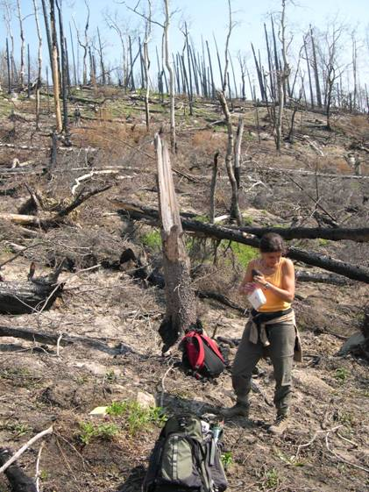
Fig. 28. Vegetation and substrate burn severity codes ‘1’. Waypoint #3, Kenai NWR.
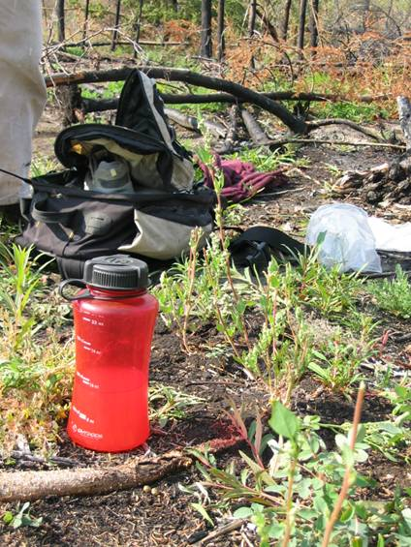
Fig. 29. Vegetation and substrate burn severity codes ‘1-2’. Waypoint #89, Yukon Flats NWR.

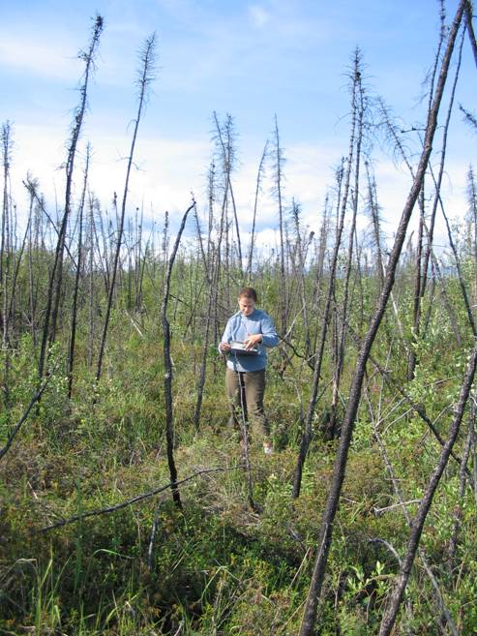
Fig. 31. Vegetation code ‘2’, substrate code ‘2-3’. Waypoint #47, Tetlin NWR.
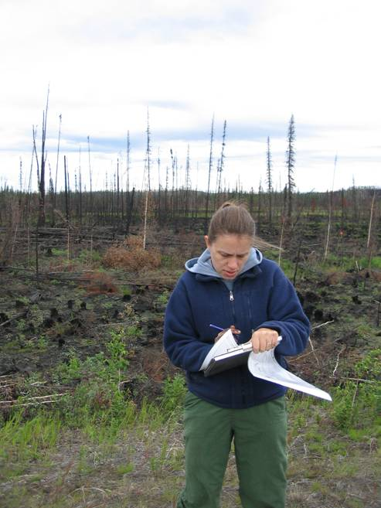
Fig. 30. Vegetation code ‘2’, substrate code ‘1-2’. Waypoint #37, Tetlin NWR.
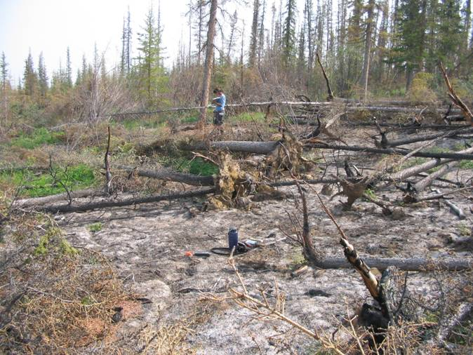
Fig. 33. Vegetation and substrate burn severity codes ‘3’. Waypoint #103, Yukon Flats NWR.
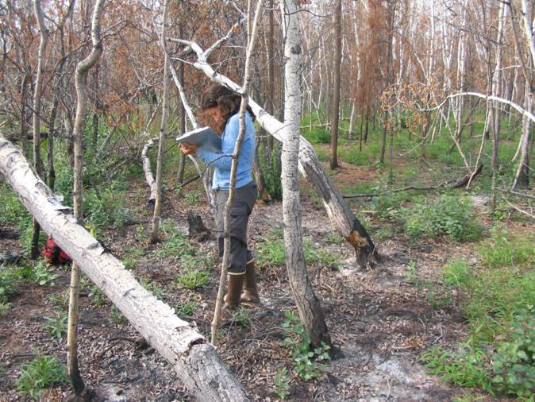
Fig. 34. Vegetation code ‘2 to 3’, substrate code ‘3’. Waypoint #96, Yukon Flats NWR.
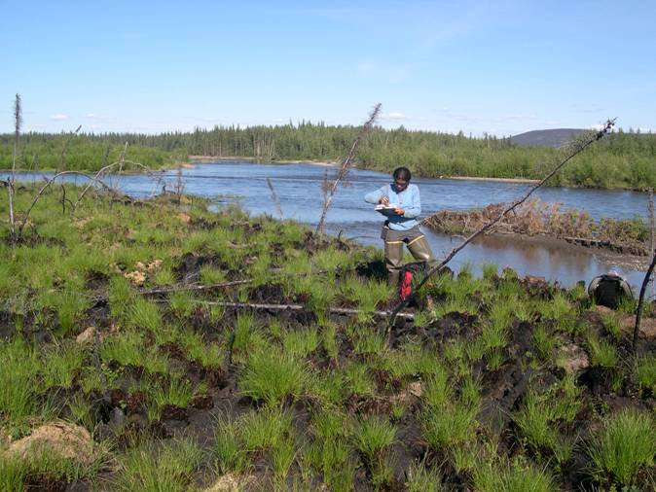
Fig. 35. Vegetation and substrate burn severity codes ‘3’. Waypoint #77, Kanuti NWR.
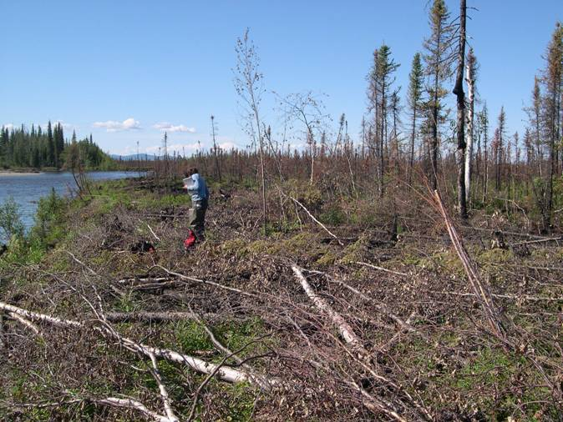
Fig. 32. Vegetation and substrate burn severity codes ‘3’. Waypoint #75, Kanuti NWR.
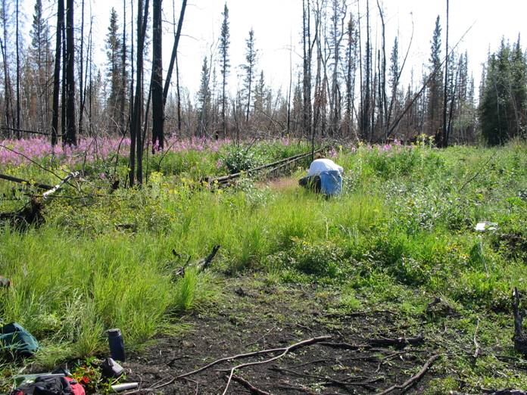
Fig. 37. Vegetation and substrate burn severity codes ‘4’. Waypoint #115, Yukon Flats NWR.
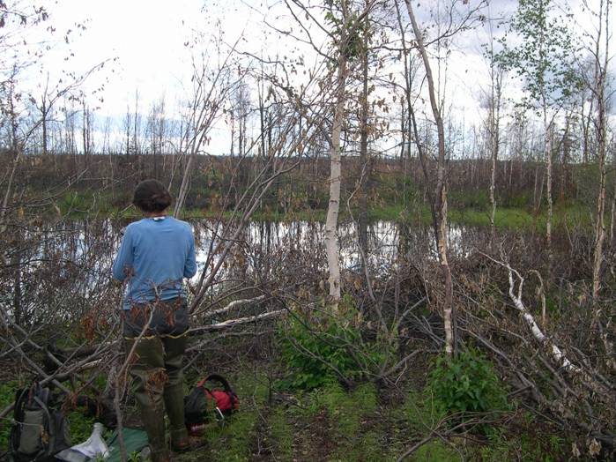
Fig. 36. Vegetation and substrate burn severity codes ‘4’. Waypoint #66, Kanuti NWR.
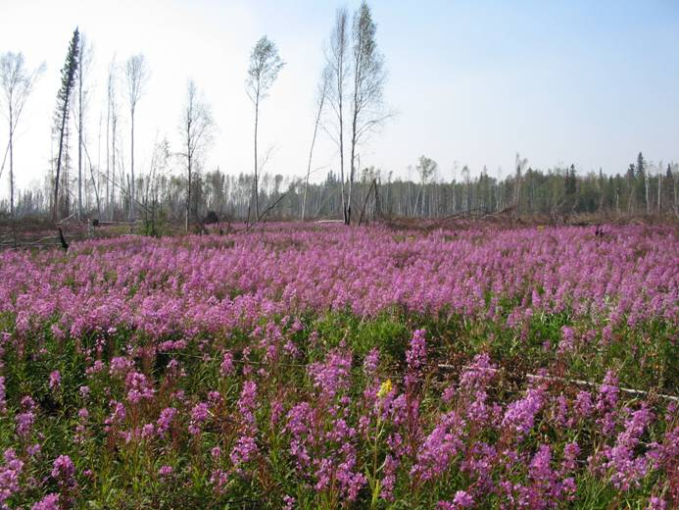
Fig. 38. Vegetation and substrate burn severity codes ‘4’. Waypoint #118, Yukon Flats NWR.
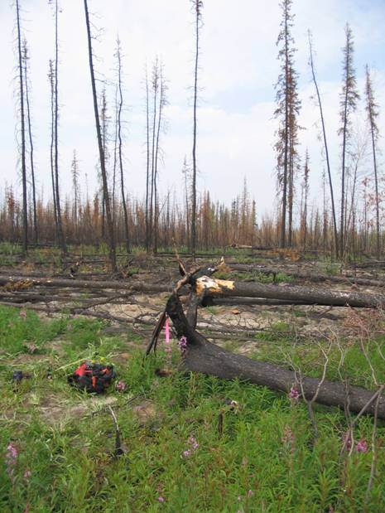
Fig. 39. Vegetation and substrate burn severity codes ‘4’. Waypoint #104, Yukon Flats NWR.
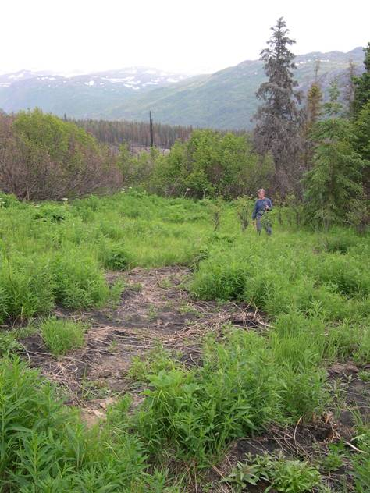
Fig. 40. Vegetation code ‘4 to 5’, substrate code ‘5’. Waypoint #11, Kenai NWR.
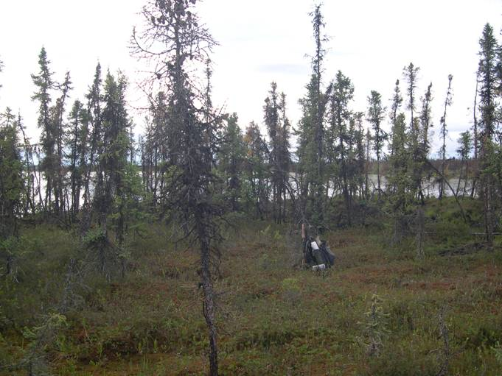
Fig. 42. Vegetation and substrate burn severity codes ‘4 to 5’, Waypoint #53, Kanuti NWR.
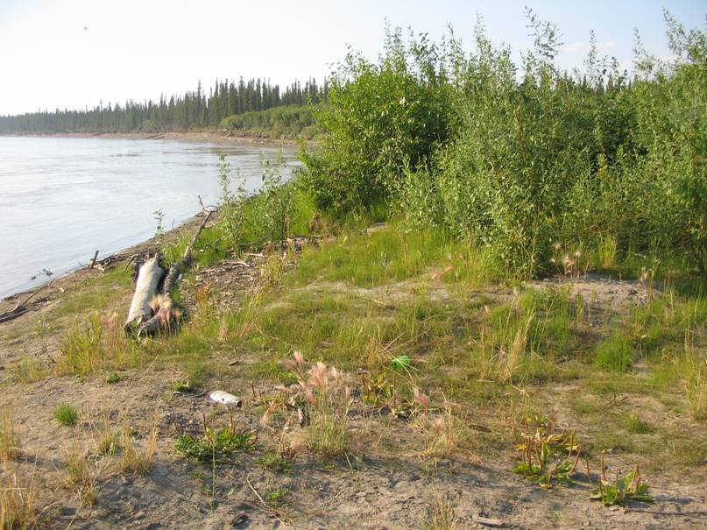
Fig. 43. Vegetation code ‘4 to 5’, substrate code ‘5’. Waypoint #117, Yukon Flats NWR.
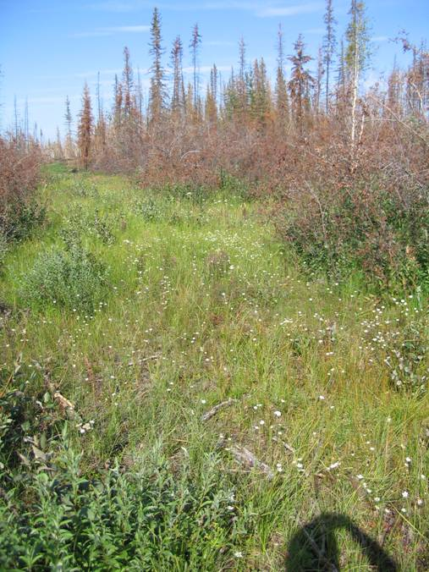
Fig. 41. Vegetation code ‘4 to 5’, substrate code ‘5’. Waypoint #117, Yukon Flats NWR.

Table 10. US Forest Service/AKNHP list of “Alaskan Invasive” plant species.
In this work, permanent plots were set up when we encountered any of the taxa included in this list, except for Hordeum jubatum.
Scientific name | Common name
Alliaria petiolata | Garlic mustard
Bromus tectorum | Cheatgrass
Centaurea biebersteinii | Spotted knapweed
Cirsium arvense | Canada thistle
Cirsium vulgare | Bull thistle
Cotula coronopifolia | Common brassbuttons
Crepis tectorum | Narrowleaf hawksbeard
Cytisus scoparius | Scotchbroom
Dactylis glomerata | Orchardgrass
Elymus repens | Quackgrass
Galeopsis tetrahit | Brittelestem hempnettle
Hieracium aurantiacum | Orange hawkweed
Hieracium umbellatum | Narrowleaf hawkweed
*Hordeum jubatum | Foxtail barley
Hypochaeris radicata | Hairy catsear
Leucanthemum vulgare | Oxeye daisy
Linaria vulgaris | Butter and eggs
Lythrum salicaria | Purple loosestrife
Medicago lupulina | Black medick
Melilotus alba | White sweetclover
Melilotus officinalis | Yellow sweetclover
Phalaris arundinacea | Reed canarygrass
Polygonum cuspidatum | Japanese knotweed
Prunus padus | European bird cherry
Saponaria officinalis | Bouncingbet
Senecio jacobaea | Stinking willie
Sonchus arvensis | Field sowthistle
Tanacetum vulgare | Common tansy
Tragopogon dubius | Yellow salsify
Vicia cracca | Bird vetch
Vicia villosa | Winter vetch
* Species names preceded by asterisk may be native but have adventive characteristics or are of ambiguous origin (e.g. both native and introduced populations).

