Formation of an Illegal Dumping Prevention Program to Reduce Potential Impacts of E. coli 0157:H7 in Agricultural Produce Grown in Monterey County

2006-2007

Environmental Public Health Leadership Institute Fellow:

John C. Ramirez, M.P.A., REHS

Assistant Director of Environmental Health

Monterey County Health Department
1270 Natividad Rd.
Salinas CA 93906
(831) 755-4542
ramirezj1@co.monterey.ca.us

Mentor:

Robbin E. Rose, M.S., REHS

Supervisor, Food Protection Program

Environmental Health Services Division

Washoe County District Health Department

(Acknowledgements):

I would like to recognize and thank the following individuals for their support of my fellowship in the Environmental Public Health Leadership Institute:

Len Foster

Director of Health, Monterey County Health Department

Allen J. Stroh, M.P.A., REHS

Director of Environmental Health, Monterey County Health Department

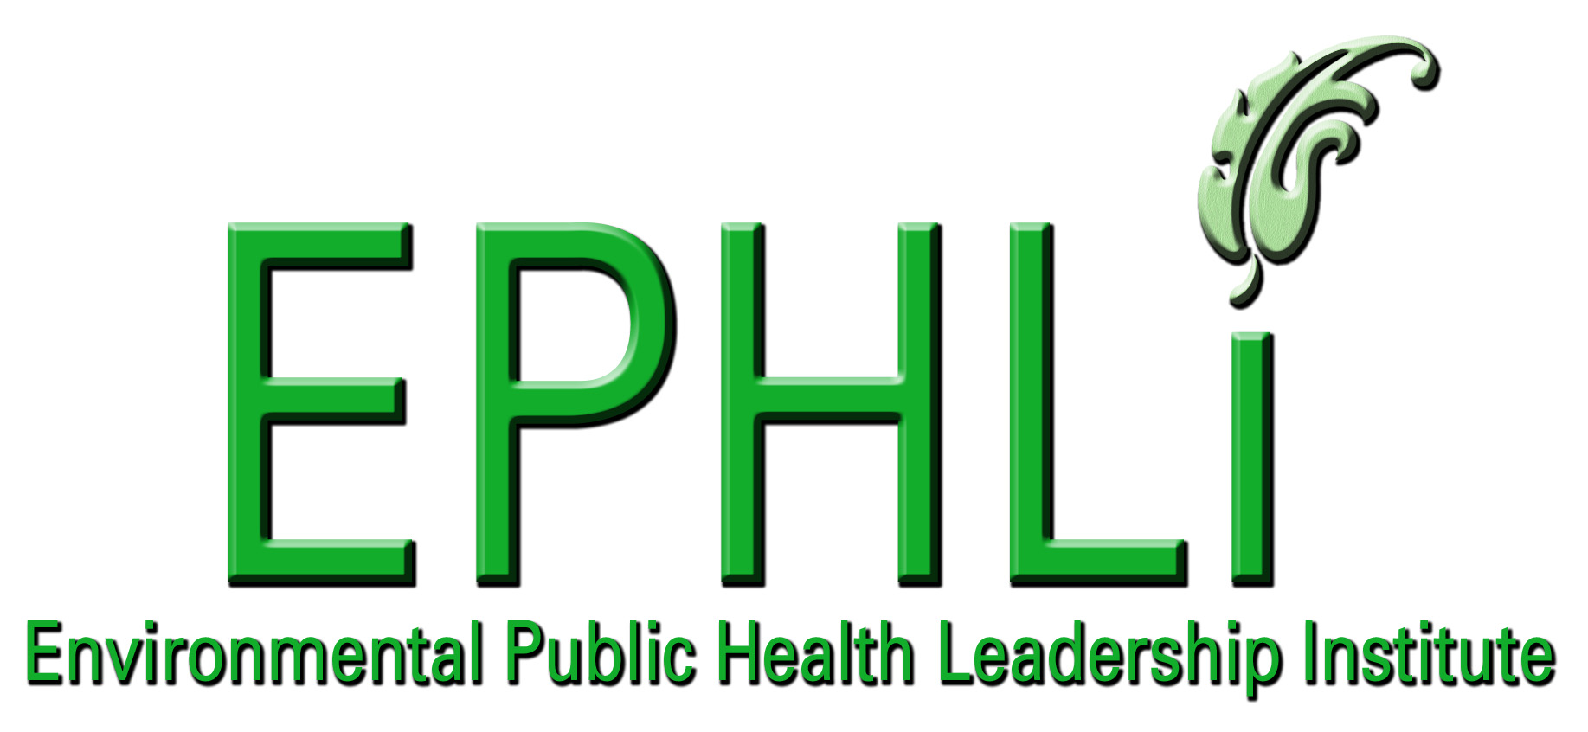

EXECUTIVE SUMMARY:

Illegal dumping and littering of solid waste has been and continues to be a problem for many communities nationwide. Monterey County does not fare any better as it has seen an increase in littering and illegal disposal of solid waste over the last five years with no end in sight. This problem has taken on new emphasis as the accumulation of solid waste along or within surface water drainage systems has contributed to increased flooding of agricultural lands. The California Department of Health Services (DHS) and the Federal Food and Drug Administration (FDA) have determined that the flooding of agricultural produce fields in 2002 and 2004 were directly linked to several outbreaks of Escherichia coli 0157:H7 (E. coli 0157:H7) in “ready-to-eat” produce grown in Monterey County. It is speculated that these floodwaters may have contained the E. coli 0157:H7 bacterium, which were then deposited upon the produce prior to distribution nationwide.

The Monterey County Health Department, Environmental Health Division has taken proactive measures to address the illegal dumping and littering of solid waste by developing an Illegal Dumping Prevention program through the formation of an Illegal Dumping and Litter Abatement Task Force. The task force was created to work closely with State and local agencies, community groups, and agricultural representatives to develop a multifaceted approach on reducing and/or eliminating the incidence of illegal dumping and littering to protect the environment and eliminate health hazards. The reduction or elimination of illegally disposed solid waste would decrease the potential for agricultural flooding, and in turn would reduce the potential of E. coli 0157:H7 contamination of produce.

This report will describe the process involved in the development of the Illegal Dumping Prevention Program using a systems approach. This report will also describe how the Illegal Dumping and Litter Abatement Task Force was created by identifying key stakeholders, recognizing political & budgetary realities, examining systems thinking logic models to describe current performance problems, and predicting potential hurdles and conflicts which may arise during the program implementation process.

This report will also examine how systems thinking can be used to develop similar programs to address other potential causes of E. coli 0157:H7 contamination in produce grown in Monterey County.

INTRODUCTION/BACKGROUND:
Problem Statement:

The Monterey County Health Department, Environmental Health Division, provides services for 13 incorporated cities and the unincorporated communities within the Monterey County. These services are provided to over 400,000 people covering 2,127,359 acres of Monterey County. The Environmental Health Division is tasked with protecting the environment and ensuring the public’s health and safety.

Illegal dumping of solid waste impacts public health, safety, and the environment. Additionally, this creates odors, provides harborage for vermin and vectors, and creates environmental problems by clogging surface water/storm water drainage systems. Illegal dumping and littering in Monterey County has steadily increased over the last five years, and cleanup response on 1,242 miles of county roads has been hampered due to reduced state and local funding. Past failures to properly address illegal dumping and littering has resulted in an increased public outcry for action to prevent environmental and public health threats. These public health threats have now included the possibility of the E. coli 0157:H7 bacterium contaminating surface waters/storm waters that may spread to agricultural produce fields through flooding. E. coli O157:H7 is one of hundreds of strains of the bacterium Escherichia coli. Although most strains are harmless, this strain produces a powerful toxin that can cause severe illness. E. coli O157:H7 has been found in the intestines of healthy cattle, deer, goats, and sheep.

The ongoing efforts in prevention of illegal dumping of solid waste took on new emphasis in 2004. This occurred when flooded agricultural produce fields were implicated by the FDA & the California Department of Health Services as a possible contributor to an outbreak of E. coli 0157:H7 in ready-to-eat produce. Prior outbreaks of E. coli O157:H7 had occurred in San Diego, California; San Mateo, California (2003); Orange County, California; and Washington State (2002). These outbreaks of E. coli O157:H7 were linked to produce grown in Monterey County. Although it is unlikely that flooding from agricultural water sources caused contamination in all of these outbreaks, the FDA clarified (in 2006) that it considers ready-to-eat crops (such as lettuce & spinach) that have been in contact with flood waters to be adulterated due to potential exposure to sewage, animal waste, heavy metals, pathogenic microorganisms, or other contaminants

In response to the 2004 findings, the Environmental Health Division, in cooperation with the Department of Health Services, conducted several creek surveys in the Salinas Valley to locate, identify, and eliminate sources of potential surface water contamination. Expanded sampling of soil and water indicated that creeks and rivers in the Salinas Valley watershed are contaminated periodically with E. coli O157:H7. The specific source of contamination that led to previous outbreaks was not identified. However, several possible sources of contamination were identified including the accumulation of solid waste in the creeks and rivers. This identified solid waste included used pesticide containers, animal carcasses, appliances, animal fecal material, rubbish and garbage.

In response to this new threat the Environmental Health Division has taken proactive measures by developing an Illegal Dumping Prevention Program through the formation of an Illegal Dumping and Litter Abatement Task Force. The task force was created to work closely with State and local agencies, community groups, and agricultural representatives to develop a multifaceted approach to reduce and/or eliminate the incidence of illegal dumping and littering which would protect the environment and to eliminate health hazards. The reduction or elimination of illegally disposed solid waste would reduce the amount of solid waste impacting proper surface water/storm water drainage, and in turn would reduce the potential of E. coli 0157:H7 that may be in surface water to contaminate produce.

The members of the Illegal Dumping and Litter Abatement Task Force are stakeholders who individually contend with various aspects of illegal dumping and littering. Elected officials, solid waste haulers, landfill operators, and local and state agencies are continually challenged by the public to clean up the litter or illegal dumpsites. These efforts have been affected by limited funding and in the availability of resources. The formation of the task force combines the resources and funding of all the stakeholders by addressing problems that no one stakeholder is able to accomplish alone. Each stakeholder becomes part of the process in creating change to reduce or eliminate illegal dumping, and each stakeholder will then benefits from this change:

- Elected officials will be viewed as effective in dealing with important local issues.
- The public will benefit by having cleaner roadways and highways and thereby shifting their tax dollars to critical health and service needs.
- Solid waste haulers will be viewed as responsive to public health concerns rather than with the bottom line. They will also benefit in increased tonnage of solid waste entering the landfills, which will increase profits by accepting waste that would end up in illegal dumps.
- The Environmental Health Division will benefit by the elimination of environmental contamination and harborage for vermin and insects, which will improve public health and safety.
- The agriculture industry will benefit as ready-to-eat produce will have one less potential contributor to the cause of E. coli 0157:H7 and in turn consumer confidence, and profits will build.

Current efforts of the task force to address illegal dumping and littering have not fully addressed the impacts of the agricultural industry. The agriculture industry has become an “Accidental Adversary” as the industry attempts to rebuild consumer confidence through implementation of voluntary food safety guidelines that do not examine illegal dumping and littering impacts.

Behavior Over Time Graph:

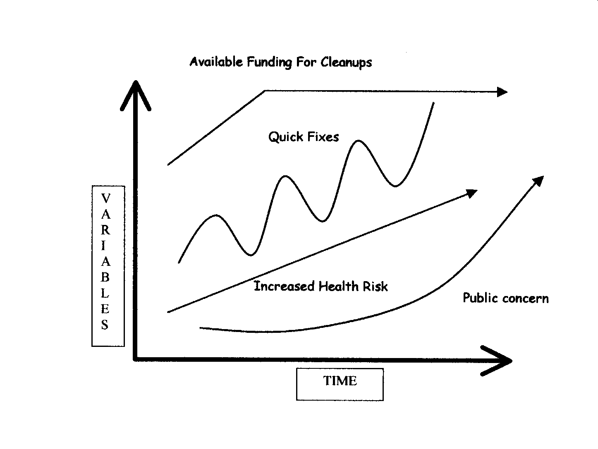
Figure #1

Figure #1

Illustrates several notable impacts created by illegal dumping. The typical response to litter and illegal dumping by county and state agencies has been addressed by the “Quick Fix.” This quick fix to clean up the dumps sites is completed with little thought to planning or prevention efforts. State and local agencies typically respond until funds decrease and diminish or until legislative actions increase funding for litter removal or illegal dumping abatement. By continually addressing the problem through the quick fix, the problem, is perpetuated in a cyclical response by all agencies in answer to public concern.

The “Increased Public Health Risk” to the environment and public from illegal dumping increases over time as state and local funds are reduced or eliminated. The “Available Funds for Cleanups” will initially increase but then level off or slightly decline as funding decreases. These budgetary impacts affect the resources and staffing needed to abate litter and illegally dumped solid or hazardous waste materials. “Public concern” will initially be low as litter and illegal dumps are addressed but may soon turn to outrage over time as resources diminish as the environment and/or food safety is impacted.

Causal Loop Diagrams and applicable archetypes:

Fixes that Backfire Archetype:

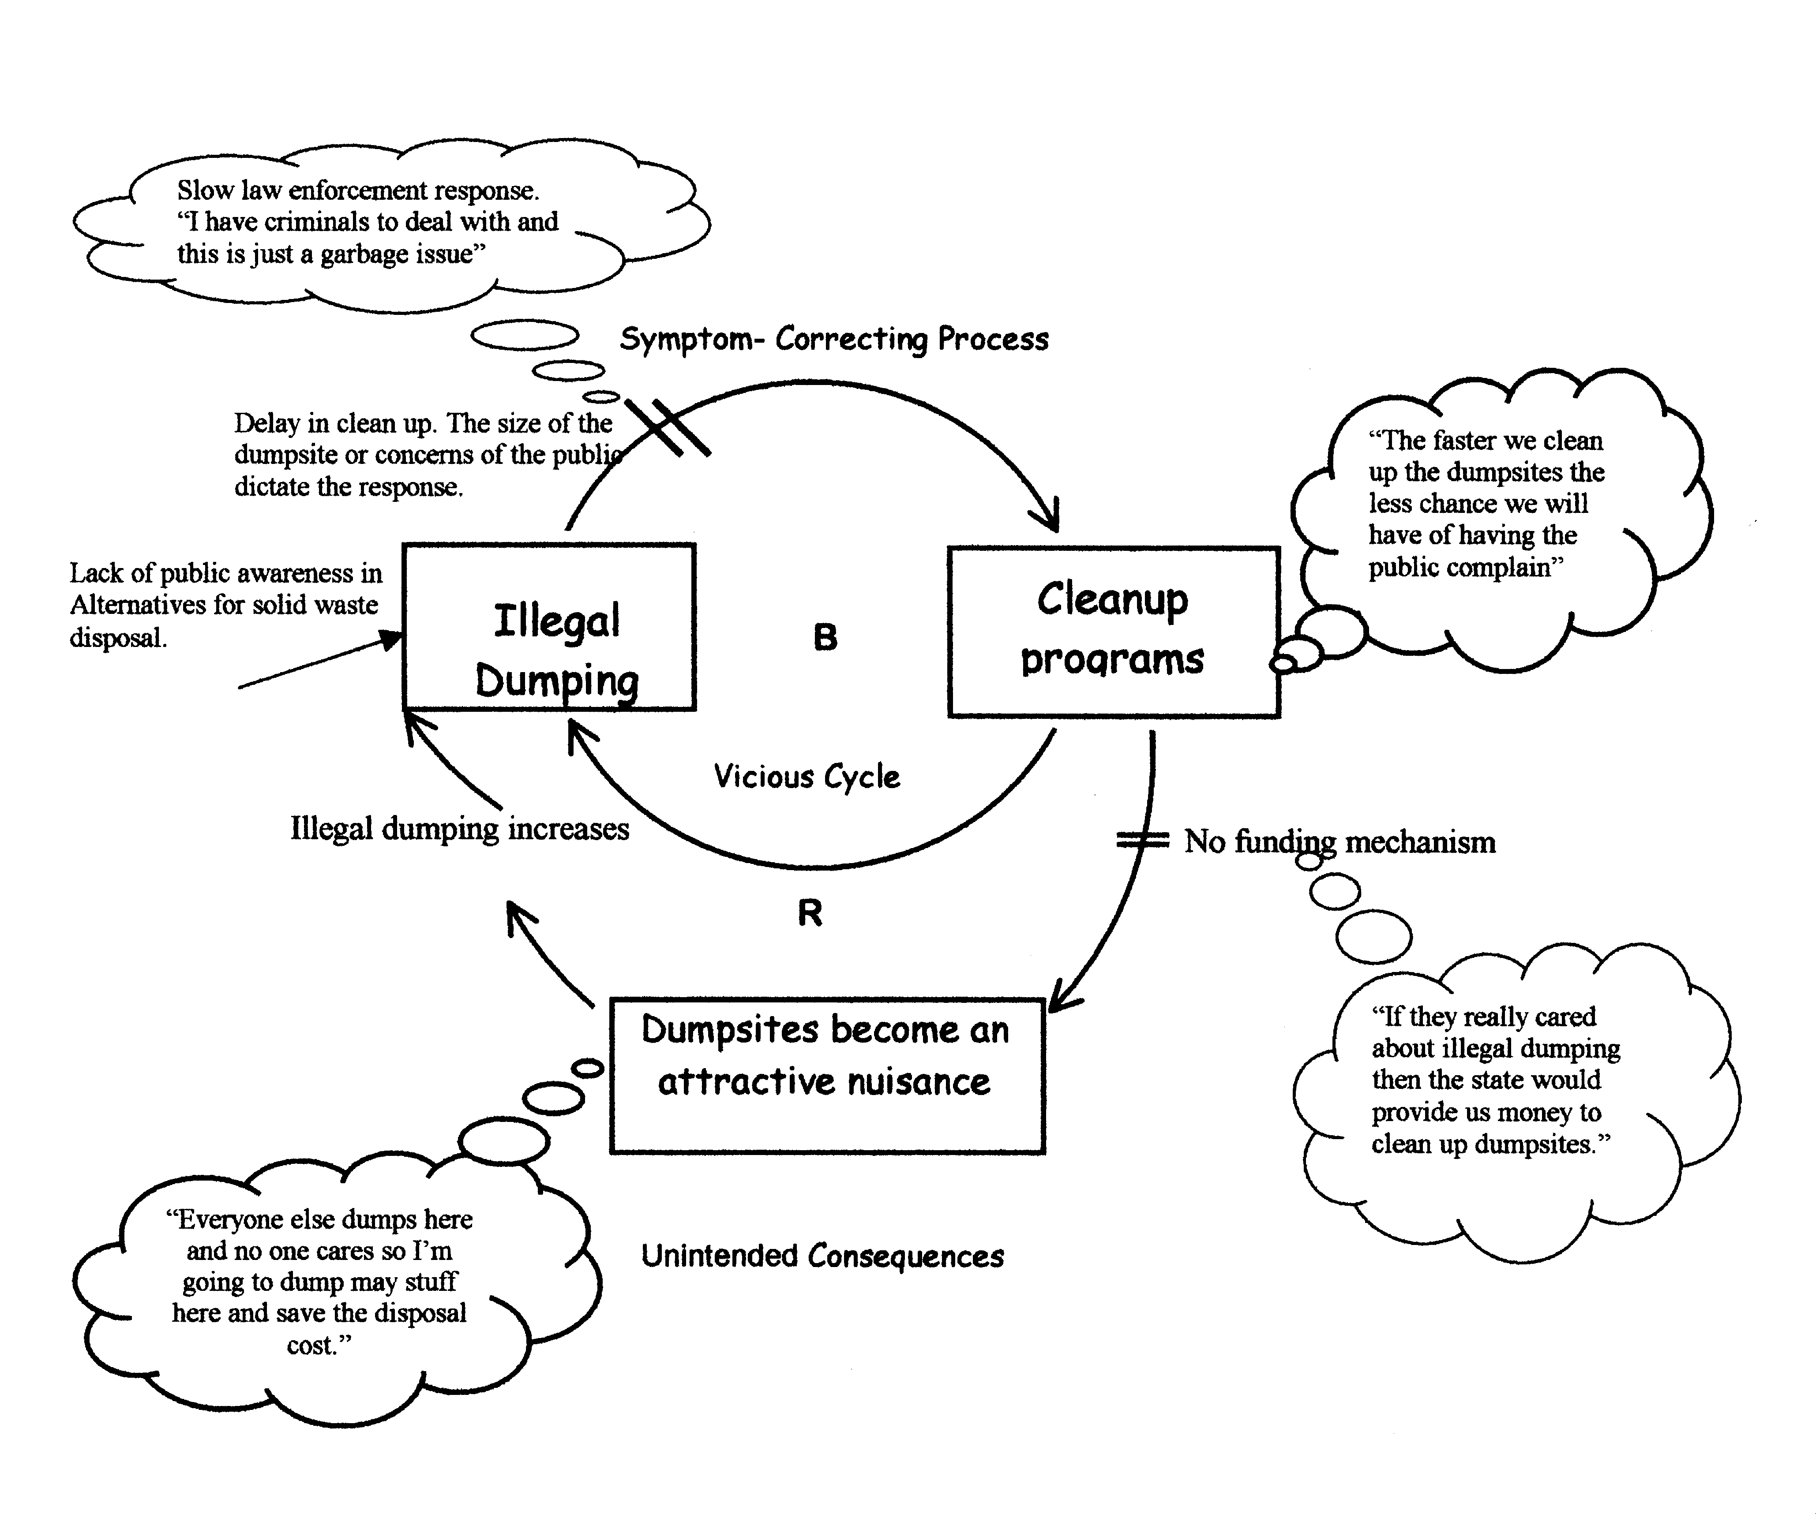
Figure #2; Fixes that backfire

Fiqure#2

Demonstrates the “Quick Fix” response that “Backfires” when actions taken to clean up the litter or illegal dump sites fail and the problem perpetuates into as a vicious cycle. With decreases or delays in funding the cleanups, the illegal dumpsites become attractive nuisances and this is the unintended consequence of this archetype. The “Mental Models” indicate what the participants may be thinking and how this thinking allows the fix to backfire.

Accidental Adversary Archetype:

Figure#3 Accidental Adversaries

Figure #3

Demonstrates the activities implemented to address food safety issues by the agricultural industry and the Illegal Dumping and Litter Abatement Task Force that have caused them to become “Accidental Adversaries.” This has occurred as both groups have drawn attention to the food safety issues associated with E. coli 0157:H7. The focus on illegal dumping and its effects in the agricultural setting may cause the public to view agricultural conditions as unsafe and unsanitary.

10 Essential Environmental Health Services:

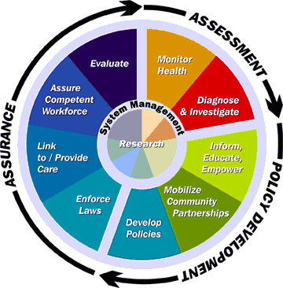
Figure 4: Ten Essential Services of Environmental Health-as developed
By Carl Osaki, RS, MSPH, Northwest Center for Public Health Practice.

This project seeks to enhance the following eight Essential Environmental Health Services in Monterey County.
- Essential Health Service No. 1- Monitor environmental health status to identify and solve community environmental health problems by:
- tracking the amount of illegally disposed of solid waste in the unincorporated portions of the county.
- using compiled information to evaluate the content of solid waste to focus efforts in recycling or alternatives to illegal disposal of solid waste.
- assessing increases or decreases in illegal dumping to measure the effectiveness of the program efforts.
- Essential Health Service No. 2- Diagnose and investigate environmental health problems and health hazards in the community by:
- investigating increases in illegal dumping as it relates to agricultural farmland implicated in new outbreaks of E. coli 0157:H7.
- Essential Health Service No. 3- Inform, educate, and empower people about environmental health issues by:
- conducting informational presentations to community groups and organizations that describes the environmental and health hazard associated with illegal dumping.
- providing educational materials and brochures to identify and report illegal dumping.
- establishing a county-wide cleanup effort to promote public involvement in the clean up of the environment. Also, encouraging recycling, reuse, and reduction efforts and,
- establishing a website with links to local cities and government agencies for reporting illegal dumping and littering and to provide the public with information.
- Essential Health Service No. 4- Mobilize community partnerships and actions to identify and solve environmental health problems by:
- increasing public participation in the Illegal Dumping and litter Abatement Task Force for Monterey County.
- mobilizing community groups to participate in the annual County Clean Up Day.
- increasing participation of agricultural groups to eliminate agricultural generated solid waste disposal along farmland and major roadways and highways in the county.
- Essential Health Service No. 5- Develop policies and plans that support individual and community environmental health efforts by:
- creating an illegal dumping ordinance.
- Essential Health Service No. 6- Enforce laws and regulations that protect environmental health and ensure safety by:
- creating an illegal dumping citation /enforcement document for use by law enforcement officials.
- establishing an enforcement-training program for environmental health staff with the district attorneys office (, and,)
- prosecuting violators of illegal dumping or littering laws or regulations.
- Essential Health Service No. 8- Assure competent environmental health workforce by:
- providing ongoing training to environmental health staff in all service programs of the Environmental Health Division.

National Goals Supported

Healthy People 2010 Objectives- Focus Area 8-8, Increase the proportion of assessed rivers, lakes, and estuaries that are safe for fishing and recreational purposes.

The efforts of the Illegal Dumping and Litter Abatement Task Force is focused to reduce the incidence of solid waste disposal as well as the illegal dumping of hazardous waste in the Salinas Valley watershed. The reduction in illegally disposed pesticides, hazardous waste, animal carcasses, and solid waste will reduce the amount of potentially harmful contaminants entering into surface waters of Monterey County. These efforts will increase public health and safety in accessing these waters for recreational purposes such as swimming or fishing.
.
CDC Health Protection Goals- Healthy Communities

The efforts to reduce the incidence of illegal dumping and littering will reduce the potential for environmental hazards, vermin & vector infestation, and contamination of surface waters potentially reducing the impacts to the agricultural produce grown in Monterey County. The continuing participation of members of the Illegal Dumping and Litter Abatement Task Force will increase the number of communities participating in the effort to protect and promote health and safety, and to prevent illness and injury by reducing impacts of West Nile Virus, E. coli 0157:H7 and other waterborne diseases.

These efforts will increase the quality and years of healthy life in the community and eliminate health disparities between rural communities and the incorporated cities of Monterey County. In addition, these efforts will identify deficiencies in communities lacking high-quality water and reduce the public’s risk of exposure to toxic chemicals, infectious agents, and/or other environmental health hazards.

Project Logic Models:
Resources/Inputs | Activities (process) | Outputs | Short & Long Term Outcomes | Impacts.
Funding  - California Dept. of  Transportation  - Local Landfills  - Health Department | Program Design and Development  - Increase participation in state Adopt-a-Highway program  - Increase participation in county Adopt-a-Road program  - Develop a solid waste Voucher Program  - Develop a tracking system of illegal dumpsites  - Research grant funding opportunities | Actions  - Issue 50 vouchers by  12-31-07  - Complete at least  four grant  applications by  12-31-06  - Complete GIS/GPS  map of dumpsites  - Increase  participation in  adopt-a-road &  highway programs  by 20% | Learning  - Increased awareness  of illegal dumping  and littering impacts  - Improved  participation in  adopt-a-highway  programs  - Increased awareness  of alternatives to  solid waste disposal  - Increased  collaboration  between the public and  public agency  partners  - Improved  communication  between agencies  - Improved  funding mechanisms | Behavior  - Increased awareness  of alternatives to  illegal disposal of  solid waste

Resources/Inputs | Activities (process) | Outputs | Short & Long Term Outcomes | Impacts.
Educational Awareness Program | Training  - Conduct assessment  of available training  materials  - Conduct assessment  of available training  programs  - Conduct onsite  training sessions  with business and  industry  - Conduct off-site  presentations on  illegal dumping and  littering  - Evaluate  effectiveness of  training | Actions  - Complete at least 12 training sessions  in local schools,  businesses and  organizations  - Increase the level of education in the  Spanish speaking  population by 50%  - Training will focus on illegal dumping and alternatives  - Complete  evaluations of the  materials presented  - Evaluations completed by at least  100 training  participants  - Training materials  should have at least  80 % range of  competency | Learning  - Public gains  knowledge of illegal  dumping alternatives  - Public awareness of  recycling, reuse and  reduction  alternatives to  dumping  - Public officials  aware of ongoing  efforts to curb  littering and  dumping  - Improved  educational efforts  - Increased frequency  of training  Cleaner highways,  roadways, and  waterways resulting  in fewer impacts to  agricultural fields | Behavior  - Increased awareness  of environmental and  health impacts

Resources/Inputs | Activities (process) | Outputs | Short & Long Term Outcomes | Impacts. (Behavior)
Laws/Ordinance | - Create an Illegal Dumping and Littering Ordinance  - Create a violation code guide for law enforcement | Actions  - Implement Ordinance by 12-31-07  - Provide violation code guide to 4 local law enforcement agencies per quarter (max 12) | Learning  - Increased penalties assessed to violators  - Increased total of violations issued by law enforcement | - Reduction in illegal  dumpsites  - Reduction in impacts  to agricultural  produce from  E. coli 0157:H  - Improved surface  water quality  - Improved of public  and government  agencies
Task Force Partners  - Community Groups  - Health Department  - Cal-Trans  - Landfill Operators  - Law Enforcement  - Agriculture  - Business & Farm  Community  - Public Works | - Teams/individuals submit project proposals.  - Six Subcommittees identify and complete a focus projects  - Project feedback by Task force  - Presentation to the Board of Supervisors | Actions  - One County Clean Up  Day, April 22, 2007  - 40% community  groups participation  - Four task force meetings  - Progress report to the Board of Supervisors | Learning  - Increased  partnerships between  public agencies and  community  - Projects addressing  needs of underserved  communities/or  populations | - Reduction in illegal  dumpsites  - Reduction in impacts  to agricultural  produce from  E. coli 0157:H  - Improved surface  Water quality

PROJECT OBJECTIVES/DESCRIPTION/DELIVERABLES:

Program Goal
To implement an Illegal Dumping Prevention Program that is aimed at reducing the rate of illegal dumping and littering in Monterey County. The reduction in illegal dumping and littering may also reduce the potential for floodwaters containing the E. coli 0157:H7 bacterium to contaminate produce grown and harvested in Monterey County.

Health Problem
Illegal dumping in Monterey County has been identified as one of many possible contributors to recent outbreaks of E. coli 0157:H7 in ready-to-eat produce marketed worldwide. Illegal dumping and littering impact storm water runoff by clogging drainage ditches, canals, and other surface water channels causing flooding of produce fields.
The California Department of Health Services and the Division of Environmental Health conducted an investigation of surface water and soil adjacent to farmland in 2005-06. This investigation provided data implicating floodwaters as a possible vector for contaminating agricultural fields with E. coli 0157:H7 in ready-to-eat produce.
Agricultural flooding of farmland may occur after heavy rains, and some of the agricultural fields may become contaminated with waters containing residue from animal carcasses, fecal matter from animals and rodents as well as contaminants from illegally dumped chemicals and hazardous waste. These same contaminants also lead to environmental impacts on the Monterey Bay Marine Sanctuary and the wildlife and sea life within.

Outcome Objective
By December 31, 2007, reduce the amount of illegal dumpsites to 50%, and reduce the impacts to the environment and public health by reducing the potential of flooding of agricultural produce fields.

Determinant
  - Reduction in the amount or extent of agricultural flooding.
  - No increased incidence of E. coli 0157:H7 found in produce from Monterey County.
  - Reduction in the number of illegal dumping complaints reported to Environmental Health.
  - Increased public participation in eliminating illegal dumps and litter.

Impact Objective
By December 31, 2007 the public and the agricultural industry will work effectively together to reduce the incidence of illegal dumping and littering in Monterey County which in turn will reduce the potential of E. coli 0157:H7 contamination in ready to eat produce.

Contributing Factors
- Lack of public awareness of alternatives to illegal dumping of solid waste through recycling, reuse and/or reduction of solid waste and waste oils.

- Lack of public awareness of existing alternatives provided by Solid Waste Hauler(s) (i.e. handling bulky items) and lack of knowledge of existing procedures to have additional amounts of solid waste removed as part of their curbside service between pick up dates.

- Economic factors lead to illegal dumping by those who cannot afford to pay disposal fees for large bulky items.

- Lack of participation of law enforcement in curtailing illegal dumping or in citing those who do litter.

- Lack of bilingual programs and solid waste disposal information in Spanish.

- Lack of an ongoing educational program on illegal dumping and littering and the risk(s) associated with these practices.

Process Objectives
- Improve participation of law enforcement officials in the enforcement of existing laws for illegal dumping and littering.

- Increase participation of community groups in a planned Monterey County clean
up event.

- Demonstrate an increase in the publics’ awareness of alternative solid waste disposal programs.

METHODOLOGY:

Events and Activities
By October 30, 2006, improve participation by law enforcement to enforce existing laws on illegal dumping and littering in Monterey County.

- Event: Implement joint training program in identification of illegal dumpsites.

Activities:
- Use GIS/GPS mapping information to locate existing and historical dumpsites for use by law enforcement and the public.
- Provide training for law enforcement officials on new enforcement processes.
- Complete development of an illegal dumping ordinance.
- Provide illegal dumping informational sheets to include dumpsites, violation codes and contact numbers for agency response.

By April 22, 2007 20% of Monterey County community groups will participate in clean up events.

- Event: Monterey County Clean Up Day.
Activities:
- Members of the Illegal Dumping and Litter Abatement Task Force will coordinate the event in four regions of Monterey County.
- Contact 75% of all known community groups for participation.
- Provide equipment, bags and prepaid disposal vouchers to participating groups.
- Conduct quarterly surveys during special events to assess the knowledge of the public on illegal dumping and littering.

By July 30, 2007 50% of Monterey County residents will demonstrate an awareness
of available alternative solid waste disposal programs.

- Event: Awareness Campaign
Activities:
  - Develop a bilingual advertising program using public service announcements,
presentations to businesses and schools, and brochures.
  - Conduct quarterly surveys during special events to assess the knowledge of
the public on illegal dumping and littering.
  - Conduct presentations with business groups and local Chambers of
Commerce for participation in the state Adopt-a-Highway Program and
Monterey County Adopt-a-Road Program.
  - Increase attendance and participation in the Monterey County Illegal
Dumping and Litter Abatement Task Force.
  - Involve the agricultural community through participation in the Monterey
County Illegal Dumping Task Force.

RESULTS:

Results to date:
- The first Monterey County Cleanup Day event was completed on April 22, 2006.
- Eight Illegal Dumping and Litter Abatement Task Force meetings have occurred to date.

CONCLUSIONS:

The Illegal Dumping Prevention Program described in this report only examines one potential impact to the environment and most importantly the food safety issues concerning ready-to-eat produce in Monterey County. Implementation of the Monterey County Illegal Dumping and Litter Abatement Task Force initiatives will help to eliminate this as one factor of many that may cause food safety concerns. It is not anticipated that a successful program alone will eliminate the threats to food safety. The knowledge gained in this program will enable the Environmental Health Division to use the systems thinking approach in addressing other potential threats to food safety identified by the FDA and the State Department of Health Services. These potential threats have been identified as fecal matter from cattle & geese, feral pigs, farm worker field sanitation, composting operations, failed septic systems, illicit dischargers and storm water discharges.

The next steps and future goals of the program to protect the environment and public health and safety will evaluate these potential threats in preventing E. coli 0157:H7 contamination in Monterey County produce, these include:

- The Environmental Health Division will continue to work with the Department Of Health Services staff and the appropriate California Integrated Waste Management Board (CIWMB) staff to review current manure composting, sampling and inspection procedures. Environmental Health Division program staff will increase the inspection frequency of all compost facilities adjacent to waterways.

- The Environmental Health Division is currently implementing a field toilet registration and inspection program to focus on hand washing facilities and the availability and proximity of field toilets to all farm workers in all agricultural settings. The Environmental Health Division will follow the recommendations outlined in the October 26, 1998 Guide to Minimize Microbial Food Safety Hazards for Fresh Fruits and Vegetables, specifically sections IV (Worker Health and Hygiene), and V (Sanitary Facilities). Full implementation of this program will be completed by July 2007. In the interim, Environmental Health Division staff will work on educating farm labor contractors and farm managers on the new program requirements and recommend early implementation.

- The Environmental Health Division will continue enforcement of existing Onsite Waste Water programs per the Monterey County Code. The Environmental Health Division is designated as the regulatory agency for disposal of domestic waste of less than 2500 gallons per day by the Regional Water Quality Control Board (RWQCB). The installation of all septic systems must be no less than 100 feet from surface water and water wells. Environmental Health Division staff conducting any mandated inspection on farm land or private property will ensure that no violations are observed that would lead to possible surface water contamination or contamination of produce.

- Environmental Health Division, in conjunction with the Department Of Health Services, will ensure that any and all produce impacted by sewage or wastewater releases of any kind will be removed from harvesting to protect public health.

- The Environmental Health Division will work closely with the Monterey Regional Storm Water Permit Management Group in its storm water management plan to include Best Management Practices for stormwater discharges. The Monterey Regional Storm Water Management Program will help to eliminate or reduce impacts from wastewater discharges into creeks from cities and communities in the Salinas Valley.

- The Environmental Health Division will continually evaluate the programs in place for the Illegal Dumping Prevention Program and will assist the Department of Health Services in food safety surveillance through the existing mandated programs in retail food safety.

LEADERSHIP DEVELOPMENT OPPORTUNITIES:

John C. Ramirez

Aceptance to EPHLI as a fellow is one of the highest honors I have received. I have met and networked with a group of outstanding leaders and peers whom have greatly influenced and encouraged me in my carrer. I have found that we share many challenges and face similar obstacles nationwide, and I am not alone in trying to find solutions to our similar problems or concerns.

EPHLI has helped me develop both personally and professionally through this educational opportunity. Prior to my participation in EPHLI there was some concern on my part as to how I was developing as a leader. Through the use of the Skillscope assessment, the Myers-Briggs and the Change Style Indicator, I have learned more about my leadership style and how I approach situations involving change. I have also learned where my personal leadership style needs improvement and how to use the Indivdual Development Plan to measure and plan for my future develpoment.

I am honored that I was selected, and I am grateful to my mentor and my instuctors who have provided me with a lifelong learning experience that few may have the opportunity to take advantage of. The skills I have learned will allow me to use them effectively throughout my carrer, and I am anxious to continue learning more about systems thinking and how it can help me in my current position.

ABOUT THE EPHLI FELLOW

John Ramirez is the Assistant Director of Environmental Health for the Monterey County Health Department in Salinas California. He holds a Bachelors of Science Degree in Organic Chemistry from the University of Oregon and a Masters Degree in Public Administration from Golden Gate University, San Francisco. His career in public health began in 1989 as a hazardous materials specialist for Monterey County. He is a State of California Registered Environmental Health Specialist and a Certified Hazardous Materials Specialist through the California Specialized Training Institute (CSTI).

In 1999 Mr. Ramirez was appointed supervisor of the Hazardous Materials Management Services program. In 2004, he and his team gained recognition for leadership as the Outstanding Certified Unified Program Agency (CUPA) in the State of California.
.
Mr. Ramirez was appointed Assistant Director of Environmental Health for Monterey County in 2004. He currently directs a total of 30 staff in the Solid Waste Management Services, the Recycling Services as well as the Consumer Health Protection services for Monterey County.

In his over 17 years of experience, he has served on a variety of local and statewide committees; most recently he served as a member of the State of California Illegal Dumping Enforcement Task Force at the request of the Californian Integrated Waste Management Board.
REFERENCES

- Osaki, C. Essential Services of Environmental Health. Northwest Center for Public Health Practice, University of Washington School of Public Health and Community Medicine, Seattle, WA. July 2004.

- U. S. Department of Health & Human Services, Office of Disease Prevention & Human Services. Health People 2010. Available at: http://www.healthypeople.gov. Accessed March 11, 2006.

- CDC. A National Strategy to Revitalize Environmental Public Health Services. Atlanta, GA: Dept. of Health and Human Services. (US) CDC: September 2003.

