QUARTERLY REPORT

Date of Report: October 30, 2005

Contract Number: AGREEMENT NO. DTRS56-03-T-0007

Prepared for: US DOT and PRCI

Project Title: FIRST MAJOR IMPROVEMENTS TO THE TWO-CURVE DUCTILE FRACTURE ARREST MODEL – EFFECT OF DIFFERENT SOIL TYPES ON DUCTILE FRACTURE ARREST, AND SEPARATING ELASTIC AND PLASTIC CONTRIBUTIONS TO THE CRACK-DRIVING FORCE

Prepared by: Engineering Mechanics Corporation of Columbus

For quarterly period ending: September 30, 2005

List Activities/Deliverables Completed during this reporting period by Task Number and indicate if it is a milestone.

SCH Date CMPL Date
Task 1.4: 2nd yr Experiments Sept 2005 Sept 2005
Task 1.5 Reduce data from experiments Dec 2005 Ongoing
Task 1.8: Refine additional Instrumentation Sept 2005 Sept 2005
Task 1.9: Apply instrumentation Sept 2005 Sept 2005
Task 1.10 Reduce instrumentation data Dec 2005 Ongoing
Task 1.12: Additional Soil Studies Jan 2007 Ongoing
Task 3.2: Quarterly Report Oct 2005 Oct 2005

It should be noted that the work in Task 1.4 is complete but all of the subcontractor’s invoices have not been received to date.

Technical Status - description of tasks completed, data from test results, research findings and/or discoveries.

The work in the quarter focused on the conduct of the second series of Mojave experiments.

Pretest Hydrotesting

After the first series of experiments in August 2004, the remaining pipe material was buried in the dry sand to protect it from the environment. During the preparation of the second set of experiments, these pipes were unburied and inspected. Due to excessive rain in the Mojave during the Jan-Feb 2005 timeframe, moisture on the pipe caused some pitting corrosion, see Figure 1. To better inspect the pipe, each test pipe was sand blasted to remove the scale and the damage inspected. The pits that had formed were small, shallow and localized. Molds were taken on several of the more sever pit areas. The maximum pit depth was approximately 0.76 mm (0.03 inch) and the average size was about 2.5 mm (0.1 inch) in diameter. In order to verify that these pits were not going to influence the burst pressure of the pipes, a hydrotest to failure was conducted on one of the test pipes. This pipe failed at 27.6 MPa (4,000 psi), which is very close to an ultimate strength failure of the unflawed pipe, i.e., calculations gave the failure pressure ranging from 26.2 MPa to 31 MPa (3,800 to 4,500 psi) depending on the failure equations assumed. In addition, the pipes that were to be tested were hydrotested to 25.8 MPa (3,750 psi), which is 1MPa higher than the 24.8 MPa (3,600 psi) test pressure.

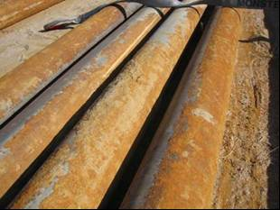
Figure 1 Pipe photograph showing some corrosion

Extra instrumentation development

As described in the last monthly report, the lab work for the development of the extra instrumentation was conducted during this quarter. Experiments were conducted to aid in the design development of the Wire CTOA device and the soil pressure gages. Difficulties in the development of the Hall Effect device precluded any laboratory tests prior to the Mojave experiments. It was planned that post test calibrations would occur.

Wire CTOA

The initial concept for this device was to have a series of timing wires with a predetermined amount of slack, so the wires would break at different crack-opening displacements than a typical tight timing wire. The difficulty with this concept was that the timing wires used were copper wires and had a large elongation to failure. The elongation to failure in various commercially available copper and aluminum wires was much larger than desired; a notching procedure is required for low strain failure. Although we explored ways to notch the wires in a manner that gave consistent results, we quickly determined that this was not a reasonable approach to take for this device. Instead of relying on breaking of a wire that spans the opened crack, it was decided to have a stronger wire that opens an electrical contact, which would be more precise and repeatable.

The development of the Wire CTOA device evolved to the final design shown in Figure 2. Figure 3 shows a photograph of the Wire CTOA devices on the Mojave test pipes, as well as the Hall Effect device and timing wires.

There are four key subassemblies in the Wire CTOA device.
- The high-strength small-diameter wire that spans across the crack and pulls the sliding bar across the contacting brass-tipped set screws. This is standard music wire of a specific diameter.
- A sliding bar with a socket-head screw to crimp the end of the music wire in place.
- An anchor block that has a clearance hole for a sliding aluminum bar and electrical conducting brass-tipped set screws. This block is made from an electrical non-conducting high-strength composite material.
- Another anchor block with set screws that pretensions the wire and crimps it into place with set screws. This block is made from aluminum.

Key aspects that required analysis and testing of each of these subassemblies are briefly described below.

Music Wire – This wire has to be strong enough to span the crack and not deflect or deform from the pressure loads of the exhausting gas coming from the crack opening of about 25 mm (1 inch). Analyses were conducted to determine the deflection of the wire and what the pullout forces would be from the pressure loading. Larger diameter wire gives a greater strength, but the large diameter also increases the pressure loads. An optimal diameter was determined.

Sliding Bar – There are two key aspects to the sliding bar subassembly design. One aspect is how the music wire is attached to it. The second is how the brass-tipped conducting screws are tightened. (1) The music wire has a very high strength (~2 GPa [300 ksi]), therefore, with the diameter needed, it cannot be bent to a tight radius. The wire is attached to the aluminum sliding bar with the use of a steel socket head screw that crimps the wire into the aluminum bar. The aluminum is much softer than the music wire, and deforms as the socket head screw is tightened. The depth of the socket-head screw hole below the music wire clearance hole is a critical parameter. It was experimentally determined that if this depth was too great, the music wire would break at loads less than expected due to the excessive bending of the wire. Once the proper depth of the socket-head screw hole was determined, tests were performed to determine the proper torque on the socket-head screw. (2) The second aspect of this subassembly was how the surface finish affected the torque requirements on the brass-tipped set screws. These sets screws are what is holding the rod in place to resist the force exerted on the wire from the decompressing gas. Experiments were conducted to determine the pull-out force of the rod from the block with different brass-tipped set-screw torques, surface finishes, and with and without graphite lubrication. It was experimentally determined that there was less scatter in the results when unlubricated aluminum rods were used with a 100 grit final surface polishing. The pullout force was directly related to the brass-tipped set-screw torque. This force needs to be above the force from the pressure pull-out loads.

Sliding Bar Anchor Block – This anchor block needed to be made from an electrical non-conducting material. A cross-plied-mat composite material with a strength of 345 MPa (50 ksi) was chosen. This material had to be non-conducting since the brass-tipped setscrews carried the electrical signal of interest. Key aspects of this subassembly were selecting the proper composite orientation to maximize the strength, and determining the brass set screw maximum torques that could be applied before cracking the composite block. It was experimentally determined that the composite block failed when the set screw torque was above 35 in-lb, which is much higher than the 10-in-lb of torque that is required to resist the pressure loading. With the factor of 3.5 on the torque limit, the composite material holding the set screw in place should not creep from the time it was tightened to the time of the test.

Pre-tension Anchor Block – This block is made out of aluminum and has two steel set screws to crimp the music wire. These two screws are redundant, and potentially one of them could be eliminated. The torque to crimp the music wire in place is the critical parameter, and was determined experimentally. As in the sliding rod case, the depth of the set-screw hole relative to the clearance hole for the music wire is a critical dimension. Experiments were conducted with composite material, steel, aluminum, and brass to determine the best way to crimp the music wire. Aluminum had the correct strength and ductility to deform and hold the wire in place without damaging the wire.

A final aspect was how to best attach the two anchor blocks to the test pipe. An adhesive that was too brittle (i.e., super glue or off-the-shelf 5-minute epoxy) would allow the device debond from the pipe due to the deformation of the pipe walls, as documented in one of our high-speed videos. Spot welding brass screws to the pipe with a stud-gun did not provide sufficient strength for this Wire CTOA device. For the final design, a specially manufactured high-ductility epoxy was used to secure the blocks to the pipe. This epoxy could tolerate 6% strain and still have sufficiently high strength. This was a two-part epoxy that required clean, rough surfaces for good bonding, and completely set up in 2 hours with an adequate amount of working time. The surfaces of the pipe were roughened by a Dremil grinding wheel to get a better bonding surface.

The deformation of the pipe walls is also one of the factors that determine the minimum distance that the anchor blocks can be located from the crack plane. We measured the reduction in thickness back from the crack plane from past pipes tested in the first set of Mojave experiments. This distance was relatively small due to the low toughness of the material and smaller thickness of the pipe in our Mojave tests. This distance could be a more significant consideration in large-diameter pipe tests with thicker and tougher material.

A final consideration was to start the alignment of the music wire and sliding rod in the same plane. All screw torque values were determined using a laboratory assembly that kept the device in the same plane as the crack opening occurred. In reality there is some rotation of the pipe walls that could affect these settings.
Figure 2 CTOA Wire device assembly on 6” pipe tests (drawn to scale)
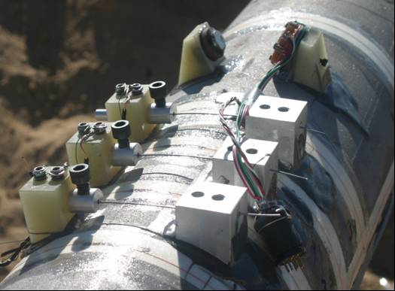
Figure 3 Photo of three CTOA-Wire device, CTOA-Hall Effect device, and timing wires on Mojave test pipe (Photo taken before final epoxy coating on lead wires.)

Soil Pressure

Following the manufacturers recommendations, an amplifier was built to excite and control the soil pressure gages during the Mojave experiments. The excitation to the gage was adjusted so that the maximum output of 5V would relate to a load of 4.4kN (1,000 lbs). Several laboratory experiments were conducted with different gages and two different amplifiers. These results are shown in Figure 4. As shown in this figure, there is reasonable difference between gages, but not much difference between the amplifiers that were built.

The major difference in the response of the gages come from how the accurately the gages are loaded. The active portion of the soil pressure gage is a 9.5 mm (3/8-inch) diameter circle in the center of the gage. A precision loading platen was built so that the load from the test machine could be uniformly placed on the active portion of the soil gage. The effect of loading position can be seen in Figure 4 for the two curves labeled Gage 1. In one case the loading platen was offset by 1.5mm, cause a large difference in the output. Since it is unknown how the soil will load these gages, it was decided to put a linear fit through all of the data for calibration purposes. With this curve fit, the uncertainty in the signal is large, but in reality, in these tests we are simply looking for order of magnitude in terms of load; therefore, this calibration should be sufficient.

Figure 4 Soil pressure gage calibration
Hall Effect

The pre-test work on the Hall Effect device was not as extensive as expected due to the some of the difficulties in developing the amplifier. The difficulty came from developing a pattern of sensors that could be used to capture the flap movement in three dimensions. The premise of the device is that the Hall Effect Sensor output voltage is linear with distance away from the magnet. Therefore in order to make one unit for measuring displacement in three dimensions, an array of these sensors were required. The final array is shown in Figure 5 as mounted on the 6-inch diameter pipe used in the Mojave experiments. The outputs of five sensors are then electronically manipulated by the amplifier to output voltage in the vertical, horizontal and transverse directions.

Due to the time to develop this amplifier/conditioner for the device, a direct calibration scheme was not developed pre-test. The device will output raw voltages, but how these relate to the actual displacement measurements has not been developed. This calibration will occur during the next few reporting periods.

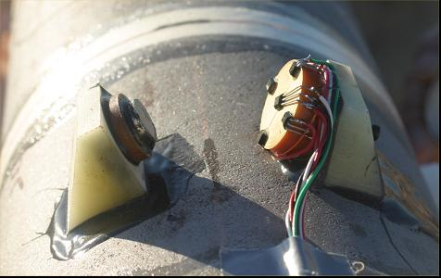
Figure 5 Hall Effect Device mounted on pipe

Second Series Mojave Experiments

Due to the costs of conducting the first year experiments, the test plan for the second year set of experiments was revised. The first year experiments were conducted with one half of the pipe unbackfilled and the other half of the pipe with a certain soil backfill. In order to reduce the number of experiments and still develop the same amount of data, the pipe were prepared with each side of the pipe partially backfilled and partially unbackfilled as shown in Figure 6.

Figure 6 Schematic of test layout for Year 2 tests

With this configuration, the crack will be initiated in the unbackfill region, and enter the backfilled region at steady-state speeds. By investigating the change in fracture velocity as the crack enters the soil, the effects of backfill can be determined.

Each pipe was instrumented with the following instrumentation:
- 51 timing wires for measuring crack speed,
- Three soil pressure gages in each backfilled section. The gages were located at 22, 45 and 90 degrees from the top of the pipe,
- Soil pressure film located near the soil pressure gages to get an average measure of the soil forces,
- Wire CTOA device both in the unbackfilled and backfilled section of one side of the pipe, and
- Hall Effect device both in the unbackfilled and backfilled section of one side of the pipe.

Test #2.1

Experiment 2.1 was conducted on August 31, 2005. The pipe identification number was 4-1. For this experiment, the pit was prepared with the clay used in the last year’s experiments. The North end of the pipe was prepared with 27% moisture and was 90% compacted, while the south side was prepared with 19.3% moisture with a compaction of 92%. For this soil, the optimum moisture is 25.5%.

Pressurization of this pipe began at 6:30 pm. A liquid nitrogen pumper truck was used to add nitrogen to pressurize the system. Because of the poor control on the pumper truck valve, a ball valve at the end of the piping system was used to manually vent the pipe in order to control the test pressure. The target pressure for this experiment was 24.8 MPa (3,600 psi). As the pressure passed 20.7 MPa (3,000psi), the relief ball value failed in the closed position. Before word could get to the nitrogen pumper truck operator, the pressure in the pipe rose above 4,000psi and the pipe failed. On the south side of the pipe, a ring-off occurred, while on the north side of the pipe, an axial crack propagated into the soil and was arrested approximately 2.7 m (8.8 feet) from the center of the pipe. Since this was an unexpected failure, no data was collected for this experiment. The fracture features for this experiment are shown in Figure 7. The arrest location at the north end of the pipe is shown in Figure 8.

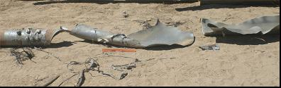
Figure 7 Fracture features for Test #2.1

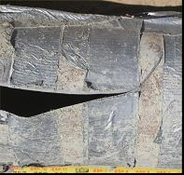
Figure 8 Arrest location at North end of Test #2.1
On the north side of the pipe, the crack arrested due to the reflected wave, which suggests it was propagating through the very moist soil.

Test #2.2

Experiment 2.2 was conducted on September 1, 2005. The pipe identification number was 3-1. For this experiment, the pit was prepared with the native sand used in the last year’s experiments. The North end of the pipe was prepared with 2% moisture and was 86% compacted, while the south side was prepared with 10.5% moisture with a compaction of 98%. For this soil, the optimum moisture is 11.8%.

Pressurization of this pipe began at 4:01pm. The test pressure was set at 24.8 MPa (3,600 psi). At 4:55pm, the 0.15m (6 inch) long, linear explosive cutter was ignited. An axial ran for about 0.6m in both directions and then rang off at both ends. The fractured ends of the pipe are shown in Figure 9.

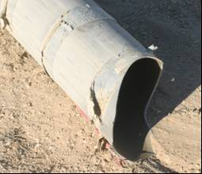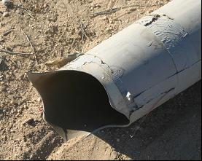
Figure 9 Ring off at ends of Experiment #2.2

Because of the short axial fracture before the ring-off, only one timing wire on each side of the pipe was broken, therefore insufficient data exists to extract the fracture speeds.

This test results raises an important point about conducting these types of experiments. In this particular test, the soil underneath the pipe in the unbackfilled regions was very loosely compacted. It is suspected that due to the minimal support under the pipe, a large bending moment was placed on the pipe from the downward jet force that occurs as the crack propagates. This large bending moment, coupled with the tearing action from the large flap movements behind the crack, can cause the maximum principal stress to shift from circumferential to some combination of circumferential and axial causing the pipe to tear around the circumference.

Ring-offs in small diameters pipe tests are not uncommon and have occurred near the origin in some past 2-inch and 4-inch pipe tests by British Gas, and University of Washington. All of these tests had the pipes fully supported on the bottom. Also in some 6-inch diameter nuclear pipe test with axial cracks, the pipe was supported by jacks close to the origin, and the cracks rang off before reaching the support.

Because of this difficulty, more care was taken to support the pipe in the next experiment.

Test #2.3

Experiment 2.3 was conducted on September 2, 2005. The pipe identification number was 7-1. For this experiment, the pit was prepared with the native sandy silt that is found about 1-1.5m (3-5 feet) under the sand in the Mojave desert The North end of the pipe was prepared with 9% moisture and was 90% compacted, while the south side was prepared with 12.5% moisture with a compaction of 94%. For this soil, the optimum moisture is 10%.

To prevent the ring-off that occurred in the previous test, special care was taken to compact the soil underneath the pipe and in the haunch region. Pressurization of the pipe began at 10:08am, with the target pressure at 24.8 MPa (3,600 psi). At 11:34am, the 0.15m (6inch) explosive cutter was ignited. An axial ran for about 2.6m (8.5 feet) in both directions before it arrested. The fractured ends of the pipe are shown in Figure 10.

The fracture speed data was reduced from the timing wires and the results are shown in Figure 11. Also included in this figure is the speed of the decompressing wave as it travels to the endcap, and reflects back to the running crack. Note that this plot assumes that the decompression wave does not change speed as it reflects off the endcap. In reality, the decompression wave will slow as it travels back through already decompressed gas. From this figure, it is clear that the fracture speed begins to slow rapidly as the reflected wave reaches the fracture path, indicating that the arrest was caused by the reflected wave and not the material toughness.

The results also indicate that the fracture speeds slowed down as the crack entered the soil backfill. On the 12.5% moisture side, the average fracture speed in air was 174 m/s, and slowed to 159 m/s in the soil, which is about an 8.5% drop in speed. On the drier side, the crack speed dropped 10% from 188 m/s to 169 m/s. Within the uncertainty of the experiments, it appears that this difference is negligible.

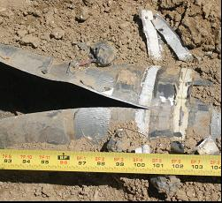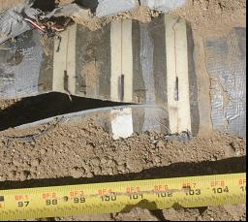
North South
Figure 10 Arrest ends for Experiment #2.3
Figure 11 Fracture speed data from Experiment #2.3

Of the extra instrumentation, data was only available from the soil pressure film and the Hall Effect device. In all cases, the Wire CTOA failed incorrectly as the crack passed the device. The tension on the aluminum rod was too large in all cases; the wire failed or was pulled out of the aluminum block before the aluminum rod slipped out of the fiberglass base. It is suspected that the angle that is created as the crack opens may have caused side loading on the aluminum rod, which would increase the force required for pull-out. In addition, this angle may have bent the high strength wire, which may have cause premature failure of the wire. Further refinement of this device is needed before incorporating this device on future tests. In addition, no data was available for the soil pressure transducers since the crack never reached these devices in the experiments.

Data from the Hall Effect device is shown in Figure 12. The output of the Hall Effect device gives relative displacements in the circumferential, longitudinal, and radial directions. The results indicate that most of the movement is in the circumferential (opening) direction, with some minimal movement in the other directions. The output is also linear with fracture speed, as indicated by the constant velocity curve (169 m/s) that is cross plotted with the Hall Effect data. Therefore, this data suggests that if the output of this device is linear with displacement, then the opening of the crack (CTOA) is constant with crack location. However, a direct calibration for the Hall Effect sensor output has not been developed at this point. It is suspected that this calibration will be carried out within the next few reporting periods.

Figure 12 Hall Effect data for Experiment #2.3

The final set of data from this experiment was from the soil pressure film. On this experiment there were four types of film placed on the pipe: medium (9.6 MPa – 49MPa [1,400 -7,100 psi]), low (2.4 MPa – 9.6 MPa [350-1400 psi]), superlow (0.5MPa – 2.4 MPa [70-350 psi]) and ultra low (0.2MPa – 0.5 MPa [28-85 psi]). For this experiment, a photograph of the film after the experiment is shown in Figure 13. The data from this figure indicates that the superlow and ultra low films were saturated. In addition, the medium film shows almost no change in color. Therefore, the results indicate that the soil pressure falls between 2.4 MPa (350 psi) and 9.6 MPa (1,400 psi). These photographs will be sent to the manufacturer of the soil pressure film for further interpretation.

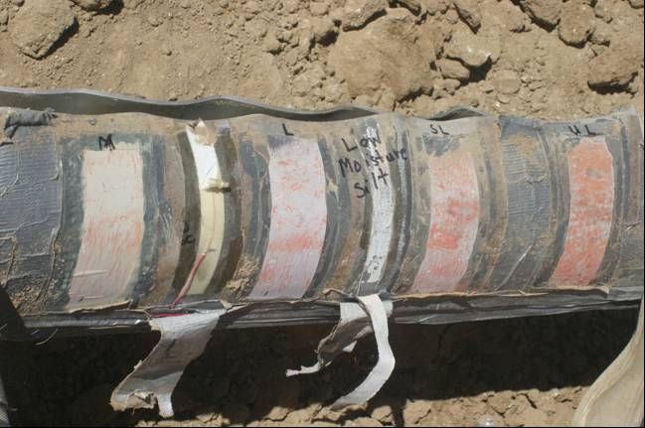
1,400 - 7,100psi
350 - 1,400psi
70 - 350psi
28 - 85psi
Figure 13 Soil pressure film data from Experiment #2.3

Analysis of Results

A summary of the results from both the 1st and 2nd series of experiments is given in Table 1.

The data generated in this program can be compared against other small diameter pipe tests as shown in Figure 14. Data was available from three different programs conducted previously at Battelle,,. In this figure, calculated versus measured steady-state fracture speed data from various small diameter pipe tests are compared with the fracture speeds from this study. For this analysis, the calculated fracture speeds were calculated using the Battelle Two-Curve (BTC) approach with the original soil backfill coefficients. From this figure, it appears that the original BTC approach does a reasonable job predicting the fracture speeds in soil within the scatter of the data. However, the air backfill cases are severely overpredicted with the BTC approach. The reason for this large discrepancy will be investigated in upcoming reporting periods.

The fracture speed data for these experiments can be plotted against the moisture content to determine if a correlation exists. These results are shown in Figure 15. It appears that there is inverse relationship between fracture speed and moisture contact, i.e., as the moisture content increase, the fracture speed decreases. Also, it appears that the type of soil does not play into the effect. However, more than likely, the fracture speed is driven by total density (Water + soil) than just by moisture content. These and other correlations between fracture speed and soil properties will be investigated in future reporting periods.

Table 1 Summary of Mojave experiments
Test Number | Description | Test Pressure | Unbackfill |  | Backfill |  |  | Note
Test Number | Description | Test Pressure | Vf | Crack length | Vf | Crack length | Length/ Diameter | Note
Test Number | Description | MPa(ksi) | mps (fps) | m(in) | mps (fps) | m(in) |  | Note
1-1 | Loose Sand | 19 (2.75) | N/A | N/A | N/A | N/A |  | Failure at endplug
1-2 | Clay, 39% moisture, 72% compacted | 14.8 (2.15) | N/A | 1.02 (40) | N/A | 0.7 (28.5) | 4.75
1-3 | Clay, 15% moisture, 90% compacted | 8.6 (1.25) | N/A | N/A | N/A | N/A |  | Endplug failure
1-4 | Clay, 25% moisture, 90% compacted | 20.3 (2.95) | 178 (585) | 2.9 (115.5) | 130 (425) | 1.1 (45) | 7.50
1-5 | Loose Sand | 20.3 (2.95) | 197 (647) | 3.2 (124.5) | 184 (603) | 1.05 (41.5) | 6.92
2-1a | Clay (26% moisture, 90% compact) | 27.6 (4.0) | N/A | P | N/A | 2.7 (108) |  | Valve failure
2-1b | Clay(19% moisture, 92% compact) | 27.6 (4.0) | N/A | ~0.6 (24) | NA | NA |  | Valve failure
2-2a | Dry sand (2% moisture, 86% compact) | 24.8 (3.60) | NA | ~0.6 (24) | NA | NA | 4.00 | Base metal ring off
2-2b | Wet sand (10.5% moisture, 98% compact) | 24.8 (3.60) | NA | ~0.6 (24) | NA | NA | 4.00 | Base metal ring off
2-3a | Sandy Silt (9% moisture, 90% compact) | 24.8 (3.60) | 188 (616) | P | 169 (553) | 2.6 (101.5) | 16.92 | Reflected wave arrest
2-3a | Sandy Silt (12.5% moisture, 94% compact) | 24.8 (3.60) | 174 (572) | P | 159 (522) | 2.6 (101.5) | 16.92 | Reflected wave arrest

Figure 14 Comparison of predicted and measured fracture velocity for small diameter pipe experiments
Figure 15 Fracture speed versus moisture content for these experiments
D. Rudland will travel to Denmark in October to witness the third JGA experiment and talk to FORCE technology about the additional instrumentation to be added to the June 2006 experiment. As usual if either the DOT or PRCI want to send a representative to witness the JGA experiments, please let Emc² know in advance so arrangements to visit the test site and witness the experiments can be made.

Schedule - tasks completed during this reporting period as related to agreement with any modifications. If Completion Date is different from Scheduled Completion Date, explain.

As part of Contract Modification #4, the schedule for this program was extended to February 2007. The details of the adjusted schedule can be found in that contract modification. Therefore, at this early point, the program is on schedule.

Payable Milestones -completed during this reporting period

For the seventh quarter of this program, the payable milestones completed are:
- 100% instrumentation development is complete (Subtask 1.8),
- 60% Second year experiments is complete (Subtask 1.4)
- 100% of the apply instrumentation task is complete (Subtask 1.9)
- 90% of the reduce instrumentation task is complete (Subtask 1.10)
- 30% of second year test data reduction is complete (Subtask 1.5)
- Additional data reduction on soil properties was conducted (Subtask 1.12)
- Planning for applying the instrumentation to the JGA tests has begun (Subtask 1.11)
- Quarterly reporting and cost tracking occurred (Subtask 3.1 and 3.2).

It should be noted that Subtask 1.7 is over budget, but Subtask 1.9 is complete and under budget and Subtask 1.10 is 90% complete and under budget. Also, even though the second year tests are complete (Subtask 1.4), the subcontractor final invoices have not been submitted to date.

The quarterly and cumulative program costs are shown in Tables 1 and 2.

Table 1 Quarterly costs for Agreement DTRS56-03-T-0007

Table 2 Cumulative costs for Agreement DTRS56-03-T-0007

Results and Conclusions (Including findings, discoveries and attachments of any test data and/or pictures)

In this reporting period, the second series of Mojave experiments were conducted. The tests were conducted during the time from August 25 – September 2, 2005. In that time period, three pipe experiments were conducted. Each of these experiments had timing wires (fracture speed), thermocouples, Hall Effect, Wire CTOA, soil pressure film, and soil pressure transducers. Each of the test pipes for this series of experiments were prepared with different soils at different moisture contents. Half of each side of the pipe was unbackfilled and the other half was backfilled with a certain moisture content. Certain problems arose with valve failures and ring-offs during the course of the experiments. However, the available data shows that the fracture speeds measured in the soil can be predicted with the Battelle Two Curve approach with the original soil backfill constant within the scatter of the data. Interestingly, a correlation appears to hold between moisture content and fracture velocity. However, it is expected that the total density or the material strength will provide a better correlation to the fracture velocity. At this point, these data have not been reduced but will be reduced within the next reporting period.

Issues, Problems or Challenges: (Including anything that may cause a schedule delay)

As of this reporting period, the program is on schedule and there are no major problems facing the program. The task to apply the additional instrumentation to the November JGA test had to be postponed since the JGA test was postponed until June 2006. This will slip the schedule slightly, but still be within the contract time limit of February 2007.

Plans for Future Activity: (Including potential meetings, tests, and/or demonstrations scheduled over the next quarter.)

The plans for the next quarter include
- Investigate the effects of total soil density/strength on the fracture speed,
- Compare the current JGA test results with those generated in this program,
- Finalize the data reduction from this series of experiments, and
- Develop a year-end report that will provide all of the details for the second year experiments and analysis.
Public Page

FIRST MAJOR IMPROVEMENTS TO THE TWO-CURVE DUCTILE FRACTURE ARREST MODEL – EFFECT OF DIFFERENT SOIL TYPES ON DUCTILE FRACTURE ARREST, AND SEPARATING ELASTIC AND PLASTIC CONTRIBUTIONS TO THE CRACK-DRIVING FORCE

Summary

The objective of the proposed program is to make the first major improvements to the most commonly used ductile fracture arrest criterion. There are two tasks in this effort.

The first task is to improve the accuracy of the Two-Curve Ductile Fracture Model to be able to account for different types of soil backfills, i.e., sand, clay, etc. To make this improvement, a series of intermediate-diameter (6 to 12-inch) pipe burst tests with different soil types, compaction, and moisture content will be conducted at the Emc² burst test site in the Mojave Desert in California.

The second task involves making an improvement to the crack-driving force equations in the Two-Curve Method so that there will be elastic and plastic contribution to the crack-driving force. Experimental results have shown that the arrest toughness value determined from the Two-Curve Ductile Fracture Model should be continually increased as the grade of the pipe is increased. A significant portion of this empirical correction comes for the elastic energy being higher than was accounted for in the current Two-Curve Ductile Fracture Model. Making this improvement will allow for safer future pipeline design with higher-grade steels.

Progress as of June 2005

In the first year of this project, five small diameter pipe burst tests were conducted at the Mojave test site using different combinations of moisture and compaction levels on two different soil types. Unexpected end-plug failures caused minimal data to be taken in three of the five tests. Modifications to the test plan for future tests will allow two sets of data to be developed from each pipe test, which will make each test more economical while still meeting the program objectives. In addition, a literature review was conducted and data was gathered from old pipe tests that were used to develop the original backfill coefficients. This data was digitized and re-analyzed to verify the backfill coefficients with great success. The data was then analyzed again removing the elastic portion of the crack-driving force from the original equations. New backfill coefficients were developed.

To date in the second year of this program, an information exchange agreement between JGA and DOT/PRCI has been finalized, which will allow the free exchange of experimental, numerical, and analytical data between this program, and the large full-scale pipe experimental program conducted by the JGA. The second year experiments were conducted in August/September 2005. The results of these experiments are still being analyzed, but the initial results indicate that the fracture speeds may be a function of the soil moisture content, or total density.

Poynton, W.A., and Christian, J.R., “An Experimental Study of Shear Fracture Propagation using Small Scale Models,” Symposium of Crack Propagation in Pipelines, Paper 5, British Gas Corporation, New Castle, Upon Tyne, England, Marsh 26&27, 1974.
Kobayashi, A.S., Emery, A,F., Love, W.J., and Chao, Y. –H., “Subsize Experiments and Numerical Modeling of Axial Rupture of Gas Transmission Lines,” Journal of Pressure Vessel Technology, Vol. 110, May 1988, pp. 155-160.
Tang, H.T., Duffey, R.B, Singh, A., abd Bausch, P., “Experimental Investigation of High Energy Pipe Leak and Rupture Phenomena,” Proceedings of the 1985 Pressure Vessel and Piping Conference, ASME, PVP-Vol 98-8, June 23-26 1985, pp. 125-134.
Wilkowski, G. M., and Eiber, R. J., “CAGSL Model Crack Arrestor Program,” Report to Northern Engineering Services Company, Ltd., July 1977.
Wilkowski, G. M. and Eiber, R. J., “The Evaluation of Ductile Fracture Propagation Behavior in Frozen Soil,” proprietary report to Northwest Alaskan Pipeline Company, September 4, 1980.
Wilkowski, G., Scott, P., and Maxey, W., “Design and Optimization of Mechanical Crack Arrestors for Pipelines,” NG-18 Report 134, July 1983.

