System Implementation

Introduction
This appendix describes how the GENII-V2 computer was implemented to create an integrated system for the Dose Reconstruction Project at the Savannah River Site. The first step in the implementation was the understanding how GENII-V2 could be used to implement the requirements for this project. An analysis of the scope of the problem identified the following: 1) upwards of 40 unique locations for exposure, 2) approximately 17 releases points, 3) 39 years of release data, 4) approximately 25 isotopes released, 5) both atmospheric and liquid releases, 6) six different age groups for most exposure locations, and 7) each receptor’s dose output was needed by isotope and pathway. In addition there could be up to 100 uncertainty/sensitivity runs for each of the above runs.
Several tasks were identified to reduce the scope of the calculations. These included reducing the number of locations to 10 and combining the release point to 4. Through understanding the GENII-V2 methodology, it was concluded that based on assuming that GENII-V3 calculated doses for a receptor was of known age and known usage rates/ exposure times, additional doses/risks could be produced for a receptor of any age and any usage rate/ exposure times. It was also found that doses could be generated for receptors at 10 different exposure locations within a given GENII-V2 computer run. At this point a single GENII-V2 input file (GID file) consisted of over 8,000 lines of data in a text format. Manually setting up and verifying the input for these runs and ensuring that the input is successfully activating GENII-V2 would require a significant labor commitment and risk creating input errors. A single output file consisted of over 2 megabytes of data in a comma delimited text format. Reading and analyzing the output would also require a significant labor commitment and also incur potential errors.
It was concluded that the process of generating, running and analyzing a GENII-V2 analysis would require automation. It was decided that two separate programs would be generated: a preprocessor to generate input files and a postprocessor to “read” the output and prepare output suitable for further analysis. Automating the input activities using a customized pre-processor interface to GENII-V2 would result in faster and less labor-intensive modeling efforts, and reduce the likelihood of data input errors. In addition, a post-processor would read and extract GENII-V2 output (HIF) files based on the user’s requirements.
The System Architecture is discussed in Chapter G.2. Details of the computer programs are presented in Chapter G.3, Pre-Processor, and Chapter G.4, Post-Processor. Testing of the computer programs is discussed in Chapter G.5.

System Architecture
The pre-processor and post-processor modules were both written in Microsoft Visual Basic and use Microsoft Access database table structure and calculations. Due to the limitation and no thread capability of the Access database, any database file stored in Access can not be larger than 2GB of data. Thus, the SRSDR system was designed by using dual database files, one was for application and parameter tables, and the other was for temporary and processing data tables. This method provides the capability to compact and optimize the temporary database files without interrupting the processing of data. Also, since the program requires a large amount of disk space and time to run, the data for each facility will be run independently. Both the pre- and post-processor run on distributed client systems, with the required input files for both modules located on each client system. The output for the post-processor is written to the Access database for the appropriate receptor family located on a shared network drive.
The overall scheme for generating a series of GID files consists of a series of loops. All process operations are table driven within the database. Once the user specifies the facility, the type of release, the years desired, whether uncertainty is to be run, and file names, the pre-processor will loop over the isotopes within the release file and loop over the number of runs to be created, generating a GID file for each completion of a loop over the number of runs. These output files are stored in the local hard drive to be used by GENII-V2 for calculation. At the same time when generating the GID files, each file name and its location path is written to a batch file to be executed by the integrated GENII-V2 system, and a list of the file information is written to the QC file for quality assurance purpose.
The post-processor takes in a set of GENII-V2 output (HIF) files for a given facility and prepares a set of dose/risk results for the receptors designated in the scenario requirements for that facility. It will then combine the facility based results to form results for the entire site once all the facility results are available. The post-processor has the capability of providing various levels of results depending on the user input. The post-processor output is written to the Access database for the appropriate receptor family located on a shared network drive.
Figure G-1 illustrates these system modules, and briefly describes the input flow for each module.
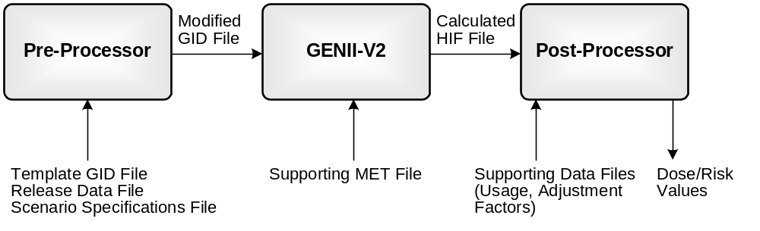
Figure G-1 System Module Input Flow

The Pre-Processor
The pre-processor will take a standardized GENII-V2 input file (GID file) and make changes in the standardized GID to account for varying facilities releases by isotope, year of operation and receptor combination. In addition, for each facility, year, and receptor combination, there could be up to 101 GID files generated as required by the uncertainty analysis (one for the point estimate data and 100 for the uncertainty data).
The overall processing was designed to proceed in the following fashion.
- Read user-specified input.
- Read template (standardized) GID file(s) as required.
- For a user specified facility and release type (atmospheric or liquid).
- Read the isotope description data file.
- Read the uncertainty data files (both the source term and parameters) to determine the point estimate and the set of uncertainty values for each parameter in the file.
- Cycle over the available standardized GID files.
- Modify the standardized GID data for changes required only once.
- Cycle over the years of operation.
- Cycle over the number of uncertainty runs (There will always be one run to evaluate the point estimate data.).
- Prepare the release data by isotope.
- Prepare the values for the parameters in the uncertainty file.
- Generate an input file for execution by GENII-V2.

The Pre-Processor User Interface
The user selects the pre-processor module from the SRS Dose Reconstruction System (SRSDRS) main menu screen, as shown in Figure G-2.
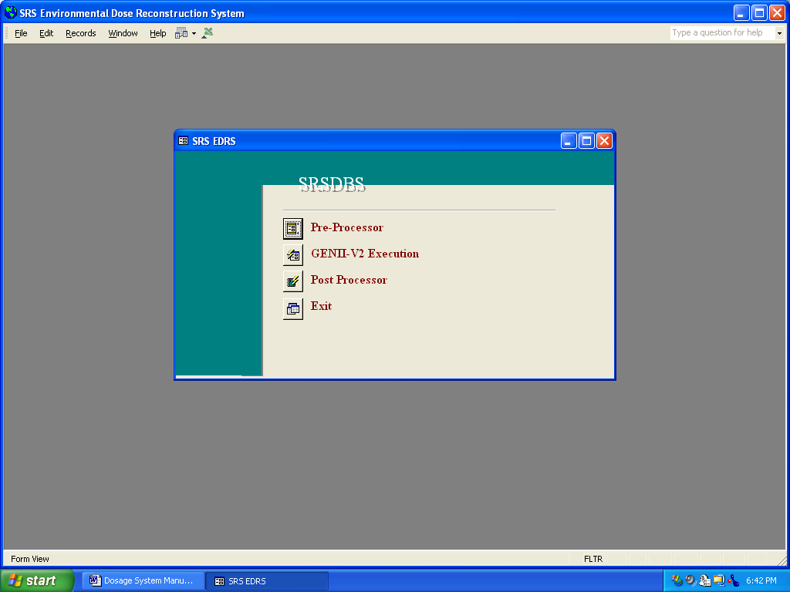
Figure G-2 SRSDRS Menu Screen
The user then enters the following information:
- Facility name and ID,
- The type of release (atmospheric and liquid), and
- The year or range of years for processing the source terms,
The Pre-Processor user interface screen is shown in Figure G-3. Table G-1 describes the type of information that should be entered into the screen.
Based on the information entered into this screen, the user is presented with a list of facility release data files that comply with the above requirements. The list of files is composed of files with names having the format of ABCDEFX.XLS where
- A is the type of release (A for atmospheric, and L for liquid),
- B is the facility ID,
- CD is the last two digits of the first year of releases,
- EF is the last two digits of the last year of releases, and
- X is the version.
NOTE: The year or range of years required by the user must be contained between the years specified by CD and EF. The user will be asked to select the file name containing the appropriate release data.

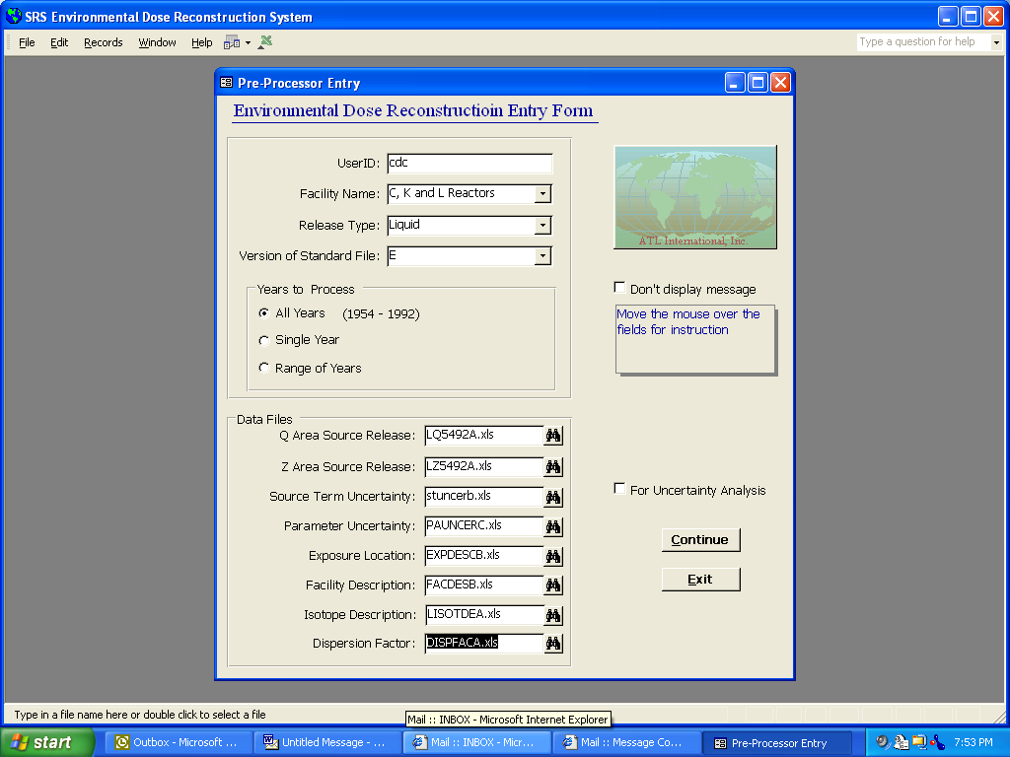
Figure G-3 Pre-processor User Interface Screen
Table G-1 Data Entry for the Pre-processor User Interface Screen
Field Name | Description
User ID | Enter the user ID to identify the person who runs the program.
Facility Name | Select the facility name from the dropdown menu. Available facility names include A M & SRL, H&F Area, C K & L Reactors, P&R Reactors, and All Site Liquid Release
Release Type | Select the release type from the dropdown menu. Available release types include Atmospheric and Liquid.
Version of Standard File | The identification code to the modified version of the standard template file.
Years to Process | Select the radio button corresponding to the appropriate year or range of years. Valid selections include 1954 - 1992, Single Year (enter the single year of your choice), and Range of Years (enter the year range of your choice).
Data Files | For each Data File type, select a data file from the dropdown menus. The dropdown menus that will be visible and the files that will be available for selection will depend upon the facility selected. These data files are described in more detail in the following paragraphs.
There are nine additional data files that the preprocessor needs to read. All of these files are EXCEL files and are located in the C:\CDC\Preprocessor\Input directory.
The user is prompted to select a file for the source term uncertainty file from a list of available files. The list is composed of files having names with a format of STUNCERx.XLS.
The user is then prompted to select a file for the parameter uncertainty file from a list of available files. The list is composed of files having names with a format of PAUNCERx.XLS.
The user is then presented with a list of exposure location description files available. The list is composed of files having names with a format of EXPDESx.XLS. The user is asked to select a file name.
The user is then presented with a list of facility description files available. The list is composed of files having names with a format of FACDESx.XLS. The user is asked to select a file name.
The user is then presented with a list of isotope description files available. The list is composed of files having names with a format of ISOTDESx.XLS. The user is asked to select a file name.
The user is then presented with a list of dispersion parameter files available. The list is composed of files having names with a format of DISPDECx.XLS. The user is asked to select a file name.
The user is then prompted to determine whether an uncertainty analysis is needed. If the user replies by checking the Uncertainty Run option, then the number of runs is needed to be selected, and that number of GID files will be prepared for each standardized GID file read. Otherwise, only the point estimate file will be prepared for each standardized GID file read.
NOTE: If the user specifies an input that results in an incorrect value, such as a facility not contained in the facility description file, a facility without a release file, or year not within the range of years in existing release files, a message will be written to the message file and the pre-processor will abort.
When data entry is complete, the Continue button will take the user to the pre-processor confirmation screen shown in Figure G-4.
Click the Create GID button on the Pre-processor Confirmation screen to generate the GID input file for GENII-V2. A message will be displayed that the GID has been successfully created.

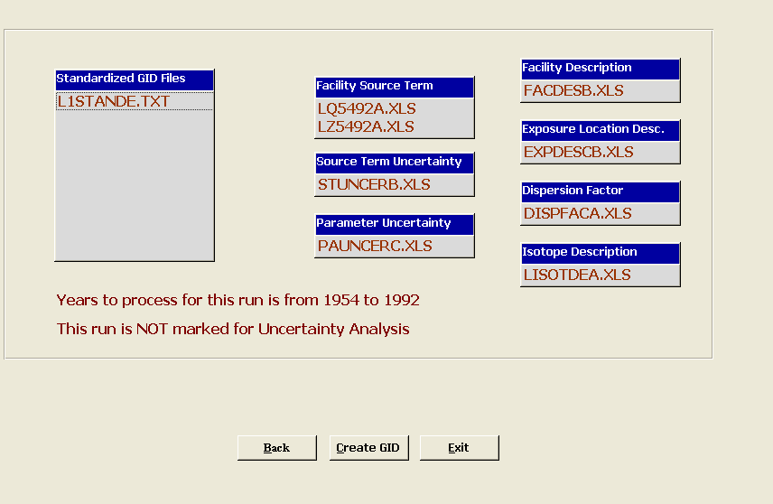
Figure G-4 Pre-processor Confirmation Screen

Standardized GID Files (Template Files)
The template files are located in the C:\CDC\Preprocessor\Input directory, they must have the TXT file extension. Their names have the following format: xySTANDz.TXT where
- x = A, L or S (A – Atmospheric, L – liquid)
- y = 1,2,3, or 4 is the number of depending on the total number of exposure locations, each template GID file can have up to 10 exposure locations
- z = A, B, C, etc depending on the total number of revisions that have been made to the template files
When the user has responded, the pre-processor must cycle through the appropriate number of template files with the release type and revision number specified by the user. For example, if the user has specified an atmospheric release and there are three atmospheric template files (that means more than 30 exposure locations in this scenario) , the file names will be A1STANDA.TXT, A2STANDA.TXT and A3STANDA.TXT assuming version “A” of the template file was specified. Therefore the pre-processor needs to read these three files.
The template GID files are ASCII files containing prepared input files suitable for execution by GENII-V2. These files contain data which will be modified by processing; however, the format (the number of lines, format of each line, etc) will not be changed. In general, each line within the GID file has the following format:
Variable Name
Seven index values
Two string values
A value in either an integer or string format.
There are many sections within a GID file, each section has a module ID, and the number of lines of data that follow for that module.
If there is an error in reading any of the template files, a message will be written to the message file and the pre-processor will abort. The message should contain the file name and the contents of the last line of data read. If possible, the line causing the error should also be written if possible.

Generating GID Files -- Processing Overview
The overall scheme for generating a series of GID files consists of a series of loops. Once the users has specified the facility, the type of release, the years desired, whether or not uncertainty is to be run, and file names, the pre-processor will loop over the number of years, loop over the isotopes within the release file and loop over the number of runs to be created, generating a GID file for each completion of the loop over the number of runs.
Some processing will need to be done only once and it will apply to all runs for a given facility, type of release and receptor combination (for a given template file). For atmospheric releases, one variable may have to be changed based on the release year. Some processing will need to be done for all runs. The processing requirements will be divided into atmospheric releases, and liquid releases. Presently, only the atmospheric processing requirements will be addressed. Some processing will refer to a section within the GID file such as “src” or “exp.” It should be noted that the label for a section is three characters followed by a number (such as src5 or exp21.) For some sections (exp, rcp and hei), the number is the exposure location index; for other sections (src, air, con), the number is just a number generated when the template file was created.

Atmospheric Release Processing -- Required only Once

Source Term Data
Two changes in the “src” section will need to apply for all runs (for all years and for both the point estimate and the uncertainty runs.) These include the variables “two” and “three.”
"two",3,0,0,0,0,0,0,"m","m",0
"three",3,0,0,0,0,0,0,"m","m",0
The value for two is the release height obtained from the facility description file. The value for three is the height of adjacent building obtained from the facility description file.

Air Dispersion Data
The ten “ARRADVAL” variables need to be read and adjusted to reflect the distances between the release facility and each exposure location. The ten values need to be put into increasing order. For some template files, there may not be 10 exposure locations or 10 different distances. In this case, the unused values can be filled with the smaller distances from the file.
In the “air” section the 10 values in the following variables need to be changed. These variables and values represent the standardized spacing between the 10 annular distances used by GENII-V2. The following presents a fragment from a GID containing these variables and values.
"ARRADVAL",1,1,1,0,0,0,0,"m","m", 805
"ARRADVAL",1,1,2,0,0,0,0,"m","m", 2414
"ARRADVAL",1,1,3,0,0,0,0,"m","m", 4023
"ARRADVAL",1,1,4,0,0,0,0,"m","m", 5632
"ARRADVAL",1,1,5,0,0,0,0,"m","m", 7241
"ARRADVAL",1,1,6,0,0,0,0,"m","m", 12069
"ARRADVAL",1,1,7,0,0,0,0,"m","m", 24135
"ARRADVAL",1,1,8,0,0,0,0,"m","m", 40255
"ARRADVAL",1,1,9,0,0,0,0,"m","m", 56315
"ARRADVAL",1,1,10,0,0,0,0,"m","m", 72405
As can be seen from the fragment, the first two indices are always 1. The third index is the ring number varying from 1 to 10 (the number of rings allowed by GENII-V2.) The values need to be changed to reflect more closely the distances from the release facility to each exposure location within the standardized GID file.
The 10 values are stored in a temporary matrix. The distances from the releasing facility to the each receptor are calculated within the template file. The data for each receptor is contained in the exposure location description file. The exposure location index from this file is the same as contained in the “expx” line of each “exp” section of the GID file. The facility X-UTM (Universal Transverse Mercator) and Y- UTM measurements are obtained from the Facility Description File associated with the facility ID requested by the user. The distance is calculated by the following formula:
Distance = square root [(Delta X-UTM )² + (Delta Y-UTM)²]
Where Delta X-UTM = Facility X-UTM – Receptor X-UTM and
Delta Y-UTM = Facility Y-UTM – Receptor Y-UTM
The distances are inserted into the temporary matrix. The distances are then ordered from the smallest to largest distance.
If there are less than 10 exposure locations in the template file, the remaining unused values are not changed in the temporary matrix.

G.3.3.1.3 Exposure Location Data
The next item to be performed is the identification of the correct section of the GID file in which the exposure location name and easting and northing values are placed. The exposure location index (for example 1) will be combined with the string “exp” to form a new string of the form “exp1”. This string will be used to search the GID file for the variable expName with that value (see the following fragment from a GID file.) The second index will be collected. The value for the expLabel (with the correct second index) will be changed if different than that contained in the exposure description file. The expX and expY (with the correct second index) for the location will be changed to the easting and northing values.
"expName",1,1,0,0,0,0,0,"N/A","N/A","exp1"
"expLabel",1,1,0,0,0,0,0,"N/A","N/A","Rural Family-Gaird,GA"
"expModel",1,1,0,0,0,0,0,"N/A","N/A","GENII V.2 Chronic Exposure Module"
"expDesPath",1,1,0,0,0,0,0,"N/A","N/A","\FRAMES\Gen_Exp.des"
"expX",1,1,0,0,0,0,0,"N/A","N/A",10
"expY",1,1,0,0,0,0,0,"N/A","N/A",10
To calculate the easting and northing, the following steps are performed:
The offset from the exposure location file is converted into radians by multiplying the offset in degrees by PI/180.
The angle “alpha” which is an angle in the UTM coordinate system is calculated by:
Alpha = inverse tan (DeltaY-UTM/DeltaX-UTM)
The magnitude of the distance easting in kilometers = Distance * cos(Alpha – offset) / 1000
The magnitude of the distance northing in kilometer = Distance * sin(Alpha – offset)/ 1000
If Delta Y-UTM is negative then the distance northing is negative. Similarly if Delta X-UTM is negative then the distance easting is negative.

Miscellaneous Processing
The site name is read from the template file. The year of the release and facility is added to the SiteName and a new site name is written.
For each “xxxModelStat” variable (such as “rcpModelStat”) the value is 1 except for the “conModelStat” which should be set to 2.
For each “ModState” variable, the value is 1.

Processing Over Release Years
The meteorological file name, obtained from the Dispersion File, is inserted into the value for the variable ARMETFILE.
"ARMETFILE",1,1,0,0,0,0,0,"N/A","N/A","C:\FRAMES\SRS7579.5YR"

Processing Over Uncertainty Runs
Once the above changes have been made, the pre-processor cycles over the number of required years processing the release data, the uncertainty data for the source term, and the parameters for each year desired. The description of the processing is divided into processing the source term data and processing the parameters in the parameter uncertainty file. Once the processing over a given uncertainty run, a GID file is created.

Source Term Processing
For each isotope, the lines in Example G-1 need to be read from the template file, processed, and modified as necessary and written. There are always at least these lines for every isotope with the initial release quantities. A “casid” line will be followed by two sets of “ctime” lines. Within each set of “ctime” lines there will be one or more “cflux” lines. The number of “cflux” lines per “ctime” line pairs will be dependent on the number of flux types for each type of release (at least two flux types for atmospheric releases and one flux type for liquid release).
The following is a partial example of an atmospheric release with two flux types (CO60 was the first isotope in this example).
Example G-1
"casid",3,1,0,0,0,0,0,"yr","pCi/yr","CO60"
"ctime",3,1,0,1,0,0,0,"yr","yr",0
"cflux",3,1,0,1,1,0,0,"pCi/yr","pCi/yr",0
"cflux",3,1,0,1,2,0,0,"pCi/yr","pCi/yr",10
"ctime",3,1,0,2,0,0,0,"yr","yr",100
"cflux",3,1,0,2,1,0,0,"pCi/yr","pCi/yr",0
"cflux",3,1,0,2,2,0,0,"pCi/yr","pCi/yr",10
Table G-2 contains the meaning of each of the seven indices used within the source term data section.
Table G-2 Index Values for Source Term Data
Index Position | Value | Meaning
Cflux
1 | 0 | Not Used
1 | 1 | Not Used
1 | 2 | Liquid Release
1 | 3 | Atmospheric Release
1 | 4 | Not Used
2 |  | Isotope Index
3 |  | Daughter Index
4 | 1 | First Time Period
4 | 2 | Second Time Period
5 |  | Flux Type
6 and 7 |  | Not Used

For some isotopes, there may be a “casid” line with the third index as 1. These lines are not changes. These are daughters of the isotope. The amounts of these daughters will have initial releases of zero (no cflux lines).
The processing of the isotope data begins with a “casid” line containing the isotope name and isotope index. There will be two “ctime” lines each followed two or more “cflux” lines. Each “ctime” line starts the release data for a given time. Each “cflux” line contains the release data. The pre-processor will read the facility release file for the quantity of isotopes released by year. From the Atmospheric Isotope Description file, the pre-processor will obtain the isotope index and flux type associated with the isotope name. From the Source Term Uncertainty file, the preprocessor will obtain a set of scaling factors for the point estimate and uncertainty runs. The preprocessor will cycle over the required years. For each year, the pre-processor will cycle over the point estimate values and the 100 uncertainty files (if desired), by isotope, changing the values contained in the GID file as necessary. For a given isotope, the released value is the quantity released, from the Source Term File, multiplied by the quantity of 1x10¹², multiplied by the appropriate factor in the Source Term Uncertainty File. The resulting value is entered in both “ctime” groups. Only one “cflux” line within each “ctime” group will be changed (the “cflux” line with the correct isotope index and the flux type.) The remaining “cflux” lines will remain with a zero release.
In summary, only the values in two lines for each isotope are changed. These are the “cflux” values for the correct “cflux” type, one in each “ctime” group.
If there are isotopes contained in the template file for which the release is not changed, the values should be changed to zero. A message will be written to the message file.

Parameter Uncertainty Data
The processing for the parameter uncertainty data is driven by the data within the Parameter Uncertainty File. This file contains a list of parameters for which a point estimate and 100 uncertainty data values are provided. Each parameter is identified by a variable name, isotope name (if applicable) and a series of three indices. An additional index is also provided to allow a parameter to be changed from exposure location to exposure location. Since the list of parameters is provided by tabular input, specific sections within a GID file cannot be identified. The pre-processor will search the template file for a match with a variable name and its three indices. If the exposure location index is zero, then all occurrences of the variable name and its three indices are changed. If the exposure location index is not zero, the variable for the specified exposure location is changed.
If any parameter contained in the Parameter Uncertainty file is not used, a message will be written in the message file.

Creating a GID File
Once the processing is completed for a given point estimate or uncertainty run, a GID file can be generated. The GID file will be comprised of all the lines in the template file with the appropriate values changed as describe above. The output GID file will be written to a folder in C:\CDC\GENIIV2\Input with a name as specified as follows:
ABCDEFGH.GID
where:
- A is for atmospheric release,
- B is the second character of the standardized GID file,
- C is the facility ID,
- DE is the last two digits of the year of the release, and
- FGH is a number that varies from 000 (the point estimate) to 100 (the number of the uncertainty runs).

Generating Other Output Files
There are three output files other than the GID files used for input into the GENII-V2 calculation. These are: a QCQA file, a batch file and a message file.
Each file name will have the following format:
ABCDEFG.xxx
Where
- A is the type of releases,
- B is the facility,
- CD is the last two digits of the first year of releases processed,
- EF is the last two digits of the last year releases processed,
- G is the version of the standardized GID file processed, and
- xxx is QA for the QCQA file, BAT for the batch file and MES for the message file.
The contents of each file are described below.

QC/QA File
This file contains information related to the documentation of the creation of the GID files. Included in this file are:
- The date of the pre-processor run,
- The version of the pre-processor run,
- The list of all the user inputs (user name, facility selected, type of release, the year or range of years chosen, files selected and date of the run),
- The list of GID files generated,
- The name of the batch file generated, and
- The name of the message file generated.

Batch File
This file contains the command line information for the execution of GENII-V2 of the GID files created. The file should also contain commands to delete all files created by GENII-V2 except for the GID file used as input and the “HIF” file once GENII-V2 has completed processing a GID file. The commands move each processed “GID” file and “HIF” file to a folder of completed runs..

Message File
This file contains all messages generated by the pre-processor. Messages could consist of two types. The first type are messages generated to document such items as parameter variables that are not processed, such as a parameter variable in the Parameter Uncertainty File. These are merely information messages and not errors. This situation could arise during the pre-processing when a parameter included in the file is not appropriate for the type of release calculated (such as a parameter which relates to a liquid release and the type of release being processed is an atmospheric release.) The second type of message results from an error having occurred during the processing. Error messages could be generated from any of a number of reasons. These include:
- An isotope contained in the facility release data that is not found in the Isotope Description file,
- An isotope release quantity set to zero when its data is not included in the Facility Release File,
- A facility ID contained in the facility release data that is not found in the Facility Description file
- A receptor found in the standardized GID that is not contained in the Exposure Location Description file.
- A Mismatch in the number of uncertainty values in the source term and parameter uncertainty files, and
- A file missing or misread.
If an error message is generated, the pre-processor will immediately write the message to both the message file and to the screen. Then the pre-processor will abort.

The Post-Processor
Briefly, the post-processor will read a calculated GENII-V2 output file (HIF file) for a given facility, and will also read user-defined report parameters (Pathway file), and prepare a set of dose/risk results for the receptors designated in the scenario requirements for the facility. It will then combine the facility-based results to generate results for the entire site once all the facility results are available. The post-processor has the capability of providing various levels of detail depending on the user input. The primary level of detail will be the Total Effective Dose Estimate (TEDE) and the effective cancer incidence and cancer fatalities by scenario receptor. The most detail will consist of the dose and risk numbers by organ, year, exposure pathway, isotope, and facility.
For the first stage, the post-processor "reads" a set of HIF file(s). The set of HIF files could consist of up to 3939 output files for a given facility (39 years of releases times up to 101 runs per year.) The post-processor also reads two files containing the scenario receptor description and behavior. One file contains the year of birth of each receptor. The second file contains data where each receptor is located and what they consume, the consumption rates, and duration that they are at the location. The post-processor also reads a file of dose conversion and risk conversion factors. The post-processor uses this data to adjust the GENII-V2 output results to account for each receptor’s behavior and age. As an intermediate result, the post-processor will produce a table of results for each scenario receptor that includes the dose/risk results specified by the user for up to 101 runs by release year. Once all facilities have been processed, a final table of results is produced combining all of the intermediate results by facility into the doses/risks on a site basis.
For the second stage, the post-processor reads each facility's results and combines them into the results for the site.
The following briefly describes the flow of information processing, as shown in Figure G-5:
- The user-specified input data is read: Facility ID, Release Type (Air or Liquid), Pathway File, and Year(s)
  - The Facility IDs available for selection depend upon the Release Type.
If Atmospheric is selected for Release Type, then:
Facility IDs will include the following:
A, M and SRL; C, K, and L Reactors; H and F Area; and P and R Reactors
If Liquid is selected for release type, then:
Facility IDs include the following: AllSiteLiquidRelease
  - The years desired (from 1954 to 1992).
  - Number of uncertainty runs (from 0 to 100).
  - The level of detail:
Total Effective Dose/Risk of cancer incidents and cancer fatalities.
Dose/Risk values by organ, exposure pathway, isotope and years.
  - The Receptor names.
- The specified Pathway file is loaded to the database table.
  - The pathway file contains the usage factors for each exposure location corresponding to the receptor(s) under study.
- The Risk and Dose factor file is loaded to the database table.
  - The Risk Factor file contains the risk factor value for each body organ by isotope by pathway by age.
  - The Dose Factor file contains the dose factor value for each body organ by isotope by pathway by age.
- The GENII-V2 generated HIF file is read. Each HIF file contains sets of dose and risk value for each body organ by exposure location.
  - Exposure location (for example, hei1) is read.
  - Under each exposure location, the data for each isotope is read.
  - For each isotope, the data for every possible pathway is read.
  - For each pathway, read the dose and risk data for each organ is read.
The Risk and dose factors based on age of the user-specified receptor(s) are applied.
The Usage or Exposure Factor based on the age of the user-specified receptor(s) are applied.
- Is this the last exposure location?
- If yes, then report is generated.
- If no, then the next exposure location is read.
- Cycle through all exposure locations, isotopes, and associated pathways and organ dose data, as described above.
- A report is generated.
The calculations performed by the post-processor involve the following:
- Determination of the age of the receptor (the difference between the year of birth and current year processed).
- Based on the receptor’s age, the correct dose factors, risk factors are obtained and usage/exposure factors by pathway, isotope and organ.
- Multiply the values for the doses/risks in the HIF File by the dose and risk factor for the correct age of the selected recipient(s).
- Divide the adjusted doses by the dose factor for the adult receptor (used in GENII-V2) year period.
- Divide the adjusted risks by the risk factor for the 0-110 age receptor.
- Multiply the results of the above calculation by the receptors usage/exposure factor.
- Perform summations as indicated by the user input choices, such as summation over isotopes for a given pathway/route, summation over isotopes and pathway/routes, etc.
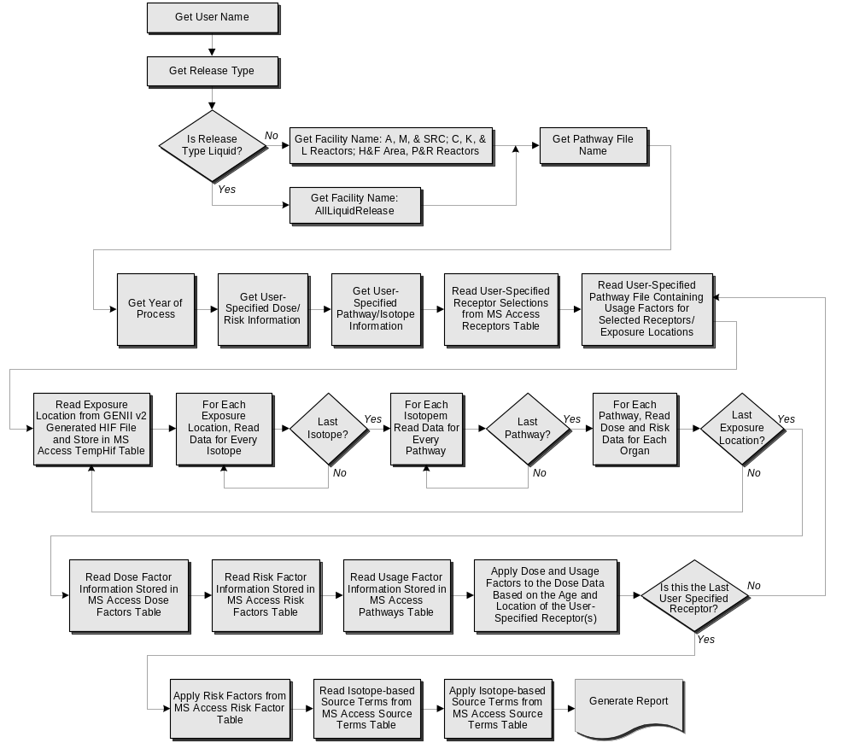

Figure G-5 High-level Post-Processor Process Flow

The Post-Processor User Interface
The post-processor user interface is composed of the following tabs. Information entered into each of these tabs determines the content of the post-processor output report.

The General Information Tab
In the General Information tab, as shown in Figure G-6, the user inputs the User Name, and selects the Release Type and Facility Name from dropdown menus. Release Type includes Atmospheric and Liquid, and Facility Names. Facility Names will be provided based on the selected release type. For atmospheric the available facility types are “A, M and SRL”, “F and H Area”, “C, K and L Reactors”, and “P and R Reactors”. For liquid releases, only one facility name will be provided: “All Site Liquid Release”. The user specifies the Pathway Data File, which is an Excel spreadsheet containing data about the selected pathway type. This value may either be keyed directly, or the user must browse to locate a file. Years to Process may include All Years (1954 – 1992), Single Year, or Range of Years. The user enters the desired range if this option is selected. All values of dropdown menus are stored in Access lookup tables. The post-processor uses the information entered by the user on this screen to determine the exposure location, release type, and which pathway table to read. The dose and risk factors that will be applied during the calculation of the effective dose over time will be determined by these values. Table G-3 provides descriptions of the General Information fields.

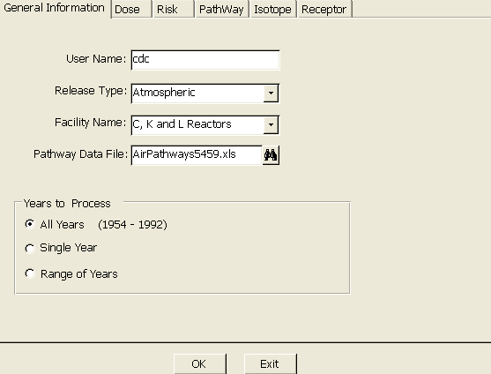
Figure G-6 General Information Tab
Table G-3 Field Descriptions for the General Information Tab
Field Name | Description
User Name | Enter a user name to identify the person who creates the reports.
Release Type | Atmospheric or Liquid.
Facility Name | Based on the release type a list of available facilities is displayed in a drop down box. The user can then choose any one facility from the list.
Pathway Data File | Brows to select a data file. The files that will be visible to you will depend upon the selections made for Facility Name and Release Type.
Years to Process | Select the radio button corresponding to the appropriate year or range of years. Valid selections are based on the range of years determined in the source term files available for use based on the above user selections.

The Dose Tab
The user selects Total Effective Dose Estimate (TEDE) or By Organs to control the amount of dose information presented in the results report. If By Organs is selected, the user must select which organs are to be included in the report. Selected organs are then stored in an Access temporary table to be referenced during Post-processor calculations.
Figure G-7 shows the Dose Tab, with “By Organs” selected. Figure G-8 shows the Dose Tab with TEDE selected.

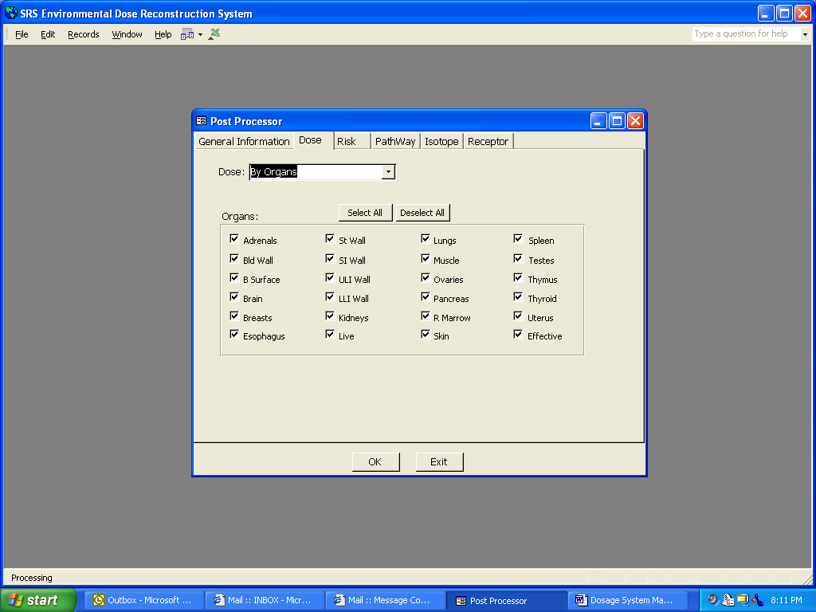
Figure G-7 The Dose Tab, “By Organs” Selected

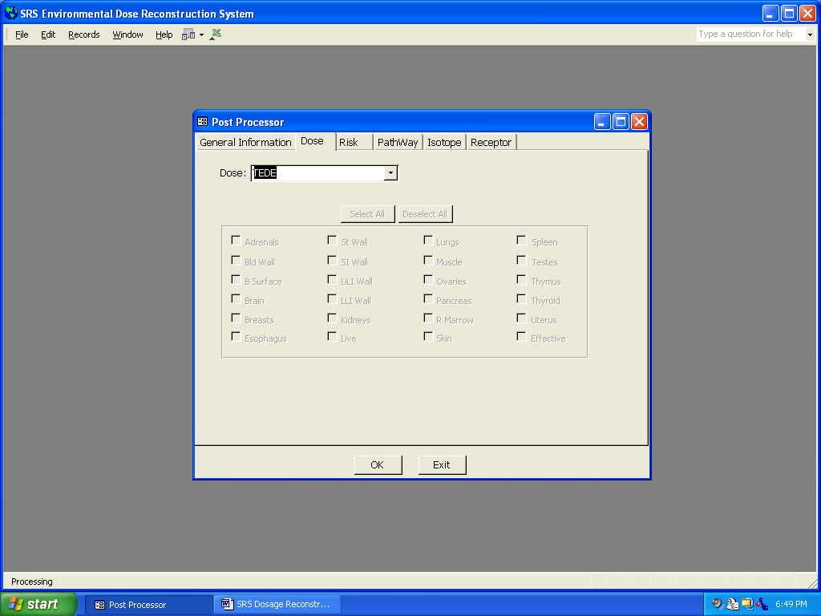
Figure G-8 The Dose Tab, “TEDE” Selected

The Risk Tab
This tab is used to calculate the cancer risks. The user elects whether to create the results report with or without cancer results. If the user chooses With Cancer Results, two selections become available, Cancer Incidents, and Cancer Fatalities. When the user selects one or both of these options, a list of organs becomes available. The user may select all, or select specific organs to be included in the report.
Figure G-9 shows the Risk Tab with “No Cancer Results” selected. Figure G-10 shows the Risk Tab with cancer results.
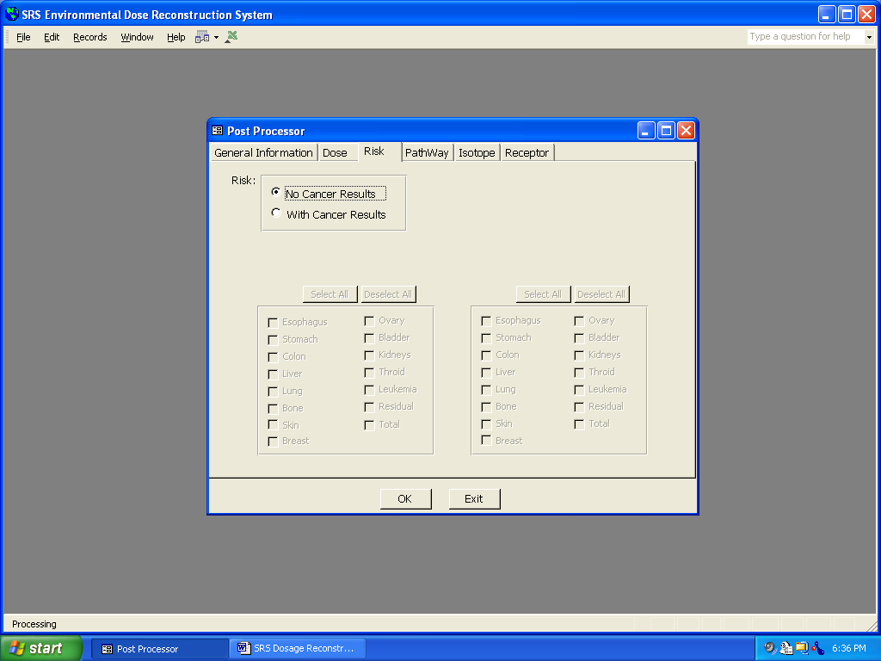
Figure G-9 The Risk Tab, “No Cancer Results” Selected

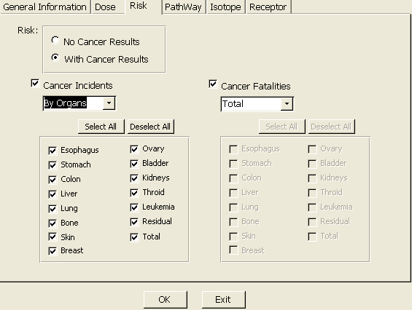
Figure G-10 The Risk Tab, “Cancer Results” Selected

The Pathway Tab
This tab controls how the results are displayed for the various pathways (Summed Over All Pathways, or By Pathway). If By Pathway is selected, a listing of pathways becomes available. The user may select all, or select specific pathways. Doses and/or risks will be presented for the selected pathways. Depending upon the selections the user makes on this tab, information on this tab is used to build the query for the results report. If pathways are selected that are not included in the GENII-V2 HIF file, they will not be included in the report file. Figure G-11 shows the Pathway tab, with By Exposure Pathways selected.

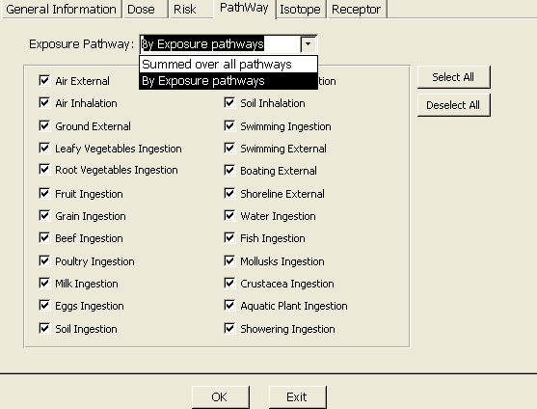
Figure G-11 The Pathway Tab, “By Exposure Pathways” Selected

The Isotope Tab
This tab is used to control the display of results as a function of isotopes (Summed Over All Isotopes, or By Isotope.) If By Isotope is selected, a listing of isotopes becomes available. The user may select all, or select specific isotopes. Results will be displayed for the selected isotopes only. Isotope names are stored in an Access lookup table. Information selected on this tab is used to build the query for the results report. If isotopes are selected that are not included in the GENII-V2 HIF file, they will not be included in the report file.
Figure G-12 shows the Isotope Tab with “Summed Over All Isotopes” selected. Figure G-13 shows the Isotope Tab with “By Isotope” selected.

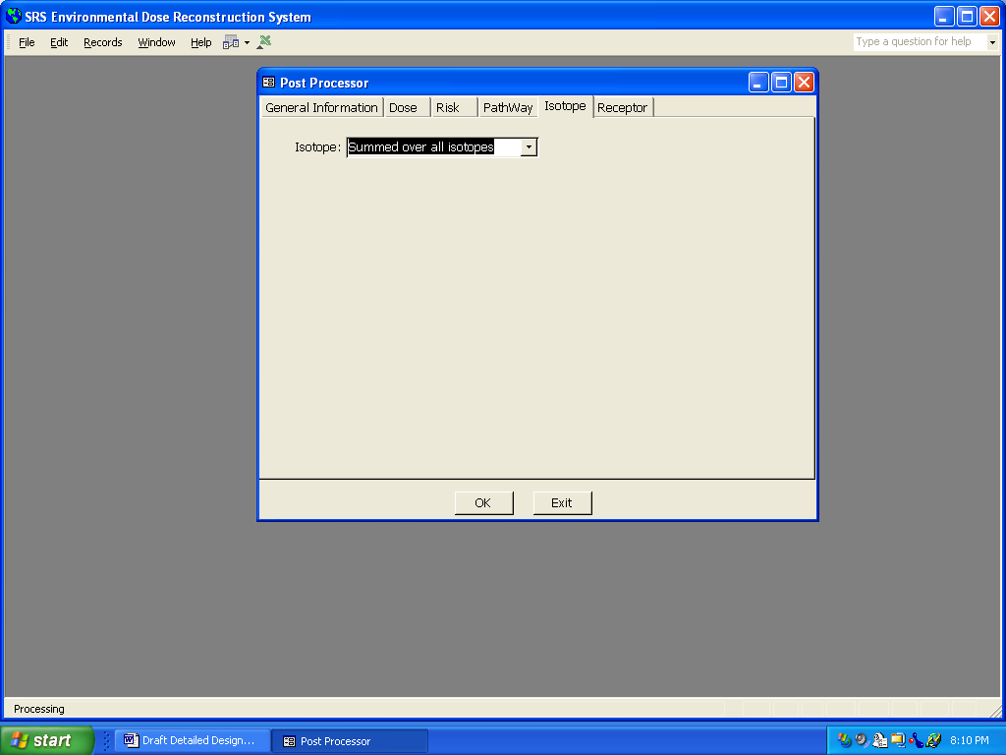
Figure G-12 Isotope Tab, “Summed Over All Isotopes” Selected

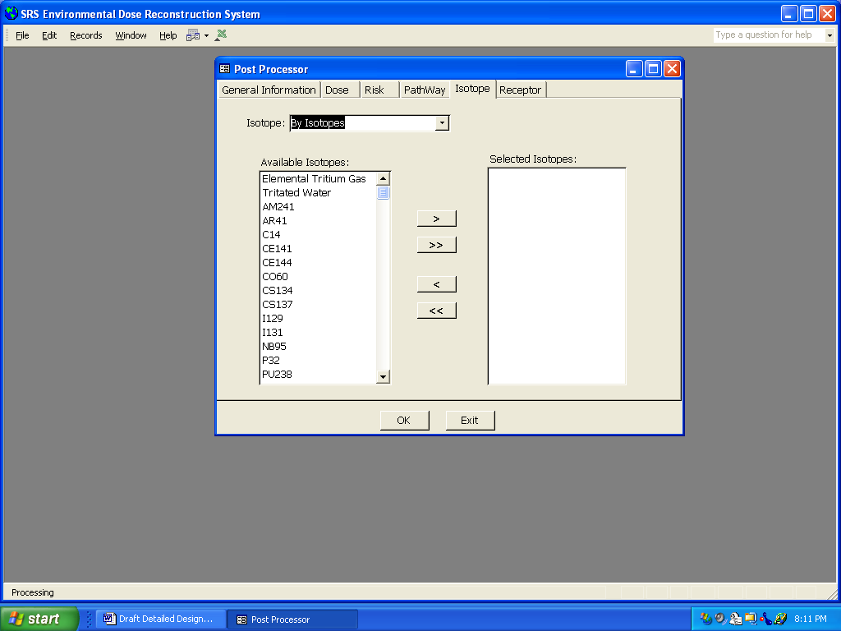
Figure G-13 Isotope Tab, “By Isotope” Selected

The Year Tab
The user selects Summed over all years or By year to control the detail of dose information presented in the results report. If Summed over all years is selected, the output result will be the total of the range of years. If By year is selected, the output result will be grouped by each year.
Figure G-14 shows the Year Tab with the “Summed over all years” or “By year” selections visible in the dropdown menu.

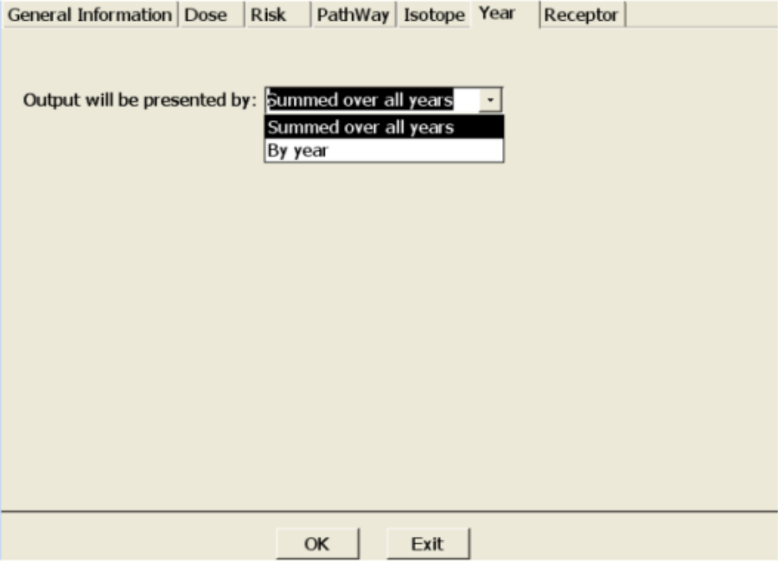
Figure G-14 Year Tab with "Summed over all Years" or "By Year"
Selections Visible

The Receptor Tab
The user selects one or more possible recipients for which doses/risks will be calculated. User choices include: All Family, Rural Family #1, Rural Family #2, Urban Family, Delivery Family, etc. Information selected on this tab is read from the Access Receptor table, which contains fixed values.
At least one receptor must be selected to generate a report.
The post-processor will generated a dose/risk report for each selected receptor from the list based on the above user input information. Figure G-15 shows the Receptor Tab.

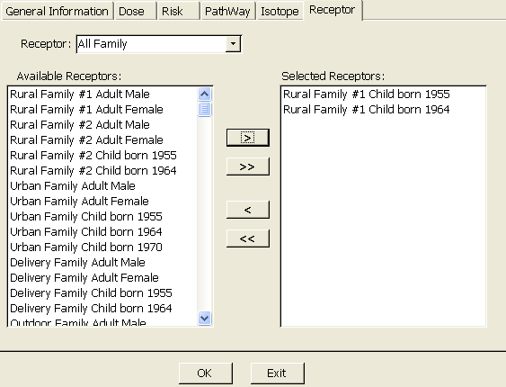
Figure G-15 The Receptor Tab

The Post-Processor Input File Requirements
There are three file types required for any given post-processor run. These include: 1) GENII-V2 output data contained in the GENII-V2 files with the HIF extension, 2) pathways behavior file (Usage factor), isotope description file, Dose adjustment file (Dose factor), and Risk adjustment file (Risk factor), and 3) data selected by the user from the post-processor user interface by facility, which will be used as input for developing site doses and risk numbers.
There are a total of seven input files required by the Post-processor:
- One HIF file, which will be determined by the system based on the user-input information
- One user-specified input file (Pathways)
- Five other supporting tables which are already loaded to the database during the system development cycle:
  - DoseFactor – contains adjustment values from the Federal Guidance Report 13 (1) for all isotopes, all pathways, all routes, all lung-classes, and all organs at all ages.
  - RiskFactor – contains adjustment values from the Federal Guidance Report 13 (1) for all isotopes, all pathways, all routes, all lung-classes, and all organs at all ages.
  - IsotopeNames – contain names of all radionuclides for both atmospheric and liquid releases.
  - IsotopeList – contains descriptions of isotopes such as isotope index number, daughter index if any, and its lung-class value.
  - Receptors – information of receptor’s name, family name, and the birth year.

The GENII-V2 HIF File
GENII-V2 produces several output files during the execution of a given computer run. These files contain doses, cancer incidents, and cancer fatalities by exposure location, by isotope, by pathway, and organ. Due to the strict naming convention established in the pre-processor requirements, the post-processor can identify GENII-V2 results by type of release, facility, year of release, and uncertainty run ID. The filename has the standard format for GENIIV2 output, for example, ABCDE000.HIF:
Where
- A = A (atmospheric) or L (Liquid),
- B is the second character of the template file,
- C is the facility ID,
- DE is the last two digits of the year of the release, and
- FGH is a number that varies from 000 (the point estimate) to 100 (the number of the uncertainty runs).
The HIF files are ASCII files containing the generic values which were calculated by GENII-V2. These values are for each organ by all pathways by all isotopes. In general, each HIF file has ten sections, each section has a section header following by the number of lines in that section. A section header is three characters, “hei”, plus the exposure location number.
Within each “hei” section, there will two lines with organ names, one is the header for risk organs, and the other one is the header for dose organs, followed by a section for each isotope. Within each isotope section, there will be three lines for each pathway, the first two lines list the generic values for each risk organ, and the third line contains the values for the dose organs. Figure G-16 shows the contents of an HIF file:
"hei1",2069
4,
This GLYPH has data for 1 RECEPTOR sources.
GENII VER 2.0 B1
Run on: 02-21-2004 at 11:57:17
1,"chronic",
1,
"chronic","exp1","Air", 1, 1, 18, 15, 24,
"Esophagus","Stomach","Colon","Liver",……….,"Thyroid","Leukemia","Residual","Total",
"Adrenals","Bld Wall","B Surface",…….,"Testes","Thymus","Thyroid","Uterus","Effective",
11.1,"km", -35.8,"km",
0., 70.,"yr",
"AM241","AM241", 0, 1,
0.00,"yr", 1.000,"yr", 42,
1.,"Air","external","risk","cancer incidence",
3.20E-10, 3.10E-10, 2.40E-10, 0.00E+00, ......, 0.00E+00, 0.00E+00, 0.00E+00, 5.20E-08,
1.,"Air","external","risk","cancer fatalities",
3.10E-10, 3.40E-10, 2.40E-10, 0.00E+00, ......, 0.00E+00, 0.00E+00, 0.00E+00, 6.20E-08,
1.,"Air","external","Sv","radiation dose",
3.20E-10, 3.10E-10, 2.40E-10, 0.00E+00, ......, 0.00E+00, 0.00E+00, 0.00E+00, 7.20E-08,
…
…
"AR41","AR41", 0, 1,
0.00,"yr", 1.000,"yr", 42,
1.,"Air","external","risk","cancer incidence",
0.00E+00, 0.00E+00, 0.00E+00, 0.00E+00, ......, 0.00E+00, 0.00E+00, 0.00E+00, 0.00E+00,
1.,"Air","external","risk","cancer fatalities",
0.00E+00, 0.00E+00, 0.00E+00, 0.00E+00, ......, 0.00E+00, 0.00E+00, 0.00E+00, 0.00E+00,
1.,"Air","external","Sv","radiation dose",
0.00E+00, 0.00E+00, 0.00E+00, 0.00E+00, ......, 0.00E+00, 0.00E+00, 0.00E+00, 0.00E+00,
…
...
"hei2",2069
"Esophagus","Stomach","Colon","Liver",……….,"Thyroid","Leukemia","Residual","Total",
"Adrenals","Bld Wall","B Surface",…….,"Testes","Thymus","Thyroid","Uterus","Effective",
11.1,"km", -35.8,"km",
0., 70.,"yr",
"AM241","AM241", 0, 1,
0.00,"yr", 1.000,"yr", 42,
1.,"Air","external","risk","cancer incidence",
0.00E+00, 0.00E+00, 0.00E+00, 0.00E+00, ......, 0.00E+00, 0.00E+00, 0.00E+00, 0.00E+00,
1.,"Air","external","risk","cancer fatalities",
0.00E+00, 0.00E+00, 0.00E+00, 0.00E+00, ......, 0.00E+00, 0.00E+00, 0.00E+00, 0.00E+00,
1.,"Air","external","Sv","radiation dose",
0.00E+00, 0.00E+00, 0.00E+00, 0.00E+00, ......, 0.00E+00, 0.00E+00, 0.00E+00, 0.00E+00,
…
"AR41","AR41", 0, 1,
0.00,"yr", 1.000,"yr", 42,
1.,"Air","external","risk","cancer incidence",
0.00E+00, 0.00E+00, 0.00E+00, 0.00E+00, ......, 0.00E+00, 0.00E+00, 0.00E+00, 0.00E+00,
1.,"Air","external","risk","cancer fatalities",
0.00E+00, 0.00E+00, 0.00E+00, 0.00E+00, ......, 0.00E+00, 0.00E+00, 0.00E+00, 0.00E+00,
1.,"Air","external","Sv","radiation dose",
0.00E+00, 0.00E+00, 0.00E+00, 0.00E+00, ......, 0.00E+00, 0.00E+00, 0.00E+00, 0.00E+00,
…
Figure G-16 HIF File

The User-Specified Excel Pathways File (User Supplied)
The user-specified Pathways matrices contain information about the means by which the radioactivity was transmitted (Air, Liquid). These matrices are in Excel spreadsheet format. The post-processor reads the information in this file and loads it into the Access Pathways table for use by the system. The columns of this matrix are shown in Table G-4.
Table G-4 Pathways Matrix Column Heading Descriptions
Matrix Column Heading | Definition
Receptor Location | The location of the recipient at the time of exposure
Receptor Age | The age of the recipient at the time of exposure
Medium | The medium or substance by which the radiation was transmitted
Route | The means by which the radiation traveled. Values include external, inhalation, and ingestion.
Exposure Location 1 | A code indicating the location of the recipient at the time of exposure.
Usage Factor 1 | A value indicating the extent of usage of the medium that transmitted the radiation. For example, if the medium is air, then this value would be the number of hours the air was breathed by the recipient.
Adjustment Factor 1 | A factor by which the dose calculation will be adjusted to allow for the fact that the recipient may not have been exposed 100% of the time. For example, if the recipient was estimated to have eaten 100 kg of vegetables per year, but half of these vegetables were purchased at a location that carried non-local food, then the adjustment factor would be 0.5.
Exposure Location 2 | A code indicating a second location of the recipient at the time of exposure.
Usage Factor 2 | The usage factor applied to exposure location 2.
Adjustment factor 2 | The adjustment factor applied to exposure location 2
Exposure Location 3 | A code indicating a third location of the recipient at the time of exposure.
Usage Factor 3 | The usage factor applied to exposure location 3.
Adjustment factor 3 | The adjustment factor applied to exposure location 3
Exposure Location 4 | A code indicating a fourth location of the recipient at the time of exposure.
Usage Factor 4 | The usage factor applied to exposure location 4.
Adjustment factor 4 | The adjustment factor applied to exposure location 4

Other Supporting Files (pre-loaded)
This section will describe the contents of additional files that need to be read by the post-processor, and the relationship that exists between various files. There are seven additional Excel files that the post-processor needs to read. These Excel files are pre-loaded to the database during the system development cycle.

The Dose Factor Table
The Dose Factors Table contains a set of dose factors for various age groups, lung classes, selected pathways, routes, and isotopes by organ. The entries for this file are extracted out of the Federal Guidance Report 13 (1).
The columns of the Dose Factors table are shown in Table G-5.
Table G-5 Dose Factors Table Column Heading Descriptions
Table Field | Definition
Isotope | Abbreviations of all isotopes relevant to the exposure
Pathway | The pathway by which the exposure was received by the recipient (Air, Liquid)
Route | The route by which the dose was received (inhalation, ingestion, external)
Lung_class | Values include F, M, S, V, and G. The lung class determine the solubility from Federal Guide Report 13
Age | Age group for the dose factor (Infant, 1 yr old, 5 yr old, 10 yr old, 15 yr old and adult)
Twenty two columns of dose factor by organ | Dose factor for a given organ by pathway, route, lung class and age.
Adrenals | Dose factor for the adrenal glands by pathway, route, lung class, and age.
UB Wall | Dose factor for the UB wall by pathway, route, lung class, and age
B_Surface | Dose factor for the B Surface by pathway, route, lung class, and age
Brain | Dose factor for the brain by pathway, route, lung class, and age
Breast | Dose factor for the breast by pathway, route, lung class, and age
ET_Region | Dose factor for the esophagus-trachea Region by pathway, route, lung class, and age
St_Wall | Dose factor for the stomach wall by pathway, route, lung class, and age
SI_Wall | Dose factor for the small intestine wall by pathway, route, lung class, and age
ULI Wall | Dose factor for the upper large intestine wall by pathway, route, lung class, and age
LLI Wall | Dose factor for the lower large Intestine wall by pathway, route, lung class, and age
Kidneys | Dose factor for the Kidneys by pathway, route, lung class, and age
Liver | Dose factor for the Liver by pathway, route, lung class, and age
Lung | Dose factor for the Lung by pathway, route, lung class, and age
Muscle | Dose factor for the muscle tissue by pathway, route, lung class, and age
Ovaries | Dose factor for the ovaries by pathway, route, lung class, and age
Pancreas | Dose factor for the pancreas by pathway, route, lung class, and age
R_Marrow | Dose factor for the red marrow by pathway, route, lung class, and age
Skin | Dose factor for the skin by pathway, route, lung class, and age
Spleen | Dose factor for the spleen by pathway, route, lung class, and age
Testes | Dose factor for the testes by pathway, route, lung class, and age
Thymus | Dose factor for the thymus by pathway, route, lung class, and age
Thyroid | Dose factor for the thyroid by pathway, route, lung class, and age
Uterus | Dose factor for the uterus by pathway, route, lung class, and age
E_50 | Equivalent dose factor by pathway, route, lung class and age

The RiskFactor Table
The Risk Factors Table contains information about the calculated cancer risks factors. The entries for this file are extracted out of the Federal Guidance Report 13 (1).
Table G-6 describes the columns of the Risk Factors Table.
Table G-6 Risk Factors Table Column Heading Descriptions
Table Fields | Definition
Isotope | The Abbreviations of all isotopes relevant to SRS exposures.
Pathway | The pathway by which the exposure was transmitted. Values include Air, D Water (drinking water), Dietary, Ground, or Swimming
Route | External, Inhalation, or Ingestion.
Lung_Class | Values include F, M, S, V, and G. The lung class determines the solubility from Federal Guide Report 13
Age | Age group for the risk factors (0-5 yr, 5-15yr, 15-25yr, 25- 70yr and 0-110 yr)
Thirty columns of risk factors by organ | The risk factors are grouped first by risk of cancer incidence and by risk of cancer fatalities...
Esophagus | Cancer Fatality Risk Factor for the esophagus by pathway, route, lung class, and age.
CFStomach | Cancer Fatality Risk Factor for the stomach by pathway, route, lung class, and age
CFColon | Cancer Fatality Risk Factor for the colon by pathway, route, lung class, and age
CFLiver | Cancer Fatality Risk Factor for the liver by pathway, route, lung class, and age
CFLung | Cancer Fatality Risk Factor for the lung by pathway, route, lung class, and age
CFBone | Cancer Fatality Risk Factor for the bone by pathway, route, lung class, and age
CFSkin | Cancer Fatality Risk Factor for the skin by pathway, route, lung class, and age
CFBreast | Cancer Fatality Risk Factor for the breast by pathway, route, lung class, and age
CFOvary | Cancer Fatality Risk Factor for the ovary by pathway, route, lung class, and age
CFBladder | Cancer Fatality Risk Factor for the bladder by pathway, route, lung class, and age
CFKidney | Cancer Fatality Risk Factor for the kidney by pathway, route, lung class, and age
CFThyroid | Cancer Fatality Risk Factor for the thyroid by pathway, route, lung class, and age
CFLeukemia | Cancer Fatality Risk Factor for Leukemia by pathway, route, lung class, and age
CFResidual | Cancer Fatality Risk Factor for the residual organs by pathway, route, lung class, and age
CFTotal | Total Cancer Fatality Risk Factor by pathway, route, lung class, and age
CIEsophagus | Cancer Incidence Risk Factor for the esophagus by pathway, route, lung class, and age.
CIStomach | Cancer Incidence Risk Factor for the stomach by pathway, route, lung class, and age
CIColon | Cancer Incidence Risk Factor for the colon by pathway, route, lung class, and age
CILiver | Cancer Incidence Risk Factor for the liver by pathway, route, lung class, and age
CILung | Cancer Incidence Risk Factor for the lung by pathway, route, lung class, and age
CIBone | Cancer Incidence Risk Factor for the bone by pathway, route, lung class, and age
CISkin | Cancer Incidence Risk Factor for the skin by pathway, route, lung class, and age
CIBreast | Cancer Incidence Risk Factor for the breast by pathway, route, lung class, and age
CIOvary | Cancer Incidence Risk Factor for the ovary by pathway, route, lung class, and age
CIBladder | Cancer Incidence Risk Factor for the bladder by pathway, route, lung class, and age
CIKidney | Cancer Incidence Risk Factor for the kidney by pathway, route, lung class, and age
CIThyroid | Cancer Incidence Risk Factor for the thyroid by pathway, route, lung class, and age
CILeukemia | Cancer Incidence Risk Factor for the Leukemia by pathway, route, lung class, and age
CIResidual | Cancer Incidence Risk Factor for the residual organs by pathway, route, lung class, and age
CITotal | Total Cancer Incidence Risk Factor by pathway, route, lung class, and age

The Isotope Names Table
The Isotope Names Table lists the name of each isotope to be displayed in the isotope list box for atmospheric or liquid pathways. Column headings of the Isotope Names Table are described in Table G-7.
Table G-7 Isotope Names Table Column Heading Descriptions
Table Fields | Definition
Isotope | The names of all relevant isotopes involved in the exposure.
Selected (true or false) | Specifies whether or not the user selected the isotope for use in the dose calculations.
AtmosphericRelease | Specifies whether or not the dose was received by atmospheric release.
LiquidReleases | Specifies whether or not the dose was received by liquid release.

Isotope List Table
The IsotopeList table lists the correct isotope number, the isotope abbreviations, the index of any daughter isotope, and the lung-class, which determines the solubility of the contaminant according to Federal Guide Report 13 (1). The column headings of the IsotopeList table are described in Table G-8.
Table G-8 Isotope List Table Column Heading Descriptions
Table Fields | Definition
Isotope | The abbreviations of all relevant isotopes involved in the exposure.
IsotopeNum | The index of an isotope.
DaugIndex | The index of any daughter isotopes that the parent isotopes yield due to radioactive decay.
Lung_Class | The lung class determines the solubility from Federal Guide Report 13. Values include F, M, S, G, and V.

The Receptors Table (User Supplied)
The Receptors Table contains the location, age at the time of exposure, age range over the duration of the exposure, and birth year of all receptors. Users select specific receptors through the post-processor user interface, and their selections are recorded in the Selected field. The column headings of the Receptors table are described in Table G-9.
Table G-9 The Receptors Table Column Heading Descriptions
Table Fields | Definitions
Name | Type of receptor, for example, Rural Family #1 Adult Male.
Location | The location of the receptor, for example, Rural Family #2.
Receptor | The age range of the receptor, for example, Adult Male.
YearBorn | The birth year of a given receptor type.
Selected | A yes/no field indicating that the user has selected an option.

Detailed Processing Required to Generate the Final Post-processor Report
The post-processor will read the files described in G.4.2.3. The post-processor will then obtain the user's choices. Then, based on the user's choices, the post-processor will read the appropriate GENII-V2 HIF files. As the post-processor reads each HIF file, the computer code will adjust the results according to the information in the behavior file and by the dose conversion/risk factors. The results will then be accumulated into the correct cells of the DoseRisk Table depending on the user's choices.
This section describes the logic that the post-processor will use during the calculations. The logic flow begins after the post-processor has obtained the user choices and read the supplemental files. Briefly, for a given exposure location, the post-processor will read doses/risk results by isotope and pathway. The post-processor will adjust the dose/risk numbers for a given receptor to account for that receptor's behavior contained in the behavior file and birth year files. The adjustments will include an adjustment of the dose/risk to change the results from age independent to age dependent dose/risk factors and age dependent location behavior.
For example, look at the Rural Family #1 Child born in 1955 with the external air pathway and a release year of 1969. The receptor is now a teenager who resides at his house for 7500 hours per year (exposure location 1) and goes to school for 1260 hours per year (exposure location 2.) The post-processor will adjust GENII-V2 dose/risk results for each isotope and organ. For exposure location 1, the dose/risk results would be multiplied by a factor of 6760 and multiplied by the teenager air external dose conversion factor by isotope and organ divided by the adult air external dose factor by isotope and organ. The resulting dose/risk will be stored and summed as required by the user.

The Dose Reconstruction Report
The logic flow begins after the post-processor has obtained the user choices and read the supplemental files. For a given exposure location, the post-processor will read the doses/risk results by isotope and pathway. The post-processor will adjust the dose/risk numbers for a given receptor to account for that receptor's behavior, as described in the behavior file and birth year files. The adjustments will include an adjustment of the dose/risk to change the results from age independent to age dependent dose/risk factors and age dependent location behavior.
For example, look at a child born in 1954 with the external air pathway and a release year of 1969. The receptor is now a teenager who resides at his house for 7375 hours per year (exposure location 1) and goes to school for 1295 hours per year (exposure location 2.) The post-processor will adjust GENII-V2 dose/risk results for each isotope and organ. For exposure location 1, the dose/risk results would be multiplied by a factor of 6760 and multiplied by the teenager air external dose conversion factor by isotope and organ divided by the adult air external dose factor by isotope and organ. The resulting dose/risk will be stored and summed as required by the user.
The post-processor collects information from the user input window, based on the release type, facility ID, and the year of process, then loops through the GENII-V2 output files and checks to see if this run is valid for Uncertainty or just for Point-Estimate. For a given release type, facility ID and year of processing, if there are 101 GID files, the system will assign 100 to the MaxRun variable. Otherwise, it will set MaxRun equals 0). Once this process has completed, the post-processor will load the user-specified Pathway file into the Pathways table in the database.
For each receptor in the selected list, the receptor’s name is assigned to the RecpName variable. Based on the RecpName value, the Location, Receptor, and YearBorn are obtained from the Receptor table.
For each year of the specified processing years (the user specifies the starting year and the ending year of the process), the current processing year is assigned to the intYear variable (intYear is used to determine which HIF file should be loaded and the current age of the receptor).
As the processing year goes up, the receptor’s age is also changing. All age group variables must be reassigned with a proper value based on the receptor’s current age at that processing year. (See Age Group Assignment Table for detail)
There are four varying age group variables:
RecepAge = 1900 + intYear – YearBorn
RiskAge = Risk factor age based on the RecepAge
DoseAge = Dose factor age based on the RecepAge
USFAge = Usage factor age based on the RecepAge
For RunNum from 0 to MaxRun
Clean up the HIFData and TempHIF tables
Load HIF file based on RunNum to HIFData table
Read each record from the HIFData table, arrange require fields and write to TempHIF table
Select all records from the Pathways table based on the known Location and USFAge values
For each record read above
Assign the first set of values from the Pathways table to the variables of ExpLoc, Pathway, Route, UsageFactor, and AdjFactor
Read all records from TempHIF table based on the known ExpLoc, UsageFactor, and AdjFactor
For each record read from the TempHIF table, assign the Isotope value to the Isotope variable
Read the Isotope Table based on the Isotope value to get the lung-class
Get DoseFactor for each organ and store in a 1 by 24 temporary array called DoseFactor(24)
The DoseFactor for each organ is equal to the current age Dose AdjFactor divides by the adult age Dose AdjFactor
The current age Dose AdjFactor is read from the DoseFactor table based on the Isoto, Route, Pathway, Lung-class, and DoseAge
The adult age Dose AdjFactor is read from the DoseFactor table based on the Isoto, Route, Pathway, Lung-class, and DoseGroup, which equals “Adult”
Certain rules may apply to the DoseFactor:
The DoseFactor table does not have values for a Route equals “Inhalation” and the Pathway equals “Indoor Air”. In this case, the Pathway will be assumed to “Air”.
If Route equals “External” the DoseFactor value will 1.
Get RiskFactor for each organ and store in a 1 by 30 temporary array Call RiskFactor (30)
The RiskFactor for each organ is equal to the current age Risk AdjFactor divides by the adult age Risk AdjFactor
The current age Risk AdjFactor is read from the RiskFactor table based on the Isoto, Route, Pathway, Lung-class, and RiskAge
The adult age Risk AdjFactor is read from the RiskFactor table based on the Isoto, Route, Pathway, Lung-class, and RiskGroup which equals “0-110 y”
Certain rules may apply to the RiskFactor:
The DoseFactor table does not have values for a Route equals “Inhalation” and the Pathway equals or “Indoor Air”. In this case, the Pathway will be assumed to “Air”.
If Route equals “Ingestion” and Pathway equals “Swimming”, or “Showering”, or “Water” then the Pathway will be set to “D Water” when reading the RiskFactor table.
If the Pathway equals “Fish” then the Pathway will be set to “Dietary” when reading the RiskFactor table.
Apply the UsageFactor and each of the RiskFactor (30) to the first 30 organs from the TempHIF record.
Apply the UsageFactor and each of the DoseFactor (24) to the last 24 organs from the TempHIF record.
Write TempHIF record to DoseRisk table.
Read next TempHIF record
Read next Pathway record
Process next RunNum through
Process next intYear through the end
Export DoseRisk table to C:\CDC\Postprocessor\Completed for the current receptor in an Excel format.
Process next Receptor from selection list.

Other Output Files
Two Post-processor output files are generated in addition to the calculated Excel Dose/Risk Report. These are a QA file and a message (MES) file.
Each file name will have the following format:
ABCDEFG.xxx
Where
- A is the type of releases (A, S, L)
- B is the facility
- CD is the last two digits of the first year of releases processed
- EF is the last two digits of the last year releases processed
- G is the version of the standardized GID file processed. and
- xxx is QA for the QA file and MES for the message file

QA File
This file contains referencing information related to the processing of the post-processor during the creation of the report files. Included in this file are:
- The post-processor start date and time.
- The user who created the post-processor run
- The Facility Name
- Pathway Usage Factors excel file used
- The list of output files generated
- A message describing if the post-processor run completed successfully and the date and time of completion.

MES File

The Message (EMS) file documents any errors that occurred during the post-processor run. The program generates an error message for the EMS file and displays it to the user if any unexpected condition arises. Several conditions that could arise are:

- Missing of GENII-V2 output file
- An exposure location that is not in an output file.
- An isotope name is not found.
- An error occurred when reading input file.

Testing
The Quality Assurance Application Test Plan for the Pre- and Post-Processors to GENII-V2, contains the detailed test plan. The following sections briefly describe testing approaches for the pre- and post-processor.

Pre-Processor

Input Data Creation
The test data for the Pre-Processor is set up to address specific test scenarios and is contained in a combination of standard GID templates for given exposure location sets and facility specific source term data files. Reference data is contained in pre-defined isotope description files, dispersion factor files, exposure description files, facility description files, parameter uncertainty files and source term uncertainty files. The appropriate combination of input files is set up for each execution run as they pertain to the test scenarios within that particular run. Many input reference files remain constant across test scenarios and will be re-used by multiple test runs as necessary. Any variation of input files is documented and kept for reference.

Expected Results Calculation
Expected results for each test scenario are determined through both manual calculations and other tool-assisted methods. In the most basic scenario, the application obtains data directly from a source term file for a given media and facility, then multiplies by a unit conversion factor and places the data in a specific row within the GID output file based on corresponding variable names and row indices for a given isotope or exposure location. These calculations are relatively simple, self-explanatory and do not require additional explanation beyond referencing the detailed design requirement. Distance calculations are slightly more complex and a separate tool was developed using Excel to determine values for expected results. Since user interface requirements typically affect all test runs and only occur during execution setup, they have no particular test scenarios and no specific expected results to compare. Visual verification will suffice to confirm application functionality for most user interface requirements.

Error Messages Confirmation
Error message functionality is confirmed by setting up various error scenarios within the input files and capturing output text within message files. Since the same message output filename may be used for several error scenarios, the message output files will be re-named after each error run to include the corresponding scenario for easy traceability.

Output Data Comparison Analysis
Once each test execution run has completed successfully, the output files for each run will be captured and analyzed using a text editor or Excel to assist in the analysis.
For each test scenario within the corresponding GID output file, the specific field name and index values are matched to find the actual quantity, distance or setup values. The row number is noted and the entire row of data is captured and the actual values are placed in the traceability matrix for comparison with the expected values.
If the actual value matches expected results within acceptable tolerances, the scenario is marked as passed in the verification column. If the value does not match the expected results, the scenario is marked as failed in the verification column and placed in the failed history. Failed scenarios must be retested as fixes are made available.

Post-Processor

Input Data Creation
The test data for the post-processor needs to be generated by the GEN-II V2 dose calculation software and will be contained in a combination of HIF files based on selected media, facility, year range and uncertainty criteria. Reference data is contained in pre-defined receptor description files, isotope description files, risk factor files, dose factor files and behavior pathway usage files. The appropriate combination of input files will be set up for each execution run as they pertain to the test scenarios within that particular run.

Expected Results Calculation
Expected results for each test scenario are determined through both manual calculations and other tool-assisted methods. In the most basic scenario, the application obtains data directly from an HIF file for a given media, exposure set, facility, year and uncertainty, then multiplies by a series of risk, dose and usage factors and places the data by organ and total in a specific row within the XLS output file based on corresponding row indices for a given location, receptor, year, uncertainty, pathway and isotope. These calculations are relatively simple, self-explanatory and do not require additional explanation beyond referencing the detailed design requirement. A tool was be developed using Excel to determine risk and dose values for expected results.

Output Data Comparison Analysis
Once each test execution run has completed successfully, the output files for each run are captured and analyzed using a text editor or Excel to assist in the analysis.
For each test scenario within the corresponding XLS output file, the index values are matched to find the actual risk and dose values for specific organ name or total. The row number is noted and the index portion of the row of data is captured including the organ name or total and the actual risk or dose values are placed in the traceability matrix for comparison with the expected values.
If the actual value matches expected results within acceptable tolerances, the scenario is marked as passed in the verification column. If the value does not match the expected results, the scenario is marked as failed in the verification column and placed in the failed history. Failed scenarios must be retested as fixes are made available.

References
1. U.S. Environmental Protection Agency. Federal guidance report 13. “Cancer Risk Coefficients for Environmental Exposure to Radionuclides”: CD supplement. EPA 402-C-99-001, Rev. 1. Oak Ridge National Laboratory and United States Environmental Protection Agency. April 2002.

