CHAPTER 3

COMPONENTS OF THE RETAIL MOTOR-FUEL DISPENSING SYSTEM

CHAPTER OBJECTIVES

Upon completion of this chapter, you should be able to:

1. Identify the major components of each of the following types of retail motor-fuel dispensing systems:

• self-contained systems;

• remote pump (or dispenser) systems; and

• mechanical and electronic systems.

2. Explain the purpose and function of each of these major components.

INTRODUCTION

What the motorist sees of a modern fuel-dispensing system is very impressive—a metal cabinet, extending perhaps eight feet in height, lighted price and volume indicators, a length of hose or hoses, with nozzles on the end, push buttons, possibly a card reader, maybe even a small TV screen and instructions for operating the device. While the outward appearance may be impressive, the reality of the dispenser hydraulic, mechanical and electronic complexity is hardly recognizable.

Opening the cabinet reveals a profusion of components, tubing, wiring, gears, and linkages, enough to daunt even the mechanically or electronically minded amateur. In this chapter, you will learn to recognize these parts, and gain a basic knowledge of how they work together.

The fuel-dispensing system performs several interrelated functions. The purpose of some components is to maintain hydraulic continuity, to regulate the direction of flow and fluid pressure. Others are responsible for pressurizing the fuel and moving it through the system. Still others, of course, are involved in metering the liquid fuel, registering accurately the quantity delivered, and computing the price of the delivery. Finally, some components serve to control the operation of the system, switching it on and off, resetting the volume and price indicators, regulating the delivery, and so on. We will proceed to look at the major components in each of these functional areas.

HYDRAULIC CONTINUITY

Fuel-dispensing systems are designed to measure, register, and deliver accurately the desired quantities of fuel product. The customer is paying for motor fuel, not air or fuel vapor. So these gases must be prevented from entering the dispenser's metering device. In addition, in order to be able to lift the fuel efficiently from an underground storage tank to the dispensers—especially in a self-contained system—the pipelines must be essentially free of air and vapor.

The most practical means of eliminating these gases is to keep the entire system—from the storage tank to the delivery nozzle—filled with liquid fuel at all times, even when the system is temporarily idle, as it is between deliveries, or when the station is shut down overnight. This could be accomplished in a number of ways, but the most practical and efficient design incorporates a simple automatic valve, called a check valve. In the cutaway drawing shown in Figure 3-1, you can see how one works. When fuel entering the valve inlet is under sufficient pressure to push the valve off its seat against the resistance of a spring and the pressure of liquid on the opposite side, the valve is opened, allowing liquid to flow through the valve in the direction of the arrows. When the source of pressure difference ceases, flow will discontinue, and the force of the spring will reseat the valve, preventing liquid from flowing through the valve in the opposite direction.

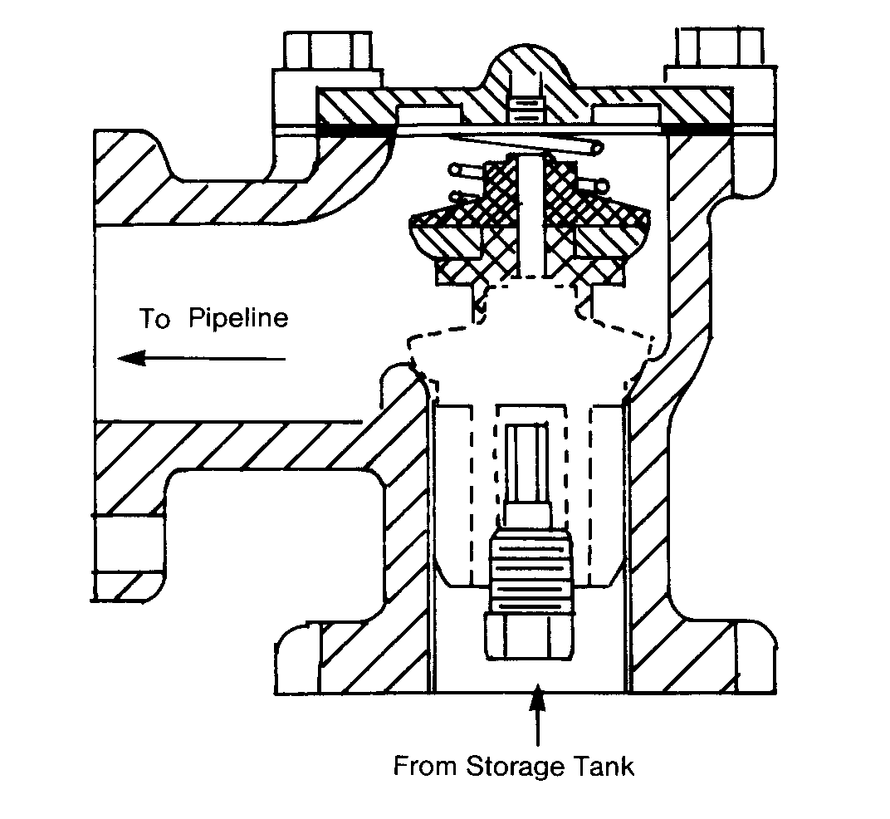
FIGURE 3-1. AUTOMATIC CHECK VALVE

In a fuel-dispensing system, a check valve permits liquid fuel to flow toward the delivery nozzle, but never back toward the storage tank. A check valve is located between the storage tank and the dispenser (as shown in Figure 3-2), usually close to the outlet of the storage tank, either at the angle joint where the pipeline drops vertically into the tank (self-contained systems), or inside the discharge manifold that sits atop a submerged pumping unit. (In some self-contained systems, a foot valve, located at the bottom of the intake pipe, performs the function of the check valve.)

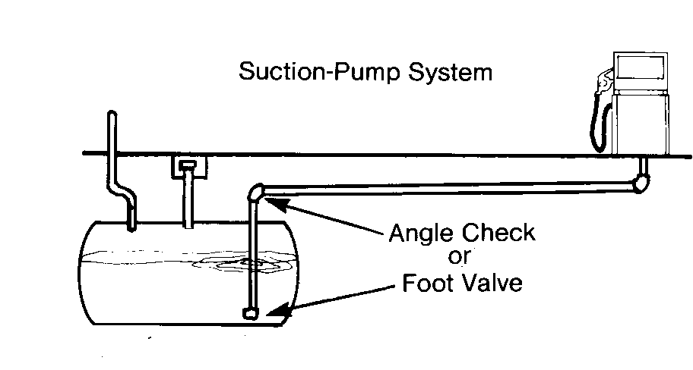 | 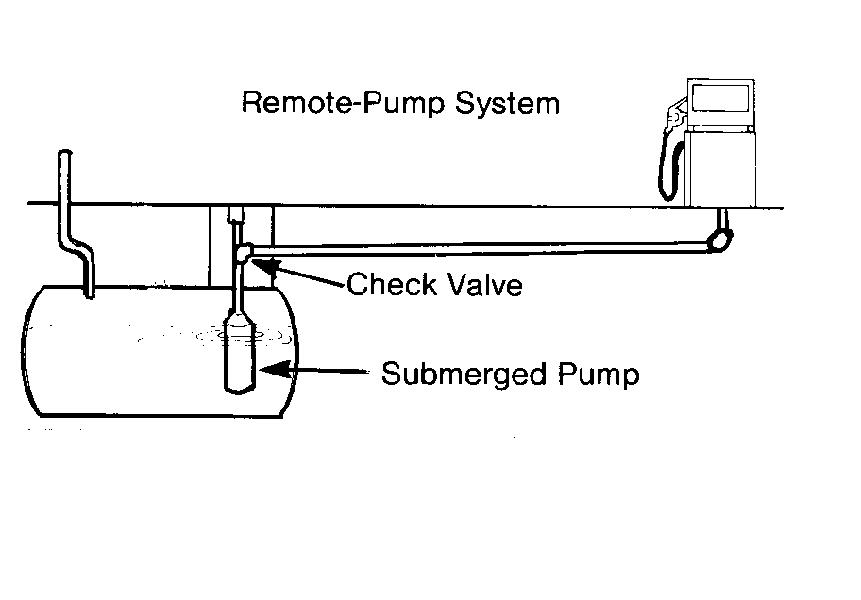
FIGURE 3-2. LOCATION OF SYSTEM CHECK VALVES
As we proceed through the system, you will see other automatic valves that operate in much the same way as these system check valves, functioning to regulate the direction of flow or fluid pressure of the product as it makes its way toward the meter and discharge hose. You will also see how a similar valve, located at the opposite end of the system, prevents fuel from draining from the discharge hose, assuring delivery of the full metered amount of fuel.

PRESSURIZING AND MOVING THE FUEL

In retail fuel-dispensing systems, a motor-driven pump furnishes the hydraulic pressure that moves fuel from the storage tank to the dispenser, through the metering device, and to the discharge hose and nozzle. As you know, two basic types of systems are in common use—self-contained and remote pump systems. Most of
the systems you will encounter today will be remote pump systems. These lend themselves to larger multiple dispenser installations. However, let us take a look at each type.

Self-contained Systems

In self-contained systems, the pumping unit is located inside the dispenser. Its major components are:

• a pump
• an electric motor
• an air eliminator
• flow regulating valves

Several manufacturers produce a self-contained unit, which includes the pump, air eliminator, valves, and flow passages connecting them, all enclosed in a single casing, as in Figure 3-3. The electric motor is separate, and drives the pump by means of a belt and pulleys.
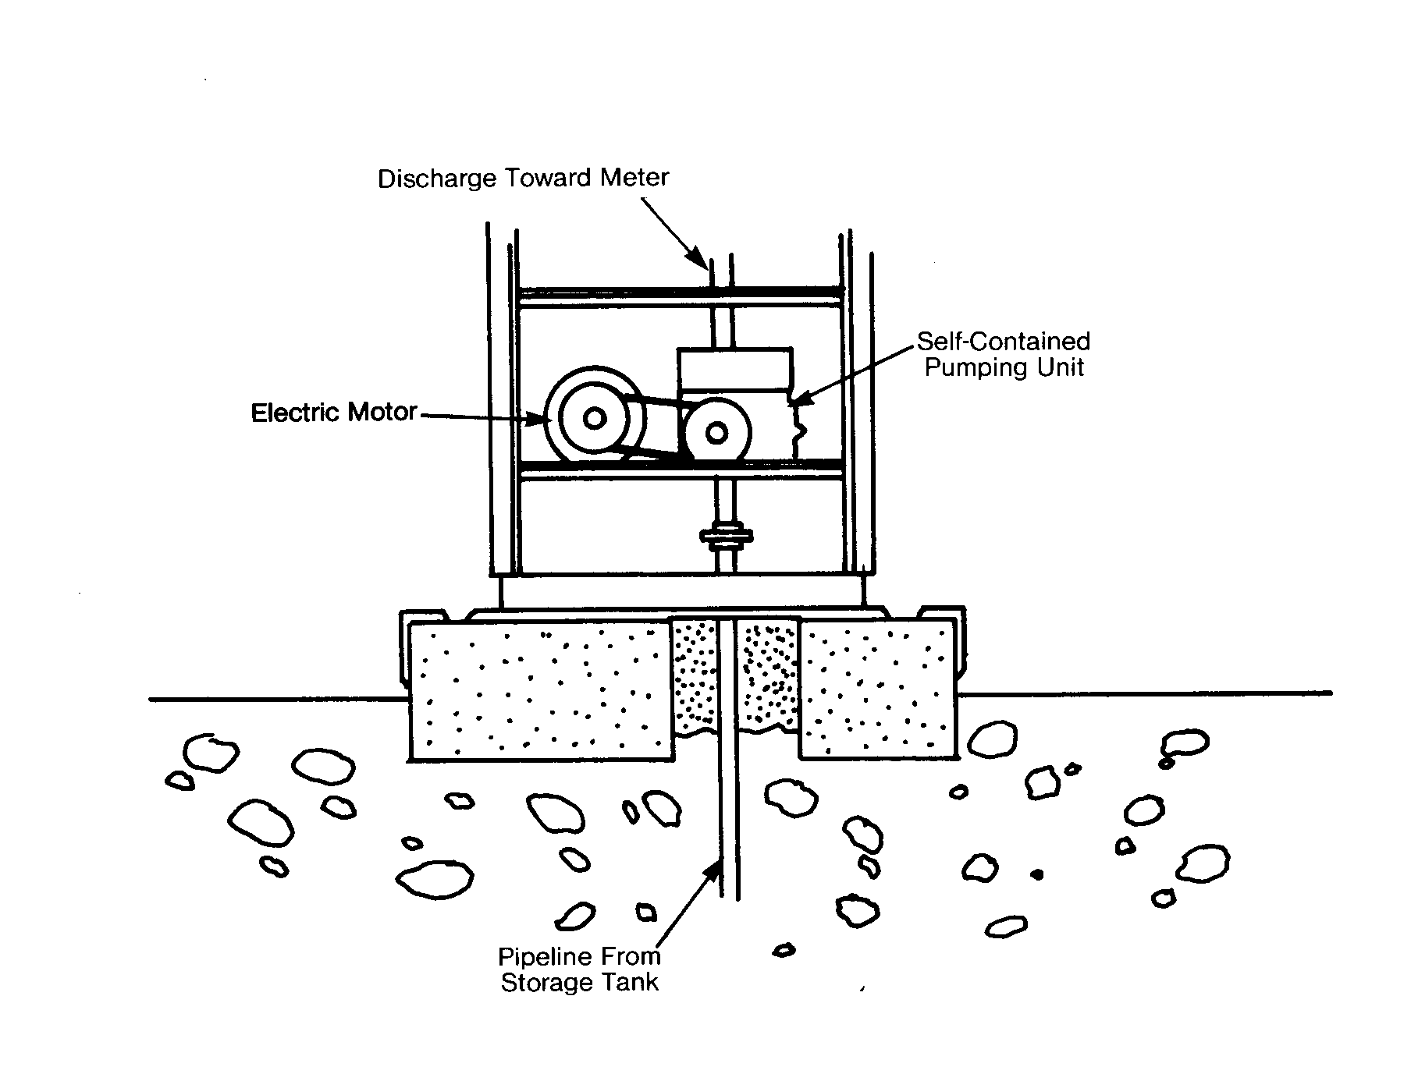

FIGURE 3-3. SELF-CONTAINED PUMPING UNIT AND MOTOR

The operation of a typical self-contained pumping unit is illustrated in Figure 3-4. When the dispenser's on-off switch is placed in the “on” position, the electric motor is activated, and begins to turn the rotary-vane pump (other pump types may be used). As the pump turns (clockwise in Figure 3-4), it propels fuel forward from its outlet. This displacement of the liquid creates a partial vacuum at the pump inlet.

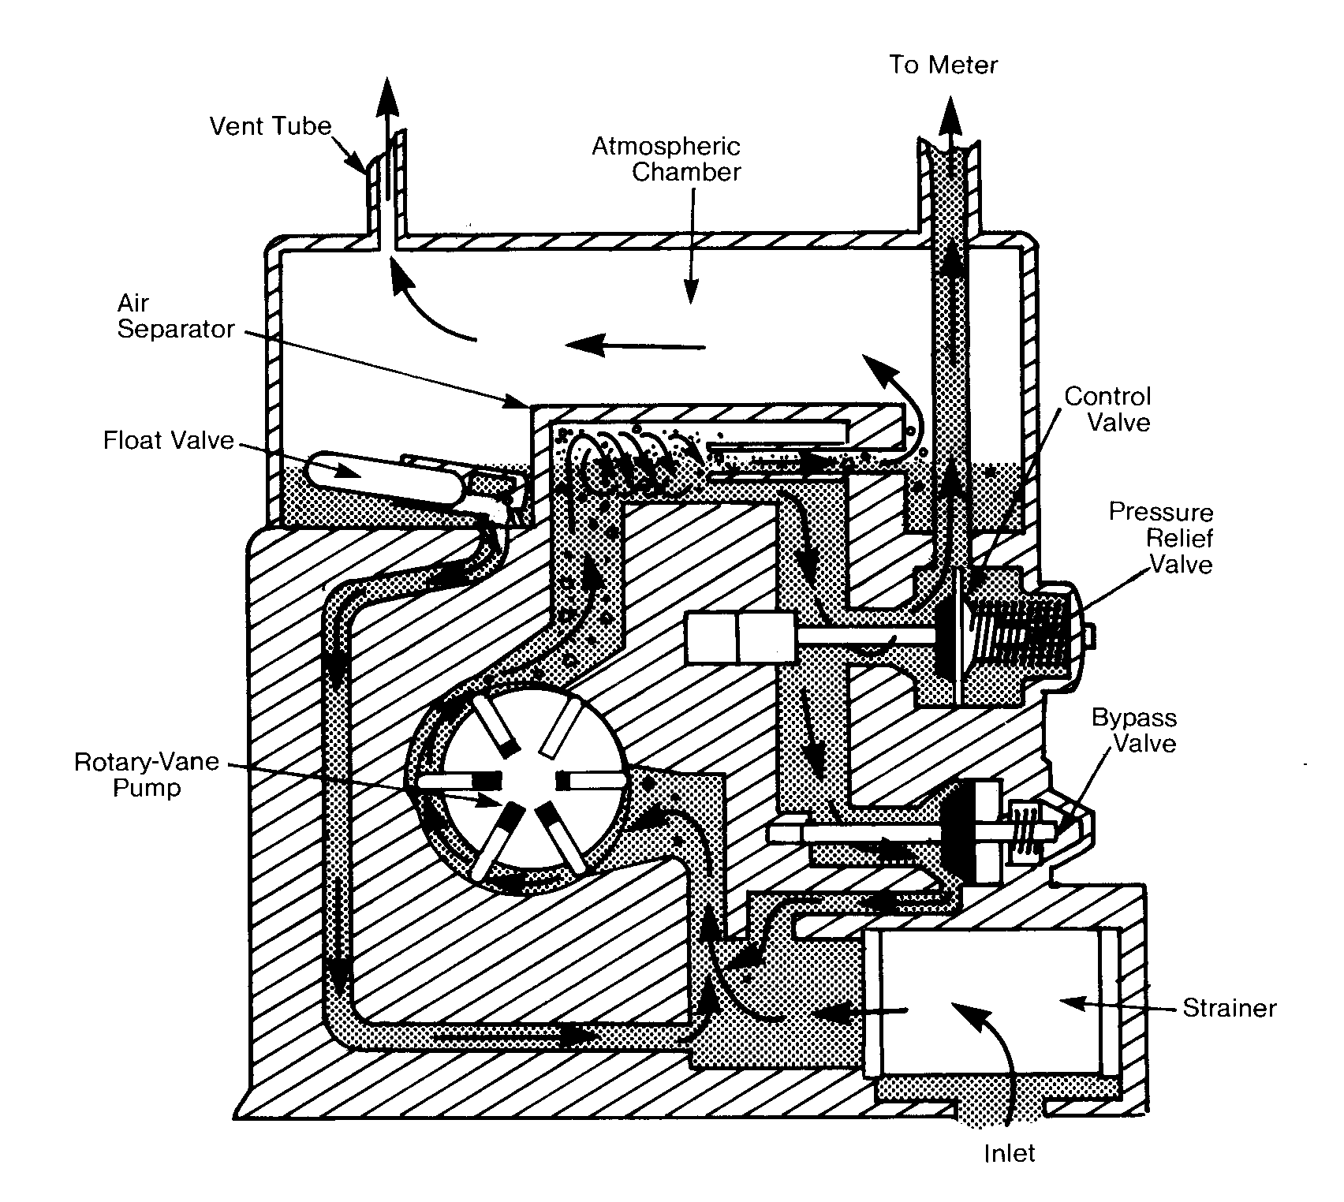
FIGURE 3-4. CUTAWAY OF TYPICAL SELF-CONTAINED PUMPING UNIT

As long as the discharge nozzle remains closed, this vacuum is relieved by fuel circulating continuously through the unit—you'll see how in a moment. But when the nozzle is opened, suction pressure is transferred instantaneously from the pump inlet all the way back through the pipeline to the storage tank. There, atmospheric pressure bearing on the surface of the fuel forces it to flow through the inlet pipe and check valve we saw earlier, into the pipeline, and toward the dispenser. As it enters the pumping unit, it passes through a strainer or filter, which removes any solid contaminants, and is drawn into the pump inlet.

Small quantities of trapped air and fuel vapor must be removed from the fuel before it passes to the meter. So, as it flows from the pump outlet, the fuel, now under pressure (typically 18-25 psi) enters the air separator chamber. The shape of this chamber forces the rapidly flowing fuel to swirl, with the result that the air and vapor, along with a small amount of liquid fuel, are forced through an orifice into the atmospheric chamber. Here the fuel comes to rest at atmospheric pressure. This allows the air and vapor to rise to the top portion of the chamber, where they leave the dispenser through a vent tube. The level of the liquid that remains in the bottom of the chamber rises until it raises the float, thereby opening a valve that allows it to leave the chamber and be drawn along a passageway back to the pump inlet.

At the same time, the main body of fuel, free of air and vapor, passes from the separating chamber to the automatic control valve. This valve is similar in design to the check valve we looked at earlier; it permits fuel to flow only in the direction of the meter, never back toward the pump. It also regulates the pressure of the fuel as it leaves the pumping unit and enters the meter, by closing when pressure on both sides has equalized (when the dispenser has been turned on but the nozzle remains closed, for example) preventing excess pressure from building in the meter and hose.
The control valve also has a built-in relief valve, which normally operates only when the dispenser is shut off. It relieves excess pressure caused by expansion of fuel on the discharge side of the valve by allowing a small amount to pass back through an orifice in the center of the control valve into the air separator chamber, where pressure can be relieved into the atmospheric chamber if necessary. The relief valve is very important, especially in warm-weather climates, because fuel expands when heated, and this expansion could raise pressure sufficiently to cause seals to fail, resulting in fuel leaks, or even burst the discharge hose if not relieved.

When the pump is operating (dispenser switch is in the “on” position) but the nozzle remains closed, the control valve will also close, as soon as pressure is equalized. The resulting increase in pressure in the separator chamber will open the bypass valve, permitting fuel to flow back to the pump inlet, thus relieving suction pressure and preventing additional fuel from being drawn from the storage tank.

In some self-contained systems, especially older ones, these components may be separate, and they may be referred to by different names. (For example, the atmospheric chamber of the self-contained unit, when separate, is usually called the sump.) But your basic knowledge of the interrelated functions of the pumping components should make it possible for you to recognize them, even when separated. In newer, larger fueling facilities the use of self-contained systems is declining. Currently less than ten percent of dispensers in new locations are self-contained. Remote pumping systems and remote dispensers explained in the following sections are more of today’s norm.

Remote pump (or remote dispenser) Systems

In this type of system, fuel is pressurized and propelled toward the dispenser by a pumping unit located at or in the storage tank. The basic components of the pumping system are:

• a motor and pump assembly and discharge head,
• an emergency shut-off valve, located in each dispenser, and
• a control valve, also located at each dispenser.

In rare cases remote pumping systems employ a rotary vane pump like that used in self-contained systems, which sits atop the storage tank. However most remote systems employ a submerged pump. As its name suggests, the pump and motor assembly are completely submerged in the storage tank. As you can see in Figure 3-5, the pump—usually a multi-stage vertical turbine—is at the very bottom of the assembly. The intake of the submerged pump is located approximately four inches from the bottom of the storage tank to reduce the possibility of pumping water or sediment into the fuel system.

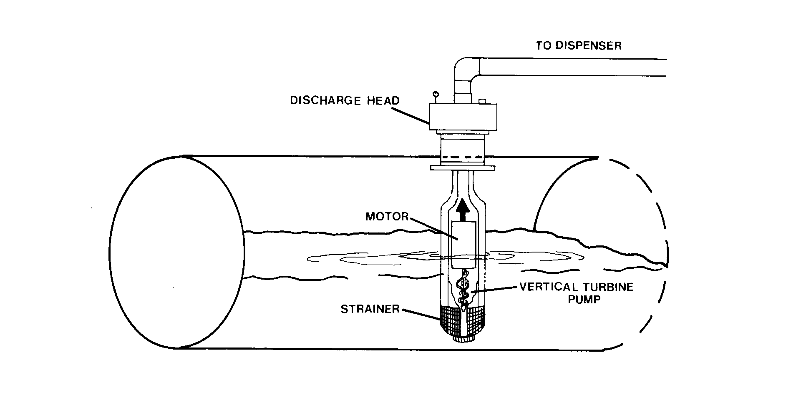
FIGURE 3-5. SUBMERGED PUMP AND DISCHARGE HEAD

Fuel is drawn into it through a metal strainer and flows from the turbine around the outside of the motor casing and through a section of pipe to the discharge manifold (head), which usually sits on top of the tank. The system check valve and the air eliminator are located inside the discharge head (manifold). The air eliminator functions in much the same way as its counterpart in a self-contained unit: air and vapor, along with a small quantity of fuel, are separated from the main body of fuel and drawn through an orifice. But in this type of system, the gases and fuel drain directly back into the storage tank; the tank itself functions as the atmospheric chamber or sump does in a self-contained unit.

In remote systems, several dispensers are often served by the same pump. When the on-off switch at any of these dispensers is placed in the on position, the pumping unit is activated, and all pipelines connected to the pump are pressurized (to 24-28 psi for a typical unit). To prevent the discharge nozzles of all the dispensers from being pressurized, each dispenser is equipped with its own control valve.

This control valve must not be confused with the control valve in a self-contained system: its design and function are quite different. The control valve in a remote system is not automatic: it is actuated by the dispenser's on-off switch, or is controlled by the electronic computer system. Figure 3-6 illustrates how a typical control valve works.

The control valve itself usually consists of a piston and cylinder (or diaphragm) and a spring, as shown in the cutaway drawing. A removable filter/strainer at the inlet to the valve (or at the fuel inlet to the dispenser) traps solid contaminants in the fuel flow before they enter the valve. When the piston is retracted, the valve is open and product flows through it toward the meter; when the piston is seated, product cannot pass through the valve.

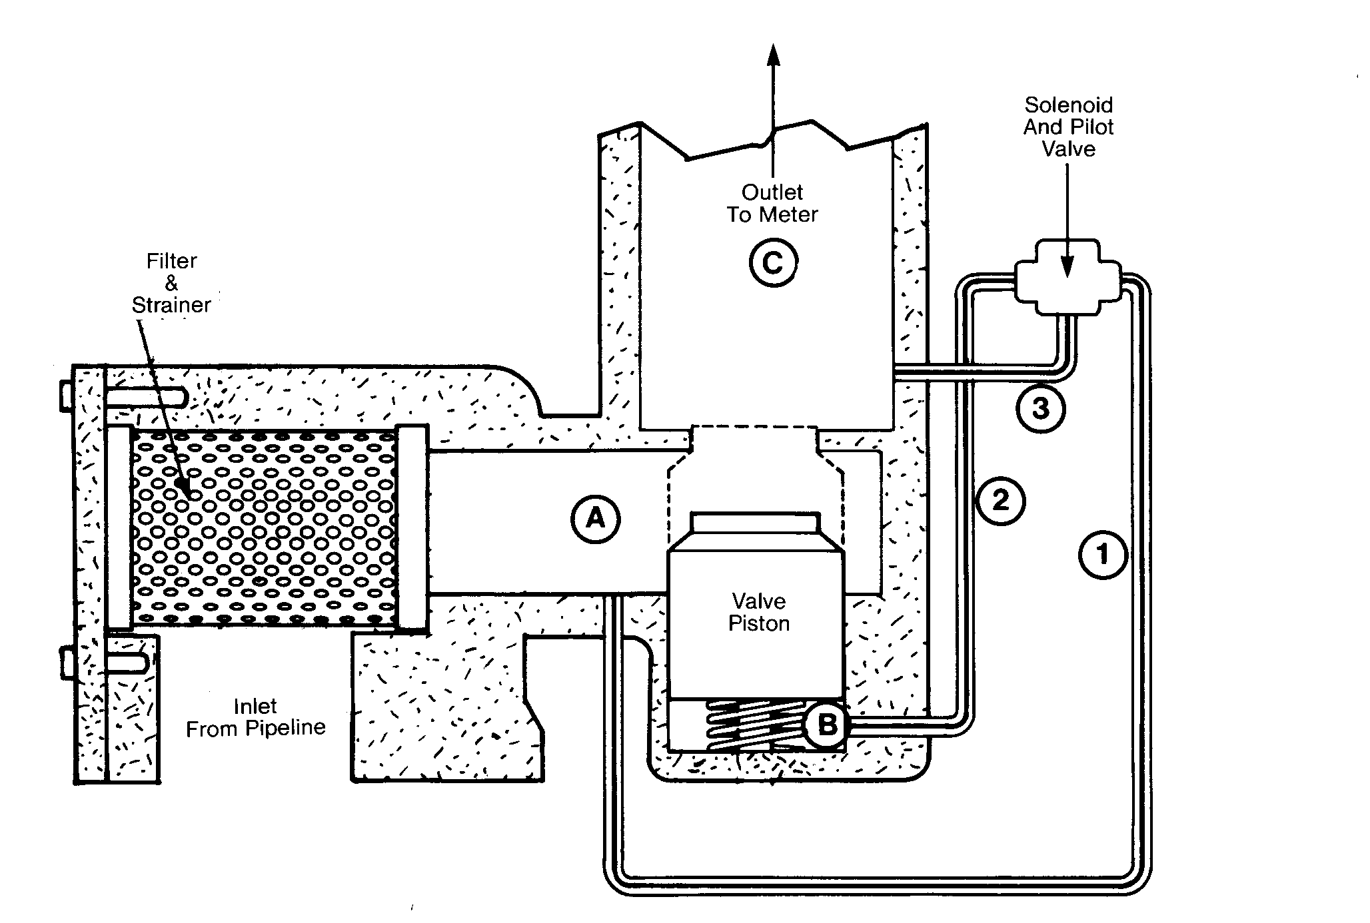
FIGURE 3-6. REMOTE-DISPENSER CONTROL VALVE

In older systems, the control valve may be operated mechanically, by means of a linkage between the valve and the dispenser on-off switch. Today, however, a more sophisticated electrical operator, including a solenoid and pilot valve, has been incorporated in most designs, as depicted in Figure 3-6. In some systems both the main valve and the pilot valve are incorporated into the same valve body. The device operates the valve by regulating the fluid pressure in the cylinder behind the piston or diaphragm (the area marked “B” in the drawing). When the dispenser is not being used (that is, the dispenser switch is in the “off” position), the solenoid is not energized and the pilot valve rests in such a position as to connect fluid lines (1) and (2). This maintains equal pressure on all sides of the valve piston, allowing the spring to keep the valve tightly closed.

When the dispenser switch is turned “on” or when the electronic computer sends power to the valve, the solenoid is energized, opening the pilot valve. This has the effect of opening a passageway between lines (2) and (3), and simultaneously closing off line (1). As long as the discharge nozzle remains closed, pressure remains the same in regions (A), (B), and (C), and the control valve remains closed. However, when the nozzle is opened, pressure at the outlet (C) falls, bleeding pressure from the space behind the cylinder (B). Pressure is now higher at (A) than at (B), and pressure on the head of the valve piston pushes it off its seat. When the dispenser is shut off, the solenoid is once again de-energized, closing the pilot valve and thereby shutting off the connection between (2) and (3) and opening the connection between (1) and (2). When pressure is once again equal at (A), (B), and (C), the spring (or diaphragm) forces the piston onto its seat, closing the valve.

The control valve prevents a remote dispenser from delivering product unless it has been switched on, and thus prevents accidental discharge under normal conditions. However, if a remote dispenser were to be struck with sufficient force, as might happen if a moving vehicle collided with it, even at relatively slow speed, piping in the dispenser could quite easily be ruptured. Since the fuel entering the dispenser is pressurized, this situation could cause fuel to flow uncontrollably from the ruptured pipe, creating an extreme safety hazard. To prevent this, every remote dispenser is equipped with an automatic emergency shut-off valve, also called an impact valve or shear valve because of its function, or a fire valve (as shown in Figure 3-7).

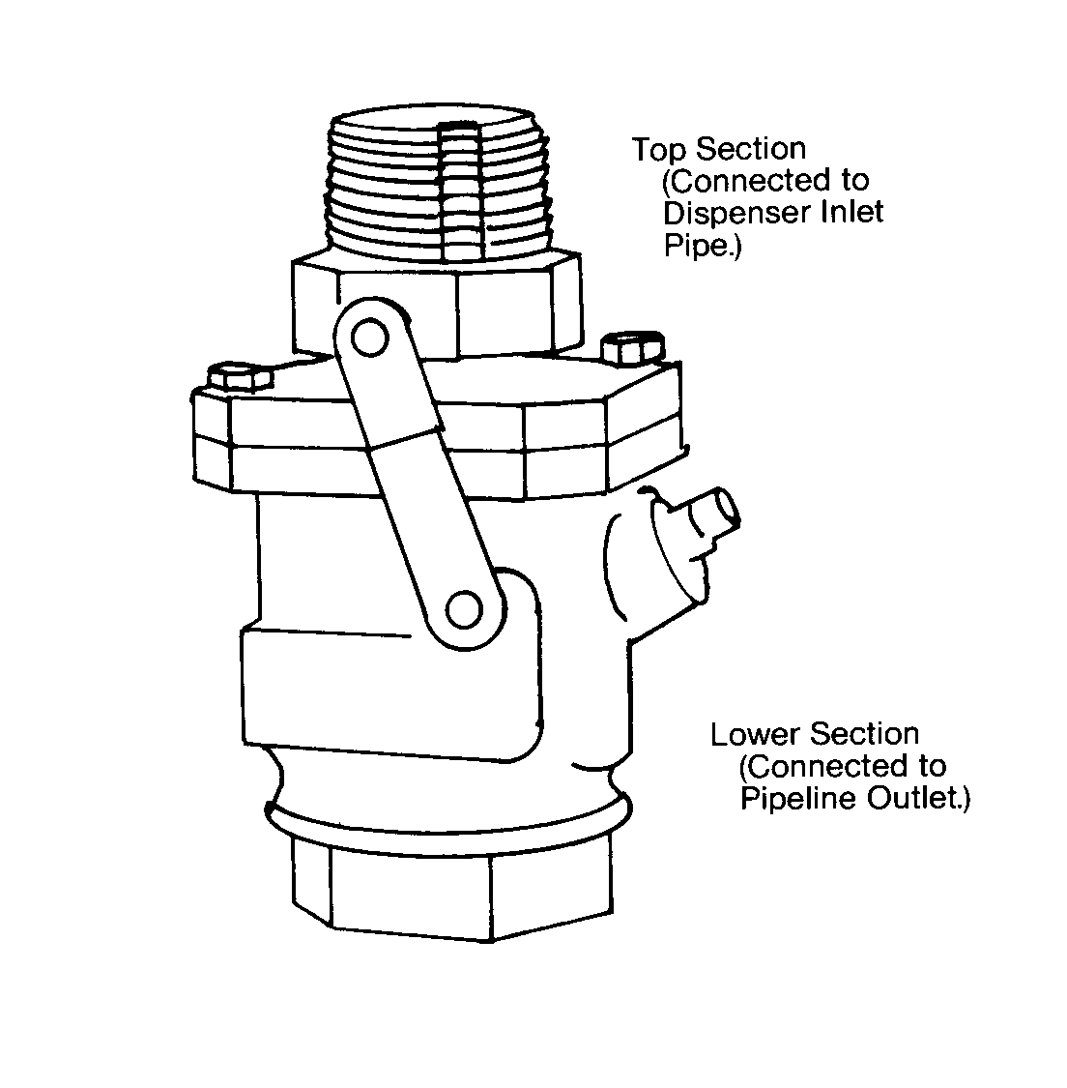
FIGURE 3-7. REMOTE SYSTEM EMERGENCY SHUT-OFF
(IMPACT OR FIRE) VALVE

This valve is located at the bottom of the dispenser, connected to the pipeline at the point where it enters the unit. The operation of this valve is very simple. In the event of damaging impact, the top portion of the valve shears away, isolating the damaged dispenser, and a spring valve automatically closes off the pipeline, preventing any further flow of fuel from that source. If it has not been too severely damaged by the collision, the control valve in the dispenser should then respond to the sudden drop in system pressure and close automatically, keeping fuel loss from the dispenser also to a minimum.

Self-contained systems do not require an emergency shut-off valve because fuel is pressurized inside the dispenser. So, a damaging collision will not result in uncontrolled flow from the storage tank pipeline, since suction pressure will cease immediately when a severe rupture occurs.

Blended-product Dispensers (Blenders)

The components that pressurize and move product in a blended-product system are essentially the same as those described above. However, the control valves in a blended-product system serve an additional function: they must be capable of controlling the volume flow rate of product, so that the blend will contain the correct proportions of component products. Such devices are commonly called metering or proportioning valves, and are somewhat more complex in operation than the basic on/off control valve described above. Blended-product dispensers have become more common in recent years and their proliferation is expected in the future due to environmental concerns with leaking underground storage tanks and associated piping. With blenders a retail outlet can provide three or more products to the consumer from only two underground storage tanks. Thus, the environmental hazard is reduced by having fewer underground tanks. Generally the blended product is delivered to the customer through a single product hose. When taking a sample for fuel quality (octane), special notice needs to be given to the flushing recommendations made in EPO 22.

Multi-product Dispensers

Prior discussion on pressurizing and moving fuel has concentrated on single and dual product dispensers. Many, if not most, dispensers used in fuel outlets today are of the multi-product design. Here three or more fuel products are available from a single dispenser. Usually only one product at a time is available for delivery from each side of the dispenser. Like the blended-product dispenser only one computer is provided on each face of the multi-product dispenser. The multi-product dispenser may have a hose and nozzle assembly for each product, or there may be only one hose per dispenser side (face). In the case of the single hose multi-product dispenser the three (or more) product discharge lines are manifolded into one casting at or near the hose outlet fitting. Special notice should be made of the requirements in EPO 21 for flushing the line before taking samples for fuel quality (octane) testing.

METERING AND INDICATING FUEL DELIVERY, AND COMPUTING PRICE

Two major components are involved in metering and indicating the quantity of fuel delivered and computing the price of the delivery. In both self-contained and remote pump (or dispenser) systems, pressurized fuel flows from the pumping unit (self-contained systems) or control valve (remote systems) through a meter, which measures the fuel as it is being delivered. The meter is connected to the computer, which gets its name from one of its primary functions, that of computing the price of the delivery. In the case of mechanical, analog computing systems the meter is connected directly to, and drives, the computer through by mechanical linkage. In the case of electronic digital computers the computer receives its information in form of an electrical signal (pulse) from the pulsing mechanism (pulser) which is mechanically driven by the meter. The computer indicates the amount of product delivered, the price per gallon, and may perform other functions as well, as you will see. The meter is typically a mechanical device, but the computer may be mechanical, electronic, or both.

The Meter

Metering devices in most gasoline and diesel retail fuel-dispensing systems are positive-displacement meters, so called after the basic principle of their operation. In a positive displacement meter finite quantities of fuel are separated into compartments of known volume. These compartments may be cylinders within a piston meter, segments between two vanes in a vane type meter, or the space between rotors in other meters. The most popular type meter in retail fuel-dispensing systems is the piston meter. This discussion will concentrate on piston meter type of positive displacement meters.

A piston moving through a cylinder filled with liquid will displace a quantity of liquid ahead of it. The amount of this displacement is determined by the bore of the cylinder (its inside diameter) and the stroke of the piston (the maximum distance that it travels in one direction). The positive displacement method of metering is employed in fuel dispensers because it is capable of highly accurate measurement.

The meter itself consists of two or more (but usually no more than four) reciprocating pistons (each in its own cylinder), intake and outlet ports, and fluid channels. The pistons are connected to a crankshaft, or other stroke-regulating mechanism, so that one cylinder is discharging fuel during its piston's forward (discharge) stroke while another is being filled during the backward (intake) stroke of its piston. This provides a continuous flow of fuel through the meter. Figure 3-8 depicts meters from several manufacturers . In some piston type meters the pistons operate in the horizontal plane. In some systems the pistons are in the vertical plane and convert their to reciprocating action to a rotary shaft output to drive either the pulser or the mechanical computer.
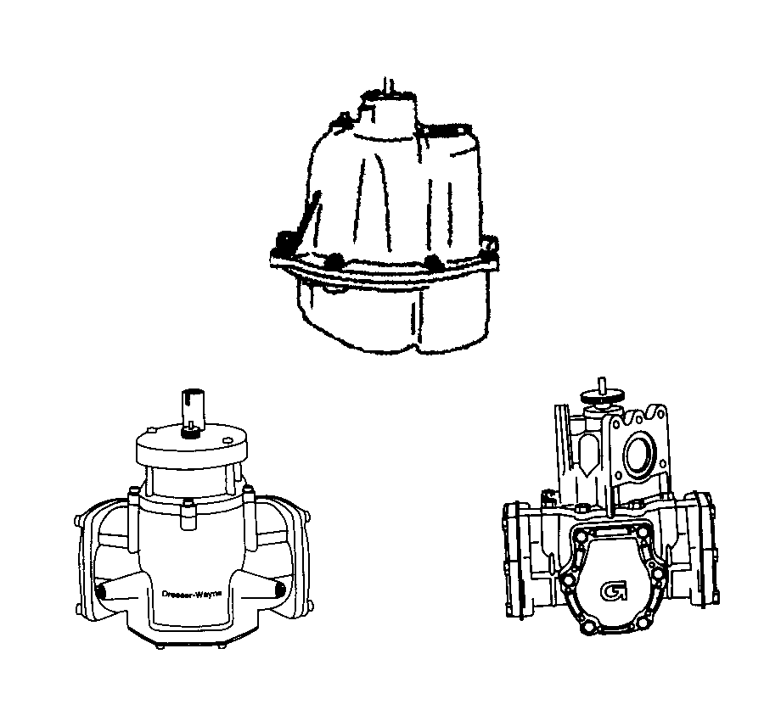
FIGURE 3-8. TYPICAL POSITIVE DISPLACEMENT METERS

The pistons are driven by fluid pressure supplied by the system pump. The cutouts on the piston heads function as valves, alternately opening and closing channels in such a way as to allow fuel to enter the cylinder during its intake stroke only from the inlet (pump side) and allowing it to exit the meter on the discharge stroke only through the meter outlet (nozzle side).

Other positive displacement metering concepts, as mentioned previously, are used, primarily for high speed dispensers in truck stop applications. In these metering systems a precise quantity of fuel is isolated between vanes or rotor blades in the metering chamber. The result is the same, highly accurate measurement is accomplished and the dynamic movement of the fuel converts the fluid motion to a rotary shaft motion to drive the computer, either mechanically or electronically.

The meter units are calibrated at the factory, and are designed to meter fuel accurately and reliably. However, recalibration will be necessary if the meter is found to be the source of over- or under-registration, so an adjustment mechanism is built into the unit. Adjustment may be accomplished by increasing or decreasing the throw of the pistons or by changing the size of the meter chamber. Changing the throw has the effect of increasing or decreasing the pistons' stroke, and thereby increasing or decreasing their displacement. These adjustments can be made in very small increments, changing the meter's discharge by as little as 1/3 cubic inch per 5 gallons indicated (or an average of less than 3/10,000 of a gallon per gallon indicated).

The adjusting mechanism may be located on the top of the meter or on one of the piston caps. It may be a knurled knob, keyed disk, or calibrated wheel (as in Figure 3-9), or have some different design. But it should be immediately identifiable by one feature: the adjusting mechanism must be designed to be protected with a security seal. This seal, if broken, may indicate someone has tampered with the meter, or has made a needed calibration adjustment. Without this assurance, an unscrupulous retailer could adjust the meter to deliver less than a gallon for each gallon registered, and thereby charge customers for fuel that they are not actually receiving. So, as part of your inspection procedure, you will check this seal. With some of the high capacity systems, there may be no adjustment mechanism on the meter. In these cases the adjustment may be made electronically, you will need to refer to the Certificate of Conformance for the specific model to determine how to access the adjustment mechanism and the method of sealing used to protect the adjustment mechanism. Figure 3-10 shows the adjuster portion of several meters, which will be encountered in the course of field inspections.

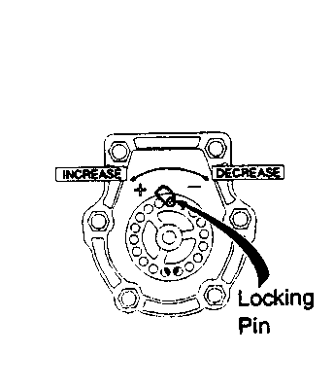 | 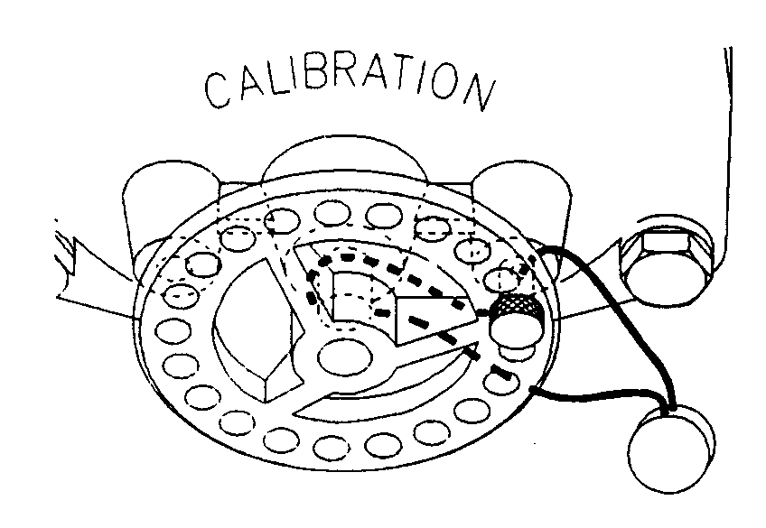
 | 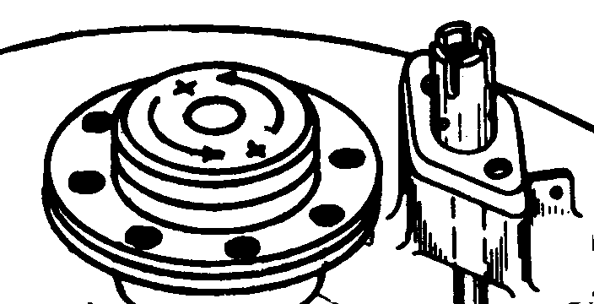
FIGURE 3-9. TYPICAL METER ADJUSTERS

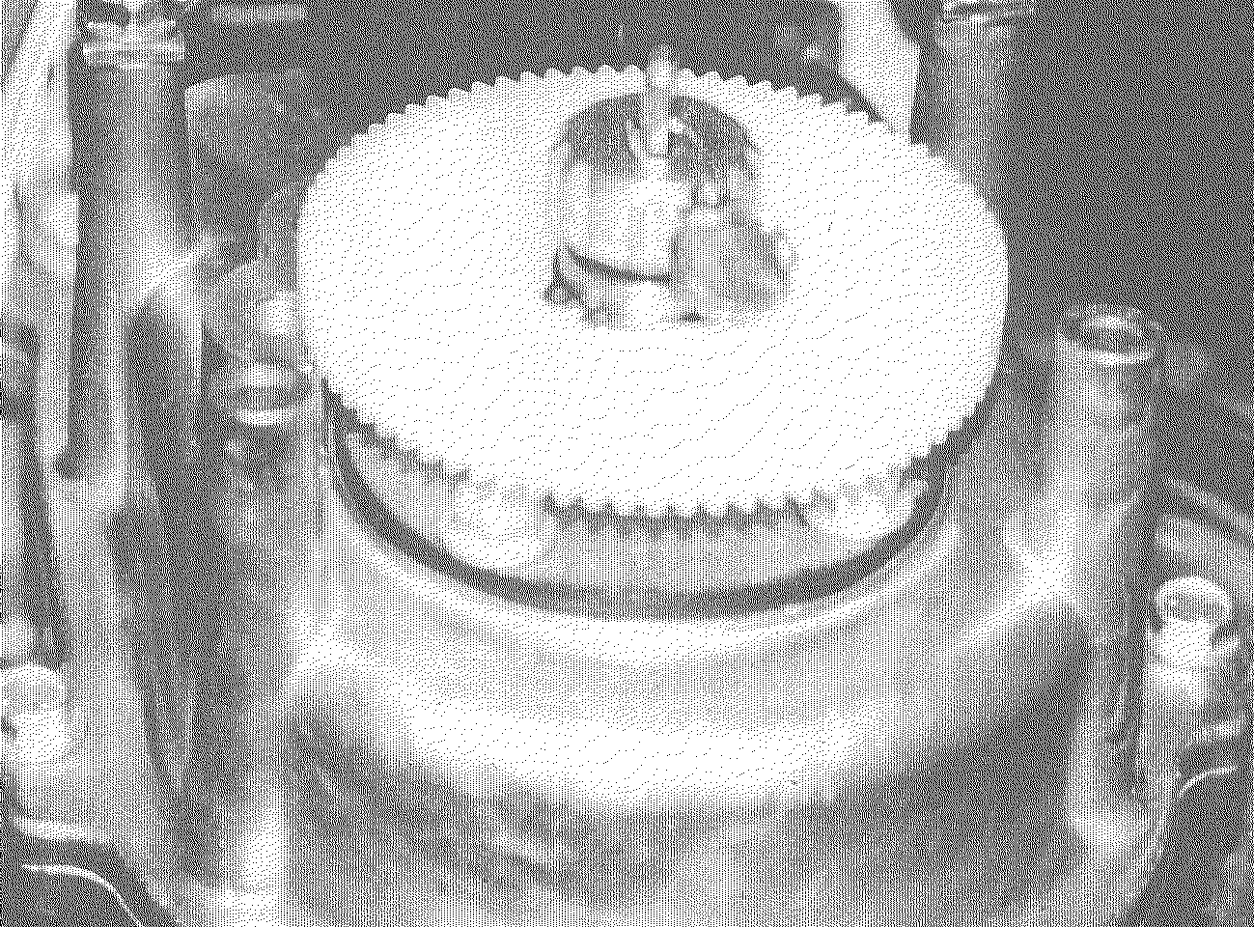 | 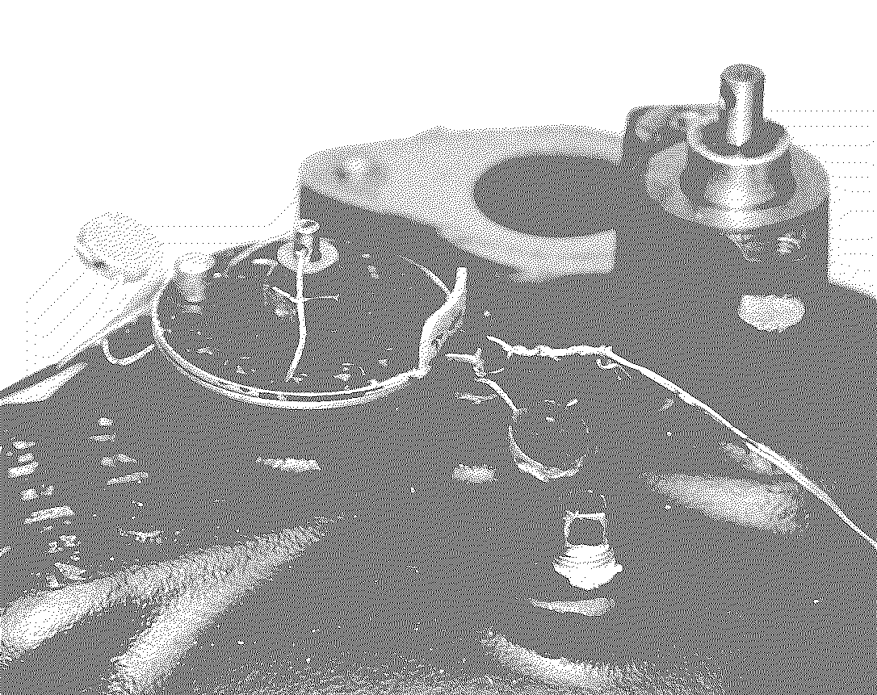
FIGURE 3-10. METER ADJUSTERS

The Computer

Each time the meter's crankshaft makes a complete revolution, an exact quantity of product has been metered. The quantity per revolution of the meter crankshaft varies from manufacturer to manufacturer, and with the meter design. So, the revolution of this shaft provides the most direct and accurate indication of the amount delivered. Whether the computer is mechanical or electronic, the computer or pulsing mechanism is driven directly—or through a universal coupling—by the meter shaft. Mechanical and electronic computers are quite different in design and operation, so we will take a brief look at each separately.

Mechanical Computers

Only a small percentage of new dispensers placed into service domestically have mechanical computers. Some of the dispenser manufacturers have discontinued mechanical dispensers as part of their product line.

What the motorist sees of a computer like the one shown in Figure 3-11 certainly does not look very complicated. Three sets of number wheels are visible: one set indicates the price of the delivery, another the amount delivered, and the third the price per gallon (unit price). Of these, of course, only the first two sets actually move during a delivery.

In fact, each computer has two identical groups of number wheels, one on each side, so that the attendant and the customer can see how much fuel is being delivered regardless of which side of the service island they are using.

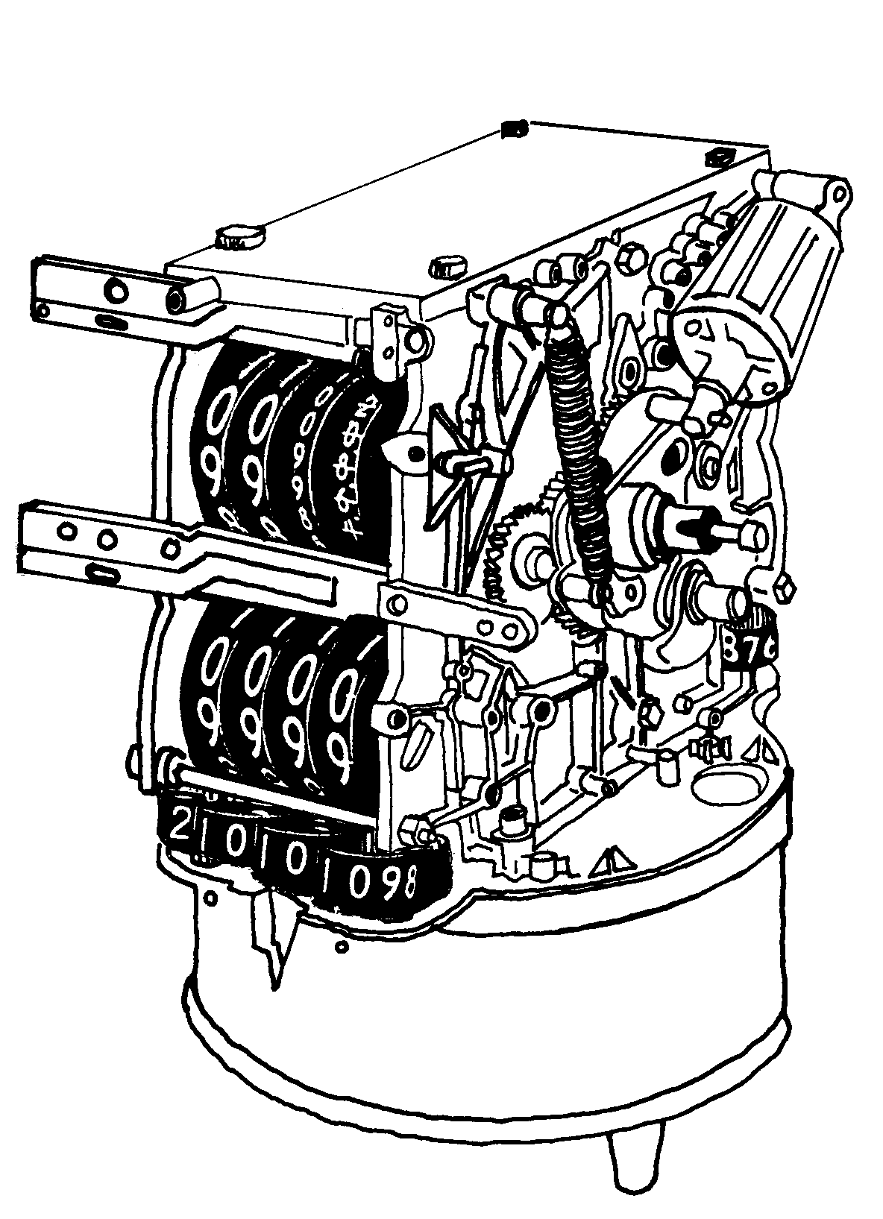 | FIGURE 3-11. MECHANICAL COMPUTER

Each individual wheel turns independently, and the numbers inscribed on it represent one digit of a decimal number. For example, the wheel furthest to the right in the price set represents cents, the next number represents multiples of 10 cents, the next multiples of 100 cents (dollars), and so on. As the wheels revolve, a fixed pointer indicates the values.

What the motorist does not see, the “insides” of the computer, does not look at all simple: a multitude of gear wheels, drive shafts, chains, and spring mechanisms. The design is indeed complicated, as you might expect of a precision instrument, but the principle is really quite straightforward.

The mechanical fuel-dispensing computer is basically a clockwork mechanism. In fact, the computer is sometimes referred to as the clock, as according to a technical definition, it is. As in a mechanical grandfathers clock, trains of gears transmit and modify mechanical action in stages. A mechanical computer works in a very similar way: one gear train, deriving its movement originally from the meter crankshaft, will operate the 1/10th gallon wheel (compare the second hand in the grandfather clock). Another, deriving its movement from the same source, will operate the gallons wheel (compare the clock's minute hand). And so on.

This is how the computer operates both price and volume wheels. However, there is an additional element in the price computation, because—as we all know the price of fuel changes frequently. So the system of gear trains for the price wheels must be variable: otherwise, the station owner would have to install a new computer each time prices changed! This is accomplished by a component called the variator, which is usually located in the bottom portion of the computer assembly. The variator consists of a cone gear and a series of range arms, one for each price number wheel.

The cone gear is actually nine separate gears, one for each decimal value from 1 to 9. All nine revolve at the same rate—usually that of the meter crankshaft. A single gear on the range arm can be raised or lowered to key to any one of the gears in the cone. Changing the gear to which the range arm gear is keyed will result in a higher or lower gear ratio, so the range gear will revolve more or fewer times for each rotation of the cone gear shaft, and this rate will be transmitted by the range shafts to the gear trains that operate the price number wheels. The range shaft is also connected directly to the price-per-gallon wheels, so that when a change in price is made by raising or lowering one or more of the range arms, that change will be indicated automatically.

The volume and price indicator wheels must be reset to zero before each delivery. We will discuss this function later. But in addition to the indicators that the motorist sees, the computer also operates sale and volume totalizers. These are not automatically reset between deliveries. So the totalizers, as their name suggests, indicate running totals, which are useful for inventory control, and also protect the station owner from theft by employees, since sales totals can be expected to match sales receipts. The totalizers are required to be nonresettable. Some manual reset mechanisms may be sealed so that tampering can not be done without mutilating the seal and, thus, leaving detectable evidence. Again, this is to protect the owner, since totalizers are generally not used as indicators for individual sales.

Electronic Computers

As you know, the modular design of most electronic systems permits the incorporation of a variety of extended functions, so their functional capabilities usually are considerably more extensive than those of mechanical systems: they go beyond simply indicating the quantity of fuel delivered and computing and indicating its price, as mechanical computers generally do not. We will discuss some of these extended features later in this chapter. For now, though, let us simply consider the functions that correspond to those of a mechanical computer.

Understanding the technical details of electronic systems requires some knowledge of various high-technology components—integrated circuits, microprocessors, logic components, interfaces, and so on. Presenting this basic knowledge is beyond the scope of this course. So keep in mind that our discussion will be focusing on a functional description. The basic functional components we are concerned with are illustrated in Figure 3-12.

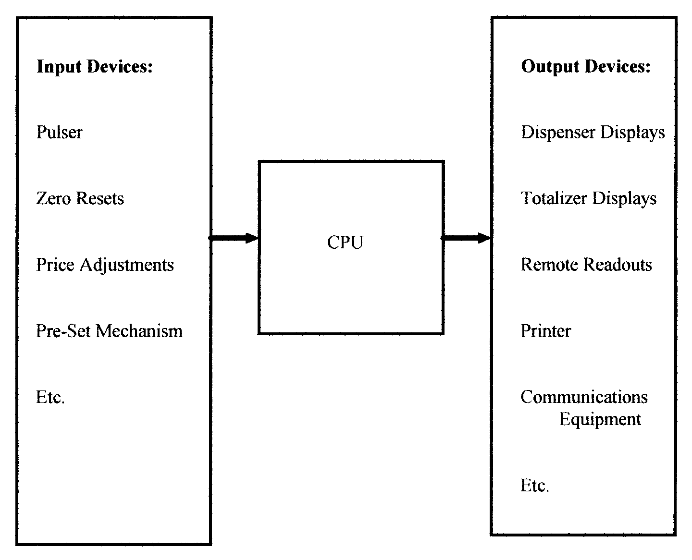
FIGURE 3-12. FUNCTIONAL COMPONENTS OF AN
ELECTRONIC FUEL DISPENSING COMPUTER

The transducer (or pulser, as it is commonly called) is coupled directly to the meter shaft, just as in a mechanical computer. The function of the pulser is to transform the mechanical action of the revolving shaft into digital signals. It does this by generating a fixed number of discrete electrical pulses per revolution of the meter shaft. (A discrete number of pulses are generated per gallon delivered; while several dispenser manufacturers use 1000 pulses per gallon, or 250 pulses per revolution of the meter shaft, that is not so with all systems.)

The pulser is essentially a switch, which is actuated periodically by the meter shaft (usually via a gear train). The terminals of the switch are connected to an external power source. Each time the switch is closed, voltage is applied; when the switch is open, voltage ceases to be applied. In most systems the low voltage pulse is generated by a metallic element making and breaking a magnetic field. In some cases the magnets are imbedded in a disc and the magnet poles rotating in front of a sensor generate the electrical pulse. The result, diagramed in Figure 3-13, is a single discrete pulse.
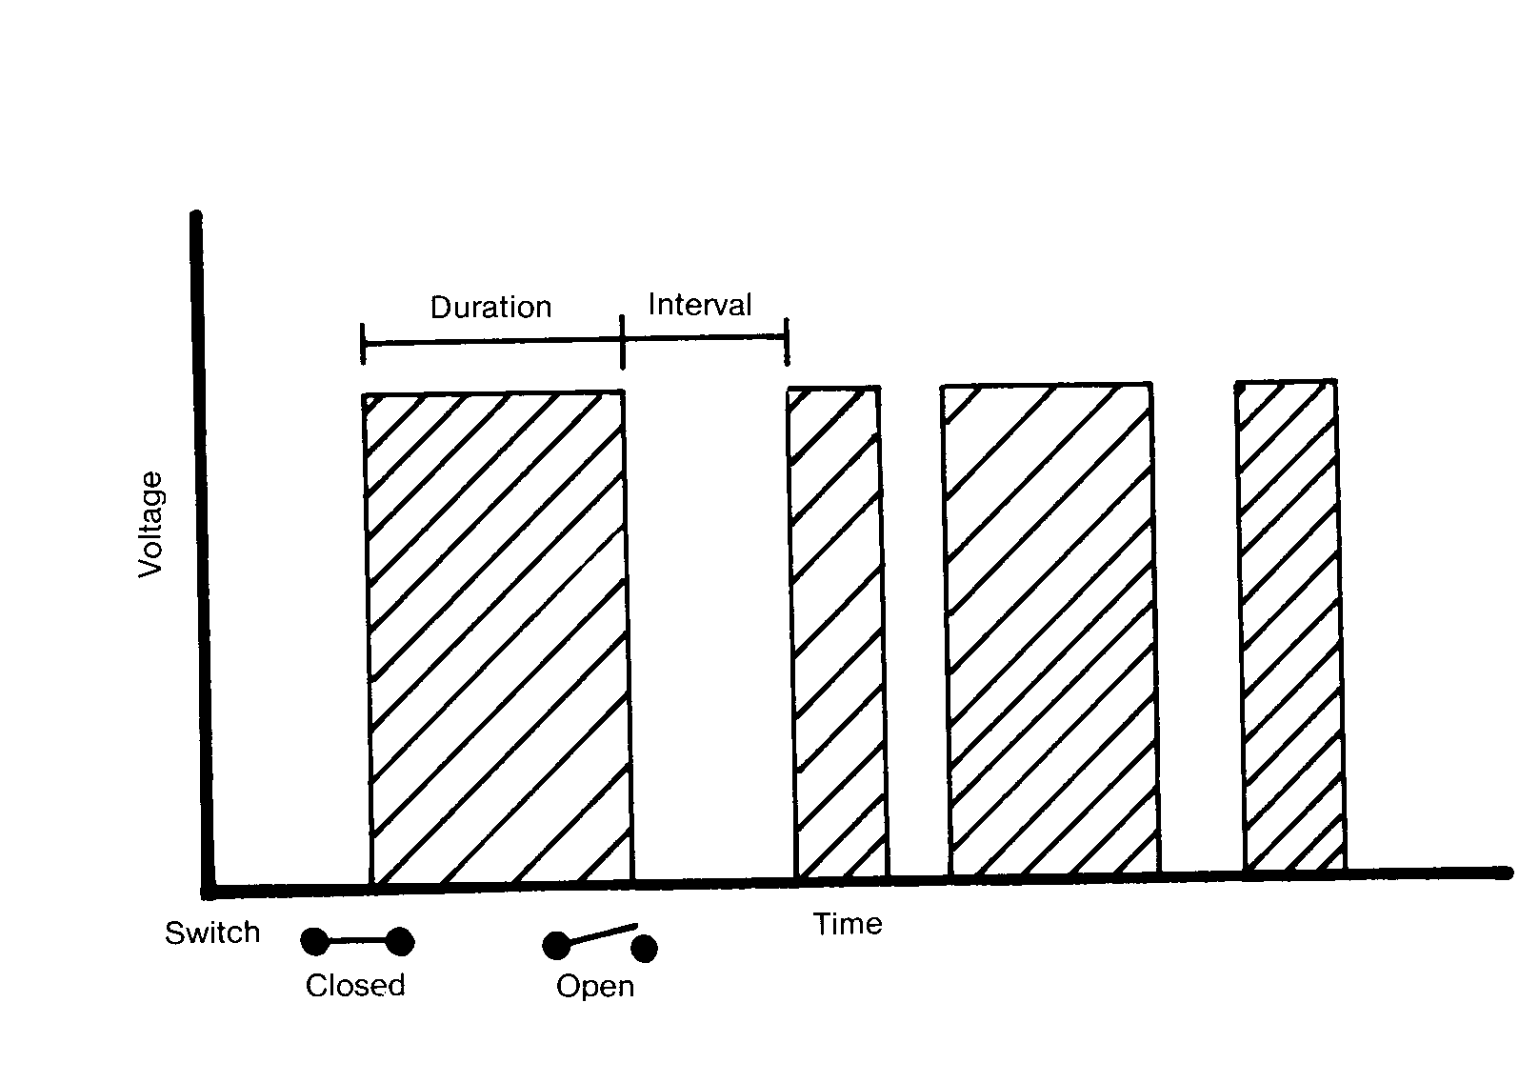
FIGURE 3-13. GENERATING DISCRETE PULSES

The duration of individual pulses created in this way, and the intervals between them will vary with the rate of rotation of the meter shaft, but their value (voltage) will be the same and, for the duration of each pulse, constant.

These pulses are transmitted as input to the central processing unit (CPU). The first thing the CPU must do is recognize the pulses as signals from the pulser and not from another input device; as Figure 3-12 illustrates, even a very simple system like the one we are looking at has various sources of input (zero reset devices for the totalizer and pulser, and the price-per-gallon adjustment device), and these must be distinguished from one another so that they can be processed correctly. So the CPU checks the characteristics of the incoming signal against information stored in its memory. Once it has determined that the source of the signals is the pulser, the CPU is able to process the information, “counting” the discrete pulses and computing the volume being delivered and its price with each pulse received. Again, its memory provides the necessary information for these computations (pulses per gallon, price per gallon, number of pulses already received, accumulated price).

The final step for the CPU is to convert the “results” of its computations into signals that will actuate the indicating devices, usually light-emitting diodes (LEDs) or liquid crystal displays (LCDs). This output is transmitted to the appropriate indicator (dispenser price/volume indicator or totalizer) where the display is generated automatically.

This all may seem complicated and even cumbersome when compared with the relatively simple clockwork operation of a mechanical computer. But remember that the functions we have just considered can be performed by the electronic computer virtually instantaneously, employing very few moving parts (only in the pulser), and with great accuracy and reliability. At the beginning of this section, it was said that computers can be both mechanical and electronic. This is often the case when an older system is adapted for use with an electronic control console or other electronic devices.

Usually this involves linking a pulser to one of the shafts of the existing mechanical computer (for example, the one-cent wheel shaft). The important thing to keep in mind when inspecting such a device is that the dispenser indicator is an analog device while the console readout is a digital device. Handbook 44 includes special guidelines for inspecting such installations.

CONTROLLING THE OPERATION OF THE FUEL-DISPENSING SYSTEM

All of the components of a fuel-dispensing system we have discussed so far in this chapter operate automatically or like the remote dispenser control valve—are activated by other components during fuel deliveries. Of course, many of these components are adjustable, like the meter and computer, but these adjustments are not part of the operating function of the dispenser, and are normally made while the dispenser is shut down.

Operating a gasoline pump is one of the few truly simple procedures that most of us have to master in our adult lifetimes. One reason for this is that there are relatively few controls to manipulate, and these master controls are operated in a definite and invariable sequence. We will conclude this chapter with a look at these system controls—some of which are not as simple as they may seem.

The Discharge Nozzle

The customer receives exactly the quantity of fuel he or she wishes to purchase from a properly installed and adjusted fuel-dispensing system. Yet the customer does not receive all of the fuel that has passed through the meter between the time when the dispenser was switched on and the time when it was switched off. These two statements seem contradictory, but they are really not, and this puzzle—if you have not already guessed the solution—provides a good introduction to one of the fuel-dispensing system's primary control devices, the discharge nozzle.

To summarize, the discharge nozzle performs three basic control functions. It:

• controls fuel delivery,

• prevents vehicle tank over-fill (when the nozzle is so-equipped), and

• prevents the discharge hose from draining after completion of a delivery.

Additionally the nozzle may be equipped with mechanisms which prevent flow of fuel unless the nozzle is inserted into the fuel filler pipe of the automobile. Some nozzles are equipped with pressure sensitive devices which prevent the main poppet valve of the nozzle from opening unless the fuel system is pressurized. In pre-pay situations nozzles are sometimes replaced into their holders with the nozzle lever still cocked or in the open position. This feature causes the nozzle poppet to close when the dispenser is turned off and will not allow flow until the system is again pressurized (by turning the dispenser on) and the nozzle lever released and then reopened.

Of these three functions, the last two are fully automatic, and require no action on the part of the operator (either the station attendant or the self-service customer). However, the nozzle outlet valve (see Figure 3-14) must be opened before fuel can flow into the customer's vehicle. In fact, fuel does not flow through any part of the system (except the self-contained air eliminator and by-pass circuit and the submersible pump riser tube and air eliminator) until the discharge nozzle is open. The operation of the nozzle outlet valve, by means of the control lever, causes fuel to flow—or cease flowing through the entire system; it also regulates the rate of delivery, so the valve must have a continuous range of openings.

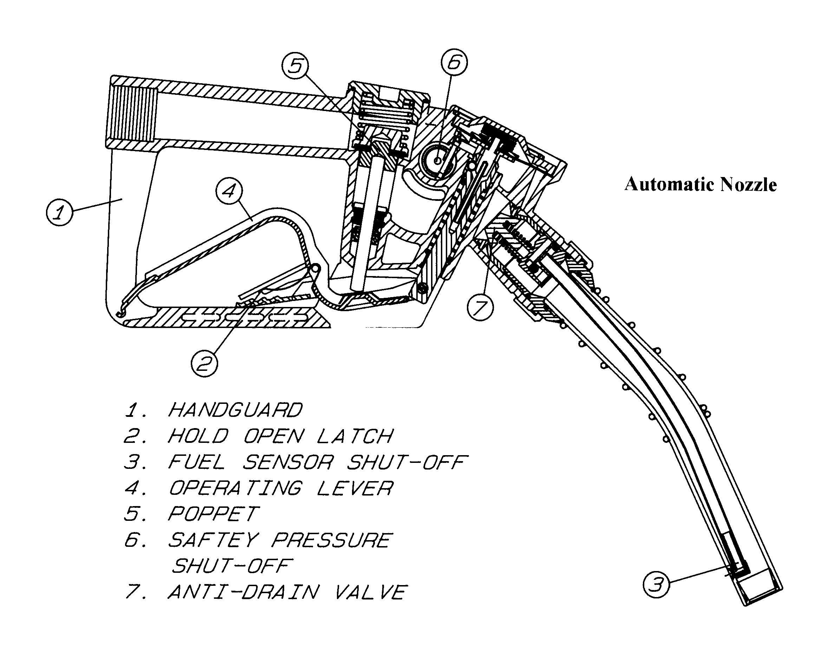
FIGURE 3-14. DISCHARGE NOZZLE

In most locations retail dispensers are required to be equipped with automatic shut-off devices, which prevent fuel from being delivered once the vehicle tank is full, thus reducing the risk of over-flow and resulting spillage, which is always hazardous.

There are several different designs of automatic shut-offs in common use. One design (shown in Figure 3-14) incorporates a small air tube, called a venturi, which runs down the length of the nozzle. The shut-off mechanism is designed to “breathe” through this tube. As long as air can pass through the tube, the delivery is regulated only by the outlet valve. But when the entrance to this tube is blocked—by touching liquid fuel, or anything else—even momentarily, the shut-off mechanism automatically trips the outlet valve shut, preventing delivery until the venturi is again unobstructed.

When the discharge nozzle is opened at the beginning of a delivery, fuel flows from the nozzle outlet immediately. This is because the discharge hose, like the rest of the dispensing system, is filled with liquid fuel at all times. (For this reason, retail motor-fuel dispensers are referred to as “wet” hose devices.)

Here, of course, is the answer to the puzzle that introduced this section: the fuel that fills the hose at the beginning of a delivery actually passed through the meter during the previous delivery. The assurance that the customer always receives exactly the quantity of fuel he or she is paying for is the principle of displacement. Fuel metered during a delivery will initially displace exactly the quantity contained in the discharge hose.

Fuel usually flows with gravity through at least part of the discharge hose. So, in order to keep the hose full at all times, and assure accurate deliveries, the nozzle must have some means of preventing fuel from being drained from the hose after the dispenser has been shut off. If this was not done, one customer might receive more fuel than he or she has paid for by draining some of the fuel in the hose, while the next customer could receive less than he or she has paid for, because at the beginning of the delivery, fuel flowing through the meter is displacing air, not liquid fuel.

The device that prevents this is called the antidrain means. In retail systems its operation is automatic. It works by permitting fuel to flow only while the system is pressurized by the pump. Many newer nozzles will not allow the main poppet to open unless the system is pressurized by the pump.

The pressure-regulating valves in the pumping unit (or control valve in a remote system) will maintain stable pressure as long as the dispenser is turned on. System pressure drops immediately when the dispenser is turned off, and this drop in pressure activates the antidrain means, preventing further delivery or draining of fuel from the nozzle and hose.

As mentioned in the last chapter, many States now require that gasoline pumps be equipped with vapor recovery systems. Over the past few years there has been a proliferation of states or local jurisdictions requiring vapor recovery. Use of these systems is expected to grow in the future. Since the design and operation of the discharge nozzle is substantially affected by the incorporation of vapor recovery, this is an appropriate place to describe this feature briefly.

Technology in vapor recovery equipment is expanding as rapidly, keeping pace with the expanding requirements for use of vapor recovery. At one time the most apparent component of the balanced vapor recovery system was the “boot,” a semi-rigid corrugated tube that surrounds all but the very tip of the discharge spout. In order to pump gas, the end of the nozzle must be pushed firmly into the vehicle fill pipe and held in this position, so that the boot is compressed, with its lower end seated tightly against the rim of the fill pipe, as shown in Figure 3-15a. Additionally Figure 3-15b gives more detail of the internal parts of a balanced system vapor recovery nozzle. If insufficient pressure is applied, or if the seal is broken, the automatic shutoff mechanism remains disengaged, and the nozzle can not be operated.

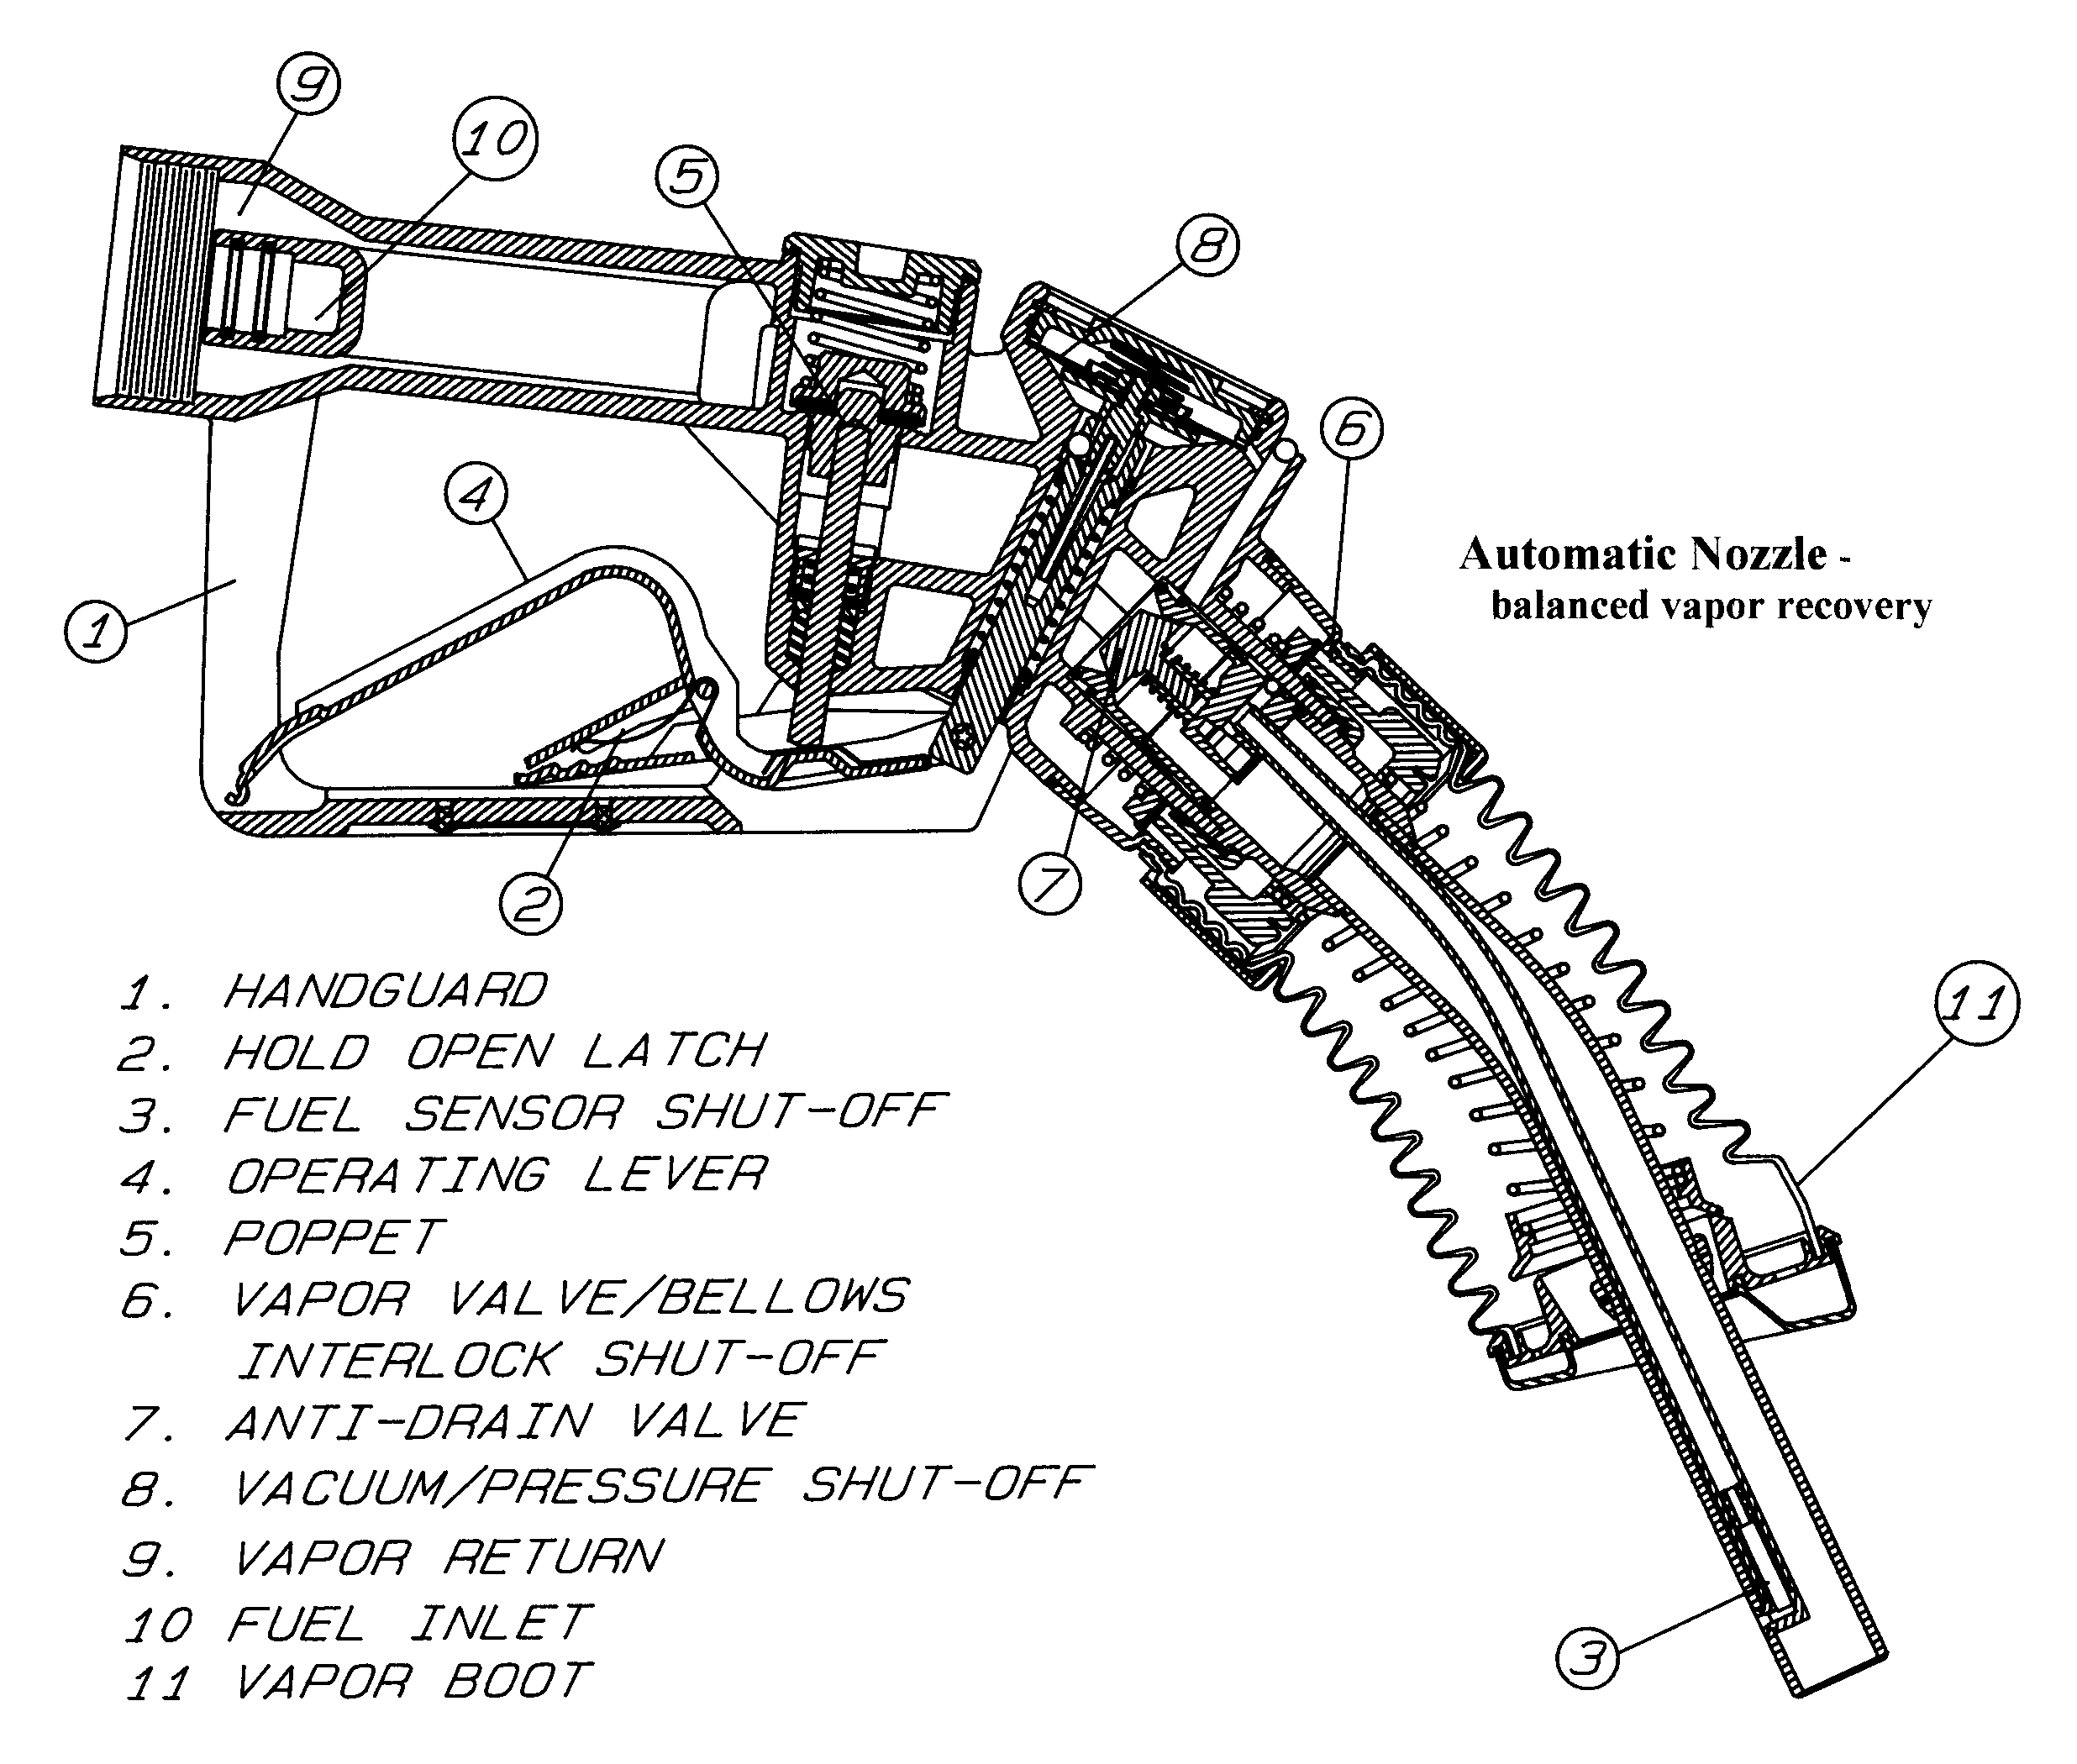
FIGURE 3-15a. VAPOR RECOVERY NOZZLE

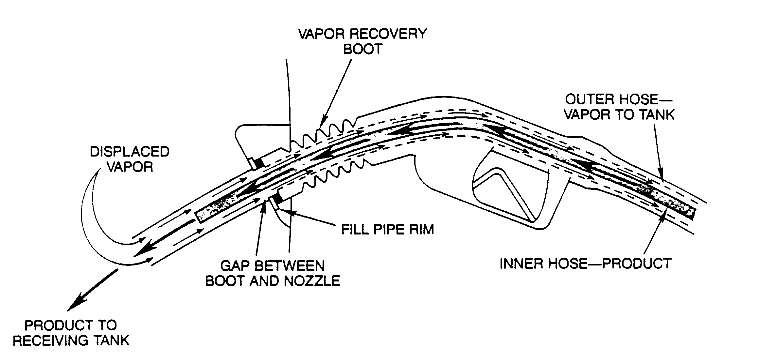
FIGURE 3-15b. VAPOR RECOVERY NOZZLE

As can be seen in Figure 3-15a, when product is being delivered, air and vapor inside the receiving tank, which are displaced by the rising liquid level, pass up the fill pipe and through the clearance between the boot and the discharge spout (this clearance is only open when the boot is compressed). The vapor is kept separate from the liquid flow inside the nozzle, and enters a hose at the dispenser end, which leads back to the air space of the facility's product storage tank for that product.

Since product is being drained from the storage tank at the same rate as vapor is discharged from the receiving tank, pressure is continuously equalized, and because the system remains closed, vapor does not escape to the atmosphere. Most vapor recovery systems now incorporate a concentric “hose-within-a hose” design, like that shown in Figure 3-17, with the product hose running inside the vapor hose. This makes the hose less unwieldy. With the balance system the outer of the two hoses is the vapor return line and the inter hose the fuel line.

More recently introduced into the market place are systems which have vacuum assist. A vacuum pump or venturi within the system develops a vacuum which helps to “pull” the gasoline vapors from the automobile’s fuel tank and “push” them into the underground storage tank. Some of these systems have a boot which is much smaller than the balanced system boot as shown in Figure 3-16a. In these systems there is not a requirement for the seal at the interface of the nozzle bellows and the automobile fill pipe as with the balance system. Here the bellows end serves more as a funnel to direct the vapors into the nozzle, and thus back to the underground tank.

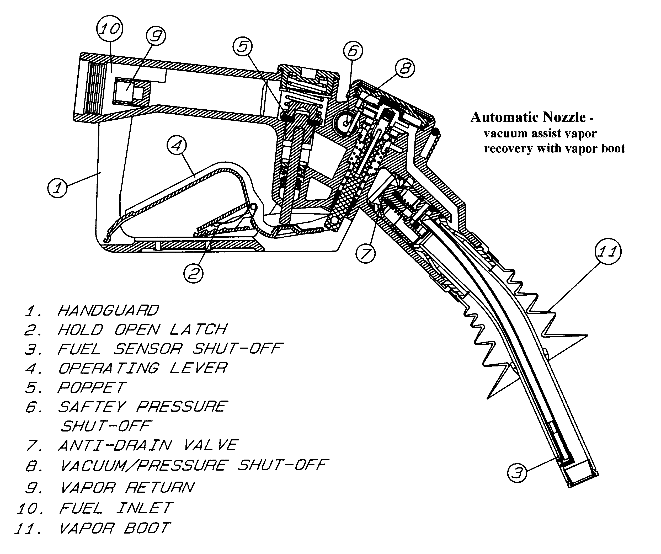
FIGURE 3-16a. VACUUM ASSIST VAPOR RECOVERY NOZZLES (WITH BOOT)

Still other nozzles used in vacuum assist systems have no boot as shown in Figure 3-16b. In these systems the vapor is drawn from the automobile fill pipe through small holes near the nozzle tip. Vacuum assist nozzles of this type are hardly distinguishable from a conventional automatic shutoff nozzle. The hose is slightly larger than a conventional hose since it must contain both vapor and fuel hoses in a coaxial arrangement. With vacuum assist systems, since there is an “assist” to get the vapors to the underground tank, the vapor line generally is the smaller inter hose. Fuel flows through the outer hose in the concentric hose design. This arrangement allows for a smaller hose than the balanced system hose.

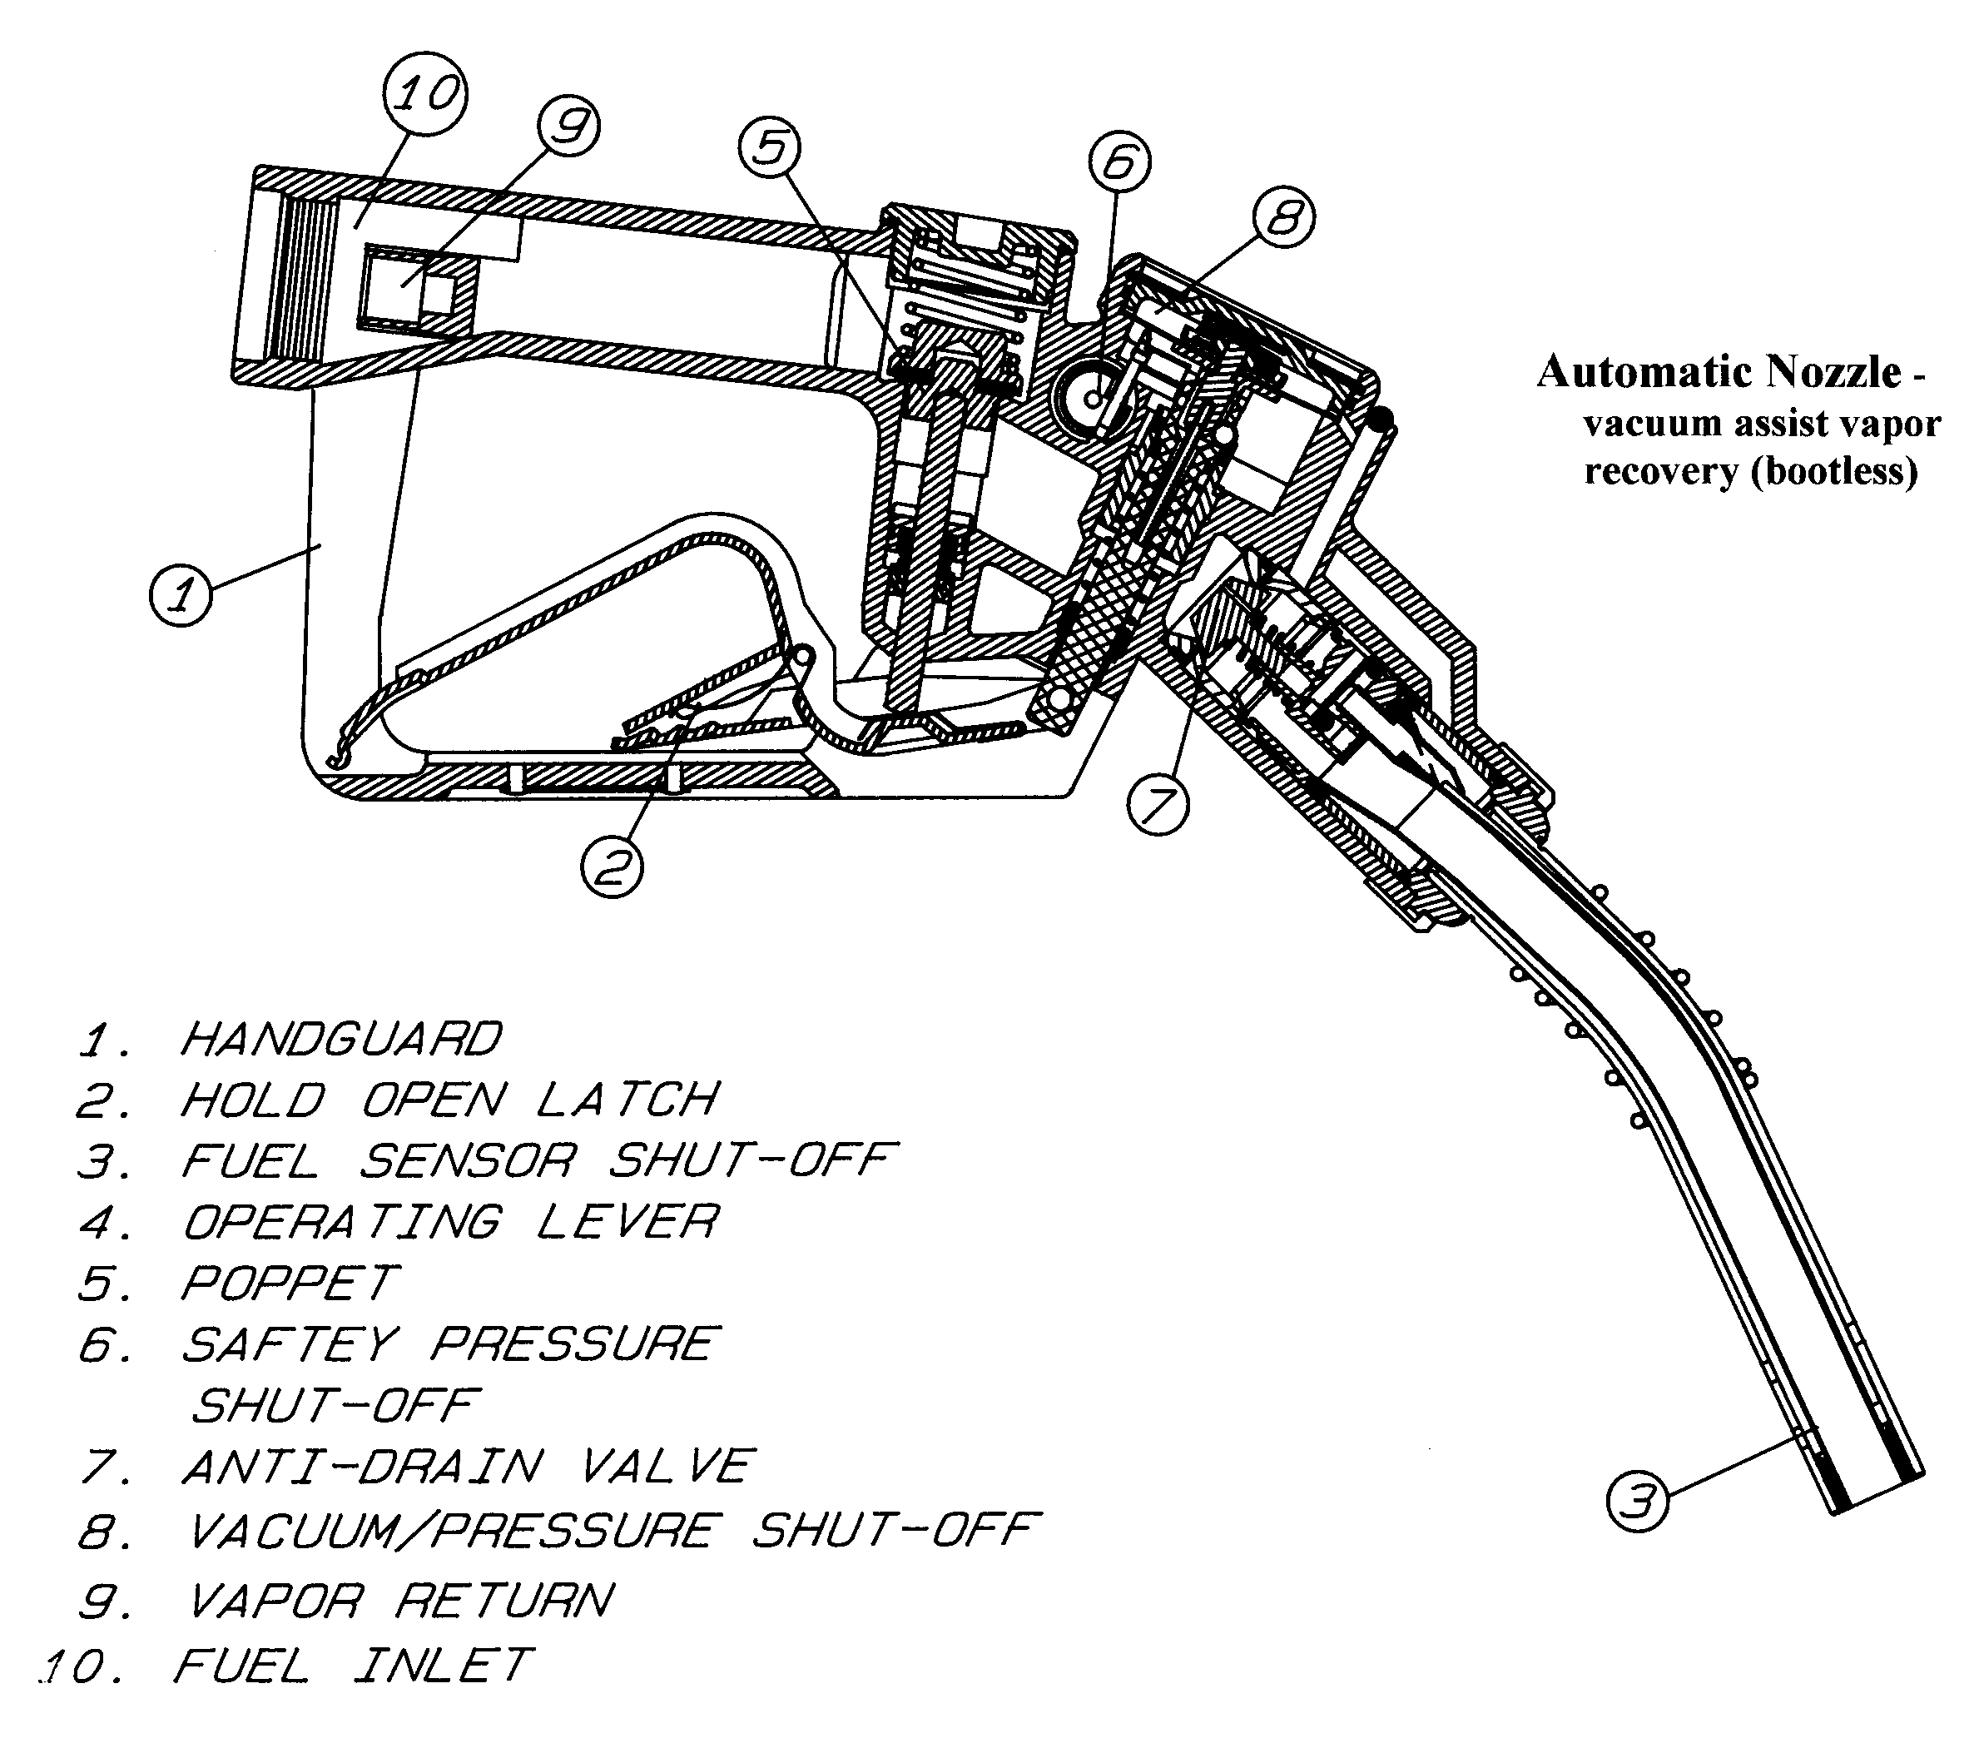
FIGURE 3-16b. VACUUM ASSIST VAPOR RECOVERY NOZZLES (BOOTLESS)

The vapor recovery system is quite effective in reducing vapor emission during delivery. However, the weights and measures inspector must be aware of factors that can affect measurement accuracy during testing. One of these is the tendency for some product to become trapped inside the boot or within the vapor return portion of the hose at the end of a delivery, especially if the operator attempts repeatedly to over-fill (top-off) the tank. Although the amount of liquid trapped after any single delivery is likely to be small, it can accumulate in the boot and back into the vapor recovery hose. When the nozzle is held in a nearly vertical position (as it is when filling a test measure) the trapped liquid will drain from boot and/or hose. It is therefore recommended that when testing vapor recovery equipment any trapped liquid be carefully drained before commencing a test draft (for procedure, see Chapter 4).

Figure 3-17 shows two types of hose used with vapor recovery systems. The larger hose on the left is used in balanced vapor recovery systems, where the larger outside hose is the vapor hose. The smaller hose on the right is used in assist vapor recovery systems. In these systems the vapor hose is the smaller inside hose.

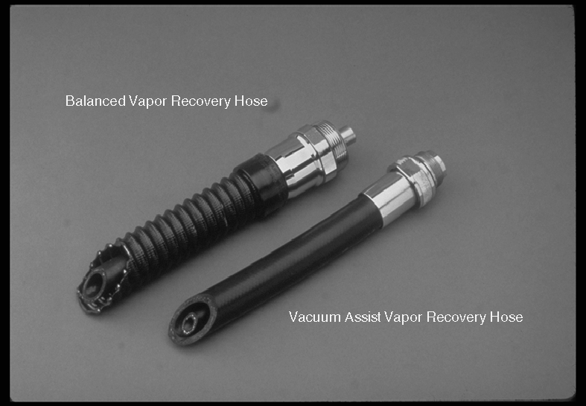
FIGURE 3-17. VAPOR RECOVERY HOSE SYSTEMS

Other Manual Controls

When the dispenser is turned on, two things happen:

• The dispenser's computer is reset to zero.

• The system pump is activated, in a self-contained dispenser; in remote systems, power is applied to the submersible pump, and the control valve is opened (a short delay, 2-4 seconds, may be experienced between the time the pump started and the valve is opened).

The sequence must happen in this order to assure accurate measurement and indication of quantity and price. Systems vary widely in the method used to perform the dual function to reset the computer and start fuel flow. For mechanical computer systems and some electronic computer systems the nozzle is lifted from its normal hanging position and the on-off lever (as Figure 3-18) is rotated or lifted to cause these functions.

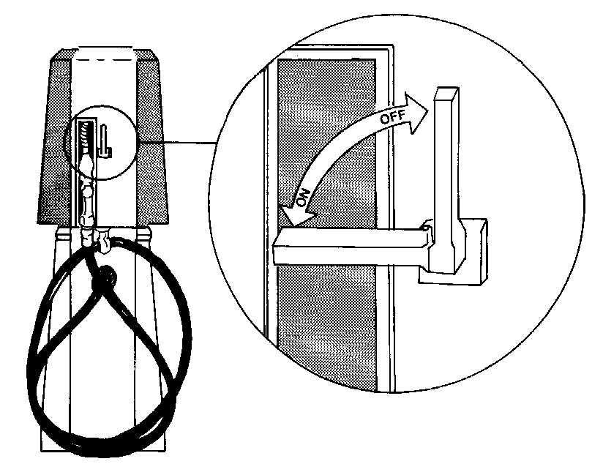
FIGURE 3-18 DISPENSER CONTROL LEVER

Many electronic systems use selection of a grade, price, or pressing a “push to start” button or icon to perform the start function. Safety regulations prohibit lifting of the nozzle from being the only action required to set the pump or dispenser into its fuel delivery mode. Regardless of the operating method, the dispenser computer is reset to zero and then pumps are turned on and valves opened to allow fuel delivery from the nozzle.

In some systems, the pump control switch and zero reset are operated by separate controls. In this case, an interlocking device prevents the pump control switch from being activated first. This design is most common in self-service facilities, with the zero reset operable only by means of a key held by the attendant. This feature prevents unsupervised self-service deliveries.

Dispensers are designed in such a way that the nozzle cannot be reinserted in its hanger until the on-off control has been returned to the off position. This feature is intended to prevent a dispenser from being inadvertently left on after a delivery has been completed, permitting the dispenser to be used again before the computer has been reset. In some cases merely replacing the nozzle into the nozzle receptacle (boot) performs the action to shut-off the dispenser. A shut-off switch linked to a “flap” within the nozzle boot deactivates the dispenser when the nozzle tip strikes the “flap.” Some dispensers with the flap type actuators also have a stop button located on the face of the dispenser, either pushing the stop button or replacing the nozzle will deactivate the dispenser. Some systems require that the start-stop lever be rotated to the off position (as discussed previously) or part of the nozzle hanger mechanism to be pushed downward to shut the device off and allow replacement of the nozzle.

Service, Payment, and Product Selector Controls

Until the mid 1980s, the only controls on most gas pumps were the on/off control lever and the discharge nozzle control lever; all other operations were automatic. However, advances in technology, especially in the area of electronic computers, and new marketing strategies—including self-service, blending, single hose multi-product dispensers, multi level pricing, and card readers or cash acceptors in the dispenser or on the island—have given the consumer choices to make. This variety of choices and operating characteristics also make the task of pumping gas somewhat more complicated.

The late 1980s and early 1990s brought a surge of multi-tier pricing—discount for cash, cash/credit, and full-serve/self-serve. With the exception of full-serve/self-serve, the other multi level pricing marketing strategies have pretty much gone by the way side. In most installations full-serve/self-serve are handled with dedicated islands according to the type of service. Seldom are both offered through the same dispenser.

In most cases selection of the cash or credit payment mode, today, relates to “in pump” cash and/or card acceptors and has no impact on the price the consumer pays for the product. The few facilities that offer discount for cash (cash/credit) generally have controls on the dispenser for selection of the payment method. An example of such a dispenser is shown in Figure 3-19.

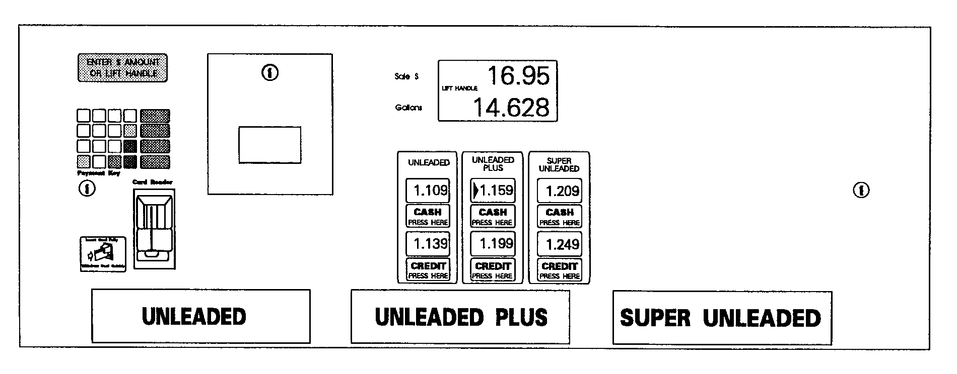
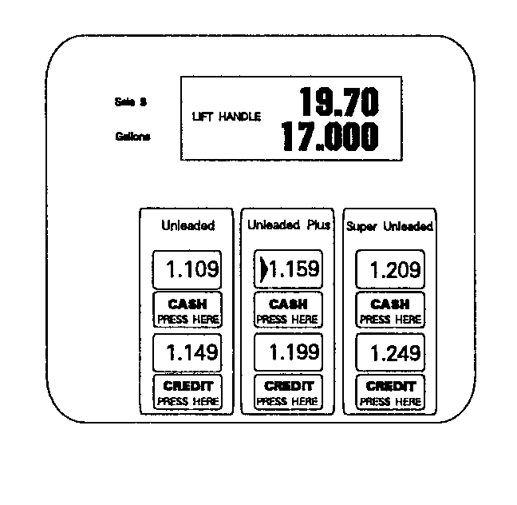
FIGURE 3-19. MULTI-PRICING DISPENSER

In 1988, the National Conference on Weights and Measures adopted the policy that “the use of a single-price-computing dispenser for sale of motor fuel at multiple unit prices is inappropriate, facilitates fraud, and should be eliminated.” As you will learn in Chapter 5, nonretroactive changes were later made to Handbook 44 in support of this policy.

The cash and credit unit prices for each product offered at this multi-product dispenser are displayed beneath the markings that identify the product dispensed from each hose (premium unleaded, etc.). As the instructions in the upper left corner of the display panel indicate, the operator first selects the method of payment by pressing either the cash or credit pushbutton. When the product is selected, by raising the nozzle rest (the control lever on this dispenser), the price-per-gallon display for the current sale (on the right hand side of the panel in this example) is automatically updated to display the selected price for the selected product. For example, if “credit” and “unleaded plus” were selected, this dispenser would display a price per gallon of $1.149. The computer would also be set automatically to compute the total sale at the selected price per gallon.

Equipment like that shown in Figure 3-19 could be adapted to provide multi-tier pricing and computing capability for an additional type of service (full- or self-serve). This would require the display of twice as many unit prices, and additional selector buttons. Or, a more likely scenario is that manufacturers would probably design equipment to “scroll” the unit price for the various modes since Handbook 44 does not require all the unit prices to be simultaneously displayed.

As described in the last chapter, blended-product dispensers are capable of delivering several different products from the same dispenser. In the case of multi-hose blended-product dispensers, like the one shown in Figures 3-19 and 2-11, the operator selects the desired product by operating the control lever for the corresponding hose (which is marked to indicate the product dispensed). For single-nozzle blended-product dispensers, the operator usually selects the product by means of a separate control on the dispenser (selector dial, pushbuttons, etc.). When this is done, the computer and display are automatically updated for the unit price of the selected product.

As you will learn shortly, Handbook 44 includes a number of regulations relating specifically to selector type controls and multi-pricing displays. These regulations are intended to minimize confusion for the customer and discourage abuse or fraud by the owners or operators of such sophisticated fuel-dispensing equipment.

Electronic Control Consoles

Electronic control consoles and point of sale (cash registers) systems are being installed in more and more fueling facilities, because of the popularity of self-service, and because of the many additional features and efficiency they provide. The modern console is more than a display that duplicates the current sale information on the dispenser. It is a valuable business tool which aides in inventory control, shift performance, and the like.

As was the case with electronic computers, we can only undertake a simplified, functional description in this course. However, you should also have some familiarity with the basic “external” features of these devices, since remote consoles are, at least in part, indicating devices, and so must be checked in the course of your inspection.

You will recall from our discussion of electronic computers that two types of devices were linked to the CPU: input devices (the pulser, price adjustment, zero resets) and output devices (dispenser and totalizer displays). Control consoles incorporate functions of both input and output devices, as illustrated in Figure 3-20 on the following page.

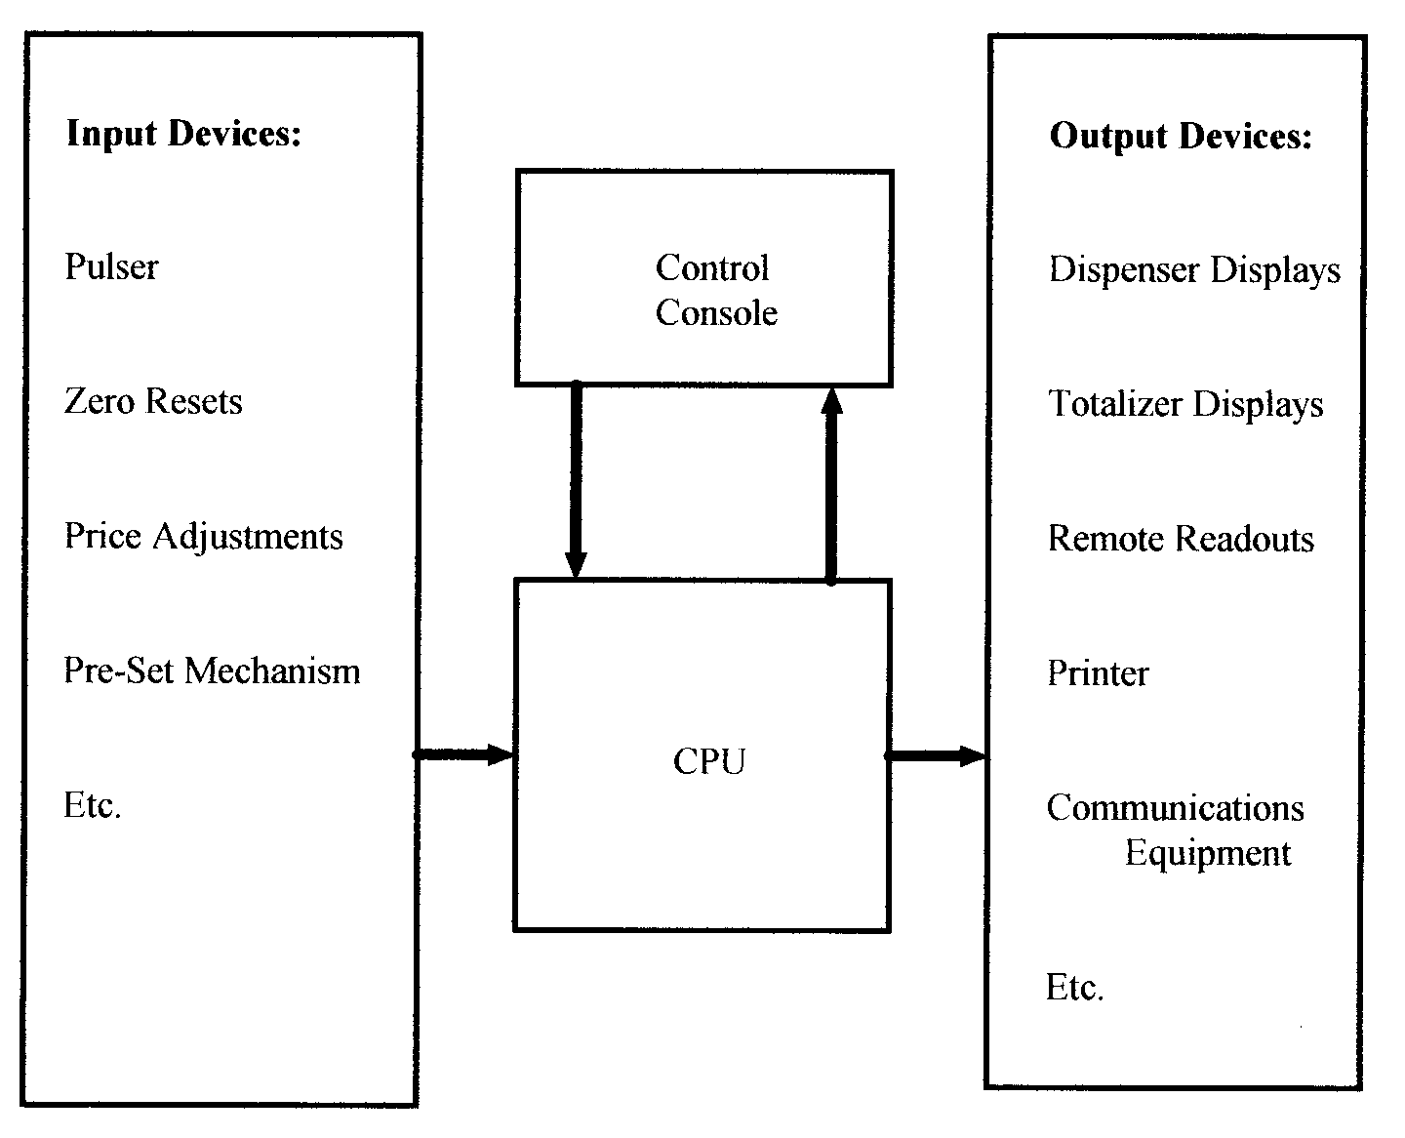
FIGURE 3-20. CONTROL CONSOLE AS A FUNCTIONAL ELEMENT

As output devices, they:
• show the status of each dispenser (on or off);

• provide readouts of the same delivery information (quantities delivered, price and price per gallon) as shown on the dispenser; and

• display sale/transaction information sent as input to the CPU, and the results of any computations made (e.g., change due, credit OK).

As input devices, control consoles may be used:

• to pre-set the quantities or total price of fuel to be delivered (pre-pay);

• to control individual dispensers, allowing deliveries only upon “authorization” by the console operator;

• to provide emergency shut-off control for one or all dispensers;

• as a cash register (point of sale terminal), to enter non-fuel purchases and payment received;

• to transmit credit card numbers for verification and authorization; or

• to program the CPU (to change the price per gallon, or to collect, process, and store or communicate data from other input devices).
The external features of the control console are its displays, keypad, and control buttons. To get a better sense of these “external” features, let us take a look at a typical control console, like the one shown in Figure 3-21.

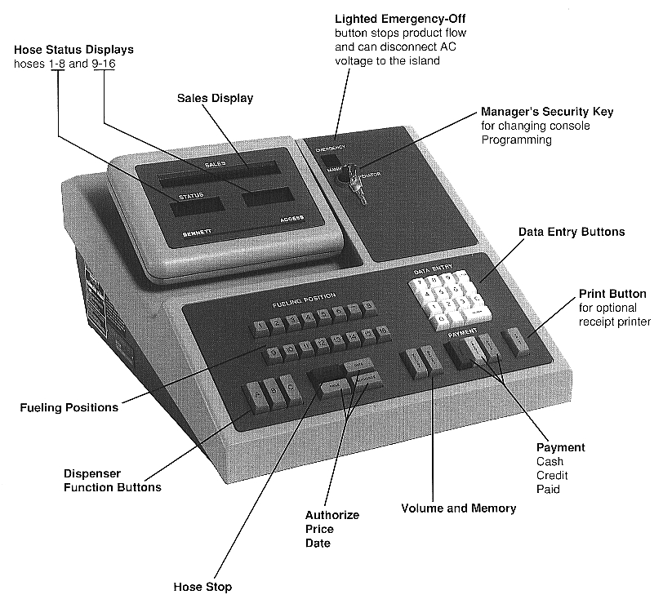
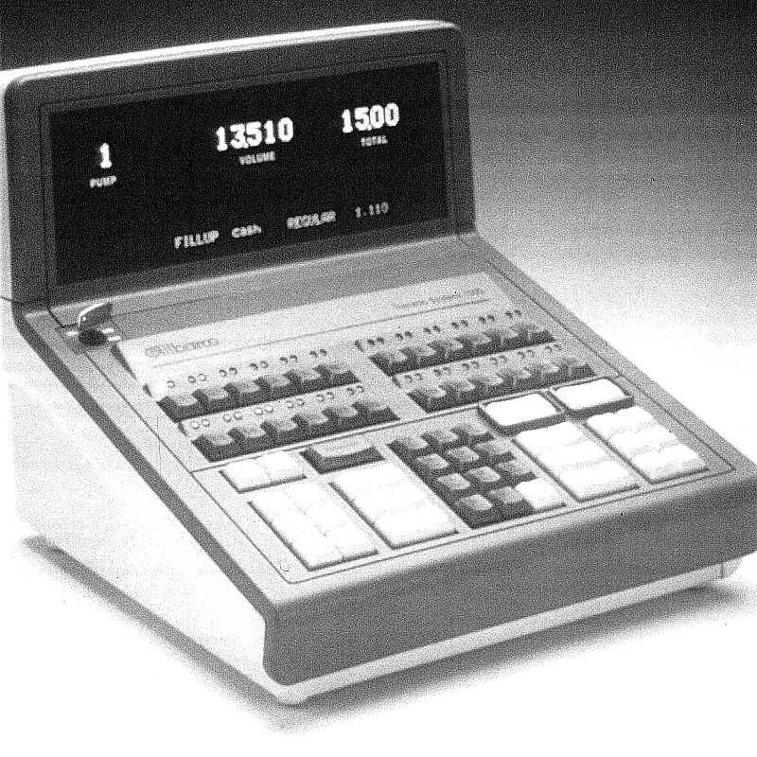
FIGURE 3-21. FEATURES OF TYPICAL CONTROL CONSOLES

As you can see, the display area placement varies with different manufacturers, but generally the consoles have similar display and keyboard layouts. The upper area displays volume, price, and price per gallon, and also a numerical identification of the dispenser (hose) for which this delivery information is being displayed. The lower display shows the status of each dispenser. Information for these displays is “called up” by depressing one of the dispenser identity buttons (there are 12 on this model) These two displays represent the output device functions of the control console.

The keypad in the center provides the operator with the means of entering information or commands from the console in a variety of “modes.”

The buttons on the right of the keypad are used to send information to the CPU, while the buttons on the left are used to send particular commands, via the CPU, to the individual dispensers (authorizing them or halting them), or to request transmission of data to another output device (a printer). In addition, an emergency switch controls the entire dispensing system.

The console is designed in this way to facilitate the monitoring and control of the operation of an entire fuel-dispensing system by a single operator.

SUMMARY

A number of separate elements work together to assure the safe, efficient, and accurate operation of a retail motor-fuel dispensing system. Because of their functional interdependence, the failure or malfunction of one element can inhibit the effectiveness of others and impair the correct operation of the entire system. Specific requirements relating to the selection, installation, maintenance, and use of these elements are described in detail in Chapters 5 and 6.

