INFORMATION MEMO FOR THE RECORD

From: Edward V. Podleckis, Ph.D., Senior Entomologist, APHIS-PPD
Shaharra J. Usnick, Ph.D., Senior Risk Manager, APHIS-PPQ-Plant Health Programs

Date: September 22, 2005

Issue:

The government of the Peoples Republic of China requested permission to export ‘Fragrant Pear’ (Pyrus ussuriensis Maxim.) fresh fruit from the Korla region in Xinjiang Province into the United States. In 2005, the Peoples Republic of China verified the scientific name of Fragrant Pear in a letter to APHIS. They requested that the species name change from Pyrus ussuriensis Maxim to Pyrus sp. Nr. Communis. Currently, only Chinese ‘Ya Pear’ (Pyrus x bretscheideri Rehd.) fresh fruits from the Provinces of Hebei and Shandong are enterable into the United States. PPQ is proposing to allow Fragrant Pear importations from Xinjiang Province based on Agency determinations of the pest risk and the adoption of phytosanitary measures to mitigate the identified risks. This memo evaluates the scientific basis for the name change and reviews the pest risks identified in Agency assessments of the proposed importation and evaluates phytosanitary measures intended, where necessary, to mitigate those pest risks. This evaluation is based on the risk assessments completed in 1994 and 1997, a program analysis and trip report completed in 2001, published literature and additional information developed during the course of the current Chinese Ya Pear importation program that has been in place since 1997.

Background:

The genus Pyrus is traditionally divided into two groups, Occidentalis and Oriental pears, based on their geographical location (Teng et al., 2002). However, taxonomists disagree about the exact number of species contained in those two groups. Until relatively recently, the cultivated species of Pyrus originating in China were poorly understood by those outside of China. As a result, species were often misidentified in taxonomic literature (Teng et al., 2002). Pyrus sp. Nr. communis cultivars are distinct from other Asian pear cultivars (Teng et al., 2002). This information memo will address Fragrant pears (Pyrus sp. Nr. communis).

Fragrant pear (Pyrus sp. Nr. communis) is also commonly called the European or common pear. Fragrant pear probably evolved from pear species that are native to Eastern Europe and Asia Minor near the Mediterranean, but it is not known when they may have hybridized to yield P. communis (Rieger, 2005). Approximately 3,000 years ago, Asian pears were domesticated in China about the same time European pears were in Europe (Teng and Tanabe, 2004). Chinese writings dating from 200-1000 BC describe pear propagation and culture (Teng and Tanabe, 2004). Fragrant pears apparently originated in the Korla area approximately 1600 years ago. Asian pears moved from China to Japan, Korea, and Taiwan, where they are cultivated commercially today.

Fragrant pears are grown in Korla, a city of approximately 100,000 in Xinjiang Province. Korla is a 12-hour train ride south of the province’s major city, Urumqi, Xinjiang, population 1,500,000. Urumqi is the capital city of Xinjiang Province, the most westerly of all provinces in China. Xinjiang Province is an Autonomous Region is populated mainly by the Uygurs, a minority ethnic group with strong ties to countries to the west. The Korla area is west of the Gobi Desert and on the northern edge of the Takla Makan Desert and is characterized by very hot, dry summers and exceedingly cold, dry winters. Situated deep in the interior of Asia and unpenetrated by the air currents from the oceans, Xinjiang has conspicuous continental climate, with highly changeable temperature, sharp difference in temperature between day and night, abundant sunshine, intense evaporation and little precipitation. The mean annual temperature of northern Xinjiang is 4-8 ºC. and that of southern Xinjiang 9-12 ºC. The arid south has a mean annual precipitation of 25-100 mm., while the greater part of the north has 100-500 mm (West-East Gas Project, 2003). The average monthly low for January, the coldest month, is -19 ºC while the average monthly high for July, the warmest month is 31 ºC (Xinjiang Province, 2003). Spring and fall are each approximately 2-3 weeks long. The Korla area is watered by the Peacock River which comes from snow melt out of the Tain Shan mountains, a major mountain chain directly to the north. Harvest is approximately 2 weeks long and can occur late August to mid September. Heavy winds can occur just prior to harvest. There is very little rainfall, approximately 14 mm annually. Xinjiang Province is significantly isolated from the rest of China, both in a geographical sense and a cultural sense. The Fragrant pear growing areas around Korla are also significantly isolated from the major population center, Urumqi.

Chinese plant quarantine officials negotiating the opening of their markets in the early 1990's indicated a desire to export their ‘Fragrant’ and ‘Ya’ pears to the United States. In 1994, PPQ conducted a pest risk assessment (PRA) for Pyrus spp. fruit from China (USDA, 1994). That assessment covered fruit of P. bretschneideri, P. ussuriensis and P. pyrifolia (sand pear) and was conducted in PPQ’s “Decision Sheet” format. In 1995, Ya pear imports from the province of Hebei were approved under a systems approach for pest risk mitigation. Much of the pest risk of the Ya pears was mitigated by the cultural practice of bagging the pears during the growing season. In addition, because the Chinese could not provide trapping data to show the absence of Oriental Fruit Fly (Bactrocera dorsalis) in the production area, the pears had to be cold treated in-transit. The Fragrant pears, grown only in Xinjiang Province in western China, are considered to have a different inherent pest risk because the pest complex and climatic conditions different from Ya pears in Hebei Province, and bagging was said to not be possible, as the bags acted as sails in the heavy winds, causing the fruit to drop.

In 1996 PPQ began work on a Supplemental PRA for Chinese Ya and Fragrant pears. This revision (USDA, 1997), superseded the 1994 Decision Sheet and was completed and delivered to Chinese officials in late February, 1997. At that time, PPQ identified 14 pests of concern for the pears of Xinjiang Province and requested information on them. China’s response mainly stated the 14 pests did not occur in Korla, the Fragrant pear production area in Xinjiang Province.

At bilateral meetings held in 1997 and 1998, China requested APHIS make progress on the Fragrant pear issue and APHIS requested evidence that the 14 pests were not present in the growing region. APHIS requested that a PPQ team visit the growing area to ascertain the situation. In 1999, a PPQ delegation was invited to visit Xinjiang in late August, the most appropriate time to review the growing, harvesting, processing, packing, storage, and certification for export.

A Technical Team, consisting of John Thaw, Trade Director for Asia, Phytosanitary Issues Management Team, PPQ; Mike Guidicipietro, Trade Specialist, PPQ San Francisco, CA.; and Lu Sidong, APHIS International Services, Beijing traveled from Beijing to the western province of Xinjiang, China to assess the pest risk of importing Fragrant pears from there into the United States.

Based on the information collected in the 1994 and 1997 PRAs and additional information collected since, APHIS does now have sufficient information to propose allowing the importation of Fragrant pears from the Korla region of Xinjiang Province in China. This information is primarily derived from:

- the 1994 Decision Sheet (USDA, 1994);

- the Supplemental PRA for Ya and Fragrant Pears from China (USDA, 1997);

- a draft document, entitled “Program Analysis: Pest Risk of the Export of Fragrant Pears From the Production Areas of Korla, China to the United States” (Thaw, 2001) completed in 2001 as both a trip report and an evaluation of the proposed export program.

1994 Decision Sheet

The Decision Sheet document is a one-page analysis with attachments that evaluates the pest risk for Chinese pears, specifically Ya, Sand and Fragrant pears and provides specific recommendations for allowing importation. In the attachments, 64 quarantine pests were identified. Thirteen pests were evaluated as pests of concern:

- Carposina niponensis Walsingham;
- Tetranychus viennensis Zacher;
- Tetranychus kanzawai Kishida;
- Conogethes punctiferalis (Guenée);
- Cydia inopinata (Heinrich);
- Cydia funebrana (Treitschke);
- Acrobasis pirivorella (Matsumura) (Synonym: Numonia pirivorella);
- Bactrocera dorsalis (Hendel);
- Leucoptera malifoliella Costa;
- Alternaria spp. (especially A. gaisen Nagano);
- Gymnosporangium spp. (G. confusm is discussed);
- Monilinia fructigena Honey;
- Venturia spp. (V. nashicola and V. pyrina; anamorph Fusicladium pyrorum.)

The entomology findings / recommendations of the analysis were to “Permit entry with treatment or the establishment of a fruit fly free zone for Bactrocera dorsalis. Also we recommend permitting entry subject to inspection of clean fruits that have been produced under a “Systems Approach”. A workplan....would include such things as: phytosanitary measures taken...to reduce pest load, bagging of the fruits...field inspections, registration of participating growers, procedures to prevent co-mingling of fruit not for export to the United States, procedures to maintain integrity of the shipments, provide safeguards to prevent contamination...and phytosanitary certification.”

The pathology findings /recommendations were similar: “Sand pears have been imported into the U.S. from Japan since 1984 and Korea since 1991 using a “Systems Approach”...The program consists of timed chemical applications...cultural methods such as removal of diseased tissues, bagging of fruit...field inspections, phytosanitary certification, etc. These programs have been very effective in excluding pests...Although some of the pests...in China differ from those in Japan or Korea, we believe these same mitigative measures would be effective.”

1997 Supplemental Pest Risk Assessment (USDA, 1997)

The primary components of the supplemental risk assessment are:

- A listing of Pyrus pests known to occur in China;
- Selected biological information on those pests;
- A categorization of those pests to determine which satisfy the internationally accepted criteria of quarantine pests (FAO, 2001);
- Further categorization of those quarantine pests to determine which “quarantine pests may reasonably be expected to follow the pathway.” (USDA, 2000);
- A qualitative assessment of the consequences of introducing the quarantine pests likely to follow the pathway;
- A qualitative assessment of the likelihood of the establishment of quarantine pests likely to follow the pathway;
- A characterization of the overall pest risk potential; and,
- Brief recommendations regarding measures to manage plant pest risk.

The risk assessment identified 280 pests of Pyrus in China, 53 pathogens and 227 arthropods. Of the 280 pests identified, 193 (14 pathogens and 179 arthropods) satisfied the geographic and regulatory requirements of a quarantine pest. Of these 193 quarantine pests, only ten arthropods and three pathogens were expected, based on their biology, to reasonably follow the pathway of imported pear fruit for consumption. These ten arthropods and three pathogens were then selected for further analysis:

    - Bactrocera dorsalis (Hendel);
    - Carposina sasakii Matsumura;
    - Conogethes punctiferalis (Guenée);
    - Cydia funebrana (Treitschke);
    - Cydia inopinata (Heinrich);
    - Numonia pirivorella Matsumura;
    - Rhynchites foveipennis Fairmaire
    - Rhynchites heros Roel
    - Tetranychus viennensis Zacher;

    - Tetranychus kanzawai Kishida;
    - Alternaria gaisen Nagano;
    - Monilinia fructigena Honey; and,
    - Pear rusty skin viroid (syn. Apple scar skin viroid)

The13 pests were rated qualitatively for their “Pest Risk Potential” (PRP). The ratings are based on a series of risk elements that estimate the likelihood and consequences of a pest’s introduction (USDA, 2000). The PRP is considered to be a biological indicator of the potential destructiveness of the pest. All of the pests except Numonia pirivorella, Alternaria gaisen and Pear rusty skin viroid, were rated as high for Consequences of Introduction. These three pests were rated as medium. Similarly, all of the pests except Numonia pirivorella and Pear rusty skin viroid were rated high for likelihood of introduction. N. pirivorella and Pear rusty skin viroid received ratings of medium for likelihood of introduction. The overall “Pest Risk Potential” was determined by summing each pest’s ratings for consequences of introduction and likelihood of introduction. The results are summarized below in Table 1.

Table 1: Pest Risk Potential
Pest | Pest Risk Potential
Bactrocera dorsalis | High
Carposina sasakii | High
Conogethes punctiferalis | High
Cydia funebrana | High
Cydia inopinata | High
Numonia pirivorella | Medium
Rhynchites foveipennis | High
Rhynchites heros | High
Tetranychus kanzawai | High
Tetranychus viennensis | High
Alternaria gaisen | High
Monilinia fructigena | High
Pear rusty skin viroid | Medium

Unlike the 1994 Decision Sheet (USDA, 1994; Attachment 1), the 1997 PRA, while not recommending specific mitigation measures, states, “Pests rated with Low PRPs may require only Port of Entry inspection to maintain phytosanitary security. However, pests with Medium to High PRPs may require phytosanitary measures more stringent than those provided, solely, by Port of Entry inspections.”

Program Analysis: Pest Risk of the Export of fragrant Pears from the Production Areas of Korla, China to the United States (Thaw, 2001)

This document reviews the risk associated with 14 pests identified in the earlier PRAs as attacking Pyrus spp. in China. The pests are evaluated using evidence from published literature, a 2000 site visit, firsthand observations of APHIS IS officials and from the government of China. A short data sheet was developed for each of the 14 pests of concern listed in the document. The 14 pest include the 13 listed in the 1997 PRA plus one additional fungal pest:

- Bactrocera dorsalis (Hendel);
- Carposina sasakii Matsumura;
- Conogethes punctiferalis (Guenée);
- Cydia funebrana (Treitschke);
- Cydia inopinata (Heinrich);
- Numonia pirivorella Matsumura;
- Rhynchites foveipennis Fairmaire;
- Rhynchites heros Roel;
- Tetranychus viennensis Zacher;

- Tetranychus kanzawai Kishida;
- Alternaria gaisen Nagano;
- Monilinia fructigena Honey;
- Mycosphaerella pomacearum (Cord.) Sacc. and,
- Pear rusty skin viroid (syn. Apple scar skin viroid)

Based on its distribution, host range, biology, symptoms / economic impact and survey data, each pest was evaluated qualitatively as to the pest risk it presents in commercial shipments of Fragrant pear fruit from the Korla region. For 13 of the 14 pests, the analysis characterized the risk as low, based for most on their absence from the production area. Only T. viennensis, a tetranychid mite, was considered slightly more risky, low to moderate, based on its presence in Xinjiang Province, though not in the Korla production area.

The Program Analysis concluded, “We were unable to find any pest condition that would indicate there is unacceptable risk to American agriculture due to the importation of Fragrant pears from Xinjiang Province” and recommended “...that Fragrant pears be allowed entry.”

In 2005, at the request of China, we changed the Latin name of Chinese Fragrant pear from Pyrus ussuriensis to Pyrus sp.Nr. Communis. At that time, the information memo was re-evaluated for accuracy. A literature search for additional pests of concern was also done. No pests that were not previously addressed in the PRA and informational memo were found to be on Fragrant pears in the Korla region of China.

Evaluation of the Various Pests of Concern

A total of 17 different pests of concern were identified by the three different analyses described above. The following section briefly describes the evidence used by APHIS to determine that none of these pests poses an inherently unacceptable risk or a risk that cannot be adequately mitigated. The evidence cited was gathered from the above documents, published literature and existing APHIS import programs.

- Bactrocera dorsalis (Hendel)

Two major factors contribute to the conclusion that this fruit fly is unlikely to pose a risk in Fragrant pear fruit exports from Korla: pest distribution (or lack of distribution in Xinjiang) and an unfavorable climate in the production area. According to CABI (CPC, 2002), B. dorsalis is found in Southeast Asia, including the following provinces in China: Sichuan, Yunnan, Guizhou, Hunan, Guangxi, Guangdong, Fujian, and Taiwan (Figure 1). In addition, Bactrocera dorsalis is found in Bangladesh, Bhutan, Brunei Darussalam, Cambodia, India, Laos, Macau, Malaysia, Myanmar, Nepal, Pakistan, Thailand, Vietnam, Hawaii, and Guam. The closest natural occurrence of B. dorsalis is in Sichuan Province, approximately 1000 miles away. There is little direct commerce between Sichuan Province and Xinjiang (Thaw, 2001).
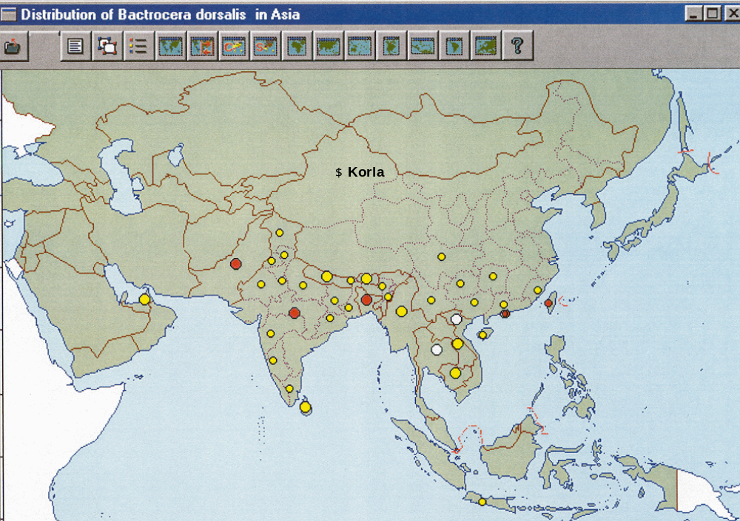
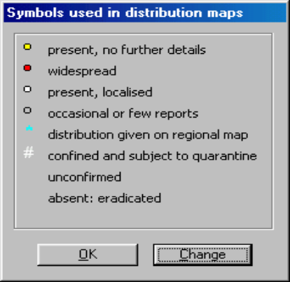
Figure 1. Distribution of Bactrocera dorsalis in Asia (CPC, 2002)

This is a tropical fruit fly, which would not survive the winters of Korla. The adults are best able to survive low temperatures with a normal torpor threshold of 7 ºC, dropping as low as 2 ºC in winter (EPPO, 1997). Immatures did not develop at temperatures lower than 12 ºC (PNKTO, 1982). As noted above, the mean annual temperature of northern Xinjiang is 4-8 ºC. and that of southern Xinjiang 9-12 ºC, but the average monthly low for January, the coldest month, is -19 ºC (West-East Gas Project, 2003; Xinjiang Province, 2003) well below the temperature limits of B. dorsalis. The Korla production region falls in the equivalent of Zone 6 on the USDA Plant Hardiness Zones Map (USDA, 1990). This would correspond to areas in the United States ranging between Boston, Philadelphia and New York- areas well outside the range where tropical fruit flies could reasonably be expected to survive.

In addition, China conducted trapping for B. dorsalis for three years in the orchards at 1 trap per hectare using Jackson traps with methyl eugenol lure as requested by APHIS (Thaw, 2001). All results have been negative. Approximately 10,000 metric tons of pears are exported from Xinjiang annually (Thaw, 2001). There has never been a report from trading partners of an interception of a fruit fly larvae in pears from Xinjiang Province (Thaw, 2001; Canada, 1995). During processing, the pears are closely inspected for insects and insect damage and packers have never reported an interception of a fruit fly larvae (Thaw, 2001). To satisfy the Japanese, who import Fragrant pears, fruit fly traps are maintained in the 28th Regiment during the growing season. No B. dorsalis have ever been found (Thaw, 2001).

- Carposina sasakii Matsumura (syn.: Carposina niponensis Walsingham)

The conclusion that this moth is unlikely to pose a risk in Fragrant pear fruit exports from Korla is based on its absence from the production area and the Province of Xinjiang. CABI (CPC, 2002) lists the distribution of this pest in China as Fujian, Guangdong, Hebei, Heilongjiang, Henan, Jiangsu, Jilin, Liaoning, Shaanxi, Ningxia, Shandong and Zhejiang Provinces- all in eastern China (Figure 2).

Specific surveys have not been conducted for C. sasakii in the production area or the Province, but according to Thaw (2001) general survey teams work in the area and APHIS has reports of the surveys in the Korla region:

- Between 1971 and 1975, part of Bazhou was surveyed using sweep nets and black light traps in the orchards. Unfortunately, C. sasakii does not come to black light traps. None found.

- Between 1985 and 1989 Li Jianglin of the Bazhou Plant Protection Station Production Farm of Xinjiang Shihezi Agriculture University conducted a general inspection. Again, no C. sasakii found.

- Between 1991 and 1996, Urumqi Animal and Plant Protection Station, Bazhou Plant Protection Station, Forest Bureau of No.2 Farm, Urumqi Plant Protection Station continued their general surveys and conducted limited research on selected pests of Fragrant pears. No C. sasakii found.

Figure 2. Distribution of Carposina sasakii in Asia (CPC, 2002)
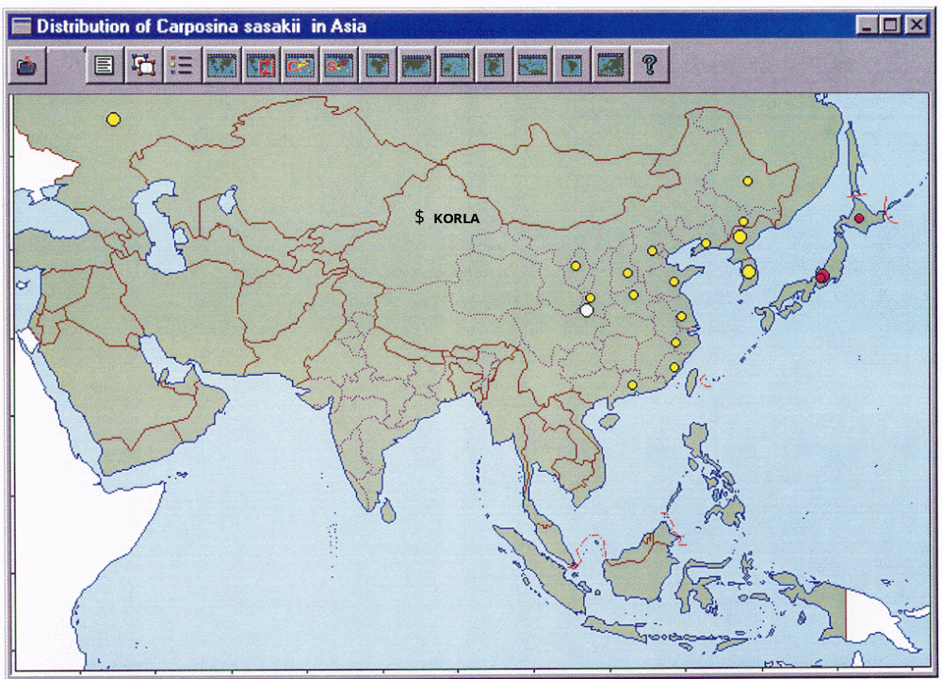

- Conogethes punctiferalis (Guenée)

The conclusion that this moth is unlikely to pose a risk in Fragrant pear fruit exports from Korla is based on its absence from the production area and the Province of Xinjiang. CABI (CPC, 2002) lists the distribution of this pest in China as the following provinces in eastern and southern China: Liaoning, Tianjin, Hebei, Shandong, Shanxi, Shaanxi, Henan, Jiangsu, Anhui, Hubei, Sichuan, Zhejiang, Jiangxi, Hunan, Fujian, Guangdong, Guangxi, Xizhang and Yunnan (Figure 3). C. punctiferalis is also present in Australia, India, Indonesia, Japan, Korea, Laos, Malaysia, Myanmar, Philippines, Sri Lanka, Taiwan, Thailand, and Vietnam.

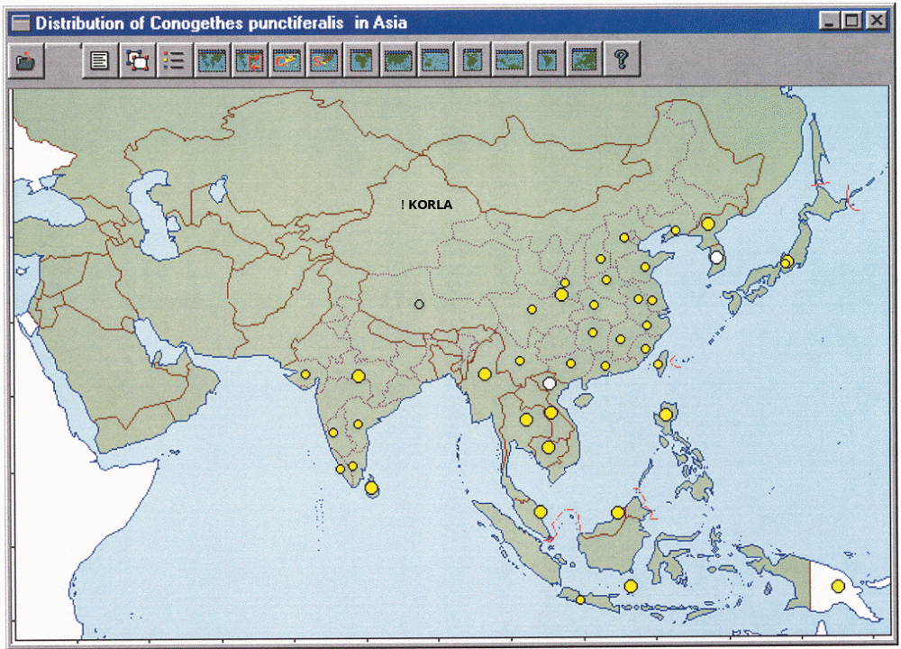

Figure 3: Distribution of Conogethes punctiferalis in Asia (CPC, 2002).

According to Thaw (2001), between 1971 and 1975; part of the production area was surveyed using general inspection and black light traps in the orchards at a density of 1 trap per 25 km² per acre. C. punctiferalis is attracted to black lights and would have been detected if it had been present. Black lights were also used in the annual surveys of 1985-1989, and 1991-1996. Again, no C. punctiferalis were found. C. punctiferalis has never been intercepted in any of the fruit exported from the Korla region (Thaw, 2001).

C. punctiferalis is one of the most important insect pests on peaches in southern China and an important pest on apples in northern China, and infestations result in the stunting, scorching and falling of fruit (Thaw, 2001). C. punctiferalis excretions, which cover the fruit surface and have high sugar content, attract other insect pests and diseases, which damage fruit. Peaches attacked by C. punctiferalis appear discolored, scorched, and are covered with brown excretion mass around holes. The fruits fall or rot with an unpleasant smell (CPC, 2002). The damage it causes to a variety of crops should also make it fairly obvious were it present. Given the careful scrutiny each fruit receives as part of the standard pack house procedures and phytosanitary inspections by Chinese officials at origin, APHIS believes inspection of a sample of the fruit on arrival should be a sufficient mitigative procedure for this insect.

4. and 5. Cydia funebrana (Treitschke) and Cydia inopinata (Heinrich) (syn. Grapholita inopinata)

The conclusion that these moths are unlikely to pose a risk in Fragrant pear fruit exports from Korla is based on their absence from the Korla production area and the Province of Xinjiang. CABI (CPC, 2002) lists the distribution of C. inopinata in China as the following provinces: Guangdong, Heilongjiang, Henan, Jilin and Liaoning (Figure 4). C. funebrana present in Hebei, Jilin, and Liaoning Provinces (CIE, 1978) is somewhat more restricted in its distribution.

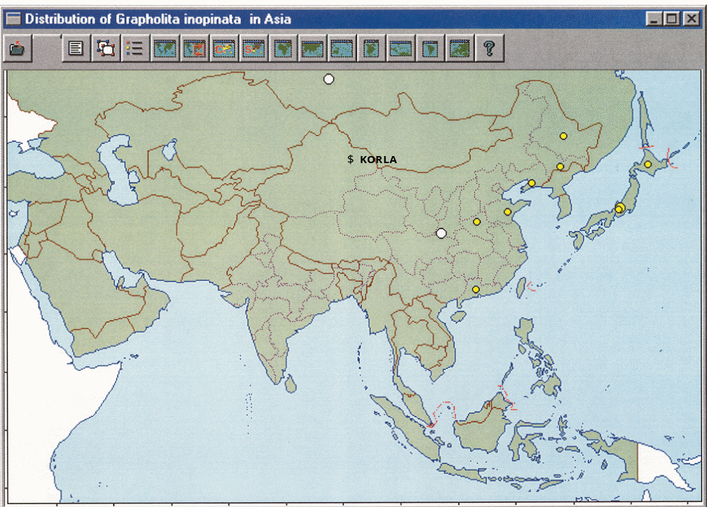
Figure 4. Distribution of Grapholita inopinata in Asia (CPC, 2002)

A synthetic pheromone blend is used for Grapholita molesta detection that is quite similar to that used for C. funebrana in other countries and the same as that used for C. inopinata (Thaw, 2001). In the Korla region, Chinese officials routinely use detection traps for G. molesta (Thaw, 2001); these traps would also detect C. inopinata were it in Xinjiang. CIQ indicates they do not know whether the moth comes to black lights or not. C. inopinata has never shown up in any of the general surveys, dating back to 1971. It is not widely found in eastern China. It has never been found in any domestic or export marketed Fragrant pears (Thaw, 2001).

C. funebrana larvae bore into the fruit leaving a conspicuous entrance hole surrounded by frass. The larvae tunnel into the pulp, leaving behind decaying tissues mixed with excrement (Bradley, et al., 1979. Infested fruits tend to ripen prematurely (Alford, 1981). These symptoms make infested fruit easy to detect, particularly late in the season when fruit ripens prematurely (Thaw, 2001). Thaw (2001) states that, according to the Chinese, when C. inopinata larvae bore into pear fruit, they leave a hole. The area around the hole turns blackish brown and the hole fills with excrement. The larvae are visible to the naked eye (CPC, 2002).

6. Leucoptera malifoliella Costa

This pest was initially included as a pest of concern in the 1994 Decision Sheet (USDA, 1994). In subsequent assessments (USDA, 1997), the analysts concluded that the pest was not likely to follow the pathway because this pest is primarily a leafminer. Larvae do not feed on fruit, but have been intercepted on fruit as pupae usually in the stem or calyx end cavities (PNKTO, 1985). Larvae prefer to pupate on leaves. In climates with long growing seasons, late season generations of high population densities may seek less desirable pupation sites such as fruit (PNKTO, 1985). However, such long growing seasons are uncharacteristic for Korla. Fruit interceptions have occurred on European apples and pears (PIN309, 2003). Interceptions have not been made on Chinese fruit. Distribution in China is not definitively known- the single Japanese report cited in USDA, 1994 and PNKTO, 1985 describes the distribution as “Northern China). No reports of this pest in Xinjiang are known to exist. The obvious leaf mines and premature leaf drop this pest causes (PNKTO, 1985) would have been detected in the general surveys carried in the production area if this pest was present. Both PNKTO (1985) and the Decision Sheet (USDA, 1994) indicate that this pest may be inspected for, if it were present.

7. Numonia pyrivorella (Matsumura) (syn.: Acrobasis pirivorella)

The conclusion that this moth is unlikely to pose a risk in Fragrant pear fruit exports from Korla is based on its absence from the Korla production area and the Province of Xinjiang. CABI (CPC, 2002) lists the distribution of N. pyrivorella in China as the following provinces: Heilongjiang, Liaoning, Shaanxi, Jilin and Nei Menggu (Figure 5).

N. pyrivorella is attracted to black lights. Black light traps were used in the surveys conducted in 1971-1975, 1985-1989 and 1991-1996 (Thaw, 2001). Furthermore, in spring, the larvae emerge and move to fresh buds, feeding on the developing buds, flowers and fruitlets, eating out the core of the latter. Larvae may move from fruit to fruit. The older larvae penetrate into the developing fruit to pupate. Before doing so, they wander over the surface of the fruit spinning a web particularly around the stalk. The larvae generally enter the fruit near the calyx end or on the side of the fruit, making a prominent hole with an overhanging lip of silk and excreta. Fruits that have been infested by larvae remain black and shriveled on the tree (CPC, 2002) and would be readily detected during general surveys. No N. pyrivorella have ever been detected in Xinjiang Province.

The main means of spread would be international trade of planting material with infested buds. Infested fruits may also carry the pest, but its presence is conspicuous (CPC, 2002).
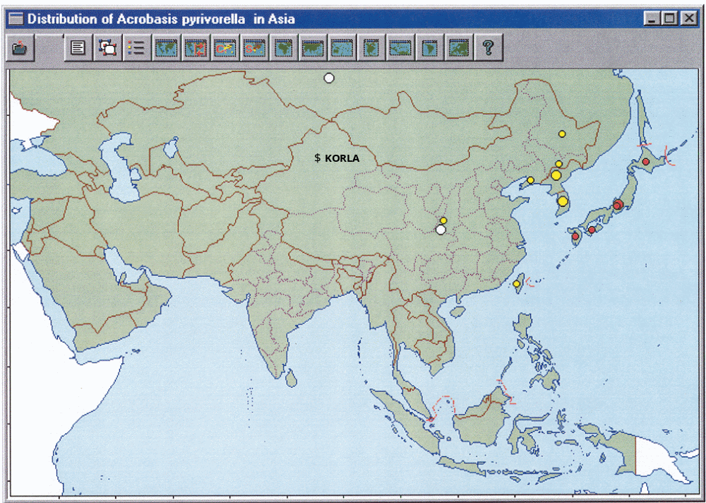

Figure 5. Distribution of Numonia pyrivorella in Asia (CPC, 2002)

8. and 9. Rhynchites foveipennis Fairm. and Rhynchites heros Roel

The conclusion that these weevils are unlikely to pose a risk in Fragrant pear fruit exports from Korla is based on their absence from the Korla production area and the Province of Xinjiang and aspects of their biology that make them unlikely to be present in export quality fruit and readily detectable if they were.

There is some confusion about the existence of Rhynchites heros in China. A 1966 reclassification of the species of Rhynchites in China (Chao and Lee, 1966) seems to indicate R. heros exists only in Japan. It is probable that the literature references indicating R. heros in eastern China are actually R. foveipennis. Because of this confusion and the similarity in their biology, these two weevils are treated together in this discussion. R. foveipennis (including R. heros) occurs in the following provinces in China: Hebei, Hubei, Shandong, Shanxi, Liaoning, Jilin, Helongjiang, Inner Mongolia, Zhejiang, Fujiang, Shannan, Sichuan, and Yunnan Provinces (Chao and Lee, 1966).
Between 1971 and 1975, part of Korla was surveyed using sweep nets and black light traps located in orchards. No Rhynchites heros or R. foveipennis found. Between 1985 and 1989 a general inspection by Li Jianglin of the Bazhou Plant Protection Station Production Farm of Xinjiang Shihezi Agriculture University found no R. heros or R. foveipennis (Thaw, 2001). And between 1991 and 1996, Urumqi Animal and Plant Protection Station, Bazhou Plant Protection Station, Forest Bureau of No.2 Farm, continued their general surveys and conducted limited research on selected pests of Fragrant pears. No R. heros or R. foveipennis found (Thaw, 2001).

R. heros infests apple, peach, pear, cherry, plum, apricot, quince, and fig (INKTO, 1958). Adult females feed on buds, flowers, and immature fruit. According to Hanson (1963), “This weevil eats pears day and night with its sharp mouth, causing great damage.” This damage would be readily evident to surveyors and fruit packers. “Moreover, the adult after having laid an egg in the fruit cuts the stalk...” (Hanson, 1963). The fruit may drop to the ground after the female lays an egg in the fruit and cuts the stem (Roberts, 1950; AQIS, 1998), or it may remain on the tree (INKTO 45, 1958). Rhynchites sp. was intercepted once on Chinese pear; presumably, these were larvae (PIN309, 2003).

10. Tetranychus kanzawai Kishida

The spider mite, Tetranychus kanzawai Kishida, was synonymized with Tetranychus hydrangeae Pritchard & Baker (Navajas et al., 2001). Tetranychus hydrangeae is present in the United States and is not considered a quarantine pest at this time.

11. Tetranychus viennensis Zacher

APHIS’ estimate of the risk posed by T. viennensis in Fragrant pear fruit exports from Korla as low to moderate is based on its absence from the Korla production area, though it is present in the Province of Xinjiang. CABI (CPC, 2002) lists the distribution of T. viennensis in China as the following provinces: Anhui, Gansu, Henan, Jiangsu, Liaoning, Ningxia, Shandong and Xinjiang. Within Xinjiang Province, T. viennensis occurs in Heshuo, a small farming community approximately 50 miles north of Korla, in the mountains, where they raise vegetables, livestock, corn, wheat, and apples. Pear trees are used in places as windbreaks. There is no commercial production of pears or any other commodity. China indicates it is unlikely T. viennensis will move from Heshuo as there is very little reason someone would take agricultural commodities to Korla. Heshuo residents go to Korla to buy the food and any produce they lack (Thaw, 2001). This mite is, however, windborne and may be carried accidentally by large insects, birds and even humans on their clothing (CPC, 2002).

Plant quarantine officials in Xinjiang are very aware of U.S. and Canadian concerns about the population of T. viennensis in the little community of Heshuo. These concerns arise from rejections of Fragrant pear shipments to Canada due to the presence of mites (Canada, 1995). China understands that the presence of T. viennensis in the Korla production area would impact their ability to export pears (Thaw, 2001). General survey teams work in the region and APHIS has their survey reports. Between 1971 and 1975, part of the region was surveyed using sweep nets and black light traps located in orchards. During this period, a mite, Tetranychus turkestani, was found, but no T. viennensis. Between 1985 and 1989 Li Jianglin of the Bazhou Plant Protection Station Production Farm of Xinjiang Shihezi Agriculture University conducted a general inspection. Again, no T. viennensis were found, nor was any new species of mite. Between 1991 and 1996, Urumqi Animal and Plant Protection Station, Bazhou Plant Protection Station, Forest Bureau of No.2 Farm, continued their general surveys and conducted limited research on selected pests of Fragrant pears. No T. viennensis found. In 1996 - 1997, because of the problems caused by rejections of shipments of pears by Canada due to mite interceptions, Chinese officials organized a workshop to give advanced identification training to their extension agents in Korla. They conducted several intensive surveys and identified all mites that were collected. These surveys indicated that Tetranychus turkestani, T. cinnabarinus, T. truneatus, and Eotetranychus pruni are present in the area (Thaw, 2001). None of these species of mites are considered of quarantine significance by the United States.

T. viennensis is found mainly on the leaves and stems of host plants, especially during the flowering, seedling, and vegetative growing stages (CPC, 2002). The female overwinters mainly in cracks in the bark of host trees, rarely in the calyx of host fruit. CPC (2002) specifically lists fruit as a plant part not known to carry the pest, however this pest has been intercepted on fruit (PIN309, 2003).

Some Ya pear fruit packers in eastern China to eliminate mites use forced air cleaning of the stem and calyx ends of fruit, but this may not be feasible on Korla. APHIS has used inspection to mitigate for T. viennensis on European apples, but has no experience with this pest on pears.

12. Alternaria spp.

The conclusion that these fungi are unlikely to pose a risk in Fragrant pear fruit exports from Korla is based on their absence from the Korla production area and the Province of Xinjiang. CABI (CPC, 2002) lists the distribution of A. gaisen in China as the following provinces: Guangdong, Guangxi, Hebei, Henan, Jiangsu, Jilin, Liaoning, Qinghai and Zhejiang (Figure 6). In 2002, PPQ intercepted one, possibly two previously undescribed Alternaria species on Ya pear fruit from Hebei Province in China (Roberts, 2002). Chinese officials identified these previously undescribed species as A. alternata (a nonquarantine species). Other than Hebei Province, where the rejected pear shipments originated, the distribution of this previously undescribed Alternaria is unknown.

Alternaria species produce obvious and recognizable symptoms on pear leaves, shoots, flowers and fruits (CPC, 2002; Jones and Aldwinckle, 1990), yet no Alternaria gaisen was detected in the surveys conducted in 1971- 1975, 1985-1989 and 1991-1996 (Thaw, 2001).

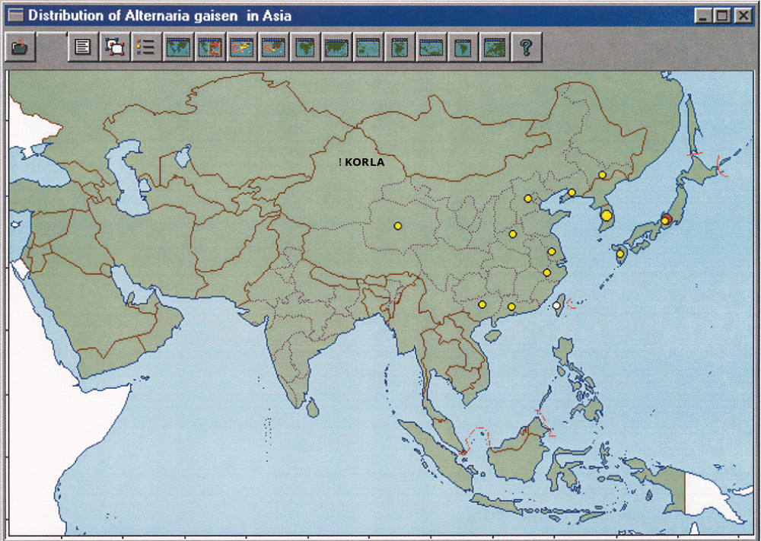
Figure 6. Distribution of Alternaria gaisen in Asia (CPC, 2002).

13. Gymnosporangium spp.

The 1994 Decision Sheet cites two species G. asiaticum and G. confusm. Both species are also reported to occur in the United States and would not be considered quarantine pests. The 1997 PRA (USDA, 1997) also mentions two species, G. asiaticum and G. fuscum. A single report of G. fuscum in Shaanxi Province in Central China exists (CPC, 2002). There are no reports indicating that these fungi are present in the Korla production area or the Province of Xinjiang. G. fuscum has also been reported to occur in the United States (Alabama and California) (CPC, 2002) though it has not been seen in California in about 20 years (Palm, 2002).

Laundon (1977) stated that G. confusm only causes occasional weak infections on pear fruit. CPC (2002) states, “While fruits can be infected [by G. fuscum], it is very unlikely that infected fruits would be harvested or meet quality standards for export.” The CPC (2002) also states “G. fuscum has been deregulated in the USA [on nursery stock], essentially since it was found that the commonly used fungicides were cheaper than regulation. The possibility of deregulation has also been under discussion in Canada.” G. fuscum was recently listed as a reportable pest in the USDA Catalogue of Reportable pests (Palm, 2002) meaning that quarantine action would be taken on a commodity if this pest were detected.

14. Monilinia fructigena Honey

The conclusion that this fungus is unlikely to pose an unacceptable risk in Fragrant pear fruit exports from Korla is based on its absence from the Korla production area and the Province of Xinjiang and the fact that it is readily detected by visual inspection of the fruit. According to CPC (2002), M. fructigena occurs in the following provinces in China: Gansu, Hebei, Heilongjiang, Henan, Jiangsu, Liaoning, Ningxia, Shaanxi, Shandong, Shanxi, Sichuan, Taiwan, Yunnan, and Zhejiang (Figure 7).

Figure 7. Distribution of Monilinia fructigena in Asia (CPC, 2002)
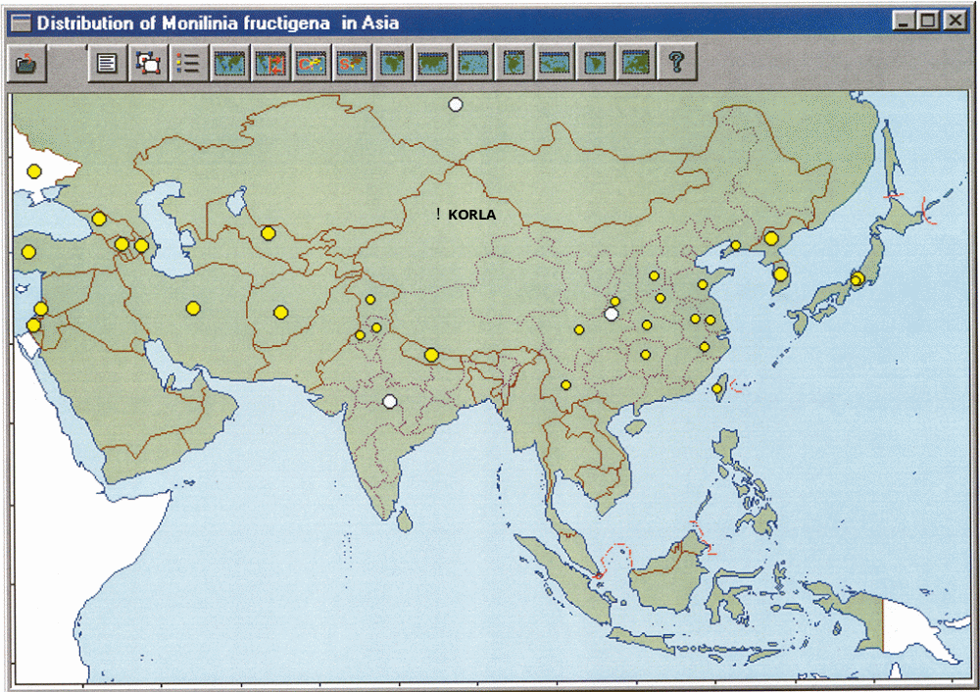
Brown rot on ripening or mature fruit typically develops as a rapidly spreading, firm, brown decay. Infection of fruits can take place at any stage during fruit development but only in those fruits approaching the ripening stage is the disease more severe (Figure 8). The first symptoms on ripe fruits are small, superficial, circular brown spots that quickly turn to rotting. Eventually the whole fruit becomes discolored and water is lost so that a mummified fruit is formed. Diseased fruits tend to remain attached to the tree. Mummified fruit hang on branches of trees until spring or, alternatively fall to the ground where they remain throughout the winter months, partly or completely buried beneath the soil or leaf litter. Disease symptoms are clearly visible in the field (CPC, 2002).

Figure 8. Symptoms of Monilinia fructigena pear (CPC, 2002)

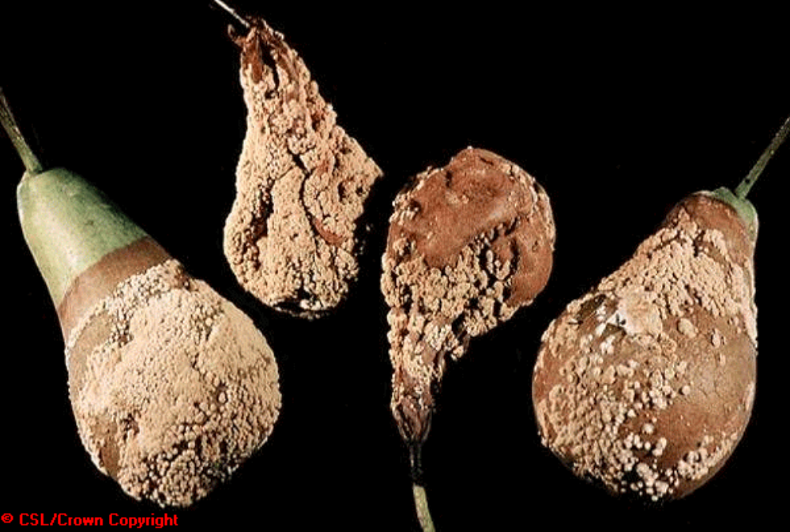
Between 1971 and 1975, part of the region was surveyed for agricultural pests (Thaw, 2001). M. fructigena symptoms can clearly be seen in the field. Any reasonable survey would have found the disease. No M. fructigena were detected in the similar surveys conducted in 1985-1989 ( and 1991-1996 (Thaw, 2001). The United States already imports a number of host plant commodities from other countries where M. fructigena occurs (7CFR § 319.56-2r) without requiring measures beyond normal port of entry inspection.

15. Mycosphaerella pomacearum (Cord.) Sacc.

The conclusion that this fungus is unlikely to pose an unacceptable risk in Fragrant pear fruit exports from Korla is based on its absence from the Korla production area and the Province of Xinjiang. Biological information also indicates that this fungus does not attack the fruit. M. pomacearum occurs only in the following provinces in eastern China: Jilin, Hebei, and Shandong (Tai, 1979).

According to information provided by China, M. pomacearum is only found on the leaves (Thaw, 2001). This is consistent with other species of Mycosphaerella known to attack pears in the United States and elsewhere (Jones and Aldwinckle, 1990).

This pathogen was not listed in the original 1994 Decision Sheet (USDA, 1994). In the 1997 PRA (USDA, 1997), it was listed as a quarantine pest, but was not included on the list of quarantine pests likely to follow the pathway. It is unclear why, as indicated in Thaw (2001) it was later included as a pest of concern. The Thaw (2001) report and this analysis have been unable to uncover evidence to support the assumption that M. pomacearum is likely to follow the pathway of imported fresh Fragrant pear fruit from Korla.

16. Venturia nashicola

This fungus was listed in the 1994 Decision Sheet (USDA, 1994), however the discussion centered on Japan and Korea. This is probably because the distribution of V. nashicola is restricted to those two countries (CPC, 2002; CABI /EPPO, 1998). No reports of distribution in China were listed in previous assessments, nor were any uncovered during this analysis. Furthermore, Jones and Aldwinckle (1990) listed V. nashicola as a synonym of V. pirina, the causal agent of pear scab disease, which occurs in the United States. For these reasons, V. nashicola was not listed as attacking Fragrant and Ya pears in China in the 1997 PRA (USDA, 1997) nor was it addressed by Thaw (2001).

However, in March of 2002, PPQ intercepted Chinese Ya pears from Hebei Province with what was identified as the Fusicladium anamorph (asexual) state of V. nashicola (Feinstein, 2002). Quarantine action was taken on the shipment and Chinese officials were made aware of the need to control scab in export orchards. The scab fungi, like Alternaria species, produce obvious and recognizable symptoms on pear leaves and fruits (Figure 9). The two diseases pose similarly low risks since neither is known to occur in the Korla production region and would be mitigated in much the same way.

Figure 9. Pear scab symptoms
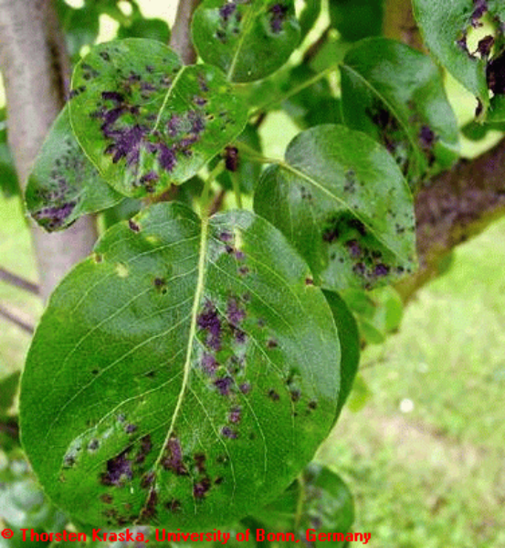
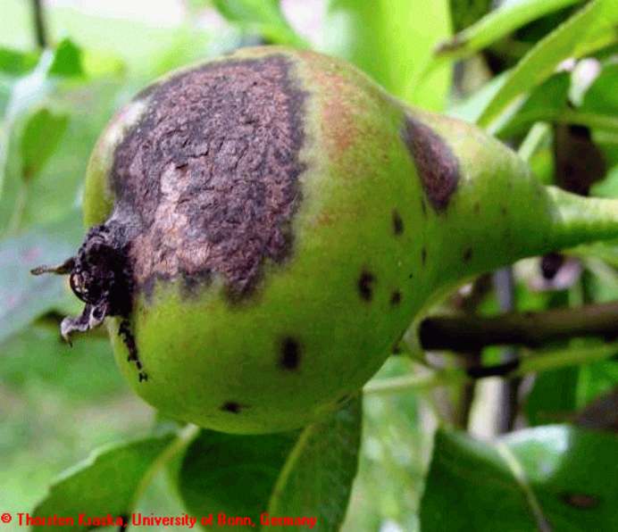

17. Pear rusty skin viroid (syn. Apple scar skin viroid)

Pear rusty skin viroid is a synonym for Apple scar skin viroid (ASSVd) the type member of the Apscaviroid genus in the Pospiviroidae family (ICTV, 2000). Technically it is correct, in one sense, to say that ASSVd follows the pathway: infected pear trees will produce at least some fruit with pulp containing the viroid. Such fruit is of no consequence, however, in the spread of the disease. There are no known vectors for ASSVd and at least two separate studies (Hurtt and Podleckis, 1995; Howell, et al., 1998) have demonstrated that ASSVd is not seed transmitted in pears. Consequently, fruit poses no risk for the movement of this viroid and it should be removed from the list of pests of concern.

Conclusion

We have reviewed the 1994 Decision Sheet (USDA, 1994), the 1997 risk assessment (USDA, 1997),the draft document, entitled “Program Analysis: Pest Risk of the Export of fragrant Pears from the Production Areas of Korla, China to the United States (Thaw, 2001), published literature and other relevant information. We find that the evidence, assumptions and conclusions support the proposal to allow the importation of fresh, commercial Fragrant pear fruit from the Korla production region of Xinjiang Province, China provided certain safeguards are incorporated into the operational workplan for the proposed importation. Those safeguards include, but are not necessarily limited to the following:

A. Grown in Korla Regain, Province of Xinjiang, China:

Bactrocera dorsalis; Oriental Fruit Fly - As discussed above this is a tropical fruit fly that could not become established in the climate that exists in Korla. Requiring that the pears originate from this region is sufficient mitigation along with normal general surveys and inspections conducted as part of normal production procedures.

B. Pest free production site and shipment freedom required for these pests:

Carposina sasaki Peach Fruit Borer- APHIS requires bagging for this pest from on pears from other areas (e.g., 7CFR§ 319.56-2ee). Pyrus spp. is a primary host, the pest survives in stored fruit and several larvae can infest a single fruit ( CPC, 2002 ). APHIS intercepts this pest regularly in fruit (PIN309, 2003).

Conogethes punctiferalis Yellow Peach Moth - APHIS requires bagging for this pest from other areas (e.g., 7CFR§ 319.56-2ee). Pyrus spp. is not a primary host but the pest survives in stored fruit ( CPC, 2002 ). APHIS intercepts this pest regularly in fruit (PIN309, 2003).

Cydia inopinata Apple Fruit Moth - Pyrus spp. is not a primary host but the pest survives in stored fruit. This is a serious pest. ( CPC, 2002 ). APHIS has little experience with this pest and with fragrant pears because of their limited distribution.

Tetranychus viennensis Hawthorn Spider Mite - Although, APHIS has used inspection as the main mitigation for this pest on apples from Europe because it is not associated with commercial shipments, we have little experience with this pest on pears especially with fragrant pears.

Cydia funebrana Red Plum Maggot - Although, APHIS has uses inspection as the main mitigation on apples for this pest from Europe (7CFR§ 319.56-2r) because it is not normally associated with commercial shipments, we have little experience with this pest on pears especially with fragrant pears.

Monilinia fructigena Brown Rot - Although, APHIS has used inspection as the main mitigation on apples for this pest from Europe (7CFR§ 319.56-2r) because it is not normally associated with commercial shipments, we have little experience with this pest on pears especially with fragrant pears.

Alternaria spp., Venturia nashicola (Fusicladium anamorph), Gymnosporangium fuscum- Like M. fructigena these fungi produce recognizable symptoms and are not known to occur in the Korla region but they are potentially serious pests so an added declaration of production site and shipment should be required.

C. Shipment freedom required for these pest:

Numonia pirivorella Large Pear Borer - Pyrus spp. is a primary host but the infested fruits are much damaged and are unlikely to be shipped . If infested fruit was shipped inspection would be adequate

Rhynchites foveipennis Pear Curculio - Pyrus spp. is a primary host but the fruit infested by Rhynchites spp. are much damaged and are unlikely to be shipped ( INKTO 45, 1958 ). If the shipment was infested inspection would provide adequate mitigation.

Rhynchites heros Japanese Apple Curculio - Pyrus spp. is a primary host but the fruit infested by Rhynchites spp. are much damaged and are unlikely to be shipped ( Hanson, 1963 ). If the shipment was infested inspection would provide adequate mitigation.

This memo has been reviewed by Edwin Imai and Gary Cave of the Center for Plant Health Science and Technology, Wayne Burnett and Paul Gadh of the Plant Protection and Quarantine, Phytosanitary Issues Management Team and Richard Fite and Charles Miller of the Policy and Program Development Risk Analysis Staff and they are in agreement with the conclusions herein.

References

Alford, D.V. 1981. Plum fruit moths. Ministry of Agriculture, Fisheries and Food Leaflet 768. MAFF (Publications) Lion House, Willowburn Estate, Alnwick, Northumberland, NE66 2PF.

AQIS. 1998. Final Import Risk Analysis of the Importation of Fruit of Fuji Apple (Malus pumila Miller var. domestica Schneider) from Aomori Prefecture in Japan. Australian Quarantine Inspection Service. 58 pp.

Bradley, J. D., Tremewan, W. G., Smith, A. 1979. Cydia funebrana (Treitschke). p. 248-250, No. 153. In: British tortricoid moths: Tortricidae: Olethreutinae. London, England: British
Museum (Natural History).

CABI/EPPO. 1998. Venturia nashicola. Distribution Maps of Quarantine Pests for Europe No. 248. Wallingford, UK, CAB International.

Canada. 1995. Insect Interceptions on Fruit of Pyrus from China Entering Canada, 1994-1995. Centre for Plant Quarantine Pests. Agriculture and Agri-Food Canada.

Chao, Y.-C. and Lee, Y.-J. 1966. A revision of some common species Rhynchites Scheider (Coleoptera, Attelabidae), in China. Acta Entomologica Sinica 15: 249-250.

CIE. 1978. Commonwealth Institue of Entomology. Map No. 380. Cydia funebrana (Treitsch.) Kew, Surrey, Engalnd. 2pp.

CPC. 2002. Crop Protection Compendium. CAB International, Wallingford, Oxon, UK.

EPPO. 1997. Quarantine Pests for Europe, Second Edition. CAB International, Wallingford, Oxon, UK. 1425 pp.

FAO. 2001. International Standards for Phytosanitary Measures, Publication No. 5. Glossary of Phytosanitary Terms. Food and Agriculture Organization of the United Nations. Rome, Italy.

INKTO 45. 1958. Insects not known to occur in the United States: Fruit Weevil. USDA-ARS, Cooperative Economic Insect Report, 2 pp.

Jones, A.L. and Aldwinckle, H. S. 1990. Compendium of Apple and Pear Diseases. APS Press, St. Paul, MN. 100 pp.

Laundon, G. 1977. CMI Descriptions of Pathogenic Fungi and Bacteria, No. 544. Commonwealth Mycological Institute, Kew, Surrey, England. 1 pp.

Navajas, M.; Gutierrez, J.; Williams, M. and Gotoh, T. 2001. Synonymy between two spider mite species, Tetranychus kanzawai and T. hydrangeae (Acari:Tetranychidae), shown by ribosomal 1TS2 sequences and cross-breeding experiments. Bull. Entomol. Res., 91: 117-123.

Palm, M. 2002. E-mail from Mary Palm, National Mycologist, USDA, APHIS, PPQ, National Identification Services to Joe Cavey, Branch Chief, USDA, APHIS, PPQ, National Identification Services. 9 September. 2002. (Subject: Gymnosporangium fuscum; on file with PPQ, Riverdale, MD)

PIN 309. 2003. Port Information Network Database of Intercepted Pests. USDA, APHIS, PPQ, Riverdale, MD.

PNKTO. 1982. U.S. Department of Agriculture. Pests Not Known to Occur in the United States or of Limited Distribution, No. 20: Oriental Fruit Fly. APHIS-PPQ. APHIS 81-40. July 1982.
Prepared by USDA, APHIS, PPQ, Biological Assessment Support Staff, Federal Building Room 402, Hyattsville, MD 20782

PNKTO. 1985. U.S. Department of Agriculture. Pests Not Known to Occur in the United States or of Limited Distribution, No. 63: Pear Leaf BlisterMoth. APHIS-PPQ. APHIS 81-46. September 1985. Prepared by USDA, APHIS, PPQ, Biological Assessment Support Staff, Federal Building Room 402, Hyattsville, MD 20782

Rieger, M. 2005. Pears - Pyrus communis, Pyrus pyrifolia; http://www.uga.edu/fruit/pear.htm#origin

Roberts, R. 1950. Economic entomology in Japanese agriculture. Shell Co., 94 pp.

Roberts, R.G.. 2002. Letter from Rodney Roberts, Research Plant Pathologist, Western Tree Fruit Research Laboratory, USDA, Agricultural Research Service to Alan Green, Assistant Director, USDA, APHIS, PPQ, Phytosanitary Issues Management (30 September. 2002) (on file with the USDA, APHIS, PPQ, subject: Alternaria species found on imported Chinese Ya pears).

Tai, F.L. 1979. Sylloge Fungorum Sinicorum. Science Press. Academia Sinica, Peking, China.
1527 pp.

Teng, Y., Tanabe, K., Tamura, F., and Itai, A. 2002. Assessment of Genetic Relatedness among Large-Fruited Pear Cultivars Native to East Asia Using RAPD Markers. Acta Hort. 587: 139-145.

Teng, Y. and Tanabe, K. 2004. Reconsideration on the Origin of Cultivated Pears Native to East Asia. Int. Symp. Taxonomy of Cultivated Plants, Proc. XXVI; Acta Hort. 634: 175-182.

Thaw, J. 2001. Program Analysis: Pest Risk of the Export of Fragrant Pears from the Production Areas of Korla, China to the United States. United States Department of Agriculture, Animal and Plant Health Inspection Service, Plant Protection and Quarantine, Riverdale, MD.

USDA. 1990. USDA plant hardiness zone map. USDA- Agricultural Research Service (ARS). Miscellaneous Publication Number 1475. USDA-ARS, Washington, DC 20002

USDA. 1994. Decision on Entry Status of Fruits and Vegetables Under Quarantine No.56: Ya Pears (Pyrus bretscheideri) and Sand Pears (Pyrus pyrifolia), Peoples Republic of China. United States Department of Agriculture, Animal and Plant Health Inspection Service, Plant Protection and Quarantine, Riverdale, MD.

USDA. 1997. Importation of Fragrant and Ya Pear Fruit from China into the United States. A Supplemental Pest Risk Assessment United States Department of Agriculture, Animal and Plant Health Inspection Service, Plant Protection and Quarantine, Riverdale, MD.
USDA. 2000. Guidelines for Pathway-Initiated Pest Risk Assessments. Version 5. http://www.aphis.usda.gov/ppq/pra/commodity/cpraguide.pdf.

West-East Gas Project. 2003. Travel: Climate: Xinjiang. China Internet Information Center. http://www.china.org.cn/english/travel/42070.htm. Last accessed 27 January. 2003.

Xinjiang Province. 2003. Families with Children from China, Average Weather Data. http://www.fwcc.org/xinjiang.htm. Last accessed 27 January. 2003.

