
February 25, 2008
Local Veteran group surprises
Ms. Nadine Love with award for superb customer service
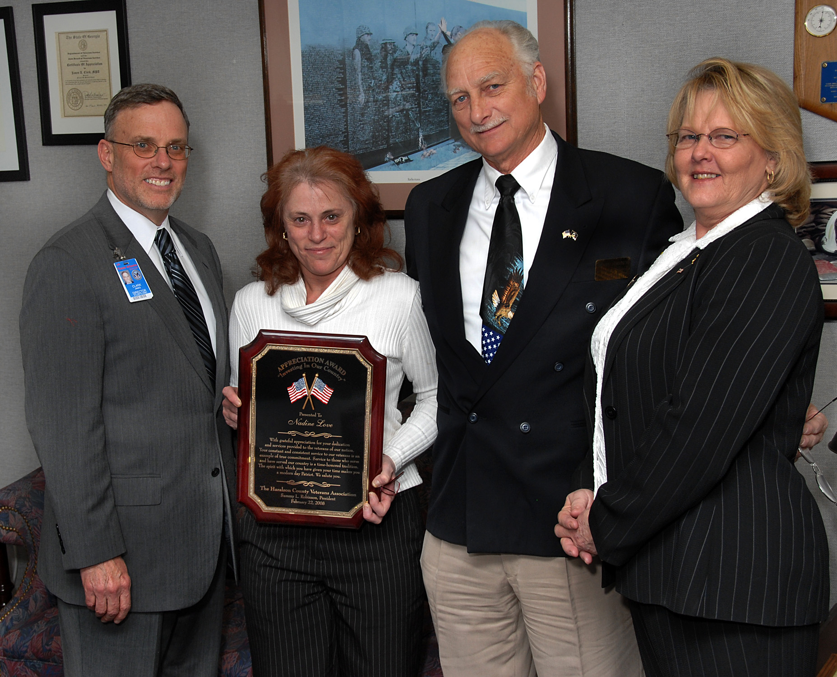
Ms. Nadine Love accepts her surprise award from Sammy
Robinson, his wife Brenda and VAMC Director James
Clark.

When Nadine Love received word from her supervisor to report immediately to the Director’s office last Friday, she first wondered what she had done wrong.
“It reminded me of that feeling you experienced in school after being told to report to the principal’s office,” Ms. Love said of her initial reaction.
But her worries quickly turned into unexpected surprise once she showed up and received an award from a local veteran organization for what it described as Ms Love’s “incredible commitment to our nation’s veterans.”
Haralson County Veterans Association President
See Love on page 2
News Briefs

Director’s Town Hall Meeting- Primary Care will host the next Director’s Town Hall Meeting on Feb 26 in the Pete Wheeler Auditorium at 3pm.
Black History Month- This year’s program will take place Feb 27 from 11am to noon in the Peter Wheeler Auditorium. The guest speaker will be State Representative Stan Watson.
Sensitive Information: VA sensitive information is all Department data, on any storage media or in any form or format, which requires protection due to the risk of harm that could result from inadvertent or deliberate disclosure, alteration, or destruction of the information. The term includes proprietary information and records about individuals requiring protection under various confidentiality provisions such as the Privacy Act and the HIPAA Privacy Rule and information that can be withheld under the Freedom of Information Act. Examples of VA sensitive information include: individually-identifiable medical benefits and personnel information, financial and budgetary, research, quality assurance, confidential commercial, critical infrastructure, investigatory, and law enforcement information. Also information that is confidential and privileged in litigation such as information protected by the deliberative process privilege, attorney work-product privilege, and the attorney-client privilege and other information which, if released, could result in violation of law or harm or unfairness to any individual or group, or could adversely affect the national interest or the conduct of federal programs.
Voluntary Leave Transfer Program – The following are approved participants in the VLTP and are eligible to receive annual leave donations. If you wish to make a leave donation, call ext 6306 or 4376 to complete form OF-630A:
Patient Care Services- Alfreda Hamilton-Clay, Janet Salters, Rhonda Grear, Kimberly Miller, Verna Funderburk, Pacita Riddle, Julia Okoro,Thomas Cerame, Akosua Sedenu
Mental Health - Kimberly Thornton, Teresa Ross.
Medical Specialty- Terrylynn Pierre.
Information Technology- Ronald Disco, Faith Thompson.
National Cemetery Administration- Patricia Jacques.
Primary Care -Michelle Pough, Katherine Greco.
Surgical & Perioperative - Herman Salle.
Laboratory- Joseph Hudson, Laura Lamar, Berlinda Ringo.
EMS- Fletcher Hudson, Frankie Isreal, Sandy Holmes.
Management Team-Rebecca Swan. Police Services- Eric Adams.

with a burning desire to build a park that would honor the men and women of our armed forces both past and present, according to Mr. Robinson.
He added that on July 4, 1992 the dream became a reality with the dedication of the Haralson County Memorial Park named after two local veterans killed in Vietnam.
Mr. Robinson went on to say that Ms Love, as well as most of the VAMC staff, represented that same spirit of dedication to our nation’s heroes.
"I am really very pleased with the service I receive,” Mr. Robinson said to Mr. Clark. “You have an excellent group of people working here.”

Love from page 1

Sammy L. Robinson explained why his group singled out Ms. Love for such recognition.
“Nadine has a loving and caring nature and my association with her has always been positive. She has been a strong advocate for veterans in securing VA services that they deserve and have earned,” Mr. Robinson said.
Mr. Robinson’s wife Brenda and VAMC Director James Clark also took part in the surprise presentation. The Haralson County Veterans Association was formed in 1991

23-Hour Observation Unit holds Grand Opening
By Dr. Maziar Zafari and Roger Phillips, RN

involved in current operations as well as the new staff members of the 23-Hour Observation Unit.
The 23-Hour Observation Unit, the “brainchild” of Dr. Kreton Mavromatis, was started to ensure expedient service to our veterans requiring interventional cardiology procedures. The unit is currently serving a broader spectrum of patients overnight on Monday, Wednesday, and Thursday to care for an array of cardiac and non-cardiac patients. These include patients who have established care at the Atlanta VAMC as well as referrals from other VA facilities for percutaneous coronary interventions, cardiac arrhythmia ablations, and biventricular device implantations.
The 23-Hour Observation Unit allows other sections in the Medical Specialty Care Service Line as well as other Departments to provide high quality care, including diagnostic and therapeutic procedures to veterans in a safe and efficient manner. The opening of this unit was done purposefully and efficiently to reduce the demands on the Medical Intensive Care Unit for these types of cases.

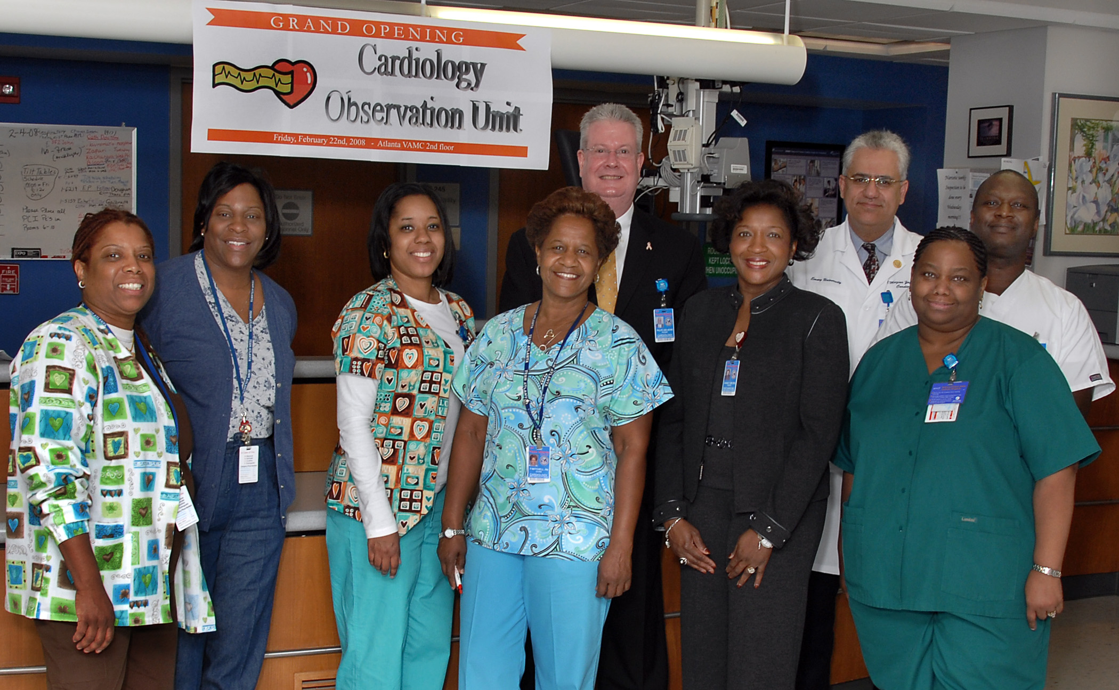
Staff of 23-Hour Observation Unit celebrates Grand Opening.

The official “Grand Opening” of the 23-Hour Observation Unit was held on Friday morning Feb 22. The event was attended by Mr. Clark, Dr. Bower, Mr. Becker, and Ms. Leake representing the executive management staff. Dr. Brown, Ms. Handy, Ms. Freel-Whitt, and section chiefs from across the Medical Specialty Care Service Line also attended the celebration. Many other Medical Center Nurse Executives came to represent nursing and wish this new unit well.
Section Chief of Cardiology Services Dr. Maziar Zafari and Nurse Manager
Roger Phillips decided to have a “meet and greet” function to introduce the staff

