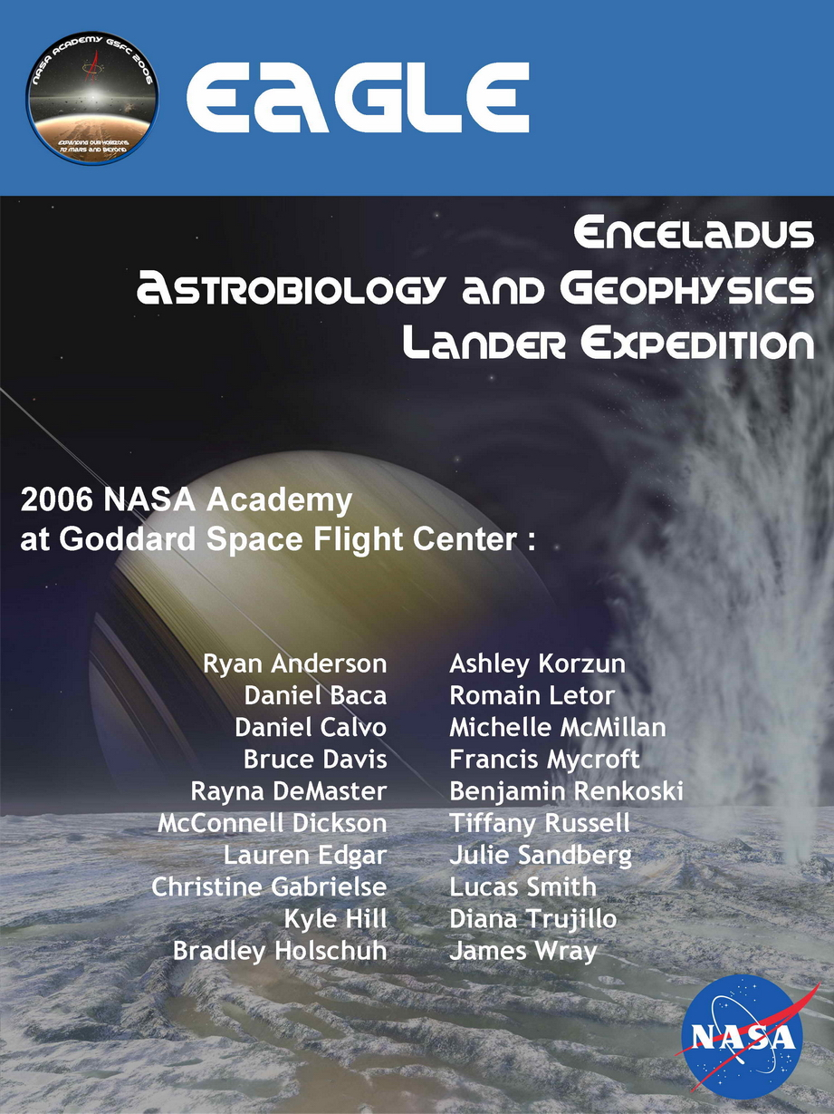

Table of contents i
Table of contents
List of Figures iv
List of Tables vi
1 Executive Summary 1
2 Enceladus Background Summary 4
2.1 Current State of Saturn Knowledge 4
2.2 Current State of Enceladus Knowledge 4
2.3 Mission Rationale 5
3 Science 7
3.1 Science Overview 7
3.2 Scientific Objectives 7
3.3 Mission Objectives 7
3.4 Science Requirements 8
3.4.1 Photopolarimeter/Radiometer 8
3.4.2 Laser Altimeter 8
3.4.3 Magnetometer 8
3.4.4 Near-infrared mapping spectrometer 8
3.4.5 Enceladus Descent Imager (EDI) 8
3.4.6 Seismometer 9
3.4.7 Pancam 9
3.4.8 Saturn Orbiting Camera (SOC) 9
3.4.9 ChemCam 9
3.4.10 Enceladus Surface Analyzer by Mass Spectrometry (ESAMS) 9
3.4.11 Amino Acid Analyzer (UREY) 10
3.5 Trade Studies 10
3.6 Connection to Past, Present, and Future Saturn Missions 10
4 Payload 11
4.1 Instruments 11
4.1.1 Lander 11
4.1.1.1 Amino Acid Analyzer 11
4.1.1.2 Alpha Particle X-Ray Spectrometer 12
4.1.1.3 Camera/Descent Imager 14
4.1.1.4 ChemCam 14
4.1.1.5 Laser Altimeter 16
4.1.1.6 Magnetometer 17
4.1.1.7 Enceladus Surface Analysis by Mass Spectrometry (ESAMS) Experiment 17
4.1.1.8 Near-Infrared Mapping Spectrometer 18
4.1.1.9 Photopolarimeter/Radiometer (PPR) 19
4.1.1.10 Drilling and Sample Delivery Subsystem (SD2) 20
4.1.1.11 Seismometer 20
4.1.1.12 Wide Angle Camera 21
4.1.2 Orbiter 23
4.1.2.1 Camera 23
4.1.2.2 Student Payload 23
4.1.2.3 Radio Science 24
4.2 Up-scope Options 24
4.3 Planetary Protection 24
4.4 Conclusions 26
5 Mission Architecture 27
5.1 Overview 27
5.1.1 Launch Vehicle and Earth Escape 27
5.1.2 Interplanetary Trajectory 28
5.1.3 Orbiter Mission Trajectory 31
5.1.4 Enceladus Approach 31
5.1.5 Future Trajectory Refinement 31
5.1.5.1 The Launch Window 32
5.1.5.2 Saturn Orbital Insertion 32
5.1.5.3 Additional Refinements 33
5.1.6 Conclusions 33
6 Systems Engineering 34
6.1 Requirements and Constraints 34
6.2 Baseline Design 34
7 Spacecraft Subsystems 36
7.1 Structures and Mechanisms 36
7.1.1 Requirements 36
7.1.2 Proposed Architecture 36
7.1.2.1 Saturn Orbiter 37
7.1.2.2 Enceladus Lander 37
7.1.2.3 Propulsion Stage 38
7.1.3 Protection from the Space Environment 39
7.1.4 Materials 40
7.1.5 Separation Method 40
7.1.6 Conclusions 40
7.2 Environmental Control 41
7.2.1 Temperature Control – External 41
7.2.2 Temperature Control – Internal 42
7.2.3 Radiation 42
7.2.4 Micrometeorite Shielding 43
7.2.5 Conclusions 43
7.3 Radioisotope Power Systems 43
7.3.1 Requirements 43
7.3.2 Subsystem Design 45
7.3.3 Trade Studies 46
7.3.4 Conclusions 47
7.4 Communications 47
7.4.1 Requirements 47
7.4.1.1 Command Requirements 47
7.4.1.2 Telemetry Requirements 48
7.4.2 Subsystem Design 48
7.4.2.1 Orbiter 48
7.4.2.2 Lander 50
7.4.3 Alternate Design Configurations 51
7.4.4 Conclusions 51
7.5 Command & Data Handling 51
7.5.1 Requirements 51
7.5.2 Subsystem Design 52
7.5.2.1 Small Deep Space Transponder 52
7.5.2.2 S-Band Transponder 53
7.5.2.3 Power Amplifier 53
7.5.2.4 RAD750 Processor (uses VSWorks) 53
7.5.2.5 Solid State Recorders 53
7.5.2.6 cPCI-1553 & RS232/422 53
7.5.3 Trade Studies 54
7.5.4 Alternate Design Configurations 54
7.5.5 Conclusions 54
7.6 Guidance, Navigation & Control 54
7.6.1 Requirements 54
7.6.2 Subsystem Design 55
7.6.3 Trade Studies 56
7.6.4 Alternate Design Configurations 57
7.6.5 Conclusions 57
7.7 Propulsion 58
7.7.1 Requirements 58
7.7.2 Subsystem Design 58
7.7.3 Trade Studies 60
7.7.4 Alternate Design Configurations 60
7.7.5 Conclusions 60
8 Cost and Schedule 62
8.1 Cost 62
8.2 Schedule of Activities for Project 64
8.3 Outreach 65
8.3.1 Student Design Payload 65
9 Conclusions 65
10 Appendices 67
10.1 Science Trade Studies 67
10.2 List of Acronyms 69
10.3 References 69

Figure 1: Tiger stripes in the vicinity of the South Pole⁵⁴ 5
List of Figures
Figure 2: Amino acid analyzer (‘UREY’) instrument^{3,66} 12
Figure 3: Engineering rendering of MARDI for MSL camera head as well as electronics box. (Courtesy of Malin Space Science Systems) 14
Figure 4: Mass Spectrometer Gas Chromatograph 18
Figure 5: Near-Infrared Mapping Spectrometer¹³ 19
Figure 6: Exploded view of photopolarimeter⁶⁷ 20
Figure 7: Miniature seismometer 21
Figure 8: Cassini’s Wide Angle Camera. 23
Figure 9: Performance comparison of 5 launch vehicles for high energy (earth escaping) orbits. ¹⁵ 27
Figure 10: Delta IVH launch profile to LEO.⁸ A final burn from the 185 km parking orbit will send the EAGLE spacecraft into the interplanetary cruise phase. 28
Figure 11: EAGLE’s interplanetary trajectory 28
Figure 12: Enceladus orbit is highlighted in red in this view of the Saturn system on the date of EAGLE’s arrival into the Saturn system.³⁰ 29
Figure 13: Direct capture by Enceladus, as shown in the above figure, is too costly and too long a maneuver to perform.³⁰ 29
Figure 14: EAGLE’s SOI burn occurs above the C-Ring, 20,000 km above Saturn’s clouds. Eagle passes between the F and G rings twice. 29
Figure 15: Orange represent’s EAGLE’s commissioning orbit, and green represents EAGLE’s mission orbit. Enceladus’ orbit is shown in red. 30
Figure 16: EAGLE passes through Saturn’s rings, with periapsis slightly above the ecliptic plane. 30
Figure 17: Rhea’s orbit, in blue; Titan’s orbit, in orange; Iapetus’ orbit, in purple. Note the inclined nature of Iapetus’ orbit. 30
Figure 18: Full Saturn approach trajectory. 30
Figure 19: The alignment of the inner planets constrains EAGLE to a Venus arrival on December 3rd, 2023. 32
Figure 20: Launch configuration, including the interplanetary insertion propulsion stage. 36
Figure 21: Orthogonal view of the orbiter 37
Figure 22: Top view of the orbiter 37
Figure 23: Orthogonal view of the lander configuration. 38
Figure 24: Top view of the lander configuration. 38
Figure 25: Propulsion stage 39
Figure 26: Illustration of orbiter separation. 40
Figure 27: V-clamps 40
Figure 28: MMRTG & SRG power distribution in transit (BOM). 45
Figure 29: Power distribution for the Saturn orbiter 8 years after launch. 46
Figure 30: Power distribution for the Enceladus lander during decent to surface. 46
Figure 31: Plot of atmospheric attenuation v. frequency. Once can see that, in certain cases, a signal can be almost entirely lost when transmitted at a high enough frequency. 48
Figure 32: Flow chart for the Command & Data Handling subsystem. 51
Figure 33: Small deep space transponder. 52
Figure 34: Processor design roadmap⁵⁰ 53
Figure 35: Mission Timeline with Reviews and Milestones. Mission activities will be broken up by the NASA standard phases. 65

Table 1: Assumptions involved in launch vehicle performance estimates 27
List of Tables
Table 2: Swingby altitudes and dates 29
Table 3: Summary of Saturn system trajectory burns. 30
Table 4: Summary of ECS design components 43
Table 5: Saturn orbiter: 2 SRG exclusive (BOM max = 116 Watts each) 44
Table 6: Enceladus lander: 1 MMRTG exclusive (BOM = 125 W) 45
Table 7: Trade study for the RPS 47
Table 8: Trade study considering BOM power 47
Table 9: Link budget for the orbiter-DSN downlink using HGA. 49
Table 10: Link budget for orbiter-DSN downlink using one LGA. 49
Table 11: Link budget for downlink from lander to orbiter. 49
Table 12: The data rates for all of the science instruments on the lander. Note that several of the instruments will not be sending data back to the Earth. 50
Table 13: Applications of Command & Data Handling components.⁵⁰⁵¹⁵² 52
Table 14: Specifications of C&DH components⁵⁰⁵¹⁵² 54
Table 15: Summary of GNC components 56
Table 16: Summary of the Propulsion system 59
Table 17: Costs by Work Breakdown Structure 62
Table 18: Total mission cost funding profile. 64

Executive Summary

From the time that scientists and engineers received the first high-resolution images of the Saturn system provided by the Voyager 1 and Voyager 2 flybys in 1980 and 1981, respectively, the level of understanding of Saturn and its moons has grown significantly, primarily due to the contributions of the Cassini-Huygens mission to Saturn. At the time of this study, Cassini was two years into its primary science mission, providing tantalizing glimpses into a complex and intricate system of rings and moons. Among the most intriguing discoveries in the Saturn system are the South Polar hot spot and erupting geysers of the small moon Enceladus.

The composition of Enceladus is primarily water ice, with varying types of terrain across the surface of the moon, including smooth regions with no craters, surface fissures called tiger stripes, and other types of surface deformations. The South Pole has active geysers spewing primarily water vapor and water ice, but also constituents of CO₂, N₂, CH₄, and light organics. Cassini will obtain further data during a flyby in 2008, during which the spacecraft will pass at an altitude of approximately 1000 km above the surface. While the Cassini flybys provide appealing clues to the complex physical and geological processes that shaped this moon, a dedicated mission to Enceladus will answer many of the questions posed by these brief encounters.

This concept study proposes a dedicated orbiter/lander mission to the surface of Enceladus. This mission, the Enceladus Astrobiology and Geophysics Lander Expedition (EAGLE), has a complex set of mission objectives. These objectives include determining whether liquid water is present and mapping its distribution, investigating the surface chemical composition, including any possible organic compounds, understanding the physical processes that shaped the surface and the interior, and finally probing the subsurface to identify the sources of heat in the region of the South Pole. The following sections describe a design concept capable of accomplishing each of these goals.

One of NASA’s primary objectives under the Vision for Space Exploration is to “follow the water” as exploration extends beyond the Moon and Mars. The potential presence of liquid water combined with the hot spots in the South Polar Region make Enceladus a primary exploration target. Furthermore, water is a critical component in the development of life; if there are organic compounds on the surface of Enceladus, the hot spots in the South Pole may be an ideal place for life to exist.

The EAGLE mission includes two primary components: the Saturn orbital communications and imaging platform, and the Enceladus lander. The Saturn orbital vehicle will provide communications support for the lander vehicle. Additionally, the mission orbit for the orbital craft permits several flybys of many of Saturn’s primary moons, allowing the camera system on the vehicle to image these moons and further the understanding of the Saturn system.

The transfer trajectory from the Earth to Saturn involves using a Venus-Venus-Earth flyby approach. Launching in June of 2023, the transfer to Saturn will take approximately seven years. The spacecraft will then enter an orbit with its periapsis at the radius of Enceladus’ orbit, and the apoapsis near Iapetus. During closest approach of the spacecraft to Enceladus, the lander will separate from the Saturn orbital vehicle, and orbit Enceladus for several days. During this time, the lander vehicle will use its laser altimeter to map the surface, and its magnetometer to investigate the subsurface structure. The surface characteristics mapped while the vehicle is in orbit will determine the final landing site selection. Upon completion of the orbital phase, the lander will descend to the surface to begin its primary mission.

The Cassini flyby of Enceladus in 2008 will provide further information about the terrain of the moon in general, as well as the terrain in the region around the South Pole, specifically. This data will be crucial to determining the landing site for the EAGLE lander. While the science objectives demand that the lander investigate the most scientifically interesting region as possible, this may not be feasible if the terrain is dangerous or unsuitable for a precision landing. Therefore, based on the data received from Cassini, the lander will conduct its experiments in a region that is scientifically valuable, but does not risk the safety of the lander or the mission.

Once the lander is on the surface of Enceladus, the primary mission will begin. The lander will use a ChemCam instrument for laser-induced remote sensing for chemistry and micro imaging. This instrument has the capability of detecting hydrated minerals, as well as elemental composition of the surface. It can also characterize the geology of the landing site, as well as nearby locations.

Several instruments on the lander require samples from the near subsurface; therefore, the lander payload includes the Drilling and Sample Delivery System, which uses an integrated drill to gather samples from a shallow depth. An incorporated carousel receives the samples and distributes them to the Mass Spectrometer and the Amino Acid Analyzer.

Using the sample taken from the Sample Delivery System, the Amino Acid Analyzer has the capability of identifying and measuring complex organic molecules such as amino acids, amines, and nucleobases. It also has the ability to identify the chirality of amino acids. The sensitivity of this instrument exceeds that of the Mars Viking experiments by several orders of magnitude.

The lander payload will incorporate ten small sample collection ovens, or pyrolysers, which will heat samples obtained from the near subsurface. The Mass Spectrometer or Gas Chromatograph will then analyze the samples to identify a range of masses from noble gases to organics.

In order to determine the elemental chemistry of the surface at the landing site, the payload contains an Alpha Particle X-Ray Spectrometer. By exposing the surface material to energetic alpha particles and x-rays from a radioactive source, the APXS determines the elemental composition by measuring the backscattered particles. This will provide information about the surface structure, and identify possible compounds necessary for organics.

Finally, the miniature seismometers, placed on the legs of the lander, will investigate the physical structure of the surface and interior of the moon, and characterize any tectonic activity found in the subsurface. The seismometers could also aid in the identification of the source of the hot spots in the South Polar Region.

Upon completion of the primary mission, the extended mission will encompass a surface operations phase of hopping to different sites, and conducting similar experiments to those described above. The low surface gravity of Enceladus means that the propulsive requirements to lift off and land are very low. This hopping option during the extended mission allows for greater mobility and increased science return for the mission. Furthermore, this allows for a progression from caution to ambition in the operations at the surface, which is a proven technique implemented during the Mars Exploration Rovers missions.

The launch vehicle payload capability constrains the mass of each spacecraft. This mission will launch on a Delta IV (4050H-19), which can carry payload mass of 7600 kg into an Earth-escape trajectory. This mass placed a mass constraint of 600 kg dry mass on the Saturn orbiter, and 800 kg dry mass for the lander.

Finally, the cost of the EAGLE mission falls into NASA’s flagship mission classification. The cost of this mission in FY2006 dollars is $838 million. The total cost for the lifetime of the mission, including development phases A through D, launch costs, and communications support is $1.13 billion.

Enceladus Background Summary

Saturn, a gas giant that is the sixth planet from the Sun, is the second largest planet in the Solar System, and has the most complex ring-system. Its rings consist of ice particles, rocky debris and dust that extend from 6,630 km to 120,700 km above Saturn’s equator. There is a distinct gap in the rings, first identified by astronomer Jean-Dominique Cassini in 1675. The gravitational influence of Saturn’s moon Mimas is believed to be responsible for the so-called Cassini Division. However, the Voyager missions in 1980 and 1981 revealed that within the two main groups of rings, there is an intricate structure of thousands of gaps and ringlets. The rings likely originated from a former moon of Saturn whose orbit decayed until it was so close to Saturn that tidal forces ripped it apart, or that the moon disintegrated after a collision with a comet or asteroid. Another theory is that the rings are the remains of nebular material from the formation of Saturn. The rings, with a thickness of almost one kilometer, are primarily made of silica rock, iron oxide and ice particles, which range in size from a few micrometers to several tens of meters in diameter.

Current State of Saturn Knowledge

Due to the large sizes of the objects in the rings, it is difficult to classify how many natural satellites Saturn has, but NASA has identified 56 objects as moons. Seven of these are massive enough to have collapsed into a spheroid under their own gravitation: Mimas, Enceladus, Tethys, Dione, Rhea, Titan and Iapetus.

Saturn itself is unique, as the only planet in the Solar System with a density less than water – its average specific density is only 0.6873 g/cm³. Saturn’s structure consists of a rocky core surrounded by a layer of liquid metallic hydrogen, with a layer of molecular hydrogen above that. Its interior is extremely hot, with temperatures reaching 12,000 Kelvin at the core. Saturn is an oblate spheroid, flattened at the poles and bulging at its equator, as a result of its rapid rotation and fluid state. With an equatorial diameter of 120,536 km, Saturn has a volume that is 755 times that of Earth. It has a mass of 5.6846 x 10²⁶ kg, a rotation period of 0.449375 d, and an axial tilt of 26.73º. Its atmosphere is approximately 93% Hydrogen, 5% Helium and 0.2% methane, and exhibits a banding pattern similar to that seen on Jupiter.

Although many of the physical and chemical characteristics of Saturn are known today, the most significant questions remain about its unique moons, and the possibility of finding liquid water and perhaps life on an extraterrestrial body.

Evidence for unusual processes operating on Enceladus was first provided by Voyager 2, which returned low-resolution images of a world half covered by craters and half smooth terrain. The perception of Enceladus has changed dramatically over the past two years due to a series of findings by the Cassini spacecraft.

Current State of Enceladus Knowledge
On February 17, 2005, Cassini executed its first Enceladus flyby at an altitude of 1,176 km, taking high-resolution images that revealed smooth, crater-free plains, a sign of geological youth. Multiple cracks in the icy surface were also observed, indicating tectonic activity. The cracks appear to have different composition or ice crystal size from their surroundings.³⁹ In addition to these findings, the Near-Infrared Mapping Spectrometer (NIMS) showed that the surface is made of nearly pure water ice,¹⁰ and the Cassini Magnetometer revealed a tenuous atmosphere that distorts Saturn’s magnetic field lines.²⁰ During a second flyby on March 9, 2005, the Magnetometer found that the atmosphere is concentrated above the South polar region.²⁰

In its third Enceladus flyby on July 14, 2005, with a minimum altitude of 175 km, Cassini detected a “cloud” above the South pole. This cloud was composed mostly of water vapor and water ice, with CO₂, N₂, CH₄, and possibly light organics identified as trace constituents.⁵⁸ In addition to these findings, the Composite Infrared Spectrometer (CIRS) data revealed hot spots at the South Pole aligned along the “tiger stripe” surface cracks,⁵⁴ and the high-resolution images (4 meters/pixel) showed house-sized ice boulders in the South polar terrain.³⁹ Furthermore, particle measurements by the Cosmic Dust Analyzer confirmed that Enceladus is the major source of Saturn’s E ring.⁵³

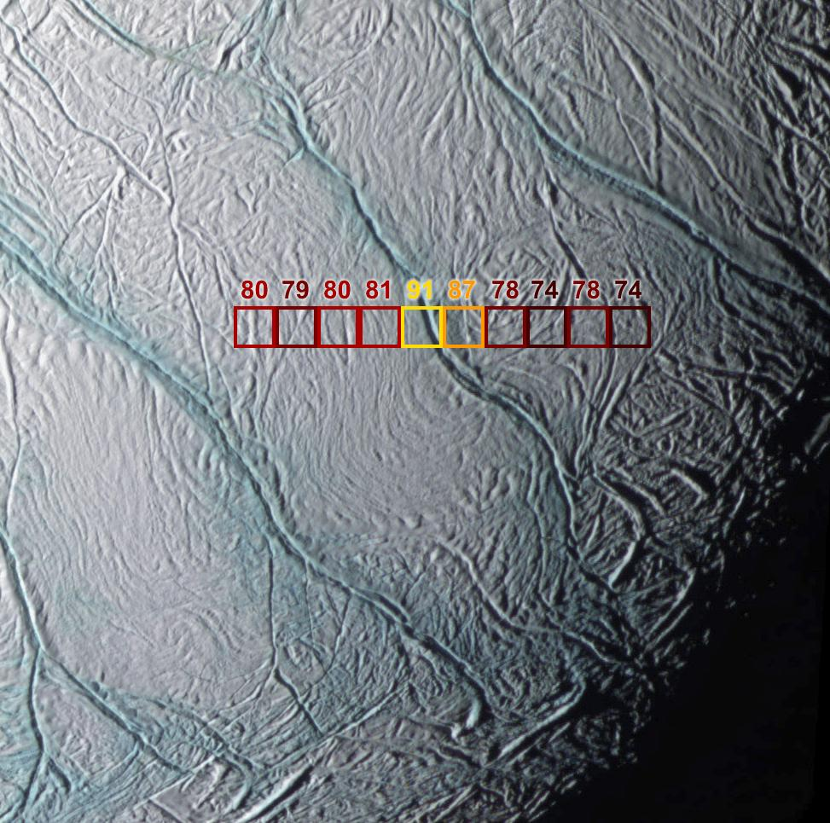
Figure 1: Tiger stripes in the vicinity of the South Pole⁵⁴

On November 27, 2005 Cassini collected very high phase angle images of Enceladus, revealing multiple collimated jets that form a plume of material (mostly water), extending hundreds of kilometers above the South Polar surface.³⁹

In mankind's search for life and habitable environments on other worlds, evidence of liquid water elsewhere in the Solar system is of great importance. In 2005, images sent back from the Cassini-Huygens mission to Saturn revealed water vapor and ice erupting from the south pole of Saturn's moon Enceladus. The Cassini spacecraft has performed several flybys of Enceladus, sending back images of a dynamic body with a relatively young surface covered in ice, exhibiting at least five different types of terrain. Cassini will fly by Enceladus only once more in March 2008, leaving many questions unanswered. Thus, a dedicated mission to Enceladus is the only effective way to fill the gaps that Cassini will leave behind. This mission will send a lander to the moon's surface, which will: 1) determine if liquid water is present and map its distribution, 2) investigate the existence of life and/or organic molecules, 3) learn about the physical processes that created the surface, and 4) probe the physical structure of the moon's interior and potentially identify sources of heat for the south pole geysers. This mission will actively engage students in NASA science by introducing outreach projects and involving the public in the search for life. Landing on Enceladus plays a key role in NASA's mission by advancing the search for life and contributing to the exploration of the universe.

Mission Rationale

Science

As described above, images sent back from the Cassini-Huygens mission to Saturn revealed water vapor and ice erupting from the south pole of Enceladus. These recent discoveries indicate that this small moon of Saturn is one of the only active bodies in the Solar system. Since Cassini will fly by Enceladus only once more in March 2008, many questions will remain unanswered. The very large plume at its southern pole could imply the existence of a subsurface liquid layer, creating possibilities for important astrobiology findings.

Science Overview

In order to fill the gaps that Cassini will leave behind, a dedicated mission to Enceladus is proposed. This dedicated mission will include a lander that descends to the moon's surface, and:

Scientific Objectives
- Determines if liquid water is present and maps its distribution,
- Investigates the surface chemical composition, such as elemental abundances and organic molecules that are critical to life,
- Studies the physical processes that created the surface, and
- Probes the physical structure of the moon's interior, potentially identifying sources of heat for the south pole geysers.

The EAGLE mission will carry several instruments that address the scientific goals listed above. Some of these goals will be achieved during the first stage of an Enceladus-orbiting spacecraft. This spacecraft will carry a near-infrared mapping spectrometer (NIMS), a photopolarimeter/radiometer (PPR), an Enceladus descent imager (EDI), a laser altimeter, and a magnetometer. On the spacecraft’s second stage, a different science payload will be carried to the surface of Enceladus. The instruments selected for this package include miniature seismometers, a panoramic camera (Pancam), a drilling and sample delivery system (SD2), a laser-induced remote sensing instrument for chemistry and micro-imaging (ChemCam), an amino acid analyzer (UREY), an Enceladus Surface Analyzer Mass Spectrometer (ESAMS), and an alpha-particle X-ray spectrometer (APXS).

Mission Objectives

From orbit around Enceladus, EAGLE will study the differences between various regions of the surface. The NIMS will address EAGLE’s second and third scientific objectives by identifying short-chain organic molecules in the surface ice, and by measuring the size and crystallinity of the ice particles to reveal how and when they were formed. The PPR will contribute to EAGLE’s fourth scientific objective by mapping the temperature distribution across the surface of Enceladus and identifying hot spots. During the orbit and descent phases, the EDI and laser altimeter will meet the third objective by mapping the surface in three dimensions at high resolution. Scientific objectives one and four will be met by using a magnetometer. The magnetometer will attempt to discover evidence of liquid water by investigating Enceladus’ subsurface structure when EAGLE is in the orbit phase.

Landing on Enceladus will enable more detailed characterization of the surface properties near the vents. Miniature seismometers will help identify pockets of liquid water (science objective #1) and activity in the subsurface (science objective #4). The Pancam high-resolution images will show structures that should provide more information about the processes shaping the surface (science objective #3), whereas the ChemCam and APXS instruments will determine the elemental composition of the surface by observing various targets (science objective #2). By analyzing samples from SD2 and from the plume, UREY and ESAMS will measure the abundances of complex and simple organic molecules, respectively (science objective #2).
The Photopolarimeter/Radiometer will study surface texture and temperature variations. It will map thermal emission and polarization properties across the South Polar region, and has the capability of taking these measurements elsewhere on Enceladus. The Photopolarimeter/ Radiometer must have an accuracy of 1 K and a 2.5-mrad field of view. The primary instrument functional requirement is that its internal components must be temperature-calibrated. The Photopolarimeter/ Radiometer also requires that the spacecraft have an orbit that allows for complete surface mapping.

Science Requirements

Photopolarimeter/Radiometer
The objectives for the laser altimeter are to determine elevation and changes in topography. It is also a critical part of the decent phase for the lander, used in conjunction with the autonomous landing software. The laser altimeter will take measurements of the time required for the laser pulse to complete a round trip from the instrument to the surface of Enceladus and back to the instrument. In order to make these measurements, the instrument must be directed towards the surface. The functional requirements for the instrument include a range up to 750m and a resolution of 50mm. Measurements must be taken while in orbit and during decent phase of the mission.

Laser Altimeter
The magnetometer will investigate the atmosphere and subsurface of Enceladus. To do so, it will measure variations in the interaction between Enceladus and Saturn’s magnetic field, covering a range of 0 to ±256nT. The main instrument and mission requirements are that the magnetometer be at the end of a 9 m long boom, and will operate during while in orbit around Enceladus.

Magnetometer
The Near-infrared mapping spectrometer will study surface composition and ice structure on Enceladus. It will be capable of mapping near-IR reflectance across the South Polar region and elsewhere. This requires a resolution of 0.5-mrad, and an orbit that will provide opportunities for complete surface mapping. Furthermore the instrument must be passively cooled to ~150 K.¹³

Near-infrared mapping spectrometer
During the orbiting phase and during entry, decent and landing, the Enceladus Descent Imager (EDI) will map Enceladus and provide imagery for the automated landing software. It will take color images using multiple filters with a wavelength range of 400-1100 nm. This will require a telephoto zoom with a varied field of view from 50º to 10º. The Enceladus Descent Imager (EDI) also requires a resolution between 24m/pixel and 5m/pixel, and greater during descent.

Enceladus Descent Imager (EDI)
The miniature seismometers will observe tectonic activity in order to characterize the subsurface of Enceladus from 10 to hundreds of meters. To do so, the seismometers will measure tectonic activity over a period of time (days to weeks, depending on the activity of the region). The Seismometers must be placed on a stable part of the lander, and ideally measurements will be taken at a time when lander vibrations are at a minimum – not during periods of active drilling. However, data can be collected occur continually.

Seismometer
Throughout the mission, the Pancam will assess the morphology, topography, magnetic properties, and geologic context of the landing site. It must be able to constrain surface photometric and physical properties as well as generate digital terrain models. The Pancam will also obtain information regarding the density or physical properties of the geyser material, monoscopic and stereoscopic images and mosaics, and multispectral images over a range of viewing geometries. The Pancam is also required to provide adequate stereo coverage as well as view and obtain images of geyser material. To accomplish this, the Pancam must be raised above lander (on a mast) and have capability to swivel 360°. It must resolve one millimeter per pixel from 10 feet away, be in line of sight of the calibration target, and take panoramic images in all directions from the lander. Pancam must also be able to look up towards geyser material and take approximately 20 images a day.

Pancam
The Saturn Orbiting Camera (SOC) will take wide-angle color images of Saturn and its moons aboard the Saturn Orbiter. This requires 18 filters covering a wavelength range from 380-1100 nm. The camera must have field of view of 3.5º in order to image moons from a distance of 13,000 km to greater than 100,000 km while in orbit. In addition to imaging while in the Saturnian system, SOC must also be powered on to image during gravity assist flybys of Venus and Earth.

Saturn Orbiting Camera (SOC)
ChemCam’s science requirements include: characterizing the geology of the landing region, accessing any organics present in the target, detecting water ice, and measuring surface composition near the lander. The laser must operate at a distance of 1-13 m at a frequency range of 1-20 Hz and a wavelength of 1067 nm. The laser should be directed onto the sample causing ablation into light emitting excited states. The micro-imager will provide very high resolution images of targets. The mass unit must detect elements such as H, Li, Be, B, C, N, O, Ba, Sr, Cs.

ChemCam
The Enceladus Surface Analyzer by Mass Spectrometry (ESAMS) must find the composition of Enceladus’ surface and be able to detect carbon chains if they exist. The mass spectrometer will have sensitivity at a range of 1-300 amu. ESAMS will use SD2 to take samples from the surface and place them in the ovens before pyrolysis before analysis. Samples will be collected from 2-3 depths with SD2 as well as from the Falling Sample Collector (FSC).

Enceladus Surface Analyzer by Mass Spectrometry (ESAMS)
The Amino Acid Analyzer (UREY) will find complex organic molecules in surface samples. It must identify and quantify amino acids and nucleobases with parts-per-billion sensitivity. It must also measure chirality of amino acids from solid sample(s) collected from the surface. SD2 is needed to accomplish these goals.

Amino Acid Analyzer (UREY)
See the Section 10.1: Science Trade Studies.Science Trade Studies

Trade Studies

The first flyby of the Saturn system was performed by the Pioneer 11 spacecraft in 1979. Pioneer took low-resolution images of Saturn and several moons, but no surface features could be discerned due to the resolution. Our knowledge of the Saturn system was enhanced by the Voyager 1 and 2 missions in 1980 and 1981, which took the first high resolution images of Saturn, its rings and its moons. Voyager 1 also performed a flyby of Titan to investigate its atmosphere. However, the most enlightening mission thus far has been the Cassini-Huygens mission, launched in 1997. Cassini is presently orbiting Saturn, and continues to send back images and data that further our understanding. The Cassini-Huygens mission has served as a great foundation for this mission, and the images of Enceladus taken by the Cassini spacecraft are what initially sparked interest in this moon. In 2005, the Cassini spacecraft revealed large geysers of water vapor spewing from the South Pole of Enceladus. The Eagle mission intends to use some of the high resolution images taken by Cassini to help select a landing site on Enceladus. Additional information will be gained in Cassini’s next flyby of Enceladus, scheduled for 2008.

Connection to Past, Present, and Future Saturn Missions

Payload

Instruments

Lander
The amino acid analyzer (“UREY”) is an instrument suite under development for the European ExoMars mission, currently slated for launch in 2011 or 2013.⁶⁵ Using a solid sample, the instrument suite will be capable of identifying and measuring the abundance of complex organic molecules including amino acids, amines, nucleobases, and polycyclic aromatic hydrocarbons (PAHs). The latter are found in almost all sedimentary fossils uncovered on Earth, while the other molecules are the building blocks of protein, DNA, and RNA, the compounds essential to life on Earth. Sensitivity to these compounds will be in the part-per-billion to part-per-trillion range, exceeding that of the Viking experiments on Mars by several orders of magnitude. Chirality of amino acids will also be measured, which will distinguish between a biogenic vs. abiogenic origin of the amino acids.

Amino Acid Analyzer

The UREY package includes four components, which work together to study the organic chemistry of planetary surfaces.^{3,66} First, a subcritical water extractor (SCWE) extracts the targeted compounds from the collected sample. These compounds are then heated to the point of sublimation in an instrument called the Mars Organic Detector (MOD), thereby isolating the organic molecules of interest and increasing their concentration. The vaporized organics are trapped on a cold finger in the MOD and bombarded with ultraviolet laser light, which causes PAHs to fluoresce with a characteristic spectrum. The cold finger is also coated with fluorescamine, which bonds to amino acids, amines, and nucleic acids to create fluorescing compounds. MOD identifies each of these organics using a fluorescence spectrograph.

Instruments and Operations

If MOD detects organics in a sample, then the sublimed molecules are transferred via a “sipper” to a “lab-on-a-chip” microcapillary electrophoresis (CE) system for further composition analysis at the part-per-trillion level. The CE device also measures the chirality of any amino acids in the sample. Finally, a Mars Oxidant Instrument (MOI) is included with the SCWE/MOD/CE suite for further study of possible oxidative surface environments, such as that discovered on Mars by the Viking landers. Oxidation reactions would rapidly break up organic molecules on the surface, so that if MOI finds the surface to be highly oxidizing, then a non-detection of organic compounds by MOD will be understandable.

The total mass of the instrument is 3.2 kg, and it occupies a volume of 11 cm x 14 cm x 15 cm. It has a peak power requirement of 28 W.

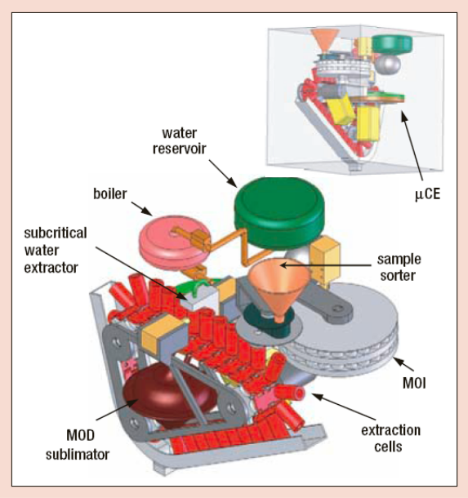
Figure 2: Amino acid analyzer (‘UREY’) instrument^{3,66}
To determine the elemental chemistry of the material at the landing site, the payload includes an Alpha Particle X-ray Spectrometer (APXS), similar to those on the MER and Rosetta missions, on the bottom of the lander. By exposing the target material to energetic alpha particles and x-rays from a radioactive ₂₄₄Cm source, the APXS determines the elemental composition by measuring the energy spectra of backscattered alpha particles and emitted x-rays. There are six of these small radioactive sources in the APXS “head”.²

Alpha Particle X-Ray Spectrometer

The radioactive sources emit the alpha particles, which bounce back from the target material—after directly hitting an atomic nucleus—into a detector in the APXS, along with some x-rays that are excited from the target in the process. By using the laws for Rutherford Backscattering in an angle close to 180°—conservation of energy and conservation of linear momentum—it is possible to calculate the mass of the nucleus hit by the alpha particle. Light elements absorb more energy, while heavy nuclei reflect more back. The resulting energy spectrum of the scattered alpha particles then exhibits 25% to almost 100% of the initial particles, depending on how many were absorbed. X-ray fluorescence is also emitted when the alpha particles bump out lower shell electrons, forming vacancies that are filled by electrons from upper shells. This easily detectible x-ray fluorescence is characteristic of each element, having best resolution for heavier elements.

The detectors then measure the energy distribution of the alpha particles and x-rays, and the analysis determines the amounts of different chemical elements present. Most of Enceladus’ surface is water ice; however, it is desirable to measure the surface composition to discover what elements are in the ice, along with their proportions. The elemental composition provides information about the formation of the moon’s surface, and identifies the amount of critical elements necessary for life.

The x-ray mode is sensitive to major elements, such as Mg, Al, Si, K, Ca, and Fe, and to minor elements, including Na, P, S, Cl, Ti, Cr, and Mn. The alpha mode is sensitive to lighter elements, most importantly C and O. The depth of analysis varies with atomic number, ranging from about 10 to 20 micrometers for sodium, to about 50 to 100 micrometers for iron. The detection limit is typically 0.5 to 1 weight percent, depending on the element. The APXS is insensitive to small variations in the geometry of the sample because all major and minor elements sum to 100 weight percent.²

The APXS instrument consists of a sensor head mounted on the bottom of the lander within a cylindrical casing, with electronics mounted in the lander’s warm electronics box. The casing will be lowered from within the lander via rack and pinion so that the sensor will be within a maximum distance of 40 mm from the target, though closer to the point of touching is preferred. The total strength of the six 244Cm alpha radioactive sources is about 30 mCi. The sources are each covered with 3-µm aluminum foils that reduce the energy of emitted alpha particles from the initial value of 5.8 MeV to about 5.2 MeV.² This significantly reduces the alpha particle scattering cross section of carbon and removes much of the atmospheric background in the alpha spectra. However, since the excitation spectrum is broadened, there is a slight degradation of the alpha spectral resolution. Collimators in front of the sources define the instrument’s field of view, which is about 38 mm in diameter at the nominal working distance of 29 mm. For best results, the APXS must be placed with its front aperture ring in contact with the sample surface and the axis of the sensor head must be within 20 degrees of normal to the surface.¹¹

The accumulation time for the APXS will usually be at least 10 hours per sample analysis, although much shorter durations are acceptable when only the x-ray mode is used. However, the total accumulation time can be separated into several shorter accumulation periods. The APXS can store up to 12 sets of accumulated spectra and can transmit the data to the lander after one set is accumulated or after all sets are accumulated.²

A pair of doors protects the entrance to the detector head from potential contaminants. These doors swing inward and lock open when the sensor head is pressed against a target or other hard surface. They can be closed again by actuation of a release mechanism. The inner surfaces of the doors provide a calibration reference surface for the instrument.

Proper preflight calibration is necessary to properly analyze APXS data, so the instrument will undergo an extensive calibration program mirroring that of the Athena APXS on MER. The Athena calibration measurements were made in a chamber filled with a mixture of gases that closely matched the composition of the Martian atmosphere, at the appropriate atmospheric density. Since Enceladus has no atmosphere, EAGLE’s APXS will be calibrated within a vacuum unless Cassini’s June 2008 flyby shows a change in atmospheric composition in the South Polar region. Calibration measurements will include:
- spectral “library” measurements of pure elements and oxides;
- geochemical standards that span the full range of plausible Enceladus surface compositions;
- standard targets in both hard ice and powdered form, to investigate texture effects;
- the APXS flight calibration target;
- several blind certified geochemical reference standards, for independent assessment of the accuracy with which compositions can be measured. ²

The APXS has a mass of 0.57 kg, and is 10.5 x 8.0 x 6.5 cm.⁴⁷ It uses on average 0.3 W, though with associated power supplies draws 0.8 W of raw power. Nonvolatile APXS memory stores a maximum of 64 Kbits, even with power off, and plays back a maximum of 16 Kbits per query at 9600 baud (RS 232) when turned on. It has a data rate of 9600 kb/s. (NSSDC ID: MESURPR-01) The lander CPU does not need to run during APXS operation, except for on/off commands and APXS data playback.

On MER, the APXS sensor head only operated when the surrounding Martian ambient temperature was between -100°C and +25°C. This is much warmer than the surrounding Enceladus ambient temperature, so thermal control measures will be necessary to provide an adequate environment.²

Since versions of the APXS flew on both MER and Rosetta missions, it has extensive applicable flight heritage.

The goal of the Enceladus Descent Imager (EDI) is to map the moon during the orbilander phase, as well as provide information to automated software for landing. This versatile camera must be able to provide high resolution images from an orbit 50 km above the surface, and continue imaging as the orbilander descends, to a distance of 5 m from the surface. It must also have low mass due to the large amount of fuel required to take mass into Enceladus orbit. Considering these constraints, the best instrument to fulfill the requirements resembles Malin Space Science Systems’ Mars Descent Imager (MARDI) from the Mars Science Laboratory (MSL)³⁴.

Camera/Descent Imager

This instrument will have flight heritage from cameras aboard the Mars Polar Lander, Phoenix, and Mars Science Laboratory; however, technological advancements will improve EDI’s performance by the time of launch. EDI includes many features such as telephoto zoom, focus, high-speed data acquisition, and multispectral imaging from 400-1100nm. The zoom optics provide a field of view ranging from 10º at the long focal length position to 50º at the shortest focal length. The detector is a 1600x1200 pixel CCD which produces low noise images. EDI will be capable of mapping Enceladus’ entire surface with approximately 24 m/pixel resolution while in 50 km orbit, with the capability to obtain high resolution images at about 5 m/pixel. During descent, EDI will continue to image the surface. This information will be used for navigation as described in Section 4.1.1.5.2. The entire package will have a mass of approximately 0.6 kg, operate at an average power of 10 W, and will be 7 x 7 x 10 cm³ in dimension³⁴.
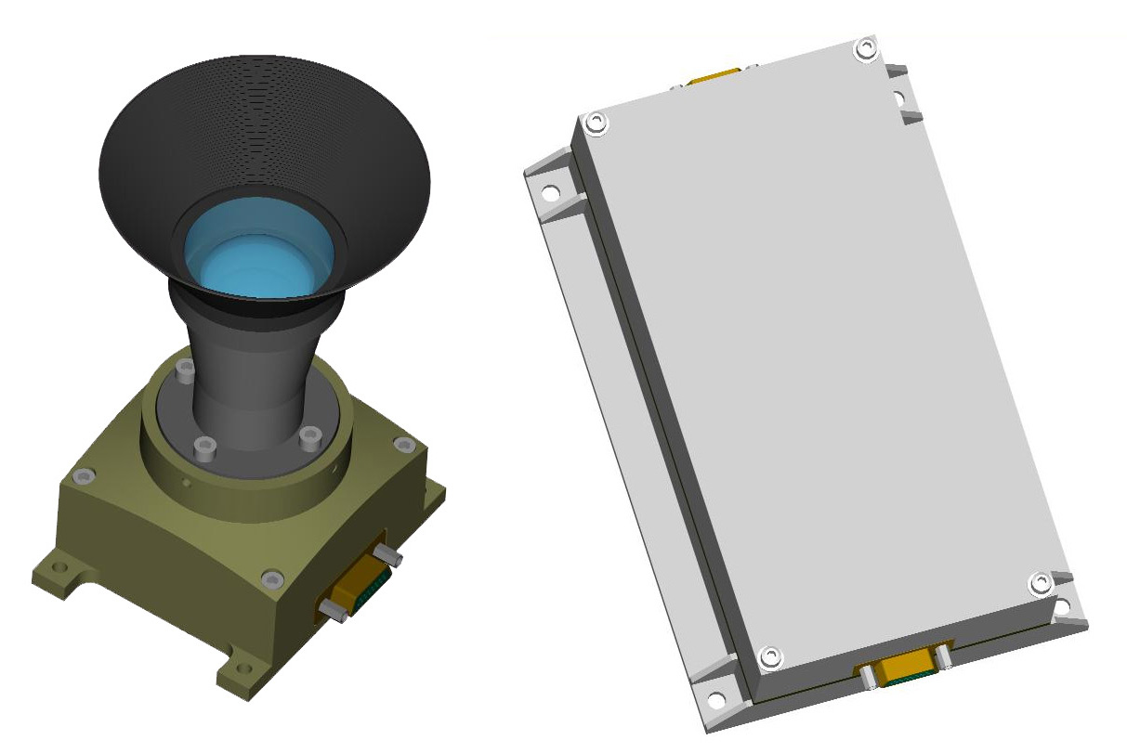
Figure 3: Engineering rendering of MARDI for MSL camera head as well as electronics box. (Courtesy of Malin Space Science Systems)

After the EAGLE lander reaches the surface of Enceladus, several scientific investigations will occur. However, the mobility and scope of scientific investigations will be limited by the icy terrain. To overcome this constraint, the payload includes the ChemCam, which has the ability to capture elemental composition of samples located at great distances.

ChemCam

The ChemCham will meet the following science objectives:

Science Objectives

- Fast analysis of the sample (6 minutes)
- Trace quantitative elemental composition of different samples, from which H, Li, Be, B, C, N, O, Ba, Sr, Cs are very sensible for detection.
- Detect hydrated minerals.
- Characterize geological features of the surroundings.
- Provide superficial and subsurface profiles of samples.
- Wide range of site investigations allowing several measurements at diverse locations, permitting a comparison of elements among different targets.

The ChemCam analysis is conducted mainly by two groups of instruments, the Laser-Induced Breakdown Spectrometer (LIBS) and the Remote Micro-Imager (RMI). The LIBS is comprised of a powerful laser and three spectrometers. After selecting the desired sample, the laser beam will be directed toward the target, removing the outermost layer of the sample, and inducing atom excitement. This atomic stimulation causes light emission, which is then measured by the UV spectra, the red visible spectra, and the blue visible spectra. The following are the advantages that LIBS presents to the EAGLE Mission:

Instrument Task Description

The LIBS does not require sample collection for analysis.
It operates at distances several meters away from the lander.
The time to analyze the sample and recharge for next operation is short.
By removing the outer layer of the sample, it will provide a depth profile for a better investigation.
LIBS maximizes the capability of element detection from the sample in comparison with other instruments.
LIBS minimizes the amount of power required.

The primary advantage of RMI is the production of the highest possible resolution images without an operational sample. RMI provides a close-up imaging of the target at long distances, revealing sub-millimeter structural analysis.

The ChemCam design has three separate units:

Instrument Subsystems

Body Unit:
Spectrograph x 3
Power Box
Data Processing Unit
Mass Unit:
Laser
Remote Micro Imager
Telescope
Focus Laser
Calibration Unit:
Target Calibration

The ChemCam executes three steps to collect and analyze data after target selection:

Instrument Operation

Monochromatic light illuminates the target. The light is scanned and monitored at the correct wavelength of the spectrograph, correcting the focus based on the maximum data fit.
The RMI takes a general image with a resolution of 1024 X 1024 pixels prior to LIBS analysis, and a 128 X 128 pixel image will be taken after the LIBS analysis.
The LIBS laser fires at the target approximately 75 times, producing plasma as it contacts the sample, which is recorded by the spectrograph. This instrument may conduct further laser tests if additional analysis is necessary.

The Mars Science Laboratory Rover, which will launch in 2009, incorporates the ChemCam into the science payload. This instrument quickly characterizes the chosen sample, and identifies additional samples without having to move the whole vehicle. The specifications of this instrument are as follows:

Specifications

The laser altimeter will determine elevation, and will be especially important during the mapping and landing phases of the mission. Elevation will be determined by measuring the time required for the laser pulse to complete a round trip from the instrument to the surface and back to the instrument. The laser altimeter design will be similar to the LD90-3800-FLP, developed by Riegl Laser Measurement Systems. The altimeter mass will be approximately 4.4 kg, with external dimensions of 232 x 184 x 100 mm, and will require 11-28 Volts DC, with approximately 10 W built-in protecting circuitry for over-voltage and reverse polarity⁴⁴. The altimeter developed by Riegl Laser Measurements System will have a range of 750 m if reflectivity > 0.8, a resolution of 50 mm and an accuracy of 50 mm.

Laser Altimeter

The laser altimeter will be used in conjunction with Autonomous Vision-Guided Safe and Precise Landing (AVGSPL) software to land safely on the surface of Enceladus autonomously. The software is currently being developed under CICT’s Intelligent Systems (IS) Project. Core components of AVGSPL were demonstrated in the landing of the Mars Exploration Rovers (MER), using a subsystem known as DIMES - Descent Image Motion Estimation Subsystem. The software will use a series of images taken in the final seconds before landing, along with data from the laser altimeter, to determine altitude. Pre-programmed actions and reflexes will enable the lander to quickly adapt and respond to changes in the environment and within itself²⁹. Prior to landing, the vision althgorithms construct an elevation map. Software operators are then applied to the terrain map to locate regions that are free of steep slopes and uneven terrain. When a safe landing site is identified, the lander will enter what is known as “object-track mode” and a state estimation algorithm will send commands to the autonomous flight controller. The vision-based controller will command the lander to enter “landing mode” once it is above the desired landing site²⁹.

Autonomous Landing Software

With the limited data available, it is difficult to select an exact landing site at the time of this study. However, some potential areas could be selected from the high resolution images taken by Cassini, and the next fly-by of Enceladus in 2008 may reveal even more information. The landing site will be selected using the high resolution images from Cassini, combined with images taken during the first phase of the landing mission, during which a considerable amount of time will be spent orbiting and mapping the moon. The science objectives dictate that the lander will land in the South Polar region of Enceladus, ideally close to a plume. Investigation of the “Tiger Stripes” in this region is also of primary interest to the science mission objectives--as they may be relatively younger ice--and these cracks are potentially closer to liquid water

Landing Site Selection

Cassini’s Dual-Technique Magnetometer (MAG) discovered Enceladus’ plume during a flyby of that moon. By measuring the interaction of Enceladus with Saturn’s magnetic field, the Cassini team was able to detect deviations that indicated mass ejection from the surface. Following this measurement, cameras imaged the region to reveal the plume ejecting from the surface. Magnetometers can also investigate subsurface structure such as underground oceans. The EAGLE lander will carry a magnetometer while orbiting Enceladus to map the moon’s interaction with Saturn’s magnetosphere more precisely, and thus infer properties of the subsurface.

Magnetometer

EAGLE’s magnetometer will be similar to one of the magnetometers flown on Cassini²¹. The vector/scalar helium magnetometer developed at the Jet Propulsion Laboratory (JPL) has two modes of operation. The vector mode measures the field in three dimensions to get a precise direction of the magnetic field; whereas, the scalar mode measures only the magnitude when measuring stronger magnetic fields. The instrument must be placed at the end of a 9 m long boom in order to isolate it from the spacecraft’s mass and electrical currents. The total mass is less than 3 kg plus the mass of the boom and it uses 3 W of power²¹.

Cassini has found strong evidence for the existence of water and organic molecules on Enceladus¹⁰. In order to accomplish one of EAGLE’s main objectives, the search for organic molecules, surface sampling is necessary to confirm Cassini’s findings. The Enceladus Surface Analysis by Mass Spectrometry (ESAMS) experiment will perform in-situ investigation in order to detect complex organics using a gas chromatograph and time of flight (TOF) mass spectrometer. Samples will be delivered to the experiment in two ways; from the surface by SD2 (Section 4.1.1.10), or directly from the plume using the Falling Sample Collector (FSC) attached to the top of the lander. The main heritage for this instrument will be from the COmetary SAmpling and Composition (COSAC) experiment currently flying aboard ESA’s ROSETTA mission to Comet 67P/Churyumov-Gerasimenko⁴⁵. A mass restriction of 5 kg and a power restriction of 16 W are placed on the instrument design.

Enceladus Surface Analysis by Mass Spectrometry (ESAMS) Experiment

As with COSAC, samples will be collected from the surface and feed into small ovens for pyrolysis. Ten pyrolysers sit on a carousel that will take the delivered sample from the drill to the GC/MS input. Each small oven will be used only once to prevent cross contamination. The ovens are platinum cylinders measuring 6 mm in height and 5 mm in diameter. Each oven weighs less than 1 gram but is capable of heating to 600 ºC to vaporize the samples. The FCS will also be able to deposit samples into the carousel. This will be a cup-like collection device with a surface area large enough to collect a 5 mm³ sample within the first week of landing on Enceladus. The rate of deposition from the plume onto the surface is not yet known; however, Cassini will be able to deliver this information as it continues to study Enceladus from Saturn orbit.

Gas from the ovens can be analyzed by gas chromatograph (GC), mass spectrometry (MS) or in combined GC/MS mode (see Figure 4.1.4.1). For GC mode, the gas exiting an oven will be moved using He carrier gas stored in stainless-steel containers. Several columns will be used in the capillary gas chromatograph, which will be developed to identify a wide range of masses from noble gasses to organic molecules.

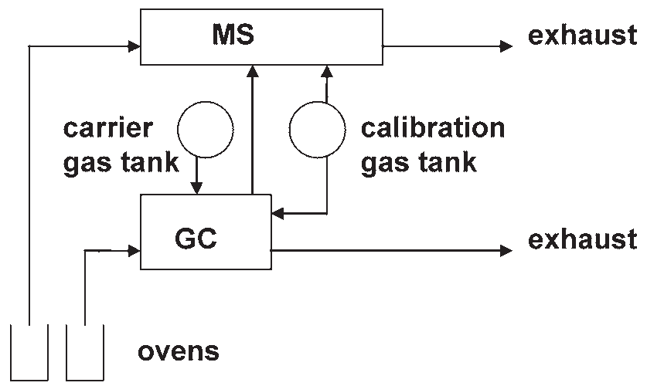
Figure 4: Mass Spectrometer Gas Chromatograph

An electron beam ionizes gas molecules entering the mass spectrometer. The ions are then accelerated through a constant voltage. The velocities of ions depend on the mass-to-charge ratio, which can be measured using the time it takes ions to reach the detector. The mass spectrometer will have a range between 1-300 amu, which is large enough to detect all hydrocarbon chains expected to pass thought this instrument⁴⁵. The calibration process will determine the level of Earth organics in the mass spectrometer, thereby validating any detection of non-Earth compounds.

Surface samples will provide the best results, assuming that the freshly deposited surface will be the least effected by radiation. Furthermore, the FSC may complement any data by ensuring the purity of the sample. Samples can also be taken at each hopping site to look at composition distribution on the surface. All of these measurements will provide information on the composition of the moon as well as the possibility of detecting life.

The NIMS will produce a near-IR spectral map of the surface of Enceladus from orbit. The primary goal of this study will be to examine the composition of Enceladus’ ice at various locations across the surface. The surface is nearly pure water ice, but carbon dioxide and short-chain organics are also present in the region of the tiger stripe features. Some of the primary science objectives focus on further study of the form and distribution of these organics. The wavelength range also covers absorption bands of carbon monoxide and ammonia, the latter of which is important both to interior models of Enceladus and to solar system formation theory. Additional spectral features will provide information about the grain size and structure—amorphous vs. crystalline—of the ice; these parameters can in turn yield a better understanding of the time and temperature at which the ice formed. Mapping the entire surface of the moon at near-IR wavelengths will enable comparative studies of ice properties and trace constituent composition across the surface, which will facilitate selection of a landing site.

Near-Infrared Mapping Spectrometer

The Galileo-NIMS instrument¹³ is the model for EAGLE’s NIMS. Light enters the spectrometer through a telescope of aperture 22.8 cm. By rotating the secondary mirror, the telescope scans in a single direction, providing 1x20-pixel strips of imaging data. This corresponds to a field of view of 0.5 x 10 mrad per strip. The light passes through an optical chopper, creating a dark reference, and onto a diffraction grating, which disperses the light on its way to the focal plane assembly. An array of filters and 17 detectors populate the focal plane. The instrument can measure up to 408 spectral channels, spanning the range from 0.7 μm to 5.2 μm, by moving the grating so that different colors fall onto each detector.

Components and Operations

The total instrument mass is 18 kg; the optics occupy a volume of 83 cm x 37 cm x 39 cm, while the electronics occupy 20 cm x 25 cm x 13 cm. The average power draw is 12 W, and the peak power required is 13 W. The instrument is passively cooled to 150 K during operations, when it achieves a data rate of 11.52 kbps.

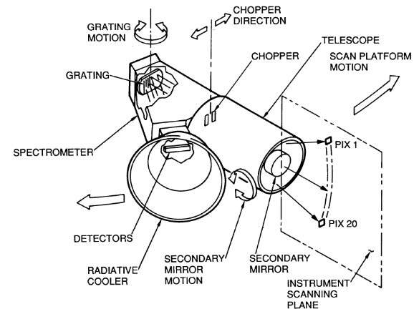
Figure 5: Near-Infrared Mapping Spectrometer¹³

The radiometer will image the surface of Enceladus from orbit in the thermal infrared portion of the spectrum. The global distribution of temperature across the surface will thus be ascertained, allowing the identification of hot spots, which may serve as attractive potential landing sites. In addition, a photopolarimeter is packaged with the radiometer; this will enable additional studies of the texture and composition of the surface ice.

Photopolarimeter/Radiometer (PPR)

The Galileo-PPR instrument⁶⁷ is the model for EAGLE’s PPR. Light enters the spectrometer through a telescope of aperture 10 cm. Separate detectors and operating modes exist for infrared radiometry, optical photometry, and polarimetry. For radiometric measurements, a chopper provides observations alternating between the scene-viewing telescope and the space-viewing telescope; the latter observes an empty patch of sky for temperature calibration. All electronic components are carefully calibrated and have temperature sensors, enabling useful radiometric measurements without cooling to cryogenic temperatures. For photometry and polarimetry, the chopper is not used, and a polarizing beamsplitter separates the light into orthogonal polarizations. All of these modes yield images with a 2.5 mrad circular field of view. Five spectral bands ranging from 15 to approximately 100 μm provide broad radiometric coverage of the thermal infrared, while seven visible/near-infrared bands are used for photometry, and three visible/near-IR bands for polarimetry.

Components and Operations:

The total instrument mass is 5.2 kg; it occupies a volume of 44.8 cm x 39.1 cm x 32.7 cm. The peak power required for operating the instrument is 11.0 W; its heaters require an additional 4.5 W. PPR can operate within a temperature range from -20 to 5 °C; to survive while not operating, it must be maintained between -25 and 30 °C. The data rate for PPR is 216 bps.

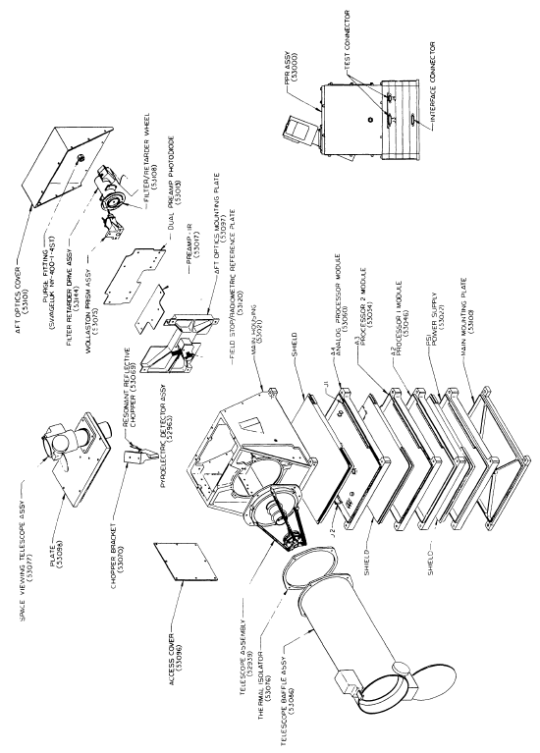
Figure 6: Exploded view of photopolarimeter⁶⁷

The ESAMS experiment and the amino acid analyzer instruments on EAGLE require samples taken directly from the surface or near subsurface. To fulfill this requirement the payload includes the Drilling and Sample Delivery System (SD2).^{68,69} The SD2 is an integrated driller, sample tool, and carousel instrument that will provide samples from near the surface to a depth of 230 mm. The carousel then distributes the samples to the appropriate instruments.

Drilling and Sample Delivery Subsystem (SD2)

The SD2 was developed for the ROSETTA mission, a cometary rendezvous mission incorporating small masses, while obtaining a reasonable sample for the other instruments to analyze. The specifications for the SD2 are the following:

Specifications
The drill bit may penetrate the surface to a maximum depth of 0.23 meters. Once the desired depth has been reached, the drill bit begins raising material and placing it above the carousel. This collection method takes multiple samples between the surface and the depth of penetration, and supplies them to the instruments for analysis. After placing the sample in the carousel, it is then transferred to a sealed oven and begins the ESAMS and Amino Acid analysis.

Operations

The primary goals of the seismometers are to probe the physical structure of the moon's interior and determine its tectonic activity. Furthermore, information gained from the seismometers could potentially be used to identify sources of heat for the South Pole geysers. The lander will hold 2 seismometers, each with a mass of 0.2 kg and requiring only 0.1 W⁷⁰. The Microdevices Laboratory of JPL is currently developing these seismometers, which are intended for extraterrestrial applications. The miniature seismometers measure 2 x 2 x 3 cm (see Figure 7), and their low mass, volume and power requirements make them ideal for such planetary expeditions. These instruments can provide high-quality seismic measurements, comparable to that of conventional terrestrial seismometers.

Seismometer

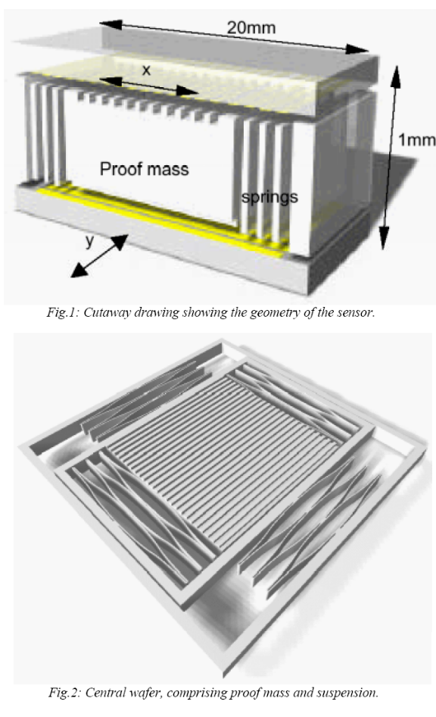
Figure 7: Miniature seismometer

The seismometers will be positioned on the legs of the lander, ideally operated at a time when lander vibrations are at a minimum; although the instruments allow for continuous data collection. Key elements of the seismometer include a suspension mechanism, proof mass and capacitor plates, and a very sensitive capacitive displacement transducer, which will use a force-rebalance feedback system.

Seismometers are an excellent method for investigating subsurface structure-- especially in the near-subsurface--where the propagation of waves is more sensitive to density and degree of compaction. The use of seismometers could help to identify the presence of water, as well as different layers in the upper crust of Enceladus⁷⁰.
The lander will have a Panoramic Camera (Pancam) attached to it, similar to those implemented in the MER mission launched in 2003. The scientific goals of the Pancam are to obtain color pictures of the surrounding terrain, to assess the morphology, topography, and geologic context of the landing site, and to obtain any information regarding the density or physical properties of the geyser material falling back to the surface. Simply analyzing images of the landing site can provide information on the history of its formation. The Pancam can also help in locating hazardous terrain to avoid during a “hop”, and identify potential relocation sites. The pictures can also be utilized in public outreach and educational products.

Wide Angle Camera

Pancam is a multispectral, stereoscopic, panoramic imaging system consisting of two digital cameras mounted on a mast 50-70 cm above the lander deck. On the mast, Pancam can image the full 360° in azimuth and ±90° in elevation. Each Pancam camera has a 1024 x 1024 active imaging area frame transfer CCD detector array. The cameras are designed to each use half of their pixels, making for a total active imaging area of 1024 x 2048, while the other half is used as a storage/readout area masked from illumination by an opaque black-painted aluminum light shield.⁵

Multispectral panoramic imaging provides information on the mineralogical composition of surface materials. It is expected to find mostly ice, but it has the capability of detecting any possible mineral abundances that might have been deposited as meteorites. Current studies of Enceladus find that the surface is mostly covered in water ice; however, should the lander discover any rocks, the Pancam has the ability to study their reflectance properties to constrain surface grain size, degree of compaction, macroscopic roughness, and particle internal structure. The Pancam can also be used for solar imaging. Both solar filters (L8: 440 nm and R8: 880 nm) are sensitive to dust and large ice particles, while the blue solar filter is also sensitive to small ice particles. This will help constrain the opacity of ice particles near the plume where they will be falling back towards the surface.

The Pancam optics have an effective focal length of 43 mm and a focal ratio of f/20, yielding an instantaneous resolution of 0.27 mrad/pixel and a field of view of 16°x 16°. The two Pancam ‘‘eyes’’ are separated by 30 cm and have a 1° toe-in to provide adequate stereo parallax.⁵ Toe-in results in 100% image overlap at a distance from the camera proportional to the toe-in angle, in this case 10 m. The 30 cm separation maximizes the accuracy of far-field ranging, which places the lower limit of its range at 1.5 m. If later research shows that higher accuracy for closer images is desired, the separation distance can be shortened.

Each camera has a mass of about 0.27 kg and operates from 218—278 K. The thermal system on the Enceladus lander will ensure the Pancam remains within this range. The minimum non-operating temperature for all components is 163 K, while the maximum is 328 K. A small 3.5 W (maximum) strip heater is attached to each electronics box and filter wheel to provide survival and warm-up heating if required. Each camera requires +7.1 V and –10.4 V from the lander power supply. Power usage during full-frame imaging is 1.4 W while idle, 2.4 W during integration and readout, and 3.8 W maximum during CCD fast flush. Each full-frame image generates 12.98 Mbits of data. The CCD frame transfer time is 5.2 ms; the readout rate is 200 kHz. This leads to a total readout time of approximately 5 s per full frame image.⁵

Each camera has an eight-position filter wheel in which thirteen of the slots were designed to take images of the surface or to look skyward, two were designed for direct imaging of the Sun, and one was left empty to maximize sensitivity during low-light and ambient Earth temperature (preflight) imaging conditions. Filters range from 440 nm to 1000 nm. A short sunshade and set of black internal baffles provide rejection of stray and scattered light.⁵

A calibration target is included on the lander to verify and validate the preflight calibration of the Pancam imaging system and to monitor the stability of the calibration during the mission. It is located so the Pancam has an unobstructed view of it when deployed and is as far away as possible for best focus. The target is 8 x 8 cm² with a 6 cm high black vertical post for casting a shadow. Measurements in and out of the shadowed region provide a way to quantify the direct versus diffuse components of incident scene radiance. The surface of the calibration target contains three gray level annuli of 20%, 40%, and 60% reflectivity (“black,” “gray,” and “white” rings, with the white ring farthest from the post), and four pieces of pigmented “color chip” materials in the corners. The calibration target materials consist of silicone RTV pigmented with either titanium dioxide or carbon black to raise or lower the reflectivity, or submicron powders of hematite, goethite, chromium oxide, or cobalt aluminate to generate the red, yellow, green, and blue color chips, respectively. The materials were UV-irradiated to handle 30 Martian sols for the MER mission, to minimize any UV degradation of the reflectance levels during operations. It will provide calibrated reflectance and color surfaces that will be used to validate, monitor, and refine Pancam calibration.⁵

The Pancam system is a science instrument designed by members of the Athena science team at Cornell in cooperation with engineers and scientists at the Jet Propulsion Laboratory (JPL) and Ball Aerospace. Pancam components were constructed by JPL, Ball, and many other vendors, and fabrication and integration of the system occurred at JPL.

Orbiter
An essential element of any outer planetary mission for both scientific reasons and public relations is the color imager. The Saturn orbiting phase of the mission will be a bare bones satellite mainly to provide communications. However, while in Saturn’s system, the spacecraft will be in a perfect position to collect stunning images like those received with Cassini’s Imaging Science Subsystem (ISS). The chosen orbit around Saturn allows flybys of the inner moons out to Iapetus, including Titan, Rhea, Hyperion, Dione, Tethys, and of course Enceladus. EAGLE will have a wide-angle camera capable of taking color images, mainly for press releases, but also to expand on Cassini’s imaging science.

Camera

The SOC will have a 3.5º field of view with a 60 μrad/pixel resolution, similar to Cassini’s ISS Wide Angle camera⁴¹. This should allow a full view of Titan during several flybys and more detailed images with closer approaches in the orbit. It will have 18 filters covering a range of 380-1100 nm. SOC will be an f/3.5 with a 20 cm focal length. The detector is a square array of 1024 pixels. The total mass of the system will be around 25 kg, fitting in a cylinder approximately 80 cm in length by 40 cm in diameter (both of these figures include the associated electronics)⁴¹. During the cruise stage, SOC will image Venus and Earth during gravity assists, ideally with enough bandwidth to record several image sequences that can be complied into video clips.

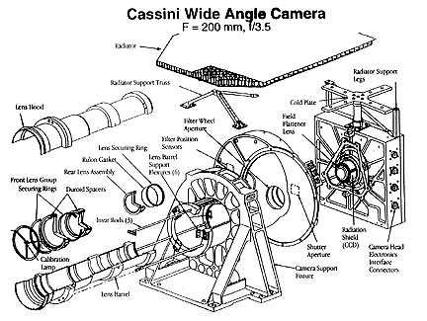
Figure 8: Cassini’s Wide Angle Camera.

The only other science instrument on board the Saturn orbiter besides the Saturn Orbiting Camera (SOC) will be a payload designed and built by students. Mass (10 kg) and power (5 W) will be reserved in the spacecraft design to fill a volume 20 cm x 20 cm x 50 cm on the outside of the orbiter. The science goals of the payload will be at the discretion of the team chosen to build the instrument. Section 8.1 outlines the procedure for team selection.

Student Payload

The orbiter communications system is equipped with an ultra-stable oscillator that has the ability, when coupled with the ground antennas of NASA's Deep Space Network (DSN), to perform radio science experiments. Although Enceladus has only a very thin global atmosphere, the DSN can detect refraction, Doppler shifts, and other radio signal modifications during occultations to determine the temperature and composition profiles of the atmosphere. Furthermore, Doppler and two-way ranging measurements generated by the DSN allow for investigation of the Enceladus gravity field and ephemeredes. A host of other radio science experiments, including tests of general relativity and experiments in solar science, may be performed during the interplanetary cruise phase of the mission.

Radio Science

Given additional mass, power, and a mode of communication, seismic packages similar to those designed for the Mars Netlander SEIS experiment could be deployed from orbit around Enceladus. The EAGLE lander will carry two seismometers on its legs, but additional information could be gained by deploying seismometers around the equator. Three seismic packages could be deployed during the mapping phase of the mission, distributed around the equator of Enceladus rather than the pole. The objectives for the Netlander seismometers are to perform both seismic and tidal measurements, in an effort to determine if the South Pole geysers are the result of tidal stresses. Each seismometer will have a mass of 2.3 kg, a diameter of 15 cm and will require 1-3 W of power⁴⁹. As in the proposed Netlander experiment, each seismometer will send a data volume of approximately 2.5 Mbits/day⁴⁹. An extensive seismic experiment such as this one could better determine the interior structure of the moon, and perhaps lead to the discovery of liquid water, severe tidal stressing, or a dynamic core.

Up-scope Options
The purpose of planetary protection is to protect life, remnants of past life, and the precursors of life on other solar system bodies, so that they can be discovered by future exploration missions (forward contamination). Planetary protection also involves backward contamination, which protects the Earth from contamination by sample return missions. Since the EAGLE mission does not include any sample returns, it only needs to address protection against forward contamination.

Planetary Protection

The EAGLE mission is a Category IV mission since it is targeting a body with origin-of-life interest in which a lander presents a significant chance of contamination that could jeopardize future biological exploration. Requirements for a Category IV mission include detailed documentation, bioassays to specify the burden, a probability of contamination analysis, an inventory of the bulk constituent organics, and an increased number of implementing procedures. The latter may include trajectory biasing, the use of clean rooms (Class 100,000 or better) during spacecraft assembly and testing, bioload reduction, possible partial sterilization of the hardware having direct contact with the target body, a bioshield for that hardware, and, in rare cases, a complete sterilization of the entire spacecraft.⁴⁶

In-depth studies for the planetary protection requirements of an orbiter or lander for Enceladus have not yet been defined; however, for Europa, the constraint is to reduce the probability of inadvertent contamination of a Europan ocean to less than 1x10⁻⁴ per mission. Modifying the critical factors to apply to Enceladus at a very general level, the considerations become:
- Microbial burden at launch.
- Cruise survival for contaminating organisms.
- Organism survival in the radiation environment adjacent to Enceladus.
- Probability of landing on Enceladus.
- The mechanisms of transport to the subsurface of Enceladus.
- Organism survival and proliferation before, during, and after subsurface transfer.³⁸
Preliminary calculations of the probability of contamination suggest that microbial reduction will likely be necessary for Europa orbiters as well as for landers. Since there is a significantly less harsh radiation environment in the Saturnian system than the Jovian system, there is a greater chance for contamination and thus any derived requirements for a Europa mission will be absolutely necessary for Enceladus. This will require the use of clean room technology, the cleanliness of all parts before assembly, and the monitoring of spacecraft assembly facilities to understand the bioload and its microbial diversity, including specific problematic species. Specific methods should be developed to eradicate problematic species. Methods of microbial reduction should reflect the type of environments found on Enceladus, focusing on Earth extremophiles most likely to survive on Enceladus, such as cold and radiation tolerant organisms.
As defined by federal standard, NASA requires that planetary protection procedures involving sterile items and sample processing must be conducted in Class 100 clean rooms. These clean rooms have laminar-air-flow systems to filter out contaminants, which work by keeping the air within a space moving in one direction along parallel flow lines at a uniform velocity through very fine filters. Planetary protection procedures specify the types of devices that may be used for air sampling in these environments. ⁴⁶

Those who execute the planetary protection procedures during assembly, testing, and launch operations must wear protective clothing to prevent contamination. This includes using hoods, masks, surgical gloves, booties, and bunny suits. For the EAGLE mission, active microbial barriers will be necessary to protect against the recontamination of the spacecraft after microbial reduction processing. Further studies must be conducted to determine whether to operate under high pressure or ambient pressure. High-pressure planetary protection schemes involve maintaining a barrier at a specific, continuous static pressure level above ambient air pressure to prevent microbiological recontamination. Air must flow from inside a pressurized microbial barrier toward the outside. If it operates at ambient air pressure, filters capable of retaining 99.97 percent of all particles or organisms greater than 3 x 10⁻⁷ m in size must be employed to protect against microbiological recontamination. As described by the Planetary Protection Office, passive microbial barrier methods include the use of sterile stainless steel fallout strips and Teflon fallout ribbon to collect samples of airborne microbial contamination accumulating on surfaces. These strips or ribbons are assayed periodically. ⁴⁶

Currently, dry heat microbial reduction is the only NASA-approved method for spacecraft sterilization. The Viking Mars landers were cleaned to reduce their total surface biological burden to a specific level, then packaged in a fully enclosed bioshield to be baked in an oven at 111.7°C for 30 hours. Because some advanced equipment is heat-sensitive and could be damaged by such high-temperature treatment, NASA researchers are developing a low-temperature vapor-phase hydrogen-peroxide-based sterilization process for the outer surface of the spacecraft.⁴⁶ This would not be sufficient for the entire payload to Enceladus, though, since the buried and mated bioburden would not receive treatment. Since some of the instruments were designed for the MER mission, they were already designed to handle dry heat microbial reduction. It would be beneficial as the EAGLE project continues to design or modify the rest of the hardware to handle it as well. Providing hardware covers where possible would also improve protection.

One dilemma with the EAGLE mission is that after all the components’ masses are added together, while accounting for the mass margin including a bioshield would exceed the lifting capability of the launch vehicle. To moderate the issue, it has been suggested to surround the spacecraft with a Tyvek or Tedlar bag before putting it into the fairing. The fairing could then be used to protect the “unstiff” bioshield. The bag is necessary because it would be very difficult to sterilize the fairing’s acoustic blankets without damaging the spacecraft. The spacecraft could then be treated in the Tyvek/Tedlar bag, the bag could be affixed to a reasonably clean fairing, and a mechanism could ensure that the bag splits and goes away with the fairing after launch. The fairing would have to undergo more stringent sterilization than the normal requirement.

The Science subsystem selected this specific payload in order to accomplish the mission objectives. With these instruments, the Saturn orbiter is capable of imaging Saturn’s moons for public release and possibly creating short image sequence videos. The orbilander will be able to map Enceladus’ surface and gain information on the subsurface structure. And most importantly, the lander will be able to measure surface composition, image the surface, and detect organic molecules and potentially life. A large majority of these instrument specifications are taken from instruments that have already flown or are already designed for future missions. The Science team assumes that technologies will improve prior to launch in 2023, which will lead to more sensitivity and less massive instruments. This section is intended to give an overview of the payload capability with the understanding that many of the specifics will change as further work yields more exact requirements, and as Cassini continues to gather information on Enceladus during future flybys.

Conclusions

Mission Architecture
The mission architecture team primarily used JAQAR® Space Engineering’s Swingby Calculator and Analytical Graphics® Inc.’s Satellite Tool Kit (STK) with Astrogator module to design an optimized trajectory from Earth to the Saturn system. This trajectory minimizes the ∆V needed to reach the desired orbit in the Saturn system by making two gravity assists at Venus followed by one gravity assist at Earth. At Saturn orbital insertion (SOI), the EAGLE spacecraft will follow a trajectory similar to the Cassini/Huygens mission, passing through the gap between the F and G rings with a minimum altitude above Saturn’s clouds of 20,000 km. This close approach reduces the fuel needed to achieve Saturn capture. Once captured by Saturn, the spacecraft will adjust to an elliptical mission orbit with periapsis matching the orbital radius of Enceladus and apoapsis at the orbital radius of Iapetus. At closest approach to Enceladus, the EAGLE spacecraft will separate into an orbiter and a lander. The orbiter will remain in the elliptical Enceladus-Iapetus orbit and will serve as a communication link and imaging platform. The lander component will orbit Enceladus and map it with onboard instruments for several days before landing and performing analysis of its surroundings.

Overview

The EAGLE mission will launch on a Delta IV (4050H-19) from SLC-37 at Cape Canaveral. This vehicle demonstrates the best performance out of those considered in Figure 9.

Launch Vehicle and Earth Escape

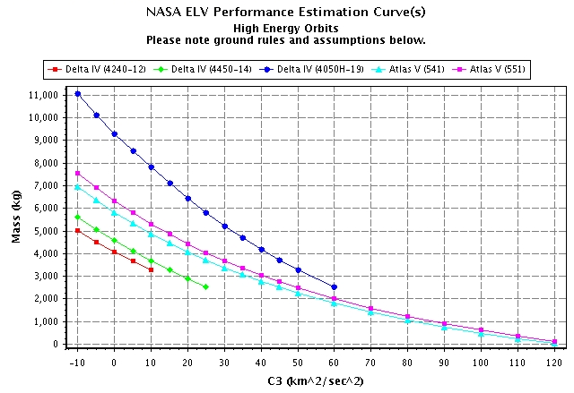
Figure 9: Performance comparison of 5 launch vehicles for high energy (earth escaping) orbits. ¹⁵

The performance estimates include several assumptions. Table 1 lists the vehicle-specific assumptions. In addition, the estimates assume a 185 km altitude perigee and 28.6º inclination for the parking orbit and therefore a 185 km perigee for the escape orbit for all vehicles. Estimates do not include orbital debris compliance, and all assume a 3-sigma Stage-2 commanded shutdown probability, plus additional reserves determined by launch site procedures.

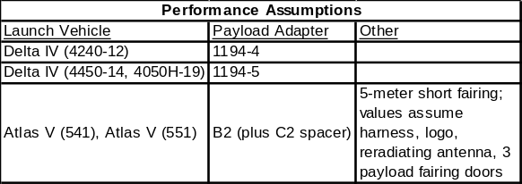Table 1: Assumptions involved in launch vehicle performance estimates

EAGLE can potentially remain in its parking orbit for several days, thereby increasing the duration of the launch window. Figure 10 shows a typical Delta IVH launch profile to LEO.

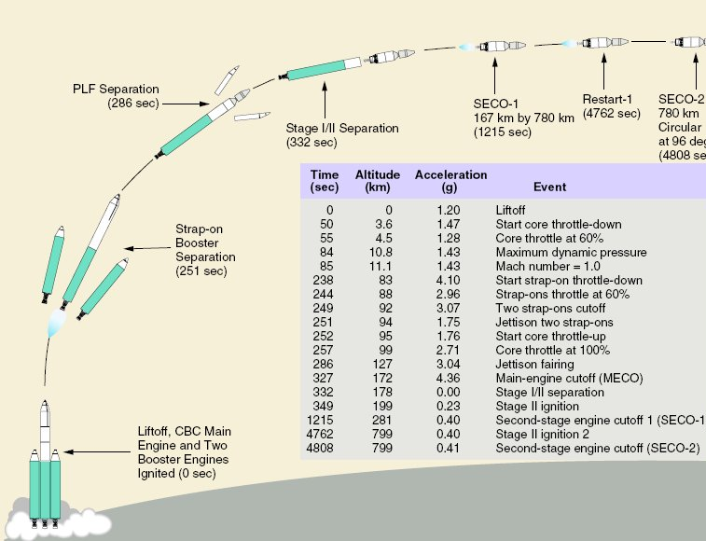
Figure 10: Delta IVH launch profile to LEO.⁸ A final burn from the 185 km parking orbit will send the EAGLE spacecraft into the interplanetary cruise phase.

Once EAGLE is in the 185 km altitude parking orbit, Swingby Calculator predicts a required C₃ of 12.561 km²/s² to escape Earth on the appropriate trajectory to the Saturn system. This C₃ corresponds to 7600 kg in the earth-escape trajectory. The current EAGLE mission requires 6867.1 kg. This gives a mass margin of approximately 10%.

Interplanetary Trajectory
The EAGLE spacecraft will make use of multiple gravity assists to reduce the ∆V necessary to reach Saturn. Jupiter is only in a favorable position for gravity assist to Saturn approximately every 20 years, and the next two favorable alignments occur in roughly 2018 and 2038.³⁰ These dates are somewhat too soon and much too late, respectively, for the EAGLE mission. Consequently, the trajectory team focused on Swingby Calculator optimized trajectories that do not use a Jupiter assist. Venus-Venus-Earth and Venus-Earth-Earth assists are popular for such missions.

The relative positions of the inner planets present a nearly ideal launch opportunity in June of 2023. The EAGLE mission will take advantage of this alignment, which governs EAGLE’s primary launch window. The final trajectory is shown in Figure 11 and involves two assists at Venus and an assist at Earth. Between the Venus swingbys, there is a small deep space maneuver of 16.078 m/s. The cruise time from launch to arrival at Saturn is 2550 days, almost exactly 7 years. EAGLE’s altitude above the gravity assist body at nearest approach is given in Table 2.

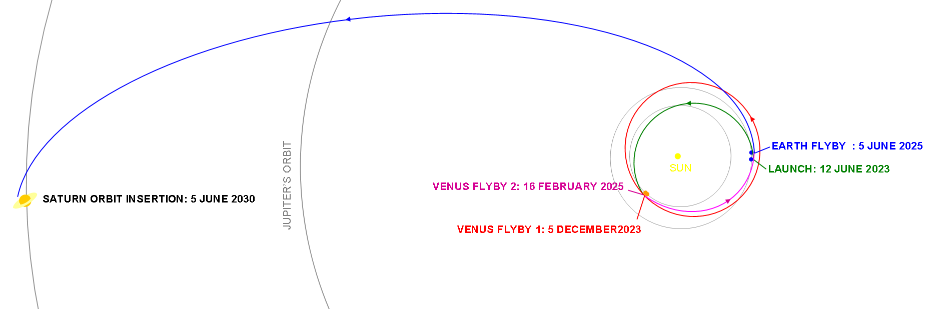
Figure 11: EAGLE’s interplanetary trajectory

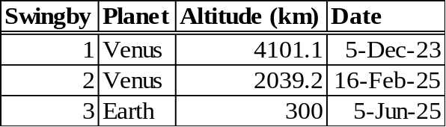Table 2: Swingby altitudes and dates

In May of 2030, EAGLE will arrive in the Saturn system (Figure 12), traveling at approximately 10.4 km/s relative to the sun and 740 m/s relative to Saturn. Once within Saturn’s gravitational well, EAGLE will accelerate considerably. The primary objective during the Saturn approach phase is to counter this acceleration efficiently and in a magnitude sufficient to allow for capture by Enceladus.

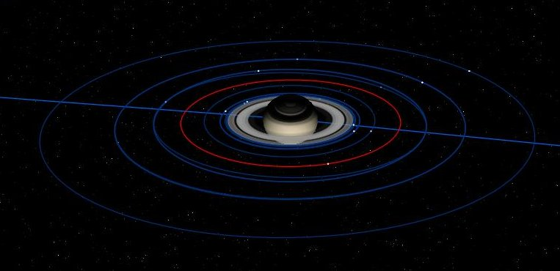
Figure 12: Enceladus orbit is highlighted in red in this view of the Saturn system on the date of EAGLE’s arrival into the Saturn system.³⁰

Enceladus is no easy target. Indeed, the need to be captured by Enceladus presents one of the most challenging tasks in celestial mechanics. The moon orbits hardly one Saturn-radius beyond Saturn’s outer rings²² and carries a mass just more than one-thousandth that of our moon³⁹. As EAGLE sinks into Saturn’s gravitational well, a 6 km/s burn will be required to become captured by Enceladus (Figure 13). Such a burn requires very large thrusters and produces considerable loss in efficiency due to its long duration. Correspondingly, EAGLE will steer clear of a direct capture by Enceladus, in favor of a second solution.

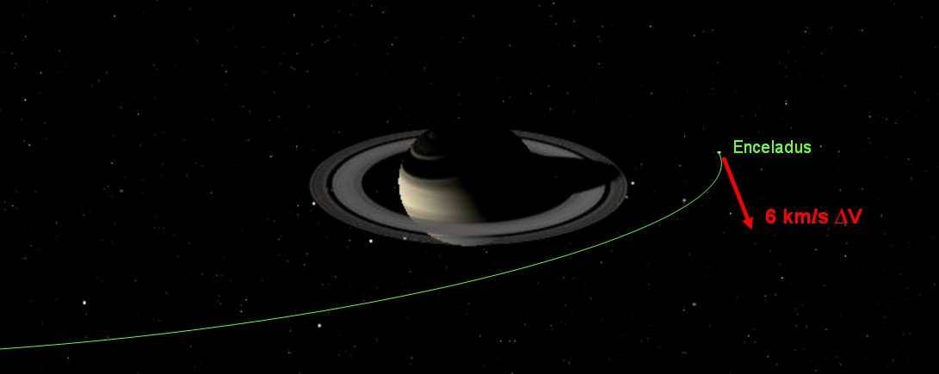
Figure 13: Direct capture by Enceladus, as shown in the above figure, is too costly and too long a maneuver to perform.³⁰

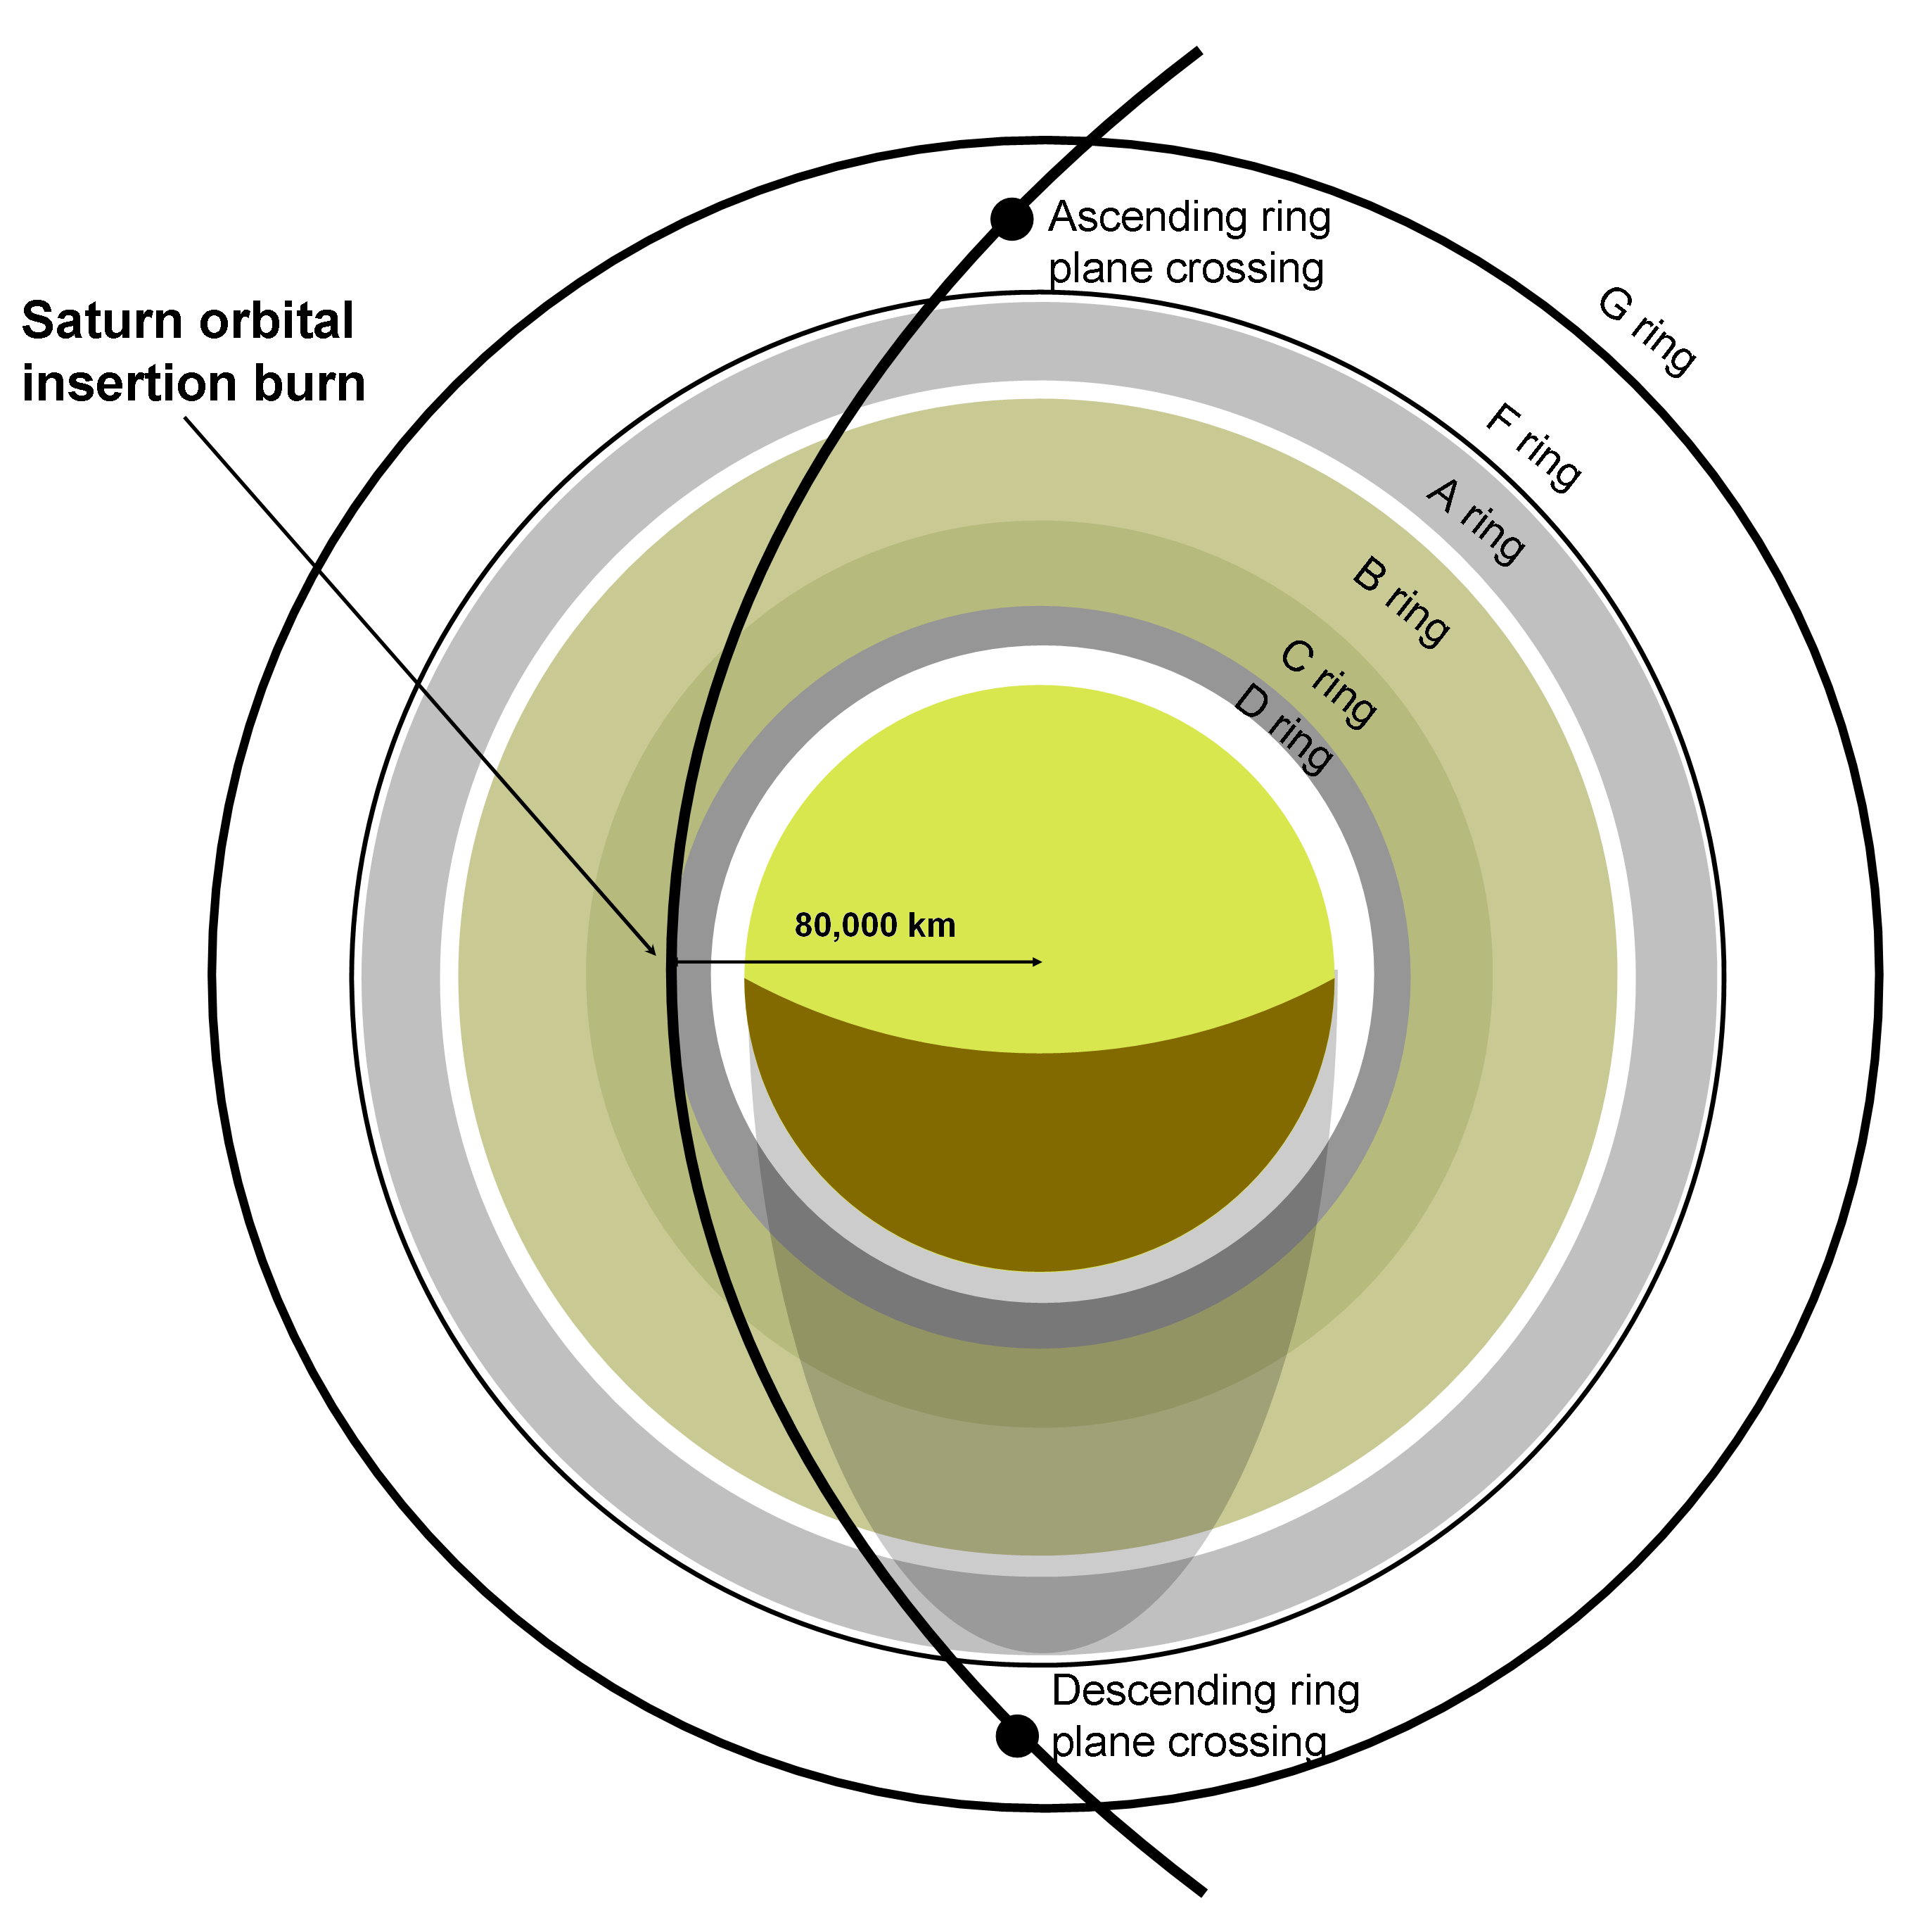Figure 14: EAGLE’s SOI burn occurs above the C-Ring, 20,000 km above Saturn’s clouds. Eagle passes between the F and G rings twice.

The second solution requires a closer approach to Saturn. As mentioned earlier, efficiently reducing the craft’s energy is the primary goal of the approach phase. One can easily show that the greatest decrease in energy can be affected when the burn is performed at maximum orbital velocity. In light of this fact, EAGLE will perform its primary Saturn Orbital Insertion (SOI) burn above Saturn’s C-Ring, 20,000 km from Saturn’s cloud tops. This burn at periapsis reduces EAGLE’s velocity by 910 m/s, down to 30.4 km/s, and allows for capture of EAGLE within its commissioning orbit (Figure 15). In order to avoid collision with large ring particles, the mission analysis team has designed EAGLE’s hyperbolic trajectory with a slight inclination relative to Saturn’s ring plane (Figure 16). The craft will fly between Saturn’s F and G rings. The orbiter will remain in this slightly inclined orbit during the commissioning phase.

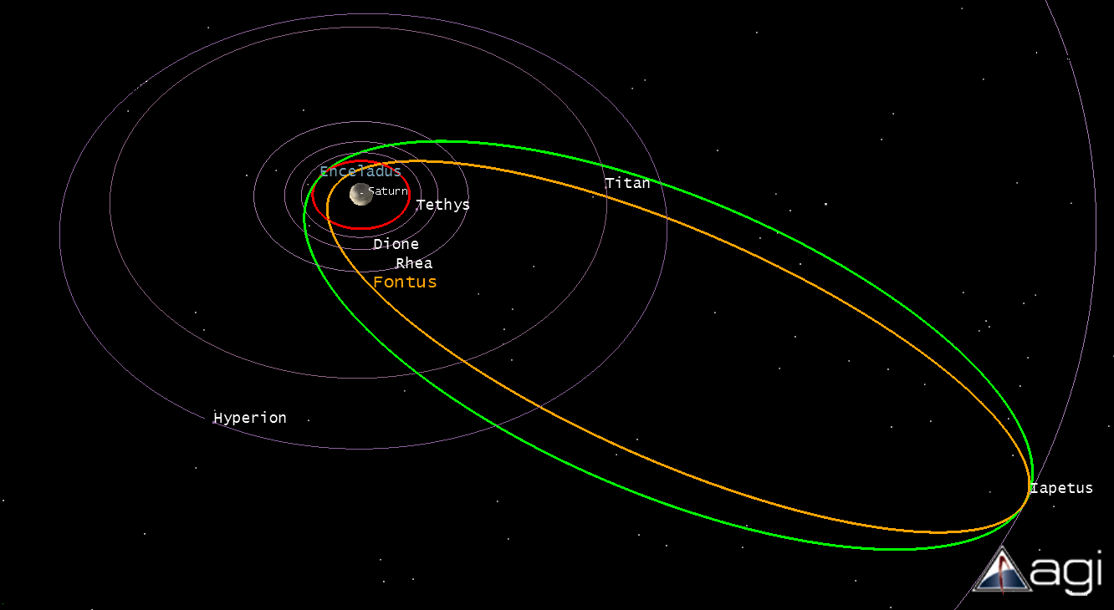
Figure 15: Orange represent’s EAGLE’s commissioning orbit, and green represents EAGLE’s mission orbit. Enceladus’ orbit is shown in red.

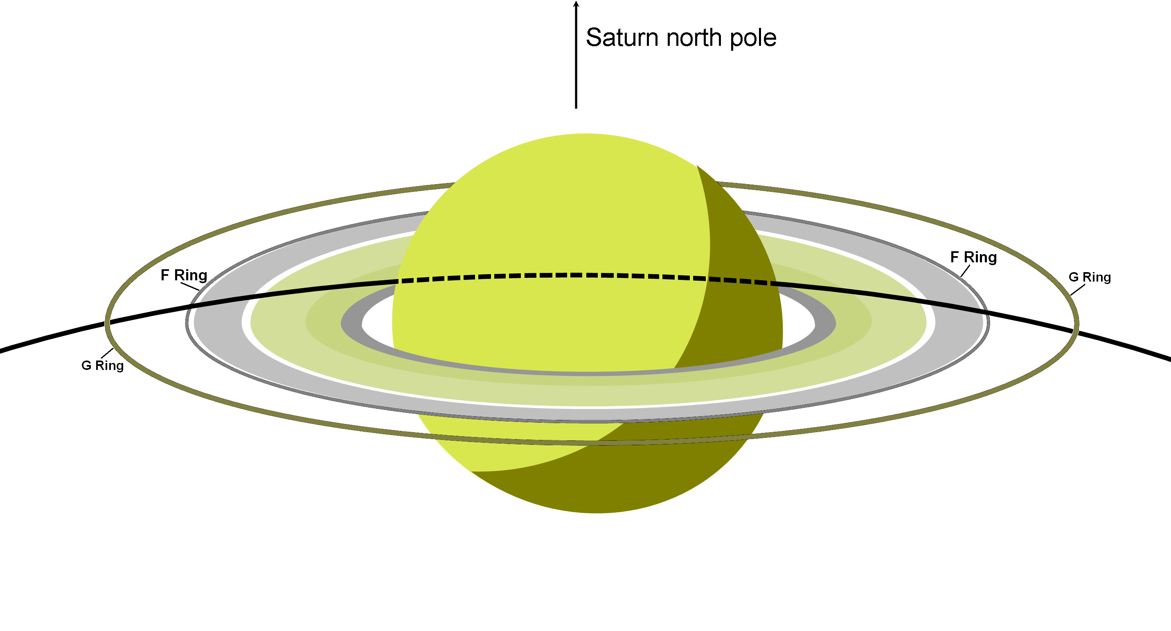Figure 16: EAGLE passes through Saturn’s rings, with periapsis slightly above the ecliptic plane.

The SOI burn places EAGLE in a highly eccentric orbit, with apoapsis near Saturn’s moon Iapetus. Iapetus’ orbit was selected for apoapsis due to the outstanding scientific questions posited by Iapetus’ surface features. At apoapsis, EAGLE burns its main thrusters once more to bring its periapsis safely beyond Saturn’s rings. This approximately 470 m/s burn positions the EAGLE orbiter in its mission orbit, from which it will be capable of providing communications between the EAGLE lander and Earth. After reducing the mild inclination with respect to the ecliptic plane, the mission orbit permits EAGLE to flyby several of Saturn’s natural satellites, including Titan, Iapetus, Hyperion, Dione, and Rhea, all of which have attracted considerable scientific interest.

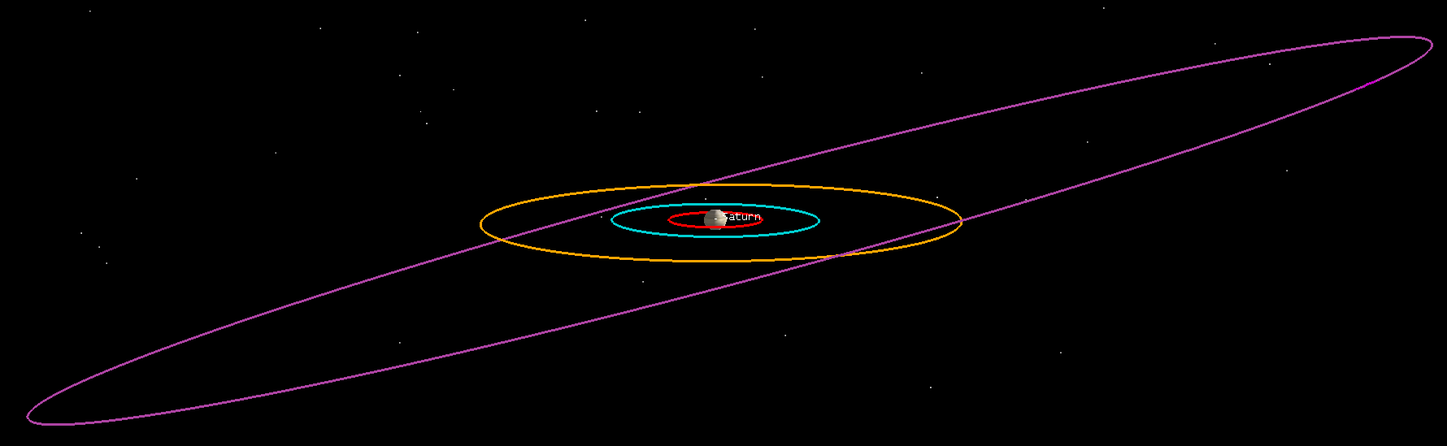
Figure 17: Rhea’s orbit, in blue; Titan’s orbit, in orange; Iapetus’ orbit, in purple. Note the inclined nature of Iapetus’ orbit.

As shown in Figure 17, Iapetus is highly inclined with respect to the ecliptic. In order to flyby Iapetus, EAGLE’s argument of periapsis must be set such that apoapsis coincides with Iapetus’ longitude of the ascending node. The mission orbit satisfies this requirement.

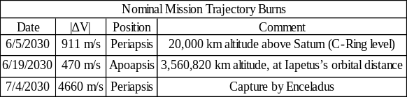Table 3: Summary of Saturn system trajectory burns.

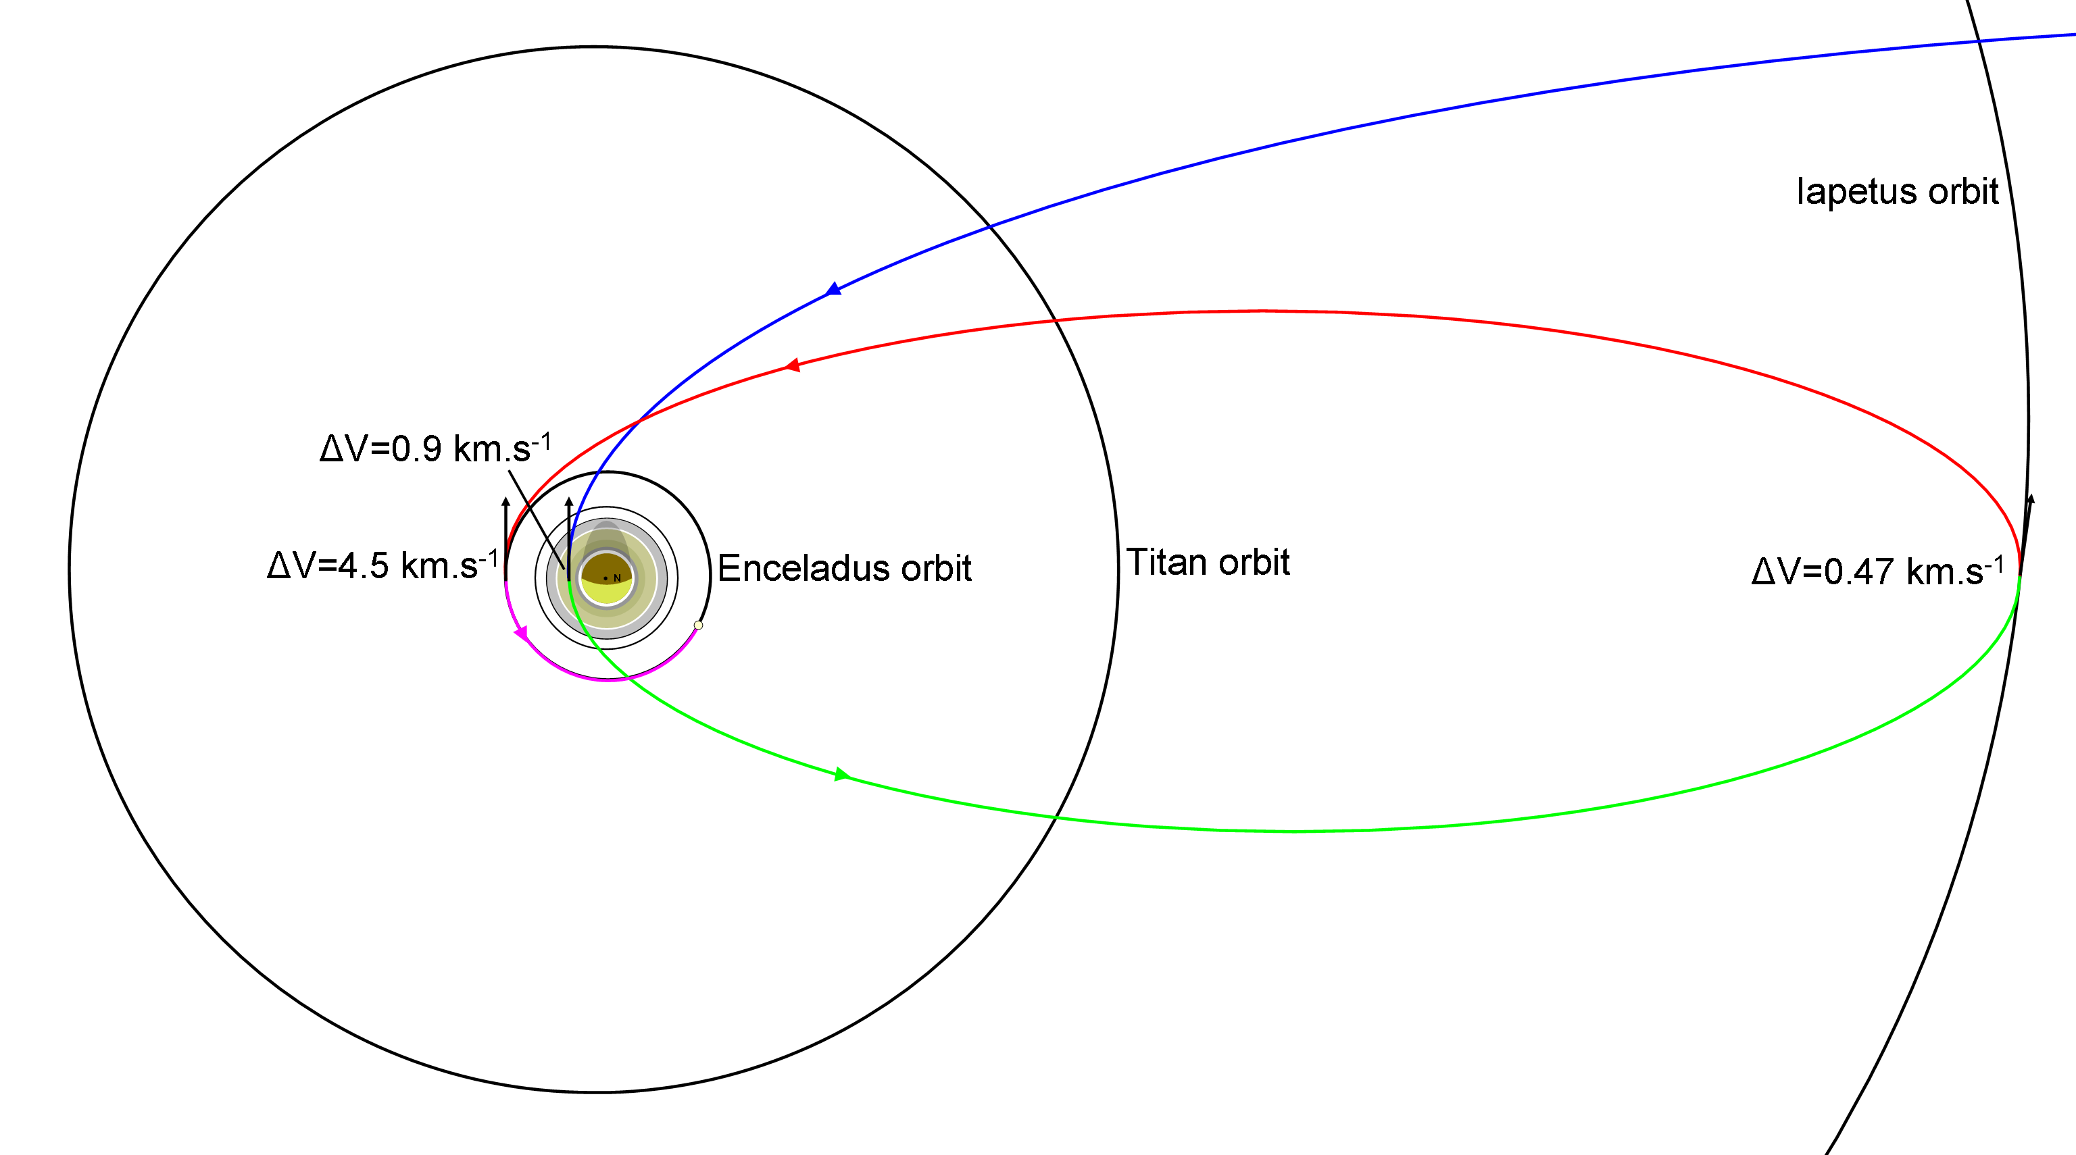
Figure 18: Full Saturn approach trajectory.

For this mission proposal, the lander is considered to be the primary science package, while the prime function of the orbiter is considered to be that of communications relay. The long orbital period of the mission orbit increases the communication link time available. The orbiter also carries a wide-angle camera, but science data from this camera is a secondary objective. Flybys of Titan, Iapetus, and Rhea will be done as the opportunity presents itself. The mission design team expects approximately three Titan flybys every two years, one Iapetus flyby every four years, and frequent Enceladus and Rhea flybys. Such flybys serve several purposes. The flybys may be used to adjust the mission orbit’s inclination and other parameters, as well as collect images in the 380-1100 nm range.

Orbiter Mission Trajectory

The best places for any desired station-keeping would be as the orbiter passes near Enceladus, Titan, or Iapetus. Burns at these locations will enable closer flybys and high resolution pictures of some of Saturn’s more interesting moons. As a result of gravitational assists, maneuvers at these locations will also provide a ∆V bonus.

Near the apoapsis of EAGLE’s Saturn-centered commissioning orbit, the spacecraft performs two maneuvers. The first, as has been previously mentioned, is of 471 m/s in magnitude and circularizes the commissioning orbit into the mission orbit (Figure 18). The EAGLE lander separates from the orbiter after this burn and prepares to target Enceladus. The second maneuver modifies the orbital period slightly to ensure arrival at periapsis just as Enceladus arrives. Due to Enceladus’ short orbital period (1.37 days) relative to EAGLE’s mission orbit period (1 month) this targeting burn is negligible in magnitude. Two weeks after these targeting burns, the EAGLE lander’s nominal mission trajectory calls for an Enceladus Orbital Insertion (EOI) burn of ∆V of 4.66 km/s. Nominally, EOI will occur above the north pole of Enceladus, positioning EAGLE in a polar orbit. In actually, this burn is sufficiently long that it will have to be broken into several burns, the first of which intended to merely reduce the eccentricity of the Saturn-centered orbit. Future analysis, discussed below, will pursue these options. After performing the EOI burn, the large motor and expended fuel tank will be jettisoned.

Enceladus Approach

Once in a circular, polar orbit at a 50 km altitude, the EAGLE lander will survey the terrain for potential landing sites over a three to four Earth-day period (20-30 orbits). The polar orbit provides access to Enceladus’ southern regions, which are of considerable scientific interest. Saturn’s significant third-body effects, the uncertainty in Enceladus’ gravitational field and EAGLE’s limited fuel supply, limit the EAGLE lander to an orbit time on the order of days to weeks. After Enceladus’ southern regions have been mapped, the EAGLE lander will begin its entry, descent, and landing phase.

The orbital velocity around Enceladus at 50 km altitude is only 154.42 m/s. To land, in the ideal case, the orbiter will make a 7.13 m/s burn to transfer from a 50 km circular orbit to an elliptical orbit with periapsis at the surface. It will then perform a 176.5 m/s burn to reduce its velocity to zero at periapsis.

Future Trajectory Refinement
While a launch on June 12th of 2023 is optimal, weather and other uncontrollable events may prevent an optimal launch. Launches prior and after this date require increased energy expenditure. EAGLE may launch on any day prior to or after June 12th, provided that the launch vehicle can produce the additional energy required to match the optimal trajectory. The Delta IV (4050H-19) upper stage generates sufficient impulse to propel EAGLE beyond Earth’s sphere of influence with a C₃ of 13 km²/s² (The Delta IV Heavy can actually accelerate the EAGLE payload to a C₃ of ~17 km²/s². 13 km²/s² is a conservative value which takes into account a significant mass and fuel safety margin). Correspondingly, EAGLE’s launch opportunities exist on any date between June 4th and June 22nd (Figure 19). Were a mission controller to choose to launch before June 4th, EAGLE can remain in its parking orbit with a 185 km for several days before boosting to Venus for its first gravity assist. This option may potentially extend the launch window’s opening to late May.

The Launch Window

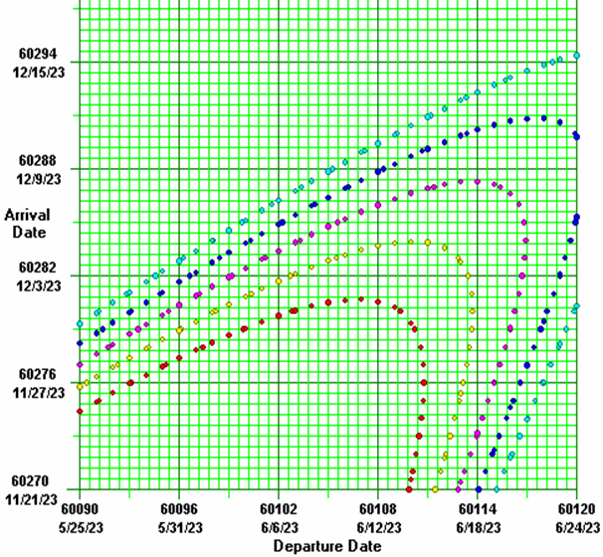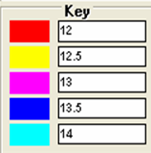
Figure 19: The alignment of the inner planets constrains EAGLE to a Venus arrival on December 3rd, 2023.

Given the constraint on Venus arrival, the above graph visually depicts the available launch window (beneath the purple curve). Departure dates between June 4th and June 21st provide an arrival on December 3rd within the C₃ constraint. The key is C₃ in km²/sec².

Currently, EAGLE’s orbital insertion about Saturn closely resembles that of the Cassini-Huygens mission. Cassini-Huygens passed through the gap between the F and G rings twice to closely analyze Saturn’s ring system. However, EAGLE is not designed to study the rings and this insertion maneuver risks collision with ring particles. Therefore, other potential trajectories are being considered. As mentioned in an earlier section, Eagle can save fuel by performing the orbital insertion burn as close to Saturn as possible. One potential trajectory deserving future study would have EAGLE perform the burn 5000 km above Saturn’s surface, within the inner most ring. While most efficient, this maneuver lacks heritage and consequently adds risk. A more feasible trajectory deserving consideration sets the orbital insertion burn at an altitude of 85000 km, between Saturn’s F and G rings. While slightly less efficient than our current trajectory, this trajectory holds several benefits over the current. First, EAGLE must pass through Saturn’s rings only once, rather than twice. Second, the inclination of the orbit required to avoid the rings is less, reducing the fuel required to return EAGLE to the ecliptic plane. Future studies will analyze these potential orbital insertion maneuvers.

Saturn Orbital Insertion
Currently, all maneuvers are modeled as impulsive. In future studies, the SOI, EOI, and EDL burns will be modeled as finite. Finite models may increase fuel mass requirements by as much as 20%, and EAGLE has been designed with margin to account for these non-idealities. In particular, the mission trajectory team will likely break the 4.5 km/s ∆V EOI into several more manageable burns. EOI-1 would reduce the eccentricity of the Saturn-centric orbit. Enceladus will then capture EAGLE in a highly eccentric orbit after the EOI-2 maneuver. Several finite circularization burns will then lower the orbit to a 50km altitude, circular, near-polar orbit. Due to Saturn’s large third body gravitational effect, EAGLE’s orbit will be highly unstable and require intensive station keeping prior to arrival in the optimally stable 40-50 km parking orbit.

Additional Refinements
The EAGLE spacecraft will launch on a Delta IV (4050H-19) with a C₃ of 12.561 km²/s². During the interplanetary cruise phase, the spacecraft will perform two gravitational assists at Venus and an assist at the Earth to minimize the ∆V necessary to reach Saturn. After a cruise time of 7 years, EAGLE will enter into an elliptical orbit around Saturn, passing as close as possible to the planet to maximize the efficiency of the orbital insertion burn. The total ∆V for the trajectory from earth escape to Saturn capture is 4.47 km/s.

Conclusions

Once captured, the spacecraft will execute a 0.47 km/s burn to enter a mission orbit with periapsis at the orbit of Enceladus and apoapsis at the orbit of Iapetus. It will then separate into two components: an orbiter that will remain in the Enceladus-Iapetus orbit and serve as a communications relay and imaging platform, and a lander. The lander will execute a 4.66 km/s burn to enter into a 50 km polar orbit around Enceladus. It will remain in this orbit for approximately 3 days to map the surface in detail. Finally, the lander will target a site at the tiger stripes on the South Pole. It will take a ∆V of 183.63 to reach the surface.

Systems Engineering

The EAGLE lander will include instruments primarily to search for evidence of liquid water and organic compounds, and investigate the physical properties of the surface and subsurface. The systems design goal is to satisfy the programmatic requirements, while balancing the requirements and constraints of the other subsystems. Achieving a successful systems design requires managing the mass, power, and cost data budgets.
Enceladus is a moon with significant interest to the scientific community, with the potential to generate noteworthy discoveries and enhance the current understanding of the solar system. Therefore, the design team decided to develop a flagship mission to investigate as many science objectives as possible.

Requirements and Constraints

The EAGLE mission will launch aboard a Delta IV 4050H-19, with a launch C₃ of 12.6 km²/s². The transfer trajectory to Saturn uses Venus-Venus-Earth assists, and the lander platform will utilize retrorockets to descend to the surface of Enceladus.

As a flagship mission to the Saturn system, there is a high degree of commonality with the Cassini-Huygens mission; therefore, many aspects of the design trace their flight heritage to Cassini. While this heritage does not significantly affect the cost of this mission, it may reduce the required contingency in the design to the typical 5-15%.

The timeline for this mission extends far into the future; in order to ensure the total mission costs remain within NASA’s budget, the Phase-A mission design will begin in 2013, or ten years before the scheduled launch date. After the seven-year cruise phase, and six month primary mission duration, the projected end-of-life date is 2030. Based on this timeline, the total mission cost is $1.13 billion.
The EAGLE spacecraft consists of three separate components: the Booster, Lander and Orbiter. The three sections remain as one unit during launch and while in transit until Saturn orbit insertion. From there, the Orbiter continues to circle Saturn while the Lander and Booster detach and are placed in orbit around Enceladus. After orbiting for several days, the spent Booster stage detaches and the Lander begins its descent to the surface of Enceladus.

Baseline Design

The orbiter is a small spacecraft consisting of two instruments and its own power, command, communications and GN&C subsystems. This section of the spacecraft controls the EAGLE during transit and until Lander/Orbiter separation. At this point, the orbiter will continue around Saturn and serve to relay communications back to Earth. In addition, to the Saturn orbiter will take images with the high-resolution camera and record data from the student instrument.

The Booster section consists of the magnetometer instrument, two thrusters and accompanying fuel tanks. This section of the spacecraft is expendable and will be used to accomplish the burns needed for Saturn orbital insertion and Enceladus orbital insertion. Once in orbit around Enceladus, this section will deploy the magnetometer instrument on a boom and take measurements for several orbits before being jettisoned. The Booster will be dependent on the Lander for power, command and communications.

The Lander section contains the remaining instruments as well as power, communications, and GN&C subsystems. This section of the spacecraft becomes independent of the orbiter after separation and is then inserted into Enceladus orbit. The lander eventually makes its way to the surface using three sets of thrusters. Once on the ground, the Lander will raise its mechanical tower to obtain a better view of the surrounding area with two sets of cameras in stereo as well as the ChemCam instrument. Underneath the Lander, several instruments will deploy including the APXS, which will be lowered down on an elevator arm, and the IR Spectrometer/Amino Acid Analyzer, which will measure drill samples. The nominal mission design will be 6 months

Spacecraft Subsystems

Structures and Mechanisms
The EAGLE spacecraft is designed to support the science payload and other subsystems hardware. The structure adheres to size and mass budgets and protects the spacecraft from the harsh space environment. The spacecraft experiences a variety of environments during transit and on the surface of Enceladus, and it must be optimized to meet these demands. It must also survive assembly, test, and launch operations (ATLO), fluctuating radiation levels during the cruise phase, micrometeoroid bombardment in Saturn’s rings, and the intense cold of deep space and on the surface of Enceladus. While satisfying these requirements, the spacecraft fits inside the launch fairing, meets the mass budget, and completes all scientific mission objectives during the mission.

Requirements

The need for two separate platforms and a detachable propulsion stage drives the EAGLE design. Each platform has its own power supply, communication, and attitude control. After determining the lander platform could not support the High Gain Antenna (HGA) and the mass of the fuel tanks, the propulsion stage was integrated into the spacecraft configuration. The propulsion stage is jettisoned prior to landing on Enceladus, saving considerable mass and ΔV. Figure 20 illustrates the proposed launch configuration.

Proposed Architecture

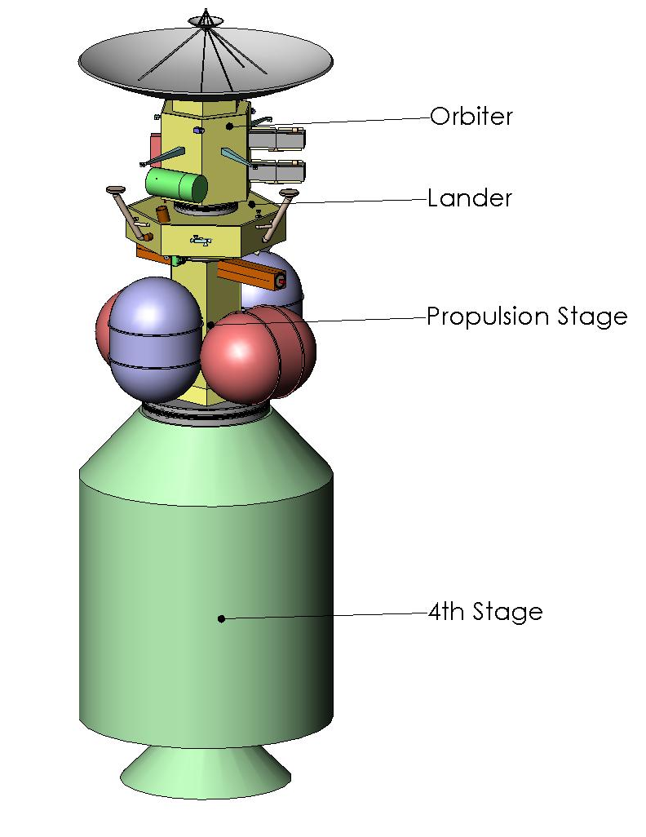
Figure 20: Launch configuration, including the interplanetary insertion propulsion stage.

The design is a robust vehicle capable of withstanding launch load profiles while minimizing the mass. Of primary concern is the large diameter of the HGA. The proposed structural design places the antenna on the top (+z axis) of the spacecraft in order to minimize the stress experienced during launch. This configuration also allows the HGA to act as a sun shield during the Venus flybys. The propulsion system is on the opposite side of the spacecraft (z axis) to isolate the payload from vibration and reduce shear stress. During launch, a spacecraft can experience up to 135 dB in vibration if a metal fairing is used. As a result, EAGLE uses passive damping by using visco-elastic materials (VEMs).

The spacecraft bus structure optimizes the placement of the science payload and meets the mass budget for the lander. The most efficient design is a three-legged configuration, leading to a hexagonal bus structure, 1.2 m on a side. This configuration allows for a simpler attachment of the legs and offers a large inner volume for the payload. The orientation of the spacecraft in orbit dictates that the science instruments utilized in orbit and the instruments for landed operations be on the same surface. The hexagonal bus provides sufficient surface area to support the entire payload with the proper shielding.

The primary function of the Saturn orbiter is to serve as a communications relay for the lander. The orbiter bus and spacecraft structure are designed to support the mass of the communications dish and create a simple attachment for the lander. To maintain pointing accuracy during communications windows with either Earth or the lander, the orbiter requires an accurate attitude control system. Hydrazine thrusters are attached to extended booms which will act as moment arms to improve efficiency. This allows the vehicle to use less fuel per maneuver. The two SRG power units are located on the exterior of the orbiter to avoid overheating the payload.

Saturn Orbiter
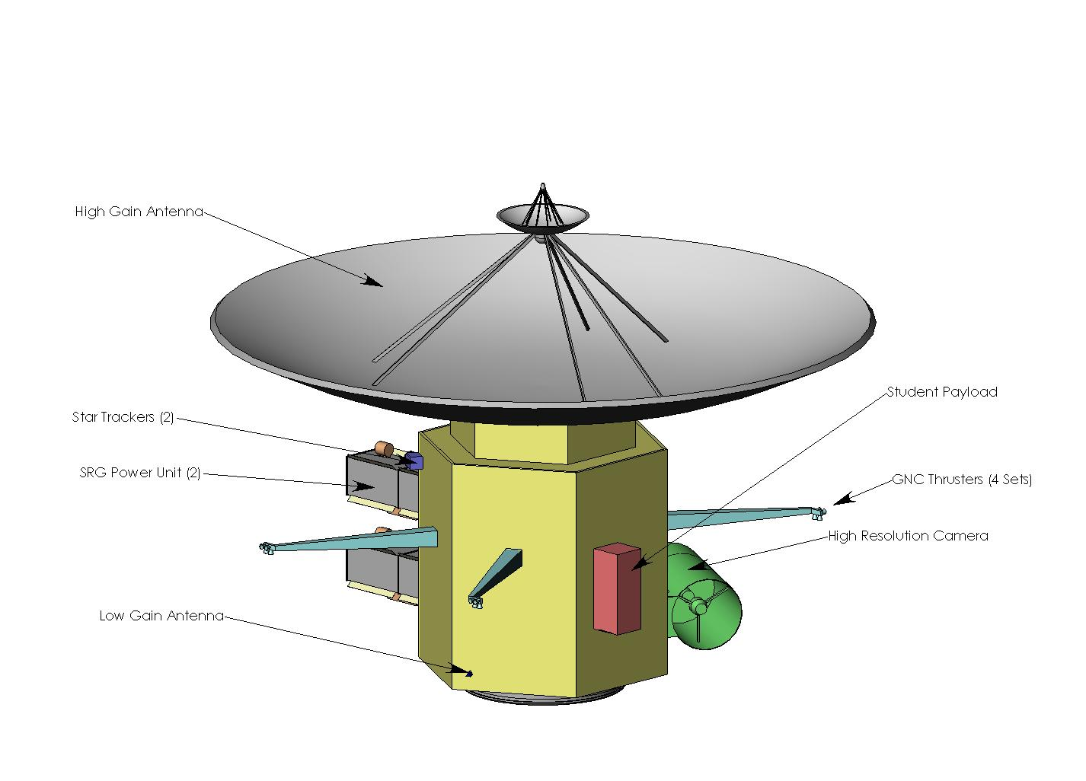
Figure 21: Orthogonal view of the orbiter

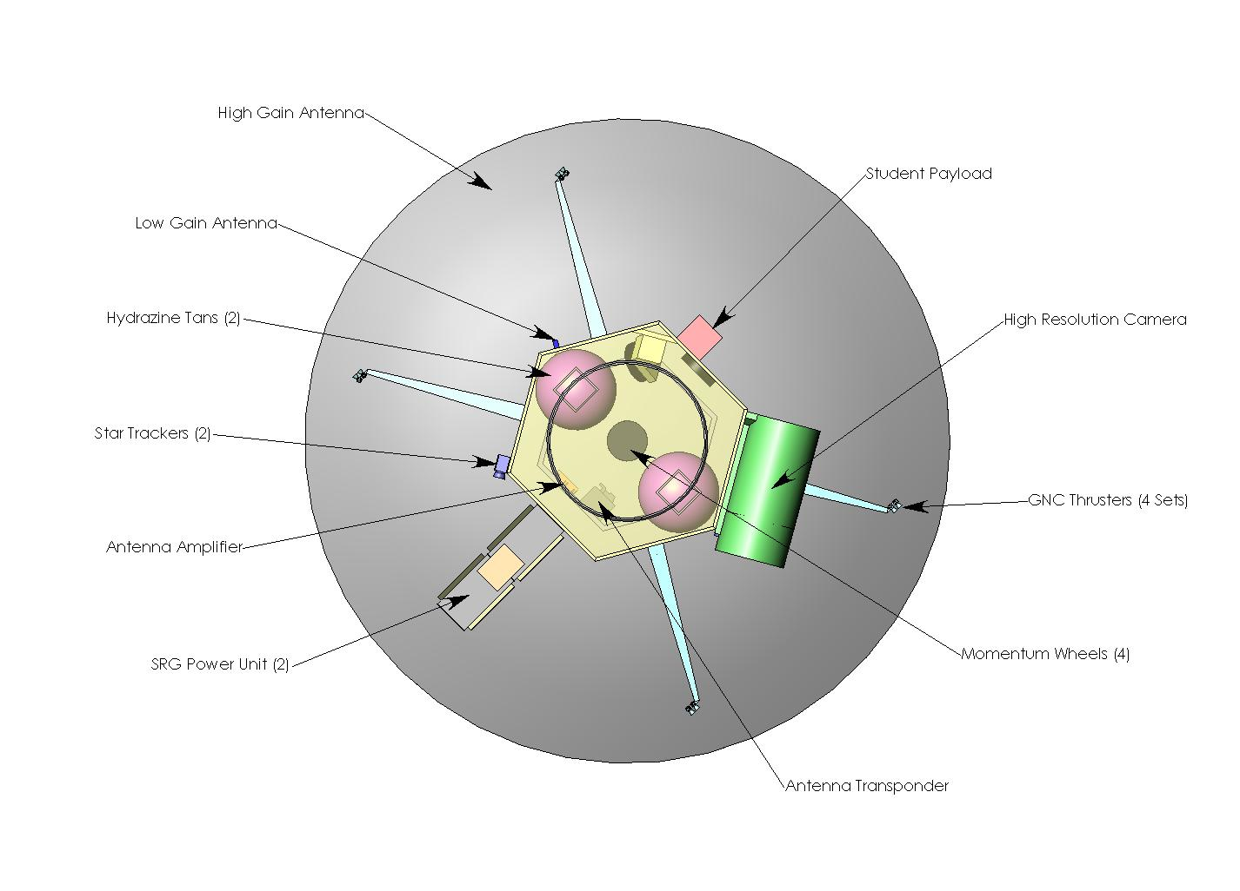
Figure 22: Top view of the orbiter

The science payload drives the complexity of the lander design. The majority of the science instruments need to be placed on the bottom (-z axis) of the spacecraft for instruments to map Enceladus while orbiting, and the landed experiments to have surface access. To accommodate all the science instruments, the lander has a large surface area and is short enough to be stable while on the surface. Some of the scientific instruments are very large and extend out well below the bottom of the lander bus. Therefore, the EAGLE design includes legs to protect the instruments while landed. Deployable legs are not necessary on the lander because, unlike other lander designs, the EAGLE spacecraft does not have to fit within a heat shield during entry, descent, and landing (EDL). Reducing the number of deployable mechanisms also increases the chances of mission success. The static legs are also advantageous to the science mission objectives by allowing seismometers to be placed on the footpads of the lander. This eliminates the need for a separate seismometer deployment mechanism. The leg spring system dampens vibrations created by the lander instruments while gathering data from the seismometers.

Enceladus Lander

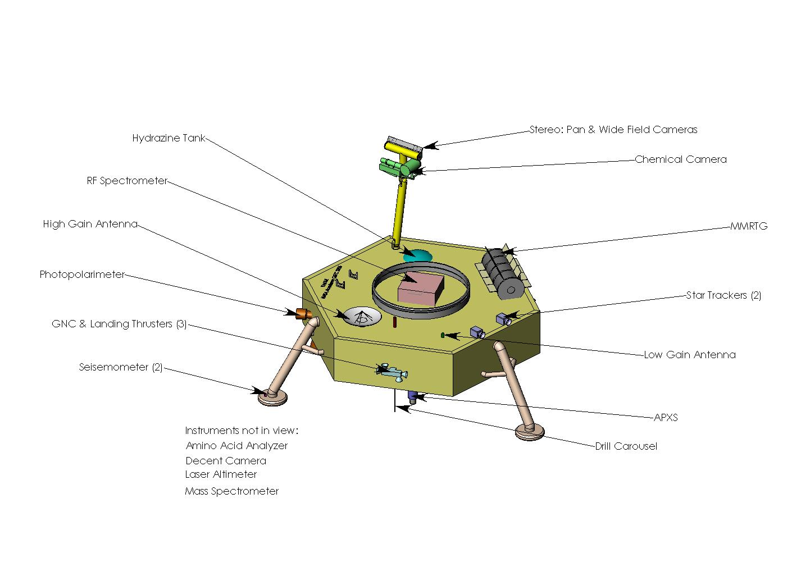
Figure 23: Orthogonal view of the lander configuration.

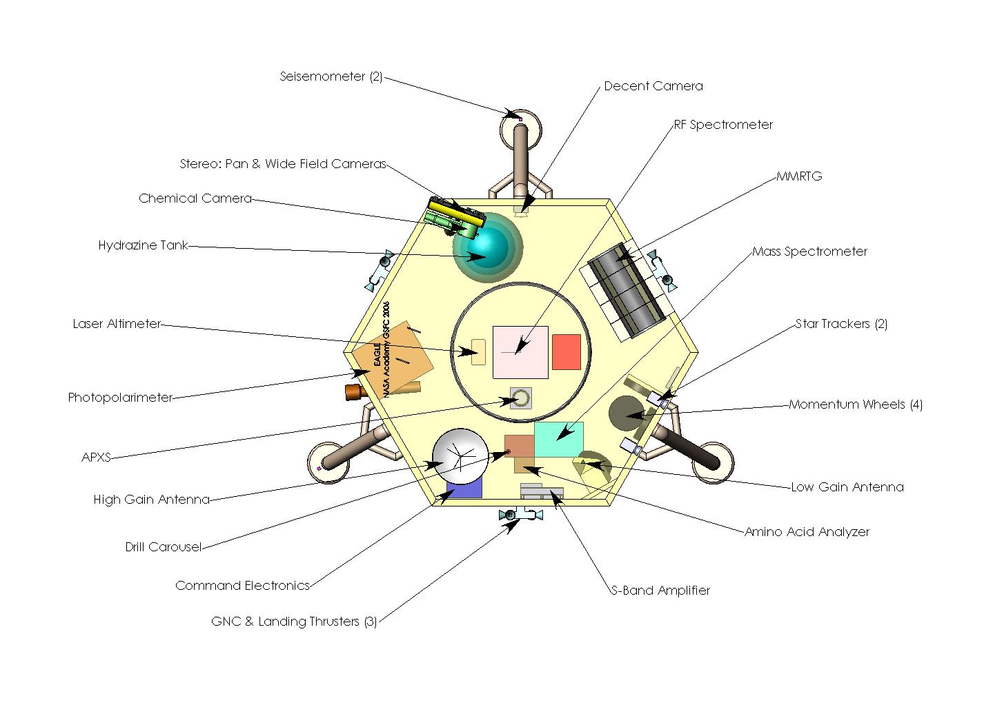
Figure 24: Top view of the lander configuration.

One of the most important tools on the lander is a drill that supplies samples to various instruments in the payload. The drill tip must be placed no more than 0.5 m off the surface and contained in a 0.72 m tube. To reduce the size of the spacecraft bus, many of the instruments extend past the defined surfaces, lowering the center of mass. The two instruments that need to be lowered, the drill and the APXS, are placed slightly off center so that a small rotation with the retro-rockets will render a new sample area in the event of hydrazine contamination.

To reduce the contamination due to the hydrazine plume, the downward thrusters are angled away from the lander’s body. The sensitive science instruments are placed inside the Warm Electronics Box (WEB) to further minimize contamination. This helps protect the payload from the radiation environment, extreme cold on Enceladus, and space and geyser debris. Due to the low gravity on Enceladus, it is not difficult to maneuver large objects on a gimbaled boom. Therefore, ChemCam and PanCam are connected on a robotic mast with a large range of motion. This allows both instruments to measure the same sample and improve the scientific results of the tools. These two instruments are shielded during flight by the propulsion stage and, while folded, the lenses of the instruments are facing towards the lander to protect the CCDs from sunlight and radiation. The RTG is mounted on the top of the lander, away from the payload to prevent overheating. However, a portion of the generator is seeded below the surface of the lander to supply a limited amount of heat to the inside of the lander.

The retrorockets, designed to slow down the decent of the lander, also act as attitude control during orbit and a method of hopping during the extended mission. The thrusters are placed in three separate clusters on the open faces of the lander. This allows for six degrees of freedom and reduces the amount of contamination to the surface of Enceladus.

The propulsion stage was designed entirely to support the fuel tanks. The square structural bus provides the simplest and strongest attachment for two MMH and two NTO tanks. The interior of the bus contains the Pressure Control Assembly (PCA) and the helium tank, both of which are small enough to allow for a thin rectangular support system. The proposed design for the propulsion stage is not equipped with any individual control or communication, and it incorporates only one science instrument. The magnetometer, which will only be used while orbiting Enceladus, needs to be extended on a long boom to protect it from the interference of the spacecraft. The deployment mechanism is too large to fit on the lander and too heavy to carry to the surface, so it will detach with the rest of the propulsion system. The telescoping magnetometer boom is controlled and powered through the lander and deploys shortly after entering the Saturn system. The propulsion system also houses the two main thrusters, located on the bottom of the lander along the vertical Z axis of the spacecraft. The thrusters are gimbaled to minimize the shear forces on the spacecraft.

Propulsion Stage

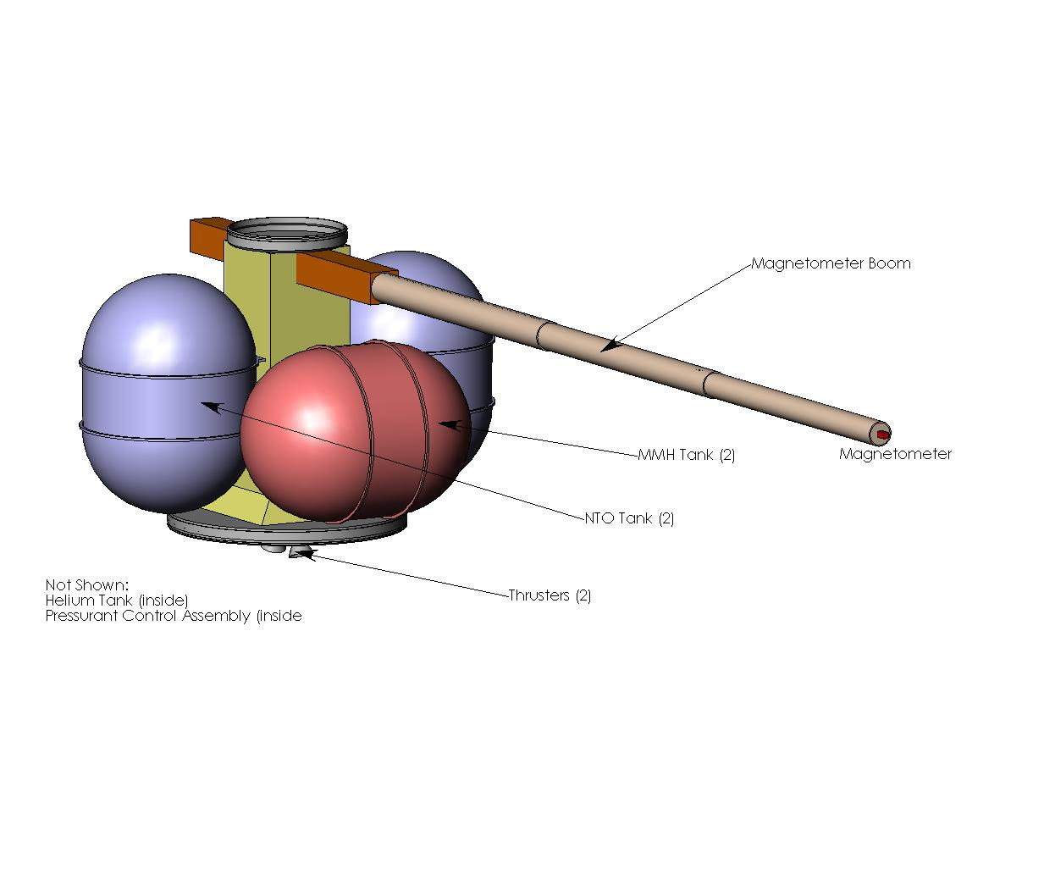
Figure 25: Propulsion stage

The spacecraft layout and materials were chosen to minimize the risk of a system failure resulting from the dangerous space environment. The primary radiation concerns will be resolved by the multi-layer insulation covering the bus of the spacecraft. The exposed scientific instruments will be protected during the cruise phase, either by incorporated folding methods, or due to the shielding provided by other parts of the spacecraft.

Protection from the Space Environment

The Saturn orbital insertion trajectory requires the spacecraft to travel between Saturn’s the F and G Rings. This requires that the instruments and spacecraft be protected from any dust and debris. Honeycombed aluminum will be used to construct the bus structure due to its exceptional ability to protect against micrometeorites. A trade study lead to the conclusion that using honeycombed aluminum provided more protection than the alternatives. ²³

Spacecraft survivability during the 7 year cruise phase was another consideration in the overall design. Extended exposure to the high vacuum of space can result in outgassing of materials. This prevents using materials like zinc and cadmium. Poor choices in materials can cause short circuits, as well as material deposits on the instruments. It was found that using aluminum 7075-O for the internal truss structure and honeycombed aluminum for the skin is the most reliable material to use for long duration missions.⁴⁸

When the spacecraft is built, it will be vital to test the rate at which it outgases. Current vacuum technology can only reach 10⁻⁸ torr, whereas, the interplanetary environment is 10⁻¹¹ torr. This means that outgassing data must be extrapolated to obtain accurate values. Though outgassing will not destroy the satellite, it can disrupt individual components, leading to a mission failure. A database located on the NASA Goddard website has a list of materials that have very low outgassing characteristics. ^{48, 57}

The spacecraft must also be thermally stable. Thermal conductivity and thermal expansion coefficients are important considerations in the design. Three examples of materials that have a net expansion coefficient of nearly zero are Kevlar 49, UHM carbon, and Invar. Invar is used on optical components like cameras since it has similar properties to glass. This material can also be used to help mount electronics within EAGLE since the coefficient of thermal expansion is similar to silicon.²⁷

The ease of manufacture of the materials must be considered. The spacecraft will not be using composites because they are difficult to manufacture, and therefore expensive. Composites are also too brittle to be primary structure. The strength of the honeycombed aluminum depends on how the force transfers between the sheets of aluminum. ²³

Materials

A large quantity of titanium, in addition to the aluminum, will be used for the spacecraft. The titanium will be used for the fuel tanks of the spacecraft. There will be a future trade study to investigate the possibility of using aluminum-lithium fuel tanks. This was found to be effective for the External Tank on the Space Shuttle which has 1/8th inch thick aluminum-lithium alloy.^{7, 9}

The spacecraft will be attached to the fourth stage by the spring-loaded Marmon clamp system. V-clamps with an explosive-bolt release mechanism will connect the lander to the propulsion stage on the top, and the lander stage on the bottom. This separation system is preferred because the detachment forces will act strictly in the Z-axis. This will reduce the shear stresses on the spacecraft that usually result from the use of pyro-bolts.⁸

Separation Method

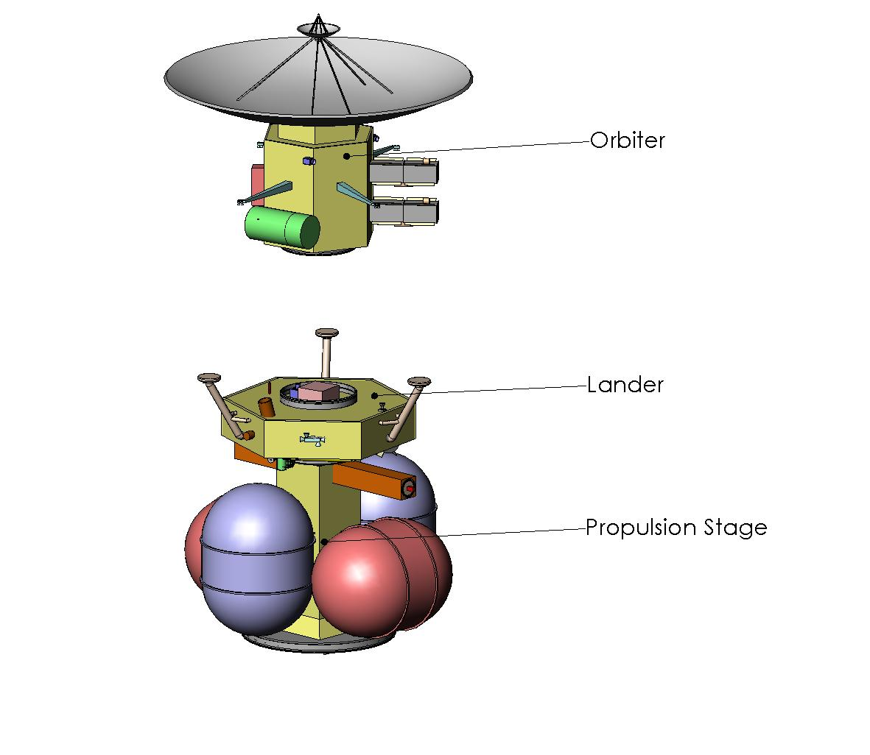
Figure 26: Illustration of orbiter separation.

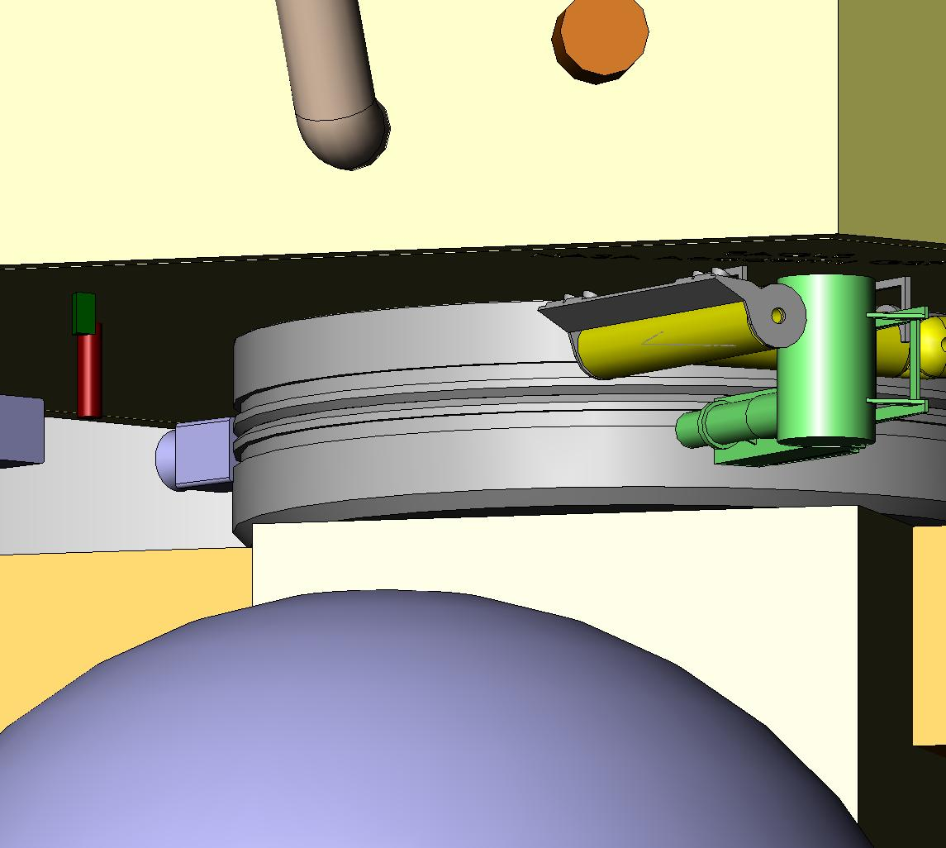
Figure 27: V-clamps

The primary focus of structures was designing a robust spacecraft structure, while minimizing the mass of the vehicles. The hexagon became the most effective shape to withstand the stresses of launch, provide enough space inside for the equipment and instruments, and still fulfill the other mission objectives. The rest of the satellite was designed around the hexagonal lander. The placement of the dish ensures that it will manage the launch loads, and the propulsion stage was designed to be jettisoned in order to reduce the landed mass of the vehicle.

Conclusions
.
After the basic design was generated, the details of the structure had to be examined. Some considerations included materials, vibrations, acoustics, the launch faring, and the space environment. Though the vibration and acoustic calculations could not be accomplished due to time constraints, the spacecraft does meet the basic requirements and should withstand all expected stresses during the mission.
The environmental control system (ECS) on EAGLE includes internal and external temperature control for spacecraft avionics and science payload instrumentation, protective measures for radiation exposure, and micrometeorite shielding. The EAGLE ECS is based strongly on the TPS and exposure data from the Cassini-Huygens mission to Saturn and Titan, minus EDL system components from the Huygens probe. The EAGLE ECS concept accounts for extremes experienced during transit and the expected operational lifetimes for the Saturn orbiter and Enceladus lander.

Environmental Control
Extremes in equilibrium temperature, T_{eq}, over the duration of the mission are found during the transit time spent around Venus and the operational phase at Saturn, with T_{eq} ranging from 318K at Venus to 90K at Saturn.¹⁸ Such variances in planetary equilibrium temperatures and ambient temperature of 4K during other phases of the transit trajectory require the use of MLI on all exposed surfaces of the EAGLE spacecraft, for both the Saturn orbiter and the Enceladus lander. The external temperature control system also accounts for the incident sunlight on the spacecraft and the amount of time spent at Saturn, where the incident sunlight is approximately 100 times less intense than that at Earth.¹⁸

Temperature Control – External

Based on the required operating temperatures of the scientific payload instrumentation and spacecraft avionics, the targeted equilibrium temperature for EAGLE is 220K, achieved using two different lay-ups of Kapton-based MLI. The MLI lay-ups are based on results from the high temperature exposure testing done in preparation for Cassini-Huygens TPS design. Kapton is a synthetic material capable of withstanding temperatures up to 670K.^{31,32} An all-embossed Kapton ply of 20 layers, each spaced by Dacron netting, is the designated “high temperature blanket” and is used on the top of the orbilander near the RTG and on the underside of the spacecraft near the main engine and ACDS thrusters. All layers are 0.025 mm thick.³² Non-uniformity in thermal emittance of an entirely Kapton MLI prevents its use on the entire surface area of the spacecraft.^{31,32}

A standard lay-up involving a hybrid of 5 layers of embossed Kapton with 15 layers of Mylar/Dacron can withstand up to 520K, making it suitable for the majority of the spacecraft surface area at its hottest environmental ambient temperature point, 0.65 AU.^{31,32} The layer spacing with the Mylar/Dacron net makes the MLI lay-up appropriate for micrometeorite shielding as well, as discussed later in this section.³²

In the same manner as Cassini-Huygens, EAGLE uses the 4 m diameter high gain antenna as a heat and sun shield during the transit time spent in the Venus system. The antenna will be directed toward the sun during the time EAGLE spends at distances of 0.65 AU to 1 AU. The Hexcel/epoxy and carbon fiber/epoxy honeycomb structure is coated with high reflectivity and low absorption paint, as specified for the Cassini-Huygens mission. The entire external temperature control system, including MLI blanketing and coatings, totals 11 kg.

Internal temperature control includes both active and passive systems for maintaining the operating temperatures of the avionics and science payload instrumentation. The MLI maintains a spacecraft equilibrium temperature of approximately 220K. For the majority of the science payload, this thermal environment is well within the operating temperature range for the instruments. However, several require operational temperatures below 200K. Passive radiative cooling systems built into the instruments maintain proper thermal environment for these instruments, most specifically the IR camera.

Temperature Control – Internal

During thermal cycling caused by orbit variation and trajectory, additional passive measures are required, namely partially embedding the RTG power source on the lander and including Radioisotope Heater Units (RHUs) with the payload. During the night cycle, RHUs are used to passively heat the spacecraft interior. Based on the number of RHUs on Cassini-Huygens, EAGLE will include 3 kg of RHUs (75 individual units) to provide an additional 75 W (thermal) to the payload.

Active internal temperature control is achieved through the use of temperature sensors and electric heaters embedded in the payload. Each instrument has a temperature sensor for each operation critical component, averaging 4 sensors per instrument. This network of sensors is linked into the onboard computer, which monitors the temperature of the components critical for instrument operation. Electric heaters, each 10 W thermal, and averaging one heater for every two instruments, actively heat avionics and science instrumentation using feedback from the temperature sensors.

The radiation environment expected during transit and the operational lifetime of EAGLE is not expected to require a separate protection system. The absence of Mars and Jupiter passes in the transit trajectory reduces the possibility of the spacecraft passing through the severe radiation belts associated with both planets.

Radiation

All avionics and instrumentation on EAGLE prescribe radiation hardened, spaceflight qualified hardware. The majority of the science payload instrumentation has flown on the Mars Exploration Rovers (MER) and survived radiation environments more severe than those expected at Saturn.¹⁸ Should additional data analysis from Cassini’s remaining flyby of Enceladus in 2008 show a more severe radiation environment than currently known, the current mass budget allows for the inclusion of a polyethylene radiation shield for the lander payload.
The MLI covering the entire exterior of both the Saturn orbiter and Enceladus lander also protects the spacecraft from micrometeorite impacts. The MLI is capable of preventing payload damage from dust sized particles traveling at speeds ranging from 4-10 km/s.³⁶

Micrometeorite Shielding

For the complete spacecraft configuration and the Saturn orbiter independently, the composite structure and sensitivity range of the high gain antenna provide a shield against particles larger than dust size (0.01g) as may be seen with the close flybys of Saturn’s E, F, and G rings.³⁶ The greatest particle impact threats to the lander, while in Enceladus orbit, are those in the E ring, likely being produced by the geysers on the Enceladus surface. On the surface, the impact threats to the lander are from the geyser ejecta falling back to the surface as snow and ice particles. The MLI on the lander and RTG on the top side of the lander protect the science payload.

The ECS on EAGLE requires the use of both active and passive systems, including MLI, RHUs, temperature sensors, and electric heaters to maintain equilibrium temperatures in the operating ranges for the science payload and avionics. Table 4 summarizes the quantities, mass, and other design characteristics of the ECS.

Conclusions

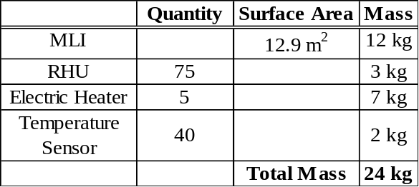Table 4: Summary of ECS design components

EAGLE is a deep space mission designed to do many scientific operations over a long time scale. The power demands will be significant, thus requiring a robust power system that can operate for longer periods of time with a high efficiency rate, has low mass, and does not interfere with the science instruments. Currently, the best option for deep space power systems are nuclear based with the system relying on Plutonium 238 as fuel.

Radioisotope Power Systems

Since EAGLE will be using various instruments on the Enceladus lander and the Saturn orbiter, Power has decided to use two separate Radioisotope Power System (RPS) units. The Multi-Mission Radioisotope Thermoelectric Generator (MMRTG) will be used exclusively for the Enceladus lander and two Stirling Radioisotope Generators (SRGs) will be used during launch, transit and on the Saturn orbiter. All three systems will provide >110 W; at beginning of mission (BOM) the MMRTG will produce 125 W and the SRG will produce 116 W (BOM) each.⁷¹ After 14 years of operation, the expected power output of the MMRTG is 100 W while both SRG will output 101 W.

EAGLE will require power to operate three separate stages of the mission. Once the overall structure reaches Saturn, it will break into two different sections: the Saturn orbiter and the Enceladus lander. The latter will eventually land on the surface of Enceladus. Therefore, when the structure separates, the two SRG units will stay with the Saturn orbiter to provide power for the Command and Data Handling components as well as the camera and Propulsion/Attitude Control systems. Overall, the Saturn orbiter will have an average power allotment of 110W.

Requirements

The Enceladus lander will have one MMRTG that provides an approximate average of 110 W by the time the system lands on the surface of Enceladus, eight years after launch from Earth. Since there are no moving parts on the MMRTG, the lander will not have any additional vibrations from the lander when the seismometer is in use.⁷² The fuel used in both systems will be Plutonium 238, with a decay rate of 0.8% per year.⁷² The overall power decay rate of the MMRTG is 1.6% per year and the SRG is 1% per year.⁷² These numbers rely heavily upon the thermal insulation systems of the units as well as the mechanical moving parts on the SRG.

During transit, EAGLE will not pass by Mars or Jupiter, which reduces the amount of exposure to extreme radiation environments. Since the design of the MMRTG accounts for operations on Mars, it is safe to assume that this unit will be able to operate under the radiation environment of Saturn.⁷² As for the SRG, while under development, it can be assumed that the design will allow for operations under extreme radiation environments as well.

Below is a chart listing the power demands of each subsystem with respect to the Saturn orbiter and the Enceladus lander stages of EAGLE:

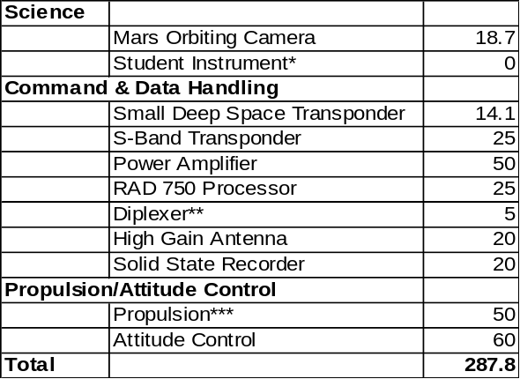Table 5: Saturn orbiter: 2 SRG exclusive (BOM max = 116 Watts each)

*Constant power demand
**80 Watts initially for 100 milliseconds during burn then 50 W demand for the duration of the burn.
***When there is further development of the power system, a more concrete power cushion can be suggested. In regards to the current power SRG allocation, it would be desired to have 5 W for the student instrument but right now it is not feasible (thus the reason for the zero).
****The Diplexer requires a continuous power of 5 W but at times, the power need could reach 100W.

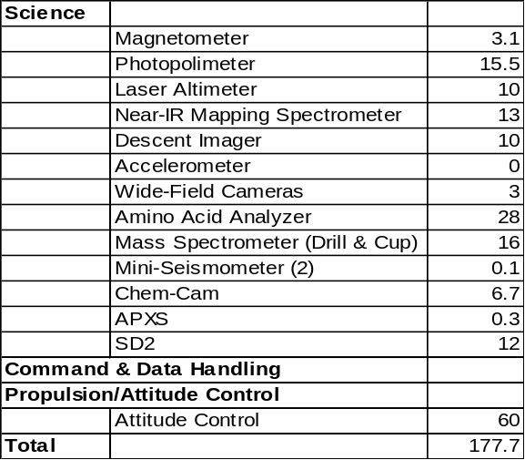
Table 6: Enceladus lander: 1 MMRTG exclusive (BOM = 125 W)

At the beginning of the entire mission, Power will have a total output of 357 Watts with a power demand of 429.6 Watts with all components active at full power. Therefore, the final power system should include the use of power modes, and thereby not require the addition of another RPS.

MMRTG
125We
2 SRG’s
232 We
Science
Standby
125We
C & DH
116We
Propulsion
50We
Attitude Control
60We
P/AC
140We
101We Burn Ignition
Propulsion
Burn Ignition: 80We
For 100 milliseconds

Figure 28: MMRTG & SRG power distribution in transit (BOM).

Each subsystem will benefit from the respective power system, depending on its location and demands during the various stages in the mission. Having two separate power systems would benefit the mission greatly because it reduces the fuel demand, and amount of mass. Furthermore, the MMRTG and SRG have complimentary advantages for deep space missions. The MMRTG generates power from thermocouples connected to eight General Purpose Heating Sources (GPHS) that are stacked on top of each other. What sets the MMRTG apart from the RTG units used on Cassini is the total mass of 44.2 kg and a fuel mass of 4 kg.⁷¹ The Cassini RTG had a mass of 55.5 kg and a fuel mass of 7.8 kg.⁷² Therefore, for future missions it is imperative to reduce the amount of fuel needed and ensure that the RPS is more efficient.

Subsystem Design

The two SRG units will go onto the over structure and will provide power to the Propulsion/Attitude Control and the Command & Data Handling Subsystems. The SRG has a higher efficiency than the MMRTG and requires a smaller amount of fuel. With two 55 W Stirling engines on each SRG, the system will receive the thermal component of the system from two GPHS.⁷³ With a reduction in the amount of fuel used (1 kg), the overall thermal power that requires dissipation is only 500 Watts for each SRG.⁷⁴ For surrounding instruments that require cooler operating temperatures, this is a friendlier neighbor. To reduce thermal and vibration interference, the two SRG systems will be on the back of the orbiter.

2 SRG’s
108We
C & DH
106We
Propulsion
50We
P/AC
110We
Propulsion
Burn Ignition 80We
Attitude Control
60We
Figure 29: Power distribution for the Saturn orbiter 8 years after launch.

In order to conserve power demands from all of the instruments and systems involved, the power system will implement the use of standby or power modes. Only vital systems will draw power from their respective RPS on a constant basis. The MMRTG on the Enceladus lander will only keep the instruments on safe power mode during transit. Before EAGLE separates, there will be a burn time where the MMRTG will act as an additional power resource for the Propulsion/Attitude Control (P/AC) system.

MMRTG
111We
Descent Imager
10We

Attitude
Control
60We
Science
Power Mode: Standby
41We

Figure 30: Power distribution for the Enceladus lander during decent to surface.

Command power needs were not available by the time of this study. However, due to the initial high power requests from C&DH, one of the SRG units will be used exclusively for the C&DH components, while the P/AC will use most of the power output from the second SRG. As mentioned before, if P/AC requires more power, the MMRTG may provide additional support.
During the research process, Power considered many different types of deep space powering systems. The total amount of solar energy is drastically reduced when EAGLE reaches Saturn, eliminating the potential use of solar panels. The Department of Energy (DOE) has poured millions of dollars into RPS research and development programs across the country. NASA Glenn Research Center has devoted a large amount of time and money, in conjunction with Stirling Technology Company, to produce deep space power systems using Stirling engine technologies.

Trade Studies

The SRG 110, which is the primary unit suggested for use in this mission, is in the prototype phase of development at the Glenn Research Center. According to researchers, the finalized design will lead to a working engineering model in the near future. Due to the low power output of the SRG (116 Watts) compared to the RTG used on Cassini (300 Watts each), there is a brand new focus on developing the Advanced SRG. The expected power output of this system is 160 Watts at BOM and 140 Watts after 14 years.⁷¹

Below are charts of comparisons between different RPS considered for EAGLE:

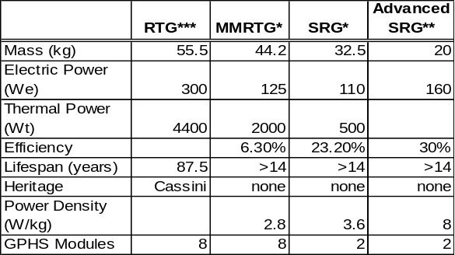Table 7: Trade study for the RPS

*Prototype phase
**Currently in initial development
***One Cassini RTG
Power Outage During Mission: DC Electric (Watts)

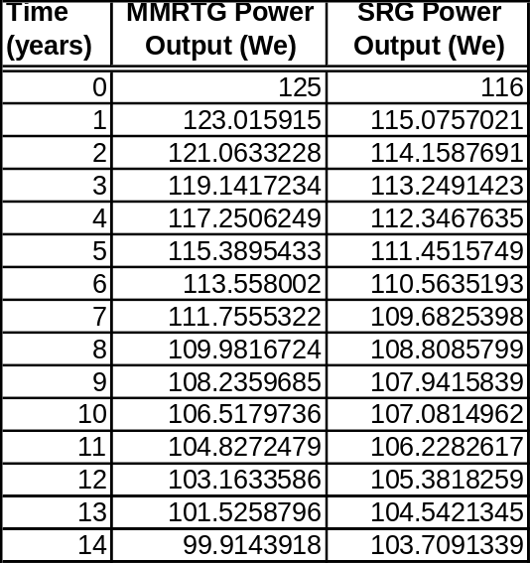
Table 8: Trade study considering BOM power

The goal is for EAGLE be the most efficient spacecraft for a deep space mission by the time it launches in the next 20 years. Accounting for the current shortage of Plutonium 238, it is exceedingly important to develop missions that require a smaller amount of fuel without sacrificing performance. RPS are the best options for future missions and SRG development is the key to producing a highly efficient power source with the smallest amount of total and fuel mass.

Conclusions

The responsibility of the Communications subsystem is to receive and transmit commands from NASA’s Deep Space Network and send some of those commands to the EAGLE lander. The EAGLE orbiter must also receive data from the lander and send that data telemetry to the Deep Space Network. The design of the communications system requires an intricate balance of power, mass, and cost while achieving a data rate and link margin sufficient to achieve the science goals of the mission.

Communications

Requirements
The EAGLE communications system will need to receive and demodulate command waveforms transmitted from the Deep Space Network. The goal is to do this with a bit error rate (BER) of 10⁻⁵; there will only be one erroneous bit for every 100,000 transmitted bits.

Command Requirements

The spacecraft must also be able to receive commands while it undergoes Earth and Venus gravity assists. During this phase of the mission, however, the thermal protection system will use the high gain antenna (HGA) as a solar radiation shield. The spacecraft will therefore receive commands using one of its two low gain antennas (LGAs). In the later phase of the mission, it will receive commands predominantly through the HGA.

The EAGLE orbiter must generate and modulate the downlink carrier containing data from the onboard instruments and data acquired from the Enceladus lander. During the interplanetary cruise phase of the mission, one of the LGAs can provide the telemetry downlink until the spacecraft is 1.5 AU from the Earth. The HGA will not be used until several months after the Earth gravity assist.

Telemetry Requirements

The orbiter-DSN downlink will meet the requirements indicated below:

34m DSN antenna, 12 hour downlink per day, 300 MBits/day
70m DSN antenna, 12 hour downlink per day, 1.3 GBits/day
The EAGLE mission consists of a spacecraft which will break into an orbiter and a lander when it reaches the Saturnian system. The lander will orbit Enceladus, choose a landing site, and eventually land on Enceladus. The lander contains most of the science instruments and the Saturn orbiter is essentially an orbital relay satellite to provide communications support for the EAGLE lander.

Subsystem Design

It is standard to put one HGA and two LGAs on a spacecraft traveling to the outer planets and the Communications team has continued this practice. The HGA is necessary for long range/high data rate communications and the LGAs are necessary for communications while the spacecraft is near the Earth and for potential emergencies later in the mission.

Orbiter

There are only three frequency bands allotted to deep space communications: S-band (2.29 – 2.30 GHz downlink, 2.11 – 2.12 GHz uplink), X-band (8.40 – 8.45 GHz downlink, 7.15 – 7.19 GHz uplink), and Ka-band (31.8 – 32.3 GHz downlink, 34.2 – 34.7 GHz uplink)³⁷. Although a higher frequency corresponds to a higher data rate, Ka-band was not used for orbiter-DSN communications because the high frequency produced higher levels of atmospheric attenuation than lower frequencies (see Figure 31). S-band causes the lowest amount of atmospheric attenuation, but it does not correspond to a data rate high enough to meet the science goals. X-band, therefore, is the optimum frequency; it provides a high enough data rate and low enough signal loss, so the Communications subsystem implemented it as the uplink and downlink frequency for the orbiter-DSN communications link.

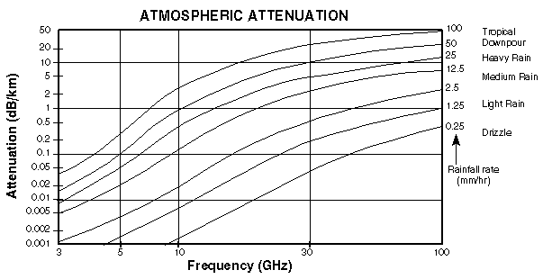
Figure 31: Plot of atmospheric attenuation v. frequency. Once can see that, in certain cases, a signal can be almost entirely lost when transmitted at a high enough frequency.

To choose antenna size and transmitter power for the orbiter, the Communications team established a link budget to confirm that the communications link would include a sufficient link margin (3 dB). A careful analysis of previous deep space missions and the current link budget caused the team to choose 20 W as the power for all antennas (LGAs and HGAs). To achieve a data rate of 7 kilobits/second, which should be high enough to achieve the science goals, the diameter of the HGA on the orbiter is 4 m and the diameter of the LGAs on the orbiter is 0.20 m. A conservative estimate of 0.60 has been used for the antenna efficiency and a total of -2 dB has been used for the line, propagation, and polarization loss²⁸. The appropriate link budgets are given in the following tables.

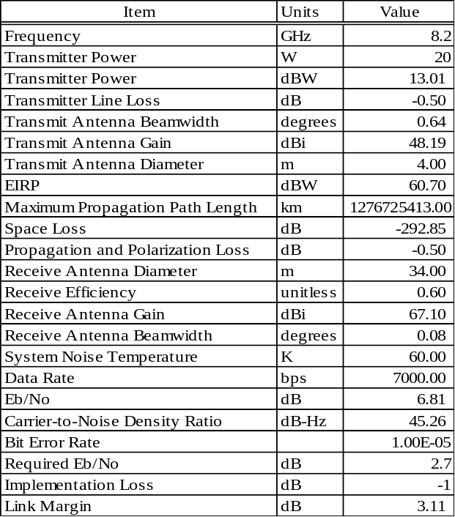
Table 9: Link budget for the orbiter-DSN downlink using HGA.

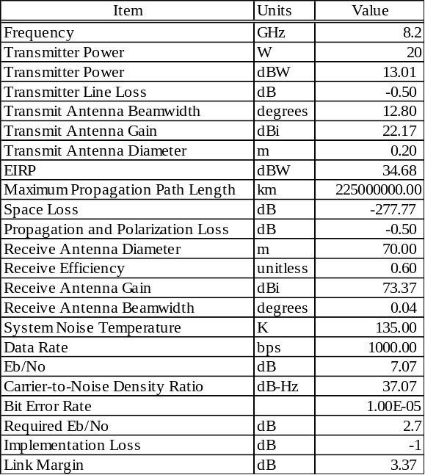
Table 10: Link budget for orbiter-DSN downlink using one LGA.

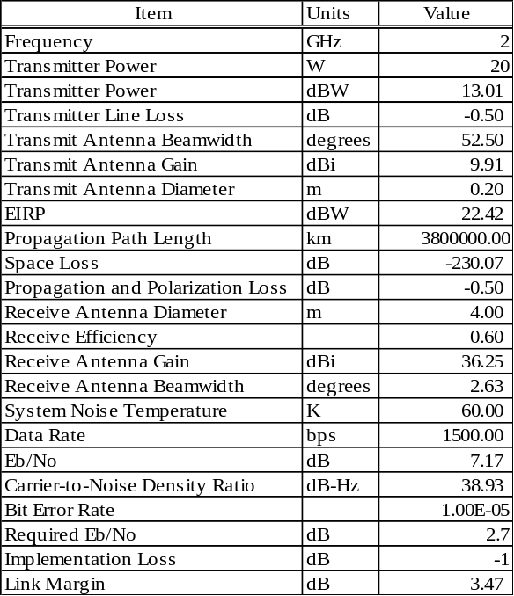
Table 11: Link budget for downlink from lander to orbiter.

All current space missions use a digital encoding scheme called phase shift keying. This technique conveys data by modulating the phase of a carrier wave and lowers the required digital signal to noise ratio (E_{b}/N₀) relative to an uncoded signal. The Communications team chose binary phase shift keying (BPSK) and Plus Reed-Solomon Viterbi Decoding because it gives the best bit error rate (BER) performance for a given E_{b}/N_{o}⁵⁵. In this case, the system achieved a BER of 10⁻⁵ using a required E_{b}/N_{o} of 2.7 dB.

The EAGLE lander contains almost all of the science instruments and the lander communications system is vital to the success of the mission. To that end, there are two LGAs on the lander which will transmit data to the Saturn orbiter over an S-band frequency. An HGA would have provided a much higher data rate, but would have also required a much higher mass, so it was not included on the lander.

Lander

The fact that an electromagnetic signal spreads over larger areas at increased distances from a source causes a significant signal loss for deep space communication. This free space loss is greatly reduced as the orbiter approaches Enceladus. The bit rate can therefore increase by very large amounts near orbital periapsis. The period of the orbit is approximately one month, so each month will have characteristic times when the lander can achieve high data rates. During other times, it will only be possible to transmit at much lower data rates. Evidently the Science team should attempt to use the high data rate instruments such as the Alpha Particle X-ray Spectrometer and the Wide Field Cameras (which have a variable data volume depending on how many images one is acquiring) during the appropriate time in the orbit each month.

The downlink data rate from the lander to the orbiter is a minimum of 1.5 kilobits/second, but that will increase to megabits/second or even gigabits/second near orbital periapsis. Downlink times between the lander-orbiter and the orbiter-DSN will therefore vary depending on the orbiter’s position. Table 12 shows the data rates for the science instruments on the lander.

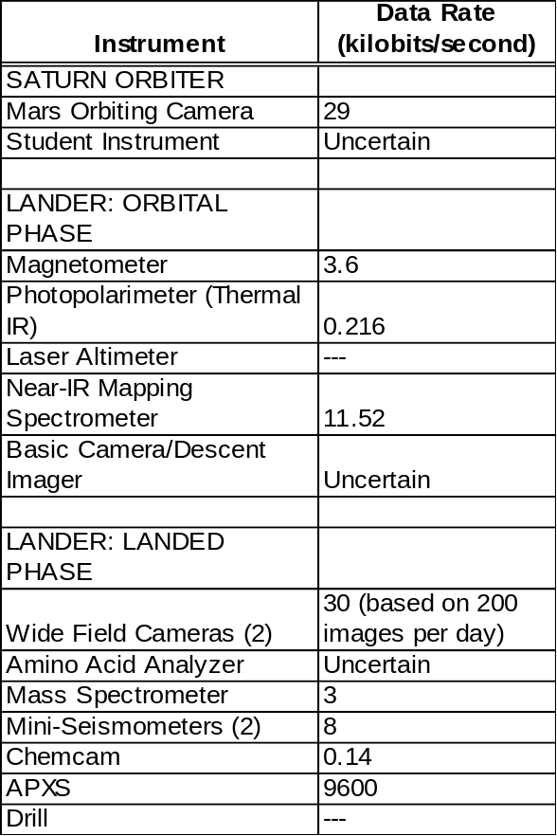
Table 12: The data rates for all of the science instruments on the lander. Note that several of the instruments will not be sending data back to the Earth.

An alternate design configuration would be to place a high gain antenna on the lander. This was done on the Mars Exploration Rovers and would have allowed, in this case, for much higher data rates with the Saturn orbiter and the possibility of low data rate communication between the lander and the Earth. However, HGAs are very expensive and heavy, so the system uses two LGAs instead.

Alternate Design Configurations

During the initial gravity assist phase of the mission, the mission design uses the HGA as a solar radiation shield, while two LGAs provide X-band communications with the Earth at a data rate of 1 kilobit/second. Several months after the Earth gravity assist, the HGA will be deployed and will commence X-band communications with the Earth at a minimum of 7 kilobits/second. Once the lander has reached Enceladus, it will communicate with the Saturn orbiter at an S-band frequency with a minimum data rate of 1.5 kiloibts/second. Significantly higher data rates will be possible when the orbiter is closer to Enceladus. All antennas operate with a power of 20 W and the entire communications subsystem has a mass of 109.5 kg (orbiter) and 4 kg (lander).

Conclusions

Command & Data Handling
The responsibility of the Command & Data Handling (C&DH) subsystem is to design a system that will meet all of the C&DH requirements designated for this mission. These requirements are to record all scientific data on the surface of Enceladus and process them for relay to earth via the Saturn orbiter. The primary focus is double redundancy, mainly in the transponder, antennas and recording devices. Figure 32 illustrates the flow of information for the C&DH subsystem to allow a clear understanding of the transmission and how it relates to the telecommunication subsystem.

Requirements

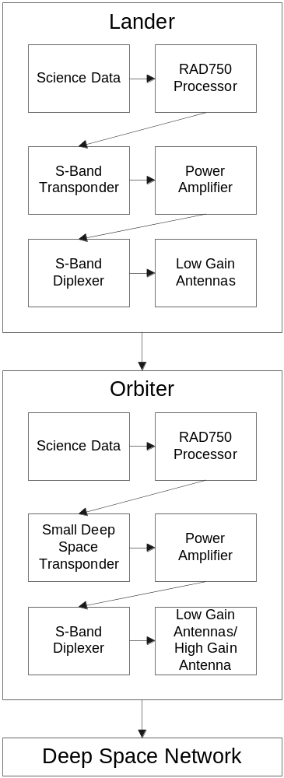

Figure 32: Flow chart for the Command & Data Handling subsystem.

The Command & Data Handling subsystem is critical to the operation of the spacecraft and has several key components that allow for communication between each system on the vehicle. The current design is designed around the science objectives, as well as the transfer of data between other systems. The finalized scientific objectives and payload specifications will help determine the overall design of the C&DH system as well as the specifications of each component. shows the components of the C&DH system.

Subsystem Design

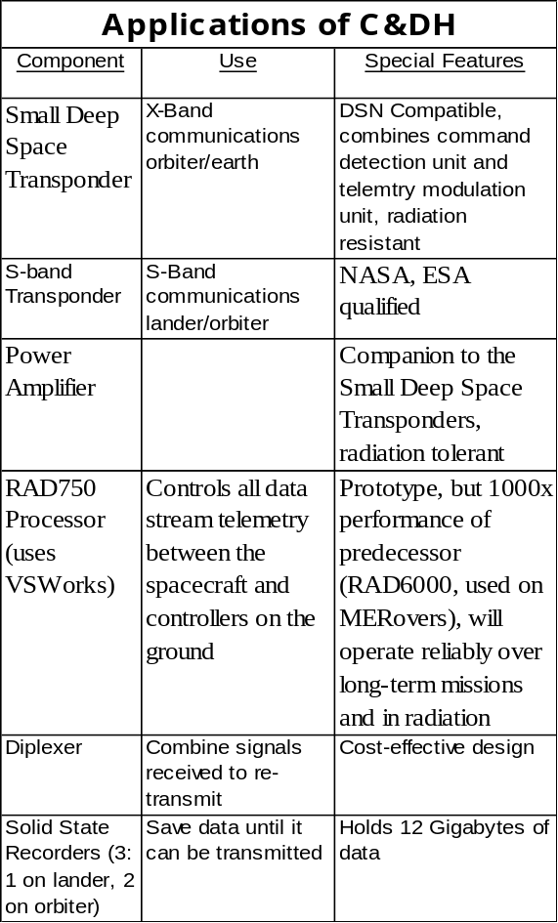

Table 13: Applications of Command & Data Handling components.^{50, 51, 52}

The Small Deep Space Transponder (SDST) will send and receive transmissions via the High Gain Antenna (HGA) and Low Gain Antennas (LGAs) when communicating between the Saturn orbiter and Earth. It is the predecessor of the Deep Space Transponder (DST) used on the Cassini-Huygens mission, and can operate at a wide range of frequencies to allow for redundancy in the communication subsystem. This design has less mass and smaller dimensions, and it uses less power for communications. Furthermore it combines the Command Detection Unit (CDU) and Telemetry Modulation Unit (TMU). The Jet Propulsion Laboratory (JPL) in Pasadena, California funded the development of this transponder by Motorola Inc. The C&DH team chose the SDST for this mission in part because it is efficient in X-band communications for deep space. Additionally, it is radiation resistant, light in mass, and uses less power than the DST. The testing and verification phase of development will be completed for this deep space orbiter vehicle mission before the preferred launch date.^{51, 52}

Small Deep Space Transponder

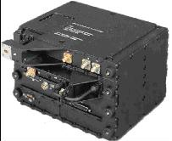
Figure 33: Small deep space transponder.

The S-band transponder will be used when transmitting and receiving data between the orbiter and Enceladus lander. It will be efficient in the frequency range of 2.2 GHz to 2.3 GHz and communicate between the Enceladus lander and the Saturn orbiter. The basic requirements for the S-band transponder will be to transmit at least 256 kbps at a frequency range 2200-2300 MHz and receive at a frequency range of 2000-2120MHz with 2dB or less noise. Its mass will be approximately 4kg or less and have an output power of 5W. Though these specifications are preliminary, it will use the least amount of power for the maximum data rate using the most up-to-date technology available at the date of launch.

S-Band Transponder

For a deep space mission to the Saturn system, the telecommunication system requires amplification to transmit data over large distances. The amplifier will have small mass and size, and will be completely space qualified to have a high radiation tolerance. It needs to operate in the X-Band frequencies in order to enhance the transmission power of the High Gain Antenna (HGA) for communications with Earth. This amplifier will be complementary to the SDST, which will connect to it using a standard 1553 data interface. The power amplifier will be used only when during downlink from the Saturn orbiter to Earth.

Power Amplifier

This processor will be capable of performing all the necessary actions to control the C&DH subsystem of EAGLE. It will build on the heritage of previous processors used on spacecraft, and it will implement VSWorks software. For more information, see Section 7.5.3, Trade Studies.⁵⁰

RAD750 Processor
(uses VSWorks)

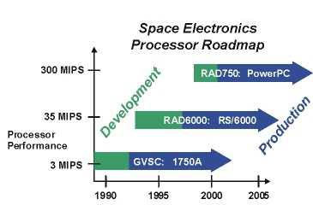

Figure 34: Processor design roadmap⁵⁰

Solid State Recorders
The Solid State Recorder (SSR) on the lander will save data collected from science instruments until the lander can transmit this information to the orbiter. Two SSRs are located on the Saturn orbiter: one will record data while the other will be used in case of contingency. The limiting factors for data transmission depend on the location of Enceladus with respect to the orbiter and Saturn. The orbiter will have an additional two SSRs to save all of the data received from the lander until the orbiter can it relay it to the Deep Space Network (DSN) on Earth. The transmission time from the orbiter to Earth will be determined mostly by costs of using the DSN and in part by the allowed communications windows for transmission between the two points.

cPCI-1553 & RS232/422
These components will allow for the high-speed transmission of data within the Enceladus Lander, as well as within the Saturn orbiter.

The specifications of each component will vary depending on finalized data rates, cost, size, and power. shows approximated values using specifications given on commercial web sites.

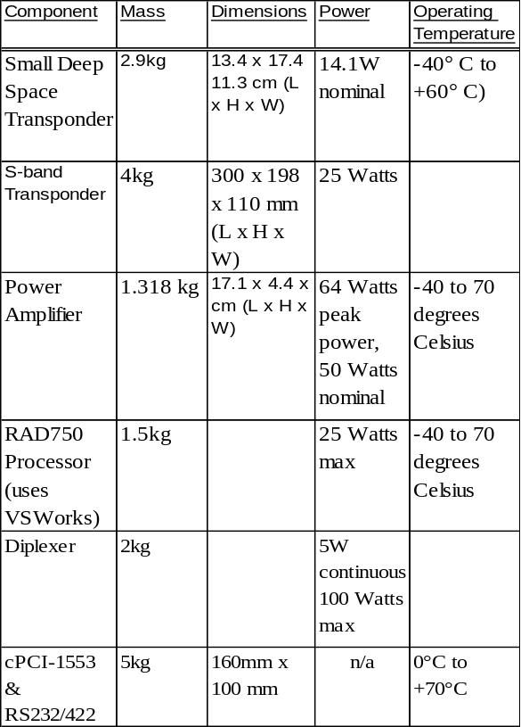
Table 14: Specifications of C&DH
components ^{50, 51, 52}

The Command & Data Handling team conducted a trade study to determine the most reliable processor. Compared to the RAD6000, the RAD750 can operate at a higher frequency, operates at a higher rate with more Read-Only Memory (ROM), and can withstand a wider range of temperatures and radiation exposure. Due to these advantages, the RAD750 is the best component.⁵⁰

Trade Studies

The C&DH subsystem has many commonalities with previous deep space missions, so only the level of technology will be unique. The components will need to be efficient and reliable, but at the same time, they should be only as advanced as required. The computing capabilities of this subsystem should not exceed that of the amount of expected science data recorded and analyzed. The C&DH subsystem of EAGLE will be doubly-redundant through multiple communication antennas, an extra SSR, and a multi-frequency transponder. A non-redundant system could be implemented with the calculated risk of failure to any of the major C&DH components. This design would be limited to one frequency of communication and less data storage.¹²

Alternate Design Configurations
The Command & Data Handling subsystem of EAGLE shall include all components necessary to collect and effectively transmit data between earth, orbiter, and lander, based on the requirements of the science data and other subsystems. It will be composed of the most up-to-date software and hardware at the date of launch, as well as parts that have been space/radiation tested and qualified.

Conclusions

Guidance, Navigation & Control
The Guidance, Navigation & Control (GNC) subsystem is responsible for monitoring the spacecraft’s position and attitude through its interplanetary trajectory, and making attitude changes as necessary to comply with both pre-planned and corrective burn sequences. For this mission, the GNC subsystem must provide the following capabilities: the system must determine, in real-time, the exact spacecraft position and attitude during its interplanetary trajectory and related gravity assist maneuvers. The system must be able to orient the spacecraft in a way that the communications dish is always facing the sun in order to provide radiation protection during the portion of the trajectory where solar radiation is above acceptable levels. The system must process this information on board to determine what corrections, if any, are necessary to ensure successful Saturn orbit insertion; the system must have the means to re-orient the spacecraft to allow both pre-planned and corrective burn sequences, and to enable potential interplanetary science-related operations. Finally, the system must provide both station-keeping capability for the orbiter spacecraft to maintain and correct its steady-state orbit, and surface mobility capability to the lander spacecraft to allow for potential surface traversal activities. The pointing accuracy is required to be on the order of degrees in order to attain these objectives. Additional requirements include minimizing the power required and minimizing the necessary mass.

Requirements

The GNC design team studied a variety of previous NASA interplanetary missions for examples of GNC subsystems. The most analogous missions were Voyager and Cassini-Huygens; therefore, the GNC subsystem for EAGLE has strong commonalities with both of these spacecraft. Guidance and navigation of the spacecraft will be accomplished using a series of two star trackers, each of which will take measurements of the star background and transmit this information to a central processor. This processor, equipped with an exhaustive database of known star positions, will triangulate the exact position of the spacecraft based on a comparison between the star database and primary measurements. Three inertial reference units included in the spacecraft will relay the orientation of the spacecraft to the central processor. Once the exact position of the spacecraft is known, the GNC system will make corrections to the flight path based on comparisons between the calculated interstellar trajectory and the actual path of the spacecraft.

Subsystem Design

In order to make such corrections, the GNC subsystem implements a combination control system consisting of monopropellant hydrazine thrusters and reaction wheel mechanisms. Reaction wheel systems provide large-scale attitude corrections, and the monopropellant thruster system accounts for precision pointing.²⁸ The GNC team selected to include both types of attitude control for a variety of reasons. First, the reaction jets were necessary to attain the precision required for communications between ground control and the lander and for communication between the lander and Earth as well. Due to the length of the mission, the reaction wheels are a secondary system that will allow the spacecraft to conserve fuel. By using reaction wheels, the three-axis stabilized spacecraft can be augmented with spin stabilization when precision pointing is not required. The attitude control system uses a total of three 10 kg reaction wheels, in a mutually orthogonal configuration on the Saturn orbiter portion of the spacecraft. Such a configuration provides three-axis spacecraft control through precision angular momentum changes.

The spacecraft utilizes twenty-eight 1-N hydrazine thrusters. Sixteen of these thrusters, organized into clusters of four, are attached to four one-meter booms on the orbiter portion of the spacecraft, enabling full 3-axis spacecraft control. These thrusters comprise the primary control system during the interplanetary voyage when both lander and orbiter are connected and when the orbiter is in orbit around Saturn. This system is partially redundant, as full attitude control can be achieved using only 8 thrusters. The remaining three clusters of four thrusters are attached to alternating vertices of the underside of the hexagonal lander spacecraft platform. This system provides attitude control for the lander as it orbits Enceladus and during entry, descent, and landing. These thrusters
will serve a primary function of providing “hopping” capability to the structure once it reaches the surface of Enceladus. These thrusters will also serve as backup interplanetary attitude control thrusters, providing an additional level of redundancy prior to lander-orbiter separation, should the orbiter thruster system fail. Both separate attitude control systems will contain respective monopropellant tank systems, with the orbiter system having twice the hydrazine mass, since it will provide the main attitude control for the interplanetary voyage and will require precision pointing while the lander relays science data. The conservative fuel mass estimate is 200 kg of hydrazine. The monopropellant tanks are made of titanium and have pressure fed systems for the thrusters. Table 15 summarizes the GNC components:

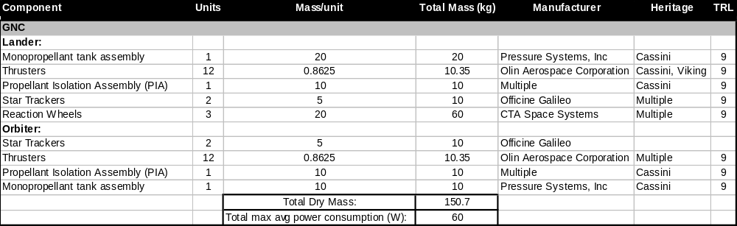Table 15: Summary of GNC components

Trade Studies
The Guidance, Navigation & Control subsystem weighed several different qualitative options prior to choosing the current system design. Star-tracker based position determination has become an industry standard practice, and the process of active position determination based on star tracker measurements has been refined and proven on many successful interplanetary missions, with the most recent mission being the Cassini mission to Saturn. This proven flight capability and traceable heritage, coupled with low instrumentation mass requirements and high levels of precision, makes star-tracker determination the best method of position determination for this mission.

The use of star-tracking based position determination weighed heavily in the decision to implement 3-axis thruster/reaction wheel control system as opposed to other attitude control systems. Spin stabilization, a commonly used method that places the craft into a controlled single- or multi-axis spin and uses angular momentum to maintain axial directionality, poses problems for star-tracking navigation. If the spacecraft is constantly rotating, taking measurements of distant stars for navigation becomes significantly more challenging. Spin stabilization also eliminates any possibility of interplanetary camera-based observation, and complicates any potential in-flight scientific experimentation. For these reasons, spin-stabilized attitude control is not the primary mode of attitude control for this mission.

Remaining viable alternatives for attitude control include reaction jets, reaction wheels and momentum wheels. There are a few options in terms of reaction jets, but hydrazine thrusters have an extensive heritage, including Voyager, Viking, and Cassini, and provide the most thrust and highest specific impulse for the lowest mass. Hydrazine thrusters, while very precise, require consumable fuel (and therefore fuel tanks) to operate, thus increasing overall system mass and complicating structural layout and thermal requirements as compared to reaction wheels. However, attitude control thrusters have the added benefit of potentially doubling as a limited propulsion system, enabling surface or interplanetary thrusting capability. Momentum and reaction wheels, while less precise than thruster systems, are less massive than thruster/fuel systems and require no consumable fuel. For these reasons, along with recent proven performance on the Cassini mission, a combination system using both reaction wheels and hydrazine thrusters was selected for this mission, enabling both large scale and precise attitude control. Therefore, the attitude control system meets all design requirements, with little sacrifice in terms of mass.
Manipulating the number and configuration of monopropellant thrusters could yield alternative spacecraft geometries. A system of 16 thrusters in four clusters on the orbiter could provide greater control for the spacecraft. This will result in increased mass but also yield greater control authority. For the lander, 2-N thrusters and a larger fuel tank would make the attitude control system more powerful, which would give the lander a greater range of mobility for exploring the surface. However, this would add more mass and would require high levels of precision due to the low gravitational force of Enceladus. Too much thrust may cause the lander to overshoot the target, possibly achieve exit velocity, and leave the surface of the moon.

Alternate Design Configurations

Both star tracker-based position determination, and monopropellant hydrazine thruster/reaction wheel attitude control have proven flight capability and traceable mission heritage. The combination system enables both redundant interplanetary GNC capability prior to vehicle separation and station keeping/surface mobility capabilities after vehicle separation. This design successfully meets the mission requirements while providing a desired amount of efficiency.

Conclusions

Propulsion
The propulsion subsystem is responsible for all spacecraft propulsive needs beyond interplanetary trajectory insertion. For this mission, the propulsion subsystem must provide the following capabilities: the subsystem must be capable of providing time-lapse burns during the spacecraft’s interplanetary voyage in accordance with both planned and corrective trajectory burns; the subsystem must provide the thruster capability necessary to ensure spacecraft Saturnian orbit capture; the subsystem must provide thruster capability to the lander spacecraft such that the vehicle can enter temporary orbit around Enceladus. The requirements for these burns are included in the Trajectory subsystem section, with the largest propulsive requirement being the 4.5 km/s burn required to enter into Enceladus orbit.

Requirements
In the design of the propulsion subsystem, the Cassini spacecraft contributed the most significant flight heritage to this mission. However, the Cassini mission had a much lower propulsive constraint, so EAGLE will need a unique propulsion system to meet the requirements. This system, which exploits a chemical reaction between Monomethylhydrazine (MMH) and Nitrogen Tetroxide (NTO) to create thrust, has been used extensively for deep-space exploratory vehicles, most recently on the Cassini mission to Saturn.⁶ The MMH/NTO bipropellant system provides a specific impulse of 340 s,⁴ which is the highest attainable by chemical propellant systems for interplanetary travel.

Subsystem Design

Two separate, pressurized fuel tanks house 1220.4 kg of fuel (MMH) and 1952.7 kg of oxidizer (NTO) components. Using the propulsive requirements provided by the Trajectory team, along with the specific impulse of the fuel, the Propulsion team used the rocket equation to determine the masses of each propellant. A pressure system containing 16 kg of highly pressurized Helium gas will maintain the pressure within these tanks. Two Pressurant Control Assemblies (PCAs) pump the Helium out of its highly pressurized composite tank housing to provide pressurization during regulated maneuvers.⁶ The fuel and the oxidizer flow through the Propellant Isolation Assembly (PIA) to be combined in the Main Engine Assembly (MEA) to provide thrust for the spacecraft.⁶ The attitude control system described in the previous section will align the spacecraft in the correct orientation to enable successful completion of both planned and corrective burn sequences.

The main bipropellant tanks are located in the center of the spacecraft with the main rocket engine located on the opposite end of the spacecraft from the communications dish. The entire propulsion system is to be contained in this area because at Enceladus orbit insertion, the Saturn orbiter will disconnect from the lander and travel on another trajectory. Then the lander spacecraft will re-orient so that the propulsion system can insert the lander into Enceladus orbit. After this main burn, the lander will jettison the entire propulsion system, including fuel tanks and the main rocket engine assembly; these components will then enter into Enceladus orbit or crash into the surface of Enceladus. The lander ejects this stage because it is a large amount of mass and volume that serves no further purpose to the lander. The fuel tanks will be empty and the spacecraft requires no more large burns; the attitude control system will provide the small propulsive requirements to land the spacecraft. The deployment of the main propulsion system makes the wiring and plumbing a crucial component that must be completely self-contained.

The propulsion system has a total dry mass of 360 kg, with an additional 5052 kg necessary for fuel. This system will provide the spacecraft an I_{SP} of 340 sec, a thrust of 445 N, and will provide all the propulsion for the interplanetary portion of the mission as well as Enceladus orbit insertion. This system has an average mass power load of only 50 W, except for the main burn when there is an initial spike of about 80 W, lasting only 100 ms, which is necessary to open the main valve.⁶ Enceladus entry and descent will be controlled using the hydrazine monopropellant GNC system discussed in the Section 7.6.2. Table 16 provides a summary of the Propulsion system:

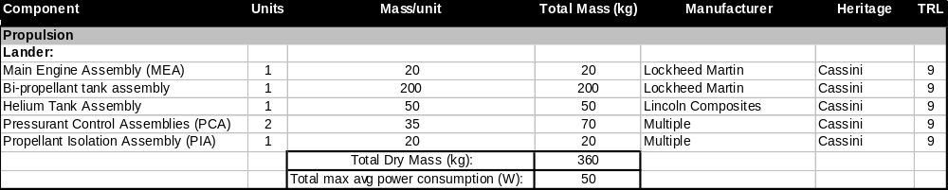Table 16: Summary of the Propulsion system

The propulsion team conducted basic trade studies to determine which propulsion system most adequately satisfied the requirements of this mission. At the time of this study, two potential options existed that could realistically bring a spacecraft to the Saturn-Enceladus system: chemical propulsion and electrical propulsion.

Trade Studies

Chemical propulsion has been flight verified on several interstellar missions, and its successful performance has been refined and improved several times. In the case of MMH/NTO, the propellant system provides a significant level of thrust (445 N) at its given I_{SP} of 340 s. However, chemical propulsion requires extremely high amounts of fuel (in this situation 5052 additional kg of mass), consuming a considerable proportion of the overall spacecraft mass budget. Electrical propulsion does not require nearly as much mass and can theoretically achieve much higher specific impulses, on the order of 1,000 s.²⁸ However, electric propulsion systems require much higher electrical budgets and, most importantly, impart orders-of-magnitude less thrust than chemical propulsion. Such low levels of thrust would significantly increase the length of interstellar travel time, which in turn would significantly complicate the design of other subsystems. The EAGLE spacecraft is simply so massive that the most sophisticated electrical propulsion still would not provide enough thrust to reach Saturn. Progress is being made in electrical propulsion, but currently, there is no system powerful enough to meet the mission requirements.

For these reasons, combined with Cassini’s recent success in reaching the Saturn system using a similar propulsion system, chemical propulsion was selected for this mission. This design satisfies every propulsion-related mission requirement, and has sufficient flight heritage to enable successful system implementation.

The propulsion team considered a range of configurations for the subsystem, many of which were determined to be inefficient and/or too complicated. However, one significant design challenge in the current configuration is the fact that the spacecraft jettisons the rocket assembly and the fuel tank after depletion as if they are a separate stage. This leads to complexity in wiring and piping and creates space debris. An alternative would be to have the fuel tanks and main rocket engine remain attached to the lander and utilize the main propulsion system for Enceladus orbit insertion and the entry, descent, and landing phase. This provides more power than the hydrazine thrusters in the current configuration, and would not have a large fuel requirement. After landing, it is possible that the lander could disconnect from the main rocket assembly and then “hop” to another location to perform scientific readings. This alternative configuration results in landing a much larger amount of empty mass on Enceladus, which is why it was not selected as the final design.

Alternate Design Configurations

The propulsion system is by far the most massive of all the subsystems on the spacecraft. For this reason, any added efficiency will have a large effect on the available mass for other subsystems. Because of this, the Propulsion team paid special attention to reducing mass, in terms of both fuel and hardware. The MMH/NTO bipropellant system is currently the most efficient propulsion system available for interplanetary spaceflight. A more efficient and more powerful propulsion system may be developed in the 15 years before this mission is launched, but this cannot be planned into the design. With existing technologies, the Propulsion team has selected what it believes to be the best propulsion system to accomplish the requirements with the lowest use of mass.

Conclusions

Cost and Schedule
Several methods were employed in order to determine the cost of this mission. The primary method was parametric cost estimation using the Unmanned Space Vehicle Cost Model, 8th edition (USCM8). This model uses Cost Estimating Relationships (CERs) that were derived from a historical database of actual unmanned space missions. All costs were assumed to be nonrecurring and were calculated based on a theoretical first unit (TFU). In addition, a nonstandard bus was assumed. With all this considered, the USCM8 is used to find costs in FY 2000 dollars, which are then inflated to reflect current FY 2006 dollars. Thus, the total cost of the EAGLE mission in 2006 dollars is expected to be $838 million, which falls under NASA’s classification of a flagship mission.

Cost

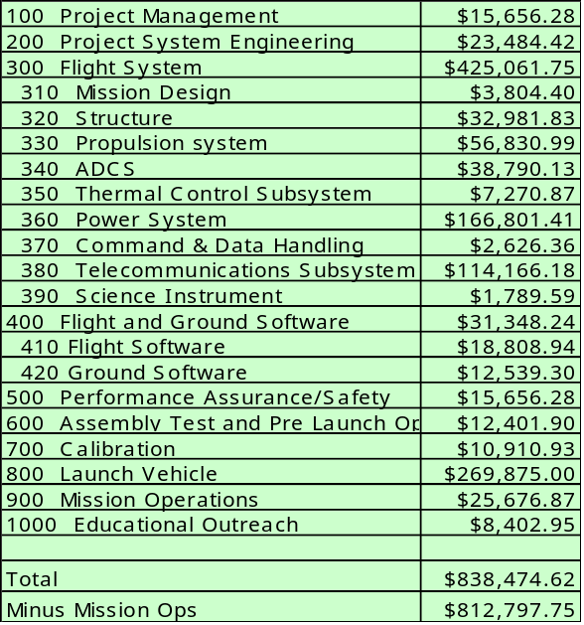Table 17: Costs by Work Breakdown Structure Note: all costs are given in thousands of dollars.

Due to the error inherent in purely parametric estimating methods, engineering build-up methods were supplemented where appropriate. Specifically, the power and propulsion subsystems were estimated using a combination of the CERs and actual costs found in the literature. In addition, more accurate costs were determined for other subsystems by using the component level CERs rather than subsystem level CERs.

The Program Management and System Engineering cost allocations were based on the Program Level CER specifically for science missions such as EAGLE. This particular CER was based on the total cost of the spacecraft plus the cost of integration, assembly, and testing. The product actually combines the two disciplines, but they are represented separately based on the relative percentages of the budget they typically occupy.

For the purposes of this project, mission design is defined as all calculations that take place to create a flight path for the spacecraft. Thus, the cost is predominantly representative of a handful of employees and their respective labor costs. Some software licensing was added for such programs as STK and Matlab.

The thermal control estimate was derived using both a mass based CER and values found in the literature since the use of RHUs is not standard. The cost of the RHUs was found directly by multiplying the quantity by $35K per RHU. It should also be noted that the Environmental Impact Statement (EIS) required for the use of RTGs was assumed to include the investigation of the safety of the RHU thermal system. Therefore, some of the costs incurred by thermal were actually included in the power estimate.

The power subsystem’s cost was also estimated by using a combination of parametric and direct methods. Due to a lack of MMRTG or SRG representation in the heritage database, specific costs based on RTG heritage were acquired from Mike McGrath, Director of Engineering at the Laboratory for Atmospheric and Space Physics (LASP). Also included was $15 million for an EIS as required when any kind of nuclear device is flown in space. The CER for power conditioning and distribution was used in order to provide a more complete cost of the power subsystem.

Performance Assurance/Safety, Assembly Test & Launch Operations (ATLO), and Calibration CERs were all used to come up with the values listed. All of these CERs were based on the total cost of the spacecraft. As was done for Program Management and Systems Engineering cost estimations, ATLO and Calibration were separated out of the same CER by the relative percentages of the budget they typically occupy.

The cost of Mission Operations was calculated by using NASA’s own Mission Operations Cost Model (MOCM). The primary driver of this CER was the total mission cost (less mission operations) and can be adjusted to fit communications, planetary, physics/astronomy, manned, and Earth observation spacecraft. The planetary mission model was used for the values given in tables 8-1 and 8-2.

The cost of the launch vehicle was found separately from any parametric cost estimation methods. According to astronautix.com, the cost to launch a Delta IV in the 4050H-19 configuration is $254 million in FY04 dollars. This number was inflated to current FY06 dollars using actual inflation values obtained from inflationdata.com. Thus, the cost for launching a Delta IV Heavy in FY06 dollars is approximately $270 million.

Educational outreach was assumed to be 1-2% of the total mission cost minus launch vehicle expenses. All of these costs are distributed over the lifetime of the mission and adjusted for inflation. Table 8-2 represents the total mission cost (TMC) in real year dollars according to the inflation values taken from SMAD and provided by the Office of the Secretary of Defense.

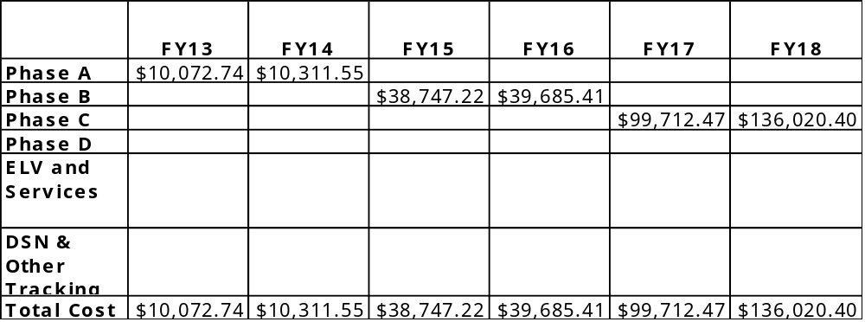

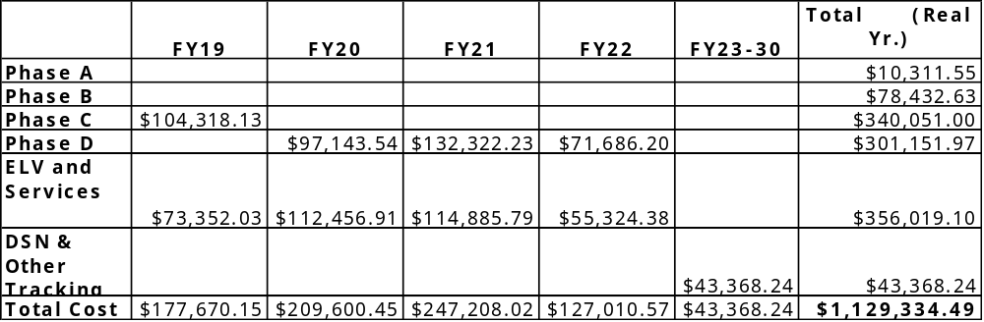

Table 18: Total mission cost funding profile.

Mission activities will be broken up by the NASA standard phases.

Schedule of Activities for Project
1. Advanced Studies-Pre-Phase A (Currently)
Conceptual design phase
Development of performance goals and requirements
Establishment of science working group
Trade studies of mission concepts
Feasibility and preliminary cost analysis
2. Preliminary Analysis-Phase A (Currently)
Proof of concept analysis
Mission operations concepts
Make vs. Buy trade studies
Payload definition
Project Schedules
3. Definition-Phase B (2013-14)
Define baseline technical solution
Define Science Schedule
Create requirements documents
System requirement and system design reviews
4. Design-Phase C/D (2015-23)
Detailed Design Process
Cutting Metal
Test and Analysis
PDR, CDR, Test Readiness, Launch Readiness reviews.
5. Operations-Phase E (2023-2030+)
Launch
Mission operations
Maintenance and Troubleshooting
Failure Monitoring
End of Life Disposal
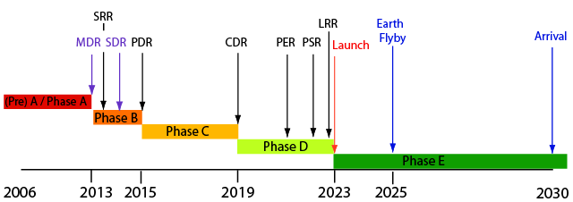

Figure 35: Mission Timeline with Reviews and Milestones. Mission activities will be broken up by the NASA standard phases.

Outreach
An occasionally overlooked but always essential part of any NASA mission, or any scientific endeavor for that matter, is a strong outreach component to draw in public enthusiasm. There are many ways to communicate NASA’s goals for any specific mission. The Mars Exploration Rover website is an excellent example of an extremely successful outreach campaign, recording 1.7 billion hits in the week after Spirit’s landing and setting the bar far above any previous NASA missions. As part of the EAGLE design and as part of the NASA Academy in general, outreach has been integrated to “inspire the next generation of explorers as only NASA can.”

Student Design Payload
As any student who has participated in a research or design project can attest, the most valuable learning comes with hands on activities. So, as a group of students, the NASA Academy has introduced a project that can provide invaluable research experience for future students. On the Saturn orbiter phase of EAGLE, there will be mass and power allocated to an instrument designed and built by students.

The EAGLE project will send out a call for proposals to universities for project ideas. The proposed instrument must be less than 10 kg in mass, use less than 5 W of power, and fit within a space 20 x 20 x 50 cm³. It must be an engineering or science experiment that will push the boundaries of technology or improve humanity’s understanding of the universe. The teams should be comprised of undergraduate and graduate students supported by one or more academic mentors. Proposals must show an organizational structure and a timeline of development, taking into account the fact that the development of this instrument may outlast any one student’s career at a particular institution.

All proposals received by a given date will be considered based on the goal and organization of the project, the creativity, and the feasibility. The team will then be matched with a NASA center to facilitate the design and manufacturing of the instrument. The team will be involved in all phases of the mission if possible, from blueprint to launch, giving the students a unique perspective on NASA missions.

The EAGLE mission will be instrumental in facilitating the study of potential sites of extraterrestrial biological activity. By incorporating both a lander and orbiter, EAGLE will ensure both breadth and depth by meeting the science objectives mentioned previously. This mission is a logical next step to follow Cassini that will increase scientific knowledge across a variety of disciplines, including geology, chemistry, and biology. In addition, it serves as a testbed for future planetary exploration missions such as potential missions to Europa currently under consideration.

Conclusions

At an estimated $1.12 billion, EAGLE is considered by NASA to be a flagship mission. However, this is only one third of the cost of the Cassini mission currently in orbit around Saturn. It will also provide much more scientific data than can be achieved by an orbiter alone. Additionally, multiple sources of heritage have been incorporated in an effort to mitigate risk and keep cost.

This study is a first cut at defining the science that needs to take place at Enceladus as well as one potential engineering design that can be implemented to achieve that science. Future work will entail refining this design through a series of trade studies and updating it with knowledge gained from future Cassini discoveries, such as those anticipated by the next Enceladus encounter in 2008.

Enceladus is currently the center of attention among the astronomical community and Cassini has merely whet the appetite of scientists all over the world. Enceladus is a unique moon that clearly needs more study and may hold clues to the most fundamental question of the universe: Are we alone? It is in this vein that the EAGLE mission is proposed.

Appendices
In order to choose the best instruments for EAGLE’s specific mission objectives, a study of the instruments used on other planetary missions was conducted. The following table lists instrument packages for nine different missions that were used as trade studies.

Science Trade Studies

RANGER 4 | SURVEYOR 3 | NEAR
Camera | Camera | MultiSpectral Imager (MSI)
Gamma Ray Spectrometer | Radar Altimeter | Gamma Ray Spectrometer
Radar Altimeter | Temp sensors | X-Ray Spectrometer
Seismometer | Strain Gages | Infrared Spectrograph
 |  | Laser Rangefinder (NLR)
CLEMENTINE | PHOBOS 1/2 | SELENA
Ultraviolet/Visible Camera | Camera | Gamma Ray Spectrometer
Near-Infrared Camera (NIR) | Eadar Altimeter | X-Ray Spectrometer
Thermal Infrared spectrometer | Temp. Sensor | Near-Infrared Camera (NIR)
Penetrator | Strain Gages | Laser Altimeter
Star Tracker Cameras | Mass Spectrometer | Multiband Imager
Laser Altimeter | X-Ray Fluorecence Spectrometer | Lunar Radar Sound
Bistatic Radar Experiment | APXS | Magnetometer
 | P False color image of Enceladus  enetrator | Upper atmosphere and Plasma Imager
 | Thermal Infrared Spectrometer | Charged Particle Spectrometer
 | Near Infrared Imaging Spectrometer | Radio Science
 | Thermal Imaging Camera
 | Magnetometer
 | X-Ray Telescope
 | Laser Altimeters
VEGA 1 | PIONEER VENUS | BEPICOLOMBO
LANDER | Gas-Phase Chromatograph | Camera
Camera | Malachite Mass Spectrograph | UV Spectrometer
Pressure Sensors | Infrared Radiometer | X-ray Spectrometer
Tem. Sensors | Nephelomete | Visible NEAR-IR Map. Spect
UV spectrometer | Solar Flux Radiometer | Thermal IR Spect
Gas-Phase Chromatograph | Temperature Sensors | Laser Altimeter
X-Ray Spectrometer | Pressure Sensor | Gammma Spectrometer
Malachite Mass Spectrograph
VM-4 Hygrometer H20
IPF Aerosol Analyzer

Based on this study, the following instruments were selected for the science payload:

Near-IR spectrometer | Magnetometer | Pancam
Thermal IR imager | Altimeter | Mass Spectrometer
Descent imager | Seismometer | Amino Acid Analyzer

Additional trade studies were performed to select instruments for measuring the elemental composition of the surface and for collecting collect microscopic images. The following table depicts the instruments which were considered.

Instruments | Mass | Power | Elements
ChemCam | 5.62 kg | 6.7 W | Ca,Si,Al,Sr,Fe,Ba,C,Mg,Ti,Na,H,Li,K,O
APXS | 0.57 Kg | 0.3 W | Si,S,Cl,Ca,Fe,Ni
Gamma-Ray | 8.6 Kg | 3 W | Si,O,Fe,Mg,K,Al,Ca,S,C,H,Th,U
Neutron Spectrometer | 3.9 Kg | 2.5 W | C,O,N,Cl,Fe,Ti,Si,Ni,Mg,Al,Ca,K,Th,U

Various combinations of the instruments were considered, but a combination ChemCam-APXS package was selected since it will minimize the science payload mass while providing maximum information about the elemental composition of Enceladus. Since ChemCam includes a remote microscopic imager, this package also means it is not necessary to include a separate microscopic imager in the payload.

List of Acronyms
COSAC- COmetary SAmpling and Composition (from Rosetta)
ECS – Environmental Control System
EDI-Enceladus Descent Imager
EDL – Entry, Descent, and Landing
ESAMS-Enceladus Surface Analysis by Mass Spectrometry
FSC-Falling Sample Collector
GC-Gas Chromatograph
ISS-Imaging Science Subsystem (from Cassini)
MAG- Dual-Technique Magnetometer
MARDI-Mars Descent Imager (from MSL)
MER – Mars Exploration Rover
MLI – Multi Layer Insulation
MMH- Monomethylhydrazine
MS-Mass Spectrometer
MSL-Mars Science Lab
NTO- Nitrotetroxide
RHU – Radioisotope Heating Unit
RTG – Radioisotope Thermal Generator
SOC-Saturn Orbiting Camera
TOF-Time of Flight (mass spectrometry)
TPS – Thermal Protection System

References
- “Alpha Particle X-Ray Spectrometer (APXS)”, NASA, June 20” [http://marsrovers.jpl.nasa.gov/mission/spacecraft_instru_apxs.html]
- “Alpha Particle X-ray Spectrometer”, a technical description by the Athena group at Cornell, [retrieved 28 July 2006 http://athena.cornell.edu/pdf/tb_apxs.pdf]
- Bada, et. al. 2005, Astronomy and Geophysics 46, 26-27
- Barber, T.J.; and Cowley, R.T.: “Initial Cassini Propulsion System In-Flight Characterization,” AIAA Paper 2002-4152, July 2002.
- Bell, J. F. et. al., “Mars Exploration Rover Athena Panoramic Camera (Pancam) investigation”, Journal of Geophysical Research, Vol. 108, No. E12, 8063, doi:10.1029/2003JE002070, 2003.
- Berry, Robert L; Eberhardt, Ralph N; Leeds, Michael W: “Development of the Cassini spacecraft propulsion system,” AIAA Paper 96-2864, July 1996.
- Blum, D., Bourque C., Mehta, G., “The Alloy with a Mission” Berkley Report, URL: [http://www.mse.berkeley.edu/classes/matsci102/F01reports/allithium.pdf]
- The Boeing Company, “Delta IV Payload Planners guide,” Boeing, Huntington Beach, Ca, 1998
- Braukus, M., Malone, J., “Shuttle Super Lightweight Fuel Tank Completes Test Series” NASA , URL: [http://www.findarticles.com/p/articles/mi_pasa/is_199607/ai_2389882821 cited 2 August 2006]
- Brown, R. H., et al. 2006. Science 311, 1425-1428.
- J. Brückner, et. al., The Rosetta Alpha X-Ray Spectrometer (APXS) [http://www.mpch-mainz.mpg.de/~kosmo/spacepage/english/rosetta/rosetta.htm]
- “Canberra Deep Space Communication Complex.” Deep Space Network: Jet Propulsion Laboratory, Pasadena, CA. [http://www.cdscc.nasa.gov/Pages2/pg01j_history.html. Accessed July 1, 2006]
- Carlson et al. 1992, Space Science Reviews 60, 457-502
- Carman, G., Chaplya, P., McKnight, G., “Investigating the Passive damping Properties of Active Materials” [www.icase.edu/series/Morphing/Carman/nasapresentation2.pdf cited 7 August 2006 ]
- Carney, M. J., Haddox, E.M., “ELV Mission Analysis Launch Vehicle Information,” May 2006 [http://elvperf.ksc.nasa.gov/elvMap/staticPages/launch_vehicle_info1.html]
- “Cassini-Huygens”, Wikipedia, August 2006 [http://en.wikipedia.org/wiki/Cassini-Huygens]
- “Cassini Saturn Orbital Insertion Timeline,” June 2004 [http://www.astrobio.net/news/article1044.html]
- “Cassini-Huygens Saturn Arrival,” NASA Press Kit, Jun. 2004.
- Delta Launch Services, “Delta IV Payload Planner’s Guide”, Boeing, MDC 00H0043, October 2000
- Dougherty, M. K., Khurana, K. K., Neubauer, F. M., Russell, C. T., Saur, J., Leisner, J. S., & Burton, M.E. Science 311, 1406-1409.
- Dunlop, M.W., Dougherty, M.K., Kellock, S.J. and Southwood, D.J., Operation of the dual magnetometer on Cassini: Science performance, Planet. Space Sci., 47, 1389-1405, 1999.
- “Enceladus (moon)”, Wikipedia, August 2006 [http://en.wikipedia.org/wiki/Enceladus_(moon)]
- Frasier, D., Kleespies H., and Vasicek, C., “Spacecraft Structures,” Fall 1991
- “Frequency and Channel Assignments.” Telecommunications Link Design Handbook, Jet Propulsion Laboratory, Pasadena, CA. [http://deepspace.jpl.nasa.gov/dsndocs/810-005/201/201.pdf. Accessed June 28, 2006
- Herkenhoff, M. T. Lemmon, T. J. Parker, R. J. Sullivan, D. Y. Sumner, P. C. Thomas, E. E.
- “Iapetus (moon)”, Wikipedia, August 2006 [http://en.wikipedia.org/wiki/Iapetus_(moon)]
- “Invar – Wikipedia, the free encyclopedia” [http://en.wikipedia.org/wiki/Invar] (wikipedia, space shuttle program) [cited 6 August 2006 ]
- Larson, W. J., Wertz, J. R., Space Mission Analysis and Design, Kluwer Academic Publishers, Dordrecht, Netherlands, 1994.
- Laufenberg, Larry, “Mars Rovers Land Right on the DIMES,” Computing, Information, and Communications Technology Program.
- Laurel, C., Weisbrod, C., Schrempp, F., Teyssier, C., Celestia 1.3.2, 2004 [http://www.shatters.net/celestia]
- Lin, E.I. and Stultz, J.W., “Cassini MLI Blankets High-Temperature Exposure Tests,” AIAA Paper 95-0633,
- Lin, E.I., Stultz, J.W., and Reeve, R.T., "Test-derived Effective Emittance for Cassini MLI Blankets and Heat Loss Characteristics in the Vicinity of Seams," AIAA Paper 95-2015, Jan. 1995.
- Malin, M. C., J. F. Bell III, J. Cameron, W. E. Dietrich, K. S. Edgett, B. Hallet, K. E.
- Malin, M. C., et al., "The Mast Cameras and Mars Descent Imager
(MARDI) for the 2009 Mars Science Laboratory," Lunar and Planetary
Science XXXVI, Extended Abstract No. 1214, Lunar and Planetary
Institute, Houston, Texas, 2005.
- Marsal, O. et al, “Netlander: The First Scientific Lander Network on the Surface of Mars,” American Institute of Aeronautics and Astronautics (1999).. Available at [http://netlander.fmi.fi/pub/NetLanderMissionDescription.pdf]
- "Micrometeoroid Protection," NASA Preferred Reliability Practices, Practice No. PD-EC-1107, May 1996.
- Pisacane, V. L., Moore, R. C., Fundamentals of Space Systems, Oxford University Press, New York, NY, 1999.
- “Planetary Protection Provisions for Robotic Extraterrestrial Missions”, NASA Procedural Requirements 8020.12C, April 2005 [http://nodis3.gsfc.nasa.gov/displayDir.cfm?Internal_ID=N_PR_8020_012C_&page_name=main]
- Porco, C. C., et al. 2006. Science 311, 1393-1401.
- C. C. Porco et al. (2006). "Cassini Observes the Active South Pole of Enceladus". Science 311 (5766): 1393-1401.
- Porco, Carolyn C., "ISS Engineering Technical Write-up," Jet
Propulsion Lab, California,
April, 2005. [http://saturn.jpl.nasa.gov/spacecraft/inst-cassini-iss-details.cfm,
Accessed 8/8/06.]
- Porco, Carolyn C., "Imaging Science Subsystems", Engineering.com.
[http://www.qa.engineering.com/content/ContentDisplay?contentId=41007033
Accessed 8/8/06.]
- “Rings of Saturn”, Wikipedia, July 2006 [http://en.wikipedia.org/wiki/Rings_of_Saturn]
- Riegl Laser Measurement Systems, “Specifications of LD90-3800-FLP,” July 2006. [http://www.riegl.com/distancemeters_/ld90_3_/english_/ld90_3_general_/ld90_3_all_.htm]
- Rosenbauer, H., et al., "The COSAC Experiment on the Lander of the
Rosetta Mission", Adv. Space Res. Vol. 23, No. 2, 1999, pp. 333-340,
1999.
- Rummel, John, “About Planetary Protection”, Planetary Protection, All of the Planets, All of the Time, SAIC, July 2006 [http://planetaryprotection.nasa.gov/pp/about/categories.htm]
- Runkle, A. J., “MPF Rover Mars Alpha Proton X-ray Spectrometer EDR V1.0,” MPFR-M-APXS-2-EDR-V1.0, NASA Planetary Data System, 1998 [http://pdsproto.jpl.nasa.gov/catalog/instrument/Results.CFM?resultsselbox=MPFR%2FAPXS]
- Sarafin, Thomas P., Spacecraft Structures and Mechanisms, Vol. 4, El Segundo, Ca, 1995
- Schibler, P. et al, “The SEIS experiment: a Mars seismic package,” Sixth International Conference on Mars (2003). Available at [http://www.lpi.usra.edu/meetings/sixthmars2003/pdf/3078.pdf]
- “SCS750 Single Board Computer for Space.” Maxwell Technologies, Microelectronics, San Diego, CA. [http://www.maxwell.com/microelectronics/products/_sbc/index.html. Accessed July 15, 2006]
- “Small Deep Space Transponder (SDST) DS1 Technology Validation Report.” Jet Propulsion Laboratory, Pasadena, CA. [http://nmp-techval-reports.jpl.nasa.gov/DS1/SDST_Integrated_Report.pdf. Accessed July 15, 2006]
- “Small Deep Space Transponder: X-Band and Ka-Band.” General Dynamics C4 Systems, Scottsdale, AZ. [http://www.gdc4s.com/documents/sdst.pdf. Accessed July 15, 2006]
- Spahn, F., et al. 2006. Science 311, 1416-1418.
- Spencer, J. R., et al. 2006. Science 311, 1401-1405.
- Taylor, J., Sakamoto, L., Wong, C-J, “DESCANSO Design and Performance Summary Series: Article 3 – Cassini Telecommunications,” Jet Propulsion Laboratory, Pasadena, CA, Jan. 2002.
- “Titan (moon)”, Wikipedia, August 2006 [http://en.wikipedia.org/wiki/Titan_(moon)]
- Thomas, D., “Outgassing Data for Selecting Spacecraft Materials System” NASA, URL: [http://outgassing.nasa.gov/ cited 6 August 2006 ]
- Waite, J. H., Jr., et al. 2006. Science 311, 1419-1422.“X-Band Solid State Power Amplifier. “ General Dynamics, Scottsdale, AZ. [http://www.gdc4s.com/documents/xband.pdf accessed August 1, 2006]
- Weins, R. “ChemCam” Los Alamos National Laboratory, Los Alamos NM
- Weins, R. “ChemCam Instrument Description” Los Alamos National Laboratory, Los Alamos, NM
- Wohl, M. A. Ravine, M. A. Caplinger, and J. N. Maki, "The Mast Cameras and Mars Descent Imager (MARDI) for the 2009 Mars Science Laboratory," Lunar and Planetary Science XXXVI Extended Abstract No. 1214, Lunar and Planetary Institute, Houston, Texas, 2005.
- [http://marsrovers.jpl.nasa.gov/mission/spacecraft_instru_apxs.html]
- [http://en.wikipedia.org/wiki/APXS]
- [http://www.exploratorium.edu/mars/rovers.html]
- [http://astrobiology.berkeley.edu/projects.htm#Pasteur]
- [http://astrobiology.berkeley.edu/PDFs_articles/Bada_et_al_ExoMars2005.pdf]
- Russell et al. 1992, Space Science Reviews 60, 531-563
- Espinasse S."Philae Lander Fact Sheet", Agencia Spacialle Italiana [http://ars.asi.it/~webars/esa/rosetta/rosetta.html]
- University of Michigan College of Engineering. "Comet Rendezvous, Sample Acquisition Isolation and Return" Space Mission Design , Michigan,, MI, April 2003
- Bandert, W.B. and Pike, W.T., "A Miniaturized Seismometer For Subsurface Probing On Mars," Conference on the Geophysical Detection of Subsurface Water on Mars, 2001. [http://www.lpi.usra.edu/meetings/geomars2001/pdf/7056.pdf]
- Personal communication (telephone), Lanny Thieme, July 25, 2006.
- Abelson, Richard D., ed., et al. “Expanding Frontiers with Radioisotope Power Systems,” Jet Propulsion Laboratory & NASA Headquarters, January 12, 2005. [http://solarsystem.nasa.gov/multimedia/downloads/Standard_RPS_Report_Final_011205.pdf] Accessed July 2006.
- Thieme, Lanny, et al. “Stirling Converter Technologies Being Developed for a Stirling Radioisotope Generator,” NASA Glenn Research Center, June 25, 2003. [http://www.grc.nasa.gov/WWW/RT2002/5000/5490thieme.html] Accessed July 2006.
- “Space Radioisotope Power Systems: Stirling Radioisotope Generator,” Department of Energy & NASA, April 2002 [http://www.ne.doe.gov/pdf/stirling.pdf] Accessed July 2006.

