USDA Foreign Agricultural Service
GAIN Report

Global Agriculture Information Network
Template Version 2.09

Voluntary Report - Public distribution
Date: 10/25/2007
GAIN Report Number: CH7624
CH7624
China, Peoples Republic of
Market Development Reports
Mooncake Mania - golden opportunity for Chinese baking sector, but what about U.S. ingredients ?
2007

Approved by:
Joani Dong
U.S. Agricultural Trade Office Guangzhou
Prepared by:
Evid Liu

Report Highlights:
Mooncakes are Chinese delicacies enjoyed by families as they reunite for the Mid-Autumn festival between mid- to late September each year, followed by a ‘Golden Week’ of National holidays. As the economy grows, sales for mooncakes also increase as families, friends and associates seek out ever more generous gifts during this important festive season. Record sales in CY 2006 of US$ 1.4 billion plus growing hunger for trendy new style mooncakes with innovative fillings mean there’s a niche market for U.S. ingredients. However, the chief challenges are price and ingredient awareness. They need to be combined to maximize taste and profit.

Includes PSD Changes: No
Includes Trade Matrix: No
Trade Report
Guangzhou ATO [CH3]
[CH]

Table of Contents

Table of Contents 2
I. Mooncakes are big business worth US$ 1.4 billion in CY 2006 and growing 3
II. It’s a fragmented market 5
III. Shifting demands mean opportunities for U.S. ingredient suppliers 6
IV. Varieties with new fillings offer a niche for U.S. ingredient suppliers 7
V. There are production constraints 8
– price, food safety and packaging are big issues 8
Appendix I Types of Mooncakes – Feature and Available Regions 10
Appendix II Types of Mooncakes - Photos 11
Appendix III Post Contact Information 12

I. Mooncakes are big business worth US$ 1.4 billion in CY 2006 and growing

Mooncake bakers and retailers enjoy a boom in demand as mainland incomes rise and corporations and individuals seek out generous gifts for families, friends and associates each year during the Mid-Autumn period, which falls into mid- or late September followed by the locally known ‘Golden Week’ National Holidays in the first week of October. Accordingly, this trend represents a potentially golden opportunity for U.S. ingredient suppliers to support local manufactures to meet demand leading up to this important festive season enjoyed by mainland and Chinese nationals abroad each year, but there are challenges.
Chinese Mid-Autumn day is an important festival each year falling between mid- or late September each year (based on the Chinese lunar calendar).

Traditional mooncake recipes include sweet pastry ‘cakes’ filled with various sweet fillings such as lotus seed puree, red bean, nuts or Chinese dates. Cooked egg yolk to represent the moon is included in the middle of this very rich tasting dessert.

While several legends surround the origins of mooncakes, perhaps the most popular is a romantic story of Chang-O (recognized as one of the most beautiful woman in Chinese mythology) and the ‘elixir of life’. What is known is that during this time each year, Chinese families get together and celebrate this festival by eating mooncakes under the splendor of the mid- autumn full moon. Naturally, romance has also become more associated with the holiday.

Today, the mooncake industry has been estimated at US$ 1.4 billion based on 2006 sales revenue (refer to above graph) and growing at 20 percent in both low and high-end product categories.

For Chinese bakers, the annual mooncake season is probably the most important period of the year.

The commercial season begins in early July with aggressive presales promotion events and peaks towards the end of August.

September sales reflect last minute panic buying leading up to the night before the mid-autumn festival (this year it was September 25).
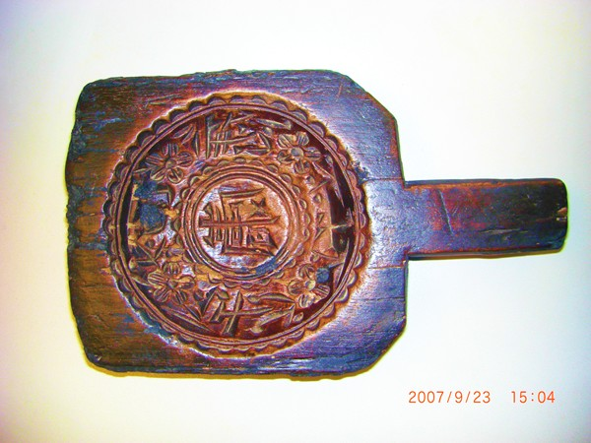
Mooncake with hundreds of years of history in China has grown to a business of US$ 1.4 billion annual sales. This is an antique mooncake mould with traditional Chinese character “longevity” in the center.

 Conventional lotus plant where lotus seeds come from. Taikong Lian ( Space lotus) produces 50 percent more than the conventional ones.
Domestic competition is fierce, with rival bakers and retailers deploying aggressive sales and promotion tactics. They invest heavily in mass marketing and elaborate packaging – or even excessive packaging in some cases - for a chance to grab their share of this lucrative market opportunity.

The mooncake industry can be viewed as comprising filling manufacturers, large scale producers, bakeries, hotels and restaurants.

Mooncake production includes making the fillings, making the crust, wrapping the fillings with the crust, shaping the mooncake and baking. Filling makers generally focus on the central fillings and sell their products to large scale producers and specialty bakers, while mooncake makers buy fillings from filling makers and make the crust, wrapping and baking in their own plants.

However, recently there has been increasing vertical integration in the industry. Some filling makers are not only manufacturing OEM mooncakes for hotels, restaurants or other food companies, but also developing their own brand for sale in the market.

Similarly, some large scale producers have invested in their own in-house filling production facilities.

Lotus seeds accounts for the largest portion – about 50 percent - of the mooncake ingredients market due to the dominance of puree based fillings, followed by red beans which has become popular in recent years. Most of the large lotus seed puree makers are located in the south, whereas the largest red bean puree makers are located in Shandong province in the north.

Varieties of lotus seeds include:

- Xiang Lian (originated from and mostly planted in Hunan province)
- E Lian (mostly planted in Hubei province)
- Min Lian (mostly planted in Fujian province)
- Tai Kong Lian (Space Lotus, a series of new varieties selected from lotus seeds exposed in space by China’s space ship, have been in commercial production)
- Tai Lian (mostly imported from Cambodia)

Among them, Xiang Lian is of the best quality for its high starch content, while the Taikong Lian has the highest production - reportedly 50 percent more production than conventional ones.

II. It’s a fragmented market

The mainland’s traditional mooncake market has numerous recipes, but the main styles include:

- Guang style (Guangdong or Cantonese style, originated from Guangdong province and dominant in South China. It has become popular in East and North China in recent couple of decades. Industry sources believe that Guang style mooncakes account for over 50 percent of the country’s mooncake sales.)
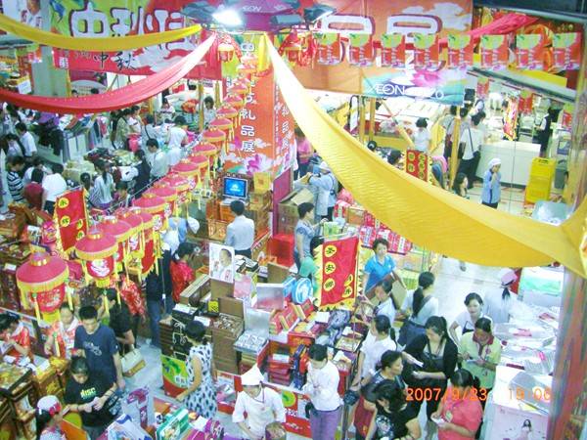
Aggressive mooncake promotion with traditional festive deco in a supermarket

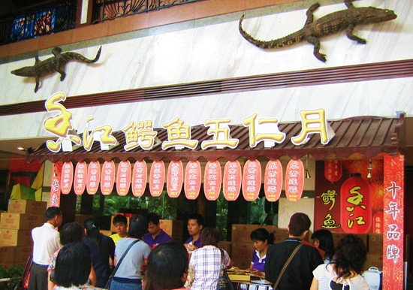
A hotel promotes its alligator mooncakes
- Jing style (Beijing style. Originated from Beijing area and still available in northern provinces)
- Su style (mostly in Eastern China, including Shanghai, Jiangsu and Zhejiang)
- Dian style (mostly in Yunnan province bordering Vietnam)
- Tai style (originated from Taiwan, but has won a small market share on the mainland)
- Chao style (popular in Chaozhou area – east of Guangdong province)

Each style has its own unique characteristics in terms of crust and fillings (refer to Appendix I and II for more details), but tend to be available only in areas where they are locally produced.

Leading regional producers include:

There are no nationally recognized leading brands. However, the market could be characterized by three main regional styles including;

- Southern region Guangzhou Jiujia and Lian Xiang Lou are considered the leading producers although there are many producers with similar production capacity.

- Eastern provinces Xing Hua Lou and Guan Sheng Yuan dominate this region.

- North and Northeastern provinces Dao Xiang Cun and Hao Li Lai are considered number one and two respectively.

III. Shifting demands mean opportunities for U.S. ingredient suppliers

Traditional mooncake recipes include an outside crust of flour, lard, oil and sugar while fillings vary across regional styles. However, common to most styles is fillings made of highly concentrated mixtures of sugar, oil and fat, together with lotus seed paste, or red and green bean paste along with egg yolk and, in some cases, greasy meat all aimed at enhancing taste.
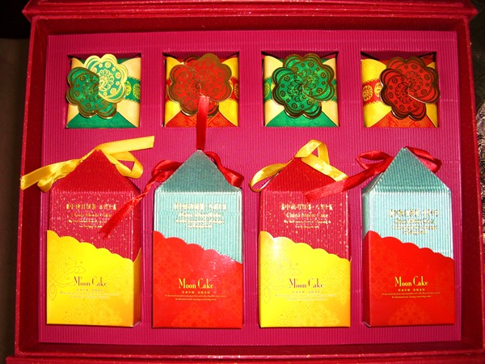
Fancy mooncake package
Wu Ren (five-nuts) is also a traditional nationwide mooncake filling that was made from a combination of kernels, including olive, winter melon seeds, pumpkin seeds, sunflower seeds, walnut, sesame or peanuts. The combination of nuts for the Wu Ren mooncakes varies from region to region. For example, peanuts are included in the Northern market but generally not in the South. Meanwhile, expensive mooncakes are filled with more pricey nuts e.g., almond and olive kernel instead of less expensive peanut, sesame, winter melon seeds and pumpkin seeds.

Increasingly today, concerns are being raised about the unhealthy concentrations of fat and calories. In response, innovative new mooncake recipes are emerging with a wide range of healthier alternative ingredients from fruit, seeds and nuts. Particularly in higher income first tier cities, healthier alternative recipes are growing in popularity. It is this emerging trend that offers U.S. ingredient supplier’s new opportunities to promote their fruits, nuts, and dairy ingredients as interesting alternative exotic flavors and styles for this traditional fare.

New, non-traditional mooncake varieties that have enjoyed recent success include chocolate, green tea, fruit (actually fruit flavored watermelon puree), nuts (e.g., almonds), and in one case alligator meat as a filling.

Pricey ingredients such as shark fin, bird’s nest and abalone are also incorporated into fillings to catch the high end market. Tapping into this emerging trend Starbucks leveraged their brand position to launch a coffee-flavored mooncake, and Haagen-Dazs, an ice-cream flavored product.

What is interesting is these new varieties are quite expensive for local consumers priced in the range of US$ 40, but have become popular among the more affluent in urban areas. The market driver behind this trend is the fact that mooncakes are a traditional but popular gift corporations buy for highly valued customers or employees, as well as family and friends buy for each other during this period of the mooncake festival. Therefore, there is a willingness to spend generously on those people who really matter to demonstrate respect and importance (which are very important Chinese cultural norms described as “face”).

Another key driver behind this emerging new recipe trend is producers seek differentiating advantage over fierce rivals, and as such this presents itself as an emerging niche for U.S. ingredient suppliers to explore further.

IV. Varieties with new fillings offer a niche for U.S. ingredient suppliers

High quality, healthy alternatives with nutritional benefits are good selling points for U.S. ingredients suppliers to enter the mainland mooncake industry. Dried or processed fruit ingredients, nuts, as well as light flavored cheese have good potential for this market since they add health and nutritional benefits. Various high quality U.S. ingredients such as cranberries and almonds have been creatively mixed with conventional lotus seed puree or multiple nuts in some recipes.

However, many bakers, or filling development technicians, are unaware of many ideal U.S. ingredients that could be explored. Language is perhaps a major barrier as descriptions for ingredients are often available only in English.

Across the country, middle and upper class consumers tend to be more open to innovative and healthy filling options, though the preference of taste, e.g., sweetness or greasiness varies from region to region. Technically, Su style mooncakes are best suited for high moisture fruit filling over the Cantonese style, due to the former’s thicker crust.
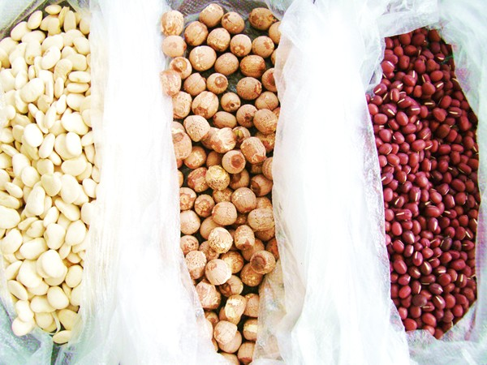
Mooncake filling ingredients: White beans (left), lotus seeds (middle) and red beans (right)

Working with Chinese filling makers who have strong product development capabilities is prime targets for ingredients suppliers as potential points of entry to penetrate into this fast growing sector. Larger filling makers also tend to better understand local consumer preferences and would therefore offer good guidance during early adoption phases for new fillings.

For U.S. ingredients exporters looking to enter this market, working with larger filling makers would be a recommended first step to test new recipes in line with current and early emerging trends cost effectively. At the same time, it would provide a platform to:

- Educate both filling makers and early adopters with innovative new products;
- Gain access to technical expertise on traditional filling styles and production practices;
- Cooperate with local experts to develop recipes that best suit local palettes and interests;
- Jointly promote new recipes to achieve commercial goals successfully.

V. There are production constraints

– price, food safety and packaging are big issues

Price

Price sensitivity are the biggest barriers prohibiting U.S. ingredients suppliers entering the more traditional segments of the market as U.S. imported ingredients cost more than the local ones.

Since 2005, the producers have been challenged with rising costs ranging from raw materials and labor, to transportation and distribution channels. At the same time the average price for traditional mooncakes has not been keeping pace with rising production costs. Subsequently producers feel squeezed profit margins quickly diminish.

Even large scale producers are looking for new opportunities as their traditional product range is being eaten up by rivals employing aggressive new promotion strategies, as well as new entrants offering innovative new recipes and styles.
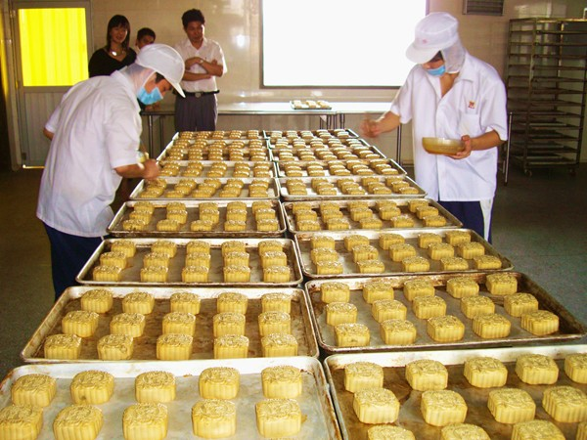
At a mooncake manufacturing plant

An average traditional gift box of four mooncakes retails for US$ 12.5 per box (each cake weighs approximately 600-750 grams net weight). According to industry representatives, average profit margins for producers were in the range 10-20%. The real opportunity for U.S. ingredients suppliers would be the higher end, new recipe product market where much higher margins could be achieved.

Food Safety

Another key constraint having a significant impact on the market in the past years has been growing concerns about food safety. For the mooncake industry, new regulations were announced to regulate the industry’s practice and assure product quality and safety. The National Mandatory Standard on Moon Cakes (GB 19855-2005) became effective on June 2006 regulating all mooncake production and retail practices.

This new regulation also has focuses on the quality of ingredients from the use of additives to the manufacturing process, storage and distribution channels. Another key regulatory move is a new National Quality standard for mooncake fillings being drafted to provide guidelines concerning pesticide residues, antibiotics, heavy metals, as well as other key additives such as sugar substitutes, coloring, and preservatives.

From Oct 1, 2007, mooncake producers and filling providers are required to pass strict food quality and safety inspections to gain QS certification. Without this QS certification, producers will not be permitted to make or sell their products. This new scheme may eliminate small and medium sized operators that do not operate with high quality controls. Meanwhile, one of the two leading baking associations in the country, All China Baking Association (ACBA), has initiated a campaign encouraging its members to sign a quality assurance commitment to promote quality and safety standards amongst their members and suppliers.

According to the new standard, non-temperature sensitive mooncakes are required to have a shelf life of not less than 25 days at room temperature. This is feasible for conventional fillings such as lotus seed paste in which the high content of sugar ensures a long shelf life. However, for low sugar fillings, this is a distribution and retail logistics issue that requires careful attention. Another technical challenge is maintaining the traditional shape with new ingredients such as fruit that tend to lose form compared with traditional mooncakes.

Packaging

The standard sets two mandatory limits to eliminate the excessive package of mooncake:

- the cost of package should not exceed 25 percent of the mooncake ex-factory price;
- the dimension of the package on per kilogram mooncake should not exceed 9.0 X 103 cubic centimeters.

The mooncake industry believes the limit of 25 percent package cost will not have much impact on the industry because it is difficult for the authorities to confirm detailed cost. However, the limit on package dimensions will certainly eliminate over-sized package. The new regulation also indirectly refocuses the industry operators, especially those who target the high end market niches, back from package to mooncake products themselves.

Appendix I Types of Mooncakes – Feature and Available Regions

Type of Mooncakes | Features | Available Regions
Guang Style (Guangdong style or Cantonese Style) | Crust  Thin crust and high proportion of high quality fillings. Ratio of crust vs. filling about 2:8 or 1:9. Usually on the top surface of the mooncake crust there is a carved pattern or characters created by a mould indicating the brand name, filling or even the name of business (hotel or restaurant).  Filling  Common filling varieties include lotus seed paste and preserved egg yolk, red bean paste, multiple nuts (usually called “Wu Ren”, consisting of several types of kernels such as olive, winter melon seeds, pumpkin seeds, sunflower seeds, walnut etc as well as seasoned pork). New and exotic varieties, including fruit filling (actually fruit flavored winter melon jam), ice-cream, wine cranberry, almond featured in Wu Ren, have emerged in recent years to satisfy the diverse demand by the young middle-class. Pricey ingredients, such as shark fin, bird nest, and abalone have also been incorporated in the filling to catch the high-end market niche. | Originally from and dominant in Guangdong province. One decade ago expanded to many parts of the country along with the penetration of the Cantonese eating and food culture. Still dominant in Guangdong and popular in big cities outside of Guangdong.
Jing Style  (Beijing Style) | Crust  Very thick crust as ratio of crust vs. filling is about 4:6. Characters are stamped on top.  Filling  Traditional filling is a mix of sugar, grounded peanut and sesame. Nowadays, bean puree, date puree and sesame are the common fillings. | Originated from Beijing, Tianjin and surrounding area, popular in north China
Su Style | Crust  Flaky. There is a stamp of characters on top indicating the filling.  Filling  Very sweet filling. Bean puree, sesame and multiple nuts are common fillings | Originated from and popular in east China, including Shanghai, Jiangsu and Zhejiang provinces.
Dian Style (Yunnan Style) | Crust  Made from wheat flour and baked. Usually no characters on top.  Filling  Yunnan ham filling (preserved pork). Mixed taste of sweetness and salt. Also adds fresh flowers into the filling (for fragrance) | Originated and popular in Yunnan and Guizhou provinces. Gradually expanding its market out of Yunnan and Guizhou.
Tai Style (Taiwan Style) | Crust  Flaky. Usually no characters on top.  Filling  Bean puree, nuts, fruit flavored jam or even pork. | Originally from Taiwan, but modified in mainland China to suit local markets.
Chao Style (Chaozhou Style) | Crust  Very flaky. Sometimes characters are stamped on top.  Filling  Mostly bean puree or olive seed kernel filling. | Originated and still limited in Chaozhou area - northeast of Guangdong province.

Appendix II Types of Mooncakes - Photos

A 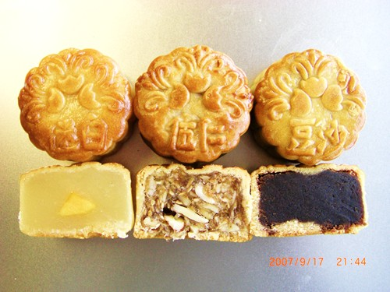 B 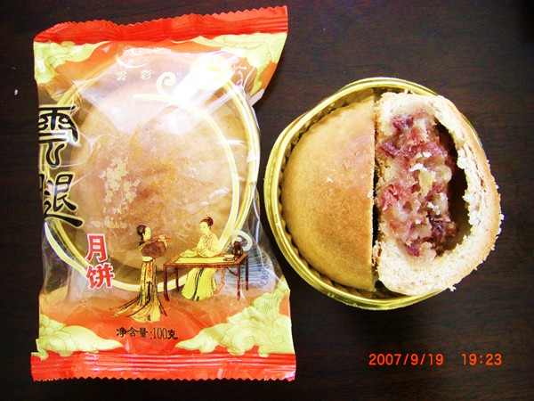

A. Guang style with conventional fillings: lotus seed puree with egg yolk (left), Wu Ren (multiple nuts, middle) and red bean paste (right)

B. Dian style featured as Yunnan ham filling

C 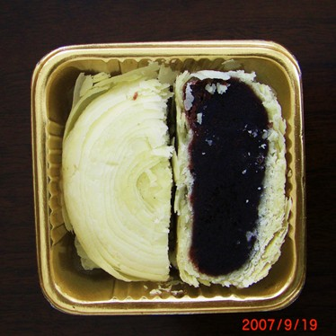 D 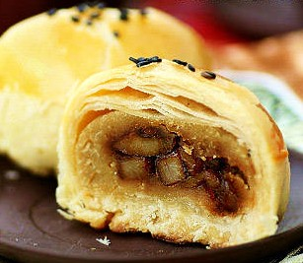

C. Chao style of very flaky crust and red bean puree filling

D. Tai style of flaky crust and preserved pork filling

Appendix III Post Contact Information

For further information about the China market, as well as updates on our upcoming events and activities, please visit out website at www.usdachina.org or contact one of USDA’s offices in China:

FAS/Office of Agricultural Affairs (OAA), Beijing
5-2 Qijiayuan Diplomatic Compound
Jianguomenwai, Beijing, China, 100600
Phone: (8610) 6532-1953
Fax: (8610) 6532-2962
E-mail: agbeijing@fas.usda.gov

Agricultural Trade Office (ATO), Beijing
Kerry Center, South Tower
24th Floor Suite #2425
No. 1 Guanghua Lu, Beijing, China 100020
Phone: (8610) 8529-6418
Fax: (8610) 8529-6692
E-mail: atobeijing@fas.usda.gov

IPR Office
E-mail: yuanchuan.liang@usda.gov

Agricultural Trade Office (ATO), Guangzhou
14/F, Office Tower
China Hotel, Guangzhou, China 510015
Phone: (86-20) 8667-7553
Fax: (86-20) 8666-0703
E-mail: atoguangzhou@fas.usda.gov

Agricultural Trade Office (ATO), Shanghai
Shanghai Center, Suite 331
1376 Nanjing West Road, Shanghai, China 200040
Phone: (8621) 6279-8622
Fax: (8621) 6279-8336
E-mail: atoshanghai@fas.usda.gov

Agricultural Trade Office (ATO), Chengdu
Opening in mid December, 2007

Animal and Plant Health Inspection Service (APHIS), Beijing
Room 618, Beijing International Club Office Building
No. 21 Jianguomenwai Avenue, Beijing, China 100020
Phone: (8610) 6532-3212
Fax: (8610) 6532-5813
E-mail: theresa.boyle@aphis.usda.gov

