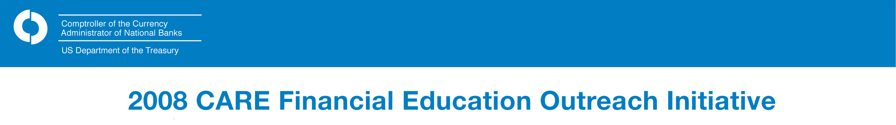

The Coalition of African American Regulatory Employees (CARE) organization at the Office of the Comptroller of the Currency (OCC) has chosen financial education as the focus of this year’s Black History Month celebration. With this in mind, CARE has planned a 2008 Financial Education Outreach Initiative that will run from Tuesday, February 5* through Wednesday, April 30, 2008.

Under the initiative, themed “Our Communities Count,” CARE members will conduct financial education presentations to middle school, high school, and college students in educational institutions throughout the United States. Through such efforts, CARE hopes 1.) to provide students with an understanding of basic financial principles and 2.) for an understanding of these principles to remain with students in the years ahead.

The 25 – 45-minute presentations will be on topics such Managing Bank Accounts, Tips on Budgeting and Saving, and Borrowing Basics/Managing Credit. They will be delivered in schools located in the following targeted cities.

- Atlanta
*On February 5, 2008, CARE will launch this initiative at OCC Headquarters with a keynote address by Rev. Dr. Floyd Flake of Greater Allen A.M.E. Cathedral of New York.

For more information on this initiative,
contact Glenda Cross at Glenda.Cross@occ.treas.gov
or (202)874-4811; Deb Mitchell at (901) 523-4063 or Deb.Mitchell@occ.treas.gov; or Dian Brown at (678) 731-9723, ext. 250 or Dian.Brown@occ.treas.gov.

- Baltimore
- Birmingham
- Charlotte
- Chicago
- Cleveland
- Dallas
- Detroit
- Denver
- Houston
- Huntsville, Alabama
- Indianapolis
- Los Angeles
- Memphis
- Miami
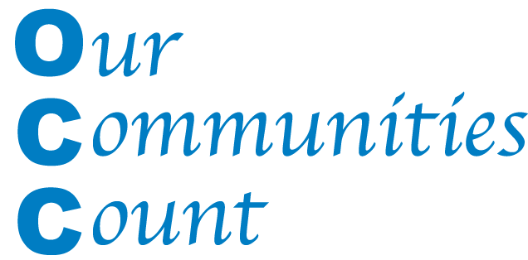
- New Orleans
- New York
- Oakland, California
- Philadelphia
- Washington, D.C.

