Guidelines for the installation and operation of

Irrigation systems near high voltage transmission lines

Bonneville power administration

Transmission Maintenance
&
Electrical Effects

TNLD

February 15, 2002

This guideline is intended to assist the public in planning and installing irrigation systems near BPA transmission lines. It is also intended for use by BPA employees in answering questions from the public, reviewing applications for right-of-way use, and for locating transmission lines in irrigated areas. Information in this guide is intended only as general guidelines.
Irrigation systems fall into two categories: fixed and mobile. Fixed irrigation systems include the fixed pipe-type systems and the row and rill-type systems. Mobile systems, which have gained in popularity, can be broken down into roughly four types: pipe-type, wheel-type, circular irrigation system, and high volume, high velocity systems. Each of the types has its own characteristics which the installer and operator should be aware of when working adjacent to high voltage transmission lines. For each type of system, installation suggestions and safe working practices near high voltage transmission lines will be presented.

I. FIXED-TYPE SYSTEMS

Pipe-Type and Row and Rill-Type

Fixed pipe-type irrigation systems are used for long term watering of landscaping, such as golf courses and playing fields, or crops such as orchards and vineyards. The irrigation piping is usually installed underground, and sprinkler heads are permanently or temporarily connected to the feed piping by risers of various lengths. The length of a riser depends on the type of vegetation and the purpose for the sprinkling. The row and rill-type of irrigation uses long trenches dug in the surface of the soil, and fed by gates, valves, or siphon tubes installed in a canal or ditch at the head of each trench.

Installation Suggestions
Equipment used to install fixed-type irrigation systems should never be closer than the minimum distance to transmission line conductors as shown on Table I (page 11). The sprinkler heads should be located so that they never spray water on the transmission line conductors. All underground water supply piping crossing BPA right-of–way should do so at an angle of not less than 60 degrees to the centerline of the transmission lines. It should be buried, whenever possible, a minimum of 24 inches underground, and should be marked, when practical, where it enters and leaves the right-of-way and at all angle points within the right-of way. These last two conditions will prevent damage to the piping due to movement of heavy equipment on the right-of way.
All metal pipelines, above or below ground, should be kept 50 feet (15 m) from any part of a BPA structure, and 15 feet (5 m) from any grounding system.
Any movement of earth on a transmission line right-of-way which might reduce the stability of a transmission tower or pole or would permanently decrease the conductor to ground distance, shall not be allowed unless approved by the appropriate BPA area office.

Safe Working Practices
The fixed pipe-type sprinkler systems are always in contact with the ground. There is very little chance of feeling even a small electrical shock while contacting one of these systems, which is close to a transmission line. Care must be exercised when installing and removing the riser pipes so that an adequate distance is maintained between the overhead conductors and the riser pipes. The recommended minimum distances are shown on Table I (page 11).

II. MOBILE SYSTEMS

Pipe-Type Systems

Mobile pipe-type irrigation systems are assembled, disassembled, and moved by hand. The pipes in these systems are laid on the surface of the ground and the water supply is usually connected to the irrigation system through valves in a header pipe. The header pipe is often located at one side of the field, and taps are located in the header pipe at convenient intervals so that moving the pipe from one tap to another assures coverage of the whole field. Sprinkler heads are installed along the irrigation piping and apply water to circular areas, the diameters of which are governed by the nozzle size and water pressures.

Installation Suggestions
Equipment used to install mobile systems should never be closer than the minimum distance to transmission line conductors as shown on Table I (page 11). All underground water supply piping crossing BPA right-of-way should do so at an angle of not less than 60 degrees to the centerline of the transmission lines. It should be buried, whenever possible, a minimum of 24 inches underground, and should be marked, when practical, where it enters and leaves the right-of-way and all angle points within the right-of-way. These last two conditions will prevent damage to the piping due to movement of heavy equipment on the right-of-way.
All metal pipelines, above or below ground, should be kept 50 feet (15 m) from any part of a structure, and 15 feet (5 m) from any grounding system.
Any movement of earth on a transmission line right-of-way which might reduce the stability of a transmission tower or pole or would permanently decrease the conductor to ground distance, shall not be allowed unless approved by the appropriate BPA area office.

Safe Working Practices
Because this type of system is laid on the ground surface when operating, the chance of feeling even a small shock when picking up a length of pipe that was lying under or near a transmission line is unlikely.
A person carrying a length of pipe from one location to another should always carry the pipe in the horizontal position, especially while crossing under any power line. Standing pipe on end to remove dirt or small animals should never be done before a careful check has been made to see if the pipe could come close to any overhead lines. After carrying a pipe section under the transmission line to a new setup point, the operator may experience a nuisance shock when he touches the header pipe if the ground is very dry. A slight shock may also be felt if a piece of pipe is being unloaded from a rubber-tired vehicle located near a transmission line.
The likelihood of shocks and incidents of contacts between upended pipes and power lines can be greatly reduced if the pipe is never unloaded under the transmission line. A distance of more than 50 feet (15 m) from the centerline of the transmission line is recommended for unloading the pipe. If very dry soil conditions exist, such as at the beginning of the irrigating season, connecting the first length of pipe to the head pipe and proceeding by connecting short lengths to the first is a good practice especially when within 50 feet (15 m) of the transmission line centerline.

- Wheel-Type Systems

Wheel-type systems are very similar to the pipe-type system previously addressed (i.e., a long straight length of 4-5 inch (10-13 cm) pipe equipped with distributed sprinkler heads). However, in this case, instead of the pipe being disassembled to be moved, it is rolled down the field on 4-5 foot (1.2-1.5 m) diameter wheels (usually metal). The pipe actually forms the axle for the group of wheels supporting it. In this case, the pipe is suspended 2-2.5 feet (60-80 cm) off the ground (see Fig. 1, page 8). The motive power can either be manpower for short lengths or a power unit for long lengths. The power unit is usually located close to the center of the pipe run.

Installation Suggestions
When possible, the system should be installed with its length perpendicular to the transmission line. Equipment used to install wheel-type systems should never be closer than the minimum distance to transmission line conductors as shown on Table I (page 11). All underground water supply piping crossing BPA right-of-way should do so at an angle of not less than 60 degrees to the centerline of the transmission lines. It should be buried, whenever possible, a minimum of 24 inches underground, and should be marked, when practical, where it enters and leaves the right-of-way and at all angle points within the right-of-way. These last two conditions will prevent damage to the piping due to movement of heavy equipment on the right–of-way.
All metal pipelines, above or below ground, should be kept 50 feet (15 m) from any part of a BPA structure and 15 feet (5 m) from any grounding system.
Any movement of earth on a transmission line right-of–way which might reduce the stability of a transmission tower or pole or would permanently decrease the conductor to ground distance, shall not be allowed unless approved by the appropriate BPA area office.

Safe Working Practice
When a wheel-type system is to be operated near or under a transmission line, the assembling of the system should follow the same procedure as mentioned for pipe-type systems. In many cases, the wheel-type system will be operated with its length parallel to the transmission lines. For wet soil conditions and because of the good ground contact through at least one or two of the metal wheels, very few shock sensations will be experienced when touching the pipe. A simple precaution should be observed during dry soil conditions when the long system is being connected to header pipe valves within 50 feet (15 m) of the centerline of the transmission line.
Under these conditions, the operator should connect the pipe to the valve with a short length of wire equipped with a clamp on each end (see Fig. 1, page 8). This will effectively drain off any accumulated charge on the irrigation pipe. This wire connection should be made to the header pipe valve connecting the irrigation pipe.

- Circular Irrigation Systems

This system consists of water pipe held above ground with sprinkler heads distributed along its length (see Fig. 2, page 9). The system is often 1/4 mile (400 m) long and pivots around a center point, which is the water source. The pipe is carried on motor-propelled supports spaced along the pipe. Rotation of the system irrigates a circular area or with special equipment, odd-shaped areas. The system will not cover a 360-degree rotation when an obstruction such as a transmission line structure intersects the pattern. For these cases, reversing travel to avoid obstructions or a special guidance system is used. Unlike the wheel system, the circular system is rarely disconnected from the source point, except for periodic maintenance.

Installation Suggestions
Equipment used to install circular irrigation systems should never be closer than the minimum distance to transmission line conductors as shown on Table I (page 11). All underground water supply piping, electric power cables, and communication cables crossing BPA right-of-way should do so at an angle of not less than 60 degrees to-the centerline of the transmission lines. It should be buried, whenever possible, a minimum of 24 inches underground, and should be marked, when practical, where it enters and leaves the right-of-way and at all angle points within the right-of-way. These last two conditions will prevent damage to the piping and cables due to movement of heavy equipment on the right-of-way.
All metal pipelines, pivots, electrical power cables, and communication cables, above or below ground, should be kept 50 feet (15 m) from any part of a BPA structure and 15 feet (5 m) from any grounding system. The center point or pivot point of the irrigation system should be located 20 feet (6.5 m) laterally outside the outermost conductor.
Any movement of earth on a transmission line right-of-way which might reduce the stability of a transmission tower or pole or would permanently decrease the conductor to ground distance, shall not be allowed unless approved by the appropriate BPA area office.
Nozzles should be positioned so that they do not spray water on the transmission line conductors. When this is not practical, distances given in Table II (page 12) should be used between nozzle and centerline of the transmission line. The circular irrigation system should be installed so that the minimum distance given in Table I (page 11) is maintained between conductors and sprinkler system hardware. All nozzle risers, which pass under a transmission line, should be equipped with spoilers or automatic shut-offs in case a nozzle breaks or drops off. This will insure that that a solid stream of water is not projected into the transmission line.

Safe Working Practices
If the pivot point of a circular irrigation system is near or under a transmission line, the irrigation system could acquire an electrostatic charge during operation. To prevent this electrostatic charge buildup, the pivot point should provide a good electrical ground for the sprinkler system. This will eliminate electrostatic shock nuisances during operation.
This electrical ground, however, does not eliminate hazards due to inductive coupling between the transmission line and the sprinkler pipe. With the irrigation system near or under a transmission lines, the pipe could rotate to two locations parallel or nearly parallel to the transmission line. This situation is similar to the position of the wheel-type system in Fig. 1, page 8.
It is recommended that personnel not touch the sprinkler pipe or its supporting structures when the system is operating under or parallel to and near a transmission line.

The pipe used in circular irrigation systems is larger, higher off the ground, and generally longer than wheel-type systems. Also, the driving wheels are usually rubber-tired and under dry conditions, could insulate the pipe from ground. With the sprinkler pipe parallel and close or under the transmission line, the inductive coupling between the transmission line and the sprinkler boom can result in hazardous shock currents if a person touches the system while the boom is connected to the pivot point. For these reasons, any maintenance work should be done with the sprinkler pipe perpendicular to the transmission lines. This situation is illustrated in Fig. 2, page 9. When this is not practical, the ends of the pipe should be electrically grounded (connected to or in contact with earth) before beginning maintenance work and each disjoined length of the system should be individually grounded on both sides of the coupling before it is decoupled. Metallic ground rods are recommended for this grounding procedure.

- High Volume, High Velocity Systems

These systems use large high-pressure nozzles to sprinkle large areas. The Vermeer mobile irrigator is an example of this type of system (see Fig. 3, page 10). High velocity, high volume nozzles are located at each end of two arms approximately 70 feet (21 m) in length. The arms rotate due to discharge of water through the nozzles. They rotate on a base attached to a small chassis, which can be towed or pushed to different points in the field. Nozzle diameters normally vary from 3/4 inch (2 cm) to 1 15/16 inch (5 cm). Water pressures used are in the range of 80-100 psi. The nozzles discharge a high velocity solid stream of water from the ends of the arms. The water stream may reach a height of 30-35 feet (9-11 m), and may be projected as much as 200 feet (60 m) horizontally. Other systems using single nozzles (water cannons) with clapper have similar characteristics.

Installation Suggestions
Maintaining an adequate distance between the irrigation equipment and transmission line conductors is essential for safe operation of these types of systems. The irrigation equipment should be positioned so that water is not projected into transmission line conductors. When this is not practical, distances given in Table II (page 12) should be used between nozzle and centerline of the transmission line. The irrigation systems should be located so that the recommended minimum distance given in Table I (page 11) are maintained between the conductors and the sprinkler system hardware. All underground water supply piping crossing BPA right-of-way should do so at an angle of not less than 60 degrees to the centerline of the transmission lines. It should be buried, whenever possible, a minimum of 24 inches underground, and should be marked, when practical, where it enters and leaves the right-of-way and at all angle points within the right-of-way. These conditions will prevent damage to the piping due to movement of heavy equipment on the right-of-way.
All metal pipelines, above or below ground, should be kept 50 feet (15 m) from any part of a BPA structure and 15 feet (5 m) from any grounding system.
Any movement of earth on a transmission line right-of-way which might reduce the stability of a transmission tower or pole or would permanently decrease the conductor to ground distance, shall not be allowed unless approved by the appropriate BPA area office.

Safe Working Practices
Great caution should be exercised when moving these types of systems under transmission lines. The small wheel bases tend to be unstable on rough ground and could cause the equipment to swing off balance lifting a piece of the system into the overhead conductors. If mobile surface piping is used for supply, a person carrying a length of pipe from one location to another should always carry the pipe in a horizontal position especially while crossing under any power line. Standing the pipe on end to remove dirt or small animals should never be done before a careful check has been made to see if the pipe could come close to any overhead lines.

II. NOTE

This document is the result of editing and modifications of the original document “Guidelines for the Installation and Operation of Irrigation Systems near High Voltage Transmission Lines,” February 21, 1978, authored by D.J. Nichols.

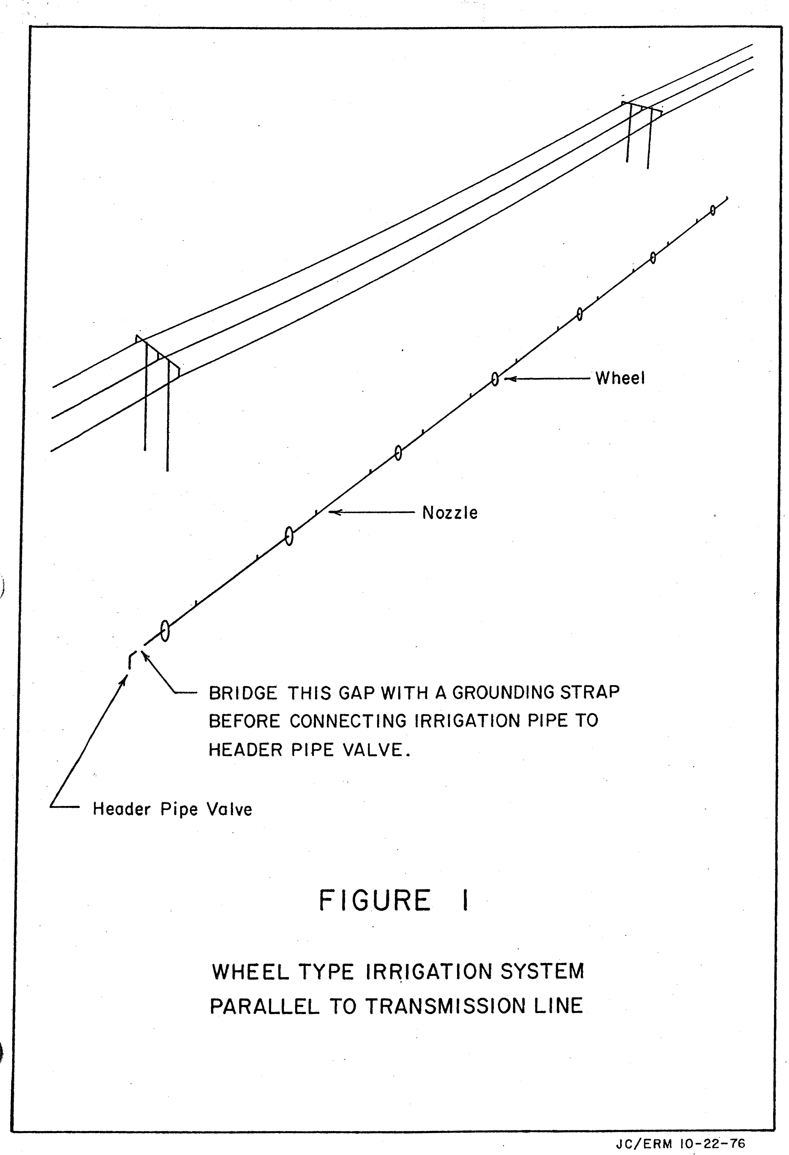

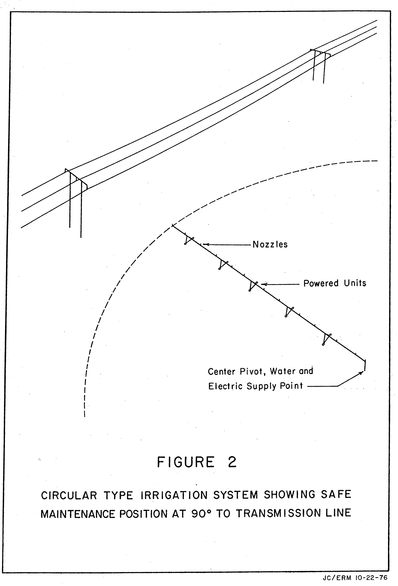
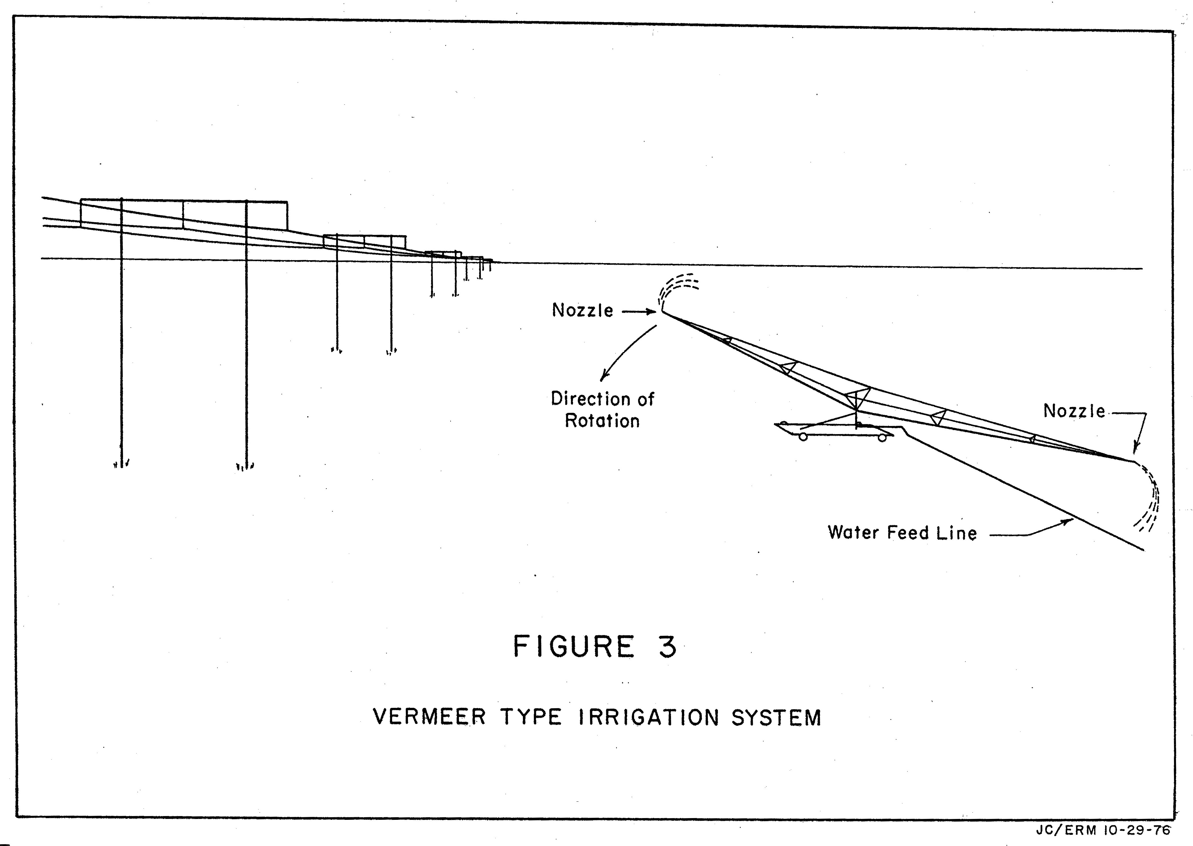

TABLE I

RECOMMENDED MINIMUM DISTANCES BETWEEN
EQUIPMENT AND TRANSMISSION LINE CONDUCTORS

TRANSMISSION LINE VOLTAGE | DISTANCE BETWEEN CONDUCTOR AND EQUIPMENT
TRANSMISSION LINE VOLTAGE | FEET | METERS
287 KV AC and below | 15 | 4.6
345 KV AC | 16 | 4.9
500 KV AC | 20 | 6.1
± 400 KV DC | 17 | 5.2
± 500 KV DC | 21 | 6.4

NOTE: NEVER PHYSICALLY MEASURE THESE
DISTANCES WITH DEVICES SUCH AS
TAPE MEASURES, POLES, ETC.
TABLE II

RECOMMENDED MINIMUM DISTANCES
BETWEEN HIGH PRESSURE IRRIGATION NOZZLES AND
HIGH VOLTAGE TRANSMISSION LINES

SPRINKLER NOZZLE DIAMETER |  | HORIZONTAL DISTANCE NOZZLE TO CENTER LINE OF POWER LINE
 |  | 115 KV AC LINE |  | 230 KV AC LINE |  | 345 KV AC LINE |  | 500 KV AC LINE |  | ±400 KV DC LINE |  | ±500 KV DC LINE
in. | cm. | ft. | m. | ft. | m. | ft. | m. | ft. | m. | ft. | m. | ft. | m.
1/4 | 0.635 | 29 | 8.8 | 43 | 13.0 | 51 | 15.4 | 61 | 18.4 | 40 | 12.2 | 50 | 15.2
3/8 | 0.952 | 37 | 11.1 | 51 | 15.5 | 63 | 19.0 | 73 | 22.2 | 42 | 12.8 | 54 | 16.4
1/2 | 1.270 | 44 | 13.1 | 60 | 18.1 | 68 | 20.5 | 82 | 24.8 | 53 | 16.1 | 67 | 20.3
5/8 | 1.587 | 51 | 15.5 | 69 | 20.8 | 80 | 24.2 | 92 | 27.9 | 65 | 19.7 | 79 | 24.1
3/4 | 1.905 | 53 | 16.1 | 73 | 22.2 | 87 | 26.5 | 106 | 32.3 | 80 | 24.4 | 100 | 30.2
7/8 | 2.222 | 68 | 20.7 | 84 | 25.6 | 97 | 29.6 | 106 | 32.3 | 80 | 24.4 | 100 | 30.2
1 | 2.540 | 68 | 20.7 | 89 | 27.1 | 97 | 29.6 | 111 | 33.8 | 87 | 26.4 | 107 | 32.5
1 1/8 | 2.857 | 84 | 25.6 | 104 | 31.7 | 118 | 36.0 | 132 | 40.2 | 110 | 33.5 | 136 | 41.2
1 3/8 | 3.492 | 89 | 27.1 | 109 | 33.2 | 123 | 37.5 | 137 | 41.7 | 115 | 35.0 | 142 | 43.1
1 5/8 | 4.127 | 99 | 30.2 | 125 | 38.1 | 138 | 42.1 | 157 | 47.8 | 138 | 41.9 | 169 | 51.5
1 15/16 | 4.928 | 124 | 37.8 | 150 | 45.7 | 164 | 50.0 | 182 | 55.5 | 166 | 50.6 | 204 | 62.3

