SINGLE FAMILY HOUSING REPAIR SPECIFICATIONS

Address and type of Home:

Brief Description of Work to be completed:

GENERAL PARAGRAPHS
1. Work Included: The Contractor shall provide all materials, labor and equipment necessary to clean and repair this home and provide a complete and usable home ready to occupy in accordance with the minimum standards as set forth in this scope of work.
2. Performance of Work: All work shall be performed in accordance with these General Paragraphs and the attached detailed specifications for all work as stated in this scope of work.
3. Contract Completion Time: The Contractor shall complete all work and cleanup within the specified time limits established in the contract.
4. (Government Coordination: The Contractor shall notify the Rural Development, Community Development Manager, (insert phone number), two working days (48 hours) prior to beginning each phase of construction so as to schedule an inspection of that work by Rural Development personnel.)
5. Code Compliance: All work shall be in accordance with applicable Federal, State, and local laws, Rural Development regulations and the most recent ICC Codes, as applicable.
6. Excavation Permit: Excavation shall be coordinated with all utilities so as to avoid disturbing or destroying utility service lines. The Contractor must verify the location of all utilities prior to commencement of any excavation activities. The Contractor is responsible for all coordination and any liabilities associated with excavation.
7. Dumping: All trash and rubbish shall be discarded off-site in an approved and lawful manner. Unless otherwise stated, all material scheduled for removal or disposal becomes the property of the Contractor. Burning or burying of rubbish on-site is prohibited.
8. Products: All materials shall be of best quality for purpose intended and shall be manufactured by companies that regularly engage in the manufacturing of the product specified.
9. Workmanship: All work shall be performed by skilled craftsman that are regularly engaged in work to be performed and shall be at the Journeyman level or directly supervised by a Journeyman.
10. Craftsmanship: All work shall be crafted in a professional manner. No drips, flaws, or second rate work will be accepted. If craftsmanship is lacking, the Contractor shall correct the deficiencies at no additional cost to the owner.

COMPOSITION SHINGLE ROOF REPLACEMENT
1. Removal of Existing Shingles: If the roof has 2 or more layers of existing shingles, remove them and the building paper underlayment.
2. Roof Sheathing: Repair or replace roof sheathing as necessary to match existing materials and meet current structural requirements. Remove and replace any damaged or deteriated sheathing. At a minimum CDX grade plywood or OSB roof sheathing and plyclips shall be used.
3. Underlayment: 15 lb. asphalt-saturated building felt installed in accordance with the shingle manufacturer's instructions. If slope of roof is less than 4/12 then 2 layers of 15 lb. felt shall be used. Provide valley flashing per manufacturer’s instructions.
4. Shingles: Contractor shall provide and install asphalt shingles warranted by the manufacturer for 20 years over the entire roof. Asphalt shingles must be installed on a roof slope of 2/12 or greater.
5. Accessories: Furnish ridge shingles and drip edging. Replace flashing with corrosion resistant sheet metal. Flashing at masonry flues should be let-in to mortar joints. All roof edges shall be provided with metal drip edge. Install new step metal flashing around chimney.
6. Vent Caps: Replace roof vents that have rusted and are weathered. Replace collars with thermoplastic roof flashing.
7. Submittal: Submit specifications and color samples for selection and approval.
- Ventilation: Provide additional roof ventilation with continuous ridge vent or gable end vents, if specified in Bid Schedule.

FLOOR REPAIR
- Utilities: Contractor to disconnect water, sewer, electrical, plumbing fixtures, appliances, etc. as required to repair floor structure.
- Structure: Remove and replace rotten, insect damaged, or structurally inadequate floor framing members as required to level floor. Provide and install additional joists, girders, concrete pier pads, piers, etc. as required to provide adequate strength (40# live load) for the floor. All wood within 8” of ground to be treated lumber.
- Floor: Remove and replace damaged floor sheathing to match existing sheathing height.
- Floor Covering: Remove and replace existing floor covering with new floor covering.
- Reconnect: Reconnect all water, sewer, electrical, appliances, etc.
- Insulate: Install R-19 Unfaced fiberglass insulation in all joist spaces. Insulate all water lines in crawl space. Install 6 mil poly ground cover over entire crawl space.

CARPET REPLACEMENT
1. Subfloor Preparation: Strip the floor of the existing carpet, pad, tack strips, or method of adhesion. Clean and repair the subflooring as necessary and in accordance with the carpet manufacturer's instructions.
2. Padding: Provide new carpet pad (7/16 or 1/2 inch thick) rebond or urethane with a 5 or 6 pound density.
3. Carpet: All carpet shall be from the same manufacturer's dye lot. In addition, carpet shall meet the following specifications:
Carpet Fiber: Nylon, Polypropylene, or Nylon/Polypropylene Blend or similar.
Backing Primary and Secondary Backing of Jute or Synthetic Jute
Carpet Pile: Level Loop (preferred) or Cut Pile
Pile Height: 1/4 (0.25) inch (as necessary for density factor)
Yarn Weight: 28 ounce per sq. yard (as necessary for density factor)
Density Factor: 3000 Minimum (36 x yarn weight, divided by pile height)
Colors: As specified in Bid Schedule
Warranty: 10 Year Wear Warranty
4. Installation: Installation shall be professional and all seams shall be consistent with the run of the carpet and be unnoticeable to the casual observer. Provide adequate tack strips and stretch the carpet as necessary. Carpet installation shall be in accordance with carpet manufacturer's instructions.
5. Cleaning: After installation, clean the carpet of all loose material yarn and have ready for occupancy.
- Submittal: Submit carpet specifications and color samples for selection and approval.

VINYL FLOOR REPLACEMENT
- Remove existing floor covering and trim and replace with sheet vinyl of minimum thickness of .05”. Color and pattern to be selected by owner. Installation shall be in accordance with manufacturer’s recommendations inclusive of floor preparation. Pattern to properly match with all seams parallel (individual room). Caulk wall/floor joint to eliminate air infiltration. Install 2 ½” wood base molding or rubber molding, as specified in bid schedule, throughout dwelling where sheet/tile is replaced. Molding shall be stained/painted to match wall covering and as approved by owner.

PAINTING
1. Surface Preparation: Clean and prepare the surfaces to be painted. Chip and scrape all loose paint and clean according to paint manufacturer’s instructions all exterior trim, siding, wood porch and step railings, garage door, and carport ceiling as applicable to the house.
2. Primer: Acrylic primer shall be used to prime all bare wood. Brush and/or roller application is required (no spraying). Metal primer shall be rust inhibiting type.
3. Exterior Finish Coats: Provide, at a minimum, two coats, with the first coat being a primer and the second coat being 100% acrylic latex semigloss OR Provide, at a minimum, one coat of 100% acrylic latex semigloss, as specified in Bid Schedule. Paint shall have a 10-year warranty. Semi-gloss finish, enamel or equal. Paint shall be applied uniformly and shall fully cover the existing paint. The newly painted exterior surface shall have a consistent appearance. If additional coats are required to cover over existing paint, contractor shall provide the additional coats at the contractors expense.
4. Interior Finish Coats: Paint ceiling with two coats of white 100% acrylic latex ceiling paint. Paint walls with two coats of 100% acrylic latex paint. Apply color specified in the Bid Schedule. Flat or semigloss finish. Paint shall have a 10 year warranty.
5. Application: Application shall be such that drips, spatters, flaws, streaking, shadowing or other types of inferior workmanship does not occur.
- Submittal: Submit paint specifications and color samples for selection and approval.

VINYL SIDING
- Preparation: Remove all the existing siding and trim that is damaged or decayed. Replace deteriorated siding and trim with exterior grade plywood and/or exterior grade trim or other substrate approved for use by the siding manufacturer. Secure any loose but usable existing siding. Clean and prepare the surface of application in accordance with the manufacturer's instructions. Provide insulation board underlayment where required to ensure smooth surface behind siding.
- Air Infiltration Barrier: Install an air infiltration barrier if required in the manufacturer's instructions.
- Vinyl Siding: Provide and install new vinyl siding and trim over the entire dwelling exterior. Vinyl shall be (44 mil.) thickness, double 4 inch lap, and color shall be selected by owner. Vinyl siding shall comply with ASTM D 3679, with a flame spread index of less than 25 and ASTM E 84 with a smoke density of less than 450. Vinyl siding shall be from the same manufacturer's lot number and installed in accordance with the manufacturer's instructions. Siding shall be installed in accordance with the Rigid Vinyl Siding Application Instructions from the Vinyl Siding Institute.
- Accessories: Install accessories for vinyl siding in accordance with the vinyl siding manufacturer's instructions.
- Wood Trim: All exposed wood trim (fascia, rake, etc.) to be covered with vinyl or aluminum.
- Soffits: Remove existing plywood soffits or provide openings in the existing plywood soffits to allow adequate ventilation through new soffits. Install new vinyl or aluminum perforated soffit. Provide adequate backing for new soffits according to manufacture’s requirements.
- Submittal: Submit specifications, manufacturer’s installation instructions, and color samples for selection and approval.

PROVIDE REPLACEMENT WINDOWS
1. Removal of Existing Windows: For all windows identified for replacement remove the window frame and repair and/or modification the opening to receive the new replacement window and insect screen.
2. Replacement Windows: The window must be designed and constructed as a replacement type window and shall be installed in accordance with manufacturer's instructions. The minimum requirements are:
a. Window Performance Standard: Exterior windows and glass doors shall be tested by an approved independent laboratory, and bear a label identifying manufacturer, performance characteristics and approved inspection agency to indicate compliance with the requirements of the AAMA/NWWDA 101/I.S.2. Windows must be double pane Low E insulated glass assemblies. Windows must have a U-factor of 0.35 or less. Insect screens shall conform to ASTM D 3656, Class 2, 18 x 14 mesh plastic fabric. Insect screen frames shall be aluminum, complete with all necessary hardware, and shall have a baked enamel finish to match window frame color.
- Warranty: Exterior windows and glass doors shall be provided with the following minimum manufacturer’s warranty (for owner occupied single family homes, original purchaser):
Vinyl Frame & Sash Lifetime
Hardware Lifetime
Glass Lifetime
Labor Lifetime
*Actual warranty provided for commercial application of windows may be less than specified above.
In order to determine whether or not a window submittal meets these criteria, the submittal must include verification from the manufacturer in one of the following forms (the burden of proof is the responsibility of the contractor): printed manufacturer's literature or letter of certification from the manufacturer.
c. Low Maintenance: Windows should be maintenance free, not require painting, resist decay, and enhance the building in which they are installed.
3. Install Windows: Install window frames, glass and glazing in accordance with manufacturer’s instructions. Anchors and fasteners shall be compatible with adjoining construction. Area between window frame and framed opening shall be insulated, trimmed, weatherstripped, and caulked so as to minimize air infiltration to the maximum extent possible. The window shall freely and easily operate and shall not bind or be restricted in any way from improper installation. Install replacement window, install or re-install molding and perform other duties as required to deliver a finished product.

KITCHEN and BATH
- Countertops: Provide and Install new countertops to replace existing countertops in kitchen. High-pressure laminated plastic. Post formed top with front edge and integral 4” back splash wherever cabinet meets wall. Formica or equal.
- Cabinets: Provide and install new cabinets in kitchen. Stock design from manufacturer’s standard line. Completely prefinished. (30” wall cabinets with two adjustable shelves.) Base cabinets to have fixed plywood shelves. Color to be selected by Owner and/or Rural Development. Use (birch) (3/4” exterior plywood). Manufacturer and style of cabinets shall comply with ANSI A161.1, Recommended Minimum Construction & Performance Standards for Kitchen Cabinets, and shall be labeled same. Apply white silicone sealant around cabinets, countertop and bath vanity.
- Kitchen Equipment: Range hood 160 cfm, minimum 2 speed or variable speed fan, 1 60 – watt light with switch. Must discharge to exterior in a new metal duct (or reuse existing).
- Exhaust Fans: Inspect existing exhaust fans in bathroom(s). Check to make sure fan is exhausted to the outside. If it is not, install discharge duct to the exterior with a backdraft damper OR Install 100 cfm fan in bathroom with discharge duct to the exterior equipped with a backdraft damper, as specified in the Bid Schedule.
- Bathroom cabinets: Remove existing cabinets in quantity specified in Bid Schedule. Provide and install an equivalent height vanity or height as specified in Bid Schedule. Base of vanity to be prefinished. Vanity top to have 4” backsplash at back and/or wherever it meets the wall. Top to be Formica or as specified in Bid Schedule. Install new lavatory, porcelain over cast iron, medium grade Kohler or equal, color white. Provide and install single lever or dual control chrome finished faucet, medium grade Delta or equal.
- Accessories: Install new chrome finish (24”) towel bar(s). Install a chrome toilet paper holder. Install a chrome metal shower rod for shower curtain. Rod to be plumb with outside of tub. All accessories to be anchored in stud walls or with hollow wall anchors.
- Submittal: Submit specifications, manufacturer’s installation instructions, and color samples for selection and approval.

CONCRETE DRIVEWAY and SIDEWALKS
1. Scope: Provide concrete driveway specified in Bid Schedule. Driveway to extend from street to house. Install driveway to approximate driveway length specified in Bid Schedule.
2. Preparation: The soil under the concrete slab needs to be undisturbed soil or compacted and moist, but not powdery dry or muddy. Place 4 inches of compacted 3/4” base course over the native prepared and compacted soil. Concrete shall not be placed over frozen ground/rock base.
3. Concrete: Provide 4” thick sidewalks and 5” thick driveways. Concrete shall have a 28-day compressive strength of 3000 psi in accordance with ASTM C 94 with 5% - 7% air entrainment. When concrete placement is authorized during cold weather (ambient air temperature less than 50 degrees Fahrenheit), the concrete shall be kept at a temperature of at least 50 degrees for not less than 6 days by the use of concrete blankets are other approved means. Concrete placed during weather exceeding 90 degrees shall be protected from exposure to the sun, wind, and from excessive moisture loss. Moist cure for 7 days. Do not add water to the mix after it reaches the construction site (4" max. slump) and do not add water to the surface during finishing operations.
4. Aggregate: Concrete aggregate shall be 1 inch diameter crushed quarried rock or washed river gravel free of organic materials.
5. Reinforcing: Concrete driveways shall contain 6 x 6 - 10/10 welded wire mesh or a #3 rebar grid at 3'- 0" on center. Rebar or welded wire mesh shall be properly supported with dobies, chairs or other approved methods. Pulling or hooking welded wire mesh to its prescribed depth during slab placement shall not be allowed.
6. Joints: Control joints shall be struck or sawed the width of the driveway and not more than 12'- 0" o.c. Control joints for sidewalks shall be 5'-0" on center. Provide expansion joints between new and existing concrete/materials and at intervals of no greater than 30 feet for sidewalks.
7. Finish: Concrete shall be broom finished.
8. Ramps: Shall comply with the Uniform Federal Accessibility Standards.

EXTERIOR DOORS, STORM DOORS and INTERIOR DOORS
1. Preparation: Remove existing jamb and framework. Repair and clean the door opening as necessary.
- Exterior Door: Install pre-hung, pre-drilled, steel or heavy duty wood frame, and steel insulated entrance door (no vinyl or plastic trim). Door shall come complete with magnetic weather-stripping.
- Interior Doors: Remove and replace interior doors in the quantity specified in the Bid Schedule. Replace doors with 1 3/8” hollow core doors. Reuse existing hinges and strike plates, when possible. Provide new latchsets. Remove door stops and replace with new door stops, as specified.
3. Threshold and weather-stripping: Aluminum/vinyl thermal break threshold at exterior doors to accommodate the door and provide weather tight seal. Jamb and head weather-stripping aluminum anodized clear and/or vinyl. Set all thresholds in caulk.
4. Storm Door: Provide and install a storm door as specified locations shown in Bid Schedule. Storm door shall be a durable steel 1-1/4 inch thick with hardware and frame that will be compatible with the steel entrance door. The door shall have full glazing with operable sash, insect screen, weather-stripping, vinyl door sweep, pneumatic closer, and pushbutton latch.
5. Hardware: Provide a keyed entrance door lock for the entrance door. Provide keyed deadbolt latchset. Use medium priced hardware such as Schlage or equal.
6. Submittal: Submit specifications and color samples for selection and approval.

INSULATION
1. Preparation: Clean, repair/prepare the surfaces to receive insulation in accordance with the manufacturer's instructions.
- Crawl Space/Basement Insulation: Install R-21 fiberglass batt insulation in crawl space or basement and secure in place with metal “tiger claws” or other acceptable method approved by owner. Crawl space floor shall be covered with minimum 6 mil. Poly, lapped 6 inches and turned up 6 inches on the foundation walls and secured.
or
Install minimum R-20 insulation on the crawl space walls. Ensure the crawl space is not vented to outside air. Apply the insulation on the inside of the crawl space wall, downward from the sill plate to the exterior finished grade level and then vertically and/or horizontally for at least an additional 24 inches. Cover the exposed earth in the crawl space with a continuous vapor retarder.

As specified in Bid Schedule.

- Wall Cavity Insulation: Fill wall cavity with fiberglass batt insulation to achieve the greatest R-value possible.
- Ceiling/Attic Insulation: Add blown-in insulation for a total R-value of 30 or R-30 unfaced fiberglass. Install baffles or air chutes as necessary to contain the insulation and ensure proper ventilation of the attic.
- Certification: The contractor shall certify R-values by placing a certification tag in a visible area.

NEW HEATING, VENTILATION, AND AIR CONDITIONING (HVAC) SYSTEM
- Remove existing heat pump or HVAC unit (typically a split system with interior furnace and exterior condensing unit) and install new heat pump (minimum SEER 14) or HVAC (minimum 90% efficient furnace, minimum SEER 14) unit. Contractor to provide calculations to homeowner showing proper size unit to be installed. New unit shall be installed with all necessary clearances, electrical, venting, supply and return ducts, plumbing, thermostats, etc. as required to provide adequate heating and cooling to each individual room. All ductwork in unconditioned spaces is required to be insulated, all ductwork shall be adequately secured and all new work shall comply with codes. All gas lines need to be checked by a qualified serviceman.

PLUMBING REPAIR
- Water Service: All corroded, compressed, or damaged supply lines shall be removed. Replace with new supply lines. All new supply lines shall be copper, CPVC, (or other materials conforming to state codes). All plumbing shall be adequately secured. Supply water line to be ¾”, branch lines to be ½”.
- Fixtures: All damaged, corroded, dripping or inadequate plumbing fixtures and appliances shall be replaced as specified in the Bid Schedule. Contractor to submit specifications of new fixtures to owner for selection and approval.
- Drain, Waste, Vent (DWV) Lines: Replace all inadequate, corroded, or damaged DWV lines. New DWV lines shall be Schedule 40 PVC or other material approved by code. All penetrations through the roof to be with integral flashing. (do not use tar or caulk instead of flashing).
- Washer/Dryer Rough-In: Install a washing machine supply and drain complete with single 110v and single 220v electrical outlets for washer and dryer. Provide and install ½” hot water and ½” cold water with valve and 1 ½’ drain for washer. Provide vent through wall complete with backdraft damper and exterior cover. Trim, caulk, and seal all openings.
- Wall hydrant: Provide frost proof wall faucet with ¾” male hose thread. Provide ½” water connection.
- Certification: All work shall be performed by a licensed plumber in accordance with Idaho codes.

HOT WATER HEATER
1. Preparation: Remove existing water heater and replace with water heater specified in Bid Schedule.
2. Water Heater: Provide and install a new minimum 40 gallon capacity, automatic vertical storage type water heater. Cap off any unused piping. Seal any new penetrations in the walls.
3. Shut Off: Provide shut off valves on the supply and discharge lines of the water heater.
4. Relief valve: Provide relief valve to within 5” of floor, outside building, or into a waste receptor.
5. Certification: All new materials and installation to meet the current edition of the ICC’s International Plumbing Code.

LEAD BASED PAINT TESTING
1. Lead Based Paint Testing: This home was constructed prior to 1978 and is required by federal law to be tested for lead based paint. Test all interior and exterior painted surfaces for the presence of lead. This testing shall be performed prior to any repair work. Test results shall be furnished to the owner and USDA Rural Development Loan Specialist within 10 calendar days of the notice to proceed.
2. Certified Tester: The testing shall be accomplished and a report furnished by a certified and licensed individual. All procedures and testing methods shall comply with federal, state, and local laws and regulations.
3. Lead Based Paint Abatement, Removal, or Encapsulation: If any surfaces test positive for the presence of lead based paint, the contractor shall recommend the most cost effective method of abating, removing, or encapsulating the hazard and a bid for the accomplishment of the required work.

CONSTRUCT ASSESSIBLE RAMP
1. General: Any part of an accessible route with a slope greater than 1:20 shall be considered a ramp. As specified in the Bid Schedule, modify or construct the current accessible route to comply with this specification.
2. Slope and Rise. The least possible slope shall be used for any ramp. The maximum slope of a ramp in new construction shall be 1:12. The maximum rise for any run shall be 30 inches.
3. Clear Width. The minimum clear width of a ramp shall be 36 inches.
4. Landings. Ramps shall have level landings at the bottom and top of each run. Landings shall have the following features:
(1) The landing shall be at least as wide as the ramp run leading to it.
(2) The landing length shall be a minimum of 60 inches clear.
(3) If ramps change direction at landings, the minimum landing size shall be 60 inches by 60 inches.
(4) If a doorway is located at a landing, then the area in front of the doorway shall comply with 4.13.6 of UFAS.
5. Handrails. If a ramp run has a rise greater than 6 inches or a horizontal projection greater than 72 inches, then it shall have handrails on both sides. Handrails are not required on curb ramps. Handrails shall be 1-1/4 inches to 1-1/2 inches in diameter. Handrails shall comply with 4.26 of UFAS and shall have the following features:
(1) Handrails shall be provided along both sides of ramp segments. The inside handrail on switchback or dogleg ramps shall always be continuous.
(2) If handrails are not continuous, they shall extend at least 12 inches beyond the top and bottom of the ramp segment and shall be parallel with the floor or ground surface.
(3) The clear space between the handrail and the wall shall be 1-1/2 inches.
(4) Gripping surfaces shall be continuous.
(5) Top of handrail gripping surfaces shall be mounted between 30 inches and 34 inches above ramp surfaces.
(6) Ends of handrails shall be either rounded or returned smoothly to floor, wall or post.
(7) Handrails shall not rotate within their fittings.
6. Cross Slope and Surfaces. The cross slope of ramp surfaces shall be no greater than 1:50. Ramp surfaces shall comply with 4.5 of UFAS.
7. Edge Protection. Ramps and landings with drop-offs shall have curbs, walls, railings, or projecting surfaces that prevent people from slipping off the ramp. Curbs shall be a minimum of 2 inches high (see Figure 1).
8. Outdoor Conditions. Outdoor ramps and their approaches shall be designed so that water will not accumulate on walking surfaces.

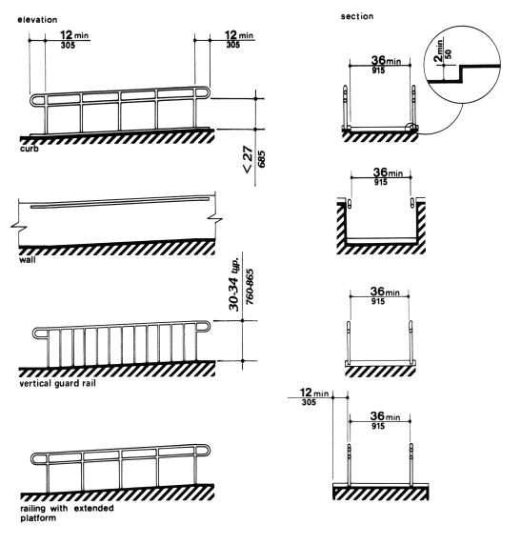

Figure 1

MODIFY WATER CLOSET SPACE
1. As specified in the Bid Schedule modify the water closet, including removal and reconstruction of walls and associated work as necessary to meet the following requirements:
(1) Clear floor space at the water closet shall be as shown in Figure 1. The water closet may be located with the clear area at either the right or left side of the toilet.
(2) The height of the water closet shall be at least 17 inches and no more than 19 inches, measured to the top of the toilet seat.
(3) Structural reinforcement or other provisions that will allow installation of grab bars shall be provided in the locations shown in Figure 2. Grab bars shall be installed as shown in Figure 3 and shall comply with 4.26 of UFAS.
(4) The toilet paper dispenser shall be installed within reach as shown in Figure 2.
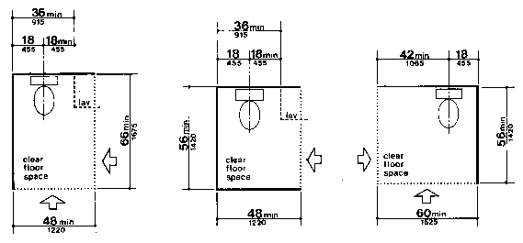
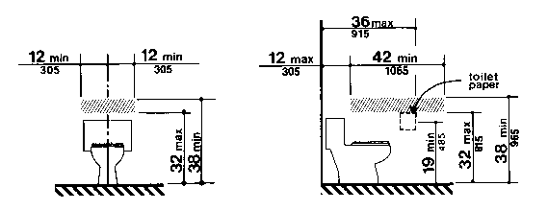
Figure 1
Note: The hatched areas are reinforced to receive grab bars.
Figure 2

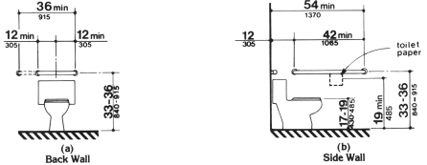

Figure 3
(a) Back Wall. A 36 inch minimum length grab bar is required behind the water closet mounted at a height between 33 and 36 inches. The grab bar must extend a minimum of 12 inches beyond the center of the water closet toward the side wall and a minimum of 24 inches toward the open side for either a left or right side approach.
(b) Side Wall. A 42 inch minimum length grab bar is required to the side of the water closet spaced 12 inches maximum from the back wall and extending a minimum of 54 inches from the back wall at a height between 33 and 36 inches. The toilet paper dispenser shall be mounted at a minimum height of 19 inches.

BATHTUB, ACCESSIBLE – PROVIDE AND INSTALL
1. Bathtub. As specified in the Bid Schedule provide a bathtub with the following features:
(1) Floor space. Clear floor space at bathtubs shall be as shown in Figure 1.
(2) Seat. An in-tub seat or a seat at the head end of the tub shall be provided as shown in Figure 1 and Figure 2. The structural strength of seats and their attachments shall comply with 4.26.3 of UFAS. Seats shall be mounted securely and shall not slip during use.
(3) Grab bars. Structural reinforcement or other provisions that will allow installation of grab bars shall be provided in the locations shown in Figure 3. If provided, grab bars shall be installed as shown in Figure 2 and shall comply with 4.26 of UFAS.
(4) Controls. Faucets and other controls shall be located as shown in Figure 2 and shall comply with 4.27.4 of UFAS.
(5) Shower unit. A shower spray unit with a hose at least 60 inches long that can be used as a fixed shower head or as a hand-held shower shall be provided.
2. Bathtub Enclosures. Enclosures for bathtubs or shower stalls shall not obstruct controls or transfer from wheelchairs onto shower or bathtub seats. Enclosures on bathtubs shall not have tracks mounted on their rims.
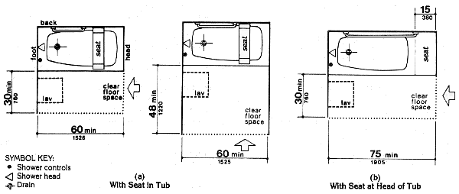
3. Clear Floor Space. Clear floor space at fixtures may overlap.

Figure 1
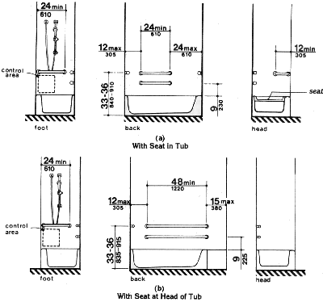

Figure 2

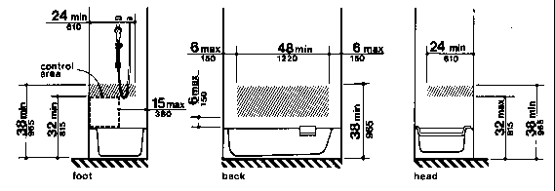

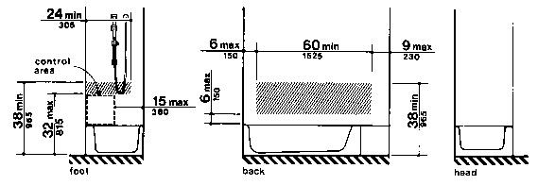
Figure 3(a)
Location of Grab Bars and Controls
of Adaptable Bathrooms - With Seat in Tub

Figure 3(b)
Location of Grab Bars and Controls
of Adaptable Bathrooms - With Seat at Head of Tub
Note: The hatched areas are reinforced to receive grab bars.
Figure 3

SHOWER, ACCESSIBLE – PROVIDE AND INSTALL
1. Shower. As specified in the Bid Schedule provide a shower with the following features:
(1) Size and clearances. Shower stall size and clear floor space shall comply with either Figure 1 or Figure 2. The shower stall in Figure 1 shall be 36 inches by 36 inches. The shower stall in Figure 2 will fit into the same space as a standard 60 inch long bathtub.
(2) Seat. A seat shall be provided in the shower stall in Figure 1 as shown in Figure 3. The seat shall be 17 inches to 19 inches high measured from the bathroom floor and shall extend the full depth of the stall. The seat shall be on the wall opposite the controls. The structural strength of seats and their attachments shall comply with 4.26.3 of UFAS. Seats shall be mounted securely and shall not slip during use.
(3) Grab bars. Structural reinforcement or other provisions that will allow installation of grab bars shall be provided in the locations shown in Figure 4. Grab bars shall be installed as shown in Figure 5 and shall comply with 4.26 of UFAS.
(4) Controls. Faucets and other controls shall be located as shown in Figure 5 and shall comply with 4.27.4 of UFAS. In the shower stall in Figure 1, all controls, faucets, and the shower unit shall be mounted on the side wall opposite the seat.
(5) Shower unit. A shower spray unit with a hose at least 60 inches long that can be used as a fixed shower head at various heights or as a hand-held shower shall be provided.
2. Shower Enclosures. Enclosures for bathtubs or shower stalls shall not obstruct controls or transfer from wheelchairs onto shower or bathtub seats. Enclosures on bathtubs shall not have tracks mounted on their rims.
3. Clear Floor Space. Clear floor space at fixtures may overlap.
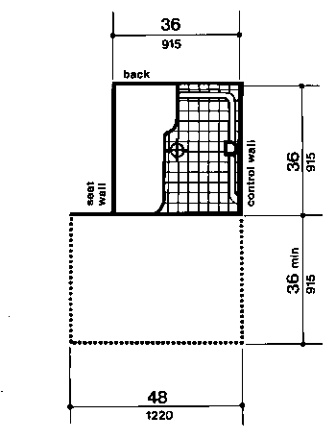

Shower Size and Clearances
36-in by 36-in Stall

Figure 1
The clear floor space shall be a minimum of 48 inches in length by a minimum of 36 inches in width and allow for a parallel approach. The clear floor space shall extend 1 foot beyond the shower wall on which the seat is mounted.
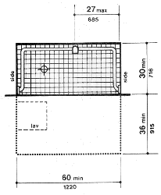

Shower Size and Clearances
30-in by 60-in Stall

Figure 2
The clear floor space alongside the shower shall be a minimum of 60 inches in length by a minimum of 36 inches in width.
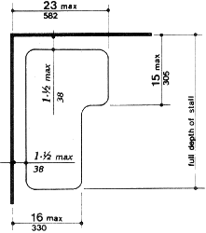

Shower Seat Design

Figure 3
The diagram illustrates an L-shaped shower seat extending the full depth of the stall. The seat shall be located 1-1/2 inches maximum from the wall. The front of the seat (nearest to the opening) shall extend a maximum 16 inches from the wall. The back of the seat (against the back wall) shall extend a maximum of 23 inches from the side wall and shall be a maximum of 15 inches deep.
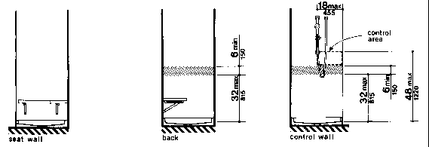

Figure 4(a)

Location of Grab Bars and Controls
of Adaptable Showers - 36-in by 36-in Stall

Note: The hatched areas are reinforced to receive grab bars.
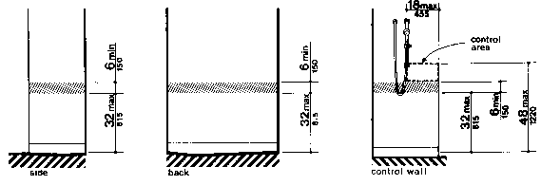

Figure 4(b)

Location of Grab Bars and Controls
of Adaptable Showers - 30-in by 60-in Stall

Figure 4

Note: The hatched areas are reinforced to receive grab bars.
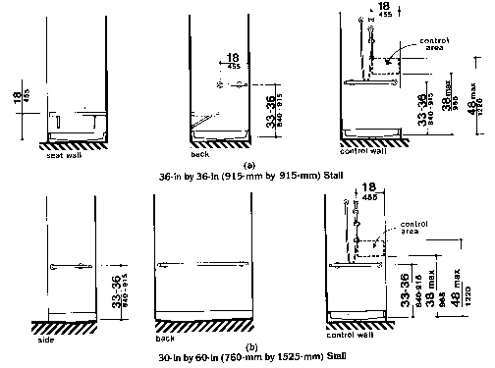

Grab Bars at Shower Stalls

Figure 5

Fig. 37(a)
36 inches by 36 inches Stall. The diagram illustrates an L-shaped grab bar that is located along the full depth of the control wall (opposite the seat) and halfway along the back wall. The grab bar shall be mounted between 33 to 36 inches above the shower floor. The bottom of the control area shall be a maximum of 38 inches high and the top of the control area shall be a maximum of 48 inches high. The controls and spray unit shall be within 18 inches of the front of the shower.

Fig. 37(b)
Fig. 37(b) 30 inches by 60 inches Stall. The diagram illustrates a U-shaped grab bar that wraps around the stall. The grab bar shall be between 33 to 36 inches high. The controls are placed on a side wall in an area between 38 inches and 48 inches above the floor. The controls and spray unit shall be within 18 inches of the front of the shower.

