  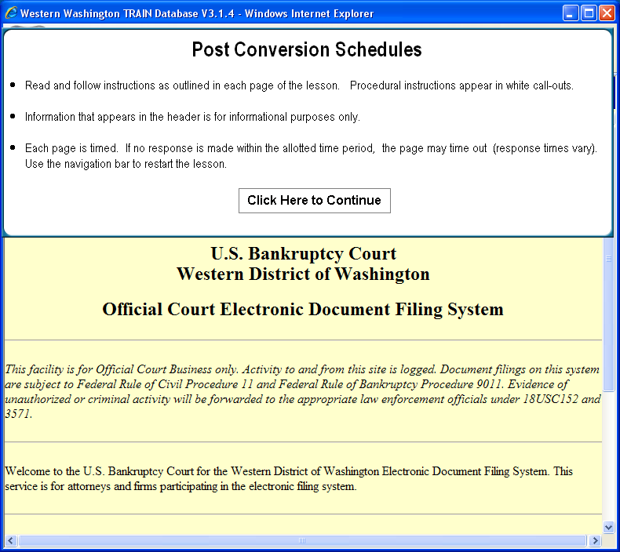
  Slide 1
  Text Captions: Post Conversion Schedules
  Read and follow instructions as outlined in each page of the lesson. Procedural instructions appear in white call-outs. Information that appears in the header is for informational purposes only. Each page is timed. If no response is made within the allotted time period, the page may time out (response times vary). Use the navigation bar to restart the lesson.
  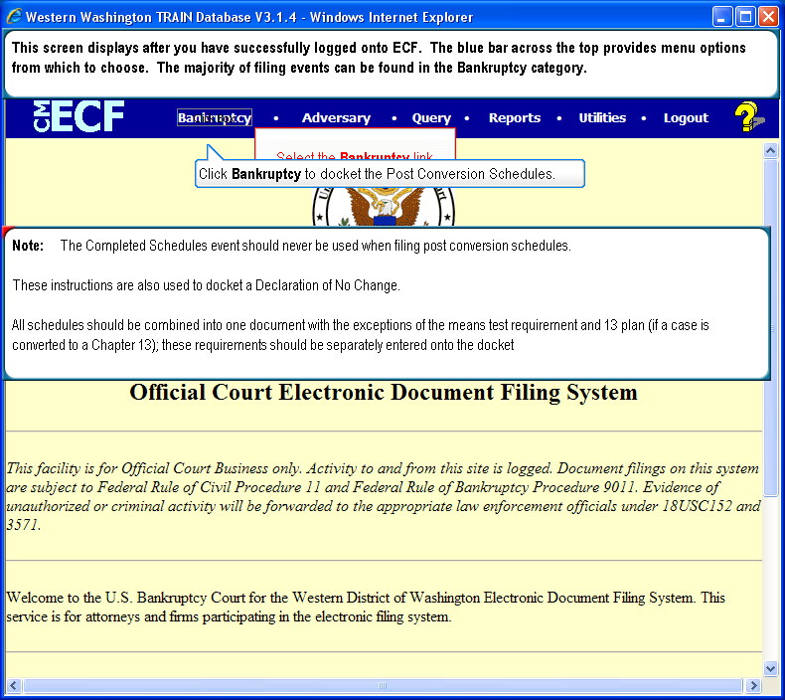
  Slide 2. Text Captions: This screen displays after you have successfully logged onto ECF. The blue bar across the top provides menu options from which to choose. The majority of filing events can be found in the Bankruptcy category. Click Bankruptcy to docket the Post Conversion Schedules. Note: The Completed Schedules event should never be used when filing post conversion schedules. These instructions are also used to docket a Declaration of No Change. All schedules should be combined into one document with the exceptions of the means test requirement and 13 plan (if a case is converted to a Chapter 13); these requirements should be separately entered onto the docket.
  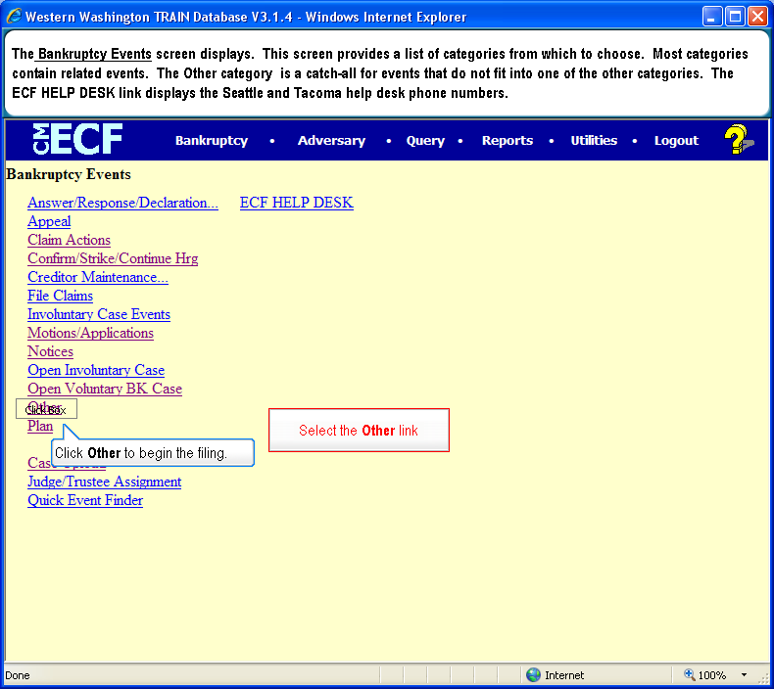
  Slide 3
  Text Captions: The Bankruptcy Events screen displays. This screen provides a list of categories from which to choose. Most categories contain related events. The Other category is a catch-all for events that do not fit into one of the other categories. The ECF HELP DESK link displays the Seattle and Tacoma help desk phone numbers.
  Click Other to begin the filing.
  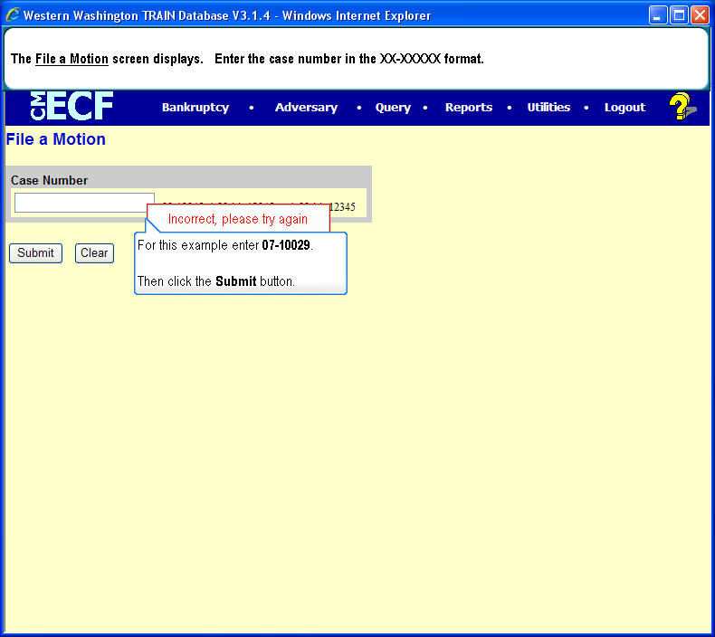
  Slide 4
  Text Captions: The File a Motion screen displays. Enter the case number in the XX-XXXXX format.
  For this example enter 07-10029.
  Then click the Submit button.

  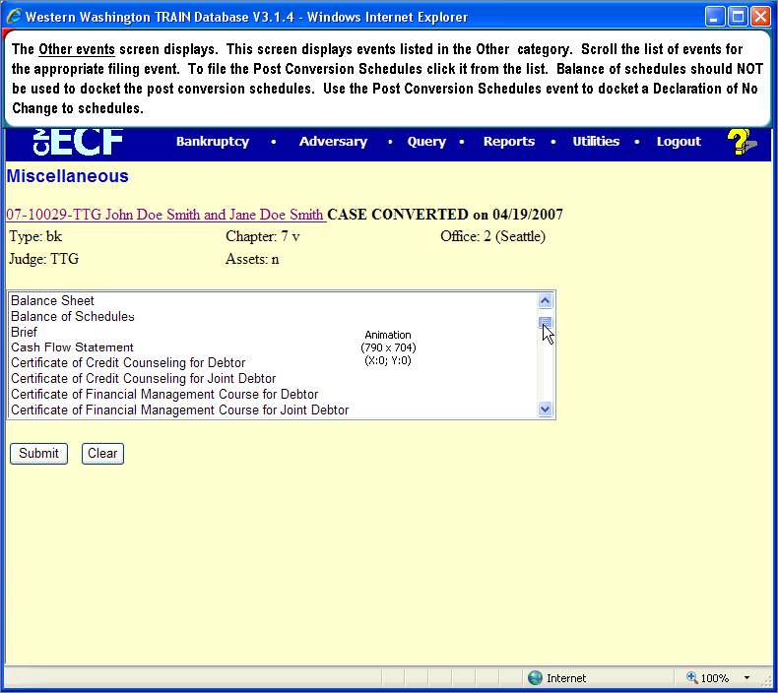
  Slide 5
  Text Captions: The Other events screen displays. This screen displays events listed in the Other category. Scroll the list of events for the appropriate filing event. To file the Post Conversion Schedules click it from the list. Balance of schedules should NOT be used to docket the post conversion schedules. Use the Post Conversion Schedules event to docket a Declaration of No Change to schedules.
  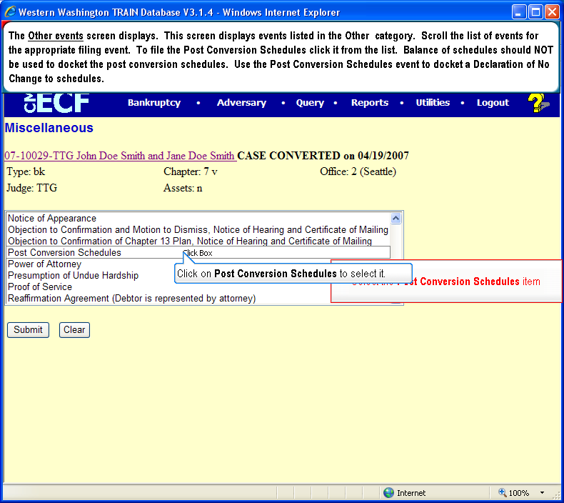
  Slide 6
  Text Captions: The Other events screen displays. This screen displays events listed in the Other category. Scroll the list of events for the appropriate filing event. To file the Post Conversion Schedules click it from the list. Balance of schedules should NOT be used to docket the post conversion schedules. Use the Post Conversion Schedules event to docket a Declaration of No Change to schedules.
  Click on Post Conversion Schedules to select it.
  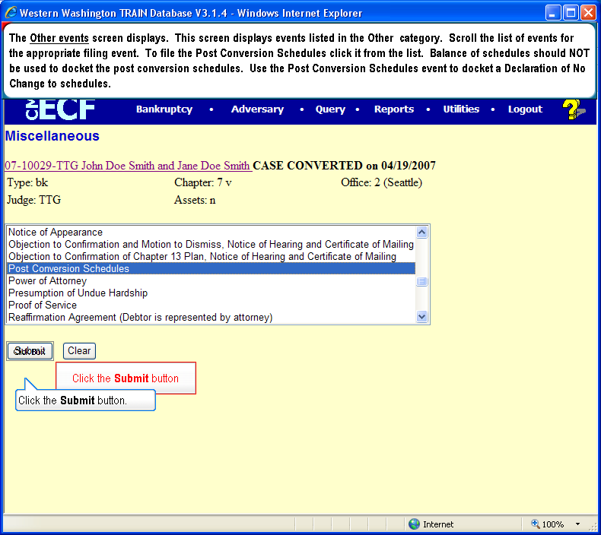
  Slide 7
  Text Captions: The Other events screen displays. This screen displays events listed in the Other category. Scroll the list of events for the appropriate filing event. To file the Post Conversion Schedules click it from the list. Balance of schedules should NOT be used to docket the post conversion schedules. Use the Post Conversion Schedules event to docket a Declaration of No Change to schedules.
  Click the Submit button.
  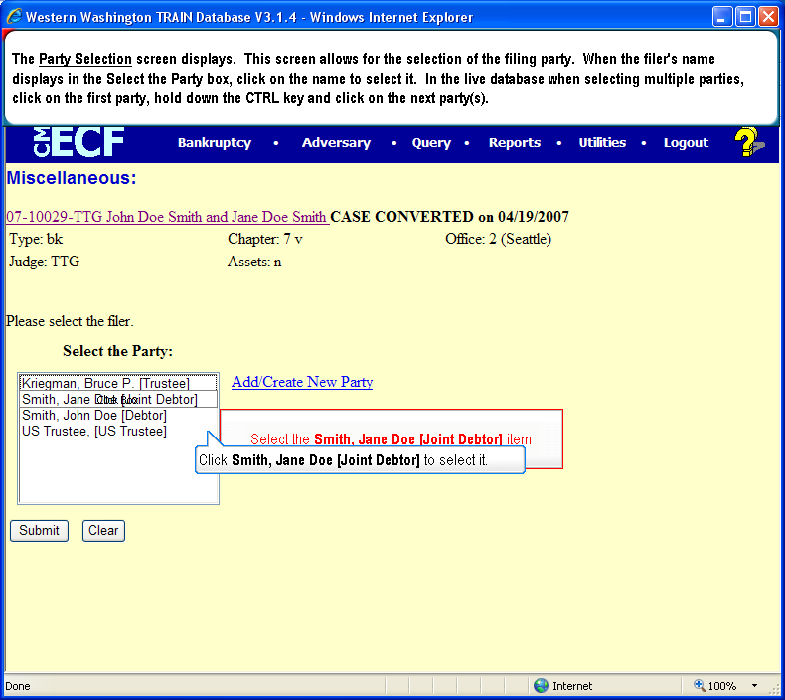
  Slide 8
  Text Captions: Click Smith, Jane Doe [Joint Debtor] to select it.
  The Party Selection screen displays. This screen allows for the selection of the filing party. When the filer's name displays in the Select the Party box, click on the name to select it. In the live database when selecting multiple parties, click on the first party, hold down the CTRL key and click on the next party and so on.

  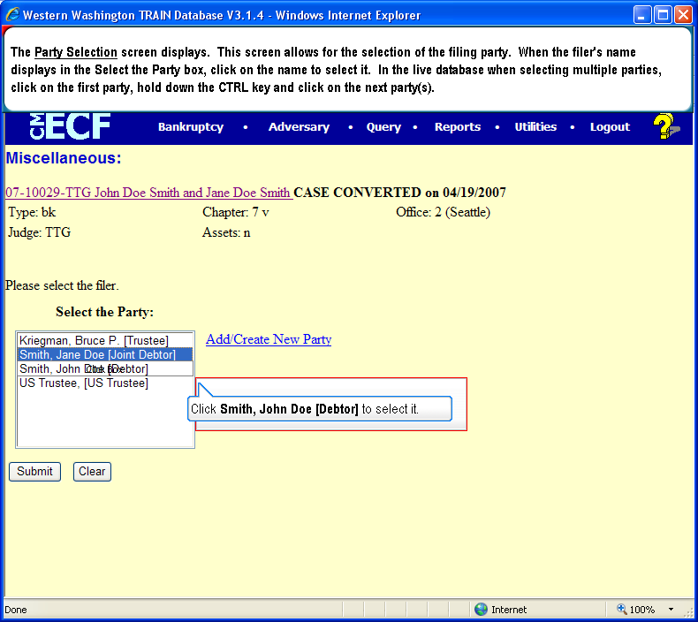
  Slide 9
  Text Captions: Click Smith, John Doe [Debtor] to select it.
  The Party Selection screen displays. This screen allows for the selection of the filing party. When the filer's name displays in the Select the Party box, click on the name to select it. In the live database when selecting multiple parties, click on the first party, hold down the CTRL key and click on the next party and so on.
  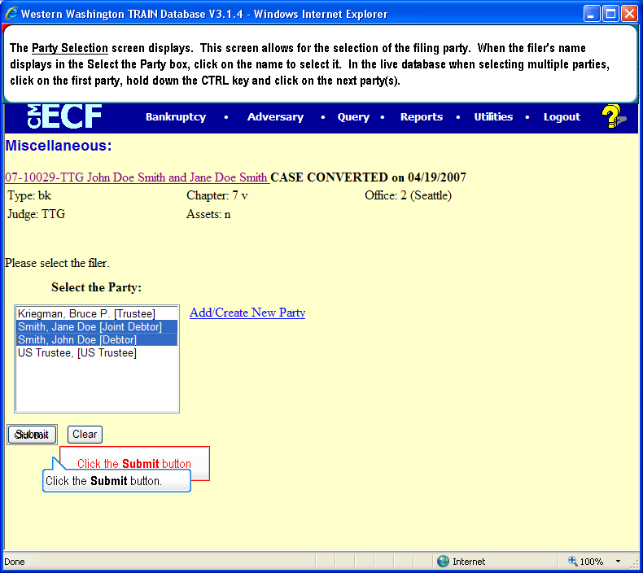
  Slide 10
  Text Captions: Click the Submit button.
  The Party Selection screen displays. This screen allows for the selection of the filing party. When the filer's name displays in the Select the Party box, click on the name to select it. In the live database when selecting multiple parties, click on the first party, hold down the CTRL key and click on the next party and so on.
  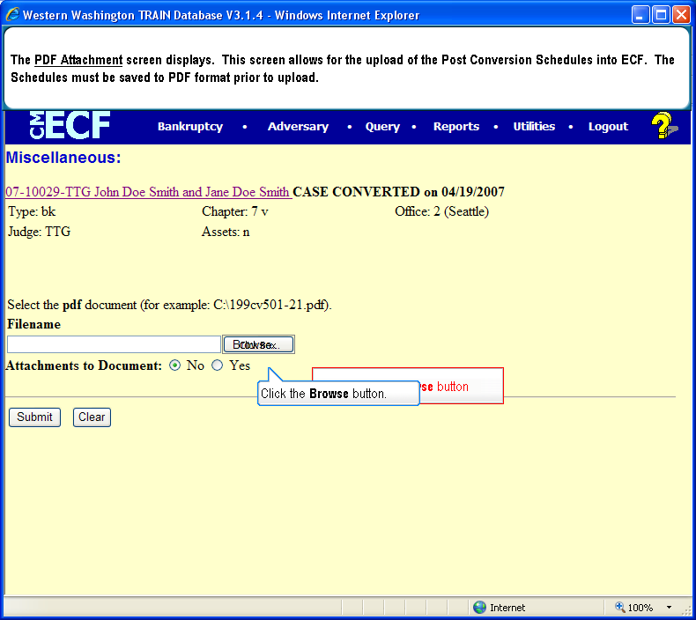
  Slide 11
  Text Captions: Click the Browse button.
  The PDF Attachment screen displays. This screen allows for the upload of the Post Conversion Schedules into ECF. The Schedules must be saved to PDF format prior to upload.
  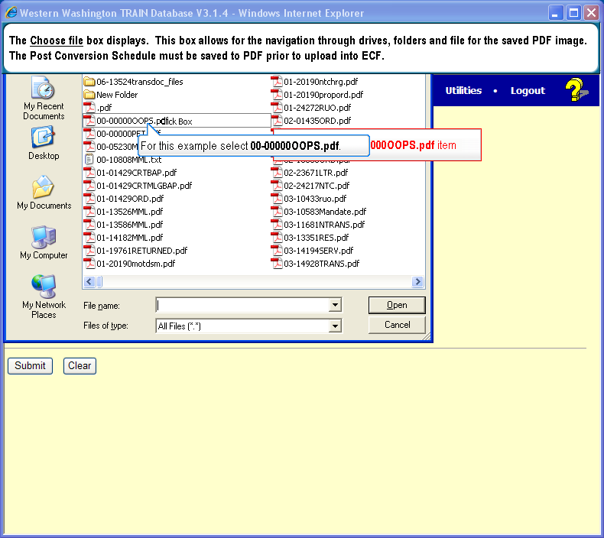
  Slide 12
  Text Captions: The Choose file box displays. This box allows for the navigation through drives, folders and file for the saved PDF image. The Post Conversion Schedule must be saved to PDF prior to upload into ECF.
  For this example select 00-00000OOPS.pdf.

  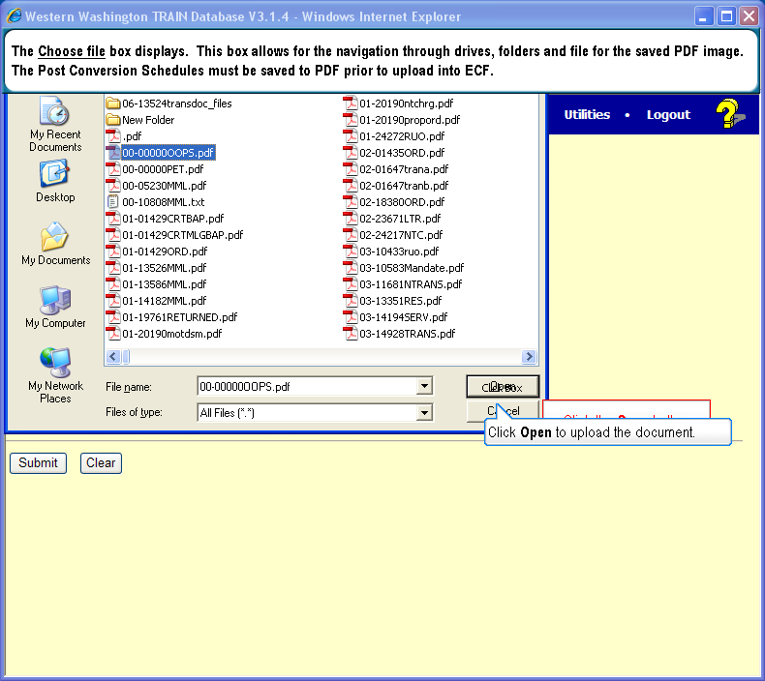
  Slide 13
  Text Captions: The Choose file box displays. This box allows for the navigation through drives, folders and file for the saved PDF image. The Post Conversion Schedules must be saved to PDF prior to upload into ECF.
  Click Open to upload the document.
  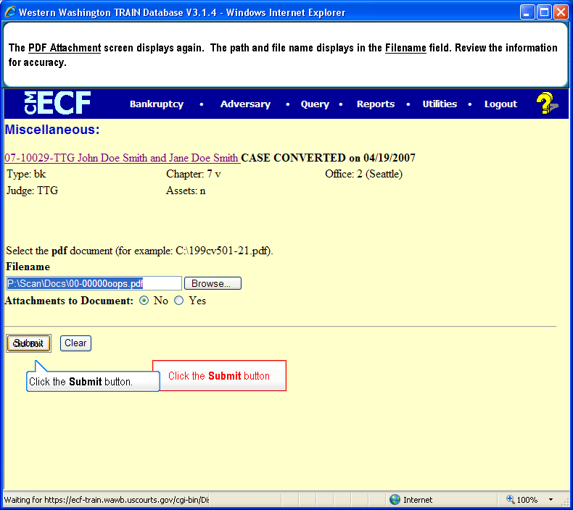
  Slide 14
  Text Captions: The PDF Attachment screen displays again. The path and file name displays in the Filename field. Review the information for accuracy.
  Click the Submit button.
  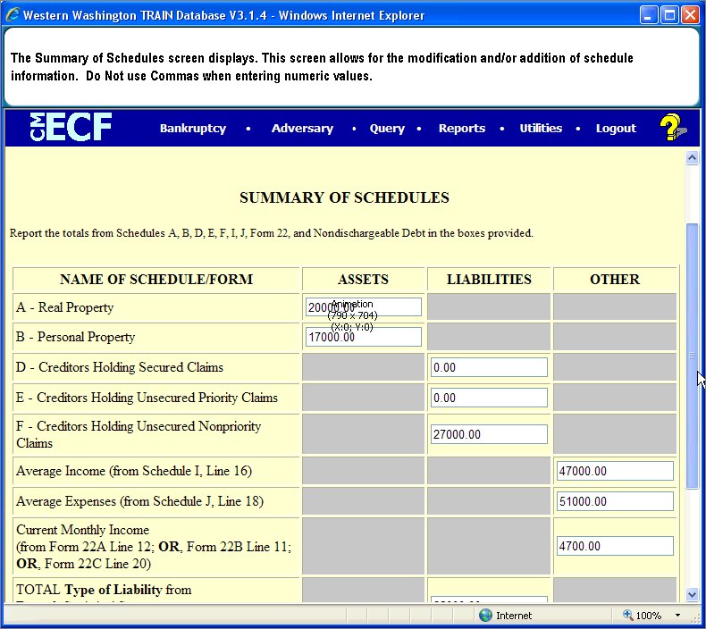
  Slide 15
  Text Captions: The Summary of Schedules screen displays. This screen allows for the modification and/or addition of schedule information. Do Not use Commas when entering numeric values.
  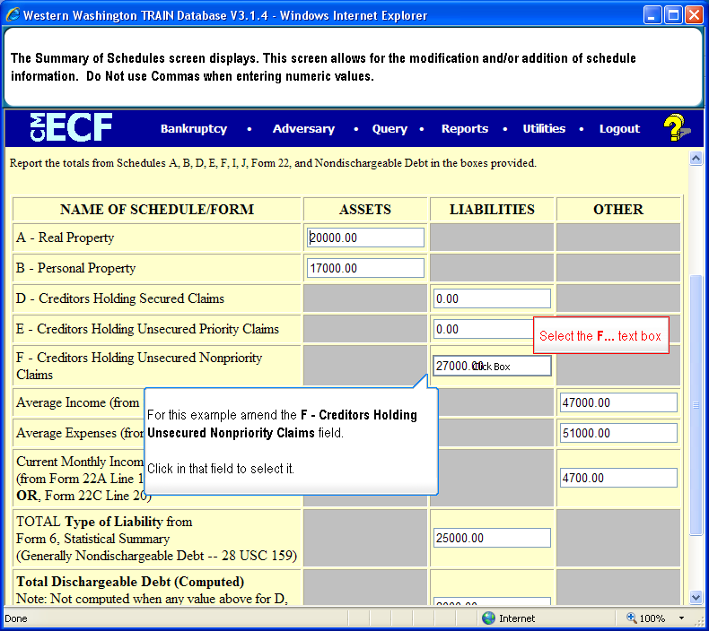
  Slide 16
  Text Captions: The Summary of Schedules screen displays. This screen allows for the modification and/or addition of schedule information. Do Not use Commas when entering numeric values.
  For this example amend the F - Creditors Holding Unsecured Nonpriority Claims field.
  Click in that field to select it.

  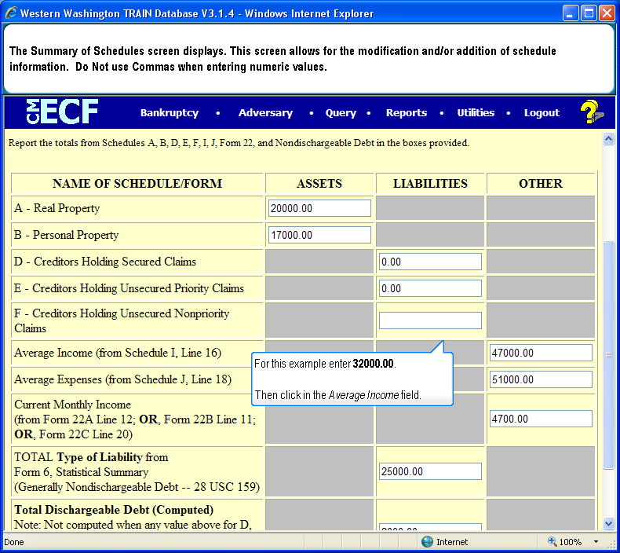
  Slide 17
  Text Captions: The Summary of Schedules screen displays. This screen allows for the modification and/or addition of schedule information. Do Not use Commas when entering numeric values.
  For this example enter 32000.00.
  Then click in the Average Income field.
  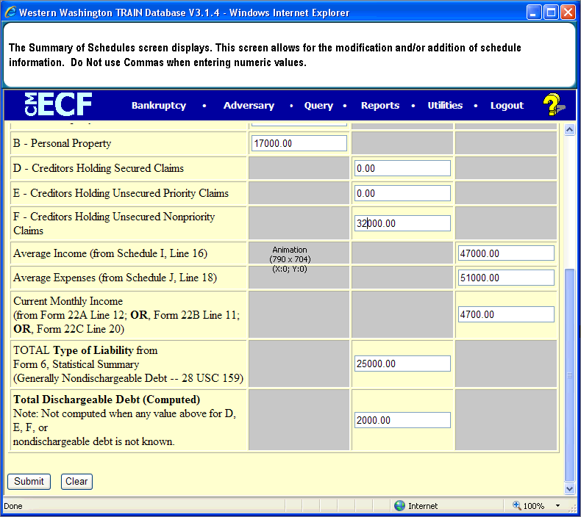
  Slide 18
  Text Captions: The Summary of Schedules screen displays. This screen allows for the modification and/or addition of schedule information. Do Not use Commas when entering numeric values.
  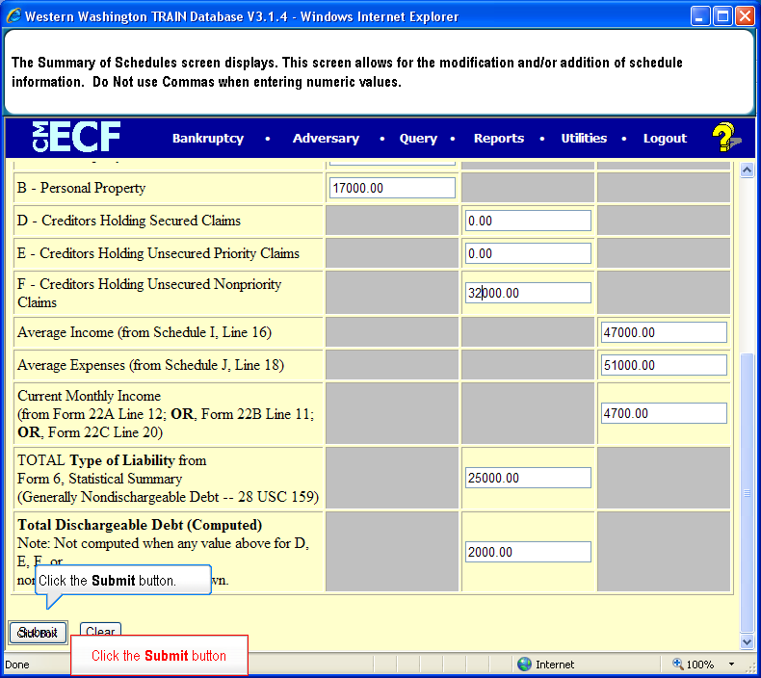
  Slide 19
  Text Captions: The Summary of Schedules screen displays. This screen allows for the modification and/or addition of schedule information. Do Not use Commas when entering numeric values.
  Click the Submit button.
  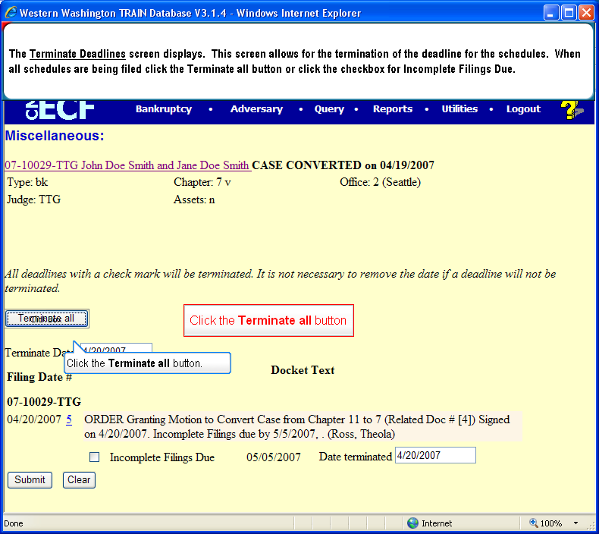
  Slide 20
  Text Captions: The Terminate Deadlines screen displays. This screen allows for the termination of the deadline for the schedules. When all schedules are being filed click the Terminate all button or click the checkbox for Incomplete Filings Due.
  Click the Terminate all button.

  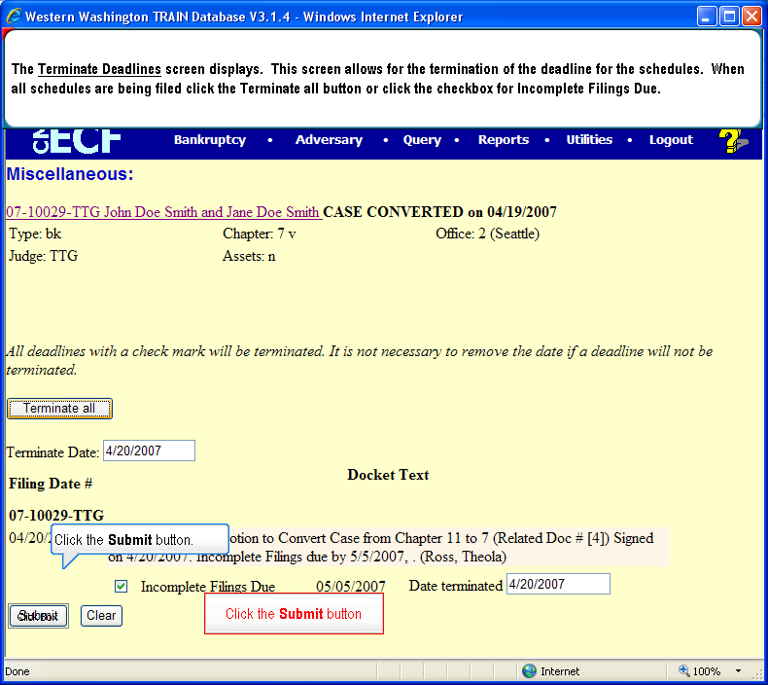
  Slide 21
  Text Captions: The Terminate Deadlines screen displays. This screen allows for the termination of the deadline for the schedules. When all schedules are being filed click the Terminate all button or click the checkbox for Incomplete Filings Due.
  Click the Submit button.
  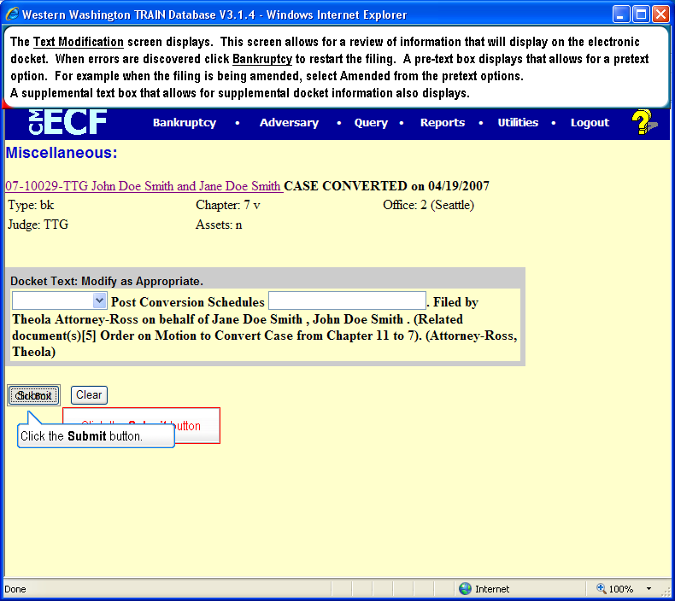
  Slide 22
  Text Captions: The Text Modification screen displays. This screen allows for a review of information that will display on the electronic docket. When errors are discovered click Bankruptcy to restart the filing. A pre-text box displays that allows for a pretext option. For example when the filing is being amended, select Amended from the pretext options.
  A supplemental text box that allows for supplemental docket information also displays.
  Click the Submit button.
  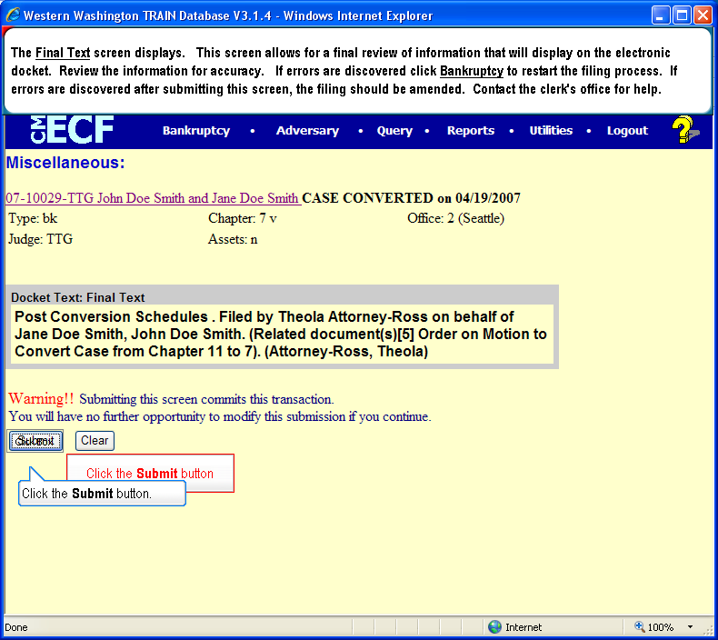
  Slide 23
  Text Captions: The Final Text screen displays. This screen allows for a final review of information that will display on the electronic docket. Review the information for accuracy. If errors are discovered click Bankruptcy to restart the filing process. If errors are discovered after submitting this screen, the filing should be amended. Contact the clerk's office for help.
  Click the Submit button.
  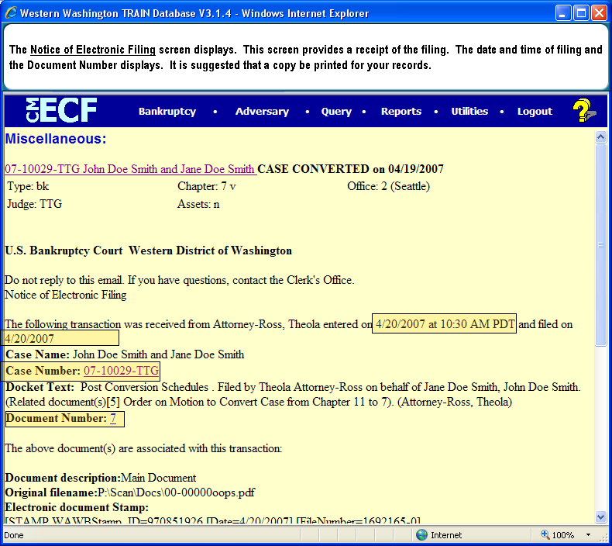
  Slide 24
  Text Captions: The Notice of Electronic Filing screen displays. This screen provides a receipt of the filing. The date and time of filing and the Document Number displays. It is suggested that a copy be printed for your records.

