Office of the Chief Financial Officer



ePayroll Project

Formulation Plan
July 12, 2003

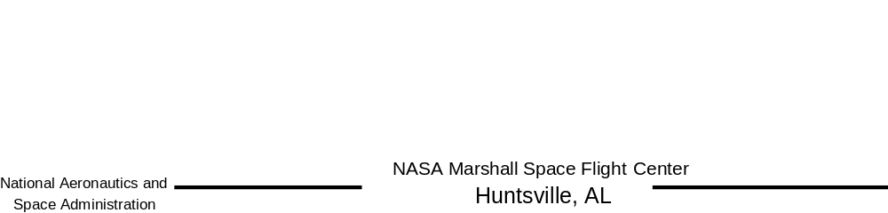

SIGNATURE PAGE

Submitted By:

___________________________________________________________ [INSERT NAME, INSERT TITLE] Date

Concurrence By:

___________________________________________________________ [INSERT NAME, INSERT TITLE] Date

Approved By:

___________________________________________________________ [INSERT NAME, INSERT TITLE] Date

DOCUMENT HISTORY LOG

Status (Baseline/  Revision/  Canceled) | Document Revision | Effective Date | Description of Change
Baseline | A |  | Initial Document Release

TABLE OF CONTENTS

1.0 Executive Summary 6
2.0 Project Organization 9
2.1 Project Reporting Structure 9
2.2 Roles and Responsibilities 10
2.2.1 NASA Headquarters Integrated Financial Management Project Office 10
2.2.2 e-Payroll Steering Committee 10
2.2.3 e-Payroll Project Office 11
2.2.4 Integration Project Office 11
2.2.5 Information Technology Points of Contact 12
2.2.6 Consolidated Payroll Office 12
2.2.7 NASA Migration Team 12
2.2.8 NASA Payroll and HR Sub-Process Teams 13
2.2.9 Center-level Payroll and HR Points of Contact 13
2.2.10 Department of Interior/ National Business Center 13
2.2.11 Office of Personnel Management 14
3.0 NASA Payroll and Personnel Processes 15
3.1 Payroll Process 15
3.2 Personnel Process 16
4.0 NASA and DOI PAYROLL/PERSONNEL SYSTEM CAPABILITIES 18
4.1 NASA Personnel and Payroll System (NPPS) 18
4.2 DOI Federal Personnel and Payroll System (FPPS) 18
5.0 Formulation Strategy 22
5.1 Project Team Development 22
5.1.1 NASA Migration Team 22
5.1.2 NASA Payroll and HR Sub-Process Teams 23
5.2 Process Assessment 24
5.3 Process Reviews 25
5.4 Interfaces 25
5.4.1 Center-level Interfaces 26
5.4.2 Agency-level Internal Interfaces 27
5.4.3 Agency-level External Interfaces 27
5.5 Reports 28
5.6 Data Conversion Standards and Methodology 29
5.7 Telecommunications 29
6.0 Project Formulation activities 30
6.1 Establish Module Project 30
6.2 Define Project Scope 30
6.3 Project Resources 30
6.3.1 Migration Team (Civil Servant Personnel) 30
6.3.2 Migration Team (Contractor Personnel) 31
6.3.3 HR and Payroll Sub-Process Teams 31
6.3.4 Integration Project Office 32
6.4 Management Steering Committee 32
6.5 Requirements Definition 32
6.6 Functional Business Drivers 33
6.7 Framework Agreements 34
6.7.1 Business Case Analysis 34
6.7.2 Project Plan 35
6.7.3 Integration Project Agreement 35
6.7.4 Risk Management 35
6.7.5 Issue Management 35
6.7.6 Change Management 36
6.7.7 Communication 36
6.8 Implementation 37
6.9 Project Commitment Agreement (PCA) 37
7.0 e-PAYROLL PROJECT REVIEWS 37
7.1 Management Reviews 38
7.1.1 Initial Project Review 38
7.1.2 Independent Assessments 38
7.2 Technical Reviews 38
APPENDIX A: List of Acronyms 40
APPENDIX B: e-payroll project Formulation process 42
APPENDIX C: project resource listS 44
C-1 e-Payroll Migration Team 45
C-2 Payroll Sub-Process Team 46
C-3 HR Sub-Process Team 47
C-4 e-Payroll Technical Team Error! Bookmark not defined.

1.0 Executive Summary
Overview
The purpose of this document is to define the project formulation phase for the National Aeronautics and Space Administration (NASA) implementation of the Office of Personnel Management’s (OPM) e-Payroll project. This document will detail the organization, approach, and requirements for the e-Payroll Project Formulation phase.
The primary purpose of the e-Payroll Project Formulation phase is to conduct a review of the Payroll and Human Resource (HR) processes for NASA requirements definition and to identify processes that can be standardized within the e-Payroll effort where impact to process reengineering is minimal and there is no impact to the planned OPM implementation timeline for e-Payroll migration.
Background
Payroll was identified as a future Integrated Financial Management Program (IFMP) module to be implemented as part of the Integrated Human Capital Management (IHCM) module. Under the President’s Management Agenda, the OPM sponsored e-Payroll initiative accelerated the timeline for replacement of NASA’s payroll functions under IFMP. The initiative addresses payroll functionality similar to that planned under IFMP with the goal of migrating all Federal Agencies’ existing payroll service to one of four consolidated Federal payroll service providers. NASA has agreed to implement e-Payroll rather than establish a new payroll capability as an extension of the IFMP human resources function.
The e-Payroll initiative is part of the larger e-Government initiative to streamline and modernize Human Capital systems in order to effectively support Agency missions. As the overseer of payroll and managing partner for the e-Payroll initiative, OPM established and led a working group to analyze Federal civilian payroll service delivery from a Government-wide perspective in order to identify options for future investments in the modernization and improvement of payroll systems and processes. The working group (OPM, Office of Management and Budget (OMB), and payroll providers) determined that the consolidation of payroll service delivery could be achieved by reducing the number of federal agencies providing payroll services and systems operations. Consolidation of payroll processes was the first step in achieving the end state, integrated HR/Payroll services. In September 2002, the OPM announced that it intended to consolidate payroll activities at 22 Federal agencies into the four ‘best qualified’ organizations: Department of Defense, Department of Agriculture, Department of the Interior, and General Services Administration. NASA was paired with the Department of Interior.
OPM e-Payroll milestones are shown below:
- May – July 2002 Service Provider Solicitations
- August – September 2002 Service Provider Evaluation and Scoring
- November 2002 OPM Selection of Top Four Service Providers
- December 2002 Agency Preliminary Alignments with Providers
- February 3, 2003 Agency Commitments to Providers
- February 5, 2003 Alignments Announced
- February 2003 Government-wide Migrations Begin
- September 2004 Government-wide Migrations End
In response to the OPM e-Payroll initiative, NASA engaged a working group of Payroll and HR experts across the Agency to study feasible alternatives for migrating its payroll service delivery to the Department of Interior (DOI). The recommendation emerging from the e-Payroll Study proposed that NASA move forward with migration of its payroll services to DOI along with the use of the DOI system capabilities for SF50/52 automated workflow, HR transactional processing, and the use of current NASA time and attendance systems. NASA’s formal e-Payroll implementation activities will begin in September 2003.
Since HR functions as well as a few Payroll functions are not standardized across the Agency, it was determined that the time leading up to formal implementation (March – August 2003) would be used to review HR and Payroll processes and identify areas where standardization can be achieved. This timeframe has been identified as the e-Payroll Formulation Phase. The following tasks will be covered during this phase:

- Define “to be” business processes
- Define Level IV functional requirements
- Identify interfaces and perform high-level requirements analysis
- Identify reports and perform requirements analysis
- Establish data conversion requirements
- Define project technical architecture
- Define technical requirements
- Finalize requirement analysis and document gaps
- Establish Project Plan for the Implementation Phase
- Establish cost, schedule, and technical success criteria
Department of Interior’s National Business Center is the implementer of e-Payroll. After formulation, NASA and DOI will work jointly with implementation activities which include the following tasks:

- System analysis
- System modification and testing (including interface development)
- Conversion Design, Programming, and Testing
- Change Communication
- Training
- Client Orientation
- Parallel Processing
- Accomplishing Operational Readiness
- Implementation
- Transfer of Records

2.0 Project Organization

This section identifies the organizational reporting structure and responsibility of each organization to accomplish the tasks leading up to formal implementation of NASA’s payroll operations.

2.1 Project Reporting Structure
The IFM Program Office at NASA Headquarters (HQ) will provide program oversight for the e-Payroll initiative with configuration management and project scope being monitored and approved by the e-Payroll Steering Committee.
The e-Payroll Project Office located at Marshall Space Flight Center (MSFC) will provide day-to-day project level management and be responsible for project coordination between NASA Centers, the Department of Interior, and NASA HQ. The overall project reporting structure is shown in Figure 1.
Figure 1: NASA e-Payroll Project Reporting Structure
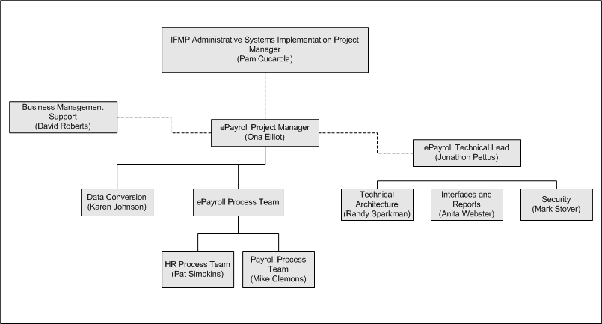

2.2 Roles and Responsibilities
This section provides an overview of the roles and responsibilities of the organizations and groups identified for the e-Payroll formulation phase.

2.2.1 NASA Headquarters Integrated Financial Management Project Office
The NASA Chief Financial Officer (CFO) established the Integrated Financial Management Project Office at NASA Headquarters in 1995 to plan, coordinate, and manage all aspects of the work necessary to streamline and standardize business processes, and to acquire and implement an integrated financial management system solution throughout NASA.

IFM Program Office at NASA HQ is responsible for:

- Setting program objectives, priorities
- Approving and allocating project funding
- Reporting
- Establishing a framework for conducting program business
- Assessing project performance (establishing metrics, obtaining status feedback, tracking progress)
- Change Management during formulation and implementation

2.2.2 e-Payroll Steering Committee
The e-Payroll Steering Committee consists of Office of the NASA Deputy Chief Financial Officer-Financial Management (Chair), Associate Administrator Office of Human Resources and Education, the Chief Information Officer, and IFM Program Director. The Committee will serve as the principal forum for reviewing functional and implementation issues, recommending actions to the Project Manager for resolving those issues, and ensuring that the project’s functional drivers are met.
Specific areas of responsibility include:

- Defining the Project scope
- Resolving functional processes/policy issues
- Approving Level IV requirements
- Resolving cross Center issues
- Ensuring formulation and implementation planning
- Ensuring formulation and implementation staffing

2.2.3 e-Payroll Project Office
The e-Payroll Project Office will be responsible for:

- Providing day-to-day project level management
- Providing status reports to program management
- Providing Steering Committee status reports
- Project coordination between NASA Centers, the Department of Interior, and NASA HQ
- Planning formulation activities
- Monitoring activities to ensure the formulation schedule is maintained
- Communication to stakeholders
- Change management (training, communications)

2.2.4 Integration Project Office
The Integration Project Manager is responsible for establishing a viable technical infrastructure and ensuring the coordination of the various functional module implementations. Specific responsibilities include:

- Defining the technical requirements and the NASA technical architecture necessary to implement and operate the DOI system
• Coordinate the development of interface requirements for implementing the DOI system
- Implementation of the integration architecture necessary to consistently integrate the DOI system with other IFM applications, external systems, other Agency systems, and Center level systems
• Lead the development and implementation of each interface with the DOI system
- Develop the security requirements and work with DOI in the development of the Security Plan for e-Payroll
• Work with e-Payroll Project and DOI to establish reporting strategy for e-Payroll
- Work with DOI to establish SLA and operational procedures necessary to sustain the e-Payroll system
- Transition any NASA maintained components to the IFM Competency Center for long term sustaining support
- Work with NASA Center IFM IT Points of Contact (ITPOC) to insure Center level technical infrastructure is in place to support e-Payroll deployment

2.2.5 Information Technology Points of Contact
The Information Technology Points of Contact (ITPOC) continues interaction with Integration Project Office concerning Information Technology (IT) infrastructure elements and associated service providers required to deploy IFMP applications at a Center. The ITPOC at each Center will provide technical support to the Center and Project Manager.

2.2.6 Consolidated Payroll Office
The Consolidated Payroll Office (CPO) and its technical support staff will:
- Provide functional and technical support for Payroll and HR process reviews
- Coordinate data calls for Payroll and HR interface and report activities
- Coordinate NPPS Demos
- Provide data files for analysis of NPPS/FPPS database crosswalk activities
- Provide consultation for clarification of files and data elements
- Support the IPO and DOI’s Automated Data Processing (ADP) staff with the NASA network and connectivity process
- Provide support for defining existing NPPS reporting capabilities and data structures
- Assist the IPO in interface definition activities

2.2.7 NASA Implementation Team
The NASA Implementation Team will lead e-Payroll migration for NASA with oversight guidance provided by the e-Payroll Steering Committee. The team will work directly with DOI throughout the formulation and implementation process and will be responsible for assisting with:
- Coordination of e-Payroll formulation activities and tasks
- Facilitation of e-Payroll workshops
- Implementation planning and support
- Conducting NPPS Demos
- Providing Agency policy and regulatory documentation
- Ensuring all e-Payroll formulation prerequisites are fulfilled prior to formal implementation
- Monitoring e-Payroll formulation and implementation schedule tasks to ensure timeliness
- Change management (training, communications)

2.2.8 NASA Payroll and HR Sub-Process Teams
The Payroll and Human Resource Sub-Process Teams will be the key players for the Payroll and HR Process Reviews during the formulation phase of e-Payroll and will serve as Center-level points-of-contact for the life of the project. The sub-process teams will consist of a functional and technical resource from each Center. The teams will be tasked to evaluate and document current Payroll and HR processes under the direction of sub-process team leads. Results of the process reviews will validate the existing processes and provide functional requirements for the NPPS to FPPS payroll implementation.
Sub-Process Team Leads will be responsible for:
- Directing the coordination of e-Payroll formulation workshops
- Monitoring status of e-Payroll actions
- Supporting the e-Payroll Migration Team with formulation activities and data calls
Sub-process teams will be responsible for:
- Supporting Agency workshops for process reviews, interface inventory, and report requirements
- Providing Center policy and regulatory documentation as needed
- Supporting the e-Payroll Migration Team with formulation activities and data calls

2.2.9 Center-level Payroll and HR Points of Contact
Center Payroll and HR Points of Contact will mostly likely be the same individuals that form the sub-process review teams. They will be responsible for:
- Providing guidance on Center policies and procedures
- Assisting with problem resolution
- Supporting the sub-process teams with resolving Center-level issues

2.2.10 Department of Interior/ National Business Center
The formulation and implementation of e-Payroll will be a joint effort on the part of DOI’s National Business Center (NBC) and NASA. This section identifies NBC’s responsibility during the formulation phase. In general, NBC will:
- Develop and manage detailed implementation plans
- Submit e-Payroll client progress reports to OPM
- Conduct joint review of DOI’s implementation plan for NASA’s payroll migration
- Support NASA process review work shops
- Support NASA formulation activities
- Perform NPPS data file analysis during formulation phase (for data elements crosswalk and building historical file)

2.2.11 Office of Personnel Management
The Office of Personnel Management will be responsible for monitoring the progress of NASA’s payroll migration. As the managing partner for e-Payroll, OPM will:
- Track the progress of NASA’s payroll migration by collecting information from DOI on a biweekly basis
- Facilitate resolution of questions or issues between NASA and DOI
- Serve as the final decision-maker on e-Payroll related issues between DOI and NASA

3.0 NASA Payroll and Personnel Processes

3.1 Payroll Process
The Consolidated Payroll Office (CPO) now processes payroll information for the ten NASA Centers and conducts payroll business activities from Marshall Space Flight Center (MSFC). Agency payroll processing performed at the CPO uses a single consolidated system, the NASA Personnel and Payroll System (NPPS), and standardized operating procedures.
Each Center populates NPPS with limited payroll data. The CPO performs the more technical payroll functions and is responsible for processing and certification of the final payroll products. The NPPS data for each Center is independent in that only data that is relevant to that Center is available. Center-level operating procedures, to some degree, are not standardized.
The CPO processes the biweekly Payroll within three business days of the pay period end. On the first business day following each pay period, NASA Centers are required to submit all employees’ time and attendance information (via flat file) to CPO. CPO processes that information, produces an Errors and Missing Timecards report, and calculates pay and leave data. The second business day, errors and missing timecard issues are resolved and pay products and updates to history are processed. On the third day of Payroll processing, the CPO ensures Payroll is balanced and certified, and data is submitted to the Department of Treasury, Thrift Savings Plan (TSP) Board, and other external agencies. Also, pay processed data and reports are available to the Centers. Following Payroll processing each Center receives a download of data used as input to their labor and/or accounting and time & attendance systems.
The biweekly Payroll process varies at the quarterly cycles, fiscal year-end cycle, and the calendar year end. The pay year-end process is the most involved due to reconciliation and processing of W-2s, generation of wage and tax file to the IRS, and re-initialization of yearly pay and leave balance.
Figure 2 depicts the Systems and Interfaces that support the Payroll Function.

Figure2: Systems and Interfaces That Support the Payroll Function

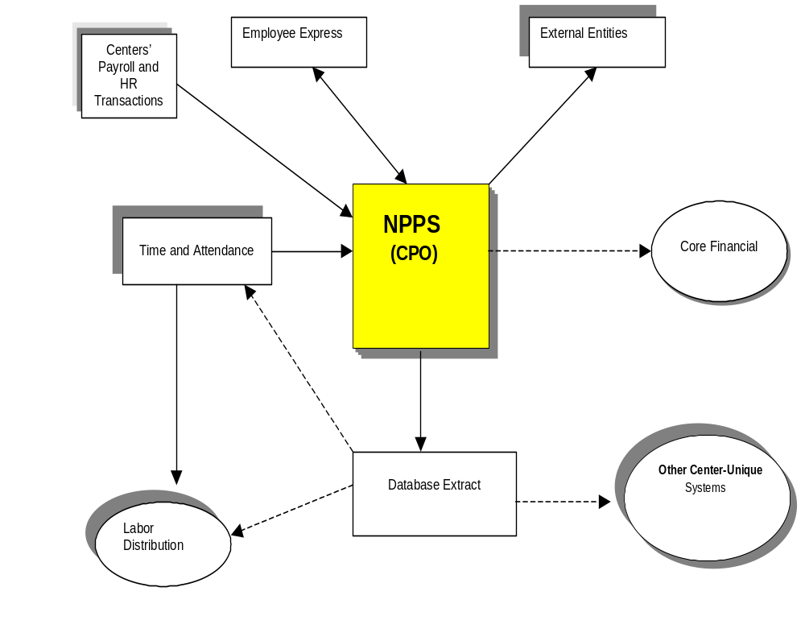

3.2 Personnel Process
NASA’s principal automated personnel system is the NPPS. It provides administrative assistance for employee personnel and payroll processing and record keeping activities. The system allows users to enter data, view employee records, process SF50/SF52 personnel actions, and select and schedule hard-copy reports.
The HR staff at each NASA installation utilizes NPPS independently. Although, the Personnel NPPS data are centrally located at Marshall Space Flight Center, the personnel business activities continue to be functionally supported by personnel at each Center. HR operating procedures are not standardized across the Agency.
The current system’s user community is comprised primarily of personnel office administrative staff members who are specially trained to use the system to perform transactional processing and reporting. The system supports a very limited subset of HR business processes, and does not provide the comprehensive, automated tools necessary to meet their current and future HR requirements.
In addition to NPPS, each NASA Center and Headquarters have existing personnel systems that are custom developed to support each installation’s unique business process requirements. The systems and interfaces that support the personnel functions are illustrated in Figure 3.

Figure 3: Systems and Interfaces That Support the Personnel Function

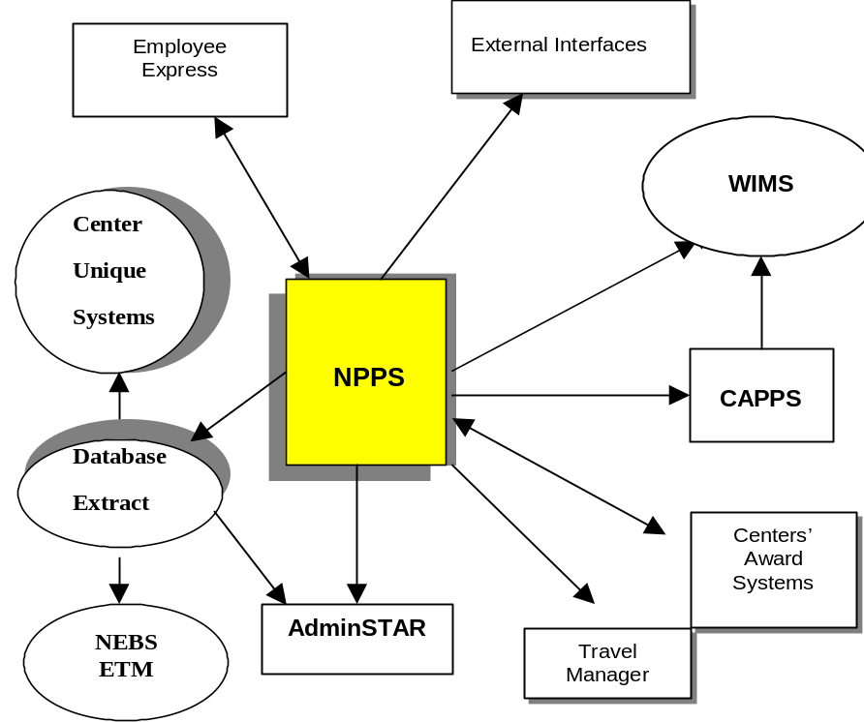

On an Agency-wide level, the personnel functions of NPPS require the system to interface with AdminSTAR, the NASA Employee Benefits Statement (NEBS), and the Consolidated Agency Personnel Payroll System (CAPPS), and Travel Manager.
On a biweekly basis CAPPS brings Payroll and HR data from each installation together in a single database to allow for Agency-wide reporting. CAPPS is neither flexible nor fast enough in its current state. CAPPS produces monthly and quarterly reporting of personnel actions and status and full time equivalents to the Central Personnel Data File managed by OPM.
External to NASA, NPPS interfaces with OPM and Employee Express (EE) systems. Employee Express is a system that was developed and is governed by a consortium of Federal agencies. The system utilizes a biweekly extract of employee personnel and payroll data which allows employees to perform a variety of personnel and payroll transactions that are within their discretion as well as view certain existing data. Currently, use of the system is optional but there are plans to make it mandatory across the Agency.
At the Center-specific level, the HR functions of NPPS require the system to download Personnel and Payroll data to Center-unique systems. An upload of data by a batch interface to NPPS is performed for Centers’ award data.

4.0 NASA and DOI PAYROLL/PERSONNEL SYSTEM CAPABILITIES

4.1 NASA Personnel and Payroll System (NPPS)
NPPS executes within an environment provided by the NASA Automated Data Processing (ADP) Consolidation Center (NACC), located at Marshall. The system is managed by the CPO and provides payroll and personnel service for approximately 19,000 NASA employees.
NPPS is basically designed to address six functions: 1) process personnel and payroll transactions, 2) process T&A data, 3) process the biweekly Payroll, 4) maintain an employee database for internal and external reporting, 5) create data files needed by external agencies, and 6) maintain personnel and payroll history.
NPPS provides administrative assistance for employee personnel and payroll processing and record keeping activities. The system allows users to accomplish data entry for required personnel and payroll action processing, view employee records, process Centers’ time and attendance data, process payrolls, select and schedule vouchers and hardcopy reports, provide data downloads for labor cost reconciliation and other Center-specific applications, and create files for transmission to external entities such as the Treasury, Thrift Savings Plan (TSP) Board, OPM, and Employee Express. Although the system is fairly automated, it has limited editing, out-of-cycle pay, and automated retroactive correction capabilities.

4.2 DOI Federal Personnel and Payroll System (FPPS)
FPPS is a fully integrated personnel and payroll system. The system is managed by the Department of the Interior’s National Business Center (NBC) and provides payroll service to 28 agencies, serving 220,000 employees.
The NBC offers a range of multi-functional payroll and personnel processing applications and services in compliance with the Joint Financial Management Improvement Program (JFMIP) SR-99-5, OPM’s Guide to the Central Personnel Data File (CPDF), and Human Resources & Payroll Systems Requirements for payroll management activities. The system allows users to accomplish data entry for personnel and payroll transactional processing, process time and attendance associated with project codes within the payroll calculation process, provides labor cost data file with associated project codes, and creates files for external entities such as the Treasury, TSP Board, OPM, and Employee Express. Other FPPS features include:
- Web-based user interface
- Paperless transactional processing (i.e., pay and leave changes, retroactive adjustments)
- Automated routing (workflow)
- Automated retroactive pay and leave processing
- Automated workflow (i.e., SF 50/52 processing)
- System triggered actions
- E-mail messaging
- Employee self service
- Web-based Data Mart (user-friendly Oracle database uses modem to query, analyze, chart, report)

The DOI services are a mix of standard baseline services and optional services. Baseline
services are provided to all clients and are priced based upon the number of employees paid.
Optional services have separate costs. FPPS system baseline services include:

- Assistance in submission of Time and Attendance (T&A)
- T&A processing and adjustments
- Pay certification and disbursement
- Payroll reconciliation
- Reissued and supplemental checks
- Maintenance and certification of leave, health, Thrift Savings Plan, and retirement records
- Payment and reconciliation of Federal, state, and local taxes; issuance of W-2's
- Unemployment reporting using contract services
- Processing of court ordered deductions and tax levies
- Payroll debt collection
- Pay and leave adjustments and payments
- Separations processing
- Customer Support

Optional services provided by DOI in support of payroll and personnel processing are:

- OPM's Employee Express
- Client specific ad-hoc reporting or other unique requests
- Training, after initial implementation
- Client-specific interface development/implementation
- Client-specific telecommunications
- Client-specific software modifications
- Quicktime employee-based T&A system
- Conversion and maintenance of historical data
- Licensing of Data Mart retrieval software

A comparison of NASA and DOI baseline capabilities is shown in Figure 4 below.

Figure 4: NASA and DOI Baseline System Capabilities

FUNCTIONS | NASA (NPPS) | DOI (FPPS)
PAYROLL ACCOUNTS MAINTENANCE
Integrated Time & Attendance System |  | X | Basic time and attendance collection; timekeeper time entry required
Time & Attendance Collection & Editing | X | X | Cost associated with project code during pay roll calculation in FPPS
Labor Distribution |  |  | FPPS does not provide an integrated Labor Distribution system. A labor cost file is produced during payroll calculation for use in performing Labor Distribution in clients’ existing systems.
Leave and Pay Processing | X | X | Leave adjustments automated in FPPS/manual in NPPS
Back Pay | X | X | Automated in FPPS/manual in NPPS
Error Correction/Adjustment | X | X | Adjustments to pay automated in FPPS/manual in NPPS
Off-Cycle Payments |  | X
Employee Self-Service (Employee Express) | X | X
Audit and Research | X | X
Extensive Number of Preformatted Payroll Queries (Data Mart) |  | X
DEBT MANAGEMENT
Salary Overpayments | X | X | Automated in FPPS/manual in NPPS
Collection Actions | X | X | Automated in FPPS/manual in NPPS
Debt Reporting & Tracking | X | X | Automated in FPPS/manual in NPPS
Garnishments & Legal Action | X | X
PAYROLL ACCOUNTING
Treasury/Bank Liaison | X | X
Lost/Stolen Checks and Bonds | X | X | Accounting for lost and stolen checks will be performed by DOI
Accounting Reconciliation for Disbursements | X | X | Payroll accounting will be performed by DOI
TAXES AND COLLECTIONS
Federal | X | X | Tax returns and W-2 processing performed by DOI
State | X | X
City | X | X
Local | X | X
EMPLOYEE BENEFITS
Retirement | X | X
Federal Employees Life Insurance (FEGLI) | X | X
NASA Employee Benefits Association | X |  | NASA unique – will require modification to FPPS
Federal Employees Health Benefits (FEHB) | X | X
Thrift Savings Plan and Thrift Loans | X | X
PERSONNEL
Transactional Processing | X | X
Automated SF 50/52 Processing |  | X
Automated Guide to Personnel Processing |  | X
Online Central Personnel Data File Editing |  | X
Automated Retroactive Processing |  | X
System-generated Ticklers for Future Actions | X | X
Automatic Routing and e-Mail Notification of Personnel Actions |  | X
Equal Opportunity Reporting Standard Reports  - Supervisory Level  - Target Disability  - Separations  - Class Ceiling  - Award Payments  - Retirement Eligible  - RIF Results  - Others |  | X
Automated Employment Verification |  | X
Employee Self Service via Employee Express | X | X
Mass Change Capability | X | X
Extensive Number of Preformatted Personnel Queries (Data Mart)  - Personnel/Organizational Rosters  - Average Grade  - Employee Transfer Information  - Managerial Projections  - Retirement Data |  | X

5.0 Formulation Strategy
This section describes the project teams required for the formulation phase and the overall strategy for tasks leading up to e-Payroll implementation.

5.1 Project Team Development
Project teams will be developed during the formulation phase. The preliminary assessment indicates a need for a NASA Migration Team as well as Payroll and HR Sub-Process Teams.

5.1.1 NASA Migration Team
The NASA Migration Team will consist of Agency-level Payroll and HR staff, and technical, reporting, and integration experts from the IPO at MSFC. This team will work directly with DOI throughout the implementation process to support the conversion of NASA’s payroll operations from NPPS to FPPS. The NASA Migration Team will be composed of the following skill mix:

- Project Manager | - Business Process Specialists
- Payroll Coordinator | - Training Coordinator
- HR Coordinator | - IT/Telecommunications Specialists
- Payroll Specialists | - Change Management Lead
- HR Specialists | - Process Review Support
- Accountant/Finance Specialist | - Administrative Support
- Applications and Data Experts | - IPO Technical Support

Project Manager - provide day-to-day project level management and be responsible for project coordination between NASA Centers, the Department of Interior, and NASA HQ.

Payroll and HR Coordinators – provides Agency-level sub-process team lead support for process reviews during the formulation phase and implementation support for e-Payroll implementation activities.

Payroll Specialists – Payroll experts knowledgeable of:

- Agency Payroll Business processes and workflow
- Payroll rules, regulations, policies, union agreements
- Current reporting requirements within the Agency

HR Specialists - HR experts knowledgeable of:
- Agency HR Business processes and SF52/50 workflow
- Personnel rules, regulations, policies, union agreements
- Current reporting requirements within HR and other interfaces to internal offices
Accountant/Finance Specialist – individual knowledgeable of accounting for payroll from an Agency perspective. Since DOI will be responsible for NASA’s Payroll accounting after implementation, this individual must have an expert knowledge of the requirements for transitioning this function to DOI and the impact to NASA’s accounting process. This individual will work with DOI to ensure that NASA’s accounting requirements for payroll are fulfilled.

Application and Data Expert – individual with expert knowledge of the NPPS its metadata. This person must also be familiar with NASA’s current data warehouse and needed interfaces.

Business Process Specialist – individual knowledgeable of NASA’s business process flow for mapping NASA users to the FPPS application user security and route paths.

Training Coordinator – individual who serves as a point of contact for scheduling training for NASA personnel. This individual works directly with NBC for scheduling training rooms, setting up class rosters, coordinating travel for NASA participants, ensuring connectivity and necessary equipment is available, and ensure all logistics are in place.

IT/Telecommunication Specialist - responsible for working with NBC ADP staff to ensure connectivity for all users of FPPS. This individual must be knowledgeable of the NASA network, how many users will have access, and be able to determine the best means to connect to NBC using NASA network. This individual would also work with NBC to transmit data that will be migrated to NBC for data conversion beginning in the e-Payroll formulation phase. This transmission will occur every two weeks through implementation.

Change Management Lead – responsible for e-Payroll communication and change management activities.

Process Review Support – responsible for coordinating and facilitating process reviews for e-Payroll formulation.

Administrative Support – provides project administrative support for the life of the project.

IPO Technical Support – provides technical architectural support for the life of the project.

NASA Payroll and HR Sub-Process Teams
A Payroll and HR sub-process team lead will be designated to manage process review activities.
NASA Centers will be asked to identify technical and functional representative with in-depth knowledge of their Center-level Payroll and HR operations to participate on sub-process teams. There will be one technical and one functional person from each Center to support the sub-process teams.

The purpose of the sub-process teams is two-fold; 1) to review the existing Payroll and HR processes and determine areas where the processes can be standardized, and 2) finalize the assessment of functional requirements for the FPPS system.

5.2 Process Assessment
The e-Payroll transition to DOI will begin with the NASA formulation phase. The Payroll and HR community have conducted previous reviews of the FPPS Payroll and HR processes. The primary purpose of e-Payroll formulation is to conduct a review of NASA’s Payroll and HR processes and to identify processes that can possibly be standardized within the e-Payroll effort where impact to process reengineering is minimal and there is no impact to the implementation schedule. The process reviews will be accomplished by conducting a series of workshops and teleconferences, mostly with DOI, during March – August 2003.

Payroll processes are largely standardized and should require minimal process re-engineering to accommodate DOI’s FPPS. HR processes at NASA’s ten Centers are not standardized. Standardization for HR processes will be evaluated under the NASA Shared Services Center (NSSC) initiative. Since several members on the HR NSSC team will potentially be members of the e-Payroll Sub-Process teams, HR Standardization has been identified as an area that can be worked in concert with the NSSC initiative to alleviate redundancy of effort during e-Payroll formulation.

The following tasks will be performed by the sub-process teams during the e-Payroll formulation phase:

- Review NASA and DOI/FPPS Business Processes
- Identify, document, and disposition gaps between FPPS and NPPS processes
- Inventory Interfaces
- Identify Report Requirements
- Evaluate Data Conversion
Primary tasks in the Formulation Phase will be accomplished with four workshops. The first two workshops will be held separately for Payroll and HR. The third and fourth workshops will be a joint sessions. Dates and duration of these workshops can be found in the e-Payroll Project Formulation Schedule. A brief description of each Workshop is shown below:

- Workshop 1 – HR Process understanding and requirements gathering (NASA only)
- Workshop 2 – PR Process understanding and requirements gathering (NASA only)
- Workshop 3 – Process validation, standardization identification, historical data conversion (NASA/DOI)
- Workshop 4 – Process confirmation/interface/report requirements (NASA/DOI)

HR and Payroll workshops will be held at Headquarters, Washington, D.C. and MSFC, Huntsville, Alabama, respectively. Teleconferences and data calls will be utilized for workshop follow-up activities.

At the end of the formulation phase in August 2003, NASA and DOI will finalize and document requirements and gap analyses based on results of the Payroll and HR process review efforts. This documentation will be used to assess the functional and technical gaps between NASA and DOI systems. It is important that any necessary modifications to FPPS are documented and started early to keep the implementation on schedule.

5.3 Process Reviews
The purpose of the Payroll and HR process reviews is to gain an understanding of NASA Centers’ daily business operations in order to 1) determine NASA requirements for the DOI payroll implementation, 2) eliminate process redundancies, and 3) standardize processes where possible. As mentioned in Section 5.2 above, four workshops are defined to accomplish these objectives.

Workshops 1 and 2 will involve NASA participants only for process understanding. Workshop 3 is designed to communicate NASA’s business process flow to DOI and gain and gain the understanding needed for making decisions on historical data conversion. Workshop 4 confirms business processes and data conversion requirements, assesses interface and report requirements, and establishes a telecommunications proposal.
Process reviews will include a two-step approach for requirement analysis; NASA reviews FPPS documentation and studies its functionality, while the NBC studies the NASA’s current policies, regulations, system documentation, and procedures to establish a common ground for discussion. After process requirement analysis is complete, standardization points will be identified and documented.

NASA business policies and regulations will be provided to DOI prior to Workshop 3. Interface and report data will be collected and evaluated by the CPO and IPO to prepare for Workshop 4.

5.4 Interfaces
A complete review of Payroll and HR interfaces and data requirements will be conducted during Workshop 4. The CPO and IPO technical team will coordinate the effort to collect the information necessary to conduct this review.

NPPS performs data exchanges/interfaces with Center-level systems, Agency-level internal systems, and external entities. Figure 5 provides an overview of the NPPS interfaces.

Figure 5: Overview of NPPS Interfaces
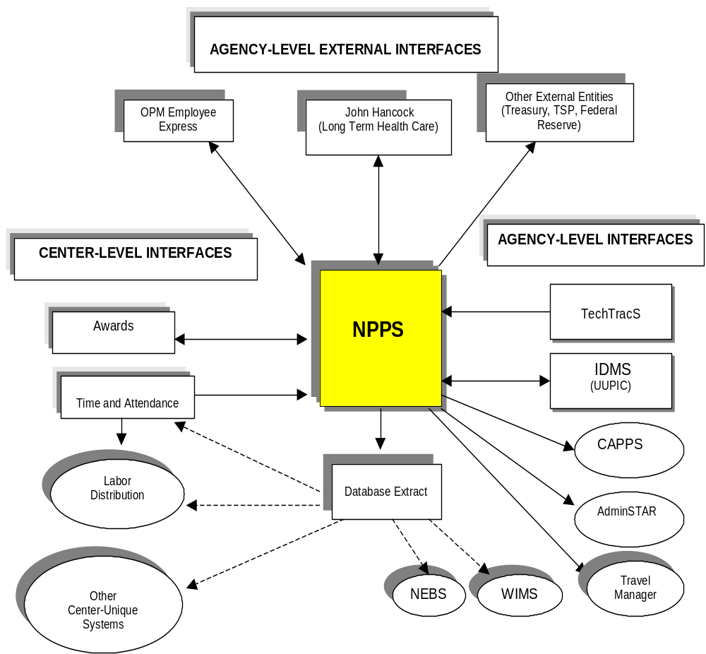

5.4.1 Center-level Interfaces
After Payroll is processed, NPPS data downloads are provided to each Center in support of their installation-specific business process requirements. Personnel data is provided to numerous Center-level personnel interfaces. The Centers also use the data in their Labor or Accounting systems and other Center unique systems. The WebTADS T&A system receives a standardized download of data elements (employee attributes) from NPPS four times each pay period. A complete description of these data elements is found in the NPPS Agency Interface Definition Agreement for WebTADS.
In addition to downloads, there are two Center-level systems that provide data (uploads) to NPPS. They are the Center T&A systems for biweekly T&A data and the Center award systems for employee awards. All the data provided to NPPS via the interfaces is loaded by the use of interface files and a batch processes. There are no direct updates to NPPS through the interfaces.

5.4.2 Agency-level Internal Interfaces
Several Agency-wide systems use employee data that is downloaded from NPPS. NPPS also receives data from two of these systems, the Identity Management System (IDMS) and the Technology Transfer System (TechTracS). The data elements are documented in the NPPS Interface Definition Agreement documents. Figure 6 describes NASA’s Agency-level internal interfaces.

Figure 6: Agency-level Internal Interfaces

SYSTEM | DESCRIPTION
Travel Manager | A unilateral interface to the Travel Manager System for employee verification and employee financial institution name and account number.
AdminStar Training System | A unilateral interface to AdminStar for employee verification data.
Identity Management System | This interface will be implemented in Spring 2003. It will be a bilateral interface. The purpose is to pass employee verification data to IDMS and pass the Uniform Universal Person Identification Code (UUPIC) to NPPS. DOI will need to establish the UUPIC data element in FPPS.
Technology Transfer System | This interface supports the Inventions and Contributions Board (ICB) awards that are given to current and former NASA employees through the Technology Transfer Office. The system up-loads award actions to NPPS personnel suspense.
CAPPS | Consolidated Agency Personnel/Payroll System
NEBS | NASA Employee Benefits Statement
WIMS | Workforce Information Management System
HEIDI (Assistant Pro) | The software used to manage NASA’s drug and alcohol testing program.

5.4.3 Agency-level External Interfaces
External interfaces are data files that are transmitted to entities outside of NASA. The interfaces shown below are one-way (from NASA to outside entities) with the exception of Employee Express and John Hancock Long Term Health Care - where there is a two-way data exchange from and to these two entities. The unilateral and bilateral exchange of data with external entities is the same for DOI’s FPPS. Figure 7 describes the Agency-level external interfaces.

Figure 7: Agency-level External Interfaces

INTERFACES | DESCRIPTION | NASA (NPPS) | DOI (FPPS)
Department of Treasury (EFT) | Electronic funds transfer (EFT) disbursements | X | X
Department of Treasury  (Non-EFT) | Hard copy check disbursements | X | X
National Finance Center | Thrift Savings Plan (TSP) contributions and loans | X | X
OPM (Retirement/Insurance) | Retirement and insurance disbursement | X | X
CPDF | Central Personnel Data File (managed by OPM) | X | X
OPM (Employee Express) | Employee self-servicing system | X | X
OPM Electronic Health Benefits | Automated group health changes |  | X
Unemployment Compensation | Unemployment Taxes | N/A | X
Equal Employment Opportunity Report System |  | X | X
John Hancock Insurance Co. (Long Term Health Care) | Employee long term health care deductions | X | X
CLER Health Benefit Enrollment Reconciliation | Employee health insurance reconciliation | X | X
TALX and Co.– Employee Verification | Employee verification – effective 02/2003 for NASA | X | X
Federal Reserve (Bonds) | Savings bond file | X | X
Directory of New Hires and Quarterly Wage Data (SSA) | Social Security Administration (SSA) file for child support enforcement | X | X
Directory of New Hires and Quarterly Wage Data | State of California | X | X
SSA/IRS | W-2 file | X | X
NASA Employee’s Benefits Association (NEBA) | NASA –unique employee insurance deductions (Great West/ Anthem Insurance) | X

5.5 Reports
Payroll and HR report requirements will be completed during Workshop 4 of e-Payroll formulation. The CPO and IPO technical team will coordinate the effort to collect the information necessary to conduct this assessment.

As part of the Formulation phase requirements definition process, DOI FPPS reporting capabilities will be evaluated by the sub-process teams against current and desired NPPS/CAPPS reports. This will include analysis of real-time reports against the FPPS transactional system as well as the FPPS Datamart. An assessment of how the DOI/FPPS reporting capabilities will influence the IFMP Information Delivery Strategy will be completed so that overall Project scope can be defined in total.

5.6 Data Conversion Standards and Methodology
The migration of NASA’s payroll data to DOI’s FPPS software will require standard policies and strategies for converting data from NPPS. These standards will be used to develop overall requirements and technical approaches to data conversion.

To maximize the efficiency of the e-Payroll implementation, NASA's policy will be to convert the minimum level of data required to:

- Comply with Federal and/or NASA regulations governing data retention
- Support NASA’s requirements, particularly concerning the handling and retention of payroll and human resource data
- Facilitate eventual decommission of NPPS

Preliminary assumptions from the e-Payroll study address the conversion of all NPPS historical data to the DOI’s FPPS Datamart. ‘Correction’ capability to converted historical data has been defined as a regulatory requirement for HR operations.

Historical data conversion requirements will be fully evaluated during the formulation phase. Data conversion activities will be a joint effort between the CPO, IPO, and DOI for defining Center unique applications requirements, technical architecture, and reporting requirements.

It is crucial for Centers to clean up, reconcile, and close out data, wherever possible, prior to the conversion of data from NPPS to FPPS.

5.7 Telecommunications
During the formulation phase, DOI’s NBC and NASA will coordinate to identify telecommunication requirements and assess the approach for network connectivity and file transfer capabilities. The IPO, MFSC’s Office of the Chief Information Officer, and the Sustaining Engineering Support for Agencywide Administrative Systems (SESAAS) will work jointly with DOI to determine a telecommunications strategy that meets NASA’s requirements for accessing both the NBC data Center and Disaster Recovery Hot Site.

6.0 Project Formulation activities

6.1 Establish Module Project
The payroll initiative was originally slated to be a segment of the Integrated Human Capital Management (IHCM) module of NASA’s IFM Program. Driven by the President’s Management Agenda for the e-Payroll initiative, the payroll segment of the IHCM module was separated and is now the e-Payroll module. The scope of this module has been assessed and is an approved IFMP module.

6.2 Define Project Scope
The primary purpose of the e-Payroll Project Formulation phase is to conduct a review of the Payroll HR processes and to identify processes that can be standardized within the e-Payroll effort where impact to process reengineering is minimal and there is no impact to the planned implementation schedule for e-Payroll migration. The process reviews will be accomplished by conducting a series of workshops and teleconferences, mostly with the DOI for NASA requirement analysis.
The scope of the e-Payroll Project will be limited to:
- Migration of NASA’s Payroll service delivery to DOI
- Migration of HR transactional processing from NPPS to FPPS
- Incorporating additional functionality of SF 50/52 automated workflow
- Status Quo T&A processing
- Potentially additional HR standardization as proposed by Process Review/Migration Teams and approved by e-Payroll Executive Steering Committee where the impact to business process reengineering is minimal and there is no impact to the planned e-Payroll implementation schedule
- Establishing report capabilities and interfaces to remaining legacy systems
During formulation, a decision will be made concerning the advisability of utilizing a standard Labor Distribution system, or developing interfaces with the existing unique Center systems.

6.3 Project Resources

6.3.1 Migration Team (Civil Servant Personnel)
The NASA Migration Team, composed predominately of Agency-level civil servant and contractor personnel, will work directly with DOI to migrate NASA’s payroll operations. A detailed listing of migration team members is shown in Appendix C-1. The level of commitment for civil servants on the Migration Team is shown in Figure 8.

Figure 8: Migration Team Civil Servant Commitment

Migration Team Civil Servant  Skill Mix | # of Team Members | Commitment | Duration | Hours per Team Member | Total Hours
Project Manager | 1 | 100% | LoP | 2080 | 2080
PR Sub-Process Team Lead | 1 | 50% | LoP | 1040 | 1040
HR Sub-Process Team Lead | 1 | 50% | LoP | 1040 | 1040
PR Specialists | 1 | 50% | LoP | 1040 | 1040
PR Specialists | 2 | 100% | 9 Months | 1560 | 3120
HR Specialists | 1 | 50% | LoP | 1040 | 1040
HR Specialists | 2 | 100% | 9 Months | 1560 | 3120
Accountant/Finance Specialist | 1 | 100% | 4 Months | 693 | 693
Applications and Data Expert | 1 | 100% | 6 Months | 1040 | 1040
Business Process Specialists | 2 | 50% | 6 Months | 520 | 1040
IT/Telecommunications | 2 | 100% | 6 Months | 1040 | 2080
The Life of Project (LoP) is March 2003 – September 2004.

6.3.2 Migration Team (Contractor Personnel)
Contractor support for the Migration Team will consist of personnel form Booz Allen Hamilton (BAH), Distributive Information Systems (DIS), and Computer Sciences Corporation (CSC). The level of commitment for contractor support is shown in Figure 9.

Figure 9: Migration Team Contractor Level of Commitment

Migration Team Contractor Skill Mix | # of Team Memberss | Commitment | Duration | Hours per Team Member | Total Hours
Training Coordinator | 1 | 100% | 4 Months | 693 | 693
Change Management Lead | 1 | 100% | 6 Months | 1040 | 1040
Process Review Support | 2 | 50% | 6 Months | 520 | 1040
Applications and Data Expert | 1 | 100% | 6 Months | 1040 | 1040
Administrative Support | 1 | 50% | LoP | 1040 | 1040
IPO Technical Support | 2 | 100% | LoP | 2080 | 4160
IPO Technical Support | 1 | 50% | Lop | 1040 | 1040
The Life of Project (LoP) is March2003 – September 2004.

6.3.3 HR and Payroll Sub-Process Teams
The HR and Payroll Sub-Process Teams will consist of a functional and technical resource from each Center. These team members will be the primary support for HR and Payroll Process Reviews during the formulation phase of e-Payroll (March – August 2003) and will serve as Center-level points-of-contact for the life of the project. The teams will be tasked to evaluate and document current Payroll and HR processes. Results of the process reviews will validate existing processes and provide functional requirements for the NPPS to FPPS implementation. The HR and Payroll Sub-Process Teams will work directly with the HR and Payroll Team Leads identified in Figure 8 above. A detailed listing of sub-process team members is shown in Appendices C-2 and C-3. Figures 10 and 11 illustrate the level of commitment for these teams.
Figure 10: HR Sub-Process Team Level of Commitment

Formulation HR Sub-Process Team | # Per Center | Commitment | Duration | Hours Per Team Member | Total Hours
Functional | 1 | 25% | 6 Months | 260 | 260
Technical | 1 | 25% | 6 Months | 260 | 260

Figure 11: Payroll Sub-Process Team Level of Commitment

Formulation HR Sub-Process Team | # Per Center | Commitment | Duration | Hours Per Team Member | Total Hours
Functional | 1 | 25% | 6 Months | 260 | 260
Technical | 1 | 25% | 6 Months | 260 | 260

Integration Project Office
The Integration Project Office is responsible for establishing a viable technical infrastructure and ensuring the coordination of the various functional module implementations. Specific responsibilities include those identified in Section 2.2.4 of this document.

6.4 Management Steering Committee
The HR Steering Committee serves as the principal forum for ensuring that the Project’s functional drivers are achieved. The Project Steering Committee will review functional and implementation issues and recommend actions to the Project Manager for resolving those issues.

Requirements Definition
The primary purpose of e-Payroll Formulation is to conduct a requirements analysis of the Payroll and HR processes and identify processes that can possibly be standardized within the e-Payroll effort.

The steps for defining NASA’s Payroll and HR requirements are outlined below:
- Conduct process reviews
- Identify potential requirement gaps
- Develop potential business process changes or workarounds
- Review potential gap resolutions with e-Payroll Sub-Process Teams
- Present preliminary gaps to e-Payroll Steering Committee
- Prepare scenarios for recommended resolutions and DOI demos
- Obtain process owner review/approval of resolutions
- Issue requirements package to DOI
- Obtain DOI response and determine final resolution

6.6 Functional Business Drivers
The overarching goal of the Integrated Financial Management Program is to improve the financial, physical, and human resources management processes throughout the Agency. IFMP will reengineer NASA's business infrastructure in the context of industry "best practices" and implement enabling technology to provide necessary management information to support the Agency's strategic plan implementation.

IFMP is aligned with the Manage Strategically crosscutting process defined in the NASA Strategic Plan to provide critical information management capabilities to internal customers and communication among both internal and external customers. As such, IFMP supports NASA values and elements common among of the five strategic Enterprises. To accomplish its goal and support the crosscutting activity, IFMP has identified the following objectives that are characterized as Agency Business Drivers:

- Provide timely, consistent, and reliable information for management decisions – Implement standard systems and processes, data integration, and a single point of data entry which will eliminate reconciliation and provide every management level with consistent data for financial and program decision making. IFMP will also provide analysis and reporting tools to get the right information to the right people at the right level so that they can make timely, informed decisions.

- Improve NASA's accountability and enable full cost management - Implement full cost accounting resulting in increased accountability by providing the means to understand cost drivers, determine total program costs, and relate costs to value. This will allow the Agency to manage programs using full cost management techniques and enhance the ability to manage institutional capabilities.

- Achieve efficiencies and operate effectively – NASA must evaluate and improve the efficiency and effectiveness of business processes to appropriately support mission program requirements. Budgets and staffing levels have already been reduced in many administrative areas. New tools are required to ensure that processes operate effectively (the results are what the process intended and they facilitate accomplishing NASA values such as enhancing safety), are conducted efficiently (reduce resources to implement the processes), and result in overall savings to the Agency (the products managed or acquired by the process are better or cost less).
- Exchange information with customers and stakeholders – Implement the infrastructure and tools that will provide information internally and externally to increase Agency-level accountability, achieve integrity of data and information, and communicate cost effectiveness of NASA's actions.

- Attract and retain a world-class workforce - Continue to attract and retain highly qualified individuals to support the goals and objectives of the strategic Enterprises and the infrastructure of the Agency. To accomplish this, IFMP will:
- Provide tools to enable NASA to compete with commercial markets for a highly motivated workforce representing a broad range of skill levels.
- Provide tools to our employees that minimize frustration and maximize their ability to perform value-added functions
- Enhance the ability of employees to work in teams across organizations and functions

The assessment completed during the formulation phase will provide the necessary information to measure the functional business driver success criteria.

6.7 Framework Agreements
The following framework agreements will be developed during the e-Payroll Formulation Phase.

6.7.1 Business Case Analysis
In response to the OPM e-Payroll Consolidation initiative, NASA engaged a working group to study options for migrating its payroll service delivery to the Department of Interior, one of the four Federal payroll service providers selected by OPM under competitive sourcing. The working group consisted of representatives from the Payroll and Human Resources (HR) community (Consolidated Payroll Office, Headquarters Policy Office, Information Technology (IT) Managers, HR and Payroll Managers, Training, Employee Self-Service).
Information supporting the e-Payroll Study was collected using several methods including the following:
- A review of NASA’s Integrated Human Capital Business Case (October 25, 2002)
- A workshop conducted with Payroll, HR, Policy experts, and IT representatives
- A review of NASA and DOI payroll service offerings
- A review of NASA and DOI Agency-level external interfaces
- A review of NASA Agency-level internal interfaces
- A review of NASA’s Center-level legacy systems
- Formal workshop discussions with representatives from the Department of Interior, and its component, National Business Center (NBC)
The working group studied three feasible alternatives for transitioning NASA’s payroll service to the Department of Interior based on the following options:
- Implement just DOI Payroll functionality
- Implement full DOI Payroll and HR functionality
- Implement a hybrid of DOI Payroll and HR functions that optimize NASA’s ability to shut down legacy systems

The e-Payroll Study was completed March 21, 2003. Based on the evaluation of the information mentioned above, the study team recommended the migration of NASA’s payroll service delivery, HR transactional processing, and use of the automated workflow for SF 50/52 functionality in the FPPS. The OPM schedule for completion of Agencies’ payroll migration is September 2004.

6.7.2 Project Plan
The purpose of this plan is to establish an overarching structure for managing the e-Payroll Project, including general requirements and performance goals, organization and management structure; participants and their roles and responsibilities; resources, schedules, and controls, risk management; quality management; implementation approach, and customer definition and advocacy. The e-Payroll Project Plan will cover the period of formal implementation activities, September 2003 – 2004. The Plan will be developed using the guideline established within the NASA NPG 7120.5A

6.7.3 Integration Project Agreement
This document serves as a contract between the e-Payroll Project and the Integration Project Office. This agreement details the scope of the Integration Project’s responsibilities for supporting the e-Payroll Project, as well as the Module Project’s responsibilities for communicating and working with the Integration Project. Once these activities are established and approved, this document will represent the final and conclusive list of Project and Integration Team responsibilities.

6.7.4 Risk Management
This document is the Risk Management Plan for the e-Payroll project. The purpose of the Risk Management Plan is to establish the strategy for managing risks for the e-Payroll Project. Roles and responsibilities for each level of Project risk management as well as standard processes and techniques for identifying, analyzing, planning, tracking, and controlling risks are documented. This plan also addresses the top risks currently identified by the e-Payroll project. Risk mitigation strategies and steps have been developed, and emerging NASA risk management techniques have been addressed where applicable. The Risk Management Plan will be developed within the overall guidelines of the IFM Program Risk Management Framework and NPG 7120.5.

6.7.5 Issue Management
Effective issue management is a critical component of successful system implementation projects. A clear issue resolution process is required. The issue management process will be documented and an issue management tracking system implemented during the e-Payroll Project Formulation phase.
On a macro level, project team members will have the responsibility to identify issues within the e-Payroll implementation. Issues will be categorized, assigned, a suspense date assigned and entered into the issue management tracking system. Weekly issue management meetings will be conducted to review and status individual issues.

6.7.6 Change Management
The objective of the Change Management function is to coordinate e-Payroll management, training, and communication issues. The Change Management team will be tasked to share project information across all NASA centers and execute actions to minimize organizational barriers to change.

6.7.7 Communication
Project communication management includes all the processes required to ensure timely and appropriate generation, collection, dissemination, storage, and ultimate disposition of project information. It provides the critical link among all customers, stakeholders, ideas, and information necessary for the project's success.

Effective communication is critical to the success of the e-Payroll Project, it is vital to building awareness, understanding, buy-in and commitment for this change initiative. Communication increases acceptance of change and enhances uptake of the outcome. To successfully manage change, those impacted by what is changing must understand the vision driving NASA, the purpose for the IFM Program and the personal and organizational benefits that will accrue from implementing the e-Payroll Project.

Managing change initiatives effectively requires communication throughout the entire change process. It means providing the right information to the right people at the right times through the right channels to achieve specific goals. The e-Payroll Project Communication Strategy helps to manage expectations and provides consistent messages among project team members, NASA employees and other impacted stakeholders of the Project.

To facilitate implementation of e-Payroll, communication should address the following:
- Awareness of the e-Payroll Project
- e-Payroll Project stakeholder expectations
- Motivational information, which includes the benefits of the e-Payroll Project
- Information about how change will impact individual employees and/or departments
- Content which provides knowledge to Agency, Project and Receiving Center employees, as well as other key stakeholders, about specific e-Payroll Project topics.
- e-Payroll Project updates, which include: status; progress; upcoming meetings or events; and other overall e-Payroll Project-related information

6.8 Implementation
After formulation and at the start of formal implementation, NASA and DOI will work together to perform the following implementation tasks:

- System Analysis
- Technical Requirements Definition
- Functional Requirements Validation
- System Modification and Testing
- Conversion Design, Programming, and Testing
- Change Communication
- Training
- Client Orientation
- Parallel Processing
- Accomplishing Operational Readiness
- Implementation
- Transfer of Records

6.9 Project Commitment Agreement (PCA)
The Project Commitment Agreement is a document at the program level that provides details on the following:
- Program Objectives
- Program Overview
- Program Authority
- Technical Performance Commitments
- Cost and Schedule Commitments
- Acquisition Strategy
- High Risk Areas

The e-Payroll project module will provide an addendum to the program PCA addressing the key areas mentioned above, excluding the acquisition strategy.

7.0 e-PAYROLL PROJECT REVIEWS

Various reviews will be conducted over the life of the Project as follows.

7.1 Management Reviews
Management reviews will be scheduled periodically. The type and frequency of the reviews will be established according to the project needs and requirements. Reviews will be scheduled to keep Agency, Center, program and project management informed of the current status of existing or potential problem areas. Special reviews by any level of management will be scheduled when the need arises.

Management reviews will include:

- Project Monthly Status Reviews to the Program

- e-Payroll Steering Committee Reviews (as often as necessary but at least once a month)

- Systems Management Office (SMO) Review

- Independent Assessment at major project milestones

- Systems Compliance Reviews

- Requirements Reviews

7.1.1 Initial Project Review
As requested by the Independent Program Assessment Office (IPAO) and the IFM Program Office, MSFC’s System Management Office (SMO) will conduct a review of the Project. The SMO will make a recommendation to both the MSFC PMC and IFM Program Office regarding the readiness of the Project to proceed with the implementation phase. An additional review may be required during the implementation phase.

7.1.2 Independent Assessments
The IFMP Program will employ professional independent assessment services at various milestones throughout the life of the e-Payroll Project. The objectives of this approach include the ability to identify issues early in the process and the ability to reduce risks, costs, and schedule slippage.
Independent assessment responsibilities are divided between the NASA Fairmont Independent Verification and Validation (IV&V) facility and an Independent Assessment Contractor. The IV&V will focus on the assessment of the establishment, management, and volatility of requirements.

7.2 Technical Reviews
Various technical reviews will be conducted as required. The purpose of these reviews is to ensure that the Project is achieving the desired technical performance on schedule and within budget. The timing of these reviews will be based on the Project lifecycle. In programs of this nature, detailed lifecycle phases are driven based upon the specific implementation methodology defined by the software package(s) and implementation partner(s) being utilized. As this methodology becomes known, specific technical reviews will be defined and scheduled for the Project. At a minimum, the following reviews will be conducted: Requirements Review, Test Readiness Review, and Operational Readiness Reviews.

APPENDIX A: List of Acronyms

List of Acronyms
ADP | Automated Data Processing
BAH | Booz Allen Hamilton
CAPPS | Consolidated Agency Personnel Payroll System
CFO | Chief Financial Officer
CSC | Computer Sciences Corporation
DIS | Distributive Information Systems
DOI | Department of Interior
EE | Employee Express
HCM | Human Capital Management
HQ | Headquarters
IDMS | Identity Management System
IFMP | Integrated Financial Management Program
IHCM | Integrated Human Capital Management
IPO | Integration Project Office
IT | Information Technology
ITPOC | Information Technology Point of Contact
MPIS | MSFC Personnel Information System
MSFC | Marshall Space Flight Center
NASA | National Aeronautics and Space Administration
NBC | National Business Center
NEBS | NASA Employee Benefits Statement
NPPS | NASA Personnel and Payroll System
NSSC | NASA Shared Services Center
OMB | Office of Budget and Management
OPM | Office of Personnel Management
PAS | Personnel Awards System
PATS | Personnel Action Tracking System
PMA | President’s Management Agenda
SESAAS | Sustaining Engineering Support for Agencywide Administrative Systems
SLA | Service Level Agreement
STARS | Space Transportation Accounting and Resource System
T&A | Time and Attendance
TIDBITS | TID Personnel Tracking System
TSP | Thrift Savings Plan
WebTADS | Web-Based Time and Attendance Distribution System

APPENDIX B: e-payroll project Formulation process
Program Role
Module/Project Role
Process Team Role
Functional Owner Role
Integration Project Role
Agency 7120 Process
Update
Project Plan
Project Plan Approval
Establish Module Project

Develop Integration Project Agreement
Establish Config. Control for Requirements and Process

Project Steering Committee Approval
Validate Process Flow and Requirements Match via IV&V
Issue Draft Addenda to PCA
First IAR or SMO Independent Review

PMC Approval
Sign PCA Addenda (Acceptance of Schedule/Cost)

Issue Authority to Proceed
Begin Implementation
Update Budget and Schedule
Create Detailed Integration Requirements
Create Detailed
Technical

Requirements
Develop Framework Agreements

Develop Preliminary Project Plan
A
Integration Project Steering Committee
Approves Technical Requirements
Update Process Flows

Approval of Plans
Develop Concept of Operations Plan
Update BCA
Create Detailed Functional Requirements
Define Success Levels for Functional Driver Metrics

Define Minimum Acceptable Level of Performance

APPENDIX C: project resource listS

C-1 e-Payroll Migration Team
Name | Title | Center | Phone | Email
Ona Elliott | Project Manager | MSFC | (256) 544-7342 | ona.b.elliott@nasa.gov
Pat Simpkins | HR Sub-Process Team Lead | HQ | (202) 358-4320 | patrick.simpkins@nasa.gov
Mike Clemons | Payroll Sub-Process Team Lead | MSFC | (256) 544-7345 | michael.c.clemons@nasa.gov
Karen Johnson | Business Process Specialist | MSFC | (256) 544-7300 | karen.c.johnson@nasa.gov
Lou Nosenzo | Business Process Specialist | MSFC | (256) 544-7401 | lou.nosenzo@nasa.gov
Rosemary Gregory | Project Support | HQ | (256) 358-1339 | Rosemary.Gregory@nasa.gov
Ron Bowman | Project Support | HQ | (202) 358-2490 | rbowman@nasa.gov
Terrie Robinson | Project Support | HQ | (202) 358-1203 | Terri.robinson@nasa.gov
Bill Vaughn | Project Support | MSFC | (256) 544-7273 | bill.vaughn@nasa.gov
Julia Lee | Payroll Specialist | MSFC | (256) 544-1491 | julia.a.lee@nasa.gov
Debbie Gonzalez | Payroll Specialist | MSFC | (256) 544-5525 | deborah.c.gonzalez@nasa.gov
Tarrie Hood | Payroll Specialist | MSFC | (256) 544-1475 | tarrie.a.hood@nasa.gov
Carolyn Plank | HR Specialist | MSFC | (256) 544-6200 | carolyn.c.plank@nasa.gov
Dianne Stokes | HR Specialist | JSC | (281) 483-9971 | Dianne.w.stokes@nasa.gov
Lou Nosenzo | HR Specialist | MSFC | (256) 544-7401 | lou.nosenzo@nasa.gov
Shashi Varshney | Accountant/Finance Specialist | MSFC | (256) 544-1542 | shashi.p.varshney@nasa.gov
Karen Johnson | Application and Data Expert | MSFC | (256) 544-7300 | karen.c.johnson@nasa.gov
Sheila Fogle | IT/Telecommunications | MSFC | (256) 544-5638 | sheila.fogle@nasa.gov
Marisa Wofford | IT/Telecommunications | MSFC | (256) 544-7482 | marisa.s.wofford@nasa.gov
Teresa Wenger | Application and Data Expert | MSFC (DIS) | (256) 544-3794 | teresa.wenger@msfc.nasa.gov
Datta/St.Michele/Johnson | HR Process Review  Training Coordinator | HQ/BAH | (703) 902-5554
Patrick Jordan | Payroll Process Review  Change Management  Administrative Support | MSFC/BAH | (256) 544-2916 | Patrick.Jordan@msfc.nasa.gov
Neil Rodgers | IPO Technical Support | MSFC | (256) 544-5628 | Neil.Rodgers@nasa.gov
Anita Webster | IPO Technical Support | MSFC | (256) 544-1469 | Anita.G.Webster@nasa.gov
TBD | IPO Technical Support | MSFC (CSC)
TBD | IPO Technical Support | MSFC (CSC)
TBD | IPO Technical Support | MSFC (CSC)

C-2 Payroll Sub-Process Team
Name | Title | Center | Phone | Email
Eleanor Monteleone | Functional | ARC | 650-604-5293 | eleanor.monteleone-1@nasa.gov
Bill Likens  Janet Jarmann | Technical  Technical | ARC ARC | 650-604-3210  650-604-5607 | william.c.likens@nasa.gov janet.h.jarmann@nasa.gov
Jim Walker | Functional | DFRC | 661-276-3605 | jim.walker@dfrc.nasa.gov
Lydia Dorfman | Functional | DFRC | 661-276-3306 | lydia.d.dorfman@nasa.gov
Linda Henninger | Functional | GRC | 216-433-2563 | linda.m.henninger@nasa.gov
John Stricker | Technical | GRC | 216-977-1256 | john.m.stricker@grc.nasa.gov
Joyce Green | Functional | GSFC | 301-286-5938 | joyce.v.green@nasa.gov
Sheila Fry | Technical | GSFC | 301-286-0555 | sheila.d.fry@nasa.gov
Bernadette Keane | Functional | HQ | 202-358-1051 | brenadette.keane@hq.nasa.gov
Pam Fetters | Technical | HQ | 202-358-0867 | pamela.k.fetters@nasa.gov
Gwen Obert | Functional | JSC | 281-483-5805 | gwendolyn.s.obert@nasa.gov
Stan Lim  Kevin Candee | Technical  Technical | JSC  JSC | 281-336-3810  281-483-5113 | slim@saicmail.jsc.nasa.gov  kevin.l.candee@nasa.gov
Sheree Gillard  Ed Gawronski  Kathy Bryant | Functional  Functional  Point of Contact | KSC  KSC  KSC | 321-867-3894  321-867-2721  321-867-2752 | sheree.g.gillard@nasa.gov  edward.m.gawronski@nasa.gov  kathy.t.bryant@nasa.gov
Ron Allen | Technical | KSC | 321-867-7325 | ronald.allen-1@ksc.nasa.gov
Avis Smith | Functional | LaRC | 757-864-2084 | avis.d.smith@nasa.gov
Gerri Edmonds | Functional | LaRC | 757-864-2084 | g.r.edmonds@larc.nasa.gov
Mary Kennedy | Functional | SSC | 228-688-1625 | mary.v.kennedy@nasa.gov
Rachel Raines | Technical | SSC | 228-688-7275 | rachel.raines@ssc.nasa.gov
Julia Lee | Functional | MSFC | 256-544-1491 | julia.a.lee@nasa.gov
Debbie Gonzalez | Functional | MSFC | 256-544-5525 | deborah.c.gonzalez@nasa.gov

C-3 HR Sub-Process Team
Name | Title | Center | Phone | Email
Janet Jarmann | Technical | ARC | 650-604-5607 | Janet.H.Jarmann@nasa.gov
Beverly Norris | Functional | ARC | 650-604-4224 | Beverly.Norris-1@nasa.gov
Susan Kalb | Functional | ARC | 650-604-5624 | Susan.A.Kalb@nasa.gov
Sandee Evans | Functional | DFRC | 661-276-2099 | Sandra.evans@dfrc.nasa.gov
Paulette Johnson | Functional | DFRC | 661-276-3312 | Paulette.Johnson@dfrc.nasa.gov
William McDonald | Technical/Functional | GRC | 216-433-2500 | William.C.Macdonald@nasa.gov
Diane Bittner | Functional | GSFC | 301-614-6938 | Diane.b.Bittner@nasa.gov
Keith Lowe | Functional | GSFC | 301-286-6623 | Keith.P.Lowe@nasa.gov
Tonyia Richardson | Functional | GSFC | 301-286-2001 | Latonyia.n.Richardson@nasa.gov
Linda Ledman | Technical | GSFC | 301-286-6111 | Linda.S.ledman@nasa.gov
Dianne Stokes | Functional/Technical | JSC | 281-483-9971 | Dianne.W.Stokes@nasa.gov
Mike Hill | Functional | KSC | 321-867-2408 | Michael.S.Hill@nasa.gov
Julie Hallum | Technical | KSC | 321-867-3382 | Julia.K.Hallum@nasa.gov
Maret Tennison | Functional/Technical | KSC | 321-867-2130 | Marietta.Tennison-1@nasa.gov
Peggy Phelps | Functional | LaRC | 757-864-9770 | Peggy.A.Phelps@nasa.gov
Lois Alliss | Technical | LaRC | 757-864-2509 | Lois.G.Aliss@nasa.gov
Anita Harrell | Functional/Technical | SSC | 228-688-7399 | Anita.F.Harrell@nasa.gov
Linda Pultz | Functional | HQ | 202-358-1568 | Linda.L.Pultz@nasa.gov
Julie Porter | Technical | HQ | 202-358-1546 | lporter@nasa.gov
Terri Robinson | Functional | Agency | 202-358-1203 | Terri.Robinson@nasa.gov
Craig Conlin | Technical | Agency | 202-358-1180 | Craig.conlin@nasa.gov
Carolyn Plank | Functional | MSFC | 256-544-6200 | Carolyn.C.Plank@nasa.gov
Lou Nosenzo | Technical | MSFC | 256-544-7401 | Louis.V.Nosenza@nasa.gov
Debbie Allen | Functional | MSFC | 256-544-7536 | Debbie.Allen@msfc.nasa.gov

C-4 e-Payroll Technical Team
Name | Title | Center | Phone | Email
Jonathan Pettus | IPO Manager/Competency Center Manager | MSFC | (256) 544-9271 | jonathan.q.pettus@nasa.gov
Neil Rodgers | IPO Deputy | MSFC | (256) 544-5628 | neil.n.rodgers@nasa.gov
Randy Sparkman | IPO Technical Architecture | MSFC | (256) 544-2997 | randy.p.sparkman@nasa.gov
Anita Webster | IPO Interface Development | MSFC | (256) 544-1496 | anita.g.webster@nasa.gov
Erin Birchmeier | IPO Reporting | MSFC | (256) 961-9799 | erin.k.birchmeier@nasa.gov
Bill Likens | ITPOC | ARC | (650) 604-3210 | william.c.likens@nasa.gov
John Irizarry | ITPOC | DFRC | (661) 276-3179 | john.h.irizarry@nasa.gov
Don Sosoka | ITPOC | GRC | (216) 433-5207 | don.sosoka@grc.nasa.gov
Dwaine Kronser | ITPOC | GSFC | (301) 286-7460 | dwaine.a.kronser@nasa.gov
Jeanette Scissum | ITPOC | HQ | (202) 358-1351 | jeanette.scissum@nasa.gov
Ted Dyson | ITPOC | JSC | (281) 483-1990 | thornton.e.dyson@nasa.gov
Bryan Bookhart | ITPOC | KSC | (321) 867-8366 | bryan.bookhart-1@nasa.gov
John Kusterer | ITPOC | LaRC | (757) 864-9372 | john.m.kusterer@nasa.gov
David Howell | ITPOC | MSFC | (256) 544-6030 | david.b.howell@nasa.gov
Rachel Raines | ITPOC | SSC | (228) 688-7275 | rachel.raines@ssc.nasa.gov

