Chapter 7: Incremental Benefits of Attaining Alternative Ozone Standards Relative to the Current 8-hour Standard (0.08 ppm)

Synopsis
Based on projected emissions and air quality modeling, in 2020, 28 counties in the U.S. with ozone monitors are anticipated to fail to meet an alternative ozone standard of 0.075 ppm for the 4th highest maximum 8-hour ozone concentration. This number falls to 11 for an ozone standard of 0.079 ppm, and increases to 89 for a standard of 0.070 ppm, and increases to 231 for an alternative standard of 0.065 ppm (see Figure 3.4 in Chapter 3). We estimated the health benefits of attaining these alternative ozone standards across the nation using the EPA Environmental Benefits Modeling and Analysis Program (BenMAP) using a two-stage analysis.
In the first stage, we estimated the benefits associated with improving modeled air quality using known control technologies. These control strategies were sufficient to bring some, but not all, areas into attainment with the alternative standards. Thus, for some areas, the benefits computed during this first stage only represented partial attainment. In the second stage, we estimated the benefits of fully attaining the standards in all areas by using a “rollback” method. This method reduced ozone concentrations at nonattaining monitors to a level that would just meet the standards. To estimate the benefits for the 0.075 ppm and 0.079 standards, we deviated from this two-stage approach. Instead, we used an interpolation technique (please see Appendix 7a for more details on this technique). Benefits for the South Coast and San Joaquin areas of California (which are not expected to reach attainment of the current standard after 2020) are estimated separately and can be found in Appendix 9b. For all alternative standards, we used health impact functions based on published epidemiological studies and valuation functions derived from the economics literature to calculate the monetary value of the adverse health outcomes potentially avoided due to these reductions in ambient ozone levels. Key health endpoints included premature mortality, hospital and emergency room visits, school absences, and minor restricted activity days.
There is considerable uncertainty in the magnitude of the association between ozone and premature mortality. This analysis presents four independent estimates of this association based upon different functions reported in the scientific literature. We also note that this range of estimates do not fully capture the uncertainties within each study. Recognizing that additional research is necessary to clarify the underlying mechanisms causing these effects, we also consider the possibility that the observed associations between ozone and mortality may not be causal in nature. Using the National Morbidity, Mortality and Air Pollution Study (NMMAPS), which was used as the primary basis for the risk analysis presented in our Staff Paper and reviewed by Clean Air Science Advisory Committee (CASAC), we estimated 250 avoided premature deaths annually in 2020 from reducing ozone levels to meet a standard of 0.070 ppm. When added to the other projected benefits from reduced ozone, including 3,000 hospital and emergency room admissions, 640,000 school absences, and over 1.7 million minor restricted activity days, we estimated a total ozone-related benefit of $2.2 billion/yr (2006$). Using three studies that synthesize data across a large number of individual studies, we estimate between 810 and 1,100 avoided premature deaths annually in 2020 from reducing ozone to 0.070 ppm, leading to total monetized ozone-related benefits of between $6.5 and $9 billion/yr. Alternatively, if there is no causal relationship between ozone and mortality, avoided premature deaths associated with reduced ozone exposure would be zero and total monetized ozone-related morbidity benefits would be $230 million/yr.
For the selected standard of 0.075 ppm, using the NMMAPS ozone mortality study resulted in 71 premature deaths avoided and total monetized benefits of $620 million/yr, incremental to attainment of the 0.08 ppm standard. Using the three synthesis studies, estimated premature deaths avoided for the less stringent standard are between 230 and 320 with total monetized ozone benefits between $1.9 and $2.6 billion/yr. Alternatively, if there is no causal relationship between ozone and mortality, avoided premature deaths associated with reduced ozone exposure would be zero and total monetized ozone-related morbidity benefits would be $73 million/yr.
For a less stringent standard of 0.079 ppm, using the NMMAPS ozone mortality study resulted in 24 premature deaths avoided and total monetized benefits of $220 million/yr, incremental to attainment of the 0.08 ppm standard. Using the three synthesis studies, estimated premature deaths avoided for the less stringent standard are between 80 and 110, with total monetized ozone benefits between $640 and $890 million/yr. Alternatively, if there is no causal relationship between ozone and mortality, avoided premature deaths associated with reduced ozone exposure would be zero and total monetized ozone-related morbidity benefits would be $28 million/yr.
For a more stringent standard of 0.065 ppm, using the NMMAPS ozone mortality study resulted in 450 premature deaths avoided and total monetized benefits of $3.9 billion/yr, incremental to attainment of the 0.08 ppm standard. Using the three synthesis studies, estimated premature deaths avoided for the more stringent standard are between 1,500 and 2,100, with total monetized ozone benefits between $12 and $16 billion/yr. Alternatively, if there is no causal relationship between ozone and mortality, avoided premature deaths associated with reduced ozone exposure would be zero and total monetized ozone-related morbidity benefits would be $420 million/yr.
These estimates reflect EPA’s interim approach to characterizing the benefits of reducing premature mortality associated with ozone exposure. EPA has requested advice from the National Academy of Sciences on how best to quantify uncertainty in the relationship between ozone exposure and premature mortality in the context of quantifying benefits associated with alternative ozone control strategies. We expect to receive this advice later this spring.
The monetary benefits of visibility improvements from PM_{2.5} reductions associated with from the 0.070 modeled attainment strategy in selected federal Class I Areas in 2020 is $160 million/yr.
In addition to the direct benefits from reducing ozone, attainment of the standards would likely result in additional health and welfare benefits because reducing the ozone precursors NOx and VOC will also reduce PM_{2.5}. Using both modeled and extrapolated reductions in these precursor emissions, we estimated PM-related co-benefits for the four alternative standards. For each alternative standard, we provide a range of estimated benefits based on several different PM mortality effect estimates. These effect estimates were derived from two different sources: the published epidemiology literature and an expert elicitation study conducted by EPA in 2006.
For the 2020 attainment of the 0.075 ppm alternative, incremental to attainment of the 0.08 ppm standard, we estimate total ozone and PM_{2.5}-related co-benefits to be between $3.6 and $16 billion/yr; this range encompasses the expert functions and the ozone mortality functions as well as the possibility that there is no causal relationship between ozone and mortality.
For the 2020 attainment of the 0.079 ppm alternative, incremental to attainment of the 0.08 ppm standard, we estimate total ozone and PM_{2.5}-related co-benefits to be between $2 and $11 billion/yr; this range encompasses the expert functions and the ozone mortality functions as well as the possibility that there is no causal relationship between ozone and mortality.
For the 2020 attainment of the 0.070 ppm alternative, incremental to attainment of the 0.08 ppm standard, we estimate total ozone and PM_{2.5}-related co-benefits to be between $6.5 and $27 billion/yr (3% and 7% discount rates, 2006$); this range encompasses the expert functions and the ozone mortality functions as well as the possibility that there is no causal relationship between ozone and mortality.
For the 2020 attainment of the 0.065 ppm alternative, incremental to attainment of the 0.08 ppm standard, we estimate total ozone and PM_{2.5}-related co-benefits of between $11 and $42 billion/yr; this range encompasses the expert functions and the ozone mortality functions as well as the possibility that there is no causal relationship between ozone and mortality.

7.1 Background
The purpose of this analysis is to assess the human health benefits of attaining the selected 8-hour ozone standard of 0.075 ppm as well as alternative standards, including 0.079 ppm, 0.070 ppm, and 0.065 ppm, incremental to attainment of the current 8-hour ozone standard of 0.08 ppm. We applied a damage function approach similar to those used in several recent U.S. EPA regulatory impact analyses, including those for the 2006 Particulate Matter (PM) NAAQS (U.S. EPA, 2006) and the Clean Air Interstate Rule (U.S. EPA, 2005). This approach estimates changes in individual health and welfare endpoints (specific effects that can be associated with changes in air quality) and assigns values to those changes assuming independence of the individual values. We calculated total benefits simply by summing the values for all non-overlapping health and welfare endpoints. This analysis largely builds on both the analytical approach used in the 2006 PM NAAQS RIA and the analysis of ozone health impacts reported in Hubbell et al. (2005) and the Clean Air Interstate Rule RIA (2005). For a more detailed discussion of the principles of benefits analysis used here, please see those documents, as well as the EPA Guidelines for Economic Analysis (2000).,,
We applied a two-stage approach to estimate the benefits of fully attaining each alternative standard. In the first stage, we estimated the benefits associated with improving modeled air quality using known and available control technologies. These control strategies were sufficient to bring some, but not all, areas into attainment with the various alternative standards. Thus, for some areas, the benefits computed during this first stage only represented partial attainment (see Chapter 3 for details on these control technologies and the results of the air quality modeling). In the second stage, we estimated the benefits of fully attaining the standards in all areas by using a “rollback” method. This method reduced ozone concentrations at residually nonattaining monitors to a level that would just meet the standards (see Appendix 7a for details on this methodology). We tested the sensitivity of our results to different assumptions, including the choice of health effect estimates from epidemiological studies and economic valuation parameters for those health effects. A quantitative assessment of non-health benefits (e.g., benefits from reduced ozone-related crop damage) was beyond the scope of this analysis due to data and resource limitations.
For this assessment, we estimated the benefits of reducing ozone and PM concentrations by applying illustrative control strategies on ozone precursor emissions to attain alternative ozone NAAQS. With the exception of ozone-related premature mortality, we used methods consistent with previous PM and ozone benefits assessments. Specifically, we used the same approach to analyze PM co-benefits as the 2006 PM NAAQS RIA (U.S. EPA, 2006). In addition, we used a nearly identical approach to analyze the ozone benefits as the 2007 Ozone RIA (U.S. EPA, 2007).
All estimates of ozone benefits and PM_{2.5} co-benefits in this chapter are incremental to a baseline of national full attainment with 0.08 ppm. This baseline incorporates emission reductions projected to be achieved through an array of federal rules such as the Clean Air Interstate and Non-Road Diesel Rules, as well as ozone and PM_{2.5} state implementation plans. Moreover, the PM_{2.5} co-benefits are incremental to an assumption of full attainment of the 2006 PM_{2.5} NAAQS. See Chapter 3 for a complete discussion of the baseline. The PM co-benefits presented in this chapter are incremental to the PM benefits estimated in the 2006 PM NAAQS RIA and reflect the PM benefits from NOx reductions associated with each ozone control strategy.
Furthermore, none of the estimates of incidence or monetary benefits provided in this chapter include South Coast and San Joaquin Valley Air Basins. Attainment dates will be determined in the future through the SIP process based on criteria in the CAA, future air quality data, and future rulemakings and are not knowable at this time. For analytical simplicity, and in keeping with the proposal analysis, we have chosen to use an analysis year of 2020 and generally assume attainment in that year. The exception is the San Joaquin and South Coast California areas where SIP submittals for the current standard show that they would have current standard attainment dates later than 2020. For these two areas in California, we are assuming a new standard attainment date of 2030. Estimates of the costs and benefits of attaining the 0.075 ppm standard and the alternate air quality standards for these two areas in 2030 not included in the primary benefit analysis and are provided in Appendix 9b.
For purposes of this analysis, we assume attainment by 2020 for all areas except San Joaquin Valley and South Coast air basins in California. The state has submitted plans to EPA for implementing the current ozone standard which propose that these two areas of California meet that standard by 2024. We have assumed for analytical purposes that the San Joaquin Valley and South Coast air basin would attain a new standard in 2030. There are many uncertainties associated with the year 2030 analysis. Between 2020 and 2030 several federal air quality rules are likely to further reduce emissions of NOx and VOC, such as, but not limited to National rules for Diesel Locomotives, Diesel Marine Vessels, and Small Nonroad Gasoline Engines. These emission reductions should lower ambient levels of ozone in California between 2020 and 2030. Complete emissions inventories as well as air quality modeling were not available for this year 2030 analysis. Due to these limitations, it is not possible to adequately model 2030 air quality changes that are required to develop robust controls strategies with associated costs and benefits. In order to provide a rough approximation of the costs and benefits of attaining 0.075 ppm and the alternate standards in San Joaquin and South Coast air basins, we have relied on the available data. Available data includes emission inventories, which do not include any changes in stationary source emissions beyond 2020, and 2020 supplemental air quality modeling. This data was used to develop extrapolated costs and benefits of 2030 attainment. These results indicate that benefits would be between $0.13 billion and $2.0 billion for the selected ozone standard of 0.075 ppm in 2030. To view the complete analysis for the San Joaquin Valley and South Coast air basins, see Appendix 9b.3
The remainder of this chapter describes the data and methods used in this analysis, along with the results. Appendix 7a of this RIA provides additional details of the analysis. Section 7.2 discusses the probabilistic framework for the benefits analysis and how key uncertainties are addressed in the analysis. Section 7.3 discusses the literature on ozone- and PM-related health effects and describes the specific set of health impact functions we used in the benefits analysis. Section 7.4 describes the economic values selected to estimate the dollar value of ozone- and PM- related health impacts. Finally, Section 7.5 presents the results and implications of the analysis.

7.2 Characterizing Uncertainty: Moving Toward a Probabilistic Framework for Benefits Assessment
The National Research Council (NRC) (2002) highlighted the need for EPA to conduct rigorous quantitative analysis of uncertainty in its benefits estimates and to present these estimates to decision makers in ways that foster an appropriate appreciation of their inherent uncertainty. In response to these comments, EPA’s Office of Air and Radiation (OAR) is developing a comprehensive strategy for characterizing the aggregate impact of uncertainty in key modeling elements on both health incidence and benefits estimates. Components of that strategy include emissions modeling, air quality modeling, health effects incidence estimation, and valuation.
Two aspects of OAR’s strategy have been used in several recent RIAs and are also employed in this analysis.,, First, we used Monte Carlo methods for estimating characterizing random sampling error associated with the concentration response functions from epidemiological studies and economic valuation functions. Monte Carlo simulation uses random sampling from distributions of parameters to characterize the effects of uncertainty on output variables, such as incidence of premature mortality. Specifically, we used Monte Carlo methods to generate confidence intervals around the estimated health impact and dollar benefits. The reported standard errors in the epidemiological studies determined the distributions for individual effect estimates. Table 7.4 describes the distributions for unit values.
Second, because characterization of random statistical error omits important sources of uncertainty (e.g., in the functional form of the model—e.g., whether or not a threshold may exist) we used a recently completed expert elicitation of the concentration response function describing the relationship between premature mortality and ambient PM_{2.5} concentration. Use of the expert elicitation and incorporation of the standard errors approaches provide insights into the likelihood of different outcomes and about the state of knowledge regarding the benefits estimates. Both approaches have different strengths and weaknesses, which are fully described in Chapter 5 of the PM NAAQS RIA.
In benefit analyses of air pollution regulations conducted to date, the estimated impact of reductions in premature mortality has accounted for 85% to 95% of total benefits. Therefore, it is particularly important to attempt to characterize the uncertainties associated with reductions in premature mortality. The health impact functions used to estimate avoided premature deaths associated with reductions in ozone have associated standard errors that represent the statistical errors around the effect estimates in the underlying epidemiological studies. In our results, we report credible intervals based on these standard errors, reflecting the uncertainty in the estimated change in incidence of avoided premature deaths. We also provide multiple estimates, to reflect model uncertainty between alternative study designs. In addition, we characterize the uncertainty introduced by the inability of existing empirical studies to discern whether the relationship between ozone and pre-mature mortality is causal by providing an effect estimate preconditioned on an assumption that the effect estimate for pre-mature mortality from ozone is zero.
For premature mortality associated with exposure to PM, we follow the same approach used in the RIA for 2006 PM NAAQS (U.S. EPA, 2006), presenting several empirical estimates of premature deaths avoided, and a set of twelve estimates based on results of the expert elicitation study. Even these multiple characterizations, including confidence intervals, omit the contribution to overall uncertainty of uncertainty in air quality changes, baseline incidence rates, populations exposed and transferability of the effect estimate to diverse locations. Furthermore, the approach presented here does not yet include methods for addressing correlation between input parameters and the identification of reasonable upper and lower bounds for input distributions characterizing uncertainty in additional model elements. As a result, the reported confidence intervals and range of estimates give an incomplete picture about the overall uncertainty in the estimates. This information should be interpreted within the context of the larger uncertainty surrounding the entire analysis.

7.3 Health Impact Functions
Health impact functions measure the change in a health endpoint of interest, such as hospital admissions, for a given change in ambient ozone or PM concentration. Health impact functions are derived from primary epidemiology studies, meta-analyses of multiple epidemiology studies, or expert elicitations. A standard health impact function has four components: 1) an effect estimate from a particular study; 2) a baseline incidence rate for the health effect (obtained from either the epidemiology study or a source of public health statistics such as the Centers for Disease Control); 3) the size of the potentially affected population; and 4) the estimated change in the relevant ozone or PM summary measures.
A typical health impact function might look like:
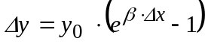
where y₀ is the baseline incidence (the product of the baseline incidence rate times the potentially affected population), β is the effect estimate, and Δx is the estimated change in the summary ozone measure. There are other functional forms, but the basic elements remain the same. Chapter 3 described the ozone and PM air quality inputs to the health impact functions. The following subsections describe the sources for each of the other elements: size of potentially affected populations; effect estimates; and baseline incidence rates.

7.3.1 Potentially Affected Populations
The starting point for estimating the size of potentially affected populations is the 2000 U.S. Census block level dataset (Geolytics 2002). Benefits Modeling and Analysis Program (BenMAP) incorporates 250 age/gender/race categories to match specific populations potentially affected by ozone and other air pollutants. The software constructs specific populations matching the populations in each epidemiological study by accessing the appropriate age-specific populations from the overall population database. BenMAP projects populations to 2020 using growth factors based on economic projections (Woods and Poole Inc. 2001).

7.3.2 Effect Estimate Sources
The most significant monetized benefits of reducing ambient concentrations of ozone and PM are attributable to reductions in human health risks. EPA’s Ozone and PM Criteria Documents outline numerous health effects known or suspected to be linked to exposure to ambient ozone and PM (US EPA, 2006; US EPA, 2005; Anderson et al., 2004). EPA recently evaluated the PM literature for use in the benefits analysis for the 2006 PM NAAQS RIA. Because we use the same literature for the PM co-benefits analysis in this RIA, we do not provide a detailed discussion of individual effect estimates for PM in this section. Instead, we refer the reader to the 2006 PM NAAQS RIA for details.
More than one thousand new ozone health and welfare studies have been published since EPA issued the 8-hour ozone standard in 1997. Many of these studies investigated the impact of ozone exposure on health effects such as changes in lung structure and biochemistry; lung inflammation; asthma exacerbation and causation; respiratory illness-related school absence; hospital and emergency room visits for asthma and other respiratory causes; and premature death.
We were not able to separately quantify all of the PM and ozone health effects that have been reported in the ozone and PM criteria documents in this analysis for four reasons: (1) the possibility of double counting (such as hospital admissions for specific respiratory diseases); (2) uncertainties in applying effect relationships that are based on clinical studies to the potentially affected population; (3) the lack of an established concentration-response relationship; or (4) the inability to appropriately value the effect (for example, changes in forced expiratory volume) in economic terms. Table 7.1 lists the human health and welfare effects of pollutants affected by the alternative standards. Table 7.2 lists the health endpoints included in this analysis.
In order to select appropriate epidemiological studies to use for our effect estimates, we applied several criteria to determine the set of studies that is likely to provide the best estimates of effects in the U.S. To account for the potential effects of different health care systems or underlying health status of populations, we gave preference to U.S. studies over non-U.S. studies. In addition, due to the potential for confounding by co-pollutants, we gave preference to effect estimates from models that included both ozone and PM over effect estimates from single-pollutant models.,
A number of endpoints that are not health-related may also contribute significant monetized benefits. Potential welfare benefits associated with ozone exposure include increased outdoor worker productivity; increased yields for commercial and non-commercial crops; increased commercial forest productivity; reduced damage to urban ornamental plants; increased recreational demand for undamaged forest aesthetics; and reduced damage to ecosystem functions (U.S. EPA 1999, 2006). Although we estimate the value of increased outdoor worker productivity, estimation of other welfare effects is beyond the scope of this analysis.

7.3.2.1 Premature Mortality Effects Estimates
While particulate matter is the criteria pollutant most clearly associated with premature mortality, recent research suggests that short-term repeated ozone exposure also likely contributes to premature death. The 2006 Ozone Criteria Document states, “Consistent with observed ozone-related increases in respiratory- and cardiovascular-related morbidity, several newer multi-city studies, single-city studies, and several meta-analyses of these studies have provided relatively strong epidemiologic evidence for associations between short-term ozone
Table 7.1: Human Health and Welfare Effects of Ozone and PM_{2.5}
Pollutant/Effect | Quantified and Monetized in Base Estimatesª | Unquantified Effects—Changes in:
PM/Health^{b} | Premature mortality based on both cohort study estimates and on expert elicitation^{c,d}  Bronchitis: chronic and acute  Hospital admissions: respiratory and cardiovascular  Emergency room visits for asthma  Nonfatal heart attacks (myocardial infarction)  Lower and upper respiratory illness  Minor restricted-activity days  Work loss days  Asthma exacerbations (asthmatic population)  Respiratory symptoms (asthmatic population)  Infant mortality | Subchronic bronchitis cases  Low birth weight  Pulmonary function  Chronic respiratory diseases other than chronic bronchitis  Non-asthma respiratory emergency room visits  UVb exposure (+/-)^{e}
PM/Welfare | Visibility in Southeastern, southwestern and California Class I areas | Visibility in northeastern and Midwestern Class I areas  Household soiling  Visibility in residential and non-Class I areas  UVb exposure (+/-)^{e}
Ozone/Health^{f} | Premature mortality: short-term exposures  Hospital admissions: respiratory  Emergency room visits for asthma  Minor restricted-activity days  School loss days  Asthma attacks  Acute respiratory symptoms | Cardiovascular emergency room visits  Chronic respiratory damage  Premature aging of the lungs  Non-asthma respiratory emergency room visits  UVb exposure (+/-)^{e}
Ozone/Welfare |  | Decreased outdoor worker productivity  Yields for commercial crops  Yields for commercial forests and noncommercial crops  Damage to urban ornamental plants  Recreational demand from damaged forest aesthetics  Ecosystem functions  UVb exposure (+/-)^{e}
a Primary quantified and monetized effects are those included when determining the primary estimate of total monetized benefits of the alternative standards.
b In addition to primary economic endpoints, there are a number of biological responses that have been associated with PM health effects including morphological changes and altered host defense mechanisms. The public health impact of these biological responses may be partly represented by our quantified endpoints.
c Cohort estimates are designed to examine the effects of long-term exposures to ambient pollution, but relative risk estimates may also incorporate some effects due to shorter term exposures (see Kunzli, 2001 for a discussion of this issue).
d While some of the effects of short-term exposure are likely to be captured by the cohort estimates, there may be additional premature mortality from short-term PM exposure not captured in the cohort estimates included in the primary analysis.
e May result in benefits or disbenefits. Appendix 7d includes a sensitivity analysis that partially quantifies this endpoint. This analysis was performed for the purposes of this RIA only.

f In addition to primary economic endpoints, there are a number of biological responses that have been associated with ozone health including increased airway responsiveness to stimuli, inflammation in the lung, acute inflammation and respiratory cell damage, and increased susceptibility to respiratory infection. The public health impact of these biological responses may be partly represented by our quantified endpoints.
^{g} The categorization of unquantified toxic health and welfare effects is not exhaustive.
Table 7.2: Ozone and PM Related Health Endpoints Basis for the Concentration-Response Function Associated with that Endpoint, and Sub-Populations for which They Were Computed
Endpoint | Pollutant | Study | Study Population
Premature Mortality
Premature mortality—daily time series, non-accidental | O3 (8-hour max)  O3 (8-hour max)  O3 (8-hour max)  O3 (8-hour max) | Bell et al (2004) (NMMAPS study)  Meta-analyses:  Bell et al (2005)  Ito et al (2005)  Levy et al (2005) | All ages
Premature mortality—cohort study, all-cause | PM_{2.5} (annual avg) | Pope et al. (2002)  Laden et al. (2006) | >29 years  >25 years
Premature mortality, total exposures | PM_{2.5} (annual avg) | Expert Elicitation (IEc, 2006)>24 years
Premature mortality—all-cause | PM_{2.5} (annual avg) | Woodruff et al. (1997) | Infant (<1 year)
Chronic Illness
Chronic bronchitis | PM_{2.5} (annual avg) | Abbey et al. (1995) | >26 years
Nonfatal heart attacks | PM_{2.5} (24-hour avg) | Peters et al. (2001) | Adults (>18 years)
Hospital Admissions
Respiratory | O3 (24-hour avg) | Pooled estimate:  Schwartz (1995)—ICD 460–519 (all resp)  Schwartz (1994a; 1994b)—ICD 480–486 (pneumonia)  Moolgavkar et al. (1997)—ICD 480–487 (pneumonia)  Schwartz (1994b)—ICD 491–492, 494–496 (COPD)  Moolgavkar et al. (1997)—ICD 490–496 (COPD) | >64 years
Respiratory | O3 (24-hour avg) | Burnett et al. (2001) | <2 years
Respiratory | PM_{2.5} (24-hour avg) | Pooled estimate:  Moolgavkar (2003)—ICD 490–496 (COPD)  Ito (2003)—ICD 490–496 (COPD) | >64 years
Respiratory | PM_{2.5} (24-hour avg) | Moolgavkar (2000)—ICD 490–496 (COPD) | 20–64 years
Respiratory | PM_{2.5} (24-hour avg) | Ito (2003)—ICD 480–486 (pneumonia) | >64 years
Respiratory | PM_{2.5} (24-hour avg) | Sheppard (2003)—ICD 493 (asthma) | <65 years
Cardiovascular | PM_{2.5} (24-hour avg) | Pooled estimate:  Moolgavkar (2003)—ICD 390–429 (all cardiovascular)  Ito (2003)—ICD 410–414, 427–428 (ischemic heart disease, dysrhythmia, heart failure) | >64 years
Cardiovascular | PM_{2.5} (24-hour avg) | Moolgavkar (2000)—ICD 390–429 (all cardiovascular) | 20–64 years
Asthma-related ER visits | O3 (8-hour max) | Pooled estimate:  Jaffe et al (2003)  Peel et al (2005)  Wilson et al (2005) | 5–34 years  All ages  All ages
Asthma-related ER visits (con’t) | PM_{2.5} (24-hour avg) | Norris et al. (1999) | 0–18 years
Other Health Endpoints
Acute bronchitis | PM_{2.5} (annual avg) | Dockery et al. (1996) | 8–12 years
Upper respiratory symptoms | PM10 (24-hour avg) | Pope et al. (1991) | Asthmatics, 9–11 years
Lower respiratory symptoms | PM_{2.5} (24-hour avg) | Schwartz and Neas (2000) | 7–14 years
Asthma exacerbations | PM_{2.5} (24-hour avg) | Pooled estimate:  Ostro et al. (2001) (cough, wheeze and shortness of breath)  Vedal et al. (1998) (cough) | 6–18 yearsª
Work loss days | PM_{2.5} (24-hour avg) | Ostro (1987) | 18–65 years
School absence days | O3 (8-hour avg)  O3 (1-hour max) | Pooled estimate:  Gilliland et al. (2001)  Chen et al. (2000) | 5–17 years^{b}
Minor Restricted Activity Days (MRADs) | O3 (24-hour avg) | Ostro and Rothschild (1989) | 18–65 years
Minor Restricted Activity Days (MRADs) | PM_{2.5} (24-hour avg) | Ostro and Rothschild (1989) | 18–65 years
ª The original study populations were 8 to 13 for the Ostro et al. (2001) study and 6 to 13 for the Vedal et al. (1998) study. Based on advice from the Science Advisory Board Health Effects Subcommittee (SAB-HES), we extended the applied population to 6 to 18, reflecting the common biological basis for the effect in children in the broader age group. See: U.S. Science Advisory Board. 2004. Advisory Plans for Health Effects Analysis in the Analytical Plan for EPA’s Second Prospective Analysis –Benefits and Costs of the Clean Air Act, 1990—2020. EPA-SAB-COUNCIL-ADV-04-004. See also National Research Council (NRC). 2002. Estimating the Public Health Benefits of Proposed Air Pollution Regulations. Washington, DC: The National Academies Press.
^{b} Gilliland et al. (2001) studied children aged 9 and 10. Chen et al. (2000) studied children 6 to 11. Based on recent advice from the National Research Council and the EPA SAB-HES, we have calculated reductions in school absences for all school-aged children based on the biological similarity between children aged 5 to 17.
exposure and all-cause mortality, even after adjustment for the influence of season and PM” (EPA, 2006: E-17). The epidemiologic data are also supported by recent experimental data from both animal and human studies, which provide evidence suggestive of plausible pathways by which risk of respiratory or cardiovascular morbidity and mortality could be increased by ambient ozone. With respect to short-term exposure, the Ozone Criteria Document concludes, “This overall body of evidence is highly suggestive that ozone directly or indirectly contributes to non-accidental and cardiopulmonary-related mortality, but additional research is needed to more fully establish underlying mechanisms by which such effects occur” (pg. E-18).
With respect to the time-series studies, the conclusion regarding the relationship between short-term exposure and premature mortality is based, in part, upon recent city-specific time-series studies such as the Schwartz (2004) analysis in Houston and the Huang et al. (2004) analysis in Los Angeles. This conclusion is also based on recent meta-analyses by Bell et al. (2005), Ito et al. (2005), and Levy et al. (2005), and a new analysis of the National Morbidity, Mortality, and Air Pollution Study (NMMAPS) data set by Bell et al. (2004), which specifically sought to disentangle the roles of ozone, PM, weather-related variables, and seasonality. The 2006 Criteria Document states that “the results from these meta-analyses, as well as several single- and multiple-city studies, indicate that co-pollutants generally do not appear to substantially confound the association between ozone and mortality” (p. 7-103). However, CASAC raised questions about the implications of these time-series results in a policy context. Specifically, CASAC emphasized that “…while the time-series study design is a powerful tool to detect very small effects that could not be detected using other designs, it is also a blunt tool” (Henderson, 2006: 3). They point to findings (e.g., Stieb et al., 2002, 2003) that indicated associations between premature mortality and all of the criteria pollutants, indicating that “findings of time-series studies do not seem to allow us to confidently attribute observed effects to individual pollutants” (id.). They note that “not only is the interpretation of these associations complicated by the fact that the day-to-day variation in concentrations of these pollutants is, to a varying degree, determined by meteorology, the pollutants are often part of a large and highly correlated mix of pollutants, only a very few of which are measured” (id.). Even with these uncertainties, the CASAC Ozone Panel, in its review of EPA’s Staff Paper, found “…premature total non-accidental and cardiorespiratory mortality for inclusion in the quantitative risk assessment to be appropriate.”
Consistent with the methodology used in the ozone risk assessment found in the Characterization of Health Risks found in the Review of the National Ambient Air Quality Standards for Ozone: Policy Assessment of Scientific and Technical Information, we included ozone mortality in the primary health effects analysis, with the recognition that the exact magnitude of the effects estimate is subject to continuing uncertainty. We used estimates from the Bell et al. (2004) NMMAPS analysis, as well as effect estimates from the three meta-analyses. In addition, we include the possibility that there is not a causal association between ozone and mortality, i.e., that the effect estimate for premature mortality could be zero. EPA expects to receive advice from the National Academy of Sciences on how best to quantify uncertainty in the relationship between ozone exposure and premature mortality in the context of quantifying benefits associated with alternative ozone control strategies later this spring.
We estimate the change in mortality incidence and estimated credible interval resulting from application of the effect estimate from each study and present them separately to reflect differences in the study designs and assumptions about causality. However, it is important to note that this procedure only captures the uncertainty in the underlying epidemiological work, and does not capture other sources of uncertainty, such as uncertainty in the estimation of changes in air pollution exposure (Levy et al., 2000).
Ozone Exposure Metric.

Both the NMMAPS analysis and the individual time series studies upon which the meta analyses were based use the 24-hour average or 1-hour maximum ozone levels as exposure metrics. The 24-hour average is not the most relevant ozone exposure metric to characterize population-level exposure. Given that the majority of the people tend to be outdoors during the daylight hours and concentrations are highest during the daylight hours, the 24-hour average metric is not appropriate. Moreover, the 1-hour maximum metric uses an exposure window different than that that used for the current ozone NAAQS. Together, this means that the most biologically relevant metric, and the one used in the ozone NAAQS since 1997 is the 8-hour maximum standard. Thus, although our analysis at proposal calculated impact functions based on either the 24 hour average or 1-hour maximum ozone levels originally reported in the epidemiogical studies, for the final rule analysis, we have converted ozone mortality health impact functions that use a 24-hour average or 1-hour maximum ozone metric to maximum 8-hour average ozone concentration using standard conversion functions.
This practice is consistent both with the available exposure modeling and with the form of the current ozone standard. This conversion also does not affect the relative magnitude of the health impact function. An equivalent change in the 24-hour average, 1-hour maximum and 8-hour maximum will provide the same overall change in incidence of a health effect. The conversion ratios are based on observed relationships between the 24-hour average and 8-hour maximum ozone values. For example, in the Bell et al., 2004 analysis of ozone-related premature mortality, the authors found that the relationship between the 24-hour average, the 8-hour maximum, and the 1-hour maximum was 2:1.5:1, so that the derived health impact effect estimate based on the 1-hour maximum should be half that of the effect estimate based on the 24-hour values (and the 8-hour maximum three-quarters of the 24-hour effect estimate).
In EPA’s risk analysis for the ozone NAAQS rule, mortality risks were estimated for 8 urban areas based on application of city-specific effect estimates derived from single city studies and from the Bell et al (2004) and Huang et al (2005) multi-city studies. These effect estimates were based on 24-hour average daily ozone concentrations. While it may have been preferable to use shorter averaging times, conversions from daily averages to shorter averaging times was not appropriate due to the lack of city-specific conversion factors. In our benefits analysis for the ozone NAAQS, we applied national effect estimates based on the pooled multi-city results reported in Bell et al (2004) and the three meta-analysis studies. Bell et al (2004), Bell et al (2005), Levy et al (2005), and Ito et al (2005) all provide national conversion ratios between daily average and 8-hour and 1-hour maxima, based on national data. However, these conversions were not specific to the ozone “warm” season which was the period used in the health risk assessment. As such we were able to convert the national C-R function parameters from daily average to 8-hour average, albeit with the introduction of additional uncertainty due to the use of effect estimates based on a mixture of warm season and all year data in the epidemiological studies. Given the heterogeneity in ratios of daily average to 8-hour and 1-hour maxima that exists between cities, it would be inappropriate to use national conversion ratios to adjust C-R functions for individual cities.

7.3.2.2 Respiratory Hospital Admissions Effect Estimates
Detailed hospital admission and discharge records provide data for an extensive body of literature examining the relationship between hospital admissions and air pollution. This is especially true for the portion of the population aged 65 and older, because of the availability of detailed Medicare records. In addition, there is one study (Burnett et al., 2001) providing an effect estimate for respiratory hospital admissions in children under two.
Because the number of hospital admission studies we considered is so large, we used results from a number of studies to pool some hospital admission endpoints. Pooling is the process by which multiple study results may be combined in order to produce better estimates of the effect estimate, or β. For a complete discussion of the pooling process, see Abt (2005). To estimate total respiratory hospital admissions associated with changes in ambient ozone concentrations for adults over 65, we first estimated the change in hospital admissions for each of the different effects categories that each study provided for each city. These cities included Minneapolis, Detroit, Tacoma and New Haven. To estimate total respiratory hospital admissions for Detroit, we added the pneumonia and COPD estimates, based on the effect estimates in the Schwartz study (1994b). Similarly, we summed the estimated hospital admissions based on the effect estimates the Moolgavkar study reported for Minneapolis (Moolgavkar et al., 1997). To estimate total respiratory hospital admissions for Minneapolis using the Schwartz study (1994a), we simply estimated pneumonia hospital admissions based on the effect estimate. Making this assumption that pneumonia admissions represent the total impact of ozone on hospital admissions in this city will give some weight to the possibility that there is no relationship between ozone and COPD, reflecting the equivocal evidence represented by the different studies. We then used a fixed-effects pooling procedure to combine the two total respiratory hospital admission estimates for Minneapolis. Finally, we used random effects pooling to combine the results for Minneapolis and Detroit with results from studies in Tacoma and New Haven from Schwartz (1995). As noted above, this pooling approach incorporates both the precision of the individual effect estimates and between-study variability characterizing differences across study locations.

7.3.2.3 Asthma-Related Emergency Room Visits Effect Estimates
We used three studies as the source of the concentration-response functions we used to estimate the effects of ozone exposure on asthma-related emergency room (ER) visits: Peel et al. (2005); Wilson et al. (2005); and Jaffe et al. (2003). We estimated the change in ER visits using the effect estimate(s) from each study and then pooled the results using the random effects pooling technique (see Abt, 2005). The study by Jaffe et al. (2003) examined the relationship between ER visits and air pollution for populations aged five to 34 in the Ohio cities of Cleveland, Columbus and Cincinnati from 1991 through 1996. In single-pollutant Poisson regression models, ozone was linked to asthma visits. We use the pooled estimate across all three cities as reported in the study. The Peel et al. study (2005) estimated asthma-related ER visits for all ages in Atlanta, using air quality data from 1993 to 2000. Using Poisson generalized estimating equations, the authors found a marginal association between the maximum daily 8-hour average ozone level and ER visits for asthma over a 3-day moving average (lags of 0, 1, and 2 days) in a single pollutant model. Wilson et al. (2005) examined the relationship between ER visits for respiratory illnesses and asthma and air pollution for all people residing in Portland, Maine from 1998–2000 and Manchester, New Hampshire from 1996–2000. For all models used in the analysis, the authors restricted the ozone data incorporated into the model to the months ozone levels are usually measured, the spring-summer months (April through September). Using the generalized additive model, Wilson et al. (2005) found a significant association between the maximum daily 8-hour average ozone level and ER visits for asthma in Portland, but found no significant association for Manchester. Similar to the approach used to generate effect estimates for hospital admissions, we used random effects pooling to combine the results across the individual study estimates for ER visits for asthma. The Peel et al. (2005) and Wilson et al. (2005) Manchester estimates were not significant at the 95 percent level, and thus, the confidence interval for the pooled incidence estimate based on these studies includes negative values. This is an artifact of the statistical power of the studies, and the negative values in the tails of the estimated effect distributions do not represent improvements in health as ozone concentrations are increased. Instead, these should be viewed as a measure of uncertainty due to limitations in the statistical power of the study. We included both hospital admissions and ER visits as separate endpoints associated with ozone exposure because our estimates of hospital admission costs do not include the costs of ER visits and most asthma ER visits do not result in a hospital admission.

7.3.2.4 Minor Restricted Activity Days Effects Estimate
Minor restricted activity days (MRADs) occur when individuals reduce most usual daily activities and replace them with less-strenuous activities or rest, but do not miss work or school. We estimated the effect of ozone exposure on MRADs using a concentration-response function derived from Ostro and Rothschild (1989). These researchers estimated the impact of ozone and PM_{2.5} on MRAD incidence in a national sample of the adult working population (ages 18 to 65) living in metropolitan areas. We developed separate coefficients for each year of the Ostro and Rothschild analysis (1976–1981), which we then combined for use in EPA’s analysis. The effect estimate used in the impact function is a weighted average of the coefficients in Ostro and Rothschild (1989, Table 4), using the inverse of the variance as the weight.

7.3.2.5 School Absences Effect Estimate
Children may be absent from school due to respiratory or other acute diseases caused, or aggravated by, exposure to air pollution. Several studies have found a significant association between ozone levels and school absence rates. We use two studies (Gilliland et al., 2001; Chen et al., 2000) to estimate changes in school absences resulting from changes in ozone levels. The Gilliland et al. study estimated the incidence of new periods of absence, while the Chen et al. study examined daily absence rates. We converted the Gilliland et al. estimate to days of absence by multiplying the absence periods by the average duration of an absence. We estimated 1.6 days as the average duration of a school absence, the result of dividing the average daily school absence rate from Chen et al. (2000) and Ransom and Pope (1992) by the episodic absence duration from Gilliland et al. (2001). Thus, each Gilliland et al. period of absence is converted into 1.6 absence days.
Following recent advice from the National Research Council (2002), we calculated reductions in school absences for the full population of school age children, ages five to 17. This is consistent with recent peer-reviewed literature on estimating the impact of ozone exposure on school absences (Hall et al. 2003). We estimated the change in school absences using both Chen et al. (2000) and Gilliland et al. (2001) and then, similar to hospital admissions and ER visits, pooled the results using the random effects pooling procedure.

7.3.2.6 Outdoor Worker Productivity
To monetize benefits associated with increased worker productivity resulting from improved ozone air quality, we used information reported in Crocker and Horst (1981). Crocker and Horst examined the impacts of ozone exposure on the productivity of outdoor citrus workers. The study measured productivity impacts. Worker productivity is measuring the value of the loss in productivity for a worker who is at work on a particular day, but due to ozone, cannot work as hard. It only applies to outdoor workers, like fruit and vegetable pickers, or construction workers. Here, productivity impacts are measured as the change in income associated with a change in ozone exposure, given as the elasticity of income with respect to ozone concentration. The reported elasticity translates a ten percent reduction in ozone to a 1.4 percent increase in income. Given the national median daily income for outdoor workers engaged in strenuous activity reported by the U.S. Census Bureau (2002), $68 per day (2000$), a ten percent reduction in ozone yields about $0.97 in increased daily wages. We adjust the national median daily income estimate to reflect regional variations in income using a factor based on the ratio of county median household income to national median household income. No information was available for quantifying the uncertainty associated with the central valuation estimate. Therefore, no uncertainty analysis was conducted for this endpoint.

7.3.2.7 Visibility Benefits
Changes in the level of ambient PM_{2.5} caused by the reduction in emissions associated with the alternative standards will change the level of visibility throughout the United States. Increases in PM concentrations cause increases in light extinction, a measure of how much the components of the atmosphere absorb light. This chapter contains an estimate of the monetized benefits of improved visibility associated with the simulated emission control strategy to attain the 0.070 ppm ozone standard. The methodology we followed to estimate changes in visibility benefits is consistent with the PM_{2.5} RIA (EPA, 2006), which is described on page 5-60 of that document.

7.3.2.8 Other Unquantified Effects
Direct Ozone Effects on Vegetation. The Ozone Criteria Document notes that “current ambient concentrations in many areas of the country are sufficient to impair growth of numerous common and economically valuable plant and tree species” (U.S. EPA, 2006, page 9-1). Changes in ground-level ozone resulting from the implementation of alternative ozone standards may affect crop and forest yields throughout the affected area. Recent scientific studies have also found that at sufficient concentrations ozone negatively affects the quality or nutritive value of some sensitive crops (U.S. EPA, 2006, page 9-16).

Well-developed techniques exist to provide monetary estimates of these benefits to agricultural producers and to consumers. These techniques use models of planting decisions, yield response functions, and the supply of and demand for agricultural products. The resulting welfare measures are based on predicted changes in market prices and production costs. Models also exist to measure benefits to silvicultural producers and consumers. There is considerable uncertainty, however, in such estimates, including the fact that the extensive management of agricultural crops may mitigate the potential O3-related effects. For this reason, the estimates of economic crop loss developed using the updated AGSIM model were not relied on for this analysis of alternative O3 standards. In addition, these models have not been adapted for use in analyzing ozone-related forest impacts. Again, because there commercial activities are highly managed the potential benefits of alternative O3 standards are uncertain. Because of these uncertainties and resource limitations, we are unable to provide benefits estimates for the commercial production of agricultural and silvaculture commodities.
An additional welfare benefit of reducing ambient ozone concentrations is the economic value of reduced aesthetic injury to forests. There is sufficient scientific information available to reliably establish that ambient ozone causes visible injury to foliage and impair the growth of some sensitive plant species (U.S. EPA, 2006, page 9-19). However, present analytic tools and resources preclude us from quantifying the benefits of improved forest aesthetics.
Urban ornamentals (floriculture and nursery crops) are an additional vegetation category that may experience negative effects from exposure to ambient ozone and may affect large economic sectors. However, the absence of adequate exposure-response functions and economic damage functions for the potential range of effects relevant to these types of vegetation precludes us from quantifying these direct economic benefits. The farm production value of ornamental crops was estimated at over $14 billion in 2003 (USDA, 2004). This is therefore a potentially important welfare effects category, but information and valuation methods are not available to allow for plausible estimates of the percentage of these expenditures that may be related to impacts associated with ozone exposure.
Nitrogen Deposition. Deposition to Estuarine and Coastal Waters. Excess nutrient loads, especially of nitrogen, cause a variety of adverse consequences to the health of estuarine and coastal waters. These effects include toxic and/or noxious algal blooms such as brown and red tides, low (hypoxic) or zero (anoxic) concentrations of dissolved oxygen in bottom waters, the loss of submerged aquatic vegetation due to the light-filtering effect of thick algal mats, and fundamental shifts in phytoplankton community structure (Bricker et al., 1999). A recent study found that for the period 1990–2002, atmospheric deposition accounted for 17 percent of nitrate loadings in the Gulf of Mexico, where severe hypoxic zones have been existed over the last two decades (Booth and Campbell, 2007).
Reductions in atmospheric deposition of NOx are expected to reduce the adverse impacts associated with nitrogen deposition to estuarine and coastal waters. However, direct functions relating changes in nitrogen loadings to changes in estuarine benefits are not available. The preferred WTP-based measure of benefits depends on the availability of these functions and on estimates of the value of environmental responses. Because neither appropriate functions nor sufficient information to estimate the marginal value of changes in water quality exist at present, calculation of a WTP measure is not possible.
Deposition to Agricultural and Forested Land. Implementation strategies for alternative standards that reduce NO_{X} emissions will also reduce nitrogen deposition on agricultural land and forests. There is some evidence that nitrogen deposition may have positive effects on agricultural output through passive fertilization. Holding all other factors constant, farmers’ use of purchased fertilizers or manure may increase as deposited nitrogen is reduced. Estimates of the potential value of this possible increase in the use of purchased fertilizers are not available, but it is likely that the overall value is very small relative to other health and welfare effects. The share of nitrogen requirements provided by this deposition is small, and the marginal cost of providing this nitrogen from alternative sources is quite low. In some areas, agricultural lands suffer from nitrogen over-saturation due to an abundance of on-farm nitrogen production, primarily from animal manure. In these areas, reductions in atmospheric deposition of nitrogen from PM represent additional agricultural benefits.
Information on the effects of changes in passive nitrogen deposition on forests and other terrestrial ecosystems is very limited. The multiplicity of factors affecting forests, including other potential stressors such as ozone, and limiting factors such as moisture and other nutrients, confound assessments of marginal changes in any one stressor or nutrient in forest ecosystems. However, reductions in deposition of nitrogen could have negative effects on forest and vegetation growth in ecosystems where nitrogen is a limiting factor (US EPA, 1993). Moreover, any positive effect that nitrogen deposition has on forest productivity would enhance the level of carbon dioxide sequestration as well.,,
On the other hand, there is evidence that forest ecosystems in some areas of the United States (such as the western U.S.) are nitrogen saturated (US EPA, 1993). Once saturation is reached, adverse effects of additional nitrogen begin to occur such as soil acidification, which can lead to leaching of nutrients needed for plant growth and mobilization of harmful elements such as aluminum. Increased soil acidification is also linked to higher amounts of acidic runoff to streams and lakes and leaching of harmful elements into aquatic ecosystems.
Ultraviolet Radiation.
Atmospheric ozone absorbs a harmful band of ultraviolet radiation from the sun called UV-B, thus providing a protective shield to the Earth’s surface. The majority of this protection occurs in the stratosphere where 90% of atmospheric ozone is located. The remaining 10% of the Earth’s ozone is present at ground level (referred to as tropospheric ozone) (NAS, 1991; NASA). Only a portion of the tropospheric fraction of UV-B shielding is from anthropogenic sources (e.g., power plants, byproducts of combustion). The portion of ground level ozone associated with anthropogenic sources varies by locality and over time. Even so, it is reasonable to assume that reductions in ground level ozone would lead to increases in the same health effects linked to in UV-B exposures. These effects include fatal and nonfatal melanoma and non-melanoma skin cancers and cataracts. The values of $15,000 per case for non-fatal melanoma skin cancer, $5,000 per case for non-fatal non-melanoma skin cancer, and $15,000 per case of cataracts have been used in analyses of stratospheric ozone depletion (U.S. EPA, 1999). Fatal cancers are valued using the standard VSL estimate, which for 2020 is $6.6 million (2006$). UV-B has also been linked to ecological effects including damage to crops and forest. For a more complete listing of quantified and unquantified UV-B radiation effects, see Table G-4 and G-7 in the Benefits and Costs of the Clean Air Act, 1990–2010 (U.S. EPA, 1999). UV-B related health effects are also discussed in the context of stratospheric ozone in a 2006 report by ICF Consulting, prepared for the U.S. EPA.
There are many factors that influence UV-B radiation penetration to the earth’s surface, including latitude, altitude, cloud cover, surface albedo, PM concentration and composition, and gas phase pollution. Of these, only latitude and altitude can be defined with small uncertainty in any effort to assess the changes in UV-B flux that may be attributable to any changes in tropospheric ozone as a result of any revision to the Ozone NAAQS. Such an assessment of UV-B related health effects would also need to take into account human habits, such as outdoor activities (including age- and occupation-related exposure patterns), dress and skin care to adequately estimate UV-B exposure levels. However, little is known about the impact of these factors on individual exposure to UV-B.
Moreover, detailed information does not exist regarding other factors that are relevant to assessing changes in disease incidence, including: type (e.g., peak or cumulative) and time period (e.g., childhood, lifetime, current) of exposures related to various adverse health outcomes (e.g., damage to the skin, including skin cancer; damage to the eye, such as cataracts; and immune system suppression); wavelength dependency of biological responses; and interindividual variability in UV-B resistance to such health outcomes. Beyond these well-recognized adverse health effects associated with various wavelengths of UV radiation, the Criteria Document (Section 10.2.3.6) also discusses protective effects of UV-B radiation. Recent reports indicate the necessity of UV-B in producing vitamin D, and that vitamin D deficiency can cause metabolic bone disease among children and adults, and may also increase the risk of many common chronic diseases (e.g., type I diabetes and rheumatoid arthritis) as well as the risk of various types of cancers. Thus, the Criteria Document concludes that any assessment that attempts to quantify the consequences of increased UV-B exposure on humans due to reduced ground-level O3 must include consideration of both negative and positive effects. However, as with other impacts of UVB on human health, this beneficial effect of UVB radiation has not previously been studied in sufficient detail. EPA has conducted a screening level analysis of the effects of reduced ozone concentrations on UVB exposures. This analysis is based on the air quality modeling conducted for the proposed Ozone NAAQS RIA, and is described in Appendix 7d to the this RIA. The screening analysis has been peer-reviewed and a summary of the peer-review comments and responses are provided with the report.
Climate Implications of Tropospheric Ozone. Although climate and air quality are generally treated as separate issues, they are closely coupled through atmospheric processes. Ozone, itself, is a major greenhouse gas and climate directly influences ambient concentrations of ozone.
The concentration of tropospheric ozone has increased substantially since the pre-industrial era and has contributed to warming. Tropospheric ozone is (after carbon dioxide and methane) the third most important contributor to greenhouse gas warming. The National Academy of Sciences recently stated that regulations targeting ozone precursors would have combined benefits for public health and climate. As noted in the OAQPS Staff Paper, the overall body of scientific evidence suggests that high concentrations of ozone on a regional scale could have a discernible influence on climate. However, the Staff Paper concludes that insufficient information is available at this time to quantitatively inform the secondary NAAQS process with regard to this aspect of the ozone-climate interaction

Climate change can affect tropospheric ozone by modifying emissions of precursors, chemistry, transport and removal. Climate change affects the sources of ozone precursors through physical response (lightning), biological response (soils, vegetation, and biomass burning) and human response (energy generation, land use, and agriculture). Increases in regional ozone pollution are expected due to higher temperatures and weaker circulation. Simulations with global climate models for the 21st century indicate a decrease in the lifetime of tropospheric ozone due to increasing water vapor, which could decrease global background ozone concentrations.
The Intergovernmental Panel on Climate Change (IPCC) recently released a report that projects, with “virtual certainty,” declining air quality in cities due to warmer and fewer cold days and nights and/or warmer/more frequent hot days and nights over most land areas. The report states that projected climate change-related exposures are likely to affect the health status of millions of people, in part, due to higher concentrations of ground level ozone related to climate change.
The IPCC also reports that the current generation of tropospheric ozone models is generally successful in describing the principal features of the present-day global ozone distribution. However, there is much less confidence in the ability to reproduce the changes in ozone associated with perturbations of emissions or climate. There are major discrepancies with observed long-term trends in ozone concentrations over the 20th century, including after 1970 when the reliability of observed ozone trends is high. Resolving these discrepancies is needed to establish confidence in the models.
The EPA is currently leading a research effort with the goal of identifying changes in regional US air quality that may occur in a future (2050) climate, focusing on fine particles and ozone. The research builds first on an assessment of changes in US air quality due to climate change, which includes direct meteorological impacts on atmospheric chemistry and transport and the effect of temperature changes on air pollution emissions. Further research will result in an assessment that adds the emission impacts from technology, land use, demographic changes, and air quality regulations to construct plausible scenarios of US air quality 50 years into the future. As noted in the Staff Paper, results from these efforts are expected to be available for consideration in the next review of the ozone NAAQS.

7.3.3 Baseline Incidence Rates
Epidemiological studies of the association between pollution levels and adverse health effects generally provide a direct estimate of the relationship of air quality changes to the relative risk of a health effect, rather than estimating the absolute number of avoided cases. For example, a typical result might be that a 10 ppb decrease in daily ozone levels might, in turn, decrease hospital admissions by 3 percent. The baseline incidence of the health effect is necessary to convert this relative change into a number of cases. A baseline incidence rate is the estimate of the number of cases of the health effect per year in the assessment location, as it corresponds to baseline pollutant levels in that location. To derive the total baseline incidence per year, this rate must be multiplied by the corresponding population number. For example, if the baseline incidence rate is the number of cases per year per million people, that number must be multiplied by the millions of people in the total population.
Table 7.3 summarizes the sources of baseline incidence rates and provides average incidence rates for the endpoints included in the analysis. For both baseline incidence and prevalence data, we used age-specific rates where available. We applied concentration-response functions to individual age groups and then summed over the relevant age range to provide an estimate of total population benefits. In most cases, we used a single national incidence rate, due to a lack of more spatially disaggregated data. Whenever possible, the national rates used are national averages, because these data are most applicable to a national assessment of benefits. For some studies, however, the only available incidence information comes from the studies themselves; in these cases, incidence in the study population is assumed to represent typical incidence at the national level. Regional incidence rates are available for hospital admissions, and county-level data are available for premature mortality. We have projected mortality rates such that future mortality rates are consistent with our projections of population growth (Abt Associates, 2005).

7.4 Economic Values for Health Outcomes
Reductions in ambient concentrations of air pollution generally lower the risk of future adverse health effects for a large population. Therefore, the appropriate economic measure is willingness-to-pay (WTP) for changes in risk of a health effect rather than WTP for a health effect that would occur with certainty (Freeman, 1993). Epidemiological studies generally provide estimates of the relative risks of a particular health effect that is avoided because of a reduction in air pollution. We converted those to units of avoided statistical incidence for ease of presentation. We calculated the value of avoided statistical incidences by dividing individual WTP for a risk reduction by the related observed change in risk. For example, suppose a pollution-reduction regulation is able to reduce the risk of premature mortality from 2 in 10,000 to 1 in 10,000 (a reduction of 1 in 10,000). If individual WTP for this risk reduction is $100, then the WTP for an avoided statistical premature death is $1 million ($100/0.0001 change in risk).
Table 7.3: National Average Baseline Incidence Rates
Endpoint | Source |  |  | Notes | Rate per 100 people per year^{d} by Age Group
Endpoint |  |  |  | Notes | <18 | 18–24 |  | 25–34 | 35–44 |  | 45–54 | 55–64 | 65+
Mortality | CDC Compressed Mortality File, accessed through CDC Wonder (1996–1998) |  |  | non-accidental | 0.025 | 0.022 |  | 0.057 | 0.150 |  | 0.383 | 1.006 | 4.937
Respiratory Hospital Admissions | 1999 NHDS public use data files^{b} |  |  | incidence | 0.043 | 0.084 |  | 0.206 | 0.678 |  | 1.926 | 4.389 | 11.629
Asthma ER visits | 2000 NHAMCS public use data files^{c}; 1999 NHDS public use data files^{b} |  |  | incidence | 1.011 | 1.087 |  | 0.751 | 0.438 |  | 0.352 | 0.425 | 0.232
Minor Restricted Activity Days (MRADs) | Ostro and Rothschild (1989, p. 243) |  |  | incidence | — | 780 |  | 780 | 780 |  | 780 | 780 | —
School Loss Days | National Center for Education Statistics (1996) and 1996 HIS (Adams et al., 1999, Table 47); estimate of 180 school days per year |  |  | all-cause | 990.0 | — |  | — | — |  | — | — | —
Endpoint |  | Source | Notes |  |  |  |  |  |  | Rate per 100 People per Year
Asthma Exacerbations |  | Ostro et al. (2001) | Incidence (and prevalence) among asthmatic African-American children |  |  |  | Daily wheeze  Daily cough  Daily dyspnea |  |  | 0.076 (0.173)  0.067 (0.145)  0.037 (0.074)
 |  | Vedal et al. (1998) | Incidence (and prevalence) among asthmatic children |  |  |  | Daily wheeze  Daily cough  Daily dyspnea |  |  | 0.038  0.086  0.045
ª The following abbreviations are used to describe the national surveys conducted by the National Center for Health Statistics: HIS refers to the National Health Interview Survey; NHDS—National Hospital Discharge Survey; NHAMCS—National Hospital Ambulatory Medical Care Survey.
^{b} See ftp://ftp.cdc.gov/pub/Health_Statistics/NCHS/Datasets/NHDS/
^{c} See ftp://ftp.cdc.gov/pub/Health_Statistics/NCHS/Datasets/NHAMCS/
^{d} All of the rates reported here are population-weighted incidence rates per 100 people per year. Additional details on the incidence and prevalence rates, as well as the sources for these rates are available upon request.

WTP estimates generally are not available for some health effects, such as hospital admissions. In these cases, we used the cost of treating or mitigating the effect as a primary estimate. These cost-of-illness (COI) estimates generally understate the true value of reducing the risk of a health effect, because they reflect the direct expenditures related to treatment, but not the value of avoided pain and suffering (Harrington and Portney, 1987; Berger, 1987). We provide unit values for health endpoints (along with information on the distribution of the unit value) in Table 7.4. All values are in constant year 2006 dollars, adjusted for growth in real income out to 2020 using projections provided by Standard and Poor’s. Economic theory argues that WTP for most goods (such as environmental protection) will increase if real income increases. Many of the valuation studies used in this analysis were conducted in the late 1980s and early 1990s. Because real income has grown since the studies were conducted, people’s willingness to pay for reductions in the risk of premature death and disease likely has grown as well. We did not adjust cost of illness-based values because they are based on current costs. Similarly, we did not adjust the value of school absences, because that value is based on current wage rates. Table 7.4 presents the values for individual endpoints adjusted to year 2020 income levels. The discussion below provides additional details on ozone related endpoints. For details on valuation estimates for PM related endpoints, see the 2006 PM NAAQS RIA.

7.4.1 Mortality Valuation
To estimate the monetary benefit of reducing the risk of premature death, we used the “value of statistical lives” saved (VSL) approach, which is a summary measure for the value of small changes in mortality risk for a large number of people. The VSL approach applies information from several published value-of-life studies to determine a reasonable monetary value of preventing premature mortality. The mean value of avoiding one statistical death is estimated to be roughly $6.6 million at 1990 income levels (2006$), and $7.9 million (2006$) at 2020 income levels. This represents an intermediate value from a variety of estimates in the economics literature (see the 2006 PM NAAQS RIA for more details on the calculation of VSL).

7.4.2 Hospital Admissions Valuation
In the absence of estimates of societal WTP to avoid hospital visits/admissions for specific illnesses, estimates of total cost of illness (total medical costs plus the value of lost productivity) typically are used as conservative, or lower bound, estimates. These estimates are biased downward, because they do not include the willingness-to-pay value of avoiding pain and suffering.
The International Classification of Diseases (ICD-9, 1979) code-specific COI estimates used in this analysis consist of estimated hospital charges and the estimated opportunity cost of time spent in the hospital (based on the average length of a hospital stay for the illness). We based all estimates of hospital charges and length of stays on statistics provided by the Agency for Healthcare Research and Quality (AHRQ 2000). We estimated the opportunity cost of a day spent in the hospital as the value of the lost daily wage, regardless of whether the hospitalized individual is in the workforce. To estimate the lost daily wage, we divided the 1990 median weekly wage by five and inflated the result to year 2000$ using the CPI-U “all items.” The resulting estimate is $109.35. The total cost-of-illness estimate for an ICD code-specific hospital stay lasting n days, then, was the mean hospital charge plus $109 multiplied by n.
Table 7.4: Unit Values for Economic Valuation of Health Endpoints (2006$)
Health Endpoint | Central Estimate of Value Per Statistical Incidence
Health Endpoint | 1990 Income Level | 2020 Income Level | Derivation of Distributions of Estimates
Premature Mortality (Value of a Statistical Life) | $6,600,000 | $7,900,000 | Point estimate is the mean of a normal distribution with a 95% confidence interval between $1 and $10 million. Confidence interval is based on two meta-analyses of the wage-risk VSL literature: $1 million represents the lower end of the interquartile range from the Mrozek and Taylor (2002) meta-analysis and $10 million represents the upper end of the interquartile range from the Viscusi and Aldy (2003) meta-analysis. The mean of the distribution is consistent with the mean estimate from a third meta-analysis (Kochi et al 2006). The VSL represents the value of a small change in mortality risk aggregated over the affected population.
Chronic Bronchitis (CB) | $410,000 | $500,000 | The WTP to avoid a case of pollution-related CB is calculated as 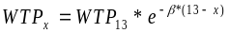, where x is the severity of an average CB case, WTP13 is the WTP for a severe case of CB, and  is the parameter relating WTP to severity, based on the regression results reported in Krupnick and Cropper (1992). The distribution of WTP for an average severity-level case of CB was generated by Monte Carlo methods, drawing from each of three distributions: (1) WTP to avoid a severe case of CB is assigned a 1/9 probability of being each of the first nine deciles of the distribution of WTP responses in Viscusi et al. (1991); (2) the severity of a pollution-related case of CB (relative to the case described in the Viscusi study) is assumed to have a triangular distribution, with the most likely value at severity level 6.5 and endpoints at 1.0 and 12.0; and (3) the constant in the elasticity of WTP with respect to severity is normally distributed with mean = 0.18 and standard deviation = 0.0669 (from Krupnick and Cropper [1992]). This process and the rationale for choosing it is described in detail in the Costs and Benefits of the Clean Air Act, 1990 to 2010 (EPA, 1999).
Nonfatal Myocardial Infarction (heart attack)  3% discount rate  Age 0–24  Age 25–44  Age 45–54  Age 55–65  Age 66 and over  7% discount rate  Age 0–24  Age 25–44  Age 45–54  Age 55–65  Age 66 and over | $79,685  $88,975  $93,897  $167,532  $79,685  $77,769  $87,126  $91,559  $157,477  $77,769 | $79,685  $88,975  $93,897  $167,532  $79,685  $77,769  $87,126  $91,559  $157,477  $77,769 | No distributional information available. Age-specific cost-of-illness values reflect lost earnings and direct medical costs over a 5-year period following a nonfatal MI. Lost earnings estimates are based on Cropper and Krupnick (1990). Direct medical costs are based on simple average of estimates from Russell et al. (1998) and Wittels et al. (1990).  Lost earnings:  Cropper and Krupnick (1990). Present discounted value of 5 years of lost earnings:  age of onset: at 3% at 7%  25–44 $8,774 $7,855  45–54 $12,932 $11,578  55–65 $74,746 $66,920  Direct medical expenses: An average of:  1. Wittels et al. (1990) ($102,658—no discounting)  2. Russell et al. (1998), 5-year period ($22,331 at 3% discount rate; $21,113 at 7% discount rate)
Hospital Admissions
Chronic Obstructive Pulmonary Disease (COPD) | $16,606 | $16,606 | No distributional information available. The COI estimates (lost earnings plus direct medical costs) are based on ICD-9 code-level information (e.g., average hospital care costs, average length of hospital stay, and weighted share of total COPD category illnesses) reported in Agency for Healthcare Research and Quality (2000) (www.ahrq.gov).
Asthma Admissions | $8,900 | $8,900 | No distributional information available. The COI estimates (lost earnings plus direct medical costs) are based on ICD-9 code-level information (e.g., average hospital care costs, average length of hospital stay, and weighted share of total asthma category illnesses) reported in Agency for Healthcare Research and Quality (2000) (www.ahrq.gov).
All Cardiovascular | $24,668 | $24,668 | No distributional information available. The COI estimates (lost earnings plus direct medical costs) are based on ICD-9 code-level information (e.g., average hospital care costs, average length of hospital stay, and weighted share of total cardiovascular category illnesses) reported in Agency for Healthcare Research and Quality (2000) (www.ahrq.gov).
All respiratory (ages 65+) | $24,622 | $24,622 | No distributions available. The COI point estimates (lost earnings plus direct medical costs) are based on ICD-9 code level information (e.g., average hospital care costs, average length of hospital stay, and weighted share of total COPD category illnesses) reported in Agency for Healthcare Research and Quality, 2000 (www.ahrq.gov).
All respiratory (ages 0–2) | $10,385 | $10,385 | No distributions available. The COI point estimates (lost earnings plus direct medical costs) are based on ICD-9 code level information (e.g., average hospital care costs, average length of hospital stay, and weighted share of total COPD category illnesses) reported in Agency for Healthcare Research and Quality, 2000 (www.ahrq.gov).
Emergency Room Visits for Asthma | $384 | $384 | No distributional information available. Simple average of two unit COI values:  (1) $311.55, from Smith et al. (1997) and  (2) $260.67, from Stanford et al. (1999).
Respiratory Ailments Not Requiring Hospitalization
Upper Respiratory Symptoms (URS) | $30 | $30 | Combinations of the three symptoms for which WTP estimates are available that closely match those listed by Pope et al. result in seven different “symptom clusters,” each describing a “type” of URS. A dollar value was derived for each type of URS, using mid-range estimates of WTP (IEc, 1994) to avoid each symptom in the cluster and assuming additivity of WTPs. In the absence of information surrounding the frequency with which each of the seven types of URS occurs within the URS symptom complex, we assumed a uniform distribution between $9.2 and $43.1.
Lower Respiratory Symptoms (LRS) | $19 | $21 | Combinations of the four symptoms for which WTP estimates are available that closely match those listed by Schwartz et al. result in 11 different “symptom clusters,” each describing a “type” of LRS. A dollar value was derived for each type of LRS, using mid-range estimates of WTP (IEc, 1994) to avoid each symptom in the cluster and assuming additivity of WTPs. The dollar value for LRS is the average of the dollar values for the 11 different types of LRS. In the absence of information surrounding the frequency with which each of the 11 types of LRS occurs within the LRS symptom complex, we assumed a uniform distribution between $6.9 and $24.46.
Asthma Exacerbations | $50 | $54 | Asthma exacerbations are valued at $45 per incidence, based on the mean of average WTP estimates for the four severity definitions of a “bad asthma day,” described in Rowe and Chestnut (1986). This study surveyed asthmatics to estimate WTP for avoidance of a “bad asthma day,” as defined by the subjects. For purposes of valuation, an asthma exacerbation is assumed to be equivalent to a day in which asthma is moderate or worse as reported in the Rowe and Chestnut (1986) study. The value is assumed have a uniform distribution between $15.6 and $70.8.
Acute Bronchitis | $429 | $453 | Assumes a 6-day episode, with the distribution of the daily value specified as uniform with the low and high values based on those recommended for related respiratory symptoms in Neumann et al. (1994). The low daily estimate of $10 is the sum of the mid-range values recommended by IEc (1994) for two symptoms believed to be associated with acute bronchitis: coughing and chest tightness. The high daily estimate was taken to be twice the value of a minor respiratory restricted-activity day, or $110.
Work Loss Days (WLDs) | Variable (U.S. median = $130) |  | No distribution available. Point estimate is based on county-specific median annual wages divided by 50 (assuming 2 weeks of vacation) and then by 5—to get median daily wage. U.S. Year 2000 Census, compiled by Geolytics, Inc.
Minor Restricted Activity Days (MRADs) | $61 | $64 | Median WTP estimate to avoid one MRAD from Tolley et al. (1986). Distribution is assumed to be triangular with a minimum of $22 and a maximum of $83, with a most likely value of $52. Range is based on assumption that value should exceed WTP for a single mild symptom (the highest estimate for a single symptom—for eye irritation—is $16.00) and be less than that for a WLD. The triangular distribution acknowledges that the actual value is likely to be closer to the point estimate than either extreme.
School Absence Days | $89 | $89 | No distribution available

7.4.3 Asthma-Related Emergency Room Visits Valuation
To value asthma emergency room visits, we used a simple average of two estimates from the health economics literature. The first estimate comes from Smith et al. (1997), who reported approximately 1.2 million asthma-related emergency room visits in 1987, at a total cost of $186.5 million (1987$). The average cost per visit that year was $155; in 2000$, that cost was $311.55 (using the CPI-U for medical care to adjust to 2000$). The second estimate comes from Stanford et al. (1999), who reported the cost of an average asthma-related emergency room visit at $260.67, based on 1996–1997 data. A simple average of the two estimates yields a (rounded) unit value of $286.

7.4.4 Minor Restricted Activity Days Valuation
No studies are reported to have estimated WTP to avoid a minor restricted activity day. However, one of EPA’s contractors, IEc (1993) has derived an estimate of willingness to pay to avoid a minor respiratory restricted activity day, using estimates from Tolley et al. (1986) of WTP for avoiding a combination of coughing, throat congestion and sinusitis. The IEc estimate of WTP to avoid a minor respiratory restricted activity day is $38.37 (1990$), or about $52 ($2000).
Although Ostro and Rothschild (1989) statistically linked ozone and minor restricted activity days, it is likely that most MRADs associated with ozone exposure are, in fact, minor respiratory restricted activity days. For the purpose of valuing this health endpoint, we used the estimate of mean WTP to avoid a minor respiratory restricted activity day.

7.4.5 School Absences
To value a school absence, we: (1) estimated the probability that if a school child stays home from school, a parent will have to stay home from work to care for the child; and (2) valued the lost productivity at the parent’s wage. To do this, we estimated the number of families with school-age children in which both parents work, and we valued a school-loss day as the probability that such a day also would result in a work-loss day. We calculated this value by multiplying the proportion of households with school-age children by a measure of lost wages.
We used this method in the absence of a preferable WTP method. However, this approach suffers from several uncertainties. First, it omits willingness to pay to avoid the symptoms/illness that resulted in the school absence; second, it effectively gives zero value to school absences that do not result in work-loss days; and third, it uses conservative assumptions about the wages of the parent staying home with the child. Finally, this method assumes that parents are unable to work from home. If this is not a valid assumption, then there would be no lost wages.
For this valuation approach, we assumed that in a household with two working parents, the female parent will stay home with a sick child. From the Statistical Abstract of the United States (U.S. Census Bureau, 2001), we obtained: (1) the numbers of single, married and “other” (widowed, divorced or separated) working women with children; and (2) the rates of participation in the workforce of single, married and “other” women with children. From these two sets of statistics, we calculated a weighted average participation rate of 72.85 percent.
Our estimate of daily lost wage (wages lost if a mother must stay at home with a sick child) is based on the year 2000 median weekly wage among women ages 25 and older (U.S. Census Bureau, 2001). This median weekly wage is $551. Dividing by five gives an estimated median daily wage of $103. To estimate the expected lost wages on a day when a mother has to stay home with a school-age child, we first estimated the probability that the mother is in the workforce then multiplied that estimate by the daily wage she would lose by missing a workday: 72.85 percent times $103, for a total loss of $75. This valuation approach is similar to that used by Hall et al. (2003).

7.5 Results and Implications

7.5.1 Ozone Benefit Estimates
Figure 7.1 summarizes the valuation of ozone benefits. Tables 7.6 through 7.21 summarize the reduction in incidence for ozone- and PM-related health endpoints for each of the alternative ozone standards evaluated. Tables 7.22 through 7.37 summarize the ozone-related economic benefits for each of the alternative standards. Note that incidence and valuation estimates for each standard alternative are presented in separate tables In addition to the mean incidence estimates, we have included 5th and 95th percentile estimates when available, based on the Monte Carlo simulations described above. In the tables for the 0.065 ppm and 0.070 ppm alternative standards, the change in ozone-related incidence from attaining the alternative standards is presented for both the partial attainment scenario and the full attainment scenario (i.e., sum of the change in incidence associated with achieving the partial attainment increment plus the residual attainment increment). As described in Appendix 7a, to calculate the additional change in ozone concentrations to get from partial attainment to full attainment, we rolled back the ozone monitor data so that the 4th highest daily maximum 8-hour average just met the level required to attain the alternative standard. This approach will likely understate the benefits that would occur due to implementation of actual controls to reduce ozone precursor emissions because controls implemented to reduce ozone concentrations at the highest monitor would likely result in some reductions in ozone concentrations at attaining monitors down-wind (i.e., the controls would lead to concentrations below the standard in down-wind locations); estimating benefits that occur at these downwind monitors as a result of air quality improvements below the standard would be appropriate because ozone is a non-threshold pollutant. Therefore, air quality improvements and resulting health benefits from full attainment would be more widespread than we have estimated in our rollback analyses. The incidence and valuation results for attainment of the 0.075 ppm and 0.079 ppm alternatives are derived through an interpolation technique described in Appendix 7a. As such, these estimates are presented as full attainment only.
We model all ozone-related premature mortality and morbidity to occur in the same year as the change in exposure rather than assuming a ‘lag’ in the change in health state, as we do for PM. Therefore, we do not discount ozone estimates.

Figure 7.1: Valuation of Ozone Morbidity and Mortality Benefits Results by Standard Alternative*

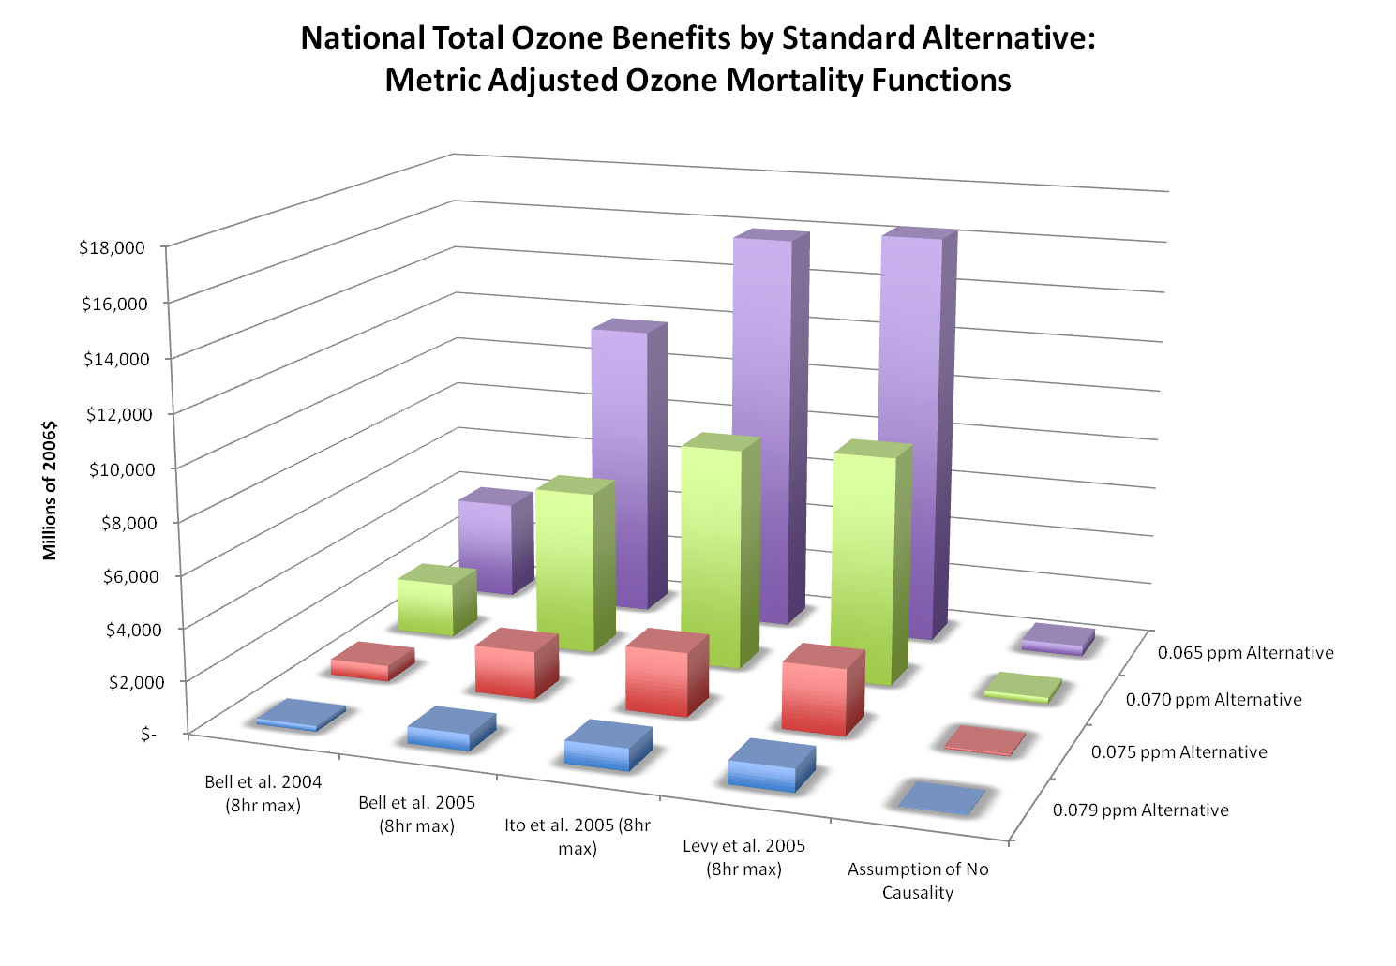
* This figure reflects full attainment in all locations of the U.S. except two areas of California. These two areas, which have high levels of ozone, are not planning to meet the current standard until after 2020. The estimates in the figure do not reflect benefits for the San Joaquin and South Coast Air Basins.

7.5.2 PM_{2.5} Co-Benefit Estimation Methodology
Figure 7.2 summarizes the valuation of PM benefits at a 3% and 7% discounted rate, respectively. A series of tables below present the PM_{2.5} co-benefits associated with full attainment of the 0.065 ppm, 0.070 ppm, 0.075 ppm and 0.079 ppm alternatives. To derive estimates of incidence and valuation for the PM_{2.5} related co-benefits of full attainment of each ozone standard alternative, we applied a scaling technique described below. To estimate total valuation estimates, we applied benefit per-ton metrics; this procedure is detailed further below. Valuation estimates of the PM_{2.5}-related full attainment benefits are presented at a 3% discount rate and at a 7% discount rate. All PM_{2.5} co-benefit estimates are incremental to the 2006 PM NAAQS RIA.
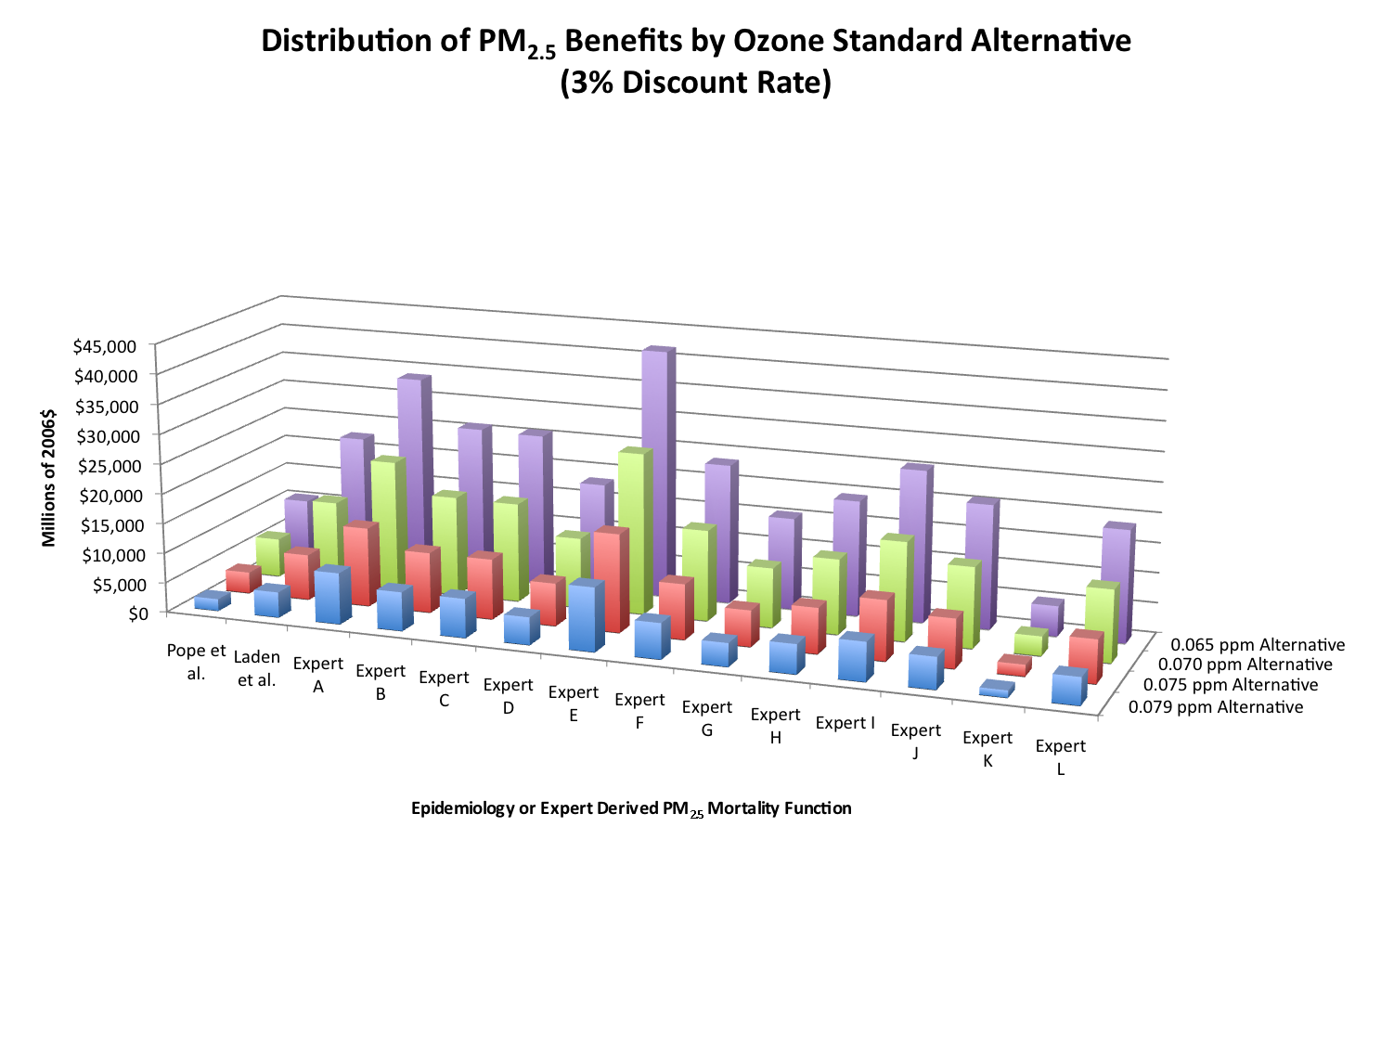
Figure 7.2: Valuation of PM Co-Benefits by Standard Alternative at 3% and 7%*
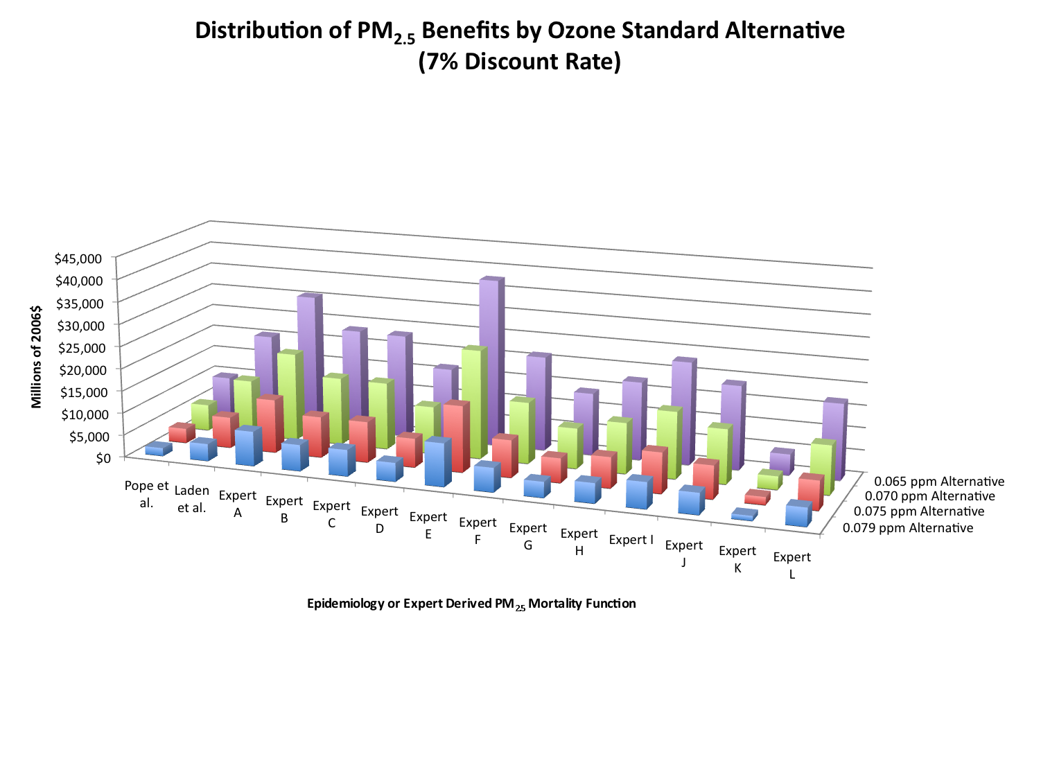
* This figure reflects full attainment in all locations of the U.S. except two areas of California. These two areas, which have high levels of ozone, are not planning to meet the current standard until after 2020. The estimates in the figure do not reflect benefits for the San Joaquin and South Coast Air Basins.

Estimating PM_{2.5} Co-Benefits Resulting from Full Attainment of the Selected Standard and Each Standard Alternative
The modeled PM_{2.5} air quality scenario reflects the PM_{2.5} changes associated with partially attaining 0.070 ppm incremental to a partial attainment of 0.08 ppm; due to analytical limitations it was not possible to model a full-attainment PM_{2.5} scenario for the selected standard or each standard alternative. Thus, using this projected air quality change to estimate PM_{2.5} co-benefits would under or overstate the benefits of attaining each standard alternative; this is due in part to the fact that the model run projects the air quality changes from NOx reductions needed to attain a baseline of 0.08 ppm. Of greater analytical value would be an estimate of the PM_{2.5} co-benefits associated with fully attaining 0.070 ppm incremental to full attainment of the 0.08 ppm standard.
To generate such an estimate, we calculated a new PM_{2.5} baseline that established the PM_{2.5} air quality associated with full attainment of 0.08 ppm. To create such a baseline, EPA utilized benefit PM_{2.5} per-ton estimates. These PM_{2.5} benefit per-ton estimates provide the total monetized human health benefits (the sum of premature mortality and premature morbidity) of reducing one ton of PM_{2.5} from a specified source. EPA has used a similar technique in previous Regulatory Impact Analyses. These estimates are based on the sum of the valuation of the Pope (2002) estimates of mortality (3% discount rate, 2006$) and valuation of the morbidity incidence. Readers interested in reviewing the complete methodology for creating the benefit per-ton estimates used in this analysis can consult the Technical Support Document accompanying this RIA.
Estimating the PM_{2.5} benefits that represented the full attainment of both 0.070 ppm incremental to full attainment of 0.08 ppm entailed the following four steps:
1. Estimate the number of tons of NOx necessary to attain a baseline of 0.08 ppm. Chapter 3 described the method used to estimate the extrapolated NOx emissions reductions necessary to attain a baseline of 0.08 ppm full attainment.
2. Calculate the benefits of attaining 0.08 ppm incremental to partial attainment of 0.08 ppm. To estimate the benefits of fully attaining 0.08 ppm incremental to partial attainment of 0.08 ppm, the relevant benefit per ton is simply multiplied by the total number of extrapolated NOx tons abated. Note that this calculation step allows us to net out the benefits of attaining the current standard, so that all subsequent benefits are incremental to the full attainment of 0.080 ppm.
3. Calculate the benefits of partially attaining 0.070 ppm incremental to full attainment of 0.08 ppm. Subtract the benefits of fully attaining 0.080 ppm incremental to the partial attainment of 0.08 ppm to create a new estimate of incremental 0.070 ppm partial attainment.
4. Calculate the PM_{2.5} benefits of fully attaining 0.070 ppm. Multiplying the estimate of the extrapolated NOx tons necessary to attain 0.070 ppm fully (found in Chapter 3) produces an estimate of the incremental benefits of fully attaining 0.070 ppm incremental to partial attainment of 0.070 ppm. By adding this incremental benefit estimate to the benefits generated in step 3, we derived a total benefit estimate of attaining 0.070 ppm incremental to 0.08 ppm.
5. Repeat step 4 to estimate the benefits of 0.075 ppm, 0.079 ppm and 0.065 ppm. Step 4 may be repeated by substituting the NOx tons necessary to attain the selected alternative of 0.075 ppm and the remaining alternatives of 0.079 ppm and 0.065 ppm to produce an estimate of total PM_{2.5} co-benefits.
The process for estimating the PM_{2.5} co-benefits of fully attaining 0.065 ppm, 0.075 ppm, and 0.079 ppm is identical to the steps above, with the following exception; in step four we substituted the number of extrapolated tons necessary to attain 0.065 ppm, 0.075 ppm, and 0.079 ppm respectively. Table 7-5 below provides the inputs to the calculation steps described above. In the example below, we calculate total benefits using the Pope et al. (2002) mortality estimate. However, in subsequent tables we present benefits using Laden et al. (2006) as well as the twelve expert functions described previously in this document. Note that while our benefit per ton estimates are associated with broad source categories (in this case, NOx emitting Electrical Generating Units, Other NOx emitting point sources and NOx emitting Mobile sources) the extrapolated tons were not. For this reason we simply assumed that the total number of extrapolated NOx tons were evenly distributed between these three source types.
The PM_{2.5} benefits of attaining 0.065 ppm, 0.075 ppm and 0.079 ppm incremental to partial attainment of 0.070 ppm are $7.5 billion, $0.6 billion and -$1 billion respectively. Simulated attainment of the 0.79 ppm alternative required fewer emission reductions than were modeled in the emissions control strategy to simulate attainment with 0.070 ppm. For this reason, we “netted out” the benefits of the incremental NOx emission reductions that were present in the 0.070 ppm control case but not necessary to attain 0.079 ppm.
The benefit per-ton estimates produce estimates of total valuation but not incidence. To estimate total incidence, we applied a simple scaling factor. To estimate PM_{2.5}-related incidence associated with the attainment of each ozone alternative, we calculated a separate scaling factor as follows: (1) we calculated the ratio of the full attainment PM_{2.5} valuation estimate (calculated using the benefit per ton metrics described below) to the partial attainment to the partial attainment PM_{2.5} valuation estimate; (2) multiply this scaling ratio against each of the PM_{2.5} partial attainment mortality and morbidity endpoints to generate a scaled estimate of mortality and morbidity. While there are clearly substantial uncertainties inherent in this technique, it does produce useful screening-level estimates of PM_{2.5}-related incidence.
The total PM_{2.5} benefits of attaining 0.065 ppm, 0.075 ppm and 0.079 ppm are $11 billion, $3.6 billion and $2 billion respectively. The full attainment PM_{2.5} benefits do not include confidence intervals. Because this full attainment estimate was derived by summing the modeled PM_{2.5} benefits and the benefits derived using the benefit per-ton metrics—and these benefit per ton metrics do not include confidence intervals—the resulting sum of total PM_{2.5} benefits do not include confidence intervals.
Table 7.5: Estimated PM_{2.5} Co-Benefits Associated with Full Attainment of 0.070 ppm Incremental to 0.08 ppmª
Calculation | Extrapolated NOx Tons | Benefit per Ton Estimate | Valuation of PM_{2.5} Benefits  (Billions 2006$)^{b}
Benefits of attaining 0.08 ppm partially and 0.070 ppm partially (i.e. the benefits of the modeled scenario): | — | — | $3.4
Benefits of attaining 0.08 ppm from a baseline of 0.08 ppm partial attainment: | NOx EGU: 37,400 | $3,200 | $0.4
 | NOx Point: 37,400 | $3,000 | $0.4
 | NOx Mobile: 37,400 | $4,800 | $0.4
Benefits of attaining 0.070 ppm partially, incremental to attainment of 0.08 ppm | — | — | $3
Benefits of attaining 0.070 ppm in 2020 incremental to partial attainment of 0.070 ppm | NOx EGU: 310,000 | $3,200 | $3.5
 | NOx Point: 310,000 | $3,000 | $3.5
 | NOx Mobile: 310,000 | $4,800 | $3.5
 | VOC: 310,000 | $430 | $3.5
Benefits of attaining 0.070 ppm incremental to attainment of 0.08 ppm |  |  | $6.5
ª Numbers have been rounded to two significant figures and therefore summation may not match table estimates. PM_{2.5} benefit estimates do not include confidence intervals because they are derived using benefit per-ton estimates.
^{b} All estimates derived using the Pope et al. (2002) mortality estimate at a 3% and 7% discount rate, in 2006$. This table reflects full attainment in all locations of the U.S. except two areas of California. These two areas, which have high levels of ozone, are not planning to meet the current standard until after 2020. The estimates in the table do not reflect benefits for the San Joaquin and South Coast Air Basins.

Table 7-6: Illustrative Strategy to Attain 0.065 ppm: Estimated Annual Reductions in the Incidence of Premature Mortality Associated with Ozone Exposure in 2020 (Incremental to Current Ozone Standard, Arithmetic Mean, 95% Confidence Intervals in Parentheses) ^{B, C, D, E}
Model or Assumption^{A} | Reference | National Modeled Partial Attainment | National Rolled-Back Full Attainment
NMMAPS | Bell et al. 2004 | 120 | 450
NMMAPS | Bell et al. 2004 | (43--210) | (170--730)
Meta-Analysis | Bell et al. 2005 | 400 | 1500
Meta-Analysis | Bell et al. 2005 | (200--610) | (760--2,200)
Meta-Analysis | Ito et al. 2005 | 550 | 2000
Meta-Analysis | Ito et al. 2005 | (340--760) | (1,300--2,700)
Meta-Analysis | Levy et al. 2005 | 560 | 2100
Meta-Analysis | Levy et al. 2005 | (390--730) | (1,500--2,600)
Assumption that association is not causal |  | 0 | 0
^{A} Does not represent equal weighting among models or between assumption of causality vs. no causality (see text in section 7.3.2.1).
^{B} With the exception of the assumption of no causal relationship, the arithmetic mean and 95% credible interval around the mean estimates of the annual number of lives saved are based on an assumption of a normal distribution.
^{C} A credible interval is a posterior probability interval used in Bayesian statistics, which is similar to a confidence interval used in frequentist statistics.
^{D} All estimates rounded to two significant figures. As such, confidence intervals may not be symmetrical and totals will not sum across columns.
^{E} This table reflects full attainment in all locations of the U.S. except two areas of California. These two areas, which have high levels of ozone, are not planning to meet the current standard until after 2020. The estimates in the table do not reflect benefits for the San Joaquin and South Coast Air Basins.

Table 7-7: Illustrative Strategy to Attain 0.065 ppm: Estimated Annual Reductions in the Incidence of Morbidity Associated with Ozone Exposure (Incremental to Current Ozone Standard, 95% Confidence Intervals in Parentheses)^{A,B}
Morbidity Endpoint | National Modeled Partial Attainment | National Rolled Back Full Attainment
Hospital Admissions (ages 0-1) | 700 | 2,700
Hospital Admissions (ages 0-1) | (310--1,100) | (1,300--4,000)
Hospital Admissions (ages 65-99) | 420 | 3,200
Hospital Admissions (ages 65-99) | (-190--1,100) | (74--6,200)
Emergency Department Visits, Asthma-Related^{C} | 550 | 1900
Emergency Department Visits, Asthma-Related^{C} | (-57--1,500) | (-130--5,500)
School Absences | 300,000 | 1,100,000
School Absences | (77,000--560,000) | (320,000--1,800,000)
Minor Restricted Activity Days | 810,000 | 2,900,000
Minor Restricted Activity Days | (350,000--1,300,000) | (1,300,000--4,400,000)
^{A} All estimates rounded to two significant figures. As such, confidence intervals may not be symmetrical and totals will not sum across columns.
^{B} This table reflects full attainment in all locations of the U.S. except two areas of California. These two areas, which have high levels of ozone, are not planning to meet the current standard until after 2020. The estimates in the table do not reflect benefits for the San Joaquin and South Coast Air Basins.
^{C} The negative 5th percentile incidence estimates for this health endpoint are a result of the weak statistical power of the study and should not be inferred to indicate that decreased ozone exposure may cause an increase in asthma-related emergency department visits.

 | Table 7-8: Illustrative 0.065 ppm Full Attainment Scenario: Estimated Annual Reductions in the Incidence of PM Premature Mortality associated with PM co-benefit^{C}
 | Mortality Endpoint | National 2020 Benefits
 | Mortality Impact Functions Derived from Epidemiology Literature
 | ACS Study^{A} | 1,000
 | Harvard Six-City Study^{B} | 2,300
 | Woodruff et al 1997 (infant mortality) | 2.9
 | Mortality Impact Functions Derived from Expert Elicitation
 | Expert A | 4,000
 | Expert B | 3,100
 | Expert C | 3,100
 | Expert D | 2,100
 | Expert E | 5,000
 | Expert F | 2,800
 | Expert G | 1,800
 | Expert H | 2,300
 | Expert I | 3,000
 | Expert J | 2,400
 | Expert K | 490
 | Expert L | 2,100
^{A} The estimate is based on the concentration-response (C-R) function developed from the study of the American Cancer Society cohort reported in Pope et al (2002), which has previously been reported as the primary estimate in recent RIAs.
^{B} Based on Laden et al (2006) reporting of the extended Six-cities study; to be reviewed by the EPA-SAB for advice on the appropriate method for incorporating what has previously been a sensitivity estimate.
^{C} All estimates rounded to two significant figures. All estimates incremental to 2006 PM NAAQS RIA. Estimates do not include confidence intervals because they were derived through a scaling technique described above. This table reflects full attainment in all locations of the U.S. except two areas of California. These two areas, which have high levels of ozone, are not planning to meet the current standard until after 2020. The estimates in the table do not reflect benefits for the San Joaquin and South Coast Air Basins.

Table 7-9: Illustrative 0.065 ppm Full Attainment Scenario: Estimated Annual Reductions in the Incidence of Morbidity Associated with PM Co-benefit^{A, B}
Morbidity Endpoint | National 2020 Benefits
Chronic Bronchitis (age >25 and over) | 970
Nonfatal myocardial infarction (age >17) | 940
Hospital admissions--respiratory (all ages) | 660,000
Hospital admissions-- cardiovascular (age >17) | 17,000
Emergency room visits for asthma (age <19) | 13,000
Acute bronchitis (age 8-12) | 110,000
Lower respiratory symptoms (age 7-14) | 2,600
Upper respiratory symptoms (asthmatic children age 9-18) | 16,000
Asthma exacerbation (asthmatic children age 6-18) | 270
Work loss days (age 18-65) | 550
Minor restricted activity days (age 18-65) | 2,300
^{A} All estimates rounded to two significant figures. All estimates incremental to 2006 PM NAAQS RIA. Estimates do not include confidence intervals because they were derived through a scaling technique described above. This table reflects full attainment in all locations of the U.S. except two areas of California. These two areas, which have high levels of ozone, are not planning to meet the current standard until after 2020. The estimates in the table do not reflect benefits for the San Joaquin and South Coast Air Basins.
^{B} Morbidity Impact Functions Derived from Epidemiology Literature

Table 7-10: Illustrative Strategy to Attain 0.070 ppm: Estimated Annual Reductions in the Incidence of Premature Mortality Associated with Ozone Exposure in 2020 (Incremental to Current Ozone Standard, Arithmetic Mean, 95% Confidence Intervals in Parentheses) ^{B, C, D, E}
Model or Assumption^{A} | Reference | National Modeled Partial Attainment | National Rolled Back Full Attainment
NMMAPS | Bell et al. 2004 | 120 | 250
NMMAPS | Bell et al. 2004 | (43--210) | (92--410)
Meta-Analysis | Bell et al. 2005 | 400 | 810
Meta-Analysis | Bell et al. 2005 | (200--610) | (410--1,200)
Meta-Analysis | Ito et al. 2005 | 550 | 1100
Meta-Analysis | Ito et al. 2005 | (340--760) | (690--1,500)
Meta-Analysis | Levy et al. 2005 | 560 | 1100
Meta-Analysis | Levy et al. 2005 | (390--730) | (800--1,500)
Assumption that association is not causal |  | 0 | 0
^{A} Does not represent equal weighting among models or between assumption of causality vs. no causality (see text in section 7.3.2.1).
^{B} With the exception of the assumption of no causal relationship, the arithmetic mean and 95% credible interval around the mean estimates of the annual number of lives saved are based on an assumption of a normal distribution.
^{C} A credible interval is a posterior probability interval used in Bayesian statistics, which is similar to a confidence interval used in frequentist statistics.
^{D} All estimates rounded to two significant figures. As such, confidence intervals may not be symmetrical and totals will not sum across columns.
^{E} This table reflects full attainment in all locations of the U.S. except two areas of California. These two areas, which have high levels of ozone, are not planning to meet the current standard until after 2020. The estimates in the table do not reflect benefits for the San Joaquin and South Coast Air Basins.

Table 7-11: Illustrative Strategy to Attain 0.070 ppm: Estimated Annual Reductions in the Incidence of Morbidity Associated with Ozone Exposure (Incremental to Current Ozone Standard, 95% Confidence Intervals in Parentheses)^{A,B}
Morbidity Endpoint | National Modeled Partial Attainment | National Rolled Back Full Attainment
Hospital Admissions (ages 0-1) | 700 | 1,500
Hospital Admissions (ages 0-1) | (310--1,100) | (720--2,400)
Hospital Admissions (ages 65-99) | 420 | 1,400
Hospital Admissions (ages 65-99) | (-190--1,100) | (-110--3,000)
Emergency Department Visits, Asthma-Related^{C} | 550 | 1000
Emergency Department Visits, Asthma-Related^{C} | (-57--1,500) | (-82--3,000)
School Absences | 300,000 | 640,000
School Absences | (77,000--560,000) | (180,000--1,000,000)
Minor Restricted Activity Days | 810,000 | 1,700,000
Minor Restricted Activity Days | (350,000--1,300,000) | (740,000--2,600,000)
^{A} All estimates rounded to two significant figures. As such, confidence intervals may not be symmetrical and totals will not sum across columns.
^{B} This table reflects full attainment in all locations of the U.S. except two areas of California. These two areas, which have high levels of ozone, are not planning to meet the current standard until after 2020. The estimates in the table do not reflect benefits for the San Joaquin and South Coast Air Basins.
^{C} The negative 5th percentile incidence estimates for this health endpoint are a result of the weak statistical power of the study and should not be inferred to indicate that decreased ozone exposure may cause an increase in asthma-related emergency department visits.

 | Table 7-12: Illustrative 0.070 ppm Full Attainment Scenario: Estimated Annual Reductions in the Incidence of PM Premature Mortality associated with PM co-benefit^{C}
 | Mortality Endpoint | National 2020 Benefits
 | Mortality Impact Functions Derived from Epidemiology Literature
 | ACS Study^{A} | 650
 | Harvard Six-City Study^{B} | 1,500
 | Woodruff et al 1997 (infant mortality) | 1.9
 | Mortality Impact Functions Derived from Expert Elicitation
 | Expert A | 2,600
 | Expert B | 2,000
 | Expert C | 2,000
 | Expert D | 1,400
 | Expert E | 3,200
 | Expert F | 1,800
 | Expert G | 1,100
 | Expert H | 1,500
 | Expert I | 1,900
 | Expert J | 1,600
 | Expert K | 310
 | Expert L | 1,400
 | ^{A} The estimate is based on the concentration-response (C-R) function developed from the study of the American Cancer Society cohort reported in Pope et al (2002), which has previously been reported as the primary estimate in recent RIAs.
^{B} Based on Laden et al (2006) reporting of the extended Six-cities study; to be reviewed by the EPA-SAB for advice on the appropriate method for incorporating what has previously been a sensitivity estimate.
^{C} All estimates rounded to two significant figures. All estimates incremental to 2006 PM NAAQS RIA. Estimates do not include confidence intervals because they were derived through a scaling technique described above. This table reflects full attainment in all locations of the U.S. except two areas of California. These two areas, which have high levels of ozone, are not planning to meet the current standard until after 2020. The estimates in the table do not reflect benefits for the San Joaquin and South Coast Air Basins.

Table 7-13: Illustrative 0.070 ppm Full Attainment Scenario: Estimated Annual Reductions in the Incidence of Morbidity Associated with PM Co-benefit^{A, B}
Morbidity Endpoint | National 2020 Benefits
Chronic Bronchitis (age >25 and over) | 630
Nonfatal myocardial infarction (age >17) | 610
Hospital admissions--respiratory (all ages) | 430,000
Hospital admissions-- cardiovascular (age >17) | 11,000
Emergency room visits for asthma (age <19) | 8,100
Acute bronchitis (age 8-12) | 72,000
Lower respiratory symptoms (age 7-14) | 1,700
Upper respiratory symptoms (asthmatic children age 9-18) | 10,000
Asthma exacerbation (asthmatic children age 6-18) | 180
Work loss days (age 18-65) | 350
Minor restricted activity days (age 18-65) | 1,500
^{A} All estimates rounded to two significant figures. All estimates incremental to 2006 PM NAAQS RIA. Estimates do not include confidence intervals because they were derived through a scaling technique described above. This table reflects full attainment in all locations of the U.S. except two areas of California. These two areas, which have high levels of ozone, are not planning to meet the current standard until after 2020. The estimates in the table do not reflect benefits for the San Joaquin and South Coast Air Basins.
^{B} Morbidity Impact Functions Derived from Epidemiology Literature

Table 7-14: Illustrative Strategy to Attain 0.075 ppm: Estimated Annual Reductions in the Incidence of Premature Mortality Associated with Ozone Exposure in 2020 (Incremental to Current Ozone Standard, Arithmetic Mean, 95% Confidence Intervals in Parentheses) ^{B, C, D, E}
Model or Assumption^{A} | Reference | National Full Attainment
NMMAPS | Bell et al. 2004 | 71
NMMAPS | Bell et al. 2004 | (27--110)
Meta-Analysis | Bell et al. 2005 | 230
Meta-Analysis | Bell et al. 2005 | (120--340)
Meta-Analysis | Ito et al. 2005 | 310
Meta-Analysis | Ito et al. 2005 | (200--430)
Meta-Analysis | Levy et al. 2005 | 320
Meta-Analysis | Levy et al. 2005 | (230--420)
Assumption that association is not causal |  | 0
^{A} Does not represent equal weighting among models or between assumption of causality vs. no causality (see text in section 7.3.2.1).
^{B} With the exception of the assumption of no causal relationship, the arithmetic mean and 95% credible interval around the mean estimates of the annual number of lives saved are based on an assumption of a normal distribution.
^{C} A credible interval is a posterior probability interval used in Bayesian statistics, which is similar to a confidence interval used in frequentist statistics.
^{D} All estimates rounded to two significant figures. As such, confidence intervals may not be symmetrical.
^{E} This table reflects full attainment in all locations of the U.S. except two areas of California. These two areas, which have high levels of ozone, are not planning to meet the current standard until after 2020. The estimates in the table do not reflect benefits for the San Joaquin and South Coast Air Basins.

Table 7-15: Illustrative Strategy to Attain 0.075 ppm: Estimated Annual Reductions in the Incidence of Morbidity Associated with Ozone Exposure (Incremental to Current Ozone Standard, 95% Confidence Intervals in Parentheses)^{A,B}
Morbidity Endpoint | National Full Attainment
Hospital Admissions (ages 0-1) | 480
Hospital Admissions (ages 0-1) | (230--730)
Hospital Admissions (ages 65-99) | 470
Hospital Admissions (ages 65-99) | (-5.1--930)
Emergency Department Visits, Asthma-Related^{C} | 280
Emergency Department Visits, Asthma-Related^{C} | (-18--830)
School Absences | 200,000
School Absences | (58,000--320,000)
Minor Restricted Activity Days | 500,000
Minor Restricted Activity Days | (230,000--760,000)
^{A} All estimates rounded to two significant figures. As such, confidence intervals may not be symmetrical.
^{B} This table reflects full attainment in all locations of the U.S. except two areas of California. These two areas, which have high levels of ozone, are not planning to meet the current standard until after 2020. The estimates in the table do not reflect benefits for the San Joaquin and South Coast Air Basins.
^{C} The negative 5th percentile incidence estimates for this health endpoint are a result of the weak statistical power of the study and should not be inferred to indicate that decreased ozone exposure may cause an increase in asthma-related emergency department visits.

 | Table 7-16: Illustrative 0.075 ppm Full Attainment Scenario: Estimated Annual Reductions in the Incidence of PM Premature Mortality associated with PM co-benefit^{C}
 | Mortality Endpoint | National 2020 Benefits
 | Mortality Impact Functions Derived from Epidemiology Literature
 | ACS Study^{A} | 390
 | Harvard Six-City Study^{B} | 880
 | Woodruff et al 1997 (infant mortality) | 1.1
 | Mortality Impact Functions Derived from Expert Elicitation
 | Expert A | 1,600
 | Expert B | 1,200
 | Expert C | 1,200
 | Expert D | 820
 | Expert E | 2,000
 | Expert F | 1,100
 | Expert G | 690
 | Expert H | 880
 | Expert I | 1,200
 | Expert J | 950
 | Expert K | 190
 | Expert L | 820
 | ^{A} The estimate is based on the concentration-response (C-R) function developed from the study of the American Cancer Society cohort reported in Pope et al (2002), which has previously been reported as the primary estimate in recent RIAs.
^{B} Based on Laden et al (2006) reporting of the extended Six-cities study; to be reviewed by the EPA-SAB for advice on the appropriate method for incorporating what has previously been a sensitivity estimate.
 | ^{C} All estimates rounded to two significant figures. All estimates incremental to 2006 PM NAAQS RIA. Estimates do not include confidence intervals because they were derived through a scaling technique described above. This table reflects full attainment in all locations of the U.S. except two areas of California. These two areas, which have high levels of ozone, are not planning to meet the current standard until after 2020. The estimates in the table do not reflect benefits for the San Joaquin and South Coast Air Basins.

Table 7-17: Illustrative 0.075 ppm Full Attainment Scenario: Estimated Annual Reductions in the Incidence of Morbidity Associated with PM Co-benefit^{A, B}
Morbidity Endpoint | National 2020 Benefits
Chronic Bronchitis (age >25 and over) | 380
Nonfatal myocardial infarction (age >17) | 370
Hospital admissions--respiratory (all ages) | 260,000
Hospital admissions-- cardiovascular (age >17) | 6,700
Emergency room visits for asthma (age <19) | 4,900
Acute bronchitis (age 8-12) | 43,000
Lower respiratory symptoms (age 7-14) | 1,000
Upper respiratory symptoms (asthmatic children age 9-18) | 6,100
Asthma exacerbation (asthmatic children age 6-18) | 110
Work loss days (age 18-65) | 210
Minor restricted activity days (age 18-65) | 890
^{A} All estimates rounded to two significant figures. All estimates incremental to 2006 PM NAAQS RIA. Estimates do not include confidence intervals because they were derived through a scaling technique described above. This table reflects full attainment in all locations of the U.S. except two areas of California. These two areas, which have high levels of ozone, are not planning to meet the current standard until after 2020. The estimates in the table do not reflect benefits for the San Joaquin and South Coast Air Basins.
^{B} Morbidity Impact Functions Derived from Epidemiology Literature

Table 7-18: Illustrative Strategy to Attain 0.079 ppm: Estimated Annual Reductions in the Incidence of Premature Mortality Associated with Ozone Exposure in 2020 (Incremental to Current Ozone Standard, Arithmetic Mean, 95% Confidence Intervals in Parentheses) ^{B, C, D, E}
Model or Assumption^{A} | Reference | National Full Attainment
NMMAPS | Bell et al. 2004 | 24
NMMAPS | Bell et al. 2004 | (10--39)
Meta-Analysis | Bell et al. 2005 | 80
Meta-Analysis | Bell et al. 2005 | (42--120)
Meta-Analysis | Ito et al. 2005 | 110
Meta-Analysis | Ito et al. 2005 | (69--150)
Meta-Analysis | Levy et al. 2005 | 110
Meta-Analysis | Levy et al. 2005 | (80--140)
Assumption that association is not causal |  | 0
^{A} Does not represent equal weighting among models or between assumption of causality vs. no causality (see text in section 7.3.2.1).
^{B} With the exception of the assumption of no causal relationship, the arithmetic mean and 95% credible interval around the mean estimates of the annual number of lives saved are based on an assumption of a normal distribution.
^{C} A credible interval is a posterior probability interval used in Bayesian statistics, which is similar to a confidence interval used in frequentist statistics.
^{D} All estimates rounded to two significant figures. As such, confidence intervals may not be symmetrical.
^{E} This table reflects full attainment in all locations of the U.S. except two areas of California. These two areas, which have high levels of ozone, are not planning to meet the current standard until after 2020. The estimates in the table do not reflect benefits for the San Joaquin and South Coast Air Basins.

Table 7-19: Illustrative Strategy to Attain 0.079 ppm: Estimated Annual Reductions in the Incidence of Morbidity Associated with Ozone Exposure (Incremental to Current Ozone Standard, 95% Confidence Intervals in Parentheses)^{A,B}
Morbidity Endpoint | National Full Attainment
Hospital Admissions (ages 0-1) | 190
Hospital Admissions (ages 0-1) | (9.0--350)
Hospital Admissions (ages 65-99) | 190
Hospital Admissions (ages 65-99) | (90--280)
Emergency Department Visits, Asthma-Related^{C} | 87
Emergency Department Visits, Asthma-Related^{C} | (-5.2--250)
School Absences | 72,000
School Absences | (21,000--110,000)
Minor Restricted Activity Days | 180,000
Minor Restricted Activity Days | (83,000--270,000)
^{A} All estimates rounded to two significant figures. As such, confidence intervals may not be symmetrical.
^{B} This table reflects full attainment in all locations of the U.S. except two areas of California. These two areas, which have high levels of ozone, are not planning to meet the current standard until after 2020. The estimates in the table do not reflect benefits for the San Joaquin and South Coast Air Basins.
^{C} The negative 5th percentile incidence estimates for this health endpoint are a result of the weak statistical power of the study and should not be inferred to indicate that decreased ozone exposure may cause an increase in asthma-related emergency department visits.

Table 7-20: Illustrative 0.079 ppm Full Attainment Scenario: Estimated Annual Reductions in the Incidence of PM Premature Mortality associated with PM co-benefit^{C}
Mortality Endpoint |  | National 2020 Benefits
Mortality Impact Functions Derived from Epidemiology Literature
ACS Study^{A} |  | 250
Harvard Six-City Study^{B} |  | 560
Woodruff et al 1997 (infant mortality) |  | 0.71
Mortality Impact Functions Derived from Expert Elicitation
Expert A |  | 1,000
Expert B |  | 760
Expert C |  | 750
Expert D |  | 530
Expert E |  | 1,200
Expert F |  | 690
Expert G |  | 440
Expert H |  | 560
Expert I |  | 750
Expert J |  | 600
Expert K |  | 120
Expert L |  | 530
^{A} The estimate is based on the concentration-response (C-R) function developed from the study of the American Cancer Society cohort reported in Pope et al (2002), which has previously been reported as the primary estimate in recent RIAs.
^{B} Based on Laden et al (2006) reporting of the extended Six-cities study; to be reviewed by the EPA-SAB for advice on the appropriate method for incorporating what has previously been a sensitivity estimate.
^{C} All estimates rounded to two significant figures. All estimates incremental to 2006 PM NAAQS RIA. Estimates do not include confidence intervals because they were derived through a scaling technique described above. This table reflects full attainment in all locations of the U.S. except two areas of California. These two areas, which have high levels of ozone, are not planning to meet the current standard until after 2020. The estimates in the table do not reflect benefits for the San Joaquin and South Coast Air Basins.

Table 7-21: Illustrative 0.079 ppm Full Attainment Scenario: Estimated Annual Reductions in the Incidence of Morbidity Associated with PM Co-benefit^{A, B, C}
Morbidity Endpoint | National 2020 Benefits
Chronic Bronchitis (age >25 and over) | 240
Nonfatal myocardial infarction (age >17) | 230
Hospital admissions--respiratory (all ages) | 160,000
Hospital admissions-- cardiovascular (age >17) | 4,200
Emergency room visits for asthma (age <19) | 3,100
Acute bronchitis (age 8-12) | 28,000
Lower respiratory symptoms (age 7-14) | 640
Upper respiratory symptoms (asthmatic children age 9-18) | 3,900
Asthma exacerbation (asthmatic children age 6-18) | 67
Work loss days (age 18-65) | 140
Minor restricted activity days (age 18-65) | 570
^{A} All estimates rounded to two significant figures. All estimates incremental to 2006 PM NAAQS RIA. Estimates do not include confidence intervals because they were derived through a scaling technique described above.
^{B} Morbidity Impact Functions Derived from Epidemiology Literature
^{C} This table reflects full attainment in all locations of the U.S. except two areas of California. These two areas, which have high levels of ozone, are not planning to meet the current standard until after 2020. The estimates in the table do not reflect benefits for the San Joaquin and South Coast Air Basins.

Table 7-22: Illustrative Strategy to Attain 0.065 ppm: Estimated Annual Valuation of Reductions in the Incidence of Premature Mortality Associated with Ozone Exposure (Incremental to Current Ozone Standard, Arithmetic Mean, 95% Confidence Intervals in Parentheses, Millions of 2006$)^{B,C,D,E}
Model or Assumption^{A} | Reference | National Modeled Partial Attainment | National Rolled Back Full Attainment
NMMAPS | Bell et al. 2004 | $960 | $3,500
NMMAPS | Bell et al. 2004 | ($140--$2,200) | ($510--$7,800)
Meta-Analysis | Bell et al. 2005 | $3,100 | $11,000
Meta-Analysis | Bell et al. 2005 | ($490--6,600) | ($1,800--24,000)
Meta-Analysis | Ito et al. 2005 | $4,200 | $15,000
Meta-Analysis | Ito et al. 2005 | (730--$8,600) | (2,700--$31,000)
Meta-Analysis | Levy et al. 2005 | $4,400 | $16,000
Meta-Analysis | Levy et al. 2005 | ($770--$8,500) | ($2,800--$31,000)
Assumption that association is not causal |  | 0 | 0
^{A} Does not represent equal weighting among models or between assumption of causality vs. no causality (see text in section 7.3.2.1).
^{B} With the exception of the assumption of no causal relationship, the arithmetic mean and 95% credible interval around the mean estimates of the annual number of lives saved are based on an assumption of a normal distribution.
^{C} A credible interval is a posterior probability interval used in Bayesian statistics, which is similar to a confidence interval used in frequentist statistics.
^{D} All estimates rounded to two significant figures. As such, confidence intervals may not be symmetrical and totals will not sum across columns.
^{E} This table reflects full attainment in all locations of the U.S. except two areas of California. These two areas, which have high levels of ozone, are not planning to meet the current standard until after 2020. The estimates in the table do not reflect benefits for the San Joaquin and South Coast Air Basins.

Table 7-23: Illustrative Strategy to Attain 0.065 ppm: Estimated Annual Valuation of Reductions in the Incidence of Morbidity Associated with Ozone Exposure (Incremental to Current Ozone Standard, 95% Confidence Intervals in Parentheses, Millions of 2006$) ^{A,B}
Morbidity Endpoint | National Modeled Partial Attainment | National Rolled Back Full Attainment
Hospital Admissions (ages 0-1) | $6.9 | $26
Hospital Admissions (ages 0-1) | ($3.4--10) | ($14.0--39)
Hospital Admissions (ages 65-99)^{C} | $9.9 | $74
Hospital Admissions (ages 65-99)^{C} | (-$3.3--$24) | ($8.40--$140)
Emergency Department Visits, Asthma-Related^{C} | $0.20 | $0.69
Emergency Department Visits, Asthma-Related^{C} | ($0.0--$0.56) | ($0.0--$2.0)
School Absences | $27 | $99
School Absences | ($8.4--$48) | ($34--$150)
Minor Restricted Activity Days | $48 | $170
Minor Restricted Activity Days | ($18--$89) | ($67--$310)
Worker Productivity | $6.8 | $49
^{A} All estimates rounded to two significant figures. As such, confidence intervals may not be symmetrical and totals will not sum across columns. This table reflects full attainment in all locations of the U.S. except two areas of California. These two areas, which have high levels of ozone, are not planning to meet the current standard until after 2020. The estimates in the table do not reflect benefits for the San Joaquin and South Coast Air Basins.
^{B} This table reflects full attainment in all locations of the U.S. except two areas of California. These two areas, which have high levels of ozone, are not planning to meet the current standard until after 2020. The estimates in the table do not reflect benefits for the San Joaquin and South Coast Air Basins.
^{C} The negative 5th percentile incidence estimates for this health endpoint are a result of the weak statistical power of the study and should not be inferred to indicate that decreased ozone exposure may cause an increase in asthma-related emergency department visits.

 | Table 7-24: Illustrative 0.065 ppm Full Attainment Scenario: Estimated Annual Valuation of Reductions in the Incidence of PM Premature Mortality associated with PM co-benefit (Millions of 2006$)^{C}
 | Mortality Endpoint | National 2020 Benefits (3% discount rate) | National 2020 Benefits  (7% discount rate)
 | Mortality Impact Functions Derived from Epidemiology Literature
 | ACS Study^{A} | $9,700 | $8,800
 | Harvard Six-City Study^{B} | $22,000 | $20,000
 | Woodruff et al 1997 (infant mortality) | $20 | $16
 | Mortality Impact Functions Derived from Expert Elicitation
 | Expert A | $33,000 | $30,000
 | Expert B | $25,000 | $23,000
 | Expert C | $25,000 | $22,000
 | Expert D | $17,000 | $16,000
 | Expert E | $41,000 | $37,000
 | Expert F | $23,000 | $20,000
 | Expert G | $15,000 | $13,000
 | Expert H | $19,000 | $17,000
 | Expert I | $25,000 | $22,000
 | Expert J | $20,000 | $18,000
 | Expert K | $4,300 | $3,900
 | Expert L | $18,000 | $16,000
 | ^{A} The estimate is based on the concentration-response (C-R) function developed from the study of the American Cancer Society cohort reported in Pope et al (2002), which has previously been reported as the primary estimate in recent RIAs.
^{B} Based on Laden et al (2006) reporting of the extended Six-cities study; to be reviewed by the EPA-SAB for advice on the appropriate method for incorporating what has previously been a sensitivity estimate.
 | ^{C} All estimates rounded to two significant figures. All estimates incremental to 2006 PM NAAQS RIA. Estimates do not include confidence intervals because they were derived through a scaling technique described above. This table reflects full attainment in all locations of the U.S. except two areas of California. These two areas, which have high levels of ozone, are not planning to meet the current standard until after 2020. The estimates in the table do not reflect benefits for the San Joaquin and South Coast Air Basins.

Table 7-25: Illustrative 0.065 ppm Full Attainment Scenario: Estimated Annual Valuation of Reductions in the Incidence of Morbidity Associated with PM Co-benefit (Millions of 2006$)^{A, B, C}
Morbidity Endpoint | National 2020 Benefits
Chronic Bronchitis (age >25 and over) | $480
Nonfatal myocardial infarction (age >17)
3% discount rate | $250
7% discount rate | $240
Hospital admissions--respiratory (all ages) | $5.8
Hospital admissions-- cardiovascular (age >17) | $15
Emergency room visits for asthma (age <19) | $0.35
Acute bronchitis (age 8-12) | $1.3
Lower respiratory symptoms (age 7-14) | $0.33
Upper respiratory symptoms (asthmatic children age 9-18) | $0.39
Asthma exacerbation (asthmatic children age 6-18) | $0.84
Work loss days (age 18-65) | $14
Minor restricted activity days (age 18-65) | $19
^{A} All estimates rounded to two significant figures. All estimates incremental to 2006 PM NAAQS RIA. Estimates do not include confidence intervals because they were derived through a scaling technique described above.
^{B} Morbidity Impact Functions Derived from Epidemiology Literature
^{C} This table reflects full attainment in all locations of the U.S. except two areas of California. These two areas, which have high levels of ozone, are not planning to meet the current standard until after 2020. The estimates in the table do not reflect benefits for the San Joaquin and South Coast Air Basins.

Table 7-26: Illustrative Strategy to Attain 0.070 ppm: Estimated Annual Valuation of Reductions in the Incidence of Premature Mortality Associated with Ozone Exposure (Incremental to Current Ozone Standard, Arithmetic Mean, 95% Confidence Intervals in Parentheses, Millions of 2006$)^{B,C,D,E}
Model or Assumption^{A} | Reference | National Modeled Partial Attainment | National Rolled Back Full Attainment
NMMAPS | Bell et al. 2004 | $960 | $1,900
NMMAPS | Bell et al. 2004 | ($140--$2,200) | ($280--$4,300)
Meta-Analysis | Bell et al. 2005 | $3,100 | $6,200
Meta-Analysis | Bell et al. 2005 | ($490--6,600) | ($1,000--13,000)
Meta-Analysis | Ito et al. 2005 | $4,200 | $8,500
Meta-Analysis | Ito et al. 2005 | (730--$8,600) | (1,500--$17,000)
Meta-Analysis | Levy et al. 2005 | $4,400 | $8,800
Meta-Analysis | Levy et al. 2005 | ($770--$8,500) | ($1,600--$17,000)
Assumption that association is not causal |  | 0 | 0
^{A} Does not represent equal weighting among models or between assumption of causality vs. no causality (see text in section 7.3.2.1).
^{B} With the exception of the assumption of no causal relationship, the arithmetic mean and 95% credible interval around the mean estimates of the annual number of lives saved are based on an assumption of a normal distribution.
^{C} A credible interval is a posterior probability interval used in Bayesian statistics, which is similar to a confidence interval used in frequentist statistics.
^{D} All estimates rounded to two significant figures.
^{E} This table reflects full attainment in all locations of the U.S. except two areas of California. These two areas, which have high levels of ozone, are not planning to meet the current standard until after 2020. The estimates in the table do not reflect benefits for the San Joaquin and South Coast Air Basins.

Table 7-27: Illustrative Strategy to Attain 0.070 ppm: Estimated Annual Valuation of Reductions in the Incidence of Morbidity Associated with Ozone Exposure (Incremental to Current Ozone Standard, 95% Confidence Intervals in Parentheses, Millions of 2006$) ^{A,B}
Morbidity Endpoint | National Modeled Partial Attainment | National Rolled Back Full Attainment
Hospital Admissions (ages 0-1) | $6.9 | $15
Hospital Admissions (ages 0-1) | ($3.4--10) | ($7.8--23)
Hospital Admissions (ages 65-99) | $9.9 | $34
Hospital Admissions (ages 65-99) | (-$3.3--$24) | ($0.59--$67)
Emergency Department Visits, Asthma-Related | $0.20 | $0.37
Emergency Department Visits, Asthma-Related | ($0.0--$0.56) | ($0.0--$1.1)
School Absences | $27 | $57
School Absences | ($8.4--$48) | ($19--$88)
Minor Restricted Activity Days | $48 | $98
Minor Restricted Activity Days | ($18--$89) | ($38--$180)
Worker Productivity | $6.8 | $27
^{A} All estimates rounded to two significant figures. As such, confidence intervals may not be symmetrical and totals will not sum across columns. This table reflects full attainment in all locations of the U.S. except two areas of California. These two areas, which have high levels of ozone, are not planning to meet the current standard until after 2020. The estimates in the table do not reflect benefits for the San Joaquin and South Coast Air Basins.
^{B} This table reflects full attainment in all locations of the U.S. except two areas of California. These two areas, which have high levels of ozone, are not planning to meet the current standard until after 2020. The estimates in the table do not reflect benefits for the San Joaquin and South Coast Air Basins.

 | Table 7-28: Illustrative 0.070 ppm Full Attainment Scenario: Estimated Annual Valuation of Reductions in the Incidence of PM Premature Mortality associated with PM co-benefit (Millions of 2006$)^{C}
 | Mortality Endpoint | National 2020 Benefits (3% discount rate) | National 2020 Benefits (7% discount rate)
 | Mortality Impact Functions Derived from Epidemiology Literature
 | ACS Study^{A} | $6,000 | $5,400
 | Harvard Six-City Study^{B} | $13,000 | $12,000
 | Woodruff et al 1997 (infant mortality) | $13 | $11
 | Mortality Impact Functions Derived from Expert Elicitation
 | Expert A | $21,000 | $19,000
 | Expert B | $16,000 | $15,000
 | Expert C | $16,000 | $15,000
 | Expert D | $11,000 | $10,000
 | Expert E | $27,000 | $24,000
 | Expert F | $15,000 | $13,000
 | Expert G | $9,500 | $8,600
 | Expert H | $12,000 | $11,000
 | Expert I | $16,000 | $14,000
 | Expert J | $13,000 | $12,000
 | Expert K | $2,700 | $2,500
 | Expert L | $12,000 | $10,000
^{A} The estimate is based on the concentration-response (C-R) function developed from the study of the American Cancer Society cohort reported in Pope et al (2002), which has previously been reported as the primary estimate in recent RIAs.
^{B} Based on Laden et al (2006) reporting of the extended Six-cities study; to be reviewed by the EPA-SAB for advice on the appropriate method for incorporating what has previously been a sensitivity estimate.
 | ^{C} All estimates rounded to two significant figures. All estimates incremental to 2006 PM NAAQS RIA. Estimates do not include confidence intervals because they were derived through a scaling technique described above. This table reflects full attainment in all locations of the U.S. except two areas of California. These two areas, which have high levels of ozone, are not planning to meet the current standard until after 2020. The estimates in the table do not reflect benefits for the San Joaquin and South Coast Air Basins.

Table 7-298: Illustrative 0.070 ppm Full Attainment Scenario: Estimated Annual Valuation of Reductions in the Incidence of Morbidity Associated with PM Co-benefit (Millions of 2006$)^{A, B, C}
Morbidity Endpoint | National 2020 Benefits
Chronic Bronchitis (age >25 and over) | $310
Nonfatal myocardial infarction (age >17)
3% discount rate | $160
7% discount rate | $160
Hospital admissions--respiratory (all ages) | $3.7
Hospital admissions-- cardiovascular (age >17) | $9.8
Emergency room visits for asthma (age <19) | $0.22
Acute bronchitis (age 8-12) | $0.85
Lower respiratory symptoms (age 7-14) | $ 0.22
Upper respiratory symptoms (asthmatic children age 9-18) | $0.25
Asthma exacerbation (asthmatic children age 6-18) | $0.54
Work loss days (age 18-65) | $8.9
Minor restricted activity days (age 18-65) | $12
^{A} All estimates rounded to two significant figures. All estimates incremental to 2006 PM NAAQS RIA. Estimates do not include confidence intervals because they were derived through a scaling technique described above.
^{B} Morbidity Impact Functions Derived from Epidemiology Literature
^{C} This table reflects full attainment in all locations of the U.S. except two areas of California. These two areas, which have high levels of ozone, are not planning to meet the current standard until after 2020. The estimates in the table do not reflect benefits for the San Joaquin and South Coast Air Basins.

Table 7-30: Illustrative Strategy to Attain 0.075 ppm: Estimated Annual Valuation of Reductions in the Incidence of Premature Mortality Associated with Ozone Exposure (Incremental to Current Ozone Standard, Arithmetic Mean, 95% Confidence Intervals in Parentheses, Millions of 2006$)^{B,C,D,E}
Model or Assumption^{A} | Reference | National Full Attainment
NMMAPS | Bell et al. 2004 | $550
NMMAPS | Bell et al. 2004 | ($81--$1,200)
Meta-Analysis | Bell et al. 2005 | $1,800
Meta-Analysis | Bell et al. 2005 | ($290--3,800)
Meta-Analysis | Ito et al. 2005 | $2,400
Meta-Analysis | Ito et al. 2005 | (420--$4,900)
Meta-Analysis | Levy et al. 2005 | $2,500
Meta-Analysis | Levy et al. 2005 | ($450--$4,900)
Assumption that association is not causal |  | 0
^{A} Does not represent equal weighting among models or between assumption of causality vs. no causality (see text in section 7.3.2.1).
^{B} With the exception of the assumption of no causal relationship, the arithmetic mean and 95% credible interval around the mean estimates of the annual number of lives saved are based on an assumption of a normal distribution.
^{C} A credible interval is a posterior probability interval used in Bayesian statistics, which is similar to a confidence interval used in frequentist statistics.
^{D} All estimates rounded to two significant figures. As such, confidence intervals may not be symmetrical.
^{E} This table reflects full attainment in all locations of the U.S. except two areas of California. These two areas, which have high levels of ozone, are not planning to meet the current standard until after 2020. The estimates in the table do not reflect benefits for the San Joaquin and South Coast Air Basins.

Table 7-31: Illustrative Strategy to Attain 0.075 ppm: Estimated Annual Valuation of Reductions in the Incidence of Morbidity Associated with Ozone Exposure (Incremental to Current Ozone Standard, 95% Confidence Intervals in Parentheses, Millions of 2006$) ^{A,B}
Morbidity Endpoint | National Full Attainment
Hospital Admissions (ages 0-1) | $4.8
Hospital Admissions (ages 0-1) | ($2.5--$7.1)
Hospital Admissions (ages 65-99) | $11
Hospital Admissions (ages 65-99) | ($0.89--21)
Emergency Department Visits, Asthma-Related | $0.10
Emergency Department Visits, Asthma-Related | ($0.00--$0.3)
School Absences | $18
School Absences | ($6.1--$27)
Minor Restricted Activity Days | $29
Minor Restricted Activity Days | ($12--$54)
Worker Productivity | $10
^{A} All estimates rounded to two significant figures. As such, confidence intervals may not be symmetrical.
^{B} This table reflects full attainment in all locations of the U.S. except two areas of California. These two areas, which have high levels of ozone, are not planning to meet the current standard until after 2020. The estimates in the table do not reflect benefits for the San Joaquin and South Coast Air Basins.

 | Table 7-32: Illustrative 0.075 ppm Full Attainment Scenario: Estimated Annual Valuation of Reductions in the Incidence of PM Premature Mortality associated with PM co-benefit (Millions of 2006$)^{C}
 | Mortality Endpoint | National 2020 Benefits (3% discount rate) | National 2020 Benefits (7% discount rate)
 | Mortality Impact Functions Derived from Epidemiology Literature
 | ACS Study^{A} | $3,300 | $3,000
 | Harvard Six-City Study^{B} | $7,400 | $6,600
 | Woodruff et al 1997 (infant mortality) | $8 | $6
 | Mortality Impact Functions Derived from Expert Elicitation
 | Expert A | $13,000 | $12,000
 | Expert B | $9,900 | $8,900
 | Expert C | $9,800 | $8,900
 | Expert D | $6,900 | $6,200
 | Expert E | $16,000 | $15,000
 | Expert F | $9,000 | $8,100
 | Expert G | $5,800 | $5,200
 | Expert H | $7,300 | $6,600
 | Expert I | $9,700 | $8,800
 | Expert J | $7,900 | $7,100
 | Expert K | $1,600 | $1,500
 | Expert L | $6,900 | $6,200
^{A} The estimate is based on the concentration-response (C-R) function developed from the study of the American Cancer Society cohort reported in Pope et al (2002), which has previously been reported as the primary estimate in recent RIAs.
^{B} Based on Laden et al (2006) reporting of the extended Six-cities study; to be reviewed by the EPA-SAB for advice on the appropriate method for incorporating what has previously been a sensitivity estimate.
 | ^{C} All estimates rounded to two significant figures. As such, confidence intervals may not be symmetrical and totals will not sum across columns. All estimates incremental to 2006 PM NAAQS RIA. Estimates do not include confidence intervals because they were derived through a scaling technique described above. This table reflects full attainment in all locations of the U.S. except two areas of California. These two areas, which have high levels of ozone, are not planning to meet the current standard until after 2020. The estimates in the table do not reflect benefits for the San Joaquin and South Coast Air Basins.

Table 7-33: Illustrative 0.075 ppm Full Attainment Scenario: Estimated Annual Valuation of Reductions in the Incidence of Morbidity Associated with PM Co-benefit (Millions of 2006$)^{A, B, C}
Morbidity Endpoint | National 2020 Benefits
Chronic Bronchitis (age >25 and over) | $180
Nonfatal myocardial infarction (age >17)
3% discount rate | $97
7% discount rate | $94
Hospital admissions--respiratory (all ages) | $2.3
Hospital admissions-- cardiovascular (age >17) | $5.9
Emergency room visits for asthma (age <19) | $0.13
Acute bronchitis (age 8-12) | $0.51
Lower respiratory symptoms (age 7-14) | $0.13
Upper respiratory symptoms (asthmatic children age 9-18) | $0.15
Asthma exacerbation (asthmatic children age 6-18) | $0.33
Work loss days (age 18-65) | $5.3
Minor restricted activity days (age 18-65) | $7.2
^{A} All estimates rounded to two significant figures. All estimates incremental to 2006 PM NAAQS RIA. Estimates do not include confidence intervals because they were derived through a scaling technique described above.
^{B} Morbidity Impact Functions Derived from Epidemiology Literature
^{C} This table reflects full attainment in all locations of the U.S. except two areas of California. These two areas, which have high levels of ozone, are not planning to meet the current standard until after 2020. The estimates in the table do not reflect benefits for the San Joaquin and South Coast Air Basins.

Table 7-34: Illustrative Strategy to Attain 0.079 ppm: Estimated Annual Valuation of Reductions in the Incidence of Premature Mortality Associated with Ozone Exposure (Incremental to Current Ozone Standard, Arithmetic Mean, 95% Confidence Intervals in Parentheses, Millions of 2006$)^{B,C,D,E}
Model or Assumption^{A} | Reference | National Full Attainment
NMMAPS | Bell et al. 2004 | $190
NMMAPS | Bell et al. 2004 | ($28--$420)
Meta-Analysis | Bell et al. 2005 | $620
Meta-Analysis | Bell et al. 2005 | ($100--1,300)
Meta-Analysis | Ito et al. 2005 | $830
Meta-Analysis | Ito et al. 2005 | (140--$1,700)
Meta-Analysis | Levy et al. 2005 | $860
Meta-Analysis | Levy et al. 2005 | ($160--$1,700)
Assumption that association is not causal |  | 0
^{A} Does not represent equal weighting among models or between assumption of causality vs. no causality (see text in section 7.3.2.1).
^{B} With the exception of the assumption of no causal relationship, the arithmetic mean and 95% credible interval around the mean estimates of the annual number of lives saved are based on an assumption of a normal distribution.
^{C} A credible interval is a posterior probability interval used in Bayesian statistics, which is similar to a confidence interval used in frequentist statistics.
^{D} All estimates rounded to two significant figures. As such, confidence intervals may not be symmetrical.
^{E} This table reflects full attainment in all locations of the U.S. except two areas of California. These two areas, which have high levels of ozone, are not planning to meet the current standard until after 2020. The estimates in the table do not reflect benefits for the San Joaquin and South Coast Air Basins.

Table 7-35: Illustrative Strategy to Attain 0.079 ppm: Estimated Annual Valuation of Reductions in the Incidence of Morbidity Associated with Ozone Exposure (Incremental to Current Ozone Standard, 95% Confidence Intervals in Parentheses, Millions of 2006$) ^{A,B}
Morbidity Endpoint | National Full Attainment
Hospital Admissions (ages 0-1) | $4.4
Hospital Admissions (ages 0-1) | ($0.60--$7.9)
Hospital Admissions (ages 65-99) | $1.9
Hospital Admissions (ages 65-99) | ($0.98--2.7)
Emergency Department Visits, Asthma-Related | $0.03
Emergency Department Visits, Asthma-Related | ($0.00--$0.09)
School Absences | $6.4
School Absences | ($2.2--$9.5)
Minor Restricted Activity Days | $11
Minor Restricted Activity Days | ($4.2--$19)
Worker Productivity | $4.7
^{A} All estimates rounded to two significant figures. As such, confidence intervals may not be symmetrical.
^{B} This table reflects full attainment in all locations of the U.S. except two areas of California. These two areas, which have high levels of ozone, are not planning to meet the current standard until after 2020. The estimates in the table do not reflect benefits for the San Joaquin and South Coast Air Basins.

 | Table 7-36: Illustrative 0.079 ppm Full Attainment Scenario: Estimated Annual Valuation of Reductions in the Incidence of PM Premature Mortality associated with PM co-benefit (Millions of 2006$)^{C}
 | Mortality Endpoint | National 2020 Benefits (3% discount rate) | National 2020 Benefits (7% discount rate)
 | Mortality Impact Functions Derived from Epidemiology Literature
 | ACS Study^{A} | $1,800 | $1,600
 | Harvard Six-City Study^{B} | $4,100 | $3,700
 | Woodruff et al 1997 (infant mortality) | $5.0 | $4.0
 | Mortality Impact Functions Derived from Expert Elicitation
 | Expert A | $8,400 | $7,600
 | Expert B | $6,400 | $5,700
 | Expert C | $6,400 | $5,700
 | Expert D | $4,400 | $4,000
 | Expert E | $11,000 | $9,500
 | Expert F | $5,800 | $5,200
 | Expert G | $3,700 | $3,400
 | Expert H | $4,700 | $4,300
 | Expert I | $6,300 | $5,700
 | Expert J | $5,100 | $4,600
 | Expert K | $1,000 | $910
 | Expert L | $4,400 | $3,900
^{A} The estimate is based on the concentration-response (C-R) function developed from the study of the American Cancer Society cohort reported in Pope et al (2002), which has previously been reported as the primary estimate in recent RIAs.
^{B} Based on Laden et al (2006) reporting of the extended Six-cities study; to be reviewed by the EPA-SAB for advice on the appropriate method for incorporating what has previously been a sensitivity estimate.
 | ^{C} All estimates rounded to two significant figures. As such, confidence intervals may not be symmetrical. All estimates incremental to 2006 PM NAAQS RIA. Estimates do not include confidence intervals because they were derived through a scaling technique described above. This table reflects full attainment in all locations of the U.S. except two areas of California. These two areas, which have high levels of ozone, are not planning to meet the current standard until after 2020. The estimates in the table do not reflect benefits for the San Joaquin and South Coast Air Basins.

Table 7-37: Illustrative 0.079 ppm Full Attainment Scenario: Estimated Annual Valuation of Reductions in the Incidence of Morbidity Associated with PM Co-benefit (Millions of 2006$)^{A, B, C}
Morbidity Endpoint | National 2020 Benefits
Chronic Bronchitis (age >25 and over) | $120
Nonfatal myocardial infarction (age >17)
3% discount rate | $62
7% discount rate | $60
Hospital admissions--respiratory (all ages) | $1.4
Hospital admissions-- cardiovascular (age >17) | $3.8
Emergency room visits for asthma (age <19) | $0.086
Acute bronchitis (age 8-12) | $0.33
Lower respiratory symptoms (age 7-14) | $0.083
Upper respiratory symptoms (asthmatic children age 9-18) | $0.10
Asthma exacerbation (asthmatic children age 6-18) | $0.21
Work loss days (age 18-65) | $3.4
Minor restricted activity days (age 18-65) | $4.6
^{A} All estimates rounded to two significant figures. All estimates incremental to 2006 PM NAAQS RIA. Estimates do not include confidence intervals because they were derived through a scaling technique described above.
^{B} Morbidity Impact Functions Derived from Epidemiology Literature
^{C} This table reflects full attainment in all locations of the U.S. except two areas of California. These two areas, which have high levels of ozone, are not planning to meet the current standard until after 2020. The estimates in the table do not reflect benefits for the San Joaquin and South Coast Air Basins.

Estimated reductions in ozone mortality incidence provided in Tables 7.6, 7.10, 7.14, and 7.18 represent the number of premature deaths potentially avoided due to reductions in ozone exposure in 2020 using warm season functions from the recent ozone-mortality NMMAPS analysis of 95 U.S. communities (Bell et al., 2004) and three meta-analyses of the available published literature on ozone-mortality effects (Bell et al., 2005; Ito et al., 2005; Levy et al., 2005). These same tables also include the possibility that there is not a causal association between ozone and mortality, i.e., that the estimate for premature mortality avoided could be zero. Model uncertainty, including whether or not the relationship is assumed to be causal, is a key source of uncertainty. Although multiple estimates are presented in these tables, no attempt was made to quantify the likelihood of a causal relationship between short-term ozone exposure and increased mortality or to weigh the results of the various models.
The estimate of central tendency for premature mortality is expressed as the arithmetic mean, with the assumption of a normal distribution, and represents the central estimate of the number of premature deaths avoided in association with the alternative standards based on each study. Statistical uncertainty associated with the model estimate for each study is characterized by the 95% credible interval around the mean estimate (i.e., 2.5th and 97.5th percent interval). Of the four available studies, the NMMAPS study by Bell et al. (2004) is considered to be the most representative for evaluating potential mortality-related benefits associated with the alternative standards due to its extensive coverage (examination of 95 large communities across the United States over an extended period of time, from 1987 to 2000) and its specific focus on the ozone-mortality relationship. Annual estimates of lives saved from this study are lower than those from the three meta-analyses, possibly due to more stringent adjustment for meteorological factors (Ito et al., 2005; Ostro et al., 2006), publication bias in the meta-analyses (Bell et al., 2005; Ito et al., 2005) or other factors. Clearly, the ozone-mortality reduction estimates are conditional on a causal relationship.
The Ozone Criteria Document (U.S. EPA, 2006) and Staff Paper (U.S. EPA, 2007) concluded that the overall body of evidence is highly suggestive that (short-term exposure to) ozone directly or indirectly contributes to non-accidental cardiopulmonary-related mortality. However, various sources of uncertainty remain, including the possibility that there is no causal relationship between ozone and mortality (i.e., zero effect). For instance, because results of time-series studies implicate all of the criteria air pollutants, and those who would be expected to be potentially more susceptible to ozone exposure are likely to have lower exposure to ozone due to the amount of time that they spend indoors, CASAC stated that it seems unlikely that the observed associations between short-term ozone concentrations and daily mortality are due solely to ozone itself (i.e., ozone may be serving as a marker for other agents that are contributing to the short-term exposure effects on mortality). Even so, CASAC concluded that the evidence was strong enough to support a quantitative risk assessment of the relationship between short-term exposure to ozone and premature mortality as part of the Staff Paper. EPA has asked the National Academy of Sciences for their advice on how best to quantify the uncertainty about the relationship between ambient ozone exposure and premature mortality within the context of quantifying projected benefits of alternative control strategies. We expect to receive this advice later this spring.
Using the NMMAPS study that was used as the basis for the risk analysis presented in our Staff Paper, we estimate 71 avoided premature deaths annually in 2020 from reducing ozone levels to meet the selected standard of 0.075 ppm, which, when added to the other projected ozone related benefits, leads to an estimated total benefit of $620 million/yr. Using three studies that synthesize data across a large number of individual studies, we estimate between 230 and 320, with total monetized ozone benefits to be between $1.9 and $2.6 billion/yr. Alternatively, if there is no causal relationship between ozone and mortality, avoided premature deaths would be zero. For a standard of 0.079 ppm, using the NMMAPS ozone mortality study, we estimate 24 premature deaths avoided and total monetized benefits of $220 million/yr. Using the three synthesis studies, we estimate premature deaths avoided for the less stringent standard to be between 80 and 110, with total monetized ozone benefits to be between $640 and $890 million/yr. For a standard of 0.070 ppm, using the NMMAPS ozone mortality study, we estimate 250 premature deaths avoided and total monetized benefits of $2.2 billion/yr. Using the three synthesis studies, we estimate premature deaths avoided for the less stringent standard to be between 810 and 1,100 avoided premature deaths annually in 2020, leading to total monetized benefits of between $6.5 and $9 billion/yr. For a standard of 0.065 ppm, using the NMMAPS ozone mortality study, we estimated to result in 450 premature deaths avoided and total monetized benefits of $3.9 billion/yr. Using the three synthesis studies, estimated premature deaths avoided for the more stringent standard are between 1,500 and 2,100, with total monetized ozone benefits between $12 and $16 billion/yr. Including premature mortality in our estimates had the largest impact on the overall magnitude of benefits: Premature mortality benefits account for more than 95 percent of the total benefits we can monetize. We note that these estimates reflect EPA’s interim approach to characterizing the benefits of reducing premature mortality associated with ozone exposure. As mentioned above, EPA has requested advice from the NAS on this issue.

7.5.3 Estimate of Full Attainment Benefits
Tables 7.38 through 7.41 below summarize the estimates of full attainment and PM_{2.5} co-benefit estimate for each standard alternative. The presentation of ozone benefits and PM_{2.5} co-benefits for each standard alternative is broken into two tables. The first table presents the national ozone benefits and PM_{2.5} co-benefits. Tables 7.42 through 7.49 summarize the combined ozone and PM_{2.5} co-benefits.

Table 7-38: Estimate of Annual Ozone and PM_{2.5} Combined Morbidity and Mortality (Millions of 2006$) for the 0.065 ppm Full Attainment
Ozone Mortality and Morbidity Benefits of Attaining 0.065 ppm |  | Total
NMMAPS | Bell (2004) | $3,900
Meta-Analysis | Bell (2005) | $12,000
Meta-Analysis | Ito (2005) | $16,000
Meta-Analysis | Levy (2005) | $16,000
No Causality |  | $420
PM_{2.5} Mortality and Morbidity Benefits of Attaining 0.065 ppm |  | Total (3% Discount Rate) | Total (7% Discount Rate)
Mortality Impact Functions Derived from Epidemiology Literature
ACS Study^{C} |  | $11,000 | $9,600
Harvard Six-City Study^{D} |  | $23,000 | $20,000
Mortality Impact Functions Derived from Expert Elicitation
Expert A |  | $34,000 | $31,000
Expert B |  | $26,000 | $24,000
Expert C |  | $26,000 | $23,000
Expert D |  | $18,000 | $17,000
Expert E |  | $42,000 | $38,000
Expert F |  | $24,000 | $21,000
Expert G |  | $15,000 | $14,000
Expert H |  | $19,000 | $18,000
Expert I |  | $25,000 | $23,000
Expert J |  | $21,000 | $19,000
Expert K |  | $5,100 | $4,700
Expert L |  | $19,000 | $17,000
^{A} Does not represent equal weighting among models or between assumption of causality vs. no causality (see text in section 7.3.2.1).
^{B} A credible interval is a posterior probability interval used in Bayesian statistics, which is similar to a confidence interval used in frequentist statistics. Credible intervals for ozone estimates and confidence intervals for PM_{2.5} estimates not provided because the valuation estimates were derived through a scaling technique (see above) that precluded us from generating such estimates.
^{C} The estimate is based on the concentration-response (C-R) function developed from the study of the American Cancer Society cohort reported in Pope et al (2002), which has previously been reported as the primary estimate in recent RIAs.
^{D} Based on Laden et al (2006) reporting of the extended Six-cities study; to be reviewed by the EPA-SAB for advice on the appropriate method for incorporating what has previously been a sensitivity estimate.
^{E} All estimates incremental to 2006 PM NAAQS RIA. Estimates derived using benefit per ton estimates discounted at 3% and 7%. This table reflects full attainment in all locations of the U.S. except two areas of California. These two areas, which have high levels of ozone, are not planning to meet the current standard until after 2020. The estimates in the table do not reflect benefits for the San Joaquin and South Coast Air Basins.

Table 7-39: Estimate of Annual Ozone and PM_{2.5} Combined Morbidity and Mortality (Millions of 2006$) for the 0.070 ppm Full Attainment
Ozone Mortality and Morbidity Benefits of Attaining 0.070 ppm |  | Total
NMMAPS | Bell (2004) | $2,200
Meta-Analysis | Bell (2005) | $6,500
Meta-Analysis | Ito (2005) | $8,800
Meta-Analysis | Levy (2005) | $9,000
No Causality |  | $230
PM_{2.5} Mortality and Morbidity Benefits of Attaining 0.070 ppm |  | Total (3% Discount Rate) | Total (7% Discount Rate)
Mortality Impact Functions Derived from Epidemiology Literature
ACS Study^{C} |  | $6,500 | $5,900
Harvard Six-City Study^{D} |  | $14,000 | $13,000
Mortality Impact Functions Derived from Expert Elicitation
Expert A |  | $22,000 | $20,000
Expert B |  | $17,000 | $15,000
Expert C |  | $17,000 | $15,000
Expert D |  | $12,000 | $11,000
Expert E |  | $27,000 | $24,000
Expert F |  | $15,000 | $14,000
Expert G |  | $10,000 | $9,100
Expert H |  | $13,000 | $11,000
Expert I |  | $17,000 | $15,000
Expert J |  | $13,000 | $12,000
Expert K |  | $3,200 | $3,000
Expert L |  | $12,000 | $11,000
^{A} Does not represent equal weighting among models or between assumption of causality vs. no causality (see text in section 7.3.2.1).
^{B} A credible interval is a posterior probability interval used in Bayesian statistics, which is similar to a confidence interval used in frequentist statistics. Credible intervals for ozone estimates and confidence intervals for PM_{2.5} estimates not provided because the valuation estimates were derived through a scaling technique (see above) that precluded us from generating such estimates.
^{C} The estimate is based on the concentration-response (C-R) function developed from the study of the American Cancer Society cohort reported in Pope et al (2002), which has previously been reported as the primary estimate in recent RIAs.
^{D} Based on Laden et al (2006) reporting of the extended Six-cities study; to be reviewed by the EPA-SAB for advice on the appropriate method for incorporating what has previously been a sensitivity estimate.
^{E} All estimates incremental to 2006 PM NAAQS RIA. Estimates derived using benefit per ton estimates discounted at 3% and 7%. This table reflects full attainment in all locations of the U.S. except two areas of California. These two areas, which have high levels of ozone, are not planning to meet the current standard until after 2020. The estimates in the table do not reflect benefits for the San Joaquin and South Coast Air Basins.

Table 7-40: Estimate of Annual Ozone and PM_{2.5} Combined Morbidity and Mortality (Millions of 2006$) for the 0.075 ppm Full Attainment
Ozone Mortality and Morbidity Benefits of Attaining 0.075 ppm |  | Total
NMMAPS | Bell (2004) | $620
Meta-Analysis | Bell (2005) | $1,900
Meta-Analysis | Ito (2005) | $2,500
Meta-Analysis | Levy (2005) | $2,600
No Causality |  | $73
PM_{2.5} Mortality and Morbidity Benefits of Attaining 0.075 ppm |  | Total (3% Discount Rate) | Total (7% Discount Rate)
Mortality Impact Functions Derived from Epidemiology Literature
ACS Study^{C} |  | $3,600 | $3,300
Harvard Six-City Study^{D} |  | $7,700 | $7,000
Mortality Impact Functions Derived from Expert Elicitation
Expert A |  | $13,000 | $12,000
Expert B |  | $10,000 | $9,200
Expert C |  | $10,000 | $9,200
Expert D |  | $7,200 | $6,500
Expert E |  | $16,000 | $15,000
Expert F |  | $9,300 | $8,400
Expert G |  | $6,100 | $5,500
Expert H |  | $7,600 | $6,900
Expert I |  | $10,000 | $9,100
Expert J |  | $8,200 | $7,400
Expert K |  | $1,900 | $1,800
Expert L |  | $7,200 | $6,500
^{A} Does not represent equal weighting among models or between assumption of causality vs. no causality (see text in section 7.3.2.1).
^{B} A credible interval is a posterior probability interval used in Bayesian statistics, which is similar to a confidence interval used in frequentist statistics. Credible intervals for ozone estimates and confidence intervals for PM_{2.5} estimates not provided because the valuation estimates were derived through a scaling technique (see above) that precluded us from generating such estimates.
^{C} The estimate is based on the concentration-response (C-R) function developed from the study of the American Cancer Society cohort reported in Pope et al (2002), which has previously been reported as the primary estimate in recent RIAs.
^{D} Based on Laden et al (2006) reporting of the extended Six-cities study; to be reviewed by the EPA-SAB for advice on the appropriate method for incorporating what has previously been a sensitivity estimate.
^{E} All estimates incremental to 2006 PM NAAQS RIA. Estimates derived using benefit per ton estimates discounted at 3% and 7%. This table reflects full attainment in all locations of the U.S. except two areas of California. These two areas, which have high levels of ozone, are not planning to meet the current standard until after 2020. The estimates in the table do not reflect benefits for the San Joaquin and South Coast Air Basins.

Table 7-41: Estimate of Annual Ozone and PM_{2.5} Combined Morbidity and Mortality (Millions of 2006$) for the 0.079 ppm Full Attainment
Ozone Mortality and Morbidity Benefits of Attaining 0.079 ppm |  | Total
NMMAPS | Bell (2004) | $220
Meta-Analysis | Bell (2005) | $640
Meta-Analysis | Ito (2005) | $860
Meta-Analysis | Levy (2005) | $890
No Causality |  | $28
PM_{2.5} Mortality and Morbidity Benefits of Attaining 0.079 ppm |  | Total (3% Discount Rate) | Total (7% Discount Rate)
Mortality Impact Functions Derived from Epidemiology Literature
ACS Study^{C} |  | $2,000 | $1,800
Harvard Six-City Study^{D} |  | $4,300 | $3,900
Mortality Impact Functions Derived from Expert Elicitation
Expert A |  | $8,600 | $7,800
Expert B |  | $6,600 | $5,900
Expert C |  | $6,600 | $5,900
Expert D |  | $4,600 | $4,200
Expert E |  | $11,000 | $9,700
Expert F |  | $6,000 | $5,400
Expert G |  | $3,900 | $3,600
Expert H |  | $4,900 | $4,500
Expert I |  | $6,500 | $5,900
Expert J |  | $5,300 | $4,800
Expert K |  | $1,200 | $1,100
Expert L |  | $4,600 | $4,100
^{A} Does not represent equal weighting among models or between assumption of causality vs. no causality (see text in section 7.3.2.1).
^{B} A credible interval is a posterior probability interval used in Bayesian statistics, which is similar to a confidence interval used in frequentist statistics. Credible intervals for ozone estimates and confidence intervals for PM_{2.5} estimates not provided because the valuation estimates were derived through a scaling technique (see above) that precluded us from generating such estimates.
^{C} The estimate is based on the concentration-response (C-R) function developed from the study of the American Cancer Society cohort reported in Pope et al (2002), which has previously been reported as the primary estimate in recent RIAs.
^{D} Based on Laden et al (2006) reporting of the extended Six-cities study; to be reviewed by the EPA-SAB for advice on the appropriate method for incorporating what has previously been a sensitivity estimate.
^{E} All estimates incremental to 2006 PM NAAQS RIA. Estimates derived using benefit per ton estimates discounted at 3% and 7%. This table reflects full attainment in all locations of the U.S. except two areas of California. These two areas, which have high levels of ozone, are not planning to meet the current standard until after 2020. The estimates in the table do not reflect benefits for the San Joaquin and South Coast Air Basins.

Table 7-42: Combined Estimate of Annual Ozone and PM_{2.5} Benefits (Millions of $2006, 3% Discount Rate) for the 0.065 ppm Alternative Standard
 | Alternative Standard and Model or Assumption^{A}
 | Bell (2004) | Bell (2005) | Ito (2005) | Levy (2005) | No Causality
Mortality Impact Functions Derived from Epidemiology Literature
ACS Study^{B} | $14,000 | $22,000 | $26,000 | $27,000 | $11,000
Harvard Six-City Study^{C} | $26,000 | $34,000 | $38,000 | $39,000 | $23,000
Mortality Impact Functions Derived from Expert Elicitation
Expert A | $34,000 | $38,000 | $46,000 | $50,000 | $50,000
Expert B | $26,000 | $30,000 | $38,000 | $42,000 | $42,000
Expert C | $26,000 | $30,000 | $38,000 | $42,000 | $42,000
Expert D | $19,000 | $22,000 | $30,000 | $34,000 | $35,000
Expert E | $42,000 | $46,000 | $54,000 | $58,000 | $58,000
Expert F | $24,000 | $27,000 | $35,000 | $39,000 | $40,000
Expert G | $16,000 | $19,000 | $27,000 | $31,000 | $32,000
Expert H | $20,000 | $23,000 | $31,000 | $35,000 | $36,000
Expert I | $26,000 | $29,000 | $37,000 | $41,000 | $42,000
Expert J | $21,000 | $25,000 | $33,000 | $37,000 | $37,000
Expert K | $5,500 | $9,000 | $17,000 | $21,000 | $21,000
Expert L | $19,000 | $23,000 | $30,000 | $35,000 | $35,000
^{A} Does not represent equal weighting among models or between assumption of causality vs. no causality (see text in section 7.3.2.1).
^{B} The estimate is based on the concentration-response (C-R) function developed from the study of the American Cancer Society cohort reported in Pope et al (2002), which has previously been reported as the primary estimate in recent RIAs

^{C} Based on Laden et al (2006) reporting of the extended Six-cities study; to be reviewed by the EPA-SAB for advice on the appropriate method for incorporating what has previously been a sensitivity estimate.

^{D} All estimates incremental to 2006 PM NAAQS RIA. Confidence intervals for PM_{2.5} estimates not provided due to the fact that the valuation estimates were derived through a scaling technique (see above) that precluded us from generating such estimates. Estimates derived using a combination of modeling data and benefit per ton estimates. This table reflects full attainment in all locations of the U.S. except two areas of California. These two areas, which have high levels of ozone, are not planning to meet the current standard until after 2020. The estimates in the table do not reflect benefits for the San Joaquin and South Coast Air Basins.

Table 7-43: Combined Estimate of Annual Ozone and PM_{2.5} Benefits (Millions of $2006, 7% Discount Rate) for the 0.065 ppm Alternative Standard
 | Alternative Standard and Model or Assumption^{A}
 | Bell (2004) | Bell (2005) | Ito (2005) | Levy (2005) | No Causality
Mortality Impact Functions Derived from Epidemiology Literature
ACS Study^{B} | $13,000 | $21,000 | $25,000 | $26,000 | $10,000
Harvard Six-City Study^{C} | $24,000 | $32,000 | $36,000 | $37,000 | $21,000
Mortality Impact Functions Derived from Expert Elicitation
Expert A | $34,000 | $42,000 | $46,000 | $47,000 | $31,000
Expert B | $27,000 | $35,000 | $39,000 | $40,000 | $24,000
Expert C | $27,000 | $35,000 | $39,000 | $40,000 | $24,000
Expert D | $20,000 | $28,000 | $32,000 | $33,000 | $17,000
Expert E | $42,000 | $50,000 | $54,000 | $54,000 | $38,000
Expert F | $25,000 | $33,000 | $37,000 | $38,000 | $22,000
Expert G | $18,000 | $26,000 | $30,000 | $30,000 | $14,000
Expert H | $21,000 | $29,000 | $33,000 | $34,000 | $18,000
Expert I | $27,000 | $35,000 | $39,000 | $39,000 | $23,000
Expert J | $23,000 | $31,000 | $35,000 | $35,000 | $19,000
Expert K | $8,600 | $16,000 | $21,000 | $21,000 | $5,100
Expert L | $21,000 | $29,000 | $33,000 | $33,000 | $17,000
^{A} Does not represent equal weighting among models or between assumption of causality vs. no causality (see text in section 7.3.2.1).
^{B} The estimate is based on the concentration-response (C-R) function developed from the study of the American Cancer Society cohort reported in Pope et al (2002), which has previously been reported as the primary estimate in recent RIAs

^{C} Based on Laden et al (2006) reporting of the extended Six-cities study; to be reviewed by the EPA-SAB for advice on the appropriate method for incorporating what has previously been a sensitivity estimate.

^{D} All estimates incremental to 2006 PM NAAQS RIA. Confidence intervals for PM_{2.5} estimates not provided due to the fact that the valuation estimates were derived through a scaling technique (see above) that precluded us from generating such estimates. Estimates derived using a combination of modeling data and benefit per ton estimates. This table reflects full attainment in all locations of the U.S. except two areas of California. These two areas, which have high levels of ozone, are not planning to meet the current standard until after 2020. The estimates in the table do not reflect benefits for the San Joaquin and South Coast Air Basins.

Table 7-44: Combined Estimate of Annual Ozone and PM_{2.5} Benefits (Millions of $2006, 3% Discount Rate) for the 0.070 ppm Alternative Standard
 | Alternative Standard and Model or Assumption^{A}
 | Bell (2004) | Bell (2005) | Ito (2005) | Levy (2005) | No Causality
Mortality Impact Functions Derived from Epidemiology Literature
ACS Study^{B} | $8,700 | $13,000 | $15,000 | $16,000 | $6,700
Harvard Six-City Study^{C} | $16,000 | $20,000 | $23,000 | $23,000 | $14,000
Mortality Impact Functions Derived from Expert Elicitation
Expert A | $24,000 | $28,000 | $31,000 | $31,000 | $22,000
Expert B | $19,000 | $23,000 | $26,000 | $26,000 | $17,000
Expert C | $19,000 | $23,000 | $25,000 | $26,000 | $17,000
Expert D | $14,000 | $18,000 | $21,000 | $21,000 | $12,000
Expert E | $29,000 | $34,000 | $36,000 | $36,000 | $27,000
Expert F | $17,000 | $22,000 | $24,000 | $24,000 | $15,000
Expert G | $12,000 | $16,000 | $19,000 | $19,000 | $10,000
Expert H | $15,000 | $19,000 | $21,000 | $22,000 | $13,000
Expert I | $19,000 | $23,000 | $25,000 | $26,000 | $17,000
Expert J | $16,000 | $20,000 | $22,000 | $22,000 | $14,000
Expert K | $5,400 | $9,700 | $12,000 | $12,000 | $3,500
Expert L | $14,000 | $19,000 | $21,000 | $21,000 | $12,000
^{A} Does not represent equal weighting among models or between assumption of causality vs. no causality (see text in section 7.3.2.1).
^{B} The estimate is based on the concentration-response (C-R) function developed from the study of the American Cancer Society cohort reported in Pope et al (2002), which has previously been reported as the primary estimate in recent RIAs

^{C} Based on Laden et al (2006) reporting of the extended Six-cities study; to be reviewed by the EPA-SAB for advice on the appropriate method for incorporating what has previously been a sensitivity estimate.

^{D} All estimates incremental to 2006 PM NAAQS RIA. Confidence intervals for PM_{2.5} estimates not provided due to the fact that the valuation estimates were derived through a scaling technique (see above) that precluded us from generating such estimates. Estimates derived using a combination of modeling data and benefit per ton estimates. This table reflects full attainment in all locations of the U.S. except two areas of California. These two areas, which have high levels of ozone, are not planning to meet the current standard until after 2020. The estimates in the table do not reflect benefits for the San Joaquin and South Coast Air Basins.

Table 7-45: Combined Estimate of Annual Ozone and PM_{2.5} Benefits (Millions of $2006, 7% Discount Rate) for the 0.070 ppm Alternative Standard
 | Alternative Standard and Model or Assumption^{A}
 | Bell (2004) | Bell (2005) | Ito (2005) | Levy (2005) | No Causality
Mortality Impact Functions Derived from Epidemiology Literature
ACS Study^{B} | $8,100 | $12,000 | $15,000 | $15,000 | $6,100
Harvard Six-City Study^{C} | $15,000 | $19,000 | $21,000 | $22,000 | $13,000
Mortality Impact Functions Derived from Expert Elicitation
Expert A | $22,000 | $26,000 | $29,000 | $29,000 | $20,000
Expert B | $17,000 | $22,000 | $24,000 | $24,000 | $15,000
Expert C | $17,000 | $22,000 | $24,000 | $24,000 | $15,000
Expert D | $13,000 | $17,000 | $19,000 | $20,000 | $11,000
Expert E | $27,000 | $31,000 | $33,000 | $33,000 | $25,000
Expert F | $16,000 | $20,000 | $23,000 | $23,000 | $14,000
Expert G | $11,000 | $16,000 | $18,000 | $18,000 | $9,300
Expert H | $14,000 | $18,000 | $20,000 | $20,000 | $12,000
Expert I | $17,000 | $21,000 | $24,000 | $24,000 | $15,000
Expert J | $14,000 | $19,000 | $21,000 | $21,000 | $12,000
Expert K | $5,100 | $9,500 | $12,000 | $12,000 | $3,200
Expert L | $13,000 | $17,000 | $20,000 | $20,000 | $11,000
^{A} Does not represent equal weighting among models or between assumption of causality vs. no causality (see text in section 7.3.2.1).
^{B} The estimate is based on the concentration-response (C-R) function developed from the study of the American Cancer Society cohort reported in Pope et al (2002), which has previously been reported as the primary estimate in recent RIAs

^{C} Based on Laden et al (2006) reporting of the extended Six-cities study; to be reviewed by the EPA-SAB for advice on the appropriate method for incorporating what has previously been a sensitivity estimate.

^{D} All estimates incremental to 2006 PM NAAQS RIA. Confidence intervals for PM_{2.5} estimates not provided due to the fact that the valuation estimates were derived through a scaling technique (see above) that precluded us from generating such estimates. Estimates derived using a combination of modeling data and benefit per ton estimates. This table reflects full attainment in all locations of the U.S. except two areas of California. These two areas, which have high levels of ozone, are not planning to meet the current standard until after 2020. The estimates in the table do not reflect benefits for the San Joaquin and South Coast Air Basins.

Table 7-46: Combined Estimate of Annual Ozone and PM_{2.5} Benefits (Millions of $2006, 3% Discount Rate) for the 0.075 ppm Alternative Standard
 | Alternative Standard and Model or Assumption^{A}
 | Bell (2004) | Bell (2005) | Ito (2005) | Levy (2005) | No Causality
Mortality Impact Functions Derived from Epidemiology Literature
ACS Study^{B} | $4,200 | $5,500 | $6,100 | $6,200 | $3,700
Harvard Six-City Study^{C} | $8,300 | $9,500 | $10,000 | $10,000 | $7,800
Mortality Impact Functions Derived from Expert Elicitation
Expert A | $14,000 | $15,000 | $16,000 | $16,000 | $13,000
Expert B | $11,000 | $12,000 | $13,000 | $13,000 | $10,000
Expert C | $11,000 | $12,000 | $13,000 | $13,000 | $10,000
Expert D | $7,800 | $9,000 | $9,700 | $9,800 | $7,300
Expert E | $17,000 | $18,000 | $19,000 | $19,000 | $17,000
Expert F | $9,900 | $11,000 | $12,000 | $12,000 | $9,300
Expert G | $6,700 | $7,900 | $8,600 | $8,700 | $6,100
Expert H | $8,300 | $9,500 | $10,000 | $10,000 | $7,700
Expert I | $11,000 | $12,000 | $13,000 | $13,000 | $10,000
Expert J | $8,800 | $10,000 | $11,000 | $11,000 | $8,300
Expert K | $2,600 | $3,800 | $4,400 | $4,500 | $2,000
Expert L | $7,800 | $9,000 | $9,700 | $9,800 | $7,300
^{A} Does not represent equal weighting among models or between assumption of causality vs. no causality (see text in section 7.3.2.1).
^{B} The estimate is based on the concentration-response (C-R) function developed from the study of the American Cancer Society cohort reported in Pope et al (2002), which has previously been reported as the primary estimate in recent RIAs

^{C} Based on Laden et al (2006) reporting of the extended Six-cities study; to be reviewed by the EPA-SAB for advice on the appropriate method for incorporating what has previously been a sensitivity estimate.

^{D} All estimates incremental to 2006 PM NAAQS RIA. Confidence intervals for PM_{2.5} estimates not provided due to the fact that the valuation estimates were derived through a scaling technique (see above) that precluded us from generating such estimates. Estimates derived using a combination of modeling data and benefit per ton estimates. This table reflects full attainment in all locations of the U.S. except two areas of California. These two areas, which have high levels of ozone, are not planning to meet the current standard until after 2020. The estimates in the table do not reflect benefits for the San Joaquin and South Coast Air Basins.

Table 7-47: Combined Estimate of Annual Ozone and PM_{2.5} Benefits (Millions of $2006, 7% Discount Rate) for the 0.075 ppm Alternative Standard
 | Alternative Standard and Model or Assumption^{A}
 | Bell (2004) | Bell (2005) | Ito (2005) | Levy (2005) | No Causality
Mortality Impact Functions Derived from Epidemiology Literature
ACS Study^{B} | $3,900 | $5,100 | $5,800 | $5,900 | $3,400
Harvard Six-City Study^{C} | $7,600 | $8,800 | $9,500 | $9,500 | $7,000
Mortality Impact Functions Derived from Expert Elicitation
Expert A | $13,000 | $14,000 | $15,000 | $15,000 | $12,000
Expert B | $9,800 | $11,000 | $12,000 | $12,000 | $9,300
Expert C | $9,800 | $11,000 | $12,000 | $12,000 | $9,200
Expert D | $7,100 | $8,400 | $9,000 | $9,100 | $6,600
Expert E | $16,000 | $17,000 | $17,000 | $17,000 | $15,000
Expert F | $9,000 | $10,000 | $11,000 | $11,000 | $8,500
Expert G | $6,100 | $7,400 | $8,000 | $8,100 | $5,600
Expert H | $7,500 | $8,800 | $9,400 | $9,500 | $7,000
Expert I | $9,700 | $11,000 | $12,000 | $12,000 | $9,100
Expert J | $8,000 | $9,300 | $9,900 | $10,000 | $7,500
Expert K | $2,400 | $3,600 | $4,300 | $4,300 | $1,800
Expert L | $7,100 | $8,400 | $9,000 | $9,100 | $6,600
^{A} Does not represent equal weighting among models or between assumption of causality vs. no causality (see text in section 7.3.2.1).
^{B} The estimate is based on the concentration-response (C-R) function developed from the study of the American Cancer Society cohort reported in Pope et al (2002), which has previously been reported as the primary estimate in recent RIAs

^{C} Based on Laden et al (2006) reporting of the extended Six-cities study; to be reviewed by the EPA-SAB for advice on the appropriate method for incorporating what has previously been a sensitivity estimate.

^{D} All estimates incremental to 2006 PM NAAQS RIA. Confidence intervals for PM_{2.5} estimates not provided due to the fact that the valuation estimates were derived through a scaling technique (see above) that precluded us from generating such estimates. Estimates derived using a combination of modeling data and benefit per ton estimates. This table reflects full attainment in all locations of the U.S. except two areas of California. These two areas, which have high levels of ozone, are not planning to meet the current standard until after 2020. The estimates in the table do not reflect benefits for the San Joaquin and South Coast Air Basins.

Table 7-48: Combined Estimate of Annual Ozone and PM_{2.5} Benefits (Millions of $2006, 3% Discount Rate) for the 0.079 ppm Alternative Standard
 | Alternative Standard and Model or Assumption^{A}
 | Bell (2004) | Bell (2005) | Ito (2005) | Levy (2005) | No Causality
Mortality Impact Functions Derived from Epidemiology Literature
ACS Study^{B} | $2,200 | $2,700 | $2,900 | $2,900 | $2,100
Harvard Six-City Study^{C} | $4,500 | $4,900 | $5,200 | $5,200 | $4,300
Mortality Impact Functions Derived from Expert Elicitation
Expert A | $8,900 | $9,300 | $9,500 | $9,500 | $8,700
Expert B | $6,800 | $7,200 | $7,400 | $7,400 | $6,600
Expert C | $6,800 | $7,200 | $7,400 | $7,500 | $6,600
Expert D | $4,900 | $5,300 | $5,500 | $5,500 | $4,700
Expert E | $11,000 | $11,000 | $12,000 | $12,000 | $11,000
Expert F | $6,200 | $6,700 | $6,900 | $6,900 | $6,000
Expert G | $4,100 | $4,600 | $4,800 | $4,800 | $4,000
Expert H | $5,200 | $5,600 | $5,800 | $5,800 | $5,000
Expert I | $6,700 | $7,200 | $7,400 | $7,400 | $6,500
Expert J | $5,500 | $5,900 | $6,200 | $6,200 | $5,300
Expert K | $1,400 | $1,900 | $2,100 | $2,100 | $1,200
Expert L | $4,800 | $5,200 | $5,400 | $5,400 | $4,600
^{A} Does not represent equal weighting among models or between assumption of causality vs. no causality (see text in section 7.3.2.1).
^{B} The estimate is based on the concentration-response (C-R) function developed from the study of the American Cancer Society cohort reported in Pope et al (2002), which has previously been reported as the primary estimate in recent RIAs

^{C} Based on Laden et al (2006) reporting of the extended Six-cities study; to be reviewed by the EPA-SAB for advice on the appropriate method for incorporating what has previously been a sensitivity estimate.

^{D} All estimates incremental to 2006 PM NAAQS RIA. Confidence intervals for PM_{2.5} estimates not provided due to the fact that the valuation estimates were derived through a scaling technique (see above) that precluded us from generating such estimates. Estimates derived using a combination of modeling data and benefit per ton estimates. This table reflects full attainment in all locations of the U.S. except two areas of California. These two areas, which have high levels of ozone, are not planning to meet the current standard until after 2020. The estimates in the table do not reflect benefits for the San Joaquin and South Coast Air Basins.

Table 7-49: Combined Estimate of Annual Ozone and PM_{2.5} Benefits (Millions of $2006, 7% Discount Rate) for the 0.079 ppm Alternative Standard
 | Alternative Standard and Model or Assumption^{A}
 | Bell (2004) | Bell (2005) | Ito (2005) | Levy (2005) | No Causality
Mortality Impact Functions Derived from Epidemiology Literature
ACS Study^{B} | $2,100 | $2,500 | $2,700 | $2,700 | $1,900
Harvard Six-City Study^{C} | $4,100 | $4,500 | $4,800 | $4,800 | $3,900
Mortality Impact Functions Derived from Expert Elicitation
Expert A | $8,000 | $8,400 | $8,700 | $8,700 | $7,800
Expert B | $6,100 | $6,600 | $6,800 | $6,800 | $5,900
Expert C | $6,200 | $6,600 | $6,800 | $6,800 | $6,000
Expert D | $4,400 | $4,800 | $5,100 | $5,100 | $4,200
Expert E | $9,900 | $10,000 | $11,000 | $11,000 | $9,700
Expert F | $5,600 | $6,100 | $6,300 | $6,300 | $5,500
Expert G | $3,800 | $4,200 | $4,400 | $4,400 | $3,600
Expert H | $4,700 | $5,100 | $5,300 | $5,400 | $4,500
Expert I | $6,100 | $6,500 | $6,700 | $6,800 | $5,900
Expert J | $5,000 | $5,400 | $5,700 | $5,700 | $4,800
Expert K | $1,300 | $1,800 | $2,000 | $2,000 | $1,100
Expert L | $4,300 | $4,800 | $5,000 | $5,000 | $4,100
^{A} Does not represent equal weighting among models or between assumption of causality vs. no causality (see text in section 7.3.2.1).
^{B} The estimate is based on the concentration-response (C-R) function developed from the study of the American Cancer Society cohort reported in Pope et al (2002), which has previously been reported as the primary estimate in recent RIAs
^{C} Based on Laden et al (2006) reporting of the extended Six-cities study; to be reviewed by the EPA-SAB for advice on the appropriate method for incorporating what has previously been a sensitivity estimate.
^{D} All estimates incremental to 2006 PM NAAQS RIA. Confidence intervals for PM_{2.5} estimates not provided due to the fact that the valuation estimates were derived through a scaling technique (see above) that precluded us from generating such estimates. Estimates derived using a combination of modeling data and benefit per ton estimates. This table reflects full attainment in all locations of the U.S. except two areas of California. These two areas, which have high levels of ozone, are not planning to meet the current standard until after 2020. The estimates in the table do not reflect benefits for the San Joaquin and South Coast Air Basins.

Figure 7.3: Ozone and PM_{2.5} Benefits by Standard Alternative (3% and 7% Discount Rates)

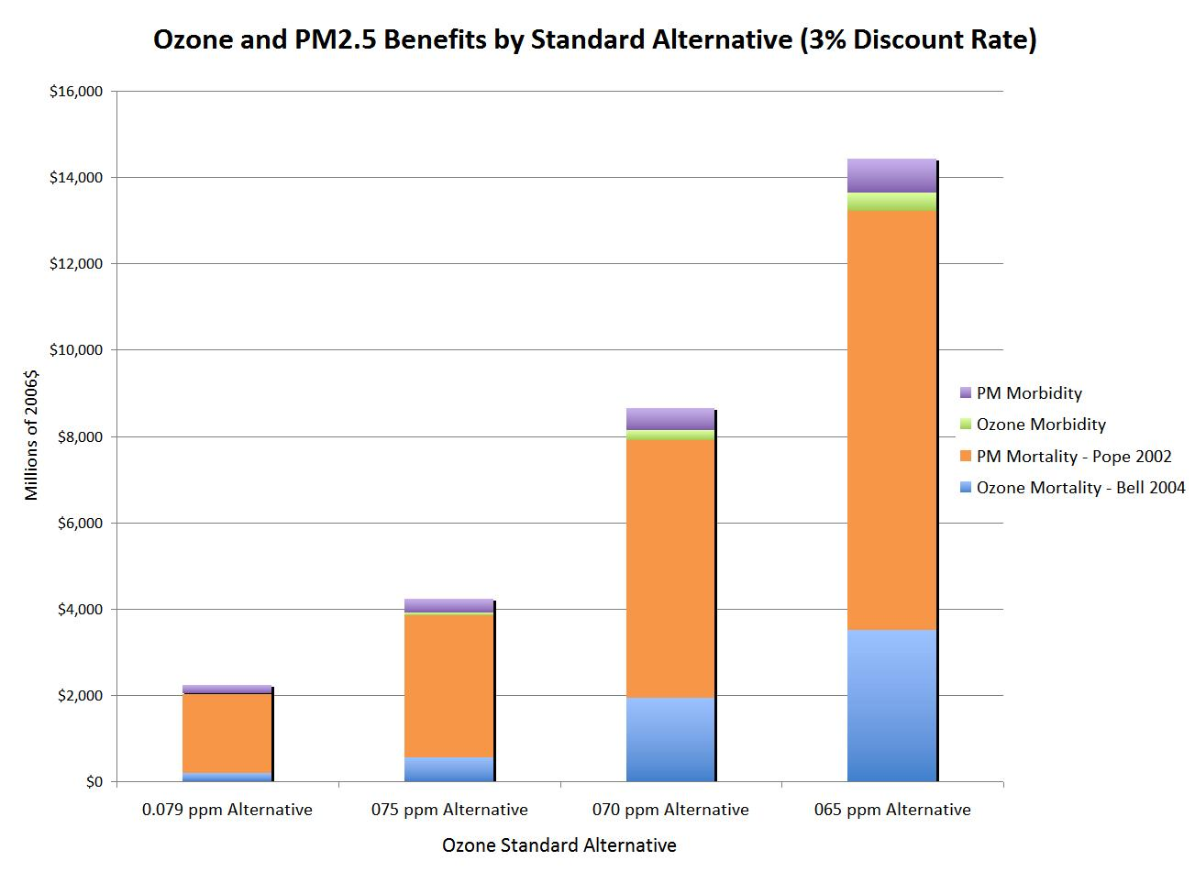
Figure 7.3 graphically shows the breakdown between ozone and PM morbidity and mortality monetized benefits for one example combination with PM benefits discounted at 3% and 7%, respectively. This example combination of Bell 2004 and Pope have been used in previous RIAs and Risk Assessments.

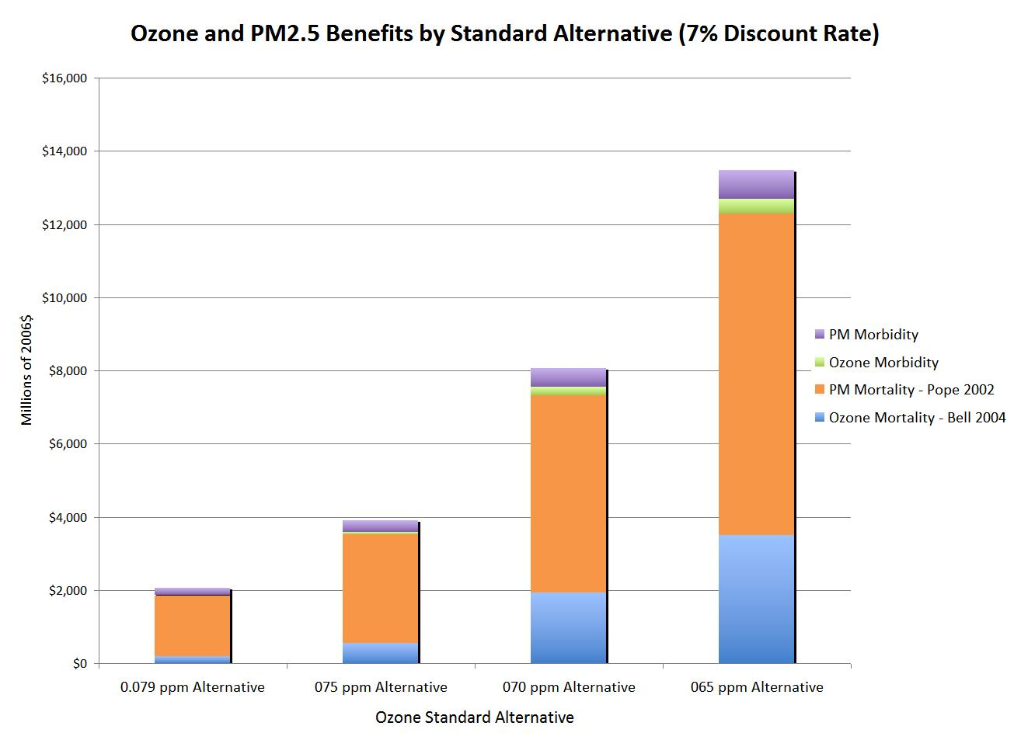

Figure 7.4: Example Combined Ozone and PM_{2.5} Monetized Benefits Estimates by Standard Alternative (3% and 7% Discount Rates)*

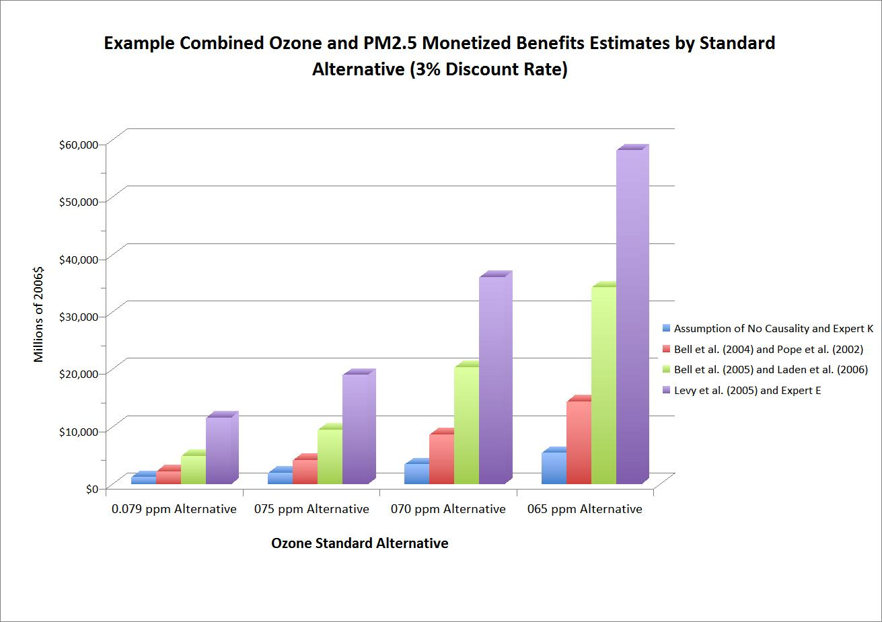
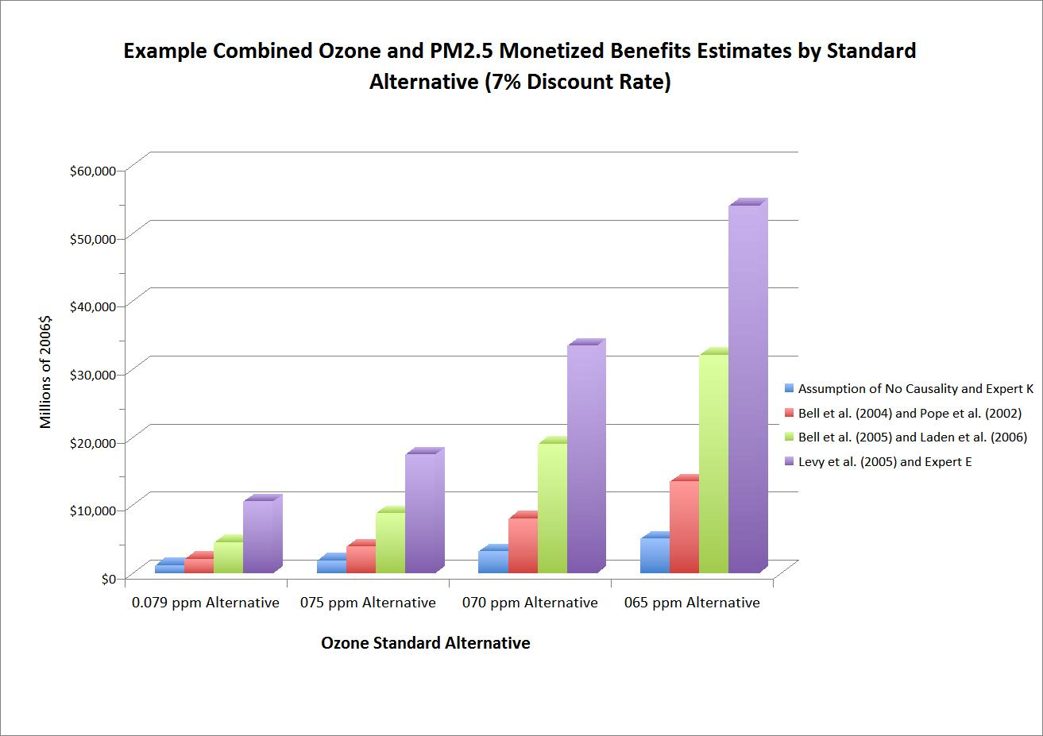
Figure 7.4 graphically shows four combinations of ozone and PM benefits estimates. These intermediate combinations represent reference points:
- Bell 2004 is the epidemiological study that underlies the ozone NAAQS risk assessment and Pope is the PM mortality function that was in several EPA RIAs, and
- Bell 2005 is one of three ozone meta-analyses and Laden is a more recent PM epidemiological study that was used as an alternative in the PM NAAQS RIA
Figure 7.5 and Figure 7.6 show the complete range of combinations of ozone and PM mortality functions at 3 and 7 percent, respectively. These graphs display all possible combinations of benefits, utilizing the five different ozone functions and the fourteen different PM functions, for each standard alternative. Each of the 70 bars represents an independent and equally probably point estimate of benefits under a certain combination of ozone and PM functions. Thus it is not possible to infer the likelihood of any single benefit estimate.
Figure 7.5:*
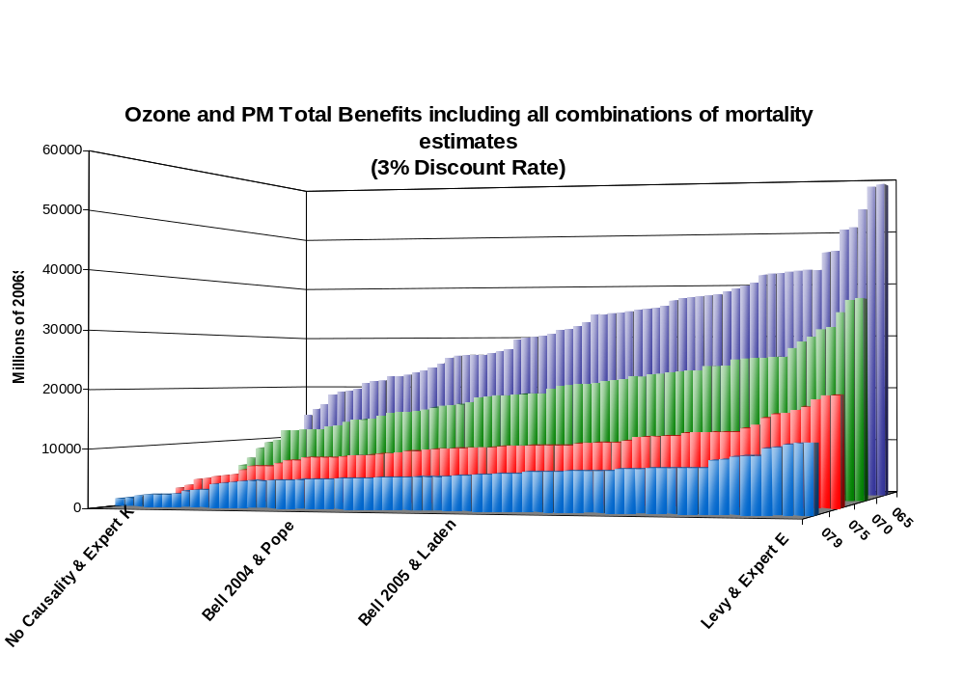

* These figures reflect full attainment in all locations of the U.S. except two areas of California. These two areas, which have high levels of ozone, are not planning to meet the current standard until after 2020. The estimates in the table do not reflect benefits for the San Joaquin and South Coast Air Basins. No causality, Bell, and Levy represent ozone estimates. Expert K, Pope, Laden, and Expert E represent PM estimates.

Figure 7.6*:
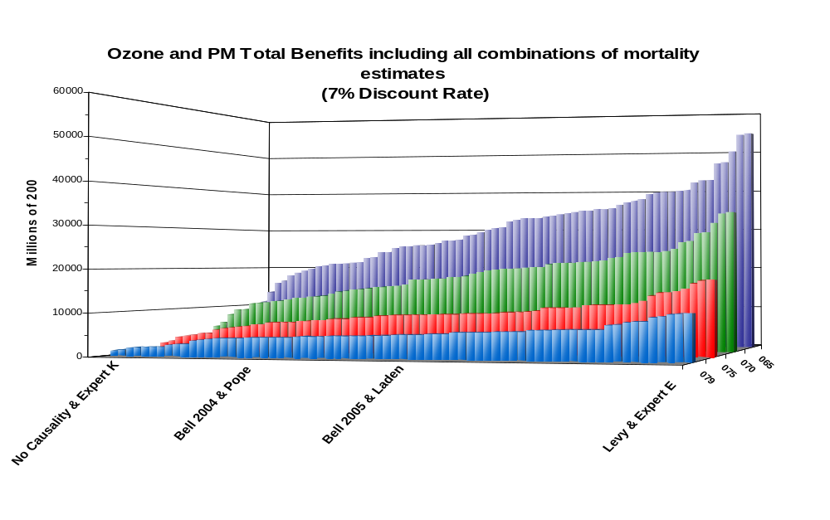

* These figures reflect full attainment in all locations of the U.S. except two areas of California. These two areas, which have high levels of ozone, are not planning to meet the current standard until after 2020. The estimates in the table do not reflect benefits for the San Joaquin and South Coast Air Basins. No causality, Bell, and Levy represent ozone estimates. Expert K, Pope, Laden, and Expert E represent PM estimates.

7.5.4 Estimates of Visibility Benefits
Table 7-50 below summarizes the regional distribution of visibility benefits in Class I areas in 2020. Note that these estimates represent the monetized visibility benefits associated with the modeled ozone emission control strategy, and do not reflect the visibility benefits of fully attaining the 0.075 ppm selected alternative. For this reason, they are not added to the human health-based benefits estimates. The methodology we followed to generate these estimates may be found in the PM_{2.5} RIA (EPA, 2006)
Table 7-50: Monetary Benefits Associated with Visibility Improvements from the 0.070 Simulated Ozone Attainment Strategy in Selected Federal Class I Areas in 2020 (in millions of 2006$)^{A}
California | Southwest | Southeast | Total
$5 | $95 | $56 | $160
^{A} All estimates are rounded to 2 significant digits. All rounding occurs after final summing of unrounded estimates. As such, totals will not sum across columns.

7.5.5 Discussion of Results and Uncertainties
The results of this analysis suggest there will be significant additional health and welfare benefits arising from reducing emissions from a variety of sources in and around projected nonattaining counties in 2020. While 2020 is the expected date that states would need to demonstrate attainment with the revised standard, it is expected that benefits (and costs) will begin occurring much earlier, as states begin implementing control measures to show reasonable progress towards attainment. Using the full range of benefits (including the results of the expert elicitation), we estimate that total ozone benefits and PM_{2.5} co-benefits would be between $2.0 and $19 billion annually for the 0.075 ppm selected alternative when the emissions reductions from implementing the new standard are fully realized. The magnitude of these estimated benefits provide additional evidence of the important role that implementation of the standards plays in reducing the health risks associated with exceeding the standard.
There are several important factors to consider when evaluating the relative benefits of the attainment strategies for each of the alternative ozone standards:
1. California (outside of San Joaquin Valley and South Coast) accounts for a substantial share of the total benefits for each of the evaluated standards. Benefits are most uncertain for California due to the unique challenge of modeling attainment with the standards in this state. These challenges include high levels of ozone, difficulties in modeling the impacts of emissions controls on air quality, and the very large proportion of California benefits that were derived through extrapolation. On the one hand, these California benefits are likely to understate the actual benefits of attainment strategies, because we applied an estimation approach that reduced concentrations only at the specific violating monitors and not surrounding monitors that did not violate the standards. The magnitude of this underestimate is unknown. On the other hand, it is possible that new technologies might not meet the specifications, development timelines, or cost estimates provided in this analysis, thereby increasing the uncertainty in when and if such benefits would be truly achieved.
2. The extrapolation and interpolation techniques used to estimate the full attainment benefits of the selected and three alternate standards contributed some uncertainty to the analysis. The great majority of benefits estimated for the 0.065 ppm standard alternative were derived through extrapolation. As noted previously in this chapter, these benefits are likely to be more uncertain than the modeled benefits. The 0.075 ppm and 0.079 ppm benefits were derived by interpolating the full attainment benefits of the 0.070 ppm alternative (a process which is described in Appendix 7a). This approach may under- or over-estimate benefits if the actual geographic distribution of air quality changes is different than that assumed in the interpolation.
3. There are a variety of uncertainties associated with the health impact functions used in this modeling effort. These include: within study variability, which is the precision with which a given study estimates the relationship between air quality changes and health effects; across study variation, which refers to the fact that different published studies of the same pollutant/health effect relationship typically do not report identical findings and in some instances the differences are substantial; the application of C-R functions nationwide, which does not account for any relationship between region and health effect, to the extent that such a relationship exists; extrapolation of impact functions across population, in which we assumed that certain health impact functions applied to age ranges broader than that considered in the original epidemiological study; and, finally, there are various uncertainties in the C-R function, including causality, the correlation among multiple pollutants, the shape of the C-R function and the relative toxicity of PM component species, and the lag between exposure and the onset of the health effect.
4. There are a variety of uncertainties associated with the economic valuation of the health endpoints estimated in this analysis. Uncertainties specific to the valuation of premature mortality include across study variation; the assumption that WTP for mortality risk reduction is linear; assuming that voluntary and involuntary mortality risk will be valued equally; assuming that premature mortality from air pollution risk, which tend to involve longer periods of time, will be valued the same as short catastrophic events; the possibility for self-selection in avoiding risk, which may bias WTP estimates upward.
5. This analysis includes estimates of PM_{2.5} co-benefits that were derived through benefit per-ton estimates. These benefit per-ton estimates represent regional averages. As such, they do not reflect any local variability in the incremental PM_{2.5} benefits per ton of NOx abated. As discussed in the PM_{2.5} NAAQS RIA (Table 5.5), there are a variety of uncertainties associated with these PM benefits.
6. PM_{2.5} co-benefits represent a substantial proportion of total benefits. For the 0.075 ppm selected standard, we estimate co-benefits from PM to be between 42% and 99% of total benefits, depending on the PM_{2.5} and ozone mortality functions used. When calculating PM_{2.5} co-benefits we assume that states will pursue an ozone strategy that reduces NOx emissions. As such, these estimates are strongly influenced by the assumption that all PM components are equally toxic. We also acknowledge that when implementing any new standard, states may elect to pursue a different ozone strategy, which would in turn affect the level of PM_{2.5} co-benefits.
7. Projecting key variables introduces uncertainty. Inherent in any analysis of future regulatory programs are uncertainties in projecting atmospheric conditions and source-level emissions, as well as population, health baselines, incomes, technology, and other factors. In addition, data limitations prevent an overall quantitative estimate of the uncertainty associated with estimates of total economic benefits. If one is mindful of these limitations, the magnitude of the benefits estimates presented here can be useful information in expanding the understanding of the public health impacts of reducing ozone precursor emissions.
8. This analysis omits certain unquantified effects due to lack of data, time and resources. These unquantified endpoints include the direct effects of ozone on vegetation, the deposition of nitrogen to estuarine and coastal waters and agricultural and forested land, and the changes in the level of exposure to ultraviolet radiation from ground level ozone. EPA will continue to evaluate new methods and models and select those most appropriate for estimating the health benefits of reductions in air pollution. It is important to continue improving benefits transfer methods in terms of transferring economic values and transferring estimated impact functions. The development of both better models of current health outcomes and new models for additional health effects such as asthma, high blood pressure, and adverse birth outcomes (such as low birth weight) will be essential to future improvements in the accuracy and reliability of benefits analyses (Guo et al., 1999; Ibald-Mulli et al., 2001). Enhanced collaboration between air quality modelers, epidemiologists, toxicologists, and economists should result in a more tightly integrated analytical framework for measuring health benefits of air pollution policies. Readers interested in a more extensive discussion of the sources of uncertainty in human health benefits analyses should consult the PM NAAQS RIA.

7.5.6 Summary of Total Benefits
Table 7.51 presents the total number of estimated ozone and PM_{2.5}-related premature mortalities and morbidities avoided nationwide in 2020. Ranges within the mortality section reflect variability in the studies upon which the estimates associated with premature mortality were derived. The lower end of the range reflects the Expert K derived mortality functions, and the upper end of the range reflects the Expert E derived mortality functions. Figure 7.7 graphically presents the total number of estimated ozone and PM_{2.5}-related premature mortalities avoided in 2020 by standard. Tables 7.52 through 7.56 show the overall ozone, PM, and combined results with regional breakdowns.
Table 7.51: Summary of Total Number of Annual Ozone and PM_{2.5} -Related Premature Mortalities and Premature Morbidity Avoided in 2020^{A}
Combined Estimate of Mortality
 |  | Combined Range of Ozone Benefits and PM_{2.5} Co-benefits by Standard Alternative^{D}
Model or Assumption |  | 0.079 ppm |  |  | 0.075 ppm |  |  | 0.070 ppm |  |  | 0.65 ppm
NMAPS | Bell (2004) | 140 | to | 1,300 | 260 | to | 2,000 | 560 | to | 3,500 | 940 | to | 5,500
 | Bell (2005) | 200 | to | 1,300 | 420 | to | 2,200 | 1,100 | to | 4,100 | 2,000 | to | 6,500
Meta-analysis | Ito | 230 | to | 1,400 | 500 | to | 2,300 | 1,400 | to | 4,300 | 2,500 | to | 7,000
 | Levy | 230 | to | 1,400 | 510 | to | 2,300 | 1,400 | to | 4,400 | 2,500 | to | 7,100
No Causality |  | 120 | to | 1,200 | 190 | to | 2,000 | 310 | to | 3,200 | 490 | to | 5,000
Combined Estimate of Morbidity |  | Combined Ozone Benefits and PM_{2.5} Co-benefits by Standard Alternative
Acute Myocardial Infarction^{B} |  | 570 |  |  | 890 |  |  | 1,500 |  |  | 2,300
Upper Respiratory Symptoms^{B} |  | 3,100 |  |  | 4,900 |  |  | 8,100 |  |  | 13,000
Lower Respiratory Symptoms^{B} |  | 4,200 |  |  | 6,700 |  |  | 11,000 |  |  | 17,000
Chronic Bronchitis^{B} |  | 240 |  |  | 380 |  |  | 630 |  |  | 970
Acute Bronchitis^{B} |  | 640 |  |  | 1,000 |  |  | 1,700 |  |  | 2,600
Asthma Exacerbation^{B} |  | 3,900 |  |  | 6,100 |  |  | 10,000 |  |  | 16,000
Work Loss Days^{B} |  | 28,000 |  |  | 43,000 |  |  | 72,000 |  |  | 110,000
School Loss Days^{C} |  | 72,000 |  |  | 200,000 |  |  | 640,000 |  |  | 1,100,000
Hospital and ER Visits |  | 890 |  |  | 1,900 |  |  | 5,100 |  |  | 9,400
Minor Restricted Activity Days |  | 340,000 |  |  | 750,000 |  |  | 2,100,000 |  |  | 3,500,000
^{A} Does not reflect estimates for the San Joaquin and South Coast Air Basins
^{B} PM-related benefits only
^{C} Ozone-related benefits only
^{D} Includes ozone benefits, and PM_{2.5} co-benefits. Range was developed by adding the estimate from the ozone premature mortality function to both the lower and upper ends of the range of the PM_{2.5} premature mortality functions characterized in the expert elicitation described in Chapter 7

Figure 7.7: Total Annual Ozone and PM_{2.5}-Related Premature Mortalities Avoided in 2020 by Standard Alternative
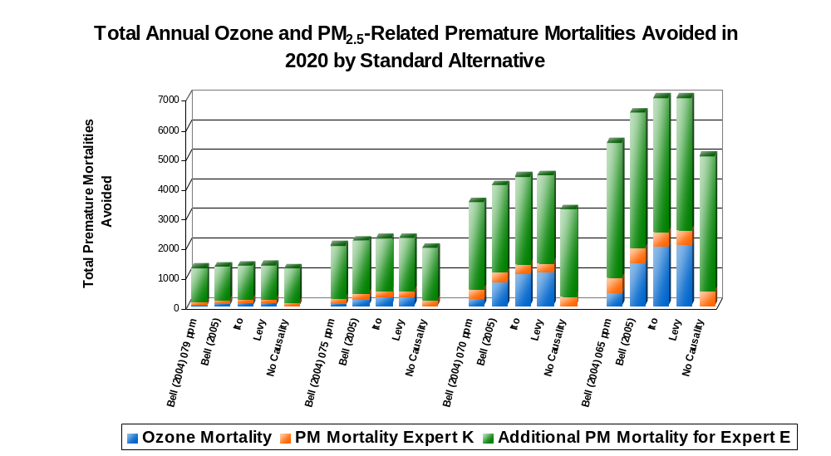
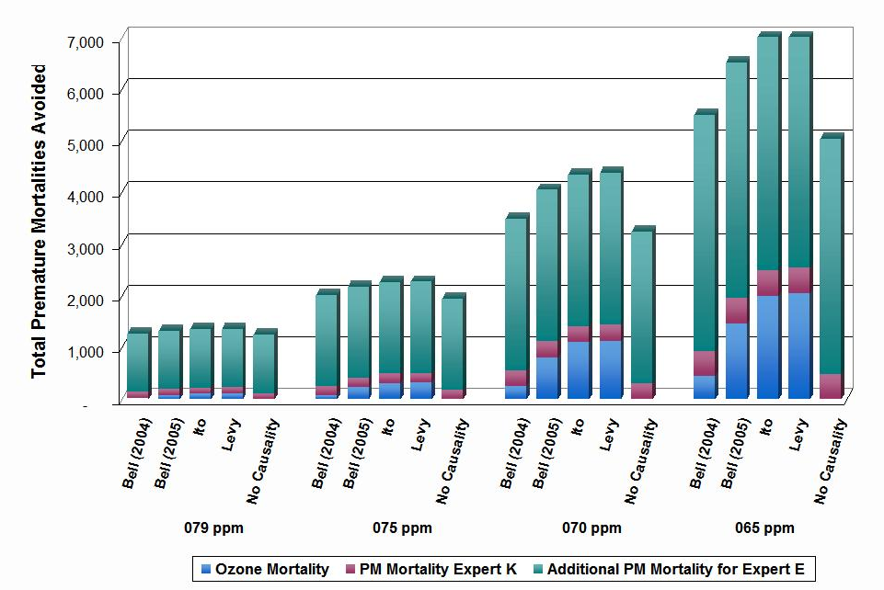

Table 7.52: Regional Breakdown of Annual Ozone Benefit Results by Health Endpoint in 2020 (thousands of 2006$)*
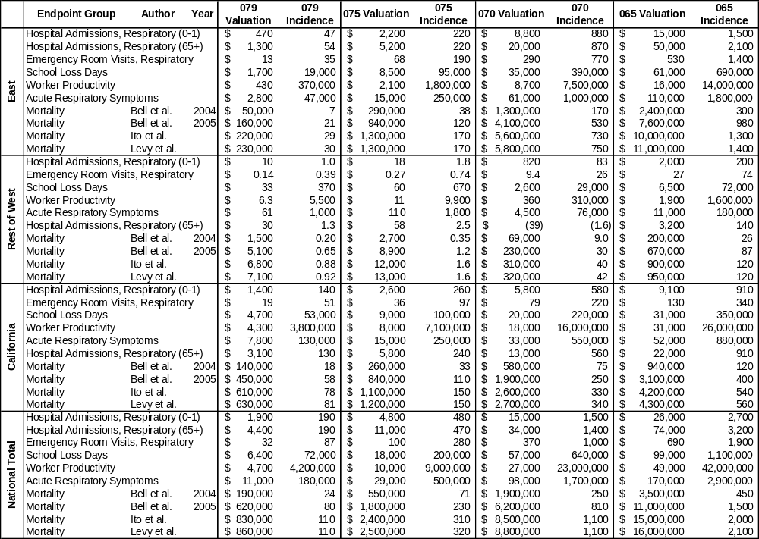
* National Total does not reflect benefits for the South Coast and San Joaquin Air Basins. Confidence intervals not available for PM estimates. All estimates rounded to two significant figures. Valuation results for mortality and nonfatal myocardial infarctions are shown at a 3% discount rate. Does not include visibility benefits.
Table 7.53: Regional Breakdown of Annual PM Benefit Results by Health Endpoint in 2020 (thousands of 2006$) at 3%*
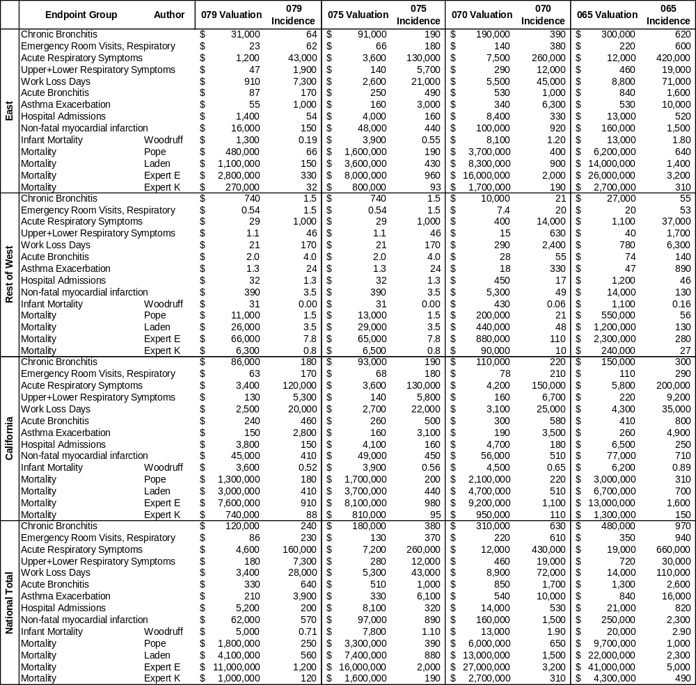
* National Total does not reflect benefits for the South Coast and San Joaquin Air Basins. Confidence intervals not available for PM estimates. All estimates rounded to two significant figures. Valuation results for mortality and nonfatal myocardial infarctions are shown at a 3% discount rate. PM incidence and other PM morbidity incidence and valuation estimates are identical to Table 7.54 because these are not discounted. Does not include visibility benefits.
Table 7.54: Regional Breakdown of Annual PM Benefit Results by Health Endpoint in 2020 (thousands of 2006$) at 7%*
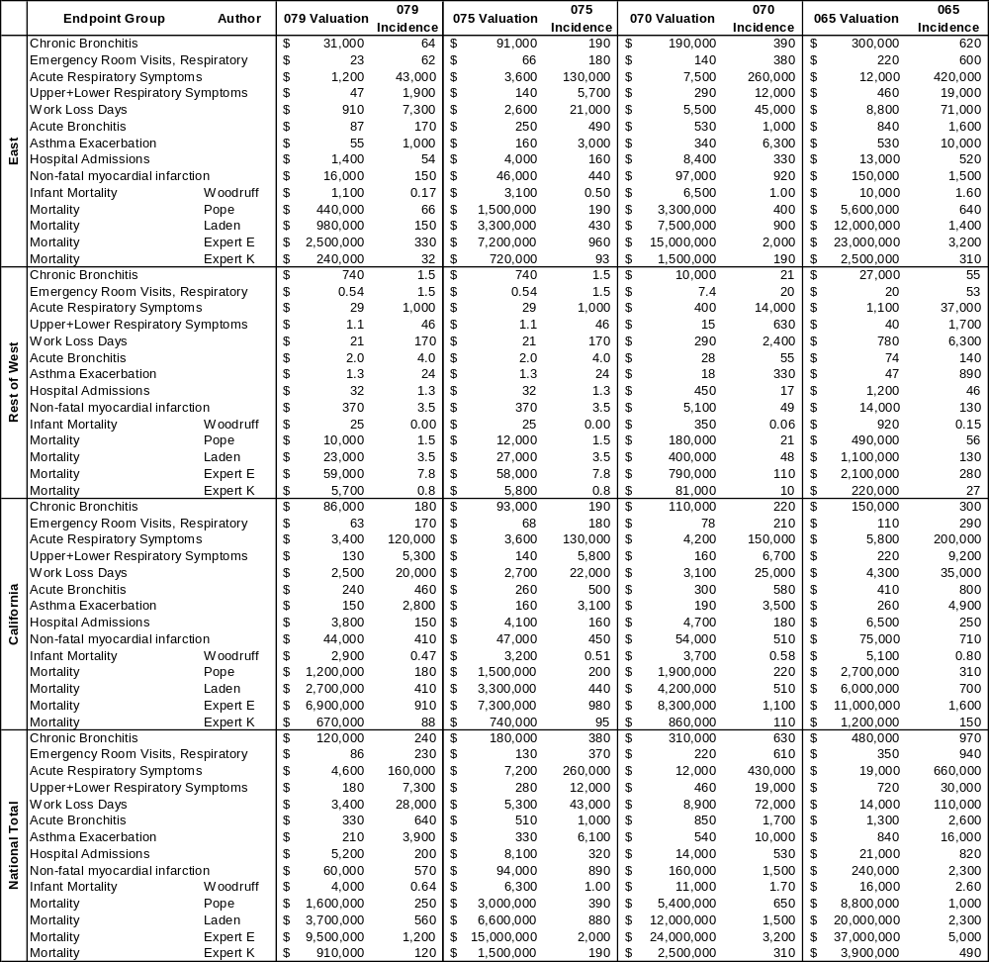
* National Total does not reflect benefits for the South Coast and San Joaquin Air Basins. Confidence intervals not available for PM estimates. All estimates rounded to two significant figures. Valuation results for mortality and nonfatal myocardial infarctions are shown at a 7% discount rate. PM incidence and other PM morbidity incidence and valuation estimates are identical to Table 7.53 because these are not discounted. Does not include visibility benefits.
Table 7.55: Regional Breakdown of Annual Ozone and PM Benefit Results by Health Endpoint in 2020 (3% discount rate, thousands of 2006$)*
 | Endpoint Group | Author | Year | 079 Valuation | 075 Valuation | 070 Valuation | 065 Valuation
East | Ozone Morbidity (non-causal) |  |  | $6,600 | $33,000 | $130,000 | $250,000
East | Ozone Mortality | Bell | 2004 | $50,000 | $290,000 | $1,300,000 | $2,400,000
East | Ozone Mortality | Bell | 2005 | $160,000 | $940,000 | $4,100,000 | $7,600,000
East | Ozone Mortality | Ito | 2005 | $220,000 | $1,300,000 | $5,600,000 | $10,000,000
East | Ozone Mortality | Levy | 2005 | $230,000 | $1,300,000 | $5,800,000 | $11,000,000
East | PM Infant Mortality | Woodruff |  | $1,300 | $3,900 | $8,100 | $13,000
East | PM Morbidity |  |  | $51,000 | $150,000 | $310,000 | $500,000
East | PM Mortality | Pope |  | $480,000 | $1,600,000 | $3,700,000 | $6,200,000
East | PM Mortality | Laden |  | $1,100,000 | $3,600,000 | $8,300,000 | $14,000,000
East | PM Mortality | Expert E |  | $2,800,000 | $8,000,000 | $16,000,000 | $26,000,000
East | PM Mortality | Expert K |  | $270,000 | $800,000 | $1,700,000 | $2,700,000
Rest of West | Ozone Morbidity (non-causal) |  |  | $140 | $260 | $8,200 | $24,000
Rest of West | Ozone Mortality | Bell | 2004 | $1,500 | $2,700 | $69,000 | $200,000
Rest of West | Ozone Mortality | Bell | 2005 | $5,100 | $8,900 | $230,000 | $670,000
Rest of West | Ozone Mortality | Ito | 2005 | $6,800 | $12,000 | $310,000 | $900,000
Rest of West | Ozone Mortality | Levy | 2005 | $7,100 | $13,000 | $320,000 | $950,000
Rest of West | PM Infant Mortality | Woodruff |  | $31 | $31 | $430 | $1,100
Rest of West | PM Morbidity |  |  | $1,200 | $1,200 | $17,000 | $44,000
Rest of West | PM Mortality | Pope |  | $11,000 | $13,000 | $200,000 | $550,000
Rest of West | PM Mortality | Laden |  | $26,000 | $29,000 | $440,000 | $1,200,000
Rest of West | PM Mortality | Expert E |  | $66,000 | $65,000 | $880,000 | $2,300,000
Rest of West | PM Mortality | Expert K |  | $6,300 | $6,500 | $90,000 | $240,000
California | Ozone Morbidity (non-causal) |  |  | $21,000 | $40,000 | $90,000 | $140,000
California | Ozone Mortality | Bell | 2004 | $140,000 | $260,000 | $580,000 | $940,000
California | Ozone Mortality | Bell | 2005 | $450,000 | $840,000 | $1,900,000 | $3,100,000
California | Ozone Mortality | Ito | 2005 | $610,000 | $1,100,000 | $2,600,000 | $4,200,000
California | Ozone Mortality | Levy | 2005 | $630,000 | $1,200,000 | $2,700,000 | $4,300,000
California | PM Infant Mortality | Woodruff |  | $3,600 | $3,900 | $4,500 | $6,200
California | PM Morbidity |  |  | $140,000 | $150,000 | $180,000 | $240,000
California | PM Mortality | Pope |  | $1,300,000 | $1,700,000 | $2,100,000 | $3,000,000
California | PM Mortality | Laden |  | $3,000,000 | $3,700,000 | $4,700,000 | $6,700,000
California | PM Mortality | Expert E |  | $7,600,000 | $8,100,000 | $9,200,000 | $13,000,000
California | PM Mortality | Expert K |  | $740,000 | $810,000 | $950,000 | $1,300,000
National Total | Ozone Morbidity (non-causal) |  |  | $28,000 | $73,000 | $230,000 | $420,000
National Total | Ozone Mortality | Bell | 2004 | $190,000 | $550,000 | $1,900,000 | $3,500,000
National Total | Ozone Mortality | Bell | 2005 | $620,000 | $1,800,000 | $6,200,000 | $11,000,000
National Total | Ozone Mortality | Ito | 2005 | $830,000 | $2,400,000 | $8,500,000 | $15,000,000
National Total | Ozone Mortality | Levy | 2005 | $860,000 | $2,500,000 | $8,800,000 | $16,000,000
National Total | PM Infant Mortality | Woodruff |  | $5,000 | $7,800 | $13,000 | $20,000
National Total | PM Morbidity |  |  | $190,000 | $300,000 | $500,000 | $780,000
National Total | PM Mortality | Pope |  | $1,800,000 | $3,300,000 | $6,000,000 | $9,700,000
National Total | PM Mortality | Laden |  | $4,100,000 | $7,400,000 | $13,000,000 | $22,000,000
National Total | PM Mortality | Expert E |  | $11,000,000 | $16,000,000 | $27,000,000 | $41,000,000
National Total | PM Mortality | Expert K |  | $1,000,000 | $1,600,000 | $2,700,000 | $4,300,000
* Totals do not reflect benefits for the South Coast and San Joaquin Air Basins. Confidence intervals not available for PM estimates. All estimates rounded to two significant figures. Valuation results for mortality and nonfatal myocardial infarctions are shown at a 3% discount rate. Does not include visibility benefits.
Table 7.56: Regional Breakdown of Annual Ozone and PM Benefit Results by Health Endpoint in 2020 (7% discount rate, thousands of 2006$)*
 | Endpoint Group | Author | Year | 079 Valuation | 075 Valuation | 070 Valuation | 065 Valuation
East | Ozone Morbidity (non-causal) |  |  | $6,600 | $33,000 | $130,000 | $250,000
East | Ozone Mortality | Bell | 2004 | $50,000 | $290,000 | $1,300,000 | $2,400,000
East | Ozone Mortality | Bell | 2005 | $160,000 | $940,000 | $4,100,000 | $7,600,000
East | Ozone Mortality | Ito | 2005 | $220,000 | $1,300,000 | $5,600,000 | $10,000,000
East | Ozone Mortality | Levy | 2005 | $230,000 | $1,300,000 | $5,800,000 | $11,000,000
East | PM Infant Mortality | Woodruff |  | $1,100 | $3,100 | $6,500 | $10,000
East | PM Morbidity |  |  | $51,000 | $150,000 | $310,000 | $490,000
East | PM Mortality | Pope |  | $440,000 | $1,500,000 | $3,300,000 | $5,600,000
East | PM Mortality | Laden |  | $980,000 | $3,300,000 | $7,500,000 | $12,000,000
East | PM Mortality | Expert E |  | $2,500,000 | $7,200,000 | $15,000,000 | $23,000,000
East | PM Mortality | Expert K |  | $240,000 | $720,000 | $1,500,000 | $2,500,000
Rest of West | Ozone Morbidity (non-causal) |  |  | $140 | $260 | $8,200 | $24,000
Rest of West | Ozone Mortality | Bell | 2004 | $1,500 | $2,700 | $69,000 | $200,000
Rest of West | Ozone Mortality | Bell | 2005 | $5,100 | $8,900 | $230,000 | $670,000
Rest of West | Ozone Mortality | Ito | 2005 | $6,800 | $12,000 | $310,000 | $900,000
Rest of West | Ozone Mortality | Levy | 2005 | $7,100 | $13,000 | $320,000 | $950,000
Rest of West | PM Infant Mortality | Woodruff |  | $25 | $25 | $350 | $920
Rest of West | PM Morbidity |  |  | $1,200 | $1,200 | $16,000 | $44,000
Rest of West | PM Mortality | Pope |  | $10,000 | $12,000 | $180,000 | $490,000
Rest of West | PM Mortality | Laden |  | $23,000 | $27,000 | $400,000 | $1,100,000
Rest of West | PM Mortality | Expert E |  | $59,000 | $58,000 | $790,000 | $2,100,000
Rest of West | PM Mortality | Expert K |  | $5,700 | $5,800 | $81,000 | $220,000
California | Ozone Morbidity (non-causal) |  |  | $21,000 | $40,000 | $90,000 | $140,000
California | Ozone Mortality | Bell | 2004 | $140,000 | $260,000 | $580,000 | $940,000
California | Ozone Mortality | Bell | 2005 | $450,000 | $840,000 | $1,900,000 | $3,100,000
California | Ozone Mortality | Ito | 2005 | $610,000 | $1,100,000 | $2,600,000 | $4,200,000
California | Ozone Mortality | Levy | 2005 | $630,000 | $1,200,000 | $2,700,000 | $4,300,000
California | PM Infant Mortality | Woodruff |  | $2,900 | $3,200 | $3,700 | $5,100
California | PM Morbidity |  |  | $140,000 | $150,000 | $180,000 | $240,000
California | PM Mortality | Pope |  | $1,200,000 | $1,500,000 | $1,900,000 | $2,700,000
California | PM Mortality | Laden |  | $2,700,000 | $3,300,000 | $4,200,000 | $6,000,000
California | PM Mortality | Expert E |  | $6,900,000 | $7,300,000 | $8,300,000 | $11,000,000
California | PM Mortality | Expert K |  | $670,000 | $740,000 | $860,000 | $1,200,000
National Total | Ozone Morbidity (non-causal) |  |  | $28,000 | $73,000 | $230,000 | $420,000
National Total | Ozone Mortality | Bell | 2004 | $190,000 | $550,000 | $1,900,000 | $3,500,000
National Total | Ozone Mortality | Bell | 2005 | $620,000 | $1,800,000 | $6,200,000 | $11,000,000
National Total | Ozone Mortality | Ito | 2005 | $830,000 | $2,400,000 | $8,500,000 | $15,000,000
National Total | Ozone Mortality | Levy | 2005 | $860,000 | $2,500,000 | $8,800,000 | $16,000,000
National Total | PM Infant Mortality | Woodruff |  | $4,000 | $6,300 | $11,000 | $16,000
National Total | PM Morbidity |  |  | $190,000 | $300,000 | $500,000 | $780,000
National Total | PM Mortality | Pope |  | $1,600,000 | $3,000,000 | $5,400,000 | $8,800,000
National Total | PM Mortality | Laden |  | $3,700,000 | $6,600,000 | $12,000,000 | $20,000,000
National Total | PM Mortality | Expert E |  | $9,500,000 | $15,000,000 | $24,000,000 | $37,000,000
National Total | PM Mortality | Expert K |  | $910,000 | $1,500,000 | $2,500,000 | $3,900,000
* Totals do not reflect benefits for the South Coast and San Joaquin Air Basins. Confidence intervals not available for PM estimates. All estimates rounded to two significant figures. Valuation results for mortality and nonfatal myocardial infarctions are shown at a 7% discount rate. Does not include visibility benefits.

7.6 References:
Abt Associates, Inc. October 2005. Methodology for County-level Mortality Rate Projections. Memorandum to Bryan Hubbell and Zachary Pekar, U.S. EPA.
Adams PF, Hendershot GE, Marano MA. 1999. Current Estimates from the National Health Interview Survey, 1996. Vital Health Stat 10(200):1-212.
Agency for Healthcare Research and Quality. 2000. HCUPnet, Healthcare Cost and Utilization Project. Rockville, Maryland. Available: http://www.ahrq.gov/HCUPnet/ [accessed 29 September 2004].
Anderson HR, Atkinson RW, Peacock JL, Marston L, Konstantinou K. 2004. Meta-analysis of time-series studies and panel studies of Particulate Matter (PM) and Ozone (O3): Report of a WHO task group. Copenhagen, Denmark: World Health Organization.
Bell, M.L., et al. Ozone and short-term mortality in 95 US urban communities, 1987-2000. Jama, 2004. 292(19): p. 2372-8.
Bell, M.L., F. Dominici, and J.M. Samet. A meta-analysis of time-series studies of ozone and mortality with comparison to the national morbidity, mortality, and air pollution study. Epidemiology, 2005. 16(4): p. 436-45.
Berger MC, Blomquist GC, Kenkel D, Tolley GS. 1987. Valuing Changes in Health Risks: A Comparison of Alternative Measures. The Southern Economic Journal 53:977-984.
Burnett RT, Smith-Doiron M, Stieb D, Raizenne ME, Brook JR, Dales RE, et al. 2001. Association between ozone and hospitalization for acute respiratory diseases in children less than 2 years of age. Am J Epidemiol 153(5):444-452.
Chen L, Jennison BL, Yang W, Omaye ST. 2000. Elementary school absenteeism and air pollution. Inhal Toxicol 12(11):997-1016.
Crocker, T.D. and R.L. Horst, Jr. Hours of Work, Labor Productivity, and Environmental Conditions: A Case Study. The Review of Economics and Statistics, 1981. 63: p. 361-368.
Freeman(III), AM. 1993. The Measurement of Environmental and Resource Values: Theory and Methods. Washington, DC: Resources for the Future.
Gilliland FD, Berhane K, Rappaport EB, Thomas DC, Avol E, Gauderman WJ, et al. 2001. The effects of ambient air pollution on school absenteeism due to respiratory illnesses. Epidemiology 12(1):43-54.
GeoLytics Inc. 2002. Geolytics CensusCD® 2000 Short Form Blocks. CD-ROM Release 1.0. GeoLytics, Inc. East Brunswick, NJ. Available: http://www.geolytics.com/ [accessed 29 September 2004].
Hall JV, Brajer V, Lurmann FW. 2003. Economic Valuation of Ozone-related School Absences in the South Coast Air Basin of California. Contemporary Economic Policy 21(4):407-417.
Harrington W, Portney PR. 1987. Valuing the Benefits of Health and Safety Regulation. Journal of Urban Economics 22:101-112.
Industrial Economics Incorporated (IEc). 1993. Memorandum to Jim DeMocker, U.S. Environmental Protection Agency, Office of Air and Radiation, Office of Policy Analysis and Review. September 30. Washington, D.C.
International Classification of Diseases, Ninth Revision. 1979. Hyattsville, MD: National Center for Health Statistics. Available: http://www.cdc.gov/nchs/about/major/dvs/icd9des.htm [accessed 29 September 2004].
Ito, K., S.F. De Leon, and M. Lippmann. Associations between ozone and daily mortality: analysis and meta-analysis. Epidemiology, 2005. 16(4): p. 446-57.
Jaffe DH, Singer ME, Rimm AA. 2003. Air pollution and emergency department visits for asthma among Ohio Medicaid recipients, 1991-1996. Environ Res 91(1):21-28.
Köchy, Martin and Scott D. Wilson, “Nitrogen deposition and forest expansion in the northern Great Plains Journal of Ecology Journal of Ecology 89 (5), 807–817
Kunzli, N., S. Medina, R. Kaiser, P. Quenel, F. Horak Jr, and M. Studnicka. 2001. “Assessment of Deaths Attributable to Air Pollution: Should We Use Risk Estimates Based on Time Series or on Cohort Studies?” American Journal of Epidemiology 153(11):1050-55.
Levy JI, Carrothers TJ, Tuomisto JT, Hammitt JK, Evans JS. 2001. Assessing the Public Health Benefits of Reduced Ozone Concentrations. Environ Health Perspect 109(12):1215-1226
Levy, J.I., S.M. Chemerynski, and J.A. Sarnat. Ozone exposure and mortality: an empiric bayes metaregression analysis. Epidemiology, 2005. 16(4): p. 458-68.
Moolgavkar SH, Luebeck EG, Anderson EL. 1997. Air pollution and hospital admissions for respiratory causes in Minneapolis St. Paul and Birmingham. Epidemiology 8(4):364-370.
National Research Council (NRC). 2002. Estimating the Public Health Benefits of Proposed Air Pollution Regulations. The National Academies Press: Washington, D.C.
Ostro BD, Rothschild S. 1989. Air Pollution and Acute Respiratory Morbidity—an Observational Study of Multiple Pollutants. Environ Res 50(2):238-247.
Ostro, B., M. Lipsett, J. Mann, H. Braxton-Owens, and M. White. 2001. “Air Pollution and Exacerbation of Asthma in African-American Children in Los Angeles.” Epidemiology 12(2):200-208.
Nadelhoffer, Knute J. et. al., “Nitrogen deposition makes a minor contribution to carbon sequestration in temperate forests” Nature 398, 145-148 (11 March 1999)
Peel, J. L., P. E. Tolbert, M. Klein, et al. 2005. Ambient air pollution and respiratory emergency department visits. Epidemiology. Vol. 16 (2): 164-74.
Schwartz J. 1994a. PM(10) Ozone, and Hospital Admissions For the Elderly in Minneapolis St Paul, Minnesota. Arch Environ Health 49(5):366-374.
Schwartz J. 1994b. Air Pollution and Hospital Admissions For the Elderly in Detroit, Michigan. Am J Respir Crit Care Med 150(3):648-655.
Schwartz J. 1995. Short term fluctuations in air pollution and hospital admissions of the elderly for respiratory disease. Thorax 50(5):531-538.
Smith DH, Malone DC, Lawson KA, Okamoto LJ, Battista C, Saunders WB. 1997. A national estimate of the economic costs of asthma. Am J Respir Crit Care Med. 156(3 Pt 1):787-793.
Stanford R, McLaughlin T, Okamoto LJ. 1999. The cost of asthma in the emergency department and hospital. Am J Respir Crit Care Med 160(1):211-215.
Thurston GD, Ito K. 2001. Epidemiological studies of acute ozone exposures and mortality. J Expo Anal Environ Epidemiol 11(4):286-294.
Tolley GS, Babcock L, Berger M, Bilotti A, Blomquist G, Brien M, et al. 1986. Valuation of Reductions in Human Health Symptoms and Risks. Prepared for U.S. Environmental Protection Agency. January. Washington, D.C.
U.S. Bureau of the Census. 2001. Statistical Abstract of the United States, 2001, Section 12: Labor Force, Employment, and Earnings, Table No. 521. Washington, DC.
U.S. Department of Education. 1996. The Condition of Education 1996, Indicator 42: Student Absenteeism and Tardiness. National Center for Education Statistics. Washington DC.
U.S. EPA. 1970. Clean Air Act. 40CFR50.
U.S. Environmental Protection Agency. 1999. The Benefits and Costs of the Clean Air Act, 1990-2010. Prepared for U.S. Congress by U.S. EPA, Office of Air and Radiation/Office of Policy Analysis and Review, Washington, DC, November; EPA report no. EPA-410-R-99-001.
U.S. Environmental Protection Agency, 2004. Final Regulatory Analysis: Control of Emissions from Nonroad Diesel Engines. EPA420-R-04-007. Prepared by Office of Air and Radiation. Available: http://www.epa.gov/nonroad-diesel/2004fr/420r04007.pdf [accessed 29 September 2004].
U.S. Environmental Protection Agency, 2006. Final Regulatory Impact Analysis: PM_{2.5} NAAQS. Prepared by Office of Air and Radiation. Available: http://www.epa.gov/ttn/ecas/ria.html [accessed 10 March 2008].
Vedal, S., J. Petkau, R. White, and J. Blair. 1998. “Acute Effects of Ambient Inhalable Particles in Asthmatic and Nonasthmatic Children.” American Journal of Respiratory and Critical Care Medicine 157(4):1034-1043.
Vitousek, Peter M. et. al., “Human Alteration of the Global Nitrogen Cycle: Causes and Consequences” Issues in Ecology No. 1 (Spring) 1997.
Wilson, A. M., C. P. Wake, T. Kelly, et al. 2005. Air pollution, weather, and respiratory emergency room visits in two northern New England cities: an ecological time-series study. Environ Res. Vol. 97 (3): 312-21.
Woods & Poole Economics Inc. 2001. Population by Single Year of Age CD. CD-ROM. Woods & Poole Economics, Inc. Washington, D.C.
World Health Organization (WHO). 2003. Health Aspects of Air Pollution with Particulate Matter, Ozone and Nitrogen Dioxide: Report on a WHO Working Group. World Health Organization. Bonn, Germany. EUR/03/5042688.

All subsequent estimates of full attainment ozone benefits and PM_{2.5} co-benefits found in this chapter exclude these two areas of California.
Health impact functions measure the change in a health endpoint of interest, such as hospital admissions, for a given change in ambient ozone or PM concentration
This is effectively 0.084 ppm due to current rounding conventions. When calculating benefits in this chapter we followed the rounding convention and rounded to 0.084 ppm.
U.S. EPA. 2006. Regulatory Impact Analysis, 2006 National Ambient Air Quality Standards for Particle Pollution, Chapter 5. Available at http://www.epa.gov/ttn/ecas/ria.html.
Hubbell, B., A. Hallberg, D.R. McCubbin, and E. Post. 2005. Health-Related Benefits of Attaining the 8-Hr Ozone Standard. Environmental Health Perspectives 113:73–82. U.S. EPA. 2000. Guidelines for Preparing Economic Analyses. http://yosemite1.epa.gov/ee/epa/eed.nsf/webpages/Guidelines.html/$file/Guidelines.pdf
U.S. EPA. 2000. Guidelines for Preparing Economic Analyses. http://yosemite1.epa.gov/ee/epa/eed.nsf/webpages/Guidelines.html/$file/Guidelines.pdf
The PM_{2.5} benefits presented below reflect the NOx emission reductions from the ozone control strategy. Reductions from Ocean-Going Vessels burning residual diesel fuel were included both East and West in the baseline PM co-benefits, but not included in the ozone baseline for the west. See chapter 3 for more details of this rule and its application.
U.S. Environmental Protection Agency, 2004a. Final Regulatory Analysis: Control of Emissions from Nonroad Diesel Engines. EPA420-R-04-007. Prepared by Office of Air and Radiation. Available at http://www.epa.gov/nonroad-diesel/2004fr/420r04007.pdf
U.S. Environmental Protection Agency, 2005. Regulatory Impact Analysis for the Clean Air Interstate Rule. EPA 452/-03-001. Prepared by Office of Air and Radiation. Available at: http://www.epa.gov/interstateairquality/tsd0175.pdf
U.S. Environmental Protection Agency, 2006. Regulatory Impact Analysis for the PM NAAQS. EPA Prepared by Office of Air and Radiation. Available at: http://www.epa.gov/ttn/ecas/regdata/RIAs/Chapter%205--Benefits.pdf
Expert elicitation is a formal, highly structured and well documented process whereby expert judgments, usually of multiple experts, are obtained (Ayyb, 2002).
Health impact functions measure the change in a health endpoint of interest, such as hospital admissions, for a given change in ambient ozone or PM concentration.
Industrial Economics, Inc. 2006. Expanded Expert Judgment Assessment of the Concentration-Response Relationship Between PM_{2.5} Exposure and Mortality. Prepared for EPA Office of Air Quality Planning and Standards, September. Available at: http://www.epa.gov/ttn/ecas/regdata/Uncertainty/pm_ee_report.pdf
U.S. Environmental Protection Agency, 2005. Regulatory Impact Analysis for the PM NAAQS. EPA Prepared by Office of Air and Radiation. Available at: http://www.epa.gov/ttn/ecas/regdata/RIAs/Chapter%205--Benefits.pdf pp. 5-29.
U.S. Science Advisory Board. 2004. Advisory Plans for Health Effects Analysis in the Analytical Plan for EPA’s Second Prospective Analysis –Benefits and Costs of the Clean Air Act, 1990—2020. EPA-SAB-COUNCIL-ADV-04-004.
National Research Council (NRC). 2002. Estimating the Public Health Benefits of Proposed Air Pollution Regulations. Washington, DC: The National Academies Press.
For an exhaustive review of the city-specific time-series studies considered in the ozone staff paper, see: U.S. Environmental Protection Agency, 2007. Review of the National Ambient Air Quality Standards for Ozone: Policy Assessment of Scientific and Technical Information. Prepared by the Office of Air and Radiation. Available at http://www.epa.gov/ttn/naaqs/standards/ozone/data/2007_01_ozone_staff_paper.pdf. pp. 5-36.
A credible interval is a posterior probability interval used in Bayesian statistics, which is similar to a confidence interval used in frequentist statistics.
An exposure metric is a measure of air quality calculated as the average or maximum of modeled ambient concentrations over a relevant time period, such as during the daylight hours of the “ozone season” (which is May through September for this analysis). The 24-hour average is therefore calculated as the average of all hourly ozone concentrations throughout the day (from 12am to 11:59pm). The 8-hour maximum is the maximum hourly value observed between 9am and 5pm each day. The 1-hour maximum is the maximum hourly value observed throughout an entire day.
Abt Associates, Incorporated. Environmental Benefits Mapping and Analysis Program, Technical Appendices. May 2005. pp. I-3
Booth, M.S., and C. Campbell. 2007. Spring Nitrate Flux in the Mississippi River Basin: A Landscape Model with Conservation Applications. Environ. Sci. Technol.; 2007; ASAP Web Release Date: 20-Jun-2007; (Article) DOI: 10.1021/es070179e
Peter M. Vitousek et. al., “Human Alteration of the Global Nitrogen Cycle: Causes and Consequences” Issues in Ecology No. 1 (Spring) 1997.
Knute J. Nadelhoffer et. al., “Nitrogen deposition makes a minor contribution to carbon sequestration in temperate forests” Nature 398, 145-148 (11 March 1999).
Martin Köchy and Scott D. Wilson, “Nitrogen deposition and forest expansion in the northern Great Plains Journal of Ecology Journal of Ecology 89 (5), 807–817.
National Academy of Sciences, “Radiative Forcing of Climate Change: Expanding the Concept and Addressing Uncertainties,” October 2005.
Denman, K.L., G. Brasseur, A. Chidthaisong, P. Ciais, P.M. Cox, R.E. Dickinson, D. Hauglustaine, C. Heinze, E. Holland, D. Jacob, U. Lohmann, S Ramachandran, P.L. da Silva Dias, S.C. Wofsy and X. Zhang, 2007: Couplings Between Changes in the Climate System and Biogeochemistry. In: Climate Change 2007: The Physical Science Basis. Contribution of Working Group I to the Fourth Assessment Report of the Intergovernmental Panel on Climate Change [Solomon, S., D. Qin, M. Manning, Z. Chen, M. Marquis, K.B. Averyt, M. Tignor and H.L. Miller (eds.)]. Cambridge University Press, Cambridge, United Kingdom and New York, NY, USA.
IPCC, Climate Change 2007: Climate Change Impacts, Adaptation and Vulnerability, Summary for Policymakers.
Denman, et al, 2007: Couplings Between Changes in the Climate System and Biogeochemistry. In: Climate Change 2007: The Physical Science Basis.
Note that the valuation estimates for ozone benefits are not discounted due to the fact that there is no lag between changes in exposure and premature mortality, as is calculated for PM_{2.5} benefits.
Note that the valuation estimates for ozone benefits are not discounted due to the fact that there is no lag between changes in exposure and premature mortality, as is calculated for PM_{2.5} benefits.
Final Regulatory Impact Analysis: Industrial Boilers and Process Heaters. Prepared by Office of Air and Radiation. Available: http://www.epa.gov/ttn/ecas/regdata/EIAs/chapter10.pdf [accessed 18 May 2007].
A credible interval is a posterior probability interval used in Bayesian statistics, which is similar to a confidence interval used in frequentist statistics.
Clean Air Scientific Advisory Committee’s Peer Review of the Agency’s 2nd Draft Ozone Staff Paper, October 24, 2006. EPA-CASAC-07-001. Available at http://www.epa.gov/sab/pdf/casac-07-001.pdf
National Academy of Sciences (2007) Project Scope. Estimating Mortality Risk Reduction Benefits from Decreasing Tropospheric Ozone Exposure. Division on Earth and Life Studies, Board on Environmental Studies and Toxicology. Available at http://www8.nationalacademies.org/cp/projectview.aspx?key=48768
Final Regulatory Impact Analysis: Industrial Boilers and Process Heaters. Prepared by Office of Air and Radiation. Available: http://www.epa.gov/ttn/ecas/regdata/EIAs/chapter10.pdf [accessed 18 May 2007].

