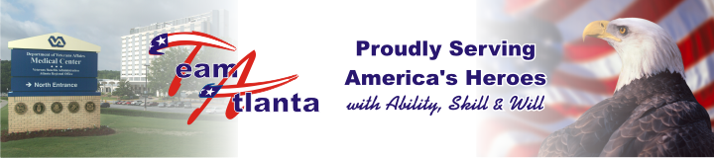
October 1, 2007
Local veterans celebrate opening of Rome Clinic

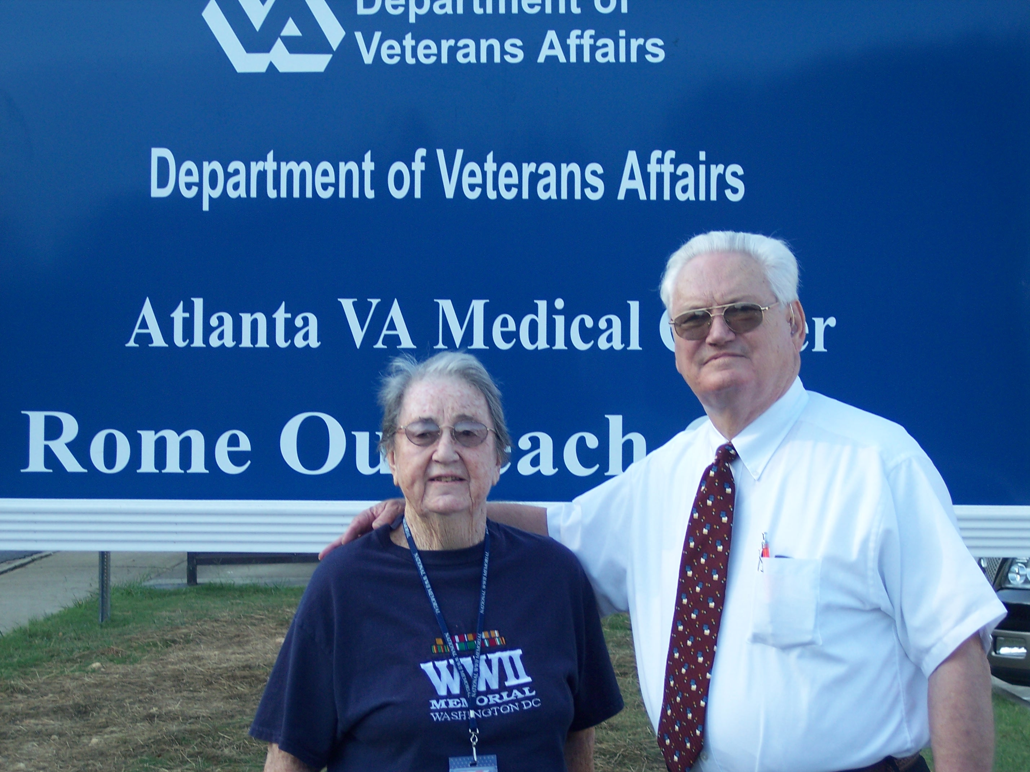
Virginia Myers and Hartwell Nolan were among the many local veterans who attended the opening of the Rome Outreach Clinic.

Northwest Georgia veterans will now have an easier time receiving health care with the opening last Friday of the new outreach clinic in Rome.
Local veterans were more than ready to celebrate, hailing the new facility as a historic and most gratifying community accomplishment.
“This is one of the greatest blessings God has ever given to me,” said Hartwell Nolan, one of the veteran leaders who worked tirelessly to make the clinic a reality.
“Everybody took this as a personal challenge to get the veterans of this area the medical care they need so badly. I think that is what got it through.”
Nolan, a 73-year-old Navy veteran, began pushing for a local VA clinic in 2005. He organized area veteran groups and gathered more than 1,500 signatures in support of the clinic.

See Rome on page 2

News Briefs

The Rome Clinic Dedication Ceremony will take place Oct 15 at 11:00 am. The clinic is located at 30 Chateau Drive, Rome, Georgia 30161. Directions to the clinic are as follows:
Take Interstate 75 north to Exit 290 (Rome)
Go west on GA 20 about two miles until it dead ends.
Turn left at the light and then make an immediate right onto Highway 41 North. Go about five miles until you see a sign for Rome (Highway 411/20West) and make a right there.
Travel about 22 miles on 411. As you enter Rome, you’ll see a Wal-Mart on the right. Go a short distance until you reach the 3rd stop light (Chateau Drive). Turn left and the clinic is about 500 yards on the right side of the road.

Women’s VetFest 2007- A tune up for the body, mind and spirit – will take place Oct 5, 9:00 am to 2:00 pm in the Pete Wheeler Auditorium. The program will feature a variety of presentations including Benefits of Prayer and Success: Your Self Portrait and a lot more.

Safety notes- The goal of the “Danger Is Near If Your Path Isn’t Clear” campaign is to prevent slips, trips and falls by proactively identifying and abating hazards.
The theme for Fire Prevention Week, Oct 7-13, is Practice Your Escape Plan. Prizes will be awarded for correctly answering a fire safety questionnaire.
Emergency Preparedness- “Shelter in Place” Disaster Drill. Oct 12- Cascade Callback Rosters must be updated by C.O.B; Oct 17- Table-Top Exercise, 9:30am- 11:00am, Director’s conference Room; Oct 18- Cascade Callback Drill; Oct 19- Disaster Drill, 1:00 pm to 2:30pm;
Oct 19- Disaster Drill Critique in the Director’s conference room, 3:00pm to 4:00 pm.

Joint Commission- For patient safety concerns, contact Quality Management at ext 6243; to file a complaint, contact the Office of Inspector General at (800) 488-8244 or VA IG at 53E/P.O. Box 50410, Washington, DC 20091 or contact Joint Commission at (800) 994-6610 or email complaint@jointcommission.org. No adverse action will be taken against those who report safety or quality of care concerns.
UC Davis Health System- physicians, clinicians, nurses and healthcare professionals are invited to attend a CME program on Pain Medications in the Pete Wheeler Auditorium on October 19, 2007 from 12:30 pm -5pm. CME/CEU credits are being awarded to all attendees. POC is Gloria Barnes-ext 6865 or Beth Holt-ext 7703.

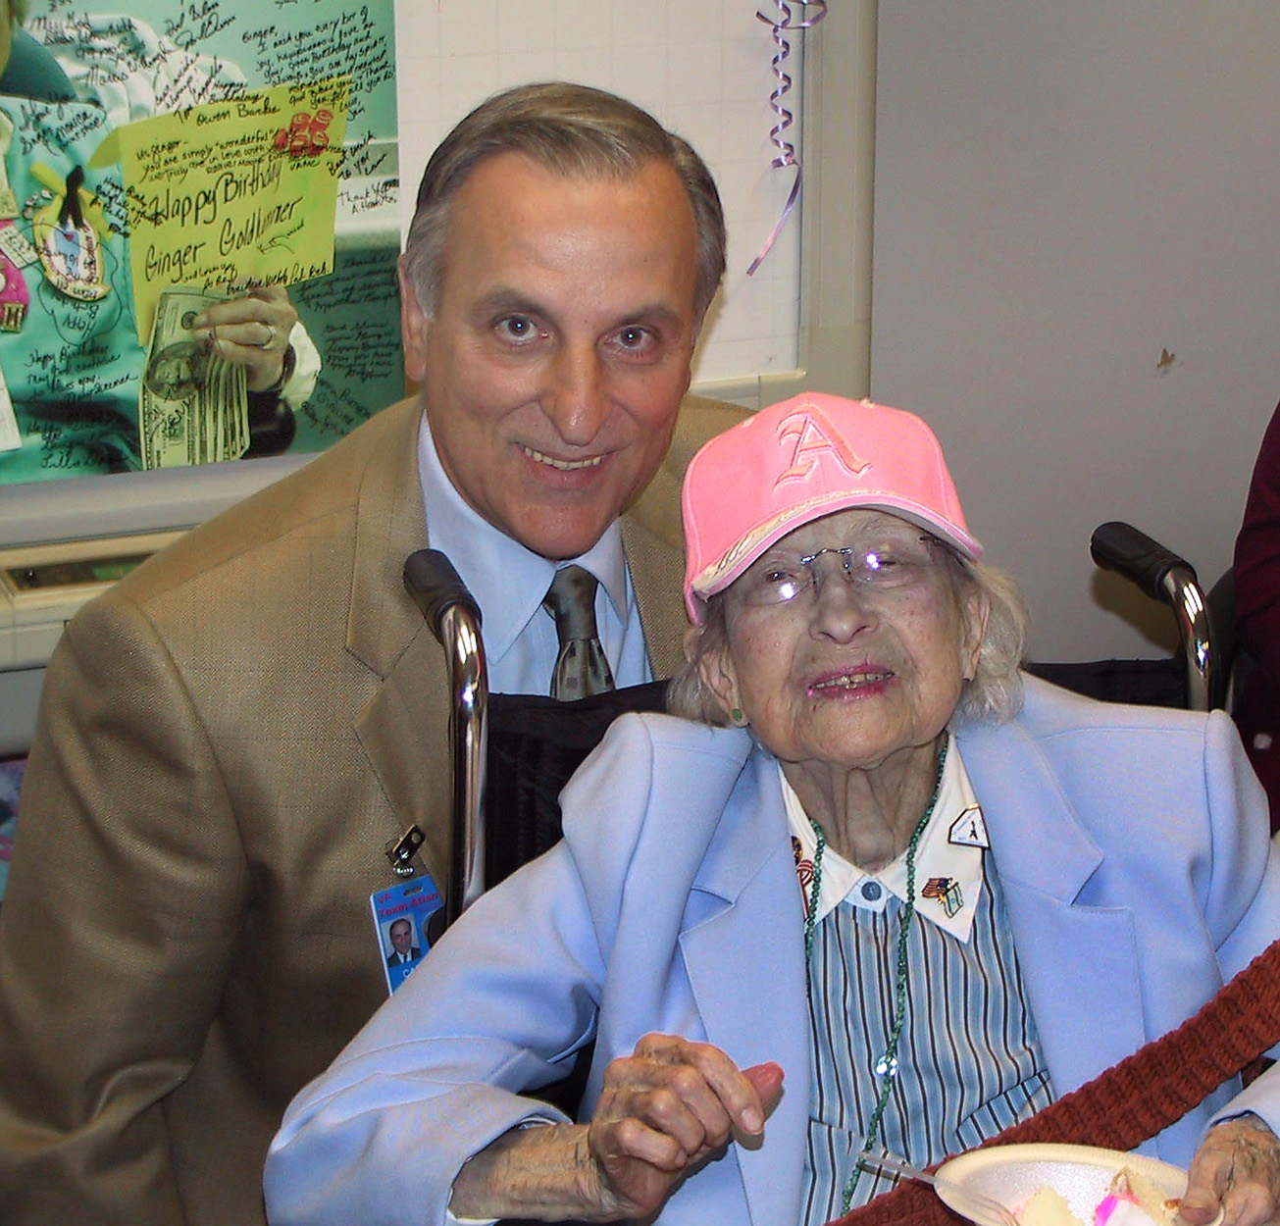

Rome from page 1
One of those signatures belonged to Virginia Myers. Myers said the new clinic means that veterans like her will not have to travel long distances for routine healthcare. “Now our veterans don’t have to travel to Atlanta and Chattanooga for care. They can get it right here,” Myers said. “The tremendous community effort to bring a VA clinic to Rome has finally paid off, and I’m happy to celebrate with other veterans on opening day.”
Robert G. Treadway, 84, had the honor of being the first patient at the new clinic. Treadway said he was so excited about opening day that he arrived at 4:00 am, stopped at nearby
restaurant and had breakfast while waiting for his 9:00 am appointment.
“I couldn’t sleep so I just decided to come early.”
The Grand Opening for the Rome Outreach
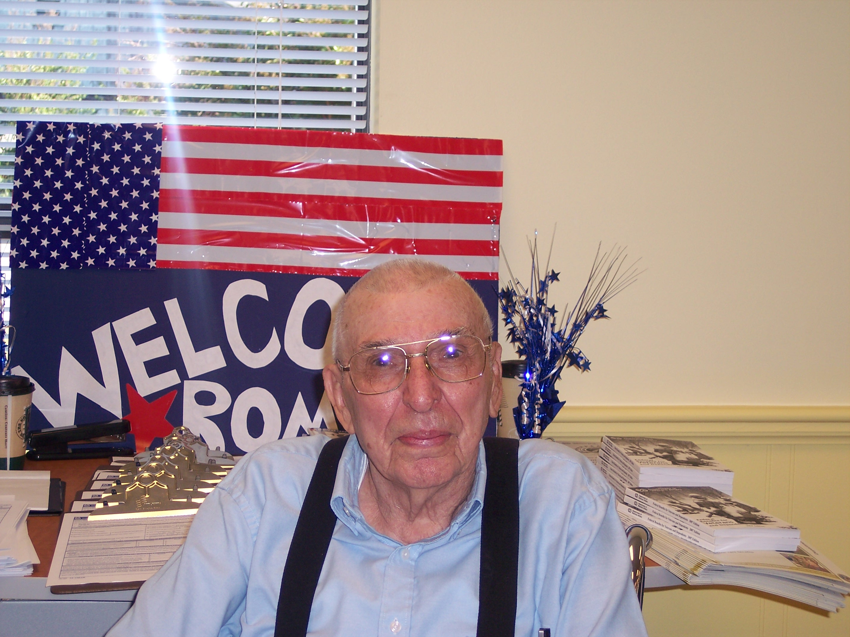
Robert G. Treadway, 84, was the first patient treated at the Rome Outreach Clinic.

Clinic is scheduled for Oct 15 at 11:00 am.
The clinic is open four days a week, Monday, Tuesday, Thursday and Friday from 8:00 am to 6:00 pm. The clinic is closed on Wednesday.

Women’s Wellness Clinic Service
By Brenda Melton
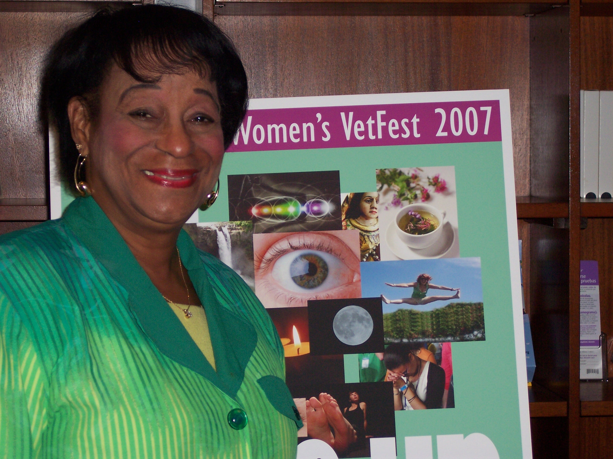
Brenda Melton serves as the coordinator of the Women Veterans Health Program.

The Women Veterans Health Program promotes the health, welfare and dignity of women veterans, and their families by ensuring equitable access to timely, sensitive, and quality health care.
At the Women’s Wellness Clinic, women veterans are treated with the respect and kindness that they deserve. We provide health care in a private, comfortable and safe environment.

Quality Management Starts with You!
By Regina Taylor
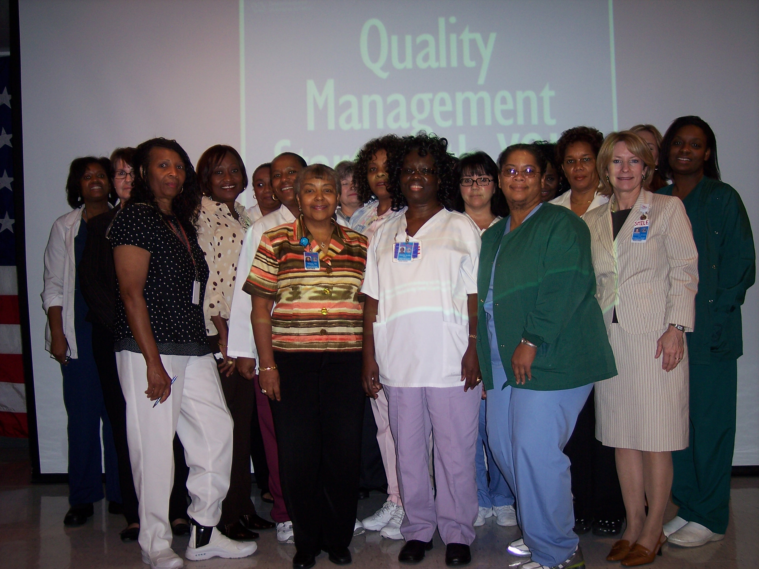
Participants of the Quality Management Starts with You Seminar received 7.1 GNA contact hours.
The Quality Management Starts with You Seminar took place on September 27, 2007, a result of a collaborative effort between Nursing and Quality Management. The seminar focused on the four stages of the performance improvement process used at VAMC and how they are used to comply with regulatory agencies. Approximately 25 employees took part in the seminar which appeared to be well-received.

