DRAFT
 | Department of the Interior  Bureau of Land Management | 

TWIN MOUNTAIN
COMMUNICATIONS SITE MANAGEMENT
PLAN

Prepared by the Bureau of Land Management
Royal Gorge Field Office, Colorado

Approved by: ____________________________________________ _______________
Field Manager Date
TWIN MOUNTAIN COMMUNICATIONS SITE MANAGEMENT PLAN

I. INTRODUCTION 3
A. Terms and Definitions 3
B. Purpose 4
C. Site Description 5
D. Area Served 5
E. Access 5
F. Site History and Development 6
G. Goals and Objectives of Site Management Plan 6
II. AUTHORITY AND DIRECTION 7
A. Authority 7
B. Relationship to Communications Site Leases/ROW Grants 8
III. GENERAL RESPONSIBILITIES 8
A. The Bureau of Land Management 8
B. Facility Owners and Facility Managers 8
C. FCC and NTIA/IRAC 10
IV. AUTHORIZED USES AND USERS WITHIN A FACILITY 10
Use by Multiple Users 10
V. FEES 11
VI. GENERAL OPERATION AND MAINTENANCE DIRECTION 11
A. Unique Resource Considerations at this Communication Site 11
B. Wiring and Grounding 12
C. Communications Equipment 13
D. Cables and Transmission Line (Wave Guides) 16
E. Radiation 16
F. Utilities-Availability of and Requirements for: 17
G. Sanitary Facilities 18
H. Security and Law Enforcement 18
I. Site Maintenance 19
J. Inspections 19
K. Fire Prevention and Hazard Reduction Requirements 20
L. Access Maintenance and Restrictions 21
VII. CONDITIONS FOR CONSTRUCTION, MODIFICATIONS OR EXPANSION 21
A. New Facility Owner Responsibilities 21
B. Construction Methods and Resource Protection 23
C. Construction Inspection 24
D. New or Remodeled/Expanded Buildings 24
E. New or Remodeled/Expanded Towers 25
VIII. SITE ASSOCIATION/ADVISORY GROUP 26
IX. APPENDICES 27
A. Location and Site Maps 27
B. Authorized Facilities 27
C. Site Photographs 27
D. Inspection Checklist 27
APPENDIX A 28
APPENDIX B 30
APPENDIX C 31
APPENDIX D 32

INTRODUCTION

Terms and Definitions
The terms used in this communications site management plan conform to the definitions listed in the April 22, 2005, Federal Register notice “Rights-of-Way, Principles and Procedures: Rights-of-Way under the Federal Land Policy and Management Act and the Mineral Leasing Act”, with further clarification provided in Bureau of Land Management (BLM) Handbook 2860-1 and the United States Code of Federal Regulations (CFR) 43 CFR 2800. In the event of a conflict, between the plan and these sources, the Federal Register notice and the BLM Handbook will govern.

The words “lease” and “lessee” as used in this plan refer to the relationship between the BLM and the communications use lease lessee, or right-of-way (ROW) holder. The words “customer” and “tenant” refer to the relationship between the lessee or holder and the occupants in the lessee’s facilities.
LEASE OR ROW – A use authorization issued to a communication Facility Owner or Facility Manager allowing for the use of public land to construct and or operate a communications facility and, unless specifically prohibited, to sublease to occupants in that facility.
LESSEE, LEASE HOLDER, OR ROW HOLDER – A Facility Owner or Facility Manager
CUSTOMER – A facility occupant who is paying a facility manager, facility owner, or tenant for using all or any part of the space in the facility, or for communication services, and is not selling communication services or broadcasting to others.
TENANT – A facility occupant who is paying a facility manager, facility owner, or other entity for occupying and using all or part of a facility. A tenant operates communication equipment in the facility for profit by broadcasting to others or selling communication services.
COMMUNICATIONS SITE – An area of BLM-managed public land designated through the land and resource management planning process as being used or is suitable for communications uses. A communications site may be limited to a single communications facility, but most often encompasses more than one. Each site is identified by name; usually a local prominent landmark, such as Twin Mountain Communications Site.
FACILITY – The building, tower, and related incidental structures or improvements authorized under the terms of the grant or lease.
FACILITY MANAGER – The holder of a BLM communications use authorization who leases space for other communication users. A facility manager does not own or operate communications equipment in the facility for personal or commercial purposes.
FACILITY OWNER – Individuals, commercial entities, organizations, or agencies, that own a communications facility on Federal land; own and operate their own communications equipment; and hold a communications use authorization. Facility owners may or may not lease space in the facility to other communications users.
NON-BROADCAST – This category includes Commercial Mobile Radio Service (CMRS), Facility Managers, Cellular Telephone, Private Mobile Radio Service (PMRS), Microwave, Local Exchange Network, and Passive Reflector.
BROADCAST – This category includes Television Broadcast, AM and FM Radio Broadcast, Cable Television, Broadcast Translator, Low Power Television, and Low Power FM Radio.
RIGHT-OF-WAY (ROW) – The public land authorized to be used or occupied pursuant to a ROW grant.
RIGHT-OF-WAY GRANT – A use authorization issued pursuant to Title V of the Federal Land Policy and Management Act of October 21, 1976 (43 U.S.C. 1701 et seq.) or issued on or before October 21, 1976, pursuant to then existing statutory authority, authorizing the use of a ROW over, upon, under or through public land for construction, operation, maintenance and termination of a project.
HOLDER – Any applicant who has received a ROW grant, lease or temporary use permit.
USERS – All ROW and lease holders, lessees, customers, and tenants that own or operate a facility or communication equipment at the communication site.
SENIOR USE – Any use whose implementation date is prior to the implementation date of the use in question.
RANALLY METRO AREA (RMA) – A series of nine population zone areas, the highest of which is greater than 5 million and the lowest being 25,000 or less. These zones are determined annually and published in the Ranally Metro Area Population Ranking, an independent publication from Rand McNally, and are used in rent determination.

Purpose
This plan will be used by BLM officials administering communications uses at Twin Mountain, existing lessees, holders, and applicants desiring a lease, grant, or an amendment to an existing lease or ROW grant. The plan will be kept updated by amending pages or sections of the plan rather than issuing a revised edition of the plan. When an administrative revision is necessary (such as the addition of a user), a letter to the holders from the Royal Gorge Field Office enclosing a copy of revised pages or sections will be used to amend the plan. The amendments will be consecutively numbered. Other proposed revisions to the plan will be circulated to holders for comment prior to implementation.
Overall management direction for the administration of communications sites is outlined in the CFR and the BLM Handbook and applicable BLM Instructional Memoranda. Specific direction for site management planning on designated communications sites is contained in BLM Handbook 2860-1. Primary regulations and policy pertaining to issuance of ROW authorizations by the BLM are found in Title 43 CFR Sections 2801- 2808 and BLM Handbook 2860-1.

The Royal Gorge Resource Management Plan (approved May 5, 1996 as amended in 2001) sets out standards for the location of communications site rights-of-way. Three conditions for proposed sites apply: 1) within exclusion areas (Wilderness Study Areas, raptor nesting/fledging areas, special status plants and animals, and National Register of Historic sites) sites will not be authorized, 2) within avoidance areas (big game birthing areas, big game critical winter habitat, Visual Resource Management Class I and II areas within Areas of Critical environmental Concern, and developed recreation areas) sites will be avoided unless those concerns can be adequately mitigated, and 3) within the remaining open areas sites will be considered on a case by case basis. Preference shall be given to co-locating facilities over establishing new sites.

This Site Management Plan provides applicable guidance and adds current policy and technical standards for better management of the Twin Mountain Communications Site. This plan governs development and management of Twin Mountain and will be modified in the future as needs and conditions warrant. Any future such uses must be designed, installed, operated, and maintained to be compatible and not interfere with the senior uses as defined in Section A above. This site-specific plan is administrative in nature and is Categorically Excluded from further review under the National Environmental Policy Act (NEPA) in accordance with 516.DM 2, Appendix 1, item 1.10, which states “ – Policies, directives, regulations, and guidelines that are of an administrative, financial, legal, technical, or procedural in nature and whose environmental effects are too broad, speculative, or conjectural to lend themselves to meaningful analysis and will later be subject to the NEPA process, either collectively or case-by-case”. Any additional development of Twin Mountain will be addressed in a site-specific NEPA document.

Site Description
The site is located approximately 6.4 miles northwest of Canon City, CO. It is on Twin Mountain, a prominent landmark in the area. The area is managed by the Royal Gorge Field Office. It is specifically located in section 2, T. 18 S., R. 71 W., 6th Prime Meridian, Fremont County, Colorado at approximately 38º 50’ 55.3” North Latitude and 105º 18’ 26” West Longitude. The elevation at the Twin Mountain Communications Site is approximately 7,800 feet above mean sea level. A site map is provided as Appendix A.

Area Served
This site does not serve a Ranally Metro Area (RMA). The population zone served is less than 25,000. These zones may be adjusted in the future as population change. This information will be used for rental fee determination.

Access
From Canon City, travel approximately 7.6 miles west on US Highway 50 to an unpaved road heading north. The unpaved road is adjacent to a commercial rafting company on the north side of the highway. Once on this unpaved road, travel approximately 3.7 miles north to the Twin Mountain communications site, which is visible from US Highway 50.

Site History and Development
There are currently three communications facilities at Twin Mountain. On April 4, 1962 the State of Colorado Administration Dept. (now the Dept. of Information Technology) was issued an authorization to use Twin Mountain as part of their statewide communications network under BLM serial number COC-71616. Their original authorization was converted to a lease in 2001.
Union Pacific Railroad was issued a grant to use Twin Mountain for their internal radio network on March 23, 1972 under BLM serial number COC-3928.
On August 30, 1979, Singleton Communications was issued an authorization to construct a facility on Twin Mountain under serial number COC-27939. That authorization was assigned to SBA in 1999, from SBA to AAT Communications in 2003, and to SBA Structures in 2007.
Celludyne was issued an authorization to use Twin Mountain as a cellular site on December 3, 1990 under serial number COC-51307. Their grant was assigned to WWC Holdings in 1998, and from WWC Holdings to Alltel Communications at a later date. Their operation is in the SBA Structures building.
Fremont County was issued an authorization to use Twin Mountain as a PMRS site on February 1, 1991 under serial number COC-51312. Their operation is in the State of Colorado DOIT building.
Any modifications to existing facilities or proposals for new facilities must be approved by the Royal Gorge Field Office according to the appropriate NEPA process and guidance described in this document.
The site currently appears to be relatively clean from interference, receiver sensitivity, and noise. If additional new uses deteriorate the receiving/transmitting operation of the existing uses, the new uses may be required to institute additional studies, equipment upgrades, frequency isolation, or physically separate from the existing uses. This may be particularly required if they are continuously transmitting in nature, or if there is an increase in transmitter power from communications uses on private land.

Goals and Objectives of Site Management Plan
1. Designate uses on the site. This site is to be used for low power communications uses only. The maximum power output expressed as ERP for the Twin Mountain Communications Site is based on the maximum output allowed for two-way radio under the Federal Communications Commission’s rules at Title 47, Code of Federal Regulations, Part 90. As of the 2003 regulation, that is 500 watts ERP. Each use must operate at or below the power level authorized by their respective FCC license as long as it does not exceed the site limitation. This power limitation does not preclude existing and new uses from being designed, operated and maintained to meet other interference, noise floor, receive sensitivity, or RFR standards included in this plan.

2. Manage communication equipment on the Twin Mountain site to maintain the radio frequency (RF) hazard to be within the Public Standard as defined by the Federal Communications Commission (FCC).
3. Systematically develop the site to maximize the number of compatible uses while ensuring safety and protection of resources. Development of new towers or buildings within each of the authorized owner’s facilities will be authorized only after their respective tower or building space area is filled to near capacity.
4. Help fulfill the public need for adequate communications sites.
5. Protect the interests of holders, lessees, tenants and customers, by preserving a safe and electronically “clean” environment.
6. Encourage the efficient development and use of space and facilities within the designated site.
7. Achieve visual quality objectives by requiring design standards that are unobtrusive and utilizing earth tone colors and non-reflective surface material and stringent site maintenance requirements.
8. Describe the BLM’s policy for road maintenance. The access road to the site is designated as a BLM road maintenance level 2 – Open road with limited administrative traffic only. Usually a high clearance vehicle is required. Drainage structures are inspected every 3 years and maintenance actions taken as needed. Grading is conducted as needed to allow administrative access. Slides may be left in place provided they do not adversely affect drainage.
9. Develop new facilities only after appropriate site-specific NEPA analysis and coordination with current lease or ROW holders and users. Any future development must be consistent with the Royal Gorge RMP and this plan.
10. Amend this Communications Site Plan as necessary to be consistent with future RMPs. BLM will provide authorization holders with proposed amendments to this plan and will allow a reasonable period of time for the holders to review and comment on the proposed changes.

AUTHORITY AND DIRECTION

Authority
The authority used by BLM to authorize communications uses on public land (administered by the BLM) is the Federal Land Policy and Management Act of 1976, 90 Stat. 2776 (43 U.S. C. 1761-1771) and is reflected in Title 43, Code of Federal Regulations (CFR), Sections 2801- 2808 and various BLM Washington Office Information Bulletins and Instruction Memoranda.
BLM authority for communications site management planning is contained in BLM Handbook 2801-1, Plan of Development. Direction on and policy for communication use authorizations is contained in BLM Manual Section 2860.
Authority for the issuance of authorizations and/or licenses for the transmission and reception of electronic radiation for communication purposes is granted by Congress and administered by the FCC and/or the National Telecommunication and Information Administration – Interagency Radio Advisory Committee (NTIA/IRAC).

Relationship to Communications Site Leases/ROW Grants
This site plan will be incorporated into all leases and ROW grants issued (now and/or in the future) for this communications site and must be used in conjunction with the granting authorization. PROVISIONS OF THIS SITE PLAN ARE ENFORCED THROUGH THE GRANTING AUTHORIZATION (LEASE OR ROW GRANT). Each lessee or holder is expected to include the requirements of the authorization and this site plan into any documents, which describe the business relationship between the lessee and their tenants and customers. The lessee or holder is responsible for enforcing those provisions.

GENERAL RESPONSIBILITIES

The Bureau of Land Management
The Bureau of Land Management retains the responsibility for issuing and amending authorizing instruments to Facility Owners and Facility Managers, only for the areas actually occupied by the authorized improvements. The issuance of a FCC license (authorization), or frequency assignment, does not authorize occupancy of public land. Granting occupancy and use of public land rests exclusively with the BLM. This includes:

- Approving any new facility(ies) at the site.
- Approving amendments to existing facilities (i.e. additions to tower, antenna, equipment or building), and approving assignments of leases and ROW grants to qualified buyers of facilities on the site.
- Approving any modifications to existing facilities including the tower, antenna, equipment or building. Also, approving any changes to the existing FCC licenses, prior to the submission of an application to the FCC.
- Frequency Management. Unless determined otherwise by the BLM Authorized Officer, BLM is not responsible for the resolution of conflicts when the licensees or agencies are operating within the limits of the FCC and NTIA/IRAC authorizations.

Facility Owners and Facility Managers
Facility owners and facility managers (or their designated representatives) are responsible for:

- Complying with their use authorization and all provisions of this site plan.
- Ensuring that all new facilities, expansions, or improvements are consistent with the Royal Gorge Field Office land use planning documents; any environmental document(s)/decisions for the site; and, this site plan.
- Ensuring facilities/equipment not complying with Federal/State/local laws/regulations/ ordinances will be removed or modified within one year of the approval of this plan. Any modification needs pre-approval by the BLM.
- Keeping all facilities within the established limits of their authorized area.
- Providing the BLM with the name, address and phone number for a local contact person. The Facility Owner and Facility Manager and the contact person may be the same individual. The contact person will be available for emergencies and will have the authority to make decisions about construction issues, facility maintenance and all equipment within the facility.
- Providing 30-day notice to all facility owners/facility managers at the site, as well as the BLM, of all new frequencies proposed for the site. A completed BLM technical data sheet or equivalent must be sent with the 30-day notice to allow for comment of potential interference. This notification requirement applies to new frequencies for facility owners/facility managers as well as their tenants and customers
- Adhering to the lease/ROW grant as follows:
  - Facility Owners and Facility Managers with Communications Use Leases are authorized to rent building/tower space to tenants and/or customers without prior written approval from the BLM.
  - Tenants and/or customers may not construct their own equipment shelter (building, shelter, generator pad, cabinet, etc.) or antenna support structure (tower or mast). The facility owner must own all communication shelters and towers under their lease or grant. [If that is not possible, a separate SF-299 application, cost-recovery fees, analysis, and authorization are required. This may also result in the use being a tenant/customer of the original lease/ROW in addition to being a separate facility for billing purposes.]
  - Tenants and/or customers using a facility covered by a Facility lease/ROW will not have separate BLM leases/ROWs to authorize their use except in situations where regulations or policy require them.
  - Facility Owners and Facility Managers are responsible for complying with the terms and conditions of the facility lease/ROW. Facility Owners/Facility Managers are also responsible for ensuring that their tenants and customers are in compliance with the terms and conditions of the lease/ROW and applicable FCC or NTIA/IRAC license terms and conditions.
  - The Facility Owner and Facility Manager may not place any unreasonable restrictions nor any restriction restraining competition or trade practices on tenants and/or customers, or potential tenants and/or customers.
- Ensuring that all communications equipment is properly installed, operated, and maintained.
- Ensuring that all communication equipment meets ANSI, FCC and BLM regulations, guidelines and standards concerning radiation limitations by:
  - Monitoring radiation levels at their facility and;
  - Immediately correcting any radiation levels that are, or could be a hazard to human health. (FCC 47CFR sections 1.1307(b), 1.1310 and 2.1093) and FCC OET Bulletin 54, August 1999.
- Providing a certified copy of all uses and the correct category of uses within the facility, along with the current phone numbers and addresses of all tenants and customers as of September 30th each year. This report is due by October 15th each year.
- Keeping the premises around their buildings free of trash and debris.
- Placing the BLM lease/ROW serial number on the door of their communications site building, or on a gate if a fenced compound.
- Correcting all interference problems. Unless otherwise determined by the BLM Authorized Officer, the users are responsible for the resolution of conflicts when the licensees or agencies are operating within the limits of the FCC and NTIA/IRAC authorizations.

FCC and NTIA/IRAC
The FCC and NTIA/IRAC are responsible for Frequency Management. The FCC and NTIA/IRAC are not normally responsible for the resolution of conflicts when the licensees or agencies are operating within the limits of the authorizations.

AUTHORIZED USES AND USERS WITHIN A FACILITY

Use by Multiple Users
Use of all facilities and improvements by more than one user will be required except where the facility owner is a government agency. Site applicants will take the lead in this area and design their proposals to accommodate multiple uses of facilities and improvements. This includes multiple uses of buildings, towers, back-up generators, grounding systems, fuel containers, access ways and parking areas.
Due to the availability of building and tower space at the site, new facilities or major modifications to existing facilities will generally not be approved until the empty space is utilized even if other users are, or could be, competitors.
Facility Owners and Facility Managers are not required to lease facility space to others if they can prove to the authorized BLM officer that:
- Space is not available;
- The use is incompatible with the existing facilities;
- Additional space is needed by the facility owner/manager;
- Additional users would violate system security needs; or,
- Potential interference is not resolvable.

FEES
The BLM will charge Facility Owners and Facility Managers annual rental fees pursuant to federal regulations contained in 43 CFR 2806. The fees are based on two factors- the type of communications use, and the population served by the use. These fees are considered fair market value for the use of public land. The population Zone 9 (less than 25,000) will be used for these calculations unless something else is specifically agreed to in writing by the authorizing officer or until populations change.
Fees that Facility Owners and Facility Managers may charge their tenants and customers are to be reasonable (consistent with, and not in excess of, other fees for similar facilities) and commensurate with the uses and occupancy of the facilities and services provided to tenants and customers.

GENERAL OPERATION AND MAINTENANCE DIRECTION

Unique Resource Considerations at this Communication Site

There are no currently identified special resource coordination considerations with on-site or adjacent resource values. Should special conditions arise through the revision process of the land use plan or other situations, this site plan will be amended accordingly.

Wiring and Grounding
1. All equipment is to be installed within existing buildings and in metal equipment racks or within metal equipment cabinets and in accordance with manufacturers’ specifications. All equipment, racks, cabinets and overhead ladder trays are to be grounded and shielded in compliance with National Electrical Code (NEC) and in accordance with accepted industry standards as described in the Motorola R56 Standards and Guidelines handbook.
2. All electrical wiring and grounding must meet the NEC and applicable State/local codes. All permanent wiring shall be installed in metallic conduit. Surge protection shall be installed between the electric service meter and the first power distribution panel.
3. Lightning protection shall be in accordance with NEC part 810-20 Antenna Discharge Units and Part 810-21 Grounding Conductors. Periodic bonding of the down conductor to the tower (Galvanized) steel shall be made with proper bonding connectors that are tin plated or made of brass.
4. Each building is to have its own separate grounding system for all users in that structure. Wherever practical, interconnection of individual grids and/or the simultaneous placement of a large sized copper ground wire with any new grounding systems that are buried on the site will be required.
5. Site or facility grounding must be constructed of copper, with #2 AWG or larger wire or 2” or larger solid copper strap, connected to an adequate site/facility ground electrode system. The site/facility ground electrode system shall be bonded to the power service entrance grounding electrode conductor. Guy wires should also be grounded using manufacturers approved methods to preclude bi-metallic junction and corrosion. All equipment on the site (buildings, towers, power units, transmitters, receivers, antennas, combiners, telephone systems, power cabinets, HVAC units, etc) must be connected to the site/facility ground by direct connection. Electrical system ground wiring is required for electrical ground fault protection and circuit breaker coordination. The grounding systems shall comply with applicable laws, codes and in accordance with standard engineering practice. Below ground connections must use either an exothermic welding process (i.e. Cadweld, Thermoweld, etc.), copper wedge pressure devices (i.e. Ampact, Burndy, Wrench-lock, etc.), or brazed copper connections in conjunction with a mechanical UL listed connector (to be used as a physical strength enhancement component). Brazing by itself is not an acceptable method of bonding below earth grade (buried).

Communications Equipment
Equipment Ownership
All equipment shall be labeled (or the information available at the site, as applicable) with:
- The owner’s name;
- Transmitter frequency(ies);
- A valid FCC, or IRAF, authorization;
- Transmitting power output(s); and
- A current 24-hour phone contact number.
Transmitting Equipment
All transmitters will have protective devices (shields, filters, isolation components), designed into or externally installed, to prevent interference with other users. All transmitters will meet FCC licensing requirements. Two-way transmitters should have dual section isolators for a total of 60 db of isolation.
The re-radiation of intercepted signals from any unprotected transmitter and its associated antenna system will be prevented by the use of appropriate filters (wide band and narrow band broadcast transmitters).
The direct radiation of out-of-band emissions (i.e. noise or spurious harmonics) will be reduced to a level such that they may not be identified as a source of interference as defined in the FCC Rules and Regulations (e.g. Part 90.209(e)). If site noise (electromagnetic noise) becomes an issue, noise threshold limits will be established, and amended into the site plan, prior to authorizing any new uses.
Direct radiation of out-of-bound emissions, (i.e. transmitter wide band noise, spurious emissions, harmonics, etc.) shall be reduced to a noninterference level by using bandpass, lowpass, and/or harmonic filtering. Where duplexing is used, use of a notch type device should be avoided. In situations where a notch type or a hybrid device is used, a bandpass filter must be used with the transmitter.
Band-reject filtering may be required in certain applications.
Re-radiation of signals from a transmitter and its associated antenna system shall be prevented by installing appropriate devices (i.e. ferrite isolators), with minimum return loss of 25 db.
All transmitters not in immediate use and not specifically designated as standby equipment shall be removed. Loads connected to circulators are to be capable of dissipating the total power output of the transmitter.
Receiving Equipment
All receivers shall comply with all applicable parts of the FCC rules, including Parts 2 and 15.
All receivers shall have sufficient “front end” pre-selection to prevent receiver spurious response. The use of bandpass, band-reject cavity or crystal filters may be required to prevent receiver-produced intermodulation or adjacent-channel interference.
Where duplexing is used, a bandpass cavity duplexer is required. Use of the notch-type device is not permitted. Where notch-type devices are currently in place and there are no interference problems, their use may continue until the equipment is replaced, at which time they must be replaced with bandpass devices.
Tower
Generally only one tower is authorized for each facility owner. Facility Owners and Facility Managers may obtain permission to construct the second tower only after submitting evidence that demonstrates that their existing tower is completely filled and full use has been made of combining systems.
- All towers will be left unpainted, if they are dull, galvanized steel. Paint is required only if the tower has a shiny (i.e., reflective) surface. If paint is required, the BLM will approve only non-reflective colors from the Munsell Soil Color Chart, Standard Environmental Colors or the equivalent.
- Maximum tower height for future towers at this site is 100 feet.
- Anti-climb devices, removable steps, or other means to discourage unauthorized climbing, are highly recommended to reduce or avoid liability claims.
- All new towers will be self supporting. No guy lines are permitted.
- To avoid possible impacts to birds or bats, follow the most current version of the U.S. Fish & Wildlife Service’s Interim Guidelines on the Siting, Construction, Operation and Decommissioning of Communication Towers, available at the following website: http://migratorybirds.fws.gov/issues/towers/comtow.html
Antennas
            - Microwave (dish) antennas (other than ground mounted satellite dishes) will be limited to a maximum of eight (8) feet in diameter. The smallest diameter dishes are preferred if technically feasible.
            - Dishes should be mounted as low as possible to reduce visual impacts.
            - All antennas must meet all OSHA safety standards. If an antenna exceeds FCC public or occupational radiation standards (see FCC OET Bulletin 57), it will be remedied within 24 hours after measurements are taken or isolated (e.g., fencing, signing, relocation, lowering power levels are all possible remedies). Ground measurements of radio frequency radiation (RFR) levels will be taken before mitigation measures are implemented.
            - Color(s) for dish antennas, or covers, must be pre-approved by the BLM. New white dish antennas and/or covers will not be approved. Existing white dishes and covers must be repainted or replaced with dishes of approved color (typically dark grey), as repairs or replacement become necessary.
            - Antennas will be purchased with or treated to have a non-reflective surface.
Interference
The responsibility for correcting interference problems is a matter for resolution between the lease/ROW holder of the facility(ies), the user causing the interference, and the affected party(ies). First users on a site have seniority with respect to the resolution of interference complaints. Senior holders have an obligation to maintain their equipment to industry standards, to operate their systems in accordance with the terms of both the FCC license and NTIA/IRAC frequency authorization, and to comply with the BLM authorization.
New users on a site must correct, at their expense, interference problems that they create. They may be required to furnish an intermodulation study, electromagnetic noise study, or other interference-related data and must agree to accept financial responsibility for elimination or prevention of any interference caused by the facility before their application can be evaluated. They must cease operation of the suspect equipment until the problem is corrected. If interference problems cannot be resolved or corrected within a reasonable time, the new use that is causing the interference may be terminated and the equipment removed.
All users shall cooperate with the Site Users Association, if one is formed, and the BLM in identification and correction of any interference. The BLM does not have authority for correcting interference problems, but can act as a mediator to help all affected parties. Interference problems must be coordinated with the FCC or NTIA/IRAC, whichever is appropriate.
Interference with law enforcement and/or emergency communications must be corrected immediately. The operation of equipment covered by this site plan shall not interfere with United States Government radio or electronic operations already in existence on public land within two (2) miles of this site. The user causing this interference, shall, at its own expense, take all action necessary to prevent or eliminate such interferences. If it does not eliminate such interference within ten (10) days after receipt of notice from the BLM to do so, this use will be terminated.
If electromagnetic noise becomes an issue, noise thresholds will be established and this site plan will be amended accordingly.

Cables and Transmission Line (Wave Guides)
All new cabling will be jacketed and shielded and shall either be flexible or semi-rigid type. Existing substandard cables will be upgraded as repairs or replacement become necessary.
Cables will be properly installed and will be strapped and fastened down. Use of ports at building entrance points will be kept to a minimum by use of combiners.
When attaching power cables onto a tower, conduits should be used. Coax and wave guides should be installed in a wave guide ladder or equally divided among all tower legs.
All transmission lines (wave guides) are to be supported in accordance with manufacturer’s specifications.
Unjacketed transmission line of any type is prohibited. No transmission line shall be left unterminated.
Double shielded braided or solid shielded cable will be used. No RG-8 type cable is permitted. No connector-type adapters will be used on transmission lines. Only correct connectors that will mate to connected devices are to be used.
Conduits will be shared when they service common areas and will be buried where possible.

Radiation
All communications uses must meet ANSI, FCC and BLM regulations guidelines and standards concerning radiation limitations. This site is considered uncontrolled for the purposes of compliance with RFR standards.

Monitoring radiation levels at the site is the responsibility of all site users and will occur at intervals to comply with FCC regulations and guidelines. A copy of these monitoring reports will be provided to the BLM upon request. The FCC is responsible for enforcement of the monitoring and standardization for compliance. The FCC could revoke the license and/or issue a fine for failure to comply. Additionally the BLM could terminate or suspend the use authorization for failure to comply.

Onsite RFR measurements will be taken using appropriate equipment that can adequately measure and record both on-tower and on-the-ground levels before mitigation measures related to RFR are implemented pursuant to FCC standards and requirements.

Security fences with RFR notice signs are required around areas that exceed public use levels including anchor points outside the primary facility compound fence, if necessary. Raising higher power transmitting antenna on the tower or modifying the antenna type to half wavelength may be necessary to eliminate RFR hazards. Reducing power may also be required if other alternatives are not feasible. All fencing location and design or new tower construction must be pre-approved by the BLM.
Warning signs will comply with ANSI C95.2 color, symbol, and content conventions. Contact information including name and telephone number will also be included on warning signs. Existing warning signs compliant with FCC 47 CFR 1.1307(b) which do not currently include name and telephone number will be accepted as long as the name and telephone number is clearly posted on other signage at the Lessee’s site.
Lowering power levels for on-tower access during maintenance will be coordinated between affected users.
Any identified RFR radiation problems that are, or could be, a human health hazard must be corrected within 24 hours after measurement tests have been completed or be removed from the site by the site user(s). If the proposed corrective action involves any new ground disturbance, it must be pre-approved by the BLM.

Utilities-Availability of and Requirements for:
Commercial Electrical Power
Commercial power is provided to the site under a separate ROW grant to Aguila Power Company. The current electrical service to the site has the capacity to service additional users at the site. Future upgrades of the electrical service will be part of the right-of-way to Aquila Power Co. and may need to be paid for by the benefiting user(s).
Telephone Service
Commercial telephone lines do not serve this site.
If additional service is ever deemed necessary, a separate ROW grant will be issued. Site users will also pay for the cost of:
- The necessary resource surveys and reports for service connections; and
- The cost of constructing service connections.
For visual reasons, overhead utility poles may not be authorized.
Fuel Tanks
Facility owners and facility managers are responsible for providing fuel storage (propane and diesel) and emergency power for their tenants and customers. No tenants or customers will be authorized to have separate fuel tanks and/or generators. Each facility owner will preferably consolidate fuel storage into a tank large enough in size to accommodate all tenants and customers within their facility. At a minimum, tanks will be grouped together in a consolidated area adjacent to their facilities. All fuel, storage tanks (e.g. LPG, propane and diesel) must meet current fire department, Federal, State and local government safety and hazardous materials requirements. Propane is the preferred fuel for future generators.
- All tanks will be:
a. Signed in red letters, “SMOKING OR OPEN FLAME PROHIBITED WITHIN 20 FEET”;
b. In conformance with National Fire Protection Association (NFPA) requirements; and,
c. Painted an approved color, or screened by an enclosure to blend in with the natural environment. If an enclosure is used, it must be pre-approved and painted an approved color from the Munsell Soil Color Chart, Standard Environmental Colors.
2. Diesel tanks will also be:
a. Enclosed in BLM and fire department approved secondary containment vaults that are painted a BLM approved color from the Munsell Soil Color Chart, Standard Environmental Colors.
b. Constructed with underground fuel lines. Fuel line must be constructed of black, treated pipe and fittings, and must be posted.
c. A containment basin must be maintained below all diesel tanks which are not designed and approved to be self contained.

Sanitary Facilities
Plans for any sanitary facilities must be pre-approved by the BLM. If it is determined by the BLM that the users need such facilities, they will be provided by the lease/ROW holder in a manner and location satisfactory to the BLM and within the requirements of the Fremont County Health Department.

Security and Law Enforcement
The Fremont County Sheriff’s Department is the key law enforcement agency for the area. They are responsible for most civil and criminal matters. The BLM will be responsible for enforcing matters related to uses of BLM lands (e.g. resource protection issues).
Patrolling and policing for security purposes is the user’s responsibility.
None of the facilities on Twin Mountain are currently fenced. If fencing is ever deemed necessary for security purposes at other facilities on the site, it must meet the following criteria:
1. All fences must meet health and safety requirements.
2. All fence locations and design require Bureau of Land Management pre-approval. The standard fencing type will be chain-link (i.e. cyclone).
3. The standard fence height will be eight (8) feet.
4. Fencing will be designed, maintained, and of a type to minimize interference issues.
5. Fences will be signed with RFR notices if RFR is above public levels.

Site Maintenance
The objective of maintenance activities is to present a clean, neat, and orderly appearance at the site and have all of the authorized improvements safe for workers and the public. All users will keep up the overall appearance of the site.
Miscellaneous debris remaining after any construction and/or equipment installation, removal or modification, is not only a hazard, but can cause interference or intermodulation problems. In particular, all loose wire or metal objects are to be removed from the site.
The users of the site will remove all graffiti within 10 working days of finding it, weather permitting.
Users will not be permitted to leave or dispose of trash, garbage or cut brush on public lands. No outside trash or litter containers will be provided. Site users will remove litter from the site as it is produced.
Policing of litter in common areas (i.e. areas between buildings and developed sites) is the shared responsibility of those holders bordering these areas.
During construction and/or maintenance, excess materials (e.g. cement, wire, metal, building materials) will be removed from public land.
Peeling paint on buildings and/or towers will be re-painted within thirty (30) days of discovery by the facility owner or facility manager and within 10 days of notification of the holder by the BLM, weather permitting.
The Lessee is responsible for the abatement and control of noxious weeds within the bounds of their lease site and common use areas. Abatement practices are to be implemented in accordance with the Royal Gorge Field Office weed abatement programs.

Inspections
Enforcement authority is vested in the BLM as the Communications Site Administrator for Twin Mountain via 43 CFR 2800. The BLM may conduct an annual inspection of each user’s facility. This inspection will verify:
  - Compliance with technical standards.
  - Structural integrity.
  - As-built plan accuracy.
  - Electromagnetic compatibility.
  - General site health, safety, and cleanliness.
The BLM shall provide written notice of the scheduled inspection date at least 30 days in advance. Each user shall arrange to have personnel available at the site at the time of the inspection.
Any non-compliance found by a user shall be reported to the BLM. The BLM will conduct an inspection and a written copy of the inspection report shall be forwarded to the violating user within 30 working days following the inspection. The report shall include:
      - A description of the violation.
      - Corrective action required.
      - Name, address, and organization of the responsible party.
      - Time allowed for completion of corrective measures.
      - Anticipated action in the event of noncompliance with remedial instructions.

Fire Prevention and Hazard Reduction Requirements
Facility owners and facility managers will be required to control vegetation within the fenced area around their facilities. Gravel or mineral soil (i.e. bare ground) must be maintained to a minimum of (10) feet clearance around buildings and a minimum of (10) feet clearance around any propane tanks. For fire protection, a greater distance may be necessary. Typically, two times the height of the fuel surrounding the structure should be cleared to provide fire protection.
Smoking is prohibited in flammable vegetation areas.
Roof structures shall be kept reasonably clear of debris at all times.
No explosives will be stored at this site. Flammable materials shall be stored in conformance with the requirements of local fire regulations. Flammables will be placed in closed containers and stored away from sources of ignition and combustible materials. If flammables are stored within a building, the building will be locked, properly signed and well ventilated.
Approved spark arresters will be required and maintained on all internal combustion engines.
At least one (1) U.L. rated 20 lb. A:B:C dry chemical fire extinguisher is required inside each building. Prior to each June, fire extinguisher(s) shall be inspected by holders and refilled, if necessary.
Any fire will be immediately reported to “911”, the nearest BLM office and/or Fremont County Sheriff.
BLM Officers will make periodic fire prevention inspections. They will call to the holder’s attention any lack of compliance with the above regulations, plus any other existing hazards. Compliance with these inspections is required within the time limits specified in the inspection report.
All fire protection standards must be accomplished by the beginning of fire season unless otherwise agreed to, and then maintained throughout the fire season.

For new construction, the Bureau of Land Management will provide the Holder with a separate Construction Fire Plan which will be prepared at that time as applicable

Access Maintenance and Restrictions
Roads
Once off the State Highway, the road to the Twin Mountains site is in generally poor condition due primarily to the steep topography. The road is very rocky and has few drainage features. Normally, the road condition in the arid climate is not a problem. However, it is certain that future use of the site will, over time, degrade the quality of the road and will require maintenance. If a user association is formed on Twin Mountains, the costs of road maintenance will be assessed by the association and enforced through this management plan. If a user association is not formed, maintenance costs will be assessed depending on the amount of use on the road. If there is disagreement among users as to the assessed costs, BLM will determine the costs to be borne by each leaseholder.
Individual users who damage or disturb the access road, or any associated structures, such as ditches, culverts, roadside vegetation, signs and/or underground utilities or facilities, will be required to repair the road and/or associated structures, to conditions equal to or superior to those prior to any damage or disturbance. This work must be done according to applicable road maintenance standards and may require the appropriate NEPA analysis.
Interior Site Driveways/ Parking Areas
Interior site driveways within the communications site will be maintained by the site users. Interior roads will be planned and approved during establishment of new facilities. Interior roads will be maintained in a manner to allow only one entrance to the site. Off-road vehicle use by a user in and around the communication site will be avoided.
Road Closures
Native surface roads are subject to periodic closures to entry during periods of extreme fire danger, inclement weather, or wet conditions. Authorized site users may use the site during these periods, but should use adequate judgment and may need to seek advance approval from the Bureau of Land Management.

CONDITIONS FOR CONSTRUCTION, MODIFICATIONS OR EXPANSION

New Facility Owner Responsibilities
In addition to the responsibilities listed in Section III, New Facility Owners and Facility Managers are responsible for:

1. Submitting a complete application to the Royal Gorge Field Office (ATTN: “Realty Specialist”) prior to any new construction, or modifications to existing improvements. The application must include:
- The appropriate cost recovery and application fees as determined by BLM.
b. A copy of the approved Site Plan Base Map showing all of the proposed (new) facilities including structures, towers, and auxiliary equipment;
c. Completed drawings/plans prepared by a registered engineer and Plan of Development approved by the BLM;
d. Identification of any microwave beam paths, a plot of their azimuth(s), and their proposed elevation(s) on the tower;
e. Documentation that shows that proposed facilities will not be obstructing, or interfering with, any existing fixed point to point antennas, omni-directional broadcast antennas, or microwave beam paths in the directions of primary population targets. Proposed beam path needs must be shown on Site Plan Base Map; and,
f. Any needed recommendations, changes or modifications to their original proposal, based on any required resource surveys and/or reports.
2. Demonstrating that their proposals will not cause undue interference with any existing uses before the BLM can approve new facilities. In addition, it is the applicant’s responsibility to show that any new facilities will make the most efficient use of the limited amount of space at the site.
3. Showing their proposals will provide for future users without additional construction.
4. Providing engineering and geotechnical investigations for development of specific foundation designs and grading plans.
5. Provide for erosion control as part of the Plan of Development prior to construction activities. At a minimum, erosion control must include: sediment control, stipulations that cut/fill slopes will be graded and contoured to prevent erosion and/or excessive runoff, and recommendations for temporary erosion control measures, (e.g. netting, silt fences, swales, and/or sediment collection areas).
6. Coordinating with other Federal (e.g., FCC and FAA), State and County agencies and obtain all required approvals and/or permits.
7. Providing 30-day notice to all facility owners/facility managers at the site, as well as the BLM, of all new frequencies proposed for the site. A completed BLM technical data sheet or equivalent must be sent with the 30-day notice to allow for comment of potential interference. This would be for new frequencies for themselves and their tenants and customers.
8. Insuring that all written approvals have been obtained from the BLM prior to construction. In addition:
a. Directional broadcast antennas (e.g. translators) will only be protected within the arch between their licensed 3 dB points.
b. New and/or modified facilities will not obstruct existing fixed point-to-point antennas or omni-directional broadcast antennas in directions of primary population targets.

Construction Methods and Resource Protection
Plans submitted by an applicant for any new construction or modifications shall specify provisions for soil rehabilitation measures including, but not limited to, soil replacement and stabilization and for proper handling of runoff from buildings, parking area, access roads, and undeveloped common areas.
The following methods and resource protection measures will be required to minimize impacts during construction:
1. Avoid and protect sensitive resource areas, as identified by the BLM.
2. Compliance with the Plan of Development and the Erosion Control Plan.
3. During construction and/or maintenance, no paint or paint thinners will be disposed of on site.
4. Minimize ground disturbance and vegetation removal as much as possible during construction activities. All ground-disturbing activities require BLM pre-approval.
5. Disturbed areas will be re-vegetated with species pre-approved by BLM as soon as possible after construction. If necessary, reseeding will be required until vegetation is successfully established as determined by the BLM.
6. No grading material will be cast off during construction/reconstruction activities. Excess soil can be used for fill material on road and/or building/tower pads.
7. Temporary, on-site storage of construction materials will require pre-approval by the BLM.
8. Construction materials and supplies, except for hazardous materials (see number 10. below) may be left unattended at the construction site at the end of each workday, but at the owner’s risk.
9. Hazardous materials, including, but not limited to all fuels, oils, and lubricants are not to be left unattended at the site at any time. During construction, these materials are to be removed from the site at the end of each workday, or temporarily stored inside a locked and signed building until the following workday.
10. All surplus construction materials and/or waste debris must be removed from the site no later than thirty (30) days after construction has been completed.
11. Any earth moving or heavy equipment (e.g. dozers, graders, cranes, backhoes, etc.) leaving the designated roadway and/or approved parking area(s) to perform authorized activities at the site, will be washed off prior to being brought onto public lands to prevent the introduction and spread of noxious weeds into the area.

Construction Inspection
1. All new construction, reconstruction, or major modification shall conform to the established technical standards and accepted engineering practices (i.e., the Uniform Building Code).
2. Any construction inspections required by other applicable agencies are the responsibility of the lessee/holder. Copies of completed inspections are to be provided to the Royal Gorge Field Office, Authorized Officer, either as they occur or as part of the final as-built plan. Inspection information shall become a permanent part of the holder’s lease/ROW case file.
3. The Lessee/Holder agrees that corrective work detailed in BLM, or other agency required compliance inspections, would be completed by the scheduled completion date. If the Lessee/Holder disagrees or has questions about specific items, the Lessee/Holder must contact the BLM in order that the disagreement or item may be resolved.
4. A final set of as-built plans will be submitted to the Royal Gorge Field Office, Authorized Officer, within 90 days of acceptance of structure (if contracted) or of completion date.

New or Remodeled/Expanded Buildings
- Any new buildings must be designed to accommodate multiple users along with fitting into the physical environment as defined in a site-specific environmental analysis developed at the time of the proposal.
- Buildings are required to be one-story. The roof must be metal or covered with metal to be fire resistant. Roofs can be equipped with antenna support structures, such as poles and railings that can extend up to 25-feet above ground level.
- Facility Owners and Facility Managers are encouraged to construct the interior of their buildings in a modular fashion, so that they can:
a. Sublease sections to others;
b. Provide tenants and customers with internal separation and security;
c. Reduce physical interference; and
d. Increase management effectiveness.
- The following materials are approved for construction of new facilities (i.e. buildings)

a. Floors – Concrete slab with drainage.
b. Walls – Concrete block, metal or pre-fabricated concrete.
c. Roof – Metal, or concrete, if painted to eliminate shiny surfaces, or other fireproof material as approved by the BLM. Proposals for wooden roofs will not be approved.
d. Partitions – If it is felt partitions are necessary in buildings, ensure they are constructed with fire resistant material (e.g., concrete block, reinforced concrete, or properly grounded fencing.
e. Color – Proposed color for use on all exterior building surfaces must be pre-approved by the BLM. The goal of the color selection for the facilities is to make the building as inconspicuous as possible and make buildings located on the skyline look inconspicuous when viewed from a distance. The intent is to reduce or eliminate glare from reflective and/or illuminated surfaces such as windowpanes, sheeting and reflective paints. Non-reflective, BLM approved colors will be used on equipment buildings.
- Building entry lights must:
a. Only light the immediate area in the vicinity of the door;
b. Be motion activated and have a limited time duration (e.g., 3-5 minutes); and
c. Have a shielded beam that is pointed at the building door.
Requests for all-night (i.e. “dusk-to-dawn”) lighting, or entry lighting that would be visible from outside of the site will not be approved. FAA required lighting would be the only exception.

New or Remodeled/Expanded Towers
- All new construction, reconstruction, and modifications to towers will be pre-approved by the BLM prior to implementation.
- It is the applicant/holder’s responsibility to assure that a new, or modified, structure will not unduly interfere electronically or physically with any existing equipment at the site. Towers must be spaced, so as to prevent ground level radiation and/or interference problems. This must be clearly demonstrated in writing to the BLM prior to issuance of a new lease/ROW or amendment.
- All new towers will comply with current structural and safety specifications and design standards, including safety-climbing devices. Towers should be as narrow and “open” as safety and structural integrity allow. New towers will be designed using maximum wind, snow, and/or tower loading anticipated for the site.

SITE ASSOCIATION/ADVISORY GROUP

A Site Association may be desirable for the Twin Mountain Communication Site as issues arise in the future requiring more user coordination, particularly road maintenance. If formed in the future, the Site Association would be responsible for obtaining access, maintenance and upkeep of internal roads and parking areas. The Site Association would also be responsible for ensuring cooperation between users for on-tower access. The Site Association would be expected to develop a Radiofrequency Radiation Plan/Agreement and recommend measures to reduce interference issues (e.g., through use of filters).
The goal of the Site Association would also be to maximize the effective use of the site. The objective of a sanctioned association will be to represent all site users as a group when dealing with the Royal Gorge Field Office on matters relating to the Site administration. The association would be able to work in cooperation with the BLM to identify problems or opportunities and make recommendations to these entities for any changes in management strategies at the site. The association could also provide input to these entities regarding the future addition of equipment and facilities at the site. While the advice and recommendations of the association would not be binding on these entities, they could use the input for administration of the site. The BLM would be a member of such a group and would help jointly develop the charter (i.e., the ground rules).
In the absence of a formal Site Association, the BLM may utilize a Site Advisory Group that can make suggestions and/or recommendations to specific problems associated with the administration of the site.

APPENDICES

Location and Site Maps

Authorized Facilities

Site Photographs

Inspection Checklist

APPENDIX A
LOCATION MAP

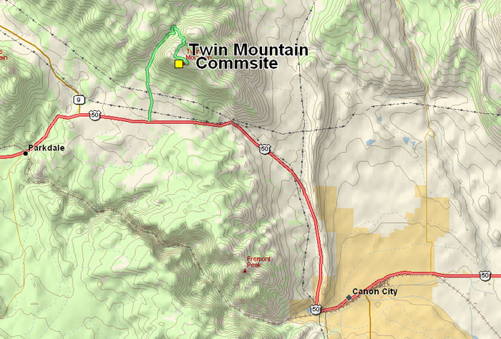
SITE MAP

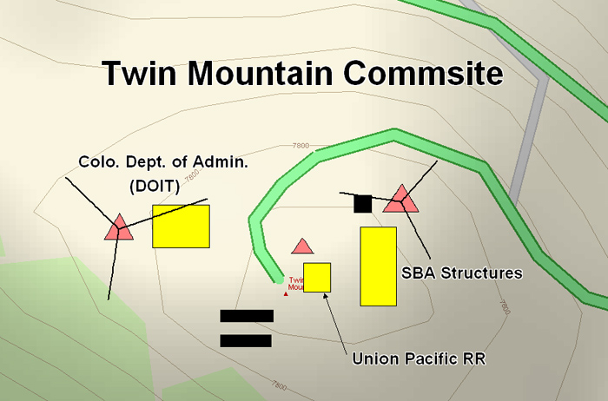

APPENDIX B
TWIN MOUNTAIN COMMUNICATIONS SITE LESSEE/HOLDER FACILITY TABLE

(See associated User’s Table on the Website)
 | Auth # | Use | Building | Tower | Access/Parking | Other
Facility #1  SBA Structures | COC-27939 | FAM | 16’ x 34’ metal | 100’ lattice guyed | Access and parking | 40 Kw Generator, diesel tank
Facility #2  Union Pacific Railroad | COC-3928 | PMRS | 6’x 6’ fiberglass | 20’ wood pole | Access and parking | none
Facility #3  Colo. Div. of Admin (DOIT) | COC-71616 | PMRS | 14’ x’ 24’ conc. Block | 140’ lattice guyed | Access and parking | 20Kw generator, 2-1000 gal propane tanks

APPENDIX C
SITE PHOTOGRAPHS

(See associated Facility Photos on the Website)

Facility 1, SBA Structures
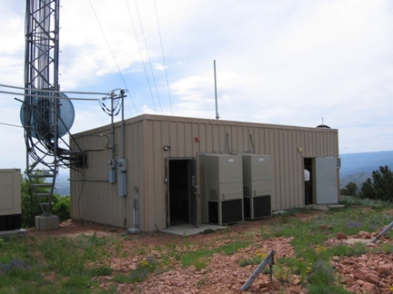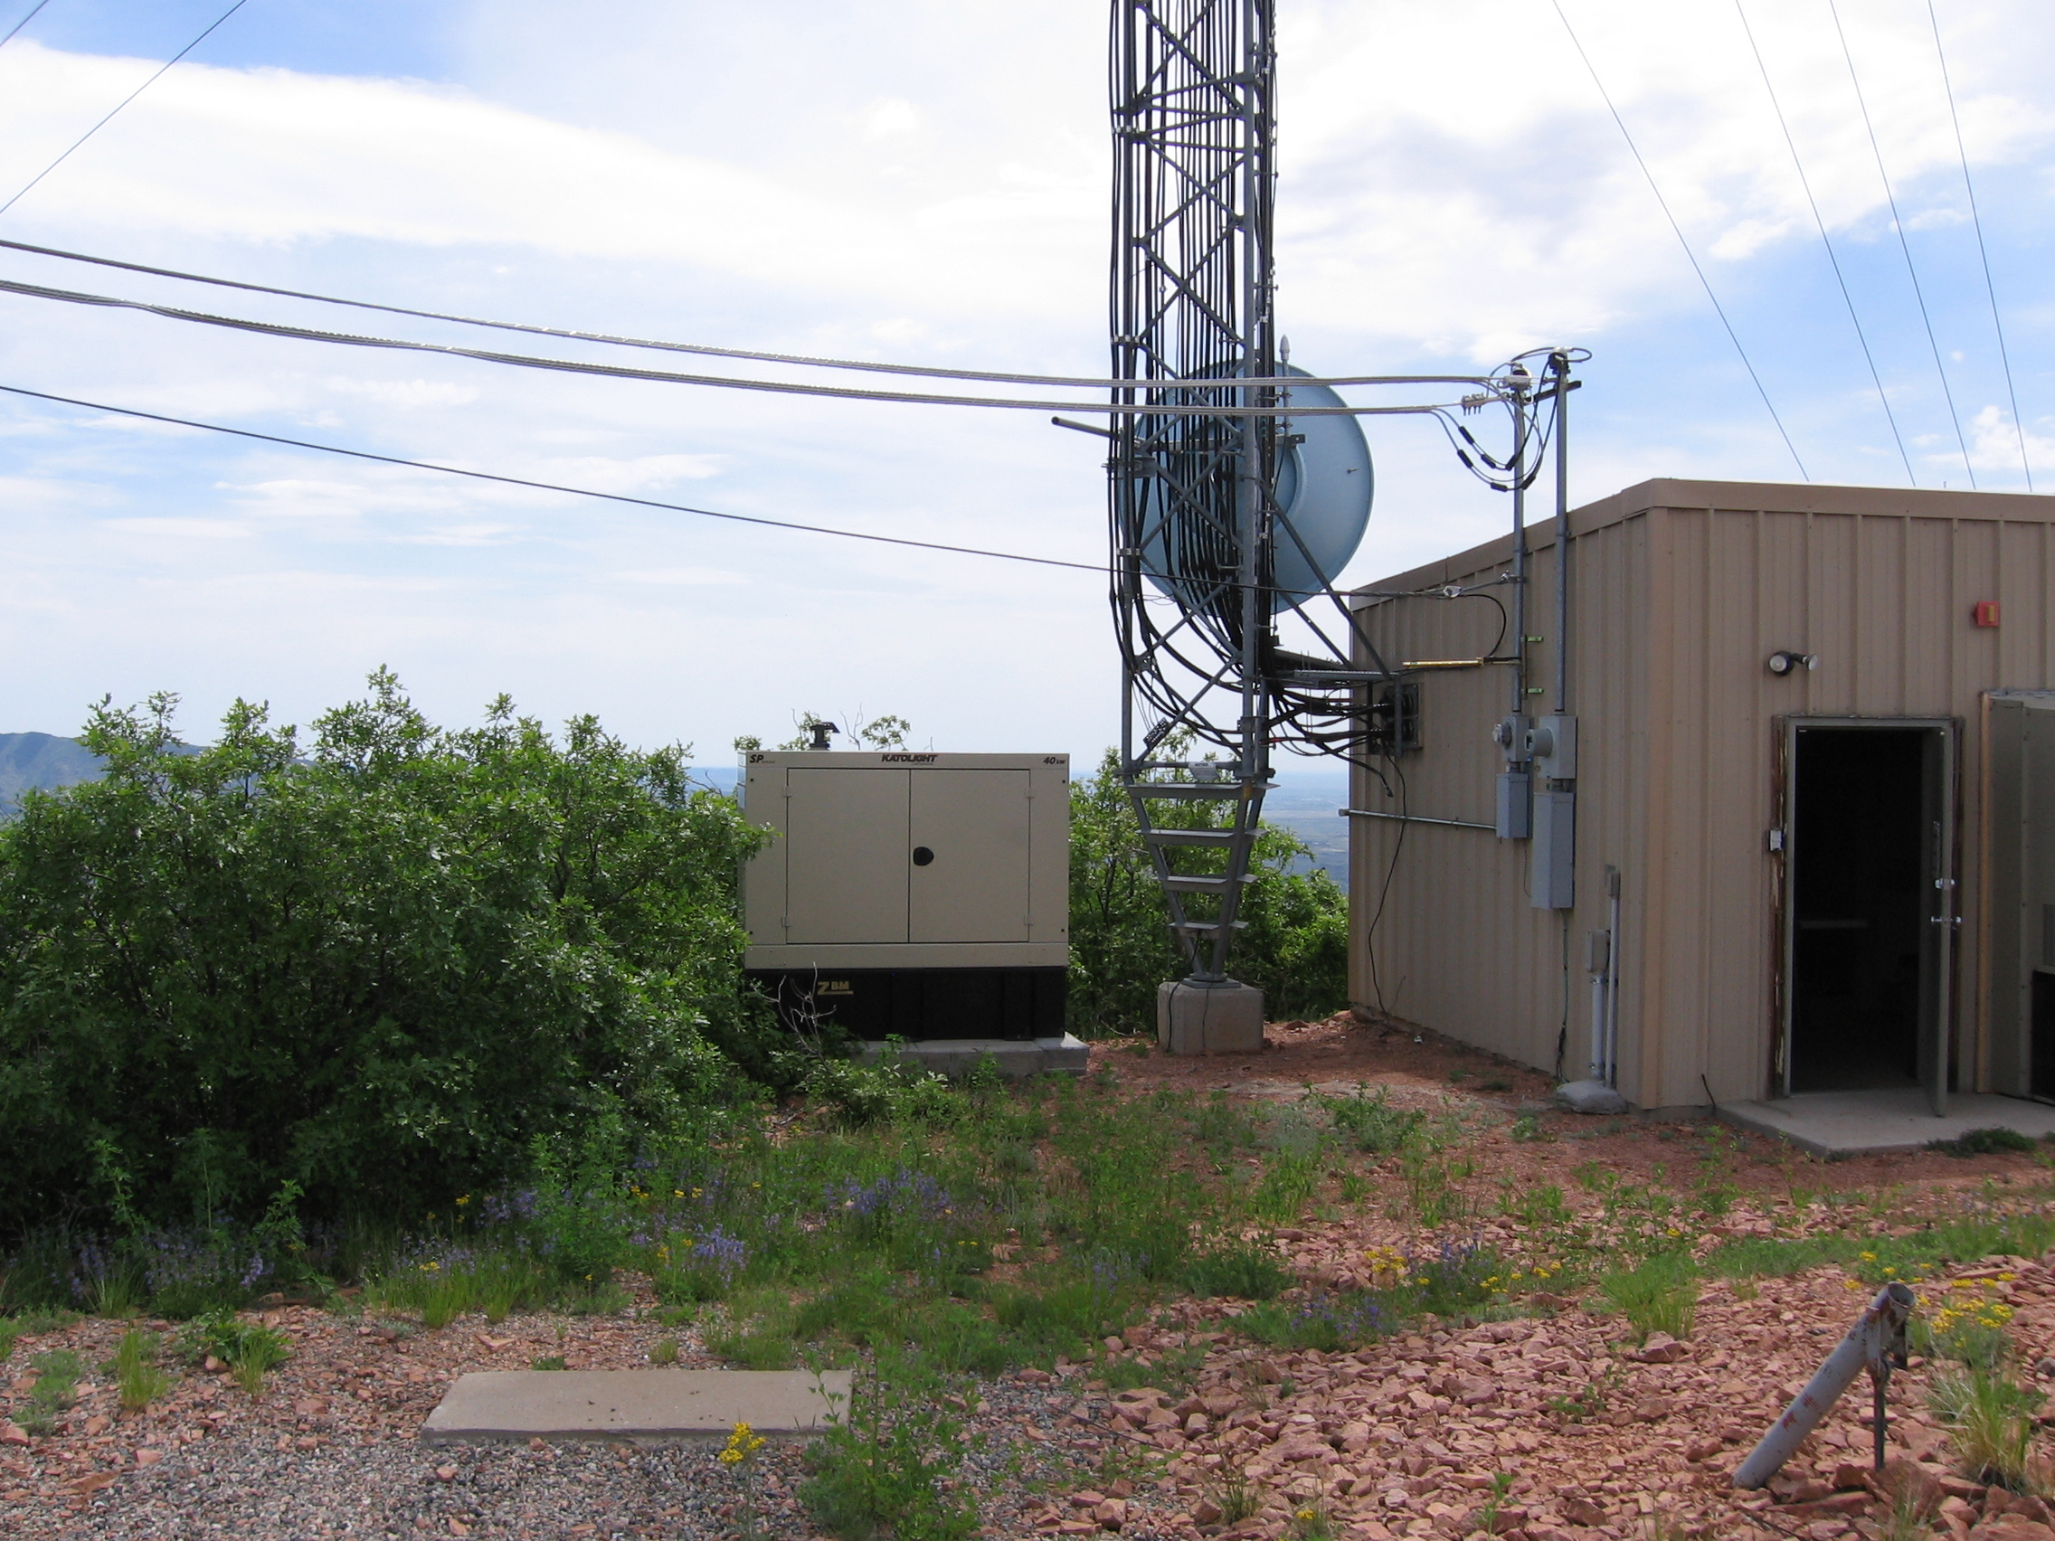

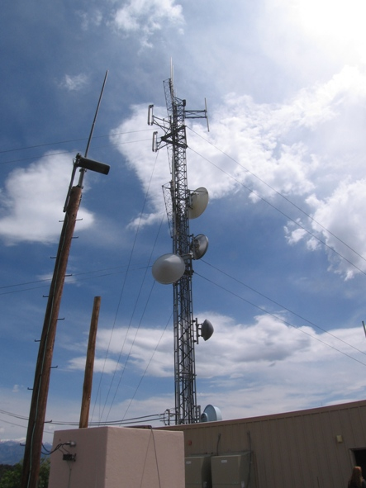

Facility 2, Union Pacific RR
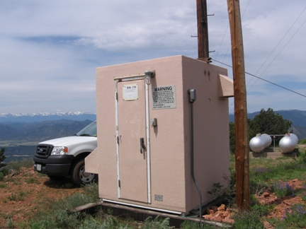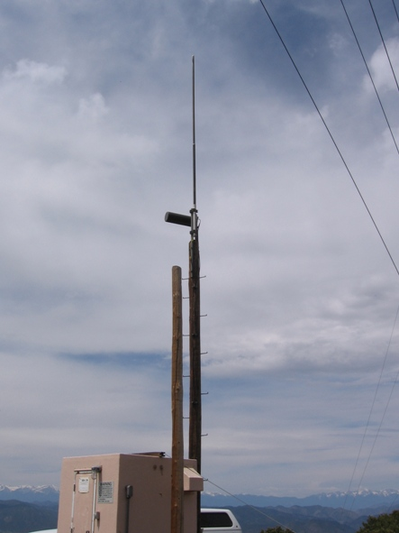

Facility 3, Colo. Admin. Dept. (DOIT)
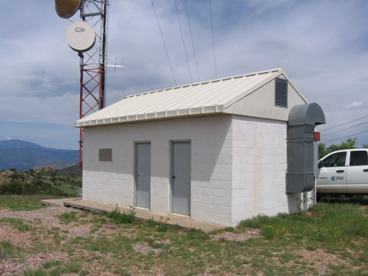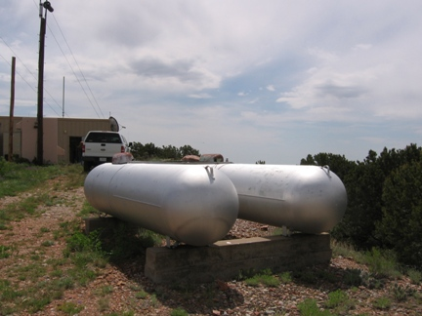

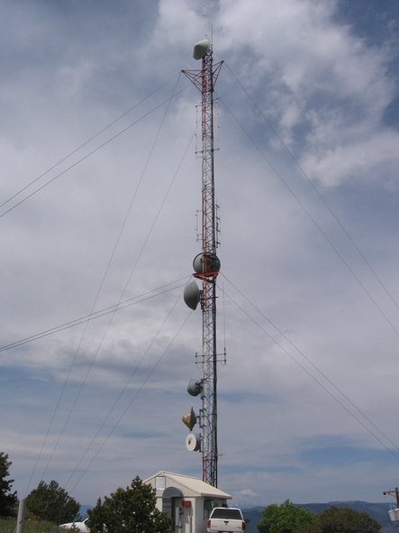

APPENDIX D
“Twin Mountain Annual Technical Inspection”
Date Inspected: _____________________________ Time Inspection: ________________________________

Permit Holder: ______________________________ Authorization # _________________________________

Site Technician: ____________________________ Phone # _______________________________________

Number of Transmitters ______________________ License Posted _________________________________

Please mark the following Items as Acceptable (A) or Unacceptable (U).

Electrical Wiring ------------------- (A) (U) Grounding --------------------- (A) (U)

Equipment Installation ------------ (A) (U) Housekeeping ----------------- (A) (U)

Building Repair -------------------- (A) (U) Tower Repair ------------------ (A) (U)

Please mark the following Items as Yes (Y) or NO (N) or (NA)

Isolators ---------------------------- (Y) (N) (NA) Circulators --------------------- (Y) (N) (NA)

Cavities ----------------------------- (Y) (N) (NA) Terminators -------------------- (Y) (N) (NA)

Filters ------------------------------- (Y) (N) (NA) Lightning Protection ---------- (Y) (N) (NA)

Comments: __________________________________________________________________________________

____________________________________________________________________________________________

Recommended Corrective Action: ________________________________________________________________

_____________________________________________________________________________________________

_____________________________________________________________________________________________

Required Corrective Action to Be Taken: __________________________________________________________

_____________________________________________________________________________________________

_____________________________________________________________________________________________

_____________________________________________________________________________________________

_____________________________________________________________________________________________

Committee Representatives: _____________________________________________________________________

Bureau of Land Management Representatives: _______________________________________________________
Please make the required corrective action within the next 120 days. Please make a written report of corrective action taken and submit to the BLM. If you should have any questions, please call the BLM office.

