On Possible use of Electron Lenses in LHC
V.Shiltsev#, FNAL, P.O.Box 500, Batvia, IL 60510, U.S.A.

Abstract

We present basic facts about electron lenses used in high-energy accelerators and discuss their possible application in the LHC. Four proposals are presented: a) electron lenses for compensation of head-on beam-beam effects; b) electron lens as tune-spreader for better beam stability; c) as electromagnetic primary collimator for ions and protons; d) satellite bunch cleaning by electron lenses. Main requirements are discussed.

INtroduction
A detailed description of electron lenses for beam-beam compensation is given in [1]. The status of the Tevatron Electron Lens project can be found in [2] and references therein. Essentially, an electron lens is very stable cylinder of about 10¹² electrons (stabilized transversely by a strong magnetic field) which can attract protons. The energy of the electrons is of the order of a few kV (maximum 10’s of kV), so the magnetic field does not play big role. For that kind of electron cloud (see Fig.1a) one can control charge density, diameter, length, transverse position, timing, velocity, shape, angle, direction – that makes it quite a versatile tool.
The space charge of an electron lens can blow up emittances in a controlled fashion; drive particles out – randomly or via resonant excitation; remove unwanted particles, bunches, e.g. only in between bunches, or just 1 out of 3000, or only satellites, or only those with a>5σ, etc. An electron lens also can reduce emittance blow-up caused by other processes: e.g. by space-charge forces, or beam-beam forces; it can reduce beam loss rates by moving particles away from dangerous resonances, it can be used for selective resonant extraction, and it can introduce incoherent tune spread to stabilize beams. The figure of merit for an eLens is the tune shift it induces:
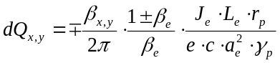
(1)

Where J_{e} is the current (see [1]). For example, the Tevatron Electron Lens-1 can move the tune of 980 GeV protons by about 0.01 (see Fig.1b) – i.e. it’s not only versatile but is a very strong instrument. Note that because in many applications the size of the electron beam a_{e} should be equal or proportional to the rms beam size, the tune shift of Eq.(1) is independent on the machine parameters and scales as Je over normalized emittance. Therefore, eLens tuneshifts in RHIC, Tevatron and LHC should be about the same for the same Je.
Two electron lenses were built and installed in the Tevatron and have proven themselves safe for operations: TEL-1 (see Fig. 2a) has been used for abort gap cleaning for 5 years in 24/7 operation (since 2002), that is >1000 HEP stores without store loss due to TEL (a very good
shiltsev@fnal.gov
record for a collider component). Only a few 8-hour accesses (over 5 years of operation) to the tunnel were required to replace failed TEL components. TEL-2 has been used for Beam-Beam Compensation studies. It was installed in June’06, commissioned for operation in August’06, used for studies in ~15 HEP stores for a few (up to 8) hours, and every store in Sep’06. There were no quenches/problems/complaints related to use of TEL-2 in the studies. Various transverse beam current profiles were tested over the years in TEL-1 and -2 (see Fig. 2b).
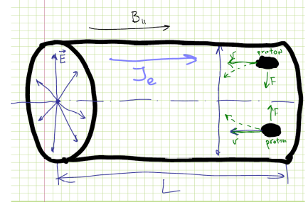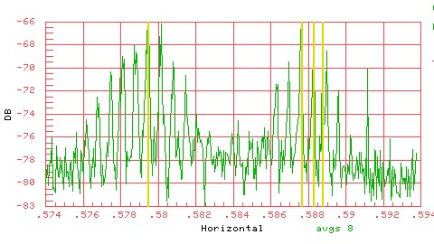
Figure 1: (a) Electron lens as charged cylinder; (b) dQ=0.009 tune shift of 980 GeV proton bunches (right) by the Tevatron Electron Lens.
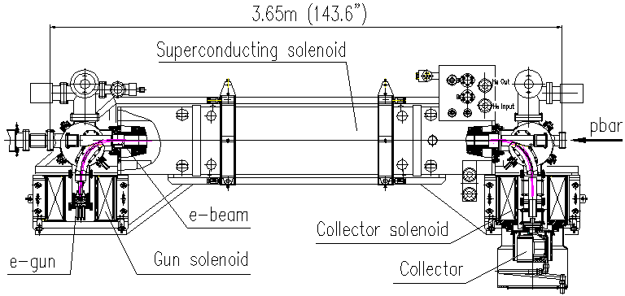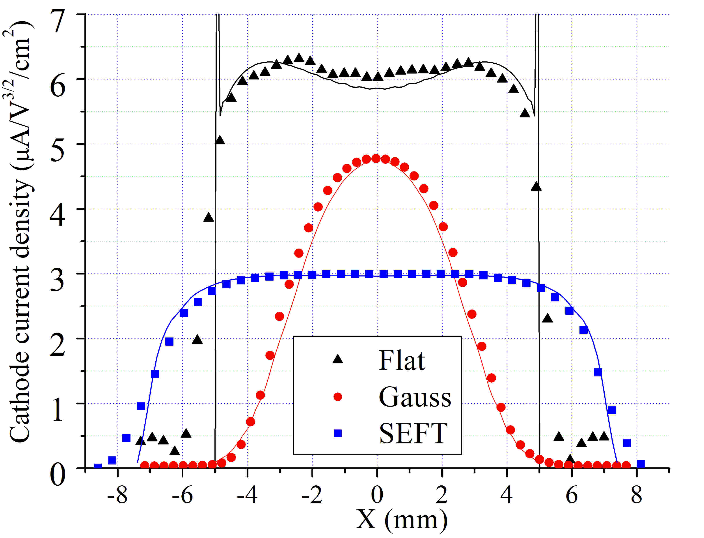
Figure 2: (a) TEL-1 layout; (b) electron beam current profiles tested in TEL-1 and TEL-2
For reference, TEL-2 can generate dQ ~ 0.004, it compensates bunch-by-bunch vertical tune spread, operates with J_{e} = 1 to 2 A of current, pulsed with characteristic pulse width of dt = 600 ns (see Fig. 3a), rep. rate = 50 kHz, β_{y} = 136 m, β_{x} = 50 m, currently, it runs with a “flat top + smooth edge” electron gun (see blue curve in Fig. 2a), a_{e} = 2.5 mm at 980 GeV, L_{e} = 2 m, U_{e} = 5 kV, B_{gun} = 0.3 T, B_{main} = 3 T.

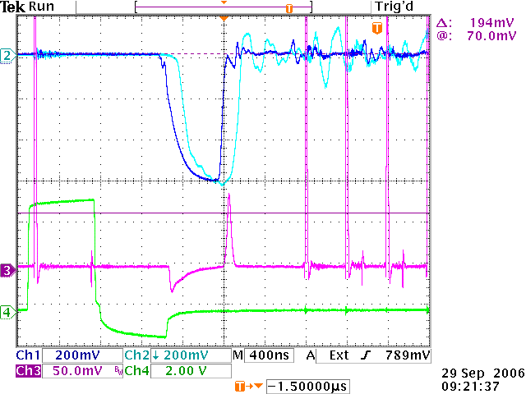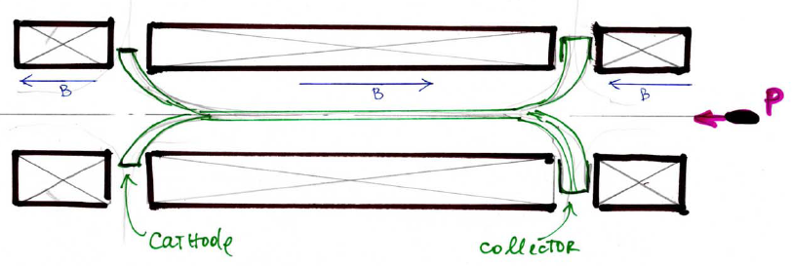
Figure 3: (a) 600 ns electron pulse in TEL-2; (b) eLens without bending magnets.

It should be noted that, in principle, the electron lens configuration could be different from the shape of TEL-1 and 2 (Π-shape) – e.g. S-shape, or even no specific shape.

LHC Electron Lenses
Four possibilities for electron lenses in the LHC (LEL) are presented in this paper:
1) LEL as Head-On Compensator at design intensities and with x (2…4?) N_{p}/bunch
2) LEL as Beam Stabilizer (Tune Spreader) to help octupoles at design N_{p} = 1.15 10¹¹
3) LEL as soft hollow collimator
4) LEL as soft “beam conditioner” (e.g. satellite killer)

1. LEL for head-on beam-beam compensation
Currently, it is believed that beam-beam effects with nominal beam-beam parameter of ~ 0.003 per IP will not limit operation of the LHC with 3 IPs [3].
On the other hand, operation with twice or more protons per bunch may be necessary if the total beam power will happen to be limited by other considerations (e.g. collimation system efficiency or electron cloud). In that case, both head-on and long-range beam-beam interactions are expected to be unbearable, as shown in
Fig.4a, which presents expected beam-beam tune spread in the LHC with 2.3 10¹¹ per bunch covering a number of potentially dangerous non-linear resonances.

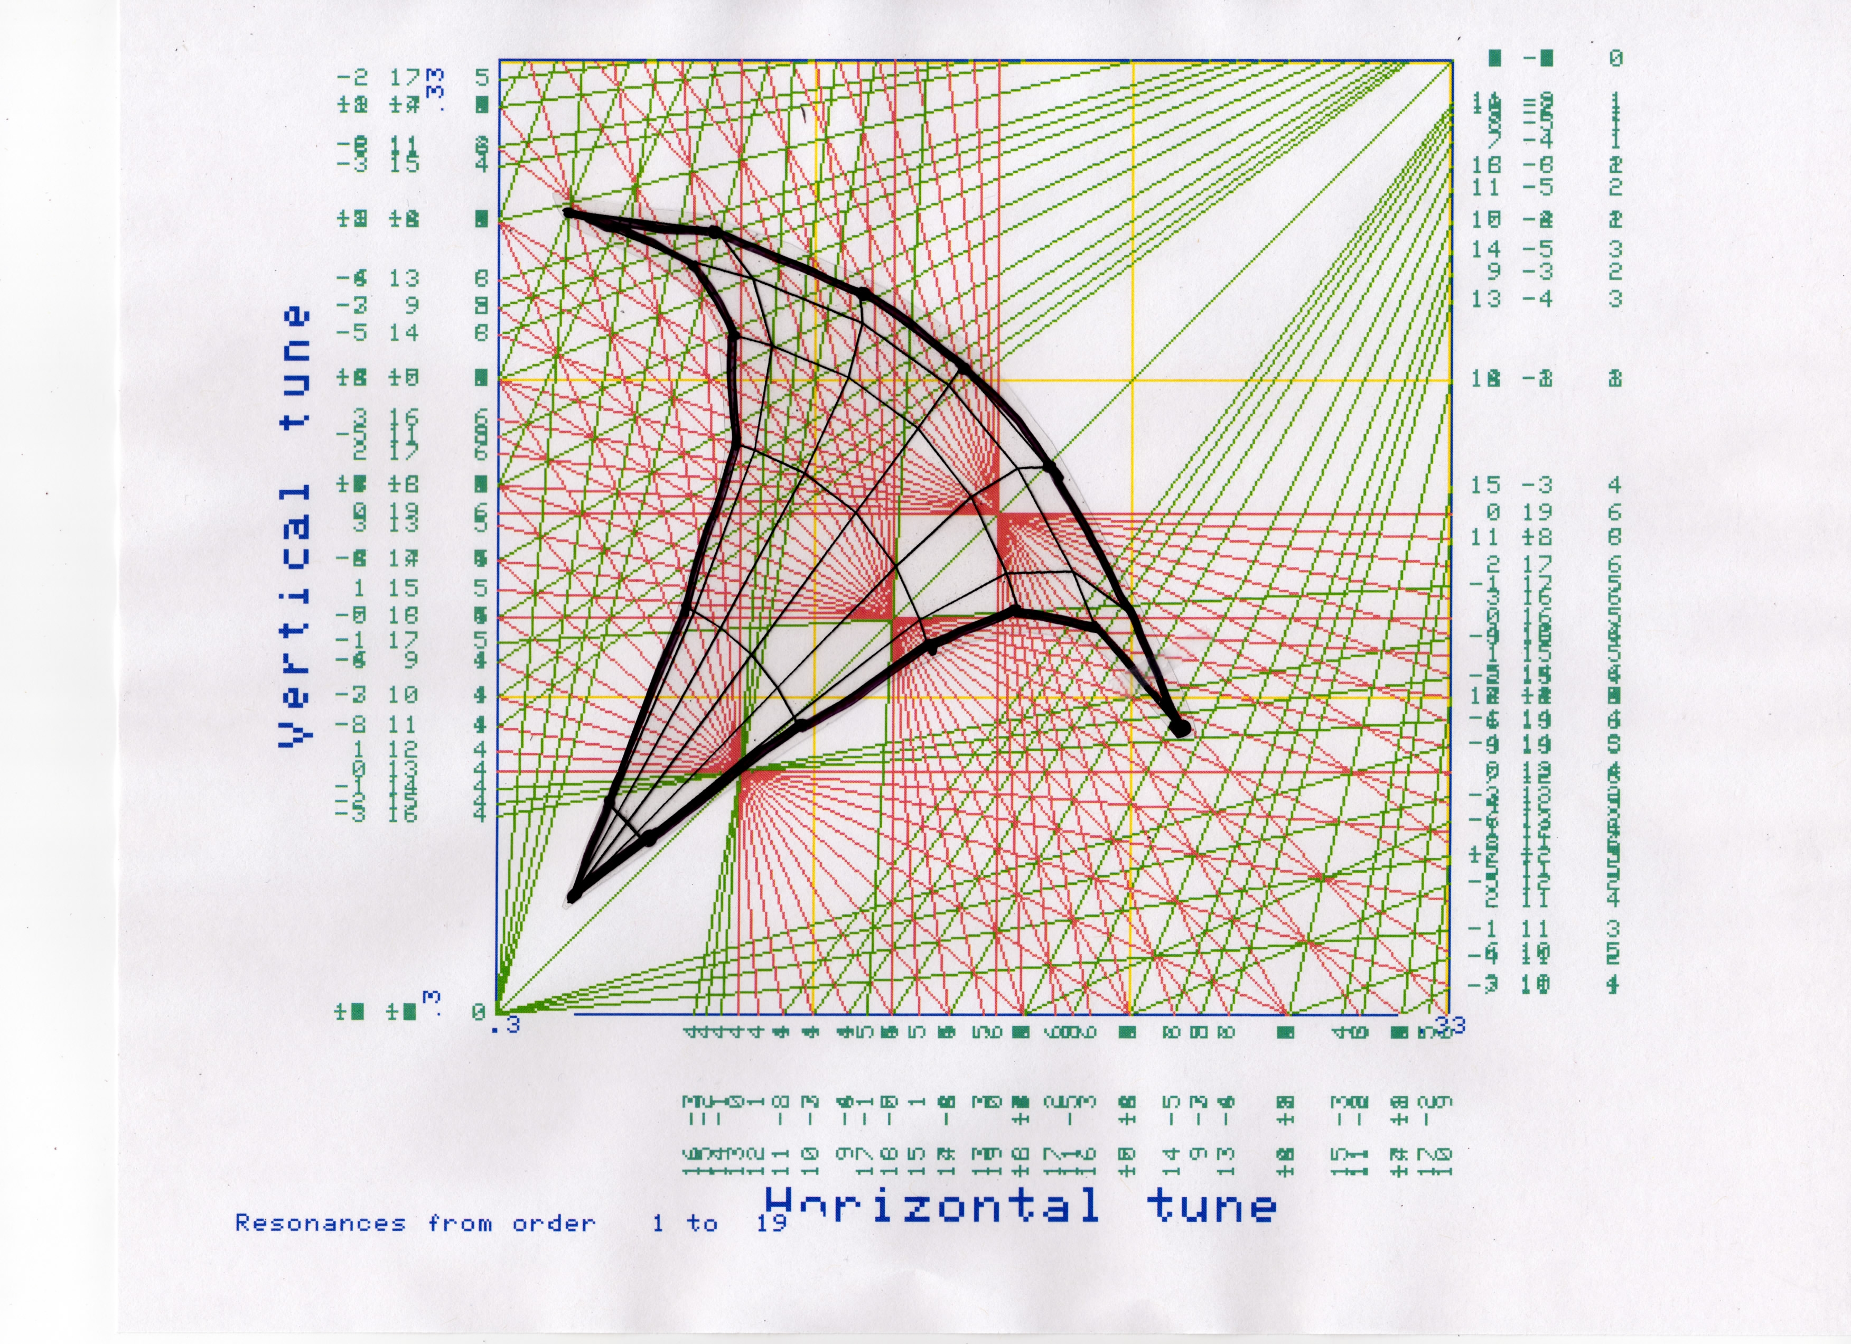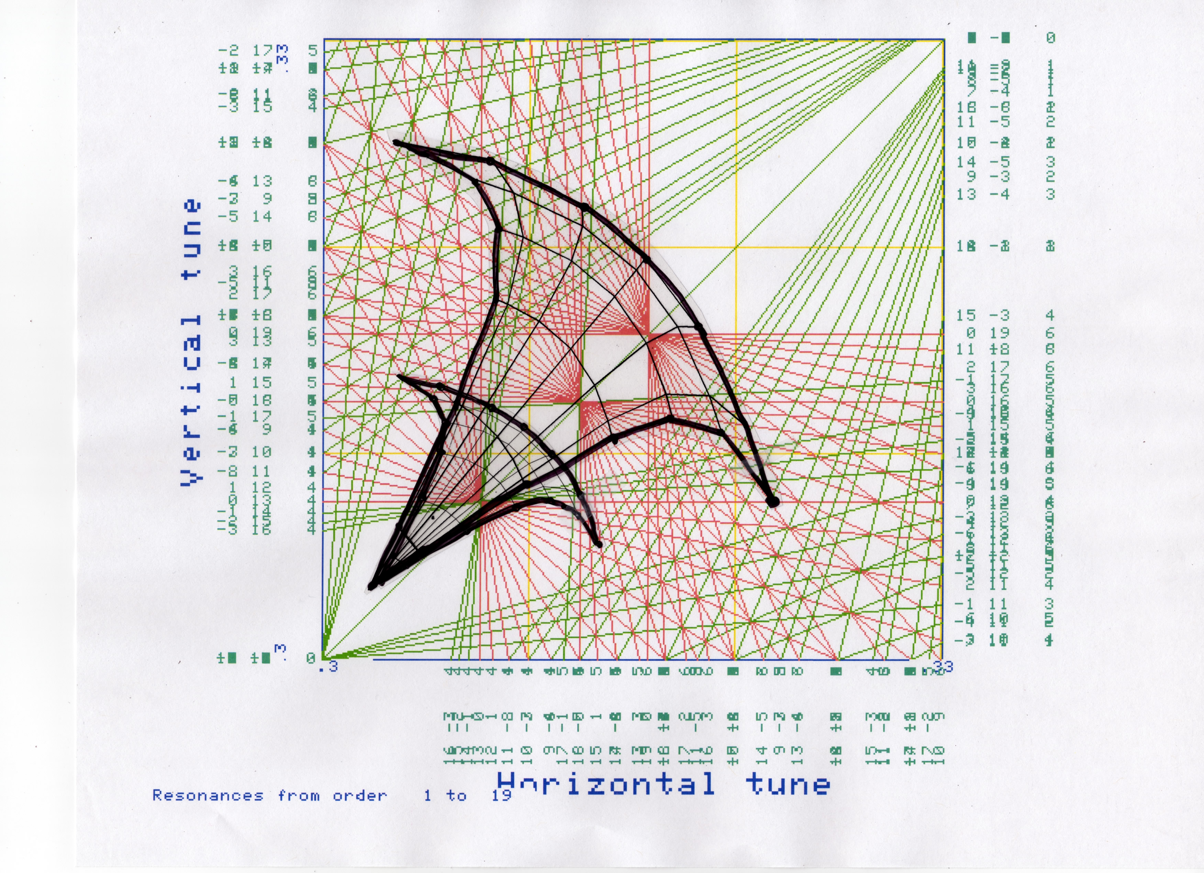
Figure 4: (a) LHC tune footprint with 2.3e11/bunch;
(b) eLens compresses the footprint by x2.

According to [1], a complete compression of head-on tune footprint is possible if the number of electrons in the LEL is N_{e} = N_{ip} N_{p} /(1+β_{e}), e.g., for the LHC N_{p} = 1.1 10¹¹, N_{ip} = 4, so for 10 kV electrons (β = 0.2) one needs N_{e} = 4.4 10¹¹, and the electron transverse beam profile exactly matches the proton beam profile (presumed to be Gaussian with an rms sigma of 0.3 to 0.5 mm). Head-on beam-beam compensation together with “wire” long-range beam-beam compensation [4] could be used to compress total footprint to an acceptable value as indicated in Fig. 4b.
The electron beam requirements for head-on compensation of 1.15 10¹¹ protons per bunch are summarized in Table 1:
Table 1: electron beam requirements for head-on compensation of 1.15 10¹¹ protons per bunch
Maximum current | 1.2 A
Regime of operation/ voltage | DC, 10 kV
Beta functions at the location | β_{x} = β_{y} => 200 m
Electron beam profile | Gaussian or optimized
e-beam radius | 0.3 mm
Magnetic fields: Gun / Main | 0.2 T / 6.5 T
Number of lenses, length | 1/beam, each 3 m long

2. LEL as a tune spreader for beam stabilization
One of known issues for the LHC high-luminosity operation is believed to be impedance of the collimators which will dominate the total LHC impedance and limit the total beam intensity to about 30 - 40% of its nominal value [5]. The existing octupoles do not have enough strength to keep the beam stable above that intensity. Moreover, even at this maximum current, octupoles will significantly reduce dynamic aperture and beam lifetime. The reason for that, as shown schematically in Fig. 5a , is that the tune spread introduced by octupoles in the beam core, will result by default in significant non-linear fields (tuneshifts, etc) for particles at larger amplitudes. The LEL can do that job without such lifetime degradation – see Fig.5b – as it can induce the tune spread solely in the core (with nothing in the halo). Such a phenomenon has been experimentally observed in the Tevatron – Fig. 5c demonstrates how misaligned TEL-1 electron current resulted in significant widening of the synchro-betatron lines of the proton Schottky spectra [6].
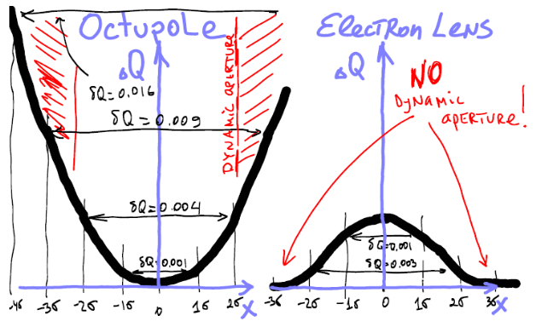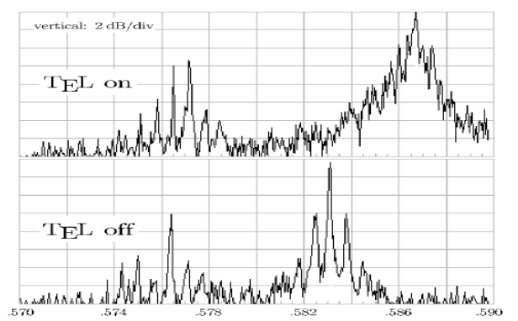
Figure 5: (a) tune spread induced by octupoles; (b) eLens induced tune spread; (c) tunespread unduced by misaligned TEL-1 beam in the Tevatron (980 GeV protons, extra tune spread ~0.003, tune shift dQ~0.004).

Table 2 summarizes the electron beam requirements to generate a tune spread dQ = 0.004 and stabilize 2.3 10¹¹ protons/bunch:

Table2: Electron beam requirements to generate a tune spread dQ = 0.004 and stabilize 2.3 10¹¹ protons/bunch:

Maximum current | 0.5 - 1 A
Regime of operation/ voltage | DC, 10 kV
Beta functions at the location | β_{x} = β_{y} => 200 m
Electron beam profile | Gaussian or bell-shape
e-beam radius | 0.3 mm (0.9 mm at inj)
Magnetic fields: Gun / Main | 0.2 T / 6.5 T
Number of lenses, length | 1/beam, 2 m long each

3. A hollow electron beam as an electro-magnetic collimator
A hollow electron beam in an LEL has very strong non-linear field components which can effectively excite betatron motion of the particles with larger amplitudes (smaller amplitude particles are not affected at all – see Fig. 6a).
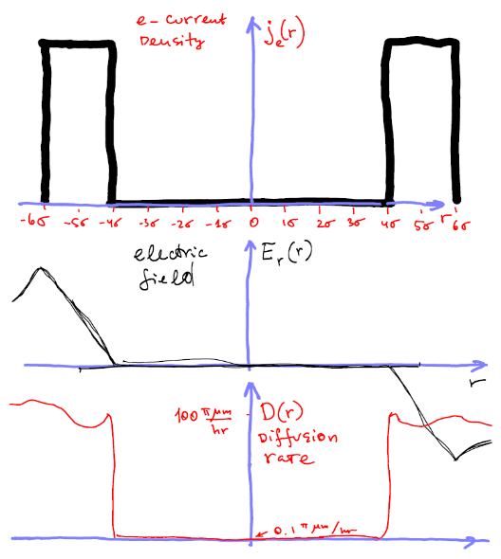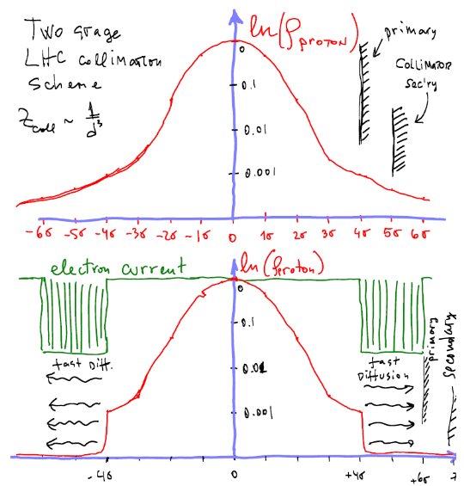
Figure 6: (a) eLens distribution for EM-Collimation; (b) Diffusion enhanced by EM-Collimation.
The speed of diffusion can be greatly enhanced if the electron current varies in time in resonance with betatron oscillations or with nearest non-linear resonance line. An estimate of the one-turn amplitude increase in the latter case is given by dA = 4πA dQ, that gives dA of about 20 μm for A (4 to 5 times rms beam size) of ~2 mm and an LEL-induced tune shift of dQ = 0.001. The arrangement offers a viable solution for a primary collimator of the LHC ion beam (see Fig. 6b), because such an electromagnetic collimator does not break an ion into fragments (as any primary collimator made of usual material would do). In that case, LELs would have to be installed to replace the current primary LHC collimators.
We note that a high current version of an LEL can increase the impact parameter for 7 TeV protons as well if its equivalent dQ can reach 0.01 (the primary collimator diffuses the halo particles by ~ 14 MeV / 7 TeV*200 m = 400 μm, while the LEL can add dA = 200 μm).
Hollow electron beam technology does exist; it is well developed and has been tested in various applications – see Figs. 7a and b, and [7, 8].
Table 3 summarizes the hollow electron beam requirements for EM collimation of ions and protons (dQ=0.001 and 0.010, respectively).

Table 3: Hollow electron beam requirements for EM collimation of ions (and protons), dQ = 0.001 (0.010)
Maximum current | 1 - 2 A / 10 A
Regime of operation/ voltage | 3 kHz mod’d, ~ 20 kV
Beta functions at the location | β_{x} = β_{y} => 200 m
Electron beam profile | hollow
e-beam radius in/out | 1.5 mm / 2 mm
Magnetic fields: Gun / Main | 0.2 T / 6.5 T
Number of lenses, length | 2-3/beam, 2 m long

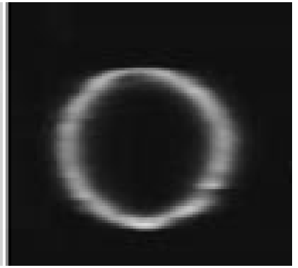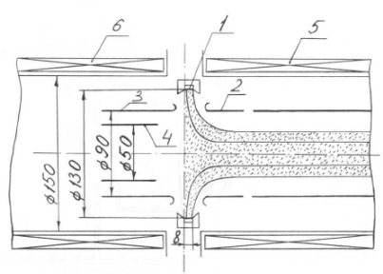
Figure 7: (a) hollow electron beam [7]; (b) cylindrical electron gun tested in [8].

4. LEL as satellite bunch killer
Finally, LEL can be used for beam conditioning in the way similar to TEL1 usage in the Tevatron – as a remover of unwanted particles [9]. In the case of the LHC, those can be satellite bunches, +- 2.5 ns, 5.0 ns, etc from the main bunch. Those bunches can lead to significant detector background because of non-centered collision point and different beam dynamics. To remove those, LEL current has to be pulsed (pulse duration ~4 ns) and modulated at ~3 kHz (betatron resonance frequency) – see Fig. 8a. The 4 ns pulsing will require having a grid for current modulation, e.g. as indicated in Fig. 8b.
The LEL beam requirements for removal of proton satellites in 1 hour, at 7 TeV Table 4 are summarized in Table 4.

Table 4: LEL beam requirements for removal, in 1 hour, of proton satellites at full energy (7 TeV)
Maximum current | 1 A
Regime of operation/ voltage | 300 4 ns pulses, 3 kHz modulated, ~80 kV
Beta functions at the location | β_{x} = β_{y} => 200 m
Electron beam profile | Rectangular (flat top)
e-beam radius in/out | 0.6 mm
Magnetic fields: Gun / Main | 0.4 T / 3.2 T
Number of lenses, length | 1/beam, 1 m long

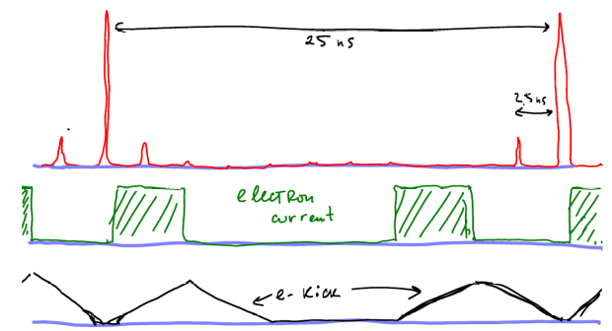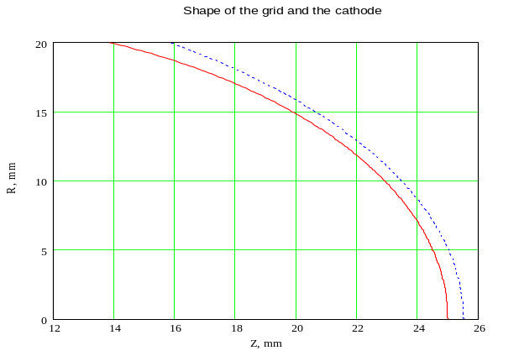
Figure 8: (a) satellite cleaning by eLens; (b) cathode and grid geometry for fast modulation.

OPEN QUESTIONS
Of course, extensive theoretical studies and numerical tracking are needed before undertaking hardware R&D to address numerous questions, like:
- Will Gaussian or truncated Gaussian e-current density distribution improve lifetime and reduce diffusion rates?
- Straightforward tracking with a weak-strong code
- Is there a better distribution?
- from the first principles, theory, analytical consideration
- Effects of β_{LEL}/β*/σ_{z}; or dP/P
- check in numerical tracking
- Importance of e-p interaction in bending sections
- Which of three configurations is better?
- Is the choice tune dependent?
- Lifetime deterioration due to e-p misalignment:
- e-beam straightness tolerances
- relative e-p displacement, angle
- Effect of low-frequency variations dJ, dX on beam lifetime
- Ion cleaning efficiency tolerances
- Cross-interaction with wires in LHC – if there is any
- e-beam effect on coherent stability or strong-strong beam-beam effects

SUMMARY
Electron lenses installed in the LHC could be used for a variety of purposes, e.g. for head-on beam-beam compensation, beam stabilization, as an electromagnetic ion collimator, or, for satellite bunch removal. It might be of mutual benefit for CERN and US-LARP to form an LHC Electron-Compensation Task Force with the charge to perform an LEL feasibility study over a period of about a year, with the goal of exploring the parameter space and effectiveness of electron lenses in the LHC and the possibility of experimental tests in RHIC.
In the case of positive outcome, the next steps may be:
Design of the eLens for RHIC 2008
Modification of eLens for RHIC 2009-2010
Demonstrate head-on compensation 2010-2011
Install LELs in LHC and commission 2011-2012

Acknowledgements
The author is indebted to V. Kamerzdhiev, G. Kuznetsov, A. Shemyakin (FNAL) for numerous valuable technical contributions to the TEL project, and for suggestions and proposals concerning LHC eLenses, and to W. Fischer (BNL), Yu.Alexahin (FNAL), F. Zimmermann, J.P. Koutchouk and R. Assmann (CERN) for useful discussions on the possible use of eLenses in the LHC.

References
[1] V.Shiltsev, et al. , Phys. Rev. ST Accel. Beams 2, 071001 (1999).
[2] V.Shiltsev, et al., Proc. IEEE PAC 2005 (Knoxville, TN, USA), p.2083.
[3] F.Zimmermann, in Proc. HALO’03, AIP Conf.Proc.693, p.20.
[4] F.Zimmermann, J.P.Koutchouk, et al., Proc. IEEE PAC 2005 (Knoxville, TN, USA), p.686.
[5] R.Assmann, et al., Proc. EPAC 2006 (Edinburgh), p.986.
[6] K.Bishofberger, PhD Thesis, UCLA (2005).
[7] A.Bubley, et.al., Instruments and Experimental Techniques, v.49, No.1 (2006), p.83.
[8] A.Sharapa, A.Shemyakin, NIM-A 336 (1993), pp.6-11.
[9] X.L.Zhang, et al., Proc. IEEE PAC 2003 (Portland, OR, USA), p.1778

