The Effects and Possible Origins of Mains Ripple in the Vicinity of the Betatron Spectrum *
Peter Cameron, BNL, Upton, NY 11973, USA
Marek Gasior, Rhodri Jones, CERN, Geneva, Switzerland
Cheng-Yang Tan, FNAL, Batavia, IL 60439, USA

Abstract
With the advent of significant improvement in the sensitivity of observation of the betatron spectrum[1], the appearance of spectral lines at harmonics of the mains power frequency has been observed in the PS and SPS at CERN, the Tevatron at FNAL, and RHIC at BNL. These lines are potentially problematic for accurate tune tracking and the implementation of tune feedback. We discuss the possible origins of these lines, and present data to support our discussion.

introduction
Identification of the source of mains ripple in beam spectra is often problematic. The difficulty is to clearly demonstrate that the observed ripple originates in the beam, rather than entering the signal path spuriously. Recent data collected at the CERN PS and SPS, the Tevatron at FNAL and RHIC at BNL using a newly developed, highly sensitive, baseband tune (BBQ) measurement system [1] suggests that the beam is being excited at the betatron resonance by high harmonics (h > 100) of the mains frequency.

*Work supported by US LHC Accelerator Research Program

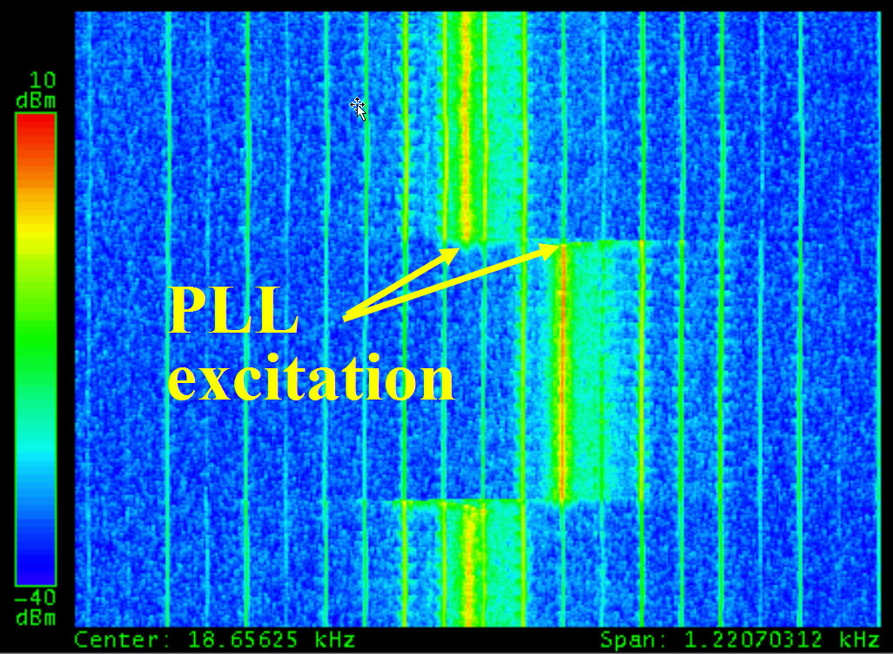
Figure 1: Spectrum with PLL excitation and 60Hz lines
Figure 1 shows the spectrum obtained from a 1m stripline pick-up looking at Copper ions in RHIC, using the Direct Diode Detection (3D) analog front end (AFE) of the BBQ system. The horizontal axis spans ~1.2KHz, centered on the betatron resonance at ~18.65KHz. The vertical axis spans ~30s, with the most recent time at the bottom. The baseband PLL tune tracker [2] is locked on the betatron resonance, which can be seen to shift by ~.002 when the quadrupole currents are changed and then returned to their original values. The 60Hz lines don't move. This illustrates the conundrum - what mechanism might cause high harmonics of the mains frequency to appear in the vicinity of the betatron resonance, yet not be sidebands of the betatron line? The obvious conclusion is that the beam is being directly excited at these frequencies. This interpretation was met with considerable scepticism from accelerator physicists and power supply specialists, the question being what mechanism might generate field ripple at such relatively high frequencies. Some of the means employed to rule out spurious sources included:
- Batteries - AFE electronics were powered from batteries, with no change in the observed spectrum.
- Electronics location - AFE was situated immediately adjacent to the pickup in the tunnel, and then ~70m away in the instrumentation room, with no change in the observed spectrum.
- Isolation transformers - AFE was operated with and without isolation transformers in the signal path, with no change in the observed spectrum.
- High pass filtering - 70MHz high pass filtering was inserted between pickup and AFE, with no change in the observed spectrum.
- Pickup movement - no spectral variation was seen with large (~1cm) changes in the position of a moveable pickup.
- Intensity variation - no spectral variation was seen with large changes in bunch charge.
- Different pickups - mains harmonics were observed from a homodyne detection AFE, a 245MHz resonant pickup, and a million-turn BPM.
All testing indicated that the apparent mains excitation was not spurious and that the beam was truly being excited at the betatron frequency by high harmonics of the mains frequency. The clue leading to the final crucial observation came from the Tevatron, where a change in the relative amplitudes of the observed mains harmonics in the horizontal and vertical planes was seen when the beam separation helix was turned on. The helix is known to introduce coupling. This prompted a brief experiment at RHIC, in which the relative amplitudes of the mains harmonics in the two planes were monitored while coupling was varied. The spectral power of the mains harmonics in the vertical plane was seen to be a linear function of the coupling strength, and was almost entirely absent when the machine was well decoupled. There was no dependence on coupling in the horizontal. From this it was definitively concluded that the observed mains harmonics are indeed on the beam, and that the excitation, at RHIC at least, is in the horizontal plane.

Observations
Beam Spectrum during Ramping
There is a lot of information in the beam spectrum during the ramp. Figure 2 shows such a spectrum from Copper ions in RHIC, seen through the 3D AFE. The horizontal axis spans ~2.4KHz, centered at ~17.6KHz. The vertical axis spans ~6 minutes, with the most recent time at the bottom. The baseband PLL kicker was off. The visible betatron signal is some combination of kicked tune excitation, 245MHz PLL excitation, and Schottky.
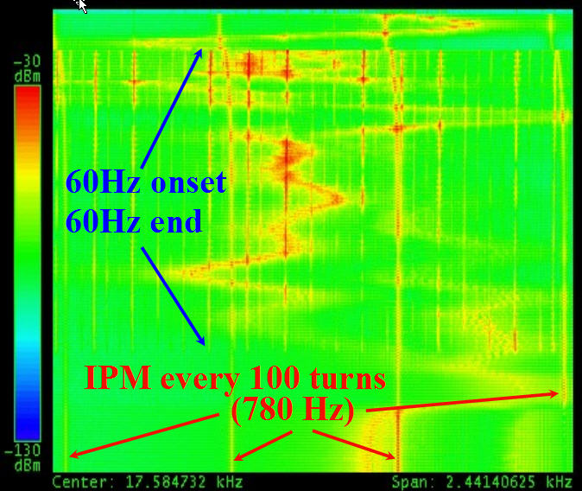
Figure 2: RHIC Spectrum during an acceleration ramp
The onset of strong 60Hz harmonics coincides with the turning on of the ramping power supplies, and the end of the harmonics with their turning off. The harmonics have a pattern that repeats every 720Hz, with 3 strong lines spaced by 180Hz. Their frequency remains constant during the ramp. The spectrum also shows coherence generated by the firing of the IPM sweep voltage every 100 turns. The frequency of the IPM signal tracks the revolution frequency up the ramp. This data suggests that the source of the ripple is the ramping power supplies.

Homodyne Detector
In the effort to confirm that the mains frequency harmonics were not due to the interaction of some spurious source with the 3D AFE, a comparison was made with spectra obtained from other pickups.
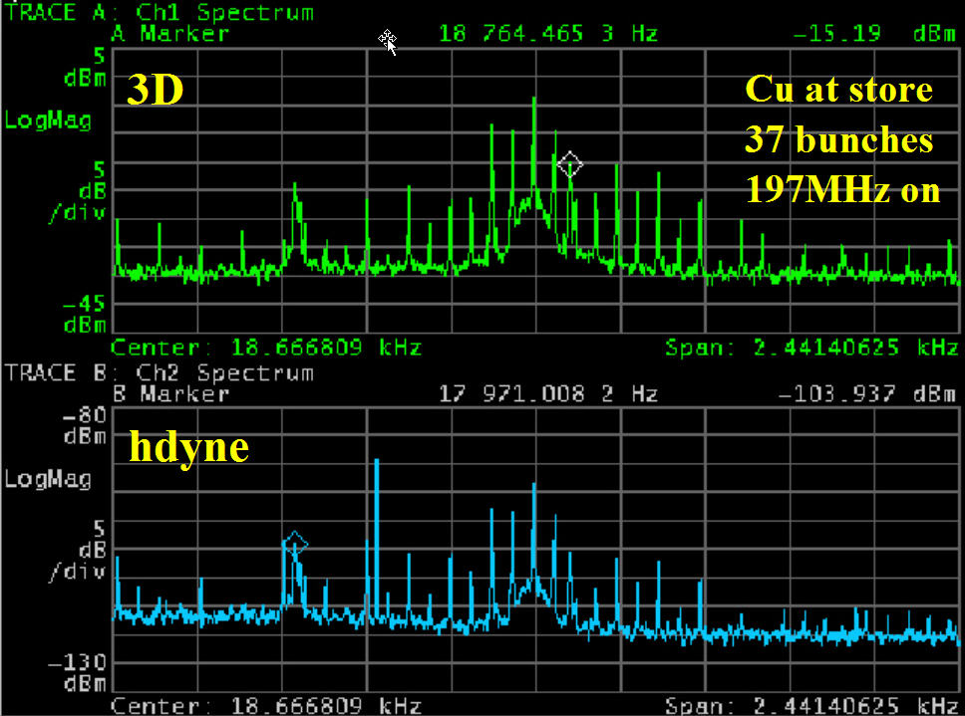
Figure 3: Spectra from 3D and homodyne AFEs
The upper portion of Figure 3 shows the spectrum in the vicinity of the betatron line as seen by the 3D AFE, while the lower portion shows the same beam as seen by a homodyne detector. The homodyne signal was obtained using the sum signal from a H9 hybrid to mix down the difference signal from the same hybrid. The instantaneous power levels were such that saturation of the hybrid or mixer was unlikely. The spectra shown in figure 3 are clearly very similar, which reinforces the notion that the mains harmonics are not an artifact somehow generated by the 3D AFE.

245MHz Resonant Pickup
Simultaneous data was also taken with the 245MHz resonant pickup used in the operational RHIC PLL system, and is shown in Figure 4.
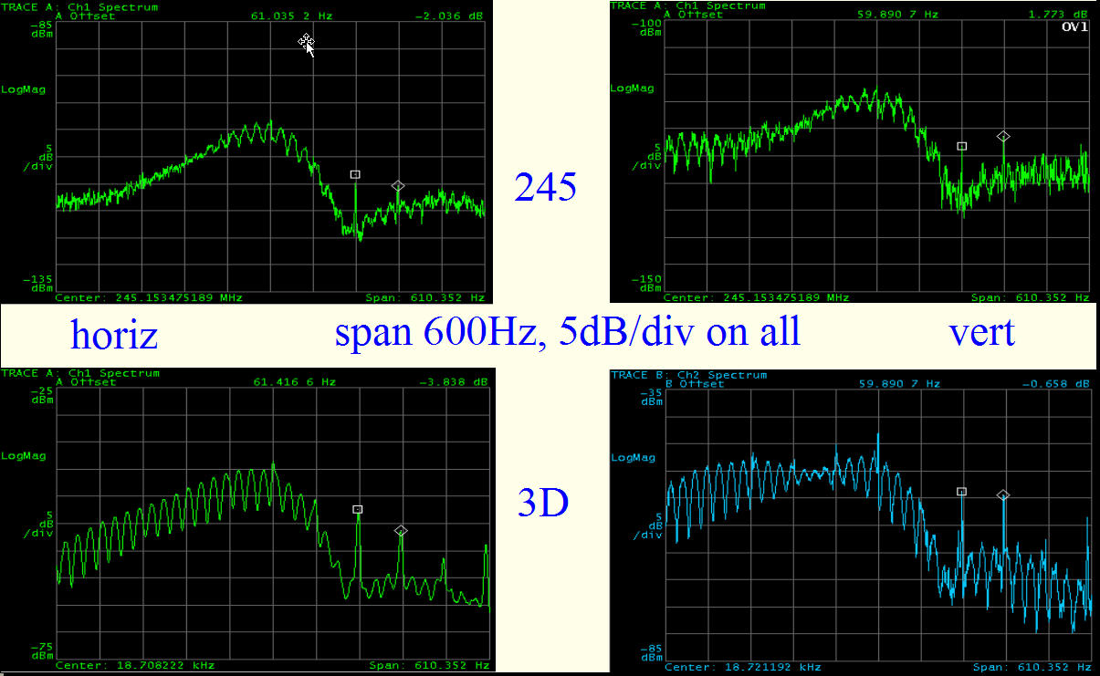
Figure 4: Spectra from 3D and 245MHz resonant pickup
The upper images show signals from the 245MHz pickup, and the lower from the 3D AFE. RHIC was at store and the gap cleaner was operating when this data was taken. The broad peak which occupies the left 2/3 of the images results from beam excitation by that kicker. Mains harmonics are clearly visible in both planes and in the signals from both detectors, in the right 1/3 of the images. These harmonics had never been noted in the 245MHz signal during the many earlier years of RHIC running. It requires some effort to observe them, as they are present only when the 197MHz storage cavities are on and produce shorter bunches, so extending the coherent spectrum up to the 245MHz pickup frequency. In this circumstance it is difficult to avoid saturation of the sensitive front-end electronics. This data again reinforces the notion that the mains harmonics are not an artefact somehow generated by the 3D AFE.

Million Turn BPM
Several of the RHIC BPMs have added memory to permit acquisition of turn-by-turn data for one million turns. These BPMs were used in the study of transition
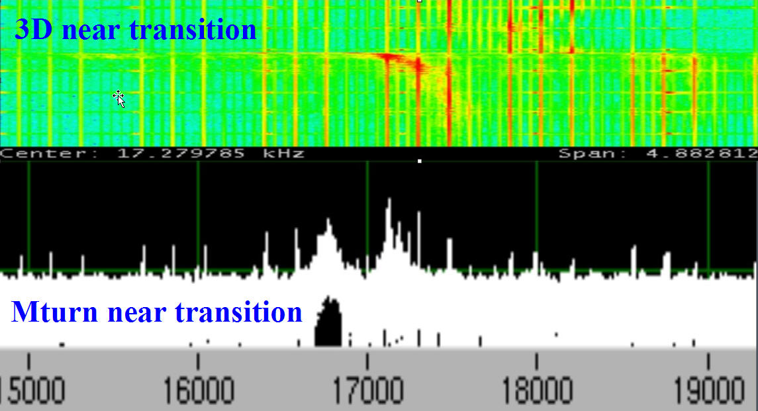
Figure 5: Spectra from 3D AFE and MTurn BPM
instabilities during the Copper run. With its excellent sensitivity and immunity to saturation, the 3D AFE also proved an excellent tool for these studies. Figure 5 shows data taken at the same time near transition (but on different ramps, with slightly different tune values). The pattern of the mains harmonics (repeating every 720Hz, with 3 strong lines spaced by 180Hz) is essentially identical for these two systems. This data once again reinforces the notion that the mains harmonics are not an artefact generated by the 3D AFE.

Coupling Scan
Motivated by the Tevatron observation that the spectrum was altered by the coupling introduced by the separation helix, a single RHIC skew quad was scanned from zero to ~10⁻³ m⁻². The result is shown in Figure 6.
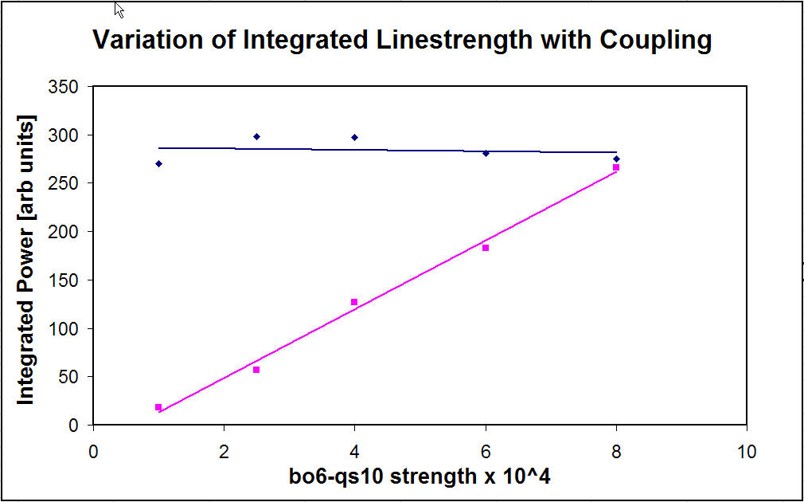
Figure 6: Power in the mains harmonics as a function of coupling strength
Power in the horizontal plane is uncorrelated with coupling strength, and strongly correlated in the vertical plane. This conclusively demonstrates that the mains harmonics are on the beam, and further that the excitation is in the horizontal plane. If the excitation originates in the ring dipoles, a field variation of a few parts in 10¹¹ would be sufficient to cause the observed effect. We estimate the magnitude to be several hundreds of nanometers at injection and store, and tens of microns during ramping, and the 3D noise floor to be ~10nm.

Effect on pll
The excellent sensitivity of the 3D AFE is a major step forward in realizing reliable operational tune feedback in
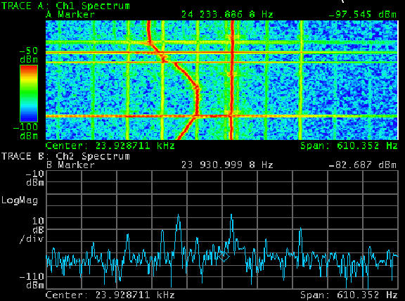
Figure 7: Baseband PLL with 100msec time constant
large hadron colliders. However, the mains harmonics revealed by this sensitivity have the potential to disrupt efforts to utilize it to full advantage. Figure 7 shows the tracking performance of the Baseband PLL in the vicinity of mains harmonics as the reference phase is manually swept. The lower portion of the figure shows that the PLL excitation is ~12dB to ~18dB above the adjacent mains harmonics. The upper portion shows that, despite this significantly greater excitation power, the PLL still locked to the mains lines at times of close proximity.
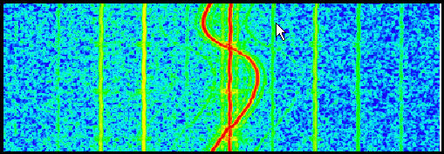
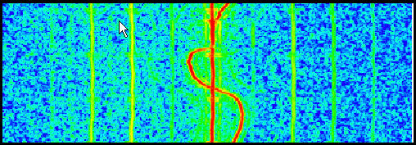
Figure 8: Baseband PLL with 1sec (upper half) and 300msec (lower half) time constants
Our expectation had been that this problem might be avoided by increasing loop gains to cause the PLL to sample a large band around the mains harmonics. The data in Figure 8 reveals that the actual behaviour is the exact opposite. As the time constant is increased (equivalent to lowering the loop bandwidth) the susceptibility to locking on a mains harmonic diminishes.

Conclusion
It has been demonstrated that the betatron spectrum is excited by harmonics of the mains frequency, and that this excitation is seriously detrimental to PLL tune tracking. This has been seen at the PS, the SPS, the Tevatron, and RHIC. One might expect that it will also be seen at the LHC, and that given the much lower betatron frequency it has the potential to be more severe. It is essential that causes and cures of these harmonics be investigated as quickly as possible. At RHIC there exists, as yet un-commissioned, a 12-phase balancing circuit for the main magnet power supply. Our hope is that spectra from the 3D AFE might be used to tune this balancing circuit, and that a similar solution might be applied at the LHC. The alternative to fixing the problem at the source is filtering in the PLL. This approach looks complicated and difficult, and is likely to adversely affect PLL reliability.

References
[1] M. Gasior and R. Jones, “High Sensitivity Tune Measurement by Direct Diode Detection”, these proceedings.
[2] P. Cameron et. al., “Advances Towards the Measurement and Control of LHC Tune, Chromaticity, and Coupling”, these proceedings.

