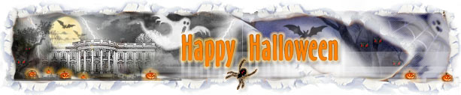
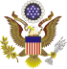


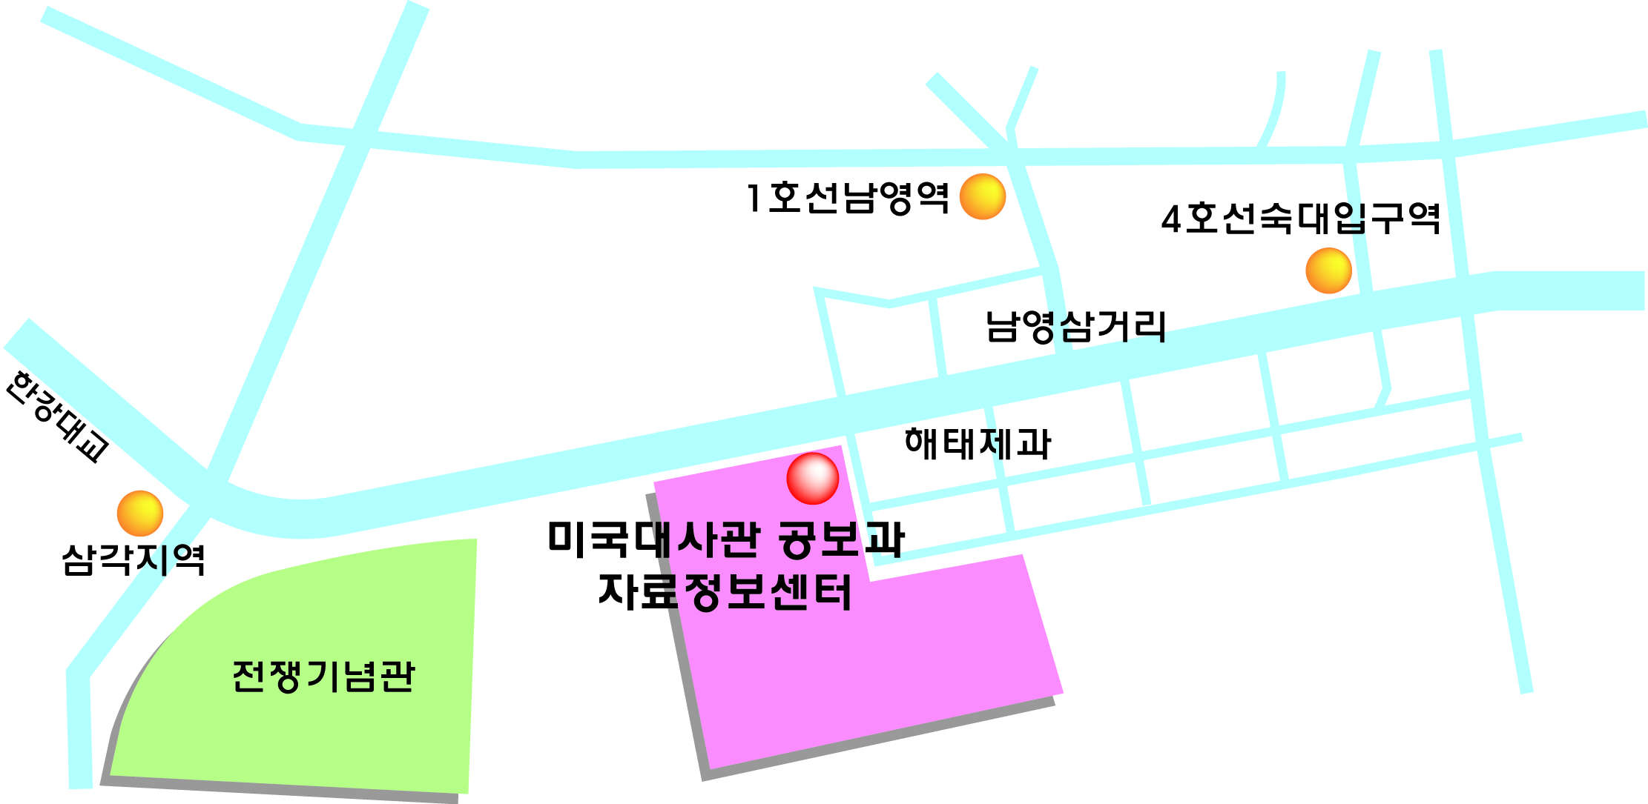

U.S. Embassy Seoul invites Korean students and young people to the U.S. Embassy Holiday Series Halloween Day program.

Date: October 31, 2008 (Friday)
Time: 09:30 a.m. – 3:30 p.m.
Place: IRC (Information Resource Center)
Organized by: IRC/Public Affairs
Schedule
09:30-10:00 a.m. DVD Screening on Halloween Day
“It's The Great Pumpkin, Charlie Brown”
10:00-10:20 Opening and Introduction of Participants
by Dr. Kim Su Nam, IRC Director
10:20-10:25 Welcoming Remarks and Introduction of the Speaker
by DPAO Mr. Robert Ogburn (Interpreter: Ms. Kim, Jin-kyung)

10:30-11:20 Panel Discussion by PAO Mr. Patrick J. Linehan on “The Halloween Tradition in American Life” (Interpreter: Ms. Kim, Jin-kyung)
11:20-12:00 Pumpkin Carving Show by American Officer & IRC Youth Coordinators (Volunteer: Mr. Tyler Carson, US Embassy Officer)
(PAO Mr. Patrick J. Linehan introduces Mr. Tyler Carson.)
12:00-13:00 Lunch & Preparation of Costume Contest
Scary Halloween Movie Screening
13:00-14:00 Music Performance by LRD Band
(Ms. Carolyn Clark introduces LRD Band.)
14:00-14:50 Costume Contest!!! (MC: USYC Jung Yung Joon, Yoo Kyung Hee)
14:50-15:20 Quiz & Door Prizes

15:20-15:30 Award Ceremony & Photo Opportunity
Awards Category: Ambassador Prize/ Best Korean Costume/Best American Costume/
Most Scary Costume/ Most Popular Costume
15:30-16:00 Music Performance by the U.S. Embassy Diplomats Group
(Ms. Carolyn Clark introduces U.S. Embassy music group.)

U.S. Embassy, Seoul
Public Affairs Section
Information Resource Center (IRC)

10 Namyeog-dong, Youngsan-gu, Seoul 140-160
Tel: (02) 397-4789, 4605, 4647
Fax: (02) 795-3606
Email: LeeJY@state.gov / ircseoul@stategov

