Extreme Fire Behavior and Weather Conditions

Firewhirls

A firewhirl is defined as: A spinning vortex of ascending hot air and gases rising from a fire and carrying aloft smoke, debris, and flame. Fire whirls range in size from less than one foot to more than 500 feet in diameter. Large fire whirls can equal the intensity of a small tornado.

Firewhirls are formed when very hot gases rising above a wildfire acquire rotation. The rotation is intensified as the column of rising hot gases accelerates and stretches in the atmosphere above the fire. The effect is quite similar to a dust devil but involving flame that provides extra heat for faster rising motion and greater spin. The hotter the fire and the more unstable the atmosphere, the greater the threat from firewhirls.

Firewhirls can begin as dust devils that form over burnt areas or on the lee sides of mountain ridges. These dust devils intensify into firewhirls if they drift over active flames. Or firewhirls can form directly over an active flaming front. They can form in seconds and intensify quite quickly, catching even vigilant firefighters by surprise. Either way, firewhirls pose a significant threat to wildland firefighters because of their high wind speeds and sudden, erratic shifts in wind direction inducing extreme fire behavior that spreads flame vertically and horizontally. Firewhirls also scatter burning embers, smoke, dust, rocks and other flying debris.

A firefighters best defense against firewhirls is to stay vigilant and be ready to escape rapidly if a firewhirl endangers a fireline.

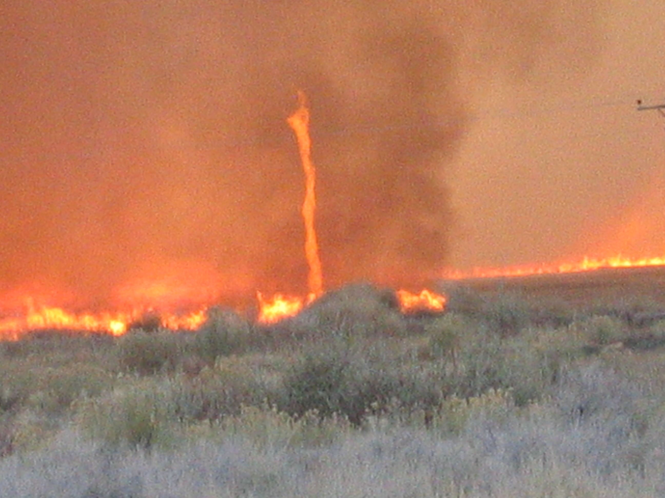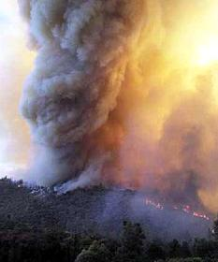
Example videos of firewhirls and fire induced vortexes can be seen at:

http://www.youtube.com/watch?v=aLtr92iBV8k
http://welcome.warnercnr.colostate.edu/clubs-chapters/firefighter/fire_video.htm

Microbursts

Microbursts (also sometimes called downbursts) are relatively small masses of air that can descend suddenly and violently from cumulus cloud buildups or fully developed thunderstorms. Microbursts tend to be short-lived, lasting only a few minutes, but they can contain wind speeds well over 100 miles per hour concentrated in a narrow impact zone less than a mile in width. Unlike tornados, there is little or no air rotation associated with microburst impacts on terrain.

Strong microburst winds are capable of stoking extreme fire behavior. They are also capable of toppling trees, overturning heavy vehicles, downing aircraft, capsizing boats and demolishing sturdy structures. The duration of microbursts is only a few minutes but the damage that results is sometimes so severe that it is mistaken as that from a tornado.

Microbursts are virtually impossible to predict. They can descend suddenly from cumulus buildups with little or no warning. Some microbursts arrive with heavy rain and hail while others are completely dry. In either case, winds at the surface may rise to over 100 mph (with even higher momentary gusts) in only a few moments time. Such winds can play havoc with escape routes and safety zones due extreme fire behavior, falling trees, heavy rain and dangerous hail, as well as poor visibility from choking clouds of dust and smoke.

Microburst winds greater than 58 miles per hour in the vicinity of a thunderstorm are sufficient to classify that storm as severe, prompting the immediate issuance of a severe thunderstorm warning if the storm is detected by the National Weather Service.

The wildland firefighter’s best defense against the threat posed by microbursts is to stay vigilant when cumulus buildups are in the vicinity and the atmosphere is unstable. Dust clouds rolling across the landscape may give a few minutes warning before microburst winds kick up dramatically.

Pay attention to your surroundings, especially if severe thunderstorm warnings are in effect. Be ready to move rapidly to safety zones if microbursts threaten. Post lookouts and make sure the lookouts can quickly share observations of severe weather activity with firefighters, dispatch and incident communication centers, as well as with the National Weather Service.

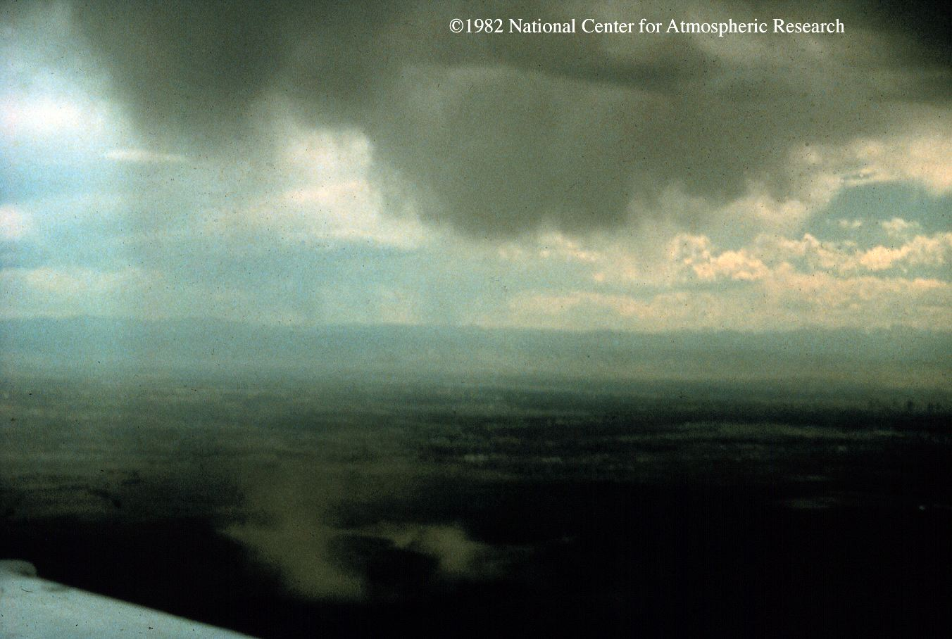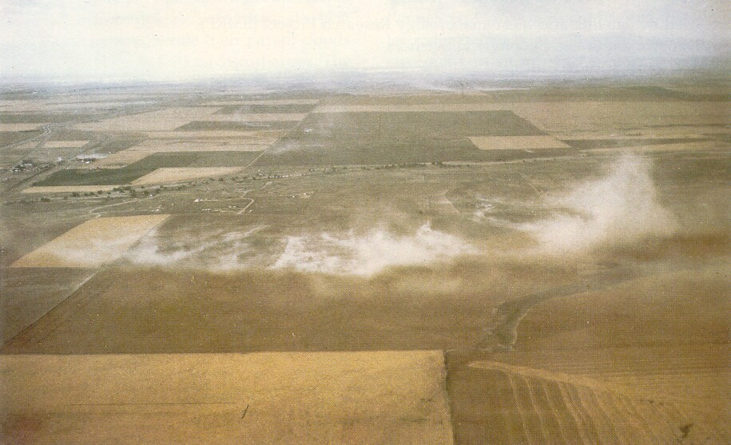

Photos, animation and more information about microbursts can be found at:

http://www-frd.fsl.noaa.gov/mab/microburst/vu_micro.html
http://www.mtexpress.com/index2.php?ID=2005121504

Lightning

Lightning constitutes another considerable threat to wildland firefighters and anyone else exposed to the elements. Lightning is defined as: a visible discharge of electrical energy in the atmosphere in the vicinity of thunderstorms, volcanic eruptions or wildfire convection columns. Lightning results from separation of electrical charges due to turbulence inside a convective cloud.

Lightning strikes are typically categorized by their polarity (either positive or negative) and their direction of travel: cloud to cloud, cloud to ground or cloud to air. Negative lightning strikes are the most frequently observed as cloud to ground (CG) flashes beneath active thunderstorm cloud bases in the vicinity of rainshowers. Negative strikes are less frequent but tend to be more powerful and appear to be capable of traveling scores of miles (or sometimes more) from the parent cloud and away from the rainfall. Other types of strikes have been documented but are beyond the scope of this article.

Lightning poses several threats. Electrocution from the strong electrical current in and near a direct lightning strike is capable of killing humans and animals. Strong currents are also possible in soil, bodies of water, and other conductors in the vicinity of a lightning strike. Lightning is capable of igniting fire and the blast effect from strikes has been known to explosively shatter the bark of trees. Humans incapacitated by a lightning strike do not carry a residual charge and can be safely moved.

The exact locations of thunderstorms are difficult to forecast accurately more than a few hours in advance. Nevertheless, thunderstorms are dramatic and usually very visible features of the atmosphere that can be recognized by vigilant wildland firefighters. The approach of a thunderstorm is commonly heralded by darkening clouds and flashes of lightning accompanied by booms of thunder growing louder and closer. Sometimes lightning is visible without the sound of thunder and at other times thunder is audible without flashes of lightning. Both need to be taken seriously and cover sought before the arrival of a storm.

The Incident Response Pocket Guide recommends the following safety precautions (among others) be observed when lightning approaches:

- Take shelter in a sturdy structure or closed vehicle
- Avoid grouping close together and find a low spot away from:
  - ridge tops and rocky outcroppings
  - open bodies of water
  - tall trees
  - wire fences
  - metal gates
  - utility lines
  - other conductors of electric energy
- Avoid operating machinery, electronics, or handling flammable materials

Survivors of lightning strikes report that a sensation of tingling in one’s body and in nearby objects may sometimes be felt shortly before a stroke of lightning. Hair may stand on end and static buildup may be sensed. If this effect is observed, experts recommend that one assume the “lightning safety position” (see figure below) by dropping hand tools and squatting on the balls of one’s feet to minimize contact with the ground. A strike sustained while in the “lightning safety position” is thought to minimize the chances of severe burns and nervous system damage from the intense electrical energy in a lightning strike.



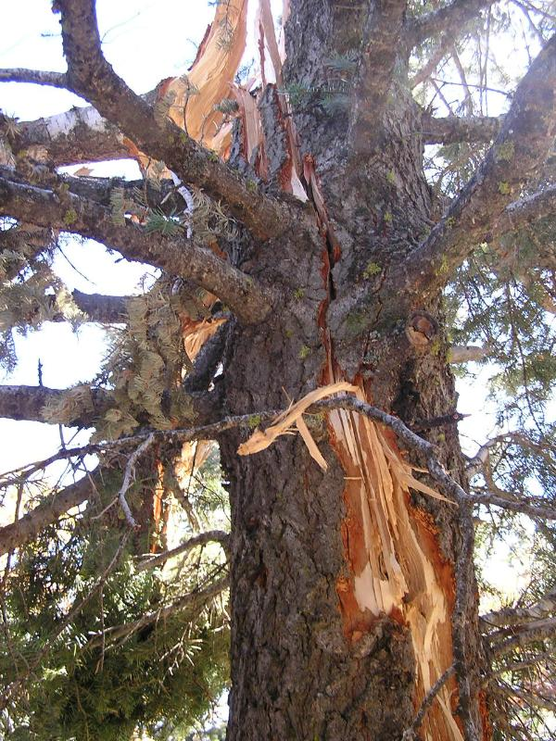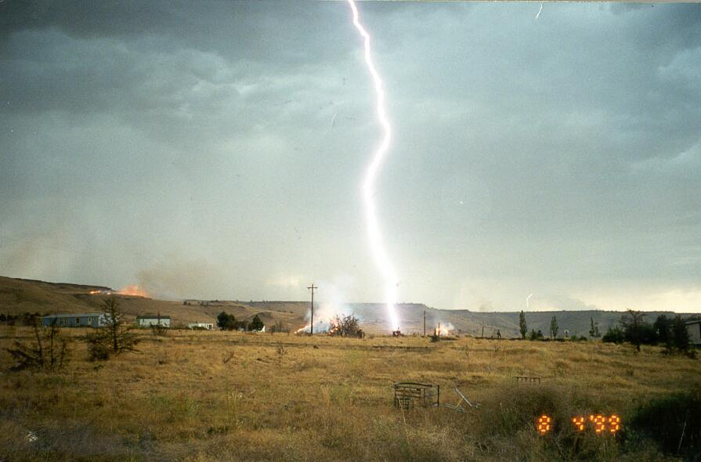

Pay attention to the sky, especially if thunderstorms or large cumulus buildups are visible in the vicinity. Be ready to take cover if thunder is heard and lightning approaches. Cease outdoor activity until 30 minutes after thunder is last heard. Post lookouts and make sure the lookouts quickly relay observations of lightning activity to firefighters, dispatch, or incident communication centers.

Video and more information about lightning can be found at:

http://www.lightningsafety.com/
http://www.nols.edu/recources/research/pdfs/lightningsafetyguideline.pdf
http://www.mthurricane.com/Lightning%20Clips.htm

Hail

Hail is common during thunderstorms and even near large cumulus buildups accompanied by precipitation. However, hail large enough to be damaging to structures and dangerous to humans and animals tends to require a fully developed severe-type thunderstorm. The National Weather Service issues severe thunderstorm warnings when hailstones greater than ¾ inch in diameter are observed or anticipated.

Hail forms when supercooled rain droplets and ice pellets collide and coalesce above the freezing level inside the turbulent interior of a cumulus cloud. When a hailstone becomes sufficiently heavy, it falls out of the storm. Hailstones as large as grapefruit or softballs have been observed during severe thunderstorms. These can weigh more than 1 ½ pounds and fall thousands of feet at speeds well over 100 miles per hour.

Like microbursts, hail is difficult to forecast in advance but tend to be brief, lasting only a few minutes. However, during those few minutes, immense damage and serious injury is possible from the impact of large hailstones. Cover should be sought well ahead of time in a covered vehicle or a sturdy structure.

Pay attention to your surroundings, especially if large cumulus buildups or thunderstorms are in the vicinity. The same safety precautions for microbursts and lightning also apply to hailstorms. Be ready to take cover before the storm arrives. Post lookouts and make sure the lookouts quickly relay observations of lightning activity with firefighters, dispatch, and incident communication centers. Reports of large hail should be communicated to the National Weather Service as soon as possible.



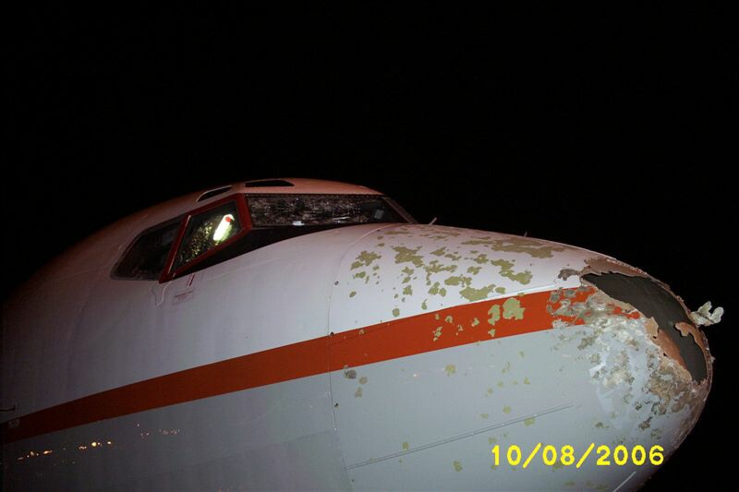

http://www.islandnet.com/~see/weather/elements/hailform.htm
http://www.erh.noaa.gov/rnk/SKYWARNonline_files/images/image102.png

Flash Floods

Flash floods are the top cause of deaths from violent weather in the United States. On average, nearly 100 fatalities have been recorded from flash floods each year for the last 30 years, surpassing lightning, hurricanes and tornados. Roughly half of all flash flood deaths occur in vehicles swept away by rapidly rising flood waters.

Flash floods typically occur when heavy rainfall, soil conditions, vegetative cover, and topography combine to rapidly funnel water into narrow canyons, river beds and low lying channels. When water accumulates faster than it can be absorbed by soil or dissipated by normal runoff channels, a flood results. Depending on the severity of conditions, water in otherwise innocent looking drainages can rise to raging torrents more than 30 feet deep in just a few minutes.

The power of rapidly moving water in flash floods should nevert be underestimated. Flash floods can roll large boulders, tear out trees, destroy structures, wash out bridges and undermine roadways. Rapidly moving water one to two feet deep is capable of dislodging vehicles. Remember: Most flash flood fatalities occur at night in vehicles swept away while attempting to cross flooded roadways.

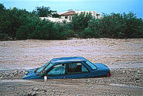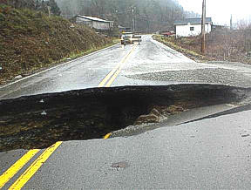

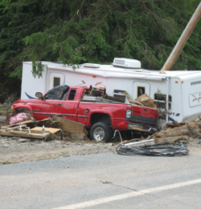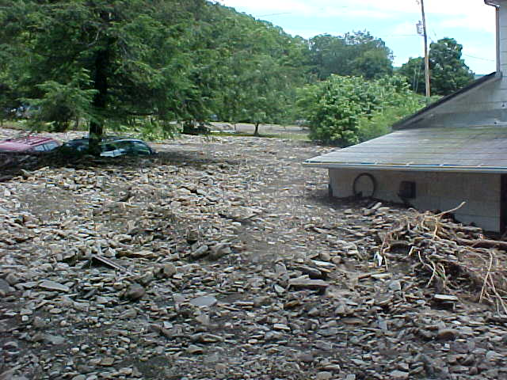

Slow moving thunderstorms with heavy rain or tropical storms and hurricanes making landfall are usually the main culprits in producing heavy water runoff. However, ice jam breakups and dam failures have also been known to cause flash floods. Remember: Sources of flood water may originate miles upstream from where flash flood effects are observed.

While the exact locations of heavy thunderstorms are difficult to predict, environmental conditions that result in flash flooding can be anticipated. The National Weather Service issues Flash Flood Watches when flood conditions are possible and Flash Flood Warnings when flooding has been observed or is imminent. Flash Flood advisories from NWS should be relayed immediately from lookouts, dispatch or incident communication centers to firefighters in the field.

Flash flood risk can be reduced by following basic safety rules:
- Avoid flood prone areas such as: dips, low spots, narrow canyons, washes, etc.
- Stay back from already-flooded and high velocity flow areas. Do not attempt to cross flowing streams. NEVER drive through flooded roadways!
- Be especially cautious at night when it is harder to recognize flood dangers.
- Do not camp or park your vehicle along streams and washes, particularly during threatening conditions.
- Move to high ground immediately if roaring is audible upstream or rapid rises in water level are observed.
Pay attention when in narrow canyons or near river drainages any time thunderstorms are possible over higher terrain upstream. Remember: Rain may not be falling near the flood prone area. Avoid flood prone areas when flash flood advisories are in effect. Be ready to move immediately to higher ground if roaring is heard or water rises rapidly.

More information about flash floods can be accessed at:

http://www.srh.noaa.gov/tadd/
http://www.redcross.org/services/prepare/0,1082,0_240_,00.html
http://www.redcross.org/static/file_cont5384_lang0_1981.pdf

