


STATEMENT OF JOHN ZIPPERT

on behalf of the

FEDERATION OF SOUTHERN COOPERATIVES/
LAND ASSISTANCE FUND

and the

RURAL COALITION/COALICIÓN RURAL

to the

U.S. House of Representatives
Committee on Agriculture
Subcommittee on Conservation, Credit, Energy, and Research

Washington, DC
March 27, 2007

For More Information Contact:
John Zippert Jzippert@aol.com
Federation of Southern Cooperatives/Land Assistance Fund
PO Box 95
Epes, Alabama
205-652-9676
or c/o Lorette Picciano, lpicciano@ruralco.org
Rural Coalition/Coalición Rural
1012 14th Street NW Suite 1100
Washington, DC 20005
202-628-7160

Introduction

My name is John Zippert. I am Program Director of the Federation of Southern Cooperatives/Land Assistance Fund and Chairperson of the Rural Coalition. I personally have worked on promoting equity in poor rural communities for more than 40 years, starting in St. Landry Parish Louisiana with the Congress of Racial Equality. I have worked with the organizations I represent today for many years.

For many years, I have worked with African American Producers in Alabama and the southeast in accessing credit and developing cooperatives. I also worked with producers in the aftermath of Hurricanes Katrina, Rita and Wilma in seeking disaster and recovery assistance.

In addition, I have personally assisted over more than 1000 farmers in Alabama in the preparation of claims and other documents in response to the Pigford v. Glickman Consent Decree. I have done this work in a paralegal capacity, under the auspices of the Chestnut, Sanders and Sanders law firm in Selma, one of the law firms connected to the class counsel in the lawsuit.

Relevant Experience of Our Organizations

We appreciate this opportunity to provide testimony to this Subcommittee as you begin important work on the credit provisions of 2007 Farm Bill. The organizations I represent are uniquely qualified to provide input and recommendations. Collaboratively and for many years, the organizations we represent have served as the primary and often only source of technical assistance and support to a significant proportion of the minority farmers in this nation.

The Federation of Southern Cooperatives/Land Assistance Fund has for almost 40 years worked with African-American farmers and landowners in some of the poorest counties in the nation. Our membership includes over 75 cooperatives and credit unions. Through our outreach program, we provide land and agriculture-related assistance to over 12,000 rural families.

The Federation implements its various programs throughout the southeast but is concentrated primarily in Alabama, Mississippi, South Carolina, Georgia and north Florida. Over the years, we have worked one on one with minority farmers and their cooperatives to develop new enterprises. A great deal of our work has had to be focused on saving black-owned farms and assisting their owners to fairly access farm credit and other farm programs and services. We assisted hundreds of farmers in seeking redress for discrimination and in responding to the class action settlement in Pigford v. Glickman. Of necessity, we have also sought legal and legislative remedies to assure fair and equitable service to minority producers, and with the Rural Coalition, as noted below, have led efforts to secure legislation that provides more equity in farm programs.

The Rural Coalition/Coalición Rural, of which the Federation is a founding member, is an alliance of over 80 culturally and regionally diverse rural community-based organizational in the US and Mexico. We have served minority and other limited resource producers for almost thirty years. The members of our Coalition include some of the most diverse and experienced minority farm organizations including the Intertribal Agriculture Council, representing more than 80 Indian Tribes; the Rural Advancement Fund, which has worked with African American producers for more than 50 years; the North Carolina Association of Black Lawyers Land Loss Prevention Program; the National Hmong American Farmers, Inc.; the National Latino Farmers and Ranchers Trade Association and many more.

Collectively, the Federation, and the Rural Coalition and its members and allies, have worked with thousands of farmers on the intricacies of their dealings with USDA and to seek structural change both administratively and in policy to assure equity and accountability in programs and services.

Over the past decade, we have supplied documents, analysis and testimony to the Civil Rights Action Team, the National Small Farms Commission, the US Congress and the US Civil Rights Commission. A half dozen of us served on the National Small Farms Commission, and we have also participated on other committees and in many sessions with the Secretary and the staff of the Department. We have led efforts to institute the USDA Partners meeting, held annually for the past three years to allow USDA to develop relationships and understanding of the work and experience of its Community Based Organization Partners.

Our collaborative legal and legislative work included the 1987 Agriculture Credit Act, the Minority Farmers Rights Act of 1990 that was accepted as section 2501 of the 1990 Farm Bill, the 1994 Agriculture Reorganization Act, and the Waiver of the Statute of Limitations that removed a critical barrier to the settlement of the longstanding class action lawsuits. Over the years, we have also worked on disaster response, especially following hurricanes Katrina, Rita and Wilma.

We have also worked with this Committee on the most recent 2002 Farm Bill. We appreciate the support the members of this committee who helped assure that structural changes instituted to promote equity were included in that bill.

Introduction to Our Findings and Recommendations

The average age of farmers continues to rise, especially among African American and other socially disadvantaged producers. For many years, inadequacies and inequities in programs and services have hastened the loss of African-American and other people-of-color owned farms. Access to credit is essential for all agricultural producers and those who aspire to be agricultural producers. This committee has the ability to take the actions needed to assure that new generations of people of color farmers and ranchers will have access to land and production.

In my years of work with the Federation of Southern Cooperatives/Land Assistance Fund, I have never met a black farmer who was not discriminated against. I believe the same is true for most of the diverse group of African-American, Latino, American Indian, Asian American and female farmers I have encountered within the Rural Coalition. As you well know, there remain issues surrounding the settlement of the Pigford v. Veneman and other still pending class action lawsuits against USDA that need to be addressed. We will provide a supplemental appendix for the record with updated statistics of the status of this settlement and on late claims.

For the past several months, our organizations have worked with a group of colleagues who represent a wide and diverse array of minority farmer and farmworker organizations called the Farm and Food Policy Diversity Initiative. As you begin your work on the 2007 Farm Bill, we share with you the collective wisdom of our organizations and our partners on some essential changes that Congress can and should make in order to prevent the actions that necessitated legal action in the first place and assure transparency and accountability in the provision of services.

We want to help bring about the day when African American and other minority farmers can turn their attention to growing crops and revitalizing rural communities instead of filing complaints and lawsuits to secure the equitable service to which they are entitled in the first place.

Because of the cumulative effects of many years of discrimination and neglect, we are also proposing remedial measures and special services intended to reverse the impact of years of discrimination and neglect on many minority farmers. Our other recommendations include actions that can be taken to improve services to the many farmers who have suffered disasters in recent years, and some ideas on how to assure that new farmer programs will also serve socially disadvantaged producers.

We also propose a moratorium on all pending accelerations and foreclosures against socially disadvantaged farmers and ranchers, with a complete review of these cases, in order to close this chapter of discrimination in farm programs and move to a new one that supplies justice and equity that are our rights in a democratic society.

Barriers to Equitable Service

The United States Department of Agriculture Farm Service Agency and its predecessor agencies were designated by Congress as the lender of last resort for agricultural producers. Because agriculture remains a complex and inherently risky enterprise, few banks that serve rural areas are prepared to provide the credit that farmers need. As such, USDA has remained a critical source of credit for socially disadvantaged farmers and ranchers and for new farmers.

Yet socially disadvantaged producers, for a complex set of reasons, still lack access to the credit they urgently need to develop viable operations. While the USDA and others have recommended directing many or most resources to socially disadvantaged and beginning farmers, this directive alone will not ensure the credit access that socially disadvantaged farmers and ranchers really need. Nor will FSA fulfill its mission as a lender of last resort.

We call your attention first to the definition of “beginning farmer.” As members of the Policy Team of the Farm and Food Policy Diversity Initiative have pointed out, a producer who meets the definition of beginning farmer should be able in fact to qualify for commercial credit. Farm Service Agency in 2003 began issuing the transparency and accountability reports as required in Section 10708 of the 2002 Farm Bill. The report on the Beginning Farmer Down Payment Loan Program for 2003 indicates, as shown in the chart below, that 92.5 % of its recipients where white male. Only four percent of the recipients were women, and of these, 3.9% where white.

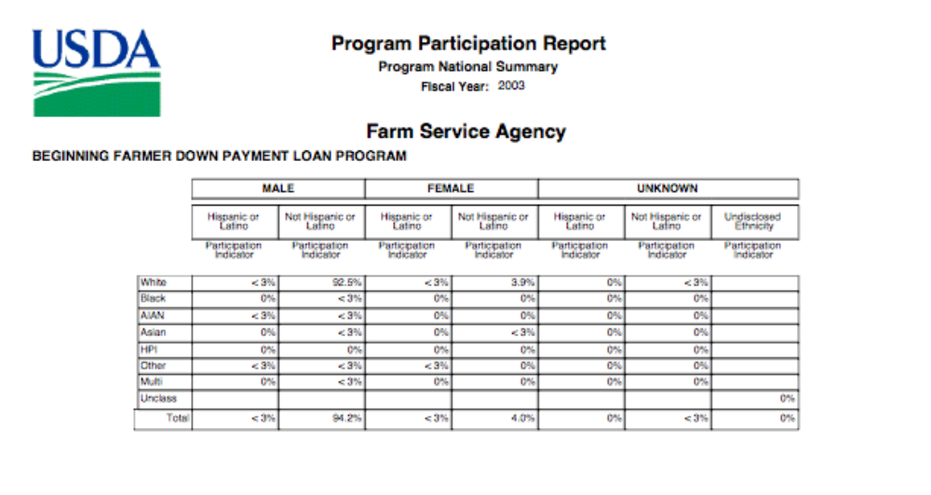
We believe that the Congress should further investigate why this is so, and what factors in the design and delivery of the program are responsible for the very low participation by socially disadvantaged producers, especially because Hispanic producers, for example, constitute one of the fastest growing populations of new entrants into agriculture. Also, the very low proportion of women producers who participate also warrants examination, as this is another example of a population whose participation in agriculture is growing.

As we have researched this question, we have several suggestions: the definition of beginning farmer still requires three years of management of experience. How this experience is defined and accounted for by the department may have a bearing on who is accepted into the program. We recommend, for example, that experience as a farmworker be counted towards the qualification for beginning farmers. In addition, the standards for credit worthiness are as stringent or more stringent than the standards used by commercial lenders.

As this committee considers the recommendations to target all credit to beginning and socially disadvantaged farmers, it will be important to consider how this recommendation may ultimately affect the availability of credit. For example, farmers who have left the peanut and tobacco programs or who are otherwise transitioning to different crops may be in need of credit for this transition. Also, directing resources generally to beginning and socially disadvantaged farmers and ranchers without more specific direction with respect to the proportions of funds for either population may have the impact of disadvantaging one or the other of these populations, most likely socially disadvantaged producers.

It is also important to realize that socially disadvantaged producers have historically had very low participation rates in commodity and conservation programs. The billions of dollars in federal support provided for these programs only reaches a small percentage of these producers. The reasons for lack of access to federal farm programs are also complex. However, the net impact of this exclusion has often affected the size of operations and the quality of the land accessible to socially disadvantaged producers, leaving less equity in the hands of socially disadvantaged farm families. As a result, credit scores may be lower and it may be more difficult for these families to at first meet the stringent creditworthiness standards FSA requires.

We believe that special attention will need to be paid to these definitions and situations in order for USDA to fulfill its mission as lender of last resort, and in order to assure access to credit for socially disadvantaged farm families who wish to enter or continue in agriculture.

Transparency and Accountability in Farm Loan Programs -In recent years, the Farm Service Agency has routinely reported that loans to socially disadvantaged farmers are made in 30 days or less, and on par with loans to other farmers. FSA staff throughout the nation can report these statistics with respect to their own county and state. With these statistics as a sole reference point, it would appear that all is well with respect to access to credit and delivery of services.

We believe these statistics are not a true picture of the actual situation. We urge the committee to look further and to establish some of the measures we have long proposed in order to move beyond the appearance of equity to real equity in services, and the establishment of new generations of people of color farmers on the land.

Over the years, we have observed and documented many practices that serve to discourage and separate minority farmers from the programs and services they need. We will briefly review some examples of these practices and some solutions we recommend.

Discouragement of Applications and Services - At the National Immigrant Farming Initiative meeting in February in Las Cruces, New Mexico, a Hmong farmer approached our Executive Director from Wisconsin. “How big is a farm?” she asked the ED. In attempting to understand the reason for her question, we determined she had been turned away by the local FSA office after being told her operation was not a farm. However, this producer reported that she owned land and sold more than $1000 of produce a year. She did not understand why she was turned away and had not been asked to provide information to be listed on the County SCIMS list.

In the aftermath of hurricanes Katrina and Wilma, we held a training session for some 50 Latino producers in Dade County, Florida. Four members of the FSA staff attended the session at our request. The producers present reported a typical pattern: following these and previous disasters, they called the county office to request disaster assistance. The office confirmed reports that they producers were told there was no assistance available. The answer was technically correct at the time, as it is usually long after a disaster that Congress approves aid.

However, the producers were not told to come into the office to sign up on the SCIMS list, or to begin the application process for any available programs, or of requirements to take out crop insurance. The FSA staff reported that they were too busy to schedule appoints and have the farmers come in. As a result, the farmers—some repeatedly and after multiple disasters--were never informed of the many services FSA might provide, of the need to have crop insurance in order to qualify for most emergency aid, and of records they needed to keep to qualify for the emergency conservation program. They also were not included on the county list to receive newsletters and other important information and notifications, including loan and insurance deadlines and notification of funds available. As a result of not being included on the SCIMS list, farmers were also being missed in the Census of Agriculture.

During the training, the FSA staff registered over one quarter of the farmers who attended who had not previously been included on the SCIMS list or received any service from USDA. Other farmers were informed of the documents they needed to bring and of the need to go into the office in the future to register. However, the outreach function that FSA needs to perform routinely was only completed because the Farm Aid supported training and organizations, including ours, went to the county to inform farmers of the services to which they are entitled.

FSA should be required to tell all farmers who request any service of the need to be listed on the SCIMS list and of their right to make an application whether or not the office is inclined to view them as qualified.

First Come, First Served Standard– FSA credit program funds are delivered by state and county based on the number of farmers, the size of operations, etc. Previous investigations by GAO and IG have found that despite the fact that socially disadvantaged farmers had been denied credit, this practice did not constitute discrimination because the applications were only denied due to lack of funds.

However, this standard is manifestly unfair when farmers are discouraged from applying for programs, are not included on county lists or otherwise informed in a timely manner of the availability of funds. If a local office wished to assure funds for some farmers over others, there is the risk that a conflict of interest is created without some independent verification that all farmers receive the same information and ability to access the funds.

We believe this situation is especially serious with regard to the provision of disaster loans. While we do believe loan limits need to be raised, we caution the Committee that increasing these limits without increasing the level of funding may in fact exacerbate the potential inequities of accessing limited pools of loan funds.

What Constitutes an Application – FSA does not consider a farmer to have applied for loan until the loan application is complete. While improvements have been made in informing farmers what documentation is necessary for an application, we have heard many stories of lengthy processes where additional information is requested. For some farmers- eg- American Indian producers who often live long distances from county offices, the need to return to the office with additional documents greatly lengthens the application process.

However, the final rule 12CFR Part 202, Regulation B, Docket No R-1008, implementing the Equal Credit Opportunity Act states:
(e) Applicant means any person who requests or who has received an extension
of credit from a creditor, and includes any person who is or may become contractually liable regarding an extension of credit…
(f) Application means an oral or written request for an extension of credit that is made in accordance with procedures used by a creditor for the type of credit requested. The term application does not include the use of an account or line of credit to obtain an amount of credit that is within a previously established credit limit. A completed application means an application in connection with which a creditor has received all the information that the creditor regularly obtains and considers in evaluating applications for the amount and type of credit requested (including, but not limited to, credit reports, any additional information requested from the applicant, and any approvals or reports by governmental agencies or other persons that are necessary to guarantee, insure, or provide security for the credit or collateral). The creditor shall exercise reasonable diligence in obtaining such information.

According to this regulation, an applicant includes a person who has requested credit, and an application includes oral and well as written requests for credit. While an application is defined as made in accordance with procedures used by a creditor, the regulation makes a distinction between an application and a completed application.

Thus, in order to evaluate the fairness of the system FSA has in evaluating applications, we recommend that Congress direct that FSA revise its reporting system to reflect the period of time it takes to process a credit application from the first submission of an application to the completion of the process. This would be a fairer reflection of the time period needed for processing.

We also recommend that Congress amend the 10708 requirements of the farm bill to require FSA to report on the national, state and county level by race, gender and ethnicity, the months in loan funds were disbursed under each type of loan program.

It makes a great deal of difference whether a loan is disbursed early in the planting season or at a later date.

Receipt for Service – Since 2002, we have proposed to the department and to Congress that USDA be required to provide to all farmers and ranchers a time and date stamped “receipt for service.” This receipt should be provided whenever any farmer requests an application or service. The receipt should details the name of the farmer or prospective farmer, the location of the office by county, what was requested, what was provide and not provided, if a request was not met, why the application or service was not provided, and what follow-up action is recommended or required. A copy of the receipt, which could be generate electronically, should be given to the farmer, and one maintained in the office. Because these receipts would not be used to evaluate applications for programs and services, Congress should also include authority and require FSA and other agencies to collect data by race, gender and ethnicity using both self-identification, and identification by the agency when the first is not provided, in order to evaluate its responsiveness.

This receipt would be critical to assuring equity for programs that are provided on a first come first serve basis, and to document situations where farmers and prospective farmers are discouraged from seeking and applying for benefits.

In addition, it would also document and allow Congress and the Department to review to the county level the actual dates on which all applications were received by the agency, and to identify places where some farmers and ranchers may receive information, services and approval more immediately than others.

USDA responded to our recommendations for a receipt for service by instituting a Customer Comment Card. This card does not serve the same purpose as a service receipt and goes back to the same complaint generated system of accountability that has hampered fairness for many years.

Creditworthiness - Many of the laws that govern farm credit arose from the agricultural credit crisis in the 1980’s. While borrowers rights and other protections were included, the experience of losses by the government, primarily with respect to emergency loans, led to the inclusion of good faith provisions and stringent creditworthiness standards.

In the present time, evaluation by FSA of creditworthiness is a factor that prevents many socially disadvantaged producers from securing credit. Our member organizations have reported that FSA’s system of determining creditworthiness is often a factor that results in the denial of applications. We believe the FSA scoring system should be reviewed based on the following standards in ECOA (final rule 12CFR Part 202, Regulation B, Docket No R-1008):

(p) Empirically derived and other credit scoring systems—(1) A credit scoring system is a system that evaluates an applicant’s creditworthiness mechanically, based on key attributes of the applicant and aspects of the transaction, and that determines, alone or in conjunction with an evaluation of additional information about the applicant, whether an applicant is deemed creditworthy. To qualify as an empirically derived, demonstrably and statistically sound, credit scoring system, the system must be:
(i) Based on data that are derived from an empirical comparison of sample groups or the population of creditworthy and noncreditworthy applicants who applied for credit within a reasonable preceding period of time;
(ii) Developed for the purpose of evaluating the creditworthiness of applicants with respect to the legitimate business interests of the creditor utilizing the system (including, but not limited to, minimizing bad debt losses and operating expenses in accordance with the creditor’s business judgment);
(iii) Developed and validated using accepted statistical principles and methodology; and
(iv) Periodically revalidated by the use of appropriate statistical principles and methodology and adjusted as necessary to maintain predictive ability.
(2) A creditor may use an empirically derived, demonstrably and statistically sound, credit scoring system obtained from another person or may obtain credit experience from which to develop such a system. Any such system must satisfy the criteria set forth in paragraph (p)(1)(i) through (iv) of this section; if the creditor is unable during the development process to validate the system based on its own credit experience in accordance with paragraph (p)(1) of this section, the system must be validated when sufficient credit experience becomes available. A system that fails this validity test is no longer an empirically derived, demonstrably and statistically sound, credit scoring system for that creditor.

Congress should review the FSA credit scoring system and the methods that it has used to develop and validate this system. It should determine if this system is periodically reviewed and maintains predictive ability. As the lender of last resort, FSA standards for all loans should be less stringent when compared to commercial lending. Congress should request that FSA compare its standards with those of commercial lenders.

Because of this history of discrimination that has held this agency liable for hundreds of millions of dollars of losses caused by the practices of the agency itself, Congress should assure that this system take into account the influence of these practices on the creditworthiness of the producers who now seek loans.

Congress should also determine to what extent approval of credit rests on access to income from other federal farm programs, and the degree to which the creditworthiness of socially disadvantaged farmers is affected by the degree of access they have to other programs.

The 10708 Transparency and Accountability Requirements should be amended to include a report on the number and percentage of farmers by race, gender and ethnicity who participate in multiple USDA programs, and the level of total benefits that are provided to producers by race, gender and ethnicity.

Waiver of Interest – In the wake of entreaties to declare moratoriums and take other action to resolve the crisis facing socially disadvantaged farmers who have suffered discrimination and all farmers who have faced serious losses as a result of the hurricanes of 2005, repeated drought and other national disasters, FSA has repeatedly asserted that it lacks the authority to waive interest

We recommend that this committee determine in fact whether any additional authority is required to provide this authority to FSA. For example, are the Standards for the Administrative Collections of Claims, 31CFR901.9 on Interest, penalties, and administrative costs adequate for this purpose?

(g) Agencies shall waive the collection of interest and administrative charges imposed pursuant to this section on the portion of the debt that is paid within 30 days after the date on which interest began to accrue. Agencies may extend this 30-day period on a case-by-case basis. In addition, agencies may waive interest, penalties, and administrative costs charged under this section, in whole or in part, without regard to the amount of the debt, either under the criteria set forth in these standards for the compromise of debts, or if the agency determines that collection of these charges is against equity and good conscience or is not in the best interest of the United States.

(h) Agencies shall set forth in their regulations the circumstances under which interest and related charges will not be imposed for periods during which collection activity has been suspended pending agency review.

The fair resolution of all outstanding claims related to discrimination by the Farm Service Agency certainly should be considered a matter of equity and good conscience, and in the best interest of the United States. We recommend the committee review this authority, and also require FSA to report on its compliance with paragraph h of this section.

We also urge that the committee review the regulations instituted following the disasters in 2005 that allowed the suspension of payments on loans for farmers in declared disaster areas, but without any waiver of interest, and that required a balloon payment of all the deferred payments and interest in January 2007. A report on the number and location of loans that may be forced into acceleration because of an inability to make this balloon payment should be made, and Congress should undertake any retroactive and remedial action necessary to prevent additional loss of farms in the wake of disasters.

Appraisals – Over the years, we have received continued complaints for farmers on the fairness of the appraisals used for loan approvals. Standards for appraisals should be reviewed and assurance of equal credit opportunity protections be established.

While in small rural communities, testing programs such as those widely used in mortgage lending are more difficult to establish, the Congress should consider ways to work through the Comptroller of the Currency to provide funding and guidance for some measure of testing to bring to light problems in both direct and guaranteed lending programs of the department, especially with regard to appraisals.

Right of First Refusal on Inventory Property – In the 1987 Agriculture Credit Act, this committee wrote the very first provisions designed to begin assisting socially disadvantaged farmers and ranchers. On provision of this law afforded socially disadvantaged farmers and ranchers the right of first refusal on inventory property. When Congress subsequently instituted programs for beginning farmers and ranchers, it replaced the right for socially disadvantaged farmers and ranchers with the right of first refusal for beginning farmers.

This situation is instructive and illustrates why in the 2007 farm bill debate, careful attention needs to be paid to securing an appropriate balance in credit law (and other areas of the Farm Bill) to the needs of these two populations. At a minimum, we suggest that the right of first refusal be restored first for socially disadvantaged farmers and ranchers, and then for other beginning farmers and ranchers.

Loan Limits – We agree with proposals to increase loan limits especially for farm ownership loans to more accurately reflect the current costs farmers face. But at the same time, we encourage this committee to consider the impacts we have outlined above, and the need to provide more funding for direct loans.

Transparency and Accountability – The federal government has been held liable for hundreds of millions of dollars of payment to farmers who won discrimination claims primarily in credit programs. While we would argue that most socially disadvantaged farmers were also denied access in many ways to other federal farm programs, their right to seek damages is only secured for credit programs.

Virtually all actions to assure fair service by FSA and other USDA actions arise from individual complaints made by farmers and ranchers. In Section 10708 of the 2002 Farm Bill, Congress adopted Transparency and Accountability requirements that require the department to provide data at the national, state and local level on participation rates by race, gender and ethnicity for each program that serves farmers.

FSA has been the most responsive agency in providing the data required under this section.

However, the usefulness of this data has been severely compromised by the matter of presentation used in the reports that are compiled by the Office of the Assistant Secretary for Civil Rights. Instead of providing searchable databases, the Office of the Assistant Secretary has presented the participation rates down to the county level as 120,000 separate PDF charts.

Ostensibly, the reason for this method or presentation is in order to protect the privacy of the lone socially disadvantaged farmer who may participate in a particular program of the department in a particular county. The US Census and the Census of Agriculture have developed other methods and defaults to protect privacy that do not compromise the integrity and usefulness of the data.

In addition, USDA has not provide, as required in 10708, a report that compares the participation of farmers by race, gender and ethnicity in programs as compared to their representation in the Census of Agriculture

Earlier in this testimony, we provided the 10708 report for the Beginning Farmer Down Payment Loan Program. In the appendix we have provided 10708 reports for other programs. A review of all of these programs would show that the participation rates of socially disadvantaged producers are abysmally low. Only in programs specifically constructed, for example, to serve American Indian farmers, is participation assured. The highest level of participation in any other program we found in our review was participation of 8% to 9% by African American producers- in the peanut buyout program.

The 10708 requirements are a very important tool for the department and Congress to develop an independent assessment of the problems in service delivery and program structure that may present barriers to equitable participation of producers. This data should be presented in a format that will allow real comparisons between similar counties and states that would allow service delivery issues to be identified and rectified, and would also allow Congress to determine where program structures and rules may be responsible for barriers to service.

County level data, and comparisons at that level to Agriculture Census numbers will allow agencies, farmers, and the organizations that represent them not only to identify programs where participation is inadequate. It will also allow outreach services and remedial actions to be taken. In addition, Congress should require that this data be utilized in the evaluation of all programs and in performance reviews of staff. In the 2002 hearing in the House Agriculture Committee, USDA testified that in the wake of the massive discrimination liabilities against the department, only an handful of staff received reprimands or any other personnel action. The lack of accountability to agencies and staff continue to foster a climate that leaves no consequence for actions that are contrary to the interests of socially disadvantaged producers, taxpayers and the United States.

We recommend that USDA be asked immediately to provide the required report comparing Agriculture Census data to the participation reports, and for its proposals on how immediate changes can be made in order to provide 10708 data in a useful form. We will provide to the committee proposed language to amend 10708 in order to assure this requirements provide the system of review that is vital to assuring quality programs and fair service.

Interest Subsidies – FSA has authority and does provide subsidized interest for farmers. Congress should assure that funds are adequate for this program, which is important to farmers. In addition, FSA should provide a 10708 report on participation in this program.

Farm Loans and Disasters – Emergency loans are critical to producers in the face of disasters. In addition, measures to protect the ability of farmers to manage current loans are also needed. However, in order to allow these to help farmers in a manner that will prevent placing them later in a precarious situation, we recommend the following measures:
- Review and provide any additional authority to allow FSA to suspend the accrual of interest in times of disaster, and take additional measures as necessary to allow delay in payments.
- Add payments to end of loans and allow extension of loans
- Extend PL 108-324 to remove the limit of coverage for farmers who have experienced multiple disasters
- Set in place an automatic disaster set aside for payments on direct FSA and RHS loan installments due in January 2007. Enable and encourage private lenders with guarantees to do the same.
- Complete suspension of offsets
- Expand servicing for 90 days past due loans
- Provide Loan forgiveness for those who will never be able to pay or who have suffered losses that reduce the value of collateral
- Allow appeal between agencies – when denied by Farm Service Agency and Small Business Administration, allow appeals to both.

Credit and Indian Agriculture - The United States Government through Farm Service Agency remains the largest source of lending for Indian Reservations. Farm lending programs need to increase their focus on youth lending as well as new farmer lending. The present beginning farmer program needs to be modified to realistically fit a beginning farmer. Present criteria limits participation to only those that have adequate capital that would allow borrowing at any commercial credit source.

- Increased effort must be put forth to facilitate the insurance that trust lands stay in trust during the debt servicing process of FSA. The new administration of the Department of Interior may be receptive to the transfer of trust title between Interior and FSA. The options presented by the 98 Credit Amendments need to be utilized by FSA, BIA and Tribes.
- Increased participation in FSA lending programs would take place if qualifying Tribal Credit Branches were allowed guaranteed lender status.
- The Tribal Credit Outreach Program should be expanded to cover a minimum of 18 states, where the largest Indian populations exist. The Extension Indian Reservation Program must be expanded to its original authorization and design that was 85 extension agents and a minimum budget of 6 million dollars.
- Offices on Indian Reservations - In Section 2501 of the 1990 Farm Bill, Congress prohibited USDA agencies from paying the cost of offices on Indian Reservations. Authority should be restored to FSA and other agencies to cover the cost of offices on Indian Reservations.
- The Indian Land Acquisition Program, which allows protection of tribal lands, should be expanded, and a similar program established for other socially disadvantaged producers.

Experience – Many new entry producers have strong experience in agriculture either as farmworkers or in the case of many refugee and immigrant farmers, experience as producers in other countries. While legal residents are eligible for loan programs, it is critical that FSA recognize farm and management experience gained as farmworkers or as producers in other countries as experience in qualifying for a loan.

Moratorium on Accelerations and Foreclosures for Socially Disadvantaged Farmers and Ranchers - African American producers have experienced a stunning 97% loss of farms since 1920. Special strategies and emergency action to stem this loss, and to reduce land loss for American Indian and other socially disadvantaged producers. The most urgent need is an immediate moratorium to protect African American farmers and ranchers who now face imminent foreclosure following inadequate protection and outcomes of civil rights complaints and individual and class action lawsuits. This immediate stay should be applied as well to other filed discrimination cases and administrative complaints that are pending for all socially disadvantaged farmers and ranchers.

In the Farm Bill, we propose that Congress declare a moratorium that provides an immediate stay on all accelerations and foreclosures against all socially disadvantaged farmers and ranchers and establish a review commission to be charged with reviewing all pending actions against socially disadvantaged farmers and ranchers. In addition, Congress should provide clear authority requiring the Secretary to waive interest and offsets, and to write off interest for all such cases during the review; and to forgive loans in cases where government action or inaction led to the foreclosure action.

This Independent Socially Disadvantaged Farmer Foreclosure Review Commission should:
- Determine whether farm land foreclosed and accepted for review by the commission complies with applicable laws or regulations, and
- Determine if actions or inactions of the government led to the foreclosure action.
- Review and improve upon the credibility and accuracy of the USDA Farm Credit Foreclosure process and procedures,
- Report programmatic inefficiencies to the House and Senate Agriculture Committee that include recommendations for legal remedies to address wrongful foreclosures against African American and any other socially disadvantaged producers.

Culturally Appropriate Service Delivery – FSA should conduct outreach and deliver service in a manner that is culturally appropriate and language accessible for socially disadvantaged producers, and should retain adequately trained loan program staff with the linguistic and cultural background adequate to serve farmers in the region.

Proposals for New Programs to Restore Equity – In order to begin the process of restoring access to socially disadvantaged producers who have been severely compromised in their ability to access land and operate viable operations, we propose a new credit program, and we encourage the committee to support and endorse a more comprehensive approach to assist this population of farmers to engage with the full range of USDA programs and Services.

New Low Documentation Loan Program for Socially Disadvantaged Farmers and Ranchers – Many socially disadvantaged producers with small-scaled diversified operations could achieve real viability with more flexible financing tools. We recommend that this committee establish a new socially disadvantaged farmers and rancher flexible loan program. We recommend that this be established at a maximum level of $50,000 per loan and that it be operated as a renewable line of credit that the producer may draw on again in future years when the balance is reduced below the limit.

We recommend that the interest rates be below market rates, and that a quick approval low documentation process be used. The lower loan rate reduces risk to the agency, but allows the flexibility that many producers need. Authority should also be provided to make individual loans for members of cooperatives of groups of farmers in order to allow development of value added and cooperative businesses that can best be conducted beyond the level of the individual.

Socially Disadvantaged Producers Risk Management and Market Access Initiative – We recommend that Congress establish a new comprehensive program to assure protections and market access that socially disadvantaged farmers need to attain financially viable operations that benefit also the poor rural communities where many of the live.

We share this recommendation with this subcommittee because we believe a comprehensive approach to service for this population would reduce the risk and increase opportunities for socially disadvantaged farmers with respect to loan programs as well.

This initiative is a comprehensive legislative approach designed to:
- preserve and build land ownership by Socially disadvantaged farms and ranchers
- bring socially disadvantaged producers into USDA programs and assure more accurate counting of this population in the Census of Agriculture;
- contribute to rural communities, and
- to address the following challenges socially disadvantaged farmers and rancher face:
  - risk management and disaster protection,
  - Secure access to land, credit and markets
  - Facilitate transition from tobacco and peanuts and other crops and to organic productions, value added,
  - Improve record keeping, general farm and financial management practices and meeting all regulatory requirements

Under this initiative, funding and technical assistance will be provided directly to farmers and ranchers, including beginning socially disadvantaged producers and farmworkers seeing to become farmers and ranchers, and who meet the criteria in order to carry out the applicable functions. Community Based organizations would receive direct support from RMA to supply the technical assistance

Eligibility: A socially disadvantaged farmer or ranchers.

- Qualification level – The producers is awarded an Initial payment of $5000, half paid in advance. The producer must within one year prepare IRS schedule F or a qualified substitute for members of Indian Tribes. The producer must also sign up for any crop insurance or NAP programs for which he or she is qualified, and must register at the FSA office, and FSA must provide his or her name to the National Agriculture Statistics Service for inclusion in the next census of agriculture. A qualified Technical Assistance Provider will receive $2000 to assist the farmer in preparing these documents and accessing these services and in preparing a plan to apply for participation in Tiers I, II and III. The producer is also encouraged and may use technical assistance to be included in the Minority Farm Registry or complete the Census of Agriculture if applicable in that year.

The producer must remain qualified at this level in order to participate in Tiers I, II or III.

- Tier I Direct payments of $10,000 per year to complete at least 3 of the following:
  - A farm and home plan,
  - Applications for any USDA program for which he or she is eligible
  - An estate plan,
  - A risk management plan, including accessing family health insurance
  - A conservation plan
  - Land acquisition
  - Disaster protection or mitigation
  - Plan to transition to another crop or crops
  - A qualified Technical Assistance Provider will receive $3000 to assist the farmer in accessing these services

- Tier II – Direct payment of $25,000 per year to complete at least 3 of the following:
  - Meet standards for GAP, Organic certification
  - Make a marketing plan
  - Access liability or other expanded insurance, including revenue insurance
  - Access farmers markets or improved marketing contracts
  - Make a plan to meet other regulatory requirements, including labor and pesticide health and safety standards, Livestock and Animal ID
  - Mentor another farmer
  - Qualifies for SARE
  - Irrigation and other production assistance
  - Waste management

  - A qualified Technical Assistance Provider will receive $4000 to assist the farmer in preparing these documents and accessing these services

- Tier III – Direct payment of $45,000
  - Cooperative development and the development of value-added enterprises.
  - Infrastructure development
  - Enter nutrition programs such as school lunch, WIC, farmers market, senior nutrition, etc.
  - Energy
  - Rural Development
  - A qualified Technical Assistance Provider will receive $5000 to assist the farmer in preparing these documents and accessing these services

ADDITIONAL PROVISIONS
- Make this a program under the commodities title and locate in RMA Outreach and Civil rights office.
- Community-based organizations would provide technical assistance.
- Provide Funds for additional staff for RMA regional offices and at headquarters.
- Authorize and Support the Small Farms Emphasis Program to work across agencies at USDA to assure coordination of services for socially disadvantaged farmers under this program.
- Include automatic entry into some USDA programs for completion of certain tiers.

Conclusion

We appreciate this opportunity to share our insights and recommendations with you. We are most willing to answer now or in the future any questions you may have or to offer any assistance we are able to the committee or to the Secretary to make USDA-Farm Service Agency Credit programs and services more equitable.

APPENDIX A

SAMPLES of USDA 10708 National Program Participations Reports

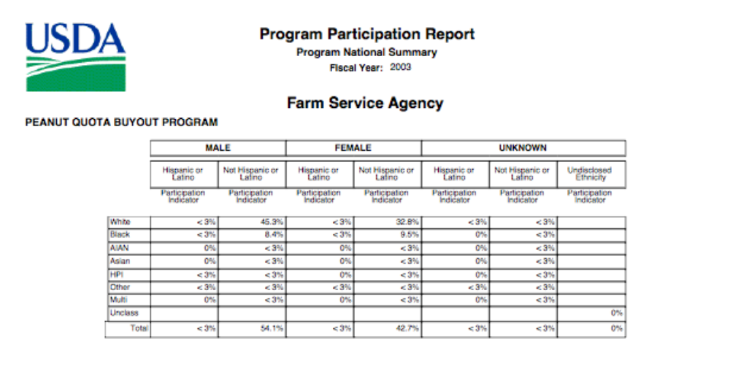

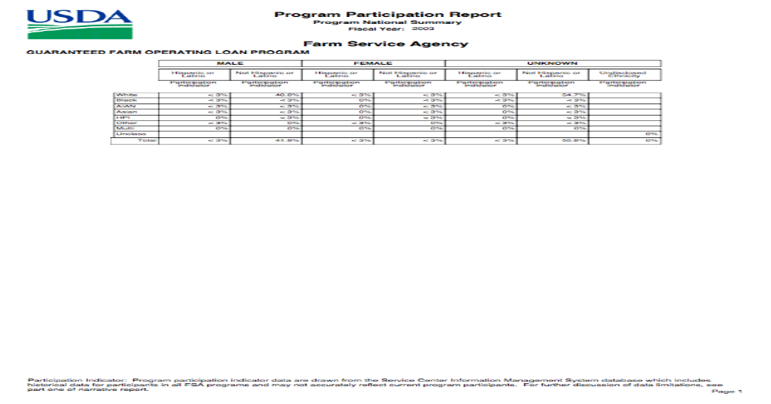

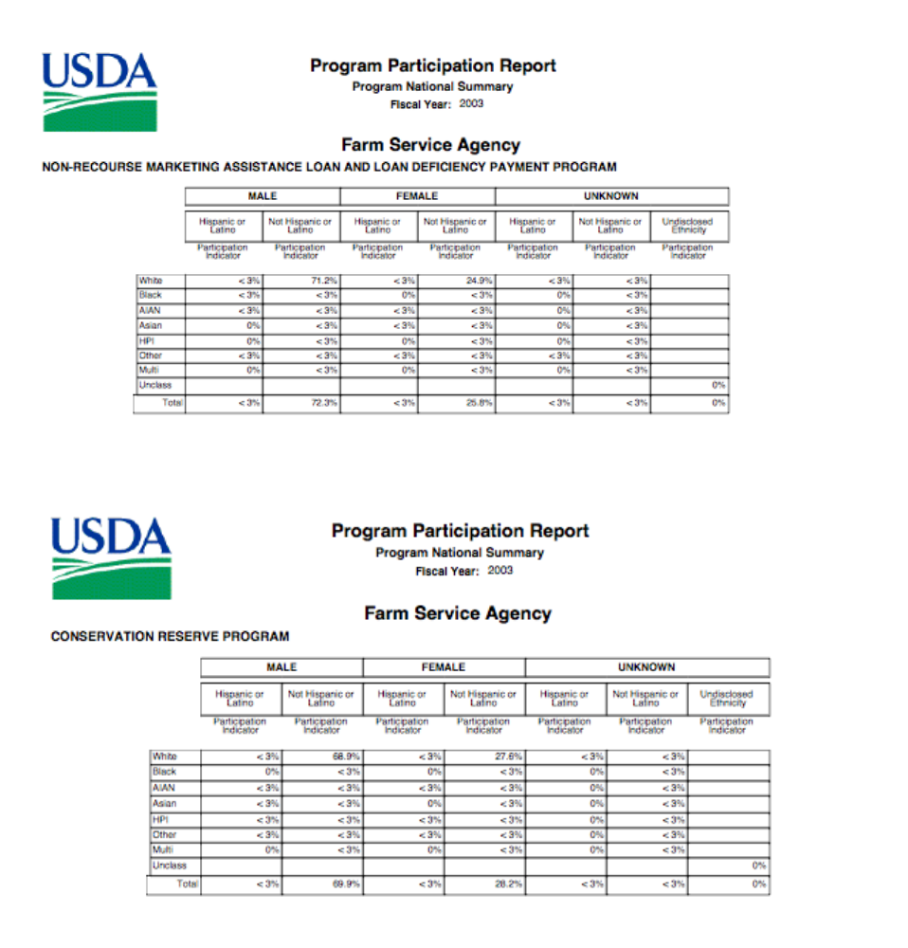

APPENDIX B: Committee on Agriculture - U.S. House of Representatives
Information Required From Non-governmental Witnesses.

Biographical Sketch
John Zippert
Federation of Southern Cooperatives/Land Assistance Fund
PO Box 95
Epes, Alabama
Email: Jzippert@aol.com Phone: 205-652-9676

Mr. John Zippert, Director of Program Operations of the Federation of Southern Cooperatives/Land Assistance Fund is a community organizer and a tireless advocate of economic and rural development for Black farmers. He has a BA degree in history from the City College of New York and has participated in numerous training sessions and courses to enhance his skills in rural development.

The Federation of Southern Cooperatives/Land Assistance Fund currently has over 70 active cooperative member groups, themselves with a membership of more than 20,000 families working together across ten southern states, with a concentration in Mississippi, Alabama, Georgia and South Carolina.

John has held a number of positions in the Federation of Southern Cooperative including co-founder and field leader. In his current role as Director of Program Operations, he is assisting in the development of programs designed to save, protect and expand the landholdings of Black family farmers in the South. He also works to develop, advocate and support public policies to benefit the membership of Black and other family farmers and low-income rural communities. He has fought for economic justice for more than 40 years. John has worked in distressed communities in cooperative and credit union development to provide technical assistance and training to individuals from low-income rural communities who have determined a need for low cost, community controlled consumer credit.

The Federation has participated in policy and advocacy and organized in rural communities to build a base for change. With hard work, collaboration with many other groups, and a consistent program of community and civic education, the Federation was able to get portions of this advocacy agenda incorporated in national farm legislation.

On October 10, 2002, John testified before the U.S. House of Representative’s Agriculture Committee on issues pertaining to civil rights programs at the U.S. Department of Agriculture (USDA). He told Congress that “injunctive relief provided in the settlement has not been clearly translated in federal regulations and actual practice at county level FSA offices. A number of farmers,” he said, “have reported to me that they were laughed at, ridiculed, or told ‘no such benefits existed’, when they attempted to secure this most important forward-looking benefit of the settlement of the law suit. One of the benefits for class members includes priority consideration in USDA offices for receiving assistance in loan packaging. The response at FSA offices is part of the general pattern of continuing discrimination and retaliation against Black farmers.

Zippert has served on the boards of many national, regional, state and local organizations. He is currently the elected chair of the Board of the Rural Coalition/Coalición Rural. He has also served on the boards of Association for Community Based Education, Rural Development Leadership Network, Alabama Black Belt Action Commission, Alabama Council on Human Relations, Alabama Organizing Project, Alabama New South Coalition, Greene County Industrial Board, Greene County Hospital and Nursing Home and the Greene-Sumter Enterprise Community to name a few. John and his wife Carol are co-publishers and editors of the Greene County Democrat, the weekly newspaper in Eutaw, Alabama since 1984. The Zipperts have three children, Rachel, Alexandria and Simon and nine grandchildren.
Committee on Agriculture
U.S. House of Representatives
Required Witness Disclosure Form

House Rules* require nongovernmental witnesses to disclose the amount and source of Federal grants received since October 1, 2004.

Name: Mr. John Zippert

Address: P.O. Box 95
Epes, Alabama 35460

Telephone: __205-652-9676_______________

Organization you represent (if any): Federation of Southern Cooperatives/Land Assistance Fund and Rural Coalition/Coalición Rural
1. Please list any federal grants or contracts (including subgrants and subcontracts) you have received since October 1, 2004, as well as the source and the amount of each grant or contract. House Rules do NOT require disclosure of federal payments to individuals, such as Social Security or Medicare benefits, farm program payments, or assistance to agricultural producers:
Source:__None

2. If you are appearing on behalf of an organization, please list any federal grants or contracts (including subgrants and subcontracts) the organization has received since October 1, 2004, as well as the source and the amount of each grant or contract:
Source:

Rural Coalition Funded Grants and Contracts
USDA Risk Management Research ($718,000 for FY 04-08), with 8 partner groups.
USDA Risk Management Outreach (225,000) for FY05), with 9 partner groups.
USDA Risk Management Outreach ($250,000 for FY 06), with 8 partner groups.

USDA Risk Management Outreach ($225,000 for FY 07), with 8 field partners.

CSREES 2501 Technical Assistance and Outreach ($299,000 over 3 years. 60% for RC) Certification for Whole Farm Viability, with two partner groups.

USDA Natural Resources and Conservation Service - Traditional Conservation Practices (USDA $200,000 for 1 year), with three partner groups.
Subcontract through Virginia State University ($71,000 in FY 2006) to conduct planning, make arrangements and fund full scholarships, hotel and travel for over 100 participants to the USDA Partners Meeting III.

Federation of Southern Cooperatives Federal Grants and Contracts
USDA, 2501 ($270,000)
USDA, NRCS ($95,000)
USDA Risk Management-Legal Risks ($200,000)
Department of Labor-Workforce Development
USDA Rural Cooperative Development

Please check here if this form is NOT applicable to you

Signature:

PLEASE ATTACH DISCLOSURE FORM TO EACH COPY OF TESTIMONY.

