A USER’S GUIDE

FOR THE

JOB ACCESS AND REVERSE COMMUTE (JARC) PROGRAM

GRANTEE QUARTERLY REPORTING (GQR) SYSTEM

U. S. DEPARTMENT OF TRANSPORTATION
FEDERAL TRANSIT ADMINISTRATION
Office of Research, Demonstration, and Innovation

Prepared for

September 28, 2001

TABLE OF CONTENTS

1. INTRODUCTION 3
2. DOWNLOADING GQR FROM TEAM 4
a. Step 1. Online Screen 4
b. Step 2. Team-Web HomePage 4
c. Step 3. Links Option Screen 4
d. Step 4 File Download Screen 5
e. Step 5. Save As Screen 5
f. Step 6. Download Complete Screen 6
g. Step 7. Download GQR System 7
h. Step 8 Directory Screen 7
3. CUSTOMIZING GQR 8
a. Screen Resolution 8
b. Tool Tip Display 8
4. NAVIGATING THROUGH GQR SYSTEM 9
5. ENTERING DATA ON THE GQR SCREENS 10
a. Starting GQR. 10
b. Startup 10
c. Step 1. Grantee Information 13
d. Step 2. Planning Partnership Data Entry Form 14
e. Step 3. Description of Services 16
f. Step 4. Financial Partnership 18
g. Step 5. Operators and Operating Partnership 19
6. UPLOADING GQR TO TEAM. 20
a. Step 1. Online Screen 20
b. Step 2. Team Web Page 20
c. Step 3. Logon Screen 21
d. Step 4. TEAM-Web Main Menu Screen 21
e. Step 5. Query Application Screen 22
f. Step 6. Project Query Result Screen 22
g. Step 7. Milestone Status Report Screen 23
h. Step 8. Attachment Screen 23
i. Step 9. Upload File Screen 24
7. APPENDICES 25
A. DATA DICTIONARY 25
GENERAL 25
STARTUP PAGE 25
GRANTEE/RECIPIENT INFORMATION 26
PLANNING PARTNERSHIP 27
DESCRIPTION OF SERVICES 27
FINANCIAL PARTNERSHIP 29
OPERATORS AND OPERATING PARTNERSHIP 30
B. FIELD INPUT INSTRUCTIONS 31
STARTUP PAGE 31
GRANTEE INFORMATION 32
PLANNING PARTNERSHIP 33
DESCRIPTION OF SERVICES 34
FINANCIAL PARTNERSHIP 37
OPERATORS AND OPERATING PARTNERSHIP 38
C. GQR TEAM MEMBERS 40

1. INTRODUCTION

Welcome to Version 1.0 of the Grantee Quarterly Reporting (GQR) System for the Job Access and Reverse Commute (JARC) Program. The GQR System is a relational database system that simplifies quarterly reporting and provides the necessary data to effectively and efficiently evaluate the JARC Program. Microsoft (MS) Access 97 and 2000 were used to develop and implement the GQR System.

This User’s Guide is divided into seven (7) sections that provide detailed information about how to use the GQR System:

- Introduction

This section defines the GQR System and provides a brief explanation of each section.

- Downloading GQR from TEAM.

This section describes how to access and download the GQR System from the Federal Transit Administration’s TEAM (Transportation Electronic Award and Management) System.

- Customizing Your Desktop

This section explains two personal computer requirements necessary to use the GQR System.

a. Screen Resolution describes how to set screen resolution.
b. Tool Tip Display describes how to set display properties.

- Navigating GQR.

This section provides detailed instructions on tools used for data entry.

- Entering Data on the GQR Screens.

This section describes each data entry screen and provides instructions for data input.

- Uploading Data to TEAM.

This section describes how to attach the completed files to TEAM for submission to FTA.

- Appendices

A. The Data Dictionary provides definitions of system data elements.

B. The Field Input Descriptions provides instructions for the input of data on each screen.

C. This is a list of the GQR Team Members and contact information

2. DOWNLOADING GQR FROM TEAM

In order to download the User’s Guide and the GQR System in either MS Access 97 or 2000, eight steps must be taken:

a. Step 1. Online Screen

Each recipient must logon to their internet service for retrieving their HomePage.

b. Step 2. Team-Web HomePage

At the respective Welcome Page, type Team-Web address ((ftateamweb.fta.dot.gov) and click go to display the Team-WebHomePage.

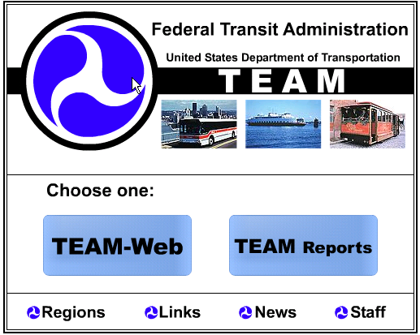

c. Step 3. Links Option Screen

When the TEAM-Web HomePage is displayed click the word Links and the Links screen will appear. Do not click the TEAM-Web command button.

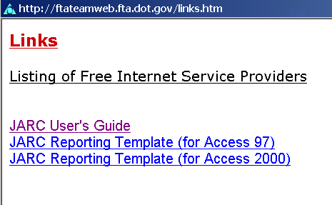

d. Step 4 File Download Screen

When the Links screen appears, three files will be displayed, double click JARC User’s Guide and the File Download screen will be displayed. Check the circle that indicates save this file to disk and click Ok. The Save As Screen will appear.

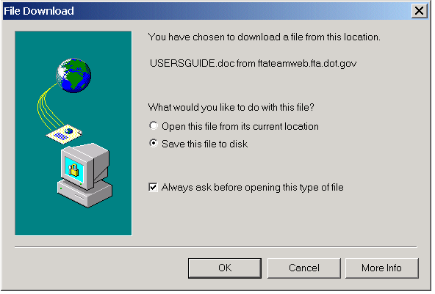

e. Step 5. Save As Screen

On the Save As Screen, select the directory in which the file is to be saved by using the drop down screen in the Save in field. In the File Name field type the file name and click Save. The Download will appear.

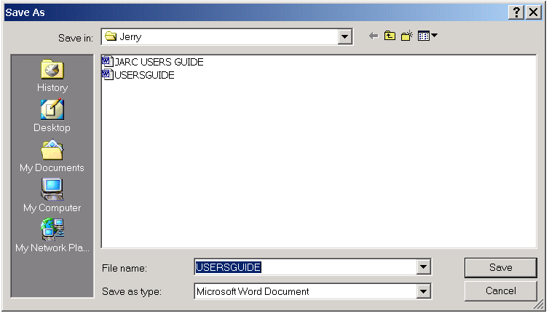

f. Step 6. Download Complete Screen

When the Download Complete Screen is displayed, click the close button. The Links Options Screen will reappear. At this point the GQR System can be downloaded.

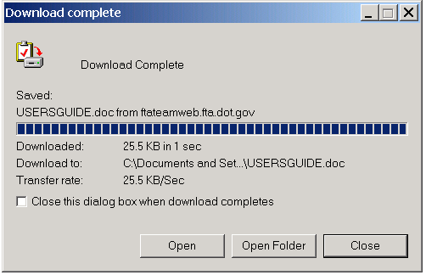

g. Step 7. Download GQR System

Repeat steps 3 through 6 for downloading the GQR System in MS Access 97 or 2000, based on which version your organization has loaded on a personal computer. When complete, exit the internet.

h. Step 8 Directory Screen

Select the directory you stored the JARC User’s Guide to retrieve the file, double click the icon to retrieve the guide for printing and reading. When the User’s Guide has been read, retrieve the GQR System for data entry.

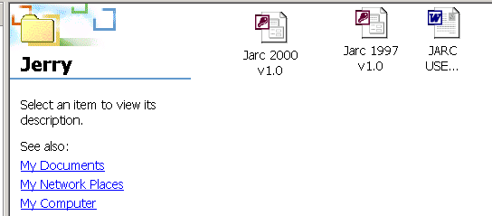

3. CUSTOMIZING GQR

There are two personal computer requirements to use the GQR System, Screen Resolution and Tool Tip Display.

a. Screen Resolution

Although the GQR System will display in a lower resolution (800x600), the optimal resolution is 1024x768. The following four (4) steps will allow most users to check or change the Screen Resolution:

- From your Windows 95/98/00 desktop, click the Start Button, highlight the word Settings, and click Control Panel.

- When the Control Panel screen appears, double click the Display icon and click the Settings tab in the Display Properties screen.

- In the Screen Area of the Display Properties’ screen, drag the slider until it shows 1024x768.

- Click the Apply Button and then click the Ok Button.

Note: Your monitor and display adapter determines whether your screen resolution can be changed.

b. Tool Tip Display

The following five steps will allow most users to check or change the Tool Tip Display:

- From your Windows 95/98/00 desktop, click the Start Button, highlight the word Settings, and click Control Panel.

- When the Control Panel screen appears, double click the Display icon and click the Appearance tab in the Display Properties screen.

- In the Item Drop-Down List, scroll up or down for “Tool Tip” then highlight and click it.

- Once Tool Tip has been selected, choose your preferred font and text size.

- After the preferred font and text size has been selected, click the Apply Button and then click the Ok Button.

4. NAVIGATING THROUGH GQR SYSTEM

It is important to become familiar with the MS Access navigation tools before beginning the data entry process. The graphics below provide examples of the navigation icons, commands, and descriptions. Please review these before you continue.

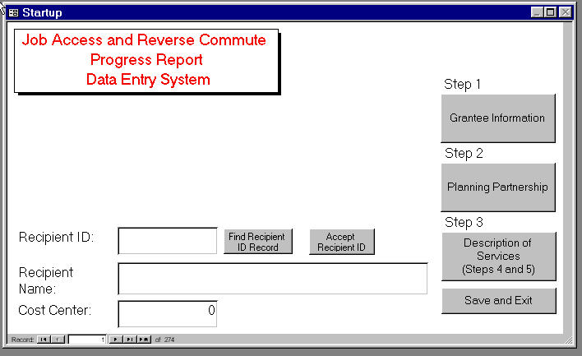

Use the navigation buttons on the tool bar at the top of the application screen to Navigate through the Records.

Button | Command | Description
 | First Record | Go to First Record.
 | Next Record | Go to Next Record.
 | Previous Record | Go to Previous Record.
 | Last Record | Go to Last Record.
 | Filter By Form | Set Search Criteria (Select records base on field entry in form).
 | Apply Filter | Execute/Remove Search (Apply selected filter using criteria entered in field on form).
 | Remove Filter/Sort | Delete Record (Remove an active Filter).

5. ENTERING DATA ON THE GQR SCREENS

Entering Report information is done in seven (7) easy ordered steps. Record data is saved initially when a new record is created, when a user edit any field on a form, and when closing a form.

a. Starting GQR.

Locate the directory in which the database has been stored and double click the icon. The Startup screen with the main menu will be displayed as shown below.

b. Startup

To begin the data entry process, you must first find your JARC project. Follow the instruction below to retrieve your project record(s). In order to enter information on a JARC project, the GQR reference table must contain a record for that project. If the correct project is not displayed, the user should contact a member of the GQR Team (Appendix C).

Project Selection – MS Access 1997/2000

- Click the Find Recipient ID Record icon. The Find and Replace pop-up screen will be displayed.
- Enter the recipient id in the Find What: field.
- Click Find Next. The recipient number, name, and cost center number will be displayed on the startup screen.
- Click cancel on the pop-up screen.
- If the information is correct, click Accept Recipient ID.
- If the information is incorrect, repeat #1 through #4 until the right information is displayed. When the right information is displayed, click Accept Recipient ID.
- The grantee information screen will now display the following fields: state id, project id, recipient id, recipient name, and cost center.
- If the information is correct, data can be entered into each entry form for Step 1 through Step 5 (The steps must be completed in sequential order)
- When data entry is complete for all steps, click Save and Exit command button to complete the data entry process. However, if data for one or more projects is to be entered for the recipient, click the Go to Next Record icon and the project id will change. Then, data for the next project can be entered into each entry form for Step 1 through Step 5. When data entry for all projects related to the recipient has been input, click the Save and Exit command button to complete the data entry process.

Incorrect Information in Step 7

- Click the Execute /Remove Search icon and all fields will become blank except state id.
- Click the Set Search Criteria icon and the state id will become blank and the recipient id will turn black.
- Type in the correct recipient id.
- Click the Execute/Remove Search icon and all fields will be filled.
- If the information is not correct, repeat #1 through #4 until the right information is displayed.
- When the right information is displayed, execute the above #8 and #9 in the first nine steps.

Note: When the correct project has been selected and validated the Startup Screen will be displayed as shown below.

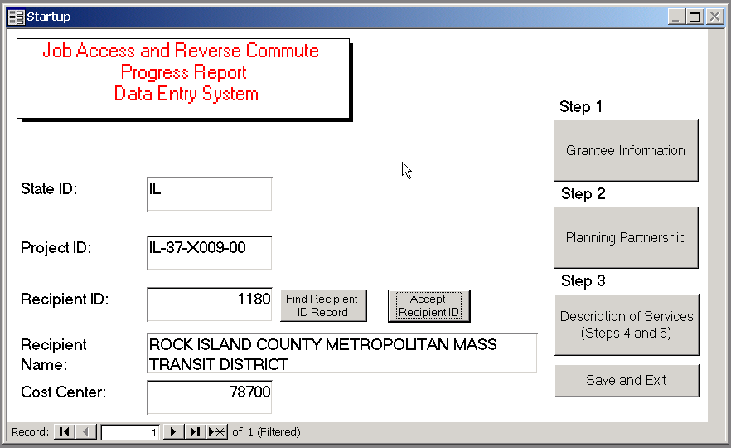

Note: Do not use Blank (new) record on Navigation bar. Always use New Record Button designated for each form.

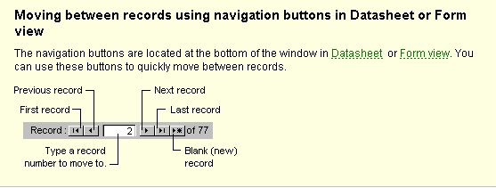

c. Step 1. Grantee Information

Step 1
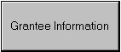 Click the Grantee command button to display the data entry form.

The first three fields will be automatically filled.

Follow the instructions below to complete the remaining fields for Step 1:

- Enter the amount of the FTA grant in this field.
- Click either Earmarked, Competitive, or Earmarked and Competitive to designate the type of grant.
- Click the drop down box to select the appropriate quarter.
- Click the drop down box to select the appropriate year.
- Click to close and return to the Startup screen.

Note: There should be only one record for this entry form.

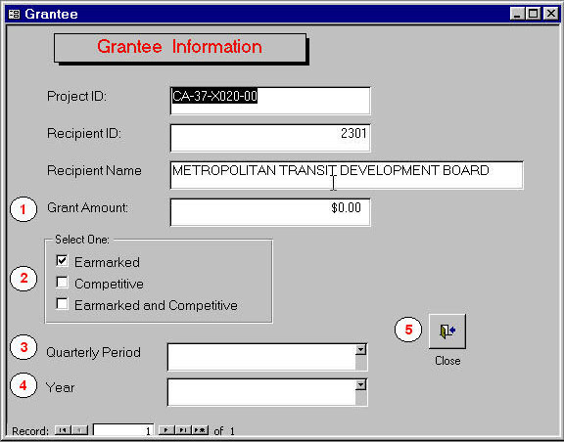

d. Step 2. Planning Partnership Data Entry Form

Step 2
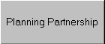 Click the Planning Partnership command button to display the data entry form.

One entry form must be completed for each planning partner. When this entry form is completed, the new record button can be clicked to obtain another entry form for each additional partners. Repeat these procedures until an entry form for each partner has been completed. The navigation button at the bottom of the form will change to indicate the number of partners entered. When finished, click the close button for returning to the Startup screen.

The first three fields will be automatically completed.

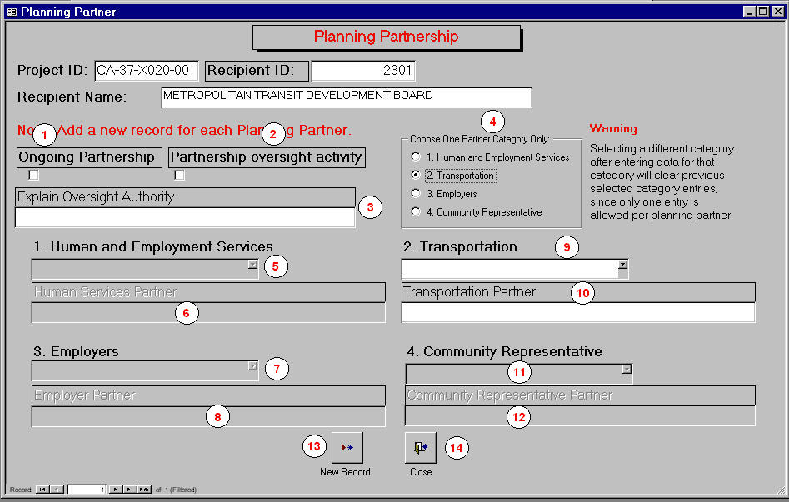

Follow the instructions below to complete the remaining fields Step 2:

- Click Ongoing Partnership to indicate if the partnership is continuous.
- Click Partnership Oversight Activity to indicate if the partnership has oversight responsibility.
- If Partnership Oversight Activity, write a brief narrative in the space provided to explain the type of oversight authority.
- To activate a Planning Partner Type select one of the options. Note: Before entering information review each category. Only one category is selectable for each Planning Partner.
- If a Human and Employment Services partnership, use the drop down menu to select the specific partnership description.
- Write a brief narrative in the space provided to explain the type of Human and Employment Services partnership. Go to #12.
- If a Transportation partnership, use the drop down menu to select the specific partnership description.
- Write a brief narrative in the space provided to explain the type of Transportation partnership. Go to #12.
- If an Employers partnership, use the drop down menu to select the specific partnership description.
- Write a brief narrative in the space provided to explain the type of Employers partnership. Go to #12.
- If a Community Representative partnership, use the drop down menu to select the specific partnership description.
- Write a brief narrative in the space provided to explain the type of Community Representative partnership. Go to #12.
- If there is another partnership record for this project, click new record and repeat #1 - # 11 for the next partner.
- If all the partnership information for this project has been entered, click close and return to the Startup screen.

e. Step 3. Description of Services

Step 3
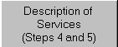 Click the Description of Services command button to display the data entry form.

Complete all fields that are applicable to the service being provided by the specified recipient or sub-recipient. The sub-recipient field must be completed. The first three fields will be automatically filled-in.

Follow the instructions below to complete the remaining fields Step 3:

- If there are no sub-recipients, enter the name of the designated recipient in the field.
1a. Enter sub-recipient or designated recipient contact data.
- Provide a name or description of the geographic area served.
- Enter the type of geographic area served.
- Enter the amount of the project funds invested by this entity.
- Use the drop-down menu to select the urbanized area.
- Enter the date the service was started.
- Use the drop-down menu to select the category of the implemented service.
- Click the service category that matches the selection in #7 to display a list of service types.
- Select the service type.
- If Information Services, provide a brief description of the service provided. (Note: The data entry area is limited to 250 characters.)
- Enter ridership data. (Note: The total in the 5-8, 8-5, and week-end fields should equal the number in the ridership field.
- Enter the cost per ride.
- Describe the method of calculation for cost per ride.
- Enter new service stops data. (Note: The total in the first two fields s should equal the total new stops field.)
- Enter the number of employers. (For demand response, describe how this number was derived).
- Enter the number of total jobs and entry-level jobs.
- Once the applicable data on the Description of Services screen had been entered, do not close this screen. Go to Step 4 Financial Partnership.
- Once the applicable data on the Financial Partnership screen had been entered, do not close this screen. Go to Step 5 Operators and Operating Partners
- If there is another service to be entered for this project, click new record and repeat #1 - # 18 for the next service.
- If all the services for this project have been entered, click close and return to the Startup screen.

Additional field input instructions are provided in Appendix B (please read).

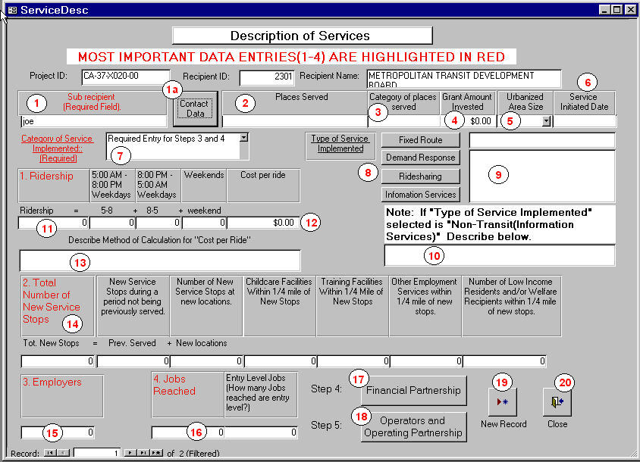

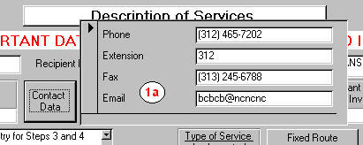

f. Step 4. Financial Partnership

Step 4.
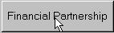 Click the Financial Partnership command button to display the data entry form.

The project id, recipient id, and category of service implemented will be automatically filled in.

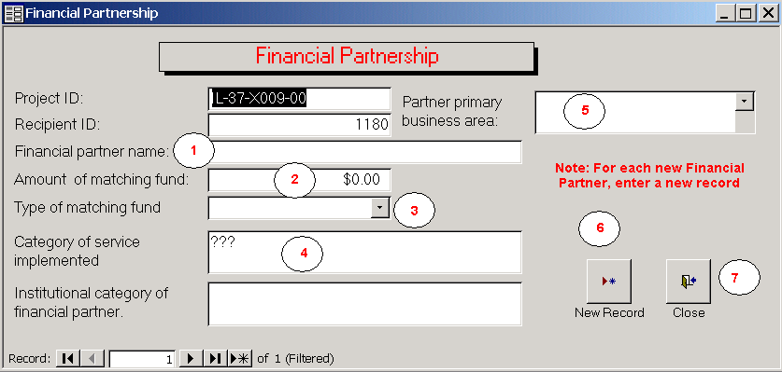

Follow the instructions below to complete the remaining fields:

- Enter the name of the financial partner
- Enter the amount of matching funds provided by the partner.
- Use the drop down menu to select the type of matching fund.
- Enter type institutional category of the financial partner.
- Use the drop down menu to select the primary business area of the partner.
- If there is another partner to be entered for this project, click new record and repeat #1 - # 5 for the next partner.
- If all the partners for this project have been entered, click close and return to the Description of Services screen.

g. Step 5. Operators and Operating Partnership

Step 5.
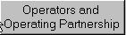 Click the Operators and Operating Partnership command button to display the data entry form.

The project id, recipient id, and category of service implemented will be automatically filled in.

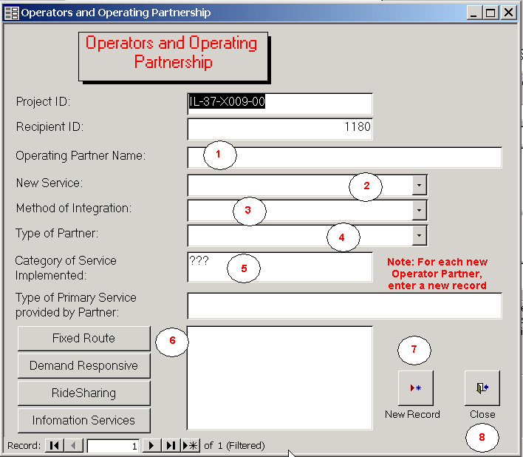

Follow the instructions below to complete the remaining fields:

- Enter the name of the operator or operating partner
- Use the drop down menu to select the type of new service.
- Use the drop down menu to select the method of integration.
- Use the drop down menu to select the type of partner.
- Click the category of service displayed in the Category of Service Implemented field. A list of specific services will be displayed.
- Click the appropriate service from the list to enter data in the Type of Primary Service provided by Partner field.
- If there is another partner to be entered for this project, click new record and repeat #1 - # 6 for the next partner.
- If all the partners for this project have been entered, click close and return to the Description of Services screen.

6. UPLOADING GQR TO TEAM.

In order to upload the GQR System in either MS Access 97 or 2000, eleven steps must be taken:

a. Step 1. Online Screen

Each recipient must logon to their internet service for retrieving their HomePage.

b. Step 2. Team Web Page

At the respective HomePage, type Team-Web address ((ftateamweb.fta.dot.gov) and click go to display the Team-Web HomePage. Click the TEAM-Web command button and the Logon Screen will appear.

c. Step 3. Logon Screen

When Logon Screen appears, user name and password must be input in the respective fields. Use the drop-down screen to select production and click logon button to display TEAM-Web Main Menu Screen.

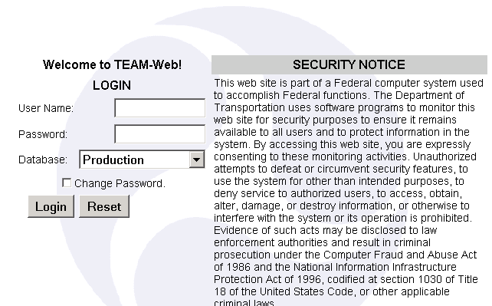

d. Step 4. TEAM-Web Main Menu Screen

When the Main Menu appears, click Project Management on the left side of the screen and the Query Application Screen will display.

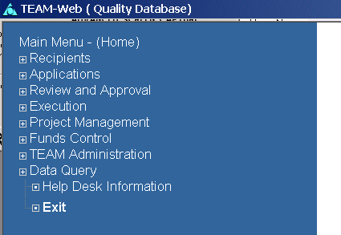

e. Step 5. Query Application Screen

When the Query Application Screen appears, type the recipient id and click submit query button to display the Project Query Result Screen.

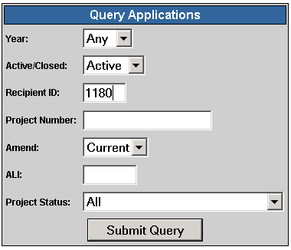

f. Step 6. Project Query Result Screen

Highlight the right project and double click the word Milestone Progress on the left side of the screen. The Milestone Status Report Screen will display.

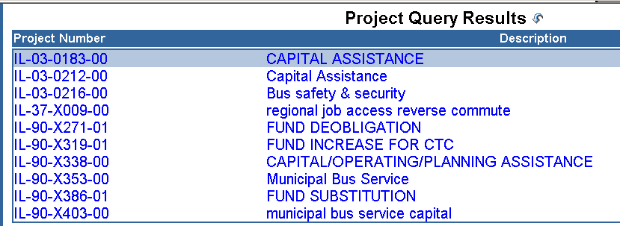

g. Step 7. Milestone Status Report Screen

With the Summary Tab selected, click the attachment document icon (paper clip) to display the Attachment Screen.

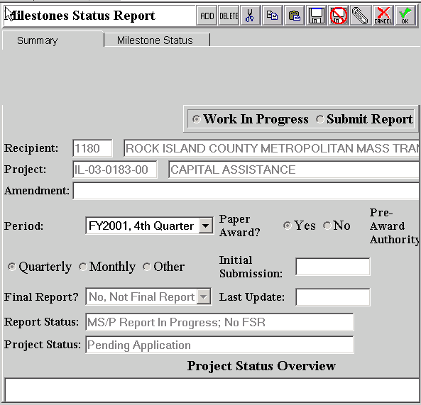

Step 8. Attachment Screen
Click the first Milestones folder to display the Upload File Screen

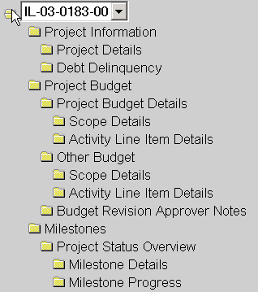

i. Step 9. Upload File Screen

In the Description field, input JARC GQR 4th Q – 2001 and click the browse button. The Choose File Screen appears and the folder containing the GQR file (JARC 2000 v 1.0) can be selected. Single click the GQR File so that its name will appear in the File Name field. Double click the open button and the Upload File Screen will be displayed. Double click the upload button to return the completed GQR File to TEAM-Web within the milestone section.

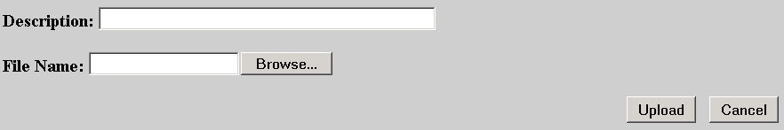

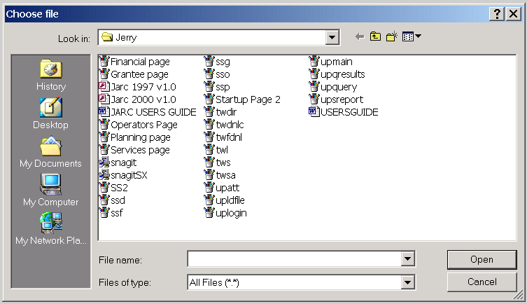

7. APPENDICES

A. DATA DICTIONARY

GENERAL

Project ID
This field represents an alphanumeric identification number assigned to each recipient’s project. Each alphanumeric identification number begins with the state abbreviation.

Recipient ID
This field represents a four digit number exclusively assigned to each recipient.

Recipient Name
This field is the recipient’s name signed on an executed grant agreement. It should be noted that the term recipient and grantee represent the same entity.

New Record
Double click this button to obtain a blank screen that new information can be input.

Close
This icon is for exiting the current screen and return to the startup screen.

STARTUP PAGE

State ID

This field represents state abbreviations.

Cost Center

This field is a five digit number used to identify the Federal Transit Administration (FTA) Region in which each recipient is located.

Step 1 Grantee Information

This screen includes the basic descriptive information about each grantee.

Step 2 Planning Partnership

This screen includes selected information about the partners listed in each recipient application. It should be noted that a planning partnership was a requirement for the recipient to submit an application

Step 3 Description of Services

This screen includes specific information about each service the recipient has implemented.

Step 4 Financial Partnership

This screen includes selected information about each recipient’s financial partner that provided matching funds.

Step 5 Operators and Operating Partnership

This screen includes selected information about each recipient’s partner involved in operating the implemented service.

Save and Exit

This button is for saving information entered into each record and exiting the database.

Find Record

This button is for finding the appropriate recipient identification number.

Accept

This button is for confirming that the appropriate recipient identification number has been selected.

GRANTEE/RECIPIENT INFORMATION

Grant Amount

This is the total amount of FTA funds provide for the implemented service.

Earmarked

A project designated as earmarked means it was selected by U.S. Congress

Competitive

A project designated as competitive means it was chosen by FTA Headquarters selection process.

Quarterly Period

This field represents the last month of each quarter in which the recipient submits their quarterly report. The quarterly report must be submitted within thirty (30) days from the end of each quarter. (Note: The quarters are based on the federal fiscal year. Quarter 1 begins October 1st and ends December 31st. Quarter 2 begins January 1st and ends March 31st. Quarter 3 begins April 1st and ends June 30th. Quarter 4 begins July 1st and ends September 30th.).

Year
This field represents the year each quarterly report is submitted. (Note: The year is based on the federal fiscal year. The federal fiscal year begins October 1st and ends September 30th. For example, the Year 2001 should be entered for the period ending September 30, 2001.)

PLANNING PARTNERSHIP

Ongoing Partnership

This field is for determining if the partnership is continuous or just for project approval.

Partnership Oversight Activity

The field is for indicating if the partnership has supervisory responsibilities for the project.

Explain Oversight Activity

This field is for summarizing the scope of supervisory responsibilities.

DESCRIPTION OF SERVICES

Sub-recipient (Required Field)

This designation is for entities that receive funds through the grantee to implement their services.
Enter Yourself as sub Recipient it No other Recipient(s) exist.

Place Served
`
This field specifies the name of each geographical area being served by an implemented service.

Category of Places Served

This field specifies the category of each geographical area being served by the implemented service e.g., city, community, neighborhood, county.

Grant Amount Invested

The total amount of funds invested in the implemented service by the designated recipient/sub-recipient is entered in this field.

Urbanized Area Size

This field is used to identify the size of the geographical area in which the recipient is located. The options are large (major – population over 200,00), medium (medium – population between 50,000 and 200,000), and small (non-urbanized – population below 50,000).

Service Initiated Date

The date (mm/dd/yy) the service was implemented is entered in this field..

Category of Service Implemented (Required Field)

This field identifies one of four service categories for an implemented service. The options are fixed route, demand response, ridesharing, and information services.
Type of Service Implemented

This field identifies the type of service choices within each category of service implemented

Ridership

This field is for number of rides taken by people using an implemented service in a given time period. The time periods include: 5:00 am – 8:00 pm weekdays, 8:00 pm – 5:00 am weekdays, and Weekends

Cost per ride

This field is for calculating the cost-effectiveness of each implemented service. In addition, a field describing the method of calculating cost per ride is limited to 250 characters.

Method of Calculation for “Cost Per Ride

Each recipient will specify how their cost per ride is calculated.

Total Number of New Service Stops

This field is for entering the number of new stops serviced by the recipient’s implemented service during
each quarterly reporting period.

Number of New Service Stops during a period not being previously served

This field is for entering the number of new stops serviced by the recipient’s implemented service during each quarterly reporting period based on the time of day. It is assumed that the stops were not previously serviced during a specific time of day.

Employment Sites

An employment site is a location where one or more employers are located.

New Service Stops at new locations

This field is for entering the number of new stops serviced by the recipient’s implemented service during each quarterly reporting period for a previously non-served geographical area.

Childcare facilities within ¼ mile of new stops

This field is for entering the number of childcare facilities within ¼ mile of new stops serviced by the recipient’s implemented service during each quarterly reporting period.

Training facilities within ¼ mile of new stops

This field is for entering the number of training facilities within ¼ mile of new stops serviced by the recipient’s implemented service during each quarterly reporting period.

Other employment services within ¼ mile of new stops

This field is for entering the number of other employment services within ¼ mile of new stops serviced by the recipient’s implemented service during each quarterly reporting period.

Other Employment Services

Other employment services include the provision of requisite skills and information that allow and an individual to become gainful employed (e.g., resume writing, dress codes, and completion of applications).

Number of Low Income and/or welfare recipients within ¼ mile of new stops

This field is for entering the number of new stops within ¼ mile or directly reaching low income and/or welfare recipients serviced by the recipient’s implemented service during each quarterly reporting period. If the implemented service is demand responsive, enter the number of residents and/r recipients actually serviced. (Note: The number of low-income residents should be determined by the number of persons in household designated as low-income by the 2000 U. S. Bureau of the Census Bureau report. The number of welfare recipients should be determined by the number individuals designated as receiving public assistance by the 2000 U. S. Bureau of the Census Bureau report.)

Employers

An employer is defined as an entity that hires one or more persons to work for salary or wages.

Jobs Reached

For an implemented service, the number of jobs reached can is either be those that are actually serviced or can be serviced

Entry Level Jobs

An entry level job is defined as the positions that require only a high school education or its equivalency.

FINANCIAL PARTNERSHIP

Partner Primary Business Area

This field identifies the category in which the partner conducts business

Amount of Matching Funds

This is the amount of funds each partner provided for matching funds.

Type of Matching Fund

This is the categorical source for matching fund.

Category of Service Implemented

This field identifies one of four service categories a implemented service may be assigned (fixed route, demand responsive, ridesharing, and information services).

Institutional Category of Financial Partner

This field identifies the category in which the partner is classified.

OPERATORS AND OPERATING PARTNERSHIP

New Service
This field specifies the category of new service implemented i.e., Current Service Expansion, Current Network Addition, or Total New Service.

Method of Integration

This field specifies the type of method used to integrate new service into an existing network or system.

Type of Partner

This field specifies the general category in which a partner may be assigned i.e., public, private, non-profit.

Category of Service Implemented

This field identifies one of four service categories an implemented service may be assigned (fixed route, demand responsive, ridesharing, and information services).

Type of Primary Service provided by Partner

This field identifies the type of service choices within each category of service implemented by the specified partner.

B. FIELD INPUT INSTRUCTIONS

The field input instructions are provided to explain: (1) what information should be input in each field; (2) how the information should be input in each field; and (3) the valid parameters for information input in each field.

STARTUP PAGE

State ID

State abbreviation is automatically input in this field once recipient id and name as well as cost center have been selected and validated. The state represents where the service is implemented and where the recipient is located.

Project ID

The project id assigned to each project by Federal Transit Administration (FTA). It is automatically input in this field once recipient id and name as well as cost center have been selected and validated.

Recipient ID

Unique id assigned to a grantee recipient by Federal Transit Administration (FTA). The recipient id is the primary system key and must be entered to initiate the GQR data entry process.

Recipient Name

The legal name of the grant recipient is displayed in this field. The name is stored on the GQR reference table and is retrieved after the recipient id is entered and validated.

Cost Center

The cost center is specified with a five-digit number that identifies a recipient’s FTA region. The cost center is stored on the GQR reference table and is retrieved after the recipient id is entered and validated

Step 1 Grantee Information

Click this button to display the Grantee Information screen.

Step 2 Planning Partnership

Click this button display the Planning Partnership screen.

Step 3 Description of Services

Click this button to display the Description of Services screen.

Step 4 Financial Partnership

Click this button to display the Financial Partnership screen.

Step 5 Operators and Operating Partnership

Click this button to display the Operators and Operating Partnership screen.

Save and Exit

Click this button to save information that has been input and exit the GQR System.

Find Record

Click this button to select the appropriate recipient identification number.

Accept
Click this icon to confirm that the appropriate recipient data has been selected.

GRANTEE INFORMATION

Information about the grant amount, type of grant (earmarked or competitive), federal fiscal year the grant was awarded, and quarter for the period being reported is entered on this screen.

Project ID

This cell will be automatically filled with the same project id selected on the startup page.

Recipient ID

This cell will be automatically filled with the same recipient id entered on the startup page.

Grant Amount

Enter the total amount of FTA funds for the implemented service.

Recipient Name

The field will be automatically filled with the same name displayed on the Startup screen.

Earmarked

Enter a check mark in this cell to indicate congressional project selection. If a check is entered in this field, the Competitive field should be blank.

Competitive

Enter a check mark in this cell to indicate competitive project selection. If a check is entered in this field, the Earmarked field should be blank.

Quarterly Period

Use the drop down screen to select the reporting period for this quarterly report. (Note: The quarters are based on the federal fiscal year. Quarter 1 begins October 1st and ends December 31st. Quarter 2 begins January 1st and ends March 31st. Quarter 3 begins April 1st and ends June 30th. Quarter 4 begins July 1st and ends September 30th.).

Year
Use the drop down screen to select the reporting year. (Note: The year is based on the federal fiscal year. The federal fiscal year begins October 1st and ends September 30th. 2001 should be entered for the period ending September 30, 2001.)

Close

Click this button to exit the Grantee Information screen.

PLANNING PARTNERSHIP

Information about each service being implemented (i.e., ongoing partnership, partnership oversight activity with narrative, name and type of partner) is entered on this screen

Project ID

This cell will be automatically filled with the same project id selected on the startup page.

Recipient ID

This cell will be automatically filled with the same recipient id entered on the startup page.

Recipient Name

The field will be automatically filled with the same name displayed on the Startup screen.

Ongoing Partnership (mutually exclusive)

Enter a check mark in this box to indicate an ongoing partnership

Partnership Oversight Activity (mutually exclusive)

Enter a check mark in this box to indicate oversight activity

Explain Oversight Activity

Enter an explanation that describes oversight activity. There is a limitation of 250 characters for this section. This includes spaces, letters, and punctuations.

Type of Planning Partner

Use the drop down screen to select the appropriate partner type. The name of each partner should be entered into the field directly below one of the categories listed below; they are mutually exclusive.

Human and Employment Services
Transportation
Employer
Community Representative

New Record

Click this button to enter data for a new planning partner.

Close

Click this button to exit the Planning Partner is screen.

DESCRIPTION OF SERVICES

Information about each service being implemented (i.e., type of service implemented, sub-recipient, place served, grant amount invested, urbanized area size, ridership, number of new stops, employers reached, and jobs reached) is entered on this screen. This screen also provides a link to the Financial Partnership and Operators and Operating Partnership screens.

Project ID

This cell will be automatically filled with the same project id selected on the startup page.

Recipient ID

This cell will be automatically filled with the same recipient id entered on the startup page.

Recipient Name

The field will be automatically filled with the same name displayed on the Startup screen.

Sub-recipient

Enter the name of both recipients and sub-recipients in this field. A new screen should be submitted for each recipient and sub-recipient participating in a project. Always enter the information for the designated recipient first. If there are sub-recipients, click the New Record icon to enter data for each sub-recipient.

Place Served

Type the proper name of the geographic area for which the service is provided.

Category of Places Served

Type the category for which the geographical area for which the service is provided. Valid values are city, community, county, state, tribal land, other.

Grant Amount Invested

Enter the total amount of project funds invested in the implemented service

Urbanized Area Size

Use the drop down screen to select the size of urbanized area being served. Valid options are large (major – population over 200,00), medium (medium – population between 50,000 and 200,000), and small (non-urbanized – population below 50,000).

Service Initiated Date

Type in the actual date (mm/dd/yy) the implemented service began.

Category of Service Implemented

Use the drop down screen to select one of four service categories to which an implemented service may be assigned. Valid values are fixed route, demand response, ridesharing, and information services.

Type of Service Implemented

Click one of the four service categories to select the type of service choices within each implemented service category.

Note

Field used to describe non-transit services implemented for a project. Input is limited to 250 characters.

Ridership

Enter the total number of rides provided during the reporting period.

5-8 Weekdays

Enter the total number of rides provided from 5:00 am until 8:00 pm weekdays during the reporting period

8-5 Weekdays

Enter the total number of rides provided from 8:00 pm until 5:00 am weekdays during the reporting period

Weekend

Enter the total number of rides provided from 8:00 pm Friday until 5:00 am Monday during the reporting period

Cost per ride

Enter the dollar amount that it costs to provide each ride for the service implemented.

Method of Calculation

Describe the method used to calculate the cost per ride. The explanation cannot exceed 250 characters.

Total Number of New Service Stops

Enter the number of new service stops during the reporting period. If the implemented service is demand response, use the Note field for Non-Transit services to indicate what the data represents. The valid values are: (1) the number of stops actually made or (2) the total possible stops within the service area.

New Service Stops during a period not being previously served

Enter the number of new service stops that resulted from providing the implemented service during a time period not previously available e.g. owl service, midday, or off-peak. If the implemented service is demand response, use the Note field for Non-Transit services to indicate what the data represents. The valid values are: (1) the number of stops actually made or (2) the total possible stops within the service area.

Number of New Service Stops at new locations

Enter the number of new service stops that resulted from providing the implemented service within a geographical area not previously available. If the implemented service is demand response, use the Note field for Non-Transit services to indicate what the data represents. The valid values are: (1) the number of stops actually made or (2) the total possible stops within the service area.

Childcare facilities within ¼ mile of new stops

Enter the number of childcare facilities with ¼ mile of new service stops. If the implemented service is demand responsive, enter the number of discrete childcare facilities actually serviced.

Training facilities within ¼ mile of new stops

Enter the number of training facilities with ¼ mile of new service stops. If the implemented service is demand responsive, enter the number of discrete training facilities actually serviced.

Other employment services within ¼ mile of new stops

Enter the number of other employment services with ¼ mile of new service stops. If the implemented service is demand responsive, enter the number of discrete employment services actually serviced.

Number of Low Income and/or welfare recipients within ¼ mile of new stops

Enter the number of low-income residents and/or welfare recipients within ¼ mile of new stops. If the implemented service is demand responsive, enter the number of residents and/or recipients actually serviced. (Note: The number of low-income residents should be determined by the number of persons in household designated as low-income by the 2000 U. S. Bureau of the Census Bureau report. The number of welfare recipients should be determined by the number individuals designated as receiving public assistance by the 2000 U. S. Bureau of the Census Bureau report.)

Employers

Enter the number of employers that are accessible within ¼ mile of the new stops. If the implemented service is demand response, use the Note field for Non-Transit services to indicate what the data represents. The valid values are: (1) the number of employers actually services or (2) the total possible employers within the service area.

Job Reached

Enter the number of jobs accessible within ¼ mile of the new stops. If the implemented service is demand response, use the Note field for Non-Transit services to indicate what the data represents. The valid values are: (1) the number of jobs actually made or (2) the total possible jobs within the service area.

Entry Level Jobs

Enter the number of jobs defined as entry level. Entry level is defined as jobs that require a high school education or its equivalency. If the implemented service is demand response, use the Note field for Non-Transit services to indicate what the data represents. The valid values are: (1) the number of jobs actually made or (2) the total possible jobs within the service area.

New Record

Click this icon to display a new Description of Services screen to enter data for a new sub-recipient.

Close

Click this icon is used to exit this screen and return to the Startup screen.

FINANCIAL PARTNERSHIP

This screen captures information about each financial partner related to the service being implemented. i.e., name and type of partner, source of matching funds, type of service provide by each partner. A separate data entry screen should be completed for each financial partner. The new record button is used to display a blank data entry screen.

Project ID

This field will be automatically filled with the same project id selected on the startup page.

Recipient ID

This field will be automatically filled with the same id displayed on the startup page.

Partner Primary Business Area

Use the drop down screen to select the primary business area. Valid values are (1) economic development, (2) employment, (3) housing, (4) human services, (5) non-profit organization, (6) profit organization, (7) transportation, and (8) other.

Financial Partner Name

Enter the name of the financial partner providing the matching funds.

Amount of Matching Funds

Enter the amount of matching funds provided by each financial partner for the service being implemented.

Type of Matching Fund

Use the drop down screen to select the categorical source of matching funds. Valid values are (1) local government, (2) state government, (3) federal government, and (4) private.

Category of Service Implemented

This field will be automatically filled with the same choice entered on the Description of Services screen.
Institutional Category of the Financial Partner

Enter the primary occupational category of the financial partner. Valid values are (1) managerial, (2) technical, (3) service, (4) government, (5) non-profit, and (6) other.

New Record

Click this icon to display a new Financial Partnership screen and enter data for a financial partner.

Close

Click the button to exit this screen and return to the Description of Services screen.

OPERATORS AND OPERATING PARTNERSHIP

Captures and displays information about each service being implemented such as new service, method of integration, type of partner, and type of service provided by each partner. A separate entry should be made for each partner. Use the new record button to display a blank data entry screen

Project ID

This cell will be automatically filled with the same id selected on the Startup screen.

Recipient ID

This cell will be automatically filled with the same id displayed on the Startup screen.
Operating Partner Name

Enter the name of the operating partner providing the implemented service.

New Service

Use the drop down screen to specify the type of new service. Valid values are (1) Current Service Expansion, (2) Current Network Addition, or (3) Total New Service.

Method of Integration

Use the drop down screen to specify the type of method used to integrate the new service into the existing network or system. Valid values are (1) Consolidated Consumer Information, (2) Transportation Brokerage, or (3) Integrated Fare Mechanism.

Type of Partner

Use the drop down screen to specify the type of partner. Valid values are (1) Public, (2) Private for Profit, or (3) Non-Profit.

Category of Service Implemented

This field will be automatically filled with the same choice entered on the Description of Services screen.

Type of Primary Service Provided by Partner

Click the button that matches the value in the Category of Service Implemented field. Options for each category of service will be displayed. Click the option that best describes the type of service provided. This data displayed in the field indicates the specific type of primary service provided by this partner.

New Record

Click this icon to display a new Operators and Operating Partnership screen and enter data for a new sub-recipient.

Close

Click the button to exit this screen and return to the Description of Services screen.

C. GQR TEAM MEMBERS

KENNETH R. COOK

Voice -- (312) 902-2269
Email – Kam1968@aol.com

SIIM SOOT

Voice – (312) 996-2666
Email – Siim@uic.edu

GLENDA F. WILSON

Voice – (213) 977-4982
Email – Ksigfw@attglobal.net

KEITHA G. WILSON

Voice – (703) 807-1185
Email – Wilsonkg@attglobal.net

