Session No. 4

Session Title: Spatial Analysis: Application Tools for Vulnerability Analysis

Time: Three Hours

Objectives:

At the conclusion of this session, students should be able to:

4.1 Explain the concept “geographic information system” (GIS) and its elements.
- Clarify how a GIS differs from an “information system.”
- Using the elements of a “system,” illustrate the components of a GIS.
- 4.2 Define “geographic spatial object classes” (line, point, and polygon)
- Explain and illustrate vector
- Explain longitude and latitude
4.3 Explain the nature of “Tiger Files”
4.4 Explain and illustrate image data sources or types
4.5 Explain the nature and purpose of geo-coding
  - Explain the nature and use of global positioning systems
4.7 Using the Q3 FIRM case study, explain how this data could be used in a vulnerability analysis and identify critical issues that must be addressed by emergency managers in using GIS.

Scope: This session will explain the nature of geographic information systems (GIS) and their application to vulnerability analysis. Elements of a GIS will be outlined and uses of GIS in emergency management will be examined.

Readings:

Instructor

Herring, Thomas A. “The Global Positioning System,” Scientific American. Feb 1996. Pp 44–50.

Ross T. Newkirk. “Extending Geographic Information Systems for Risk Analysis and Management,” Journal of Contingencies and Crisis Management. Vol. 1 #4, Dec. 1993.

State University of New York at Buffalo and GIS Resource Group, Inc. New York State Archives and Records Administration, National Center for Geographical Information and Analysis. Helping Local Government Create a GIS. 1997. (Volumes 1,2, & 3).
www.geog.buffalo.edu/ncgia/sara (Volume 2 and 3 are suggested as references. See Readings: 4-Volume1.prf for a copy of this document. Volumes 2 and 3 are also available.)
U.S. Flood Insurance Administration, FEMA. “FEMA Flood Insurance Rate Maps Case Study,” adapted from Users Guide to the Q3 Digital Flood Insurance Rate Maps, Washington, DC 1996. (See Readings: 4-Q3Case—A Word Document.)

Student

Herring, Thomas A. “The Global Positioning System,” Scientific American. Feb 1996. Pp 44–50.

State University of New York at Buffalo and GIS Resource Group, Inc. New York State Archives and Records Administration, National Center for Geographical Information and Analysis. Helping Local Government Create a GIS. 1997. (Volumes 1,2, & 3).
www.geog.buffalo.edu/ncgia/sara (Volume 2 and 3 are suggested as references. See Readings: 4-Volume1.prf for a copy of this document. Volumes 2 and 3 are also available.)

U.S. Flood Insurance Administration, FEMA “FEMA Flood Insurance Rate Maps Case Study,” Adapted from Users Guide to the Q3 Digital Flood Insurance Rate Maps., Washington, DC 1996. (See Readings: 4-Q3Case—a Word document.)

References

Adventure GPS Products, “Buyer’s Guide to GPS Receiver Features,” Lancaster, CA. http://www.gps4fun.com/how-to-use.html.

Antenucci, John C., et. al., Geographic Information Systems: A Guide to the Technology, New York: Van Nostrand Reinhold, 1991.

Aronoff, S., 1991 Geographic Information Systems: A Management Perspective. Ottawa: WDL Pub., p.194.

Berry, J.K., 1995, “Raster is Faster, But Vector is Corrector,” GIS World, 8(6):35-35.

Birkin, Mark; Clarke, Graham; Clarke, Martin; Wilson, Alan. Intelligent GIS: Location Decisions and Strategic Planning. John Wiley & Sons: New York, 1996.

Carrara, Alberto and Fausto Guzzetti, Editors. Geographic Information Systems in Assessing Natural Hazards. Kluwer Academic Publishers Group: Hingham, MA 360. 1995.

Dana, Peter H. “Global Positioning System Overview.” The Geographer’s Craft Project. Department of Geography, University of Texas. Download from http://www.utexas.edu/depts/grg/gcraft/notes/gps/gps.html.

Dana, Peter H. “Map Projection Overview” The Geographer’s Craft Project. Department of Geography, University of Texas. Download from http://www.utexas.edu/depts/grg/gcraft/notes/gps/gps.html.

ESRI, 1992b, Understanding GIS, Redlands, CA: Environmental Systems Research Institute, Inc., p. 598.

Greenway, A. Roger. Risk Management Planning Handbook: A Comprehensive Guide to Hazard Assessment, Accidental Release Prevention and Consequence Analysis. Rockville: Government Institutes, Inc. 1998.

Jarman, Alan M.G. “Smart Spatial Information Systems: Extending Geographic Information Systems in the Space Age.” Journal of Contingencies and Crisis Management. Vol. 1 #4. Pp. 229-240. December 1993.

Johnson, Glenn O. “GIS Applications in Emergency Management,” URISA Journal. 4 (Spring 1992) 66 – 72.

Korte, George B., A Practioner’s Guide: The GIS book, Sante Fe: On Word Press, 1992.

New York State Archives and Records Administration National Center for Geographical Information and Analysis, State University of New York at Buffalo and GIS Resource Group, Inc. Helping Local Government Create a GIS (Volumes 1,2, & 3), 1997.
www.geog.buffalo.edu/ncgia/sara (Volume 1 is required reading)

Volume 2: Survey of Available Data, Evaluating Hardware and Software, Database Planning and Design, Database Construction and Pilot Studies and Benchmark Tests

Volume 3: Acquisition of GIS Hardware and Software, GIS System Integration, GIS Application Development, GIS Use and Maintenance

Ross T. Newkirk. “Extending Geographic Information Systems for Risk Analysis and Management,” Journal of Contingencies and Crisis Management. Vol. 1 #4, Dec. 1993.

Srinivas, Emani, “Applications in Hazard Assessment and Management.” Explorations in Geographic Information Systems Technology. V. 6. Geneva, Switzerland: United Nations Institute for Training and Research 1996. (includes 3 computer disks, 3 ½").

Tzemos, S., R.A. Burnett. Use of GIS in the Federal Emergency Management Informatin System (FEMIS). See: http://www.esri.com/base/common/userconf/proc95/to350/p345.html.

Remarks:

Question for the Class: Geographic Information Systems: How does it fit into the emergency management system?

Geographic information systems, including their programs, data, maps, charts, and tables are used as a resource in decision making throughout the emergency management process. From planning decisions on the locations of shelters, decisions in a response concerning the best evacuation route, mitigation decisions relating to the extent of flooding, or decisions in recovery clarifying the total damage to homes in a tornado, GIS is a tool for providing needed information.

4.1 Geographic Information System: A Review of the Technology

Geographic information is information which relates to specific locations. It involves the physical environment with data associated with it. A geographic information system is an organized collection of computer hardware and software designed to efficiently create, manipulate, analyze, and display all types of geographical or spatial data. A GIS allows complex spatial operations that are very difficult to do otherwise.

The term geographic describes data that is related to geographic scales of measurement and corresponds by some coordinate system to locations on the surface of the earth. Other types of information systems may contain details about location, but in a GIS, spatial objects and their locations are the very building blocks of the system.
It is possible to use GIS to ask questions of the geographic database, obtaining “information” about the geography world. This entails the extraction of specific and meaningful information from a diverse collection of data, and it is possible only because of the way in which the data are organized into a “model” of the real world.

The geographic information “system” involves the environment and allows data to be managed in association with geographic references and questions to be posed. In the most general sense, a GIS need not be automated (for example a traditional roadmap), but should be an integrated set of procedures for the input, storage, manipulation and output of geographic information. Such a system is most readily achieved by automated means.

A geographic information system (GIS) is thus a data handling and analysis system based on sets of data distributed spatially in two dimensions. It is a geo-based or geo-coded information system. It is an information system, but one in which the data relates to a geographical location. Thus a GIS would not only have a means of creating and editing lists and tables of schools, hospitals, nursing homes, or shelters but also have the capability of displaying this data in a graphic or map format.

The data sets may be map oriented, when they comprise qualitative attributes of an area recorded as lines, points, and areas (polygons). Lines, points, and polygons are used in a Vector format. A second type of format is image oriented; the data in this format has quantitative attributes referring to cells in a rectangular grid.

A Manager’s Concern

The “Manager’s Overview” suggests that “GIS development is a process of technological innovation and requires management attention appropriate to this type of activity (p.2). It should be active as opposed to passive management involvement in the project. Failures of GIS in the past resulted not from technical difficulties but from a “lack of realistic expectations of all parties associated with the project, including GIS technicians, potential users, managers, and officials. The “Manager’s Overview” suggests that the emergency manager get involved in planning for the development of a GIS. The emergency manager may be in a position to facilitate realistic expectations from technical staff, users, and other support staff who might assist in the development of GIS data.

Question for the Class: For an emergency manager, how could geographically based data be useful in emergency management? What types of data could be used? How?

Maps provide a very visual presentation of an event, phenomenon, or idea. For emergency managers, being able to see the area affected by a disaster supports communication and decision making. An area affected by a flood or a chemical spill can be shown on a map along with other information such as the location of critical facilities including schools, hospitals, nursing homes, schools, parks, shopping areas, business areas, manufacturing areas, and transportation routes. Seeing the location of critical facilities in an area affected by an emergency could help emergency managers in determining appropriate evacuation routes or shelter locations.

Having the precise location of a school, hospital, park, or business is useful, but other information associated with these sites would enhance the manager’s decision making. Knowing the school enrollment, the number of beds at a hospital by type, or the type of patients in a nursing home could provide the emergency manager with timely information for use in making evacuation decisions. This type of information can be part of a geographic information system and available to the emergency manager.

Application of GIS

A GIS is a system that includes data, graphics, and a program to munipulate both the data and the graphics. As a system it includes the basic characteristics of all systems. GIS involves the following capabilities to manipulate geo-referenced spatial data:

- Input (encoding) (collection of phone listings, census information by geographic area—block groups or tracks)
- Data management (storage and retrieval) and analysis (GIS systems such as ArcView, MapInfo, Geo-Media, LandView/Marplot)
- Output (maps showing risk zones, vulnerable population, phone listings in vulnerable areas.)

The GIS stores, retrieves, manipulates, analyzes and displays these data according to user-defined specifications. Ideally the GIS is used as a decision support system involving the integration of spatially referenced data in a problem solving environment.

Risk analysis occurs in emergency management from two perspectives including ex ante (prior to the event) and ex post facto (after the event). Newkirk (1993) sees that a geographic information system provides critical views of potential disasters and their impact both prior to an event and in the post event analysis. He is afraid that the commercial GIS might encourage the user to assume that the data is exact. The system should be used to allow for a broader examination of the risks and their potential or actual (as calculated) impact. There is a need for the broad-based emergency management community to have a risk assessment tool that allows for close examination of events and their outcomes.

Benefits of a GIS to the Emergency Manager

Benefits center on providing information to enhance decision making associated with emergency planning, response, recovery, and mitigation efforts.

- A GIS can provide regular maps of the local community and of areas of special interest to emergency management.
- A GIS can conduct spatial queries and display the results. Such queries could include: what residents are within a 100 year flood zone; which schools or nursing homes are within 300 yards of a rail line or major state highway; or how may people live within a 100 year flood zone.
- A GIS can provide a basis for conducting complex spatial analyses such as the area, residents, and businesses that would be vulnerable from a chemical release from a fixed facility or an intersection.

Resources Required for a GIS

Question for the Class: What is involved in building a GIS?

Developing a GIS involves investment in five areas: computer hardware, computer software, geographic data, procedures, and trained staff.

- Computer Hardware: Desktop personal computers are increasing with dramatic speed to 266 MH with extensive RAM running Windows NT or Windows 95. The emergency manager should purchase the fastest computer on the market, with at least 64 Mb RAM with a large monitor (at least 17"). A color printer that is capable of printing 17 by 14 inches is essential; a plotter is useful for preparing large 36" wide maps. A scanner is useful for including photographs or maps in a GIS.

- Computer Software: Several software companies are providing local and state governments excellent GIS programs. Intergraph’s Geo-Media, ArcView, and MapInfo all have reasonably priced powerful software. Each of the shell software packages is fully capable of enabling emergency management agencies to complete complex hazard analysis.

- Geographic Data: Data will include relational databases that have either street address that can be geo-coded or geographic coordinates. The above software can either geo-code the databases or create points from the coordinate fields. Census Bureau TIGER street, highway, rail, and water features are available from distributors in common map projections. Feature image data (photos, satellite images, or USGS Quad sheets) are also available from either Federal or state agencies or commercial distributors in common projection formats.

Procedures:

The “Manager’s Guide” provides excellent recommendations for GIS procedures. The manner in which data is stored, analysis performed, maps prepared, or files shared must be established.

Training Staff and Technical Support:

Training and technical support are critical to efficient operations and effective program operations.

Staffing Requirements:

The GIS technical staff person must understand file management, database formatting, and computer aided graphics drawing programs. If the staff member has these skills, the GIS program can be learned easily. In addition, skills in understanding computer networks will be helpful in ensuring that printers function, scanners work, and server files are available to the staff.

Instructor Note: Numerous graphics are included in this session of the class. It is recommended that the instructor include the graphics in PowerPoint or print the graphics using Microsoft Paint and make slides for use in the class.

4.2. Geographic Spatial Object Concepts

Geographic information systems include graphics that illustrate the information about an area. The graphics may be either points, lines, or polygons (enclosed areas). The following figure illustrates these concepts.

Point

An object on the map represents a specific location for information. The map object is defined by a single x, y coordinate pair. Each point object is represented by a symbol style (e.g., circle, square, triangle, etc.). The following map of Louisiana shows the location of cities in the state. The cities would be points on the map.

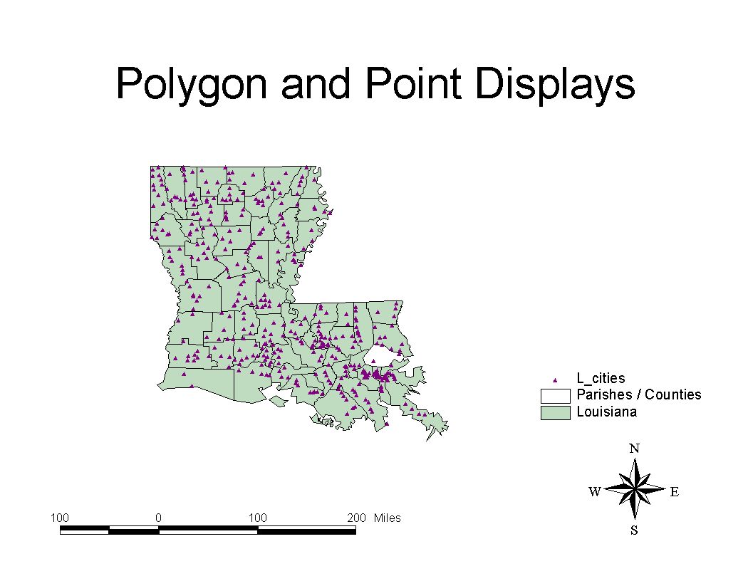
Question for the Class: What other points could be used in emergency management?

Location of special populations, resources, residents, hazard sites, churches, schools, and shelters.

Line

A straight line feature joining two points. The line is a map object defined by a set of sequential coordinates that may represent the generalized shape of a geographic feature (e.g., street centerlines, railroads, cables, stream or river). A street map is a collection of thousands of line segments joining objects together. The following illustration shows segments of the Louisiana State Highway system.

Question for the Class: What other lines could be used in emergency management?

Location of water features by type including rivers, streams, drainage ditches, or canals.
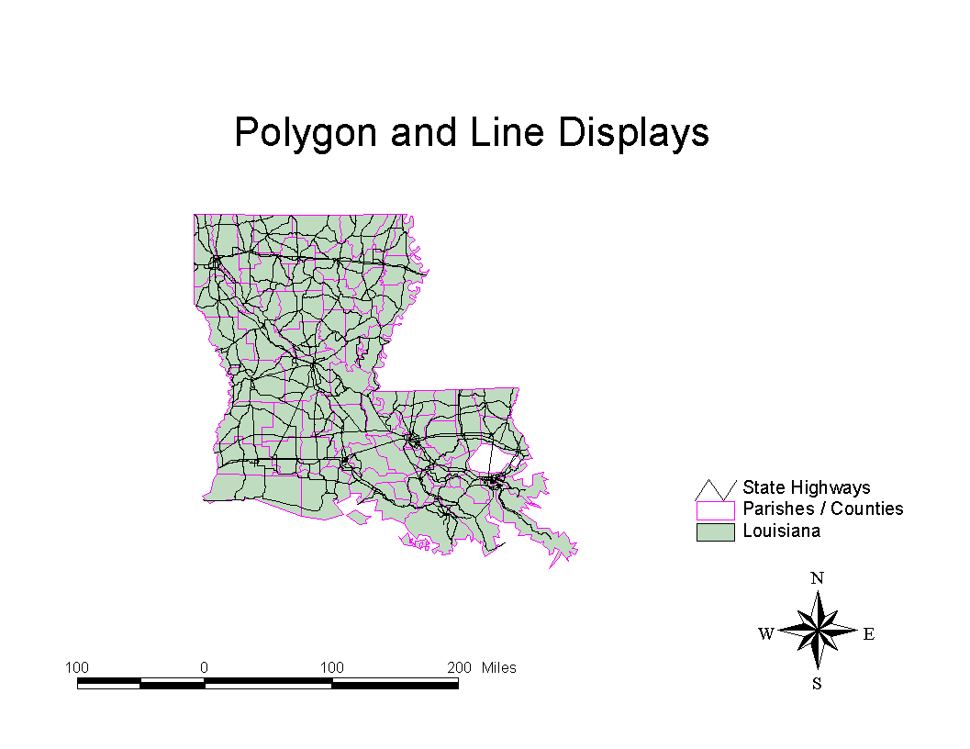
Polygon

A polygon (area, parcel) is an area feature whose perimeter is defined by a series of enclosing segments and nodes. A simple bounded region, simple in the sense that it does not consist of more than one polygon (where a boundary can consist of more than one polygon).

Question for the Class: What other polygons could be used in emergency management? Examples of a polygon include the boundaries of a state, urban area, or county (parish) as illustrated below. Information about the urban area, county, or state may be attached to the data file that is associated with the graphic image.

A Manager’s Concern

The “Manager’s Overview” states that “GIS belongs to the class of computer systems that require the building of large databases before they become useful. Unlike many other micro-computer applications where a user can begin use after the purchase of the hardware and software, the use of a GIS requires that large spatial databases be created, appropriate hardware and software be purchased, applications be developed, and all components be installed, integrated and tested before users can begin to use the GIS” (p. 4). The authors suggest that because this is a complex and difficult task, extensive planning is required. Problems often occur because:

- The GIS is not integrated with other systems where interaction may be desired;
- Staff do not fully understand the technology prior to extensive training;
- Development time estimates differ from actual task time;
- GIS involves greater uncertainty about costs;
- A greater likelihood exists that programmatic changes (to other parts of the emergency management system) will be needed during the development phases.

“The significant management point here is that these are normal conditions in the adoption of a new technology. Management needs to anticipate that such events will happen, and when they do, take appropriate management action” (p. 4). Since the introduction of a GIS affects other elements of the emergency management process, it is an opportunity to introduce fundamental change into the way emergency management operates. Emergency managers must thus be involved in the adoption of this new technology and help plan, implement, and monitor the process.

A key factor in the success of computer system adoption in the business world is the concept of the “enterprise” or “corporate” database. As implied by the name, the corporate database is a single, organization-wide data resource. The advantages of the corporate database are first, that all users have immediate and easy access to up-to-date information and, secondly that the construction of the database is done in the most efficient manner possible. (The Manager’s Overview, p. 5)

Establishing a corporate database is much more a question of policy, management cooperation and coordination, than some technical requirement.

The authors suggest that effective implementation of GIS is more than technology. GIS requires data (databases, images, pictures, and graphics) that are fundamental to the entire state or local agencies. The emergency manager should realize that other agencies will be interested in data layers, especially those that are maintained by the emergency management unit (shelters, special populations, resources, etc.). Emergency managers should thus seek out other local or state units that are interested in jointly developing a GIS (planning, public works, public safety, and education).

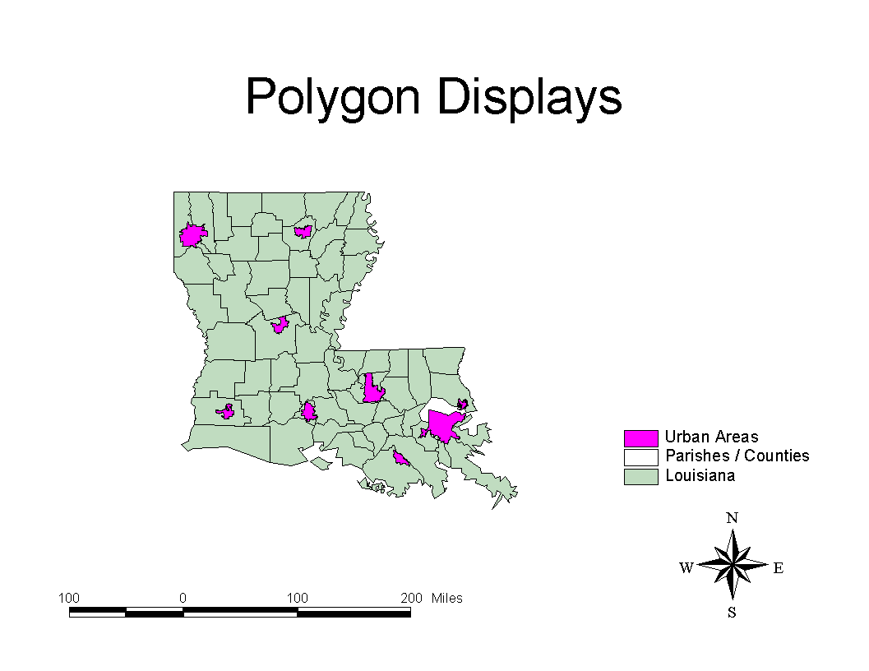
Vector Data Layers

Vector: A coordinate-based data structure commonly used to represent map features. Each object is represented as a list of sequential x,y coordinates. Attributes may be associated with the objects. The illustration below includes lines such as streets or roads, the interstate, railroads, and water features. Hospitals are illustrated by points on the map. The polygons include the boundaries of the City of New Orleans, Orleans Parish, Lake Pontchartrain, and the Mississippi River.

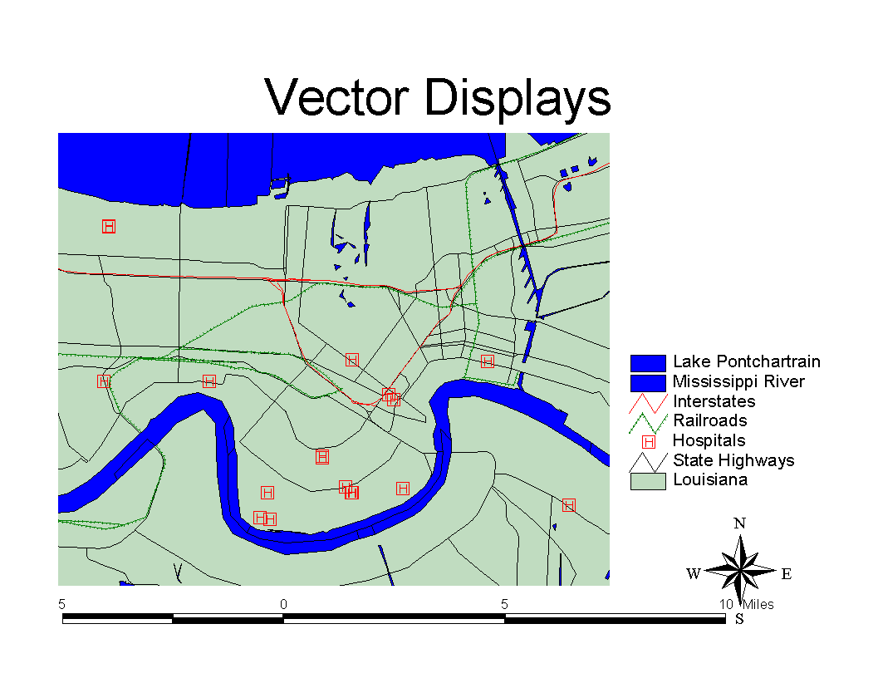
Longitude: Used to describe the East-West position of a point. The position is reported as the number of degrees east (to - 180.0 degrees) or west (to +180.0 degrees) of the prime meridian (0 degrees). Represented by vertical lines running from the North to South poles. Lines of longitude are farthest apart at the Equator and intersect at both poles, and, therefore, are not parallel.

Latitude: Used to describe the North-South position of a point as measured usually in degrees or decimal degrees above or below the equator. Latitude lines are the horizontal lines on a map that increase from 0 degrees at the Equator to 90 degrees at both the North (+90.0 degrees) and South (-90.0 degrees) poles.

Question for the Class: A key concern for the emergency manager is how accurate is the data. Should points mark the approximate location of a bridge, school building, and hospital?

The manager should determine how accurate a specific piece of data is before using it in emergency management. Maps such as the USGS/Department of Commerce TIGER Files are approximate files and good for broad views of a local area. They are not suitable for engineering purposes. Review the section on TIGER Files that follows.
4.3 Tiger Files

A Manager’s Concern

Tiger Files are some of the best data layers available for GIS applications in emergency management. They were developed by the U.S. Department of Commerce Census Bureau to assist in the census. Street and water layers were taken from U.S.G.S. maps and edited to include street and water feature names. The street files also include address ranges. These files thus have been enhanced to allow for geo-coding of data files that include street addresses. The Tiger files are the only national source of street files that include address ranges. Although many commercial vendors suggest that their maps are better than the Tiger Files, in reality their maps were drawn from the Census Bureau Tiger Files. Few commercial vendors have really enhanced these files. If the Tiger Files have been enhanced, it has been done by local communities that know the street names and have spent great effort to correct street names, delete streets that are private roads, and add street names to “unnamed street” files. The editing of the Tiger Files must be done in collaboration with local officials.

The Bureau of the Census developed TIGER (Topologically Integrated Geographic Encoding and Referencing System). It is based on the USGS DLG-3 hydrographic and transportation data. Attribute data tied to the topology include feature names, political and statistical geographic area codes, county, incorporated place, census tract, and block numbers), and potential address ranges and ZIP codes. These files are at a scale of 1:100,000 as compared to more accurate mapping in the U.S.G.S. 1:24,000 scale maps discussed below.

The U.S. Geological Survey Digital Line Graphs (DLG): The Survey developed the topologically structured digital line graph format to encode spatial and attribute data from the topographic quadrangle maps usually at the USGS 7.5 minute and 1:24,000 scale. For more information on the USGS files see: http://www.usgs.gov.

A Manager’s Concern

The development of GIS layers must address the following concerns.

- What will be the source for each data layer (shelter locations, schools, hospitals, nursing homes, or emergency management resources)?
- Who will own the data layer?
- How will the new GIS layer be integrated with existing data files (lists of schools, hospitals, nursing homes, etc.)?
- Who will be responsible for updates to the data?
- How will the cost of the data be allocated?
- Will access to the data be made available to the public? How? By whom?
- Who will be responsible for archiving and retention of the data layer? . . of the original? . . of copies?

The “Manager’s Guide” suggests that the data layers be prepared as a team effort with other administrative agencies that are involved in the emergency management system and who may use these up-to-date data layers. Planning and input from a variety of public agencies is critical in facilitating realistic expectations of the GIS.

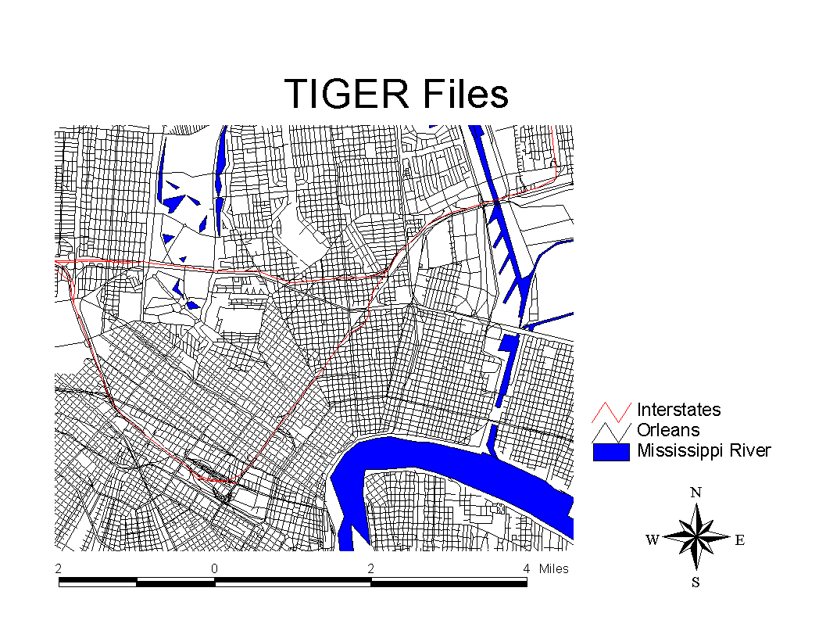
4.4 Image Data

An image is a graphic representation or description of an object that is typically produced by an optical or electronic device. Some common examples of image data include remotely sensed data—such as satellite data—scanned data and photographs. Image data such a photo is also referred to as raster data. The raster image is displayed in a series of grid-cells, or pixels; each has a certain value depending on how the image was captured and what it represents. For example, if the image is a remotely sensed satellite image, each pixel represents light energy reflected from a portion of the Earth’s surface. If, however, the image is a scanned document, each pixel represents a brightness value associated with a particular point on the document.

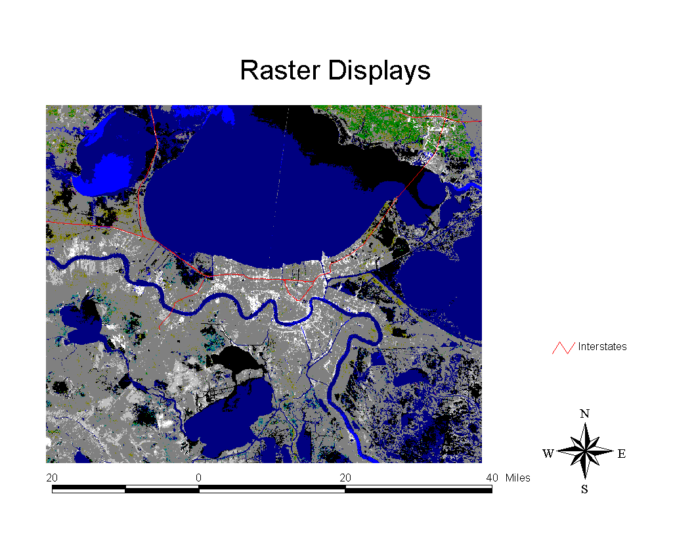
With a GIS you can display image data and feature-based spatial data together. The TIGER street network (feature-based data) can be placed over an image (photograph). Combining these types of data is very useful to the emergency manager.

Question for the Class: What advantage does an image (photograph, satellite image) have over a feature based layer (street or water network, points of interest, or city/county boundary polygon)?

(For most people, a photo allows the viewer to gain a clearer perspective on the area viewed. We can see open farmland or forest in relation to water features of local road networks.)

There are limitations to image data. The main limitation with image data is that images do not contain data (attribute information) about what is shown (the features they show).

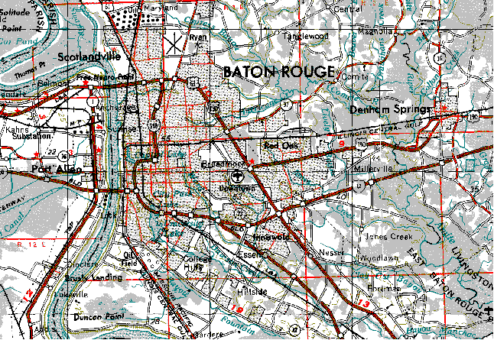
A photo or satellite image is a raster image. It is a type of computerized picture consisting of row after row of tiny dots (pixels). Raster images are sometimes known as bitmaps. Aerial photographs, scanned pictures, and satellite images are common types of raster data found in GIS. A U.S.G.S. Quad Sheet is a common map used by emergency managers. These maps appear to be similar to a state transportation road map available from state transportation or tourist agencies. The Quad Sheet Maps produced by the U.S. Geological Survey provide additional data beyond roads and waterways, such as wetland areas. The details of local areas are available on a national basis from the U.S. Geological Survey as well as from many local surveying, mapping, or blueprint vendors. The following illustration was scanned from a U.S.G.S. quad sheet.

Image data can be organized in a number of ways depending upon the particular image format. Typically, the image data file contains a header record that stores information about the image such as the number of rows and columns in the image, the number of bits per pixel, the color requirements and the geo-referencing information. Following the image header is the actual pixel data for the image. The internal organization of the image data is dependent upon the image format. Some formats contain only a single band of data, while others contain multiple bands.

4.5 Geo-Coding

Many organizations maintain large databases of events by address, such as accident and crime reports, customer records, and tax and parcel records. Addresses are, in fact, the most common form of storing geographic data. With geo-coding, you can display the tabular information in a computerized database containing addresses as points on a map and find their locations on a map easily. Address geo-coding can allow you to locate fire stations by entering their addresses, show where all the students live in relation to the schools they attend, or locate customers and thereby site facilities where the customers are concentrated.
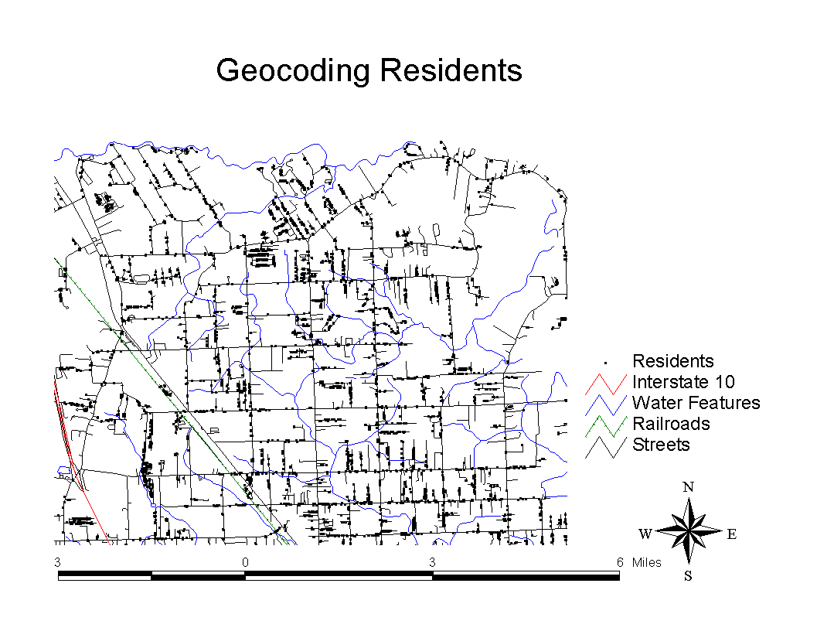
An address specifies a location in the same way that a geographic coordinate does. But since an address is merely a text string containing the information of house number, street name, direction, and/or zip codes, an address needs a mechanism for calculating the geographic coordinate for the address and then displaying the location on a map based on the assigned coordinate. To do so, addresses stored in tabular data files must first be associated with a geographic feature, usually in a street network. The coordinates of a data source can be used to calculate and assign coordinates to addresses if the data source features also have addresses. Geo-coding is the mechanism that allows you to use addresses to identify locations on a map.

Geo-coding allows for the following functions:

- You can create pin maps to show locations of various events by addresses. It is just the same as pushing stick pins onto a wall map to mark the locations of all branch offices of a bank.
- You can query and find geographic features using addresses.
- You can perform point-in-polygon analysis such as finding all customers within a trade zone.

There are a variety of planning, administrative and operational activities which use geographic data in the form of addresses. A company can match customer addresses against a street network of their distributor service areas in order to know which distributor will handle a customer. The information could also be used by emergency managers to perform the following functions:

- To analyze crimes by address. These locations can be mapped and analyzed with other demographic data.

- To enter an address, determine who should respond, and route emergency vehicles and personnel to the address.

- To match student addresses against a street map of a city. Once the homes of students are located, school assignments and busing plans can be created and analyzed.

- Identify potential impact of facilities storing hazardous materials in populated areas by matching the site addresses to a scheme containing census data.

4.6 Global Positioning Systems

This system of 24 Navstar satellites circle the earth every 12 hours at an altitude of 12,000 miles above the earth, constantly transmitting the precise time and their position in space. The system created a huge commercial market for hand held GPS receivers and is used by emergency response personnel including agencies such as police, fire, emergency medical, public works. The unit measures a location to within 30 meters. Drawing its power from flash light batteries and a small antenna, the unit takes about 10 seconds to find and lock onto radio transmission from at least three Navstar satellites.

GPS uses the triangulation of signals from the satellites to determine locations on earth. GPS satellites know their location in space and receivers can determine their distance from a satellite using the travel time of a radio message from the satellite to the receiver.

Even with highly accurate atomic clocks, certain errors do creep into the process of determining the ground position of the receiver. Selected Availability (SA) is the program implemented by the U.S. Department of Defense that makes GPS less accurate for non-military users for security reasons. With SA in effect, the accuracy of the position on the ground may be within 30 to 100 meters.

GPS products have been developed for many commercial applications. These include surveying and mapping, aviation and marine navigation, vehicle tracking systems and mobile computer and cellular platforms.

See: http://www.gps4fun.com/gps_general.html.

Obtaining Maps

Class Activity

Using the Internet, provide the class with a demonstration of the following sources of maps. Show how maps may be downloaded from these Internet sites.

1. U.S. Environmental Protection Agency: EPA has a comprehensive GIS Program. See its Internet site at http://www.epa.gov/ngispr.

2. FEMA Map Service Center: [This description is taken from the FEMA Internet site.] FEMA’s Map Service Center (MSC) provides online access to National Flood Insurance Program (NFIP) Map Products. The MSC Web site is designed to provide the latest information and support services to users on flood related data.

In its continuing efforts to expand the availability of flood risk data, FEMA’s Mitigation Directorate has announced the release of the digital Q3 Flood Data product for use in flood plain management, hazard analysis, and risk assessment activities. The digital Q3 Flood Data product is designed to serve the needs of FEMA’s Response and Recovery activities and flood insurance policy marketing initiatives.

FEMA intends to release digital Q3 Flood Data covering almost 900 counties across the United States by late 1996. These data will be available in a variety of formats for use with desktop mapping and geographic information systems. The digital Q3 Flood Data will be provided through the Internet and on CD-ROM as part of MSC’s distribution and customer support services.

Digital Q3 Flood Maps are developed by scanning the existing FIRM hard copy, vectoring a thematic overlay of flood risks. Vector Q3 Flood Data files contain only certain features from the existing FIRM hard copy. Q3 vector data are contained in one single countywide file, including all incorporated and unincorporated areas of a county.

Digital Q3 Flood Data do not replace the existing Flood Insurance Rate Map (FIRM) hard copy or, if one exists, Digital Flood Insurance Rate Map (DFIRM) product. The product is designed to support planning activities, some Community Rating System activities, insurance marketing, and mortgage portfolio reviews. It does not provide base flood elevation information; thus, it has limited application for engineering analysis, particularly for site design or rating flood insurance policies for properties located within Special Flood Hazard Areas (SFHAs).

Digital Q3 Flood Data are not tied to a base map, are not used to produce a new version of the FIRM hard copy, and are not subjected to community review. The digital Q3 Flood Data are designed to provide guidance and a general idea of the location of Special Flood Hazard Areas.

The digital Q3 Flood Data product can be a valuable tool in screening property addresses within a geographic information system to determine flood risks. However, since the geographic processing performed to develop digital Q3 flood data may introduce differences with the FIRM hard copy source, users must apply considerable care and judgment in the application of this product. For instance, digital Q3 flood data may be overlaid on highly detailed large-scale community base mapping data; but, if parcel level determinations are made, they must be prefaced with information about the accuracy of the data from which they are derived. To see more details on the Flood Insurance Rate Maps in digital form see: http://www.fema.gov/home/msc/q3flooda.htm.

3. U.S. Geological Survey: GIS technology can be used for scientific investigations, resource management, and development planning. For access to FGDC Manual of Geographic Data Products, and USGS node of the Federal Geo-spatial Data Clearinghouse, see: http://info.er.usgs.gov/research/gis/title.html.

4. Atlas.LSU.Edu: A comprehensive, diverse set of maps for each Louisiana Parish (County). Files include street/road, water, census block group, parish boundaries, zip codes, city points, hospitals, nursing homes, shelters, and schools in compressed ArcView shape files suitable for using in ArcView 3.0 or earlier program. Images include satellite photos for Louisiana and each Parish, as well as digital raster images of each U.S.G.S. Quad sheet (1:24,000, 1:50:000 and 1: 1,000,000). Meta data for each layer is provided. To view the various maps and files see: http://atlas.lsu.edu.

5. National Geophysical Data Center (NGDC) Natural Hazards Databases. A collection of databases and data on natural hazards. See http://www.ngdc.gov.

Question for the Class: In the past, what maps were used by emergency managers? How were they used? Given access to GIS, what types of maps could be created and how would they be used?

4.7 FEMA Flood Insurance Rate Map (FIRM): A Case Study

Class Assignment

Review “FEMA Flood Insurance Rate Map Case Study” [beginning on IG page 22] and answer the following questions. Be prepared to discuss your responses to the questions at the next class. (Copies of this case are available in Readings: 4-Q3Case A Word document. In addition, the reading “Digital Q3 Flood Data” is also available as an HTML document).

- How should the digital flood maps be used in emergency management?

- What other layers of information would be useful in addition to the flood zone Q3 maps?
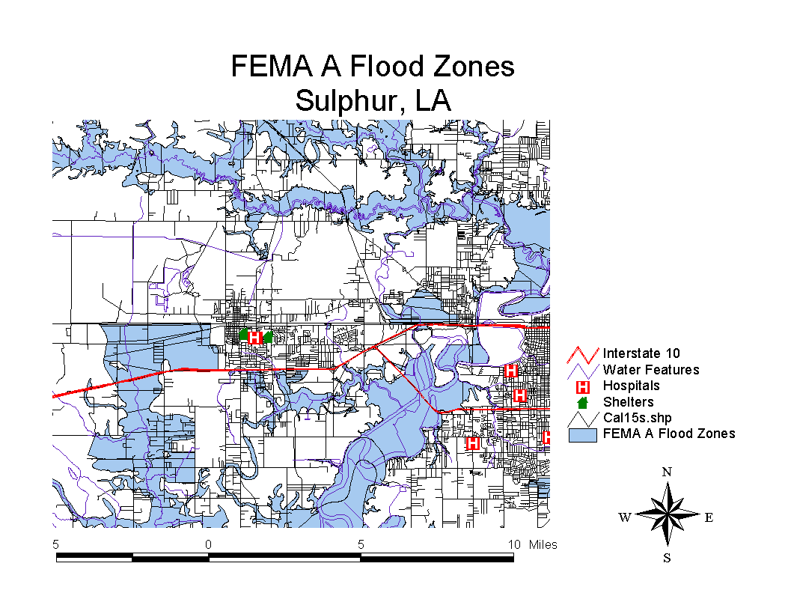
Question for the Class: The FEMA A flood zones are displayed on the map above. How could the emergency manager use this type of display in emergency planning or response?

A GIS allows users to select features in a layer (residents) that intersect with another layer (A Flood Zone). The attached list of residences [at end of case study in IG] was drawn from the above display using the GIS. These homes are in an A Flood Zone. How could the emergency manager use this list?
Class Assignment: Using the FEMA FIRM Q3 Maps – A Case Study

Review the Case “Flood Insurance Rate Maps.”

- How should the digital FEMA Flood Maps be used in emergency management?

- What other layers of information would be useful to a local emergency manager in addition to the flood zone?

FEMA Flood Insurance Rate Maps Case Study

Adapted from the “User’s Guide to the Q3 Digital Flood Maps,” U.S. Flood Insurance Administration, FEMA, Washington, DC, 1996.

BACKGROUND

History of the National Flood Insurance Program

In response to increasing losses from flood hazards nationwide, the Congress of the United States passed the National Flood Insurance Act of 1968 which established the National Flood Insurance Program (NFIP). The 1968 Act provided for the availability of flood insurance within communities that were willing to adopt floodplain management programs to mitigate future flood losses. The act also required the identification of all floodplain areas within the United States and the establishment of flood-risk zones within those areas. As a result of the 1972 Hurricane Agnes flooding along the East coast, the 1968 Act was expanded by the Flood Disaster Protection Act of 1973. The 1973 act added the mandatory purchase requirement and increased the awareness of floodplain mapping needs throughout the country. The responsibility for administration of the NFIP belongs to the Federal Insurance Administration of the Federal Emergency Management Agency (FEMA).

The risk data used to identify floodplain areas, as required by the Act, are acquired through flood insurance studies (FISs). FISs are hydrologic and hydraulic studies of flood risks, developed by FEMA. Using the results of a FIS, FEMA prepares a flood insurance rate map (FIRM) that depicts the spatial extent of special flood hazard areas (SFHAs) and other thematic features related to flood risk assessment. SFHAs are areas subject to inundation by a flood having a one-percent or greater probability of being equaled or exceeded during any given year. This flood, which is referred to as the 1% annual chance flood (or base flood), is the national standard on which the floodplain management and insurance requirements of the NFIP are based.

FEMA publishes the FIRM and distributes it to a wide range of users: private citizens, community officials, insurance agents and brokers, lending institutions, and other Federal agencies. The FIRM is the basis for floodplain management, mitigation, and insurance activities of the NFIP. Uses of the FIRM for insurance activities include enforcement of the mandatory purchase requirement of the 1973 Act, which “requires the purchase of flood insurance by property owners who are being assisted by Federal programs or by Federally supervised, regulated, or insured agencies or institutions in the acquisition or improvement of land or facilities located or to be located in identified areas having special flood hazards” (Section 2(b)(4) of the 1973 Act). In addition to the identification of SFHAs, the risk zones shown on the FIRMs are the basis for the establishment of premium rates for flood coverage offered through the NFIP.

At present, FISs have been completed and FIRMs published for virtually all communities in the nation having flood risks. Flood risks have been assessed in approximately 20,400 communities nationwide. These studies, conducted at a cost of over $900 million, have resulted in the publication of over 80,000 individual FIRM panels. Typically, 6 to 8 million FIRMs are distributed to users each year by FEMA. Over 2.5 million flood insurance policies have been written through the NFIP, providing coverage against flood loss for over $200 billion in property nationwide. In addition to initial FISs, FEMA is responsible for maintaining the FIRMs as communities grow, as new or better scientific and technical data concerning flood risks becomes available, and as some FISs become outdated by the construction of flood control projects or the urbanization of rural watersheds. Several thousand FIRMs need to be updated per year.

Flood Data Product History

Starting with Hurricane Hugo in 1989, FEMA has attempted to support disaster relief operations with digital FIRMs. Disaster loan closings by the Small Business Administration (SBA), Temporary Housing Programs, and Individual Assistance and Family Grant Programs all require a flood hazard assessment. With automated flood map reading to support these assessments, significant time can be saved and map reading quality improved, thus resulting in faster disaster relief for victims. More recently, increased funding for post-disaster mitigation activities has led to the extensive use of GIS and digital FIRMs for planning activities. Applications include selection of sites for relocation, prioritizing eligibility for home buyout programs, and identifying repeatedly damaged properties in SFHAs.

To support disaster recovery operations, FEMA has developed specifications for a digital flood map. The Q3 Flood Data product is designed to serve FEMA’s Response and Recovery activities as well as flood insurance policy marketing initiatives. This product is designed to allow rapid access to and distribution of digital FIRM data, and is compatible with all existing digital FIRM data already available and underway.

Digital Flood Map (Q3)

The Q3 Flood Data do not replace the existing hardcopy FIRM product. The product has been designed to support planning activities, some Community Rating System (CRS) activities, insurance marketing, and mortgage portfolio review. It does not provide base flood elevation information; thus, it has limited application for engineering analysis, particularly for site design or rating of flood insurance policies for properties located within SFHAs.

Q3 Flood Data are not tied to a base map, are not used to produce a new version of the hardcopy FIRM, and are not subjected to community review. Q3 Flood Data are intended to provide users with automated flood risk data suitable for determining whether features are within or outside the SFHA.

USE POLICY

Uses of Q3 Flood Data The Q3 Flood Data are designed to serve the needs of FEMA both for disaster response activities and for other National Flood Insurance Program flood insurance activities. The data are designed to answer basic in/out queries and questions about the location of the special flood hazard area, but do not provide base flood elevations. The Q3 Flood Data may be used in various GIS applications with the caveat that sound judgement must be used in interpreting the Q3 Flood Data. For instance, the Q3 Flood Data may be overlaid on highly detailed large scale community base mapping data; but, if parcel level determinations are made, they must be prefaced with information about the accuracy of the data from which they are derived.

The conversion of FIRMs to a digital format is expected to have many benefits. However, users must bear in mind that the simple conversion of FIRMs to a digital format does not inherently improve the engineering quality of the product. Many of the difficulties with interpretation of flood risk data, and the requirement for users to apply sound judgement in methods selected for decision making and map interpretation remain unchanged. It should be noted that if a structure is determined to be within or near the special flood hazard area by using a GIS, this determination must be confirmed by continuing the printed hardcopy FIRM. Q3 Flood Data are not designed to be used for engineering studies.

Community Rating System

For the purposes of the Community Rating System (CRS), Q3 Flood Data may be used in the following ways:

- for calculations of SFHA areas and similar applications that require geographic calculations and measures;

- for partial fulfillment of GIS provisions per the provisions of Section 440, “Flood Data Maintenance,” as described in the National Flood Insurance Program Community Rating System Coordinator’s Manual (Reference 5); and

- for development of “notification” lists of potentially flood-prone properties, per the provisions of Section 330; and

- for partial fulfillment of credits for the performance of flood determinations, when performed in conformance with guidelines for determination presented below.

Flood Determinations

The Q3 Flood Data can support flood determinations in a limited fashion, in conformance with the “good faith” standard, if used within the following guidelines:

- The end user has obtained a source of address or property location data and combined it with Q3 Flood Data in a manner that conforms to the Standards of Care outlined above.

- The end user has made no determinations as to the flood prone status of a property that is within 250 feet of an SFHA boundary. This requirement is due to the accuracy, resolution, and variations of the Q3 Flood Data relative to the source FIRMs.

- The end user has verified that the Q3 Flood Data FIRM panel and suffix conform to the panel and suffix of the currently effective FIRM.

- The end user has confirmed the availability of flood insurance in the community for which the determination is to be offered.

- The end user has confirmed the zone and BFE with the source FIRM or DFIRM for properties located within 250 feet of the SFHA boundary or within the SFHA.

The “Good Faith Standard”

The mandatory flood insurance purchase requirements of the 1973 National Flood Insurance Act apply only when a structure is located in an SFHA in a community that is participating in the NFIP. Such a structure must be insurable under the rules of the NFIP. Even though a portion of the land parcel upon which the structure is planned or built may be within an SFHA, the mandatory purchase requirement is triggered only if the structure itself is within an SFHA.

The compliance of lenders with the mandatory flood insurance purchase requirements of the 1973 Act is based on the “good faith standard.” Determining whether a structure is located in an area of special flood hazard requires the examination of the location of the structure in relationship to the areas of special flood hazard as shown on the applicable FIRM. The good faith standard recognizes that despite FEMA’s best efforts to make the FIRMs as useful as possible, the descriptions of SFHA areas, as depicted by some maps, may, in some instances, not be clear enough to permit lenders to decide with certainty and precision whether or not property that is the security for a loan or that is the subject of financial assistance is located in such an area. It is for this reason that FEMA has recommended a “good faith standard.”

The good faith standard requires lenders to exercise “due diligence and good faith” in determining the location of a property that is the subject of a loan relative to areas of special flood hazards as shown on a FIRM. This guidance is further explained, with additional information on the 1973 Act, in the publication Mandatory Purchase of Flood Insurance Guidelines (Reference 6). When determinations are being made by lenders, or firms or individuals retained by lenders to assist in these endeavors, collateral data in addition to the FIRM is frequently required. FIRMs do not include all roads within communities, nor do they depict address, property boundary, or structure location information. As a result, determinations frequently can be made only by using an ancillary source of data, such as a land parcel map, to determine the location of a property on the FIRM.

Digital address range data, land parcel, and structure information is available for many communities across the nation. Using these digital data and GIS technology, it is possible to make determinations relative to the 1973 Act and meet the good faith standard. However, the lenders must assure that due diligence and good faith are exercised in application of digital mapping systems to make determinations. Because of both the increased complexity and the analytical capabilities of GIS, assuring compliance with the good faith standard may require additional effort relative to use of paper maps.

A prime concern is to assure that the accuracy of the digital base map and structure location data are appropriate for use with the chosen digital FIRM data set (DFIRM or Q3 Flood Data) to make determinations relative to the 1973 Act. The concern for accuracy of the ancillary data used with DFIRMs should increase in direct proportion to the relative closeness of the property under analysis to the SFHA boundary. Thus, lenders might not find it prudent to use digital data at the 1:100,000 scale as the primary source of information upon which to make a determination regarding a property located within 250 feet of an SFHA. Such caveats should be carefully considered when U.S. Bureau of the Census TIGER data are used as the source from which property determinations will be made.

In some instances, GIS technology will enable the use of large-scale land parcel, topographic, structure, and other information, with digital FIRM data to make determinations. GIS technology allows maps to be created at any user-specified scale. Enlargement of scales does allow for precise determinations to be made. However, precise measurements are not inherently accurate. Accuracy can only be assessed from an appraisal of the quality of source data.

SFHA boundary information conveyed by Q3 Flood Data files was developed to overlay USGS 7.5-minute topographic maps at a scale of 1:24,000. Thus, Q3 Flood Data cannot be assumed to have an accuracy of better than 40 feet. Due to other limitations, FIA recommends that determinations using GIS technology and Q3 Flood Data generally be made only when structures are located 250 or more feet outside an SFHA boundary. In cases where the structure is within 250 feet of the SFHA or inside the SFHA, data such as the BFE determined from a FIS flood profile and the surveyed lowest adjacent grade and/or lowest floor elevation should be used to make a determination.

Prudence may require that a more conservative margin than 250 feet be used to determine the need for ancillary data to support a GIS determination. Terrain variations, the nature of flood hazards in the area, and the quality of all digital data being used to make the determination should be considered when establishing the need for collecting survey and flood profile data.

"Address","City","State","Zip"

172 Emory Ln, Deridder,LA,70634-7709
3589 Highway 389, Merryville,LA,70653-3710
152 Emory Ln, Deridder,LA,70634-7709
160 E Newman Rd, Ragley,LA,70657-3608
363 S A Cooley Rd, Longville,LA,70652-5209
316 Dewey Baggett Rd, Longville,LA,70652-5219
350 A B Bailey Rd, Deridder,LA,70634-8160
370 A B Bailey Rd, Deridder,LA,70634-8160
2148 Smyrna Rd, Deridder,LA,70634-7320
463 Patterson Rd, Longville,LA,70652-4029
630 Jeff Foshee Rd, Merryville,LA,70653-5405
480 Cedar St, Longville,LA,70652-3430
225 Old River Dam Rd, Merryville,LA,70653-3829
571 Jeff Foshee Rd, Merryville,LA,70653-5404
571 Jeff Foshee Rd, Merryville,LA,70653-5404
1528 Parish Line Rd, Deridder,LA,70634-4477
1531 Parish Line Rd, Deridder,LA,70634-4477
1189 Parish Line Rd, Deridder,LA,70634-4473
1471 Parish Line Rd, Deridder,LA,70634-4476
1803 Dr Beckom Dr, Deridder,LA,70634-5314
319 Fowler Rd, Deridder,LA,70634-4430
1166 Walter Singleton Rd,Dry Creek,LA,70637-3310
629 Jeff Foshee Rd, Merryville,LA,70653-5405
227 Henry Dougherty Rd, Longville,LA,70652-5216
529 Wingate Cemetery Rd,Merryville,LA,70653-3741
1121 S A Cooley Rd, Longville,LA,70652-5201
487 Bruce Quave Rd, Merryville,LA,70653-3717
113 Emory Ln, Deridder,LA,70634-7709
1058 Carpenter Rd, Deridder,LA,70634-7051
1084 Carpenter Rd, Deridder,LA,70634-7051
3139 Highway 389, Merryville,LA,70653-3706
410 Fowler Rd, Deridder,LA,70634-4431
181 Dickens Rd, Sugartown,LA,70662-3520
739 Fred Spikes Rd, Merryville,LA,70653-4043
3202 Highway 389, Merryville,LA,70653-3707
3240 Highway 389, Merryville,LA,70653-3707
204 April Rd, Merryville,LA,70653-5419
733 S A Cooley Rd, Longville,LA,70652-5205
669 Digger Franks Rd, Merryville,LA,70653-3820
653 S A Cooley Rd, Longville,LA,70652-5206
294 Vernon Cooley Rd, Longville,LA,70652-5223
716 Scallon Rd, Deridder,LA,70634-7434
105 Guernsey Dr, Ragley,LA,70657-3658
247 April Rd, Merryville,LA,70653-5419
289 April Rd, Merryville,LA,70653-5419
219 Jeff Foshee Rd, Merryville,LA,70653-5401
2477 Smyrna Rd, Deridder,LA,70634-7318
290 April Rd, Merryville,LA,70653-5419
107 Guernsey Dr, Ragley,LA,70657-3658

