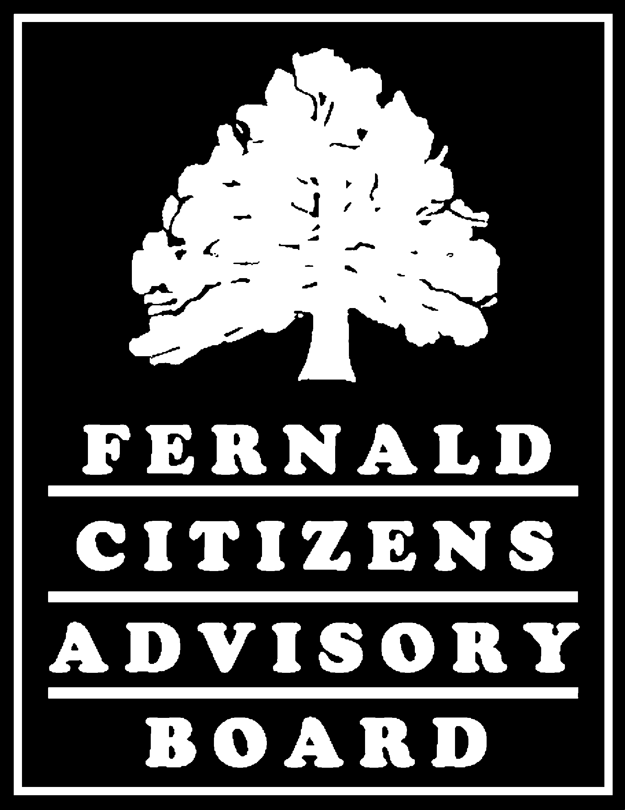
Full Board Meeting
T-214

Saturday, October 30, 2004

Draft Minutes

The Fernald Citizens Advisory Board met from 8:30 a.m. to 12:00 p.m. on Saturday, October 30, 2004, in T-214 at the Fernald Closure Project site.

Members Present: Jim Bierer
Katie Brown
Lisa Crawford
Steve Depoe
Pam Dunn
Gene Jablonowski
Graham Mitchell
Robert Tabor
Gene Willeke

Members Absent: French Bell
Sandy Butterfield
Marvin Clawson
Lou Doll

Designated Federal Official: Gary Stegner
Bill Taylor

The Perspectives Group Staff: Douglas Sarno
David Bidwell

Fluor Fernald Staff: Sue Walpole

Approximately 15 spectators also attended the meeting, including members of the public and representatives from the Department of Energy and Fluor Fernald.

Updates and Ex-Officio Announcements
Jim Bierer opened the meeting by thanking those who attended the FCAB Retreat in September. He expressed the importance of the retreat and of coming away with a better understanding of the CAB’s focus for the next year. The CAB will focus on things it can affect, and will return to the dialogue mode that was successful for the CAB in the past. He also noted it is important to cement the legacy of the FCAB in this last year.

Bill Taylor reviewed a chart of accomplishments that was distributed to the CAB. There are 28 trains out to Envirocare and 1,798 cubic yards of waste have been shipped out in 2004. 609,000 cubic yards of waste have been placed in the On-Site Disposal Facility (OSDF). The clay and liners needed in the remaining OSDF cells have been installed, and several buildings and trailers have been removed from the site. A total of 109 acres of the Fernald site have been declared clean by EPA. The DOE Combined Business Center (CBC) will be stationed in Cincinnati, and a temporary office will open in Springdale. Jack Craig (DOE-Ohio) will head the CBC, and Glenn Griffiths has also been assigned there.

At a meeting in Washington, DC, during the week of October 25th, Bill learned that Gene Schmidt at DOE-HQ will be retiring, and that Mark Frey will be taking over that position. The Ohio field office is shrinking rapidly, and things will be consolidated as closure nears at Fernald, Mound, and the Columbus site. The cleanup of the Ashtabula site is currently in litigation. The West Valley site is scheduled for closure beyond 2006. They have taken apart the melter, and there are 286 canisters of waste to dispose of.

Graham Mitchell announced that Bill Taylor, Johnny Reising, and Tom Scneider have been meeting about the Natural Resource Damages (NRD) settlement and are making good progress. Bill said that they would like to have a draft settlement package together and forwarded to the attorneys by the end of 2004.

Gene Jablonowski announced that DOE has submitted a draft Explanation of Significant Differences (ESD) for off-site temporary storage or alternate disposal of the Fernald silos waste to the U.S. EPA. The review of this document should be completed in a couple of weeks. A public meeting is planned for December 7th regarding this issue.

Lisa Crawford announced that the November 16th meeting on Risk-Based End States (RBES) is still on for 6:30 p.m. Tom Winston, Jim Saric and Bob Warther attended the Chicago meeting on RBES in early October. Johnny Reising said that the Fernald site was asked to submit the final document to DOE Headquarters by December 1st. There will be minor adjustments to the document following the November 16th meeting. A final draft will be distributed to the Board for its review.

Jack Craig announced that LM is continuing to have a presence at the site and is moving towards transition. He said that they are trying to frontload as much planning as possible, due to reductions in the site staff. The biggest issue is the transfer of databases, which include all of the environmental data.

Dennis Carr announced that FY2005 would be a crescendo year for cleanup at the site. Safety at the site continues to be good, although there have been a couple of reportable incidents recently. He said that they were taking the last hard shell building down, and that trailers will be demolished soon. Staff will be moved to nearby offices. There will be a lot of focus on soils and deep excavations this year. There are 180,000 tons of above-WAC (waste acceptance criteria) soil that need to be shipped off-site this year.

Dennis also announced that Silos Advanced Waste Retrieval (AWR) would continue, and that the Silos 1 and 2 treatment facility would be brought to readiness by mid-December. The Silo 3 facility remains on standby. Removal of waste from Silo 1 has been a big success, operations have worked smoothly, and they are approximately 45% complete moving waste out. The sluicing operation is going perfectly. The CAB watched a video showing sluicing. Dennis explained that there have been some minor challenges with sluicing operations in Silo 2. When they dug below the initial bentonite layer in the silo, they also found a thin layer of harder material that deflected the sluicing water. The layer was tested and was very close in character to rest of silos waste. It is believed to have formed when calcium-based material was used to neutralize the Silos material. The material--essentially Portland cement--can be crushed with one’s hand. He explained that they had found a way to increase the water pressure, which cut through the harder layer of material. After the silo was originally filled, workers dumped a layer of contaminated soil on top. As the soil pile was being taken down by the sluicing, operators found debris such as 2x4s and hardhats. The pump was stopped by this debris. Dennis explained that they would lower a “clamshell” on a hoist to pull out the debris. The items will be washed, and then put in drums.

Dennis explained that the Silos waste was not sticking to walls. He told the CAB that there are weir boxes on the walls, and they are working to determine how to remove the boxes and get all the materials out. Steve Depoe stated that the engineering story should be shared with the public and with other sites. He said that there are great lessons to be learned, and that they were performing technological wizardry.

Gary Stegner announced that the Community Reuse Organization (CRO) would meet on Monday, November 1. It is an organization that encompasses three townships and school boards and determines how excess site property will be distributed to the community. Furniture will be dispositioned to a warehouse off-site, and video editing equipment and sign-making equipment will go to nearby technical colleges.

Todd Martin gave the CAB a Critical Analysis Team (CAT) update. They will keep moving on Silo 1, and will continue to address that challenges with Silo 2. He said that everything still looks solid on Silo 3 facilities. He came to see an integrated test for the Silos 1 and 2 treatment facility, but it was delayed. The CAT plans to return and view the test in November. Gail Bingham said that the site is removing about 9 tons of material an hour on Silo 1, and that the pump will remove material at the bottom of the silo to about 1 inch deep.

Lisa Crawford announced that FRESH would hold its twenty-year celebration on Friday, November 19th. Please RSVP to Lisa if you received the invitation.

Steve Depoe announced that Fernald Living History, Inc. continues to build support for an education facility. They will meet with the Hamilton County Commissioners and a local environmental coalition. He said that Fernald Living History wants to make sure that DOE has an overall plan for dispositioning photographs. Steve distributed two letters. At the next meeting, he wants to explore the Weldon Spring Interpretive Center. This center was included in Weldon Spring Institutional Controls Plan.

SSAB Chairs Meeting
Graham Mitchell and Katie Brown attended the SSAB Chairs meeting at the Hanford site in Washington State during the first week of October. Graham reported that Hanford was amazing, and he stated that tremendous progress has been made at Hanford. He thanked Todd Martin for helping to run the meeting. Official notes from the meeting will come from DOE. The Chairs discussed the issue of waste disposal and the interdependency of sites in the Complex. Graham reported that the Chairs identified a need for a National Forum to discuss this issue and drafted a joint recommendation. The FCAB approved the recommendation.

Bob Tabor announced that Legacy Management would host a National Stakeholder Workshop on Legacy Management on November 16-17th in Las Vegas, NV. He would like to attend, but would need to be sponsored. Lisa said that a large portion of the workshop is focused on workers issues, but there are breakout sessions that apply to transition plans. Lisa expressed that the LM team did a poor job of communicating the workshop information to stakeholders.

Tour
To get a sense of their sizes and appearance, the FCAB toured the four trailers offered by DOE for post-closure public education. The trailers are currently being used by DOE and Fluor Management. Each FCAB member received a floor plan drawing of each trailer. The CAB also toured the 10,000 square foot warehouse currently being used by the silos project.

Site Configuration at Closure
Johnny Reising explained some of the potential scenarios of site configuration at closure. Doug said that by the end of this fiscal year, the CAB needs to make sure that they are on record on all closure issues. CAB members suggested that recommendations should include a statement of general philosophy, in addition to specifics. Doug promised that all Stewardship related recommendations would be included in the next mailing to the CAB, so they can review past recommendations.

Johnny explained that the perimeter fencing around the site would be coming down soon. The removal must begin now because it is part of the Fluor contract. Johnny noted the areas that need to be secured would still be surrounded by security fence. Adjacent landowners will have the option to take over maintenance of the fence sections and have DOE leave that section in place. Katie expressed the importance of detailed signage at the site explaining the purpose of removing the fence and what will happen next. The site should avoid removing the fence and replacing it with “No Trespassing” signs without explanation. Sue Walpole explained that every neighbor had been contacted regarding fence removal.

The FCAB discussed several possibilities for the site post-closure. All agreed that the warehouse would be the best location for museum style displays, exhibits, scale models, and other interactive displays and laboratories. The goal would be to create a compound centered around the warehouse. The surrounding trailers would serve as offices, conference and class rooms. Jim Bierer asked if LM would have an office on-site. Jack Craig explained that they are still evaluating the resource needs. Responding to a question from the Board, Doug stated that DOE would be making the grounds keeping decisions based on the available budget.

The CAB also discussed using landscaping techniques to make the trailers and warehouse feel like an education complex. Lisa stated that they should use any leftover materials possible to cut down on expenses, including placing the trailers on the concrete slab from the silos remediation facilities. Katie asked if a strip of the railroad and a rail car could be left on the site as an exhibit. Doug asked if a well and pump head could also be left as an exhibit. He asked the CAB to give these possibilities some thought.

Johnny Reising said that interim storage of trailers wasn’t preferable. He suggested using the trailers at Security Hill, Oak Grove, or the 23 acres at the site for storage. Lisa said that she believed that Security Hill would be the best location, and that the trailers should not be shrink-wrapped. Jack Craig added that LM would be taking over those trailers and would also prefer not to have them shrink-wrapped.

There were no public comments.

Next Meeting
The next meeting is scheduled for Saturday, December 4, 2004, at 8:30 am. The location will be announced.

James Bierer Date
Fernald Citizens Advisory Board Chairman

Gary Stegner Date
Deputy Designated Federal Official

