African
American
Community
Health

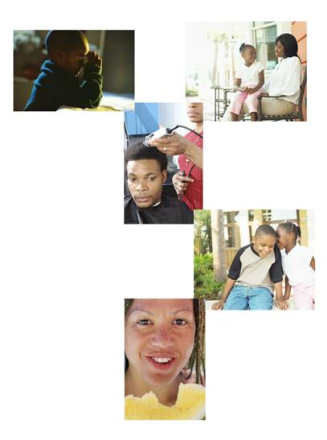

Information you can use to improve your health and the health of your community

Objectives

By the end of the session you will be able to:

- Navigate MedlinePlus.gov to find basic and African American Health Information
- Read about genetic conditions affecting African Americans
- Search for household product ingredients
- Identify other reliable health information resources
- Find resources for community outreach and funding

Agenda

- Introductions (10 minutes)
- Health Disparities (10 minutes)
- Information is Power and finding Reliable Sources (10 minutes)
- Reliable sources – Part I: NLM.gov (35 minutes)
- Break (5 minutes)
- Reliable sources – Part II: Other Health Resources on the Web (15 minutes)
- Community Outreach Basics (15 minutes)
- Funding (5 minutes)
- Wrap Up (10 minutes)

National Library of Medicine (NLM)

- The world's largest medical library
- MEDLINE is a premier bibliographic database produced by NLM that contains approximately 13 million references to journal articles in life sciences with a concentration on biomedicine.
- PubMed provides free access to MEDLINE, NLM’s database of more than 13 million bibliographic citations and abstracts.
- 750 million searches of MEDLINE are done each year by health professionals, scientists, librarians, and the public.
- NLM also produces a web site for consumer health information, MedlinePlus.gov.

National Network of Libraries of Medicine (NN/LM)

- NLM conducts much of its outreach in partnership with other libraries and community organizations across the nation.
- NLM supports many of its health information outreach projects through the NN/LM program.
- The mission of NN/LM is to advance the progress of medicine and improve the public health by providing all U.S. health professionals equal access to biomedical information.
- NN/LM wants to improve the public's access to information to enable them to make informed decisions about their health.

Advancing the progress of medicine and improving the public health through access to health information. Join the network or find local resources by calling us at 1-800-338-7657.
- 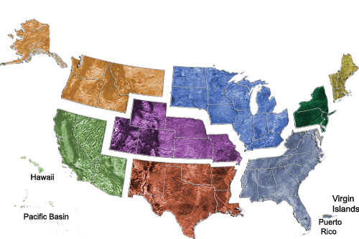

- Greater Midwest Region
- MidContinental Region
- Middle Atlantic Region
- New England Region
- Pacific Northwest Region
- Pacific Southwest Region
- South Central Region
- Southeastern/Atlantic Region

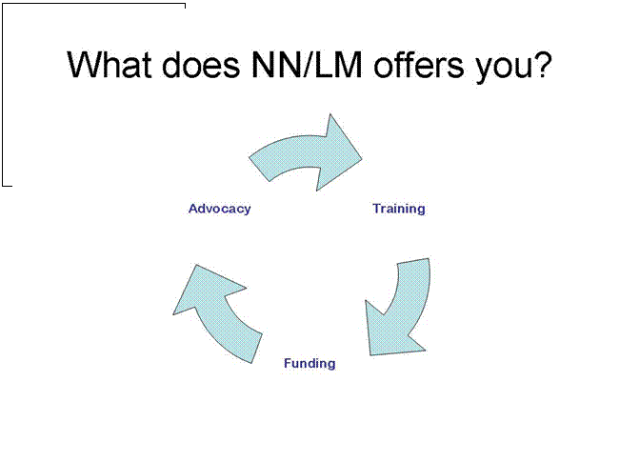
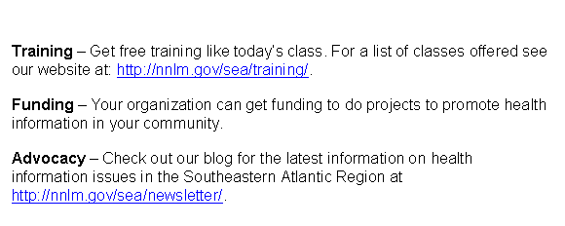
Health Disparities

A health disparity should be viewed as a chain of events signified by difference in:
- Environment
- Access to, utilization of, and quality of care
- Health Status, or a
- Particular Health Outcome that deserves scrutiny (Carter-Pokras)

“Health disparities are differences in the incidence, prevalence, mortality, and burden of diseases and other adverse health conditions that exist among specific population groups in the United States” (Addressing Health Disparities)

Factors contributing to poor health outcomes among African Americans include discrimination, cultural barriers, and lack of access to health care. (The Health Care Challenge)

What does this means to African Americans?

African Americans are more like to receive poorer quality care than Whites (National Healthcare Disparities Report)

African Americans have the highest cancer incidence and mortality rates in the United States (Siminoff)

African Americas infant death rate is nearly 2 and a half times that of White infants (Addressing Health Disparities)

The incidence of stroke is double in African Americans compared to White Americans (Pandey)

Please Rank the Ten Leading Causes of death for African Americans

- Unintentional injury
- Cancer
- Stroke
- Chronic lower respiratory diseases
- Septicemia
- Diabetes
- Nephritis
- Heart Disease
- Human immunodeficiency virus
- Homicide

Answers

- 1. Heart Disease
- 2. Cancer
- 3. Stroke
- 4. Diabetes
- 5. Unintentional Injury
- 6. Homicide
- 7. Chronic lower respiratory disease
- 8. Human immunodeficiency virus
- 9. Nephritis
- 10. Septicemia

Why quality health information?

Information is Power

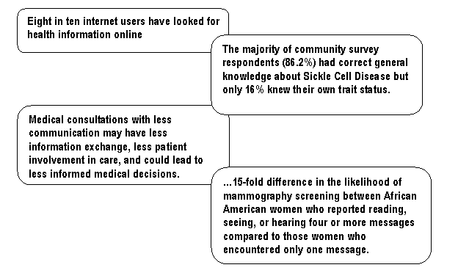

How do I find quality health information on the internet?

Authority, Accuracy, and Audience
- Look at the organization's mission and “about us” page.
- Look at the authorship and sponsorship of the site.
- Is the information provided appropriate to the audience level, well-organized and easy to use?

Availability, Maintained, and
- Up-to-date
- The Web site maintains its links and the links are not broken.
- The source for the contents of the Web page(s) and the entity
responsible for maintaining the Web site (webmaster, organization,
creator of the content) is clear.
- Information is current or an update date is included.
- Registration is not required to view the information on the site.

Special features
- The site provides unique information to the topic with a minimum of redundancy and overlap between resources.

Has there been a situation with a family member or friend where additional information was needed to make a health care decision?

- Wellness
- Health Condition/ Disease
- Medication/ drugs
- Prenatal Health
- Children
- Elderly
- Health Directories
MedlinePlus.gov 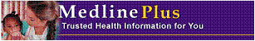

- Easy to Use
- Reliable and Up-to-Date
- Updated Daily
- No Advertisements
- No Product or Company Endorsement

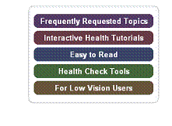
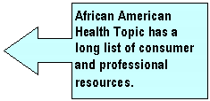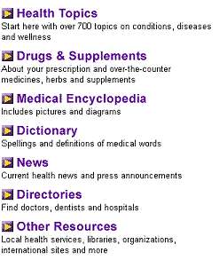
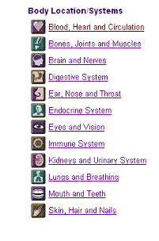
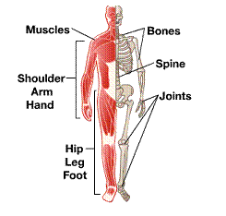
Drugs, Supplements and Herbal Information - Prescription and over-the-counter medication information is from MedMaster™†, a product of the American Society of Health-System Pharmacists (ASHP) and USP DI® Advice for the Patient® ‡, a product of the United States Pharmacopeia (USP). Information on herbs and supplements is from Natural Standard©*.

Directories - MedlinePlus provides links to over 100 directories to help you find health professionals, services and facilities, including Hospital Comparison from Centers for Medicare & Medicaid Services and Assisted living or residential care facility from National Center for Assisted Living.

Go Local – a service for finding local resources for health-related issues. Select an area from the map below to search for health services and topics.

Practice Questions:

- John is having a CAT Scan and wants to find information on the procedure. Where would you find this information?

- Cassandra takes St. John’s Wort for depression. She wants to know if there is scientific evidence for the use of this herb. Where would you find this information?

- What is a Hgb S test? What is the normal value?

- Compare two hospitals in the Venice, Florida area for Surgical Care Improvement/Surgical Infection Prevention

Other NLM Resources

ClinicalTrials.gov - provides patients, family members, health care professionals, and members of the public easy access to information on clinical trials for a wide range of diseases and conditions.

NIH SeniorHealth - aging-related health information easily accessible for family members and friends seeking reliable, easy to understand online health information.

Household Products Database - a consumer's guide that provides information on the potential health effects of chemicals contained in more than 6,000 common household products used inside and around the home.

Genetics Home Reference - the National Library of Medicine's Web site for consumer information about genetic conditions and the genes or chromosomes responsible for those conditions.

Practice Questions:

- Are companies recruiting for people who have had heart attacks in Sarasota? If so, how many? Is there an age limit?

- Karen is 70 years old and is nervous about having cataract surgery. Find a video about a person’s experience with cataract surgery.

- What is one acute health effect from Listerine Antiseptic Mouthwash?

- According to Genetics Home Reference, Sickle Cell Anemia occurs in:
  - 1 in every 100 African Americans
  - 1 in every 500 African Americans
  - 1 in every 5,000 African Americans

Other Reliable Sources

- General Health

  - Center for Disease Control (CDC)
    - http://www.cdc.gov/omhd/Populations/BAA/BAA.htm
  - Health Finder
    - http://www.healthfinder.gov/justforyou/justforyou.asp?KeyWordID=215&branch=1

- AIDS/ HIV

  - AIDS.gov
    - http://www.aids.gov/target/minority/index.html#african
  - CDC
    - http://www.cdc.gov/hiv/topics/aa/index.htm

- Cancer

  - National Cancer Institute
    - http://www.cancer.gov/cancertopics/types/disparities

- Diabetes
  - American Diabetes Association
    - http://www.diabetes.org/communityprograms-and-localevents/africanamericans.jsp

- Heart Health
  - American Heart Association
    - http://www.americanheart.org/presenter.jhtml?identifier=3025278

- Mental Health
  - Substance Abuse and Mental Health Services Administration (SAMHSA)
    - http://mentalhealth.samhsa.gov/cre/resource1.asp
    - http://mentalhealth.samhsa.gov/cre/fact1.asp

- Stroke
  - American Stroke Association
    - http://www.strokeassociation.org/presenter.jhtml?identifier=3030549

Community Outreach Basics

Outreach is:
1 : the act of reaching out
2 : the extent or limit of reach <the outreach of the Ohio floods -- Clifton Johnson>
3 : the extending of services or assistance beyond current or usual limits <an outreach program>; also : the extent of such services or assistance -© 2006 Merriam-Webster, Incorporated

Websites
Public Libraries and Community Partners: Working together to provide health information - http://nnlm.gov/outreach/community/ - A guide to encourage health information partnerships between public libraries, the National Network of Libraries of Medicine, and local health or community-based organizations.

Community Tool Box - http://ctb.ku.edu/ - Community Tool Box (CTB) provides over 6,000 pages of practical information to support your work in promoting community health and development.

Healthy People Library Project - http://www.healthlit.org/index.htm - Healthy People Library Project is designed to provide minority groups and other consumers easy access to current, reliable information on selected health topics at their local libraries.

Thrive - http://www.preventioninstitute.org/thrive/index.php - THRIVE is a tool to help you understand and prioritize the factors within your own community that can help improve health and safety.

Practice Questions

- According to Public Libraries and Community Partnerships, what is the role of public libraries with community partners?

- According to Healthy People Library Project, what are some tips for librarians who are interested in outreach?

- On the Thrive website, what are the root factors that shape community environment?

- According to the Community Toolbox, where can you find information about writing a grant application?

Funding


http://www.grants.gov/ - The single access point for over 1,000 grant programs offered by all Federal grant making agencies.

http://fundingopps.cos.com/about/fundingopps.shtml - The largest, most comprehensive database of available funding.

http://nnlm.gov/funding/ - Regional Funding Opportunities from the National Network of Libraries of Medicine

NN/LM Funding

- Exhibit Awards
- Training Awards
- Welcome Awards
- Express Outreach Awards
- Express Planning Awards
- Outreach Project Awards
- Express Follow-up Awards

Past NN/LM Projects

- For ideas, see past funded projects at
- http://nnlm.gov/sea/funding/projects.html

Bibliography:

Addressing Health Disparities: The NIH Program of Action, 2001. National
Institutes of Health, Bethesda, MD. http://healthdisparities.nih.gov/welcome.html

Carter-Pokras O, Baquet, C, What is a “health disparity”?, Public Health Reports,
2002 Sep-Oct; 117(5):426-34.

Darnell JS, Chang CH, Calhoun EA. Knowledge about breast cancer and
participation in a faith-based breast cancer program and other predictors of mammography screening among African American women and Latinas. Health promotion practice. 2006 Jul;7(3 Suppl):201S-12S. Epub 2006 Jun 7.

Fox, S. Online Health Search 2006: Most internet users start at a search engine
when looking for health information online. Report accessed November 15, 2006 at http://www.pewinternet.org/pdfs/PIP_Online_Health_2006.pdf

Gordon HS, Street RL Jar, Sharf BF, Souchek J. Racial differences in doctors'
information-giving and patients' participation. Cancer. 2006 Sep 15;107(6):1313-20

National Healthcare Disparities Report, 2006. Agency for Healthcare Research
and Quality, Rockville, MD. http://www.ahrq.gov/qual/nhdr06/nhdr06.htm

Pandey DK, Gorelick PB, Epidemiology of Stroke in African Americans and
Hispanic Americans, Medical Clinics of North America, 2005, 89:739-752.

Siminoff LA, Ross, L, Access and equality to cancer care in the USA: a review
and assessment, Postgraduate Medicine Journal 2005; 81:674-679

The Health Care Challenge: Acknowledging Disparity, Confronting
Discrimination, and Ensuring Equality. United States Commission on Civil Rights, Sept. 1999.

Treadwell MJ, McCullough L, Vishinski E. Using qualitative and quantitative
strategies to evaluate knowledge and perceptions about sickle cell disease and sickle cell trait. Journal of the National Medical Association. 2006 May;98(5):704-10.

