Vulnerability Disclosure – Poppler library (latest version)
Title: Denial of Service (crash) due to access Null pointer when parsing an illegal pdf file.
Vendor: Open Source (https://poppler.freedesktop.org/ )
Affected Product name(s) and versions: Poppler latest version including 0.54.0 and before
Software that use poppler library, e.g: Evince
Evince (https://wiki.gnome.org/Apps/Evince)
Platform used (OS): Linux – Ubuntu 16.04 x86_64
Summary of the issue:
Perf_test utility will crash (segmentation fault) when parsing an illegal PDF file due to the program access a null pointer.
Example output:
./ perf-test ~/poc/heap-buffer-overflow-619405/poc.pdf
started: /home/root/poc/heap-buffer-overflow-619405/poc.pdf
load splash: 0.00 ms
page count: 1
ASAN:DEADLYSIGNAL
=================================================================
==96731==ERROR: AddressSanitizer: SEGV on unknown address 0x000000000028 (pc 0x7f2da9eccb81 bp 0x0c2600001b86 sp 0x7ffcd31999b0 T0)
#0 0x7f2da9eccb80 (/home/root/poppler/build_clang/libpoppler.so.67+0x5d2b80)
#1 0x7f2da9ec46a1 (/home/root/poppler/build_clang/libpoppler.so.67+0x5ca6a1)
#2 0x7f2da9ec3a67 (/home/root/poppler/build_clang/libpoppler.so.67+0x5c9a67)
#3 0x7f2da9e44b78 (/home/root/poppler/build_clang/libpoppler.so.67+0x54ab78)
#4 0x7f2da9c448c1 (/home/root/poppler/build_clang/libpoppler.so.67+0x34a8c1)
#5 0x7f2da9c090d5 (/home/root/poppler/build_clang/libpoppler.so.67+0x30f0d5)
#6 0x7f2da9c27164 (/home/root/poppler/build_clang/libpoppler.so.67+0x32d164)
#7 0x7f2da9c261d1 (/home/root/poppler/build_clang/libpoppler.so.67+0x32c1d1)
#8 0x7f2da9d293f8 (/home/root/poppler/build_clang/libpoppler.so.67+0x42f3f8)
#9 0x7f2da9d290fa (/home/root/poppler/build_clang/libpoppler.so.67+0x42f0fa)
#10 0x7f2da9d32ece (/home/root/poppler/build_clang/libpoppler.so.67+0x438ece)
#11 0x4f08a3 (/home/root/poppler/build_clang/test/perf-test+0x4f08a3)
#12 0x7f2da868782f (/lib/x86_64-linux-gnu/libc.so.6+0x2082f)
#13 0x419fb8 (/home/root/poppler/build_clang/test/perf-test+0x419fb8)

AddressSanitizer can not provide additional info.
SUMMARY: AddressSanitizer: SEGV (/home/root/poppler/build_clang/libpoppler.so.67+0x5d2b80)
==96731==ABORTING

Debug info:
Program received signal SIGSEGV, Segmentation fault.
0x00007ffff797fb81 in JPXStream::readUByte (x=0x28, this=<optimized out>) at /home/root/poppler/poppler/JPXStream.cc:3351
3351 *x = (Guint)c0;
(gdb) bt
#0 0x00007ffff797fb81 in JPXStream::readUByte (x=0x28, this=<optimized out>) at /home/root/poppler/poppler/JPXStream.cc:3351
#1 JPXStream::readCodestream (this=<optimized out>, len=<optimized out>) at /home/root/poppler/poppler/JPXStream.cc:1205
#2 0x00007ffff79776a2 in JPXStream::readBoxes (this=<optimized out>) at /home/root/poppler/poppler/JPXStream.cc:780
#3 0x00007ffff7976a68 in JPXStream::reset (this=0x61300000db00) at /home/root/poppler/poppler/JPXStream.cc:275
#4 0x00007ffff78f7b79 in SplashOutputDev::drawImage (this=0x61300000dcc0, state=<optimized out>, ref=<optimized out>, str=0x61300000db00, width=999, height=999, colorMap=<optimized out>,
interpolate=<optimized out>, maskColors=0x40, inlineImg=240) at /home/root/poppler/poppler/SplashOutputDev.cc:3556
#5 0x00007ffff76f78c2 in Gfx::doImage (this=<optimized out>, ref=0x7fffffffd320, str=<optimized out>,
inlineImg=<error reading variable: access outside bounds of object referenced via synthetic pointer>) at /home/root/poppler/poppler/Gfx.cc:4711
#6 0x00007ffff76bc0d6 in Gfx::opXObject (this=0x611000009a00, args=<optimized out>, numArgs=<optimized out>) at /home/root/poppler/poppler/Gfx.cc:4213
#7 0x00007ffff76da165 in Gfx::go (this=<optimized out>, topLevel=<error reading variable: access outside bounds of object referenced via synthetic pointer>) at /home/root/poppler/poppler/Gfx.cc:767
#8 0x00007ffff76d91d2 in Gfx::display (this=<optimized out>, obj=<optimized out>, topLevel=<error reading variable: access outside bounds of object referenced via synthetic pointer>)
at /home/root/poppler/poppler/Gfx.cc:729
#9 0x00007ffff77dc3f9 in Page::displaySlice (this=0x611000009b40, out=<optimized out>, hDPI=72, vDPI=5.2727351433383131e-310, rotate=0, useMediaBox=<optimized out>, crop=<optimized out>, sliceX=-1,
sliceY=<optimized out>, sliceW=<optimized out>, sliceH=<optimized out>, printing=<optimized out>, abortCheckCbk=<optimized out>, abortCheckCbkData=<optimized out>,
annotDisplayDecideCbk=<optimized out>, annotDisplayDecideCbkData=<optimized out>, copyXRef=<optimized out>) at /home/root/poppler/poppler/Page.cc:601
#10 0x00007ffff77dc0fb in Page::display (this=0x60200002def4, out=0x40, hDPI=-1.8325506472120096e-06, vDPI=9.3872472709836843e-322, rotate=2, useMediaBox=<optimized out>, crop=<optimized out>,
printing=<optimized out>, abortCheckCbk=0x0, abortCheckCbkData=0x0, annotDisplayDecideCbk=0x0, annotDisplayDecideCbkData=0x0, copyXRef=<optimized out>) at /home/root/poppler/poppler/Page.cc:521
#11 0x00007ffff77e5ecf in PDFDoc::displayPage (this=0x60f00000ef50, out=0x61300000dcc0, page=1, hDPI=<optimized out>, vDPI=<optimized out>, rotate=0, useMediaBox=false, crop=true,
printing=<optimized out>, abortCheckCbk=<optimized out>, abortCheckCbkData=<optimized out>, annotDisplayDecideCbk=<optimized out>, annotDisplayDecideCbkData=<optimized out>, copyXRef=<optimized out>)
at /home/root/poppler/poppler/PDFDoc.cc:491
#12 0x00000000004f08a4 in PdfEnginePoppler::renderBitmap (pageNo=<optimized out>, zoomReal=100, rotation=0, this=<optimized out>) at /home/root/poppler/test/perf-test.cc:452
#13 RenderPdf (fileName=<optimized out>) at /home/root/poppler/test/perf-test.cc:941
#14 RenderFile (fileName=<optimized out>) at /home/root/poppler/test/perf-test.cc:970
#15 RenderCmdLineArg (cmdLineArg=<optimized out>) at /home/root/poppler/test/perf-test.cc:1224
#16 main (argc=<optimized out>, argv=<optimized out>) at /home/root/poppler/test/perf-test.cc:1269

Explanation:
The problem stems from assigning Null pointer to img.tiles[0].tileComps. (JPXStream.cc:readCodestream:993) The program try to assign a value to img.tiles[0].tileComps[0].quanStyle in function readCodeStream in JPXStream.cc file.
The program checks whether nComps equals img.nComps or not in line 963, but it does not check whether img.nComps equals 0 or not.
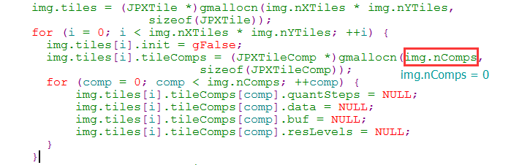
Pic 1. Assigning null to img.tiles[0].tileComps
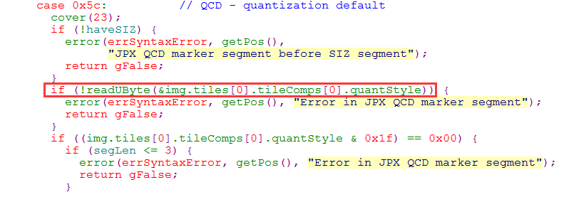
Pic 2. Trying to assign a value to img.tiles[0].tileComps[0].quanStyle
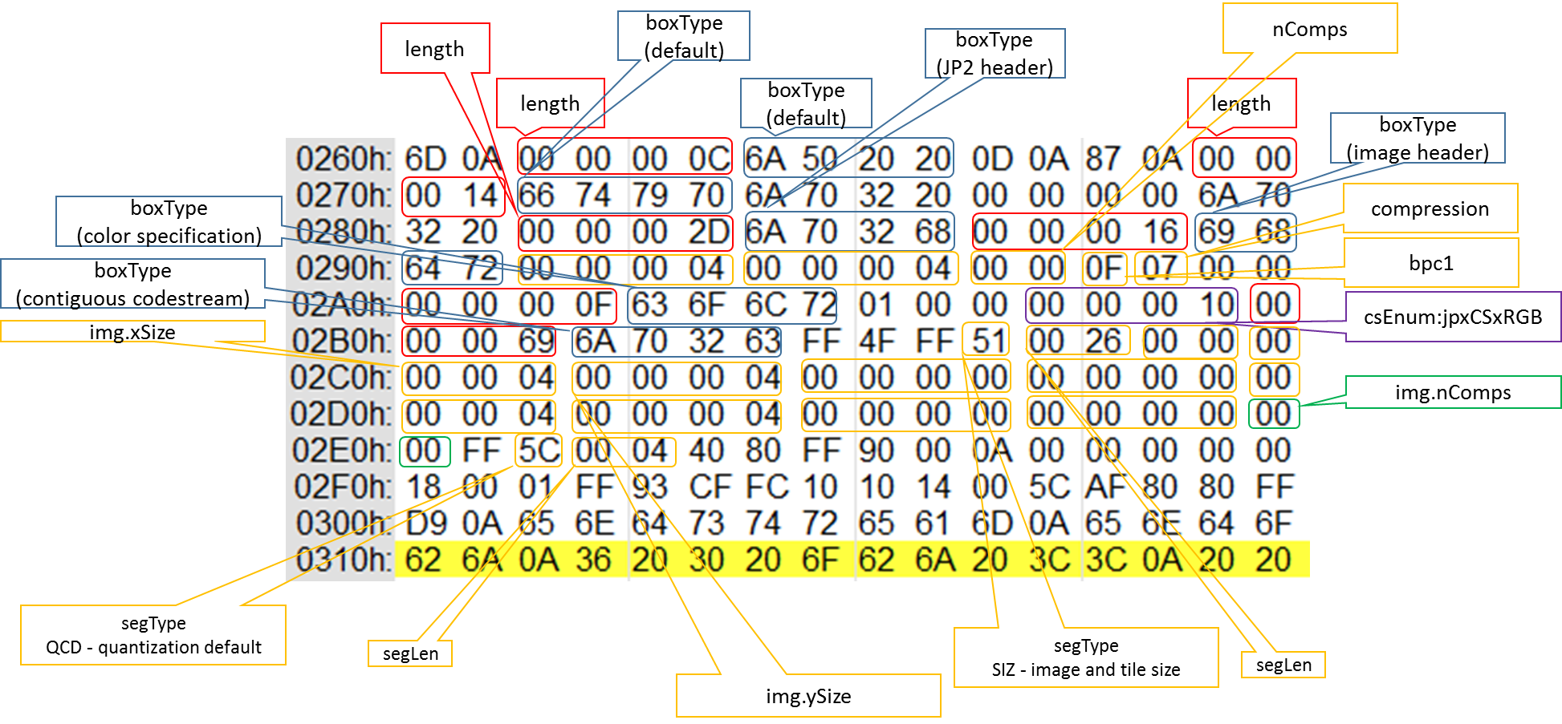
Pic 3: filed of part of PoC file
Suggestion for patch:
Add condition check for img.nComps equals 0 or not. If img.nComps == 0, just return gFalse.
Credits: Young_X from VARAS@IIE

