Issue Description
    - Open https://mozilla.github.io/pdf.js/web/viewer.html
    - Click on Open File as shown in fig below:

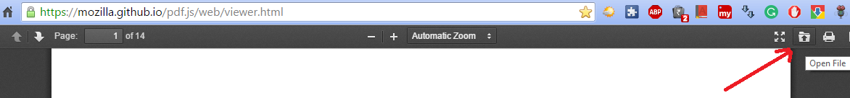

    - Open the attachment file “Chrome_Vector.pdf”
    - The table border is not displayed. This issue occurs only in google chrome , not in other browsers like Mozilla Firefox and Microsoft IE.

