Protocol ITN032AD
Induction of Tolerance through Early Introduction of Peanut in High-Risk Children
Short Title: Tolerance to Peanut in High-Risk Children
Version 0.45 (May 22, 2006)
This clinical study is supported and conducted by the Immune Tolerance Network, which is sponsored by the National Institute of Allergy and Infectious Diseases.
Protocol Chair
Gideon Lack, MD
Senior Lecturer and Consultant Allergist
Paediatric Allergy Clinical Trials Unit
Level 1, Evelina Children's Hospital, St Thomas' Hospital
Lambeth Palace Road
London SE1 7EH
Phone:
Fax:
E-mail:
ITN Clinical Trial Physician  Peter H. Sayre, MD, PhD  Executive Director  Clinical Trials Group  Immune Tolerance Network, UCSF  185 Berry St. Suite 3515  San Francisco, CA 94107  Phone: 415-353-4423  Fax: 415-353-4404  E-mail: psayre@immuntolerance.org | NIAID Medical Monitor  Marshall Plaut, MD  Chief, Allergy/Asthma Branch  National Institute of Allergy and Infectious Diseases  6610 Rockledge Drive, Room 3093  Bethesda, MD 20892-7640  Phone: 301-496-8973  Fax: 301-402-2571  E-mail: mplaut@niaid.nih.gov
ITN Manager, Clinical Operations  Nariman Nasser  Manager, Clinical Operations  Immune Tolerance Network, UCSF  185 Berry St. Suite 3515  San Francisco, CA 94107  Phone: 415-353-4418  Fax: 415-353-4404  E-mail: nnasser@immunetolerance.org | NIAID Project Manager  Joy Laurienzo, RN  Division of Allergy, Immunology, and Transplantation  National Institute of Allergy and Infectious Diseases  6610 Rockledge Drive, Room 3046  Bethesda, MD 20892  Phone: 301-451-4415  Fax: 301-402-2571  Email: jlaurienzo@niaid.nih.gov
Confidentiality Statement
This document is confidential and is to be distributed for review only to investigators, potential investigators, consultants, study staff, and applicable independent ethics committees or institutional review boards. The contents of this document shall not be disclosed to others without written authorization from ITN and NIAID, unless it is necessary to obtain informed consent from potential study participants.

Protocol Approval
Protocol ITN032AD | Version:
 | Protocol Chair: Gideon Lack, MD
Short Title: Tolerance Induction in High-Risk Children
I have read protocol ITN032AD and I approve it. As the principal investigator, I agree to conduct this protocol using good clinical practices, as delineated in ICH Guidance for Industry: E6 Good Clinical Practice: Consolidated Guidance (April 1996), and according to the criteria specified in the protocol.
_______________________________
Principal Investigator (Print)
_______________________________ _______________
Principal Investigator (Signature) Date

Synopsis
Title | Induction of Tolerance Through Early Introduction of Peanut in High-Risk Children
Short Title | Tolerance to Peanut in High-Risk Children
Sponsored by | National Institute of Allergy and Infectious Diseases
Conducted by | Immune Tolerance Network
Protocol Chair | Gideon Lack, MD
Participating Site(s) | King’s College, St. Thomas Hospital, London, UK
Enrollment Objective | 480 participants
Study Design | This is a randomized controlled trial in which children at high risk for peanut allergy, as demonstrated by eczema, egg allergy, or both, are enrolled. Participants are stratified based on skin prick test (SPT) results for peanut protein into those with a wheal diameter of 0, 1, or 2 mm (SPT two-minus stratum), and those with a wheal diameter of 3 or 4 mm (SPT three-plus stratum). Participants in each stratum are randomly assigned to receive a peanut-containing snack or to observation. Those assigned to receive a peanut-containing snack at least three times weekly until 5 years of age. The prevalence of peanut allergy at that time is compared between the peanut and the observation groups.
Study Duration | 6.5 years.
Primary Endpoint | The proportion of participants with peanut allergy at 5 years of age.
Secondary Endpoints | At 2.5 and 5 years of age: the proportion of participants with allergic sensitization to selected ingested allergens and selected inhaled allergens, and with seasonal rhinoconjunctivitis, perennial rhinoconjunctivitis, and asthma.  At 5 years of age: the proportion of participants with type 1 immediate onset food allergy to selected ingested allergens.  Incidence of adverse events and laboratory abnormalities; nutritional evaluations.  Results of cellular and humoral assessments of immune response related to the development of allergy or tolerance to specific allergens.
Inclusion Criteria | - Children >4 to <11 months old who have had solids successfully introduced into their diet.  - Egg allergy, severe eczema, or both.  - Informed consent obtained from parent or guardian.
Exclusion Criteria | - Clinically significant chronic illness, except for eczema or recurrent wheeze.  - Positive skin prick test for peanut allergy with a wheal diameter >4 mm in the presence of a negative saline control.  - Previous or current consumption of peanut protein that exceeds the amount allowed for the observation group in the per-protocol analysis specified in section 9.1.  - Investigator-suspected allergy to peanut.  - Investigator-suspected allergy to peanut in care provider or current household member.  - Diagnosis of persistent asthma.  - AST (SGOT), ALT (SGPT), or bilirubin >2 times the upper limit of age-related normal value.  - BUN or creatinine >1.25 times the upper limit of age-related normal value.  - WBC <3.5 103/mL, polymorphonuclear cell count <1500/mL, platelet count <100,000/mL, or hemoglobin <9 g/dL.  - Unwillingness or inability to comply with study requirements and procedures.
Study Intervention | Participants assigned to the peanut group will be fed at least 6 g of peanut protein per week, distributed over at least three meals per week during study participation. The preferred peanut source will be Bamba. There are 17 g of Bamba per serving, which provides 2 g of peanut protein. Thus, the specified amount corresponds to three servings per week. However, other peanut-containing foods may be substituted. Participants assigned to the observation group will avoid exposure to peanut protein during study participation.

Glossary of Abbreviations
BMI | body mass index
CFR | Code of Federal Regulations
CRF | case report form
CTCAE | Common Terminology Criteria for Adverse Events
DAIT | Division of Allergy, Immunology, and Transplantation
DBPCFC | double-blind, placebo-controlled food challenge
DSMB | data safety monitoring board
FAP | facilitated antigen presentation
GCP | good clinical practice
ICH | International Conference on Harmonization
IND | investigational new drug
IRB | institutional review board
ITN | Immune Tolerance Network
KLH | keyhole limpet hemocyanin
NCI | National Cancer Institute
NIAID | National Institute of Allergy and Infectious Diseases
PEFR | peak expiratory flow rate
PPDI | Pharmaceutical Products Development, Inc.
SAE | serious adverse event
SAEC | safety adverse event coordinator
SAP | statistical analysis plan
SPT | skin-prick test
UCSF | University of California, San Francisco
UK | United Kingdom
Table of Contents
1. Background 1
1.1 Summary and Rationale for Trial 1
1.2 Clinical Aspects of Peanut Allergy 1
1.2.1 Increased Prevalence of Peanut Allergy 1
1.2.2 Examples of Oral Tolerance 1
1.2.3 Epidemiology of Peanut Allergy 2
1.2.4 Egg, Milk, and Tree-Nut Allergies in Israel and the UK 3
1.2.5 Analysis of Protein in Bamba 4
1.3 Preclinical Aspects of Peanut Allergy 5
1.4 Rationale for Trial Design 6
1.4.1 Population and Stratification 6
1.4.2 Open-Label Design 6
1.4.3 Administration of Early Peanut Challenge 6
1.4.4 Assessment of Peanut Allergy 7
1.4.5 Eczema Severity 9
1.5 Rationale for immunological assessments 10
1.6 Known and potential risks 11
1.6.1 Peanut Group 11
1.6.2 Observation Group 11
1.6.3 Both Groups 11
2. Objectives 11
2.1 Primary Objective 11
2.2 Secondary Objectives 11
3. Study Design 11
3.1 Description 11
3.2 Primary Endpoint 12
3.3 Secondary Endpoints 12
3.4 Determination of Peanut allergy 13
3.4.1 Example Assessment Scenarios 13
3.5 Study Definitions 13
3.6 Stopping Rules 14
3.6.1 Ongoing Review 14
3.6.2 Review of Specific Adverse Events 14
3.7 Study Duration 15
4. Eligibility 15
4.1 Inclusion Criteria 15
4.2 Exclusion Criteria 15
4.3 Reassessment for Eligibility 16
4.4 Premature Termination 16
4.4.1 Premature Termination of Trial Interventions 16
4.4.2 Premature Termination from the Trial 17
5. Study Intervention 17
5.1 Peanut Administration or Avoidance 17
5.2 Assessment of Compliance with Study Intervention 17
5.3 Modification or Discontinuation of Study Treatment 17
6. Study Procedures 18
6.1 Visit Windows 18
6.2 General Assessments 18
6.3 Laboratory Assessments 18
6.4 Allergy assessments 19
6.4.1 Allergens Assessed 19
6.4.2 Skin Prick Testing: Procedures and Interpretation 19
6.5 Peanut Challenges 20
6.5.1 Scheduled Challenges 20
6.5.2 Unscheduled Challenges 20
6.5.3 Repeat Challenges 20
6.5.4 Procedure 20
6.6 Peanut Consumption 23
6.7 Unscheduled Clinic visits 24
7. Tolerance Assays 26
7.1 Frozen PBMC T-Cell Assay 26
7.1.1 Overview 26
7.1.2 Gene Expression Profiling 26
7.1.3 Secreted Cytokines 26
7.1.4 Antigen-specific Proliferative and Cytokine Responses 26
7.1.5 Regulatory T cells 26
7.2 Plasma Allergen-Specific Igg and IgE 27
7.2.1 ELISA-based Techniques 27
7.2.2 Facilitated Antigen Presentation Inhibition 27
7.3 Whole Blood DNA–HLA Genotypes 27
8. Adverse Events 27
8.1 Overview 27
8.2 Definitions 28
8.2.1 Adverse Event 28
8.2.2 Serious Adverse Event 28
8.2.3 Unexpected Adverse Event 28
8.3 Collecting Adverse Events 28
8.3.1 Methods of Collection 28
8.3.2 Collecting Serious Adverse Events 29
8.3.3 Recording Adverse Events 29
8.3.4 Recording Serious Adverse Events 29
8.3.5 Updating Source Documentation 29
8.4 Grading and Attribution of Adverse Events 29
8.4.1 Grading Criteria 29
8.4.2 Attribution Definitions 30
8.5 Reporting Serious Adverse Events 30
8.5.1 Reporting Timeline 30
8.5.2 Options for Reporting Serious Adverse Events 30
8.5.3 Reporting Serious Adverse Events to the Data Safety Monitoring Board 31
9. Statistics 31
9.1 Analysis Samples 31
9.2 Analysis of Endpoints 31
9.2.1 Analysis of Primary Endpoint 31
9.2.2 Analysis of Secondary Endpoints 31
9.2.3 Additional Analyses 32
9.3 Sample Size 32
9.4 Randomization, stratification, and blinding 32
9.5 Reporting Deviations from the Original Statistical Plan 32
10. Identification and Access to Source Data 32
10.1 Identifying Source Data 32
10.2 Permitting Access to Source Data 33
11. Quality Control and Quality Assurance 33
11.1 Data Handling 33
12. Ethical Considerations and Compliance with Good Clinical Practice 33
12.1 Statement of Compliance 33
12.2 Informed Consent and Assent 34
12.3 Privacy and Confidentiality 34
13. Publication Policy 34
14. References 35

Appendix 1. Schedule of Events 37
Appendix 2. Predictive Values: Food Allergen Specific IgE Levels and Food Allergen Skin Prick Tests 38
Appendix 3. Questions to be used for Asthma Evaluation 39
Appendix 4. Questions to be used for Rhinitis Evaluation 40
Appendix 5. Peanut Consumption Questionnaire 41
Appendix 6. Food Diary 45
Appendix 7. Modified SCORAD Evaluation 48

Table 1. Relative risk of peanut allergy in the UK as compared with that in Israel 3
Table 2. UK National BMI percentile classification 17
Table 3. Criteria for determining the outcome of food challenge 22
Table 4. NCI-CTCAE attribution of adverse events 30

Figure 1. IgE binding of Bamba and two variations of peanut butter 5
Figure 2. Determination of peanut allergy using challenges performed in the clinic. 7
Figure 3. Determination of peanut allergy using dietary and reaction history, SPT, and IgE. 8
Figure 4. Study design 12
Figure 5. Assessments to be performed at unscheduled clinic visits 25

Background

Summary and Rationale for Trial
Peanut allergy is an increasingly prevalent cause of serious allergic reactions and is a recognized public health concern. Dietary avoidance of peanut in early life has been recommended in many countries. In the United Kingdom (UK), for example, infants identified as at risk are advised to avoid peanut for the first 3 years of life.¹ However, there is evidence that the prevalence of peanut allergy is decreased in countries where children are fed peanut beginning at an early age. This raises the possibility that avoidance guidelines may promote the development of peanut allergy by preventing the induction of oral tolerance in infants exposed to high levels of environmental peanut. This trial proposes to compare the two approaches in a population of high-risk children. In addition, it will allow the mechanisms that underpin antigen-specific oral tolerance induction to be addressed.

Clinical Aspects of Peanut Allergy

Increased Prevalence of Peanut Allergy
Peanut allergy has become increasingly prevalent: recent studies demonstrate that the prevalence of peanut allergy has doubled in 10 years and approximates 1.3%–1.5%.² Peanuts are a frequent cause of anaphylaxis for which there is no established treatment except allergen avoidance. Children with peanut allergy additionally have to avoid tree nuts since up to 50% have allergies to individual tree nuts.
Studies eliminating food allergens during pregnancy, lactation, and infancy have consistently failed to reduce IgE-mediated food allergy in children. Two explanations for this failure with respect to peanut allergy include
- Sensitization to food allergens does not occur through oral exposure but may occur via other routes. For example, the use of topical preparations containing peanut oil on infants with eczema during the first 6 months of life is associated with a high risk of developing peanut allergy.3 A recent study showed that after subjects had eaten peanut and then washed their hands and cleaned the tabletops, peanut protein was detectable in significant amounts (ten to several hundred micrograms) on hands and on the tabletop surfaces.4
- Early oral exposure may be required to prevent the development of allergy. Oral tolerance induction is well recognized in murine models and has been documented in the clinical literature.^{5,6}

Examples of Oral Tolerance
One study of oral tolerance induction in adults showed that oral intake of keyhole limpet hemocyanin (KLH) results in immunological tolerance to KLH antigen.⁵ The only study that attempted to induce tolerance to a food allergen⁷ was conducted in patients who already had established milk allergy. The result of this study was promising: 71% of highly allergic children were able to tolerate a daily intake of 200 mL of milk after treatment. However, because this was an uncontrolled study, the possibility that these children would have shown spontaneous resolutions cannot be discounted.
There is some evidence that oral exposure to nickel results in tolerance. Numerous studies, both prospective and retrospective, show that early cutaneous exposure to jewelry, particularly through ear piercing, is a risk factor for the development of contact dermatitis to nickel. Three independent studies,⁸⁻¹⁰ including one prospective birth cohort study, show that the early application of orthodontic braces made of nickel strongly protects against the development of contact dermatitis to nickel (in one study there was an odds ratio of 0.07). Indeed, after the insertion of fixed orthodontic appliances, the level of nickel both in the saliva and serum of individuals increases significantly, which is thought to result in oral tolerance. Similarly, patients exposed to pancreatic extract by inhalation or contact develop IgE-mediated allergic reactions, whereas patients exposed to this extract by oral route do not.¹¹

Epidemiology of Peanut Allergy
Clinical observations from countries in Southeast Asia and Africa, where high amounts of peanuts are consumed in different snack forms during infancy, suggest a low rate of peanut allergy. As these differences could be due to genetics, we have examined these geographical variations more carefully by comparing the prevalence of peanut allergy in Jewish children in the UK and Israel. The relative risk of peanut allergy is 15-fold higher in the UK than in Israel.
There are two components to our ongoing study comparing allergies in Jewish children in the UK and Israel. We initially determined the allergy prevalence data for 4- to 18-year-old Jewish schoolchildren in the UK (n=4031) and in Israel (n=4677). In the second part of the study, we determined the peanut consumption data for 8- to 14-month-old Jewish infants in Israel and the UK.
Data on peanut consumption were prospectively obtained for 218 Jewish infants 8–14 months old (115 infants in the UK, 103 in Israel). Preliminary data suggest that most Israeli infants (81%) had eaten peanut by 1 year of age (median age 10 months), with a median peanut protein consumption of 6.0 g peanut protein per week (an interquartile range of 0–18 g per week). In contrast, the majority of UK infants (78%) had not been exposed to peanut protein by 1 year of age, and significantly lower peanut consumption patterns were recorded, a median of 0 g per week. Thus, there is a statistically significant difference between peanut protein consumption by infants in Israel and infants in the UK, with a P value of .0013 for the two-sample Wilcoxon rank-sum test.
We do not have data comparing the prevalence of allergies in Israeli children who have not eaten peanut protein—specifically, the Israeli peanut-containing snack Bamba,—because, such children are very difficult to identify after the age of 2.
Children from 11 Israeli schools and 13 Jewish UK schools participated in this study. The proportion of children of Ashkenazi (Central and Eastern European) and Sephardic (Mediterranean and North African) origin is equivalent in both countries. The return rate in Israeli schools was 83.2% (74%–89%) and 79% (70%–92%) in the UK. In total, 8% of total responders were “late responders” whose questionnaires were completed by postal reminders or telephone interviews. There are no significant demographic differences between early and late responders. An independent and random data entry audit revealed an error rate of <0.1%.
Numerous questions relating to food allergy and atopic disease remain. In this trial, we are primarily interested in a binary measure of peanut allergy, but we also look at an ordinal measure of the increasing likelihood of clinical allergy. Previously, for peanut allergy (as a binary variable), we only used the most stringent definition. Children had to react with at least one typical symptom within 2 hours of eating peanut and were required to avoid foods containing peanut in their diet. Using this definition the prevalence of peanut allergy is 0.11% in Israel and 1.54% in the UK (P <0.001). This tighter definition appears to be extremely accurate. Twenty-six children fulfilling these criteria have been clinically evaluated, and 23 children (88.4%) were found to be peanut allergic. Peanut allergy is always more common in the UK than in Israel, irrespective of the criteria we use, and this difference occurs both in children with and without eczema.
The unadjusted prevalence of peanut allergy is 15 times more common in the UK than in Israel. There is less variation in other atopic diseases, such as eczema, asthma, and allergies to cow’s milk, between the UK and Israel. We explore whether the difference in peanut allergy can be explained by the modifying effects of the underlying propensity for atopic disease in the two countries. More formally, we can calculate the relative risk of peanut allergy in the UK as compared with that in Israel after adjusting for a number of factors (see Table 1).
Table 1. Relative risk of peanut allergy in the UK as compared with that in Israel
Adjustment | Relative Risk¹ | 95% Confidence Interval | P
Unadjusted | 14.6 | 5.8–34.3 | <.001
Logistic regression, adjusted for age, sex, eczema, asthma, hay fever, egg allergy, milk allergy | 7.3 | 2.8–18.8 | <.001
Stratified analysis, matched on age, sex, eczema, asthma, hay fever and milk or egg allergy (Mantel-Haenszel estimate) | 11.2 | 3.5–36.1 | <.001
__________
¹The terms relative risk and odds ratio are used interchangeably, as the prevalence of peanut allergy in Israel
is extremely low.
In conclusion, the questionnaire-based study shows that peanut allergy is many-fold more common among Jewish children in the UK than among Jewish children in Israel. The different prevalence can only partly be explained by a difference in atopic diseases or other food allergies. Even after taking account of these factors, we find that peanut allergy is many times more common in the UK. The result is unlikely to be due to cultural differences in the way the questionnaires were completed. The difference in prevalence remains even when one uses a variety of definitions for peanut allergy, and is seen in both low-risk children (e.g., children without any atopic disease) and high-risk children (e.g., children with eczema or egg allergy).
These data are also consistent with the notion that high-dose, first-time peanut exposure may lead to oral tolerance. Indeed, if a single oral exposure to peanut were to have no effect on promoting or preventing peanut allergy, then one might expect to see numerous children react on subsequent exposures. This is not the case.

Egg, Milk, and Tree-Nut Allergies in Israel and the UK
Egg and milk are useful control allergens to compare to peanut. Although more common in the UK (combined prevalence of 3.8%), egg and milk allergies are nevertheless common in Israel, with a combined prevalence of 1.6%. The unadjusted odds ratio comparing egg and milk allergies between the UK and Israel is 2.5, but after adjusting for hay fever, asthma, and eczema, the odds ratio decreases to 1.6. In contrast, the adjusted odds ratio for peanut allergy remains extremely high, a result due to a country effect rather than to differences in atopy. Importantly, the difference between tree-nut allergies in both countries mirrors the difference seen for peanut. Thus, in the UK, the prevalence of tree-nut allergies is 1.76%, and in Israel, it is 0%.
In our study, as in other studies, 50% of children with peanut allergy had tree-nut allergies and vice versa on questionnaire. This is not surprising since the major peanut allergens Arah1, Arah2, and Arah3 belong respectively to the family of viscillins, conglutinins (2S albumen), and glycinins, highly conserved protein families found in nuts and seeds. Furthermore, there is evidence of extensive cross reactivity between peanut and tree-nut allergens and B-cell epitopes in IgE binding studies. De Leon and colleagues¹² report that preincubation of sera from peanut-allergic individuals with almond, Brazil nut, or hazelnut resulted in a marked decrease in IgE binding to peanut extract, indicating cross reactivity.
There is also the possibility that similar T-cell epitopes exist for peanut and tree-nut proteins. By doing a protein sequence BLAST search, we have found high levels of sequence homology between the three major peanut allergens and the major allergens in tree nuts. Overall protein homology and amino acid positivity exist in the 30%–50% range. These similarities are heightened when we search for limited domain homology over peptide lengths of 20–25 amino acids (multiple alignment using Clustal W software). Thus, we can identify domain homologies with amino acid identity of 70%–80% and amino acid positivity of 80%–95%. These areas of homology/positivity among the major peanut allergens could potentially explain cross sensitization in the UK population. Similarly, they could account for a cross-tolerizing effect between peanuts and tree nuts in the Israeli population, perhaps because of high dose exposure to peanut protein. This could explain the absence of both peanut and tree-nut allergies in Israel despite the relatively high prevalence of egg and milk allergies.

Analysis of Protein in Bamba
One possible explanation for the differences in the rate of peanut allergy in the UK and Israel is that children in the two countries are exposed to peanut that is processed differently. For example, in China, where people consume boiled peanuts, there is a low prevalence of peanut allergy, and in the U.S., where people consume roasted peanuts, there is a high prevalence of peanut allergy. However, this is unlikely to be the case in Israel given that Bamba is made from roasted peanut sourced from different countries.
To verify this, Dr. Soheila Maleki of the U.S. Department of Agriculture determined and compared the peanut protein content and the amount of each major peanut allergen in Bamba, in a roasted peanut control, and in two different commercial peanut butter preparations available in the UK. She found that 85% of the protein in Bamba derives from peanut (the remainder derives from maize) and that the amount of each major peanut allergen (Arah1, Arah2, and Arah3) in the peanut protein is comparable to the amount of each major allergen in the two peanut butters. Similarly, IgE binding (pooled sera from peanut allergen) was very similar between different samples of Bamba and the two peanut butters (Figure 1). Thus, Bamba contains large amounts of peanut protein, contains all three major peanut allergens in significant quantities, and, as measured by IgE binding, contains peanut protein that is highly allergenic (or just as allergenic as the peanut butter used in the UK).

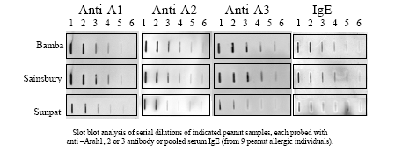
Figure 1. IgE binding of Bamba and two variations of peanut butter

Preclinical Aspects of Peanut Allergy
Certain murine studies have shown that allergic sensitization to antigen can occur on cutaneous exposure. Saloga and colleagues showed that when microgram quantities of ovalbumen were applied to the abraded skin of mice, the mice had significant anti-OVA IgE responses and positive intradermal tests.¹³ More recently, Strid and colleagues have shown that when arachis oil is applied to the abraded skin of mice, the mice have significant IgE and T-cell responses to peanut,¹⁴ even if the oil has fewer than 6 µg/mL of peanut protein.
Animal models demonstrate that a high early dose of oral protein antigen is highly effective in inducing tolerance to the respective antigen, even in the case of subsequent administrations of antigen in the presence of potent immune-adjuvants. Over the last 35 years, 33 publications on oral tolerance induction in animal models have documented that a single oral dose of antigen is sufficient to induce tolerance. This phenomenon has been demonstrated for different antigens in different experimental models, but the resulting data are consistent: they uniformly show that a single dose of oral protein administration effectively causes immunological tolerance and prevents the expression of related clinical disease.
Oral tolerance induction in animal models is most potent in its effects on delayed type I hypersensitivity responses; prevention of antibody responses through induction of oral tolerance is less consistent. However, numerous publications point to the fact that in mice a single dose of food allergen (beta-lactoglobulin, ovalbumen, peanut) is particularly effective in preventing the development of subsequent IgE-mediated responses. A recent study¹⁵ showed that naïve mice orally tolerized to beta-lactoglobulin were unable to mount significant IgE responses when they were subsequently sensitized with beta-lactoglobulin injected along with alum intraperitoneally. Similarly, there were no significant T-cell responses to beta-lactoglobulin in the pretolerized animals.
In another study in 2004, Strid and colleagues¹⁶ fed mice a single intragastric feed of defatted peanut flour at doses varying from 0.2 to 100 mg per mouse. Seven days after the feed, the mice were immunized with 100 µg of peanut antigen emulsified with Complete Freunds Adjuvant. Three weeks later, the mice were given a recall immunization with 100 µg of antigen. The mice were assayed for T-cell proliferation to peanut, cytokine production, delayed-type hypersensitivity responses, and antibody responses. Tolerizing doses of 100 g of peanut protein resulted in significant reduction of delayed-type hypersensitivity responses and inhibition of proliferative responses to peanut. Mice tolerized to 100 g of peanut protein showed significantly reduced interferon gamma and IL4 production. Specific IgE responses to peanut following sensitization were almost completely prevented by the single tolerizing dose. However, very low tolerizing doses of peanut, i.e., those below 2 mg per animal, resulted in enhanced delayed-type hypersensitivity responses, T-cell proliferative responses, cytokine production, and IgE production. Doses between 2 and 20 mg of peanut protein induced no difference between the T- and B-cell responses as compared to sham-tolerized animals. Tolerance to peanut was only achieved at doses of 100 mg per animal. Oral tolerance to peanut was shown to be antigen specific. Tolerizing doses of peanut did not promote tolerance to ovalbumen and vice versa.

Rationale for Trial Design

Population and Stratification
This trial will enroll infants who are at high risk of developing peanut allergy, which is defined by having egg allergy or eczema. The risk of developing peanut allergy is mainly determined by the presence of severe eczema. In determining the degree of eczema severity as a criterion for enrollment, two factors have been shown to be of predictive value for peanut allergy: (1) the required use of topical steroidal creams on children 6 months of age or younger, (D. Hill, personal communication), and (2) parental responses to questionnaires describing the nature of the skin condition (G. Lack, unpublished data).
In addition, participants will be stratified into risk groups based on skin-test reactivity to assess the effect of peanut consumption in those with moderate skin-test reactivity and those with minimal skin-test reactivity.

Open-Label Design
In an ideal world, we would address the study hypothesis using a randomized, placebo-controlled, double-blind design. The inclusion of a placebo has been considered in great detail. The main reason for not including a placebo snack is the impossibility of guaranteeing that it would be free from peanut since it would be manufactured in the same factories as the peanut snack. Furthermore, the cost of producing a placebo-controlled snack would be substantial, and there would be no guarantee of its nutritional equivalence to the peanut-containing snack. Finally, the children who were eating the placebo-controlled snack that tastes of peanut may develop a taste for peanut and may want to eat other foods that contain peanut, which would make adherence to the study advice impossible.
The obvious disadvantage of not including a placebo-controlled snack is that children will know which study arm they are assigned to. This disadvantage is offset by the fact that peanut allergy will be diagnosed on the basis of three objective measures: double-blind, placebo-controlled food challenge (DBPCFC); specific IgE; and skin-prick testing to peanut. On peanut challenge, neither the physician, the nurse, nor the patient will know the patient’s group assignment (peanut or placebo), so it will be impossible for the outcome of the challenge to be influenced by that knowledge. Skin-prick testing and specific IgE are highly objective measures, and the person reporting the specific IgE level will not know the status of the patient.

Administration of Early Peanut Challenge
More than 90% of the peanut-allergic children seen in our clinics react on first known exposure to peanut. It is extremely unlikely for a child to react on the second or third exposure, having tolerated peanut the first time. In the rare instances where a reaction occurs on subsequent exposure, it usually occurs because, on the first occasion, the child was only exposed to very small amounts of peanut at home and only tolerated a small amount. We believe that these patients are already allergic on first or second exposure but have not reached a threshold dose for clinical reaction; their aversion to peanut has prevented them from eating a sufficient dose. In the current trial, children with preexisting allergy will be screened from further administration of peanut by giving those who are initially randomized to the peanut group an early peanut challenge.

Assessment of Peanut Allergy
The main goal of this trial is to determine the proportion of participants with peanut allergy. It is important that as many participants as possible are evaluable for this assessment. Food challenge will be the main method of assessment, as it is recognized as the gold standard for diagnosis of peanut allergy. However, given the importance of this assessment, for those in whom food challenge is not possible, additional information will be considered, including dietary history, skin prick testing, and allergen-specific IgE levels. The algorithm for performing the assessments is presented in Figure 2 and Figure 3.

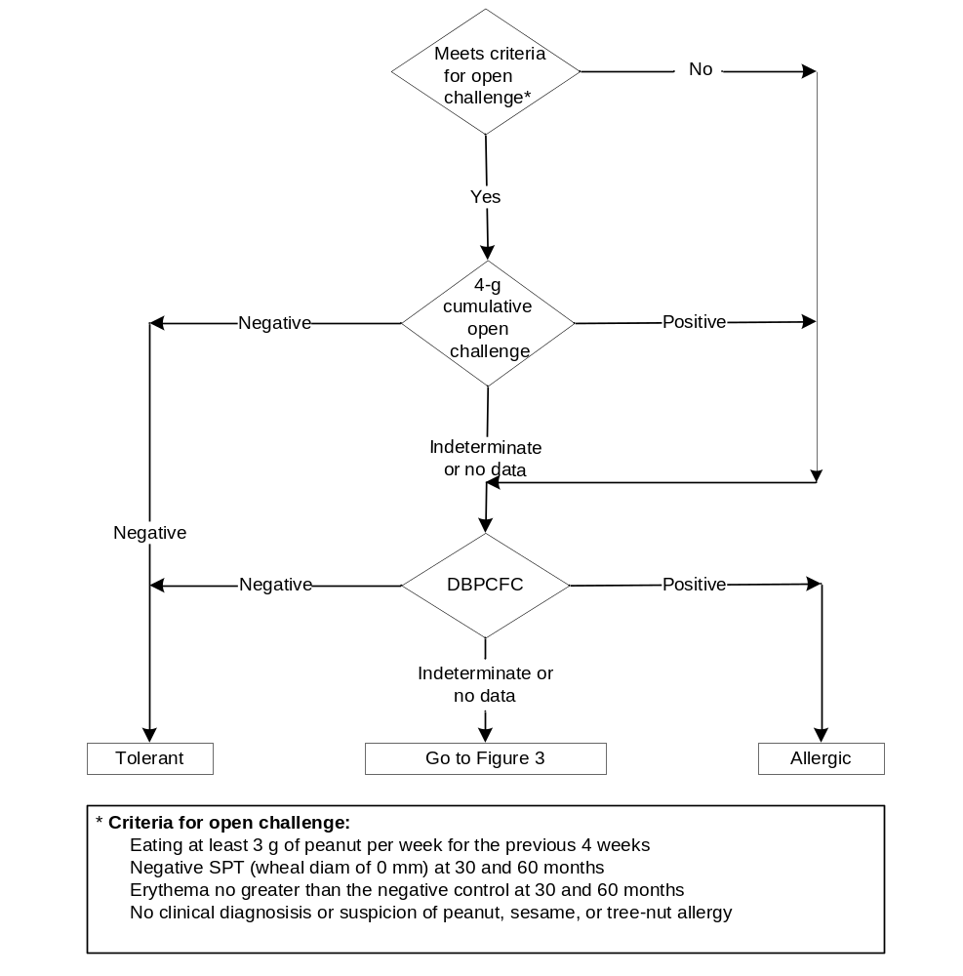
Figure 2. Determination of peanut allergy using challenges performed in
the clinic.
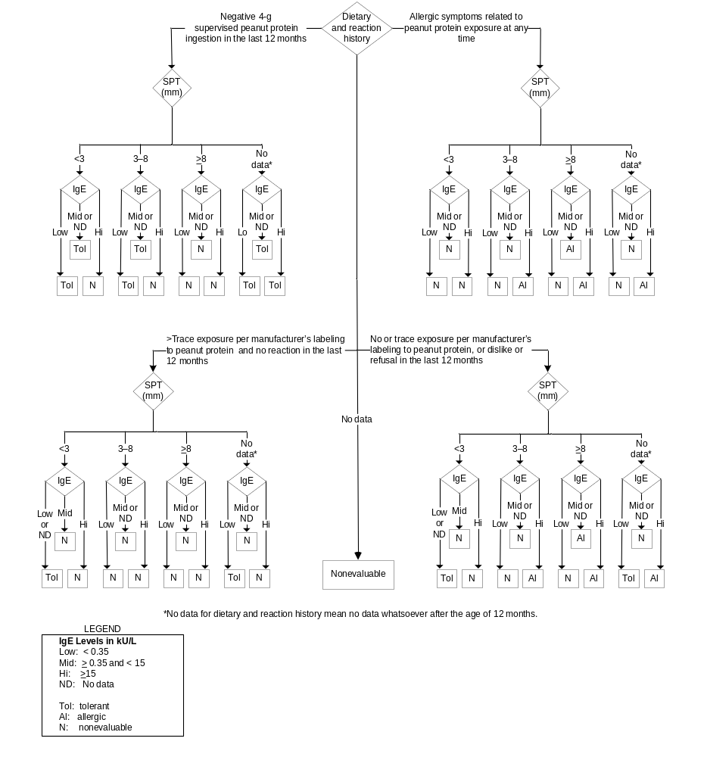
Figure 3. Determination of peanut allergy using dietary and reaction history, SPT, and IgE in the absence of peanut challenge.
We will first determine if, at 5 years of age, the participant meets the criteria for open challenge (see Figure 2). These criteria are intended to identify participants who are less likely to be
allergic. Such participants who have a negative open challenge will be considered tolerant, since the gold standard for tolerance is the open challenge. Children with a positive open challenge will be invited to undergo a double blind challenge, which is the gold standard for determination of allergy. Because we insist on no symptoms for a participant to be considered tolerant, indeterminate results may occur. In addition, positive symptoms during an open challenge may be difficult to interpret. Therefore, all such participants will be invited to DBPCFC.
Participants who do not meet the criteria for an open challenge will undergo the DBPCFC if they have been deemed clinically suitable for food challenge by a pediatric allergy specialist. A participant who also reacts positively to the DBPCFC will be considered allergic. A participant who passes the DBPCFC will be considered tolerant, bearing in mind the last step of the DBPCFC is an open challenge.
It is anticipated that 80% of participants active in the study at 5 years of age will have an outcome determined based on food challenge. However, in order to maximize the number of individuals who can be accurately evaluated for the primary endpoint, for the remaining participants we will diagnose peanut allergy or tolerance if the outcome can be determined with 95% or greater accuracy. For these participants, dietary and reaction history will be used together with the results of the SPT and peanut specific IgE to determine allergic status with ≥95% accuracy.
The general approach is that a strongly suggestive history can be combined with highly predictive (≥95%) SPT and/or IgE results to give a determination of tolerance or allergy. Even an excellent history on its own is only 70%–80% accurate in establishing a diagnosis of allergy or tolerance. There are cut off values, however, for both SPT and IgE above and below which one can respectively establish a diagnosis of allergy or tolerance with ≥95% predictive value. These cut off values will be used together with history. As a general rule, if there is a contradiction in our data set between history and the SPT/IgE results, or even between the SPT and IgE results, the participant will be considered nonevaluable in the absence of a challenge. The algorithm to do so is outlined in Figure 3.
A dietary and reaction history can be categorized in four ways with respect to the degree to which it supports tolerance or allergy.
- The upper left hand quadrant of Figure 3 represents a participant with a history strongly suggestive of peanut tolerance. A strongly suggestive history is one in which there is good documentation that a participant has been eating significant quantities of peanut at home without difficulty. In the current trial, this will be assessed by a supervised 4-g peanut ingestion at home. This supervised 4-g peanut ingestion at home constitutes an important part of the dietary history but, unlike the DBPBFC or open food challenge, is not the gold standard. This negative challenge will nearly always establish tolerance, except for the scenario where SPT ≥8 mm or spIgE ≥15kU/L.
- The lower left hand quadrant of Figure 3 represents a participant with a history consistent with peanut tolerance. A history consistent with tolerance is one in which the participant has had more than trace exposure to peanut without difficulty, but where there is no good documentation of significant dietary exposure. Here negative IgE or SPT are required because this history is not as robust as in case 1 above.
- The upper right hand quadrant of Figure 3 represents a participant with a history strongly suggestive of peanut allergy. A strongly suggestive history is one in which there is good documentation that a participant has had symptoms related to peanut exposure. A high IgE or SPT is nevertheless required to establish a diagnosis of allergy.
- The lower right hand quadrant of Figure 3 represents a participant with indeterminate history consistent with allergy the reader is directed to An indeterminate history consistent with allergy is one in which the participant has not had more than trace exposure to peanut and where there is no good documentation of symptoms related to dietary exposure. Here a very high level of IgE or SPT is required to determine allergy and very low levels to establish tolerance.
Participants for whom allergic or tolerant status cannot be determined with at least 95% certainty will be considered nonevaluable. Such participants include those in whom data are not strong enough on either the allergic or the tolerant side to make a clear determination. They also include those for whom there is a contradiction among the history, the skin test result, and the IgE measurement. For example, this would occur when the dietary and reaction history suggests tolerance but the SPT or IgE results suggest an allergic response.

Eczema Severity
In this clinical trial, we will enroll children with a high risk of developing peanut allergy based on their eczema severity. We will use three different criteria for assessing eczema severity. The first criterion will be the parents or guardians’ description of their child’s eczema severity. The second criterion will be the use of topical creams and ointments containing corticosteroids or calcineurin inhibitors. The third criterion will be a modified SCORAD (Scoring Atopic Dermatitis System) evaluation.
Eczema (atopic dermatitis) is an itchy, inflammatory skin condition with a predilection for the skin flexures. It is characterized by poorly defined erythema with edema, vesicles, and weeping in the acute stage and skin thickening (lichenification) in the chronic stage.
Assessing disease severity is problematic when there is no objective marker. The many severity scales used in clinical trials have generally not been studied for association with peanut allergy.
Lack et al found that rash over joints and skin creases as well as oozing, crusted rash had a significant association with peanut allergy. They also found a trend toward an association between the severity of rash in the first 6 months of life and the prevalence of peanut allergy.³
Recently, in the same cohort they noticed a risk of peanut allergy of approximately 20% among children whose parents described their rash as “very bad” (G. Lack, unpublished data). Hill found that peanut allergy is associated with eczema severity when severity was defined as days of topical steroid use each month (D. Hill, personal communication).
The use of modified SCORAD objective criteria will permit the inclusion of children who may not have had access to topical anti-inflammatory medications or whose parents cannot recall or report the severity of their child’s eczema. Epidemiological studies using the SCORAD in European countries in older children show mean overall SCORAD scores of 21/103 and 20/103, respectively.^{17,18} The European task Force of Atopic Dermatitis, using only the objective components of SCORAD, classified scores of <15, 15–40, and >40 as mild, moderate, or severe eczema, respectively, out of a possible total score of 83.¹⁹

Rationale for immunological assessments
This clinical trial of oral tolerance induction in children will be accompanied by a comprehensive series of studies that will permit us to identify the following:
- Biomarkers that predict susceptibility to oral tolerance induction.
- Molecular mechanisms associated with the development of oral tolerance induction to peanut allergen.
- Indicators of an active (immunomodulatory) response to oral tolerance induction during the course of therapy.
- Biomarkers of underlying allergen tolerance.
Our strategy for identifying these biomarkers, molecular mechanisms, and indicators will involve retrospective comparisons between individual allergen immune-response profiles of peanut- tolerant vs. peanut-allergic individuals. Qualitative, quantitative, and time-dependent changes in allergen immune-response profiles of participants who do or do not develop tolerance to peanut will provide data for testing current hypotheses and generating new hypotheses to explain underlying tolerogenesis mechanisms. To identify the biomarkers associated with underlying tolerance mechanisms in operation at the time of sampling, we will perform a cross-sectional analysis of the immune-response profiles at screening and at months 12, 30, and 60. Integration of biological data with clinical outcomes will provide a means to identify potential biomarkers of oral induced tolerance to peanut. Mechanistic studies will focus on T cell responses (CD4, T_{reg}) and B-cell responses (IgE epitopes, peanut specific IgE and IgG4, FAP assay). Specimens may also be used in future immune response or biomarker assays to reevaluate biological response as research tests are developed.

Known and potential risks

Peanut Group
Potential risks associated with the consumption of a peanut-containing snack are worsening of eczema, weight gain, nutritional compromise, metabolic abnormalities, and an increased risk of allergy to peanut or other allergens.
Four different studies show that the median age of reacting to peanuts is between 14 and 24 months of age. The vast majority of patients react upon first known exposure to peanut.^{3,20,21} This argues strongly against the possibility that peanut allergy is caused by eating peanuts and provides some reassurance that we will not induce peanut allergy by feeding patients peanuts.

Observation Group
In the observation group, avoidance of peanut may result in an increased risk of allergy to peanut or other allergens.

Both Groups
Undergoing laboratory assessments may involve a low risk of hemorrhage, hematoma, and infection at the venipuncture site. Risks associated with the planned peanut challenges include nausea, vomiting, itching, urticaria, angioedema, asthma, other respiratory symptoms, and anaphylaxis.

Objectives

Primary Objective
To assess whether oral administration of a peanut-containing snack can induce tolerance in children at high risk for peanut allergy.

Secondary Objectives
To assess the effect of a peanut-containing snack on additional allergy outcomes.
To assess the safety of a peanut-containing snack in this population.
To define the mechanisms through which the peanut-containing snack may induce tolerance to peanut.

Study Design

Description
This is a randomized, controlled trial that will enroll children at high risk for peanut allergy as demonstrated by eczema, egg allergy, or both. As shown in Figure 4, participants will be stratified based on their skin prick test (SPT) results for peanut: those with a wheal diameter of 0, 1, or 2 mm will be in the SPT two-minus stratum and those with a wheal diameter of 3 or 4 mm will be in the SPT three-plus stratum. Participants in each stratum will be randomly assigned to receive a peanut-containing snack or to undergo observation. Those assigned to receive the peanut-containing snack will receive it at least three times weekly until they reach 5 years of age. The prevalence of peanut allergy at that time will be compared between the peanut and observation groups.
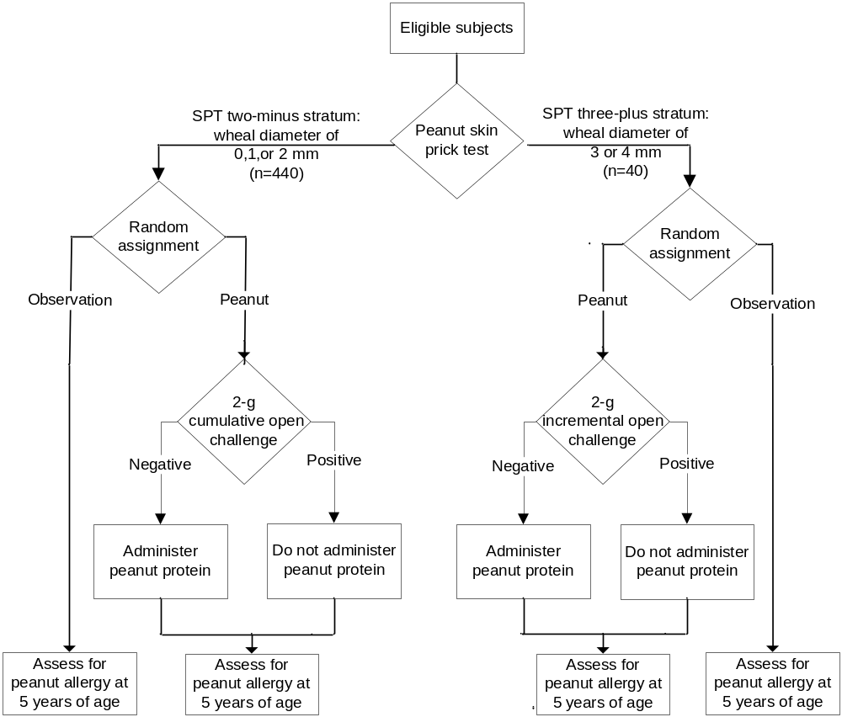
Figure 4. Study design

Primary Endpoint
The proportion of participants with peanut allergy at 5 years of age.

Secondary Endpoints
- At 2.5 and 5 years of age: the proportion of participants with allergic sensitization to selected ingested allergens and inhaled allergens, and with seasonal rhinoconjunctivitis, perennial rhinoconjunctivitis, and asthma.
- At 5 years of age: the proportion of participants with type 1 immediate onset food allergy to selected ingested allergens.
- Incidence of adverse events and laboratory abnormalities; nutritional evaluations.
- Results of cellular and humoral assessments of immune response related to the development of allergy or tolerance to specific allergens.

Determination of Peanut allergy
Figure 2 and Figure 3 provide the algorithm for determination of peanut allergy.

Example Assessment Scenarios
An interpretable outcome for either the DBPCFC or the 4-g cumulative open challenge performed in clinic is sufficient for a determination of allergy status (Figure 2).
- If there is no such outcome, peanut allergy will be assessed via interpretation of dietary history, SPT wheal diameter, and IgE levels (Figure 3).
Consider the following examples for a participant at age 5:
- A participant undergoes the DBPCFC and exhibits one or more of the indications listed in Table 4. This participant would be counted as allergic.
- A participant undergoes the 4-g cumulative open challenge performed in clinic and does not exhibit any of the indications listed in Table 4. This participant would be counted as tolerant.
- A participant is not available for in-clinic challenge (“no data”). For such participants, dietary and reaction history shall be reviewed Figure 3). Some possible scenarios follow:
- A participant has a dietary and reaction history of a negative 4-g supervised peanut protein ingestion in the last 12 months. This result directs the assessment to the upper left quadrant of Figure 4. The participant’s SPT = 2 mm. The participant’s IgE = 3 kU/L (“Mid”). This leads us to a box labeled “Tol,” that is, the participant will be counted as tolerant.
- Dietary history indicates that a participant has exhibited allergic symptoms related to peanut protein exposure. This result directs the assessment to the upper right quadrant of Figure 3. The participant’s SPT = 5 mm, and IgE = 17 kU/L. This leads us to a box labeled “Al”; that is, the participant will be counted as allergic.
- Dietary history indicates that a participant has had more than trace exposure to peanut protein in the last 12 months and has exhibited no reaction. This result directs the assessment to the lower left quadrant of Figure 3. As in the above scenario, this participant’s SPT = 5 mm and IgE = 17 kU/L. This participant will be considered nonevaluable because the high IgE, which is strongly suggestive of allergy, contradicts the history, suggesting tolerance.
- Dietary history indicates that during the last 12 months a participant has had only trace exposure to peanut protein or has persistently refused or exhibited dislike of peanut. This result directs the assessment to the lower right quadrant of Figure 3. There are no data for SPT, but the participant’s IgE = 0.2 kU/L. This participant will be counted as tolerant.
- Dietary history for a participant is not available. This participant will be considered nonevaluable.

Study Definitions
Allergic sensitization. Either allergen-specific IgE >0.35 kU/L, as defined by the CAP System™ (Pharmacia Diagnostics AB); or positive SPT, defined as SPT wheal diameter ≥3 mm with appropriate controls.
Asthma. A history of cough, wheeze, or shortness of breath that (1) was responsive to therapy with bronchodilators on two or more occasions in the previous 24 months, (2) required one visit to a physician in the previous 24 months, and (3) occurred during the night, during early morning, or upon exercising in the intervals between exacerbations at any time in the previous 12 months.
Egg allergy. Either (1) an SPT wheal diameter ≥6 mm from exposure to raw hen’s egg white after avoiding egg in the diet, or (2) an SPT wheal diameter ≥3 mm from exposure to pasteurized hen’s egg white and allergic symptoms related to exposure to hen’s egg.
Failure to thrive. Weight decrease across ≥2 deciles from the initial baseline weight.
Life-threatening anaphylaxis. An allergic reaction accompanied by any of the following: hypoxia, as evidenced by central cyanosis or oxygen saturation ≤ 89%; hypotension; loss of consciousness; or admission to intensive care.
Peanut allergy. IgE-mediated immediate hypersensitivity symptoms to peanut allergen.
Perennial rhinoconjunctivitis. Sensitization to a perennial allergen and clinical history of rhinoconjunctivitis symptoms experienced when exposed to the relevant allergen.
Seasonal rhinoconjunctivitis. Sensitization to a seasonal allergen and clinical history of rhinoconjunctivitis symptoms experienced during the relevant season.
Severe eczema. A rash that required the application of a topical creams and ointments containing corticosteroids or calcineurin inhibitors and
- if the participant is <6 months of age, lasted for at least 12 out of 30 days on two occasions, or
- if the participant is >6 months of age, lasted for at least 12 out of 30 days on two occasions in the last 6 months; or,
- has been described by the participant’s parent or guardian in a pre-enrollment questionnaire as “a very bad rash in joints and creases” or “a very bad itchy, dry, oozing, or crusted rash” or
- is described by a photograph of severe eczema that
- was present within the last 30 days if the participant is <6 months of age, or
- was present at 6 months of age if the participant is >6 months of age; or
- is currently or was previously graded >40 using the modified SCORAD evaluation (see Appendix 7).

Stopping Rules

Ongoing Review
The protocol chair, the medical monitor, the medical officer, and the NIAID Allergy and Asthma Data and Safety Monitoring Board (DSMB) will review safety data on an ongoing basis. The DSMB may stop enrollment or participation in the trial at any time if it concludes that there are significant safety concerns.

Review of Specific Adverse Events

Stopping Enrollment
Enrollment in the trial will be stopped pending review if any death occurs or if two participants are admitted to an intensive care unit for an adverse event related to study intervention.

Stopping Enrollment and Administration of Peanut-containing Snack
Enrollment in the trial and further administration of the peanut protein-containing snack will be stopped pending review if either of the following occurs for the SPT two-minus stratum:
- An analysis performed when 50 such participants per group have been followed for 3 weeks demonstrates that the lower bound of the 95% confidence interval for the proportion of participants in the peanut group with peanut allergy as determined in an unscheduled clinic visit (see section 6.7) is greater than 15%.
- An analysis performed when 50 such participants per group have been followed for 1 year demonstrates that the rate of serious adverse events is significantly greater at the 0.05 significance level in the peanut group than in the observation group.
Enrollment in the trial and further administration of peanut protein-containing snack to participants in the SPT three-plus stratum will be stopped pending review if either of the following occurs:
- One of the first 5, 2 of the first 10, or 3 of the first 15 such participants randomly assigned to the peanut group experiences life-threatening anaphylaxis (see section 3.3) during the first 3 weeks of administration of the peanut protein-containing snack.
- An analysis performed when 10 such participants in the peanut group have been followed for 1 year demonstrates that 4 or more participants have experienced a serious adverse event.

Study Duration
Enrollment is expected to take 2 years. Participation is approximately 4.5 years. Study duration is expected to be 6.5 years.

Eligibility

Inclusion Criteria
- Children ≥4 to <11 months old who have had solids successfully introduced into their diet.
- Egg allergy, severe eczema, or both.
- Informed consent obtained from parent or guardian.

Exclusion Criteria
- Clinically significant chronic illness, except for eczema or recurrent wheeze.
- Positive skin prick test for peanut allergy with a wheal diameter >4 mm in the presence of a negative saline control.
- Previous or current consumption of peanut protein that exceeds the amount allowed for the observation group in the per-protocol analysis specified in section 9.1.
- Investigator-suspected allergy to peanut protein.
- Investigator-suspected allergy to peanut protein in a care provider or current household member.
- Diagnosis of persistent asthma.
- AST (SGOT), ALT (SGPT), or bilirubin >2 times the upper limit of age-related normal value.
- BUN or creatinine >1.25 times the upper limit of age-related normal value.
- WBC <3.5 103/mL, polymorphonuclear cell count <1500/mL,
platelet count <100,000/mL, or hemoglobin <9 g/dL.
- Unwillingness or inability to comply with study requirements and procedures.

Reassessment for Eligibility
Participants who fail to meet the criteria for enrollment in the trial may be reassessed for eligibility. Such participants may be enrolled at the time of reassessment if they meet all criteria for enrollment.

Premature Termination

Premature Termination of Trial Interventions
Trial intervention will be prematurely terminated for a participant if, in the judgment of the investigator, further participation in the trial would be deleterious to the participant’s health; or if an independent dietary assessment reveals that the study intervention has led to body mass index BMI exceeding the 95th percentile for the participant’s age (Table 2)²² or failure to thrive.
Table 2. UK National BMI percentile classification
Age (years) | Boys (95%)  Obese | Girls (95%)  Obese
2 | 19.10 | 18.84
2.5 | 18.77 | 18.56
3 | 18.51 | 18.42
3.5 | 18.27 | 18.35
4 | 18.08 | 18.32
4.5 | 17.97 | 18.31
5 | 17.95 | 18.35
5.5 | 17.99 | 18.46
6 | 18.10 | 18.65
10 | 20.42 | 21.52
10.5 | 20.79 | 21.94

Premature Termination from the Trial
Participants will be prematurely terminated from the trial for either of the following:
- Withdrawal of consent
- Failure to return
Such participants will not be replaced.

Study Intervention

Peanut Administration or Avoidance
Participants assigned to the peanut group will be fed at least 6 g of peanut protein per week, distributed over at least three meals per week during study participation. The preferred peanut source will be Bamba. There are 17 g of Bamba per serving, which provides 2 g of peanut protein. Thus, the specified amount corresponds to three servings per week. However, other peanut protein-containing foods may be substituted. Participants assigned to the observation group will avoid exposure to peanut protein during study participation.

Assessment of Compliance with Study Intervention
Dieticians will monitor participant peanut protein consumption using a validated peanut frequency questionnaire in accordance with the schedule of events (see Appendix 1).

Modification or Discontinuation of Study Treatment
Participants in the peanut group will discontinue consumption of the peanut protein-containing snack if a confirmed allergic reaction to peanut protein or an adverse nutritional consequence attributable to consumption of peanut protein is experienced.
These participants will remain in the study to receive a status assessment at 5 years of age.

Study Procedures

Visit Windows
- Visits described in the schedule of events should occur as follows:
- Visits 12 and 30: within ±3 months of the planned visit date.
- Dietary consultations:
- Between visits 0 and 12: ±3 days.
- Between visits 12 and 30: ±7 days.
- Between visits 30 and 60: ±14 days.
- Visit 60: within ±6 months of the planned visit date.

General Assessments
These general assessments will be performed at the site:
- Informed consent. Written informed consent will be obtained before any study assessments or procedures are performed.
- Randomization.
- Dietary education. Dieticians will provide written and verbal information and advice regarding peanut protein consumption or avoidance to the peanut protein and observation groups, respectively. Advice on avoidance will be provided in accordance with the Department of Health Guidelines on peanut protein avoidance.
- Physical examination. Temperature, blood pressure, pulse, respiration, weight, and height.
- Medical history. A history will be taken to determine if the participant has had any clinically significant diseases or medical procedures other than the disease under study.
- Adverse events. Participants will be assessed for adverse events. All adverse events will be recorded on the case report forms (CRFs).
- Concomitant medications. All concomitant medications will be recorded on the CRFs.
- Dietary history. A dietary history will be obtained using a 3-day food diary that captures typical food consumption and provides a breakdown of macro- and micronutrient intake and total energy intake.
- Food reaction history. A history will be taken to determine if the participant has had any clinically significant food-induced, immediate-onset allergic reactions.
- Eczema evaluation. Both subjective and objective eczema severity criteria will be recorded. At screening, eczema severity will be determined using the criteria described in section 1.4.5. The modified SCORAD evaluation will be used at all visits.
- Rhinitis evaluation. Symptoms in accordance with the study definitions for seasonal and perennial rhinoconjunctivitis will be recorded.
- Asthma evaluation. Symptoms in accordance with the study definition for asthma will be recorded.
- Bioelectrical impedance. Results will be analyzed to determine fat and lean body mass.
- Dexa Scan. Dual energy x-ray absorptiometry (densitometry) will be performed to measure the amount of bone, muscle, and body fat.

Laboratory Assessments
Routine hematologic and chemistry laboratory assessments, which are detailed below, will be performed at the investigation site and recorded on CRFs.
- Hematology includes CBC with differential and platelets.
- Serum chemistries include Ca, PO₄, BUN, Cr, total protein, and albumin.
- Serum lipids include cholesterol, triglycerides, and high- and low-density lipoproteins.
- Fasting glucose and insulin.
- Insulin growth factor and receptor.
- Skin and nasal swab culture.

Allergy assessments

Allergens Assessed
The following allergy assessments will be performed:
- SPT for ingested allergens includes peanut, raw hen’s egg white, pasteurized hen’s egg white, cow’s milk, sesame, and Soya.
- SPT for tree nuts includes Brazil nut, hazel nut, cashew, and walnut.
- IgE for ingested allergens includes peanut, hen’s egg white, cow’s milk, sesame, Brazil nut, hazel nut, cashew, and walnut.
- IgE for inhalant allergens includes house dust mite (Dermatophagoides pteronyssinus), cat dander, dog dander, timothy grass pollen, and birch tree pollen.
- Oral food challenges for sesame, Brazil nut, hazel nut, cashew, and walnut will be given when clinical history and the results of SPT and IgE for these allergens are inconclusive. These challenges will be performed according to standard clinical practice.

Skin Prick Testing: Procedures and Interpretation
Prior to testing, ensure that the participant has not received short-acting antihistamine medications for at least 48 hours and/or long-acting antihistamine medications for at least 7 days.
The SPT for raw hen’s egg white will be performed using Red Lion salmonella-free egg. The other SPTs will be performed using Soluprick® extracts (ALK-Abelló). Lyophilized peanut extract (ALK- Abelló) will be analyzed for total protein and major peanut allergen concentration (Arah1, Arah2, and Arah3). The extract will be stored at −72 °C and will be used for SPT evaluations to peanut throughout the study. Saline 0.9% will be used as a negative control, and histamine (concentration of 1 mg/mL of saline) will be used as the positive control.
Tests will be performed on the forearm unless unaffected eczema-free skin patches are not available, in which case the skin on the participants back will be used for testing. Using a standardized lancet (ALK Abelló), the skin will be pricked through a drop of the extract, which will then be absorbed.
Skin test sites should be measured after 15 minutes. The wheal and flare should be measured at their widest diameters and recorded separately. Tests will be interpreted based on the widest wheal diameter.
The positive and negative control tests should be performed and measured prior to allergen SPT.
- If the saline negative control test is ≥3 mm, the testing should be rescheduled for approximately 7 days time.
- If the histamine positive control is ≤3 mm, then it should be repeated immediately. If the repeat test remains ≤3 mm, then the testing should be rescheduled for approximately 7 days’ time.
For peanut measurements, the following rules apply:
- The SPT will be performed in duplicate.
- If one result is <3 mm and one is ≥3 mm, a third SPT will be performed.
- If two of three results are <3 mm, their mean will be recorded as the final result.
- If two of three results are ≥3 mm, their mean will be recorded as the final result.

Peanut Challenges

Scheduled Challenges
For participants who are randomly assigned to the peanut arm, a 2-g open challenge will be performed after random assignment (see Figure 4).
For all participants, an in-clinic challenge will be scheduled at 60 months for determination of the primary endpoint (Figure 2). This challenge will be either a DBPCFC or an open challenge per the criteria set out in section 1.4.4.

Unscheduled Challenges
Unscheduled challenges will be performed as indicated at unscheduled clinic visits (see
section 6.7).

Repeat Challenges
If a participant fails to complete a challenge, he/she may be offered an opportunity to repeat the challenge at the investigator’s discretion.

Procedure
Before each challenge is undertaken, one of the clinical investigators or one of the attending pediatric allergists or trained pediatric allergist clinicians will be required to assess the child’s suitability for the challenge.

Step 1: Perform Clinical Assessment
For all challenges, do the following:
- Ensure that the child has had no acute exacerbation of allergic signs or symptoms within the last week.
- Ensure that the child has not received short-acting beta-2 agonists for 12 hours, long-acting beta-2 agonists for 24 hours, short-acting antihistamines in the last 48 hours, or long-acting antihistamines in the last 7 days.
- Ensure that the child has no concurrent illness.
- Check that the drug box is complete and that it is readily available.
- If there has been an acute exacerbation of any of the above, a study investigator will be informed and a decision made as to whether the challenge should continue or be rescheduled.
- If the child has a latex allergy or suspected latex allergy, he or she should avoid all latex products.
For hospital challenges, do the following:
- Inform PICU of the challenge taking place.
- Ensure that both oxygen and suction are in working order in the clinical trials unit.
- Ensure that all steps of the anaphylaxis protocol are in place and that all emergency drugs are prescribed.
- Record baseline observations, including temperature, pulse, respiration, Sa0₂, auscultation of the chest, and peak expiratory flow rate (PEFR), if the child is reliably able to perform PEFR.
- Record blood pressure on all participants older than 12 months.
- Cannulate the following participants: peanut-sensitized children (see section 3.5), children with persistent asthma, and children with a history of previous anaphylaxis to foods.

Step 2: Prepare the Food to be used in the Challenge
The dietician will prepare the challenge foods (Bamba, whole nuts, peanut butter, soups) and any carrier foods on the day of admission. The foods will be labeled and dated in the ward kitchen.

Step 3: Perform the Challenge

Double-blind, placebo-controlled challenge
Mixed challenge:
- Administer six doses of 0.1, 0.25, 0.5, 1.0, 2.0, and 4.0 g of peanut protein, interchangeably with the placebo challenge doses in 8–12 separate meals over the course of one day.
- After each dose, observe the child for 20 minutes.
- If an allergic reaction occurs following a placebo dose, perform separate peanut and placebo challenges on two separate days (separate challenge).
- At the discretion of the investigator, an additional dose pair comprising a repeat of the previous dose and a placebo in random order will be given.
- If the top dose of the mixed challenge is reached with no allergic reaction, wait 20 minutes and administer a cumulative open challenge equivalent to 2 g of peanut protein.
Separate challenge:
Day 1:
- Administer six doses, all of which are either peanut protein or placebo.
- After each dose, observe the child for 20 minutes.
Day 2:
- Administer six doses, all of which are either peanut protein or placebo (depending upon which was served on day 1).
- After each dose, observe the child for 20 minutes.
- If the top dose of the double-blind placebo-controlled challenge is reached with no allergic reaction, wait 20 minutes and administer a cumulative open challenge equivalent to 2 g of peanut protein.
At the discretion of the investigator, a dose may be repeated.
Interdose assessments and dose adjustments:
- Prior to the administration of each meal, the child will be evaluated for signs of reaction and vital signs (temperature, pulse, respiratory rate, blood pressure, SaO₂, and PEFR, if the child is reliably able to perform PEFR) will be monitored.
- The meals will be blinded by a code known to the dietician but not to the patient, nurse, or doctor. At the discretion of the study investigators, a blinded dose may be repeated or (in the case of the mixed challenge) an additional placebo dose administered.
- The challenge should be discontinued at any stage if a protocol defined reaction occurs, and action will be taken according to local hospital guidelines.
- A blinded dose will be repeated if any of the following occur:
- abdominal pain
- nausea
- chest tightness or pain
- abnormal oropharyngeal sensation
- unexplained behavioral change

Open challenges
Incremental open challenge (2 or 4 g):
- Administer five doses of 0.1, 0.25, 0.5, 1.0, and 2.0 g peanut protein
- If the child is ≥3 years of age, administer a sixth dose of 4.0 g peanut protein.
- After each dose, observe the child for 20 minutes. If there is no reaction do a full set of observations, assess, and proceed to the next stage.
Cumulative open challenge (2 or 4 g):
- For the 2-g challenge, administer at least 2 g of peanut protein within 6 hours.
- If the child is ≥3 years of age, administer at least 4 g of peanut protein within 6 hours.
- Observe the child during the challenge and for 1 hour after completion of the cumulative dose.
- No particular feeding regimen is required. Peanut meals may vary and be used interchangeably.

Step 4: Determine the Outcome
Outcome of the challenge will be determined by evaluating the participant, using the criteria in Table 3.
A positive food challenge will be defined by the presence of either of the following:
- One or more major criteria.
- Two or more minor criteria.
An indeterminate food challenge will be defined by the presence of one minor criterion.
A negative food challenge will be defined by the absence of major or minor criteria.
All symptoms should be of new onset and not due to ongoing disease. Symptoms must occur no later than 2 hours after the last dose.
Table 3. Criteria for determining the outcome of food challenge
Major Criteria
Confluent erythematous pruritic rash
Respiratory signs (at least one of the following):
wheezing
inability to speak
stridor
dysphonia
aphonia
≥3 urticarial lesions
≥1 site of angioedema
Hypotension for age not associated with vasovagal episode
Evidence of severe abdominal pain (such as abnormal stillness or doubling over) that persists for ≥3 minutes
Minor Criteria
Vomiting
Diarrhea
Persistent rubbing of nose or eyes that lasts for ≥3 minutes
Persistent rhinorrhea that lasts for ≥3 minutes
Persistent scratching that lasts for ≥3 minutes

Step 5: Consult with the Family
If the result is negative:
- Advise the family that the child may include peanut protein in the diet.
- No emergency plan is required.
- If the challenge was performed at a time other than the study termination visit, advise the family to continue feeding the child according to the protocol for participants in the intervention group.
If the result is positive:
- Advise the family that the child must avoid all peanut and tree-nut protein in the diet.
- Provide a detailed written emergency management plan.
- Provide education on peanut protein and tree-nut avoidance strategies.
- Provide training in Epi-Pen administration.
- Review the child’s inhaler technique if appropriate.
- Encourage the parents to join the UK Anaphylaxis Campaign and Medic-Alert.
- Schedule follow up appointment for the participant in an appropriate allergy clinic.
- If the challenge was performed at a time other than the study termination visit, advise the family of the procedures and visit schedule for participants in the peanut group who have reacted positively to challenge.

Step 6: Discharge the Participant
Observe the child until:
- 2 hours have elapsed since the top dose of the challenge.
- All symptoms have resolved (if the result was positive).
- The clinician confirms that the child is ready for discharge.
After the observation period is over, remove the cannula if one was installed.

Peanut Consumption
Maternal peanut protein consumption history. Information on the mother’s peanut protein consumption during pregnancy and breastfeeding will be obtained at the baseline visit.
Participant peanut protein consumption monitoring. A peanut frequency questionnaire (PFQ) will be completed to ascertain the peanut protein consumption of the participant. The information provided on the questionnaire will be converted to grams of peanut protein for entry on the case report forms. Additionally, at home visits, the dieticians will observe the feeding of participants assigned to the peanut group.
Household peanut protein consumption monitoring. Peanut protein consumption of all household members will be assessed in order to determine environmental exposure to peanut.
The 4-g supervised peanut protein ingestion is for participants who have:
- Eaten 3 g of peanut protein within a 7-day period in the last 28 days.
- An SPT wheal diameter of 0 mm at age 2.5 years (see section 3.5).
The ingestion of 4 g of peanut protein will be supervised at home by a nurse (see Figure 3, upper left quadrant).

Unscheduled Clinic visits
An unscheduled clinic visit may be conducted at any time for either of the following:
- Aversion to peanut protein, refusal of peanut protein, or both.
- Suspected peanut allergy.
Assessments to be performed at unscheduled visits are described in Figure 5. Independent of the results of these assessments, participants will continue with all subsequent study assessments. 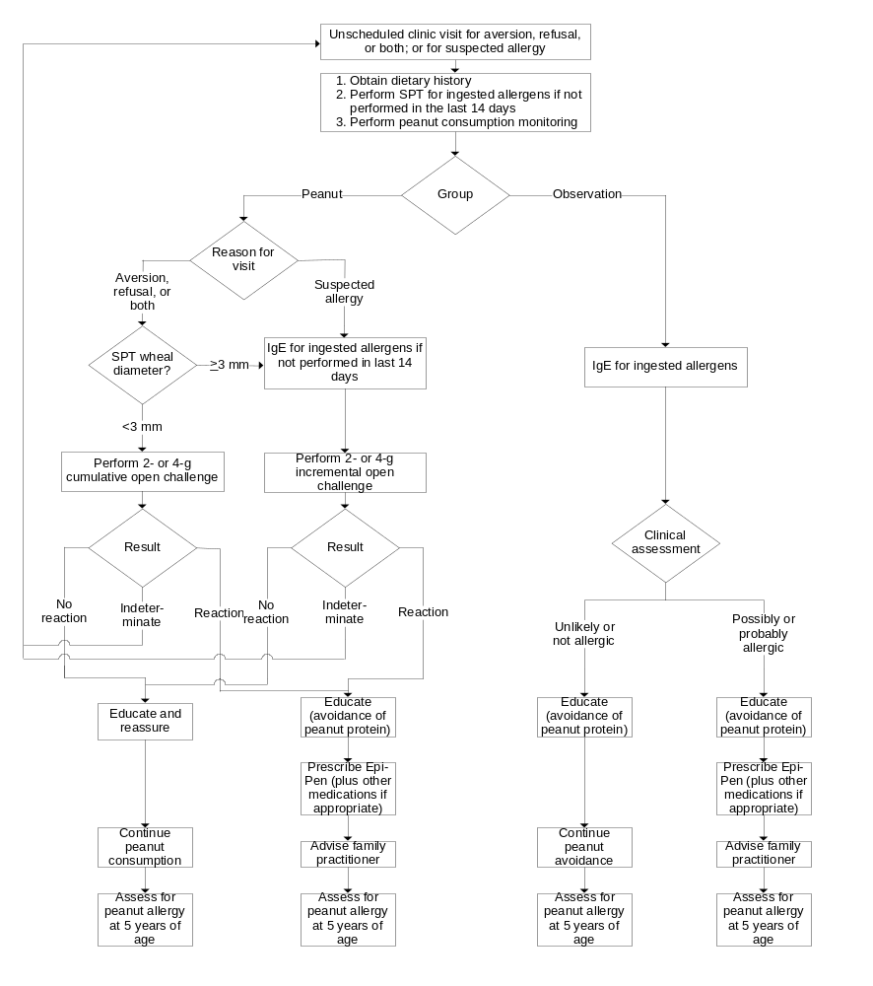
Figure 5. Assessments to be performed at unscheduled clinic visits

Tolerance Assays

Frozen PBMC T-Cell Assay

Overview
Cryobanked PBMCs will be used in assays monitoring functional changes in T cells. Samples will be cultured in vitro and stimulated with peanut antigen to see if there is peanut-specific lymphocyte proliferation and to measure cytokines secreted in response to these antigens. Cells from the stimulated cultures will be pelleted and banked in RNAlater® for RNA extraction by the ITN core lab and the supernatants frozen for future secreted cytokine profiling.

Gene Expression Profiling
Gene expression profiling will be performed using RNA isolated from non-stimulated versus in vitro stimulated cells. In this case, genes expressed in response to peanut antigen will be compared in participants believed to be tolerant versus those who go on to develop peanut allergy. Genes of interest include IL-4, IL-5, IL-13, and IFNγ to determine if an allergic participant’s T-cell responses are more T_{h}2-like; whereby a tolerant participant’s T cells may respond to antigen in a more T_{h}1-like fashion. Alternatively, genes involved in mediating immune regulation by T regulatory cells may also be differentially expressed. Of particular interest is FoxP3, which will also be analyzed and directly compared to intracellular cytokine staining. Recently IRF-4, IRF-5, and IRF-7 have been shown to be associated with Toll-like receptor signaling and inflammatory responses. These, among other genes, are potential candidates for study.

Secreted Cytokines
Cytokines secreted by in vitro stimulated cells will be monitored with the Luminex platform, a multiplex assay currently allowing for detection of 30 cytokines and chemokines from very small volumes of cell culture supernatant or serum. This analysis will be compared with gene expression and ICS data to determine if cytokines produced by T cells are released and to examine the difference between secreted cytokine profiles of peanut-tolerant and allergic participants.

Antigen-specific Proliferative and Cytokine Responses
Antigen-specific proliferative and cytokine responses will be assessed using in vitro cultures with peanut antigen as described above. Using CFSE dye as a label, we will determine how many cell divisions have occurred in response to peanut antigen in vitro and determine the phenotype of proliferating cells with multicolor flow cytometry. Proliferative responses may be lower in peanut tolerant versus allergic participants if active regulation is occurring for example. Additionally, intracellular cytokine production will be measured with ICS to determine profiles of cytokines secreted by the proliferating and nonproliferating T cells.

Regulatory T cells
Regulatory T cells play an important role in downmodulating active or inflammatory immune responses. In this case, early antigen exposure may induce tolerance by activating antigen specific regulatory T cells. Currently, regulatory T cells are isolated using CD4 and CD25 surface markers, specifically gating on CD25⁺ hi cells. CD4⁺CD25⁺ cells are mixed with CD4⁺CD25⁻ cells to evaluate the impact of regulatory T cells on antigen-specific proliferative responses by CD25⁻ cells. Again, if tolerance to peanut allergens is achieved, there may be increased regulatory T-cell activity. This assay is likely to evolve given the use of FoxP3 and potentially other markers for enumeration and isolation of regulatory T cells.

Plasma Allergen-Specific Igg and IgE

ELISA-based Techniques
ELISA-based techniques will be used to measure peanut-specific IgG4 and IgE at baseline and at several time points during the study using cryobanked plasma samples. Previous studies have shown that children who are sensitized but not allergic to peanut have higher IgG4/IgE ratios than those who are allergic to peanut. Interestingly, the fact that both sensitized and allergic children are IgE positive suggests active regulation by T cells, which results in the higher IgG4 levels in the nonallergic sensitized patients. Higher IgG4/IgE ratios found in sensitized versus allergic patients should correlate with peanut-induced tolerance in this study.

Facilitated Antigen Presentation Inhibition
Facilitated antigen presentation (FAP) inhibition is a flow cytometric-based assay that can detect participants who have allergen-specific IgG antibodies that interfere with FAP. In FAP, IgE facilitates the presentation of antigen to B cells, subsequently causing allergy-related, T-cell activation. Immunotherapy induces IgG, which competes for allergen-bound IgE, thus inhibiting allergen/IgE complexes from binding Fc receptors on antigen presentation cells (in this case, a B-cell line). Peanut consumption will increase peanut-specific IgG, especially IgG4, which interferes with FAP. The time course and magnitude of changes in plasma FAP inhibitory activity will be compared with clinical symptoms, clinical scores, and allergen-specific IgG levels.

Whole Blood DNA–HLA Genotypes
There are some indications that HLA class II genetic polymorphism may be associated with susceptibility to peanut allergy. DNA will be isolated from peripheral blood of trial participants, subjected to sequence-based class II typing, and genotyped for potential SNPs associated with persons susceptible to allergic responses.

Adverse Events

Overview
Safety data will be recorded on a CRF specifically designed for this purpose. All serious adverse events (SAEs) will be reported on an SAE report form as well as on individual CRFs. All data will be reviewed periodically by the data safety and monitoring board (DSMB). In addition, SAEs will be reported locally. The DSMB has the authority to withdraw any participants and/or terminate the study because of safety findings.
Adverse events that are classified as serious according to the definition of health authorities must be reported promptly and appropriately to the ITN, NIAID, the IND sponsor NIAID, principal investigators in the trial, institutional review boards (IRBs), and health authorities. This section defines the types of adverse events and outlines the procedures for appropriately collecting, grading, recording, and reporting them. Information in this section complies with ICH Guideline E2A: Clinical Safety Data Management: Definitions and Standards for Expedited Reporting, ICH Guideline E-6: Guideline for Good Clinical Practice, and applies the standards set forth in the National Cancer Institute (NCI), Common Terminology Criteria for Adverse Events (CTCAE), Version 3.0 (December 12, 2003).

Definitions

Adverse Event
An adverse event is any occurrence or worsening of an undesirable or unintended sign, symptom, laboratory finding, or disease that occurs during participation in the trial.
An adverse event will be followed until it resolves or until 30 days after a participant terminates from the study, whichever comes first.

Serious Adverse Event
An SAE or reaction is defined as “any adverse event occurring at any dose that suggests a significant hazard, contraindication, side effect, or precaution.” This includes but is not limited to any of the following events:
- Death. A death that occurs during the study or that comes to the attention of the investigator during the protocol-defined follow-up after the completion of therapy must be reported whether it is considered treatment related or not.
- A life-threatening event. A life-threatening event is any adverse therapy experience that, in the view of the investigator, places the participant at immediate risk of death from the reaction as it occurred.
- Inpatient hospitalization or prolongation of existing hospitalization.
- Persistent or significant disability.
- An event that requires intervention to prevent permanent impairment or damage. An important medical event that may not result in death, be life threatening, or require hospitalization may be considered an SAE when, based on appropriate medical judgment, it may jeopardize the participant and may require medical or surgical intervention to prevent one of the outcomes listed above.
Regardless of the relation of the adverse event to study participation, the event must be reported as a serious adverse event if it meets any of the above definitions.

Unexpected Adverse Event
An adverse event is considered “unexpected” when its nature (specificity) or severity is not consistent with applicable product information, such as safety information provided in the package insert, the investigator’s brochure, or the protocol.

Collecting Adverse Events

Methods of Collection
Adverse events will be collected from the time the participant begins study treatment until the time the event resolves or until 30 days after the participant completes study treatment, whichever comes first.
Adverse events may be discovered through any of these methods:
- Observing the participant.
- Questioning the participant in an objective manner.
- Receiving an unsolicited complaint from the participant.
An abnormal value or result from a clinical or laboratory evaluation (e.g., a radiograph, an ultrasound, or an electrocardiogram) can also indicate an adverse event. If this is the case, then the evaluation that produced the value or result should be repeated until that value or result returns to normal or can be explained and the participant’s safety is not at risk. If an abnormal value or result is determined by the investigator to be clinically significant, it must be recorded as an adverse event on the appropriate laboratory evaluation form(s).

Collecting Serious Adverse Events
Serious adverse events will be collected from the time the participant begins study treatment until 30 days after he/she completes study participation or until 30 days after he/she prematurely withdraws from the study.

Recording Adverse Events
Throughout the study, the investigator will record all adverse events on the appropriate adverse event CRF regardless of their severity or relation to study medication or study procedure. The investigator will treat participants experiencing adverse events appropriately and observe them at suitable intervals until their symptoms resolve or their status stabilizes.

Recording Serious Adverse Events
Serious adverse events will be recorded on the adverse event CRF and on the SAE form, and health authorities will be notified as outlined in section 8.5.2.

Updating Source Documentation
Documents describing the safety profile of a drug, such as the investigator’s brochure, will be amended as needed to ensure that the description of safety information adequately reflects any new clinical findings. Until these documents are updated, expedited reporting will be required for additional occurrences of a reaction.

Grading and Attribution of Adverse Events

Grading Criteria
The study site will grade the severity of adverse events experienced by ITN study participants according to the criteria set forth in the NCI-CTCAE Version 3.0. This document provides a common language to describe levels of severity, to analyze and interpret data, and to articulate the clinical significance of all adverse events.
Adverse events will be graded on a scale from 1 to 5 according to the following standards in the NCI-CTCAE manual:
Grade 1 = mild adverse event.
Grade 2 = moderate adverse event.
Grade 3 = severe and undesirable adverse event.
Grade 4 = life-threatening or disabling adverse event.
Grade 5 = death.
All adverse events will be reported and graded whether they are or are not related to disease progression or treatment.

Attribution Definitions
The relation, or attribution, of an adverse event to study participation will be determined by the site investigator. The site investigator will also record the determination of attribution on the appropriate CRF and/or SAE reporting form. The relation of an adverse event to the study treatment will be determined using the descriptors and definitions provided in Table 4. For additional information and a printable version of the NCI-CTCAE manual, consult the NCI-CTCAE web site: http://ctep.cancer.gov/reporting/ctc.html.
Table 4. NCI-CTCAE attribution of adverse events
Code | Descriptor | Definition
Unrelated Category
1 | Unrelated | The adverse event is clearly not related to study participation.
Related Categories
2 | Unlikely | The adverse event is doubtfully related to study participation.
3 | Possible | The adverse event may be related to study participation.
4 | Probable | The adverse event is likely related to study participation.
5 | Definite | The adverse event is clearly related to study participation.

Reporting Serious Adverse Events

Reporting Timeline
The following process for reporting a serious adverse event ensures compliance with the ICH guidelines. When an investigator identifies a serious adverse event (as defined in section 8.2.2), he or she must notify the Pharmaceutical Product Development, Inc. (PPDI) Safety Reporting Center within 24 hours of discovering the event using the PPDI 24-Hour SAE Reporting Hotline (1-800-201-8725). In addition to being reported by telephone, these events will be entered on the serious adverse event form and the adverse event CRF. Both forms will be faxed to the PPDI Safety Reporting Center within 24 hours. PPDI is responsible for notifying the study sponsor.

Options for Reporting Serious Adverse Events
After the serious adverse event has been assessed by the investigator, there are three options for reporting an event to the appropriate health authorities:
- No requirement to report. This option applies if the adverse event is deemed not serious by the PPDI Safety SAEC/medical liaison, the medical monitor and the NIAID medical officer.
- Standard reporting is required (report in the IND annual report). This option applies if the adverse event is classified as one of the following: (a) serious, expected, and treatment related; (b) serious, expected, and not treatment related; or (c) serious, unexpected and not treatment related.
- Expedited reporting is required. This option applies if the adverse event is considered serious, unexpected, and treatment related. These events must be reported by the sponsor to the appropriate health authorities within 15 days; fatal or life-threatening events must be reported within 7 days. For expedited SAEs, all sites must attach the notification letter and MedWatch/CIOMS to the current investigator’s brochure.
All investigators must report serious adverse events to their respective IRBs as mandated by them.

Reporting Serious Adverse Events to the Data Safety Monitoring Board
The DSMB will be provided listings of all SAEs on an ongoing basis. Furthermore, the DSMB will be informed of expedited SAEs by the NIAID medical officer at the same time as health authorities.

Statistics

Analysis Samples
The following groups will form samples for analysis.
- Intent-to-treat (ITT): all randomly assigned participants who are evaluable for peanut allergy at age 5.
- Safety: all participants who either receive any peanut protein-containing food or are in the observation group.
- Per-protocol (PP): participants in compliance with the dietary regimen for their assigned group and evaluable for peanut allergy at age 5. Compliance is defined as the consumption of peanut protein in the first 2 years of life:
- In the peanut group, compliance is consumption of at least 3 g of peanut protein per week for at least 50% of the weeks enrolled and consumption of at least 2 g of peanut protein on at least one occasion in both the first and second years of life.
- In the observation group, compliance is consumption of less than 0.2 g of peanut protein on any one occasion and less than 0.5 g over a single week.

Analysis of Endpoints

Analysis of Primary Endpoint

SPT Two-minus Stratum
The main analysis will evaluate participants in the ITT sample of the SPT two-minus stratum. In an additional analysis, the same comparison will be made in the PP sample. It will compare the proportion of participants with peanut allergy in the peanut and observation arms at 5 years of age using a two-tailed, chi-square test at the 0.05 level of significance.

SPT Three-plus Stratum
Peanut allergy incidence in the safety and PP samples will be evaluated in the SPT three-plus stratum. The difference in peanut allergy incidence rates at 5 years of age will be described using the difference in proportions between the two groups and a two-tailed, 95% confidence interval.

Analysis of Secondary Endpoints
The incidence of adverse events and laboratory abnormalities at five years of age will be compared between the peanut and the observation groups in the safety sample using a two-tailed chi-square test at the 0.05 level of significance. Additional specific secondary endpoints are described in section 3.3.

Additional Analyses
Additional analyses of the risk associated with peanut allergy in the treatment groups will be performed using multiple logistic regression to identify possible associations of risk with baseline participant characteristics and selected clinical and dietary measures. These analyses will be performed on the incidence of peanut allergy at age 5.0 and 2.5 years.

Sample Size
For participants in the SPT two-minus stratum, the null hypothesis states that there is no difference in the proportion of individuals with peanut allergy in the peanut group as compared to the observation group. We assume the true rate of peanut allergy in the observation group is at least 15% and that treatment will reduce that rate to 4.5 % or less in the peanut group. Assuming a 20% dropout rate, enrolling 220 participants in each group will provide 91% power to detect such differences between the groups using a two-tailed, chi-square test.
For participants in the SPT three-plus stratum, current resources allow for 20 participants to be enrolled per group. Allowing for a 20% dropout rate, 16 evaluable patients allow for the half-width of the two-sided 95% confidence interval on the difference in proportions to be a minimum of 0.25 in the range of rates expected for the primary endpoint.

Randomization, stratification, and blinding
Participants will be randomly assigned to treatment within each of the two strata using a centrally administered randomization scheme. One stratum comprises participants with skin prick tests for peanut at time of study entry of 0, 1 or 2 mm, whereas the second stratum comprises those with skin prick tests to peanut of 3 or 4 mm. In the first stratum, 420 participants will be randomly assigned in blocks of size 10, whereas 40 participants will be randomly assigned in the second stratum in blocks of size 8.

Reporting Deviations from the Original Statistical Plan
The principal features of the study design and the plan for statistical analysis of the data are outlined in this protocol and will be described in more detail in the subsequent Statistical Analysis Plan (SAP). Any changes in these features will require a protocol or an SAP amendment, which will be subject to review by the independent DSMB and the study sponsor. These changes will be described in the final report as appropriate.

Identification and Access to Source Data

Identifying Source Data
The investigator is required to keep accurate records to ensure that the conduct of the study is fully documented (see section 11). The results of all clinical and clinical laboratory evaluations will be maintained in the participant’s medical records and the data will be transferred to clinical CRFs.
Safety data will be recorded on CRFs specifically designed for this purpose. All the SAEs will be reported on an SAE report form as well as on individual CRFs. All data will be reviewed periodically by the DSMB and IRB. The DSMB and/or the IRB have the authority to withdraw any participants and/or terminate the study because of safety findings.

Permitting Access to Source Data
The investigational site participating in this study will maintain the highest degree of confidentiality permitted for the clinical and research information obtained from the participants in this clinical trial. Medical and research records should be maintained at each site in the strictest confidence. However, as a part of the quality assurance and legal responsibilities of an investigation, the investigational site must permit authorized representatives of the sponsor(s) and health authorities to examine (and when required by applicable law, to copy) clinical records for the purpose of quality assurance reviews, audits, and evaluations of the study safety and progress. Unless required by the laws that permit copying of records, only the coded identity associated with documents or with other participant data may be copied (and all personally identifying information must be obscured). Authorized representatives as noted above are bound to maintain the strict confidentiality of medical and research information that is linked to identified individuals. The investigational site will normally be notified before auditing visits occur.

Quality Control and Quality Assurance
The investigator is required to keep accurate records to ensure that the conduct of the study is fully documented.
The sponsor is responsible for regularly reviewing the conduct of the trial, for verifying adherence to the protocol, and for confirming the completeness, consistency, and accuracy of all documented data.

Data Handling
The investigator is required to ensure that all CRFs are legibly completed for every participant entered in the trial. To ensure the reliability of the data recorded in the database, double-data entry will be used for all fields on the CRF. The data will be verified by a series of computerized edit checks, and all relevant data queries will be resolved regularly. When the CRFs are complete, they will be reviewed and signed by the investigator and returned to the sponsor or designees. All data from the original signed CRF will be entered in the database, and a comparison program will be run again. All discrepancies will be reviewed, and any resulting queries will be resolved with the investigator and amended in the database. All elements of data entry (i.e., time, date, verbatim text, and the name of the person performing the data entry) will be recorded in an electronic audit trail to allow all data changes in the database to be monitored and maintained in accordance with federal regulations.

Ethical Considerations and Compliance with Good Clinical Practice

Statement of Compliance
This clinical study will be conducted using good clinical practice (GCP), as delineated in Guidance for Industry: E6 Good Clinical Practice Consolidated Guidance, and according to the criteria specified in this study protocol. Before study initiation, the protocol and the informed consent documents will be reviewed and approved by an appropriate ethics committee or IRB. Any amendments to the protocol or to the consent materials must also be approved before they are implemented.
Ethical approval for the study will also be obtained locally from the relevant Multi-centre Research Ethics Committee. All relevant trusts within the National Health System in England will also be informed of the study.

Informed Consent and Assent
The informed consent form is a means of providing information about the trial to a prospective participant and allows for an informed decision about participation in the study. All participants (or their legally acceptable representative) must read, sign, and date a consent form before entering the study, taking study drug, or undergoing any study-specific procedures. Consent materials for participants who do not speak or read English must be translated into the participants’ appropriate language.
The informed consent form must be revised whenever important new safety information is available, whenever the protocol is amended, and/or whenever any new information becomes available that may affect participation in the trial.
A copy of the informed consent will be given to a prospective participant for review and signature. The attending physician, in the presence of a witness, will review the consent and answer questions. The prospective participant will be told that being in the trial is voluntary and that he or she may withdraw from the study at any time, for any reason.

Privacy and Confidentiality
A participant’s privacy and confidentiality will be respected throughout the study. Each participant will be assigned a sequential identification number, and these numbers rather than names will be used to collect, store, and report participant information.

Publication Policy
The ITN policy on the publication of study results will apply to this trial. Authorized participants can find details of the policy statement on the ITN website at http://www.immunetolerance.org.

References
1. Peanut Allergy.UK Department of Health, Committee on Toxicity of Chemicals in Food, Consumer Products and the Environment,1997.
2. Grundy J, Matthews S, Bateman B, Dean T, Arshad SH. Rising prevalence of allergy to peanut in children: Data from 2 sequential cohorts. J Allergy Clin Immunol. 2002; 110(5):784-789.
3. Lack G, Fox D, Northstone K, Golding J. Factors associated with the development of peanut allergy in childhood. N Engl J Med. 2003; 348(11):977-985.
4. Perry TT, Conover-Walker MK, Pomes A, Chapman MD, Wood RA. Distribution of peanut allergen in the environment. J Allergy Clin Immunol. 2004; 113(5):973-976.
5. Husby S, Mestecky J, Moldoveanu Z, Holland S, Elson CO. Oral tolerance in humans. T cell but not B cell tolerance after antigen feeding. J Immunol. 1994; 152(9):4663-4670.
6. Ngan J, Kind LS. Suppressor T cells for IgE and IgG in Peyer's patches of mice made tolerant by the oral administration of ovalbumin. J Immunol. 1978; 120(3):861-865.
7. Meglio P, Bartone E, Plantamura M, Arabito E, Giampietro PG. A protocol for oral desensitization in children with IgE-mediated cow's milk allergy. Allergy. 2004; 59(9):980-987.
8. Kerosuo H, Kullaa A, Kerosuo E, Kanerva L, Hensten-Pettersen A. Nickel allergy in adolescents in relation to orthodontic treatment and piercing of ears. Am J Orthod Dentofacial Orthop. 1996; 109(2):148-154.
9. Mortz CG, Lauritsen JM, Bindslev-Jensen C, Andersen KE. Nickel sensitization in adolescents and association with ear piercing, use of dental braces and hand eczema. The Odense Adolescence Cohort Study on Atopic Diseases and Dermatitis (TOACS). Acta Derm Venereol. 2002; 82(5):359-364.
10. Van Hoogstraten IM, Andersen KE, Von Blomberg BM, Boden D, Bruynzeel DP et al. Reduced frequency of nickel allergy upon oral nickel contact at an early age. Clin Exp Immunol. 1991; 85(3):441-445.
11. Twarog FJ, Weinstein SF, Khaw KT, Strieder DJ, Colten HR. Hypersensitivity to pancreatic extracts in parents of patients with cystic fibrosis. J Allergy Clin Immunol. 1977; 59(1):35-40.
12. de Leon MP, Glaspole IN, Drew AC, Rolland JM, O'Hehir RE et al. Immunological analysis of allergenic cross-reactivity between peanut and tree nuts. Clin Exp Allergy. 2003; 33(9):1273-1280.
13. Saloga J, Renz H, Larsen GL, Gelfand EW. Increased airways responsiveness in mice depends on local challenge with antigen. Am J Respir Crit Care Med. 1994; 149(1):65-70.
14. Strid J, Hourihane J, Kimber I, Callard R, Strobel S. Disruption of the stratum corneum allows potent epicutaneous immunization with protein antigens resulting in a dominant systemic Th2 response. Eur J Immunol. 2004; 34(8):2100-2109.
15. Frossard CP, Tropia L, Hauser C, Eigenmann PA. Lymphocytes in Peyer patches regulate clinical tolerance in a murine model of food allergy. J Allergy Clin Immunol. 2004; 113(5):958-964.
16. Strid J, Thomson M, Hourihane J, Kimber I, Strobel S. A novel model of sensitization and oral tolerance to peanut protein. Immunology. 2004; 113(3):293-303.
17. Broberg A, Svensson A, Borres MP, Berg R. Atopic dermatitis in 5-6-year-old Swedish children: cumulative incidence, point prevalence, and severity scoring. Allergy. 2000; 55(11):1025-1029.
18. Schafer T, Dockery D, Kramer U, Behrendt H, Ring J. Experiences with the severity scoring of atopic dermatitis in a population of German pre-school children. Br J Dermatol. 1997; 137(4):558-562.
19. Kunz B, et al. Clinical validation and guidelines for the SCORAD index: consensus report of the European Task Force on Atopic Dermatitis. Dermatology. 1997; 195:10-19.
20. Sicherer SH, Burks AW, Sampson HA. Clinical features of acute allergic reactions to peanut and tree nuts in children. Pediatrics. 1998; 102(1):e6.
21. Sicherer SH, Furlong TJ, Munoz-Furlong A, Burks AW, Sampson HA. A voluntary registry for peanut and tree nut allergy: characteristics of the first 5149 registrants. J Allergy Clin Immunol. 2001; 108(1):128-132.
22. Cole TJ, Freeman JV, Preece MA. Body mass index reference curves for the UK, 1990. Arch Dis Child. 1995; 73(1):25-29.

Appendix 1. Schedule of Events
Age in months | 4–10 | 4–10 | 4–11 |  | 12 | 13–29 |  | 30 | 31-59 |  | 60 |  | Unscheduled
Visit | −1 | 0 | 0.01–0.36 |  | 12 | 12.01–12.39 |  | 30 | 30.01–30.30 |  | 60 |  | 99
 |  |  | Weekly dietary consultation |  |  | Biweekly dietary consultation² |  |  | Monthly dietary consultation² |  |  |  | UCV
 |  |  | Face-to- face | Phone |  | Face-to- face | Phone |  | Face-to- face | Phone
Informed consent | X
Randomization |  | X
Dietary education |  | X | X | X |  | X | X |  | X | X
General Assessments
Physical examination | X | X |  |  | X |  |  | X |  |  | X
Medical history | X |  |  |  | X |  |  | X |  |  | X
Adverse events |  | X |  |  | X |  |  | X |  |  | X
Concomitant medications | X | X |  |  | X |  |  | X |  |  | X
Dietary history |  | X | X |  | X | X |  | X | X |  | X |  | X
Food reaction history |  |  | X | X | X | X | X | X | X | X | X
Eczema evaluation | X |  |  |  | X |  |  | X |  |  | X
Rhinitis evaluation |  |  |  |  |  |  |  | X |  |  | X
Asthma evaluation |  |  |  |  |  |  |  | X |  |  | X
Bioelectrical impedance |  |  |  |  | X |  |  | X |  |  | X
Dexa Scan |  |  |  |  |  |  |  |  |  |  | X
Laboratory Assessments
Hematology | X |  |  |  |  |  |  |  |  |  | X
Serum chemistries | X |  |  |  |  |  |  |  |  |  | X
Serum lipids |  |  |  |  |  |  |  |  |  |  | X
Fasting glucose and insulin |  |  |  |  |  |  |  |  |  |  | X
Insulin growth factor and receptor |  |  |  |  |  |  |  |  |  |  | X
Skin and nasal swab culture | X |  |  |  | X |  |  | X |  |  | X
Allergy Assessments
SPT for ingested allergens | X |  |  |  | X |  |  | X |  |  | X |  | X
SPT for tree nuts |  |  |  |  |  |  |  |  |  |  | X
IgE for ingested allergens | X |  |  |  | X |  |  | X |  |  | X |  | X
IgE for inhalant allergens |  |  |  |  |  |  |  | X |  |  | X
Oral food challenges | X |  |  |  | X |  |  | X |  |  | X |  | X
Peanut challenges |  | X |  |  |  |  |  |  | X |  | X |  | X
Peanut Consumption
Maternal peanut protein consumption history |  | X
Participant peanut protein consumption monitoring | X | X | X | X | X | X | X | X | X | X | X |  | X
Household peanut protein consumption monitoring |  | X | X |  | X | X |  | X |  |  |  |  | X
4-g supervised peanut protein ingestion |  |  |  |  |  |  |  |  | X
Immunologic Assessments
Frozen PBMC  T-cell assay | X |  |  |  | X |  |  | X |  |  | X
Plasma allergen-specific IgG and IgE | X |  |  |  | X |  |  | X |  |  | X
Whole blood DNA-HLA genotypes | X |  |  |  | X
Appendix 2. Predictive Values: Food Allergen Specific IgE Levels and
Food Allergen Skin Prick Tests
Predictive value of specific IgE levels^{1–3}
Food | ≥kU/L | ≥PPV
Egg | 7 | 95
Infants ≤2 years⁴ | 2 | 95
Milk | 15 | 95
Infants ≤2 years⁵ | 5 | 95
Peanut6 | 15 | 95
Fish | 20 | 95
Tree nuts^{6,7} | 15 | 95
Predictive value of skin prick tests^{8,9}
Food | ≥Wheal Size (mm) | ≥PPV
Milk | 8 | 95
Infants ≤2 years | 6 | 95
Egg | 7 | 95
Infants ≤2 years | 5 | 95
Peanut^{6,9} | 8 | 95

¹ Sampson HA. Food allergy - accurately identifying clinical reactivity. Allergy. 2005;60
(Suppl 79):S19–S24.
² Sampson HA, Ho DG. Relationship between food-specific IgE concentrations and the risk of positive food challenges in children and adolescents. J. Allergy Clin. Immunol.1997;100(4):444–451.
³ Sampson HA. Utility of food-specific IgE concentrations in predicting symptomatic food allergy.
J. Allergy Clin. Immunol. 2001;107(5):891-896.
⁴ Boyano MT, Garcia-Ara C, Diaz-Pena JM, Munoz FM, Garcia SG, Esteban MM. Validity of specific IgE antibodies in children with egg allergy. Clin. Exp. Allergy. 2001;31(9):1464–1469.
⁵ Garcia-Ara MC, Boyano-Martinez MT, Az-Pena JM, Martin-Munoz MF, Martin-Esteban M. Cow’s milk-specific immunoglobulin E levels as predictors of clinical reactivity in the follow-up of the cow’s milk allergy infants. Clin. Exp. Allergy. 2004; 34(6):866–870.
⁶ Roberts G, Lack G. Diagnosing peanut allergy with skin prick and specific IgE testing. J. Allergy Clin. Immunol. 2005;115(6):1291–1296.
⁷ Clark AT, Ewan PW. Interpretation of tests for nut allergy in one thousand patients, in relation to allergy or tolerance. Clin. Exp. Allergy. 2003;33(8):1041–1045.
⁸ Hill DJ, Heine RG, Hosking CS. The diagnostic value of skin prick testing in children with food allergy. Pediatr. Allergy Immunol. 2004;15(5):435–441.
⁹ Sporik R. Hill DJ, Hosking CS. Specificity of allergen skin testing in predicting positive open food challenges to milk, egg and peanut in children. Clin. Exp. Allergy. 2000;30(11):1540–1546.

Appendix 3. Questions to be used for Asthma Evaluation
A diagnosis of asthma will be recorded if Questions 1-5 are answered in the positive.
(Please circle relevant answer)
Question Number | Question | Response | Response
1 | Has your child had asthma like symptoms (cough, wheeze, or shortness of breath) in the last 24 months? | Yes | No
If NO, there are no more questions. Thank you.
If YES, please answer the following
2 | Has your child been seen by a doctor for cough, wheeze or shortness of breath in the last 24 months? | Yes | No
3 | Has your child been given a reliever or blue inhaler (e.g., Salbutamol) or required nebulization in the last 24 months? | Yes | No
4 | Do you think the blue inhaler (e.g., Salbutamol) or nebulizer helped your child’s symptoms on 2 more occasions in the last 24 months, i.e. were they less wheezy or short of breath afterwards? | Yes | No
5 | In the last year has your child experienced asthma like symptoms (cough, wheeze, shortness of breath) during the night, early morning or upon exercising (running around)? | Yes | No

Appendix 4. Questions to be used for Rhinitis Evaluation
A diagnosis of seasonal rhinoconjunctivitis will be recorded if:
- questions 1 and 2a are answered in the positive, and
- the participant is sensitized to seasonal allergen.
A diagnosis of perennial rhinoconjunctivitis will be recorded if:
- questions 1 and 2b are answered in the positive, and
- the participant is sensitized to perennial allergen.

Question Number | Question | Response | Response
1 | Has your child ever experienced “hay fever-like” symptoms, such as persistent itchy, tearing eyes and/or persistent itchy, runny nose and/or persistent blocked nose and/or frequent sneezing? | Yes | No
If NO, there are no more questions. Thank you.
If YES, when do the symptoms occur?
2a | In the pollen season (spring or summer time or after playing outside or near grass, weeds, or trees) | Yes | No
2b | After exposure to any of the following:
 | Cat | Yes | No
 | Dog | Yes | No
 | Horse | Yes | No
 | Hamster | Yes | No
 | Rabbit | Yes | No
 | Dust | Yes | No
 | Moulds | Yes | No
 | Other (please specify) _____________________ | Yes | No

Appendix 5. Peanut Consumption Questionnaire
The following questions will first ask about how much peanut your child has recently been eating. We then ask these same questions about your peanut eating patterns during your pregnancy and whilst breastfeeding. NB, If the food is unfamiliar to you or has never been eaten by either you or your child then simply fill in 0, but please answer all questions.
Please read these examples of how best to answer the following questions
Examples:
If you ate 1 Snickers bar on 2 occasions in the past 4 weeks then you would fill in:
Snickers Bar 2 times 1 bars
If you ate 2 slices of bread & peanut butter on 4 occasions during the past 4 weeks then fill in:
Peanut butter 4 times 2 slices
N.B. a sandwich of 2 slices of bread filled with peanut butter would only count as 1 slice of peanut butter.

1) Please try and remember how many times YOUR CHILD ate the following PEANUT foods. (Question refers to your child who is enrolled in the study) |  | TIMES EATEN TODAY | TIMES EATEN PAST 7 DAYS | TIMES EATEN IN PAST 4 WEEKS | TYPICAL AMOUNT EATEN EACH TIME (Write how many units)
A | Peanut butter on bread |  |  |  |  | Slices
B | Whole peanuts |  |  |  |  | Handfuls
C | Bamba |  |  |  |  | Packets
D | Shoosh |  |  |  |  | Packets
E | Crunchy Nut Cornflakes |  |  |  |  | Bowls
F | Crunchy Nut Cornflakes Red |  |  |  |  | Bowls
G | Revels |  |  |  |  | Bars
H | Tracker Roasted nut |  |  |  |  | Bars
I | Rowntree’s Lion Bar |  |  |  |  | Bars
J | Cadbury’s Star Bar |  |  |  |  | Bars
K | Cadbury’s Fuse |  |  |  |  | Bars
L | Cadbury’s Picnic |  |  |  |  | Bars
M | Peanut brittle ‘Botnit’ |  |  |  |  | Bars
N | Snickers |  |  |  |  | Bars
O | Peanut M&Ms |  |  |  |  | Packets
P | Biscuits with peanuts |  |  |  |  | Biscuits
Q | Reese’s Peanut Butter Cups |  |  |  |  | Cups
R | Satay sauce |  |  |  |  | Servings
S | Other (please specify)
Research use only:

Total peanut protein consumption per week

QUESTIONS ABOUT YOUR EATING PATTERNS WHILST PREGNANT
(Questions relate to your pregnancy with the child enrolled in the study)

2) Did you eat more, less or the same amount of Peanut that you normally would, whilst you were pregnant with your child who is enrolled in the study? (Please circle the correct answer)
3) If you ate more or less of either Peanut during pregnancy, for what reason did you do so? e.g., Department of Health advise, Advice of Nurse or Doctor or read it in a magazine?
__________________________________________________________________________
__________________________________________________________________________

4) Did YOU EAT any of the following foods while PREGNANT and if so, how much?  (NB this question refers to your pregnancy with the child enrolled in the study ) |  | TIMES EATEN IN A USUAL WEEK | TYPICAL AMOUNT EATEN EACH TIME  (Write how many units)
A | Peanut butter on bread |  |  | Slices
B | Whole peanuts |  |  | Handfuls
C | Bamba |  |  | Packets
D | Shoosh |  |  | Packets
E | Crunchy Nut Cornflakes |  |  | Bowls
F | Crunchy Nut Cornflakes Red |  |  | Bowls
G | Revels |  |  | Bars
H | Tracker Roasted nut |  |  | Bars
I | Rowntree’s Lion Bar |  |  | Bars
J | Cadbury’s Star Bar |  |  | Bars
K | Cadbury’s Fuse |  |  | Bars
L | Cadbury’s Picnic |  |  | Bars
M | Peanut brittle ‘Botnit’ |  |  | Bars
N | Snickers |  |  | Bars
O | Peanut M&Ms |  |  | Packets
P | Biscuits with peanuts |  |  | Biscuits
Q | Reese’s Peanut Butter Cups |  |  | Cups
R | Satay sauce |  |  | Servings
S | Other (please specify)
Research use only:

Total peanut protein consumption per week

QUESTIONS ABOUT YOUR EATING PATTERNS WHILST BREASTFEEDING

5) For how many months was your child breastfed? (The child who is enrolled in the study.) | ________________months

6) Did your child ever receive a HYPOALLERGENIC (low allergy) FORMULA, e.g., Nutramigen, Neocate, Nan HA, Pregestimil, Alfare… | NO | YES
 |  | Name: __________
7) If YES, at how many months was this formula introduced? | ________________months
(Ignore question 5 if you did not breast feed.)

8) Did you eat any of the following foods while breastfeeding your child who is enrolled in the study, and if so, how much? |  | TIMES EATEN IN A WEEK | TYPICAL AMOUNT EATEN EACH TIME (Write how many units)
A | Peanut butter on bread |  |  | Slices
B | Whole peanuts |  |  | Handfuls
C | Bamba |  |  | Packets
D | Shoosh |  |  | Packets
E | Crunchy Nut Cornflakes |  |  | Bowls
F | Crunchy Nut Cornflakes Red |  |  | Bowls
G | Revels |  |  | Bars
H | Tracker Roasted nut |  |  | Bars
I | Rowntree’s Lion Bar |  |  | Bars
J | Cadbury’s Star Bar |  |  | Bars
K | Cadbury’s Fuse |  |  | Bars
L | Cadbury’s Picnic |  |  | Bars
M | Peanut brittle ‘Botnit’ |  |  | Bars
N | Snickers |  |  | Bars
O | Peanut M&Ms |  |  | Packets
P | Biscuits with peanuts |  |  | Biscuits
Q | Reese’s Peanut Butter Cups |  |  | Cups
R | Satay sauce |  |  | Servings
S | Other, please specify…….
Research use only:

Total peanut protein consumption per week

QUESTIONS ABOUT THE EATING PATTERNS OF HOUSEHOLD MEMBERS

Please complete this form for EACH ADDITIONAL HOUSEHOLD MEMBER (any other people currently living in your home other than yourself and your child enrolled in the study.) Additional household members may include your child’s siblings, father, grandparents etc.
9. Relationship of this household member to child __________________________________

10. Duration of stay in home since child’s birth (in months): _________________________

11) Please try and remember how many times this HOUSEHOLD MEMBER ate the following PEANUT foods. |  | TIMES EATEN IN A WEEK | TYPICAL AMOUNT EATEN EACH TIME (Write how many units)
A | Peanut butter on bread |  |  | Slices
B | Whole peanuts |  |  | Handfuls
C | Bamba |  |  | Packets
D | Shoosh |  |  | Packets
E | Crunchy Nut Cornflakes |  |  | Bowls
F | Crunchy Nut Cornflakes Red |  |  | Bowls
G | Revels |  |  | Bars
H | Tracker Roasted nut |  |  | Bars
I | Rowntree’s Lion Bar |  |  | Bars
J | Cadbury’s Star Bar |  |  | Bars
K | Cadbury’s Fuse |  |  | Bars
L | Cadbury’s Picnic |  |  | Bars
M | Peanut brittle ‘Botnit’ |  |  | Bars
N | Snickers |  |  | Bars
O | Peanut M&Ms |  |  | Packets
P | Biscuits with peanuts |  |  | Biscuits
Q | Reese’s Peanut Butter Cups |  |  | Cups
R | Satay sauce |  |  | Servings
S | Other, please specify …
Research use only:

Total peanut protein consumption per week

Appendix 6. Food Diary
As part of this study we would like to know what your child typically eats. The dietitian will discuss this with you at regular visits and will ask you to complete one of these food diaries at the beginning of the study and subsequently on a 6 monthly or yearly basis.
Please record all food and drink consumed. Record the food at the time of eating as this will be more accurate then recalling at the end of the day.
You should include all meals and snacks including sweets and drinks. Include any sauces, dressings or extras, e.g., salad dressing, stuffing.
Give as many details as possible about the type of food eaten and cooking methods used.
When indicating the quantity of food and drink consumed, use household measurements, i.e., number of teaspoons, tablespoons, rounded or heaped cups.
Please indicate if the portion sizes were small, medium or large and if thin, medium or thick, etc.
Remember:
It is very important that you do not adjust what your child eats and drinks because you are keeping a record.
We want to know what your child has really eaten! Food Frequency:
How many times per week do you eat?

Food type: | Frequency per week:
Fruit
Vegetables
Milk products
Cheese products
Meat
Fish
Bread
Potatoes
Pasta/rice
Crisps
Chocolates/sweets
Cakes
Peanut containing foods

How to fill in your food diary:
Meal Time: | Food Type & Cooking Method: | Quantity Eaten:
Breakfast | Crunchy nut cornflakes  Sugar  Semi-skimmed milk  Orange juice | Small bowl  2 teaspoons  150 mL  200-mL glass
Mid-morning | Banana | small
Lunch | Whole meal bread  Butter  Cheese spread  Crisps | 2 large slices  on 1 slice  on 1 slice  1 packet (30 g)
Mid-afternoon | Digestive biscuits | 2
Dinner | Oven baked Fish fingers  Boiled peas  Mashed potato with butter and milk | 2  Small portion  2 tablespoons
Bedtime | Hot chocolate | 1 mug

Day 1
Meal Time: | Food Type & Cooking Method: | Quantity Eaten:
Breakfast
Mid-morning
Lunch
Mid-afternoon
Dinner

Bedtime

Day 2
Meal Time: | Food Type & Cooking Method: | Quantity Eaten:
Breakfast
Mid-morning
Lunch
Mid-afternoon
Dinner

Bedtime

Day 3
Meal Time: | Food Type & Cooking Method: | Quantity Eaten:
Breakfast
Mid-morning
Lunch
Mid-afternoon
Dinner

Bedtime

Appendix 7. Modified SCORAD Evaluation

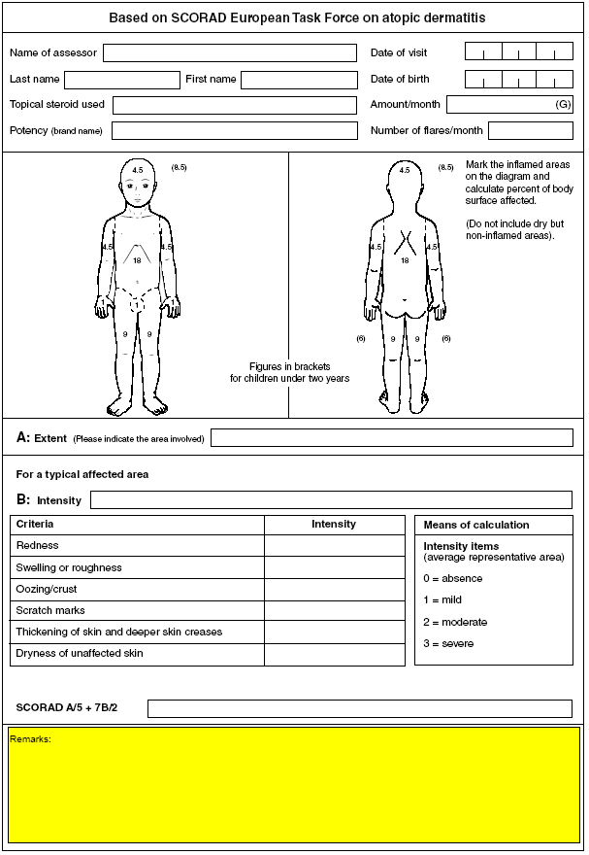

An unscheduled clinic visit may be conducted at any time for aversion to peanut, refusal of peanut, or both; or for suspected peanut allergy. Section 6.6 specifies which assessments are required for particular participants.
At least one of every four dietary consultations will be conducted face-to-face in the clinic or in the home; the others will be conducted on the phone. Dietary history will be assessed only at the visits closest to 20 months and to 42 months of age.
Oral food challenges will be performed as indicated in section 6.4.1.
Peanut challenges will be performed as indicated in sections 6.5.1 and 6.7.
Should occur between 48 and 60 months.

