Safety Analysis Report
Erin E Gabriel
July 27, 2015
This compares the number of subjects that are observed with at least one AE (0,1) and the count of AEs per subject accounting for follow-up time. All subjects that received at least one vaccination should be included here, because safety motioning starts as soon as a subject receives a vaccination. Comparisons are between 46 vaccinated subjects and 47 placebo subjects. Vaccine is always 'sample 1' and placebo is always 'sample 2' below.

Over All AE and AE by Grade and Relationship
melded binomial test for ratio
data: sample 1:(44/46), sample 2:(44/47)
proportion 1 = 0.9565, proportion 2 = 0.936, p-value = 1
alternative hypothesis: true ratio is not equal to 1
95 percent confidence interval:
0.8528816 1.1177552
sample estimates:
ratio (p2/p1)
0.9787234
Wilcoxon rank sum test with continuity correction
data: outcount$AEcount[outcount$trtfree == 1]/outcount$timeontrial[outcount$trtfree == and outcount$AEcount[outcount$trtfree == 0]/outcount$timeontrial[outcount$trtfree == 1] and 0]
W = 1056, p-value = 0.8505
alternative hypothesis: true location shift is not equal to 0
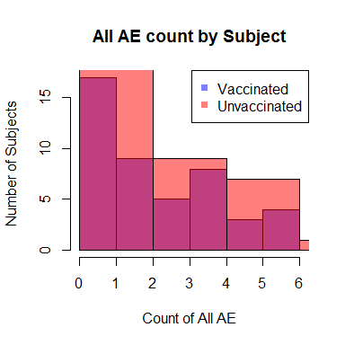

Grade 3
melded binomial test for ratio
data: sample 1:(5/46), sample 2:(4/47)
proportion 1 = 0.1087, proportion 2 = 0.085, p-value = 0.9723
alternative hypothesis: true ratio is not equal to 1
95 percent confidence interval:
0.1645184 3.4175098
sample estimates:
ratio (p2/p1)
0.7829787
Wilcoxon rank sum test with continuity correction
data: outcount$grade3count[outcount$trtfree == 1]/outcount$timeontrial[outcount$trtfree == and outcount$grade3count[outcount$trtfree == 0]/outcount$timeontrial[outcount$trtfree == 1] and 0]
W = 1106, p-value = 0.7136
alternative hypothesis: true location shift is not equal to 0
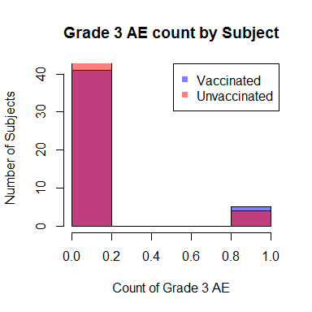

Grade 2
melded binomial test for ratio
data: sample 1:(10/46), sample 2:(14/47)
proportion 1 = 0.2174, proportion 2 = 0.298, p-value = 0.5165
alternative hypothesis: true ratio is not equal to 1
95 percent confidence interval:
0.6324645 3.1183739
sample estimates:
ratio (p2/p1)
1.370213
Wilcoxon rank sum test with continuity correction
data: outcount$grade2count[outcount$trtfree == 1]/outcount$timeontrial[outcount$trtfree == and outcount$grade2count[outcount$trtfree == 0]/outcount$timeontrial[outcount$trtfree == 1] and 0]
W = 982, p-value = 0.3247
alternative hypothesis: true location shift is not equal to 0
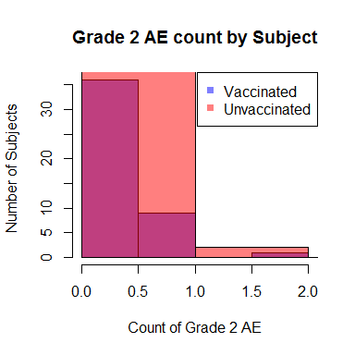

Grade 1
melded binomial test for ratio
data: sample 1:(38/46), sample 2:(37/47)
proportion 1 = 0.8261, proportion 2 = 0.787, p-value = 0.8333
alternative hypothesis: true ratio is not equal to 1
95 percent confidence interval:
0.7521777 1.2016377
sample estimates:
ratio (p2/p1)
0.9529675
Wilcoxon rank sum test with continuity correction
data: outcount$grade1count[outcount$trtfree == 1]/outcount$timeontrial[outcount$trtfree == and outcount$grade1count[outcount$trtfree == 0]/outcount$timeontrial[outcount$trtfree == 1] and 0]
W = 1086.5, p-value = 0.9692
alternative hypothesis: true location shift is not equal to 0
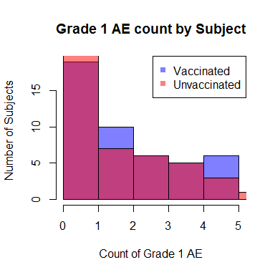

Related (everything that is possibly, probably or definitely related)
melded binomial test for ratio
data: sample 1:(9/46), sample 2:(15/47)
proportion 1 = 0.1957, proportion 2 = 0.319, p-value = 0.2609
alternative hypothesis: true ratio is not equal to 1
95 percent confidence interval:
0.7476198 3.8404634
sample estimates:
ratio (p2/p1)
1.631206
Wilcoxon rank sum test with continuity correction
data: outcount$relatedcount[outcount$trtfree == 1]/outcount$timeontrial[outcount$trtfree == and outcount$relatedcount[outcount$trtfree == 0]/outcount$timeontrial[outcount$trtfree == 1] and 0]
W = 960, p-value = 0.2285
alternative hypothesis: true location shift is not equal to 0
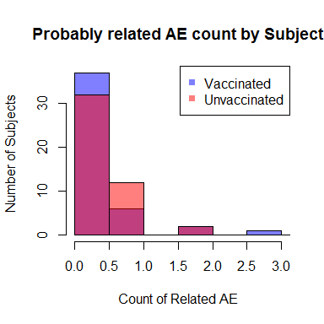

Unrelated (everything that is not possibly, probably or definitely related)
melded binomial test for ratio
data: sample 1:(44/46), sample 2:(40/47)
proportion 1 = 0.9565, proportion 2 = 0.851, p-value = 0.1683
alternative hypothesis: true ratio is not equal to 1
95 percent confidence interval:
0.7429694 1.0415407
sample estimates:
ratio (p2/p1)
0.8897485
Wilcoxon rank sum test with continuity correction
data: outcount$unrelatedcount[outcount$trtfree == 1]/outcount$timeontrial[outcount$trtfree == and outcount$unrelatedcount[outcount$trtfree == 0]/outcount$timeontrial[outcount$trtfree == 1] and 0]
W = 1167.5, p-value = 0.5082
alternative hypothesis: true location shift is not equal to 0
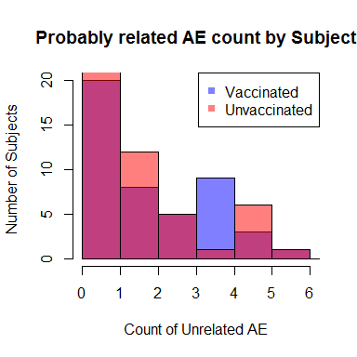

Malaria
Malaria comparison by Grade.

Grade 3
melded binomial test for ratio
data: sample 1:(2/46), sample 2:(3/47)
proportion 1 = 0.0435, proportion 2 = 0.064, p-value = 1
alternative hypothesis: true ratio is not equal to 1
95 percent confidence interval:
0.176053 16.959285
sample estimates:
ratio (p2/p1)
1.468085
Wilcoxon rank sum test with continuity correction
data: outcount$malaria3[outcount$trtfree == 1]/outcount$timeontrial[outcount$trtfree == and outcount$malaria3[outcount$trtfree == 0]/outcount$timeontrial[outcount$trtfree == 1] and 0]
W = 1057, p-value = 0.6441
alternative hypothesis: true location shift is not equal to 0
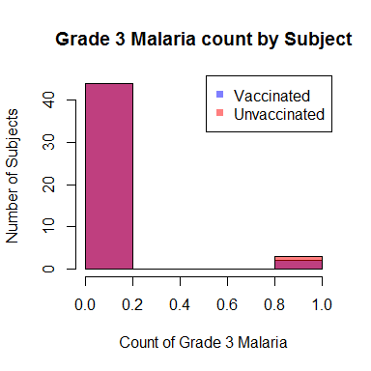

Grade 2
melded binomial test for ratio
data: sample 1:(4/46), sample 2:(7/47)
proportion 1 = 0.087, proportion 2 = 0.149, p-value = 0.548
alternative hypothesis: true ratio is not equal to 1
95 percent confidence interval:
0.4683389 7.5294848
sample estimates:
ratio (p2/p1)
1.712766
Wilcoxon rank sum test with continuity correction
data: outcount$malaria2[outcount$trtfree == 1]/outcount$timeontrial[outcount$trtfree == and outcount$malaria2[outcount$trtfree == 0]/outcount$timeontrial[outcount$trtfree == 1] and 0]
W = 1013, p-value = 0.355
alternative hypothesis: true location shift is not equal to 0
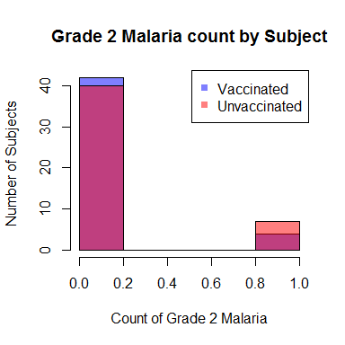

Grade 1
melded binomial test for ratio
data: sample 1:(16/46), sample 2:(17/47)
proportion 1 = 0.3478, proportion 2 = 0.362, p-value = 1
alternative hypothesis: true ratio is not equal to 1
95 percent confidence interval:
0.5635091 1.9326171
sample estimates:
ratio (p2/p1)
1.039894
Wilcoxon rank sum test with continuity correction
data: outcount$malaria1[outcount$trtfree == 1]/outcount$timeontrial[outcount$trtfree == and outcount$malaria1[outcount$trtfree == 0]/outcount$timeontrial[outcount$trtfree == 1] and 0]
W = 1062.5, p-value = 0.8715
alternative hypothesis: true location shift is not equal to 0
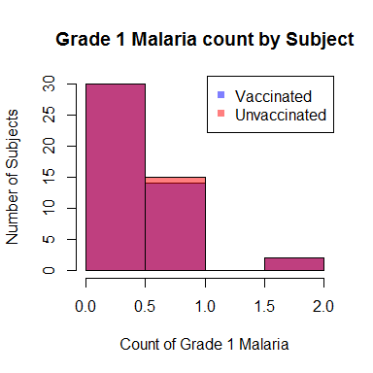

Solicited
melded binomial test for ratio
data: sample 1:(7/46), sample 2:(9/47)
proportion 1 = 0.1522, proportion 2 = 0.191, p-value = 0.8212
alternative hypothesis: true ratio is not equal to 1
95 percent confidence interval:
0.4551194 3.6700016
sample estimates:
ratio (p2/p1)
1.258359
Wilcoxon rank sum test with continuity correction
data: outcount$Solicitedcount[outcount$trtfree == 1]/outcount$timeontrial[outcount$trtfree == and outcount$Solicitedcount[outcount$trtfree == 0]/outcount$timeontrial[outcount$trtfree == 1] and 0]
W = 1030, p-value = 0.555
alternative hypothesis: true location shift is not equal to 0
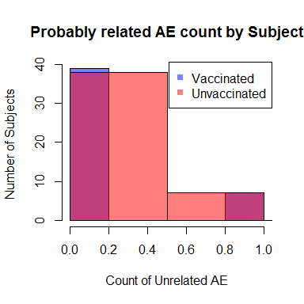

Solicited AE Binary only
1= observed having this AE during follow-up, 0= not observed having this AE during follow-up
[1] "BRADYCARDIA"
melded binomial test for ratio
data: sample 1:(0/46), sample 2:(1/47)
proportion 1 = 0, proportion 2 = 0.021, p-value = 1
alternative hypothesis: true ratio is not equal to 1
95 percent confidence interval:
0.02564238 Inf
sample estimates:
ratio (p2/p1)
Inf
[1] "GRANULOCYTE COUNT DECREASED"
melded binomial test for ratio
data: sample 1:(4/46), sample 2:(2/47)
proportion 1 = 0.087, proportion 2 = 0.043, p-value = 0.6565
alternative hypothesis: true ratio is not equal to 1
95 percent confidence interval:
0.04591296 3.23967690
sample estimates:
ratio (p2/p1)
0.4893617
[1] "HEADACHE"
melded binomial test for ratio
data: sample 1:(7/46), sample 2:(7/47)
proportion 1 = 0.1522, proportion 2 = 0.149, p-value = 1
alternative hypothesis: true ratio is not equal to 1
95 percent confidence interval:
0.316775 3.024982
sample estimates:
ratio (p2/p1)
0.9787234
[1] "PYREXIA"
melded binomial test for ratio
data: sample 1:(0/46), sample 2:(1/47)
proportion 1 = 0, proportion 2 = 0.021, p-value = 1
alternative hypothesis: true ratio is not equal to 1
95 percent confidence interval:
0.02564238 Inf
sample estimates:
ratio (p2/p1)
Inf
[1] "MALAISE"
melded binomial test for ratio
data: sample 1:(0/46), sample 2:(1/47)
proportion 1 = 0, proportion 2 = 0.021, p-value = 1
alternative hypothesis: true ratio is not equal to 1
95 percent confidence interval:
0.02564238 Inf
sample estimates:
ratio (p2/p1)
Inf
[1] "INJECTION SITE PAIN"
melded binomial test for ratio
data: sample 1:(0/46), sample 2:(4/47)
proportion 1 = 0, proportion 2 = 0.085, p-value = 0.1222
alternative hypothesis: true ratio is not equal to 1
95 percent confidence interval:
0.6748939 Inf
sample estimates:
ratio (p2/p1)
Inf
[1] "DIASTOLIC HYPERTENSION"
melded binomial test for ratio
data: sample 1:(1/46), sample 2:(0/47)
proportion 1 = 0.0217, proportion 2 = 0, p-value = 0.9892
alternative hypothesis: true ratio is not equal to 1
95 percent confidence interval:
0.00000 37.41406
sample estimates:
ratio (p2/p1)
0
[1] "SCHISTOSOMIASIS"
melded binomial test for ratio
data: sample 1:(1/46), sample 2:(2/47)
proportion 1 = 0.0217, proportion 2 = 0.043, p-value = 1
alternative hypothesis: true ratio is not equal to 1
95 percent confidence interval:
0.1055245 113.1573254
sample estimates:
ratio (p2/p1)
1.957447
[1] "ALANINE AMINOTRANSFERASE INCREASED"
melded binomial test for ratio
data: sample 1:(2/46), sample 2:(0/47)
proportion 1 = 0.0435, proportion 2 = 0, p-value = 0.4839
alternative hypothesis: true ratio is not equal to 1
95 percent confidence interval:
0.000000 5.044912
sample estimates:
ratio (p2/p1)
0
[1] "BLOOD CREATININE INCREASED"
melded binomial test for ratio
data: sample 1:(0/46), sample 2:(1/47)
proportion 1 = 0, proportion 2 = 0.021, p-value = 1
alternative hypothesis: true ratio is not equal to 1
95 percent confidence interval:
0.02564238 Inf
sample estimates:
ratio (p2/p1)
Inf
[1] "FATIGUE"
melded binomial test for ratio
data: sample 1:(3/46), sample 2:(1/47)
proportion 1 = 0.0652, proportion 2 = 0.021, p-value = 0.6005
alternative hypothesis: true ratio is not equal to 1
95 percent confidence interval:
0.006355636 3.890366854
sample estimates:
ratio (p2/p1)
0.3262411
[1] "HEMOGLOBIN DECREASED"
melded binomial test for ratio
data: sample 1:(3/46), sample 2:(3/47)
proportion 1 = 0.0652, proportion 2 = 0.064, p-value = 1
alternative hypothesis: true ratio is not equal to 1
95 percent confidence interval:
0.1373882 6.9751403
sample estimates:
ratio (p2/p1)
0.9787234
none of these are significantly different.

