PDF
001028.pdf
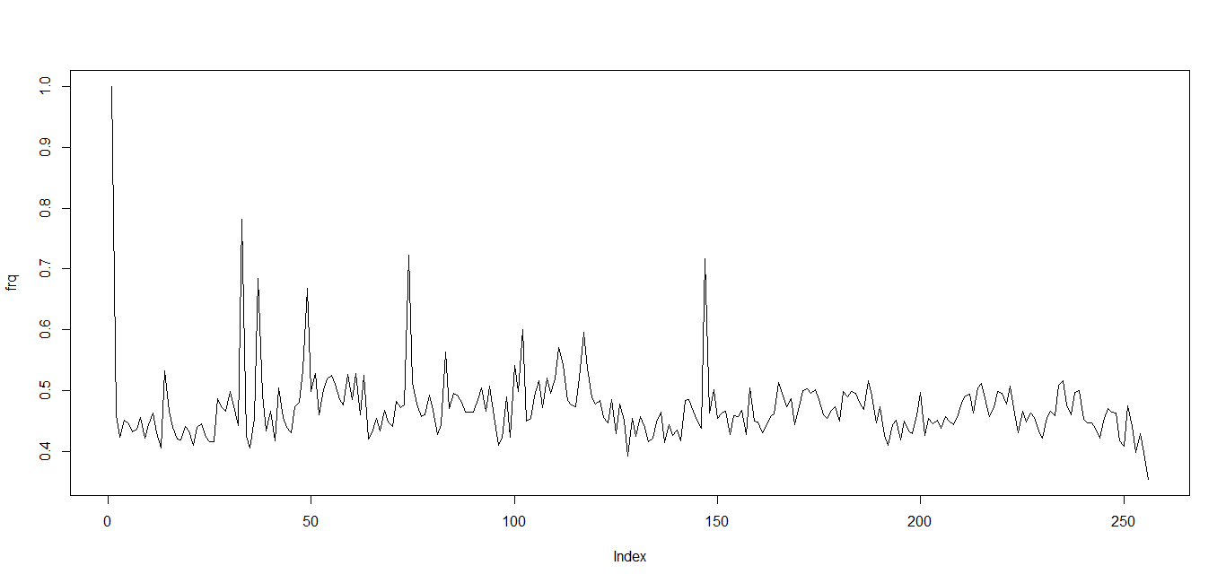
Min | 0.12560000
First Q | 0.19600000
Median | 0.21480000
Mean | 0.22680000
3rd Q | 0.24090000
Max | 1.00000000
IQR | 0.04482805
Correlation Coefficient | -0.15997065

001029.pdf (this one seems to be a bit abnormal compared to others in pdf)
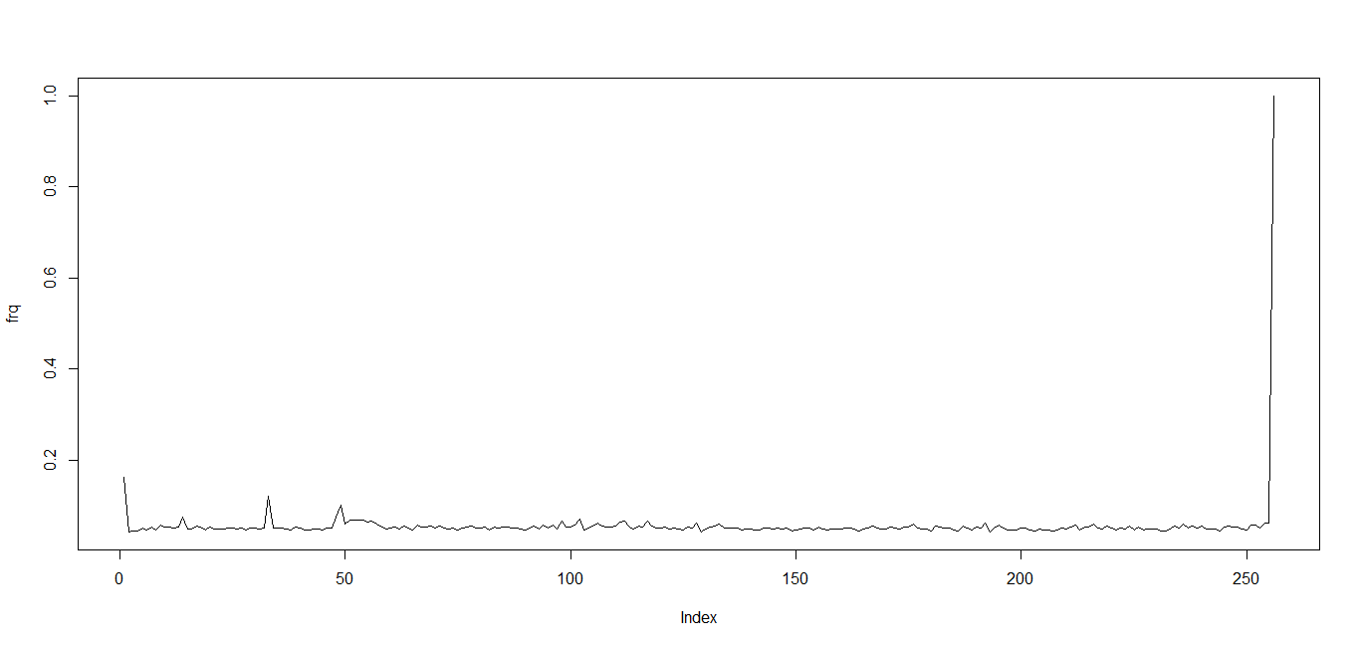
Min | 0.0017720000
First Q | 0.0023360000
Median | 0.0025850000
Mean | 0.0067730000
3rd Q | 0.0028880000
Max | 1.0000000000
IQR | 0.0005518852
Correlation Coefficient | 0.1028226089

001030.pdf
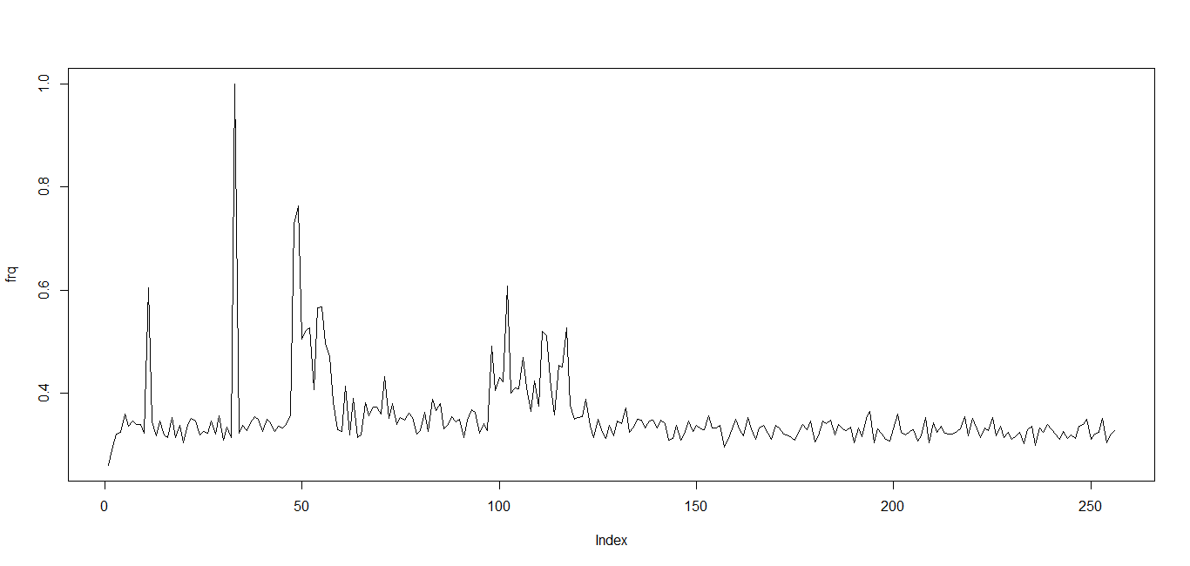
Min | 0.06799000
First Q | 0.10390000
Median | 0.11290000
Mean | 0.13210000
3rd Q | 0.12460000
Max | 1.00000000
IQR | 0.02068634
Correlation Coefficient | -0.24902849

001031.pdf
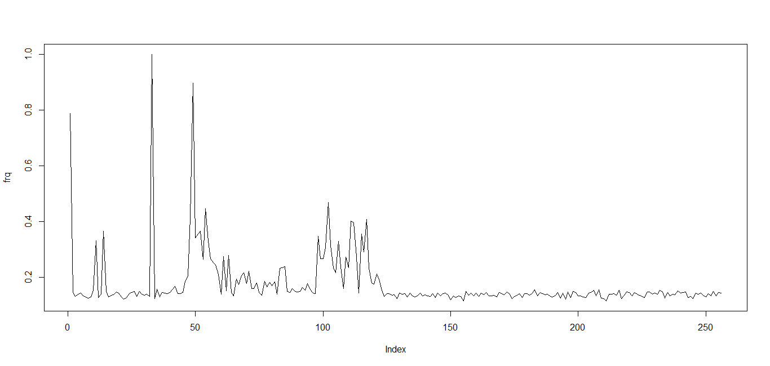
Min | 0.013300000
First Q | 0.018070000
Median | 0.020650000
Mean | 0.041370000
3rd Q | 0.025420000
Max | 1.000000000
IQR | 0.007347101
Correlation Coefficient | -0.227167810

001032.pdf
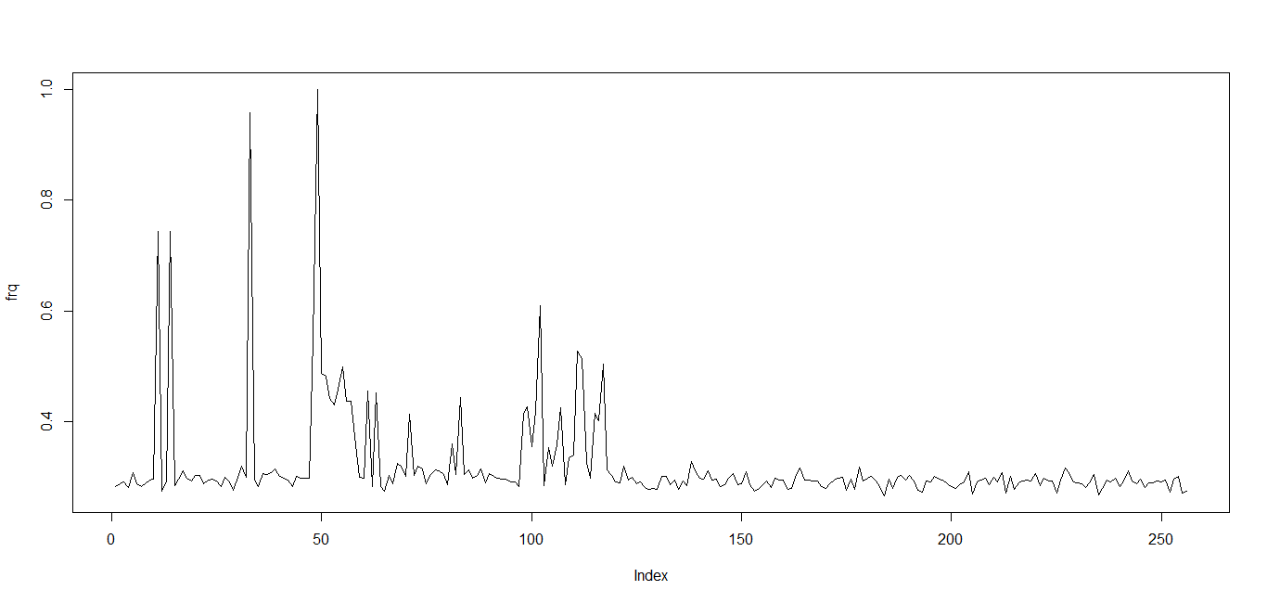
Min | 0.07077000
First Q | 0.08275000
Median | 0.08724000
Mean | 0.10980000
3rd Q | 0.09366000
Max | 1.00000000
IQR | 0.01091549
Correlation Coefficient | -0.24535978

The Correlation Coefficient indicates the direction of the distribution, a negative Correlation Coefficient tells as x increases the y decreases, the following shows the plot of the 001032.pdf histogram
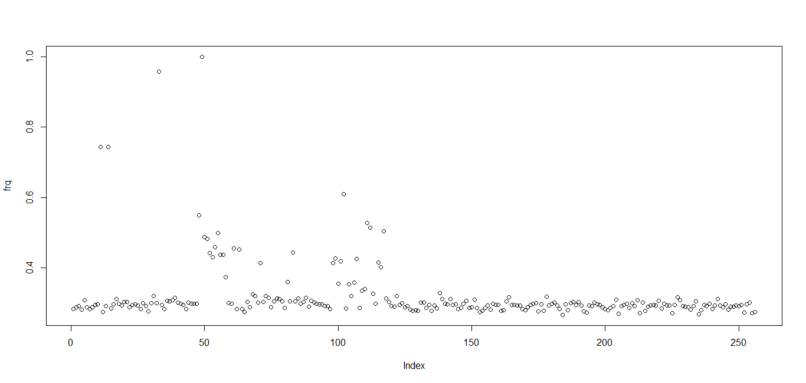
The linear distribution is not too obvious but we can still see a weaklinear direction where y decreases as x increases.

XLS
001108.xls
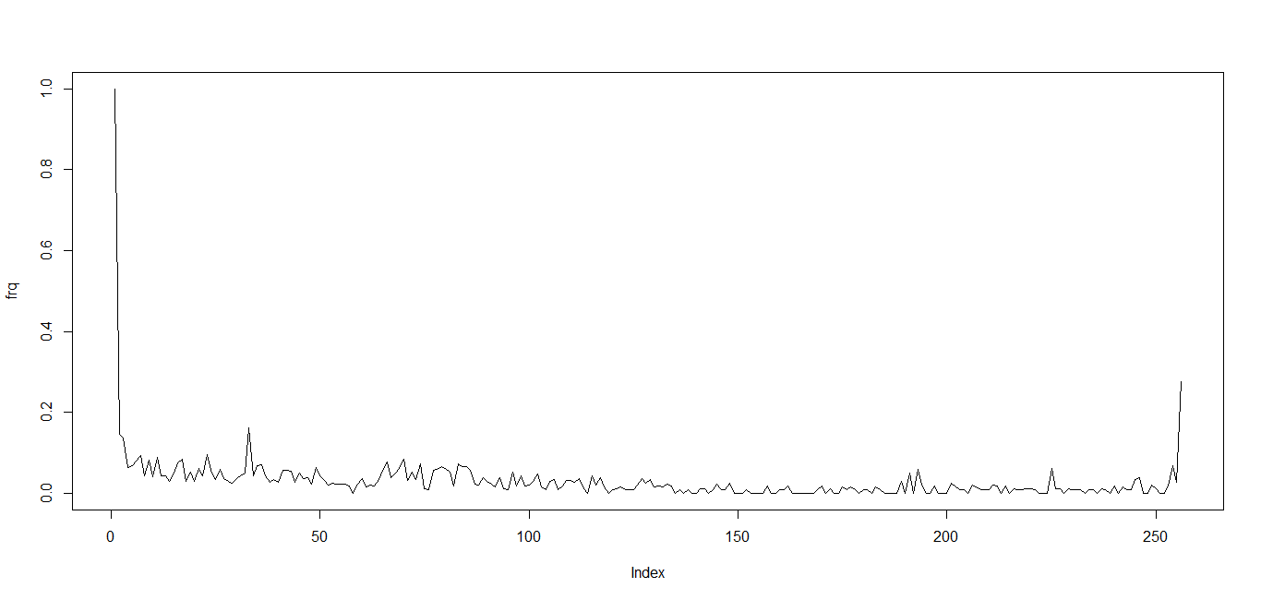
Min | 0.000000000
First Q | 0.000079180
Median | 0.000316700
Mean | 0.005542000
3rd Q | 0.001504000
Max | 1.000000000
IQR | 0.001425178
Correlation Coefficient | -0.120152862

001109.xls
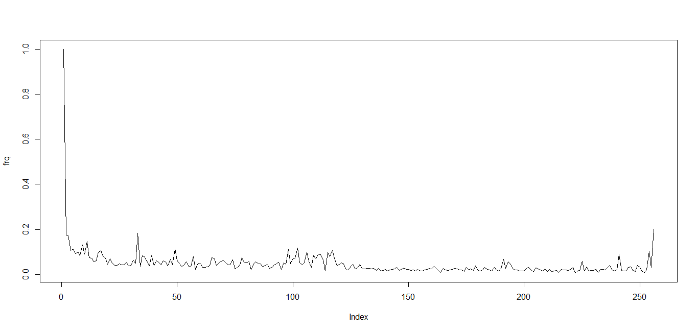
Min | 0.00004311
First Q | 0.00043110
Median | 0.00103500
Mean | 0.00672500
3rd Q | 0.00298500
Max | 1.00000000
IQR | 0.00255421
Correlation Coefficient | -0.13648889

001110.xls
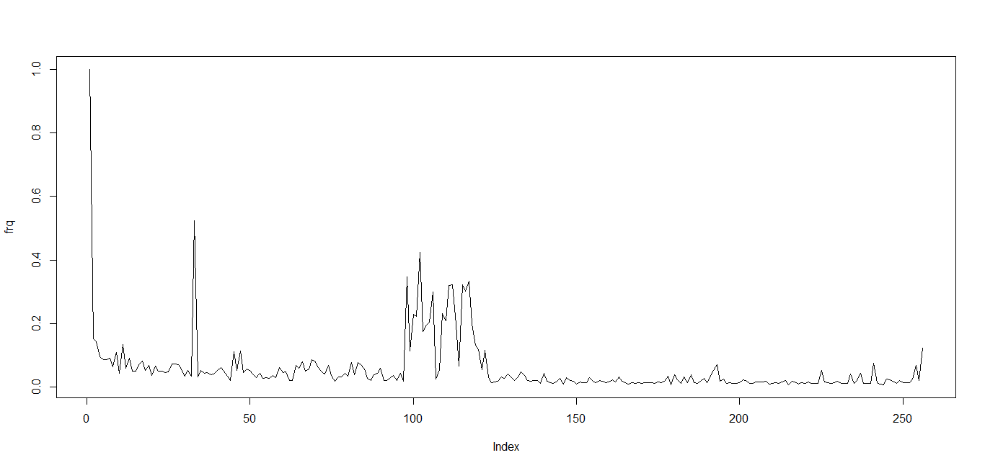
Min | 0.000046620
First Q | 0.000233100
Median | 0.000920700
Mean | 0.011980000
3rd Q | 0.003135000
Max | 1.000000000
IQR | 0.002902098
Correlation Coefficient | -0.161929443

001111.xls
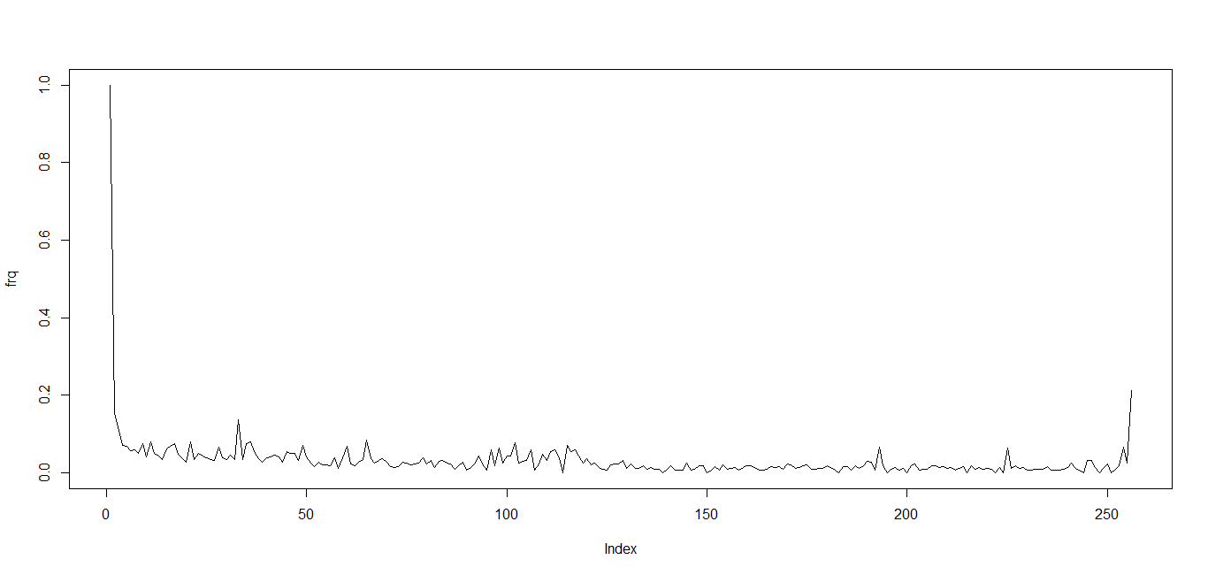
Min | 0.000000000
First Q | 0.000159500
Median | 0.000398600
Mean | 0.005315000
3rd Q | 0.001329000
Max | 1.000000000
IQR | 0.001169342
Correlation Coefficient | -0.120071162

001112.xls
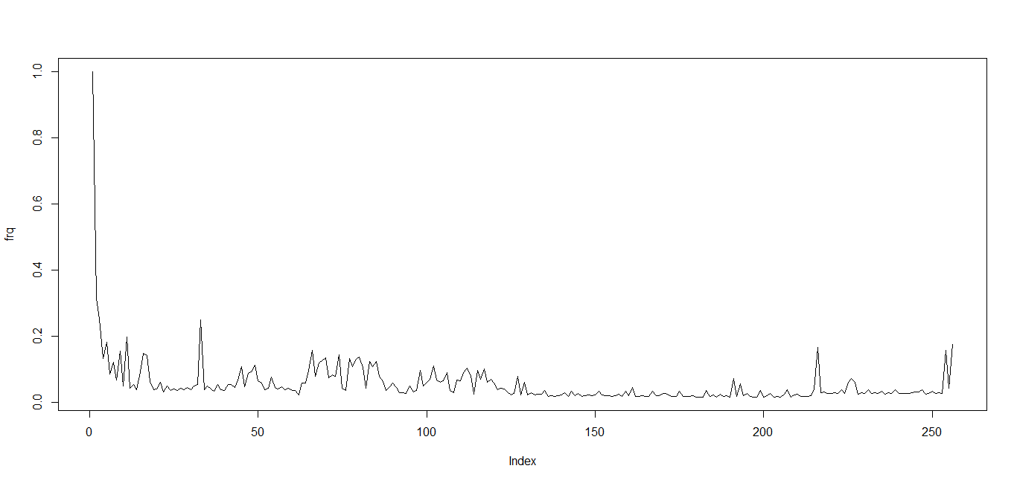
Min | 0.000233400
First Q | 0.000564100
Median | 0.001238000
Mean | 0.008404000
3rd Q | 0.003703000
Max | 1.000000000
IQR | 0.003138374
Correlation Coefficient | -0.158984624

HTML
001517.html
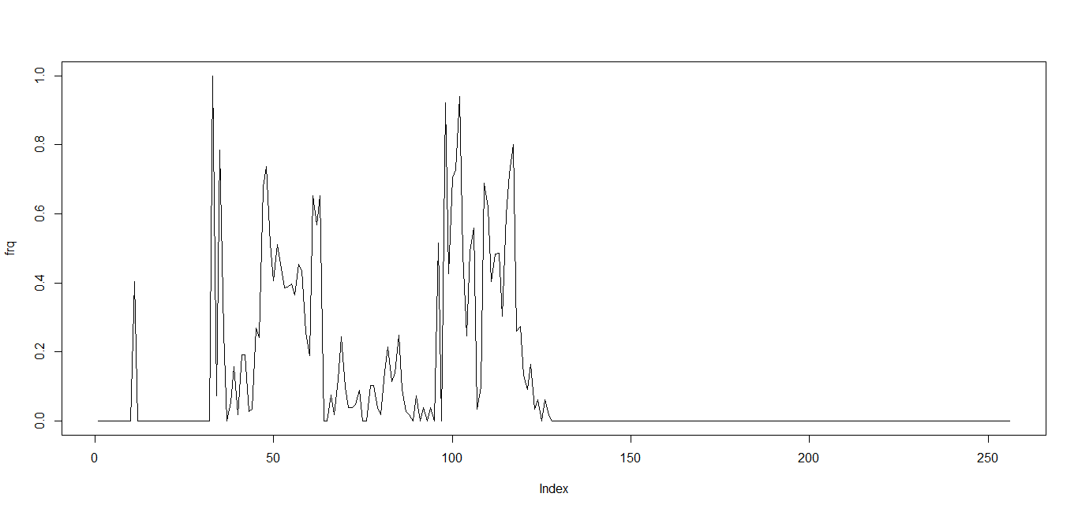
Min | 0.00000000
First Q | 0.00000000
Median | 0.00000000
Mean | 0.05437000
3rd Q | 0.00538100
Max | 1.00000000
IQR | 0.00538142
Correlation Coefficient | -0.24197609

001518.html
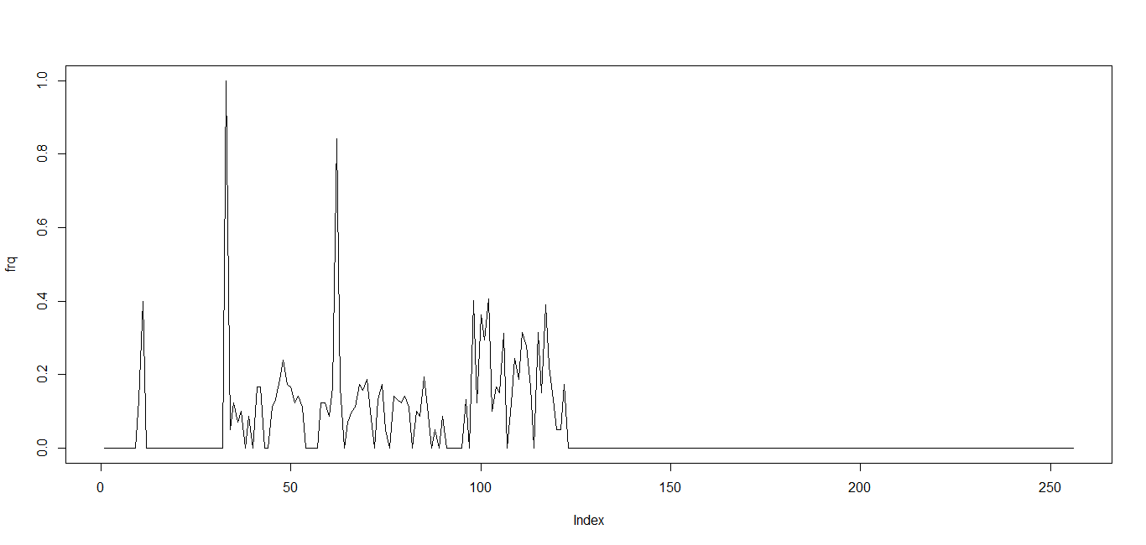

Min | 0.000000000
First Q | 0.000000000
Median | 0.000000000
Mean | 0.015880000
3rd Q | 0.004988000
Max | 1.000000000
IQR | 0.004987531
Correlation Coefficient | -0.161682085

001519.html
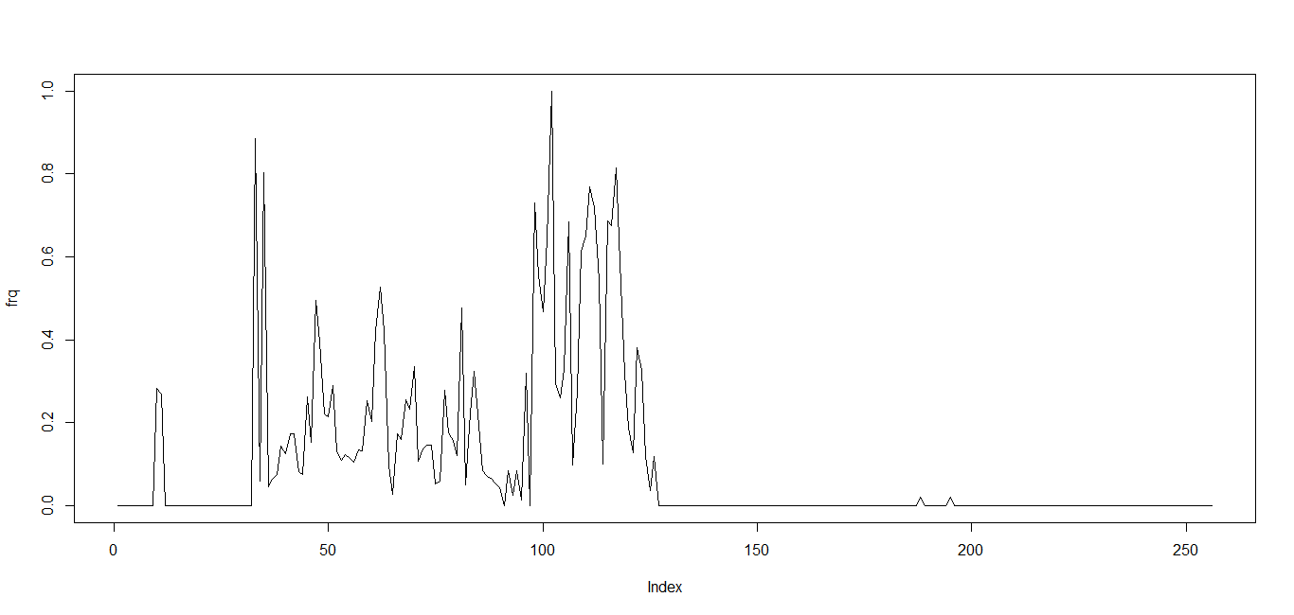
Min | 0.00000000
First Q | 0.00000000
Median | 0.00000000
Mean | 0.04762000
3rd Q | 0.01476000
Max | 1.00000000
IQR | 0.01476239
Correlation Coefficient | -0.18787470

001520.html
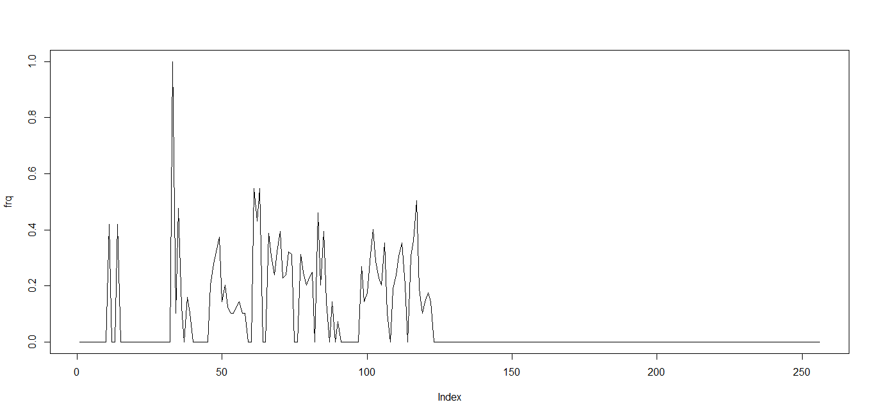
Min | 0.00000000
First Q | 0.00000000
Median | 0.00000000
Mean | 0.02429000
3rd Q | 0.01036000
Max | 1.00000000
IQR | 0.01036269
Correlation Coefficient | -0.25020609

001521.html

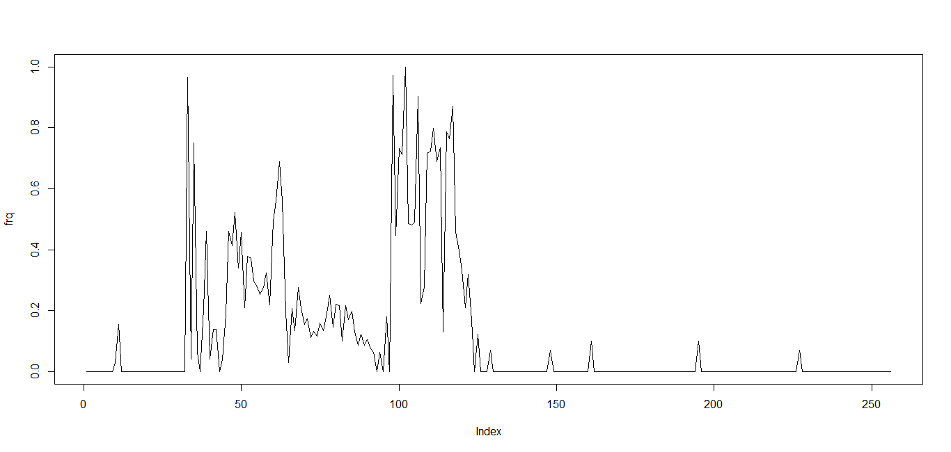
Min | 0.00000000
First Q | 0.00000000
Median | 0.00000000
Mean | 0.06247000
3rd Q | 0.02227000
Max | 1.00000000
IQR | 0.02227311
Correlation Coefficient | -0.20402850

