I have two VM’s, which I have assigned to Tag named “bc”.
- Without underscore in the Tag name (i.e bc) and the two VM’s are visible.

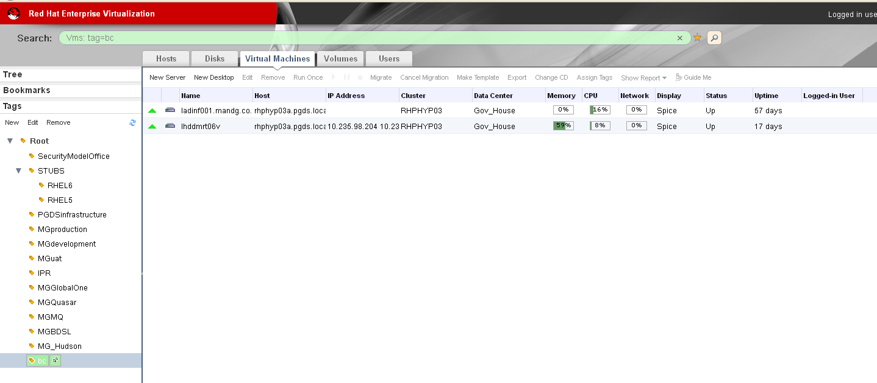

- With underscore in the Tag name (ie. b_c) and the two VM are no longer visible :-

