Prometheus retention verification
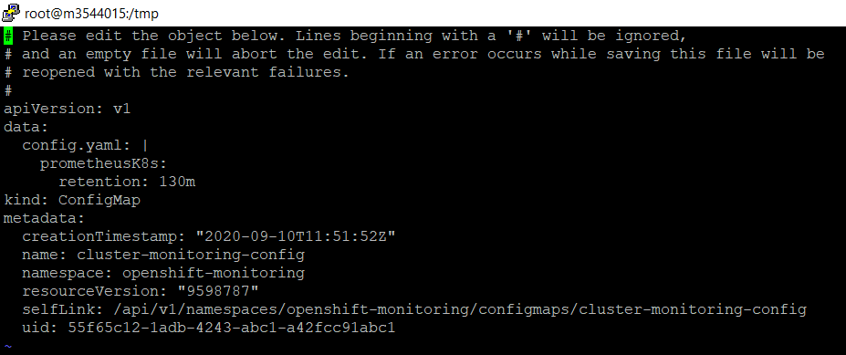

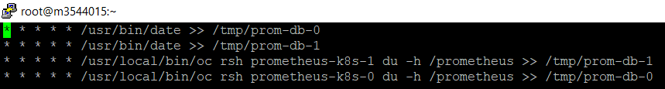

Attached files:

Screenshot before files deleted in 130 minutes of retention
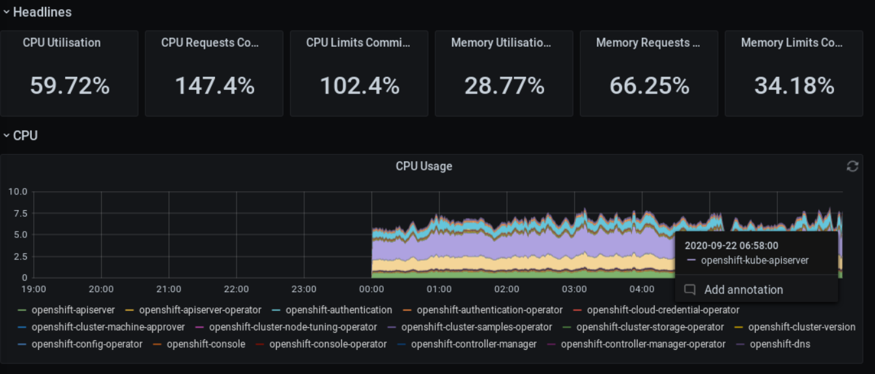

Screenshot after files deleted in 130 minutes of retention
