Recreating issue with VM reconfigure on 5.8.3.4.
Deploy cfme-vsphere-5.8.3.4-1.x86_64.vsphere.ova on a vcenter.
Open console, power on. Set IP address, hostname, set local DB configuration.
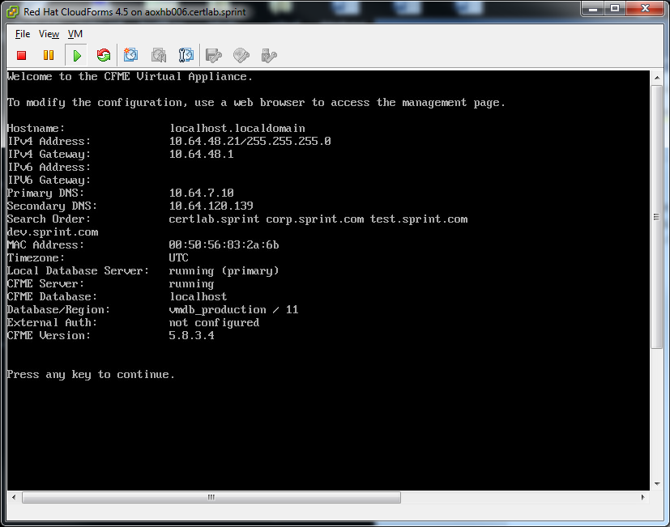

Reboot.
Open gui to the IP address.
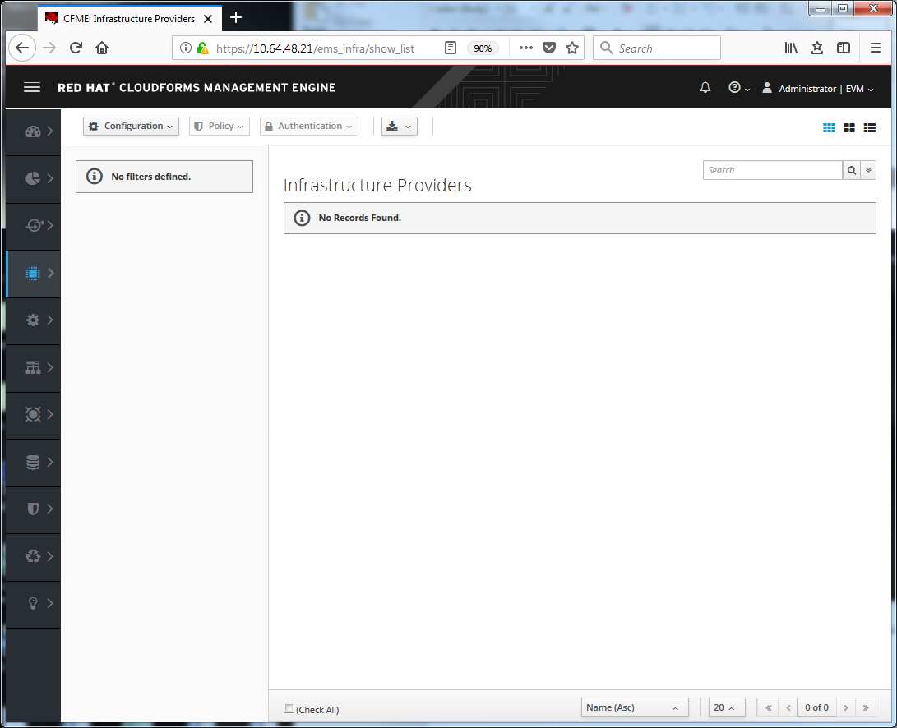
Add infrastructure provider.
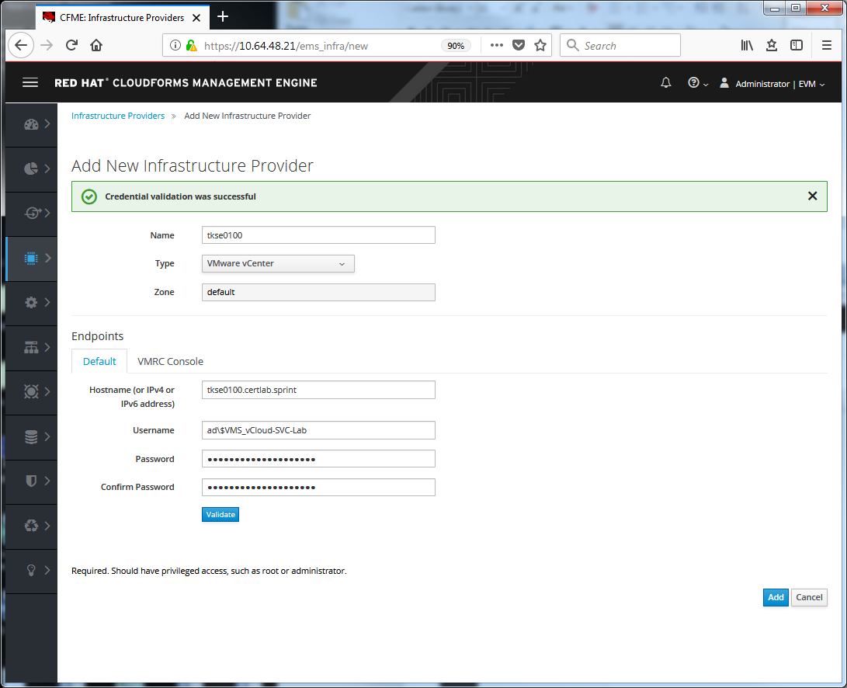
Create test domain.
Change quota to group
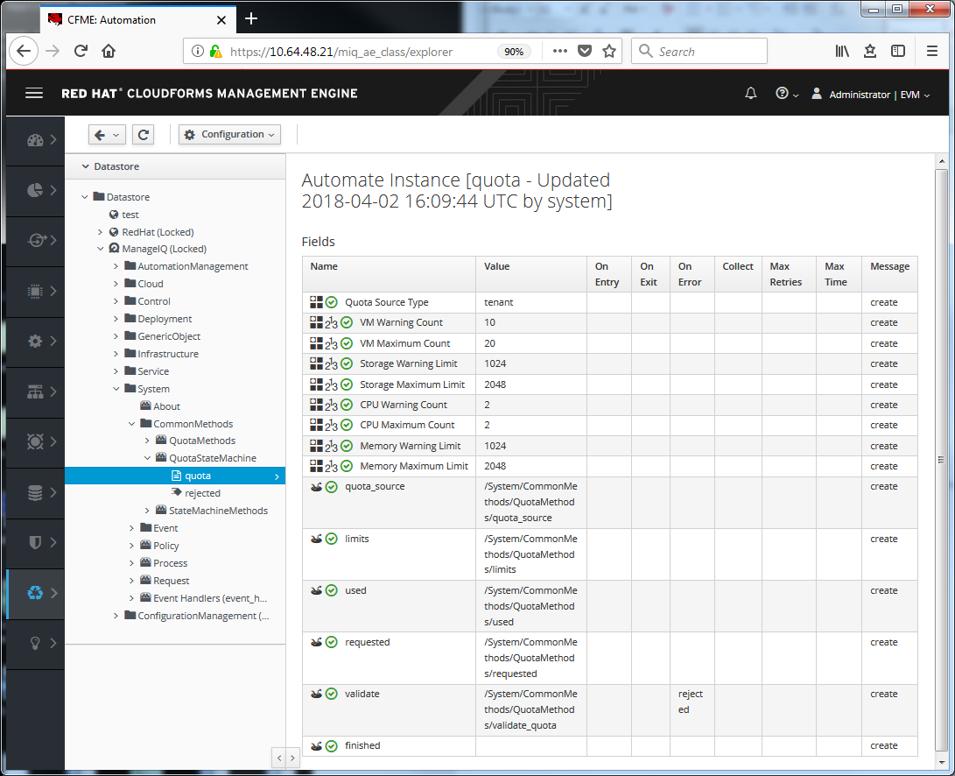
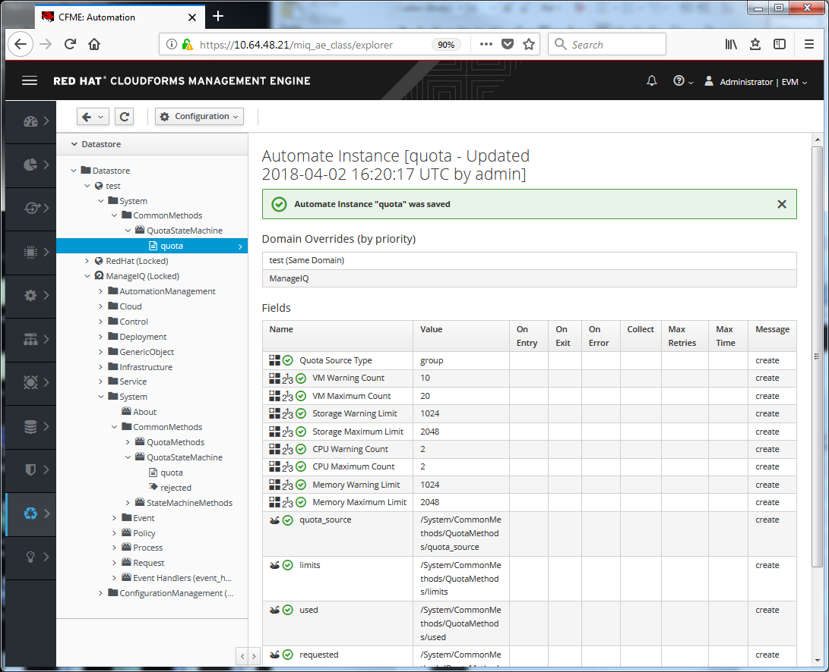
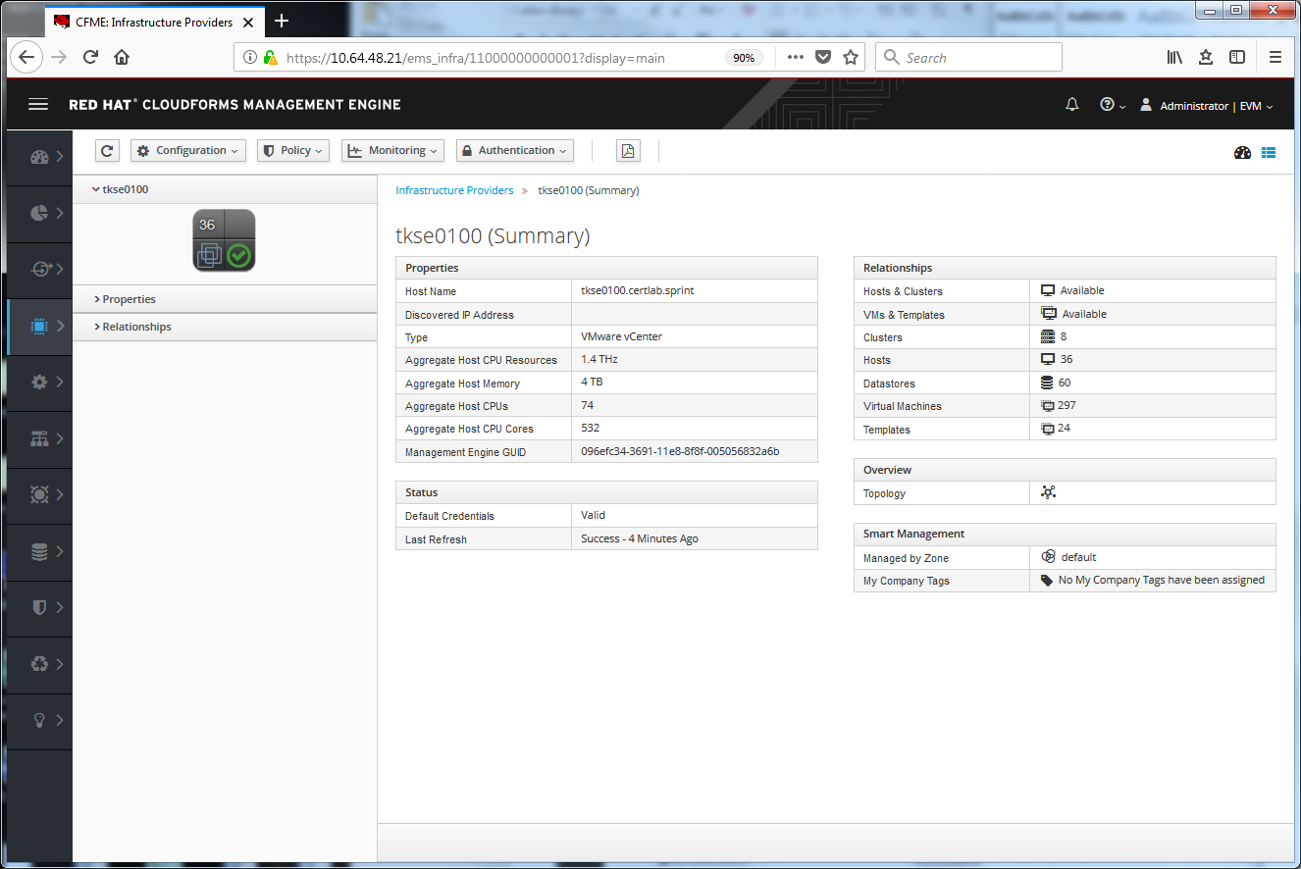
Select a VM and select reconfigure
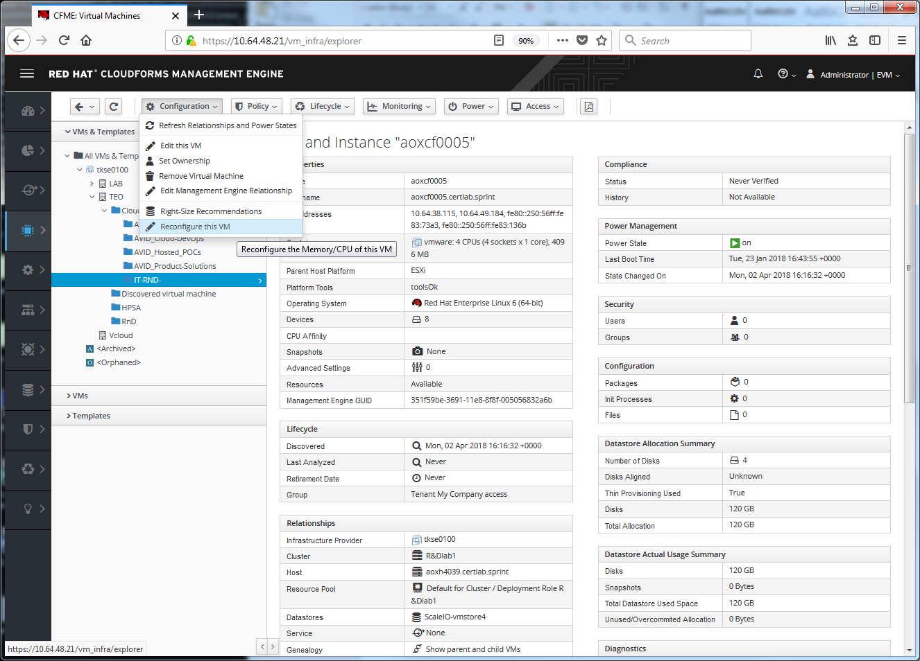

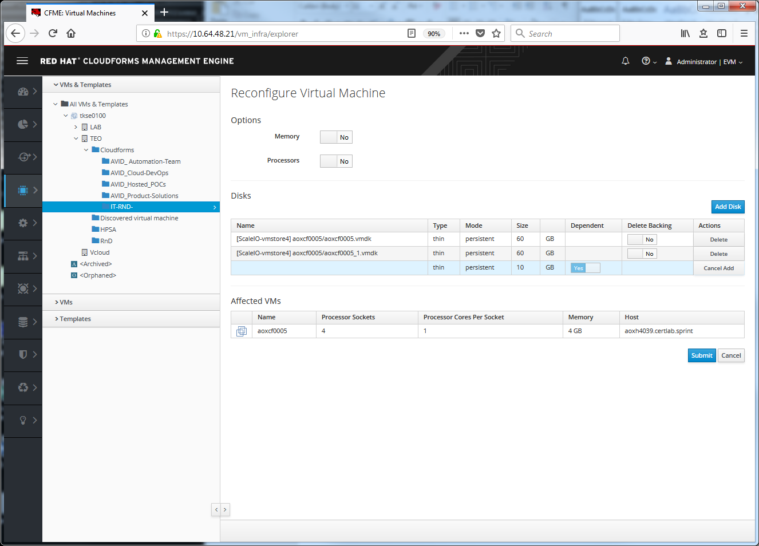

From automation.log:

[----] I, [2018-04-02T16:29:27.954042 #3205:526320c] INFO -- : Q-task_id([vm_reconfigure_request_11000000000001]) <AEMethod used> Quota source type: group
[----] E, [2018-04-02T16:29:27.960177 #3205:5a6be2c] ERROR -- : Q-task_id([vm_reconfigure_request_11000000000001]) <AEMethod used> The following error occurred during method evaluation:
[----] E, [2018-04-02T16:29:27.961116 #3205:5a6be2c] ERROR -- : Q-task_id([vm_reconfigure_request_11000000000001]) <AEMethod used> NoMethodError: undefined method `check_quota' for #<MiqAeMethodService::MiqAeServiceVmReconfigureRequest:0x0000000c562898>
[----] E, [2018-04-02T16:29:27.961972 #3205:5a6be2c] ERROR -- : Q-task_id([vm_reconfigure_request_11000000000001]) <AEMethod used> (druby://127.0.0.1:43044) /var/www/miq/vmdb/lib/miq_automation_engine/engine/miq_ae_method_service/miq_ae_service_model_base.rb:186:in `method_missing'
(druby://127.0.0.1:43044) /opt/rh/rh-ruby23/root/usr/share/ruby/drb/drb.rb:1624:in `perform_without_block'
(druby://127.0.0.1:43044) /opt/rh/rh-ruby23/root/usr/share/ruby/drb/drb.rb:1584:in `perform'
(druby://127.0.0.1:43044) /opt/rh/rh-ruby23/root/usr/share/ruby/drb/drb.rb:1657:in `block (2 levels) in main_loop'
(druby://127.0.0.1:43044) /opt/rh/rh-ruby23/root/usr/share/ruby/drb/drb.rb:1653:in `loop'
(druby://127.0.0.1:43044) /opt/rh/rh-ruby23/root/usr/share/ruby/drb/drb.rb:1653:in `block in main_loop'
/ManageIQ/System/CommonMethods/QuotaMethods/used:70:in `active_provision_counts'
/ManageIQ/System/CommonMethods/QuotaMethods/used:31:in `used'
/ManageIQ/System/CommonMethods/QuotaMethods/used:18:in `main'
[----] E, [2018-04-02T16:29:27.966444 #3205:5a6be2c] ERROR -- : Q-task_id([vm_reconfigure_request_11000000000001]) Method STDERR: (druby://127.0.0.1:43044) /var/www/miq/vmdb/lib/miq_automation_engine/engine/miq_ae_method_service/miq_ae_service_model_base.rb:186:in `method_missing': undefined method `check_quota' for #<MiqAeMethodService::MiqAeServiceVmReconfigureRequest:0x0000000c562898> (NoMethodError)

