|  |  |  |  |  |  |
| --- | --- | --- | --- | --- | --- |
|  |  | | | |  |
|  | | | |
|  | | | |
| 方圆ok1 | | | | |
|  | Analysis Report on Suspended OS Installation for a Russian Site | | 附件1-16K | |
| **Issue** | **01** |
| **Date** | **2017-03-22** |
| **HUAWEI TECHNOLOGIES CO., LTD.** | |
|  | | | |
| Copyright © Huawei Technologies Co., Ltd. 2017. All rights reserved.  No part of this document may be reproduced or transmitted in any form or by any means without prior written consent of Huawei Technologies Co., Ltd.  Trademarks and Permissions  附件3-图 and other Huawei trademarks are trademarks of Huawei Technologies Co., Ltd.  All other trademarks and trade names mentioned in this document are the property of their respective holders.  Notice  The purchased products, services and features are stipulated by the contract made between Huawei and the customer. All or part of the products, services and features described in this document may not be within the purchase scope or the usage scope. Unless otherwise specified in the contract, all statements, information, and recommendations in this document are provided "AS IS" without warranties, guarantees or representations of any kind, either expressed or implied.  The information in this document is subject to change without notice. Every effort has been made in the preparation of this document to ensure accuracy of the contents, but all statements, information, and recommendations in this document do not constitute the warranty of any kind, express or implied. | | | |

|  |  |
| --- | --- |
| Huawei Technologies Co., Ltd. | |
| Address: | Huawei Industrial Base  Bantian, Longgang  Shenzhen 518129  People's Republic of China |
| Web site: | <http://e.huawei.com> |
| Email: | [support@huawei.com](mailto:Support@huawei.com) |
|  |  |

About This Document

Trouble Ticket Information

|  |  |
| --- | --- |
| Trouble Ticket Number |  |
| Prepared by | Ye Qiang |
| Approved by | Fang Haibin |
| Approval Date | 2017-03-22 |

Change History

| Issue | Date | Author | Change Description |
| --- | --- | --- | --- |
| 01 | 2017-03-22 | Ye Qiang | This is the first issue |

Contents

About This Document iii

1 Basic Information 1-1

2 Problem Description 2-1

3 Problem Analysis 3-1

4 Root Cause 4-1

5 Corrective Action 5-1

5.1 Solution 5-1

# Basic Information

Server model: RH2288HV3

CPU: E5-2680 v4 x 2

Memory: 32 GB x 16

Server software version information:

BIOS version: (U47) 3.52

Active iBMC version: (U25) 2.30

# Problem Description

Red Hat Enterprise Linux (RHEL) 7.3 has been installed on an RH2288H V3 server since September 2016. The server was running properly until February 2017.

The customer mounted an RHEL 7.2 ISO file, restarted the server, and selected the virtual CD-ROM drive to install the OS.

According to the customer feedback, the installation suspended or the server restarted during the installation.

The same ISO file can be used properly on other servers.

The same problem occurred when different ISO files were used to install the OS.

The problem could not be resolved by upgrading the BIOS to 3.52 and BMC to 2.30, the latest versions.

The problem could not be resolved by restoring the default BIOS settings.

The OS installation was successfully on the other servers (30+) on the site.

Figure 1 Suspended OS installation

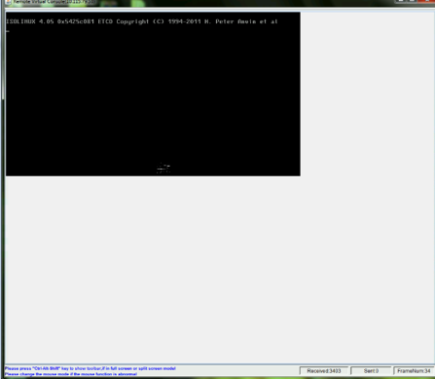

Figure 2 BMC logs



# Problem Analysis

The BMC alarm and FDM log analysis indicate that QPI link exception occurred, which resulted in system suspension or restart. According to the error type, this problem was not a hardware signal issue, but a software protocol layer exception. Some communication packets that were not supported by the QPI protocol existed in the QPI link, which results in the QPI link exception.

Figure 3 FDM logs recorded during the suspension

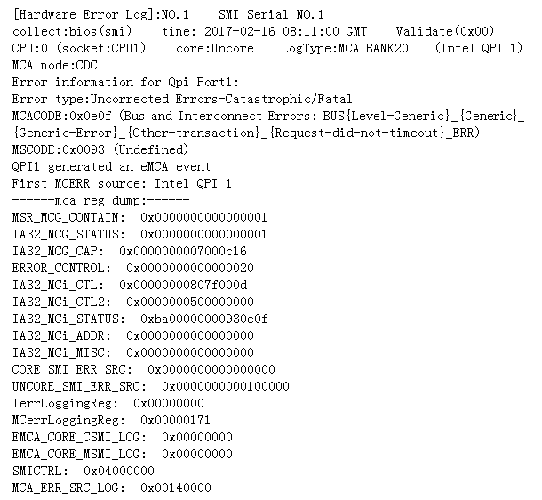

The problem was reproduced in a lab.

To reproduce the problem, the lab test used the same software and hardware configuration as those on the customer site, and simulated the customer operation process of installing RHEL 7.3 first and then mounting an RHEL 7.2 ISO file to install RHEL 7.2. After repeated attempts, the method of reproducing the problem was found. After mounting an RHEL 7.2 ISO file, the OS installation often suspended if system hot reset was performed. The BMC alarms and FDM logs were consistent with those on the customer site.

Figure 4 Lab reproduction symptom

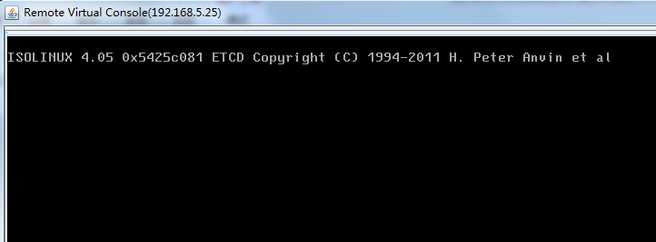

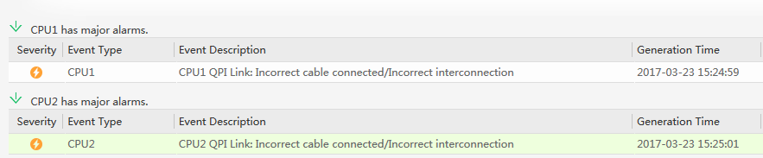

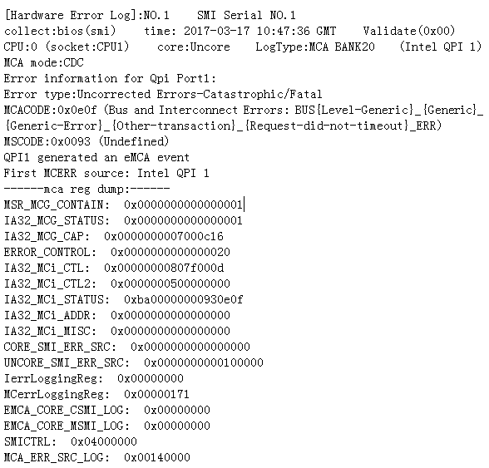

The problem was reproduced even after the CPUs, DIMMs, and hard disks were replaced and software versions were upgraded, which indicated that the problem was not caused by hardware and software configurations. Multiple OSs were also installed in the test. This problem occurred only when RHEL 7.3 was installed after hot reset was performed. However, this problem did not occur if the server was powered off and then powered on before the OS installation.

Table 1 Comparison test results of different OSs

|  |  |  |  |
| --- | --- | --- | --- |
| No. | OS Installation | Hot Reset | Server Power-off and then Power-on |
| 1 | Install RHEL 7.3 and then install RHEL 7.2. | The problem occurs frequently. | The problem does not occur. |
| 2 | Install RHEL 7.3 and then install RHEL 6.5. | The problem occurs frequently. | The problem does not occur. |
| 3 | Install RHEL 7.3 and then install SLES 12. | The problem does not occur. | The problem does not occur. |
| 4 | Install RHEL 7.3 and then install Windows Server 2012 | The problem does not occur. | The problem does not occur. |
| 5 | Install RHEL 7.2 and then install RHEL 7.3. | The problem does not occur. | The problem does not occur. |
| 6 | Install SLES 12 and then install RHEL 7.2. | The problem does not occur. | The problem does not occur. |

The same problem also occurred on HP servers under the same test conditions.

Problem analysis and verification

According to an Intel expert, during hot reset, the system does not perform memory initialization. Therefore, some residual data of RHEL 7.3 exists in the memory after hot reset. During the installation of a new RHEL OS, the residual data is considered as normal data, which causes the QPI link exception. In this case, the OS installation suspends. To verify the preceding theoretical analysis, the test engineer performed memory initialization in the BIOS of the debug version to clear the residual data of RHEL 7.3. The problem did not occur in more than 50 tests on five servers, which indicates that the theoretical analysis is correct.

This problem occurred only in RHEL 7.3. RHEL may have some defects. Huawei has provided feedback to Red Hat and ask them to analyze and resolve this problem.

# Root Cause

During hot reset, the system does not perform memory initialization. Therefore, some residual data of RHEL 7.3 exists in the memory after hot reset. During the installation of a new RHEL OS, the residual data is considered as normal data, which causes the QPI link exception. In this case, the OS installation suspends.

# Corrective Action

## Solution

To install another OS on a server that runs RHEL 7.3 previously, power off the server and then power on the server before installing the new OS.



Huawei has provided feedback to Red Hat and ask them to analyze and resolve this problem.