IMPORTANT: Before deploying a new site make sure there is “only one” logical disk configured on internal diskarray controller, use iLO GUI to check DL360 servers and BL460 blades.

DL360 iLO, only “Logical Drive 01” should be available

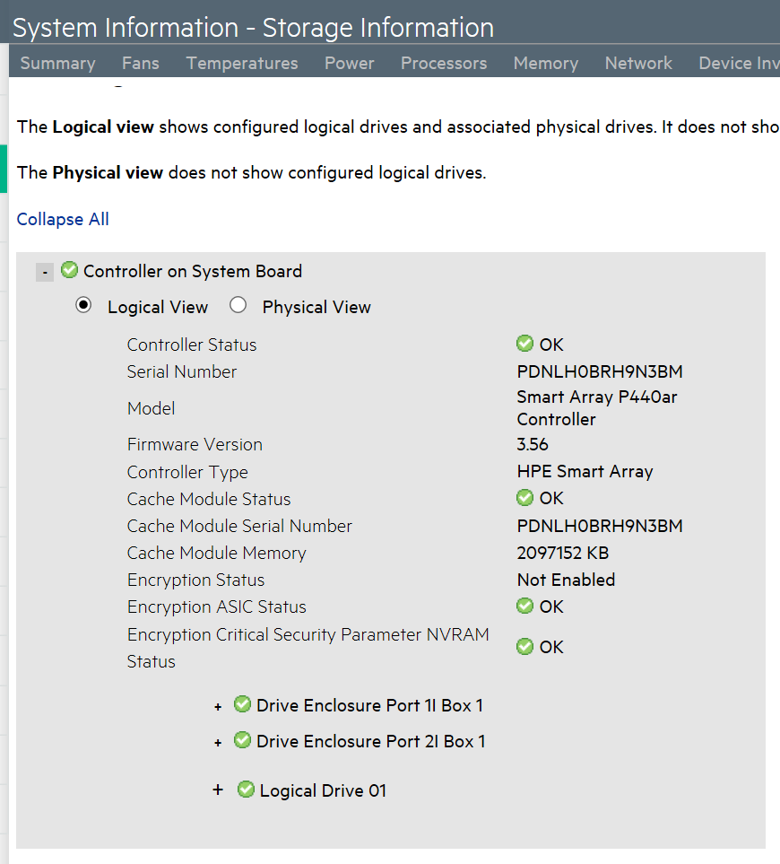

BL460 (C7K) Blade iLO, only “Logical Drive 01”

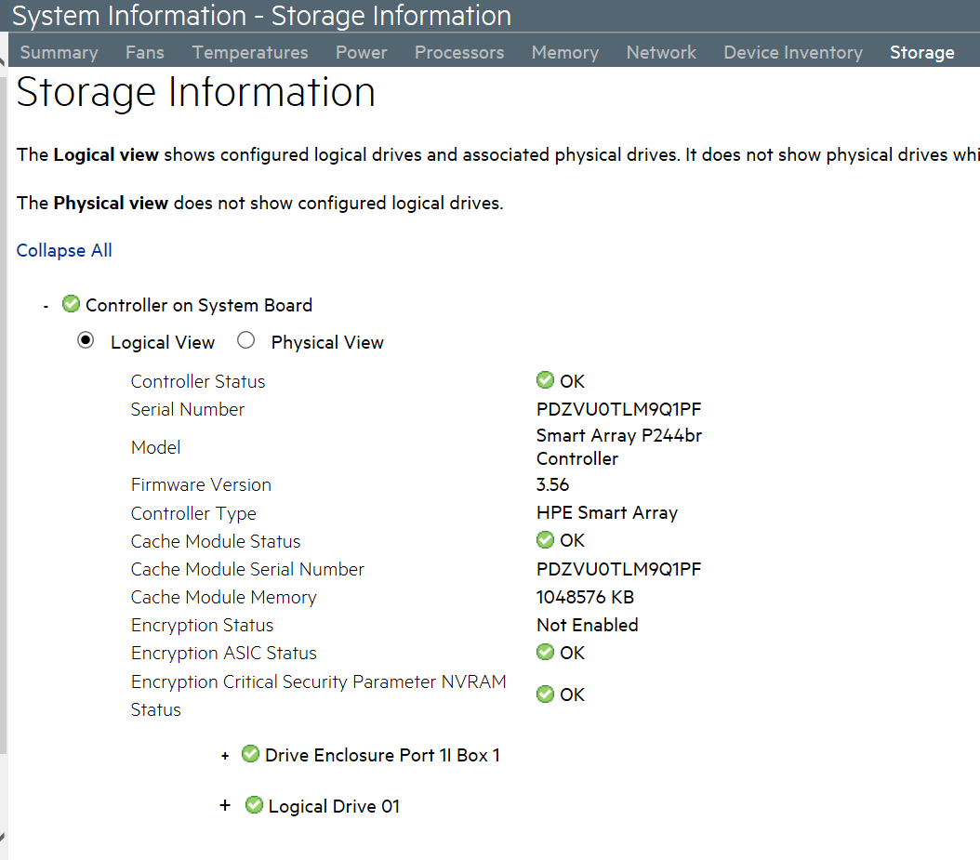

Below is a screenshot of how it should be configured on DL360

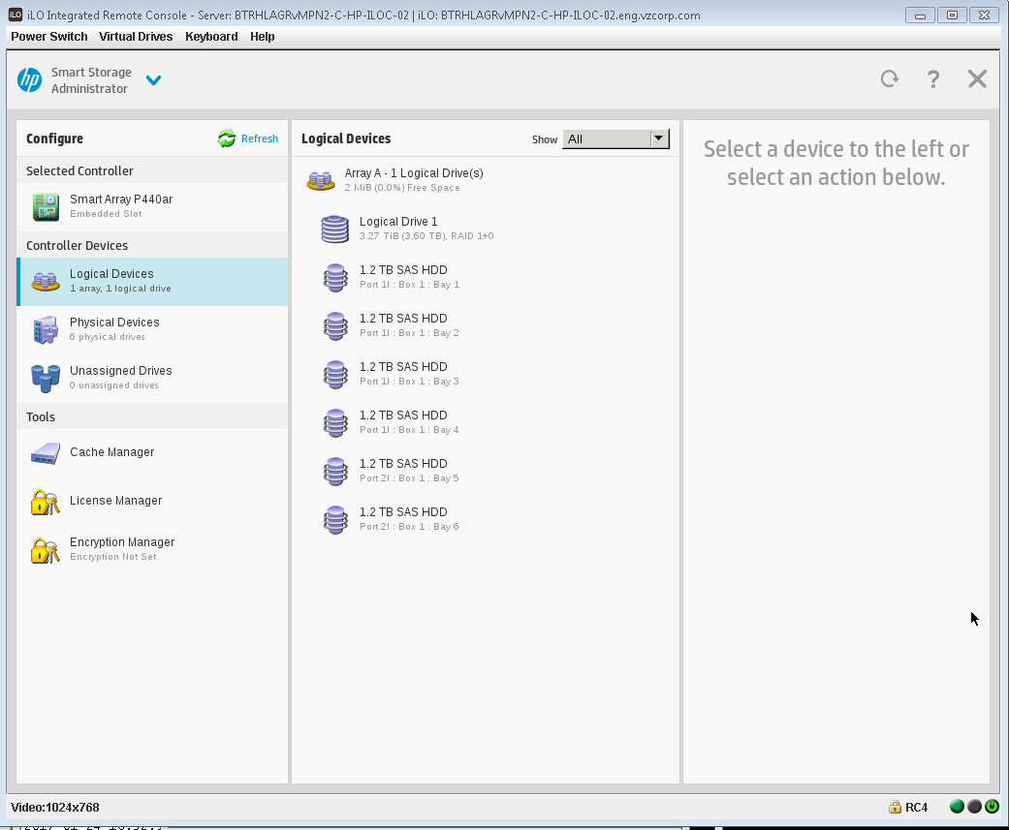

1. Login to Director server and start screen session

# screen

Or

# screen -list

# screen -rx <screen>

1. Start script to log commands and outputs

# script ~/Deploy-$(date +%Y-%d-%m).txt

1. Restart OpenStack services – The highlighted output is normal, just check Undercloud server if error is displayed.

# openstack-service restart

to restart openstack-zaqar@.service: Unit name openstack-zaqar@.service is missing the instance name.

See system logs and 'systemctl status openstack-zaqar@.service' for details.

1. Check Nodes – Node list should not have any nodes, next step will add all nodes used for overcloud deployment.

# su - stack

$ . stackrc

$ openstack baremetal node list

1. Prerequisite for this MOP is “instackenv.json” file already prepared, check if file looks like below, note that MAC addresses will change but other parameters (include IP address) should be same for all sites, just the number of nodes may varies

$ cat instackenv.json

{

"nodes":[

{

"mac":[

"e0:07:1b:f4:77:24"

],

"pm_type": "pxe_ilo",

"pm_user": "ospctl",

"pm_password": "SMITH-here",

"pm_addr": "192.168.0.4",

"cpu": "1",

"memory": "1",

"disk": "1",

"arch": "x86_64"

},

{

"mac":[

"e0:07:1b:f4:97:44"

],

"pm_type": "pxe_ilo",

"pm_user": "ospctl",

"pm_password": "SMITH-here",

"pm_addr": "192.168.0.5",

"cpu": "1",

"memory": "1",

"disk": "1",

"arch": "x86_64"

},

{

1. This imports the nodes iLO and MAC addresses for PXE boot and registers each node into the director Ironic DB.

$ openstack baremetal import --json ~/instackenv.json

Started Mistral Workflow. Execution ID: 2af96902-5f39-4819-964c-3eca6c18a882

Successfully registered node UUID 7cf55336-4da7-40f2-afa5-b9d2a6568957

Successfully registered node UUID be555558-8dc9-4a9c-977c-7b6f72f55a6c

Successfully registered node UUID a7fcf828-9763-4e69-af35-36b262b6d7b3

Successfully registered node UUID 9bcf830d-c5cf-4dc8-ad2b-2594f73a984f

Successfully registered node UUID 0d16a2ed-8e05-4cdc-9cba-36c696dbb427

Successfully registered node UUID 27134e67-f018-42eb-8b62-27fe4feb6696

Successfully registered node UUID bdc4b6c6-187a-40c7-84d4-0665a541d2bc

Successfully registered node UUID 6d8a60e2-7e8d-4a75-b2e5-04f27055dbe8

Successfully registered node UUID 185ce892-f2f6-44fa-b59d-54590e4b206d

Successfully registered node UUID 36e5451b-998c-4c6f-aa0d-1e15ebfe81b7

Successfully registered node UUID 82ff9fd6-033d-4b94-b423-861ff615149d

Successfully registered node UUID 14fb96d1-ea83-4913-b325-5a31a5cbf0c4

Successfully registered node UUID 07451c82-ab64-4413-a424-97cebc6d2699

Successfully registered node UUID c206f649-deae-4234-8318-045b8858c8a2

Successfully registered node UUID 6c760e46-1efb-4336-89a4-7e72997d85b5

Successfully registered node UUID 36c144eb-3ce0-4584-b9c9-bab6f2e10983

Successfully registered node UUID b2b62a98-e0c7-4411-bd58-56659a8ebcba

Successfully registered node UUID e0a74592-c24b-49e7-ab29-9459b3c4c80b

Successfully registered node UUID 66f7541b-d2d8-4e04-ae0d-e7d02f3b6f4b

Successfully registered node UUID 1c454763-9604-43cb-8f00-e85bfcb64213

Successfully registered node UUID bba53d49-1ab6-4e07-948f-356a890cf688

Successfully registered node UUID e46441d0-5761-41ac-b137-513597e2d554

Successfully registered node UUID ac0d9317-b6cd-4835-9df6-b4538a371eed

Successfully registered node UUID 3ac6d9de-3bd7-4e7a-b4c9-279b3fd39dd2

Successfully registered node UUID 3f6c9a4b-5f42-4741-b69d-ccfacd9257d7

Successfully registered node UUID e3cfd744-f870-4693-940e-246b92312f9f

Successfully registered node UUID aabd3d5d-36a0-4b20-9607-40af8492c2ad

Successfully registered node UUID 215ce4db-000d-455b-8726-8a6fe618f990

Successfully registered node UUID fa9f9bd6-efe0-42f6-bc54-8e442525ae4a

Successfully registered node UUID e07cdcbd-4733-49c8-85fa-9cd61c3c7460

Successfully registered node UUID 9e47e5e0-a03f-4f8a-93d9-94ff3b152cda

Successfully registered node UUID 01e50bfb-43b4-461f-b254-4fbb6dcc14a0

Successfully registered node UUID f91806d6-ee75-4ac5-8e4b-8aae6d73086e

Successfully registered node UUID f23163e9-3802-4c5c-8930-8aeb751b7a6c

Successfully registered node UUID 3ae6a61b-938d-4218-981c-17bff5c0a6b0

Successfully registered node UUID 16c0f3ca-36e2-40a0-9a0d-074504cc7daa

Successfully registered node UUID 5be27480-3916-43b8-928f-71e9f8720c2e

Successfully registered node UUID 0eb24d17-96d9-4ecb-b196-ed78d9a0c748

Successfully registered node UUID 7dab654a-1845-41cb-9305-a64a60a80cca

Successfully registered node UUID 5246298c-4d9a-4ffa-9087-2df93d44b43c

Successfully registered node UUID ba037902-f55c-42f1-ade9-cb09791ac328

Successfully registered node UUID c1c735db-ff6f-4990-be93-3e1a2b2a3f07

Successfully registered node UUID 51d03f89-5625-4165-abf1-35e44a3770d2

Successfully registered node UUID 9ab2a9a2-0527-43c4-bec9-671536313fb4

Successfully registered node UUID 8d8a6845-6a39-4b46-bbdf-0de96cf2f798

Successfully registered node UUID 03d7e391-1476-485c-8644-d2fa459a8a92

Successfully registered node UUID 43991323-d3ca-46e5-b6ea-27fc046b801f

Successfully registered node UUID 81076238-a970-4d17-9345-2bb9d7ad4541

Successfully registered node UUID e4069313-078e-44f4-a1fa-de51a4d20bfa

Successfully registered node UUID f826daaa-23d8-42a1-8682-d021ec46afca

Successfully registered node UUID 5a2409ae-8454-4c27-a50f-77048d4652a4

Successfully registered node UUID 1b00edc7-66b6-4e76-98d9-15ad97518a6a

Successfully registered node UUID 1c97cbe3-569a-4e4c-a0b9-c80a5a1ff088

Successfully registered node UUID ac8178ac-b83b-45d6-976a-eb5e7d2ab4b0

Successfully registered node UUID 848ffb37-45af-48dd-8efa-e62e23b56712

Successfully registered node UUID cb95eba2-ffb8-4994-9456-b3f4dc8f3832

Successfully registered node UUID d7dbcf61-9dfa-4e91-ab82-c52d1c92f6ee

Successfully registered node UUID d9868389-4b5e-4c78-b737-a64e21857d40

Successfully registered node UUID 6e31fa2a-cb9d-4d3b-a287-a7ef75484cbf

Successfully registered node UUID 358ba8ac-49a0-4dbc-816d-31cb0420ec70

Successfully registered node UUID be3ad18e-4377-4058-90b3-9fb651ddd597

Successfully registered node UUID 3e546cd3-9c6a-4e48-9455-3b2d08bbbaaf

Successfully registered node UUID 26879705-8600-4112-8fa0-f7434b5354e4

Successfully registered node UUID 8eaf427d-2fdd-4395-bf57-466e68af9a82

Successfully registered node UUID 447bca63-b50b-401a-8743-001d633778ed

Successfully registered node UUID d30f6605-6205-4d12-9d53-4fbabe410754

Successfully registered node UUID 39884148-16f8-4900-aa12-aded01ce4710

Started Mistral Workflow. Execution ID: 247950c8-0a05-48bb-b3e3-fb0878386f9d

Successfully set all nodes to available.

1. Assign the kernel and ramdisk images to all nodes.

$ openstack baremetal configure boot

1. Check all if nodes are stored into Ironic DB, make sure all nodes are in “power off” state, if not use “openstack baremetal node list | awk '/power on/ {print $2}'| xargs -I% openstack baremetal node power off %” to power them off.

$ openstack baremetal node list

+--------------------------------------+------+---------------+-------------+--------------------+-------------+

| UUID | Name | Instance UUID | Power State | Provisioning State | Maintenance |

+--------------------------------------+------+---------------+-------------+--------------------+-------------+

| 7cf55336-4da7-40f2-afa5-b9d2a6568957 | None | None | power off | available | False |

| be555558-8dc9-4a9c-977c-7b6f72f55a6c | None | None | power off | available | False |

| a7fcf828-9763-4e69-af35-36b262b6d7b3 | None | None | power off | available | False |

| 9bcf830d-c5cf-4dc8-ad2b-2594f73a984f | None | None | power off | available | False |

| 0d16a2ed-8e05-4cdc-9cba-36c696dbb427 | None | None | power off | available | False |

| 27134e67-f018-42eb-8b62-27fe4feb6696 | None | None | power off | available | False |

| bdc4b6c6-187a-40c7-84d4-0665a541d2bc | None | None | power off | available | False |

| 6d8a60e2-7e8d-4a75-b2e5-04f27055dbe8 | None | None | power off | available | False |

| 185ce892-f2f6-44fa-b59d-54590e4b206d | None | None | power off | available | False |

| 36e5451b-998c-4c6f-aa0d-1e15ebfe81b7 | None | None | power off | available | False |

| 82ff9fd6-033d-4b94-b423-861ff615149d | None | None | power off | available | False |

| 14fb96d1-ea83-4913-b325-5a31a5cbf0c4 | None | None | power off | available | False |

| 07451c82-ab64-4413-a424-97cebc6d2699 | None | None | power off | available | False |

| c206f649-deae-4234-8318-045b8858c8a2 | None | None | power off | available | False |

| 6c760e46-1efb-4336-89a4-7e72997d85b5 | None | None | power off | available | False |

| 36c144eb-3ce0-4584-b9c9-bab6f2e10983 | None | None | power off | available | False |

| b2b62a98-e0c7-4411-bd58-56659a8ebcba | None | None | power off | available | False |

| e0a74592-c24b-49e7-ab29-9459b3c4c80b | None | None | power off | available | False |

| 66f7541b-d2d8-4e04-ae0d-e7d02f3b6f4b | None | None | power off | available | False |

| 1c454763-9604-43cb-8f00-e85bfcb64213 | None | None | power off | available | False |

| bba53d49-1ab6-4e07-948f-356a890cf688 | None | None | power off | available | False |

| e46441d0-5761-41ac-b137-513597e2d554 | None | None | power off | available | False |

| ac0d9317-b6cd-4835-9df6-b4538a371eed | None | None | power off | available | False |

| 3ac6d9de-3bd7-4e7a-b4c9-279b3fd39dd2 | None | None | power off | available | False |

| 3f6c9a4b-5f42-4741-b69d-ccfacd9257d7 | None | None | power off | available | False |

| e3cfd744-f870-4693-940e-246b92312f9f | None | None | power off | available | False |

| aabd3d5d-36a0-4b20-9607-40af8492c2ad | None | None | power off | available | False |

| 215ce4db-000d-455b-8726-8a6fe618f990 | None | None | power off | available | False |

| fa9f9bd6-efe0-42f6-bc54-8e442525ae4a | None | None | power off | available | False |

| e07cdcbd-4733-49c8-85fa-9cd61c3c7460 | None | None | power off | available | False |

| 9e47e5e0-a03f-4f8a-93d9-94ff3b152cda | None | None | power off | available | False |

| 01e50bfb-43b4-461f-b254-4fbb6dcc14a0 | None | None | power off | available | False |

| f91806d6-ee75-4ac5-8e4b-8aae6d73086e | None | None | power off | available | False |

| f23163e9-3802-4c5c-8930-8aeb751b7a6c | None | None | power off | available | False |

| 3ae6a61b-938d-4218-981c-17bff5c0a6b0 | None | None | power off | available | False |

| 16c0f3ca-36e2-40a0-9a0d-074504cc7daa | None | None | power off | available | False |

| 5be27480-3916-43b8-928f-71e9f8720c2e | None | None | power off | available | False |

| 0eb24d17-96d9-4ecb-b196-ed78d9a0c748 | None | None | power off | available | False |

| 7dab654a-1845-41cb-9305-a64a60a80cca | None | None | power off | available | False |

| 5246298c-4d9a-4ffa-9087-2df93d44b43c | None | None | power off | available | False |

| ba037902-f55c-42f1-ade9-cb09791ac328 | None | None | power off | available | False |

| c1c735db-ff6f-4990-be93-3e1a2b2a3f07 | None | None | power off | available | False |

| 51d03f89-5625-4165-abf1-35e44a3770d2 | None | None | power off | available | False |

| 9ab2a9a2-0527-43c4-bec9-671536313fb4 | None | None | power off | available | False |

| 8d8a6845-6a39-4b46-bbdf-0de96cf2f798 | None | None | power off | available | False |

| 03d7e391-1476-485c-8644-d2fa459a8a92 | None | None | power off | available | False |

| 43991323-d3ca-46e5-b6ea-27fc046b801f | None | None | power off | available | False |

| 81076238-a970-4d17-9345-2bb9d7ad4541 | None | None | power off | available | False |

| e4069313-078e-44f4-a1fa-de51a4d20bfa | None | None | power off | available | False |

| f826daaa-23d8-42a1-8682-d021ec46afca | None | None | power off | available | False |

| 5a2409ae-8454-4c27-a50f-77048d4652a4 | None | None | power off | available | False |

| 1b00edc7-66b6-4e76-98d9-15ad97518a6a | None | None | power off | available | False |

| 1c97cbe3-569a-4e4c-a0b9-c80a5a1ff088 | None | None | power off | available | False |

| ac8178ac-b83b-45d6-976a-eb5e7d2ab4b0 | None | None | power off | available | False |

| 848ffb37-45af-48dd-8efa-e62e23b56712 | None | None | power off | available | False |

| cb95eba2-ffb8-4994-9456-b3f4dc8f3832 | None | None | power off | available | False |

| d7dbcf61-9dfa-4e91-ab82-c52d1c92f6ee | None | None | power off | available | False |

| d9868389-4b5e-4c78-b737-a64e21857d40 | None | None | power off | available | False |

| 6e31fa2a-cb9d-4d3b-a287-a7ef75484cbf | None | None | power off | available | False |

| 358ba8ac-49a0-4dbc-816d-31cb0420ec70 | None | None | power off | available | False |

| be3ad18e-4377-4058-90b3-9fb651ddd597 | None | None | power off | available | False |

| 3e546cd3-9c6a-4e48-9455-3b2d08bbbaaf | None | None | power off | available | False |

| 26879705-8600-4112-8fa0-f7434b5354e4 | None | None | power off | available | False |

| 8eaf427d-2fdd-4395-bf57-466e68af9a82 | None | None | power off | available | False |

| 447bca63-b50b-401a-8743-001d633778ed | None | None | power off | available | False |

| d30f6605-6205-4d12-9d53-4fbabe410754 | None | None | power off | available | False |

| 39884148-16f8-4900-aa12-aded01ce4710 | None | None | power off | available | False |

+--------------------------------------+------+---------------+-------------+--------------------+-------------+

1. Start Introspection.

$ openstack overcloud node introspect --all-manageable --provide

Started Mistral Workflow. Execution ID: 8f901e81-a079-41c4-8d38-0fc93ce429ae

Waiting for introspection to finish...

**Note:** In OSP10 we are having timeouts of API transactions, until we get this fixed the error below “socket is already closed” can happen, use next step to check for introspection result and restart introspection for nodes that have not finished or have failed.

Started Mistral Workflow. Execution ID: 8f901e81-a079-41c4-8d38-0fc93ce429ae

Waiting for introspection to finish...

socket is already closed.

In another shell or screen window you can monitor the introspection with command below

$ sudo journalctl -l -u openstack-ironic-discoverd -u openstack-ironic-conductor -f

1. Check Introspection result and restart introspection for nodes that failed.

$ openstack baremetal introspection bulk status

+--------------------------------------+----------+--------------------------------------------------------------------------------------------------------------------------------------------------------------+

| Node UUID | Finished | Error |

+--------------------------------------+----------+--------------------------------------------------------------------------------------------------------------------------------------------------------------+

| 7cf55336-4da7-40f2-afa5-b9d2a6568957 | True | None |

| be555558-8dc9-4a9c-977c-7b6f72f55a6c | True | None |

| a7fcf828-9763-4e69-af35-36b262b6d7b3 | True | None |

| 9bcf830d-c5cf-4dc8-ad2b-2594f73a984f | True | None |

| 0d16a2ed-8e05-4cdc-9cba-36c696dbb427 | True | None |

| 27134e67-f018-42eb-8b62-27fe4feb6696 | True | None |

| bdc4b6c6-187a-40c7-84d4-0665a541d2bc | True | None |

| 6d8a60e2-7e8d-4a75-b2e5-04f27055dbe8 | True | None |

| 185ce892-f2f6-44fa-b59d-54590e4b206d | True | None |

| 36e5451b-998c-4c6f-aa0d-1e15ebfe81b7 | True | None |

| 82ff9fd6-033d-4b94-b423-861ff615149d | True | None |

| 14fb96d1-ea83-4913-b325-5a31a5cbf0c4 | True | None |

| 07451c82-ab64-4413-a424-97cebc6d2699 | True | None |

| c206f649-deae-4234-8318-045b8858c8a2 | True | None |

| 6c760e46-1efb-4336-89a4-7e72997d85b5 | True | None |

| 36c144eb-3ce0-4584-b9c9-bab6f2e10983 | True | None |

| b2b62a98-e0c7-4411-bd58-56659a8ebcba | True | None |

| e0a74592-c24b-49e7-ab29-9459b3c4c80b | True | None |

| 66f7541b-d2d8-4e04-ae0d-e7d02f3b6f4b | True | None |

| 1c454763-9604-43cb-8f00-e85bfcb64213 | True | None |

| bba53d49-1ab6-4e07-948f-356a890cf688 | True | None |

| e46441d0-5761-41ac-b137-513597e2d554 | True | None |

| ac0d9317-b6cd-4835-9df6-b4538a371eed | True | None |

| 3ac6d9de-3bd7-4e7a-b4c9-279b3fd39dd2 | True | None |

| 3f6c9a4b-5f42-4741-b69d-ccfacd9257d7 | True | None |

| e3cfd744-f870-4693-940e-246b92312f9f | True | None |

| aabd3d5d-36a0-4b20-9607-40af8492c2ad | False | None |

| 215ce4db-000d-455b-8726-8a6fe618f990 | True | None |

| fa9f9bd6-efe0-42f6-bc54-8e442525ae4a | True | None |

| e07cdcbd-4733-49c8-85fa-9cd61c3c7460 | True | None |

| 9e47e5e0-a03f-4f8a-93d9-94ff3b152cda | True | None |

| 01e50bfb-43b4-461f-b254-4fbb6dcc14a0 | True | None |

| f91806d6-ee75-4ac5-8e4b-8aae6d73086e | True | None |

| f23163e9-3802-4c5c-8930-8aeb751b7a6c | True | None |

| 3ae6a61b-938d-4218-981c-17bff5c0a6b0 | True | None |

| 16c0f3ca-36e2-40a0-9a0d-074504cc7daa | True | None |

| 5be27480-3916-43b8-928f-71e9f8720c2e | True | None |

| 0eb24d17-96d9-4ecb-b196-ed78d9a0c748 | True | None |

| 7dab654a-1845-41cb-9305-a64a60a80cca | True | Preprocessing hook validate_interfaces: No suitable interfaces found in {u'eno56': {'ip': None, 'mac': u'00:17:a4:77:08:5e'}, u'eno54': {'ip': None, 'mac': |

| | | u'00:17:a4:77:08:5a'}, u'eno55': {'ip': None, 'mac': u'00:17:a4:77:08:5c'}, u'eno52': {'ip': None, 'mac': u'00:17:a4:77:08:56'}, u'eno53': {'ip': None, |

| | | 'mac': u'00:17:a4:77:08:58'}, u'eno50': {'ip': u'192.168.5.169', 'mac': u'00:17:a4:77:08:4a'}, u'eno51': {'ip': None, 'mac': u'00:17:a4:77:08:54'}, |

| | | u'eno49': {'ip': None, 'mac': u'00:17:a4:77:08:48'}, u'ens2f0': {'ip': None, 'mac': u'14:02:ec:75:d4:80'}, u'ens2f1': {'ip': None, 'mac': |

| | | u'14:02:ec:75:d4:81'}, u'ens1f1': {'ip': None, 'mac': u'14:02:ec:75:d4:c1'}, u'ens1f0': {'ip': None, 'mac': u'14:02:ec:75:d4:c0'}} |

| 5246298c-4d9a-4ffa-9087-2df93d44b43c | True | None |

| ba037902-f55c-42f1-ade9-cb09791ac328 | True | None |

| c1c735db-ff6f-4990-be93-3e1a2b2a3f07 | True | None |

| 51d03f89-5625-4165-abf1-35e44a3770d2 | True | None |

| 9ab2a9a2-0527-43c4-bec9-671536313fb4 | True | None |

| 8d8a6845-6a39-4b46-bbdf-0de96cf2f798 | True | None |

| 03d7e391-1476-485c-8644-d2fa459a8a92 | True | None |

| 43991323-d3ca-46e5-b6ea-27fc046b801f | True | None |

| 81076238-a970-4d17-9345-2bb9d7ad4541 | True | None |

| e4069313-078e-44f4-a1fa-de51a4d20bfa | True | None |

| f826daaa-23d8-42a1-8682-d021ec46afca | True | None |

| 5a2409ae-8454-4c27-a50f-77048d4652a4 | True | None |

| 1b00edc7-66b6-4e76-98d9-15ad97518a6a | True | Introspection timeout |

| 1c97cbe3-569a-4e4c-a0b9-c80a5a1ff088 | True | None |

| ac8178ac-b83b-45d6-976a-eb5e7d2ab4b0 | True | Introspection timeout |

| 848ffb37-45af-48dd-8efa-e62e23b56712 | True | None |

| cb95eba2-ffb8-4994-9456-b3f4dc8f3832 | True | Introspection timeout |

| d7dbcf61-9dfa-4e91-ab82-c52d1c92f6ee | True | None |

| d9868389-4b5e-4c78-b737-a64e21857d40 | True | Introspection timeout |

| 6e31fa2a-cb9d-4d3b-a287-a7ef75484cbf | True | Preprocessing hook validate_interfaces: No suitable interfaces found in {u'eno56': {'ip': None, 'mac': u'00:17:a4:77:0c:be'}, u'eno54': {'ip': None, 'mac': |

| | | u'00:17:a4:77:0c:ba'}, u'eno55': {'ip': None, 'mac': u'00:17:a4:77:0c:bc'}, u'eno52': {'ip': None, 'mac': u'00:17:a4:77:0c:b6'}, u'eno53': {'ip': None, |

| | | 'mac': u'00:17:a4:77:0c:b8'}, u'eno50': {'ip': u'192.168.5.191', 'mac': u'00:17:a4:77:0c:aa'}, u'eno51': {'ip': None, 'mac': u'00:17:a4:77:0c:b4'}, |

| | | u'eno49': {'ip': None, 'mac': u'00:17:a4:77:0c:a8'}, u'ens2f0': {'ip': None, 'mac': u'14:02:ec:75:de:34'}, u'ens2f1': {'ip': None, 'mac': |

| | | u'14:02:ec:75:de:35'}, u'ens1f1': {'ip': None, 'mac': u'14:02:ec:75:dc:e5'}, u'ens1f0': {'ip': None, 'mac': u'14:02:ec:75:dc:e4'}} |

| 358ba8ac-49a0-4dbc-816d-31cb0420ec70 | True | None |

| be3ad18e-4377-4058-90b3-9fb651ddd597 | True | None |

| 3e546cd3-9c6a-4e48-9455-3b2d08bbbaaf | True | Introspection timeout |

| 26879705-8600-4112-8fa0-f7434b5354e4 | True | None |

| 8eaf427d-2fdd-4395-bf57-466e68af9a82 | True | Introspection timeout |

| 447bca63-b50b-401a-8743-001d633778ed | True | None |

| d30f6605-6205-4d12-9d53-4fbabe410754 | True | None |

| 39884148-16f8-4900-aa12-aded01ce4710 | True | None |

+--------------------------------------+----------+--------------------------------------------------------------------------------------------------------------------------------------------------------------+

Troubleshoot the timeouts, most of cases for some reason the Ironic driver is not able to power up a blade, check if for errors are shown on OA and ILO, and check if power supplies are all working fine.

For error “Preprocessing hook validate interfaces”, normally retrying introspection solves this issue, it probably is caused by race condition, it seems to happen because we have two interfaces on control plane (eno49 and eno50) VLAN but we use just one of them (eno49).

Make sure all nodes are powered off before restart introspection on nodes that failed

$ openstack baremetal node list | awk '/power on/ {print $2}' | xargs -I% openstack baremetal node power off %

For nodes that timed out, restart introspection with command below

$ openstack baremetal introspection bulk status | awk '/Introspection timeout/ {print $2}' | xargs -I% -P32 bash -c "openstack baremetal node manage; openstack overcloud node introspect % --provide

For nodes that have not finished introspection

$ openstack baremetal introspection bulk status | awk '/False/ {print $2}' | xargs -I% -P32 bash -c "openstack baremetal node manage; openstack overcloud node introspect % --provide

For nodes that have failed because ironic agent “Preprocessing hook validate_interfaces”

$ openstack baremetal introspection bulk status | awk '/Preprocessing hook validate_interfaces/ {print $2}' | xargs -I% -P32 bash -c "openstack baremetal node manage; openstack overcloud node introspect % --provide

Check output after all introspection restart are complete, below should be the right output to move to next step

$ openstack baremetal introspection bulk status

+--------------------------------------+----------+-------+

| Node UUID | **Finished | Error** |

+--------------------------------------+----------+-------+

| 7cf55336-4da7-40f2-afa5-b9d2a6568957 | True | None |

| be555558-8dc9-4a9c-977c-7b6f72f55a6c | True | None |

| a7fcf828-9763-4e69-af35-36b262b6d7b3 | True | None |

| 9bcf830d-c5cf-4dc8-ad2b-2594f73a984f | True | None |

| 0d16a2ed-8e05-4cdc-9cba-36c696dbb427 | True | None |

| 27134e67-f018-42eb-8b62-27fe4feb6696 | True | None |

| bdc4b6c6-187a-40c7-84d4-0665a541d2bc | True | None |

| 6d8a60e2-7e8d-4a75-b2e5-04f27055dbe8 | True | None |

| 185ce892-f2f6-44fa-b59d-54590e4b206d | True | None |

| 36e5451b-998c-4c6f-aa0d-1e15ebfe81b7 | True | None |

| 82ff9fd6-033d-4b94-b423-861ff615149d | True | None |

| 14fb96d1-ea83-4913-b325-5a31a5cbf0c4 | True | None |

| 07451c82-ab64-4413-a424-97cebc6d2699 | True | None |

| c206f649-deae-4234-8318-045b8858c8a2 | True | None |

| 6c760e46-1efb-4336-89a4-7e72997d85b5 | True | None |

| 36c144eb-3ce0-4584-b9c9-bab6f2e10983 | True | None |

| b2b62a98-e0c7-4411-bd58-56659a8ebcba | True | None |

| e0a74592-c24b-49e7-ab29-9459b3c4c80b | True | None |

| 66f7541b-d2d8-4e04-ae0d-e7d02f3b6f4b | True | None |

| 1c454763-9604-43cb-8f00-e85bfcb64213 | True | None |

| bba53d49-1ab6-4e07-948f-356a890cf688 | True | None |

| e46441d0-5761-41ac-b137-513597e2d554 | True | None |

| ac0d9317-b6cd-4835-9df6-b4538a371eed | True | None |

| 3ac6d9de-3bd7-4e7a-b4c9-279b3fd39dd2 | True | None |

| 3f6c9a4b-5f42-4741-b69d-ccfacd9257d7 | True | None |

| e3cfd744-f870-4693-940e-246b92312f9f | True | None |

| aabd3d5d-36a0-4b20-9607-40af8492c2ad | True | None |

| 215ce4db-000d-455b-8726-8a6fe618f990 | True | None |

| fa9f9bd6-efe0-42f6-bc54-8e442525ae4a | True | None |

| e07cdcbd-4733-49c8-85fa-9cd61c3c7460 | True | None |

| 9e47e5e0-a03f-4f8a-93d9-94ff3b152cda | True | None |

| 01e50bfb-43b4-461f-b254-4fbb6dcc14a0 | True | None |

| f91806d6-ee75-4ac5-8e4b-8aae6d73086e | True | None |

| f23163e9-3802-4c5c-8930-8aeb751b7a6c | True | None |

| 3ae6a61b-938d-4218-981c-17bff5c0a6b0 | True | None |

| 16c0f3ca-36e2-40a0-9a0d-074504cc7daa | True | None |

| 5be27480-3916-43b8-928f-71e9f8720c2e | True | None |

| 0eb24d17-96d9-4ecb-b196-ed78d9a0c748 | True | None |

| 7dab654a-1845-41cb-9305-a64a60a80cca | True | None |

| 5246298c-4d9a-4ffa-9087-2df93d44b43c | True | None |

| ba037902-f55c-42f1-ade9-cb09791ac328 | True | None |

| c1c735db-ff6f-4990-be93-3e1a2b2a3f07 | True | None |

| 51d03f89-5625-4165-abf1-35e44a3770d2 | True | None |

| 9ab2a9a2-0527-43c4-bec9-671536313fb4 | True | None |

| 8d8a6845-6a39-4b46-bbdf-0de96cf2f798 | True | None |

| 03d7e391-1476-485c-8644-d2fa459a8a92 | True | None |

| 43991323-d3ca-46e5-b6ea-27fc046b801f | True | None |

| 81076238-a970-4d17-9345-2bb9d7ad4541 | True | None |

| e4069313-078e-44f4-a1fa-de51a4d20bfa | True | None |

| f826daaa-23d8-42a1-8682-d021ec46afca | True | None |

| 5a2409ae-8454-4c27-a50f-77048d4652a4 | True | None |

| 1b00edc7-66b6-4e76-98d9-15ad97518a6a | True | None |

| 1c97cbe3-569a-4e4c-a0b9-c80a5a1ff088 | True | None |

| ac8178ac-b83b-45d6-976a-eb5e7d2ab4b0 | True | None |

| 848ffb37-45af-48dd-8efa-e62e23b56712 | True | None |

| cb95eba2-ffb8-4994-9456-b3f4dc8f3832 | True | None |

| d7dbcf61-9dfa-4e91-ab82-c52d1c92f6ee | True | None |

| d9868389-4b5e-4c78-b737-a64e21857d40 | True | None |

| 6e31fa2a-cb9d-4d3b-a287-a7ef75484cbf | True | None |

| 358ba8ac-49a0-4dbc-816d-31cb0420ec70 | True | None |

| be3ad18e-4377-4058-90b3-9fb651ddd597 | True | None |

| 3e546cd3-9c6a-4e48-9455-3b2d08bbbaaf | True | None |

| 26879705-8600-4112-8fa0-f7434b5354e4 | True | None |

| 8eaf427d-2fdd-4395-bf57-466e68af9a82 | True | None |

| 447bca63-b50b-401a-8743-001d633778ed | True | None |

| d30f6605-6205-4d12-9d53-4fbabe410754 | True | None |

| 39884148-16f8-4900-aa12-aded01ce4710 | True | None |

+--------------------------------------+----------+-------+

1. Set all nodes to provide, it will remove any node that still in maintenance state.

$ openstack baremetal node list | awk '/manageable/ {print $2}' | xargs -I% -P32 openstack baremetal node provide %

WAIT Two minutes before check that all nodes are ready to be used for Overcloud deployment, the result below should be the number of nodes for Overcloud

$ nova hypervisor-list | awk '/up/ {print $4}' | xargs -I% nova hypervisor-show % | grep 'free_ram_mb' | grep 393216 | wc -l

64

If the output does not match the number of nodes, check which nodes are not changing the state to available, at this point it should not have any but if happens it was the introspection step before, execute introspection again for that node.

$ nova hypervisor-list | awk '/up/ {print $4}' | xargs -I% nova hypervisor-show % | egrep 'free_ram_mb|hypervisor_hostname'

| hypervisor_hostname | e07cdcbd-4733-49c8-85fa-9cd61c3c7460 |

| free_ram_mb | 393216 |

| hypervisor_hostname | 6e31fa2a-cb9d-4d3b-a287-a7ef75484cbf |

| free_ram_mb | 393216 |

| hypervisor_hostname | d9868389-4b5e-4c78-b737-a64e21857d40 |

| free_ram_mb | 393216 |

| hypervisor_hostname | d7dbcf61-9dfa-4e91-ab82-c52d1c92f6ee |

| free_ram_mb | 0 |

| hypervisor_hostname | 3ac6d9de-3bd7-4e7a-b4c9-279b3fd39dd2 |

In this case node 3ac6d9de-3bd7-4e7a-b4c9-279b3fd39dd2 probably had some issue with introspection.

1. These steps are executed only if Undercloud deployment procedure has not download the templates from Gerrit.

Check if directories and soft link “templates” are created

$ ll

total 88

lrwxrwxrwx. 1 stack stack 13 Feb 13 18:13 templates -> templates-git

drwxrwxr-x. 5 stack stack 4096 Feb 14 21:38 templates-git

drwxrwxr-x. 4 stack stack 4096 Feb 15 01:51 templates-git-sites

If output above exist, check if master templates are on the right version

$ cd templates-git

$ git rev-parse HEAD

**<Commit value based on ops-vcpe-templates-master, check the commit SHA from officially release communication/note>**

If output above is right, check the site specific templates

$ cd ../templates-git-sites

$ git rev-parse HEAD

**<Commit value based on ops-vcpe-templates-sites project, check the commit SHA for each Site from officially release communication/note>**

If any or one of templates directories is not right, download them from Gerrit

Start ssh-agent

$ eval $(ssh-agent -s)

Agent pid 8314

Copy private Key <id_rsa_stack_tools> used to access Gerrit into ~/.ssh/ and add it to ssh agent

$ ssh-add .ssh/id_rsa_stack_tools

 Passphrase is master

Remove templates directory if they exist

If master templates are going to be downloaded from Gerrit

$ rm -rf templates-git

If site specific templates are going to be downloaded from Gerrit

$ rm -rf templates-git-sites

$ rm -rf templates-git-security

Download the templates from Gerrit

For master templates

$ git clone ssh://stack_tools@10.215.206.80:29418/osp10-vcpe-templates-master templates-git

For site specific templates

$ git clone --branch $(hostname -s | cut -c-8) ssh://stack_tools@10.215.206.80:29418/osp10-vcpe-templates-sites templates-git-sites

For site specific security templates

$ git clone --branch $(hostname -s | cut -c-8) ssh://stack_tools@10.215.206.80:29418/osp10-vcpe-templates-security templates-git-security

Make sure to create soft link if it is not already there.

$ cd ;ln -s templates-git templates

Check again if all directories are good for Overcloud deployment

$ ll

total 88

lrwxrwxrwx. 1 stack stack 13 Feb 13 18:13 templates -> templates-git

drwxrwxr-x. 5 stack stack 4096 Feb 14 21:38 templates-git

drwxrwxr-x. 4 stack stack 4096 Feb 15 01:51 templates-git-sites

drwxrwxr-x. 4 stack stack 4096 Feb 15 01:51 templates-git-security

1. We need to tag the nodes, use the script download from Gerrit from projectops10-vcpe-templates-master. The script “generate_cap.sh” generates another script “set_cap.sh” to tag all nodes. They were designed considering instackenv.json file to be created in right order as nodes should be deployed, the first three nodes are controllers nodes and all other nodes are compute nodes. The compute nodes are also added to instackenv.json in order, first compute should be the first blade of first C7K chassis, and so on. Fallow the steps below to tag all nodes for deployment.

Run this script as stack user

$ ./templates/generate_cap.sh

Run this script to tag all nodes

$ ./templates/set_cap.sh

1. Install Undercloud Certificate if you had to download the site specific templates from Gerrit in the previous step.

$ test -d /etc/pki/instack-certs || sudo mkdir /etc/pki/instack-certs

$ sudo cp templates-git-security/certs/undercloud.pem /etc/pki/instack-certs/.

$ sudo ln -sf /etc/pki/instack-certs/undercloud.pem /etc/pki/ca-trust/source/anchors/undercloud.pem

$ sudo restorecon -R /etc/pki

$ sudo update-ca-trust extract

$ sudo systemctl restart haproxy openstack-keystone

1. Set root password on Overcloud image to help troubleshooting issues during PXE Boot.

$ sudo -i

# export LIBGUESTFS_BACKEND=direct

# virt-customize -a /home/stack/images/overcloud-full.qcow2 --root-password password:Root1234

# exit ; openstack overcloud image upload --image-path /home/stack/images/ --update-existing

Image "overcloud-full-vmlinuz" is up-to-date, skipping.

Image "overcloud-full-initrd" is up-to-date, skipping.

Image "overcloud-full" was uploaded.

+--------------------------------------+----------------+-------------+------------+--------+

| ID | Name | Disk Format | Size | Status |

+--------------------------------------+----------------+-------------+------------+--------+

| d479b186-a114-49d3-9db9-4abfec0a3268 | overcloud-full | qcow2 | 1295253504 | active |

+--------------------------------------+----------------+-------------+------------+--------+

Image "bm-deploy-kernel" is up-to-date, skipping.

Image "bm-deploy-ramdisk" is up-to-date, skipping.

Image file "/httpboot/agent.kernel" is up-to-date, skipping.

Image file "/httpboot/agent.ramdisk" is up-to-date, skipping.

1. Deploy only 16 compute first time, in OSP10 we are having timeout issues and we have to deploy overcloud in steps of 16 compute nodes, we may not be able to deploy all 64 nodes

$ cd ~/templates;./deploycmd 16

+ source /home/stack/stackrc

++ export NOVA_VERSION=1.1

++ NOVA_VERSION=1.1

+++ sudo hiera admin_password

++ export OS_PASSWORD=4d8ac759a3814182537076af2a68d142df7f699a

++ OS_PASSWORD=4d8ac759a3814182537076af2a68d142df7f699a

++ export OS_AUTH_URL=https://192.168.8.2:13000/v2.0

++ OS_AUTH_URL=https://192.168.8.2:13000/v2.0

++ export 'PYTHONWARNINGS=ignore:Certificate has no, ignore:A true SSLContext object is not available'

++ PYTHONWARNINGS='ignore:Certificate has no, ignore:A true SSLContext object is not available'

++ export OS_USERNAME=admin

++ OS_USERNAME=admin

++ export OS_TENANT_NAME=admin

Watch the deployment steps

Started Mistral Workflow. Execution ID: e2a3bc65-bbde-451a-936b-ad854ad458a9

2017-02-16 00:35:22Z [Networks]: UPDATE_IN_PROGRESS state changed

2017-02-16 00:35:22Z [nlvgnvoqnce-Networks-ltmhyaujord5]: UPDATE_IN_PROGRESS Stack UPDATE started

2017-02-16 00:35:22Z [ServiceNetMap]: UPDATE_IN_PROGRESS state changed

2017-02-16 00:35:22Z [DefaultPasswords]: UPDATE_IN_PROGRESS state changed

2017-02-16 00:35:22Z [nlvgnvoqnce-Networks-ltmhyaujord5.ExternalNetwork]: UPDATE_IN_PROGRESS state changed

2017-02-16 00:35:22Z [nlvgnvoqnce-Networks-ltmhyaujord5.StorageMgmtNetwork]: UPDATE_IN_PROGRESS state changed

2017-02-16 00:35:22Z [nlvgnvoqnce-Networks-ltmhyaujord5-ExternalNetwork-76vcd3fhsjp7]: UPDATE_IN_PROGRESS Stack UPDATE started

2017-02-16 00:35:23Z [nlvgnvoqnce-Networks-ltmhyaujord5.ManagementNetwork]: UPDATE_IN_PROGRESS state changed

2017-02-16 00:35:23Z [nlvgnvoqnce-Networks-ltmhyaujord5-StorageMgmtNetwork-kjd2erptbfpl]: UPDATE_IN_PROGRESS Stack UPDATE started

2017-02-16 00:35:23Z [nlvgnvoqnce-Networks-ltmhyaujord5-ManagementNetwork-lgtcqsgkhh5o]: UPDATE_IN_PROGRESS Stack UPDATE started

2017-02-16 00:35:23Z [nlvgnvoqnce-Networks-ltmhyaujord5.TenantNetwork]: UPDATE_IN_PROGRESS state changed

2017-02-16 00:35:23Z [nlvgnvoqnce-Networks-ltmhyaujord5.InternalNetwork]: UPDATE_IN_PROGRESS state changed

2017-02-16 00:35:23Z [nlvgnvoqnce-Networks-ltmhyaujord5-TenantNetwork-2uvrfq74rscs]: UPDATE_IN_PROGRESS Stack UPDATE started

2017-02-16 00:35:23Z [nlvgnvoqnce-Networks-ltmhyaujord5-InternalNetwork-tb7qfnudbcjw]: UPDATE_IN_PROGRESS Stack UPDATE started

2017-02-16 00:35:23Z [nlvgnvoqnce-Networks-ltmhyaujord5.StorageNetwork]: UPDATE_IN_PROGRESS state changed

2017-02-16 00:35:23Z [nlvgnvoqnce-Networks-ltmhyaujord5-StorageNetwork-3lfl3tmo2bih]: UPDATE_IN_PROGRESS Stack UPDATE started

2017-02-16 00:35:23Z [nlvgnvoqnce-Networks-ltmhyaujord5-StorageMgmtNetwork-kjd2erptbfpl]: UPDATE_COMPLETE Stack UPDATE completed successfully

Wait until it completes

2017-02-16 14:04:07Z [nlvgnvoqnce]: UPDATE_COMPLETE Stack UPDATE completed successfully

Stack nlvgnvoqnce UPDATE_COMPLETE

Started Mistral Workflow. Execution ID: 13ab4c7b-a9c6-444b-a990-859579ad14f4

Overcloud Endpoint: https://[2001:4888:a67:3101:643:fe0:0:2000]:13000/v2.0

Overcloud Deployed

1. Keep running deploycmd until all nodes are deployed or haproxy timeout happens.

We need to execute this step until the timeout issue is resolved, after that we can run deploy command with compute node scale using the total number of compute nodes.

$ ./deploycmd 32

+ source /home/stack/stackrc

++ export NOVA_VERSION=1.1

++ NOVA_VERSION=1.1

+++ sudo hiera admin_password

++ export OS_PASSWORD=4d8ac759a3814182537076af2a68d142df7f699a

++ OS_PASSWORD=4d8ac759a3814182537076af2a68d142df7f699a

++ export OS_AUTH_URL=https://192.168.8.2:13000/v2.0

++ OS_AUTH_URL=https://192.168.8.2:13000/v2.0

++ export 'PYTHONWARNINGS=ignore:Certificate has no, ignore:A true SSLContext object is not available'

++ PYTHONWARNINGS='ignore:Certificate has no, ignore:A true SSLContext object is not available'

++ export OS_USERNAME=admin

++ OS_USERNAME=admin

++ export OS_TENANT_NAME=admin

Started Mistral Workflow. Execution ID: 13ab4c7b-a9c6-444b-a990-859579ad14f4

Overcloud Endpoint: https://[2001:4888:a67:3101:643:fe0:0:2000]:13000/v2.0

Overcloud Deployed

$ ./deploycmd 48

+ source /home/stack/stackrc

++ export NOVA_VERSION=1.1

++ NOVA_VERSION=1.1

+++ sudo hiera admin_password

++ export OS_PASSWORD=4d8ac759a3814182537076af2a68d142df7f699a

++ OS_PASSWORD=4d8ac759a3814182537076af2a68d142df7f699a

++ export OS_AUTH_URL=https://192.168.8.2:13000/v2.0

++ OS_AUTH_URL=https://192.168.8.2:13000/v2.0

++ export 'PYTHONWARNINGS=ignore:Certificate has no, ignore:A true SSLContext object is not available'

++ PYTHONWARNINGS='ignore:Certificate has no, ignore:A true SSLContext object is not available'

++ export OS_USERNAME=admin

++ OS_USERNAME=admin

++ export OS_TENANT_NAME=admin

Started Mistral Workflow. Execution ID: 13ab4c7b-a9c6-444b-a990-859579ad14f4

Overcloud Endpoint: https://[2001:4888:a67:3101:643:fe0:0:2000]:13000/v2.0

Overcloud Deployed

$ ./deploycmd 64

+ source /home/stack/stackrc

++ export NOVA_VERSION=1.1

++ NOVA_VERSION=1.1

+++ sudo hiera admin_password

++ export OS_PASSWORD=4d8ac759a3814182537076af2a68d142df7f699a

++ OS_PASSWORD=4d8ac759a3814182537076af2a68d142df7f699a

++ export OS_AUTH_URL=https://192.168.8.2:13000/v2.0

++ OS_AUTH_URL=https://192.168.8.2:13000/v2.0

++ export 'PYTHONWARNINGS=ignore:Certificate has no, ignore:A true SSLContext object is not available'

++ PYTHONWARNINGS='ignore:Certificate has no, ignore:A true SSLContext object is not available'

++ export OS_USERNAME=admin

++ OS_USERNAME=admin

++ export OS_TENANT_NAME=admin

2017-02-16 01:58:20Z [4]: SIGNAL_COMPLETE Unknown

2017-02-16 01:58:20Z [8]: SIGNAL_COMPLETE Unknown

ERROR: <html><body><h1>504 Gateway Time-out</h1>

The server didn't respond in time.

</body></html>

If error above happens, restart all OpenStack services and rerun the last deploy command that was successful

$ sudo openstack-service restart

to restart openstack-zaqar@.service: Unit name openstack-zaqar@.service is missing the instance name.

See system logs and 'systemctl status openstack-zaqar@.service' for details.

$ ./deploycmd 48

+ source /home/stack/stackrc

++ export NOVA_VERSION=1.1

++ NOVA_VERSION=1.1

+++ sudo hiera admin_password

++ export OS_PASSWORD=4d8ac759a3814182537076af2a68d142df7f699a

++ OS_PASSWORD=4d8ac759a3814182537076af2a68d142df7f699a

++ export OS_AUTH_URL=https://192.168.8.2:13000/v2.0

++ OS_AUTH_URL=https://192.168.8.2:13000/v2.0

++ export 'PYTHONWARNINGS=ignore:Certificate has no, ignore:A true SSLContext object is not available'

++ PYTHONWARNINGS='ignore:Certificate has no, ignore:A true SSLContext object is not available'

++ export OS_USERNAME=admin

++ OS_USERNAME=admin

++ export OS_TENANT_NAME=admin

Started Mistral Workflow. Execution ID: 13ab4c7b-a9c6-444b-a990-859579ad14f4

Overcloud Endpoint: https://[2001:4888:a67:3101:643:fe0:0:2000]:13000/v2.0

Overcloud Deployed

1. Check deployment

$ . ${HOME}/overcloudrc

$ openstack catalog list

+------------+----------------+---------------------------------------------------------------------------------------------------------+

| Name | Type | Endpoints |

+------------+----------------+---------------------------------------------------------------------------------------------------------+

| nova | compute | regionOne |

| | | publicURL: https://[2001:4888:a67:3101:643:fe0:0:2000]:13774/v2.1 |

| | | internalURL: http://192.168.12.7:8774/v2.1 |

| | | adminURL: http://192.168.12.7:8774/v2.1 |

| | | |

| neutron | network | regionOne |

| | | publicURL: https://[2001:4888:a67:3101:643:fe0:0:2000]:13696 |

| | | internalURL: http://192.168.12.7:9696 |

| | | adminURL: http://192.168.12.7:9696 |

| | | |

| cinderv2 | volumev2 | regionOne |

| | | publicURL: https://[2001:4888:a67:3101:643:fe0:0:2000]:13776/v2/6852d3cf528d407197af67f18fbd5ce4 |

| | | internalURL: http://192.168.12.7:8776/v2/6852d3cf528d407197af67f18fbd5ce4 |

| | | adminURL: http://192.168.12.7:8776/v2/6852d3cf528d407197af67f18fbd5ce4 |

| | | |

| cinderv3 | volumev3 | regionOne |

| | | publicURL: https://[2001:4888:a67:3101:643:fe0:0:2000]:13776/v3/6852d3cf528d407197af67f18fbd5ce4 |

| | | internalURL: http://192.168.12.7:8776/v3/6852d3cf528d407197af67f18fbd5ce4 |

| | | adminURL: http://192.168.12.7:8776/v3/6852d3cf528d407197af67f18fbd5ce4 |

| | | |

| aodh | alarming | regionOne |

| | | publicURL: https://[2001:4888:a67:3101:643:fe0:0:2000]:13042 |

| | | internalURL: http://192.168.12.7:8042 |

| | | adminURL: http://192.168.12.7:8042 |

| | | |

| gnocchi | metric | regionOne |

| | | publicURL: https://[2001:4888:a67:3101:643:fe0:0:2000]:13041 |

| | | internalURL: http://192.168.12.7:8041 |

| | | adminURL: http://192.168.12.7:8041 |

| | | |

| ceilometer | metering | regionOne |

| | | publicURL: https://[2001:4888:a67:3101:643:fe0:0:2000]:13777 |

| | | internalURL: http://192.168.12.7:8777 |

| | | adminURL: http://192.168.12.7:8777 |

| | | |

| heat-cfn | cloudformation | regionOne |

| | | publicURL: https://[2001:4888:a67:3101:643:fe0:0:2000]:13005/v1 |

| | | internalURL: http://192.168.12.7:8000/v1 |

| | | adminURL: http://192.168.12.7:8000/v1 |

| | | |

| cinder | volume | regionOne |

| | | publicURL: https://[2001:4888:a67:3101:643:fe0:0:2000]:13776/v1/6852d3cf528d407197af67f18fbd5ce4 |

| | | internalURL: http://192.168.12.7:8776/v1/6852d3cf528d407197af67f18fbd5ce4 |

| | | adminURL: http://192.168.12.7:8776/v1/6852d3cf528d407197af67f18fbd5ce4 |

| | | |

| heat | orchestration | regionOne |

| | | publicURL: https://[2001:4888:a67:3101:643:fe0:0:2000]:13004/v1/6852d3cf528d407197af67f18fbd5ce4 |

| | | internalURL: http://192.168.12.7:8004/v1/6852d3cf528d407197af67f18fbd5ce4 |

| | | adminURL: http://192.168.12.7:8004/v1/6852d3cf528d407197af67f18fbd5ce4 |

| | | |

| swift | object-store | regionOne |

| | | publicURL: https://[2001:4888:a67:3101:643:fe0:0:2000]:13808/v1/AUTH_6852d3cf528d407197af67f18fbd5ce4 |

| | | internalURL: http://192.168.8.5:8080/v1/AUTH_6852d3cf528d407197af67f18fbd5ce4 |

| | | adminURL: http://192.168.8.5:8080 |

| | | |

| glance | image | regionOne |

| | | publicURL: https://[2001:4888:a67:3101:643:fe0:0:2000]:13292 |

| | | internalURL: http://192.168.12.7:9292 |

| | | adminURL: http://192.168.12.7:9292 |

| | | |

| keystone | identity | regionOne |

| | | publicURL: https://[2001:4888:a67:3101:643:fe0:0:2000]:13000/v2.0 |

| | | internalURL: http://192.168.12.7:5000/v2.0 |

| | | adminURL: http://192.168.12.7:35357/v2.0 |

| | | |

+------------+----------------+---------------------------------------------------------------------------------------------------------+