- Kmod error screen shot

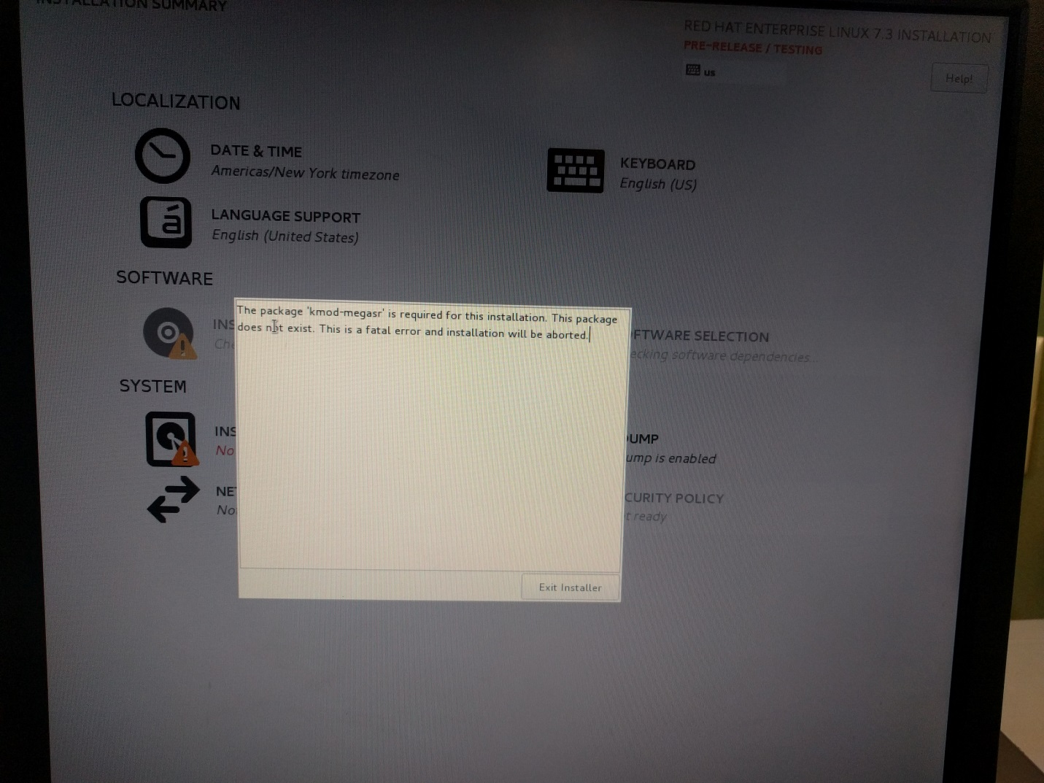

- DMESG screen shot showing megasr driver is loaded and the RAID 0 virtual drive is discovered.
