The Business Central GUI provides a process diagram for running processes. The current execution step is supposed to be highlighted in red. Previously executed steps are shown in grey. Below is a scenario where the current execution step is not displayed in red. This is just a display issue. The process is executing fine. It does make it harder for an operator to know which step a process is executing though.
Suppose the ‘Send Message And Process Response’ command fails. The process waits at the event labelled labeled ‘Error Handling Decision’. The event icon is highlighted in red as expected to indicate where the process is. Compare this to the second diagram below where the process loops around a second time.
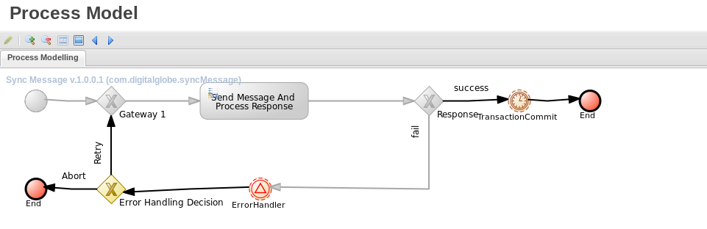

Iteration 2:
Now the error handler is invoked a second time for this same process. In other words, the ‘Retry’ branch is executed and the command fails again. The process is now waiting at the event labelled ‘Error Handling Decision’. Note that this icon is not marked in red to indicate where it is.
