Issue while updating the virtual appliance through CFME:
When we try to start or stop the virtual appliance, sometimes it works fine. Sometimes it won’t work. Though the virtual appliance gets started/stopped in the cloud(at cloud provider’s side), CFME UI shows the previous sate only.
Below is the example to ‘start’ Virtual appliance which is there in the openstack.
API Request:
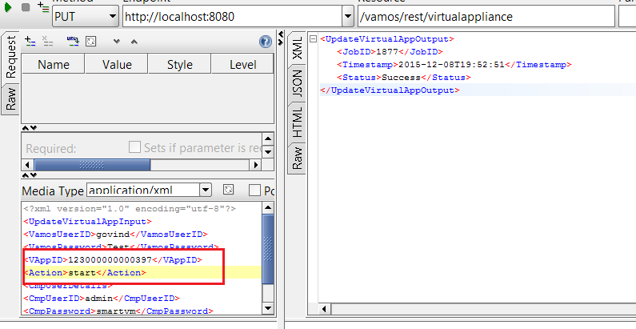

Response from the CFME: where it says status -‘Ok’
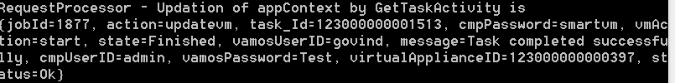

CFME UI: Showing power state as ‘off’

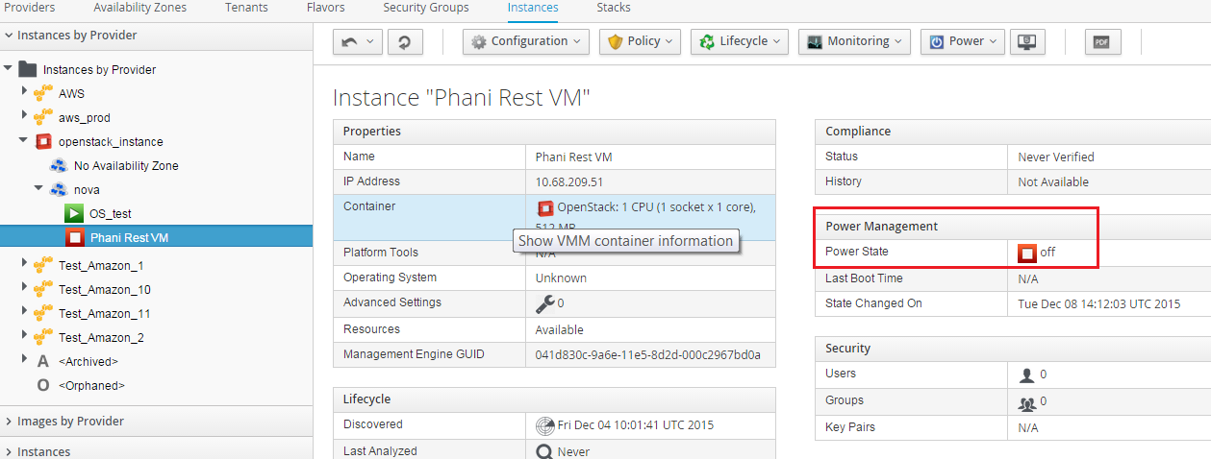

Openstack UI: showing Power state as Running

