Step 1: Created volume with an image
Step 2: Launch instance by choosing an option boot from volume

Step 3:
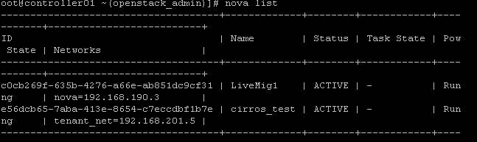
Step 4:
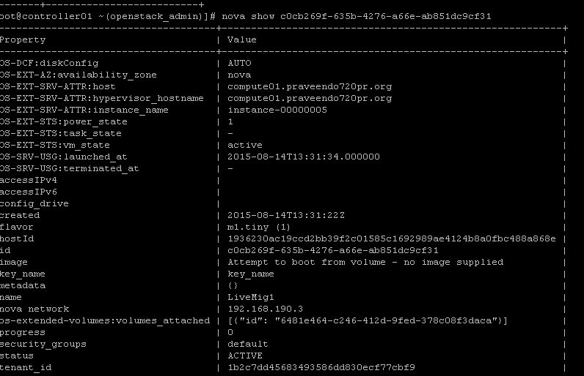

Step 5: nova service-list
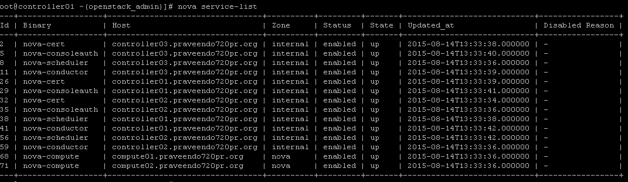
Step 6: Migrating from compute01 to compute02 but after the live migration,instance still stay on compute01.
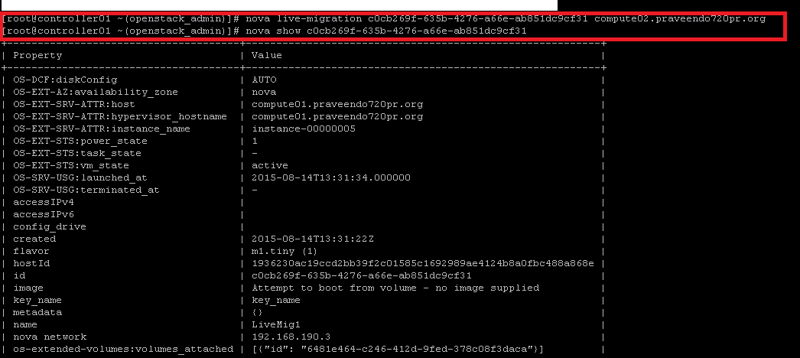

I see below errors on nova-cpmpute.log file :

, "auth_username": "volumes", "ports": ["6789", "6789", "6789"]}}}
_http_log_response /usr/lib/python2.7/site-packages/keystoneclient/session.py:224
2015-08-14 13:39:31.056 44429 DEBUG nova.virt.libvirt.driver [-] [instance: c0cb269f-635b-4276-a66e-ab851dc9cf31] Starting monitoring of live migration _live_migration /usr/lib/python2.7/site-packages/nova/virt/libvirt/driver.py:5783
2015-08-14 13:39:31.059 44429 DEBUG nova.virt.libvirt.driver [-] [instance: c0cb269f-635b-4276-a66e-ab851dc9cf31] Operation thread is still running _live_migration_monitor /usr/lib/python2.7/site-packages/nova/virt/libvirt/driver.py:5635
2015-08-14 13:39:31.060 44429 DEBUG nova.virt.libvirt.driver [-] [instance: c0cb269f-635b-4276-a66e-ab851dc9cf31] Migration not running yet _live_migration_monitor /usr/lib/python2.7/site-packages/nova/virt/libvirt/driver.py:5666
2015-08-14 13:39:31.062 44429 DEBUG nova.virt.libvirt.config [-] Generated XML ('<disk type="network" device="disk">\n <driver name="qemu" type="raw" cache="none"/>\n <source protocol="rbd" name="volumes/volume-6481e464-c246-412d-9fed-378c08f3daca">\n <host name="192.168.170.53" port="6789"/>\n <host name="192.168.170.54" port="6789"/>\n <host name="192.168.170.55" port="6789"/>\n </source>\n <auth username="volumes">\n <secret type="ceph" uuid="99aac39f-0d3c-4b99-bdc4-324ac9455327"/>\n </auth>\n <target bus="virtio" dev="vda"/>\n <serial>6481e464-c246-412d-9fed-378c08f3daca</serial>\n</disk>\n',) to_xml /usr/lib/python2.7/site-packages/nova/virt/libvirt/config.py:82
2015-08-14 13:39:31.062 44429 DEBUG nova.virt.libvirt.driver [-] Find same serial number: pos=0, serial=6481e464-c246-412d-9fed-378c08f3daca _update_volume_xml /usr/lib/python2.7/site-packages/nova/virt/libvirt/driver.py:5430
2015-08-14 13:39:31.073 44429 ERROR nova.virt.libvirt.driver [-] [instance: c0cb269f-635b-4276-a66e-ab851dc9cf31] Live Migration failure: operation failed: Failed to connect to remote libvirt URI qemu+tcp://compute02.praveendo720pr.org/system: unable to connect to server at 'compute02.praveendo720pr.org:16509': No route to host
2015-08-14 13:39:31.074 44429 DEBUG nova.virt.libvirt.driver [-] [instance: c0cb269f-635b-4276-a66e-ab851dc9cf31] Migration operation thread notification thread_finished /usr/lib/python2.7/site-packages/nova/virt/libvirt/driver.py:5774
2015-08-14 13:39:31.562 44429 DEBUG nova.virt.libvirt.driver [-] [instance: c0cb269f-635b-4276-a66e-ab851dc9cf31] VM running on src, migration failed _live_migration_monitor /usr/lib/python2.7/site-packages/nova/virt/libvirt/driver.py:5641
2015-08-14 13:39:31.563 44429 DEBUG nova.virt.libvirt.driver [-] [instance: c0cb269f-635b-4276-a66e-ab851dc9cf31] Fixed incorrect job type to be 4 _live_migration_monitor /usr/lib/python2.7/site-packages/nova/virt/libvirt/driver.py:5661
2015-08-14 13:39:31.563 44429 ERROR nova.virt.libvirt.driver [-] [instance: c0cb269f-635b-4276-a66e-ab851dc9cf31] Migration operation has aborted

