Here on Rajini’s devstack, I created the following as Admin:

I created two projects, “audra_proj” & “cooper_proj”

I created one user, “audra” with only member privs.

When I log in as audra, I can see a project dropdown list at the top of the screen.  I do not see this with the RHOSP, see below.

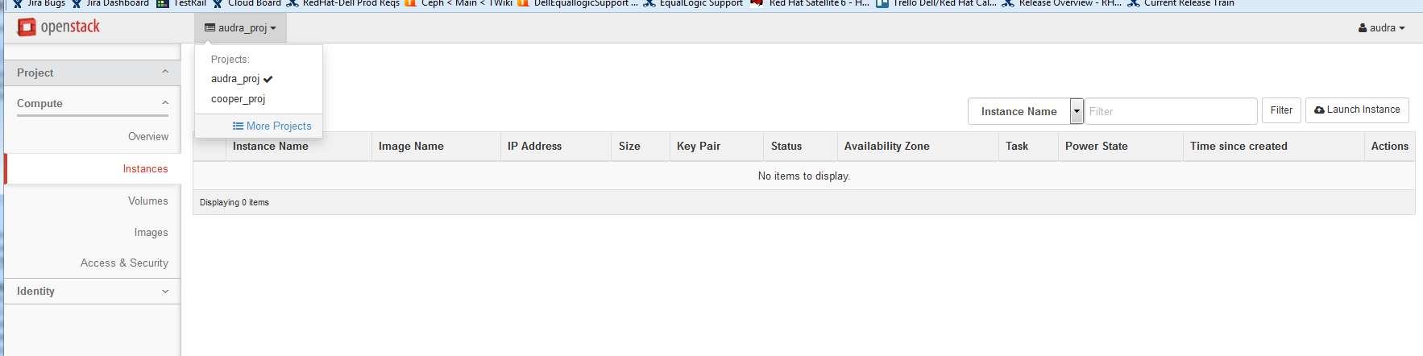

Here on my stamp, I created the following as Admin:

I created two projects, “new_proj” & “old_proj”

I created one user, “newuser” with only member privs.

When I log in as newuser, I don’t see any indication to tell me if I’m looking at new_proj or old_proj.   ???

